

Building and evaluating web-scraping solutions – how to test the efficiency and the effectiveness of a custom-built web-scraping solution.

by
Silvia Settle

Supervisor: Michael Dacey

Project submitted as part of the requirements for the award of
BSc (Hons) Computing (Software Engineering)

April 2022

DECLARATION

I, Silvia Stoianova Ivanova-Settle declare that I am the sole author of this Project; that all references cited have been consulted; that I have conducted all work of which this is a record, and that the finished work lies within the prescribed word limits.

This work has not previously been accepted as part of any other degree submission.

Date : 24 April 2024

FORM OF CONSENT

I, Silvia Stoianova Ivanova-Settle hereby consent that my Project, submitted in candidature for the B.Sc.(Hons) Computing (stream) degree, if successful, may be made available for inter-library loan or photocopying (subject to the law of copyright), and that the title and abstract may be made available to outside organisations.

Date : 24 April 2024

Table of Contents

CHAPTER 1 - INTRODUCTION 4
CHAPTER 2 – LITERATURE REVIEW 6
CHAPTER 3 – DEVELOPMENT METHODOLOGY 13
Problem Statement 13
Development Approach 13
Investigation 14
Design 15
Implementation 16
Results 17
Conclusion 17
Reflection 18
REFERENCES 20
APPENDIX 1 26
Native Applications 26
APPENDIX 2 1
Web Applications 1
APPENDIX 3 1
Target keywords 1
APPENDIX 4 3
Code for the Crawler 3

CHAPTER 1 - INTRODUCTION
Data has become increasingly important in the world of science, technology and business [1] and a lot of it is readily available on the web. Web scraping, also known as data harvesting, data wrangling, data mining, screen scraping and data extraction, offers a way of obtaining these large amounts of information faster and from various sources [2]. Web harvesting is the process of collecting publicly available data from the Internet in some form of automated way [3] and pipeline this for further cleansing, analysis, and processing [4]. Scraping is often used alongside the terms of ‘web-crawling’, ‘spidering’, ‘web-bot scraping’, which is the first part of the data-wrangling process, the one in which the target data is searched for and identified [5]. Data harvesting can be thought of as the second part of the process, where the target data is extracted [6].
Data scraping as such is not a self-contained process with its own means to an end but just one of the many other potential sources of data used in data analytics and data mining. The benefit of being able to access a huge amount of publicly available data automatically and at scale [7] is the drive behind a lot of scraping projects [8]. The appeal behind using web-scraping is the speed of data gathering and the potential to quickly expand the volume of available data, which in turn can be used to inform better analysis, knowledge-building and decision-making. These can be applied to a variety of contexts: market research, goods and service-price comparisons, search-engine optimisation strategy/monitoring, web-application monitoring, social media posts, research and behaviour patterns, etc. [9] Their range can vary significantly - from a broad scraper that is collecting data from unknown number of websites to a targeted one that is looking at a particular web-site with known number of pages [10]. The tools and techniques used will also depend on the nature and the purpose of the project [11].
Considering the above and the multitude of tools and approaches available for web-scraping, our hypothesis is that web-scraping solutions are predominantly custom-built, and as such evaluating the efficiency and the effectiveness of each project is closely dependent on the implementation and the context of the chosen framework. The benefits of using a web-scraper to obtain publicly available data should be carefully considered alongside some of the challenges faced by most web-scraping projects, and especially those running at scale – the challenge of data quality and provisioning with well-suited and finely-tuned infrastructure [12]. Ultimately, any data scraping endeavour requires a well-rounded evaluation of the investment made in the project terms of time, effort and resources versus the return from it – how useful is the data obtained.
The aim of this project is therefore to evaluate how to implement an efficient and effective web-scraper application. The objective is to investigate different approaches to web-scraping and examine how the efficiency and effectiveness of custom-built web-scraping solutions can be measured against a set of performance testing metrics. To achieve this, a closer look will be taken into the approaches and challenges of building a web-scraper, and as a result, look into constructing a framework for testing and evaluating the efficiency and effectiveness of a web-scraper.

CHAPTER 2 – LITERATURE REVIEW
Web crawling and web scraping are sometimes used interchangeably but are actually two different parts of the overall process of obtaining data and information from web resources. While the primary objective of the crawler/spider is to find information online, the task of the scraper is to extract it [5]. Web crawling has emerged historically to meet the need for webpages discovery and indexing by web-directories, search engines, and web archives [13]. The process starts with one or more page-addresses (URLs) called the ‘seed’, being passed to the crawler to traverse. The spider parses the HTML content in search of hyperlinks that lead to other internal or external pages. These are catalogued in some form of store and a distinction is made between pages that have been visited and those that are not yet visited - sometimes called the ‘frontier’ [13]. The process may be repeated over and over again either to update the existing index or to map out new content [14].
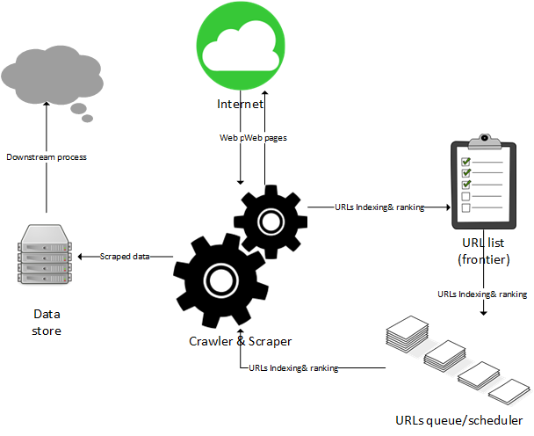
1 High-level web crawler & scraper diagram
There may be variation in how the search is performed. One approach is to use breadth-first search and to store the URLs in the same order as they are discovered using a First-In-First-Out structure [15]. These are considered ‘traditional’ or ‘indiscriminate’ crawlers. This approach highlights the need for some considerations, especially if the crawler is expected to perform at scale, and that is - when to stop. The challenge is in providing the resources needed for a crawler that can map the entire world wide web and can perform indefinitely – in reality a spider can only visit and store a finite number of pages and often the project’s budget determines its scope [13]. Any solution will have to consider and put some restriction to the number of pages visited within a particular domain (the depth of the search), and the length and the frequency of the execution time [13]. Another consideration for this approach is the need to evaluate and weigh-in the results - if the crawler needs to perform a search for web-pages that are linked to a specific search-term, then some results will be more relevant than others and would need some sort of score or ranking. The solution to this challenge is the ‘focused’ or ‘specialised’ crawler which evaluates the results against their objective and ignores results considered irrelevant [16]. The field of finding the optimal approach to a focused crawling solution is vast and includes areas such as search engine optimisation (SEO), page-ranking and classification algorithms and their performance [13, 14, 15, 17, 18, 19, 20]. This statement also applies to finding ways to resolve concurrency and collision issues encountered when more than one search processes are executed in parallel by the spider(s) and when a webpage’ status changes from unvisited to visited, or from visited to scheduled to be visited [21, 22, 23, 24].
Once an URL has been identified as a relevant source of information the job of the scraper is to extract it. In a sense, a scraper can also be considered an application programming interface (API), through which one piece of software - the data extractor, communicates and interacts with another piece of software - the webpage [8].
The solution can either make use of a ready-made off-the-shelf scraping tool such as ‘ScrapeBox’ (https://www.scrapebox.com/), ‘ScrapingBee’ (https://www.scrapingbee.com/), ‘DiffBot’ (https://www.diffbot.com/ ), ‘Parsehub’ (https://www.parsehub.com/), etc., or can be custom-built from scratch using libraries and frameworks such as BeautifulSoup, Scrapy, Selenium (for Python), JSoup, HTMLUnit and WebMagic (for Java), and Puppeteer, Cheerio, Playwright, Crawlee (for Java Script).
Depending on the type of the targeted data, the harvesting solutions can be predominantly categorised as news scrapers, sport results, e-commerce, real-estate, marketing, stock-data, travel, research, education, and search-engine results (SERS) scrapers [9, 25, 26, 27, 28]. In that sense the format of the target data can also vary significantly from project to project – from plain text to csv files, pdf, images, etc. [7] A scraper can also be used as an in-house tool for monitoring the performance of proprietary web-solutions, internal applications, ensuring compliance and enhancing security [29].
The mechanics of any scraping process involves several steps: making a request to obtain the data (this is usually an HTML content), traversing through the response to locate the target data, extracting it and storing it (this step can also include data cleansing and formatting) [8]. Some solutions may also include a prerequisite step of reviewing and inspecting the data prior to scraping it in order to choose the best approach to obtaining it [10].
Data on the internet can be presented in many ways and formats, and so it is only logical that finding and extracting it can be done in different ways. The most common approach is to request and parse the HTML content of the webpage. The html elements can be accessed directly by name or id, and so are the CSS selectors and classes [11, 30, 31]. The only caveat of this approach is that to know the exact names of the selectors the website must be accessed and inspected prior to the solution being built, and consequently, the solution would be only valid for the specific web-page content and could not be generically applied across the web to any other sites. A variation of the HTML parsing is obtaining the data from the document object model (DOM) – the representation of the structure of the web page created by the browser rather than the pure source code [11, 32, 33]. The DOM and the HTML may differ from each other when the content of a webpage is created dynamically. Traditionally, all the content of a website was generated by the server before being sent to the client’s browser in one single request-response transaction – the content did not change, and therefore the website remained the same, i.e. it was static. To optimise the performance, the dynamic content solution was introduced where the client’s browser builds the webpage by applying scripts to the code sent in the server’s response [34]. This way, the final view of the website displayed by the client’s browser could be built and changed bit by bit, in numerous small, behind the-scenes transactions, thus providing faster performance and personalized content. In terms of web-scraping, however, this poses a challenge, as what the human sees on the screen is not always the same as what the browser, and therefore the scraper necessarily gets, as the content arrives in different stages and it is hard to determine which state is the final one and where exactly everything is [35].
Other web-crawling methods include searching for web content with the help of regular expressions (RegEx, RE), traversing the XML layout of the page and using XPath queries. Regular expressions are string patterns (and hence the term ‘expressions’) that can be searched and matched against a body of text [36, 37]. Almost all programming languages offer the facility of using regular expressions and as such are very useful in scenarios when the target text is known in advance and a regex is written to perform a generic search and find any string that matches that pattern.
XML is a tree-like representation of a webpage stored in a file [38]. The nodes in this structure can be accessed by referencing the element’s name, its relation to the root of the tree or other elements in parent-child-sibling relationships. Traversing the tree structure can be done by writing XPath queries – a language used to reference the elements of an XML structure by their name, value or position in relation to other elements [39].
Alternative source of information for crawlers and scrapers can be found in the meta-data held in the webpage response headers, the data from the website’s map (if available) and even from robot.txt file – a file written to manage web-crawlers [9]. The latter is written in a specific format using the rules defined in the Robots Exclusion Protocol, it can be automatically read by a bot and is technically a list stating which bots (referred to as ‘user-agents’) can access what pages from the website. The user-agent is information included in the header of the client’s request to the server used to identify the client’s browser, version and operating system to the server [40]. Useful for the server to be able to tailor its response to better suit the requirements of the requesting system in the server-client response and request architecture, including session persistence, cookies and caching [41].
It is important to note that compliance with the robots.txt file is voluntary, so it is down to the person or organisation building and using the scraper to consider the legalities and the ethics of the process and the solution. Currently there is no specific legislative framework that purposefully deals with data harvesting [45]. As a result, web scraping may be considered a controversial field as defining what is legal and what is not depends on the specifics of each use-case. At a high-level overview each scraping project should carefully consider the nature of the data being collected, how it is been collected and for what purpose. It is also helpful if a clear distinction is made between data that is personal or copyrighted compared to data that is facts and statistics [9]. In cases of harvesting online material that is clearly labelled as copyrighted and in violation with the website’s Terms and Conditions (only applicable when the user has been presented with and agreed to these), the owner may issue a ‘cease and desist’ letter and have a strong ground for filing ‘breach of contract’ or a ‘copyright infringement’ legal case [45]. In other cases, however, there is less clarity on the legal stance of a scraping project – for example, a website does not own any data generated by its users and some copyrighted data use may be permitted under the principle of ‘fair use’ [45].
When it concerns the individual, data protection legislation in the UK in the form of the 2018 Data Protection Act and the EU General Data Protection Regulations (GDPR) are quite clear about what substitutes personally identifiable information (PPI) and what protective steps should be taken when processing this data. A high-profile example of using web-scraping solution in breach of the data-protection rights is the 2016 Cambridge Analytica scandal [46] in which personal data was harvested without the knowledge or consent of the data-subjects and the data-controller (Facebook), and without any immediate actions being taken by the latter to address the issue. While this may be considered an extreme case and one that took place prior to the relevant legislative framework being updated, it also demonstrates how impactful one single data-harvesting tool can be and how any future projects need a careful consideration into the ethics of their own data-scraping solutions.
Like other technological innovations and tools, web scraping can also be used for illegal and fraudulent purposes. When data sources and data-mining solutions co-exist in an inter-connected world, it is also important to consider international legislation. The European and the US software market both seem to operate under increasingly stricter and tighter data-protection and computer-misuse regulations – in the UK the Computer Misuse Act was updated in 2022, the Data Protection Act in 2018, the Copyright, Designs and Patents Act is from 1988, and the Data Protection and Digital Information (DPDI) Bill is in its final stages of becoming law, while the USA has the American Data and Privacy Protection Act (ADPPA) of 2022, the Digital Millennium Copyright Act (DMCA) of 1998 and the Computer Fraud and Abuse Act (CFAA) of 1986. Any unauthorised access to information is considered illegal both in the UK and the USA. Not every use-case, however, has clear-cut context and legislative framework that applies to it. In the USA there have been data-harvesting cases filed and won against a data-harvesting project under the ‘trespass to chattels’ Tort law of 1977. In this example a business (Ebay) as the owner of a possession (data from the company’s website) was given legal compensation for being deprived of access and revenue from their resource (Ebay vs. Bidder’s Edge, May, 2000) [47]. Bidder’s Edge lost the case as they continued harvesting data from Ebay’s website for several years after Ebay sent them ‘cease and desist’ letter and tried blocking the bot’s IP addresses. Ebay claimed that the Bidder’s Edge scrapers were responsible for denial of service and a significant loss of traffic and revenue [9]. In contrast, the ruling of the HighQ Labs vs LinkedIn case from 2022 was in favour of the web-scraping solution on the premise that HighQ Labs were not engaging in hacking activities and that the employee’s profile data they were harvesting from the LinkedIn’s website was publicly available, therefore not violating the CFAA [48].
The brief cases overview suggests that if in doubt and as a precaution it is best practice to seek legal advice prior to starting any data-harvesting project, especially if it involves personal or copyrighted data, and the outcome is likely to attract revenue.
The ethics and the legality of data-scraping use-cases are not the only challenge to consider when building a data-wrangling solution. As previously discussed, when designing the overall project certain decisions need to be made around the scope of the target data (what will be searched and where) and the starting point for the search – the ‘seed’; what search algorithm will be best for locating the target data – breadth-first or focused; how are the lists containing discovered, visited and unvisited URLs going to be stored and updated – how big is the data, would it be located in one data store or distributed; how is the URL content going to be categorized (indexed) and are the URL results going to be ranked or not; how are the bots going to be scheduled and run – weighing out how often and quickly the data is needed against the risk of being blocked, including considerations for distributed solutions, concurrency and preventing processes collisions; when should the crawler stop. In summary, a well-balanced solution seems to lie in the careful choice between storage capacity and processing power [49].
The challenges to consider when designing and building the scraper are more functional and are primarily concerned with making sure that the desired data is found and extracted in the desired level of detail and format. There are myriad of reasons why a scraper may not be returning the data: from error in the code (either on the solution side, or the data-source side), mismatched or missing software prerequisites and dependencies, to hardware issues, client-side connectivity, or server-side connectivity issues, etc. [9]. Choosing the right method and the best tool for the job is also important and will depend on the project’s use-case. For example, monitoring internal data logs in xml layout will be more suitable for a scraper using XML parser and/or XPath queries, while matching a live website against its design map for audit purposes will be more suited for a scraping method using an HTML or a DOM parser. The solution could be custom-built in Python because the business happened to have developers familiar with this programming language, while another business may opt for a proprietary tool such as ‘Zyte API Enterprise’ (https://www.zyte.com/zyte-api-enterprise/).
The above considerations can be grouped under the banner of feasibility study, which is usually the first step in a software development lifecycle. If scraping is seen as a possible solution for obtaining certain data, then questions of balancing time, budget and resources against the gains and the returns of the project results should be answered first.
Software development aims to solve a problem and the overall process usually goes through the stages of gathering requirements, designing and implementing the solution, testing, integration and maintenance [50]. The approach taken to develop and test a specific custom-built web-scraping solution is described next.

CHAPTER 3 – DEVELOPMENT METHODOLOGY
Problem Statement
The initial consideration for a web-scraping project was as a possible solution to the problem of being able to aggregate data about the accessibility levels of the tourist attractions in a particular geographical area. For example, if a wheelchair user was visiting a particular tourist destination and wanted to find out which of the local attractions have a wheelchair access, they would have to visit the websites for each individual venue to find out this information. Being able to collect the accessibility data for each venue within a certain geographical area and presenting it in one place was the initial ultimate objective of the project. After an investigation into the feasibility and consideration for some of the limitations of the initial idea, the scope of the project was reduced to developing a prototype for the scraping part of the solution, with focus on a testing framework for evaluating its efficiency and effectiveness. Within the context of software development, the term efficiency is understood as a measure or a level to which a desired result is achieved (i.e. how good is the software in doing what it is supposed to do), while effectiveness is about producing the desired results, accuracy and meeting the intended requirements (is the software doing what it should be doing) [51].

Development Approach
There is no single one-size-fits-all approach to software development, but a multitude of methodologies [52]. These can be grouped into three broad categories: waterfall model (the steps to software development lifecycle is sequential), iterative (the steps are executed in iterations) and component-based (this approach focuses on building a system made out of different components [50]. The development approach taken for this web-scraping solution was slightly different because of the constraints and the limitations imposed by the project’s timescale, deadlines, and resources in terms of the number of project members – just one, their skills and experience – programming knowledge of Python, and available tools and technologies (research existing solutions, available modules and libraries, software requirements and dependencies). The approach taken was similar to a Rapid Prototyping Model (RPM) and a Spike-style investigation from the context of the Agile methodology [53] in the sense that the main objective was to investigate and explore possible solutions as a proof of concept rather than a complete working solution. The benefits of this approach are rapid development with low risk of failure, reduced cost (time and resources), adaptability and flexibility of approach [54]. As secondary objectives the project aimed to validate the effectiveness of the solution through functionality testing, and its efficiency through measuring the number of tests that passed, how many of the requirements have been tested (coverage), how many defects have been detected and their severity [52]. To meet the functional purpose of the testing objective a test plan comprising of unit tests was to be developed [55]. In this context quality assurance was to be achieved by specifying how testing will meets its purpose and quality control by specifying what would be the expected outcomes of the effectives testing measures and the efficiency testing metrics [56]. Usability testing was not considered because the project was focused on developing a back-end solution, rather than a front-end user-facing components. Performance and integration testing were also not considered as there was not expectation that a complete working solution would be delivered, instead, the emphasis was on investigating possibilities for solutions to inform potential design and development decisions in the future. Although this approach may be perceived as limited in scope, working in an incremental and an evolutionary way means that the project and the solution will mature over time [51].
The test framework was expected to make use of model-driven test design [57] and dynamic test processes [567] that describe the test design requirements, the requirements for the environment, and produce evidence or log with the results. Ultimately, the understanding is that when developing a software model for a process it is to be expected that the requirements may be complex and changing, and that the choice for how these would be met would be influenced by factors such as how well the model has been understood and translated into requirements, what are the project’s limitations and what are the resources available to the team [58].

Investigation
Solutions with varying levels of similarity to the proposed project already exist both as native applications for Android and iOS devices, and as web-applications. The route for developing the project as a native application was not considered due to lack of prior development experience in this area and because of other perceived mobile apps limitations such as associated costs, advertisement inconvenience, privacy and security concerns from users [59]. Appendix 1 provides a brief overview of some of the existing similar native applications.
Similar web applications were also explored at the initial stages of the project design. Two solutions deserve a mention - ‘Accessmap’ and ‘AccessAble’. Accessmap offers a route-planning from point A to point B while meeting certain conditions such as wheelchair accessible route, walking stick suitable route, motorised wheelchair with the option to see the gradient, as well as streets, curbs and stairs, sidewalks, and crossing-adjacent-streets avoidance. Although the map visuals are excellent, the application is geographically specific. Accessible is exactly what the initial complete solution for the project was aiming to achieve. It has functional map visuals and accessibility categories symbols with the option for more details on a particular venue displayed in a pop-up window. The app is applicable to the UK, however the venue locations become very sparse when a location outside of England and in Wales or Scotland is searched.
Summary of the example solutions are enclosed in Appendix 2.

Design
The final design choices for the solution and for the testing framework were steered by the available resources, the developer’s experience, and findings from the investigation into existing projects. Ater some initial tests Python was established as the preferred choice for programming, mainly because of previous experience and the indication from the initial research that Python has a well-established scraping library called BeautifulSoup4 (https://pypi.org/project/beautifulsoup4/) with plenty of examples for existing solutions. However, the initial crawler functionality was developed as a separate component using in Java Script. This followed a test-driven development methodology (TDD) [60], in which the tests were written prior to the code that satisfies them. Another Python product was initially considered for the scraping solution but was later dismissed – Scrapy (https://scrapy.org/), because as a scraping framework it had additional functionality, and this extra complexity required additional dedicated time and a range of scenarios to experiment with before applying it to an intended solution. Another design choice was to use GitHub as a repository for any code developed because of the version control functionality, added backup security, and option to share the project if required. The integrated development environment (IDE) used was Visual Studio Code as it offers dependencies management, facilitates working in a virtual environment, offers a quick and convenient overview of the whole project, terminal execution and GitHub integration.
The design for the project’s functionality was split into a crawler and a scraper component. The requirements for the crawler was to be able to find all the links within the same domain once an starting page is passed as a the ‘seed’. The requirements for the scraper was to: 1 – make a request; 2 – convert the returned HTML content to text; 3 – convert the text content to a BeautifulSoup object to be able to traverse it and find target data; 4 – find the target data and store it as a result list; 5 – export or display the results. At the design stage it was not yet clear which parser method would be used to locate the target data as on functional level parsers are specific for the tool used. For example, BeautifulSoup has several parsers – for HTML, for XML, etc (https://beautiful-soup-4.readthedocs.io/en/latest/). The choice for parsing method used is also highly dependent on what is the target data, where is the data coming from – what is the source, and how it displayed on the target webpage – what format. This was the reason to leave this design element open for decisions to be made during the implementation stage, as there were too many unknowns. The overall goal of the scraper was to be able locate certain keywords that will indicate that the webpage has some of the desired data. Once the content of a web-page is obtained, a functionality was required to check a list of keywords against it. The format of the output was anticipated at that stage to be a CSV or .TXT file.

Implementation
The early implementation stages faced some challenges in terms of inability to obtain HTML content after the request was made. It was speculated that the reason for this is that the target webpage was blocking the scraper by cookies or IP address block. As a result, a decision was made to create a mock target website with mock data that would be used for testing purposes. Additional benefit of this approach was that there were no associated ethical or legal concerns stemming from using the scraper on public websites.
The mock website was very basic, containing several pages with keywords that would indicate that the venue (an accessible restaurant called ‘Accessible Eats’) has certain categories of accessibilities such as disabled parking, or disabled toilet, ramp access, etc. The target keywords can be found in Appendix 3. The fact that website was not built using CSS selectors and classes was the reason why a decision was made to use regex for locating the target text. This also makes the solution transferable to other public websites as it is not relying on the HTML or XML layout, which are website specific.
The crawler component was developed using JavaScript. This demonstrated functionality to find and extract any hyperlink within the same domain. The results were output as a log. It was also intentionally developed using TDD techniques to experience and test this approach to software development. The code for the crawler is attached in Appendix 4.
There were several scrapers produced as stand-alone components. They were also aimed at investigating and test different methods for extracting the target content: using HTML selectors, CSS selectors, and using RegEx. The unit-tests were added to the solution that had functions as part of a testing framework on the solution efficiency.

Results

Intiial errors linked to environmental issues
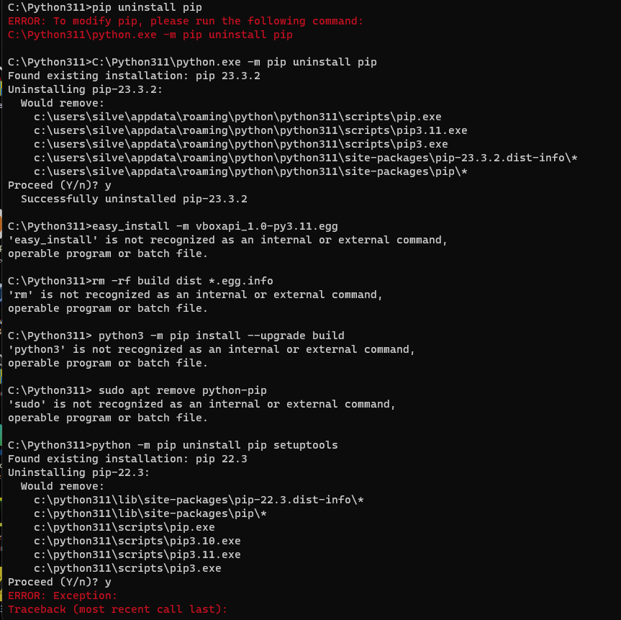
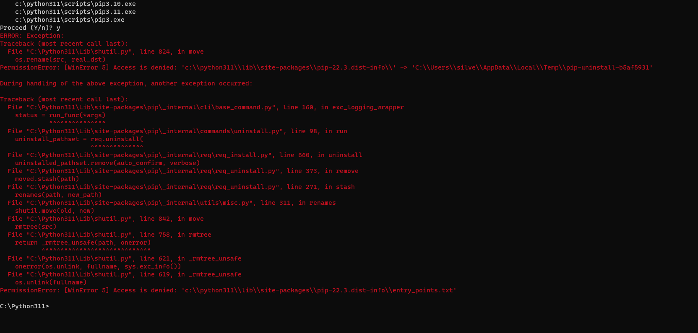

Testing output functionality
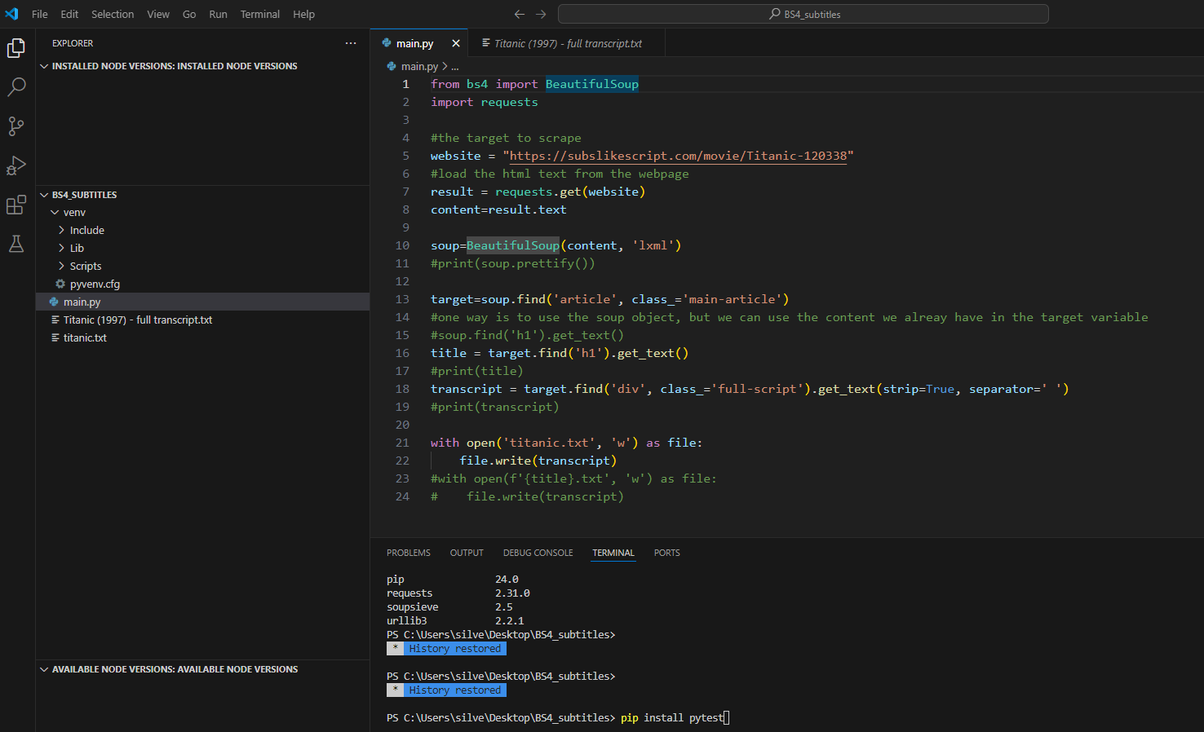
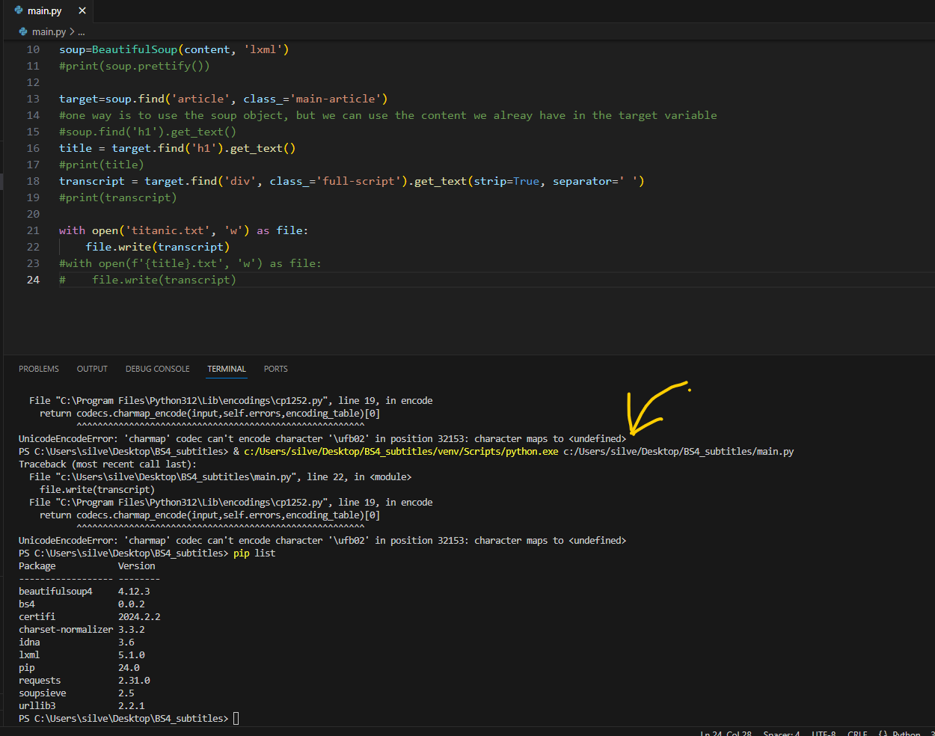
This component tested results output in a .txt file using data from a website purpose-built for scraping

Testing data return from using HTMLParser from Selectolax
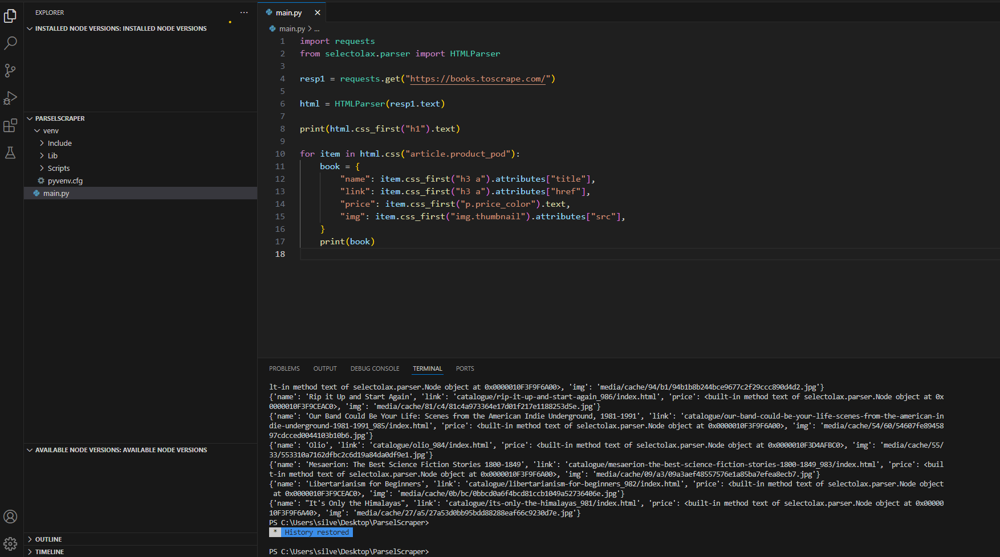
Testing html parser
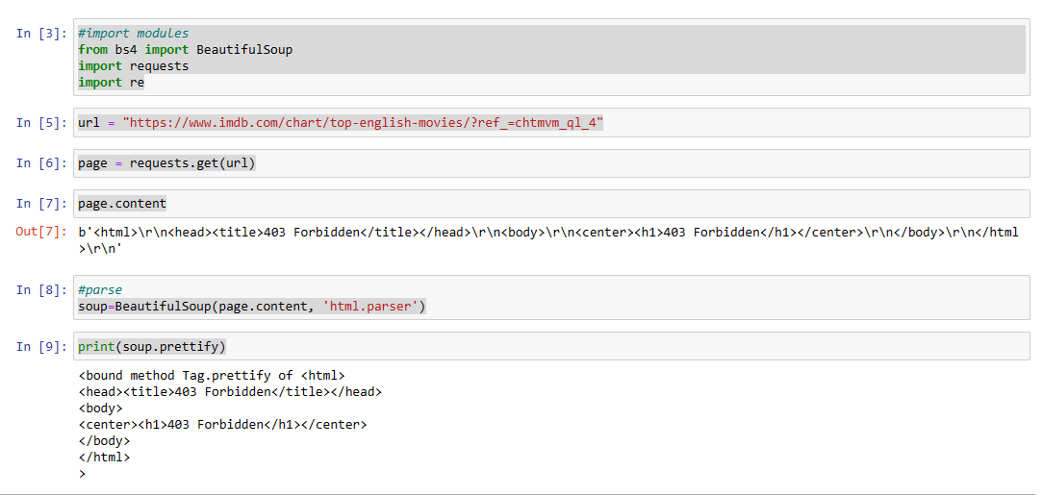

Results returned from using the regex scraper
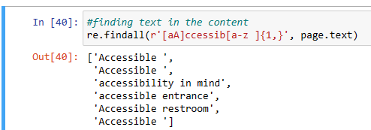

Testing output from using CSS selectors
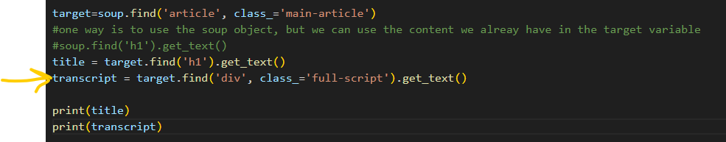

Conclusion
The test results demonstrated that the requirements were met, which also met the requirements of the project. Future work may include building a completely functional application that can be tested ‘in the wild’. Another implementation can look into using ML and AI instead of static lists of target words.
Reflection
I have learned a lot about scrapers and how to best approach a software development solution.

REFERENCES
[1] Ivan Shkvarun, Going Big: The Story Of Open Data, Nov 27, 2023, https://www.forbes.com/sites/forbestechcouncil/2023/11/27/going-big-the-story-of-open-data/?sh=43a7fd871300
[2] U. Vignesh, R. Parvathi, and R. Goncalves, “Covid Live Multi-Threaded Live COVID 19 Data Scraper,” in Structural and Functional Aspects of Biocomputing Systems for Data Processing, IGI Global, 2023, pp. 28–56. doi: 10.4018/978-1-6684-6523-3.ch002.
[3] Vargiu, Eloisa, Mirko Urru, “Exploiting web scraping in a collaborative filtering-based approach to web advertising”, in Artificial Intelligence Research. 2013, Vol. 2, No.1. https://www.sciedu.ca/journal/index.php/air/article/view/1390/1115
[3] Zyte, Web Scraping Maturity Model. A roadmap for success in web scraping. Whitepaper, 2023, The-Web-Scraping-Maturity-Model_Zyte-Whitepapers.pdf
[4] F. Qudus Khan, G. Tsaramirsis, N. Ullah, M. Nazmudeen, S. Jan, and A. Ahmad, “Smart algorithmic based web crawling and scraping with template autoupdate capabilities,” Concurrency and computation, vol. 33, no. 22, 2021, doi: 10.1002/cpe.6042.
[5] Ari Bajo, Web Crawling With Python, 05 January 2023, Web crawling with Python | ScrapingBee
[6] N. A. Sultan and D. B. Abdullah, "Scraping Google Scholar Data Using Cloud Computing Techniques," 2022 8th International Conference on Contemporary Information Technology and Mathematics (ICCITM), Mosul, Iraq, 2022, pp. 14-19, doi: 10.1109/ICCITM56309.2022.10032044.
[7] Sirisuriya, D. S. A Comparative Study on Web Scraping. Proceedings of 8th International Research Conference. 2015
[8] Ur Rahman, Rizwan, et al. "The Emerging Threats of Web Scrapping to Web Applications Security and Their Defense Mechanism." Encyclopedia of Criminal Activities and the Deep Web, edited by Mehdi Khosrow-Pour D.B.A., IGI Global, 2020, pp. 788-809. https://doi-org.ezproxy.uwtsd.ac.uk/10.4018/978-1-5225-9715-5.ch053
[9] Mitchell, Ryan. Web Scraping with Python. Data Extraction from the Modern Web. O’Reilly, 2024
[10] Fessel, Kimberly, Chirstopher Bailey. Episode #12: Web Scraping in Python: Tools, Techniques, and Legality – The Real Python Podcast, 2020. https://realpython.com/podcasts/rpp/12/
[11] R. Gunawan, et al. Comparison of Web Scraping Techniques : Regular Expression, HTML DOM and Xpath, Proceedings of the 2018 International Conference on Industrial Enterprise and System Engineering (IcoIESE 2018), 2019, Atlantis Press. Comparison of Web Scraping Techniques : Regular Expression, HTML DOM and Xpath | Atlantis Press (atlantis-press.com)
[12] Zyte, Enterprise web scraping: A guide to scraping at a scale. Whitepaper, 2021
[13] Md. H. Alam, J. Ha, and S. Lee, “Novel approaches to crawling important pages early,” Knowledge and information systems, vol. 33, no. 3, pp. 707–734, 2012, doi: 10.1007/s10115-012-0535-4.
[14] J.-G. Lee, D. Bae, S. Kim, J. Kim, and M. Y. Yi, “An effective approach to enhancing a focused crawler using Google,” The Journal of supercomputing, vol. 76, no. 10, pp. 8175–8192, 2020, doi: 10.1007/s11227-019-02787-9.
[15] S. Rajiv and C. Navaneethan, “A supervised learning‐based approach for focused web crawling for IoMT using global co‐occurrence matrix,” Expert systems, vol. 40, no. 4, 2023, doi: 10.1111/exsy.12993.
[16] R. S. Chaulagain, S. Pandey, S. R. Basnet, and S. Shakya, “Cloud Based Web Scraping for Big Data Applications,” 2017.
[17] C. Slamet, R Andrian, D S Maylawati, Suchender, W Darmalaksana and M A Ramdhani, Web Scraping Naïve Bayes Classification for Job Search Engine, IOP Publishing 2018
[18] G. Gupta and I. Chhabra, “Optimized Template Detection and Extraction Algorithm for Web Scraping of Dynamic Web Pages,” vol. 13, no. 2, pp. 719–732, 2017
[19] S. ALQARALEH, O. RAMADAN, and M. SALAMAH, “Efficient watcher based web crawler design,” Aslib journal of information management, vol. 67, no. 6, pp. 663–686, 2015, doi: 10.1108/AJIM-02-2015-0019.
[20] S. Rawat and D. R. Patil, “Efficient focused crawling based on best first search,” in 2013 3rd IEEE International Advance Computing Conference (IACC), 2013, pp. 908–911. doi: 10.1109/IAdCC.2013.6514347.
[21] R. Campos, O. Rojas, M. Marin, and M. Mendoza, “Distributed Ontology-Driven Focused Crawling,” in 2013 21st Euromicro International Conference on Parallel, Distributed, and Network-Based Processing, 2013, pp. 108–115. doi: 10.1109/PDP.2013.23.
[22] F. Qudus Khan, G. Tsaramirsis, N. Ullah, M. Nazmudeen, S. Jan, and A. Ahmad, “Smart algorithmic based web crawling and scraping with template autoupdate capabilities,” Concurrency and computation, vol. 33, no. 22, 2021, doi: 10.1002/cpe.6042.
[23] G. Rodriguez, Architectural framework for web development and micro distributed applications, First edition. Hershey, PA: Engineering Science Reference, IGI Global, 2023.
[24] N. Tonellotto, I. Ounis, and C. Macdonald, Efficient query processing for scalable web search. Boston [Massachusetts: Now Publishing Inc., 2018. doi: 10.1561/1500000057.
[25] Rahman, Rizwan Ur and Deepak Singh Tomar. “Threats of price scraping on e-commerce websites: attack model and its detection using neural network.” Journal of Computer Virology and Hacking Techniques 17 (2020): 75 - 89.
[26] A. S. Bale, N. Ghorpade, R. S, S. Kamalesh, R. R and R. B. S, "Web Scraping Approaches and their Performance on Modern Websites," 2022 3rd International Conference on Electronics and Sustainable Communication Systems (ICESC), Coimbatore, India, 2022, pp. 956-959, doi: 10.1109/ICESC54411.2022.9885689.
[27] Johnson, F., & Gupta, S. K. (2012). Web content mining techniques: A survey. International Journal of Computers and Applications, 47(11).
[28] N. A. Sultan and D. B. Abdullah, "Scraping Google Scholar Data Using Cloud Computing Techniques," 2022 8th International Conference on Contemporary Information Technology and Mathematics (ICCITM), Mosul, Iraq, 2022, pp. 14-19, doi: 10.1109/ICCITM56309.2022.10032044.
[29] U. Knorovich, The Definitive Guide to Web Scraping in 2024, January 14, 2024, available from The Definitive Guide to Web Scraping in 2024 - Nimble (nimbleway.com) [accessed on 16/03/2024].
[30] A. Chapagain. Hands-On Web Scraping with Python. Extract quality data from the web using effective Python techniques. Packt, 2023
[31] Schrenk, Michael, Developing Bots with Selenium Python for Web Scraping, Test Engineering, Data mining, and Automation. Mepso Media LLC, 2023
[32] K. Fessel. Let’s Scrape the Web: PyCon 2020 Video Tutorial, 2020, available from Let's Scrape the Web: PyCon 2020 Video Tutorial (kimberlyfessel.com) [accessed on 20/02/2024]
[33] Alam Rahmatulloh and Rohmat Gunawan, “Web Scraping with HTML DOM Method for Data Collection of Scientific Articles from Google Scholar,” Indonesian Journal of Information Systems, vol. 2, no. 2, pp. 95–104, 2020, doi: 10.24002/ijis.v2i2.3029.
[34] O. Patil and A. Shirbhate, “Design and Implementation of a Java-Based Client-Server Application,” 2024, doi: 10.48550/arxiv.2404.10107.
[35] Irfan Darmawan, Muhamad Maulana, Rohmat Gunawan, and Nur Widiyasono, “Evaluating Web Scraping Performance Using XPath, CSS Selector, Regular Expression, and HTML DOM With Multiprocessing Technical Applications,” JOIV : international journal on informatics visualization Online, vol. 6, no. 4, pp. 904–910, 2022, doi: 10.30630/joiv.6.4.1525.
[36] J. MacCormick, What can be computed? A practical guide to the theory of computation. Princeton, New Jersey: Princeton University Press, 2018. doi: 10.1515/9781400889846.
[37] F. Parolini and A. Miné, “Sound static analysis of regular expressions for vulnerabilities to denial of service attacks,” Science of computer programming, vol. 229, pp. 102960-, 2023, doi: 10.1016/j.scico.2023.102960.
[38] 1484.12.3-2020 - IEEE Standard for Learning Technology--Extensible Markup Language (XML) Schema Definition Language Binding for Learning Object Metadata. New York, New York: IEEE, 2020. doi: 10.1109/IEEESTD.2020.9059045.
[39] “XPath,” A Dictionary of Computer Science. Oxford University Press, 2016.
[40] Web services : concepts, methodologies, tools, and applications. Hershey, PA: IGI Global, 2019. doi: 10.4018/978-1-5225-7501-6.
[41] C.-Y. Huang, Y.-D. Lin, P.-Y. Liao, and Y.-C. Lai, “Stateful traffic replay for web application proxies,” Security and communication networks, vol. 8, no. 6, pp. 970–981, 2015, doi: 10.1002/sec.1053.
[42] Alan. Calder, The EU Data Protection Code of Conduct for Cloud Service Providers : A Guide to Compliance. Ely: IT Governance Ltd, 2021.
[45] V. Krotov, S. Leiser. Legality and Ethics of Web Scraping. Emergent Research Forum, 2018, available from https://www.researchgate.net/publication/324907302_Legality_and_Ethics_of_Web_Scraping, [accessed on 02/02/2024].
[46] J.Wong, The Cambridge Analytica scandal changed the world - but it didn't change Facebook, 2019, available from https://www.theguardian.com/technology/2019/mar/17/the-cambridge-analytica-scandal-changed-the-world-but-it-didnt-change-facebook, [accessed on 11/03/2024]
[47] eBay, Inc v. Bidder’s Edge, Inc., 100 F. Supp. 2d 1058 (N.D.Cal. 2000), Justia https://law.justia.com/cases/federal/district-courts/FSupp2/100/1058/2478126/
[48] M. Adavelli, L. Tonogbanua, Is Web Scraping Legal? (Everything You Need to Know), TechJury, Oct 2023, available from https://techjury.net/blog/is-web-scraping-legal/ [accessed on 16/01/2024]
[49] Tonellotto, Nicola, Craig Macdonald and Iadh Ounis. “Efficient Query Processing for Scalable Web Search.” Found. Trends Inf. Retr. 12 (2018): 319-500.
[50] Misra, Sanjay, et al. "A Brief Overview of Software Process Models: Benefits, Limitations, and Application in Practice." In Computer Systems and Software Engineering: Concepts, Methodologies, Tools, and Applications, edited by Information Resources Management Association, 1-14. Hershey, PA: IGI Global, 2018. https://doi-org.ezproxy.uwtsd.ac.uk/10.4018/978-1-5225-3923-0.ch001
[51] Zykov, Sergey V., Alexander Gromoff, and Nikolay S. Kazantsev. Software Engineering for Enterprise System Agility: Emerging Research and Opportunities. Hershey, PA: IGI Global, 2019. https://doi-org.ezproxy.uwtsd.ac.uk/10.4018/978-1-5225-5589-6
[52] Y. Priya, Test Efficiency: How It Differs from Test Effectiveness? TestSigma blog, June 2023, available from https://testsigma.com/blog/test-efficiency/ [accessed on 12/12/2023]
[53] K. K. Aggarwal, Y. Singh, Software engineering (3rd ed.). New Delhi: New Age International Publishers, 2008
[54] C. Bodea, Agile Software Project Management Methodologies: the Agile Approach. “Ecological Informatics”, 5(4), 27–31, 2005
[55] G. Fournier, Essential Software Testing, A Use-case Approach, RCR Press, 2009
[56] 29119-1-2021 - ISO/IEC/IEEE International Standard - Software and systems engineering --Software testing --Part 1:General concepts. Place of publication not identified: IEEE, 2022. doi: 10.1109/IEEESTD.2022.9698145.
[57] P. Ammann, J. Offutt, Introduction to Software Testing, Second edition, Cmabridge University Press, 2021.
[58] G. Pérez, K. El Emam, N. H. Madhavji, Customising software process models. Software process technology (pp. 70–78). Berlin: Springer. doi:10.1007/3-540-59205-9_43, 1995
[59] R. M. Dawson et al., “What makes a good health ‘app’? Identifying the strengths and limitations of existing mobile application evaluation tools,” Nursing inquiry, vol. 27, no. 2, pp. e12333-n/a, 2020, doi: 10.1111/nin.12333.
[60[ D. Janzen and H. Saiedian, “Test-driven development concepts, taxonomy, and future direction,” Computer (Long Beach, Calif.), vol. 38, no. 9, pp. 43–50, 2005, doi: 10.1109/MC.2005.314.

APPENDIX 1

Native Applications

Application Name | Purpose and look | Comments
1.iAccess Life - Accessibility | 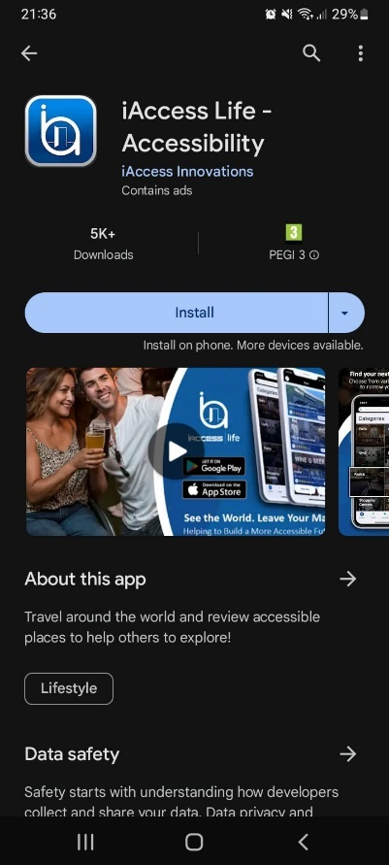 | An app that offers accessibility information based on the feedback and reviews of the users. Positives: a review can be written about almost any tourist destination around the world. Downside: the reviews can be subjective and difficult to verify. It also contains ads.
2. Passenger Assistance | 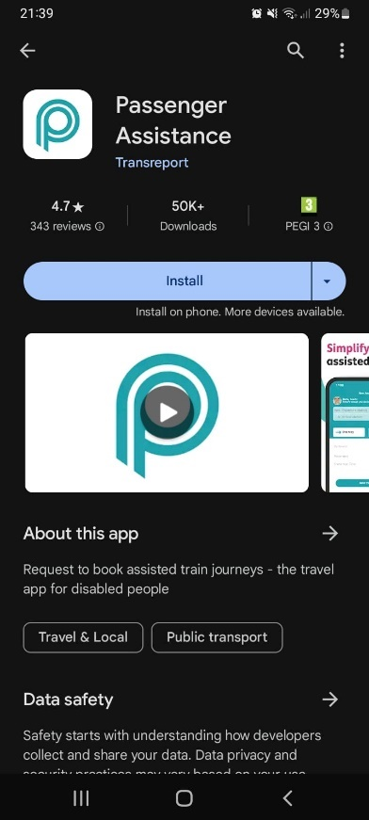 | The app is designed to help disabled passengers book and manage their assisted train journey. Positives: it improves the accessibility of the train journey and the customer experience. Negatives: it only covers train journeys, narrow scope.
3.Roadtrippers – Trip Planner | 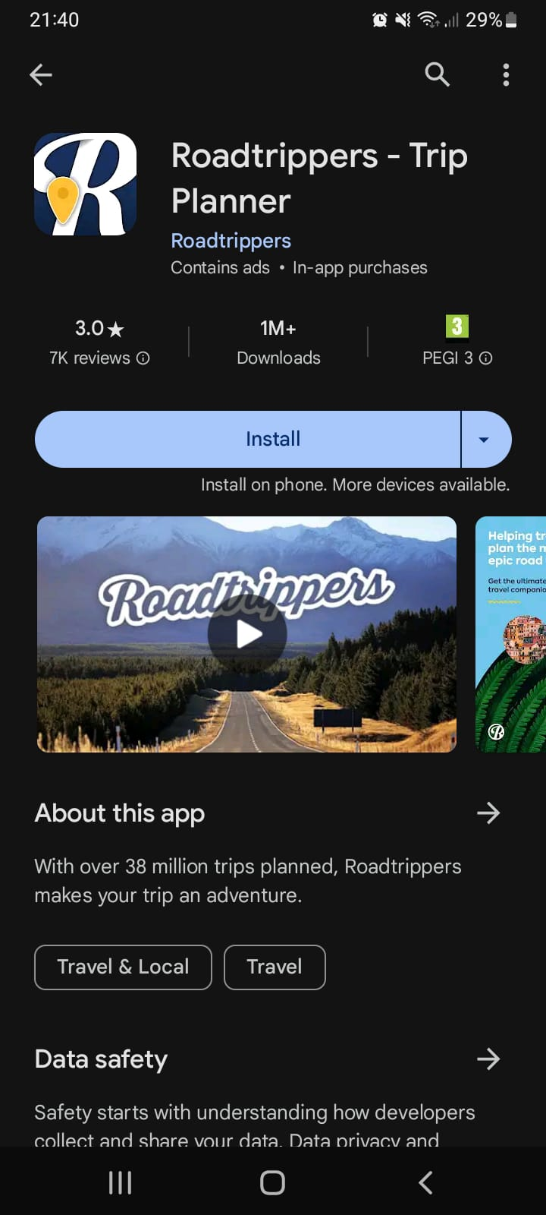 | The app helps plan a trip. Positives: a lot of information and advice on places to visit and things to do. Negatives: the trip planning is for the general user and not tailored to the needs of the disabled tourist. Scope is too broad. Also contains ads and in-app purchases.
4.Visit A City | 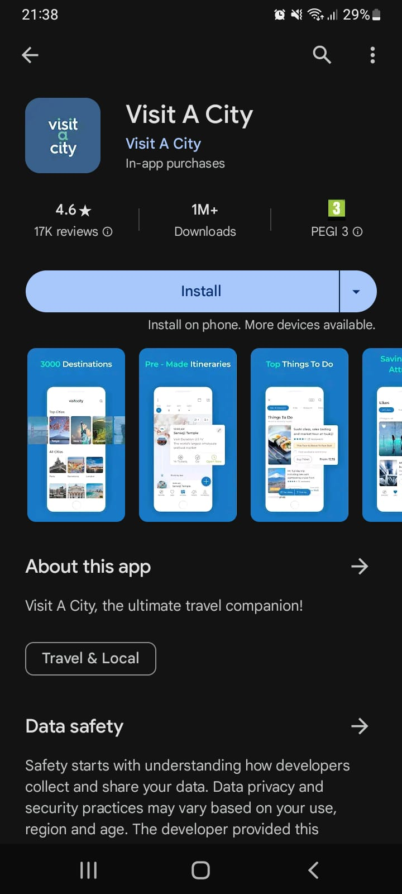 | The app helps organise trips to different cities. Positives: ideas for places to visit and things to do organised by destination. Negatives: the trip planning is for the general user and not tailored to the needs of the disabled tourist. Scope is too broad. Also contains in-app purchases.
5.Access HMNS | 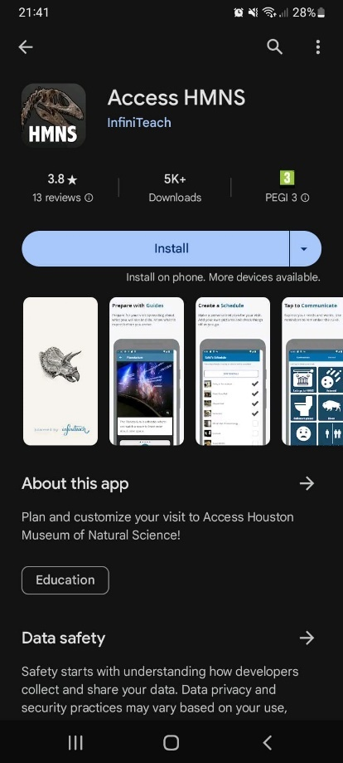 | The app helps disabled visitors organise their trip to the Houston Museum of Natural Sciences. Positives: it is tailored specifically to the needs of the disabled user. Negatives: the app is developed for one particular destination and as such the scope is too narrow.

APPENDIX 2

Web Applications

Application Name | Purpose and look | Comments
1.AccessMap www.accessmap.app | 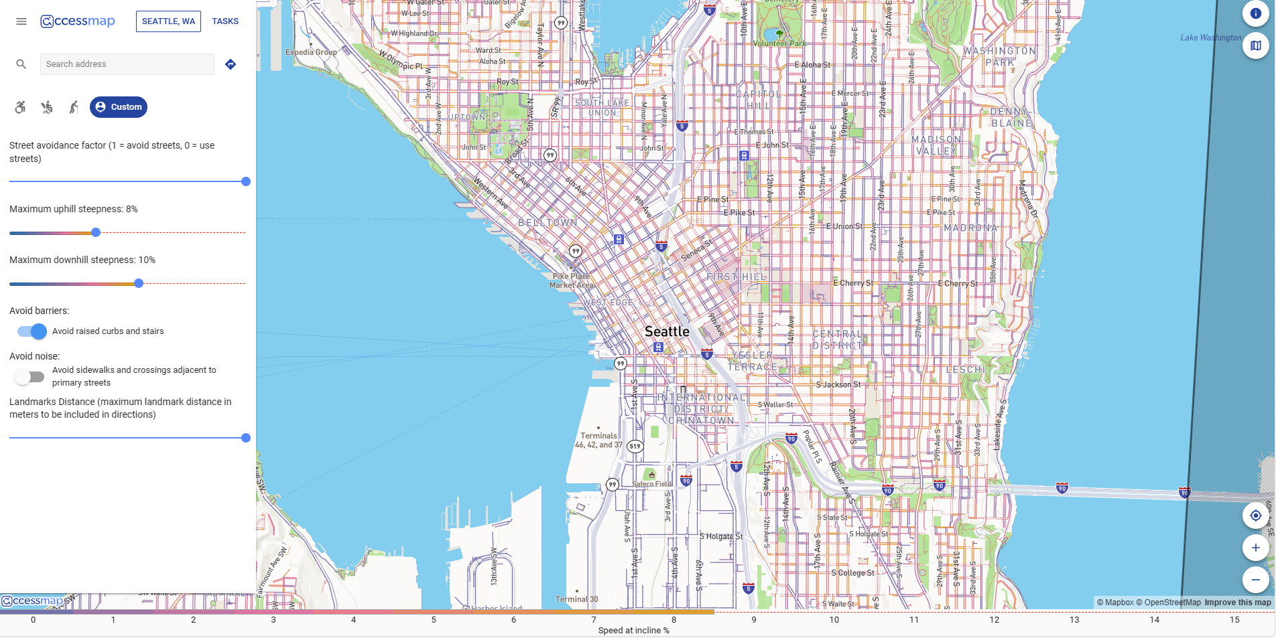 | US, gives the option for planning a route from point A to point B while meeting certain conditions: - wheelchair accessible, walking stick, motorised wheelchair (gives you gradients) and street avoidance, avoiding curbs and stairs, avoiding sidewalks and crossing adjacent to primary streets. Routing - LoroDux - previously Via-Dux (loro=parrot in Spanish and dux in Latin is a guide - so parrot guide) - OSM and Java based platform navigational software for mobile devices for blind and visually impaired people.
2. Accessiblemaps.de  Several projects listed on https://blog.openstreetmap.org/  Touch Mapper available from https://touch-mapper.org/en/ | 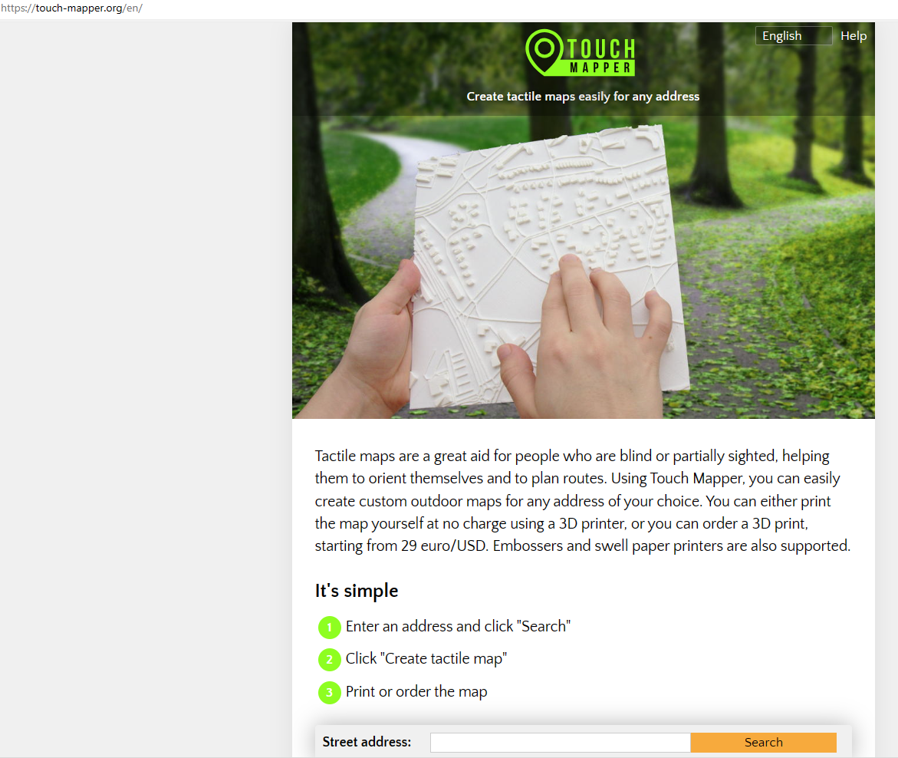 | Project led by Technische Universität Dresden in cooperation with the Karlsruher Institut für Technologie and focuses predominantly on indoor accessibility. Similarity to the proposed project – ‘Touch Mapper’ – tactile maps for blind and partially sighted people. Positives: the maps can be custom-made to suit any location. Negatives – requires equipment and time&organisation to plan and print the map
3.AccessAble https://www.accessable.co.uk/ | 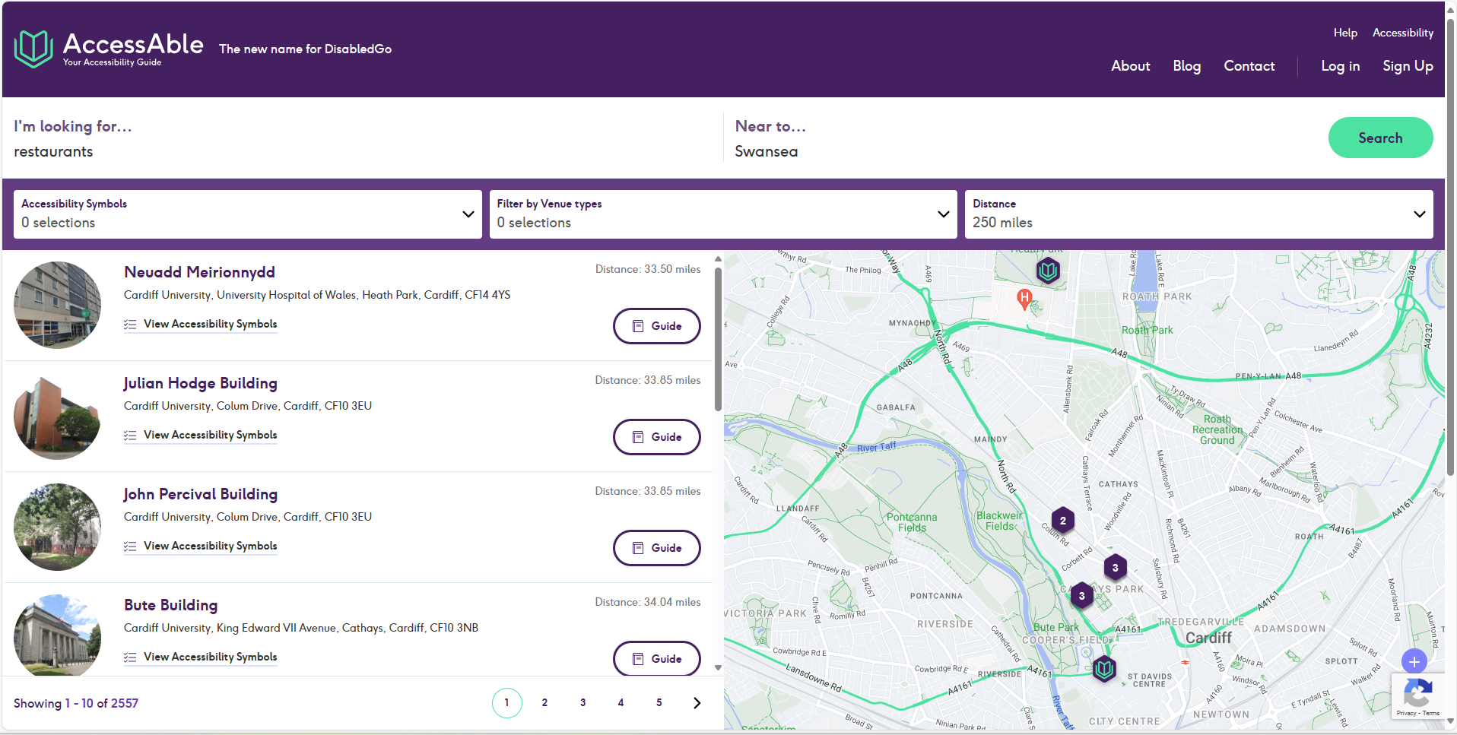 | (The new name for DisabledGo)  Option to search by categories, by a place-name, town or postcode. They have 33 Accessibility Symbols  ‘designed with consultation with disabled people - venues are visited by our surveyors and given Accessibility Symbols’. With an account, your preference settings are saved.

APPENDIX 3

Target keywords

REVIEWS PAGE
accessibility equipment
accessible toilets
autistic
neurodivergent
people with different level of abilities

CONTACT PAGE
Address details
Parking details
Train details

INDEX PAGE
inclusive dining experience
disabilities
accessibility

ABOUT PAGE
inclusive dining experience
disabilities
accessibility (x3)
diverse needs
sensory experience
noise cancelling environment
inclusivity
First Aid
British Sign Language
neurodivergent
vegan vegeterian gluten and lactose-free
Percutaneous Endoscopic Gastronomy
medical needs
medical rooms
National Standards of healthcare cleanliness
feeding aids
specialist mobility and lounging equipment
diversity

APPENDIX 4

Code for the Crawler
Project structure on GitHub
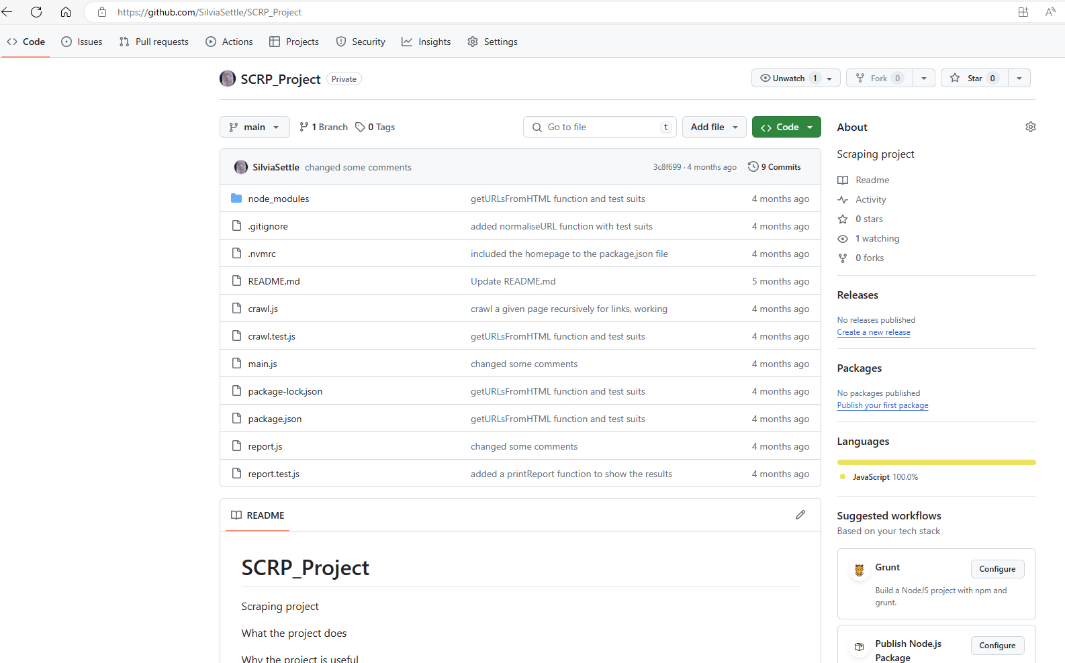

main.js
//importing the crawling function here
const {crawlPage} = require('./crawl.js')
//also importing the report function
const {printReport} = require('./report.js')

async function main (){
if (process.argv.length <3){
console.log("No website provided")
process.exit(1)
}
if (process.argv.length>3){
console.log("too many command line args")
process.exit(1)
}
const baseURL = process.argv[2]

console.log(`starting crawl of ${baseURL}` )
//calling the crawling function on the web-page input by the user
const pages = await crawlPage(baseURL, baseURL, {})

//log out the entire pages object
//for (const page of Object.entries(pages)){
// console.log(page)
//}
printReport(pages)
}

main()

crawl.test.js
const { normaliseURL, getURLsFromHTML } = require('./crawl.js')
const { test, expect } = require('@jest/globals')

test('normaliseURL strip protocol', () => {

const input = 'https://silviasettle.github.io/AccessibleEats/index.html'
const actualOutput = normaliseURL(input)
const expected = 'silviasettle.github.io/AccessibleEats/'
expect(actualOutput).toEqual(expected)
})

test('normaliseURL remove trailing slash', () => {

const input = 'https://silviasettle.github.io/AccessibleEats/'
const actualOutput = normaliseURL(input)
const expected = 'silviasettle.github.io/AccessibleEats'
expect(actualOutput).toEqual(expected)
})

test('normaliseURL remove capitals', () => {
const input = 'https://SILVIASETTLE.github.io/AccessibleEats/'
const actualOutput = normaliseURL(input)
const expected = 'silviasettle.github.io/AccessibleEats'
expect(actualOutput).toEqual(expected)
})

test('normaliseURL remove http', () => {

const input = 'http://silviasettle.github.io/AccessibleEats/'
const actualOutput = normaliseURL(input)
const expected = 'silviasettle.github.io/AccessibleEats'
expect(actualOutput).toEqual(expected)
})

test('getURLsFromHTML', () => {

const inputHTMLbody = `
<html>
<body>
<a href="https://silviasettle.github.io/AccessibleEats/">
Github.io Silviasettle
</a>
</body>
</html>
`
const inputBaseURL = "https://silviasettle.github.io/AccessibleEats"
const actualOutput = getURLsFromHTML(inputHTMLBody, inputBaseURL)
const expected = ["https://silviasettle.github.io/AccessibleEats/"]
expect(actualOutput).toEqual(expected)
})

//test relative URLs
test('getURLsFromHTML relative', () => {

const inputHTMLBody = `
<html>
<body>
<a href="/path/">
Github.io Silviasettle
</a>
</body>
</html>
`
const inputBaseURL = "https://silviasettle.github.io/AccessibleEats"
const actualOutput = getURLsFromHTML(inputHTMLBody, inputBaseURL)
const expected = ["https://silviasettle.github.io/AccessibleEats/"]
expect(actualOutput).toEqual(expected)
})

//multiple URLs both relative and absolute
test('getURLsFromHTML both', () => {

const inputHTMLBody = `
<html>
<body>
<a href="https://silviasettle.github.io/AccessibleEats/path1/">
Github.io Silviasettle Path 1
</a>
<a href="https://silviasettle.github.io/AccessibleEats/path2/">
Github.io Silviasettle Path 2
</a>
</body>
</html>
`
const inputBaseURL = "https://silviasettle.github.io/AccessibleEats"
const actualOutput = getURLsFromHTML(inputHTMLBody, inputBaseURL)
const expected = ["https://silviasettle.github.io/AccessibleEats/path1/", "https://silviasettle.github.io/AccessibleEats/path2/"]
expect(actualOutput).toEqual(expected)
})

//ignore bad URL
test('getURLsFromHTML invalid', () => {

const inputHTMLBody = `
<html>
<body>
<a href="invalid">
Invalid URL
</a>
</body>
</html>
`
const inputBaseURL = "https://silviasettle.github.io/AccessibleEats"
const actualOutput = getURLsFromHTML(inputHTMLBody, inputBaseURL)
const expected = []
expect(actualOutput).toEqual(expected)
})

report.js
function printReport(pages){
console.log("=================")
console.log("=====REPORT======")
console.log("=================")
const sortedPages = sortPages(pages)
for (const sortedPage of sortedPages){
const url = sortedPage[0]
const hits = sortedPage[1]
console.log(`Found ${hits} links to page: ${url}`)
}
console.log("=================")
console.log("==END OF REPORT==")
console.log("=================")
}

function sortPages(pages){
const pagesArr = Object.entries(pages)
pagesArr.sort((a, b) => {
aHits = a[1]
bHits = b[1]
return b[1] - a[1] //to return greatest to the least
})
return pagesArr
}

module.exports = {
sortPages,
printReport
}

The Mock Website
https://silviasettle.github.io/AccessibleEats/Pages/about.html
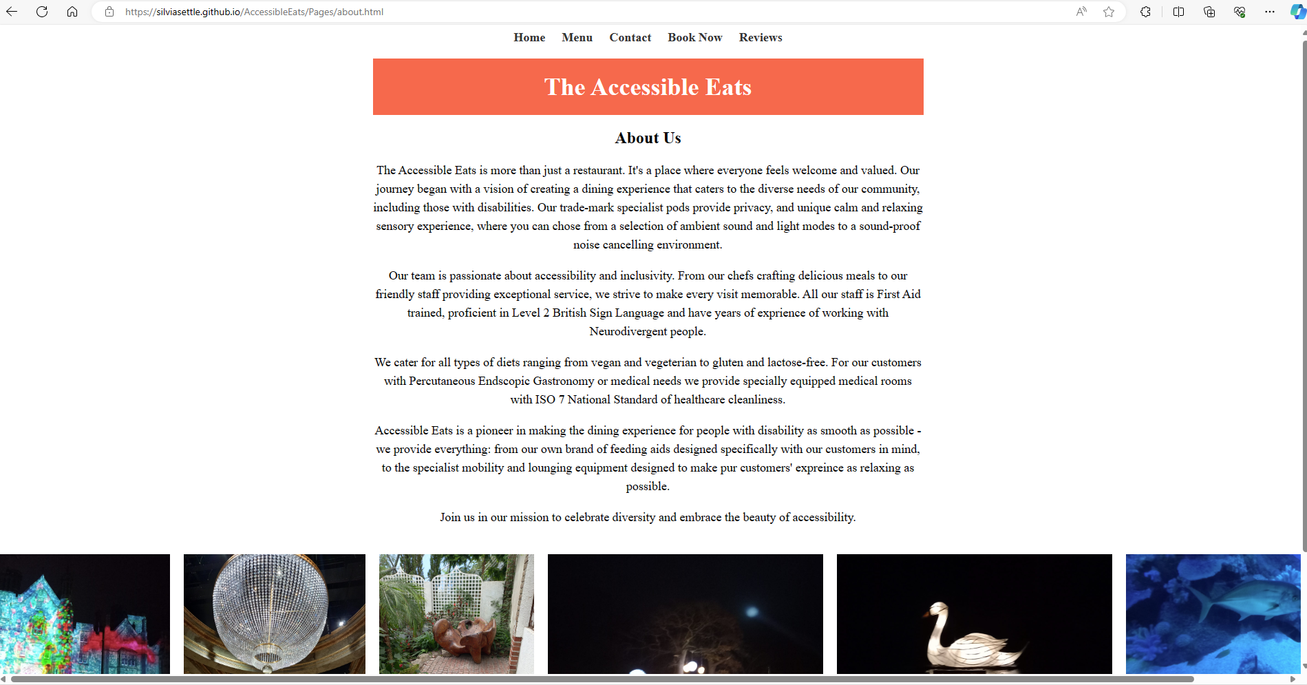

Scrapers Code
Scraper 1 using regex for locating the target data (Jupyter notebook)
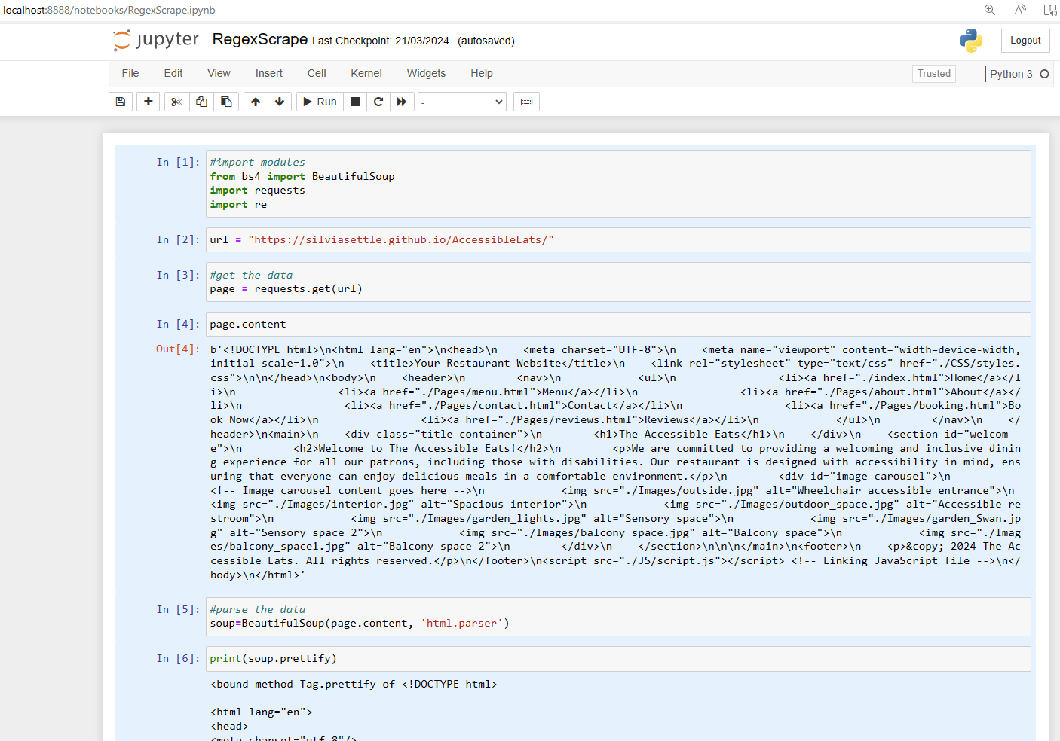
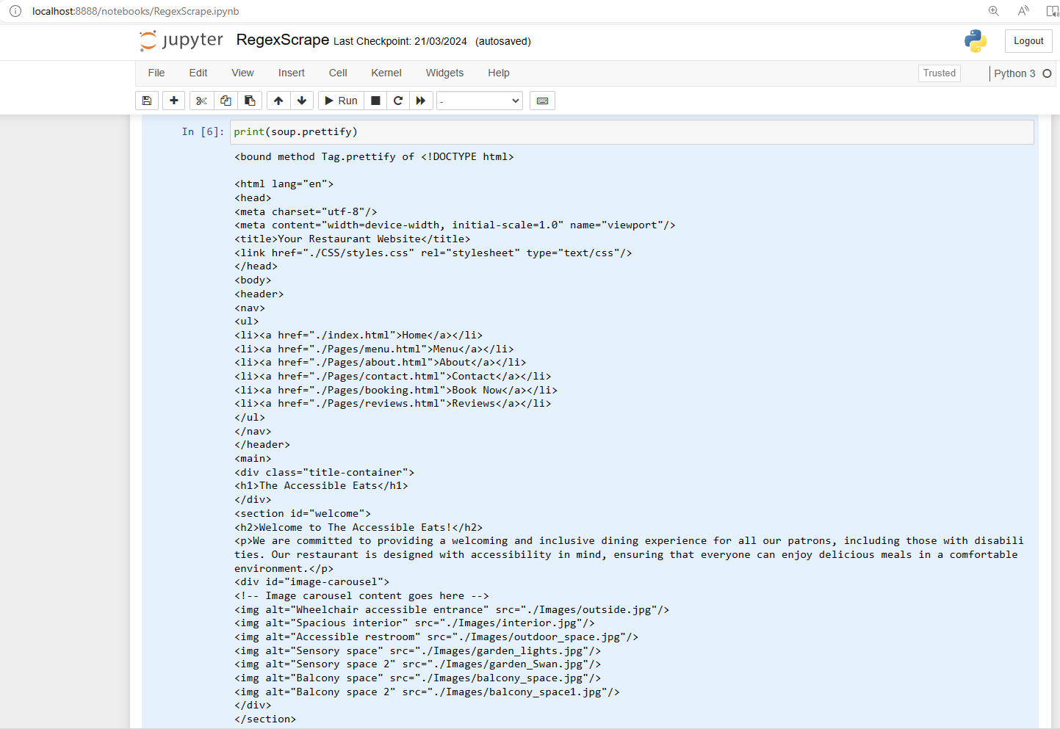
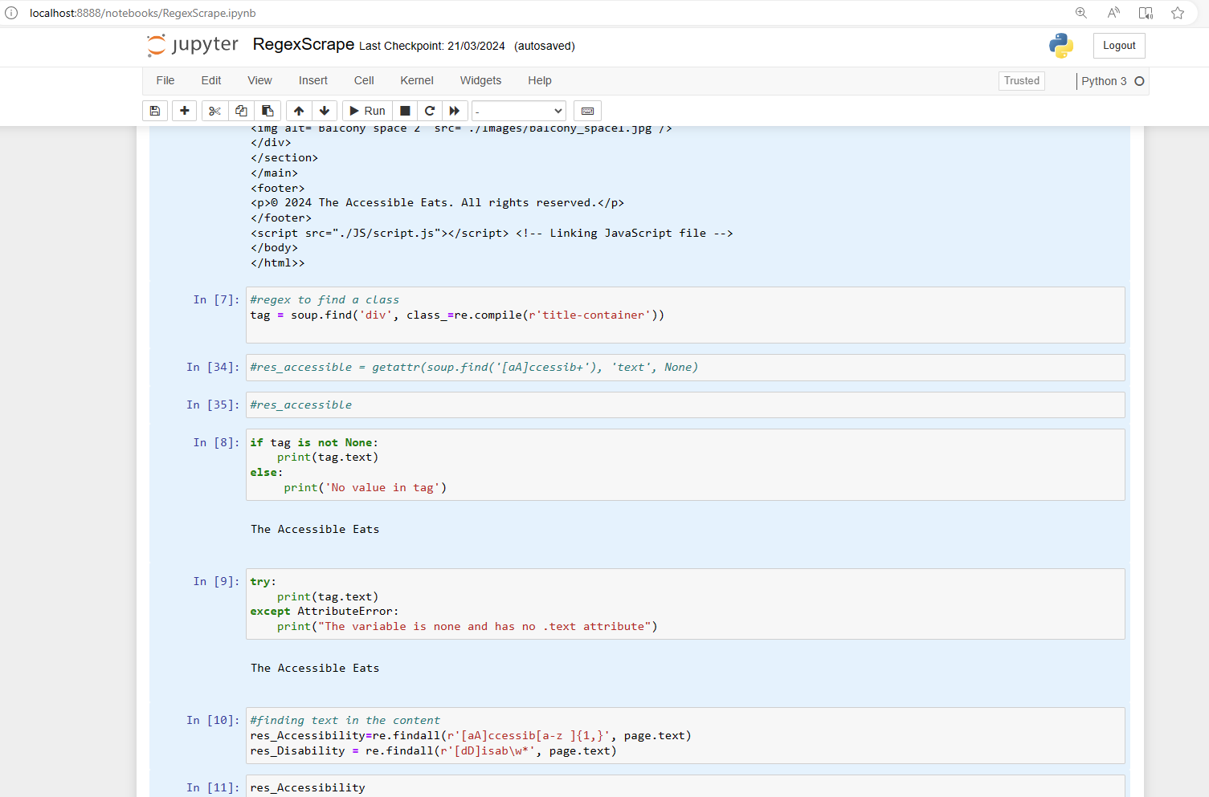
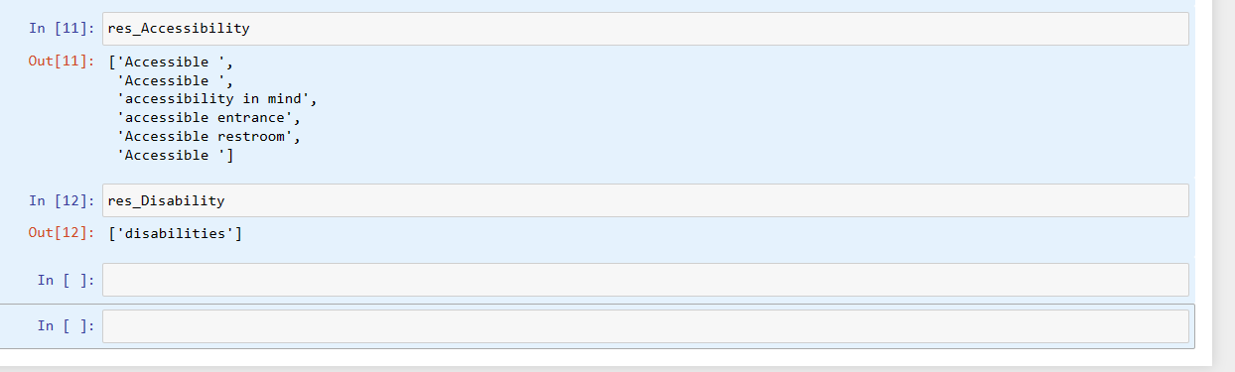

Scraper 2 with functionality and unit tests
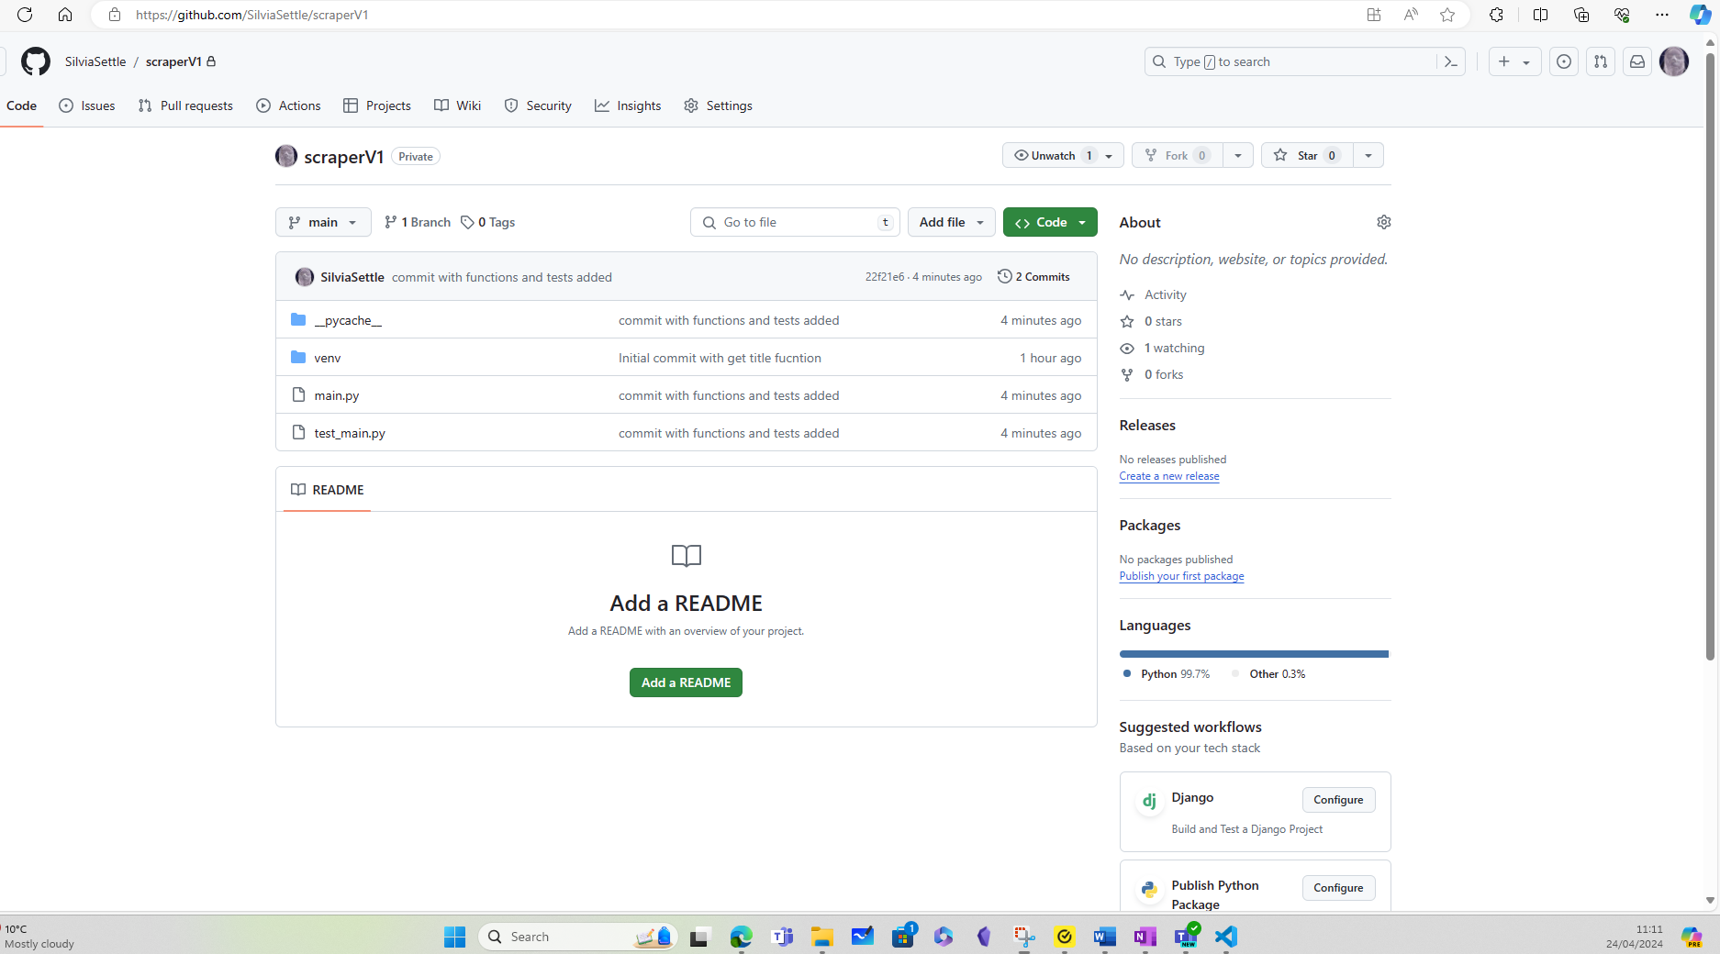

main.py
import requests
from bs4 import BeautifulSoup

def find_web_links(url):
# sends a GET request to the website
response = requests.get(url)

# Checks if the request was successful
if response.status_code != 200:
print(f"Failed to retrieve content from {url}. HTTP status code: {response.status_code}")
return []

# Parses the HTML content using BeautifulSoup
soup = BeautifulSoup(response.text, 'html.parser')

# Finds all anchor tags with the 'href' attribute
links = []
for a_tag in soup.find_all('a', href=True):
link = a_tag['href']
links.append(link)

return links

#function to find the title
def get_site_title(site_url):
url=site_url
response = requests.get(url)
page_content = response.text
soup = BeautifulSoup(page_content, "html.parser")
site_title = soup.title.text.strip()
#alternative is finding the tile using the element
#soup.find('h1')
return site_title

url = "https://silviasettle.github.io/AccessibleEats/"
web_links = find_web_links(url)
print("Found web links:", web_links)
print(get_site_title('https://silviasettle.github.io/AccessibleEats/'))

test_main.py
import pytest
from main import find_web_links

# Sample HTML content for testing
sample_html_with_links = """
<!DOCTYPE html>
<html>
<head>
<title>Test Page</title>
</head>
<body>
<a href="http://example.com/page1">Link 1</a>
<a href="/page2">Link 2</a>
<a href="http://example.com/page3">Link 3</a>
</body>
</html>
"""

sample_html_without_links = """
<!DOCTYPE html>
<html>
<head>
<title>Test Page</title>
</head>
<body>
<p>This is a test page without any links.</p>
</body>
</html>
"""

# Mocking the requests.get method to return the sample HTML content for testing
@pytest.fixture
def mock_requests_get(monkeypatch):
class MockResponse:
def __init__(self, text, status_code):
self.text = text
self.status_code = status_code

def mock_get(url):
if url == "http://example.com":
return MockResponse(sample_html_with_links, 200)
elif url == "http://example.com/no_links":
return MockResponse(sample_html_without_links, 200)
else:
return MockResponse(None, 404)

monkeypatch.setattr("requests.get", mock_get)

# Test function with a website that contains links
def test_find_web_links_with_links(mock_requests_get):
url = "http://example.com"
links = find_web_links(url)
expected_links = ["http://example.com/page1", "/page2", "http://example.com/page3"]
assert links == expected_links

# Test function with a website that contains no links
def test_find_web_links_without_links(mock_requests_get):
url = "http://example.com/no_links"
links = find_web_links(url)
assert links == []

# Test function with a website that returns a 404 status code
def test_find_web_links_404():
url = "http://invalid-url.com"
links = find_web_links(url)
assert links == []

Selenium is an automation suite that support several programming languages such as Java, Python, C#, Ruby, Java Script and Kotlin.

