ILSTON RIVER STUDY

INTRODUCTION
The Gower peninsula in south Wales ( Figure 1) is the location of the Ilston river valley and the area of our river study (Figure 2). The Ilston river flows from its source near Swansea airfield on Fairwood common to the sea at three cliffs bay, it is the ideal valley to study river process and features as the geology of the area is mainly limestone. The river itself is too small to have created the valley and would be classed as a misfit river, the valley was created as a result of surface fluvial erosion this is caused when the glacier melts in summer in periglacial environments - i.e., around the edges of ice sheets - where underground drainage through the limestone or chalk was blocked (or slowed down) by permafrost (The Geological Society, 2012). The study took place in spring on Friday 29th March and was carried out by 8 undergraduate students of University of Wales Trinity Saint David the weather had been unusually dry prior to the study taking place. After discussing the risk assessment data was collected from 8 points along the river with point 1 being at the source of the river. This data was then used to prove or disprove the 8 following hypotheses.
HYPOTHESES
1. The river becomes wider and deeper downstream.
2. The cross-sectional area of the river increases downstream.
3. The river velocity increases on the outside of a meander.
4. The highest velocity is to be found in the centre of the river.
5. The river velocity decreases downstream.
6. The size of the bedload gets smaller downstream.
7. The shape of the bedload becomes more rounded downstream.
8. The discharge of water in the river increases downstream.
Figure 1 (walesdirectory, 2019)
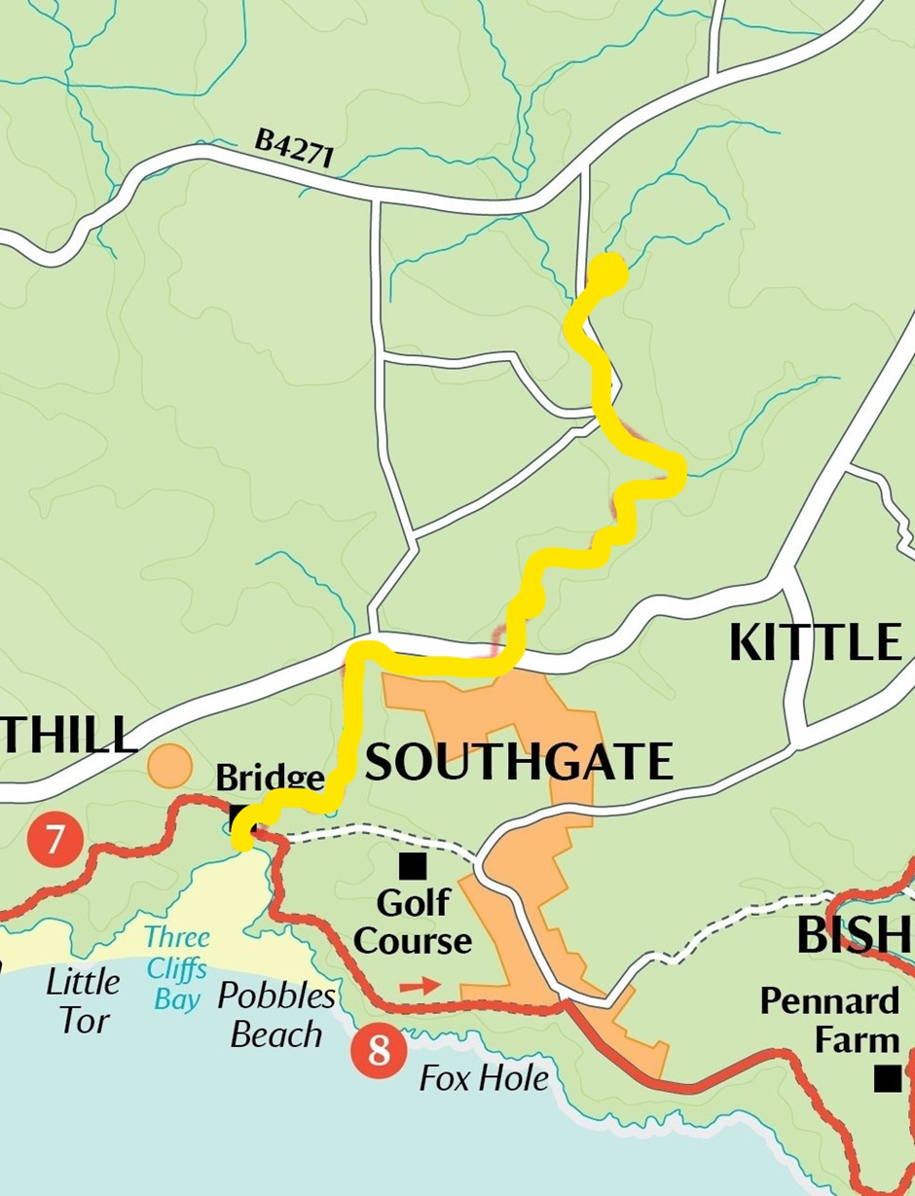
Figure 2 Study area highlighted in yellow (walesdirectory, 2019)
EQUIPMENT
- 30 metre tape measure
- Ranging poles
- Waders
- Flow meter
- Oranges
- Metre rule
METHODOLOGY
To gather the required data for hypotheses 1 and 2 the width and depth of the river was measured at 8 locations along its entirety, each location was measured at 5 points this was done by setting out ranging poles 5 metres apart and broken down into 1metre sections this enabled us to work out an average width and depth, starting on the right hand bank and facing downstream the width was measured from water’s edge to water’s edge at the 5 points (Figure 3) and recorded, the depth was measured at every 25 centimetres across the width of the river at the 5 points (Figure 4) this was done using a metre rule and measuring from the surface of the water to the bed of the river. When the data was collected and logged an average cross section was worked out for each of the locations along the river (Figure 5). Hypotheses 3, 4 and 5 were measured using a flow meter and an orange, the flow meter was placed in the river at various points and depths at a location and the readings logged, at the start point of each location (upstream) the orange was put into the middle of the river and timed with a stopwatch over a measured distance (5 meters on this study) this was done 5 times at each location and an average velocity worked out by dividing distance travelled by time, the recorded surface time was multiplied by 0.85 to give a stream velocity. Samples were then picked out of the river measured and visually inspected to enable hypotheses 6 and 7 to be proven, after all the information was recorded and logged it enabled hypotheses 8 to be proven or disproven.

Figure 3
.
Figure 4

Figure 5
RESULTS AND ANALYSIS
Hypothesis 1
The river becomes wider and deeper downstream, as the table below shows (figure 6) the river did become wider and deeper downstream even though there was evidence of flood defences along the length of the river. Locations 5 and 6 (figure 7) also got slightly narrower this could be due to sinkholes along this section of the valley (Cambrian Caving Council, 2018) the photograph below (figure 8) shows one of the many sink holes in the valley. The group stopped to observe this sink hole and could clearly hear the river running into it.

Figure 6

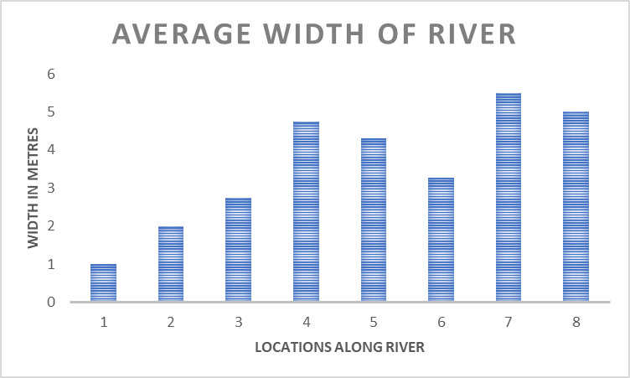
Figure 7
The river also varied in its depth along these locations (figure 9) again a possible result of the permeable limestone, the river finds its way through the cracks and crevices all along the valley into the under-ground cave systems which have been eroding for thousands of years (Cambrian Caving Council, 2018). Site management, constructing flood defences and erosion barriers along the footpaths bordering the river also have an effect by constricting the river instead of allowing it to follow its natural course, this could alter the transportation and deposition of sediment downstream as the concrete and timber defences protect some of the material that would normally be eroded and carried downstream.

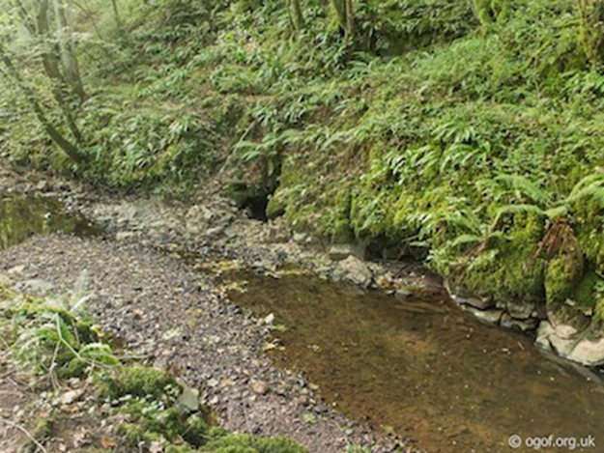
Figure 8 (Cambrian Caving Council, 2018). OSGB Grid Reference SS 55804 90173

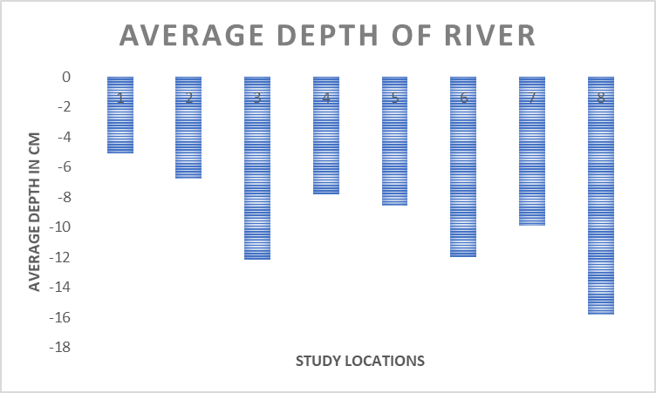
Figure 9

Hypothesis 2
The cross section of the river increases down stream (figure 10) below shows this to be the case although the cross-section areas of locations 3,4,5 and 6 show very little difference again there was a lot of evidence of flood defences having been constructed throughout these locations along the river and the sink hole (Figure 8) was between location 4 and 5 diverting the river from a natural course and altering the channel width and depth further downstream.

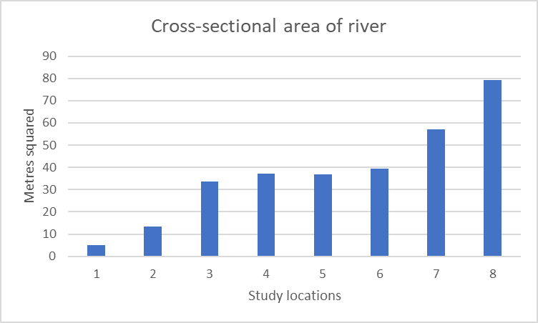
Figure 10

Hypotheses 3 and 4
The river velocity increases on the outside of a meander the graph below (figure 11) shows this to be true. However, the centre of the river was almost as fast. This also shows the velocity of the stream is faster in the centre of the channel hypotheses 4. (The data used for this graph was from a previous study as the data collected on this study was not complete).

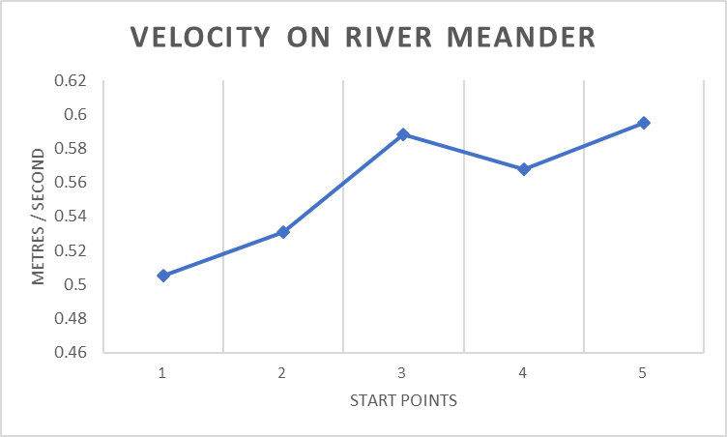
Figure 11

Hypothesis 5
The decrease of velocity downstream is clearly shown in (figure 12) below, location 1 was the third highest velocity even though it was the source of the river maybe due to the fact the surrounding area was boggy marshland and the channel had not fully eroded the peat and clay. Any run-off from the air field appears to be soaked up by the surrounding peaty material and slowed down before it reaches the river channel.
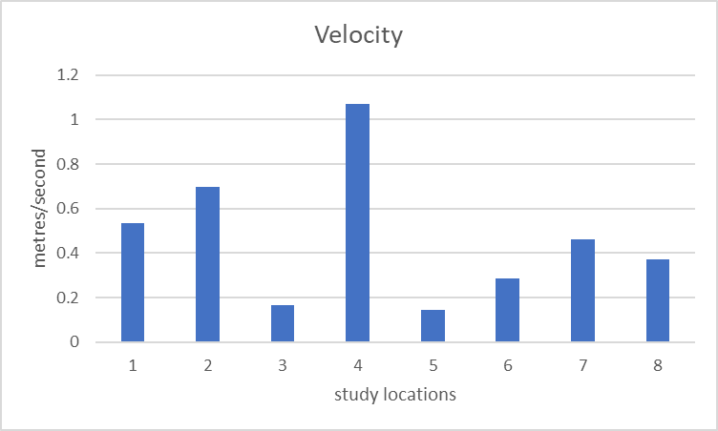
Figure 12
Hypotheses 6 and 7
Various samples of bed load were collected measured and observed using the roundness scale for sedimentary particles (Powers, 1953).(Figure13) and recorded on a table along with other observations written in the comments (Figure 14). The results show that the sample in each location appeared to be similar in size and shape from point 2 down to point 8. Point 1 of the study had no sedimentary rocks at all but peat and greying were clearly visible in the river banks. However, 15 metres downstream from the study area of point 1 some rock was beginning to appear in the channel that was forming they were not sampled as they were outside the study area .

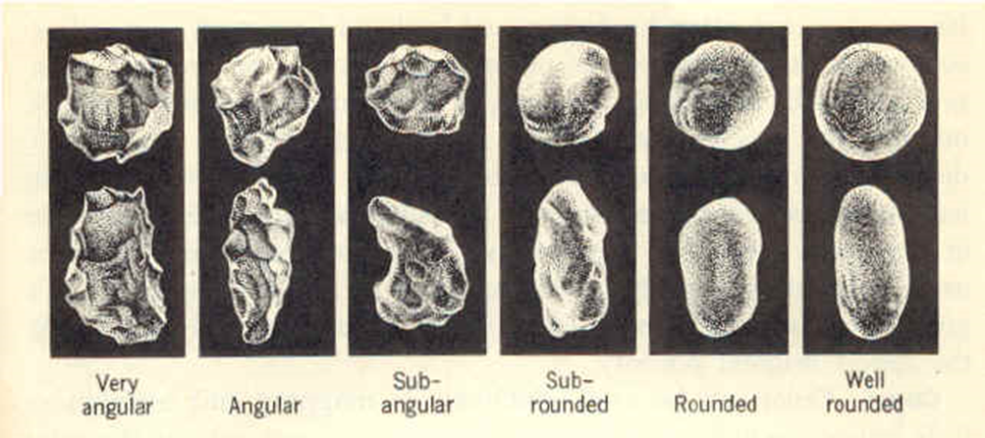
Figure 13 (Powers, 1953)

Figure 14

Hypotheses 8
The discharge of water down stream is inconclusive as shown in (Figures 15 and 16) as location 4 has the highest recorded discharge this could be due to the time of year and a period of little rain and there are several sinkholes in the valley also the river disappears totally underground between locations 5 and 7 leaving a dry river bed. The velocity data used was recorded using the orange float method as the flow meter was not available on all locations.
Figure 15

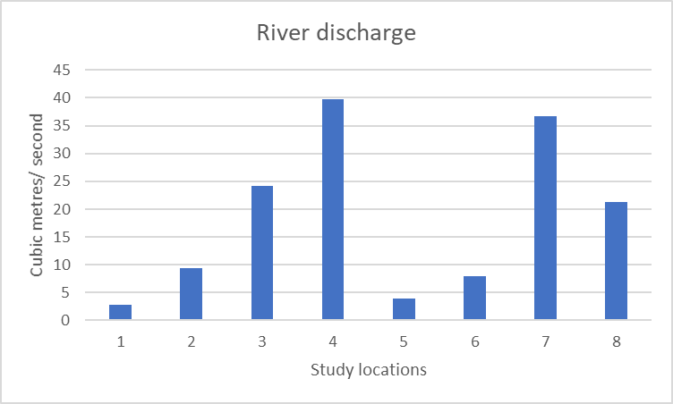
Figure 16

DISCUSSION
The Ilston river starts at Fairwood common a catchment consisting of a peat bog, then it winds down the valley into a limestone underlain area which has many features not found in other river systems, these conditions would alter the natural process of the river’s formation, like the under-ground river courses created by the dissolving limestone meaning some areas of the river would be almost permanently dry during spring and summer months. Management of the site also plays a large role on Ilston river with the construction of flood defences and some woodland management which was evident between points 4 and 7, altering the lag time but possibly increasing the rate of run-off into the river. Several bridges had also been constructed along the river using concrete buttresses which would constrict the river in these areas preventing it from widening out naturally. There was evidence of fish, invertebrates and a king fisher( Alcedo atthis) was seen at point 5 confirming the quality of water even though the river source is in close proximity to a small airfield.

CONCLUSION
The 8 hypotheses set out at the start were what you would expect on a normal river. It was also very dry for the time of year making it difficult to prove or disprove any of the hypotheses although some of the data did prove some of the hypotheses like depth ,width and cross-sectional area discharge, bed load and velocity data was not conclusive. Previous studies were done at a different time of year making it difficult to compare data as there was more water in the catchment area due to rain, this would also affect the flow and the depth of the river. The float method although giving a pretty accurate source of data was subject to whether there were obstructions or not in the river. Gathering the data with a calibrated flow meter on all the points would give more accurate data. This study could also be in slightly different locations to previous studies as no global positioning system (G.P.S.) information was given to the groups, further studies could benefit from this sort of information as you would have definite study areas and would be comparing data from the same sites exactly. It may also be beneficial to increase the amount of studies to maybe twice a year (spring-summer and autumn to winter) to see how much the dynamics change depending on the amount of water available in the river.

References
Cambrian Caving Council, (2018). www.ogof.org.uk.
Available at: www.ogof.org.uk/areas/ilston-cwm-caves.html
[Accessed 11-04-2019 April 2019].
Powers, M. C., (1953). Journal of Sedimentary Research (SEPM). Journal of Sedimentary Petrology, 23(2), pp. 117-119.
The Geological Society, (2012). The Geological Society of London.
Available at: ww.geolsoc.org.uk/Education-and-Careers/Resources/Field-Work-Resources/Gower- Field-Guide/Other-sites-of-Geological-Interest
[Accessed 11-04-2019 April 2019].
walesdirectory, (2019). walesdirectory.co.uk.
Available at: https://www.walesdirectory.co.uk/Gower-map.htm
[Accessed 14-04-2019 April 2019].

