

Assignment 2 title: Individual Report
Name: Diane Scolari
Student Number: 2412035
Lecturer’s name: Amer Kareem
Module name: Developing and Managing Individuals and Teams
Module code: LCLM5002

TABLE CONTENT
Introduction
1. Explanation of Key Factors
1.1 Adapting to Technological Advancements
- Figure 1: Lewin's Change Management Model (Unfreeze → Change → Refreeze).
1.2 Talent Acquisition and Retention
- Figure 2: Herzberg's Two-Factor Theory (Hygiene Factors vs Motivators).
1.3 Diversity, Equity and Inclusion (DEI)
2. Evaluation of Contemporary HR Practices
2.1 Technology
2.2 Talent Acquisition and Retention
2.3 Diversity, Equity and Inclusion (DEI)
3. Critical Evaluation of Managerial Implementation
3.1 Leadership Accountability
3.2 Communication Strategies
3.3 Monitoring and Performance Measurement
  - Organisational Culture
3.5 Barriers and Solutions
Conclusion
Recommendations
Appendix A
Appendix B
References

Introduction
This report analyses the contemporary Human Resource challenges faced by AMFRESH, a UK-based fresh produce company. It focuses on three key issues: technological advancements, talent acquisition and retention, and Diversity, Equity and Inclusion (DEI). The report also evaluates HR practices that can address these challenges and examines how managers can implement them successfully to improve organisational performance and long-term sustainability.
1. Explanation of Key Factors
1.1 Adapting to Technological Advancements
Technology is changing how companies operate, and AMFRESH needs to adapt to these changes to remain competitive. Digital transformation enables organisations to improve efficiency and decision-making through technology (Armstrong, 2023). From what I have learned, using automation, digital systems, Artificial Intelligence (AI), and Digital HR can help the company improve productivity, reduce errors, and streamline everyday tasks. Technology can improve efficiency through Digital HR, AI, and automation, but it requires investment, employee training, and effective change management. Lewin's Change Model demonstrates that organisations must prepare employees (Unfreeze), implement change (Change), and reinforce new behaviours (Refreeze).
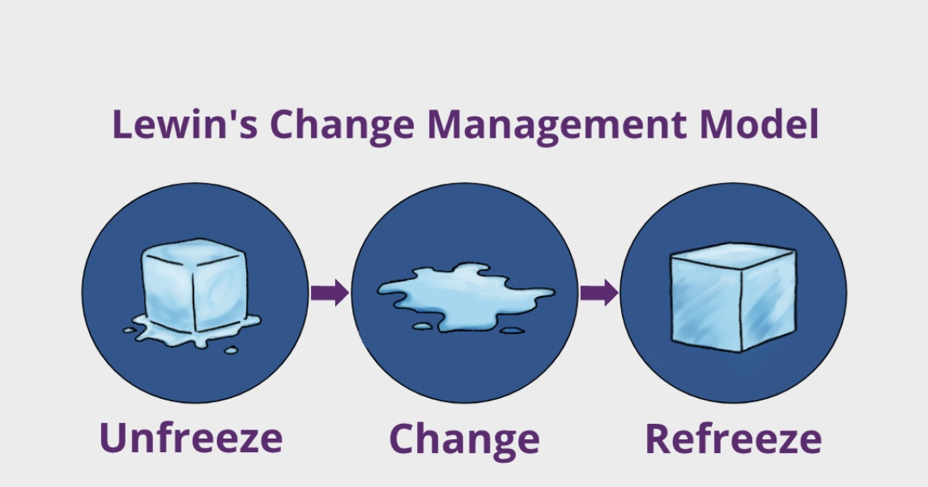
.

Automation can speed up production and improve the accuracy of different processes. Digital systems make it easier for managers to organise employee information, monitor production, and make decisions based on real-time data. AI can also support production planning and help the HR department identify suitable candidates during recruitment. Digital HR enables many HR activities to be completed online, including recruitment, employee training, performance reviews, and employee record management. This can save time and improve communication between managers and employees. However, introducing new technology also creates some challenges. Employees need proper training to use new systems confidently. Some people may also feel uncomfortable with change or worry that technology could affect their jobs. Because of this, managers should provide clear communication, regular training, and support throughout the process. Overall, I understand that adapting to new technology is important because it helps AMFRESH become more productive, improve efficiency, develop employees' skills, and remain competitive in a changing business environment.
1.2 Talent Acquisition and Retention
Finding and keeping skilled employees is an important challenge for many organisations, including AMFRESH. Employee engagement and career development improve retention and reduce turnover (Bratton and Gold, 2023). The company needs employees with the right skills to maintain product quality, meet customer demand, and support business growth. However, competition for talented workers has increased, making recruitment more difficult. Another challenge is employee turnover. When experienced employees leave the company, AMFRESH loses valuable knowledge and experience. Recruiting and training new employees also takes time and increases costs. During this period, productivity may decrease while new employees learn their roles. Employer branding can help attract more candidates by creating a positive image of the company. Offering training, career development opportunities, and a good working environment can also encourage employees to stay longer. Herzberg's Two-Factor Theory suggests that salary alone cannot retain employees. Instead, recognition, achievement and career progression are stronger long-term motivators. While competitive pay remains important, AMFRESH is likely to achieve higher employee retention by combining financial rewards with continuous learning, recognition programmes and clear career development opportunities. Overall, attracting and retaining talented employees helps AMFRESH reduce recruitment costs, improve productivity, and achieve better long-term performance.
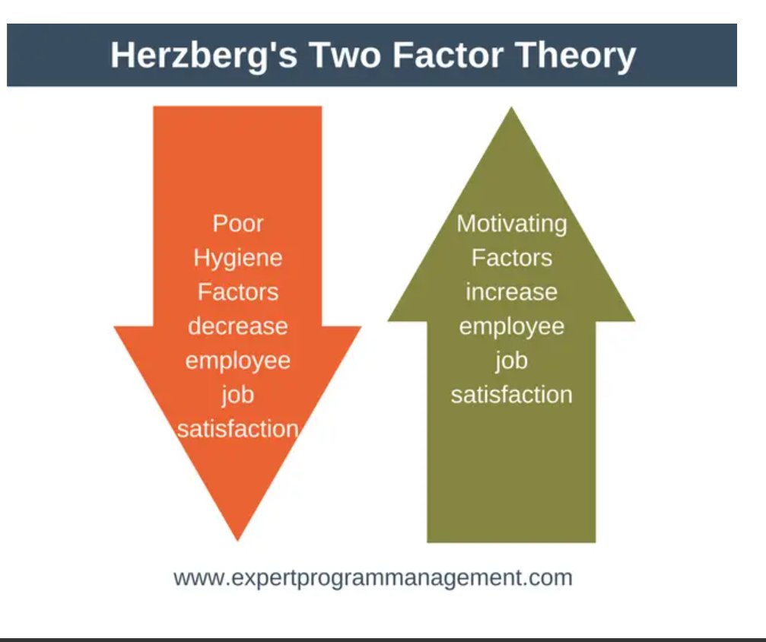

1.3 Diversity, Equity and Inclusion (DEI)
Diversity, Equity and Inclusion (DEI) is becoming increasingly important in the workplace. At AMFRESH, employees come from different countries, cultures, and backgrounds. Creating an inclusive working environment helps everyone feel respected and valued. Providing equal opportunities means that employees are treated equally regardless of their age, gender, ethnicity, disability, or background. An inclusive workplace encourages employees to share ideas and work together more effectively. A diverse workforce can bring different experiences and perspectives, which may improve creativity, innovation, and problem-solving. Inclusive workplaces improve innovation and employee performance (CIPD, 2024). Employees who feel included are often more satisfied with their jobs and more motivated to contribute to the organisation's success. Overall, promoting DEI can improve teamwork, employee engagement, and decision-making within AMFRESH.
2. Evaluation of Contemporary HR Practices
2.1 Technology
To support digital transformation, AMFRESH can use modern HR practices such as Digital HR Systems, Workforce Analytics, and Learning Management Systems (LMS). Digital HR Systems help managers organise employee information, recruitment, attendance, and performance records more efficiently. Organisations that invest in digital HR systems are better prepared to respond to changing business needs (Bratton and Gold, 2023). Workforce Analytics allows managers to use employee data to support better decisions, such as identifying staffing needs or reducing absenteeism. Learning Management Systems provide online training, making it easier for employees to develop new skills. Digital HR systems, workforce analytics and learning platforms improve decision-making but may increase implementation costs and resistance to change. Employer branding, workforce planning and career development strengthen recruitment and retention when supported by leadership. Inclusive recruitment, leadership development and DEI training improve engagement but require continuous monitoring to avoid becoming symbolic initiatives. These practices offer several benefits, including improved decision-making, fewer administrative errors, and higher productivity. However, they also have some limitations. The company may need to invest in new software, provide employee training, and manage resistance from employees who are not comfortable with new technology.
2.2 Talent Acquisition and Retention
AMFRESH can improve recruitment and retention by developing a strong employer brand, planning future workforce needs, supporting career development, and improving employee engagement. A positive employer brand helps attract qualified candidates by showing that the company is a good place to work. Workforce planning helps ensure that the organisation has the right number of employees with the right skills. Career development opportunities and employee engagement activities can also increase job satisfaction and reduce staff turnover. These practices can improve employee retention and reduce recruitment costs. However, they require time, investment, and continuous support from managers to achieve successful results.
2.3 Diversity, Equity and Inclusion (DEI)
AMFRESH can support Diversity, Equity and Inclusion by using inclusive recruitment, diversity training, leadership development, and equal opportunity policies. Inclusive recruitment helps attract candidates from different backgrounds. Diversity training increases awareness and encourages respectful behaviour in the workplace. Leadership development helps managers build inclusive teams, while equal opportunity policies promote fairness in recruitment, promotion, and career development. These practices can improve teamwork, innovation, and employee satisfaction. However, they may also face challenges such as resistance to change, additional costs, and the time needed to change organisational culture. Organisations with inclusive leadership achieve higher employee commitment (Bratton and Gold, 2023). Despite these challenges, DEI can contribute to better long-term business performance.

3. Critical Evaluation of Managerial Implementation
3.1 Leadership Accountability
Managers play an important role in making sure HR practices are successfully introduced. They should lead by example, support employees during changes, and make fair decisions. Managers are also responsible for encouraging teamwork, providing guidance, and making sure company policies are followed. Good leadership can help employees feel more confident and motivated during periods of change. Managers should demonstrate accountability, communicate change through meetings, emails and workshops, and monitor outcomes using KPIs, turnover, absenteeism and engagement surveys.
3.2 Communication Strategies
Good communication is important when introducing new HR practices or technology. Clear communication increases employee understanding and commitment during organisational change (CIPD, 2024). Managers should explain the reasons for the changes and how they will benefit both the company and employees. Regular meetings, emails, team briefings, and workshops can help employees understand new processes and ask questions. Clear communication can also reduce uncertainty and resistance to change.
3.3 Monitoring and Performance Measurement
Managers need to monitor whether HR practices are achieving the expected results. They can do this by using Key Performance Indicators (KPIs), employee engagement surveys, turnover rates, and absenteeism records. Workforce analytics supports evidence-based HR decision-making (CIPD, 2024). These measures help managers identify problems early and make improvements where necessary. Regular employee feedback can also help managers understand what is working well and what needs to change.
3.4 Organisational Culture
Creating a positive organisational culture is important for employee satisfaction and business success. Managers should encourage teamwork, respect, inclusion, and open communication. Employees are more likely to perform well when they feel valued and supported. A positive workplace can also improve employee retention and increase motivation.

3.5 Barriers and Solutions
There are several challenges when introducing new HR practices. Employees may resist change, the company may have limited budgets, or there may not be enough training available. Poor communication can also slow down the implementation process. To overcome these challenges, managers should provide regular training, communicate clearly, involve employees in decision-making, and offer support throughout the changes.
Conclusion
This report has discussed three important HR challenges faced by AMFRESH: adapting to technological advancements, attracting and retaining talented employees, and promoting Diversity, Equity and Inclusion (DEI). These challenges can affect productivity, employee satisfaction, and the long-term success of the organisation. The report has also shown that modern HR practices, together with effective leadership and communication, can help the company respond to these challenges. Overall, managers have an important role in supporting employees and ensuring that these practices are implemented successfully. AMFRESH can also improve organisational performance by integrating technology, effective leadership, and inclusive HR practices. Applying management theories together with motivation theories supports successful implementation and sustainable employee performance.
Recommendations
Based on this report, AMFRESH should continue investing in new technology and Digital HR systems to improve efficiency. Continuous investment in leadership, digital technology and workforce development supports organisational success (CIPD, 2024). The company should also provide regular training so employees can develop the skills needed for new ways of working. Strengthening employer branding and creating career development opportunities may help attract and retain talented employees. In addition, managers should regularly monitor HR performance using KPIs and employee feedback. Finally, promoting diversity, equal opportunities, and an inclusive working environment can improve teamwork, employee engagement, and long-term business performance.

APPENDIX A
SWOT Analysis of AMFRESH
The SWOT analysis highlights that AMFRESH has several internal strengths, weaknesses, opportunities and threats that require effective HR strategies and strong managerial leadership.
Strengths | Weaknesses
Established reputation in the fresh produce industry. | Employee resistance to technological change
Skilled and experienced workforce | High training costs when implementing new digital systems
Commitment to quality, food safety and sustainability. | Inconsistent digital skills across different employee groups.
Opportunities | Threats
Digital transformation through AI, automation and Digital HR systems | Labour shortages within the UK agricultural and food sector.
Workforce upskilling through continuous learning and development | • Increasing competition for skilled employees.
Greater use of workforce analytics to improve decision-making. | Rising operational and labour costs
Strengthening employer branding to attract and retain talent | Rapid technological change requiring continuous investment

APPENDIX B
This KPI dashboard helps managers measure the effectiveness of HR strategies by monitoring turnover, absenteeism, engagement, training, recruitment and diversity. These indicators support informed decision-making, continuous improvement and organisational performance

Key Performance Indicator (KPI) | Purpose | Target | Measurement Frequency
Employee Turnover Rate | Measures the percentage of employees leaving the organisation, indicating the effectiveness of retention strategies. | Less than 10% per year | Quarterly
Absenteeism Rate | Monitors employee attendance to identify potential wellbeing, engagement or operational issues. | Less than 3% | Monthly
Employee Engagement Score | Measures employee satisfaction, motivation and commitment through engagement surveys. | Above 80% | Every 6 months
Training Completion Rate | Measures the percentage of employees who successfully complete mandatory and development training programmes. | 100% mandatory training | Quarterly
Time-to-Hire | Measures the average number of days required to recruit and onboard new employees. | Less than 30 days | Monthly
Diversity Metrics | Tracks workforce diversity across gender, age, ethnicity and other protected characteristics to support DEI objectives. | Annual improvement in diversity representation | Quarterly

References

Armstrong, M. (2023) Armstrong's Handbook of Human Resource Management Practice. 16th edn. London: Kogan Page.
Armstrong, M. and Taylor, S. (2023) Armstrong's Handbook of Human Resource Management Practice. 16th edn. London: Kogan Page.
Bratton, J. and Gold, J. (2023) Human Resource Management: Theory and Practice. 8th edn. London: Palgrave Macmillan.
Chartered Institute of Personnel and Development (CIPD) (2024) People Profession Insights. London: CIPD. Available at: https://www.cipd.org (Accessed: 2 August 2026).
Chartered Institute of Personnel and Development (CIPD) (2024) The Profession Map. London: CIPD. Available at: https://www.cipd.org/en/the-people-profession/the-profession-map/ (Accessed: 2 August 2026).
CIPD (2024) People Profession Insights. London: Chartered Institute of Personnel and Development.
Herzberg's Motivation Theory - Two Factor Theory - Expert Program Management
Available at:https://hrcoursesonline.com/lewins-change-management-model/ (Accessed: 11 August 2026).

