EULALIO ALLISINO FERNENDES (2441942)

ASSIGNMENT 1
LEARNING IN THE DIGITAL ERA

TASK 1 (a)

Essential skills for study and employment are the underpinning skills necessary for learners to function academically and professionally. These include communication, critical thinking, time management, teamwork, and adaptability; these skills will enhance learning, improve performance, and better prepare individuals for the demands of today's workplace.
Study skills are a fundamental part of students' academic competency and achievement in all subjects and for different types of learners. This article presents an information-processing explanation of study skills, demonstrating their role in promoting learning through enhanced information encoding, storage, and retrieval. Four major categories of study skills are identified: repetition-based skills that reinforce memory by practice; procedural skills which plan and structure learning tasks; cognitive-based skills that allow deeper understandings; and metacognitive skills that enhance the student's processes by planning, monitoring, and evaluating learning. Evidence-based strategies that enhance these skills are also discussed, indicating that effective instruction in study strategies should be explicit, structured, and integrated within regular academic activities. Teaching students to identify proper strategies and apply them appropriately enhances their independence and general academic performance [1].
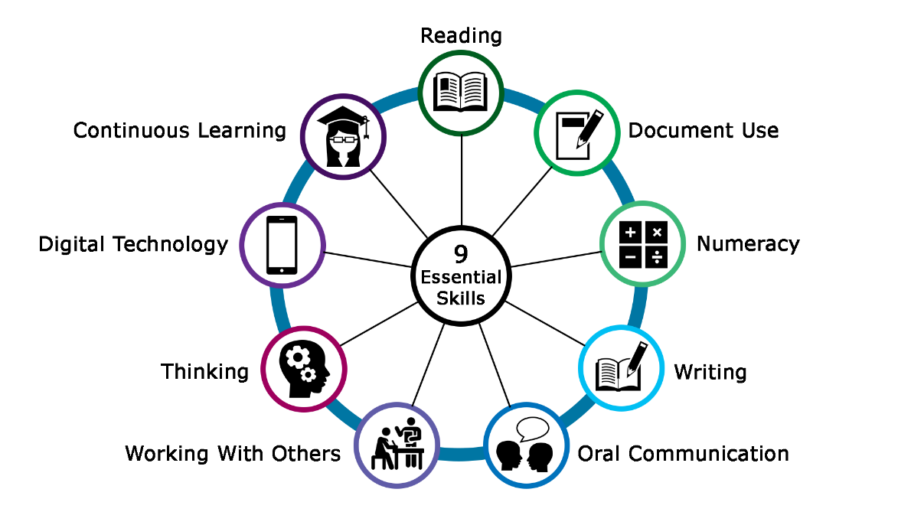

[2].
This article explores the importance of work-related social skills for promoting long-term employability, while noting that very little research in this area has been conducted in recent decades. In a replication of earlier work by Salzberg, Agran, and Lignugaris/Kraft, secondary teachers nationwide rated the importance of a number of social skills for on-the-job success and indicated how frequently they taught each of the skills. Teachers identified a number of critical skills, including seeking clarification when instructions were unclear, arriving on time, avoiding inappropriate physical contact, completing urgent tasks promptly, informing supervisors when help was needed, responding appropriately to feedback, and interacting appropriately with customers or clients. However, many of the most highly valued skills were not those most frequently taught in schools. Implications for better aligning instruction with workplace demands are discussed [3].
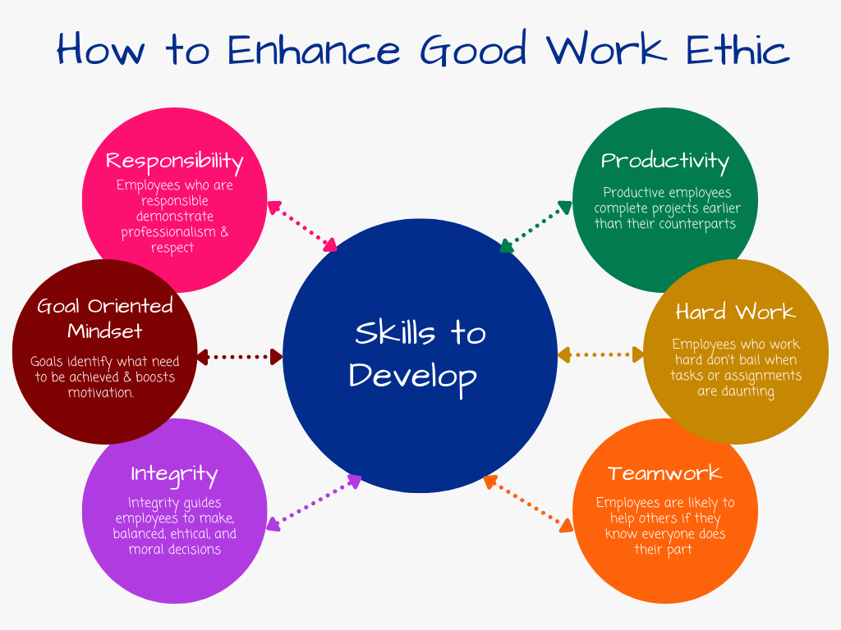

[4].

References

[1] | M. Gettinger, "Contributions of Study Skills to Academic Competence," 2002.
[2] | [Online]. Available: https://calp.ca/e-learning/?workshop=121.
[3] | P. C. H. P. a. L. A. S. P. Martin Agran, "Employment Social Skills: What Skills Are Really Valued?," 19 august 2014.
[4] | [Online]. Available: https://www.linkedin.com/pulse/essential-skills-every-employee-should-have-pratik-naik.

