UNIVERSITY OF WALES TRINITY SAINT DAVID
LONDON CAMPUS
Assignment 2
Learning in the Digital Era
Video Link: Present your Video Link here (Upload your video presentation on You Tube or OneDrive/any other platform of your choice and then share that link here).
Please be sure to give unrestricted access to your video presentation so that your work can be marked by the examiner.
Module Name: Learning in the Digital Era
Module Code: ACCA 4025

Student Name: BEATRAM BROWN
Student ID: 2438239
Group:3

Lecturer’s Name: ANEES BAQIE

Table of Contents
Introduction 2
Main Body 2
Conclusion 9
References 9

Introduction
My name is Beatram brown in this slide I would like to reflect on how I self-evaluation
Of myself it helps me to understand my strengths and my weakness.
.
Video Link: A presentation on Self-Evaluation, Professional Development Plan and Topic Summary.pptx

COVER PAGE
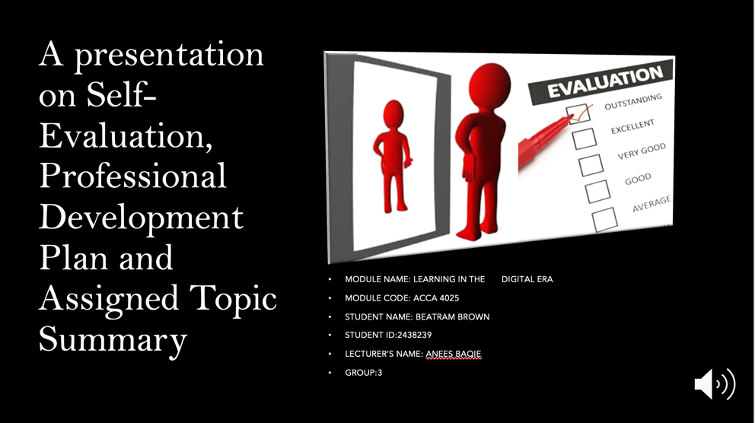
CONTENTS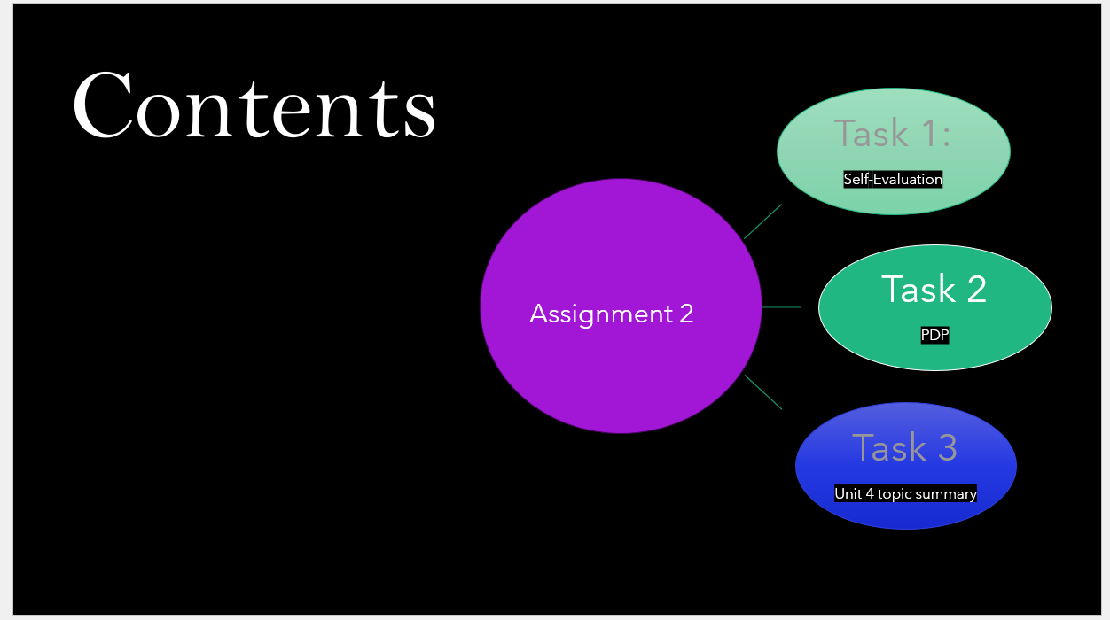

GIBB’s REFLECTIVE MODEL
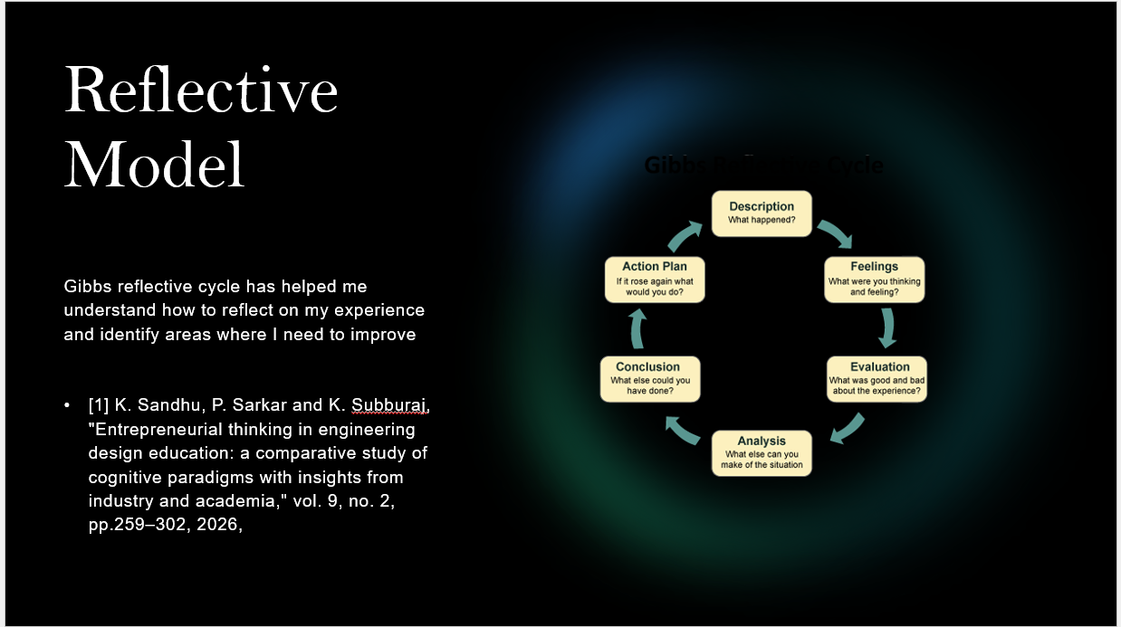
Brief explanation: I have used Gibbs reflective evaluation cycle for my self-evaluation. It has six stages, namely
TASK 1: SELF EVALUATION
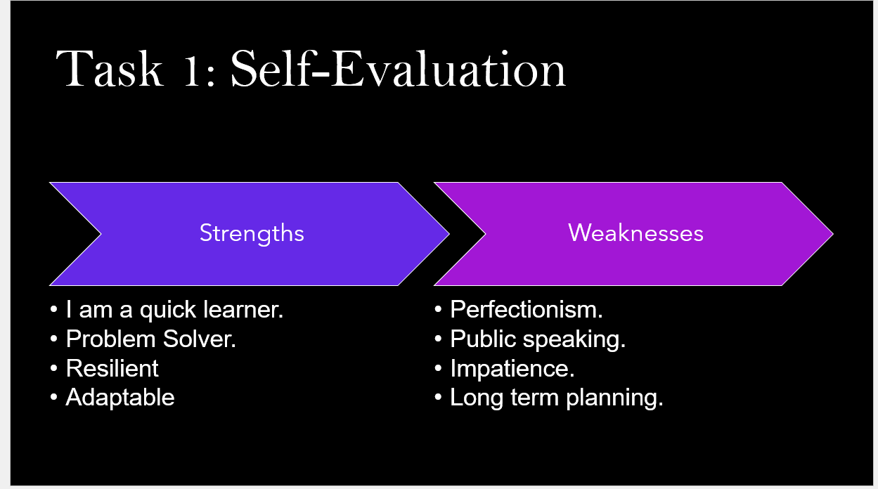
Brief explanation:
I’m a quick learner -- is a person that
Listen well and understand direction

Problem solver – is the act of finding when
you face challenge
Resilience – is the ability to bounce back
from hard times

Adaptable – able to change or adjust to new things.
My Weaknesses
Perfectionism – is a person personality driven by flawlessness
Public Speaking – becoming very nervous talking too fast bad language
Impatience – is a person that not willing to wait
Long term planning – setting big goals and making a strategic road map to reach them

TRAITS GAINED FROM THE SELF EVALUATION
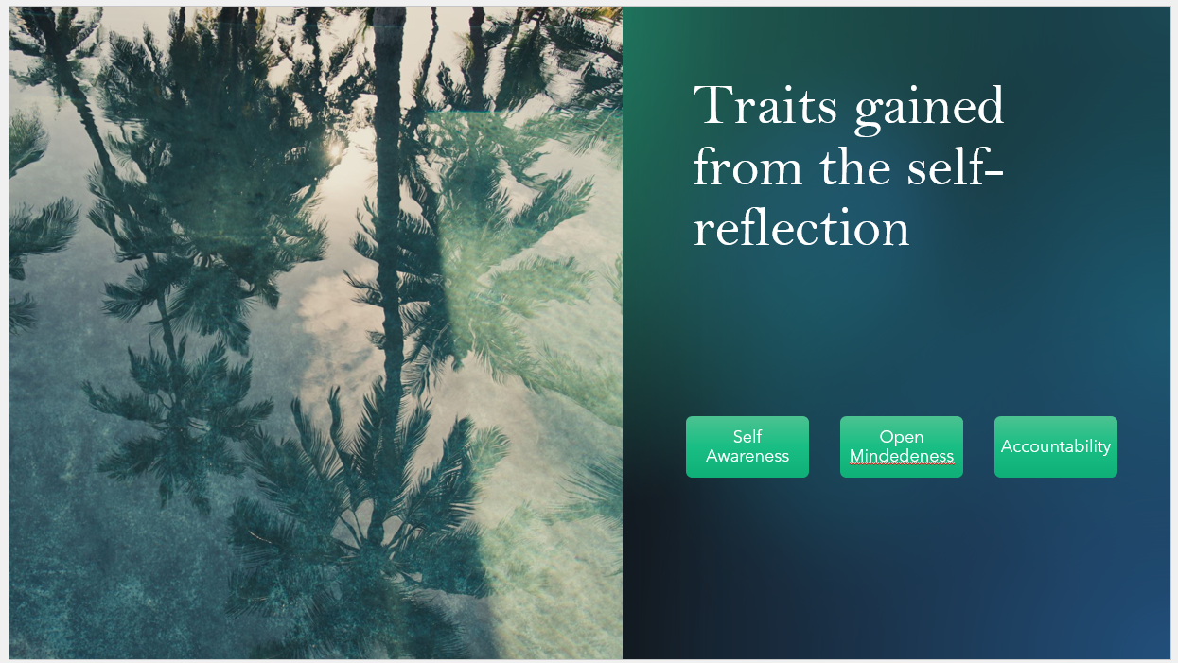

Brief explanation: Self-awareness: I have learned to recognize my own strength weakness and value pattern instead of running auto pilot.
Open Mindedness: I now accept constructive criticism rather than making it a problem.
Accountability: I take responsibility for my choice analyse what I could done different.

PROFESSIONAL DEVELOPMENT PLAN
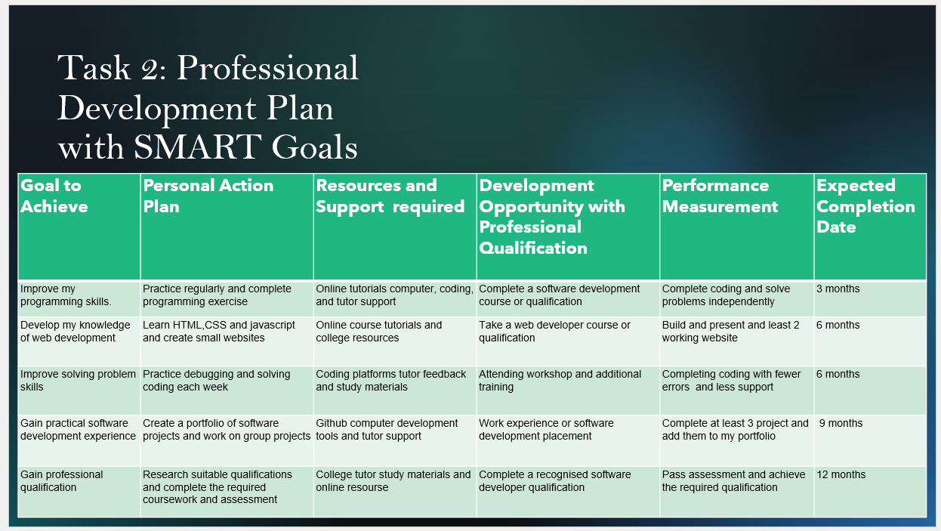
Brief explanation: in this plan it helps me to identify my goals strengths and weakness
UNIT 4 TOPIC SUMMARY
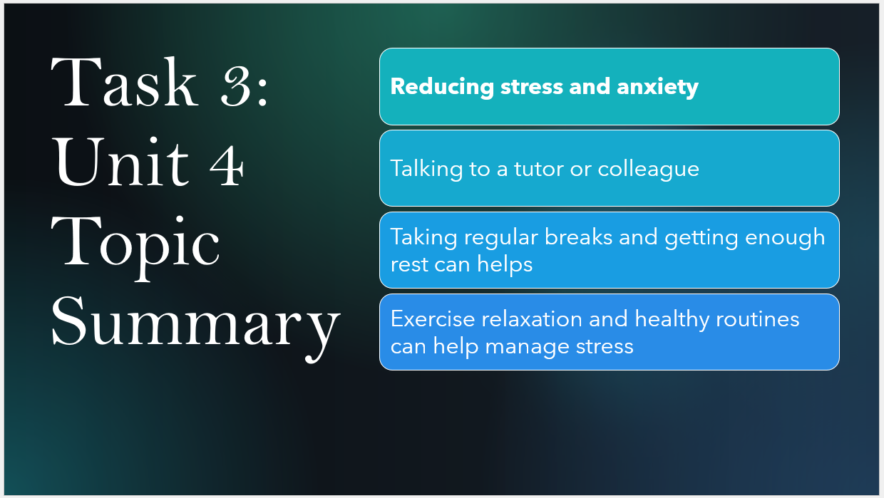
Brief explanation. REDUCING STRESS AND ANXIETY 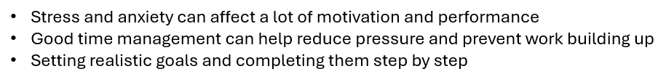
CONCLUSION +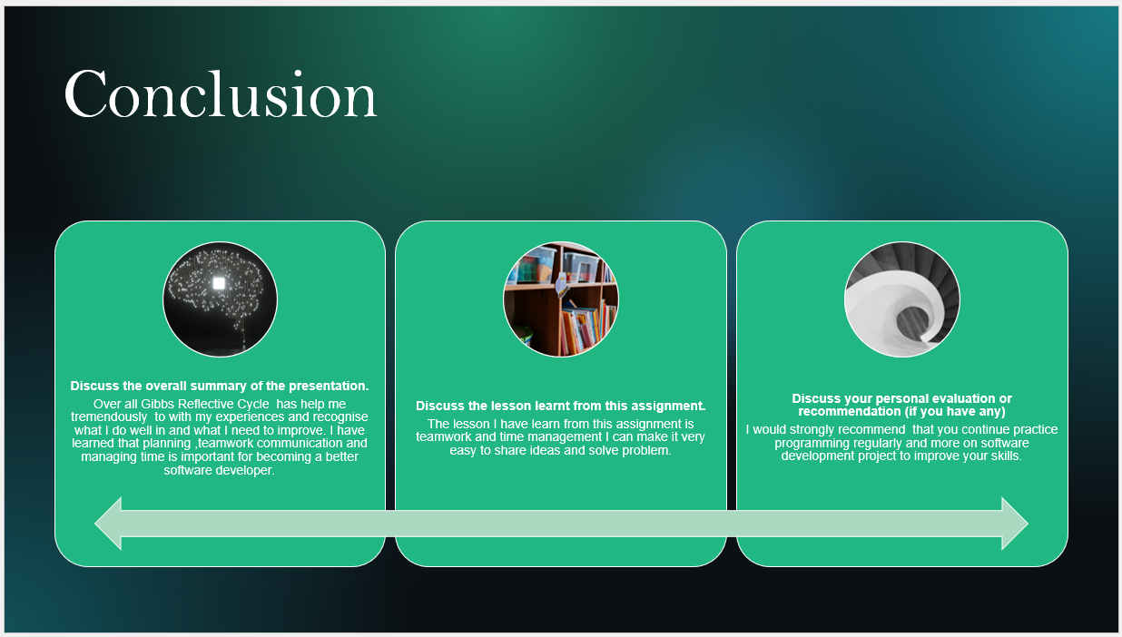
Brief explanation:
In my conclusion, my self-evaluation has helped me understand my strengths and weaknesses and areas for improvement
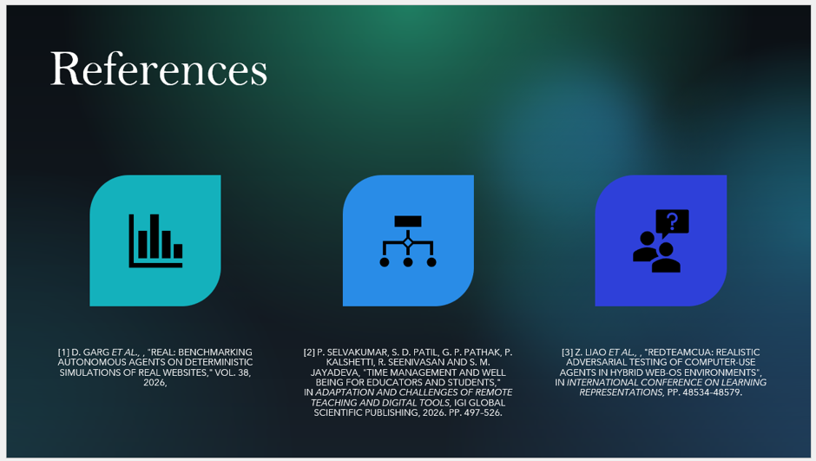

- Copy and paste the sources from your reference slid
- References
- [1] D. Garg et al., , "Real: Benchmarking autonomous agents on deterministic simulations of real websites," vol. 38, 2026,

- [2] D. Garg et al., , "Real: Benchmarking autonomous agents on deterministic simulations of real websites," vol. 38, 2026,
- [3] Z. Liao et al., , "Redteamcua: Realistic adversarial testing of computer-use agents in hybrid web-os environments", in International Conference on Learning Representations, pp. 48534–48579

IEEE referencing style must be followed.
In-text citations need to be used in the slide as well as in brief explanation section in this report.

