A Guidance Handbook for Early Years keyworkers during childhood transitions

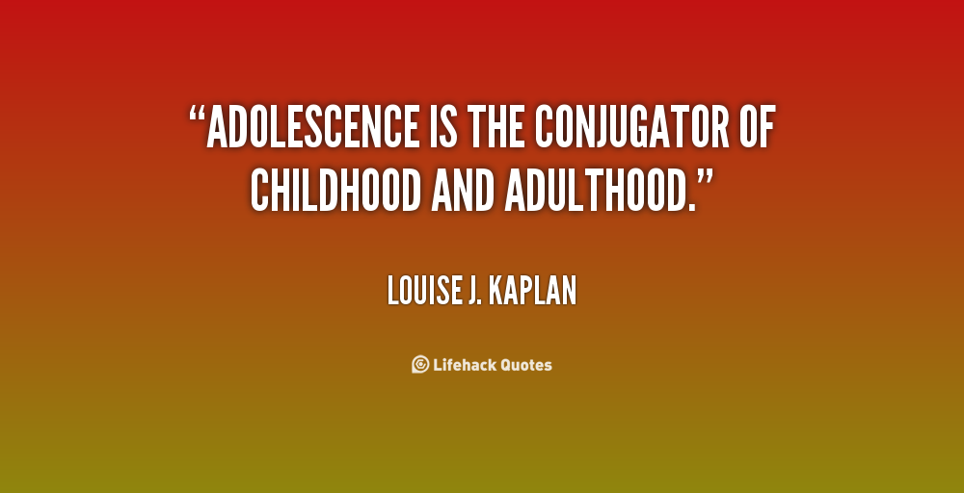
https://www.quotemaster.org/childhood+to+adulthood

Meghan Owens 2004242
Human Development
EAEE4003

Contents Page no.

- Introduction: Transitions in the Early Years 3

- How to use the guidance handbook 6

- The role of the adult 8

- The needs of the child 12

- Partnerships 17

- Interventions 19

- Proposed outcomes 21

- Reference list 23

Introduction

A transition is a situation that comes with change when children move into a new and unfamiliar environment and learn to adapt to this unusual setting. This can involve meeting new peers and listening to teachers.

Transitions are the central to young children’s development and emotional well-being. The way that the first transition is handled can have a significant impact on the child’s capacity to cope with change whether this is long or short term. Practitioners that work in early years settings should always ensure that children are supported during the new transition. (Walker. E 2019)

When adapting to new settings the transitions need to be managed sensitively and effectively in a way that suits the child. The transitions should be looked at as a process rather than one single event. Children, practitioners and parents should all be involved as part of this process. Practitioners need to ensure that policies and procedures are in place to make sure that they support children as much as possible in order to make sure that the transitions run smooth and successful.
Effective communication between all those involved during the transition is the most important key to the transition being a success. It is important as if effective communication is not used it can result in having a positive or negative affect on a child’s development during the process. This can have an effect on the child’s physical, emotional, personal or psychological development. This means that it is important for these transitions to run as smoothly as possible so that the child is left feeling happy and settled in their new environment.
Early Years workers should be aware and understand that the transition to school can be a challenging experience and that the child going through the transition should feel valued and welcomed while going through the process. Early Years workers should make sure that the parents, carers and other professionals are involved in the transitions to make sure the correct preparation is in place. (Daly, Byers, Taylor, 2009)
Bronfenbrenner (1979) states that ‘an ecological transition occurs whenever a person’s position in the ecological environment is altered as the change in role, setting or both.’ Bronfenbrenner’s system theory is useful in helping us to understand that optional development occurs through strong mesosystem links.
It is better for the interest of the child if the transitions run smoothly and run successfully. He believed that the early years, it is important that parents and key workers have a positive relationship between home and preschool. (Hilary Fabian and Aline-Wendy Dunlop, 2007)
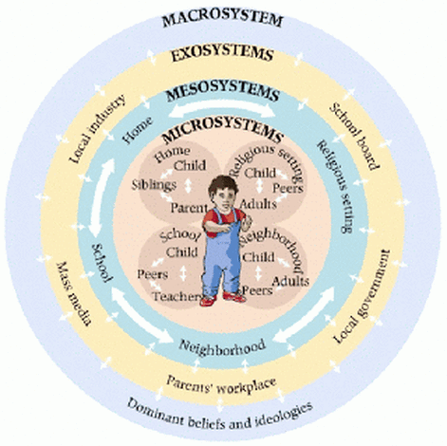

https://educ3040fall13.weebly.com

How to use this handbook
The adults in a child’s life, are responsible to enable them to achieve the best possible outcomes as the Welsh Government (2008) states. By doing this, children are able to be supported well and are able to realise their full potential.
This handbook has been designed for Early Years Keyworkers for them to use as a guide to develop their understanding to why effective communication is important for the development of children during the transitions. This handbook is based on children age 2-3. This handbook is to help keyworkers understand how to stay in control and manage the transitions from home to pre-school. This handbook will look at the role of the adult, the needs of the child and how they can be met, partnerships, interventions and proposed outcomes and this is the duty to plan and manage the transition smoothly. Welsh Government (2018)
By using this handbook this guidance will help keyworkers understand how to manage the transitions well and how to adapt to the needs of the child and how to carefully and effectively run the transitions. In order for the transitions to work the key workers and professionals need to be able to build a good and strong relationship with not only the parents but the children as well. Once the keyworkers have gained their trust from the parents this will give them a better incite to the child’s life and gain information that may help with the transitions. In order for the transitions to work the keyworkers need to be respectful of the parents or carers when supporting their child’s learning and development during the different transitions.
When a child going through this type of transitions the process needs to be slow and steady and the child needs to feel secure and their well-being needs to be maintained. The child or children going through this transition needs to know that they are able to go at their own speed and are able to take their time when doing new tasks. Each stage of the transition needs to be planned in order for it to be effective and a holistic approach is met. There needs to be a show of commitment so that the child learns to trust the keyworker and know that they will be there throughout the transition. Welsh Government (2018)

The role of the adult
Being a keyworker during early years comes with exciting opportunities and challenges. When a child leaves their home, which can also be seen as their ‘comfort blanket’ for the first time they can be anxious and very emotional. By planning out the transitions in advance and working with parents it means that the child’s or children’s needs are met properly.
It is important that not only the children, but the parents are given opportunities to familiarise themselves with the new setting and familiarise themselves with staff, in order for relationships and trust to form. There needs to be clear information for parents and carers with what is happening during the transition as the parents or carers have more of an understanding of the child that is going through the transition.
This means that there needs to be good communication and information sharing between practitioners, parents and carers before the child has started school. This transition should start early, and all relationships should be formed and have trust in order for the child to feel comfortable being in a new environment. The needs of the child should also be identified in order to encourage independence and confidence to help the child familiarise themselves with the new routine. (Croneri, 2018)
Having a key person during the transition is important as they will be able to provide a positive support system when working closely with young children.
Key worker – A key worker is a named member of staff whom has responsibilities for a child or children to ensure that they are made to feel safe and cared for. It is important in order to have a successful transition when moving from a home environment to school.
A parent or carer can help make the transition easier by joining parent teacher groups. By doing this, parents are able to keep a positive relationship with the key workers and are able to keep up to date with their child’s development and how they are performing.
By attending teacher groups, it will help a parent understand how their child is progressing and they are able to see if any additional support is needed and gain tips on how to help their child complete their homework. By attending these groups, the child or children will see that their parents have a positive relationship with their teachers, and it may help the child learn how to trust the keyworkers and practitioners around them.
For the transition to work there needs to be support available for parents. Having a pathway should show how exactly what support is available for families during each stage of the child’s development. Parents are able to make appointments to meet with key workers to gain an understanding of the different flying start services there are to offer.
The key aims of the pathway are too:
- Clarify support available for parents and what they can gain from it.
- Raise awareness with families and professional of the different services available
- Have reasonable pathways to suit all children with different abilities
- Help remind staff of how important planning is during the transitions.
Once the child begins the settling process all keyworkers should remember the following:
- Remain a good role model and follow safeguarding rules
- Reassurance for both the child and family
- Maintain observations and respect for child and family.
- Effective communication
- Play and activity experiences that reflect the child’s home life and culture.
By following these it will provide a smooth and successful transition from home life to school life for both the child and the family. By also having visitations available will help the child, parents or carers familiarise themselves with the new settings and routine can encourage confidence to build and improve relationships with staff members.

The needs of the child
All children need to be in an environment that is caring and loving. Children should not become excluded due to their religion, ethnicity, family background, gender or special needs ability. In order for this not to happen the child needs to be able to form an attachment with the keyworkers. This is important as many children may look for a ‘mother figure’ in their new environment as a coping mechanism. When the child comes into a new environment their first activity or work should be linked to what they already know. If parents are having good communication with the keyworkers, the keyworkers should have an understanding on the child’s likes and dislikes in order to make the child feel as safe and comfortable as possible. The activities that the child is taking in need to be relevant to them, so keyworkers are able to identify the level that the child is at and see what their ability is. These new experiences need to be enjoyable which will also lead to the transitions being smooth.

It is important for keyworkers and practitioners to have a child centred approach within the setting. It is a way of being able to evaluate the interests, well-being and views of the child that is going through the transition. It is important to have a child centred approach because the child could be affected both directly and indirectly by certain decisions. By having a child centred approach involves elevating the status of the child. This does not mean changing their interests.
Being a key worker and taking a more child centred approach comes with many benefits for the child going through a transition for the first time. You are able to get a better response from the child and this enables a positive relationship to form. By showing the child or children that you are considering their views and listening to them makes them feel valued and that someone will trust and believe what they say. Children have the right to express their views. This means that they can be provided opportunities to be heard in matters that are having an effect on them.

Whether you want to be full child centred organisation you need to have more consideration of the impacts that it has on the child going through the transition.
Infants and toddlers gain a better sense of security from individuals that they are familiar with and this allows them to get used to a new routine. During the transition’s children will be sensitive to change which can cause them a lot of stress and discomfort. While a lot of changes are unavoidable, you must remember that it is important to consider the impact that it may have on the child and to always have a plan in place for the child to learn how to cope.

‘Play’ is also another important aspect during the transition to pre-school as it helps the cognitive development. By having ‘play’ session it helps the child’s ability to think, understand, communicate and remember. It also helps strengthen their problem solving, learning and creative thinking. Play is important to have during the early years if a child’s life as it is needed in order to encourage a healthy brain development. This is important as it will allow the development gross motor skills that include, walking, running, jumping and coordination. It will also help develop fine motor skills such as writing. By involving play during the early years transitions helps to stimulate the child’s imagination and creativity this will allow the child to feel comfortable within their new environment. It helps to find new and innovative ways to do things and allows the child to think for themselves and to problem solve. (Marie Hartwell-Walker 2020)
The foundation Phase Framework looks at seven different learning outcomes for children that have positive links between home and childcare. For this to work the child needs to have a variety of play opportunities to enable them to achieve outcomes, such as:
- Personal and social development
- Language, literacy and communication
- Mathematical development
- Creative development

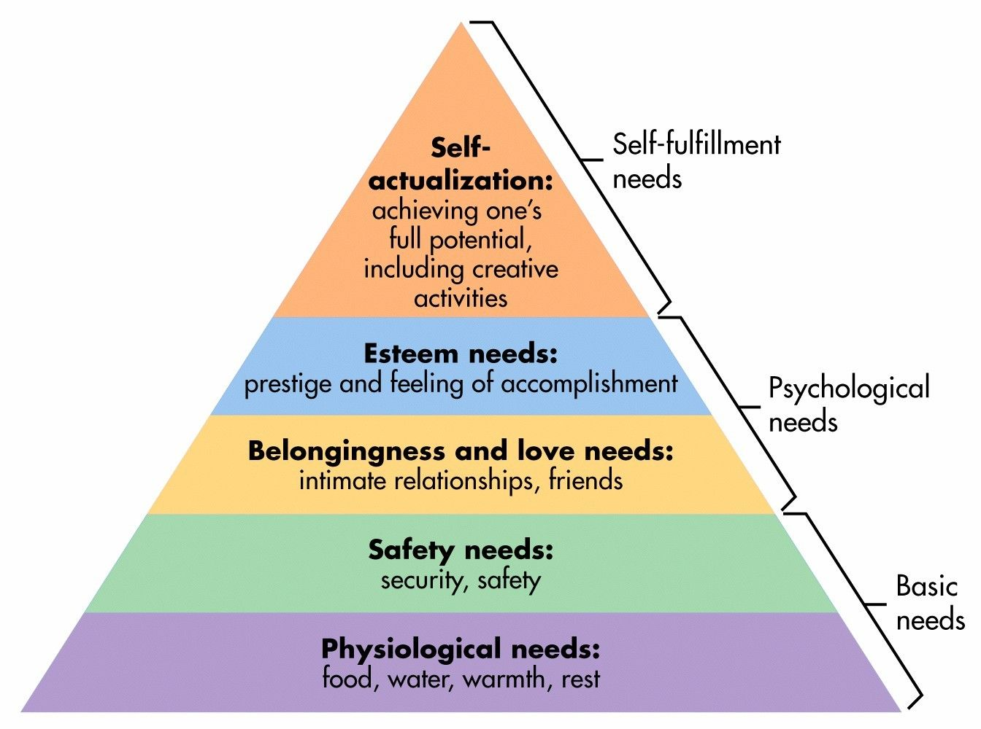

Maslow’s hierarchy of needs (2020)
https://www.simplypsychology.org/maslow.html
Maslow’s hierarchy of needs triangle shows the needs of the child and what stage the child should start are and what they need to do in order to work their way up the pyramid.

Partnerships
Keyworker
Family

Child
Multiagency

In order for partnerships with parents to work the National Minimum Standards for Registered Childcare is required. For transitions to run smoothly parent’s and carer’s need to understand that the key person is the child. It is therefore the keyworkers job to make sure that the parents are informed of their child’s progress. It is important that parents and carers are involved from the beginning of the transition and should be kept updated about changes in the settings, daily charts and social events. (Pacey, 2018)

By having a good partnership with parents means that the needs of the child are able to be met. This will show parents that key workers have respect for the child’s home environment and will show an understanding that the parents have the central role within their child’s life and the concept of a whole-child approach. (Linc programme 2016)
There needs to be strong links between the child and keyworker as it forms a positive relationship. It has long term benefits for the child as partnerships between parents and key workers will have an impact on the child’s development and learning experiences. If this happens parents should feel encouraged and supportive not only to the child but the school as well. (UK essays 1970)
The multiagency approach is able to make a contribution to early intervention services. This is because it has been shown a successful way of addressing a wide range of risk factors that have an impact on children. Having a multiagency team allows the child to communicate better with the team and improve the child’s life. Key workers will be able to identify any delay in learning development though assessments during the foundation phase.
There needs to be good communication between everyone involved in the transition whether it is verbal or non-verbal communication. There needs to be an appropriate response to how the child best communicates and key workers need to show a genuine interest in what the child is saying and doing.

Interventions
It is important that children have a high quality of support from early years key workers in order for them to feel valued, so they have the best possible outcomes for both short and long-term. From the very beginning of the transition for the child the key worker and practitioners need to be fully committed in order for the child to gain trust and experience a holistic environment. (Smidt, 1998)
In Reggio Emilia, Italy, there is a high quality of childcare that is a massive priority of all the local people since the second World War. Schools were taken seriously and where the youngest could acquire the skills and values of collaboration and critical thinking. They believe that schools are made up of relationships and children have unceasing potential. The Reggio Emilia Philosophy is an approach to early education sees the child as strong, capable and resilient. He believed that the child is the central of their own learning and should be able to decide on their own interests and create new ideas. He encourages all children to use every tool that they have in order to express how they feel. The approach should encourage key workers and practitioners to observe children rather than to direct them. Children should be able to experiment on their own and make their own mistakes, so they are able to learn from them. Key workers should observe carefully and responded positively.
The benefits of using this approach includes:
- Encouragement. He believes that being within a Reggio setting means children are able to be encouraged to be researchers. There should also be a strong development of the child social development.
- Explorative. This means that the child is able to express their understanding, creativity and thoughts.
- Problem solving. Children are given learning projects that encourage them to do research and find the key information by themselves. This allows the children to think for themselves and start to become independent. (The Scots College 2017)

Proposed outcomes
Every child is different and develop at their own rates. Each child comes from different backgrounds, they have different experiences but are able to adapt to new transitions and familiarise themselves with new routines. To help the transitions to run smoothly good practice needs to be included and the way that they should be planned and addressed. By having this proposed outcome allows children to ensure that they are receiving emotional support throughout the transitions. (Welsh Government 2018)
Lev Vygotsky (1934) thought that children were active learner but are not solitary learners like Piaget’s theory. Children need to have social interactions with people who are more skilled than them in order to increase their knowledge. This enables children aim to work above their capabilities but within their development zone. Having quality interactions between children and keyworkers are particularly important as by working together will conclude a positive intellectual problem. The new curriculum for Wales gives opportunity to practitioners in childcare settings to improve the outcomes of the transition. The transition process and the role of the practitioner will help obtain positive outcomes and will result in a smooth and successful transition. (Welsh Government 2018)

Reference List
Child centred approach (2015) Children’s Interests in the work of your organisation. https://www.occ.org.nz/assets/Publications/Being-Child-Centred.pdf Accessed 18/11/20

Croneri (2018) Managing Transitions https://app.croneri.co.uk/feature-articles/managing-transitions-early-years-provisions Accessed 15/11/20

Daly, M and Byers, E and Taylor, W (2009) Early years management in practice. 2nd ED. Essex: Heinmann, Person Education Limited

Fabian, H and Dunlop, A.W (no date) https://www.researchgate.net/publication/252093921_Outcomes_of_Good_Practice_in_Transition_Process_for_Children_Entering_Primary_School Accessed 19/11/20

Gov.Wales (no date) https://gov.wales/sites/default/files/publications/2019-07/flying-start-transition-guidance-for-professionals.pdf Accessed 15/11/20

Hartwell-Walker, M (2020) The Benefits of Play in Children https://psychcentral.com/lib/the-benefits-of-play/ Accessed 18/11/20

Key Worker (2020) Early Years Matters https://www.earlyyearsmatters.co.uk/eyfs/positive-relationships/key-person-attachment/ Accessed 15/11/20

Linc programme (2016) Reasons why Partnership with Parents is so Important.
https://lincprogramme.ie/blog/why-partnership-with-parents-is-so-important Accessed 19/11/20

NDFAdmin (2016) Transition in Early Childhood Education definition
https://novakdjokovicfoundation.org/transition-early-childhood-education/ Accessed 07/11/20

No Author (2020) Thinking and Play: pre-schoolers https://raisingchildren.net.au/preschoolers/play-learning/play-preschooler-development/thinking-play-preschoolers Accessed 18/11/20

Pacey.org (2018) Partnership with parents. https://www.pacey.org.uk/working-in-childcare/spotlight-on/partnerships-with-parents/ Accessed 19/11/20

Smidt, S (1998) A guide to early years practice. 3rd ED. Oxon: Routledge

The Scots College (2017) What is Reggio Emilia Philosophy. https://www.tsc.nsw.edu.au/tscnews/what-is-the-reggio-emilia-philosophy Accessed 19/11/20

Twenty Ways You Can Help Your Children Succeed https://www.colorincolorado.org/article/twenty-ways-you-can-help-your-children-succeed-school Accessed 15/11/20

UK Essays (1970) Benefits of Working in Partnership Children and Young People Essay. https://www.ukessays.com/essays/young-people/benefits-of-working-in-partnership-children-and-young-people-essay.php Accessed 19/11/20

Walker. E (2019) https://app.croneri.co.uk/feature-articles/managing-transitions-early-years-provisions

Welsh Assembly Government (2008) End of foundation phase assessment. Cardiff: WAG

Welsh Government (2018) https://www.cymru.gov.uk Accessed 15/11/20

Welsh Government (2018) https://hwb.gov.wales/learning-wales-information-has-moved/? Accessed 15/11/20

