My Digital Life

DS 1
2609517

Screenshot/Photo 1
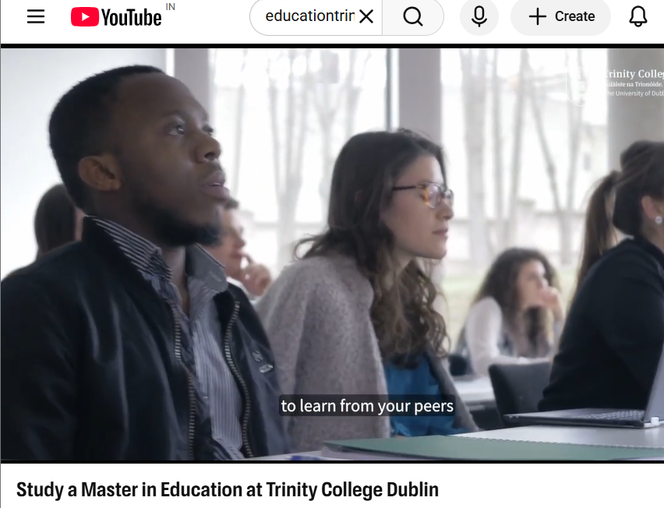
The following screenshot demonstrates that I use YouTube as an online learning resource to learn about educational opportunities and enhance my knowledge. I also view informational videos, including the ones about pursuing a Master of Education at Trinity College Dublin, to learn about alternative courses and education. YouTube helps me find helpful information, study in schools and colleges and learn new things at the speed that I require. Using this platform helps me develop independent learning skills, increase my confidence in using digital resources and make informed decisions about my future education.

Screenshot/Photo 2
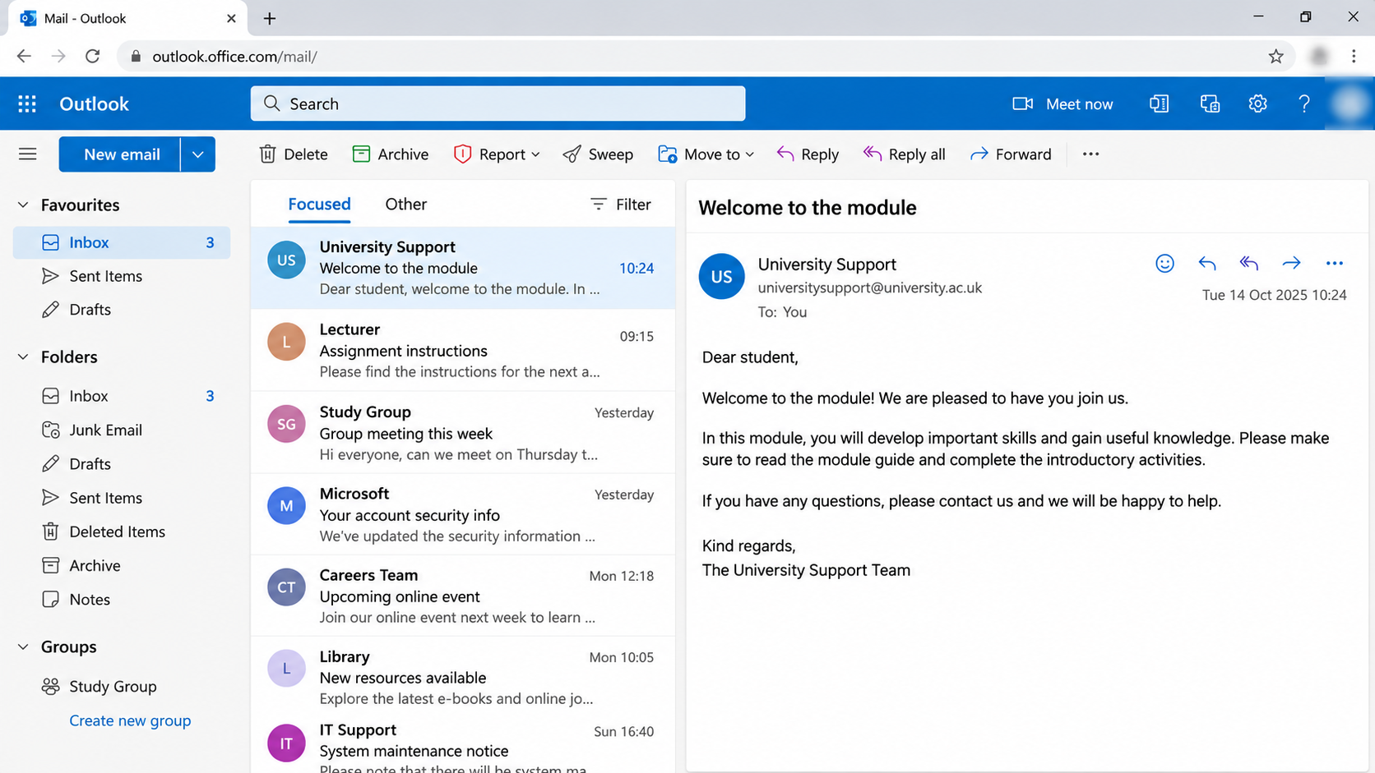
This screenshot shows how I use Microsoft Outlook to communicate with lecturers, university support teams and other students. I also use email every time to get critical updates, get assignment instructions, organise group meetings and access learning material. I can also send messages, share documents and organise emails into various folders using the outlook. This digital communication tool can keep me updated, organise my academic tasks and interact well. It also enhances my self-belief in using professional platforms of communication.

Screenshot/Photo 3
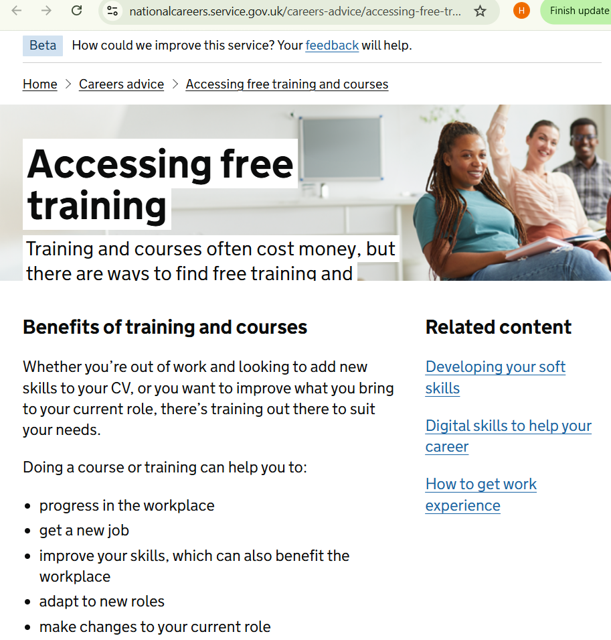
The screenshot demonstrates that I search the web to find free training programs and opportunities to enhance my skills. The site will be helpful when it comes to the benefits of training such as; enhancing the employability, learning new skills and advancing at the workplace. Online resources such as this one help me to seek learning opportunities and know how various courses may help me develop personally and professionally. Online access to educational information is useful in enabling me to increase my research acumen, decide wisely on my future career and gain experience in utilising digital technology to conduct independent research.

Screenshot/Photo 4
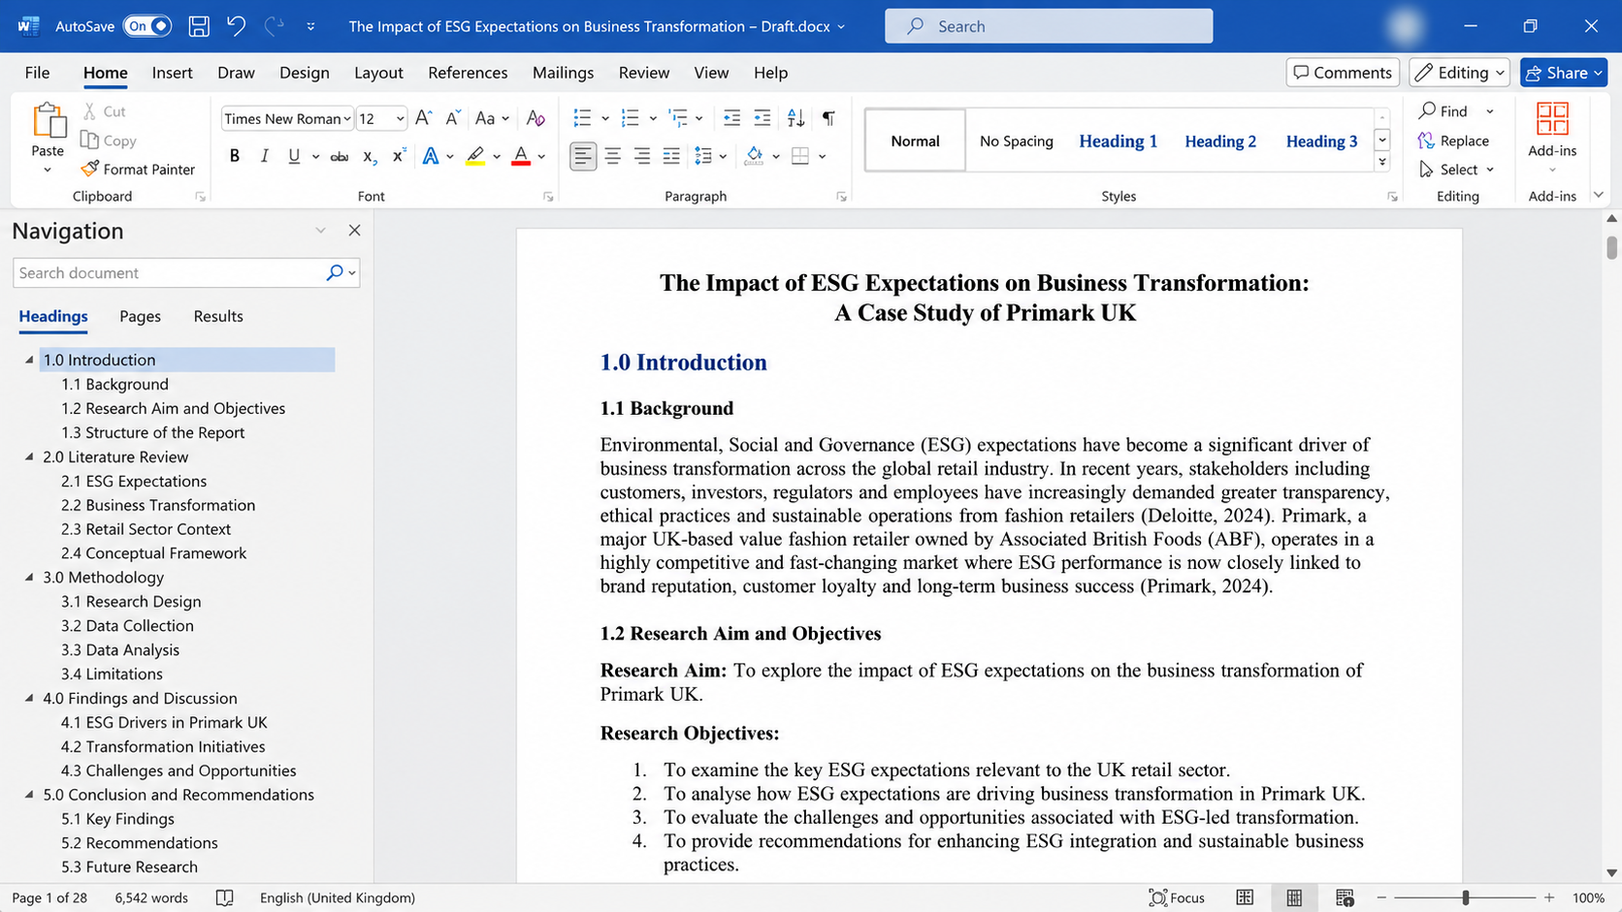
This is the screenshot of how I used the Microsoft word to prepare, edit and organise the academic assignments. Various formatting options (headings, font styles, paragraph alignment and numbered list) make my documents easy to understand and professional. The navigation pane aids me to plan the various parts such as the introduction, literature review, methodology and conclusion. Microsoft Word also enables me to check word count and enhance presentation of my written work. With the help of this application, I can train my writing, document formatting, organisational and digital productivity.

Screenshot/Photo 5
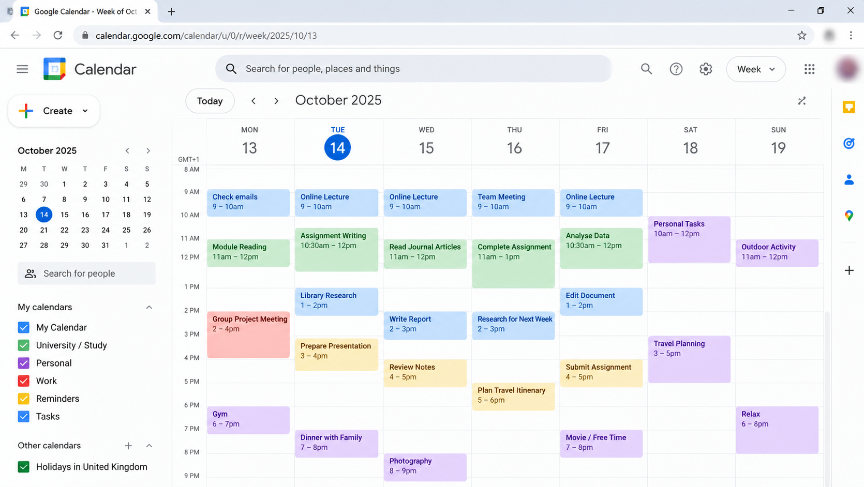
This is a screenshot of the way I manage my day, graduate work and life using Google Calendar. I apply the calendar to plan online lectures, assignment due dates, and group meetings, study sessions and personal activities. The various colours assist me to organise and prioritise various tasks. Google Calendar has also helped me since I can set reminders and plan ahead and not to miss any important deadline. This digital tool has enabled me to manage my time better, be more organised and productive and also balance my studies and personal life.

Screenshot/Photo 6
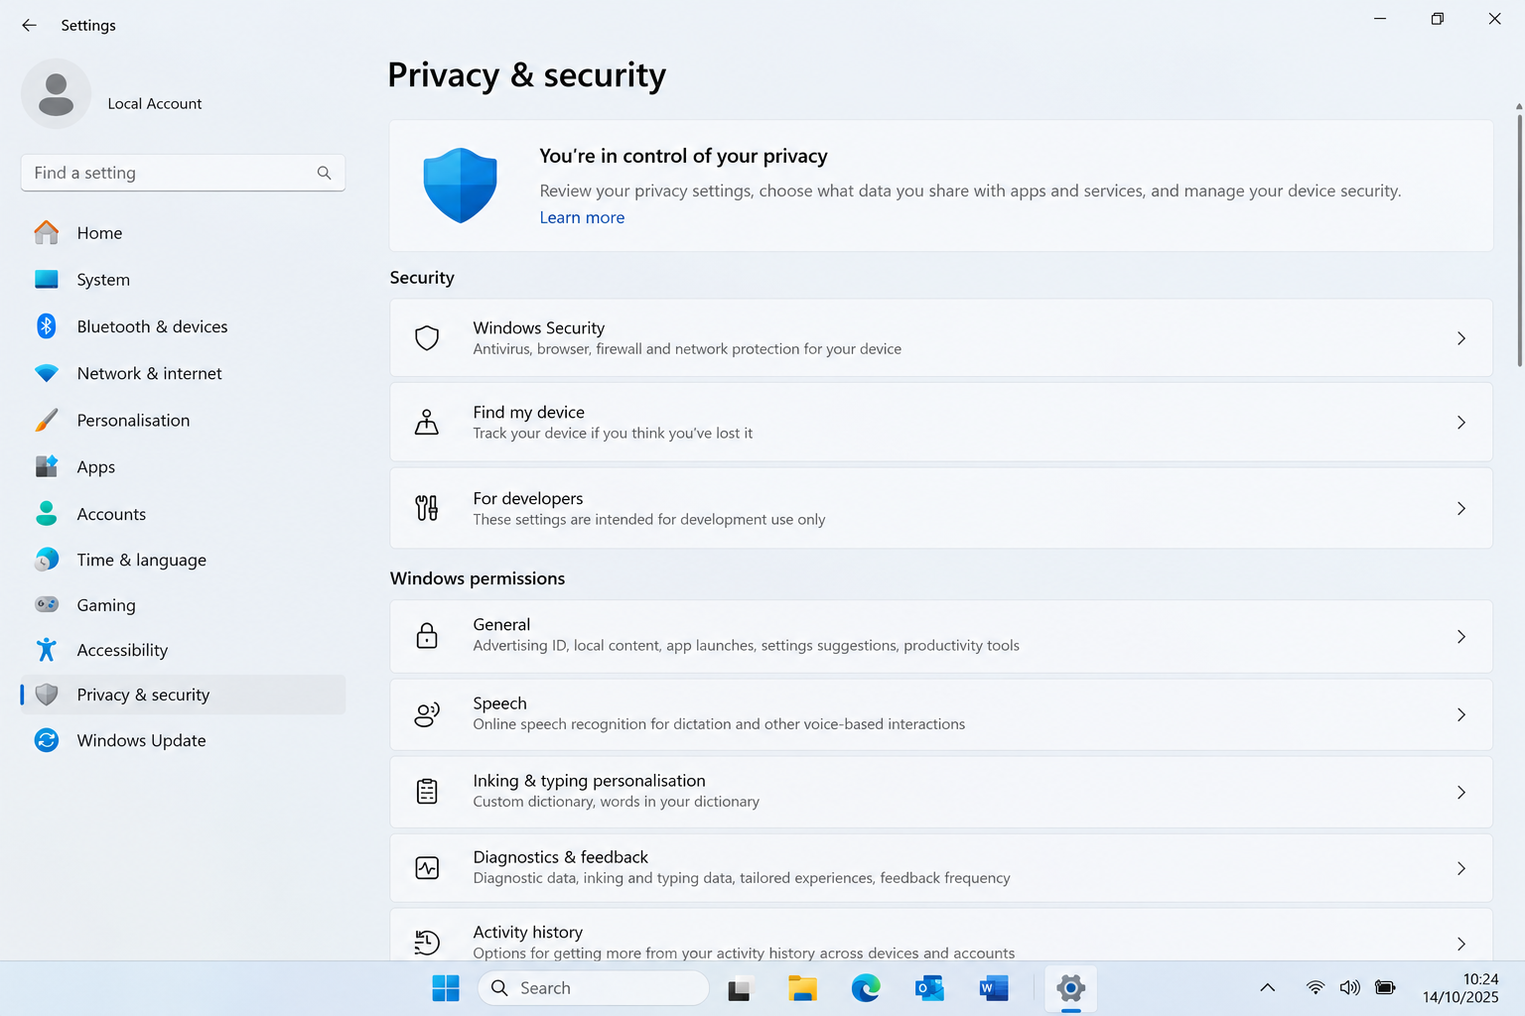This screenshot shows how I use Windows 11 privacy and security settings to understand and manage my computer's security. I can view Windows Security to analyse antivirus protection, firewall settings and other security features. The privacy settings also enable me to revisit the application permissions, manage personal data and control information shared with various services. I will employ these features to learn about the possible online threats and safeguard personal data. Information about digital security makes me feel more confident, responsible and aware of the necessity to be safe when using technology.

My Short Reflection
I rely on digital technology in my daily learning, communication, research and coordination of my daily tasks.
I also learn by watching YouTube and learning websites with new information, enhancing my knowledge and acquiring helpful skills.
I am sure that I can use Microsoft Outlook to exchange messages with other people and Microsoft Word to compose and arrange my study papers.
I also rely on Google Calendar to organise my study time, keep in mind my deadlines and balance my personal activities.
Digital tools make my daily tasks easier, save time and help me become more organised and productive.
Nevertheless, I occasionally worry about Internet frauds, data privacy and my personal information.
I would like to enhance my online security awareness, online research skills and competence in online computer applications.
I believe that this module will enable me to gain more powerful digital skills that will benefit my learning, professional and daily life.

