ASSESSMENT 2: INDIVIDUAL REPORT
‘HOTEL STANDARDS, REPUTATION MANAGEMENT AND
SERVICE CULTURE’
STUDENT NAME: Mahebub Salam
STUDENT ID: 2231040

Executive Summary
This report has focused on importance of Service culture, reputation management and hotel standards of a hotel. Different ways to maintain reputation has been identified along with importance of online reviews and impact of negative reviews. OMR tools and Customer survey has been identified for reputation management. Apart from this, brand consistency has been identified as the most important aspect to improve their brand recognition and increase revenue. In terms of service culture, employee’s dedication to serve best facilities to customers increases hotel’s brand image and reputation.

Table of Contents
Introduction 4
Findings 4
Hotel Standards 4
Reputation Management 6
Service Culture 9
Conclusion 10
Recommendations 10
Reference List 11

Introduction
This report will focus on the main three elements such as Service culture, reputation management and hotel standards. The focus of this report will be on different forms of corporate culture in hotels and its importance in the hotel industry. Apart from this, the main discussion will revolve around the ways in which hotels manage their reputation, importance of guest reviews management, and impact of negative reviews. Moreover, the purpose of the brand consistency standard and whether it is similar in all hotels or not.

Findings

Hotel Standards
Purpose of Brand Consistency Standards
As per hotel standards, managing a brand with consistency is a critical aspect of brand awareness. Brand consistency refers to maintaining the service standard and aim of a brand in all of its marketing and operational channels (Al-Msallam, 2015). It helps many stakeholders to develop their image towards a specific brand; just like the brand owner wanted. For maintaining brand consistency standards for any specific hotel, three elements are necessary such as understanding and promotion of the organisation's mission and core values by the employees (Chung and Byrom, 2021). Another key driver is maintaining brand identity and image through communication with guests. The last one is implementing a consistent and sustainable visual identity of the hotel among the customers (Chung and Byrom, 2021). Brand consistency standards driven by three key elements; help hotels to improve their brand recognition; which will raise customer’s retention rate as well as revenue.

Figure 1: 3Cs Model of Brand Messaging
(Source: Medium, 2017)
In order to maintain brand consistency 3Cs model of brand messaging is essential; which stands for Consistency, Clarity and Character. In terms of consistency, the hotel brand should remember that their brand message should be consistent and clear on all types of platforms like social media, print media, tag line, logo and offline campaigns (Medium, 2017). In terms of clarity, transparency and easy to understand words are essential to attract customers. The last one is character, and in terms of character, by listening to customers, and contributing to society is important (Medium, 2017). For example, JW Marriot, one of the leading hotel brands, relies on their commitment to service and business integrity and maintains this in all of its operational channels (Marriott, n.d). This is one kind of brand consistency strategy used by one of the leading hotels to achieve success.
Brand Standards are different for different Hotels
As per reports, customers are likely to prefer well-known hotels or resorts because of their distinguished brand standards; which make those hotels unique (Economictimes.Indiatimes, 2020). However, in terms of legal aspects, all the hotels need to maintain some specific legal structure and rules to conduct their business. For example, all the hotels need to focus on their brand’s image by relying on data protection act 2018 and under this act, they need to protect guest’s personal details safely and securely (NI businessinfo, n.d).
Moreover, the hotels need to comply with consumer protection law and treat their customers according to this single law by providing good food; good service and rely on contracts (Gov.uk, n.d). For example, one of the brands of Hilton Hotels Group is Conrad Hotels and Resort and three pillars of their brand standard are “Intuitive Service”, “Infinite Connections”, and “A World of Style” (Hilton, 2018). On the other hand, the brand standard of another hotel brand under Hilton group called LXR hotels is focusing on singular service, enduring luxury and remarkable experience through transformation of culture, and history (Hilton, 2018). Therefore, it can be stated that the aim of the brand consistency standard may be similar to all hotels; but the way of meeting, these standards are unique.

Reputation Management
The way Hotels manage their reputation effectively
Technology has a major part in the reputation management of a hotel brand in today’s world. “Online Review Management (ORM)” tools and responding to reviews through it; is effective to manage a hotel's reputation (Nguyen and Coudounaris, 2015). For example, Hotels across the world use either a professional tone or a conversational tone to respond to online reviews; which satisfies their customers and creates scope for improvement as well (Tam et al. 2022). The managers of Regal Hong Kong Hotel respond to customer’s reviews in a similar tone for every positive review and some other tone for negative reviews; which makes their customer’s feel important and maintains hotel reputation.
Conducting Guests’ Survey
Surveying the guests who come to the hotel and spend their vacation can be one of the most satisfying ways to manage their reputation in the hotel industry. Hotels can measure their own service quality and people’s perception of their service through customer surveys and take action for improvement (Mmutle and Shonhe, 2017). For example, Denihan Hospitality Group uses a specific system, which rotates five questions on the front desk during checkout for the customers; to identify their opinion on the hotel's performance (NYtimes, 2013). This survey is called a post-stay survey; which is extremely important for reputation management and the survey length is shorter to save time of customers.
Importance of effective guest reviews management
Effective “guest review management systems” within a hotel are mainly important for increasing the overall volume of customers based on degree of satisfaction related to engagement with customers and loyalty (Vo et al. 2022). Prevalence of social media use is increasing day-by-day. Few years back, people used to consult with friends and family along with travel agencies before choosing a hotel for vacation (Nguyen and Coudounaris, 2015). However, after the increasing use of social media and different kinds of travel related applications, people now mainly rely on online reviews of travellers before choosing any accommodation.
According to reports, 84% of people visit online review sites to plan their trips (Nguyen and Coudounaris, 2015). Online travel sites are getting a huge number of website visits nowadays.
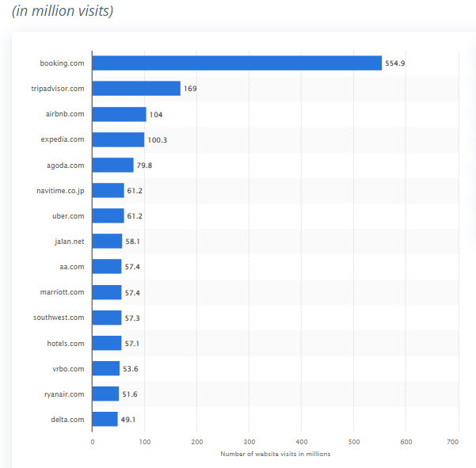
Figure 2: Most visited travel website
(Source: Statista, 2023)
Booking.com got 555 visits followed by TripAdvisors. Therefore, it is clear that people rely on these website reviews a lot. It is explained earlier as well, how hotels check online reviews and respond to it to make their customer feel that the brand cares for their concern and it eventually protects the hotel's reputation (Vo et al. 2022). Through guest’s review management, hotels can identify whether their customers are satisfied or not.
Impact of negative reviews
Negative reviews can create an unfavourable influence over new customers of a hotel. Whenever, any specific hotel fails to serve their customers with best quality food, or residence or amenities, the customers tend to leave a review on the hotel’s site or travel websites; which can alert other people to not consider that hotel (Browning et al. 2013). This is a serious and direct risk to a hotel’s reputation.
Negative reviews have a more effective impact on a customer's decision than a positive review. Therefore, the hotel should always respond to negative reviews to ensure others notice these aspects and take action against the inconvenience (Browning et al. 2013). For example, if Hilton Hotel Agra gets a negative review and responded with respect; which increases its trustworthiness (Tripadvisor, n.d).
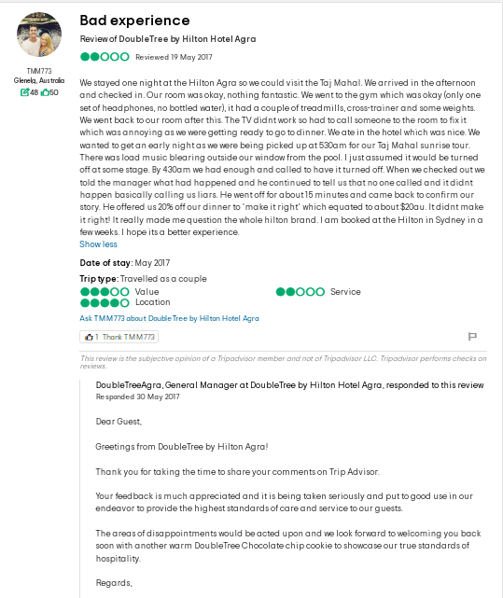
Figure 3: Hilton Hotel Agra’s response to negative Review
(Source: Tripadvisor, n.d)

Service Culture
What is Service Culture
A company with a service culture aims to serve their customers first before anything else (Dikmen and Bozdaglar, 2017). A service culture within a hotel develops a framework for employees to think of different ways to serve their customers better.
Difference between Service Culture and Corporate Culture
Corporate culture refers to the way employees think, act and understand the surrounding world (O'Fallon and Rutherford, 2010). On the other hand, Service culture only focuses on employees' aim to serve customer’s best facilities (Dikmen and Bozdaglar, 2017). Corporate culture puts organisation at the forefront and service culture puts customers at forefront. A company with service culture always tries to link organisational culture with customer service.
Importance of Service Culture in Hotel Industry
The main important aspect of service culture in the hotel industry is, it can bring a competitive edge for the hotel. After COVID, the hotel industry is facing numerous challenges to deliver quality, flawless and satisfactory services to their customers in many cases (Dikmen and Bozdaglar, 2017). Therefore, a service culture influences employees to meet the expectations of customers and earn market value. As stated by Michaelides (2017), a good service culture will be effective for the employees of a hotel to build a potential relationship with guests and improve perceived value of the performance. For example, the Hyatt group takes care of their staff and motivates them to give best services to customers and deliver distinct guest experiences; which is their key to success (Hyatt, n.d).

Conclusion
It can be concluded that managing online reviews by responding to it in a professional and conversational manner; is the most effective way to manage reputation. Moreover, a guest survey is also effective to know a guest's opinion and take action according to it. It has been found that different hotels have different approaches to maintain brand standard; though the objective is almost similar. Another major aspect is service culture, which allows hotels to focus on customer service as the first priority and improve reputation.

Recommendations
After COVID-19 crisis, the inflation rate has increased drastically and staff shortage has become a common issue in all sectors including the hotel industry. The cost of service has increased by a huge margin due to high-rise in food and fuel prices across the world (BBC, 2022). Therefore, the hotels should reframe the issue, and think creatively regarding roles of staff and their safety standards along with their wages. Adaptation of a flexible and agile staffing model may work to mitigate this issue (Mckinsey, 2023). In terms of rising cost, the hotels should cut down promotional costs and use it to improve service quality.

Reference List
Al-Msallam, S. (2015). Customer satisfaction and brand loyalty in the hotel industry. International Journal of Management Sciences and Business Research, 4.
BBC (2022). We're so short-staffed our hotel has to turn people away. [online]. Available at: https://www.bbc.com/news/uk-scotland-62049326 (Accessed on 24 May 2023)
Browning, V., So, K.K.F. and Sparks, B. (2013). The influence of online reviews on consumers' attributions of service quality and control for service standards in hotels. Journal of Travel & Tourism Marketing, 30(1-2), pp.23-40.
Chung, S.Y. and Byrom, J. (2021). Co-creating consistent brand identity with employees in the hotel industry. Journal of Product & Brand Management, 30(1), pp.74-89.
Dikmen, F. and Bozdaglar, H. (2017). The role of service culture in hospitality industry. International Journal of Business and Social Science, 8(5), pp.85-98.
Economictimes.Indiatimes (2020). Hotel / Resort “brand standards” & their significance. [online]. Available at: https://hospitality.economictimes.indiatimes.com/news/speaking-heads/hotel-/-resort-brand-standards-their-significance/79663108 (Accessed on 24 May 2023)
Gov.uk (n.d). Consumer rights. [online]. Available at: https://www.gov.uk/consumer-protection-rights (Accessed on 24 May 2023)
Hilton (2018). CONRAD_Brochure_Feb_2018. [online]. Available at: https://www.hilton.com/en/corporate/wp-content/uploads/2018/02/CONRAD_Brochure_Feb_2018.pdf (Accessed on 24 May 2023)
Hilton (2018). LXR_Brochure_Feb_2018. [online]. Available at: https://www.hilton.com/en/corporate/wp-content/uploads/2018/11/LXR_Brochure_Nov-2018.pdf (Accessed on 24 May 2023)
Hyatt (n.d). About. [online]. Available at: https://about.hyatt.com/en.html (Accessed on 24 May 2023)
Marriott (n.d). Business Conduct Guide. [online]. Available at: https://www.marriott.com/Multimedia/PDF/CorporateResponsibility/Marriott_Business_Conduct_Guide_English.pdf (Accessed on 24 May 2023)
Mckinsey (2023). Three innovations to solve hotel staffing shortages. [online]. Available at: https://www.mckinsey.com/industries/travel-logistics-and-infrastructure/our-insights/three-innovations-to-solve-hotel-staffing-shortages (Accessed on 24 May 2023)
Medium (2017). The 3 C’s Model To Brand Messaging — Consistency, Clarity And Character. [online]. Available at: https://medium.com/@MarketingMaven/the-3-cs-model-to-brand-messaging-consistency-clarity-and-character-e005c11fdc62 (Accessed on 24 May 2023)
Michaelides, R. (2017). Hospitality industry and the service culture in Europe. Tourism and Travelling, 1, pp.15-19.
Mmutle, T. and Shonhe, L. (2017). Customers’ perception of service quality and its impact on reputation in the hospitality industry. African Journal of Hospitality, Tourism and Leisure, 6(3), pp.1-25.
Nguyen, K.A. and Coudounaris, D.N. (2015). The mechanism of online review management: A qualitative study. Tourism Management Perspectives, 16, pp.163-175.
NI businessinfo (n.d). keeping-guest-register-your-tourist-accommodation-business. [online]. Available at: https://www.nibusinessinfo.co.uk/content/keeping-guest-register-your-tourist-accommodation-business (Accessed on 24 May 2023)
NY times (2013). Hotels-work-harder-to-collect-customer-responses. [online]. Available at: https://www.nytimes.com/2013/05/28/business/hotels-work-harder-to-collect-customer-responses.html (Accessed on 24 May 2023)
O'Fallon, M.J. and Rutherford, D.G. (2010). Hotel management and operations. US:John Wiley & Sons.
Statista (2023). Most visited travel and tourism websites worldwide as of March 2023. [online]. Available at: https://www.statista.com/statistics/1215457/most-visited-travel-and-tourism-websites-worldwide/ (Accessed on 24 May 2023)
Tam, S.S., Fong, L.H.N. and Law, R. (2022). Management response to online review: The case of Hong Kong luxury hotels. In Information and Communication Technologies in Tourism 2022: Proceedings of the ENTER 2022 eTourism Conference, January 11–14, 2022 (pp. 123-133). Springer International Publishing.
Tripadvisor (n.d). DoubleTree_by_Hilton_Hotel_Agra-Agra_Agra_District_Uttar_Pradesh. [online]. Available at: https://www.tripadvisor.in/ShowUserReviews-g297683-d6615158-r485519526-DoubleTree_by_Hilton_Hotel_Agra-Agra_Agra_District_Uttar_Pradesh.html (Accessed on 24 May 2023)
Vo, N.T., Hung, V.V., Tuckova, Z., Pham, N.T. and Nguyen, L.H. (2022). Guest online review: An extraordinary focus on hotel users’ satisfaction, engagement, and loyalty. Journal of Quality Assurance in Hospitality & Tourism, 23(4), pp.913-944.
Walker, J.R. (2021). Introduction to hospitality. United Kingdom: Pearson.

