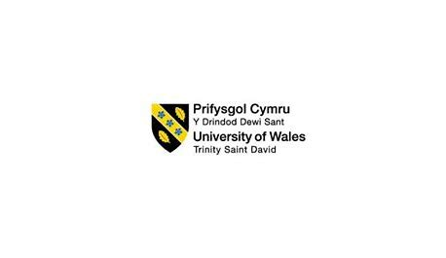

Introducing the modern workplace
By Mihaela Placinta

ID NUMBER 2028614

Contents
Introduction 3
1. Influence of organizational structure and culture 4
1.1 Organizational structure and culture 4
1.2 Organization structure 5
1.3 Organizational cultures 7
2. Influence of different factors on individual behavior within the organization 8
2.1 Behavioral approach 8
2.2 Factors affecting the individual’s behavior 8
Conclusion 10
References 11

Introduction
It is the structure, culture, and workplace or its arrangements that can go through a progressive modification in terms of enhancing the performances for acquiring the organizational goals and objectives (Grey, 2017). Considering this fact, this report is going to represent some relative issues of the organization, Morrisons, a retail business in the UK, is selected. Based on this retail business, this report is going to present the influences of organizational structures and cultures considering the conditions of Morrisons. Then, considering the behavioral approaches, the influences of the factors affecting the individual’s behavior will be presented.

Influence of organizational structure and culture
In a structured organization, like Morrisons, two or more workers or employees work together where all the functions, staff, and systems are aligned in a structured way so that they can form a team and such team can obtain the organizational goals or objectives. Systematic structure, as well as potential culture of the organization, have effective impacts on the business and the entire company’s intent on obtaining the goals (Knights and Willmott, 2012); that have been presented by different researches, like the survey of DeGarmo represented that almost 60% HR professionals consider the organizational culture as the sum of the values, norms, and faith that can be utilized for holding the entire organization and creating a shared long-term vision for the entire organization.

Organizational structure and culture
Organizational structures and their culture are two distinct issues that have significant impacts on the business operations in terms of obtaining the goals and objectives of the business (Gabriel, 2015). This structure requires some critical as well as important issues that are necessary for implementing management functions in different levels of management including top-level, mid-level, and lower management (Huczynski and Buchanan, 2013). That is why it is stated that an individual cannot form an organization’s structure solely; instead, that requires team’s efforts for forming up an effective business structure and such structure can help the entire business along with the team accomplish each function effectively and efficiently that will be enough for obtaining the business objectives. On the other hand, organizational culture requires issues that are not familiar to the issues of organizational culture where values, beliefs, styles, principles, and so many ethical factors. These issues are helpful in terms of forming or building up as well as maintaining the effectiveness in the organizational structures. Ultimately, this structure and the culture of the organization have a significant interaction; such as:
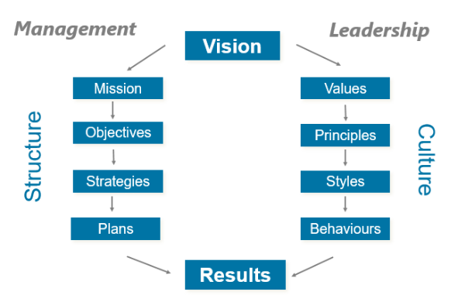
Figure 1: Culture vs structure
Source: (Biliavskа Y., 2017)
That means, the effective formation of organizational structure and the effective accomplishment of the structure’s functions as well as the positive values, styles, principles, behaviors, and ethical norms can aid in acquiring the ultimate results of the business. In the case of a retail business, like Morrisons, there is a good as well as a positive interaction between this retail business’s organizational structures and the company’s retail culture where the impacts are observed in the decision-making procedure of the business (Grey, 2017). For example, retail managers in different branches of Morrisons can plan combinedly and the same leadership styles make all the relative parties including supply chain management, employee management, marketing, financing, HR management, and so on concern about making decisions ethically and potentially.

Organization structure
Unlike an individual, a business is considered as the group of such individuals or people that collaborate for acquiring some specific goals; for which a corporate structure needs to be formed within the business by following which each member of the business can move towards their specific targets and combinedly can achieve the ultimate vision of the business (Bobkov, Denisov and Kuchmaeva, 2019). In the case of Morrisons, the organization and management are twin terms that exist side by side with each other where each one needs and aid the other. The organizational structure will be inert and useless if no management will steer it.
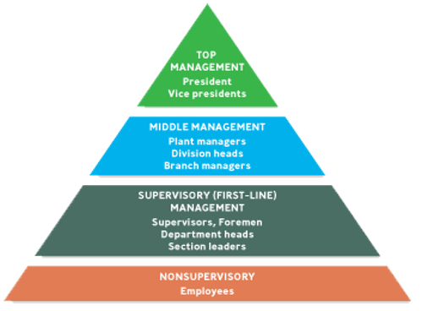
Figure 2: Levels of management
Source: (Zotov, 2021)
For forming up the organizational structure effectively, it is essential to ensure the sequences of the management in the hierarchy effectively (Martin and Fellenz, 2010). In the case of Morrison’s hierarchy, it is found out that the CEO, chairman, president, vice president, etc. and are responsible for making the ultimate decision for the business, especially such decisions are related to the company’s vision and mission of the retail business that has long-term impacts on the business (Zotov, 2021). Mid-level management includes the division and branch managers; like, retail branch managers of Morrisons are seen in leading and providing instructions of leadership to the supervisors; by utilizing them first-ling management that includes department heads and supervisors can lead the non-supervisory section of the business where such non-supervisory section includes the employees or staff of the business who work continuously for acquiring the set targets of the staff (Biliavskа Y., 2017). Considering these managements and the sequences of the management, the organizational chart of the retail business looks like this:
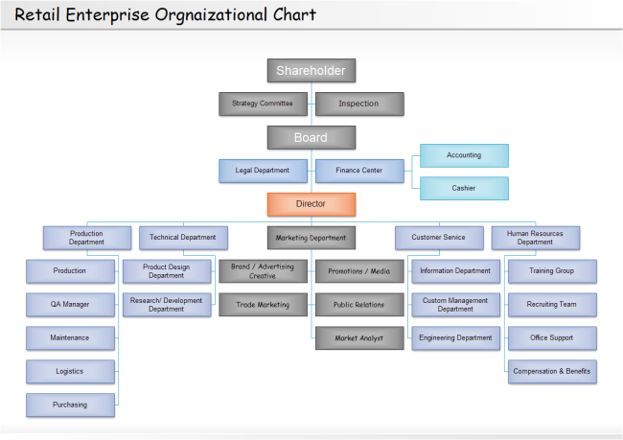
Figure 3: The retail organizational chart
Source: (Bobkov, Denisov and Kuchmaeva, 2019)
From the above organizational chart of a retail business, also followed by Morrisons, Bobkov, Denisov, and Kuchmaeva (2019) stated that a public retail business, like Morrisons, need to share issue in the stock market for having a good number of shareholders who are the owners of this retail business. They declare to form up a strategic committee and inspection by utilizing them a corporate board has been formed for planning strategically that impacts on the entire business functions of the organization (Mullins, 2016). There is a head managing director that indulges in managing and observing the performances, leadership styles, and managerial functions as well as decision-making procedure. A hierarchical structure has various layers of management having a narrow span of control where instructions from the managing directors feed downwards to the below where the staff in Morrisons are now fully empowered. Besides, the managers in each department have the responsibility for many people or tasks and delegation is necessary for all sorts of tasks that can help fasten up the communication with the employees in the same party and with other departments (Biliavskа Y., 2017).

1.3 Organizational cultures
Organizational culture is the basic values that help the entire company communicate to each other, especially to the new members in a correct way so that the members can think and act effectively (Gabriel, 2015). In the organizational culture, strategy is determined in a proper way where the goals are established where the most important issue in the operation. Besides, the employees or staff in the business, like Morrisons are influenced by the backgrounds of their distinct cultures, also known as national culture, who share their distinct values and perceptions. For example, supply chain manager in Manchester coming Southern part of the country always faces difficulty in terms of communicating with the branch manager in Glasgow. The cultural backgrounds of the employees become chronic when the employees or managers are recruited having different languages, traditions, faith, and values (Stephen Taylor. and Michael Armstrong., 2017). It has either negative or positive impacts on the overall business functions and decision-making procedure. For example, an employee from Brazil may face problems in speaking English fluently with other native employees, and their faith, as well as norms, affect the retail functions of a retail business, like Morrisons where the goodwill may get threatened by such miscommunications with the customers.
That is why a formal corporate culture is always expected which is the combination of such organizational culture and the national cultures or regional cultures. In such corporate culture, a standard form of the combination of such cultures helps influence the corporate culture of a multinational company (Grey, 2017). Considering the corporate culture of Morrisons, there is a clearly defined corporate culture and a flexible culture that put potential effects on the entire business where all the parties including internal and external parties can contribute their 100% efforts in acquiring their distinct targets and such success helps the company reach to the ultimate vision and mission of the business regarding the employees’ divergent cultures and backgrounds (Bobkov, Denisov and Kuchmaeva, 2019).

Influence of different factors on individual behavior within the organization
Within the business, like Morrisons, there are many factors found in a retail business that can affect as well as divert the employees' or managers’ behavior effectively. Before identifying such factors and their effects on the business, the company must explore the behavioral approaches to the business.

2.1 Behavioral approach
Under the behavioral approach, the managers of the business are better to realize the views of the employees for treating them as important assets of the business to acquire the ultimate objectives of the business. In this case, the management needs to take a special interest in the workers or the employees that are a special part of the special group. The behavioral approach envisages motivation for which behavior and motivation are defined as the way a person conducts themselves towards others (Huczynski and Buchanan, 2013). Like other retail companies, the HR along with other departmental heads or managers in Morrisons usually treat the workers as humans rather than machines. Besides, they respond to their specific work situation positively and that is why they need to maximize individual productivity within the business.

2.2 Factors affecting the individual’s behavior
Employers and employees can affect each other’s behavior by presenting their behavior properly for which they need to expect their rights to be upheld. In this case, motivation is such an issue that presents the energy as well as commitment with which an individual or a team or the entire business organization and the roles of such team or individuals. It is found out the employees having positive behavior work harder. People’s behavior is determined by what motivates them; that is why Puranam and Maciejovsky (2017) said that the performance of the employees is the function of their ability and motivation. Some factors affect the behavior of the individual and they are:
Positive interaction: There should be a positive interaction between the employers and the employees; for which they both need to accomplish their responsibilities to each other potentially. Positive interaction can be built by the employers’ leadership approach and styles and the employers or the managers need to observe the psychological conditions of the employees and the style of leadership and management associated with the motivated workforce that is difficult to be copied (Gabriel, 2015). As a result, this can make a potential source of competitive advantage. A positive relationship can be built up by implementing an appropriate leadership style and approach within the business.
Health and safety: A proper accomplishment of acts within the business in terms of protecting the employees and ensuring sounds or healthy environment of the business can satisfy the employees appropriately (Mullins, 2016). As a result, the employees can start carrying out their work in a way that has regard to the safety of others where the employees are expected to carry out their responsibilities provided by the employees within the business and to obey a range of requirements, like safe machinery and equipment, regular health and safety checks; for which the employees in Morrisons are trained in health and safety issues.
Equal opportunities: Obeying the acts or legislative issues within the business, the managers of the business like Morrisons can set out that employees should accept the same pay and conditions in terms of carrying out the same or broadly similar work (Stephen Taylor. and Michael Armstrong., 2017). Employees’ behaviors are driven by ensuring such opportunities within the workplace, especially proper acts that need to be accomplished that can help eradicate sexual, racial, as well as disability discrimination within the business, like Morrisons.
Minimum Wage: Every employee expects a minimum wage from the company according to their dedication towards the business. By following the national minimum wage act in the UK, the HR of Morrisons always pays appropriate salaries and wages to their employees or staff. Terms and conditions specify the minimum wage of the employees before the final recruitment procedures (Eghbali and Ahmadvand, 2020). If the employees find their appropriate accomplishment, it may direct them positively and move towards achieving the organizational goals and objectives.

Conclusion
In the end, it can be stated an effective organizational structure can ensure a positive organizational culture where the employees work as a team and obey the instructions of the employers. This has been observed considering the case of Morrisons that is a retail business in the UK. This business follows a chain of command and an effective hierarchy that provides potential instructions to the sub-ordinated management. The calm and helpful nature of the culture of Morrisons helps to be stable on moving towards the ultimate objectives. Then, behavioral approaches are based on the ability, motivation, and performances; for which some effective issues that have been discussed have crucial influences on the individual’s behaviors.

References
Biliavskа Y., Y., 2017. The vital cycle of the organizational culture of the trading enterprises. The vital cycle of the organizational culture of the trading enterprises, 1(10), pp.3-11.
Bobkov, A., Denisov, I. and Kuchmaeva, O., 2019. Research of organizational structure of the retail business and educational institution by methods of statistical analysis. Statistics and Economics, 16(1), pp.11-21.
Eghbali, H. and Ahmadvand, M., 2020. Application of (AHP) Method in Ranking the Factors Affecting the Formation of Organizational Behavior of Employees. SSRN Electronic Journal.
Gabriel, K., 2015. Organizational Development, Organizational Culture, and Organizational Change. SSRN Electronic Journal.
Grey, C., 2017. A very short, fairly interesting, and reasonably cheap book about studying organizations. 4th ed. London.
Huczynski, A. and Buchanan, D., 2013. Organizational behavior. 8th ed. Pearson.
Knights, D. and Willmott, H., 2012. Introducing organizational behavior and management. 2nd ed. South Western/Cenage.
Martin, J. and Fellenz, M., 2010. Organizational behavior and management. 4th ed. South Western/Cenage.
Mullins, L., 2016. Management of organizational behavior. 11th ed. Harlow, England; New York: Pearson, pp.20-110.
Puranam, P. and Maciejovsky, B., 2017. Organizational Structure and Organizational Learning. SSRN Electronic Journal.
Stephen Taylor. and Michael Armstrong., 2017. Armstrong's Handbook of Human Resource Management Practice, 15th Edition.
Zotov, V., 2021. Organizational Structure Modeling of Innovative Company. Revista Gestão Inovação e Tecnologias, 11(4), pp.1469-1477.

