Resourcing and Talent Management.
Bluestone National Park Resorts Ltd.
DECEMBER 2024

Stuart Davies-Jaynes (0151126)
University of Wales Trinity Saint David
PGDip/MA in Strategic People Management
Word Count = 3,822




Executive Summary

The following report critically analyses the internal and external factors influencing resourcing and talent management at Bluestone National Park Resort. It specifically examines key aspects related to the attraction, recruitment and development and retention of its workforce.

Recommendations are made for enhancing Bluestone National Park Resort’s approach to resourcing and talent management. These improvements aim to effectively address the challenges identified and to strengthen the company’s competitive position within a competitive labour market.

Table of Contents

1.0 Introduction……………………………………………………………...…… 3
1.1 What is Resourcing and Talent Management? 4

2.0 External Factors Affecting Talent Management at BNPR. 5

3.0 Internal Factors Affecting Talent Management at BNPR 9

4.0 Conclusion …13

5.0 Recommendations 16

6.0 Reference List 18

1.0 Introduction

Established in 2008, Bluestone National Park Resort, also known as BNPR, is a privately owned five-star holiday destination located in Pembrokeshire. With over 950 employees the resort offers a unique experience for guests of all ages providing a range of accommodation, including luxury lodges and cottages, as well as various amenities and activities for guests to enjoy. The resort is well known for its natural surroundings within Pembrokeshire Coast National Park and sector-leading sustainability credentials.

As one of the largest private employers in west Wales, operating within a relatively sparsely populated area of the UK, BNPR places a strong emphasis on attracting and retaining talent (ONS, 2021). Pocztowski, Pauli and Mis (2022) support this notion, suggesting that the importance of talent management increases in an increasingly competitive environment.

What is Resourcing and Talent Management?

Through its 'Professional Map' and educational syllabus, the CIPD defines resourcing and talent management as a distinct and integrated discipline within the broader field of human resource management (HRM), (Taylor, 2018a). In the context of HR, resourcing and talent management have distinct definitions and purposes, with resourcing focusing on the processes of attracting and recruiting individuals, while talent management encompasses the broader strategies for developing, engaging, and retaining employees.

According to the CIPD (2023), resourcing entails attracting and recruiting individuals for the appropriate roles at the right time and cost. It involves leveraging relevant workforce planning data and understanding the best sourcing strategies and digital platforms to access a diverse range of candidate pools. Resourcing activities are a crucial aspect of the HR function, aimed at achieving six core HRM objectives: staffing, performance, administration, change management, employer branding, and promoting employee well-being (Taylor, 2018b).

Gallardo, Thunnissen and Scullion (2020), describe talent management as the activities and processes that involve the systematic attraction, identification, development, engagement, retention, and deployment of talents that are especially valuable to an organisation, aiming to create strategic sustainable success. In simpler terms, talent management involves anticipating the need for human capital and developing a plan to address that need (Cappelli, 2009).

Talent management theories have predominantly been based on the assumption that maximising employee talents is a key source of sustainable competitive advantage. Consequently, talent management has become closely associated with HRM practices in organisations, with the aim of improving business performance (Al Ariss, Cascio and Paauwe, 2014).

This report critically analyses BNPR’s external and internal factors affecting talent management within the business.

2.0 External Factors Affecting Talent Management at BNPR

BNPR operates within a competitive labour market in Pembrokeshire’s leisure and tourism sector, making it progressively more difficult to attract new recruits, often skilled individuals are increasingly likely to leave their current employers for positions with other organisations.

Data from the ONS (2024), shows that Pembrokeshire’s unemployment rate is lower at 3.4%, compared to 3.7% in Wales overall. Furthermore, employment rates in Pembrokeshire are higher, with 76.8% of people in work, compared to 73.6% in Wales. This suggests that when BNPR seeks to attract new talent, it is likely to recruit individuals who are already employed. This employment environment indicates that both new hires and existing employees are likely to demand greater autonomy over their work, increased flexibility, improved working conditions, and more opportunities for development, in addition to competitive pay (Taylor, 2018c). Consequently, BNPR places a strong emphasis on enhancing its employee benefits as a key differentiator to attract and retain talent in this competitive landscape.

In today's competitive market, organisations are increasingly taking a proactive approach to recruiting by targeting individuals who may be passively considering new opportunities, alongside those who are actively seeking employment. Harrington (2023), supports this notion and suggests that offering high-quality benefits is not only essential for attracting new talent, but also plays a crucial role in retaining existing employees.

Brexit is an external economic factor that has had and continues to have significant implications on the supply of labour resources for BNPR. Changes in immigration policies and labour market dynamics have been part of the employment challenges impact. Restrictions on the free movement of people between the UK and the EU have implications for the leisure and tourism sector reliant on migrant labour, this is evident in low paid and low skilled workers such has housekeepers and food and beverage assistants which is a large proportion of the workforce at BNPR, (Papyrakis, Pellegrini and Tasciotti, 2022). BNPR could consider sponsorship agreements which will allow skilled workers from overseas into the workplace, but this does have cost and compliance implications which BNPR could consider (Teague and Donaghey, 2020).

BNPR is somewhat distinctive within the leisure and tourism sector as it operates year-round, maintaining an average guest occupancy rate of 97%, unlike local competitors who typically open seasonally during peak holiday periods. Competitors are often able to offer a higher hourly rate of pay over a shorter employment period (Gov.UK, 2023). Although BNPR offers entry-level roles that pay above the national minimum wage, its employee benefits package is designed to compensate for the hourly rates by enhancing both attraction and retention of employees (Bluestone, 2024).

Taylor (2018d) refers to the idea of "pull factors" as the circumstances that draw employees to alternative job opportunities. This can occur even when employees are content with their current employer and job. In such cases, they may decide to seek new opportunities in pursuit of even greater benefits or satisfaction.

BNPR places emphasis on promoting its unique employee benefits through its recruitment campaigns to stimulate interest within the labour market. A significant benefit BNPR offers is the option to join a Share Incentive Plan (SIP). The SIP is designed to encourage employees to own shares in the business following twelve months of continued service. Employees are allocated shares in a tax-efficient way, providing potential long-term financial benefits and a sense of ownership in the company (Gov.UK, 2024). Consequently, this approach contributes to enhanced employee retention rates and employee loyalty.

The image below depicts a recent targeted recruitment mail-drop campaign that highlights the main 'pull factor' benefits offered to BNPR employees.

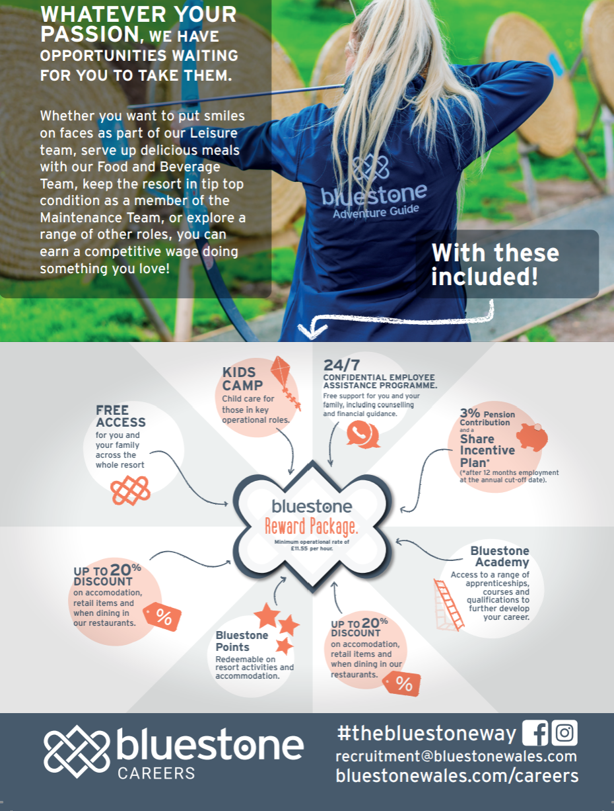

(Bluestone National Park Resorts Ltd, 2024)

BNPR is known for its leading practice in environmental and social responsibility and in-house marketing team to promote its key credentials to guests, the community and perspective employees (Bluestone Resorts Ltd, 2023). According to Lamm, Tosti-Kharas and King (2014), it is essential for employers seeking to attract employees who share similar values. As job seekers increasingly prioritise organisations that align with their environmental and social principles, highlighting sustainability initiatives can significantly differentiate employers in a competitive labour market. This alignment not only fosters job satisfaction and loyalty but also enhances employee engagement, particularly among younger generations like Millennials and Gen Z, who often place a strong emphasis on sustainability in their career choices (Ro, 2022).

BNPR’s commitment to sustainability aims to improve its reputation and employer brand, making it more appealing to prospective hires. Employees who resonate with their company’s mission tend to be more motivated and productive, often contributing innovative ideas and collaborative solutions that drive business performance (Black, 2022). Furthermore, a cohesive culture centred around sustainability encourages teamwork and retain talent, as employees feel a sense of belonging and purpose (CIPD, 2024).

Ultimately, by actively promoting sustainability, BNPR can build a dedicated workforce that not only excels in performance but also positively impacts society and the environment, positioning itself for long-term success in an increasingly eco-conscious marketplace.

BNPR continuously seeks to improve its employer brand. Employer brand serves to distinguish an organisation in complex labour market, allowing the business to attract, recruit, retain, and engage the right talent (CIPD, 2023a). A robust employer brand enables businesses to compete for top talent and build trust. BNPR’s employer brand aims to reflect the values of its guests, fostering a culture of inclusivity, ‘family orientation’, and support. This commitment is demonstrated through its ‘free-range’ and ‘Welcome to our Neighbourhood’ marketing campaign, (Bluestone Resorts Ltd, 2023b).

BNPR aims to effectively promote its employer brand, this is shaped by their reputation as a “workplace,” as viewed by prospective candidates, current employees, and those leaving the organisation (Peters, 2023). By actively sharing information about its annual employee recognition event, the ‘ACE Awards’, on various public communication platforms. This initiative not only celebrates employee achievements but also reinforces the company’s commitment to fostering a positive recognition culture. Furthermore, BNPR regularly publishes communication about its inclusive policies and including flexible working arrangements. A key feature of these benefits is the subsided ‘Kids Camp,’ a free childcare facility designed specifically for employees with children. This initiative highlights BNPR’s dedication to financially supporting its workforce and ensuring that employees can effectively balance their professional and family commitments, which is a unique employer competitive advantage within the local market.

A strong focus is placed on employee wellbeing, with annual wellbeing events organised to connect employees with resources from the broader community (Linked In, 2024). Supporting such initiatives can help lower stress levels and promote a positive work environment, benefiting both employees and the organisation. Good health and wellbeing are crucial for increasing employee engagement, reducing absenteeism, and improving overall organisational performance (CIPD, 2023c).

Promoting these initiatives is imperative in supporting the attraction of perspective employees and onward development and commitment of existing employees. According to Fuchs (2024), leisure, tourism and hospitality vacancies have surged to over 118,000, 50 percent higher than pre-pandemic levels due to factors such as reduced EU migration, job security concerns, work-life imbalances, and the perception of hospitality as a temporary career. However, by enhancing company culture through inclusive hiring practices and prioritising employee wellbeing, BNPR can tap into underutilised and diverse talent pools.

3.0 Internal Factors Affecting Talent Management at BNPR

At the core of BNPR’s strategy is its Vision Canvas, a guiding three-year framework woven throughout the organisation. This Vision Canvas (as seen below) shapes each stage of the employee experience, from hiring, where candidates are selected based on shared behavioural values, to the company onboarding and induction, which focuses on fully immersing new employees in these principles. Employee performance is measured against the behaviours 1) Genuine Care: 2) True Ownership and 3) Grow as a Team, making the Vision Canvas a vital part of the employee life cycle. This approach ensures alignment across the workforce, fostering a productive and supportive culture that enhances the guest experience and drives the company’s success (CIPD, 2023c).

Employees are encouraged to participate in quarterly Vision Canvas engagement sessions, during which the company's Directors present updates on strategic progress. This initiative fosters greater employee engagement and cultivates a sense of accountability and loyalty towards the organisation (Tkalac Verčič, Galić and Žnidar, 2021). Over time, this approach has contributed to improved employee engagement levels and reduced rates of employee attrition.

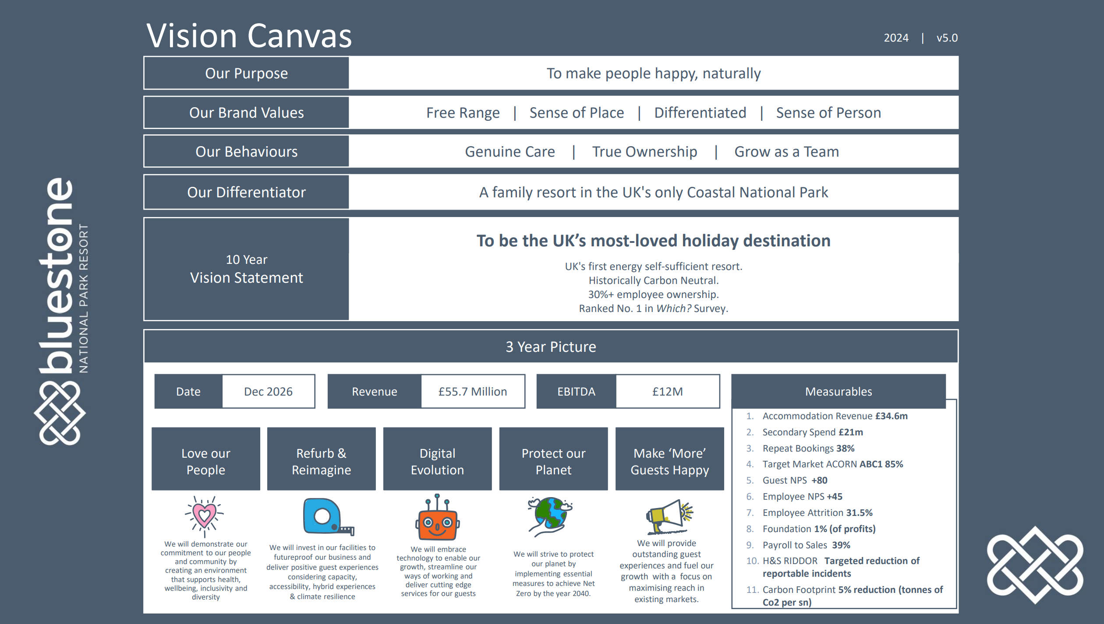

According to Tyagi (2021), organisational culture refers to the psychological atmosphere of a workplace and the set of norms that align with this atmosphere. It is a complex, multidimensional, and multilevel concept, embodying the core values, beliefs, perspectives, norms, and assumptions shared among members of the organisation.

William McNamara, the founder and CEO of BNPR, hosts engaging sessions titled "Time Out with William," designed for employees at the beginning of their career. These sessions serve as a pivotal introduction to the company’s culture, emphasising the importance of an individual's contribution to the organisation's success, regardless of their role or pay band.

During the sessions, McNamara shares his vision for BNPR, highlighting the company's mission and values. He encourages open dialogue, allowing employees to voice their thoughts and aspirations. This fosters an inclusive environment where employees feel valued and heard. Research led by the CIPD (2023b), has shown that voice can help address issues related to justice and equity (Dundon et al., 2004) and facilitate self-expression through what is termed 'employee-focused voice.' Conversely, voice has also been considered a tool for enhancing employee performance, known as promotive voice or, in this study, organisational voice (Morrison, 2014).

Employees having access to the founder and CEO promotes a sense of belonging and purpose, BNPR aims to cultivate discretionary effort. Mishra and Tyagi (2022) support this approach as it not only strengthens workforce cohesion but also reinforces BNPR’s culture of employee voice, collaboration and excellence.

In 2020, BNPR launched its L&D Academy. The Academy aims to empower employees at all levels by providing access to training & development programmes and external accredited qualifications, which support employee career growth which align with the company’s strategic goals. By promoting a culture of learning, the Academy seeks to drive innovation, improve performance, and develop talent which supports overall improved company performance (Kortsch, Bashenkhaeva and Kauffeld, 2022).

The Academy has adopted limited technology, such as e-learning, and partnered with Minecraft to establish guest experience training. However, there remains an opportunity for broader recruitment processes to embrace technology. Technology enhances recruitment by speeding up candidate screening and selection through AI-powered tools. It broadens access to talent via online platforms, improves candidate-job matching with data analytics, and boosts efficiency with automation. This leads to cost savings, a shorter time-to-hire, and an improved candidate experience, strengthening hiring outcomes overall (CIPD, 2021).
The emphasis on the professional development of its employees suggests that BNPR adopts a long-term approach to resource and talent management, in line with the Miles and Snow model (Alnoor et al., 2022). Miles and Snow identify three types of business strategies: the defender strategy, the prospector strategy, and the analyser strategy. Each of these strategies necessitates distinct approaches to people resourcing. In response to the competitive labour market, BNPR has adopted a defender strategy aimed at establishing a stable organisational structure where job roles are clearly defined and often specialised. Recognising the importance of nurturing internal talent, through the Academy, BNPR frequently appoints employees to junior positions early in their careers, enabling them to progress up the career ladder internally over time, supported by the Academy (Taylor, 2018d).

The Academy team actively communicate success stories of internal development and employee progression. The CIPD (2023d), highlights that sharing information related to such topics fosters trust and cohesion, which are essential for optimal performance. By facilitating information sharing, teams not only enhance their collaborative efforts but also strengthen the relationships among members, ultimately leading to improved outcomes.

In 2020, BNPR introduced its performance management framework, known as ‘The Bluestone Way.’ This framework was designed to develop workforce alignment with the company’s culture and values. Its aim is to cultivate emotionally intelligent leaders who can unify and leverage the diverse talents of all employees, ultimately delivering a distinctive and memorable experience for guests.

The Bluestone Way performance management process is a continuous cycle centred on open dialogue and constructive feedback. Accessible to all employees within the business, this flexible, one-to-one approach emphasises achieving set "hard targets" for roles, meeting other key outcomes outlined in job descriptions or objectives, and ensuring that the right behaviours are demonstrated. By integrating both “what” is achieved and “how” it is achieved, the process promotes continuous development and alignment with Bluestone’s organisational goals and values. Research led by Yadav and Sagar (2013), support this approach, arguing that linking performance to the company’s vision, objectives, and strategies represents a shift from an operational to a strategic focus in performance measurement. Through the Bluestone Way framework employees are able to have engaging conversations regarding their performance, career aspirations and professional development plans (PDPs) are instigated.

PDP’s promote career development and workforce stability by establishing clear objectives and pinpointing the skills necessary for enhancement. They enhance motivation, aligns individual growth with organisational goals, and cultivates self-awareness, ultimately resulting in improved performance and adaptability within a dynamic work environment (Mensah, 2015). According to People Management (2024), fostering a culture of internal career development can assist organisations in retaining top talent, reducing turnover, and increasing workforce engagement.

The Bluestone Way offers business real-time employee performance data, which could enhance strategic workforce planning. However, it is clear that the business has not fully utilised this technology to gain comprehensive visibility of this data in conjunction with other HR analytics, hindering its ability to make more informed strategic decisions. People Management (2022), argue that workforce planning is a vital function carried out by HR. At its core, workforce planning involves analysing the current workforce to identify the necessary actions required to address future resourcing needs. In a candidate-driven market, it serves as a strategy for ensuring the organisation remains competitive and prepared for the future.

4.0 Conclusion
In conclusion, BNPR operates within a multifaceted environment that significantly influences its resourcing and talent management strategy. The competitive labour market in Pembrokeshire presents unique challenges, particularly in attracting skilled employees amid low unemployment rates and higher employment levels than the national average. These conditions create a landscape where potential recruits are often already employed, prompting BNPR to adopt innovative approaches to appeal to both passive and active job seekers, (Belenzon and Tsolmon, 2015).

By emphasising a unique employer brand proposition, BNPR effectively distinguishes itself in this competitive sector. Its employee benefits package, which includes competitive salaries, opportunities for professional development, and a robust Share Incentive Plan (SIP), not only attracts new talent but also fosters loyalty among existing employees (CIPD, 2022). BNPR’s commitment to sustainability, showcased through its environmental initiatives and community engagement, resonates strongly with modern job seekers who increasingly prioritise employers aligned with their values, (Erdogan, Bauer and Taylor, 2015).

Internally, BNPR has cultivated a culture centred on continuous learning and employee recognition, which plays a critical role in talent retention. The introduction of the Leadership Development Programme and the L&D Academy demonstrates a strong commitment to upskilling employees and fostering internal career progression. By providing pathways for advancement, BNPR not only enhances job satisfaction but also instils a sense of belonging and purpose among employees. This alignment of individual aspirations with organisational goals is crucial for building a motivated workforce capable of delivering exceptional guest experiences, (Tambay, 2024).

Moreover, BNPR's performance management framework, ‘The Bluestone Way,’ integrates both qualitative and quantitative measures of employee performance, creating a culture of accountability and continuous improvement. By encouraging open dialogue about performance and career development through PDPs, the organisation ensures that employees are engaged in their growth while aligning their contributions with the company's culture and strategic objectives.

A significant opportunity for BNPR lies in the digitalisation of its workforce planning and recruitment processes. By embracing advanced technologies such as artificial intelligence and data analytics, BNPR can enhance the efficiency of its recruitment efforts, streamline candidate screening, and improve the overall candidate experience (Lee and Cha, 2023).

As BNPR navigates the evolving landscape of the leisure and tourism sector, its proactive approach to addressing both external challenges and internal opportunities will be pivotal for its continued success. By fostering a culture that values employee engagement, professional growth, and social responsibility, BNPR is well-positioned to maintain its competitive advantage with its sector (Kosfeld and Vo-Siemens, 2011).

Ultimately, the strategic focus on aligning employee values with organisational objectives, enhancing employer branding, and prioritising well-being and development will not only attract top talent but also cultivate a dedicated and high-performing workforce (Presbitero, Roxas and Chadee, 2015).

5.0 Recommendations
Following the above conclusions recommendations have been made to enhance BNPR’s approach to talent management to overcome opportunities identified.

5.1 Recommendation One – Embrace Technology in Recruitment.

By adopting advanced technologies in recruitment processes, such as artificial intelligence and data analytics, BNPR can increase efficiency, streamline candidate screening, and enhance the overall candidate experience (Lee and Cha, 2023). Digital tools would enable better alignment of candidates to job roles and BNPR’s values, optimising the hiring process and allowing HR to concentrate on strategic initiatives rather than administrative tasks. This shift towards technology would provide valuable insights into workforce trends, enabling BNPR to proactively address talent shortages and make informed decisions on future resource needs. The CIPD (2023c) promotes this approach, stating that technology can enhance workforce agility and productivity, while also fostering greater collaboration within organisations.

To introduce a digital recruitment platform, it is important to consider the resource and time costs involved in market research, platform selection, and implementation. This includes expenses for setup, integration, training, and any ongoing maintenance (Pan et al., 2021). Additionally, engagement costs, such as marketing the platform and supporting candidate communication, as well as administrative and user costs, should also be factored into the overall budget. Taking these factors into account, a budget of £10,000 is recommended, with provision made for annual subscription costs.

5.2 Recommendation Two – Digital Workforce Planning

BNPR would benefit from adopting a digital workforce planning tool, as it would enable the company to optimise HR processes and enhance overall efficiency. Akter et al., (2023) support this approach and state that by leveraging data analytics, the tool would provide valuable insights into workforce trends, helping BNPR identify skill gaps, forecast future talent needs, and address potential staffing challenges proactively. The tool would also offer live data on Bluestone Way performance metrics, allowing real-time tracking and more accurate assessment of employee performance.

Furthermore, it would streamline the recruitment process, ensuring that the right candidates are matched with the right roles more quickly and effectively. In addition, the digital tool would foster greater collaboration across departments, improve decision-making, and enable the company to respond more swiftly to competitive market conditions (Hayden, 2024). Ultimately, a digital workforce planning platform would not only save time and reduce costs but also help BNPR build a more agile, data-driven, and competitive workforce.

The associated costs with implementing a digital workforce planning tool include the time and resources needed for market research, selecting the right platform, and the subsequent setup and integration. Furthermore, expenses related to employee training, ongoing support, and system maintenance should be incorporated into the overall financial requirements. Additional costs such as user engagement, platform promotion, and administrative resources must also be accounted for. With these factors in mind, a budget of £12,000 should be allocated, ensuring sufficient coverage for initial setup and recurring subscription fees.

5.3 Recommendation Three – Promote the Bluestone Academy

It is recommended that BNPR strategically market and promote the Bluestone Academy and its internal career development pathways to further enhance its employer brand and reinforce its commitment to fostering employee growth.

By emphasising these initiatives, BNPR can position itself as an organisation dedicated to nurturing internal talent and providing clear opportunities for career progression. Promoting the Bluestone Academy externally, through targeted communications and strategic partnerships, will not only attract high-calibre candidates seeking development opportunities but also improve employee retention by demonstrating BNPR’s investment in long-term career growth (Kanwal and Hoye, 2023). The CIPD (2023C) suggests that this approach will strengthen BNPR’s reputation as an employer that prioritises the professional development of its workforce, positioning the company as an employer of choice.

To effectively implement this recommendation, BNPR should allocate a budget of £15,000 to external marketing campaigns, including digital ads, promotional materials, and partnerships to increase visibility. Internal costs will involve updating the Bluestone Academy’s resources and staff time for content creation, including costs for generating engaging videos, articles, and social media posts.

6.0 Reference List
Akter, S. et al. (2023) ‘Mastering Digital Transformation in Workforce Management’, Production Planning & Control, pp. 1–8. Available at: https://doi.org/10.1080/09537287.2023.2270465.
Al Ariss, A., Cascio, W.F. and Paauwe, J. (2014) ‘Talent management: Current theories and future research directions’, Journal of World Business, 49(2), pp. 173–179.
Alnoor, A. et al. (2022) ‘The Hybrid Strategy on the Basis of Miles and Snow and Porter’s strategies: an Overview of the Current state-of-the-art of Research’, International Journal of Engineering Business Management, 14(14), p. 184797902210802. Available at: https://journals.sagepub.com/doi/full/10.1177/18479790221080214 (Accessed: 27 October 2024).
Belenzon, S. and Tsolmon, U. (2015) ‘Market Frictions and the Competitive Advantage of Internal Labor Markets’, Strategic Management Journal, 37(7), pp. 1280–1303. Available at: https://doi.org/10.1002/smj.2395.
Black, J. (2022) ‘Generation Z: How to Recruit and Retain Them’, Financial Times, 31 July. Available at: https://www.ft.com/content/9eb9e9d2-6340-44e6-9d56-f2a140f7dee9 (Accessed: 23 October 2024).
Bluestone (2024) Our Benefits | Careers | Bluestone, careers.bluestonewales.com. Available at: https://careers.bluestonewales.com/our-benefits (Accessed: 23 October 2024).
Bluestone National Park Resorts Ltd (2024) Recruitment Mail Campaign - Summer 2024 [Mail].
Bluestone Resorts Ltd (2023a) Free Range Future | Social Responsibility | Bluestone Wales, www.bluestonewales.com. Available at: https://www.bluestonewales.com/sustainability-and-our-environment (Accessed: 27 October 2024).
Bluestone Resorts Ltd (2023b) Welcome to our Neighbourhood | 2024 TV Ad | Bluestone National Park Resort, YouTube. Available at: https://youtu.be/z5KW3NA4Z1s?si=MlCYP_At4pwJK9ia (Accessed: 27 October 2024).
Cappelli, P. (2009) ‘Talent on Demand – Managing Talent in an Age of Uncertainty’, Human Resource Management International Digest, 17(6). Available at: https://doi.org/10.1108/hrmid.2009.04417fae.002.
CIPD (2021) CIPD | Using Technology to Improve Hiring and Onboarding, CIPD. Available at: https://www.cipd.org/en/views-and-insights/thought-leadership/insight/using-technology-to-improve-hiring-and-onboarding/ (Accessed: 30 October 2024).
CIPD (2022) CIPD | Reward Management Survey, CIPD. Available at: https://www.cipd.org/en/about/news/reward-management-survey-news-benefits-packages/ (Accessed: 30 October 2024).
CIPD (2023a) CIPD | Employer Branding | Factsheets, CIPD. Available at: https://www.cipd.org/uk/knowledge/factsheets/recruitment-brand-factsheet/ (Accessed: 23 October 2024).
CIPD (2023b) CIPD | Organisational and employee-focused voice: Why Both Matter, CIPD. Available at: https://www.cipd.org/uk/knowledge/bitesize-research/organisation-employee-voice/ (Accessed: 27 October 2024).
CIPD (2023c) CIPD | People Profession 2023: International survey report, CIPD. Available at: https://www.cipd.org/uk/knowledge/reports/people-profession-survey-2023/ (Accessed: 6 November 2024).
CIPD (2023d) CIPD | the Profession Map / Core Knowledge / Technology and People, CIPD. Available at: https://www.cipd.org/uk/the-people-profession/the-profession-map/explore-the-profession-map/core-knowledge/technology-people/ (Accessed: 6 November 2024).
CIPD (2023e) CIPD | the Profession Map / Specialist Knowledge / Resourcing, CIPD. Available at: https://www.cipd.org/uk/the-people-profession/the-profession-map/explore-the-profession-map/specialist-knowledge/resourcing/ (Accessed: 16 October 2024).
CIPD (2023f) High-performing Teams an Evidence Review. Available at: https://www.cipd.org/globalassets/media/knowledge/knowledge-hub/evidence-reviews/2023-pdfs/8388-high-performing-teams-practice-summary.pdf (Accessed: 27 October 2024).
CIPD (2023g) Organisational Culture, CIPD. Available at: https://www.cipd.org/uk/views-and-insights/cipd-viewpoint/organisational-culture/ (Accessed: 27 October 2024).
CIPD (2023h) Wellbeing at Work, CIPD. Available at: https://www.cipd.org/uk/knowledge/factsheets/well-being-factsheet/ (Accessed: 27 October 2024).
CIPD (2024) CIPD | Employee suggestions drive reduced carbon footprint and enhanced Investors in the Environment accreditation for the CIPD, CIPD. Available at: https://www.cipd.org/uk/about/news/cipd-investors-in-environment-accreditation/ (Accessed: 23 October 2024).
Dundon, T. et al. (2004) ‘The Meanings and Purpose of Employee Voice’, The International Journal of Human Resource Management, 15(6), pp. 1149–1170. Available at: https://doi.org/10.1080/095851904100016773359.
Dutta, D., Mishra, S.K. and Tyagi, D. (2022) ‘Augmented Employee Voice and Employee Engagement Using Artificial intelligence-enabled chatbots: a Field Study’, The International Journal of Human Resource Management, 34(12), pp. 1–30. Available at: https://doi.org/10.1080/09585192.2022.2085525.
Erdogan, B., Bauer, T.N. and Taylor, S. (2015) ‘Management Commitment to the Ecological Environment and employees: Implications for Employee Attitudes and Citizenship Behaviors’, Human Relations, 68(11), pp. 1669–1691. Available at: https://doi.org/10.1177/0018726714565723.
Fuchs, G. (2024) Inclusive Workplaces Can Solve the Hospitality Sector’s Staffing Problems, Peoplemanagement.co.uk. PeopleManagement. Available at: https://www.peoplemanagement.co.uk/article/1889408/inclusive-workplaces-solve-hospitality-sectors-staffing-problems (Accessed: 23 October 2024).
Gallardo, E.G., Thunnissen, M. and Scullion, H. (2020) ‘Talent management: Context Matters’, The International Journal of Human Resource Management, 31(4), pp. 457–473. Available at: https://doi.org/10.1080/09585192.2019.1642645.
Gov.UK (2023) Minimum Wage Rates for 2024, GOV.UK. Available at: https://www.gov.uk/government/publications/minimum-wage-rates-for-2024 (Accessed: 23 October 2024).
Gov.uk (2024) Tax and Employee Share Schemes, GOV.UK. Available at: https://www.gov.uk/tax-employee-share-schemes/share-incentive-plans-sips (Accessed: 23 October 2024).
Harrington, J. (2023) ‘Employee Benefits That Can Give Your Firm the Competitive Advantage’, Journal of Financial Planning, 36(2), pp. 38–41.
Hayden, D. (2024) Workforce Planning, CIPD. Available at: https://www.cipd.org/uk/knowledge/factsheets/workforce-planning-factsheet/ (Accessed: 6 November 2024).
Kanwal, H. and Hoye, G. (2023) ‘Beyond Employer Brand content: the Role of Employer Brand Process Attributes in Understanding employees’ Reactions toward Their Employer’, Human Resource Management [Preprint]. Available at: https://doi.org/10.1002/hrm.22187.
Kortsch, T., Bashenkhaeva, V. and Kauffeld, S. (2022) ‘Learning from leaders: the Mediating Role of Leadership between National Culture and Organizational Learning Culture’, Human Resource Development International, pp. 1–24. Available at: https://doi.org/10.1080/13678868.2022.2060167.
Kosfeld, M. and von Siemens, F.A. (2011) ‘Competition, cooperation, and Corporate Culture’, The RAND Journal of Economics, 42(1), pp. 23–43. Available at: https://doi.org/10.1111/j.1756-2171.2010.00124.x.
Lamm, E., Tosti-Kharas, J. and King, C.E. (2014) ‘Empowering Employee Sustainability: Perceived Organizational Support toward the Environment’, Journal of Business Ethics, 128(1), pp. 207–220. Available at: https://doi.org/10.1007/s10551-014-2093-z.
Lee, C. and Cha, K. (2023) ‘FAT-CAT—Explainability and Augmentation for an AI system: a Case Study on AI recruitment-system Adoption’, International Journal of Human-Computer Studies, 171, p. 102976. Available at: https://doi.org/10.1016/j.ijhcs.2022.102976.
Linked In (2024) Wellbeing at Bluestones, Linkedin.com. Available at: https://www.linkedin.com/posts/stuart-davies-jaynes-852a78166_worldmentalhealthday-workplacewellbeing-mentalhealthmatters-activity-7250532490845589504-3iim?utm_source=share&utm_medium=member_desktop (Accessed: 27 October 2024).
Mensah, J.K. (2015) ‘A “coalesced Framework” of Talent Management and Employee Performance’, International Journal of Productivity and Performance Management, 64(4), pp. 544–566. Available at: https://doi.org/10.1108/ijppm-07-2014-0100.
Morrison, E.W. (2014) ‘Employee Voice and Silence’, Annual Review of Organizational Psychology and Organizational Behavior, 1(1), pp. 173–197. Available at: https://doi.org/10.1146/annurev-orgpsych-031413-091328.
ONS (2021) How the Population Changed in Pembrokeshire, Census 2021 - ONS, www.ons.gov.uk. Available at: https://www.ons.gov.uk/visualisations/censuspopulationchange/W06000009/ (Accessed: 16 October 2024).
ONS (2024) Local Indicators for Pembrokeshire - ONS, Ons.gov.uk. Available at: https://explore-local-statistics.beta.ons.gov.uk/areas/W06000009-pembrokeshire/indicators#economy (Accessed: 23 October 2024).
Pan, Y. et al. (2021) ‘The Adoption of Artificial Intelligence in Employee recruitment: the Influence of Contextual Factors’, The International Journal of Human Resource Management, 33(6), pp. 1–23. Available at: https://doi.org/10.1080/09585192.2021.1879206.
Papyrakis, E., Pellegrini, L. and Tasciotti, L. (2022) ‘Impacts of the Brexit Referendum on UK employment: a Synthetic Control Method Approach’, Applied Economics Letters, 30(11), pp. 1–4. Available at: https://doi.org/10.1080/13504851.2022.2056567.
People Management (2022) How to Futureproof Your Business with Effective Workforce Planning, www.peoplemanagement.co.uk. Available at: https://www.peoplemanagement.co.uk/article/1795549/futureproof-business-effective-workforce-planning (Accessed: 30 October 2024).
People Management (2024) It’s Good to talk: How Career Conversations Can Retain Talent, Peoplemanagement.co.uk. PeopleManagement. Available at: https://www.peoplemanagement.co.uk/article/1893568/its-good-talk-career-conversations-retain-talent (Accessed: 30 October 2024).
Peters, R. (2023) CIPD | Employer Brand | Factsheets, CIPD. Available at: https://www.cipd.org/uk/knowledge/factsheets/recruitment-brand-factsheet/#how-can-organisations-benefit-from-developing-an-employer-brand (Accessed: 23 October 2024).
Pocztowski, A., Pauli, U. and Mis, A. (2022) Talent Management in Small and Medium Enterprises. Routledge, pp. 5–15.
Presbitero, A., Roxas, B. and Chadee, D. (2015) ‘Looking beyond HRM Practices in Enhancing Employee Retention in BPOs: Focus on Employee–organisation Value Fit’, The International Journal of Human Resource Management, 27(6), pp. 635–652. Available at: https://doi.org/10.1080/09585192.2015.1035306 (Accessed: 30 October 2024).
Ro, C. (2022) How Climate Change Is re-shaping the Way Gen Z Works, www.bbc.com. Available at: https://www.bbc.com/worklife/article/20220225-how-climate-change-is-re-shaping-the-way-gen-z-works (Accessed: 23 October 2024).
Tambay, G. (2024) Why L&D Is Critical to Driving Employee Retention in 2024, www.peoplemanagement.co.uk. Available at: https://www.peoplemanagement.co.uk/article/1856529/why-l-d-critical-driving-employee-retention-2024 (Accessed: 30 October 2024).
Taylor, S. (2018a) Resourcing and Talent Management. 7th edn. Editorial: London: Koganpage, pp. 2–18.
Taylor, S. (2018b) Resourcing and Talent Management. 7th edn. New York Kogan Page Ltd, pp. 319–325.
Taylor, S. (2018c) Resourcing and Talent Management. 7th edn. New York Kogan Page Ltd, pp. 19–31.
Taylor, S. (2018d) Resourcing and Talent Management. 8th edn. New York Kogan Page Ltd, pp. 408–432.
Teague, P. and Donaghey, J. (2020) ‘Brexit: EU social policy and the UK employment model’, Industrial Relations Journal, 49(5-6), pp. 512–533.
Tkalac Verčič, A., Galić, Z. and Žnidar, K. (2021) ‘The Relationship of Internal Communication Satisfaction with Employee Engagement and Employer Attractiveness: Testing the Joint Mediating Effect of the Social Exchange Quality Indicators’, International Journal of Business Communication, 60(4), p. 232948842110538. Available at: https://doi.org/10.1177/23294884211053839.
Tyagi, N. (2021) ‘Aligning Organizational Culture to Enhance Managerial Effectiveness of Academic leaders: an Interface for Employee Engagement and Retention’, International Journal of Educational Management, ahead-of-print(ahead-of-print). Available at: https://doi.org/10.1108/ijem-10-2020-0447.
Yadav, N. and Sagar, M. (2013) ‘Performance Measurement and Management Frameworks’, Business Process Management Journal, 19(6), pp. 947–971. Available at: https://doi.org/10.1108/bpmj-01-2013-0003.

