PROBLEM
ANALYSIS AND SOLUTION
DEVELOPMENT

Module Name: Analysing and Solving Problems
Module Code: ACCA 4019
Student Name: Ata POLAT
Student ID: 2512871
Group:1
Lecturer’s Name: Dr. Fahad Ahmed

UWTSD-2026

Table of Contents
Table of Contents 1
1. Introduction 2
2. Deconstruct the Problem 2
2.1 MoSCoW Technique Requirement 2
2.2. Variables Identification 3
3. Proposed Solution 4
3.1 Flowchart 4
3.2 Flowchart Explanation 5
4 Reflection and Justification 6
4.1 Abstract thinking 6
4.2 Sub-dividing 7
4.3 Justification of solution 7
4.4 Limitation 7
4.5 Assumption 8
5. Conclusion 8
References 9

Introduction
In higher education, collaborative group work is a foundational pedagogical method that fosters team-building, peer learning, and complex problem-solving [1]. Computing group projects replicate real-world software engineering environments, requiring students to coordinate tasks and integrate software artifacts systematically. However, operational challenges routinely impede group performance: modern student cohorts are highly heterogeneous, juggling part-time employment, conflicting timetables, commuting constraints, and personal responsibilities [2].
These conflicts frequently prevent students from holding regular synchronous meetings, fragmenting project workflows and causing uneven workloads, free-riding, delays, and weaker submissions [3]. Addressing this requires systematic problem-solving methods and structural workflow frameworks [4].
This report analyses and designs a solution for optimizing group meeting scheduling within a college computing module. Using systems thinking and decomposition, the problem space is structured into core components [5]. Requirements are prioritized with MoSCoW, key variables are formalized, and an algorithmic flowchart solution is developed. The underlying computational thinking concepts—abstract thinking and problem subdividing—are then reflected upon, alongside the solution's limitations and assumptions.

Deconstruct the Problem
Deconstruction breaks a complex, unstructured problem into manageable sub-components, enabling systematic analysis of constraints, stakeholders, and operational variables [5]. Scheduling conflicts in college computing group projects are not merely calendar mismatches; they are multidimensional allocation problems involving resource constraints, temporal dependencies, and behavioral dynamics [6].

MoSCoW Technique Requirement
To establish clear boundaries for the proposed solution, requirements are classified using the MoSCoW technique (Must have, Should have, Could have, Won't have) [7], distinguishing critical necessities from optional enhancements and ensuring focused resource allocation [10].

Category | Requirement Description & Operational Scope
Must Have | 1. Automated conflict detection across all group members' academic timetables and mandatory employment commitments.  2. Identification of at least one common synchronous or asynchronous meeting slot prior to weekly milestone deadlines.  3. Verification that every scheduled meeting satisfies the minimum threshold duration required for collaborative technical work.  4. Generation of automated notifications and calendar sync invitations to all group members.
Should Have | 1. An automated workload tracking mechanism that logs attendance and assigns action items to ensure equitable contribution.  2. Integration with college Virtual Learning Environment (VLE) calendars and external digital calendars via standard API integrations.  3. Preferred meeting mode selection based on group location profiles.
Could Have | 1. Predictive schedule optimization using historical attendance data to suggest times with the highest likelihood of full attendance.  2. Asynchronous discussion thread generation when zero overlapping synchronous time slots exist within a given milestone window.  3. Gamified group contribution scoring to incentivize timely calendar updates and meeting attendance.
Won't Have (This Iteration) | 1. Fully automated AI-driven reallocation of academic project tasks based on individual performance metrics.  2. Direct integration with employer third-party workforce management platforms.  3. Real-time GPS location tracking of group members to determine physical proximity for impromptu meetings.

2.2. Variables Identification
In order to design a robust algorithm, the problem domain must be parameterized into quantifiable variables. These variables represent inputs, constraints, decision nodes, and output states within the optimization framework.
Variables: | Description:
Group Members Set | Group Members Set: Represents the set of n individual students assigned to a specific computing project group.
Individual Availability Vector | Individual Availability Vector: A time-indexed boolean function for member m_i, where A_i(t) = 1 if the member is free at time t, and 0 if blocked by jobs, classes, or personal commitments.
Weekly Project Milestone Deadline | Weekly Project Milestone Deadline: The fixed temporal boundary for week k by which required group deliverables and reviews must be finalized.
Required Meeting Duration | Required Meeting Duration: The minimum required continuous time block necessary to complete meaningful collaborative work.
Optimal Meeting Slot | Optimal Meeting Slot: The overlapping time window [t_start, t_end] prior to D_k where sum(A_i(t)) for all i in M is maximized.
Conflict Level Indicator | Conflict Level Indicator: A calculated metric representing schedule divergence; categorized as Low, Medium, or Critical.

3. Proposed Solution
The proposed solution takes a structured, algorithmic approach to resolving group scheduling conflicts, rather than relying on manual, ad-hoc negotiation over informal messaging—which frequently causes communication breakdowns and uncoordinated schedules [9].

Flowchart
Figure 1 illustrates the step-by-step workflow for the Group Meeting Optimization Algorithm, from initial data ingestion to meeting confirmation or fallback contingency execution [11].
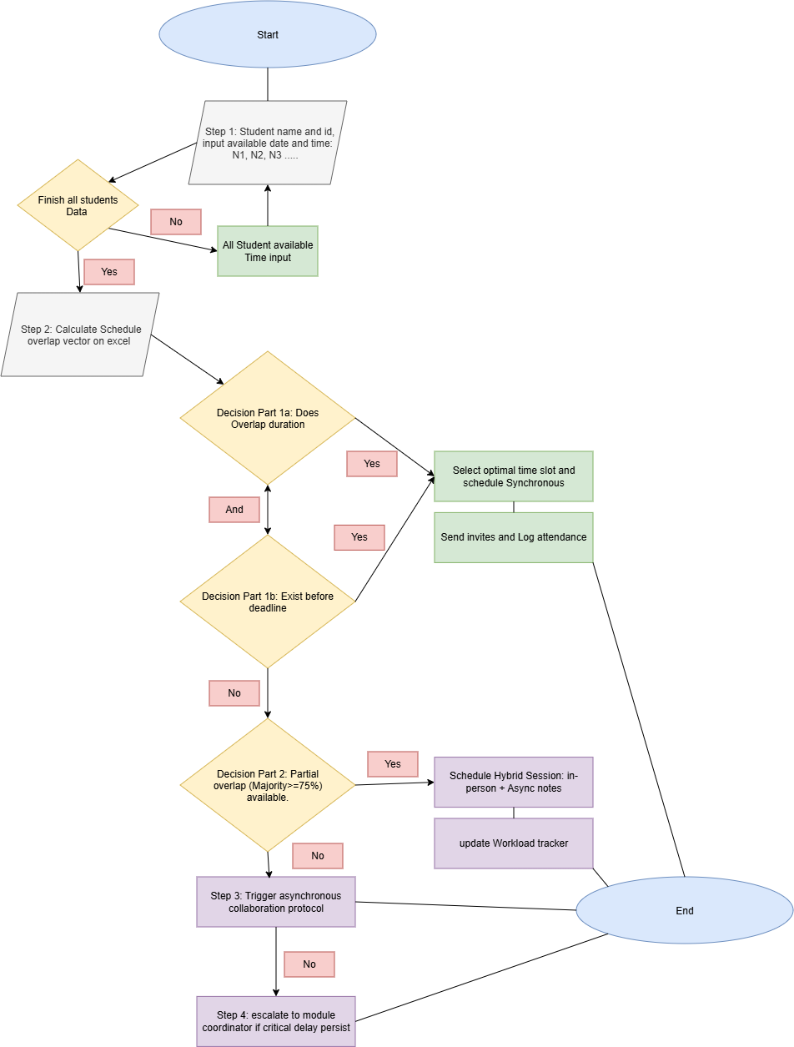
Figure 1. Flowchart schedule.

Flowchart Explanation
The flowchart in Figure 1 operationalises the algorithm outlined in Section 2.2 into an executable four-stage process: Data Collection & Validation, Overlap Computation, Tiered Decision Logic, and Asynchronous Escalation [8].
Step 1: Data Collection & Validation. At Start, each group member enters their name and ID, then inputs their available date and time slots (N1, N2, N3…), building an individual availability vector A_i(t) [6]. The decision node "Finish all students Data" checks whether every member's input has been captured; while data is still missing (No), the flow loops back through the data-input step until the set is complete. Once all members have submitted their availability (Yes), the algorithm advances to Step 2.
Step 2: Overlap Computation. All individual availability vectors are aggregated into a single schedule overlap vector, calculated in Excel, isolating the windows in which every member is simultaneously free [6]. This overlap is then tested against two conditions joined by a logical AND: Decision Part 1a checks whether the overlap duration meets the minimum meeting length T_req, and Decision Part 1b checks whether that window exists before the weekly deadline D_k [1]. Only when both are satisfied (Yes) does the algorithm select the optimal slot, schedule a synchronous meeting, send calendar invites, and log attendance, reaching End. If either condition fails (No), control passes to Decision Part 2.
Decision Part 2: Partial-Overlap Hybrid Fallback. When a full-group overlap is unavailable, Decision Part 2 checks whether at least 75% of members share a common window. If met (Yes), a hybrid session is scheduled: present members attend in person while absent members receive asynchronous notes, and the Workload tracker is updated before reaching End [2], [3]. If even a 75% majority cannot be found (No), the algorithm escalates to Step 3.
Step 3 & Step 4: Asynchronous Escalation. Step 3 triggers the asynchronous collaboration protocol, letting the group continue working without a live meeting; in most cases this resolves the gap and the process concludes at End. Where the delay persists (No), Step 4 escalates to the module coordinator, who intervenes directly before the workflow terminates at End [8].

Reflection and Justification
Designing effective solutions for complex problems requires structured cognitive frameworks [4]. In this assignment, abstract thinking and problem subdividing were systematically applied to transform an unstructured interpersonal challenge into a robust computational solution [5].

Abstract thinking
Abstract thinking filters out non-essential details of a problem domain to focus on underlying functional patterns and core logic [5]. In the student scenario, raw qualitative details—specific job descriptions, commuting routes, or daily routines—introduce noise that complicates system design.
Through abstraction, these personal factors were reduced to a unified mathematical form: binary availability vectors A_i(t) mapped against a common time axis [6]. Similarly, project deliverables were abstracted into fixed deadlines (D_k) and minimum focus windows (T_req) [1]. This enabled a generalized optimization algorithm capable of operating across any group size, timetable configuration, or module context without custom reconfiguration for individual circumstances.

Sub-dividing
Sub-dividing, or problem decomposition, partitions a complex problem into smaller, self-contained sub-problems that can be solved independently [4], [5]. The overarching challenge—'students failing to meet and complete projects on time'—was decomposed into three operational sub-problems:
1. Information Asymmetry & Collection: Addressed by isolating calendar data collection into an automated data ingestion layer [9].
2. Schedule Optimization & Conflict Resolution: Addressed through the boolean overlap computation and decision logic tree [6], [8].
3. Accountability & Task Execution: Addressed by establishing workload logging, hybrid participation rules, and coordinator escalation triggers [3].
Solving each sub-problem independently significantly reduced overall system complexity, ensuring that failure in one area (e.g., lack of synchronous availability) triggers a targeted fallback (the asynchronous protocol) rather than complete project failure [4].

Justification of solution
The algorithmic approach is well suited to this problem domain. Manual negotiation of schedules across four or five individuals with rigid commitments is inherently inefficient, subject to cognitive bias, and prone to communication fatigue [9]. Automating conflict identification eliminates administrative overhead and ensures objective, optimal slot selection [6].
Second, the tiered decision logic (Full Overlap → Partial Overlap → Asynchronous Protocol) ensures system resilience [8]. Rigid scheduling systems fail entirely at a single conflict; this solution instead adapts dynamically, keeping project progress moving regardless of calendar constraints.

Limitation
Despite its structural robustness, the proposed solution exhibits certain inherent limitations:
Input Reliance & Calendar Hygiene: the algorithm assumes all group members keep perfectly accurate, up-to-date calendars [9]. If a student fails to log a shift change or commitment, scheduling collisions will still occur.
Quality of Asynchronous Engagement: when synchronous meetings fail, the enforced asynchronous tasks often lack the immediate feedback and creative synergy of live interaction, potentially reducing solution depth in complex coding tasks [8].

Assumption
The validity of the proposed solution rests upon the following core operational assumptions:
1. Technological Accessibility: It is assumed that all group members possess continuous access to internet-connected digital devices capable of receiving calendar sync notifications and accessing college learning platforms [2].
2. Cooperative Participation: It is assumed that group members act in good faith, adhering to assigned meeting slots and completing allocated asynchronous tasks prior to milestone deadlines [3].

5. Conclusion
Scheduling conflicts and uneven workload distribution are significant barriers to successful group project work in higher education computing courses. By deconstructing the scheduling challenge through systems thinking and computational abstraction, this report has developed an algorithmic solution that mitigates timetable clashes.
Through MoSCoW prioritization, key requirements were established, separating critical scheduling needs from secondary enhancements. Identifying and parameterizing operational variables enabled a robust flowchart algorithm featuring tiered decision logic, partial-overlap hybrid workflows, and asynchronous fallback contingencies.
Critical reflection shows that abstracting schedules into boolean vectors and subdividing the workflow provides a scalable, generic framework. While limitations around calendar hygiene and asynchronous dynamics persist, the proposed solution improves group coordination, enhances workload equity, and ensures consistent adherence to weekly deadlines.

References
[1] University of Wales Trinity Saint David, "Level 4 Assessment Specification: ACCA4019 Analysing & Solving Problems," UWTSD Module Documentation, 2026.
[2] R. K. Ellis and A. P. Smith, "Managing non-traditional student commitments: Timetabling challenges and digital solutions in higher education," Journal of Higher Education Policy and Management, vol. 42, no. 3, pp. 310-325, May 2020.
[3] J. R. Lally and H. C. Chen, "Mitigating free-riding in student group projects through automated contribution tracking," Assessment & Evaluation in Higher Education, vol. 46, no. 2, pp. 201-215, Feb. 2021.
[4] J. Wing, "Computational thinking and thinking about computing," Philosophical Transactions of the Royal Society A: Mathematical, Physical and Engineering Sciences, vol. 366, no. 1881, pp. 3717-3725, Oct. 2008.
[5] A. V. Aho, "Computation and computational thinking," Computer Science Education, vol. 22, no. 4, pp. 407-418, Dec. 2012.
[6] T. Cormen, C. Leiserson, R. Rivest, and C. Stein, Introduction to Algorithms, 4th ed. Cambridge, MA, USA: MIT Press, 2022.
[7] K. Brennan and M. Resnick, "New frameworks for studying and assessing the development of computational thinking," in Proc. AERA Annual Meeting, Vancouver, BC, Canada, 2012, pp. 1-25.
[8] D. Zhang, L. Zhou, R. O. Briggs, and J. F. Nunamaker, "Instructional video in e-learning: Assessing the impact of interactive video on learning effectiveness," Information & Management, vol. 43, no. 1, pp. 15-27, Jan. 2006.
[9] G. Alonso, F. Casati, H. Kuno, and V. Machiraju, Web Services: Concepts, Architectures and Applications. Berlin, Germany: Springer-Verlag, 2012.
[10] S. Russell and P. Norvig, Artificial Intelligence: A Modern Approach, 4th ed. Upper Saddle River, NJ, USA: Pearson, 2020.
[11] E. EU Regulation, "General Data Protection Regulation (GDPR)," Regulation (EU) 2016/679 of the European Parliament and of the Council, Official Journal of the European Union, 2016.

