Kirsty Allen | 2014114

28th April 2023
ECYW6001
Yr Athrofa: Education and Humanities
Dissertation.
An investigation of life coaching and the impact it has on young people’s progression and Youth Work Practice: Creating a more structured approach to Young People’s Services.



DECLARATION FORM

Name of the Programme of Study: Youth Work and Social Education

Name of Student: Kirsty Allen

DECLARATION

I certify that the whole of this work is the result of my individual effort, and that all sources have been acknowledged.

Signed: KIRSTY ALLEN

Date: 28th April 2023

DECLARATION

I am satisfied that this work is the result of the student’s effort.

Signed: ALANA ENOCH

Date: 28th April 2023


Dissertation Declaration Form.

1. This work has not previously been accepted in substance for any degree and is not being concurrently submitted in candidature for any degree.

Signed (candidate): KIRSTY ALLEN
Date: 28th April 2023

2. This dissertation is being submitted in partial fulfilment of the requirements for the degree of BA Youth Work and Social Education (ETS endorsed).

Signed (candidate): KIRSTY ALLEN
Date: 28th April 2023

3. This dissertation is the result of my own independent work/investigation, except where otherwise stated.
Other sources are acknowledged by footnotes giving explicit references.
A reference list is appended.

Signed (candidate): KIRSTY ALLEN
Date: 28th April 2023

4. I hereby give consent for my dissertation, if accepted, to be available for photocopying, inter- library loan, and for deposit in the University’s digital repository

Signed (candidate): KIRSTY ALLEN
Date: 28th April 2023

Supervisor’s Declaration.
I am satisfied that this work is the result of the student’s own efforts.

Signed: ALANA ENOCH

Date: 28th April 2023

Contents page:
Declaration Form 1 | 1
Declaration Form 2 | 2
Contents Page | 3-4
Acknowledgements | 5
Abstract | 6-8
Acronym | 9
- Introduction | 10-16
- Literature Review | 17-25
- Methodology/Methods | 26-34
- Presentation of Results | 35-48
- Discussion of Results | 49-54
- Conclusion and Recommendations | 55-61
- References | 62-65
- Appendices
- Ethical Approval Form | 66-81
- Participant Consent Form | 82-84
- Participant Information Letter | 85-86
- Organisation Consent Form | 87-89
- Organisation Information Letter | 90-93
- Dissertation Supervision Record | 94-97
- Youth Outcome Star Information Sheets | 98-101
- Creative Focus Group Preparation | 102-105
- Youth Outcome Star and Goal Setting Sheets | 106-109
- Before and After Completed Youth Outcome Stars. | 110-114
- Pants, Vests, and Socks Washing Line Photo | 115
- Creative Focus Group Feedback | 116-121
- Documented Notes from Creative Focus Group | 122-126
- Making It Work | 127-128

Acknowledgements.

Words cannot describe my gratitude for all the help and support received by Alana Enoch and Angharad Lewis throughout my learning and through the course of this dissertation. I truly would not have been able to get this far without them. I would also like to take this moment to thank the ethical approval committee for accepting my dissertation proposal and allowing me to research the benefits of life coaching for young people.

Thanks, should also go out to librarians, guest lecturers, supervisors and mentors who have impacted and inspired me, helping me gain knowledge and know where to look for it. I would like to send my appreciation to my fellow classmates, for late night study sessions, advice, support, and humorous antics through this process helping academically and emotionally too.

Lastly, I would like to thank my family, who have provided me with addition support, that I would be lost without. Their continuous encouragement and belief in me and supporting me through difficult times have been fundamental for my development. I would also like to thank Pepper for all her emotional support, entertainment, and company.

Abstract.

The aim of this research paper is to explore the connection between providing young people with a structured life coaching programme and their progression towards their personal and professional growth and goals. The question under review ‘An investigation of life coaching and the impact it has on young people’s progression and Youth Work Practice: Creating a more structured approach to Young People’s Services’ sets out to explore the effects that life coaching can have on young people and the services they use; condensing the amount of time and support they need from the service, however, helping them reach their full potential more efficiently, preparing them with the skills they need as they transition into independence and adulthood.

Four young people will be asked to take part in this research and will complete the outcome star which is a self-scoring questionnaire with structured number scoring through a Likert scale, this will be completed at the start of the programme and after to compare their progress on six aspects facing young people; Interests and activities, hopes and dreams, wellbeing, education and work, communicating and choices and behaviour. In addition, at the end of the twelve-week programme the young people will then be asked to join a focus group to explore and evaluate their experience in the life coaching programme, and what they feel they have taken away from the experience.

The results should hopefully show an increase overall in the six aspects facing the young people, mapping their progress from start to finish on a one to five scale. In addition to tracking goals set at the start of the life coaching programme and the fulfilment of them. The focus group should provide feedback from the young people about their experience in the life coaching programme. Indicating what they enjoyed, how they felt they benefited and what they would change. They will also share what skills they have developed and what they have learnt, that will help them as they transition into adulthood and independence, such as coping mechanisms, and problem-solving skills.

If this research proves to be successful, this could benefit future Youth Work Practice by showing the benefit of providing young people with a detailed, structured life coaching programme designed around them and their needs, and what they want to improve on and where they want to be in the future.

By offering young people a life coaching programme or the chance to develop life coaching techniques within Youth Work Practice, they can help develop soft skills such as confidence and self-esteem, as well as completing goals such as finding employment or entering further education in a shorter period of time, condensing the amount of time young people need services support, maximizing the benefits of it and allowing young people to reach their full potential.

This is supported by The Youth Work in Wales National Occupational Standards (CLD standards council Scotland, 2019) by providing young people with access to support, guidance and facilitating their personal, social, and educational development as well as promoting self-awareness and confidence through active participation.

Principles and Purposes of Youth Work in Wales (2022) explain that by helping young people facilitate their personal, social and education development we enable them to have a voice and reach their full potential and influence their place in society by considering their requirements, desires, aspirations, and interests.

Supporting young people to achieve their full potential and develop their skills such as those noted above are high priorities for the Welsh Government and are supported in policies such as Youth Work Strategy for Wales (2019). Providing high quality Youth Work is crucial for young people to gain confidence, resilience and give them the opportunity to establish higher expectations and aspirations for themselves. Through informal and non-formal educational approaches Youth Work can empower a young person to change their lives for the better (Welsh Government, 2019).

Acronym.

1:1 | One to one
ACEs | Adverse Childhood Experiences
CBT | Cognitive behavioural therapy
CL | Care Leavers
YOS | Youth Outcome Star

Introduction.

This chapter will explore the layout of the question under review ‘An investigation of life coaching and the impact it has on young people’s progression and Youth Work Practice: Creating a more structured approach to Young People’s Services’ and sets out to explore the reasons for undertaking the research, why the Researcher wants to provide findings in response to the question, and what methods and actions she has chosen for this.

The Researcher noticed that there is a minimal amount of young people services providing structured life coaching. However, those that do, provide amazing results with young people and their progression into adulthood. Structured life coaching, helps young people identify what is important in their life, develop goals and provide support to reach them, by creating an action-oriented plan (Harvey, 2020).

Life coaching aims to help people before they enter a state of mental distress. Cognition (2021) identifies there is a growing need for young people to access life coaching. However, life coaches are usually an expense that young people cannot afford or are not locally available. Young people can grow from life coaching, helping them take responsibility and recognise their potential. Life coaching is an amazing opportunity to further provide support for young people. However, something that is not provided enough (Cognition, 2021).

Current impacts that Covid-19 has had on young people’s development and mental health have been catastrophic, current waiting times for young people to access mental health support services are as long as two years, pushing young people into social isolation, creating a lack of confidence, direction, and sense of purpose (Punton, 2022).

With the Researcher working in close connections to many Young People’s Services available in Swansea currently, she can see the need for many young people to have structured support such as life coaching. Most services provide support for young people’s wellbeing; however, she feels these services would benefit from having a life coaching layout, with progression tracking and goals that the young people have set and identified themselves. This will help young people reach their full potential and encourage their development from their own individual starting points as stated by the Principles and Purposes (Youth Work in Wales Review Group, 2022).

The Researcher is focused on young people’s mental health and wellbeing and argues that by using Youth Work approaches such as ‘support’ and ‘encouragement’, young people can achieve anything. Sometimes they just need a little help getting there or being signposted in the right direction, and this is what life coaching does. The Researcher has training in life coaching and mental health wellbeing, this combined with the key skills that she has developed as a youth worker through academic learning and experience in the field are fundamental for carrying out this study.

Following standards set out by CLD standards council Scotland, (2019) the Researcher can include values of Youth Work that involves engaging young people to facilitate their personal, social, and educational development, whilst enabling them to have a voice (CLD standards council Scotland, 2019).

The aim of this study is to provide current and future youth workers and Youth Work Services with the understanding of how beneficial life coaching can be to a young person’s life. Hopefully leading to an increase of Youth Services providing life coaching techniques in their practises for young people.

The Researcher identifies that young people are reporting an increased level in low mental health and wellbeing. The United Kingdom Youth Parliament (2019) identified during their 2019 Make Your Mark Campaign that mental health and wellbeing were identified in the top three issues facing young people in the United Kingdom. From these findings it was clear, that every young person that took part from the Swansea area either identified a curriculum for life (developing soft skills and life skills like budgeting and confidence building) or mental health as their top issue. Thus, showing the need for programmes that involve life coaching techniques are needed for young people to develop both personally and professionally.

Kindred and Bates (2023) notes that with an increase of social anxiety in young people after the lockdown from covid 19 many young people are now struggling to come back into society and reach their goals. Life coaching techniques are needed now more than ever, and by applying these to young people’s services we will help them become motivated, in education or employment.

The Researcher identifies that one issue, is that life coaching programmes and techniques are not commonly used in Youth Work Practice. This could be because life coaching is usually identified as support for later in life after someone has transitioned into adulthood. However resent studies such as Patsalos Transition Coaching (2023) have proven that providing young people with life coaching can help better their transition into adulthood and leave them more prepared for challenges they face, teaching them how to plan, build reliance, develop coping mechanisms, and reach goals they set out to achieve. (Patsalos, 2023).

If this study proves successful and helps structure Youth Work Services, it would be beneficial to all service users that chose to access it. Noble (2022) explains they promote life coaching training as a part of their ‘Worth-It’ campaign, helping prevent mental health problems in young people. Their training provides key workers with mental health resources that deliver targeted support programmes for young people, including life coaching. Noble (2022) sates that their “coaching has helped 1000s of young people, through becoming more reliant and building strategies for wellbeing we have helped them to reduce stress, anxiety, and depression levels” (Noble, 2022, No page number).

Carranza (2022) explains that young people that need help from services are likely to have experienced ACEs (adverse childhood experiences) in their life, creating trauma and difficulties, leading to them needing professional help. Providing young people with life coaching helps them turn the toxic stress they are experiencing from ACEs into resilient attitudes, a healthy way of living and coping with future stress as they transition into adulthood (Carranza, 2022).

Life coaching and 1:1 (one to one) support provides guidance for personal and professional growth, coping strategies, and resilience skills. Most importantly it will encourage hope and belief in the young person and give them the ability to unlock their own inner power (Carranza, 2022).

Creating structured relationships between the youth worker and young person enables the young person to feel fully involved, trusted, and feel like they truly matter and are cared for, encouraging them to put in the effort to move forward, build essential skills and take control of their own life and decisions (Sapin, 2013).

By providing young people with 1:1 support to talk and establish their thoughts, feelings, and goals, they are given the opportunity to reflect and realise where they are in life and where they want to be. A life coaching programme that is voluntary and works where the young person is at, is more likely to get them engaged and accept further support to reach their goals.

Life coaching provides young people with positive encouragement that many of them lack from their personal lives, helping them feel better about themselves and increases their wellbeing, by knowing that they are on the right path making the right steps towards a better future for themselves. This is supported by Champs (2023) where their life coaching programme is aimed at teenagers struggling with motivation, confidence, direction, and inspiration. Their programme acknowledges the complex, challenging and diverse world that young people live in today, the limitations young people face in succeeding and achieving in all areas. They aim to use effective life coaching strategies to help young people become emotionally resilient, stronger, and happier, becoming the ultimate version of themselves (Champs, 2023).

The life coaching programme the Researcher will be using is one provided by Barnardo’s that provides CL (care leavers) with three elements. A report by Barnardo’s (2021) explains that the life coaching programme provides young people with the power to unlock their full potential for positive change, providing them with tools to build resilience, improve wellbeing and better understand themselves. Young people will work 1:1 with a life coach to improve six aspects of their life, set goals and work towards completing them. Also providing them with an activity club to help young people take part in activities that are not normally accessible for them, due to the expense of ticket prices, food, and travel, encouraging social activities to broaden the understanding of the community and develop their social skills (Barnardo’s 2021).

The actions the Researcher plans to take aims to gather data through two different methods. The first will be to gather and analyse data collected from YOS (Youth Outcome Star), by providing a compassion number score in six aspects in young people’s lives, and their goals. Triangle (2023) explain that the YOS has been designed to be used in services that provide universal, community-based Youth Work, encouraging organisations to put structured effort into supporting valuable young people. The YOS helps open up communication between service provider and service user to create a structured plan to help improve a young person’s life (Triangle, 2023). (See Appendix 8.7).

The second way the research will analyse data is through a participatory creative focus group to ask the young people’s feedback on the life coaching programme, how they feel it benefitted them and what they would change (see Appendix 8.8).

The Researcher acknowledges her own motivation and bias for the research as she has worked in the Barnardo’s life coaching programme and has seen the positive affect it has on young people and their personal and professional growth. However, will remain unbiased and professional throughout the research to maintain validity in results, in hope of improving future services for young people.

The Researcher is conducting this study in hope to provide results that will show an increased need for life coaching programmes for young people. The Researcher is also interested in finding out if there are any areas that life coaching can be strengthened and how best to structure a life coaching programme that best supports young people.

In the next chapter the Researcher will provide supporting evidence for the research question, adding further evidence to increase the validity of the results in hopes to provide compelling evidence of the benefit of life coaching in Youth Work Practice.

Literature Review.

This chapter will explore the definition of life coaching, outlining why it is used, the advantages and disadvantages of using life coaching. Exploring theories linked to life coaching, how life coaching fits into Youth Work Practice. This chapter will also be supported by additional research, studies, and reports about the effects of life coaching and life coaching in Youth Work Practice.

What is life coaching?

According to Miles (2022) life coaching is defined as a programme that encourages people through their personal and professional progression in life. Helping them reach their goals, navigate through changes, build resilience, and help each person build on different areas of their life that they need support with (Miles, 2022).

Jarosz (2017) explains that results from life coaching have a positive impact on courage. Reducing fear and anxiety, helping people take on new experiences. This helps them plan for a better quality of life, set goals, and take positive steps to complete them. Life coaching helps a person pull together their thoughts, wants and beliefs to help identify and visualise where they want to be in life (Jarosz, 2017).

Life coaching supports young people with their emotional limitations and beliefs which can prevent them from achieving their goals and enjoying their life. Through working with a life coach, young people can realise their potential, realise their strengths, and build confidence, thus helping them with self-improvement, and resilience. All skills that are vital for their transition into adulthood (Lees, 2022).

Mahina (2022) explains that life coaches are wellness professionals who create personalised plans for clients based on their own wants and needs. However, life coaching specifically for young people is not wildly accessible. Young people struggle with transitional periods and stress in all areas of their life, these can include, cultivating a sense of belonging in relationships and the community, clearly defining their identities, and joining the work force. Young people often face more pressure than other generations and while life coaching can benefit anyone, young people can gain the support they may not otherwise find from their peers or communities (Mahina, 2022).

The Benefits of life coaching.

Carranza (2022) argues that life coaching is used to help young people transform toxic stress caused by trauma and ACEs in to a positive and resilient attitude helping create a smoother transition into adulthood and preparing young people with the tools and skills they need to take on challenges that they would otherwise find difficult. Life coaching helps young people unlock their inner power by encouraging personal and professional growth (Carranza, 2022).

Harvard University (2019) explain that ACEs can include physical and emotional abuse, neglect, and household violence. The more ACEs a child experiences the more likely they will suffer illness in later life. Experiencing ACEs without support can cause excessive activation of the stress-response system and can lead to long lasting damage on the brain and body, and this is called toxic stress (Harvard University, 2019).

Carranza (2022) explains that the toxic stress that stems from ACEs change the way the brain develops in a young person and negatively affects how their body responds to stress. Life coaching helps them see their potential and gentle support and guidance helps young people reach their goals and think more positively on their life.

Carranza (2022) confirms his research shows the link between ACEs and toxic stress cause physical and mental health issues, risk taking behaviour, difficulty functioning in day-to-day challenges and relationships. This combined with learnt behaviour from trauma and negative relationships effectively leave a young person stuck in a negative mindset (Carranza, 2022).

Dawson (2023) believes life coaching comes with many benefits; building on progress, goals, skills, and gaining confidence. Young people will gain clarity and purpose by understanding who they really are and what they want in life. They understand what brings them joy and how to achieve this. This helps young people develop skills, teaching them how to manage emotions, eliminate negative thoughts and unlock their full potential (Dawson, 2023).

Although life coaching comes with many benefits, a main disadvantage of it is that young people must put in the work to get the best out of it. Vece (2022) argues that young people are not ready to accept help and change. Therefore, will not see the value of life coaching or receive the full benefits. She explains young people are undergoing fundamental brain development and during this time they might not see the need to change their behaviours (Vece, 2022).

CBT (cognitive behavioural therapy) is a therapy that can help young people manage their problems and change the way they think and behave. Jay Shetty (2023) explained through their scientific evidence, CBT can be used as a useful tool in life coaching. Their evidence links that negative thoughts and feelings relate straight to unhelpful behaviour and negative actions. CBT does not give young people the answers to their problems; however, uses a goal directed and present-focused framework to help them change their thoughts and feelings. This simulates negative behaviour and provides positive change, that are strengthened by methods to improve self-awareness, confidence, resilience, leading to a better quality of life (Jay Shetty, 2023).

CBT coaching comes with many benefits, the main one being it helps young people change negative thought processing into positive long-lasting changes in their life. CBT has been scientifically proven to be effective at reducing symptoms that cause stress and anxiety that cause negative rash decisions impacting lives. It teaches useful practical skills that can be used in everyday life, even after life coaching has ended (Hellens, 2020).

Hellens (2020) identifies these practical skills are healthy eating, appropriate sleep, good hygiene, socialising, having a good work ethic, organization skills, time management, and having the confidence to take on new experiences and the resilience to bounce back when circumstances do not work out.

It is important to note that CBT may not be successful for everyone and that young people participating must be fully committed to get the most out of it. It focuses on the young person themselves and does not address wider problems such as family dynamics or root causes such as an unhappy childhood. The highly structured nature of CBT means that it may not be suitable or beneficial to those with complex mental health or learning disabilities (Jacobson, 2023).

Youth Work and Life Coaching.

The two approaches of CBT and life coaching complement each other, they both work in accordance with The Youth Work in Wales National Occupational Standards (CLD standards council Scotland, 2019) in particular this can be seen in the NOS (2019) CLD YW02; Assist young people to learn and engage with the Youth Work Service. Creating and supporting the understanding of how young people feel, what they can do, enabling them to express their aspirations, concerns and develop goals for a better future, while monitoring their safety and wellbeing (CLD standards council Scotland, 2019).

Providing young people with life coaching also links to Youth Work policy such as Youth Work Strategy for Wales (2019) by helping young people thrive; helping young people become skilled, confident while giving them the opportunity to grow, develop and play an active role in their development and decisions that affect them now and in the future, helping them feel safe and cared for while they find their sense of belonging and have fun (Welsh Government, 2019).

Youth Work Strategy for Wales (2019) underpins Youth Work Practice as a way of encouraging and enabling young people to share responsibility and become equal partners in their learning process and decision making. This encourages young people to become active citizens and participate within their community and society which supports the principles of the UN Convention on the Right of the Child (Welsh Government, 2019).

Analysis for potential Youth Work Practice and life coaching.

NCC (2017) explain that the demand for life coaching is rapidly growing, lives have become more complex, it is difficult to decide what to prioritise and when to prioritise ourselves. People are finding it difficult to set goals and create a clear path when they cannot process thoughts and feelings. Negative thoughts and feelings have been identified as issues that hold people back from moving forward. A bit of objective support, advice and guidance and help build resilience and move forward in both personal and professional areas of their lives (NCC, 2017).

According to Watts (2022) life coaching should be widely accessible for all to benefit from should they chose to, more awareness needs to be created around the benefits that life coaching brings. More organisations should see this as an opportunity for clients and service users to have structured growth, untangling threads of themselves and becoming their best selves. Life coaches become the catalyst of change that so many people need in their lives (Watts, 2022).

There is a growing need for life coaches for young people. Kalia (2019) recently reported a 280% year-on-year surge in life coaching bookings online, 54% of those were made by eighteen to twenty-two-year-olds and Global Consumer Awareness Survey (2019) reported 35% of those born after 1995 already had a life coach.

Kalia (2019) explains these results show that life coaching is a crucial step in regaining confidence, identifying negative choices leading to negative decisions. How to break down these patterns in a positive light and make more positive choices, helping young people complete goals, find employment and overall improving their wellbeing and mental health (Kalia, 2019).

Noble (2023) recommends that life coaching would make youth clubs more successful. It is an effective way of providing young people with help that make them feel more in control of their own lives, it develops confidence, resilience and gives a greater sense of belonging (Noble, 2023).

Noble (2023) notes that youth workers are there to help young people develop in a similar way to the way life coaches help people develop. By providing youth workers with life coaching training enables them to help young people become their best selves and prepares them for their transition into adulthood. Coach Training for early intervention is seen as a protective factor for a lot of young people, aiming to support the prevention of mental health problems for vulnerable or disadvantaged young people (Noble, 2023).

Noble (2023) argues that Youth Work needs more trained youth workers equipped with the skills of life coaching to provide a higher and more qualified level of support to young people that choose to access it.

This is supported by Become (2023) a children’s charity that offers free life coach training for professionals and carers. Become (2023) believes that young people lack self-belief and aspiration, with the right support young people can unleash their full potential and thrive.

Zhou (2023) research shows that, 80% of coaching clients say that they have improved self-esteem and self-confidence thanks to life coaching and 73% of coaching clients say that life coaching helped improve their relationships, communication skills, education and employment performance, work/life balance and wellbeing (Zhou, 2023).

YOS has proven to help structure support given by Youth Work Practice, 72% of youth workers have said that YOS has helped change the way they support young people through helpful discussions in response to the marking on the six-point star (Triangle, 2022).

Providing young people with life coaching gives them the opportunity to process their thoughts and emotions in a safe place, allowing them to think clearly about what has happened to them. This structures the way they receive support and helps young people make their own decisions on what affects their life. Goal setting is a big part of helping young people reach a better quality of life (Barnardo’s 2022).

This is supported by a Young Person TR (cited in, Barnardo’s, 2022, p.3) who stated:
There are better ways of doing it [supporting young care leavers], which is what Barnardo’s is doing, and it’s the right way. It’s not about giving you money and holding your hand, they push you to become more of an adult.

(Young Person TR, Cited in, Barnardo’s, 2022, p.3).

In conclusion, there are many benefits that come with life coaching the key thing to remember is that it takes a lot of engagement and commitment to see change and get the most out of the programme. Life coaching has proven to enhance young people’s wellbeing, improve their confidence and resilience as well as provide them with the tools they need for a smooth transition into adulthood and to reach both their professional and personal goals. This is supported by Barnardo’s (2023), Carranza (2022), Jarosz (2017), and Noble (2023) as mentioned previously.

In the next chapter the Researcher will be exploring the methods she chose for this research, along with the advantages and disadvantages of using each and underline the theoretical framework.

Methodology.

This chapter will explore the methods the Researcher has chosen to use for this study. The Researcher will evaluate the techniques and procedures used in this investigation. Furthermore, the Researcher will outline the advantages and disadvantages of each method as well as identifying limitations and proposing recommendations.

The Researcher will be using mixed methodology for this study. Creswell (2022) explains that mixed methodology in research, includes both quantitative and qualitative data. By using both methods the Researcher can contribute more towards the understanding of the research question, and that drawing on the two methods can combine the strengths from each, creating a better collation to the answer for the question.

Shorten (2017) explains that quantitative data allows the Researcher to gather numeric data that can be counted and has mathematical value, whereas qualitative data allows the Researcher to gather first-hand experience from participants and learn from what they experienced.

Using the YOS the Researcher will be able to gather numeric results from a number scale and provide a comparing number score to evaluate. Using the creative focus group will allow the Researcher to gather thoughts and feelings of the participants from the programme that provide qualitative data.

The research involves a twelve-week programme that young people have volunteered to take part in. At the beginning of the programme the young people will complete a YOS on an individual basis with the Researcher, they will then work alongside the Researcher, and engagement worker to receive 1:1 tailored sessions. These sessions aim to build on the areas that the young people identified as low, and they will also have the opportunity to take part in activity clubs to build their social networks and engagement in the community.

Social networks and active engagement in the community are seen as important to the process because it allows young people to develop a sense of belonging, supports good mental health and encourages their responsibilities as citizens. This is supported by Principles and Purposes of Youth Work in Wales (2022) who explain as one of the key principles of empowering young people is to encourage their contribution in communities and become aware of the social benefits and issues that affect their lives.

At the end of the twelve-week programme the participants will be asked to review their YOS remarking themselves higher, lower, or constant to see if there is any improvement. This will allow the quantitative data of the study to be observed. Once all participants have completed this, they will be asked to join a creative focus group, to generate first hand feedback for the young people’s experience of the life coaching role. This allows for the qualitative data of the study to be observed.

The first method the Researcher will be using is the YOS, which is quantitative. This involves a Likert scale designed by Triangle (2022) to help the progression of young people. Triangle (2022) explains this helps keyworkers to visually capture the development and progression with young people. YOS supports key workers to navigate difficult conversations by building relationships, opening up communication around difficult situations. By providing structured support and generating an action plan, keyworkers are able to highlight areas that a young person needs support in and helps them set goals (see Appendix 8. 9).

Below is a table exploring the advantages and disadvantages of using the YOS as a quantitative data collecting method.
Advantages of YOS: | Points to mention:
Participants fill theses out themselves. | First person data collected.
Numerical results | Cannot be interpreted with bias. Will also show a direct change.
Simple point system 1-5 | Easy for participants to understand. Comes with score chart.
Quick process | Easy and quick method.  Participants are not likely to get bored. Encourage engagement by progress tracking.
Disadvantages of YOS: | How to overcome:
Participants fill these out themselves. | Researcher will remind participants the importance of a truthful study could help future services.
Participants will interpret score evaluations differently. | YOS comes with a scoring chart.  Researcher will explain this to participants.
Untrue marking: | Researcher will remind participants that truthful marking is vital for research.  Research is confidential, and no identifying information will be used.

One of the main advantages of using this method is that it collects first person data. Valcheva (2023) explains that collecting research straight for the participants is considered primary data collection, meaning you gather data straight from the source making it reliable and specific. Data collected this way is also considered up to date, investigating current issues and affects.

However, Nasrudin (2022) explains that the disadvantage of collecting this type of primary research is that it is time consuming; once the data is collected it needs to be organised and stored. He also explains that it can be expensive, depending on the method and how it is facilitated, and that first person data can also cause ‘lower varieties’ as it only provides data from those it was collected from also creating a risk of sampling errors and unrepresentative samples.

To overcome this the Researcher plans to facilitate this method within the participants normal routine. The Researcher has planned short activities and will deliver these activities in the participant’s project. Thus, promoting a typical atmosphere for participants, making the study inexpensive, and time efficient for the young people. As for the sampling disadvantages highlighted by Nasrudin (2022) the Researcher predicts that results of this study will prove successful, and will make recommendations, that this study be replicated with different groups of young people from more Youth Work Services.

After the programme has been completed and the participants have reviewed their YOS with the Researcher, they will be asked to join a creative focus group. This will allow the Researcher to gather qualitative data from the participants about their experience in the programme. This will also provide further support about how life coaching programmes can be developed for young people.

Participants will be asked to evaluate their experience of the life coaching programme using the washing line method. Participates will be provided with blank cut-outs of pants, vests and socks and asked to write on the pants, something they did not like, on the tops, something they enjoyed, and on the socks, something they will change. They will then be asked to peg their ‘clothes’ on the washing line and join back in to open discussion about the results. They will then be given the opportunity to write what they have learnt for the life coaching programme, and what skills they will have developed.

During this activity a member of staff will be available to record participants comments and discussions. Eaton (2019) explains that using a scribe in research, captures a conversation into a clearer and digestible form that can add validation to the research and provide further data to analyse.

The Researcher will inform participants that they can withdraw at any time and provide games with an additional worker in a separate room. In case participants want to withdraw from this activity, they will have an additional activity unrelated to the research. British Educational Research Association (2018) explain that all participants have the right to withdraw from the research for any reason at all, and participants should be informed of this right.

All resources for this activity will be prepared beforehand (see Appendix 8.8).

Below is a table exploring the advantages and disadvantages of using a creative focus group as a qualitative data collecting method.
Advantages of focus group: | Points to mention:
Collects data from group interaction. | Good group dynamics.
Fits into existing practice. | Stress-free location.  Young people to feel comfortable.
Freely express ideas and opinions. | Provides a safe place to discuss life coaching programme in their own words.
Disadvantages of focus group: | How to overcome:
Group interaction may cause disagreements. | Provide a separate room.  Staff available to support.
Peer pressure | Confidential.  Making it work, signed by participants.  Right to withdraw.
Dominant individuals may influence others. | Support staff to monitor group.

According to Rotz and Wright (2021) an advantage of using a creative evaluation method with participants is that it influences their way of expressing themselves by providing them with a hands-on distraction. Freeing participants from stress and the pressure of answering. Participants are more likely to get involved and voice their opinions, thoughts and feelings whilst keeping their hands busy and do not have the pressure of facing forward and keeping eye contact.

The Researcher’s methodology choices reflect her values and principles as a youth worker and is supported by policies such as Youth Work Strategy for Wales (2019) by helping young people achieve outcomes such as having a voice, contributing, and having their opinion taken account of.

Anderson and Kilduff (2009) explain that one of the main disadvantages for a creative focus group can be dominant individuals taking over the session and influences others, rendering the research with unreliable results. The Researcher does not expect this to be an issue, as group dynamics have already been observed, participants work well together and will be asked to sign their project’s making it work (see Appendix 8.14) to remind them to be respectful of each other and remain confidential.

The facilitation style of the Researcher’s methods is also supported by The Youth Work in Wales National Occupational Standards (CLD standards council Scotland, 2019) who explains the role of the youth worker is to engage with young people to facilitate their personal, social and educational development to enable them to have a voice and influence their place in society.

The Researcher’s employment is to provide life coaching for young people and has regularly observed the positive results it provides young people in both their professional and personal lives. As a result of this the Researcher needs to be mindful of Researcher bias. Smith (2014) explains Researcher bias is a systematic distortion of statical results or a concentration on a particular interest or particular subject area. Understanding Researcher bias is important for providing true and accurate results, stretching the validity and reliability of the research, not eliminating bias can have consequences for practice. The Researcher acknowledges the bias and for the purpose of this research will ensure that all results and data collected is true and recorded ethically.

Other limitations the Researcher might encounter would be the sample size used for this research; four CL between the ages of eighteen to twenty-five, two females and two males. Not only does this create sample size limitations, however, survey bias too. The sample size used if not repressive to the whole population between the ages eighteen to twenty-five.

Furthermore, it is only representative to CL, who have experiences ACEs and would arguably benefit from services such as life coaching more. Hackshaw (2008) explains that a strength of a small sample size is that is usually low cost and less time consuming.

However, the Researcher acknowledges the experience for CL may not be as effective if they were in a bigger group. The Researcher acknowledges the importance of respecting young people and Youth Work. Due to the sensitive nature of life coaching, leaving care and ACEs, a larger group may have made participants feel uncomfortable and withdrawn. British Educational Research Association (2018) explain applying an ethic of respect needs to be considered for individuals rights, to understand each induvial involved and to make sure they are treated fairly and sensitively to avoid tensions or challenges.

Small sample size comes with other limitations, although the research may provide data for the question under review. In order to strengthen the results further, the research should be replicated using different participants in alternative situations and backgrounds to provide the research with validity.

Another limitation the Researcher acknowledges is the ‘Hawthorne effect’ Clancy (2019) explains that this refers to the phenomenon where participants behave differently when they are being observed, this can alter the validity of results as they have not behaved truly to the research question. To overcome this the Researcher will explain the importance of this study to the participants. These participants regularly give their feedback in focus groups and understand the importance for how it can inspire change.

The Researcher will suggest further recommendations for this study and can be seen in the conclusion and recommendation section. In the next chapter the Researcher will be presenting the data in a surmised format.

Presentation of Data.

This chapter will explore the data collected from the research, it will display the YOS quantitative data in the form of tables and graphs, and the qualitative data collected from the creative focus group.

YOS results.

The table below represents basic information of the participants that took part in this study.
YP | Gender | Age | Location
YP1 | Male | 20 | Swansea Area
YP2 | Female | 25 | Amman Valley Area
YP3 | Female | 22 | Swansea Area
YP4 | Male | 18 | Swansea Area

The following tables below illustrates the progress made by each participant. The table shows their self-score at the start of the life coaching programme on the YOS and their self-score on the YOS review at the end of the life coaching programme. The table also shows the number of goals set and achieved by each participant.

YOS has a five-point self-marking scale, the numbers on the table are representative to this; one being ‘stuck’ two being ‘considering’ three being ‘having a go’, four being ‘working on it’ and five being ‘enjoying and achieving’ (Triangle, 2023).
YP1  Aspects on YOS | 1st YOS | YOS Review | Difference
Interests and activities | 3 | 5 | 2 +
Hopes and dreams | 2 | 5 | 3 +
Health and Well-being | 3 | 4 | 1 +
Education and work | 1 | 5 | 4 +
Communicating | 3 | 4 | 1 +
Choices and behaviour | 2 | 4 | 2 +
Number of goals set. | Goals reached |  | Total
4 | 4 |  | 4

YP2  Aspects on YOS | 1st YOS | YOS Review | Difference
Interests and activities | 2 | 5 | 3 +
Hopes and dreams | 1 | 4 | 3 +
Health and Well-being | 1 | 4 | 3 +
Education and work | 3 | 4 | 1 +
Communicating | 3 | 4 | 1 +
Choices and behaviour | 2 | 4 | 2 +
Number of goals set. | Goals reached |  | Total
4 | 4 |  | 4

YP3  Aspects on YOS | 1st YOS | YOS Review | Difference
Interests and activities | 2 | 5 | 3 +
Hopes and dreams | 3 | 4 | 1 +
Health and Well-being | 4 | 5 | 1 +
Education and work | 4 | 5 | 1 +
Communicating | 1 | 4 | 3 +
Choices and behaviour | 2 | 4 | 2 +
Number of goals set. | Goals reached |  | Total
4 | 4 |  | 4

YP4  Aspects on YOS | 1st YOS | YOS Review | Difference
Interests and activities | 1 | 5 | 4 +
Hopes and dreams | 2 | 5 | 3 +
Health and Well-being | 2 | 4 | 2 +
Education and work | 4 | 5 | 1 +
Communicating | 3 | 4 | 1 +
Choices and behaviour | 1 | 4 | 3 +
Number of goals set. | Goals reached |  | Total
4 | 4 |  | 4

The six aspects from the YOS have been analysed individually and results of the progression are recorded below on bar charts. These results show the scored aspects at the start of the life coaching programme (before in grey) and the reviewed score at the end of the life coaching programme (after in green).

Interests and activities.

This graph shows all four participants showed an increase in interests and activities. Participants noted this was due to the sessions and the workshops the programme encouraged them to explore.

Hopes and dreams.

This graph shows all four participants showed an increase in hopes and dreams. The participants noted this was from the encouragement and support they received to realise their goals. They noted this included support on, budgeting, socializing, making friends, and getting into education or employment.

Health and wellbeing.

This graph shows all four participants showed an increase in health and wellbeing. Participants believe this rise was due to the support they received in the form of 1:1 and group sessions focused on wellbeing.

Education and Work.

This graph shows all four participants showed an increase in education and work. Participants noted this was due to support with their curriculum vitae’s, open days at education establishments and job fairs.

Communicating.

This graph shows all four participants showed an increase in communication. Participants explained that this rise was due to social opportunities with their peers such as clubs, workshops, events and support with appointments.

Choices and behaviour.

This graph shows all four participants showed an increase in choices and behaviour. Participants explained they were making choices that positively effect their lives such as, making positive relationships, saving money or seeking support from the 1:1 sessions they have learnt from.

Goal setting.

Each participant decided to set four goals for their lowest scored point on the YOS. This graph shows all four participants completed all goals set at the start of the life coaching programme.

These goals ranged from entering employment and education to learning to cook, saving money, socialising, and eliminating drug use. Participants explained they were able to reach these goals through support from 1:1 sessions, group activities, events, and sessions.

The participants were keen to see their progress, they expand on the reasons they thought this was, this can be seen in the scribes’ notes (see Appendix 8.13). YP1 said “It’s great to see the change in the star but I think I made more progress because I got support regularly to work on things”. YP2 stated “This is great, the plans set have really helped me work towards my goals”.

Creative focus group data.

The four participants joined a creative focus group together after completing their YOS review, they were accompanied by the Researcher and another member of staff that recorded the session. The participants completed the pants, vests and socks evaluation method. They were provided with blank cut outs and were asked to write how they felt; pants (something that was bad about the life coaching experience), vests (tops, something that was good about the life coaching experience) and socks (something that they would like to change about the life coaching programme). They were then asked to peg their washing on the line and engaged in an open discussion about what they thought.

The tables below show the results of pants vests and socks from the participants own notes.
Pants:

YP1 | Restricted times on activities more evenings and weekends would be better.
YP2 | Most of my support workers are only available 9-5, but maybe having them sometimes available past those times and possibly on weekends as I personally have other responsibilities such as work and can’t always make sessions to see them.
YP3 | Nothing really, I really enjoyed the process but sometimes I only got to see my worker once a week, I would have wanted to see them more.
YP4 | Nothing bad.

Overall, the participants expressed that they would like better access to the programme during the evenings and weeks, although the Researcher would like to note that one participant said, ‘nothing bad’ and one started with ‘nothing really’. The member of staff taking notes has also recorded that participants struggled to pick what was bad and they have received so many benefits, however if they had to pick something they would like to work with us in the evenings more.

Vests:

YP1 | Workshops to help me gain knowledge and put on my CV helped me find a full-time job I enjoy.
YP2 | Absolutely everything. – different activities – staff – the experiences – meeting new people/making friends – the amount of support with everything.
YP3 | Experience, workshops, programmes, helped me figure out the next step and reaching my goal to get back into education. And the review is good to see how far I’ve come.
YP4 | Activities were fun. Made significant steps towards big goals. Taking on tough challenges.

Overall, the participants mainly enjoyed the activities and workshops provided as part of the life coaching programme, this helped them gain experience, skills, and socialising with friends. The member of staff taking notes has also recorded that participants said that the programme helped them follow a step-by-step plan to reach their goals, without creating stress and was something they could replicate on their own in the future.

Socks:

YP1 | More challenging activities to gain more experience.
YP2 | Something I would change is of course the availability of workers as well as having more appropriate activities for our age.eg. choosing a movie in a cinema is nice but has to be a 12 movies when most of us are 18+.
YP3 | My sleep is better now but at the start it would have been good to do more sessions in the evening.
YP4 | Making better times for the events.

Overall, the participants mentioned again that they would like to change the times that the programme, workers and activities are available. The member of staff taking notes has also recorded that participants said that the programme provided them with lots of wellbeing activities and fun things to do, however they would like to take on more challenging and extreme activities in the future and noted the activities they had done on the residential, pushed them further.

Backpacks and purses (to represent something that was learnt/take away from the life coaching programme).

The group were then given the option to either make envelopes/purses or have a cut out of a backpack (see Appendix 8.8).

They were asked to write what they had learnt to take with them/what will benefit them from the life coaching programme, that they will be able to use again or that will continue to help them.

YP1 | Skills for the workplace. Organizational skills. Time management. Ability to deal with problems better and get less stressed. Better sleep patterns. Savings.
YP2 | Meal prepping. Cooking new dishes. Budgeting. More confidence in speaking up and asking for help when needed. Being open to try new things. Feeling better in myself. Wellbeing+.
YP3 | Ready! For doing it on my own! Experiences! Workshops and working in care programme. Healthy Habits! Food, sleep, routine. Positive Vibes! Good Friends. I’m ready for uni! I can now to set small steps and reach my goals. I can make decisions. Confidence! I feel better, my wellbeing has improved, and I feel better about myself.
YP4 | Learnt to be more resilient. Learnt to advocate on a higher level. Learnt budgeting skills.

During the creative focus group, a member of staff documented the participants feedback (see Appendix 8.13).

Overall, the data illustrated that participants gained skills, abilities, and experience from the life coaching programme. In summary this ranged from being able to save money and meal preparation to gaining experience that has helped them reach fulltime education and employment.

The member of staff taking notes has also recorded that participants said that the programme had also helped them, process simple tasks in the home that would usually be seen as stressful and be put off, the ability to function without being stressed and to handle tasks/situations with a positive mindset.

In conclusion, the results from the YOS and creative focus group have shown that life coaching has had a positive effect on the participants wellbeing, skill development and reaching their goals. The Researcher identifies these results as a positive impact and supports the research question. The Researcher will draw on the significance of this data in the next chapter; Discussion of results.

Discussion of results.

This chapter will explore the patterns and findings that have emerged from the research and the Researcher will compare these findings to others that have been outlined in the literature review.

Youth Outcomes Star data discussion.

The patterns that have emerged from the research show an increase in every aspect from the YOS. All aspects from the YOS have increased by at least one point, some have increased by four points meaning that the participants are reaching, ‘enjoying and achieving’, and ‘working on it’ now in comparison to being ‘stuck’ at the start of the YOS (see Appendix 8.10).

The Researcher believes this has happened as a result to the structured plan tailored around each participant, creating step by step actions to complete the desired goals of each participant. This combined with the 1:1 support offered to each individual and open access to activities.

All participants set out four goals they wanted to complete during the programme. These four goals related to their four lowest scores on the YOS. A step-by-step plan to reach the goals was created as part of the life coaching programme. All participants completed all four of their goals. Some reaching full time education or employment, some improving their wellbeing and day to day functioning.

Creative Focus Group data discussion.

A significant finding from the research demonstrates that all participants received many benefits from the life coaching programme. Important themes such as teaching them how to handle stress, complete tasks and goals. However, they would prefer more access to the programme and support on evenings and weekends (see Appendix 8.11 and 8.12).

Transcript data from Creative Focus Group discussion.

One key finding of the study found that participants indicated that they felt better prepared to take on new challenges and function better in day-to-day life with the skills they have learnt. This included learning how to deal with stressful tasks, making decisions, organising, and planning. Many declaring that they now know how to save, budget, achieve better sleep and make healthier choices.

This research was gathered through the note taking process of the creative focus group where the participants were encouraged to engage in open communication about their experience.

Supporting research.

The Researcher notes that she has not found similar studies to compare these results to. However, Triangle (2023) explains that there is a growing body of evidence demonstrating the validity and reliability of their Outcome Stars. They created their research for the YOS and have provided their results in factsheets; Good, and Lamont (2018) explain that 70% of service users were happy with the length of time it took to complete the YOS, and 50% felt it helped them to see their strengths and understand what needed to change.

Triangle (2023) explains the YOS is an effective tool for both key workers and service users, as they start by measuring what is important to the service user and help the key worker provide a structure to help service users reach their goals, prepare for their transition into adulthood and improve their overall wellbeing (Triangle, 2023). This is also highlighted in the literature review section.

Introducing the YOS across more Youth Services would allow youth workers to effectively provide support for young people and their individual needs, helping them set goals and realise their potential more effectively. Creating greater and more positive results in a shorter amount of time (Triangle, 2023). The literature review supports this by outlining the main benefits of life coaching, mainly the vast improvement of the participants during a life coaching programme.

The Department for Work and Pensions (2021) explains that thousands of young people will benefit from intensive support packages with youth coaches. Specially trained coaches can help young people gain skills, qualifications and help them find their feet. Many young people just need a little support, a chance to discover their worth and the opportunity show what they are capable of.

This study has demonstrated life coaching can be beneficial to young people and should be widely available, especially as they transition into adulthood. Life coaching can significantly help pull down barriers facing young people and life coaches strive to support vulnerable young people on their journey of independence (Department for Work and Pensions 2021).

Department for Work and Pension (2021) also identified a need for young people to receive support through coaching and have hired an additional 13,500 new Work Coaches meaning young people can access bespoke support through the job centre. These findings show young people need additional support as demonstrated by Carranza (2022) in the literature review.

Fuggles (2022) identified in her research, life coaching helps young people achieve the priority of inclusive growth, by supporting young people to be active citizens that are able to participate in education and employment, as well as improve the social, emotional, and mental health and wellbeing of young people. This research strengthens the data found in this study, as shown in the presentation of data, the participants completed their goals of entering employment and education through the support of the life coaching programme. Furthermore, all participants increased in points from the health and wellbeing aspect of the YOS.

Furthermore Fuggles (2022) explains young people experience significant change and development as they transition into adulthood. Some young people are more vulnerable than their peers and need additional support. Principles and Purposes of Youth Work in Wales (2022) explain that youth workers should provide young people with opportunities for significant development and assist them with information, support, and guidance.

This is further supported by Fuggles (2022) who explains Youth Work aims to help all young people to successfully navigate their journey, giving them access to new opportunities and experiences and provide information and guidance that will support their personal and social development. Life coaching complements this Youth Work approach and aims to provide this for young people, the pair go hand in hand and together will help key workers support young people better. Miles (2022) also supports this as underlined in the literature review as life coaching encourages young people with their progression through life.

The data demonstrates that life coaching supports the young person at their own individual starting point. It helps them make and reach goals that are personal to them. Youth Work aims to start where the young person is at and help them develop their personal, social and emotion needs. The literature review support this through exploring work from Dawson (2023), Noble (2023) and Zhou (2023).

This is further supported by The Welsh Government and are supported in policies underlined in the literature review such as Youth Work Strategy for Wales (2019) providing high quality Youth Work is a crucial for young people to gain confidence, resilience and have the opportunity to establish high expectations and aspirations for themselves. (Welsh Government, 2019).

Together both Youth Work and life coaching has shown to improve young people’s wellbeing, build resilience and help them reach their personal and professional goals. This research has proven that providing life coaching in a Youth Work setting has been a beneficial structure for the participants. In the twelve-week programme, participants have been able to complete four goals, improve six aspects in their life.

As a reminder of the focus of the study the Researcher was exploring An investigation of life coaching and the impact it has on young people’s progression and Youth Work Practice: Creating a more structured approach to Young People’s Services.

The Researcher believes that the results presented support a positive impact on young people’s progression both personally and professionally. The data showed that participants reached goals of entering work and education, becoming more socially active and improving overall wellbeing. The Researcher argues that this supporting evidence based on research with young people indicates that Youth Work Services could prove more beneficial for young people if they offered a structured life coaching programme. She believes that it will help young people gain more progression in a short amount of time, keeping young people on track, engaged, and effectively working toward a better quality of life.

As noted in the literature review by Vece (2022) who believes that young people are not ready to receive the full benefits that life coaching provides, due to their young age and lack of life experience. However, the research disagrees with this as results from this study show that all participants were twenty-five years old or younger and have all improved on their six aspects from the life coaching programme. This is further supported by the participants themselves that said “Yeah, the amount of support with everything was great, I needed my worker less and got more done” during the creative focus group.

In the next chapter the Researcher will conclude this research study, summarise the main findings and recommend directions for further research.

Conclusion and Recommendations.

This chapter will conclude the research question and summarise the main findings from the research. The conclusion will acknowledge contributions to Youth Work Practice and make recommendation for future Youth Work research. The aim of this study is to provide current Youth Work Services with the understanding of how beneficial life coaching can be to a young person’s life. With the aim of hopefully leading to an increase of Youth Services providing life coaching techniques in their practises.

The Researcher explored, An investigation of life coaching and the impact it has on young people’s progression and Youth Work Practice: Creating a more structured approach to Young People’s Services.

To summarise the main findings highlighted in the discussion chapter, all participants improved on each of the six aspects of the YOS. Furthermore, all participants completed all of their goals that were set at the start of the YOS. The Researcher argues that this improvement is a direct result from the life coaching programme, 1:1 sessions and open access to activity clubs. As identified in in the literature review by Lees (2022) and Miles (2022) life coaching programmes support young people to overcome their emotional limitations and encourages their personal and professional progression in life.

To revisit the discussion chapter the Researcher found, throughout the creative focus group, valuable feedback was gained, not only how to improve the life coaching programme for the future, but also how beneficial it was for each individual. The feedback gained shows, that by having this structured life coaching approach available, the participants needed to see key workers less and felt like they were getting the support they needed straightaway.

The results from the research including both the YOS and creative focus group, present the positive impact that life coaching has on young people’s personal and professional progression. Further research from the literature review supports this research such as Barnardo’s (2022) Carranza (2022) and Nobel (2023), all analyse the value of young people receiving life coaching in Youth Work Practice.

The Researcher conducted this study with methods that support Youth Work approaches. Such as using the YOS individually for each participant rather that a generic starting point for all. This is supported by the Principles and Purposes for Youth Work (Youth Work in Wales Review Group, 2022) which states ‘Youth Work should start at whatever point young people are in their lives’ and ‘recognise their potential and provide education opportunities through informal and non-formal’ methods that challenge the young people to enhance their personal, social, and political development (Youth Work in Wales Review Group, 2022).

As cited by Mazur (2018) who explains the YOS relates to Cantril’s ladder, where the ladder represents the best possible life for someone at the top and the worst possible life at the bottom with the step numbers in between using a self-scored method the client is able to mark themselves on the ladder. This has been used in a wide variety of research and is an example of a wellbeing assessment that can help young people plan for a better quality of life (Mazur, 2018).

The Researcher’s results show, YOS is an excellent tool for supporting young people and helping them make action plans for their future, developing in areas they identify as ‘low’ and making steps towards completing goals.

YOS combined with coaching techniques such as, 1:1 sessions and activity clubs are fully supported by Barnardo’s (2023). As identified in the literature review Barnardo’s (2023) explained, their life coaching programme is developed with these three techniques and a structured plan. With the aim to promote, safeguard and enhance the rights of young people to assist them to make a successful transition to adulthood and empower them to be heard and to reduce loneliness and anxiety, develop skills, to help young people fulfil their potential.

Participants attitudes towards the research methods were identified as positive. The Researcher argues that this is a direct result from the benefits this research provided for the participants. Such as, helping them with their personal and professional development, in addition to participants feelings of confidence from contributing to research that could potentially help other young people receive the benefits from life coaching.

Khan et al., (2021) explains that positive attitudes towards research is increased with the benefits that participants feel they get. The main benefits that participants feel positive towards are identified by three main types: Benefit to the participant, benefits to community connections and benefits to research. The majority of participants take part as they want to benefit themselves, and people similar to them in their local community (Khan et al., 2021).

Recommendations for further Youth Work and life coaching research and studies:

The Researcher would recommend to further prove the benefits of life coaching for young people, by replicating this study with different groups of young people. This can be done with different services to reach a wider range of young people with diverse issues and backgrounds.

The Researcher also proposes that this be replicated with young people from the ages of thirteen up, to provide a better understanding of what age life coaching can start benefiting young people. This will help verify and strengthen the results from this research paper. This will allow for larger sample sizes in comparison for the small sample size the Researcher used.

The Researcher argues that her Youth Work approach to this study has strengthened the way this study was delivered. The Researcher acknowledges that this is due to the strong values she upholds as a youth worker and are supported by youth polices such as, Principles and Purposes of Youth Work in Wales (2022) The Youth Work in Wales National Occupational Standards (CLD standards council Scotland, 2019).

From the above mentioned polices, the Researcher understands that value of maintaining a meaningful and positive relationship with young people. Furthermore, the Researcher understands the importance of respecting young people, starting where the young person is at and voluntary participation throughout. The Researcher would argue that although key workers are there to help and guide young people, the power balance should still remain with the young person.

This allows them to feel in control of their lives and make conscious decisions to improve areas of their life that are directly affecting them.

The Researcher argues that if this programme were to be delivered by a different practitioner or profession, they may not hold the same values of Youth Work. This may lead to young people disengaging from the programme, if they do not feel in control of their own decisions, feel respected and listened to or not having built a meaningful relationship with the worker.

Recommendations for future Youth Work Practice:

The Researcher argues that with the data she has presented in this research paper, Youth Work Services should take life coaching programmes under consideration for their practice. Applying simple techniques such as the YOS can help support both young person and youth worker create a structured plan that works on the areas identified by the young person.

The Researcher would argue that this process may not work for all young people. As identified in the literature review by Vece (2022) in order to receive the main benefits from life coaching a young person much be ready to engage with the process. Not all young people will be ready to engage fully, and it is important to work with them at the stage they are at. The Researcher also acknowledges that this study was completed with four young people aged eighteen to twenty-five. Young people under the age of eighteen may be able to receive some benefits from life coaching however, their lack of life experience may restrict them from receiving the full benefits. The Researcher also acknowledges that there is little research and studies on providing life coaching for young people under eighteen to compare her research to.

This life coaching programme was delivered over twelve weeks. However, some young people may need more time to progress in the YOS aspects and reach their goals. The Researcher recommends that at the end of the twelve-week programme when the young person reviews their YOS, that their progress with the programme also be reviewed. This could allow the young person to remain on the programme until further progress is made. However, the life coaching programme the Researcher has chosen to study by Barnardo’s (2023) allows young people to continue their support after the life coaching programme ends. This includes a peer-mentoring programme for young people to further develop as they support the new young people entering the programme, and full access to all activity clubs to continue their social and personal development.

By providing young people with a life coaching programme, Youth Services could help young people reach a better quality of life and prepare them for independence whilst relieving the strains put on key workers. This is supported by Barnardo’s (2022) who identified there was a need for additional support when young people were reporting they did not feel their key worker had time for them. They created a life coaching programme for CL aged eighteen to twenty-five and have worked extensively with the young people open to the service, offering weekly life coaching sessions, and open access to activities. They explain young people have built great relationships with their workers and cohort to achieve positive outcomes, young people are reporting they need their key worker less and feel prepared to live independently (Barnardo’s 2022).

As identified as Mahina (2022) in the literature review, life coaching is not widely accessible for young people and services lack the appropriate techniques to support young people adequately. This is further supported by Barnardo’s (2021) who identified that CL aged eighteen to twenty-five were reporting a drop off of support once they turned eighteen and those that were still in support, felt like their worker didn’t have time for them.

The Researcher proposes that providing a life coaching programme will relieves the strain that other key workers face with large caseloads. She believes that a structured life coaching programme can shorten the time young people are left open to a service and provide them with specialized support to prepare them for independent living as they transition into adulthood.

In conclusion, the Researcher believes she has proven how a structured life coaching programme would benefit young people. By helping key workers and service users communicate thoroughly, create an easy-to-follow plan that focus on the areas the young person wants to develop in and work towards completing the same goals with the young person.

The Researcher identifies the results from this study have proven life coaching helps young people build resilience and independence, will reduce the amount of time needed by their support workers, free up more time to help new young people accessing the service and in turn reducing the amount of young people a key worker has on their case load. Creating a more structured approach to Young People’s Services.

References.
Adler, K. (2019). Focus group interviews in child, youth and Parent research: An Integrative. Literature Review. International Journal of Qualitative Methods, 18. https://doi.org/10.1177/1609406919887274
Ajjawi, R. (2018). What really matters for successful research environments? A realist synthesis. Med Educ. 2018 Sep; 52(9): 936–950. Published online 2018 Jul 24. doi: 10.1111/medu.13643
Anderson, C., Kildudd, G. (2009). Why Do Dominant Personalities Attain Influence in Face-to-Face Groups? The Competence-Signaling Effects of Trait Dominance. Journal of Personality and Social Psychology, American Psychological Association 2009, Vol. 96, No. 2, 491–503 0022-3514/09 DOI: 10.1037/a0014201
Barnardo’s. (2021). Barnardo’s & the Moondance foundation supporting care leavers in Wales. Barkingside: Barnardo’s.
Become. (2023). Coaching. Available at: https://becomecharity.org.uk/professionals-and-carers/coaching/ (Accessed 9th April 2023).
Champs. (2023). Teen Coaching. Available at: https://www.champs-academy.co.uk/young-adult-coaching/ (Accessed 9th April 2023).
Clancy, L. (2019). Discussing your study’s limitations. Available at: Discussing your study's limitations - International Science Editing examples (Accessed 6th February 2023).
CLD standards council Scotland. (2019). The Youth Work in Wales National occupational standards. Cardiff: CLD standards council Scotland.
Cognition. (2021). Life coaching for young adults. Available at: Life Coaching for Young Adults - Cognition Coaching & Hypnotherapy (Accessed 23rd March 2023).
Creswell. (2021). A concise introduction to mixed methods research (Second edition.). London: SAGE Publications.
Dawson, E. (2023). What are the benefits of life coaching. Available at: 20 Benefits Of Life Coaching - Need to Knows (futurefit.co.uk) (Accessed: 21st March 2023).
Department for Work and Pension (2021). Specialist job coaches to help young people onto the job ladder. Available at: https://www.gov.uk/government/news/specialist-job-coaches-to-help-young-people-onto-the-jobs-ladder (Accessed: 2nd April 2023).
Dr Carranza, J. (2022). Trauma mentor and life coach. Available at: ACES LIFE COACHING (Accessed 6th February 2023).
Eaton, K. (2019). Using scribes in qualitive research as an alternative to transcription. Available at: https://nsuworks.nova.edu/tqr/vol24/iss3/12/ (Accessed 10th April 2023).
British Educational Research Association. (2018). Ethical Guidelines for Educational Research, fourth edition (2018). Available at: https://www.bera.ac.uk/publication/ethical-guidelines-for-educational-research-2018-online. (Accessed 10th April 2023).
Fuggles, V. (2022). Life Coaching within the Youth Offer. Available at: https://democracy.leeds.gov.uk/documents/s233303/Report%20to%20decision%20maker.pdf (Accessed: 2nd April 2023).
Good, A., Lamount, E. (2018). Outcome Star Psychometric Factsheet: Youth Star. Available at: http://www.outcomesstar.org.uk/wp-content/uploads/OS-Psychometric-Factsheet_Youth-Star.pdf (Accessed: 2nd April 2023).
Haaker, M. (2017). Qualitive Data. Available at: https://ukdataservice.ac.uk/learning-hub/qualitativedata/#:~:text=Qualitative%20data%20is%20non%2Dnumeric,audio%2Dvisual%20recordings%20and%20images. (Accessed: 2nd April 2023).
Hackshaw, A. (2008). Small Studies: strengths and limitations. ERS Journals Ltd 2008. Eur Respir J 2008; 32: 1141–1143 DOI: 10.1183/09031936.00136408
Hammond, M. and Ardle, M. (2020). Ark and Youth Pact position paper: Distinguishing elements of Youth Work. Available at: https://pure.ulster.ac.uk/ws/portalfiles/portal/93063995/YW_position_paper_Hammond_ARK_2020.pdf.
Harvard University (2019). What Are ACEs? And How Do They Relate to Toxic Stress? Centre on the Developing Child at Harvard University. Available at: https://developingchild.harvard.edu/resources/aces-and-toxic-stress-frequently-asked-questions/. (Accessed: 21st March 2023).
Harvey, B. (2020). Structure Of A Coaching Session – The Key Elements. Available at: Structure Of A Coaching Session - The Key Elements (authentic.com.au) (Accessed: 21st March 2023).
Hellens, J. (2020). Cognitive Behavioural Therapy (CBT) Coaching. Available at: Cognitive Behavioural Therapy (CBT) Coaching - Wellbeing Life (Accessed: 21st March 2023).
Jacobson, S. (2023). Psychodynamic Psychotherapy Vs CBT: Which to Choose? Available at: Psychodynamic Psychotherapy vs CBT: Which to Choose? (harleytherapy.co.uk) (Accessed: 21st March 2023).
Jarosz, J. (2017). An integrative literature review on the impact of life coaching on courage, fear and anxiety. International Journal of Evidence Based Coaching and Mentoring Vol. 15, No. 2, August 2017. (Accessed: 21st March 2023).
Jay Shetty. (2023). The Cognitive Behavioural Coaching Method | Life Coach Certification. Available at: The Cognitive Behavioural Coaching Method | Life Coaching (jayshettycoaching.com) (Accessed: 21st March 2023).
Kalia, A. (2019). It’s a safety Blanket: Why more and more teenagers are relying on life coaches. Available at: ‘It’s a safety blanket’: why more and more teenagers are relying on life coaches | Life and style | The Guardian (Accessed: 21st March 2023).
Khan, K.A., Aigerim, D., Zhao, X., Adil, A., Ghayas, S., Yasmeen, S., Khalid, K. and Tahir, A. (2021). Construction and Piloting of Attitude Towards Research Participation Scale for University Students. Psychology Research and Behaviour Management, Volume 14, pp.2071–2079. doi:https://doi.org/10.2147/prbm.s333450.
Kindred, R. and Bates, G.W. (2023). The Influence of the COVID-19 Pandemic on Social Anxiety: A Systematic Review. International Journal of Environmental Research and Public Health. 20(3), p.2362. doi:https://doi.org/10.3390/ijerph20032362.
Lees, E. (2022). Youth coaching. Available at: Youth Coaching | Youth Mentoring - Life Coach Directory (lifecoach-directory.org.uk) (Accessed: 21st March 2023).
Mahina, D. (2022). Life coaching for young adults – is it worth it? Available at: https://www.danamahina.com/post/life-coaching-for-young-adults-is-it-worth-it (Accessed 9th April 2023).
Mazur, J. (2018). What does Cantril Ladder measure in adolescence? Arch Med Sci. 2018 Jan; 14(1): 182–189. Published online 2016 Jun 20. doi: 10.5114/aoms.2016.60718
Miles, M. (2019). What life coaching is (and what it isn’t). Available at: What Life Coaching Is (And What It Isn’t) (betterup.com) (Accessed: 21st March 2023).
Nasrudin, A. (2022). Primary Research: Methods, Advantages, and Disadvantages. Available at: Primary Research: Methods, Advantages, and Disadvantages (Accessed 6th February 2023).
NCC. (2017). The increasing Demand for Life Coaching. Available at: The Increasing Demand for Life Coaches - Latest News (ncchomelearning.co.uk) (Accessed: 21st March 2023).
Nobal, K. (2023). Training Youth Workers to coach young people. Available at: How a charity used Worth-it's Coach Training Programme for Early Intervention (worthit.org.uk) (Accessed: 21st March 2023).
Patel, N. (2021). The Psychology of Excitement: How to Better Engage You Audience. Available at: The Psychology of Excitement: How to Better Engage Your Audience (hubspot.com) (Accessed: 28th March 2023).
Patsalos, A. (2023). Transition Coaching. Available at: https://annpatsalos.com/transition-coaching/ (Accessed 9th April 2023).
Punton, G. (2022). You’re on the waiting list. Available at: ‘You’re on the waiting list’: An interpretive phenomenological analysis of young adults’ experiences of waiting lists within mental health services in the UK | PLOS ONE (Accessed: 23rd March 2023).
Rotz, R., Wright, D. (2021). The Body-Brain Connection: How Fidgeting Sharpens Focus. Available at: ADHD Fidgeting Builds Focus: Body-Brain Connections (additudemag.com) (Accessed 6th February 2023).
Sapin, K. (2013). Essential skills for Youth Work Practice. Sage Publications Ltd.
Noble, H. (2014). Bias in research: Evidence Based Nursing. 17(4), pp. 100–101. Available at: https://doi.org/10.1136/eb-2014-101946 (Accessed 6th February 2023).
Surendran, A. (2023). Quantitative Data: What it is, types and Examples. Available at: https://www.questionpro.com/blog/quantitative-data/ (Accessed: 9th April 2023).
Sutton, J. (2021). What Is the Group Coaching Model? Available at: https://positivepsychology.com/group-coaching-model/. (Accessed: 9th April 2023).
Triangle. (2023). The Youth Star. Available at: Youth Star (2nd Edition) | Triangle (outcomesstar.org.uk) (Accessed: 21st March 2023).
United Kingdom Youth Parliament. (2019). Make Your Mark 2019 Results Report. Available at: 2019-v2-Make-Your-Mark-Report-2019-with-Infographics.pdf (byc2016.wpenginepowered.com) (Accessed 6th February 2023).
Watts, T. (2022). Creating awareness and accessibility in coaching. Available at: Creating Awareness and Accessibility in Coaching | Life Coach Magazine (Accessed: 21st March 2023).
Welsh Government. (2019). Youth Work Strategy for Wales. Available at: The Youth Work Strategy for Wales English (gov.wales) (Accessed 21st March 2023).
Young, C. (2015). Behaviour Monitoring. The Science and Technology of Counterterrorism, pp.221–281. Available at: https://doi.org/10.1016/b978-0-12-420056-2.00008-7 (Accessed 21st March 2023).
Young Person TR, Cited in, Barnardo’s. (2022). Barnardo’s Bloom Young people’s feedback. Barnardo’s & the Moondance foundation supporting care leavers in Wales. Penlan: Swansea’s Children Matter.
Youth Work in Wales Review group. (2022). Principles and Purposes of Youth Work in Wales. Cardiff: Youth work in Wales Review group.
Valcheva, S. (2023). Primary Data Vs Secondary Data. Available at: Primary Data VS Secondary Data: Definition, Sources, Advantages (Accessed 6th February 2023).
Vece, C. (2022). Is life coaching suitable for everyone? Are there disadvantages? Available at: Is Life Coaching suitable for everyone? Are there disadvantages? - Quantasia SA (Accessed: 21st March 2023).
Zhou, L. (2023). The Ultimate List of Life Coaching Statistics in 2023. Available at: The Ultimate List of Life Coaching Statistics in 2023 (luisazhou.com) (Accessed: 21st March 2023).

Appendices 8.1: Ethical approval form.

PG2 / E1 FORM

APPLICATION FOR ETHICAL APPROVAL

RESEARCH STUDENTS
This form is to be completed by the student within SIX months for full-time students and TWELVE months for part time students, after the commencement of the research degree or following progression to Part Two of your course.

Once complete, submit this form via the MyTSD Doctoral College Portal at (https://mytsd.uwtsd.ac.uk).

This document is also available in Welsh.

RESEARCH STAFF ONLY
All communications relating to this application during its processing must be in writing and emailed to pgresearch@uwtsd.ac.uk , with the title ‘Ethical Approval’ followed by your name.

STUDENTS ON UNDERGRADUATE OR TAUGHT MASTERS PROGRAMMES should submit this form (and receive the outcome) via systems explained to you by the supervisor/module leader.

In order for research to result in benefit and minimise risk of harm, it must be conducted ethically. A researcher may not be covered by the University’s insurance if ethical approval has not been obtained prior to commencement.

The University follows the OECD Frascati manual definition of research activity: “creative work undertaken on a systematic basis in order to increase the stock of knowledge, including knowledge of man, culture and society, and the use of this stock of knowledge to devise new applications”. As such this covers activities undertaken by members of staff, postgraduate research students, and both taught postgraduate and undergraduate students working on dissertations/projects.

The individual undertaking the research activity is known as the “principal researcher”.

Ethical approval is not required for routine audits, performance reviews, quality assurance studies, testing within normal educational requirements, and literary or artistic criticism.

Please read the notes for guidance before completing ALL sections of the form.

This form must be completed and approved prior to undertaking any research activity. Please see Checklist for details of process for different categories of application.

SECTION A: About You (Principal Researcher)
1 | Full Name: |  | Kirsty Leanne Allen
2 | Tick all boxes that apply: |  | Member of staff: | ☐ | Honorary research fellow: | ☐
 | Undergraduate Student | ☒ | Taught Postgraduate Student | ☐ | Postgraduate Research Student | ☐

3 | Institute/Academic Discipline/Centre: | Institute of Education and Humanities Academic Discipline of Childhood, Youth and Education.
4 | Campus: | Carmarthen
5 | E-mail address: | 2014114@student.uwtsd.ac.uk
6 | Contact Telephone Number: | 07546973901
 | For students:
7 | Student Number: | 2014114
8 | Programme of Study: | BA (Hons) Youth Work and Social Education (ETS Endorsed)
9 | Director of Studies/Supervisor: | Director of Studies/Angharad Lewis - Supervisor - Alana Enoch

SECTION B: Approval for Research Activity
1 | Has the research activity received approval in principle?  (please check the Guidance Notes as to the appropriate approval process for different levels of research by different categories of individual) |  | YES | ☐ | NO | ☐
 |  |  |  |  | Date
2 | If Yes, please indicate source of approval (and date where known): Approval in principle must be obtained from the relevant source prior to seeking ethical approval | Research Degrees Committee |  | ☐
2 |  | Institute Research Committee |  | ☐
2 |  | Other (write in) |  | ☒ | Dissertation Supervisor  Alana Enoch

SECTION C: Internal and External Ethical Guidance Materials
 | Please list the core ethical guidance documents that have been referred to during the completion of this form (including any discipline-specific codes of research ethics, location-specific codes of research ethics, and also any specific ethical guidance relating to the proposed methodology). Please tick to confirm that your research proposal adheres to these codes and guidelines. You may add rows to this table if needed.
1 | UWTSD Research Ethics & Integrity Code of Practice | ☐
2 | UWTSD Research Data Management Policy | ☐
3 | BERA Ethical Guidelines for Educational Research | ☐
4 | Code of occupational ethics for Youth Service in Wales | ☐
5 | NOS | ☐
6 | Barnardo’s Ethics Policy | ☐

SECTION D: External Collaborative Research Activity
If there are external collaborators then you should gain consent from the contact persons to share their personal data with the university. If there are no external collaborators then leave this section blank and continue to section E.
1 | Institution | N/A
2 | Contact person name | N/A  N/A
3 | Contact person e-mail address | N/A
4 | Is your research externally funded? – Project is already set up and we receive funding to complete the life coaching programme. |  | YES | ☐ | NO |  | ☒
5 | Are you in receipt of a KESS scholarship? |  | YES | ☐ | NO |  | ☒
6 | Are you specifically employed to undertake this research in either a paid or voluntary capacity? | Voluntary | YES | ☐ | NO | ☒
7 |  | Employed | YES | ☐ | NO | ☒
8 | Is the research being undertaken within an existing UWTSD Athrofa Professional Learning Partnership (APLP)? | If YES then the permission question below does not need to be answered. | YES | ☐ | NO |  | ☒
9 | Has permission to undertake the research has been provided by the partner organisation? | (If YES attach copy)  If NO the application cannot continue | YES | ☐ | NO |  | ☒

Where research activity is carried out in collaboration with an external organisation
10 | Does this organisation have its own ethics approval system? | YES | ☐ | NO | ☒
 | If Yes, please attach a copy of any final approval (or interim approval) from the organisation (this may be a copy of an email if appropriate).

SECTION E: Details of Research Activity
1 | Indicative title: | An investigation of life coaching and the impact it has on young people’s progression and Youth Work Practice: Creating a more structured approach to Youth Work and Young People’s Services.
2 | Proposed start date: | 01/01/2013 | Proposed end date: | 28/04/2023
Introduction to the Research (maximum 300 words per section)
Ensure that you write for a Non-Specialist Audience when outlining your response to the points below:
- Purpose of Research Activity
- Proposed Research Question
- Aims of Research Activity
- Objectives of Research Activity
Demonstrate, briefly, how Existing Research has informed the proposed activity and explain
- What the research activity will add to the body of knowledge
- How it addresses an area of importance.
3 | Purpose of Research Activity  The purpose of this research activity is to explore life coaching and the impact it has on young people’s lives as the transition into adulthood. Focusing on young people’s wellbeing while providing support and encouragement for young people to achieve both professional and personal goals. Life coaching helps provide structure to young people’s lives and by measuring the impact it has, should show positive results and help structure Youth Work Practice in future to provide a process of support for young people to achieve a better quality of life.  The Researcher is interested in the study because they believe that young people need better support to unlock their full potential and this study should help provide findings in response to my question to investigate life coaching and the impact it has on young people’s lives and Youth Work Practice. To help create a more structured approach to Young People’s Services.  (this box should expand as you type)
4 | Research Question  An investigation of life coaching and the impact it has on young people’s progression and Youth Work practice: Creating a more structured approach to Youth Work and Young People’s Services.  (this box should expand as you type)
5 | Aims of Research Activity  The aim of this study is to show the benefit of life coaching on young people and how the benefits that come from it can help structure young people’s thoughts and emotions. Helping them think rationally and calmy when responding to a stress factor or completing personal and professional goals, them reach their full potential and be further involved in their local community and find their place in society. With an overall outcome providing positive results through life coaching, indicating if the potential for the Youth Service provide structured life coaching techniques in their services, they too would see a positive development among young people.  (this box should expand as you type)
6 | Objectives of Research Activity  The actions I plan on taking to reach my aims is to conduct a study by gathering data through different methods such as, outcome star, individual case studies, and a focus group to evaluate what skills, coping mechanisms and life skills the you people take with them at the end of the life coaching role.  to show the increases in young people’s wellbeing and completion of goals set, achieved by supporting through the life coaching programme.  Literature review:  - Carranza, J. (2022) You are here | You are ready | Life Coaching | It’s Time. Available Barnardo’s & the Moondance foundation supporting care leavers in Wales.  - Egeland, B., Carlson, E., & Sroufe, L. A. (1993) Resilience as process. Development and psychopathology, 5(4), 517-528.  - Mind. (2023) 5 ways of wellbeing.  - Parton, N. (2005) Safeguarding Childhood: Early Intervention and Surveillance in a Late Modern Society.  - Prochaska and DiClemente (1983) Stages and Processes of Self-Change: Toward An Integrative Model of Change. Journal of Consulting and Clinical Psychology, 1983, Vol. 51, No. 3, 390-395  - Scottish Government. (2012) National Risk Framework to Support the Assessment of Children and Young People  - The Youth Work in Wales National occupational standards.  - Triangle : Outcome star reviews and resources.  - BBC interviews with young people.  - Introduction to mental health 2020 Youth Manual  - Smith, N. (2013) Neglected Minds.  - Welsh Assembly Government. (2015) Well-being of Future Generations (Wales) Act 2015. Cardiff: Welsh Assembly Government.  - Welsh Government. (2014). The National Youth Work Strategy for Wales 2014-2018 Supporting young people to reach their potential and live fulfilled lives. Cardiff: Welsh Government.  - Youth Work in Wales Review group. (2022). Principles and Purposes of Youth Work in Wales.  - Eccles, Barber, stone and hunt (2003) Activities associated with positive development.  - Neuman 2011: research methods.  - Phineas Gage by Harlow J.M research methods.  - Life Coach Directory  - Become Children’s Charity  - BERA, (2019) British Educational Research Association Ethical Guidelines.  - HMSO Data Protection Act 1998 Chapter 29.  - Guba E G & Lincoln & S (1989) Fourth Generation Evaluation.  - Maykut P & Morehouse R (1994) Beginning Qualitative Research: A Philosophic and Practical Guide.  - Punch M (1994) Politics and Ethics in Qualitative Research and in Denzin NK & Lincoln YS (eds) Handbook of Qualitative Research.  - Sercombe H (2010) Youth Work Ethics. London  (this box should expand as you type)
Proposed methods (maximum 600 words)
Provide a brief summary of all the methods that may be used in the research activity, making it clear what specific techniques may be used. If methods other than those listed in this section are deemed appropriate later, additional ethical approval for those methods will be needed. You do not need to justify the methods here, but should instead describe how you intend to collect the data necessary for you to complete your project.
7 | I plan on using mixed mythology for my study providing both qualitative and quantitative data. Shorten (2017) explains that mixthgology is where the Researcher collect and analyse both quantitative and qualitative data within the same study. Mixed methods research draws on potential strengths of both qualitative and quantitative methods, allowing the Researcher to explore diverse perspectives and uncover relationships that exist between the intricate layers of our multifaceted research questions.  I plan on collecting data in two ways; outcome star (6-point system in young person’s current progression and wellbeing and goal setting for improvement), and a focus group to evaluate the life coaching programme and their personal expenses and what they have learnt/gained from the programme. George (2022) explains that a focus group is a research method that brings together a small group of people to answer questions in a moderated setting. The group is chosen due to predefined demographic traits, and the questions are designed to shed light on a topic of interest. For the group I will be using is care leavers and their experience from the life coaching programme.  I will analyse the findings by providing a compassion number score for the outcome star showing, an increase, decrease or remains a constant result for the life coaching programme, alongside the personal and professional goals set and reached with the young people during the life coaching programme. This will be set out in a number chart clearly displaying the rise, decrease or constants around the progressions in young people’s lives with the support of life coaching. The Researcher will evidence participants well being and if they have reached their potential from their reviewed outcome star at the end of the life coaching programme, providing a table of change for each participant.  A focus group to ask the young people’s own feedback on the life coaching programme, whether they feel it benefited them and what they would change. Using the method, pants, vests, and socks. Where they write on the vests something they enjoyed, write on the pants something they dint enjoy and, on the socks, write something they would change. I will then be providing them with a rucksack, to ask them for their own individual feedback of what they will be taking away with them from the life coaching programme, for example, coping skills or developed skills. The Researcher will use the use observation method, during the focus group. This will be another worker that they know and trust to help them feel more comfortable and resemble a normal club session. They will note down any data generated by the participants that will be stored correctly.  (this box should expand as you type)
Location of research activity
Identify all locations where research activity will take place.
8 | This research will take part during normal club hours 4pm-6pm, using our club room in Swansea Children Matter Office, situated in Penlan, Swansea. Alternative club room situated in the same building, will also be available as part of a break room to provide a separate activity and worker in case a young person or young people need a break or no longer want to take part, giving them the option to opt out at any time and be provided with an alternative activity.  (this box should expand as you type)
Research activity outside of the UK
If research activity will take place overseas, you are responsible for ensuring that local ethical considerations are complied with and that the relevant permissions are sought. Specify any local guidelines (e.g. from local professional associations/learned societies/universities) that exist and whether these involve any ethical stipulations beyond those usual in the UK (provide details of any licenses or permissions required). Also specify whether there are any specific ethical issues raised by the local context in which the research activity is taking place, for example, particular cultural and/or legal sensitivities or vulnerabilities of participants. If you live in the country where you will do the research, then please state this.
9 | N/A  (this box should expand as you type)

10 | Use of documentation not in the public domain: Are any documents NOT publicly available? | NO | ☒
10 |  | YES | ☐
11 | If Yes, please provide details here of how you will gain access to specific documentation that is not in the public domain and that this is in accordance with the current data protection law of the country in question and that of England and Wales.  (this box should expand as you type)

 | Does your research relate to one or more of the seven aims of the Well-being of Future Generations (Wales) Act 2015? | YES | NO
12 | A prosperous Wales | ☒ | ☐
13 | A resilient Wales | ☒ | ☐
14 | A healthier Wales | ☒ | ☐
15 | A more equal Wales | ☒ | ☐
16 | A Wales of cohesive communities | ☒ | ☐
17 | A Wales of vibrant culture and thriving Welsh language | ☐ | ☒
18 | A globally responsible Wales | ☒ | ☐
19 | If YES to any of the above, please give details:
A prosperous Wales – young people are encouraged to be more active in the community and volunteer (this includes activities around change) as well as getting young people into education and employment and securing decent work.

A more equal Wales – helping young people to fulfil their potential through the life coaching programme no matter their background or circumstances.

A healthier Wales – helping young people’s physical and mental wellbeing is being maximised with choices and behaviours through using the outcome star and life coaching.

A Wales of cohesive communities – the life coaching programme encouraging young people to stay well connected in the local community, be social active, safe and connected.

A globally responsible Wales – Part of the funding for the life coaching programme is to provide young people with activities and event with local organisations, helping to support local businesses in the community.

A Wales of vibrant culture and thriving Welsh language – Although I am able to facilitate this research in Welsh, we currently have no Welsh speaking young people with the project to take part in the research.

(this box should expand as you type)

SECTION F: Scope of Research Activit
 | Will the research activity include: | YES | NO
1 | Use of a questionnaire or similar research instrument? | ☒ | ☐
2 | Use of interviews? | ☐ | ☒
3 | Use of focus groups? | ☒ | ☐
4 | Use of participant diaries? | ☐ | ☒
5 | Use of video or audio recording? | ☐ | ☒
6 | Use of computer-generated log files? | ☒ | ☐
7 | Participant observation with their knowledge? | ☐ | ☒
8 | Participant observation without their knowledge? | ☐ | ☒
9 | Access to personal or confidential information without the participants’ specific consent? | ☐ | ☒
10 | Administration of any questions, test stimuli, presentation that may be experienced as physically, mentally or emotionally harmful / offensive? | ☐ | ☒
11 | Performance of any acts which may cause embarrassment or affect self-esteem? | ☐ | ☒
12 | Investigation of participants involved in illegal activities? | ☐ | ☒
13 | Use of procedures that involve deception? | ☐ | ☒
14 | Administration of any substance, agent or placebo? | ☐ | ☒
15 | Working with live vertebrate animals? | ☐ | ☒
16 | Procedures that may have a negative impact on the environment? | ☐ | ☒
17 | Other primary data collection methods. Please indicate the type of data collection method(s) below. | ☐ | ☒
 | Details of any other primary data collection method:  N/A  (this box should expand as you type) | ☐ | ☒
If NO to every question, then the research activity is (ethically) low risk and may be exempt from some of the following sections (please refer to Guidance Notes).

If YES to any question, then no research activity should be undertaken until full ethical approval has been obtained.

SECTION G: Intended Participants
If there are no participants then do not complete this section, but go directly to section H.

 | Who are the intended participants: | YES | NO
1 | Students or staff at the University? | ☐ | ☒
2 | Adults (over the age of 18 and competent to give consent)? | ☒ | ☐
3 | Vulnerable adults? | ☐ | ☒
4 | Children and Young People under the age of 18? (Consent from Parent, Carer or Guardian will be required) | ☐ | ☒
5 | Prisoners? | ☐ | ☒
6 | Young offenders? | ☐ | ☒
7 | Those who could be considered to have a particularly dependent relationship with the investigator or a gatekeeper? | ☐ | ☒
8 | People engaged in illegal activities? | ☐ | ☒
9 | Others. Please indicate the participants below, and specifically any group who may be unable to give consent. | ☐ | ☒
 | Details of any other participant groups:  N/A  (this box should expand as you type) | ☐ | ☒

Participant numbers and source
Provide an estimate of the expected number of participants. How will you identify participants and how will they be recruited?
10 | How many participants are expected? | Four young people from the leaving care service all over the age of eighteen.  (this box should expand as you type)
11 | Who will the participants be? | Young people enrolled to start the life coaching programme.  (this box should expand as you type)
12 | How will you identify the participants? | Young people get referred into the life coaching programme by the Young Persons Adviser or key worker.  The study will then be explained to them, and they will be asked if they would like to take part and work on a volunteer system.  (this box should expand as you type)

 | Information for participants: | YES | NO | N/A
13 | Will you describe the main research procedures to participants in advance, so that they are informed about what to expect? | ☒ | ☐ | ☐
14 | Will you tell participants that their participation is voluntary? | ☒ | ☐ | ☐
15 | Will you obtain written consent for participation? | ☒ | ☐ | ☐
16 | Will you explain to participants that refusal to participate in the research will not affect their treatment or education (if relevant)? | ☒ | ☐ | ☐
17 | If the research is observational, will you ask participants for their consent to being observed? | ☒ | ☐ | ☐
18 | Will you tell participants that they may withdraw from the research at any time and for any reason? | ☒ | ☐ | ☐
19 | With questionnaires, will you give participants the option of omitting questions they do not want to answer? | ☒ | ☐ | ☐
20 | Will you tell participants that their data will be treated with full confidentiality and that, if published, it will not be identifiable as theirs? | ☒ | ☐ | ☐
21 | Will you debrief participants at the end of their participation, in a way appropriate to the type of research undertaken? | ☒ | ☐ | ☐
22 | If NO to any of above questions, please give an explanation
 | (this box should expand as you type)

 | Information for participants: | YES | NO | N/A
24 | Will participants be paid? | ☐ | ☒ | ☐
25 | Is specialist electrical or other equipment to be used with participants? | ☐ | ☒ | ☐
26 | Are there any financial or other interests to the investigator or University arising from this study? | ☐ | ☒ | ☐
27 | Will the research activity involve deliberately misleading participants in any way, or the partial or full concealment of the specific study aims? | ☐ | ☒ | ☐
28 | If YES to any question, please provide full details
 | (this box should expand as you type)

SECTION H: Anticipated Risks

Outline any anticipated risks that may adversely affect any of the participants, the researchers and/or the University, and the steps that will be taken to address them.

If you have completed a full risk assessment (for example as required by a laboratory, or external research collaborator) you may append that to this form.
1 | Full risk assessment completed and appended? |  | Yes | ☐
1 |  |  | No | ☐
2 | Risks to participants  For example: sector-specific health & safety, emotional distress, financial disclosure, physical harm, transfer of personal data, sensitive organisational information
 | Risk to participants:  Emotional harm - young people may experience emotional harm if they do not feel like they have reach their full potential or completed all their goals.  (this box should expand as you type) | How you will mitigate the risk to participants:  Young peoples personal progression will not shared within the focus group.  Young peoples names will not be used. All data collected will be kept confidential.  There will be a separate room set up with a support worker and separate activities providing relief should a young person need additional support. Or should they no longer wish to take part.  Further support is Offred after the life coaching programme, should the young person need or wish to have further support.  (this box should expand as you type)
3 | If research activity may include sensitive, embarrassing or upsetting topics (e.g. sexual activity, drug use) or issues likely to disclose information requiring further action (e.g. criminal activity), give details of the procedures to deal with these issues, including any support/advice (e.g. helpline numbers) to be offered to participants. Note that where applicable, consent procedures should make it clear that if something potentially or actually illegal is discovered in the course of a project, it may need to be disclosed to the proper authorities
N/A

(this box should expand as you type)
4 | Risks to the investigator  For example: personal health & safety, physical harm, emotional distress, risk of accusation of harm/impropriety, conflict of interest
 | Risk to the investigator of emotional distress and risk of Stress.  (this box should expand as you type) | How you will mitigate the risk to the investigator:  Investigator has had multiple training in how to handle distress and has learn coping mechanisms can be used on herself.  Investigator will monitor emotional reactions.  Researcher will provide frequent breaks for both herself and the young people, should they be needed.  Data collection will take place in standard practice setting eliminating distress from a new envioment, providing a more relaxing and ‘norm’ setting.  Researcher will address research bias within research.  Researcher will disclose any conflict of interest that might happen.  (this box should expand as you type)
5 | University/institutional risks  For example: adverse publicity, financial loss, data protection
 | Risk to the University:  Researcher may not work ethically.  Adverse publicity to the university.  (this box should expand as you type) | How you will mitigate the risk to the University:  Researcher will make sure she follows all ethical processes and providers and adhere to all polices.  Researcher will remain professional at all times.  The University of Wales Trinity Saint David is committed to the maintenance of high ethical standards in the research undertaken by its staff and students and in order to maintain these standards the Researcher will ensure that all work is in accordance with UWTSD's Research Ethics &Integrity Code of Practice (2017-2020). Specifically, the research will maintain that the core aspects of research integrity include honesty, rigour, transparency and open communication and care and respect. These values and principles are also central to a Youth Work approach.  (this box should expand as you type)
6 | Environmental risks  For example: accidental spillage of pollutants, damage to local ecosystems
 | Risk to the environment:  (this box should expand as you type) | How you will mitigate the risk to environment:  N/A  (this box should expand as you type)

 | Disclosure and Barring Service
 | If the research activity involves children or vulnerable adults, a Disclosure and Barring Service (DBS) certificate must be obtained before any contact with such participants. | YES | NO | N/A
7 | Does your research require you to hold a current DBS Certificate? | ☒ | ☐ | ☐
8 | If YES, please give the certificate number. If the certificate number is not available please write “Pending”; in this case any ethical approval will be subject to providing the appropriate certificate number. | 001731617915

SECTION I: Feedback, Consent and Confidentiality

1 | Feedback  What de-briefing and feedback will be provided to participants, how will this be done and when?
The Researcher will be providing member checking though the research, this is a validation method know as information feedback to help validate information given by the participants.

Summing up what the young person has said at the end of data collection to confirm their feedback and results found.

Results will be made available for participants, should they ask for them.

At the start of data collection, I will inform the young people that there is a separate room set out with another key worker and activity should they no longer want to continue of feel they need additional support.

The thumbs method will be explained and used during the focus group, to insure young people have the support they need.

To work in accordance to BERA (2018) the Researcher will do everything to make sure participants understand consent and will remain open for the possibility for participants may wish to with draw at any time. At the start of each research method involving participants, they will be reminded that everything is confidential and they have the right to withdraw at any time and their feedback will not be used.

(this box should expand as you type)
2 | Informed consent  Describe the arrangements to inform potential participants, before providing consent, of what is involved in participating. Describe the arrangements for participants to provide full consent before data collection begins. If gaining consent in this way is inappropriate, explain how consent will be obtained and recorded in accordance with prevailing data protection legislation.
A consent for will be provided for those taking part detailing the research and the right to withdraw at any time.

A making it work/code of conduct will be made and signed by young people participating for the focus group.

(this box should expand as you type)
3 | Confidentiality / Anonymity  Set out how anonymity of participants and confidentiality will be ensured in any outputs. If anonymity is not being offered, explain why this is the case.
Safeguarding statement will be given at the start of every session. This will also be included in the club making it work/ code of conduct.

I will ensure confidentiality, by following procedures to data protection. I will not use any identify information in my research.

Any data I collect with identifying information will be stored safely and correctly, minimizing anyone having access to it. Either encrypted and password protected or in a personal file cabinet with lock and key.

During the focus group I will include the making it work and making sure everyone understands confidentiality. Reminding young people not to use any personal data and to remember although I have said I will keep it confidential it is also important to remember the importance that we all need to keep in confidential however some young people may feedback to others outside the group and how this is not acceptable behaviour.

(this box should expand as you type)

SECTION J: Data Protection and Storage

 | Does the research activity involve personal data (as defined by the General Data Protection Regulation 2016 “GDPR” and the Data Protection Act 2018 “DPA”)? | YES | NO
1 | “Personal data” means any information relating to an identified or identifiable natural person (‘data subject’). An identifiable natural person is one who can be identified, directly or indirectly, in particular by reference to an identifier such as a name, an identification number, location data, an online identifier or to one or more factors specific to the physical, physiological, genetic, mental, economic, cultural or social identity of that natural person. Any video or audio recordings of participants is considered to be personal data. | ☐ | X☐
 | If YES, provide a description of the data and explain why this data needs to be collected:
2 | (this box should expand as you type)
 | Does it involve special category data (as defined by the GDPR)? | YES | NO
3 | “Special category data” means sensitive personal data consisting of information as to the data subjects’ –  (a) racial or ethnic origin,  (b) political opinions,  (c ) religious beliefs or other beliefs of a similar nature,  (d) membership of a trade union (within the meaning of the Trade Union and Labour Relations (Consolidation) Act 1992),  (e) physical or mental health or condition,  (f) sexual life,  (g) genetics,  (h) biometric data (as used for ID purposes), | ☐ | X☐
 | If YES, provide a description of the special category data and explain why this data needs to be collected:
4 | (this box should expand as you type)

 | Will data from the research activity (collected data, drafts of the thesis, or materials for publication) be stored in any of the following ways? | YES | NO
5 | Manual files (i.e. in paper form)? | ☒ | ☐
6 | University computers? | ☐ | ☒
7 | Private company computers? | ☒ | ☐
8 | Home or other personal computers? | ☐ | ☒
9 | Laptop computers/ CDs/ Portable disk-drives/ memory sticks? | ☐ | ☒
10 | “Cloud” storage or websites? | ☐ | ☒
11 | Other – specify: | ☐ | ☒
12 | For all stored data, explain the measures in place to ensure the security of the data collected, data confidentiality, including details of backup procedures, password protection, encryption, anonymisation and pseudonymisation:
Manual forms collected on programme on laptop will then be encrypted and password protected.
Paper consent forms and notes collected from sessions and focus group will be collected and stored in a locked filling cabinet I only have access too.
All information that has been stored will also be deleted 3 months after the research has been completed.

(this box should expand as you type)

 | Data Protection
 | Will the research activity involve any of the following activities: | YES | NO
13 | Electronic transfer of data in any form? | ☐ | ☒
14 | Sharing of data with others at the University outside of the immediate research team? | ☐ | ☒
15 | Sharing of data with other organisations? | ☐ | ☒
16 | Export of data outside the UK or importing of data from outside the UK? | ☐ | ☒
17 | Use of personal addresses, postcodes, faxes, emails or telephone numbers? | ☐ | ☒
18 | Publication of data that might allow identification of individuals? | ☐ | ☒
19 | Use of data management system? | ☐ | ☒
20 | Data archiving? | ☐ | ☒
21 | If YES to any question, please provide full details, explaining how this will be conducted in accordance with the GDPR and Data Protection Act (2018) (and any international equivalents, where appropriate):
N/A

(this box should expand as you type)
22 | List all who will have access to the data generated by the research activity:
Principal Researcher – Kirsty Leanne Allen

(this box should expand as you type)
23 | List who will have control of, and act as custodian(s) for, data generated by the research activity:
Principal Researcher – Kirsty Leanne Allen

(this box should expand as you type)
24 | Give details of data storage arrangements, including security measures in place to protect the data, where data will be stored, how long for, and in what form. Will data be archived – if so how and if not why not.
Data collected via computer programme is stored on one device, encrypted and password protected After the 28th April 2023 will be deleted.

Paper data will be collected and stored in a locked filing cubanite that only I have access to and will be shredded and put in the confidential waste bin after 28th April 2023.

(this box should expand as you type)
25 | Please indicate if your data will be stored in the UWTSD Research Data Repository (see https://researchdata.uwtsd.ac.uk/ ). If so please explain. (Most relevant to academic staff)
No

(this box should expand as you type)
26 | Confirm that you have read the UWTSD guidance on data management (see https://www.uwtsd.ac.uk/library/research-data-management/) | YES | ☒
27 | Confirm that you are aware that you need to keep all data until after your research has completed or the end of your funding | YES | ☒

SECTION K: Declaration
The information which I have provided is correct and complete to the best of my knowledge. I have attempted to identify any risks and issues related to the research activity and acknowledge my obligations and the rights of the participants.

In submitting this application I hereby confirm that I undertake to ensure that the above named research activity will meet the University’s Research Ethics and Integrity Code of Practice which is published on the website: https://www.uwtsd.ac.uk/research/research-ethics/
1 | Signature of applicant: |  | Date:  03/02/2023

For STUDENT Submissions:
2 | Director of Studies/Supervisor: | Alana Enoch | Date:  03/02/2023
3 | Signature: | AE | Date:  03/02/2023

For STAFF Submissions:
4 | Academic Director/ Assistant Dean: |  | Date:
5 | Signature: |  | Date:

Checklist: Please complete the checklist below to ensure that you have completed the form according to the guidelines and attached any required documentation:
☒ | I have read the guidance notes supplied before completing the form.
☒ | I have completed ALL RELEVANT sections of the form in full.
☒ | I confirm that the research activity has received approval in principle
☒ | I have attached a copy of final/interim approval from external organisation (where appropriate)
☒ | I have attached a full risk assessment (where appropriate) ONLY TICK IF YOU HAVE ATTACHED A FULL RISK ASSESSMENT
☒ | I understand that it is my responsibility to ensure that the above named research activity will meet the University’s Research Ethics and Integrity Code of Practice.
☒ | I understand that before commencing data collection all documents aimed at respondents (including information sheets, consent forms, questionnaires, interview schedules etc.) must be confirmed by the DoS/Supervisor, module tutor or Academic Director.

RESEARCH STUDENTS ONLY
Once complete, submit this form via the MyTSD Doctoral College Portal at (https://mytsd.uwtsd.ac.uk).

RESEARCH STAFF ONLY
All communications relating to this application during its processing must be in writing and emailed to pgresearch@uwtsd.ac.uk , with the title ‘Ethical Approval’ followed by your name.

STUDENTS ON UNDERGRADUATE OR TAUGHT MASTERS PROGRAMMES should submit this form (and receive the outcome) via systems explained to you by the supervisor/module leader.

Appendices 8.2: Participant consent form.

 | Rhif Adnabod Cyfranogwr:  Participant Identification Number: | ______
FFURFLEN GANIATÂD CYFRANOGIAD | PARTICIPATION CONSENT FORM
Teitl Y Prosiect: / Project Title: An investigation of life coaching and the impact it has on young people’s progression and Youth Work Practice: Creating a more structured approach to Young People’s Services.
Enw'r Ymchwilydd / Name of Researcher: Kirsty Allen

Rhowch Llythrennau cyntaf eich enw yn y blwch / Please initial box
1 | Cadarnhaf fy mod wedi darllen a deall y daflen wybodaeth dyddiedig ______ ar gyfer yr astudiaeth uchod. Rwyf wedi cael y cyfle i ystyried y wybodaeth, gofyn cwestiynau, ac rwyf wedi cael ateb boddhaol i’r rhain. |  | I confirm that I have read and understand the information sheet dated ______ for the above study. I have had the opportunity to consider the information, ask questions and have had these answered satisfactorily. |  | ____
2 | Deallaf fy mod yn cymryd rhan o’m gwirfodd a bod croeso i mi dynnu’n ôl ar unrhyw adeg, heb roi rheswm. |  | I understand that participation is voluntary and that young people involved are free to withdraw at any time, without giving any reason. |  | ____
3 | Deallaf y gellir defnyddio unrhyw wybodaeth a roddir gennyf mewn adroddiadau, erthyglau neu gyflwyniadau gan y tîm ymchwil. |  | I understand that any information given by the young people and organisation can be used in future reports, articles or presentations by the research team. |  | ____
4 | Deallaf na fydd fy enw’n ymddangos mewn unrhyw adroddiadau, erthyglau neu gyflwyniadau. |  | I understand that my name, young people’s names and the organisation will not appear in any reports, articles or presentations. |  | ____
5 | Cytunaf i gymryd rhan yn yr astudiaeth  uchod. |  | I agree for the organisation to take part in the above study. |  | ____
Enw’r Cyfranogwr Name of Participant |  | ___________ |  | Llofnodwyd  Signature __________
Enw’r Rhiant/Gwarcheidwad (os yn berthnasol)  Name of Parent/Guardian (if relevant) |  | N/A |  | Llofnodwyd  Signature:  N/A
Ymchwilydd  Researcher |  | Kirsty Allen |  | Llofnodwyd  Signature:

Cewch wrthod cymryd rhan yn yr astudiaeth hon. Cewch ddod â’ch cyfranogiad yn yr astudiaeth hon i ben unrhyw bryd. Os penderfynwch barhau’n ddienw, bydd sicrhau hynny’n flaenoriaeth a chymerir pob cam ymarferol i guddio pwy ydych. Os yw’n well gennych fod yn anhysbys, ni fydd unrhyw wybodaeth yn eich enwi ar dapiau sain na thrawsgrifiadau o’r cyfweliad hwn nac o unrhyw un arall. Ni fydd neb yn clywed unrhyw dapiau sain nac yn gweld unrhyw drawsgrifiadau heb eich cydsyniad o flaen llaw. Bydd deunyddiau a grëir yn sgil y cyfweliad hwn neu unrhyw gyfweliad arall yn aros yn gyfrinachol. | You may decline to participate in this study. You may end your participation in this study at any time. If you decide to remain anonymous, maintaining your anonymity will be a priority and every practical precaution will be taken to disguise your identity. If you prefer anonymity, there will not be any identifying information on audiotapes or transcripts of this or any interview. No-one will hear any audiotapes or see any transcripts without your prior consent. All materials generated from this or any interview will remain confidential.

Ar ôl llenwi’r ffurflen, dychwelwch hi yn yr amlen a ddarperir (lle bo’n berthnasol). Rhoddir un copi i’r cyfranogwr a chedwir y gwreiddiol yn ffeil y tîm ymchwilio yn: | When completed please return in the envelope provided (if applicable). One copy will be given to the participant and the original to be kept on the file of the research team at:
ENW A CHYFEIRIAD YR YMCHWILYDD | NAME & ADDRESS OF RESEARCHER  Kirsty Allen  7 Railway Terrace,  Fforestfach,  Swansea,  SA5 5BJ

Appendices 8.3: Participant information letter.

 | Rhif Adnabod Cyfranogwr:  Participant Identification Number: | ______
 | PARTICIPANT INFORMATION SHEET
Teitl Y Prosiect: / Project Title: An investigation of life coaching and the impact it has on young people’s progression and Youth Work Practice: Creating a more structured approach to Young People’s Services.

Dear Participant:

My name is Kirsty Allen and I am studying in the Youth Work and Social Education.

I would like to invite you to participate in my research project. This project will capture your progress and results during the twelve-week life coaching programme and aims to show the connection between a structured life coaching approach and the increase in your personal aspects and goals completed with your outcome star and focus group.

Attached to this letter is a short questionnaire developed by a short consent form, if you are happy to take part in this research study, please complete this and hand it in during the next club activity.

Through your participation in the Outcome Star reviews and focus group, I hope to ascertain both your before and after complete outcome stars, one at the start of the programme and one at the end. After this I will invite you to attend a short focus group to hear your thought and views about the life coaching programme and collect feedback through a creative activity.

All outcome star reviews and feedback from focus groups will be kept strictly confidential to the Researcher involved and at NO time will individual named outcome star reviews or identifiable data be released to the general public. This gives you a chance to express your views in a confidential and anonymous forum and still be able to make a difference. Your participation in this study is completely voluntary so you can withdraw from the study at any stage.

The outcome star reviews should take about 30-60 minutes to complete each time, but there is no time constraint. The focus group should also take about 30-60 minutes to complete and will be done as a group at the end however, there are also no right or wrong answers and this will be your opportunity to give feedback about how you have felt the life coaching programme has affected/benefited you and any ideas you have to improve the programme or what you have learnt from it.

After careful and precise analysis of the data obtained from this study, I will be happy to provide you with a copy of the findings at your request. The results of this study will hopefully enhance my understanding of life coaching in Youth Work Practice and will be stored on password protect file or locked filing cabinet that only I have access to. The results of the research will be fed back to University of Wales Trinity Saint David.

I thank you in advance for your time and participation. If any questions do arise, feel free to contact me at your convenience.

Kirsty Allen.

ENW A CHYFEIRIAD YR YMCHWILYDD | NAME & ADDRESS OF RESEARCHER  Kirsty Allen  7 Railway Terrace,  Fforestfach,  Swansea,  SA5 5BJ

Appendices 8.4: Organisation consent form.

 | Rhif Adnabod Cyfranogwr:  Participant Identification Number: | _____
FFURFLEN GANIATÂD CYFRANOGIAD | PARTICIPATION CONSENT FORM
Teitl Y Prosiect: / Project Title: An investigation of life coaching and the impact it has on young people’s progression and Youth Work Practice: Creating a more structured approach to Young People’s Services.
Enw'r Ymchwilydd / Name of Researcher: Kirsty Allen

Rhowch Llythrennau cyntaf eich enw yn y blwch / Please initial box
1 | Cadarnhaf fy mod wedi darllen a deall y daflen wybodaeth dyddiedig ______ ar gyfer yr astudiaeth uchod. Rwyf wedi cael y cyfle i ystyried y wybodaeth, gofyn cwestiynau, ac rwyf wedi cael ateb boddhaol i’r rhain. |  | I confirm that I have read and understand the information sheet dated ______ for the above study. I have had the opportunity to consider the information, ask questions and have had these answered satisfactorily. |  | ____
2 | Deallaf fy mod yn cymryd rhan o’m gwirfodd a bod croeso i mi dynnu’n ôl ar unrhyw adeg, heb roi rheswm. |  | I understand that my participation is voluntary and that I am free to withdraw at any time, without giving any reason. |  | ____
3 | Deallaf y gellir defnyddio unrhyw wybodaeth a roddir gennyf mewn adroddiadau, erthyglau neu gyflwyniadau gan y tîm ymchwil. |  | I understand that any information given by me may be used in future reports, articles or presentations by the research team. |  | ____
4 | Deallaf na fydd fy enw’n ymddangos mewn unrhyw adroddiadau, erthyglau neu gyflwyniadau. |  | I understand that my name will not appear in any reports, articles or presentations. |  | ____
5 | Cytunaf i gymryd rhan yn yr astudiaeth  uchod. |  | I agree to take part in the above study. |  | ____
Enw’r Cyfranogwr Name of Organization manager |  | ________________ |  | Llofnodwyd  Signature  ____________
Enw’r Rhiant/Gwarcheidwad (os yn berthnasol)  Name of Parent/Guardian (if relevant) |  | N/A |  | Llofnodwyd  Signature:  N/A
Ymchwilydd  Researcher |  | Kirsty Allen |  | Llofnodwyd  Signature:

Cewch wrthod cymryd rhan yn yr astudiaeth hon. Cewch ddod â’ch cyfranogiad yn yr astudiaeth hon i ben unrhyw bryd. Os penderfynwch barhau’n ddienw, bydd sicrhau hynny’n flaenoriaeth a chymerir pob cam ymarferol i guddio pwy ydych. Os yw’n well gennych fod yn anhysbys, ni fydd unrhyw wybodaeth yn eich enwi ar dapiau sain na thrawsgrifiadau o’r cyfweliad hwn nac o unrhyw un arall. Ni fydd neb yn clywed unrhyw dapiau sain nac yn gweld unrhyw drawsgrifiadau heb eich cydsyniad o flaen llaw. Bydd deunyddiau a grëir yn sgil y cyfweliad hwn neu unrhyw gyfweliad arall yn aros yn gyfrinachol. | You may decline to participate in this study. You may end your participation in this study at any time. If you decide to remain anonymous, maintaining your anonymity will be a priority and every practical precaution will be taken to disguise your identity. If you prefer anonymity, there will not be any identifying information on audiotapes or transcripts of this or any interview. No-one will hear any audiotapes or see any transcripts without your prior consent. All materials generated from this or any interview will remain confidential.

Ar ôl llenwi’r ffurflen, dychwelwch hi yn yr amlen a ddarperir (lle bo’n berthnasol). Rhoddir un copi i’r cyfranogwr a chedwir y gwreiddiol yn ffeil y tîm ymchwilio yn: | When completed please return in the envelope provided (if applicable). One copy will be given to the participant and the original to be kept on the file of the research team at:
ENW A CHYFEIRIAD YR YMCHWILYDD | NAME & ADDRESS OF RESEARCHER  Kirsty Allen  7 Railway Terrace,  Fforestfach,  Swansea,  SA5 5BJ

Appendices 8.5: Organisation information letter.

 | Rhif Adnabod Cyfranogwr:  Participant Identification Number: | _______
 | ORGANIZATION INFORMATION SHEET
Teitl Y Prosiect: / Project Title: An investigation of life coaching and the impact it has on young people’s progression and Youth Work Practice: Creating a more structured approach to Young People’s Services.

Dear Organization:

My name is Kirsty Allen, and I am studying in the Youth Work and Social Education.

I would like to invite your organisation to participate in my research project. This project will capture the progress and results during the twelve-week life coaching programme of four participants. And aims to show the connection between a structured life coaching approach and the increase in the participants personal aspects and goals using the Youth Outcome Star and a creative focus group.

Attached to this letter is a short questionnaire and consent form, if you are happy for your organisation to take part in this research study, please complete this and send back via email.

The research will be gained through participation data through Outcome Star reviews and a focus group, I hope to ascertain both before and after outcome stars, one at the start of the programme and one at the end. After this I will invite the young people participating to attend a short creative focus group to hear their thoughts and views about the life coaching programme and collect feedback through a creative activity. The focus group is outlined in the session plan attached.

All outcome star reviews and feedback from focus groups will be kept strictly confidential to the Researcher involved and at NO time will individual’s named outcome star reviews or identifiable data be released to the general public. This gives young people a chance to express their views in a confidential and anonymous forum and still be able to make a difference. The participation in this study is completely voluntary and young people retain the right to withdraw from the study at any stage.

The outcome star reviews should take about 30-60 minutes to complete each time, but there is no time constraint. The creative focus group should also take about 30-60 minutes to complete and will be done as a group at the end however, there are also no right or wrong answers, and this will give young people the opportunity to give feedback about how they have felt the life coaching programme has affected/benefited them and any ideas they have to improve the programme or what they have learnt from it.

After careful and precise analysis of the data obtained from this study, I will be happy to provide you with a copy of the findings at your request. The results of this study will hopefully enhance my understanding of life coaching in Youth Work Practice and will be stored on password protect file or locked filing cabinet that only I have access to. The results of the research will be fed back to University of Wales Trinity Saint David.

I thank you in advance for your time and participation. If any questions do arise, feel free to contact me at your convenience.

Kirsty Allen.

ENW A CHYFEIRIAD YR YMCHWILYDD | NAME & ADDRESS OF RESEARCHER  Kirsty Allen  7 Railway Terrace,  Fforestfach,  Swansea,  SA5 5BJ

Creative focus group session plan:
*All times are approximate*
Session break-down: | How: | Time: | Materials needed:
Making it work: | Before the session begins and will remind the group of the making it work that they have already agreed to as part of the life coaching programme. I will remind them of expected behaviour in the group. I will take this time to let them know a member of staff will be scribing what they say and also remind them they can leave at any time. I will ask them to sign this together if they agree. | 5 mins. | Copy of the making it work and a pen.
Pants, vests, and socks: | Cut out will be made ready before activity. String will hang up to acted as the washing line.  Participants will be asked to write on their ‘Pants’ what they didn’t like about the life coaching programme.  ‘Vests’ what they like about the life coaching programme.  ‘socks’ what they would change about the life coaching programme.  Trough the duration of filling out, pants, vests, and socks they will be asked to engage in open discussion about their thoughts, ideas, and feelings about the life coaching programme. A member of staff will scribe the discussion.  Participants will then be asked to peg their washing on the line. | 15-30 mins. | Cut outs, pens, pegs and string.  (Scribe to take notes about the feedback discussions).
Break: | We will break when participants feel they need too, halfway is an estimated point. | 15-30mins. | Refreshments.
Ruck sack/ purse: | Participants will be given the option to make their own purses or envelopes or write on a rucksack cut out.  Cuts out will be ready before the session.  If they chose to make their own, this will take 5 minutes.  - Cut the fabric to size.  - Pin to shape.  - Use fabric glue to stick together.  - Glue buttons on.  - Use string to create a tie bow.  - Use shape cut outs to fill.  Participants will then be asked to write down what they feel they will take with them from the life coaching programme. This can be skills they have learnt or things they will decide to keep doing without the support. | 15-30 mins. | Fabric material, cut outs, scissors, fabric glue, pens, pins, and string.
Back up activity and support. | Participants have the options to withdraw at any point. If they choose to do this refreshments and alternative activity will be provided in a separate room. | Duration of original activity. | Refreshments and games.

Appendices 8.6: Dissertation supervision record.

Dissertation Supervision Record.

Student Name: Kirsty Allen

Student Number: 2014114

Program of Study: BA Youth Work and Social Education (ETS Endorsed)

Module Code: ECYW6001

Faculty/School/Centre: University of Wales Trinity Saint. David

Campus: Carmarthen

Mode of Study: Full time

Method of study: Community based learning and Campus based learning.

Dissertation Title: An investigation of life coaching and the impact it has on young people’s progression and Youth Work Practice: Creating a more structured approach to Young People’s Services.

Dissertation Supervisor: Alana Enoch

Programme Director: Angharad Lewis

Supervisions

Supervision One: | Summary and Outcomes:
19/01/2023 | - Feedback from ethical approval form.  - Add in ethical approval form to appendix.  - Question and answers.  - Methodology outlined and creative focus group defined.
Student:
Supervisor: | Alana Enoch
Duration: | 30 minutes
Running time total: | 30 minutes
Supervision Two: | Summary and Outcomes:
24/01/2023 | - Use handbook to create dissertation layout.  - Use dissertation proposal to structure the layout and to make notes.  - Send Ethics form to Angharad Lewis.  - Complete abstract by Feb week two.  - Complete introduction by Feb week two.  - Complete letter to organisation by Feb week two.  - Come up with achievable target and timetable for the 6 sessions of work.  Timetable:  - Ethics form – (today)  - Introduction – 13/2/22  - Literature review – 1/2/22  - Methodology – 16/2/22  - Presentation of data –  - Discussion –  - Conclusion and recommendations –  - Layout appendix and final questions –  - Signatures and finish off –  - Spare Session if needed –
Student:
Supervisor: | Alana Enoch
Duration: | 30 minutes
Running time total: | 1 hour
Supervision Three: | Summary and Outcomes:
10/02/2023 | - Catch up.  - Send letters to organisation and participants.  - Consent forms  - Intro  Monday 13/2/22  ^{Send mythology 16/2/22}  Literature review 1/3/22
Student:
Supervisor: | Alana Enoch
Duration: | 30 minutes
Running time total: | 1 hour and 30 minutes
Supervision Four: | Summary and Outcomes:
28 /03/2023 | - Feedback for methodology section received.  - Feedback for literature review received.  - Dates for presentation and discussion of data confirmed, 12th April.  - I will go through feedback make changes and add any questions to list to go through in next supervision.  - Conclusion to be completed and sent before the 12^{th of} April.  - Soft deadline cheated for the 10^{th of} April allowing time for final checks.  - If need be to meet this deadline will send in two sections.  - Check through appendix material and start to organise in order.  Allow time for Alana to check though presentation and discussion of data and arrange next session.
Student:
Supervisor: | Alana Enoch
Duration: | 1 hour
Running time total: | 2 hours and 30 minutes
Supervision Five: | Summary and Outcomes:
20/04/2023 | - Clarified questions on feedback from sections.  - Worked through conclusion chapter feedback.  - Spoke about deadline and being ready.  - Arranged for next supervision to clear up any questions before submission date.
Student:
Supervisor: | Alana Enoch
Duration: | 1 hour
Running time total: | 3 hours and 30 minutes
Supervision Six: | Summary and Outcomes:
24 /04/2023 | Questions:  - Both declaration forms? Yes.  - When does AE sign? Send email to AE asking to insert ‘Alana Enoch’ where needed and then add text to signature spaces.  - Check appendix is in order? Yes.  - Format right for acknowledgement page? Yes.  - Format right for abstract? Yes.  - Presentation of data, YP information p.35, okay? Yes, change to area after.  - Confirm blank consent forms and letters/ no signatures? Yes.  - Include YOS completed, but no YP names? Yes.  - Include focus group photos, but no names? Yes.  - Include scribe notes, but blank out names? Yes.  - Spoke about deadline.
Student:
Supervisor: | Alana Enoch
Duration: | 1 hour
Running time total: | 4 hours and 30 minutes

*Please note, time included to check chapters is not included.

Appendices 8.7: Youth Outcome Star information sheets.

Below are the Youth Outcome Star resources sent by Triangle (2022) as part of their training programme.

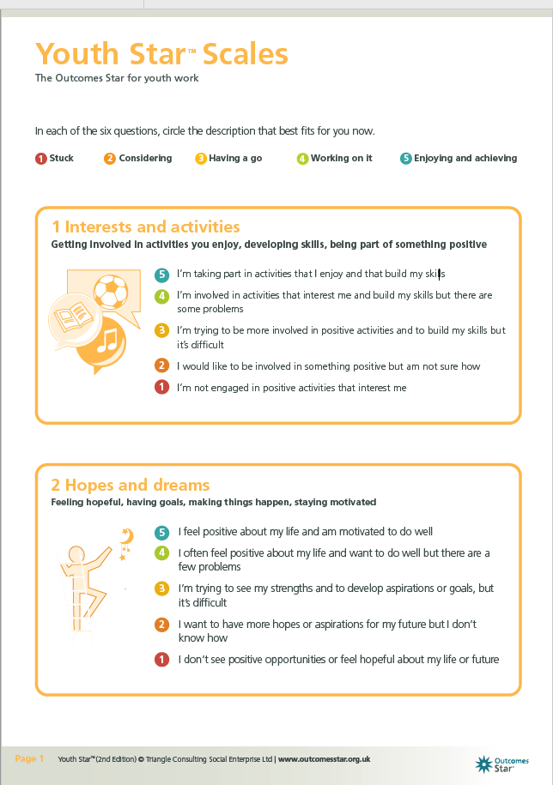

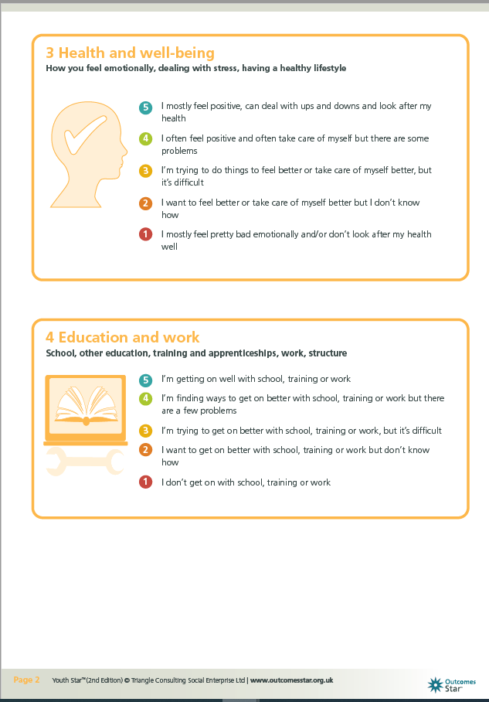

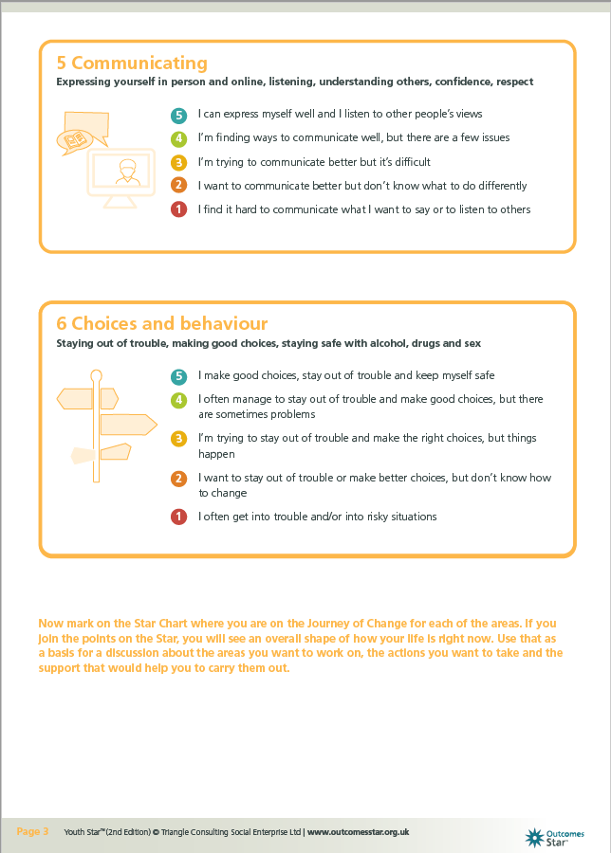

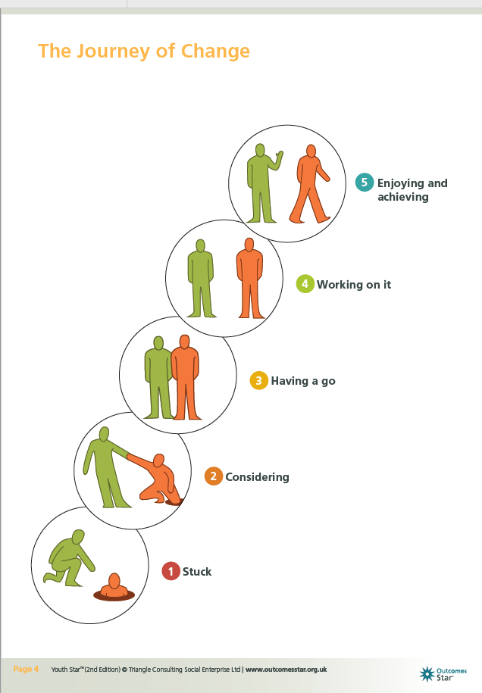

Appendices 8.8: Creative focus group preparation.

Below is the preparation for the YOS creative focus group; Pants, vests, socks and rucksack.

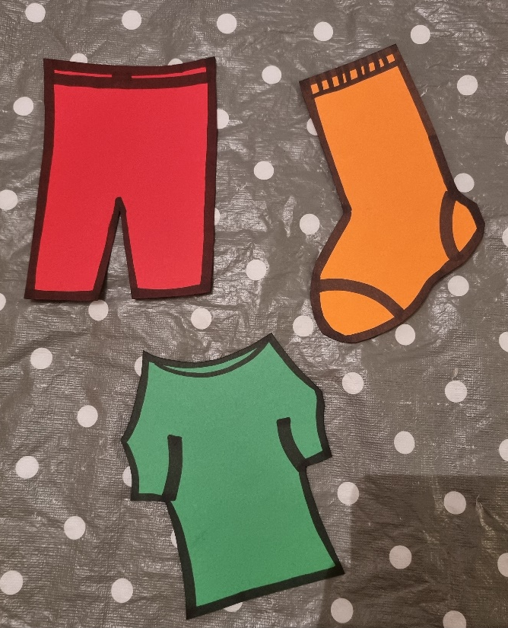

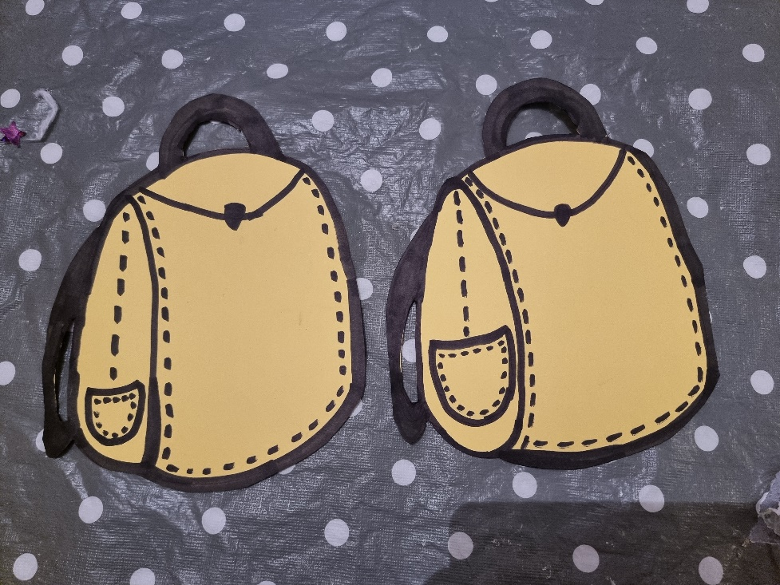



If they chose to make their own, this will take 5 minutes.
- Cut the fabric to size.
- Pin to shape.
- Use fabric glue to stick together.
- Glue buttons on.
- Use string to create a tie bow.
- Use shape cut outs to fill.

See below for creative focus group session plan:

Creative focus group session plan:

*All times are approximate*
Session break-down: | How: | Time: | Materials needed:
Making it work: | Before the session begins and will remind the group of the making it work that they have already agreed to as part of the life coaching programme. I will remind them of expected behaviour in the group. I will take this time to let them know a member of staff will be scribing what they say and also remind them they can leave at any time. I will ask them to sign this together if they agree. | 5 mins. | Copy of the making it work and a pen.
Pants, vests, and socks: | Cut out will be made ready before activity. String will hang up to acted as the washing line.  Participants will be asked to write on their ‘Pants’ what they didn’t like about the life coaching programme.  ‘Vests’ what they like about the life coaching programme.  ‘socks’ what they would change about the life coaching programme.  Trough the duration of filling out, pants, vests, and socks they will be asked to engage in open discussion about their thoughts, ideas, and feelings about the life coaching programme. A member of staff will scribe the discussion.  Participants will then be asked to peg their washing on the line. | 15-30 mins. | Cut outs, pens, pegs and string.  (Scribe to take notes about the feedback discussions).
Break: | We will break when participants feel they need too, halfway is an estimated point. | 15-30mins. | Refreshments.
Ruck sack/ purse: | Participants will be given the option to make their own purses or envelopes or write on a rucksack cut out.  Cuts out will be ready before the session.  If they chose to make their own, this will take 5 minutes.  - Cut the fabric to size.  - Pin to shape.  - Use fabric glue to stick together.  - Glue buttons on.  - Use string to create a tie bow.  - Use shape cut outs to fill.  Participants will then be asked to write down what they feel they will take with them from the life coaching programme. This can be skills they have learnt or things they will decide to keep doing without the support. | 15-30 mins. | Fabric material, cut outs, scissors, fabric glue, pens, pins, and string.
Back up activity and support. | Participants have the options to withdraw at any point. If they choose to do this refreshments and alternative activity will be provided in a separate room. | Duration of original activity. | Refreshments and games.

Appendices 8.9: Youth Outcome Star and goal setting sheets.

Below are the Youth Outcome Star resources sent by Triangle (2022) as part of their training programme.

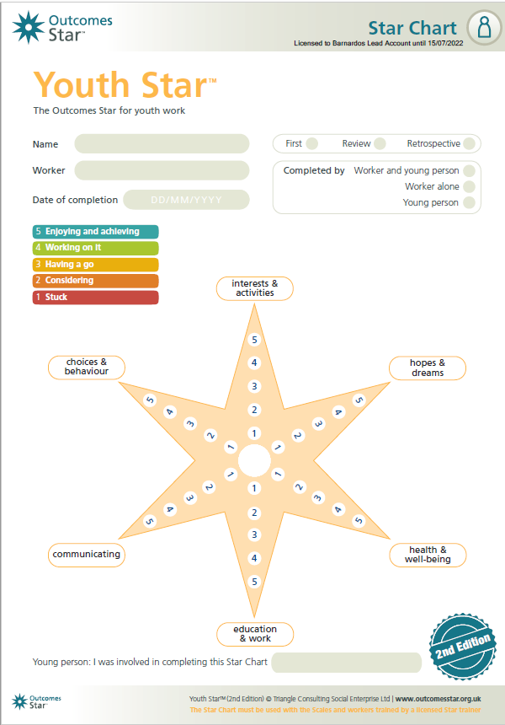

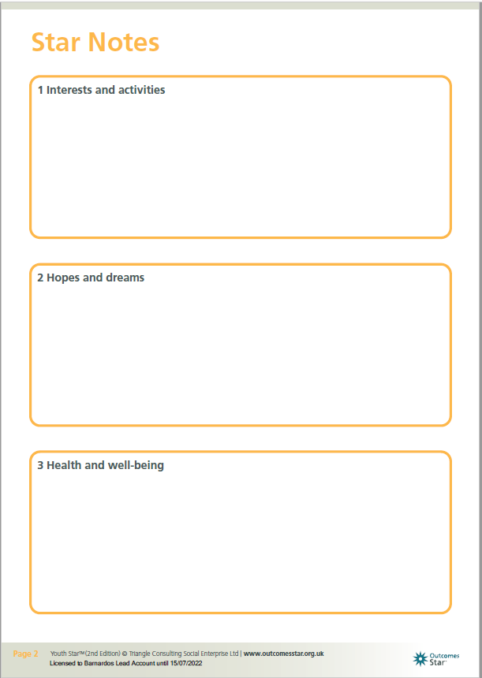

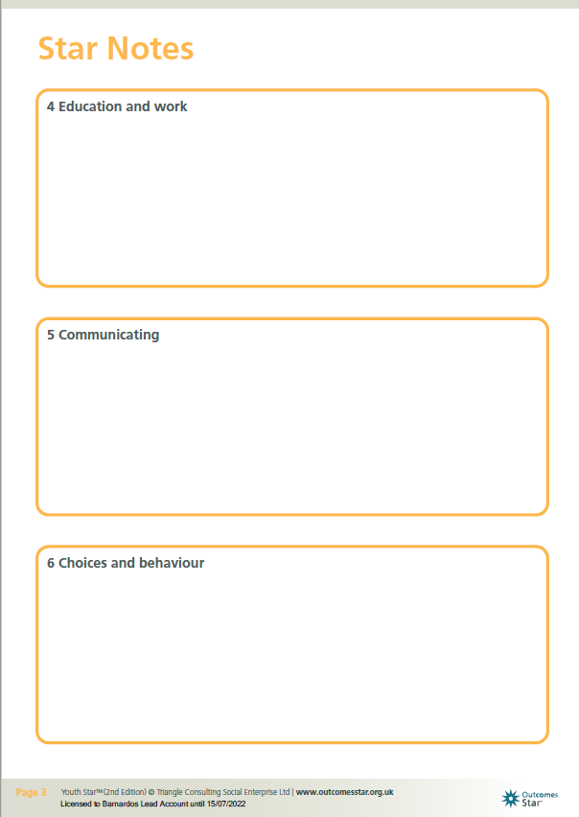

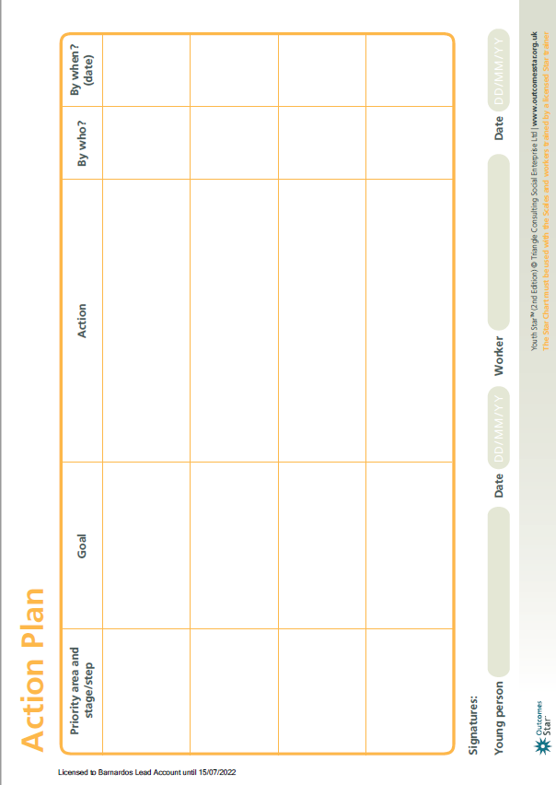

Appendices 8.10: Before and after completed Outcome Stars.

Below are the completed and reviewed Youth Outcome Starts from the four participants. Please note that Researcher has not included the goals or action plans to keep confidentiality as they have personal and identifiable information on them.

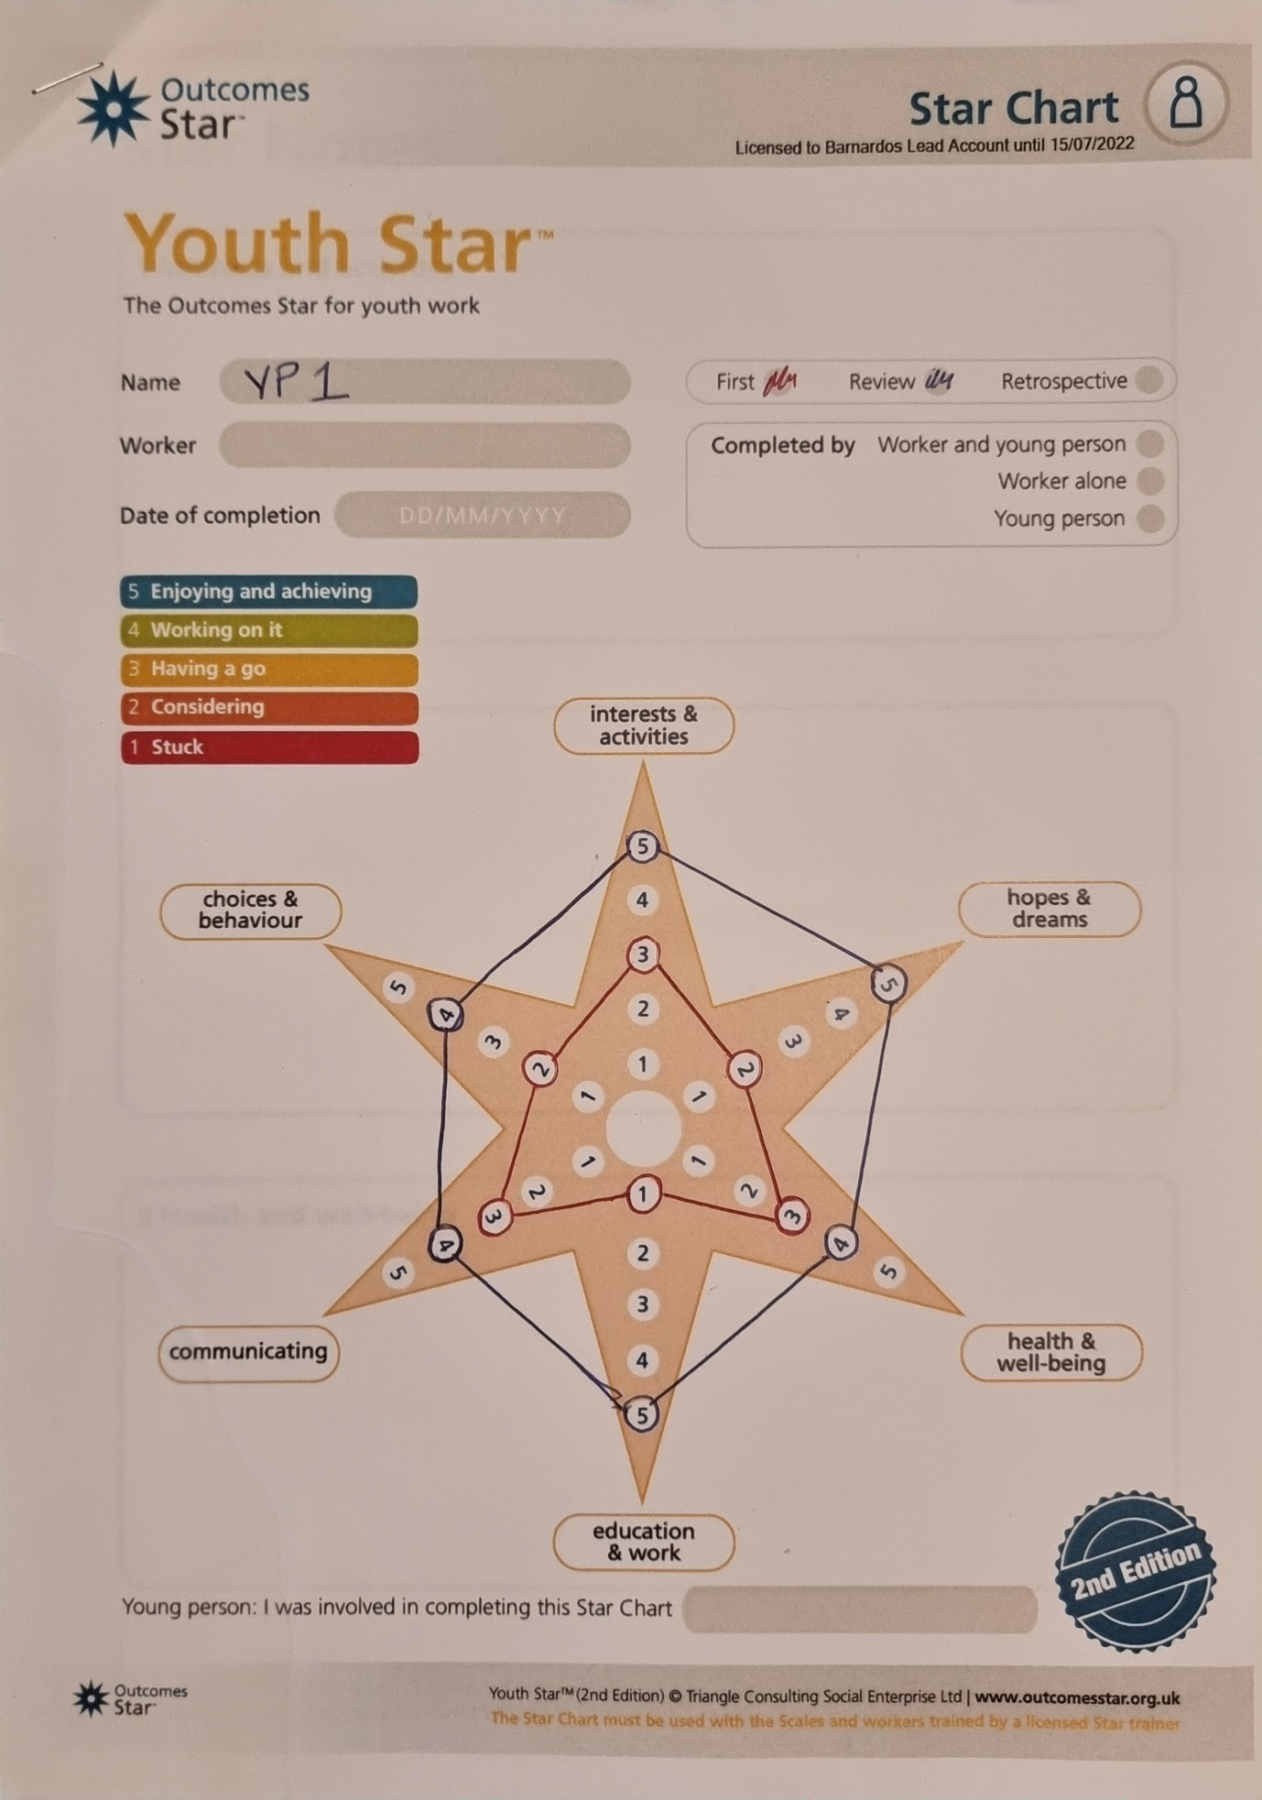

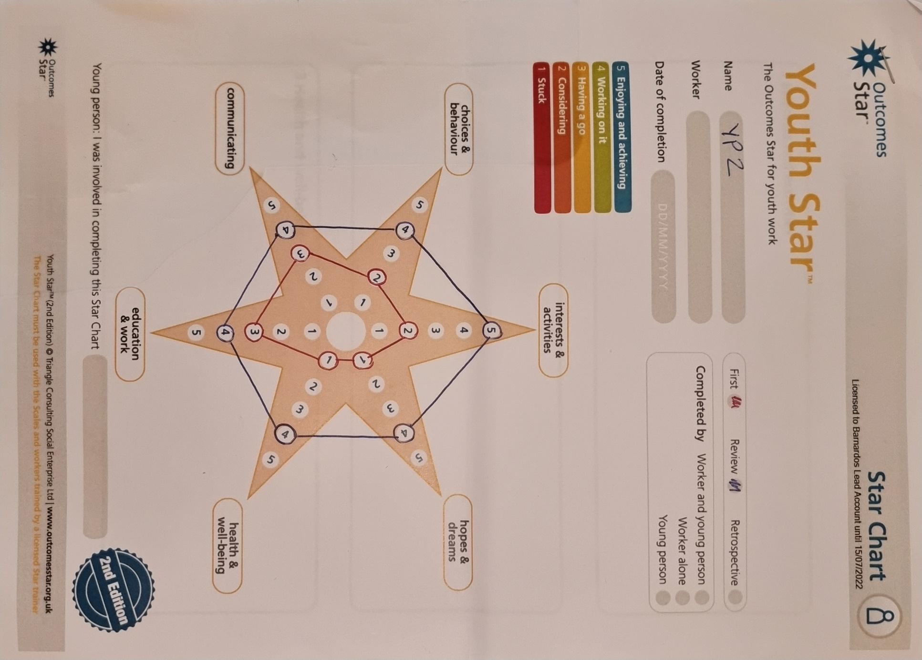

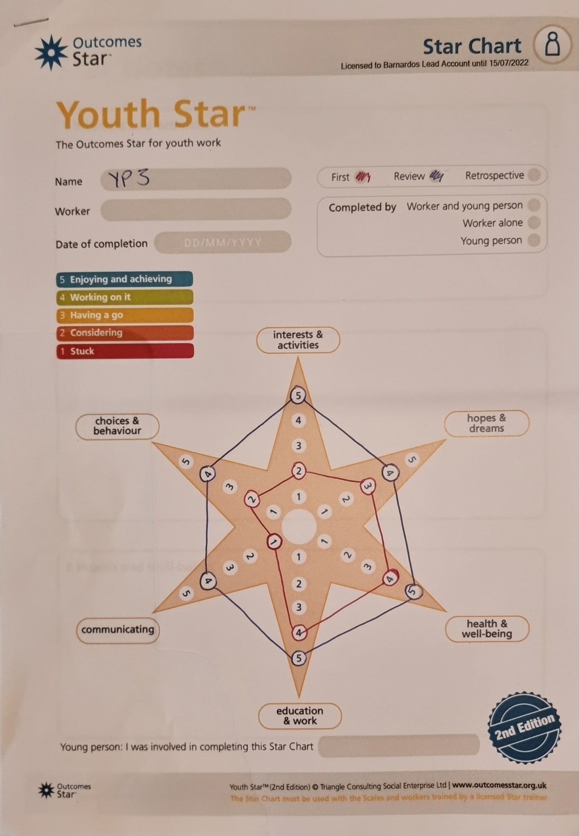

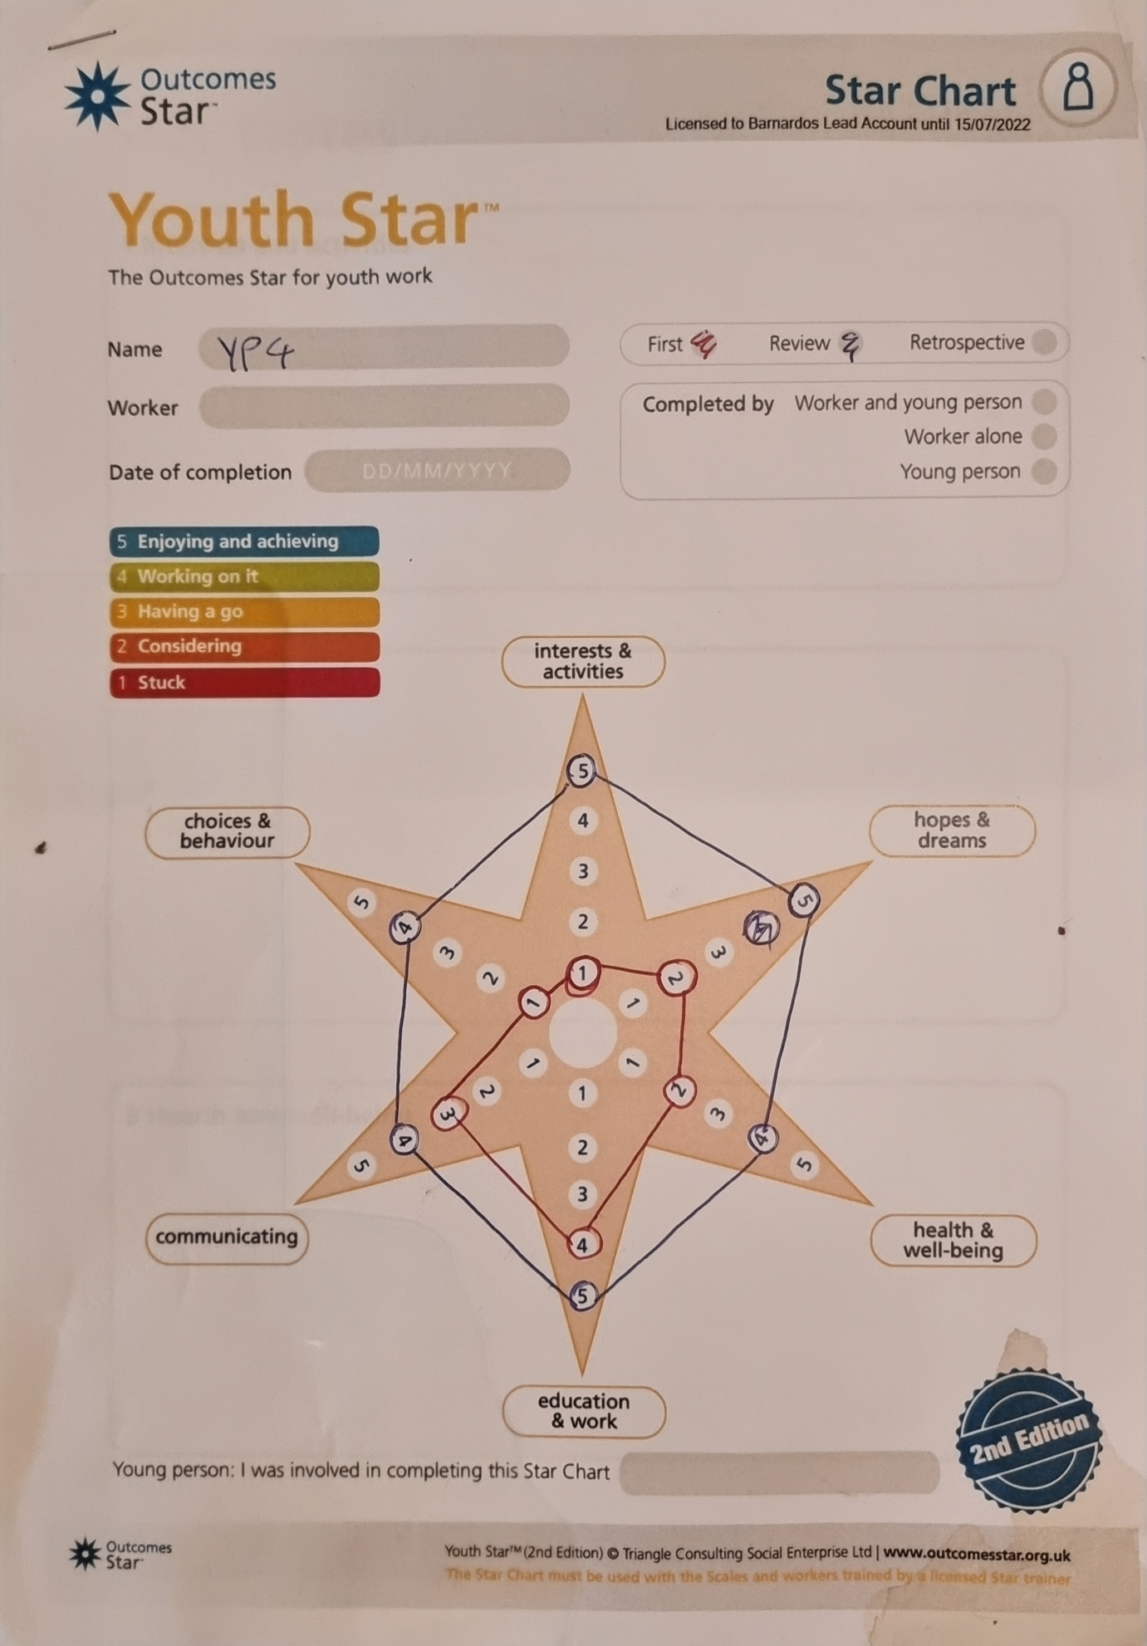
Appendices 8.11: Pants, vests and socks washing line photo.

Below are photos from the finish result of the creative focus group; Pants, vests and socks on the washing line.

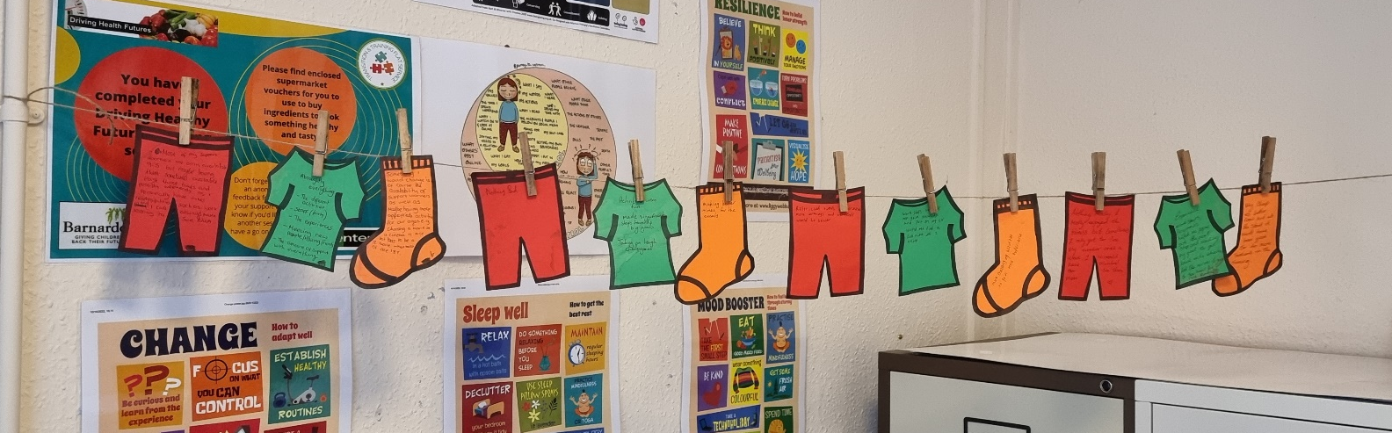

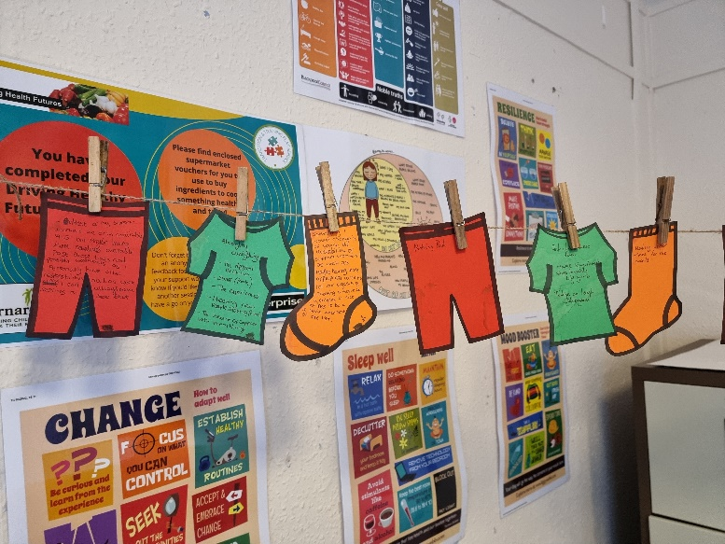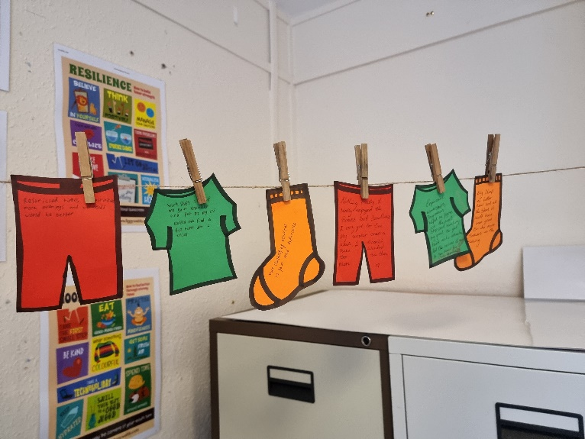

Appendices 8.12: Creative focus group feedback.

Below are photos of the creative focus group; Pants, vests and socks. Followed by photos of the rucksack activity.

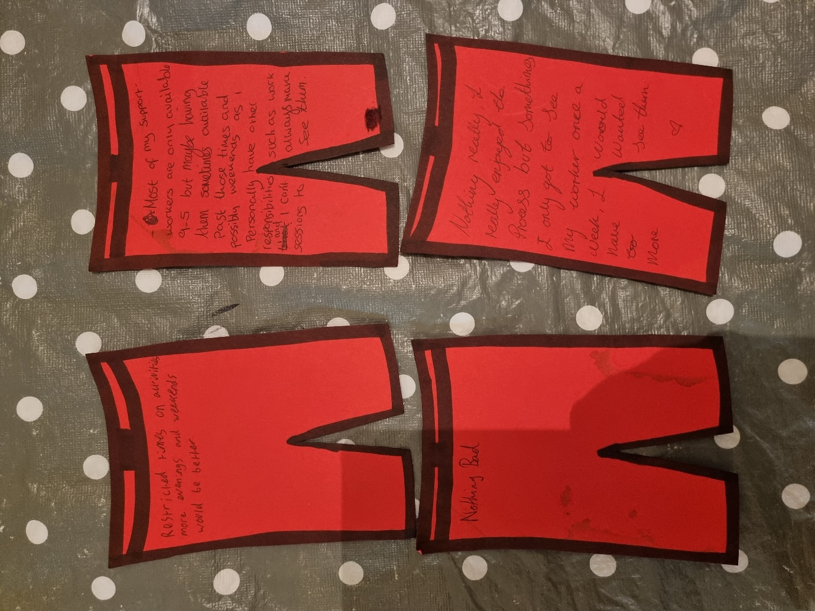

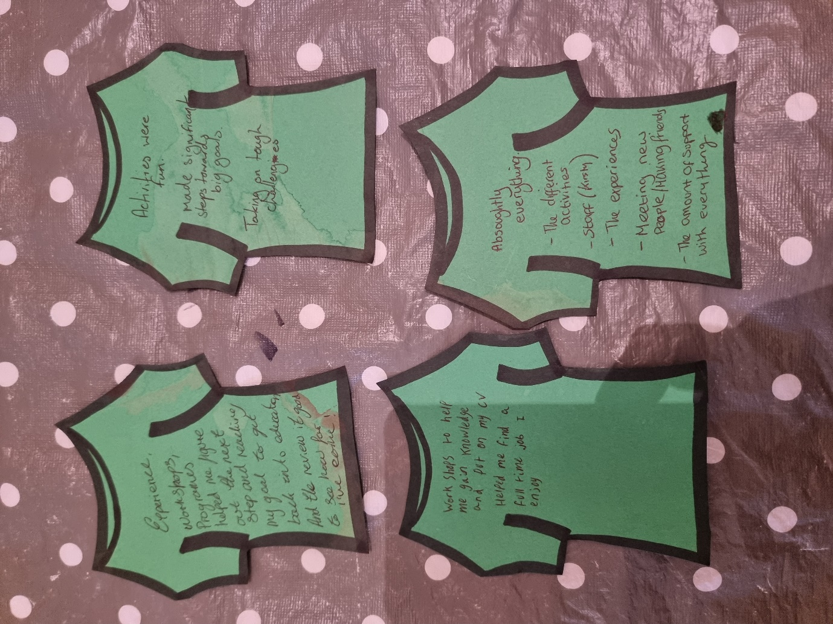
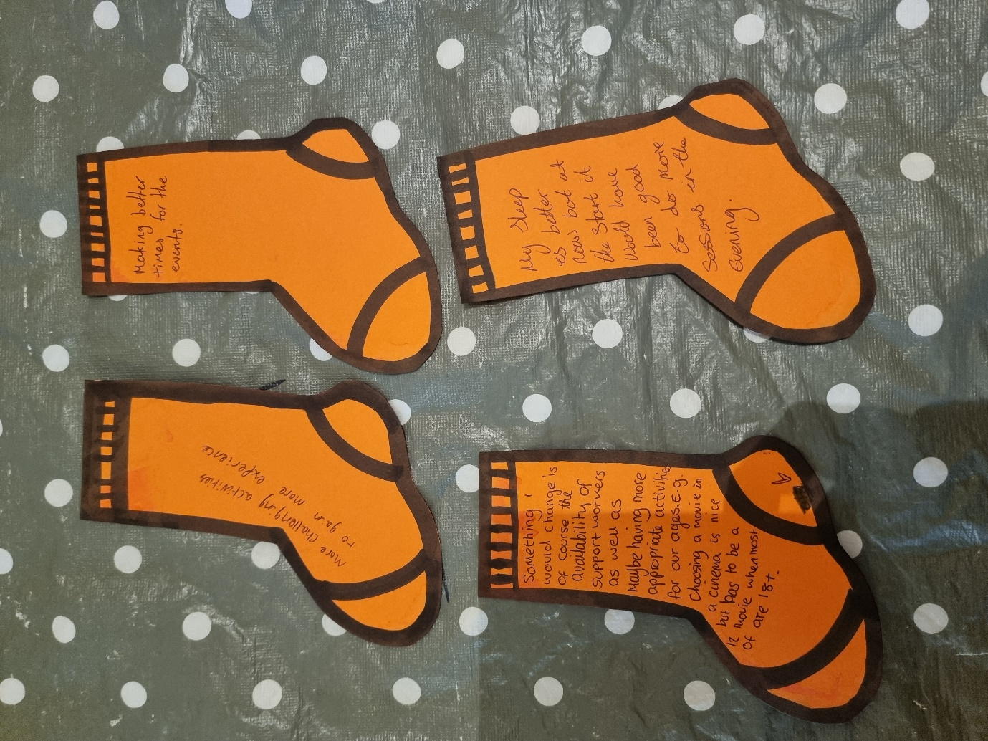

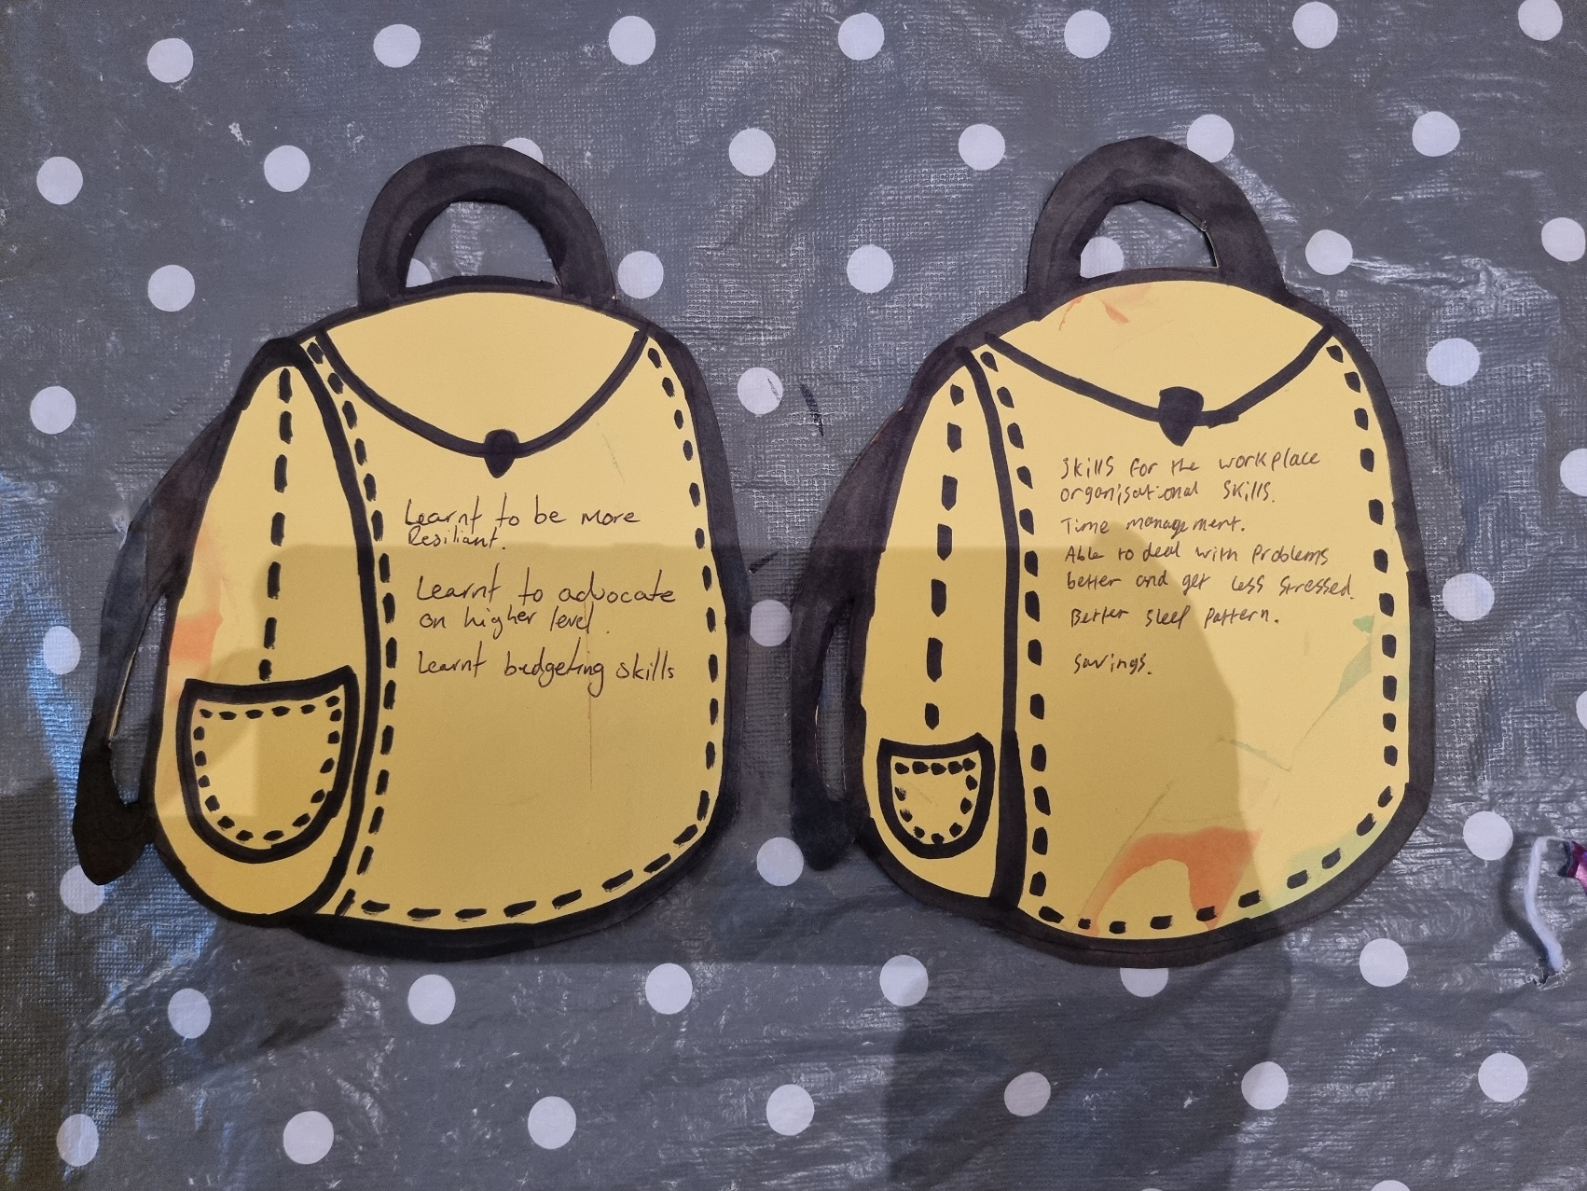

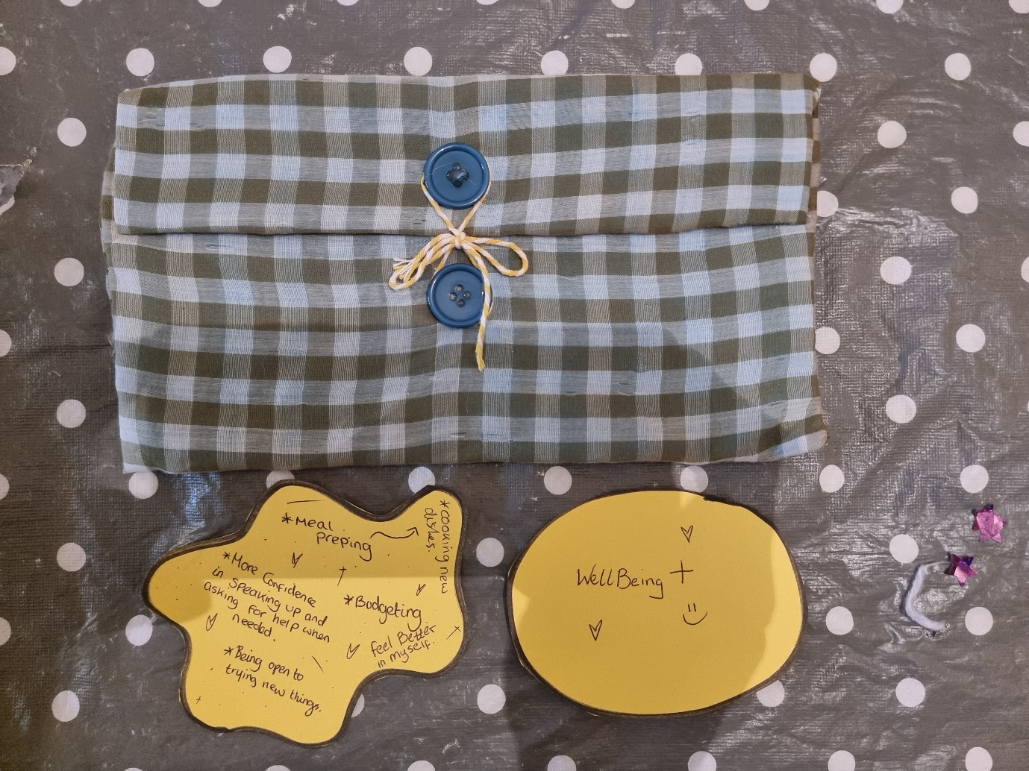

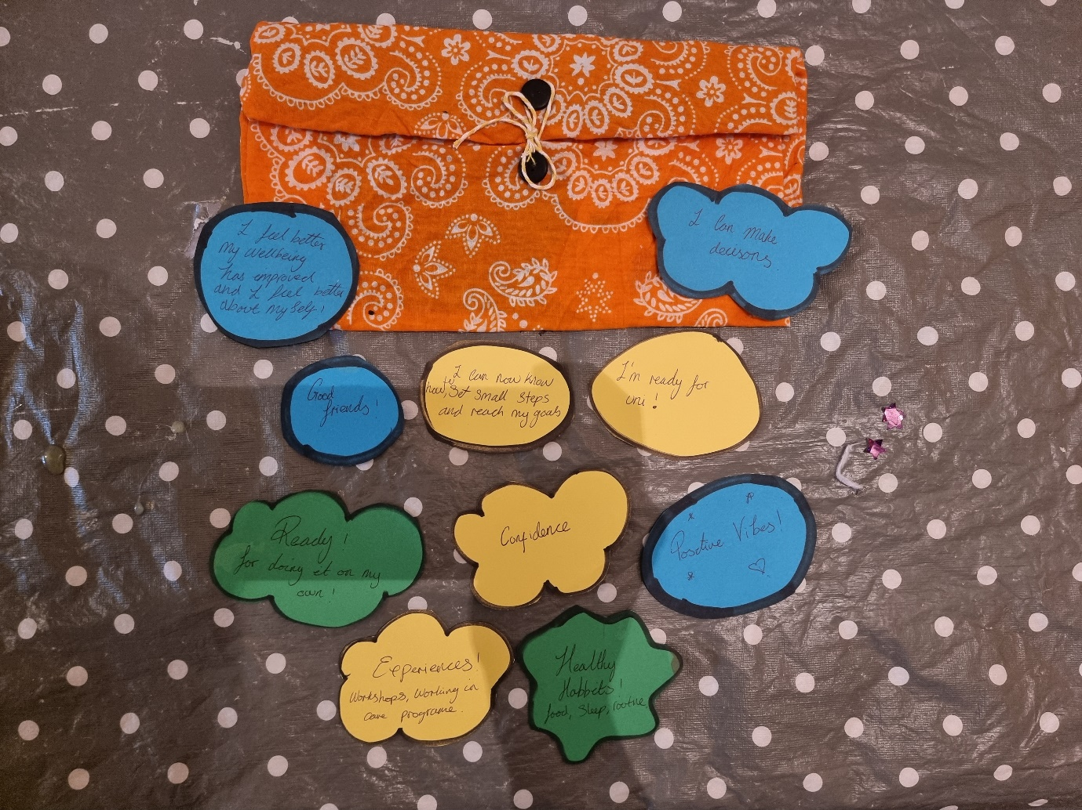

Appendices 8.13: Documented notes from creative focus group.

Life coaching creative focus group note taking.

The four participants set up in the main room with refreshments like a normal club activities.

While the Researcher set up the tasks and made sure participants were comfortable, the participants bonded well and spoke about what they had been up to recently.

The Researcher then explained the objectives of todays creative focus group and explained that if at any point they would like to leave they were welcome to, and games and another worker were in a separate room to provide additional support/activities with them.

The Researcher explained that I would be taking notes of what they were saying, she explained that this would help gather results and prove credibility, she also explained that it would be confidential and no name or identifying information would be used.

The Researcher then asked the participants to sign the pack of the making it work to agree to group rules and acknowledge they participate inn this creative focus group and that I will be taking notes.

The Researcher began by explaining the pants, vest and socks activity and handed out the cut out. The Researcher said if the participants that we would open up for discussion afterwards and for them only to join in if they felt comfortable to.

The group talked and everyone felt comfortable to share thoughts, feelings, and ideas together. As they could bounce ideas off each other and help if needed.

The Researcher then began to explain the pants section. She explained that this is where they would write and discuss what was bad about the life coaching programme.

There was a slow start and participants began to say they dint know what was bad, over all it was a really good programme. The research asked the group, “have a think of anything that could have been better and reflect on that, If there was anything you would have want to a different way, what made you feel that way?”

- “Nothing was or is bad with this programme”.
- “I mean it comes with so many benefits, I can’t think of anything bad?”
- “Yeah, I can’t think of anything bad.”
- “If I had to pick something, I guess it would be the 9-5 thing. It would be nice to meet with workers in the evening and weekends?”

The participants then joined in open discussion to reflect on this. The general group discussion was that although they had benefit from the programme 9-5 Monday to Friday, perhaps they could have done more on evenings and weekends.

- “Yeah, I have work during the week now, it does make it hard to arrange sessions, but I finish at 5 and I could make a session straight after work, if it could be after 5”.
- “I mean I like the activities, but it would be nice to plan something to look forward to on the weekends”.
- “Having sessions in the evenings could be better for other people too”.

The Researcher told the participates that this was all valid feedback and thanked them for them input and working so well as a team. The Researcher then explained vests to the young people and how it was for them to wright what they though is good about the life coaching programme. Participants began writing straight away on the top cut outs. Once they had done the Researcher asked them if they would like to discus what they had written.

- “The step by step for reaching goals! Just looking at the end goal is scary I liked that we got there by doing small steps first, there was less stress and it was like mini achievements”.
- “Yeah the step by steps helped me reach my goals too”.
- “I think this is something that will help in the future, like I know I can reach my goals if I focus on them like this”.
- “I quite liked the workshops, like activities are fun and give us something to look forward to but I learn lots from the workshops and its qualities to add to the CV”.
- “Yeah, I liked the workshops and activities too, they helped my socialise and make friends”.
- “I think the best part about the life coaching programme was the fact that I reached my goals, I made significant steps to my long term goals and hit all my little ones, I don’t think I would have been able to do that with the support I got. The activities and workshops and clubs were just added benefits”.
- “Yeah, the amount of support with everything was great, I needed my YPA less and got more done”.
- “Yeah, that’s a good point, because I’m over 20 I don’t get to see my YPA as much because he’s dealing with loads of people younger than me. I don’t feel like he has the time for me but through this programme I’ve got more done with workers that have time. I feel like they’ve got time to work with me on what I want to work on and have helped me get to a place I want to be”.
- “I liked the review part too I was very excited to work through it and see how far I’ve come. It’s made feel better just by having a visual to see”.
- “Yeah, the aspects on the star helped me realise the different areas of my life I needed support with, and I enjoyed seeing how far I had come from the start too”.
- “I’ve progressed so far with the wellbeing aspect too, I think that’s important, because if I wouldn’t be able to have progressed in other aspects without working on that, and the workers provided me with lots of support for my mental health and wellbeing, activities too”.

The Researcher thanked all the participants for their feed back and said it was good to hear how far they have all come and that they had benefited from the life coaching programme.

The Researcher then passed out the socks cut outs and explained that socks are what they would like to change about the life coaching programme. She asked them to reflect on anything that would have made the process better for them, anything they would like to change or do differently in the future.

- “Something I would of course change is the availability of the workers, it would be nice to work with them in the evening or for them to work later for us”.
- “Yeah, I get it, I wouldn’t want to work till late everyday but perhaps they could offer later sessions a couple of day a week”.
- “Better times for activities would be good to, sometimes they happen in the middle of the day and it would be good to push them later in the evening”.
- “Yeah, at the start I struggled to meet early in the day because my sleep was all over the place. It would have helped if we could have met in the evenings”.
- “I don’t think there is much else I would want to change other than that”.
- “Maybe the activities, I really like all the activities that get provided, but I would like to do more challenging ones that push me out of my comfort zone, like the ones we did on the residential”.
- “There is a lot of wellbeing activities and we’ve done a lot of thing that are available in Swansea that are fun and exciting, but I would like to do more physical activities that push me more too”.

The Researcher thanked the participants again for their feedback and said it was valuable to know how to improve the service for future. She asked the participants if they would like a small break before we do the last activity. Participants agreed and wanted a little break. Refreshments were provided and they chatted among themselves.

*Break 15 mins*

We all returned from break the Researcher set out the rucksack task, she explained to the group the purpose of this activity was to reflect on what they had taken away from the life coaching program, skills they have learnt that will help them in the future.

This could be done in two ways, they had the option to make purses/ envelopes or have a rucksack cut out. Two participants wanted to make purses out of the materials and two decided the cut outs. While the Researcher explained how to make the fabric purses, she opened up discussion to the group for what they thought they would put in their rucksacks/purses.

- “I learnt a lot for the workplace, I got I full time job I enjoy and that’s something that will continue now the life coaching programme has ended. But I’ve learnt a lot of skills for the work that that will continue using, like time management and how to organise my time better”.
- “I’ve learnt how to deal with stress better, I don’t get as worked up any more or let it get to me as much. It’s like I know it’s not going to be as bad as I think it is, deep breath and right, what’s the first step to dealing with this? I don’t shut down as much anymore”.
- I’ve now know how to make a sleep schedule that suits me now, I get better sleep and I can function more now in the days, I’ll definitely still be doing that still”.
- Yeah, I’ve done that too, I’m sleeping better to. It’s easy to adjust too depending on what I’m working, so that I’ll take with me”.

*The two participants finished their purses, and the Researcher passed them shape cut outs for them to write on and but in their purses. The other two participants have the rucksack cut outs.

- “I’ve learnt a lot about cooking, and I want to do more of that, I’ve got confidence in cooking new meals and trying new things, that’s something I’ll continue to do”.
- “Year, I’ve learnt how to meal prep and that saves me a lot of money, I’ll continue doing that, saves time and I’ve either got food ready to cook or lunch ready to eat, helps a lot when I can’t be bothered”.
- “Saving is a good one. I’ve learnt how to budget, how to keep money one side for bills, and then what’s left some goes in my savings and some’s left for me to save then”.
- “I’ve opened a savings account since starting the life coaching programme and the life coach helped me figure out how much I can save each month, I’ll carry on adding to it too now”.
- “Yeah, I’ve learnt how to budget too, I’m not sort each week”.
- “I think I feel more ready to take on new experiences, or handling situations on my own, it’s like it’s built my reliance and I just feel like I can do it or figure out how to do it”.
- “I get that, I’ve gained more confidence too”.
- “Yeah, I feel like I can stick up for myself more now, I can ask for help when needed. I’m more confident in myself”.
- “I just feel more positive amount everything, I don’t look at situations so negatively it used to always be worse case scenario but now I feel positive on doing it on my own, I guess that’s confidence too”.
- “Yeah, I feel more positive too, I feel better in myself, and that I’ve learnt how to look after my own wellbeing better and its improved, I’ll definitely keep going with things that make me feel better about myself and doing things for me”.
- “I just feel ready to do stuff on my own. Whereas before I felt like I needed someone to do it with me and going forward I’ll be able to do things on my own”.
- “Through the experiences and workshops I’ve learnt skills that I will take with me, like the care programme, that’s going to help me with me with uni and work. I’m able to pull on that experience and it gives me confidence that I know what I’m doing”.
- “I get what you mean, I think it’s good that I can plan for goals in the future, like I know how. If I set my self a new goal, I know how to plan for it and the importance of taking small step in reaching it, I’m more confident in taking steps and making decisions that affect me better”.
- “The experience has benefited me too, I’ve learnt how to advocate on a higher level, and speaking at the Senedd has really given me the confidence to archive higher goals and I couldn’t have got that far without this programme”.
- “Actually, I’ve started making better decisions too. I think that come with better wellbeing. I can see what affects my mental health now and I choose to avoid it”.
- “Yeah, I’ve picked up on health habits too! I’ve made better friends and stick to more positive people and things in my life”.

The Researcher thanked all the participants for there input and told them how valuable their feed back was, she asked the group was their anything else they would like to add or go back over, and all participants said no. She thanked the group for coming again and the session ended.

I agree that I have recorded this information from this creative focus group has been recorded accurately and to the best of my ability:

Name: Vivienne Riley

Sign: V. Riley

Date: XX/ X/2023

I confirm that these results have not been altered and confidentiality has not been broken through this note taken progress:

Name: Kirsty Allen

Sign:

Date: 31/03/2023

Making it work (see Appendix 8.14).

The rucksack/ purse activity (see Appendix 8.12).

Appendices 8.14: Making it work.

Below is a photo of the Participants making it work agreement they singed to engage in the creative focus group. Please note the Researcher has block out the young people signatures and organisations information to maintain confidentiality.





