MODULE: Entrepreneurship

NAME:Isha muskaan

STUDENT ID:2128279

MODULE CODE: LCMB7004

LECTURER: Isaiah oino

COURSE:Master’s in business administration

Entrepreneurship

Table of Contents
Introduction 3
Concepts and knowledge about enterprise and entrepreneurship 3
Entrepreneurs and small business owners 5
Key traits 5
Characteristics 6
Attributes 7
Motivations 8
Comparisons and contrasts between ‘for profit’ and ‘not for profit small organisations 9
Conclusion 11
References 12

Introduction
Entrepreneurs are familiar with new ideas as they come up with new inventions and replace old ones with new ones. They stimulate new employment through the creation of new products and services, thereby accelerating economic growth (Doern et al. 2019). Economic growth requires public policies that support and encourage entrepreneurship. However, in the report, further, various significant discussions will be held like for understanding the concept and knowledge of entrepreneurship, few popular theories will be undertaken. Moreover, in the case of small business owners and entrepreneurs, their key traits, characteristics, attributes, motivation, and recognition will be undertaken for further discussion. In the end, a comparison will be done between for-profit and not-for-profit small organizations.

Concepts and knowledge about enterprise and entrepreneurship
According to Tung et al. (2020), entrepreneurship and enterprise are both notions that are interrelated where the entrepreneur is an individual finding a chance to start a business and enterprise is a process of spotting a business opportunity and planning to generate profits. However, in order to gain a thorough understanding of this concept, entrepreneurship theory contributes to a greater understanding of how various entrepreneurs display their entrepreneurship behaviors. However, with this theory, one can gain a comprehensive understanding of the necessity of entrepreneurship and why everyone does not possess it. As stated by Ahmed et al. (2020), there are certain theories that will provide insight into various approaches as well as the perceptions carried by entrepreneurs as a whole. However, as per Urbano et al. (2020), also stated that there is more to entrepreneurial activity than starting a new business. As entrepreneurs create value and appropriate it in uncertain environments, they are defined as entrepreneurs. In order to create value, the entrepreneur must have entrepreneurial intentions (a desire for rewards).
As per Gieure et al. (2020), business is not an autonomous process; entrepreneurs play a vital role in its development. The entrepreneurial process is therefore dependent on entrepreneurial intention and resources. However, as stated by Lüdeke‐Freund et al. (2020), also said that entrepreneurs can also create sustained value using the entrepreneurial resources available. As a result, they can acquire external resources if necessary, and create sustainable value according to their needs, recapturing the entrepreneurial rewards. However, according to The Theory of Entrepreneurship, the entrepreneurial process is conceptualized as a two-stage process of value creation and appropriation. Despite this, there are also two other theories, the first is economic development which Schumpeter introduced in 1934. He emphasized the importance of the entrepreneur as the bearer of economic change and the man of action. According to Coase's theory of the firm, introduced in 1937, the entrepreneur is central to the company's formation, and transaction costs are minimal in the firm.
According to Mehmood et al. (2019), pointed out that in Schumpeter's view, entrepreneurs combine the factors that drive productivity, which means they coordinate resources and bring them together. In his definition of economic development, Schumpeter viewed it as the cause and effect of technological innovation, the development of new markets, the development of new raw materials, or the organisation of an industry in a new way. In this case, the introduction of a new product is an example, as is implementing a new method of production, creating a new market, or discovering a new source of raw materials. In other words, an entrepreneurial value creation theory can model all the inputs, outputs, and throughputs exponentially (Gregori et al. 2020). Moreover, it examines the entrepreneur and the entrepreneurial process as a whole as well as its subprocesses in depth. An entrepreneur is responsible for bringing a firm into existence. Rather than relying on market transactions to coordinate the resources of the firm, an entrepreneur coordinates them more efficiently. As per Foxall, (2020), the theory of the firm following Coase's, however, emphasizes contracting costs and firm governance costs rather than the entrepreneur or entrepreneurial process. The role played by the entrepreneur is central to all these theories of firm formation.
Inventive ideas and economic activity are solely the responsibility of entrepreneurs. Launching an enterprise and taking advantage of opportunities in a world that is full of uncertainty and risk requires extraordinary abilities and daring. Most entrepreneurs are motivated by profit, but some are motivated by dynastic ambitions or competition, or simply because they enjoy what they do. Therefore, as pointed out by Dalton et al. (2022), economic growth is inextricably linked to entrepreneurship, according to Schumpeter's analysis and without entrepreneurship, growth is at a halt.
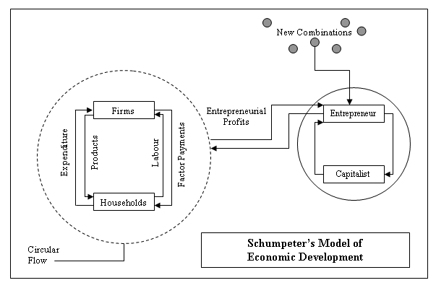
Figure 1: Schumpeter Economic Development Theory
(Source: Google, 2022)

Entrepreneurs and small business owners

Key traits
Entrepreneurs are currently leading the world of business irrespective of gender. There are certain traits of a successful entrepreneur which help the entrepreneur in properly executing the business idea and accomplishing the goals. One of the major traits of an entrepreneur is leadership quality which includes a proper vision of the organisation, critical thinking ability, understanding and development of strategies, and many more (Alshebami and Seraj, 2022). Along with that, a successful entrepreneur also has the quality of being flexible and self-motivated. These two qualities help an entrepreneur in understanding new challenges and threats, analysing the same with patience, and also adapting new strategies in compliance with the challenges. The constant urge for innovation is also an important trait of a successful entrepreneur, as it helps the entrepreneur in exploring new ideas and strategies that will help in accomplishing the goals and objectives efficiently (Presenza et al. 2020). Confidence and risk-taking behaviours are also quintessential parts of an entrepreneur. Small business owners refer to business owners who have a small workforce, revenue, sales, and organisational structure (Kerr et al. 2018). Small business owners who want to emerge their business largely in its targeted market acquire the same traits as a successful entrepreneur such as leadership qualities, flexibility, innovation, and others. Both entrepreneurs and small business owners have the quality excellent communication and collaboration with the team members which aims them in identifying opportunities, and challenges, and also in developing new strategies which will be beneficial for the organisation. But the small business owners and entrepreneurs differ in having the trait of risk-taking quality, as small business owners are not open to taking risks that may harm their business.
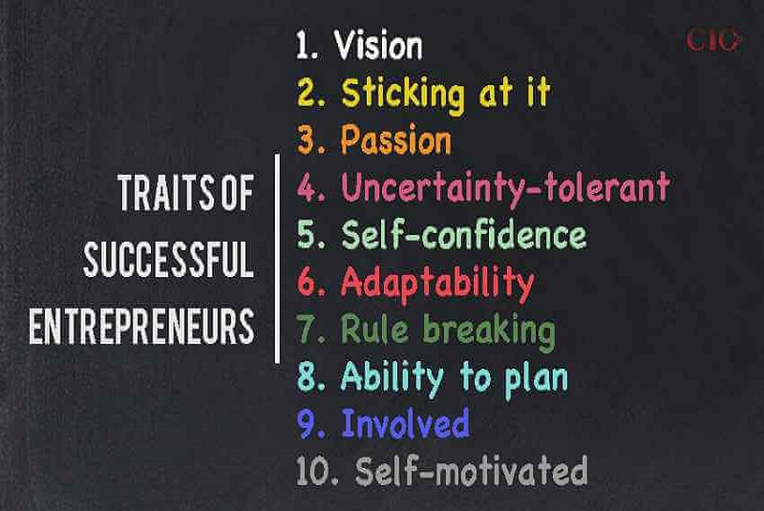
Figure 2: Traits of Entrepreneurs
[Source: Ciolook, 2022]

Characteristics
Successful entrepreneurs have certain characteristics which aid them in attaining their passion and also in emerging their business. Entrepreneurs have the characteristics of high motivation that helps them in sailing through the hardest challenges with ease. Entrepreneurs have a firm belief in their business idea and also are passionate about their goals (Sadeghi et al. 2019). The second most important trait of an entrepreneur is the quality of focusing on customer demands and requirements. As entrepreneurs focus on the requirements of their targeted consumer base, it helps them in understanding their demands and problems, and also in focusing on the services and products which will satisfy the consumers. As Entrepreneurs are likely to take more risks in order to try something new and also for attaining their objectives, therefore, entrepreneurs are prone to more risk factors and failures. But Entrepreneurs also acquire the quality of persistence which helps them in overcoming failures. Most significantly, Entrepreneurs have the excellent quality of transforming revolutionary ideas into reliable business enterprises which helps them in attaining their goals.
On the other hand, even though small business owners also focus on the demands of their customers and provide products and services accordingly, small business owners lack in having the quality of risk-taking, as it may cause them major loss and may also harm their reputation (Bawono et al. 2020). Small business owners are also passionate about their business ideas and efficiently develop strategies to satisfy the customers, but due to the lack of risk-taking behaviour, small business owners cannot always attain their predicted profitability.
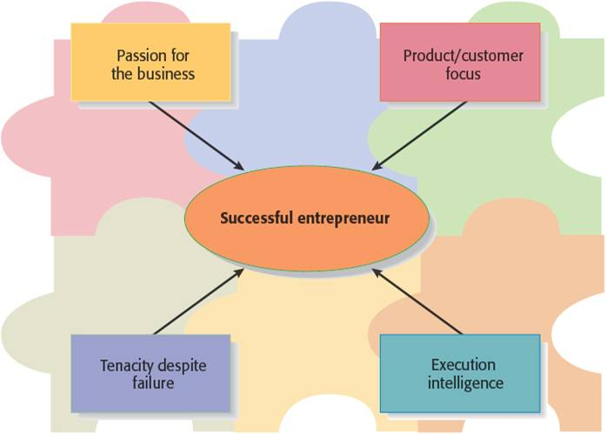
Figure 3: Characteristics of Entrepreneur
[Source: Rehamalfeez, 2018]

Attributes
A successful entrepreneur looks forward to moving forward with an innovative idea that helps the entrepreneur in resolving a particular issue of its targeted consumer base. This quality of an entrepreneur helps in accomplishing the goals of the business idea successfully and also in emerging the business to a large extent. One of the major attributes of a successful entrepreneur is a quality of understanding the demands and requirements of the targeted consumer base and properly developing strategies with the help of peers to execute the idea (Kawai and Kazumi, 2021). Moreover, entrepreneurs also have the quality of proper planning to attain their goals which helps them in staying motivated and organised as well. Entrepreneurs like to focus on their goals and objectives which help them in attaining the mission and vision of the company. In addition to that, entrepreneurs are also rapid in their decision-making process after properly analysing several relevant factors which aid the entrepreneurs in attaining success. The ability to teamwork and collaboration also can be observed in an entrepreneur who helps them in exploring new ideas and developing new strategies for the company (Arthur and Yamoah, 2019). Along with that, entrepreneurs also listen to others attentively to understand others' viewpoints and also express their own ideas elaborately in order to make others understand the leader's perspective. Small business owners also possess the same attribute of teamwork and collaboration in the small workforce as entrepreneurs and also stay focused on the mission and vision of the company.

Motivations
Entrepreneurs are the people who risk their careers to implement their innovative and creative ideas which can be very beneficial for the well-being of society and the world. Entrepreneurs significantly help to boost the economic and financial structure of a nation by opening a new market which can significantly make revenue and profit (Nisula and Olander, 2020). Along with that entrepreneurship effectively provides new jobs which increases the unemployment rate of a nation. There are some motivations that significantly drive an individual to become an entrepreneur such as achievement, power, recognition, Satisfaction, freedom, and so on.
Freedom and satisfaction - The main motivation of an entrepreneur is to access the freedom of not being controlled. An individual can implement any idea without asking for any permission from the higher authority in the business model to enhance productivity (Li et al. 2020). This factor significantly increases the satisfaction factor of an individual and influences an individual to become an entrepreneur. An individual gets the freedom to learn different skills in order to enrich their knowledge which significantly enhances personal growth as well.
Recognition - Entrepreneurship is about innovative and creative idea implementation in society. Entrepreneurship significantly opens a new market in order to increase employment as well as enhance the economic structure. An entrepreneur easily gets recognised globally because of the out of box thinking.
Impact - Another impactful motivation to become an entrepreneur is to create impactful products and services in order to help the audience in their daily life (Bhansing et al. 2018). An entrepreneur always tries to bring positive changes to the world by incorporating innovative ideas.

Comparisons and contrasts between ‘for profit’ and ‘not for profit small organisations
A ‘for-profit’ business is an alliance that is not financially nudged. This construes that it endeavors to impel the public remarkably. While a not-for-profit company is one that works for the public power help of the general populace or its kin. Profit is the basic thinking in various affiliations (Nielsen et al. 2019). Several firms are not permanently set up to pass associations on to their kin and general society with everything considered. These are benevolent establishments, extreme affiliations, clubs, clinical focuses, expert's associations, establishments, government help social orders, etc.
Non-Profit Affiliations and Not-for-Profit Affiliations sound commensurate and considered novel. Both affiliations are not permanently set up to make an increment. Regardless, the remuneration they produce from the business help in supporting their central goal. While a non-profit connection returns the extra remuneration got to the connection (Nigri and Del Baldo, 2018). Not for Profit relationships by and large compensation to whose administrators the relationship, from the remuneration, made. Every sort of business has a clarification, yet maybe the best capability profit versus non-profit affiliations have lies in the way that for-profit organisations' central mission is to make profits for individual satisfaction. They do this by making and selling things or conceivably benefits.

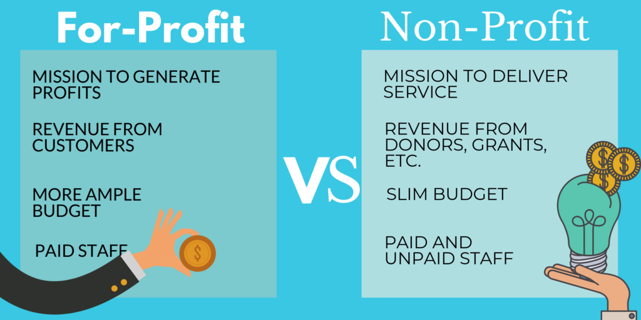
Figure 4: For-profit and Non-Profit Businesses
(Source: Central, 2022).
On the other hand, the significant objective of a non-profit connection is to make profitability for serving society. They advance social clarification by offering help with key human necessities (Stater, 2019). Non-profits mean to manage difficulties and settle basic issues, for example, backing off destitution, giving mentoring, food and water, helping with lodging, guarding risk species as well as the climate, and so on. Giving assets is the explanation of every single strong activity and experience. The seed capital of for-profit businesses is given by the pioneers or business visionaries, by bank credits, financial supporters, and wages produced using courses of action of their things and associations. Non-profit affiliations utilise a substitute strategy. They look for both private as well as corporate gifts of time, material, things, and cash (Finkler et al. 2022). Government awards are moreover utilised for supporting the activities of nonprofits, close by crowdfunding. While for-profit organisations have a much more unequivocally depicted vested party, that is all around misleading with non-profits. While for-profit organisations try to seek out a relationship with clients who purchase their things and organisations to make payments, the non-profit ones endeavor to contact a more interesting gathering including volunteers, corporate partners, supports, and the overall people (Crawford et al. 2018). Therefore, non-profits need to ponder the various interests of each piece of their gathering.
A for-profit connection can be a quietly held business or a huge endeavor with sheets and accessories (Leblanc, 2020). Since for-profits are basically spun around developing compensation, not just do these for-profit pioneers share liabilities, but they once in a while share cash-related improvements. Non-profits, then again, are not entirely set in stone by genuine supervisors, a regulating body, or a driving assortment of lawful managers’ individuals that don't have a direct monetary place. Their fundamental concern isn't about cash-related achievement, yet about neighborly or potentially customary issues.
For-profit versus nonprofit organizations is separate in their different evened-out friendly orders. Since for-profits will regularly zero in on the monetary benefit, they respect delegates who add to the making of new things and organisations, as this can assist with expanding pay (Jackson and Donovan, 2020). Workers of the Nonprofit organisations are generally seen supporting the clarification outside their regular arrangements going to occasions or passing on informative and instructive assets for neighborhood organisations in the nights or on terminations of the week.
Since for-profit organisations make gains for their own advantages, they need to pay charges exactly as the law expects. In any case, nonprofit organisations are excused from paying commitments as they make gains to help society. Also, people and organizations that accommodate nonprofits can guarantee charge derivations. On the off chance that an affiliation is a non-profitable entity, that doesn't mean it cannot be profitable (Nigri and Del Baldo, 2018). Particularly like for-profit organisations, the nonprofit ones regularly have a near strategy for overseeing conveying income and broadening profits totally reason on making more endeavors or further cultivating the current ones. Notwithstanding, the capability between for-profit and non-profit businesses is that the last decision should reinvest any profit in the mission for its motivation.

Conclusion
An enterprise is a legal entity achieving the rights to arrange business on its own and get itself self-employed. The assignment has discussed the concepts of enterprises as well as entrepreneurship from a certain range of perspectives. It has stated the appropriate theories relevant to the basic traits, particular characteristics, encouragements, and attributes of entrepreneurs and of the owners who owns small enterprises. Further, it has elaborated their characterizations along with their kind of businesses on different aspects. Later, it has explained the contrasts along with comparisons that mention both sorts of small firms.

References
Ahmed, T., Chandran, V.G.R., Klobas, J.E., Liñán, F. and Kokkalis, P., (2020). Entrepreneurship education programmes: How learning, inspiration and resources affect intentions for new venture creation in a developing economy. The International Journal of Management Education, 18(1), p.100327.
Alshebami, A.S. and Seraj, A.H.A., (2022). Exploring the influence of potential entrepreneurs’ personality traits on small venture creation: the case of Saudi Arabia. Frontiers in Psychology, 13.
Arthur, I.K. and Yamoah, F.A., (2019). Understanding the role of environmental quality attributes in food-related rural enterprise competitiveness. Journal of environmental management, 247, pp.152-160.
Bawono, I.R., Arofah, T. and Ubay, B.M.S., (2020). The effect of accounting information and internal characteristics of entrepreneurs toward SMEs productivity. Jurnal Ilmiah MEA (Manajemen, Ekonomi, & Akuntansi), 4(3), pp.337-356.
Bhansing, P.V., Hitters, E. and Wijngaarden, Y., (2018). Passion inspires: Motivations of creative entrepreneurs in creative business centres in the Netherlands. The Journal of Entrepreneurship, 27(1), pp.1-24.
Central, (2022). Organisations for profits [Accessed from: https://www.mbacentral.org/wp-content/uploads/2019/05/MBAcNonProfit3-1024x512.png] [Accessed on: 4-11-22].
Ciolook.com, (2022), traits-of-successful-entrepreneurs, Available at: https://ciolook.com/traits-of-successful-entrepreneurs/. [Accessed on: 30.10.2022].
Crawford, L., Morgan, G.G. and Cordery, C.J., (2018). Accountability and not‐for‐profit organisations: Implications for developing international financial reporting standards. Financial accountability & management, 34(2), pp.181-205.
Dalton, J.T. and Logan, A.J., (2022). The Man Who Discovered Capitalism: A documentary on Schumpeter for use in the classroom. International Review of Economics Education, 41, p.100250.
Doern, R., Williams, N. and Vorley, T., (2019). Special issue on entrepreneurship and crises: business as usual? An introduction and review of the literature. Entrepreneurship & Regional Development, 31(5-6), pp.400-412.
Finkler, S.A., Calabrese, T.D. and Smith, D.L., (2022). Financial management for public, health, and not-for-profit organizations. CQ Press.
Foxall, G.R., (2020). The theory of the marketing firm. Managerial and Decision Economics, 41(2), pp.164-184.
Gieure, C., del Mar Benavides-Espinosa, M. and Roig-Dobón, S., (2020). The entrepreneurial process: The link between intentions and behavior. Journal of Business Research, 112, pp.541-548.
Google.com, (2022), site/maeconomicsku/_/rsrc/1332925818187/home/schumpeter/SCHUMP1.GIF. [Available at:https://sites.google.com/site/maeconomicsku/_/rsrc/1332925818187/home/schumpeter/SCHUMP1.GIF]. [Accessed on: 01.09.2022]
Gregori, P. and Holzmann, P., (2020). Digital sustainable entrepreneurship: A business model perspective on embedding digital technologies for social and environmental value creation. Journal of Cleaner Production, 272, p.122817.
Jackson, A.C. and Donovan, F., (2020). Managing to survive: Managerial practice in not-for-profit organisations. Routledge.
Kawai, N. and Kazumi, T., (2021). Female entrepreneurs’ cognitive attributes and venture growth in Japan: The moderating role of perceived social legitimacy. International Journal of Gender and Entrepreneurship.
Kerr, S.P., Kerr, W.R. and Xu, T., (2018). Personality traits of entrepreneurs: A review of recent literature. Foundations and Trends® in Entrepreneurship, 14(3), pp.279-356.
Leblanc, R. ed., (2020). The handbook of board governance: A comprehensive guide for public, private, and not-for-profit board members. John Wiley & Sons.
Li, J., Sun, J.Y., Wang, L. and Ke, J., (2020). Second-generation women entrepreneurs in Chinese family-owned businesses: Motivations, challenges, and opportunities. Advances in Developing Human Resources, 22(2), pp.124-136.
Lüdeke‐Freund, F., (2020). Sustainable entrepreneurship, innovation, and business models: Integrative framework and propositions for future research. Business Strategy and the Environment, 29(2), pp.665-681.
Mehmood, T., Alzoubi, H.M. and Ahmed, G., (2019). Schumpeterian entrepreneurship theory: evolution and relevance. Academy of Entrepreneurship Journal, 25(4).
Nielsen, T.B., Brass, E.P., Gilbert, D.N., Bartlett, J.G. and Spellberg, B., (2019). Sustainable discovery and development of antibiotics—is a nonprofit approach the future?. The New England journal of medicine, 381(6), p.503.
Nigri, G. and Del Baldo, M., (2018). Sustainability reporting and performance measurement systems: How do small-and medium-sized benefit corporations manage integration?. Sustainability, 10(12), p.4499.
Nisula, A.M. and Olander, H., (2020). The role of motivations and self-concepts in university graduate entrepreneurs’ creativity and resilience. Journal of Small Business Management, pp.1-30.
Presenza, A., Abbate, T., Meleddu, M. and Sheehan, L., (2020). Start-up entrepreneurs’ personality traits. An exploratory analysis of the Italian tourism industry. Current Issues in Tourism, 23(17), pp.2146-2164.
Rehamalfeez.wordpress.com, (2018), entrepreneurship, Available at: https://rehamalfeez.wordpress.com/2018/10/03/entrepreneurship/. [Accessed on: 30.10.2022].
Sadeghi, V.J., Biancone, P.P., Anderson, R.B. and Nkongolo-Bakenda, J.M., (2019). International entrepreneurship by particular people'on their own terms': a study on the universal characteristics of entrepreneurs in evolving economies. International Journal of Entrepreneurship and Small Business, 37(2), pp.288-308.
Stater, K.J. and Stater, M., (2019). Is it “just work”? The impact of work rewards on job satisfaction and turnover intent in the nonprofit, for-profit, and public sectors. The American Review of Public Administration, 49(4), pp.495-511.
Tung, D.T., Hung, N.T., Phuong, N.T.C., Loan, N.T.T. and Chong, S.C., (2020). Enterprise development from students: The case of universities in Vietnam and the Philippines. The International Journal of Management Education, 18(1), p.100333.
Urbano, D., Audretsch, D., Aparicio, S. and Noguera, M., (2020). Does entrepreneurial activity matter for economic growth in developing countries? The role of the institutional environment. International Entrepreneurship and Management Journal, 16(3), pp.1065-1099.

