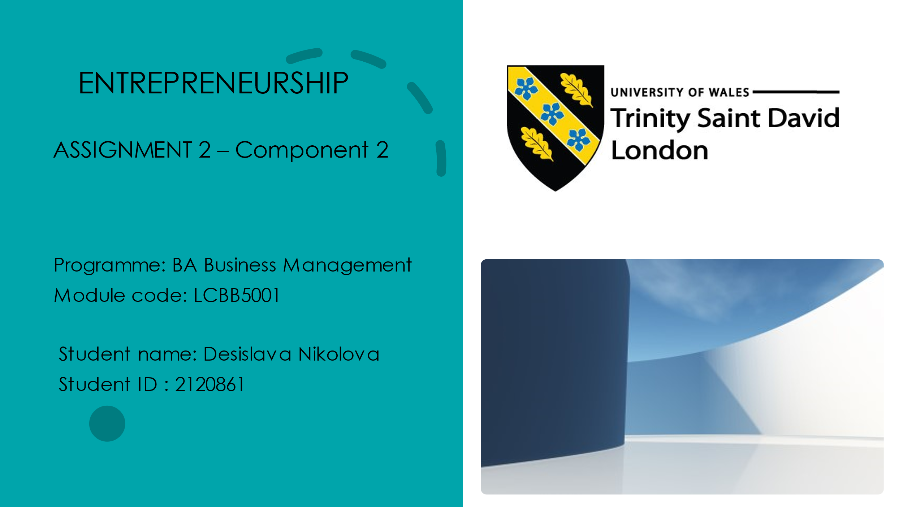

Contents

1. Evaluation of the business idea and the motivational factors 3
2. Five entrepreneurship skills, traits, and behaviors 4
3. SWOT Analysis 5
4. Extensive market research, including PEST analysis 6
5. References: 8

- Evaluation of the business idea and the motivational factors
I offer an overview of a company idea in my presentation. In this report, I will provide an appraisal and further information. To begin, the company concept is about Webstercare, and I represent the primary concept, goods, and services that it offers. Webstercare offers individualized healthcare services. As a result, the company concept corresponds with an increasing need for telehealth services, particularly among the elderly and those suffering from chronic illnesses. Webstercare's emphasis on tailored healthcare programs may improve patient outcomes and satisfaction. Remote monitoring techniques can aid in the early diagnosis of health problems and the prevention of hospital readmissions.
Compliance with healthcare rules and licenses can be complicated, necessitating legal expertise and compliance methods. Some older patients may need to become more familiar with gadgets, which may be a barrier to accessing the possibility for growth into markets with a large aging population and a high demand for specialist healthcare services. Collaborating with healthcare providers, insurance companies, and eldercare institutions can create new income streams. With multiple providers, the digital health sector is competitive. It is critical to distinguish Webstercare's services. Protection of information and the confidentiality of patients are critical, and disruptions can harm the firm's credibility.
Furthermore, various motivating elements have influenced my decision. As the world's population ages, the elderly will require more frequent medical attention. As a result, there is a rising demand for healthcare services that may be accessed remotely to serve this generation. Diabetes and heart disease are becoming more prevalent. Telemedicine can aid with effective and continual chronic illness treatment. Access to health care may be challenging, particularly for persons living in rural or underprivileged locations. Webstercare intends to fill this void. Telemedicine becomes increasingly viable and successful as technology progresses, such as video conferencing and remote monitoring systems.
This business concept I developed for the company solves huge market needs while aligning with demographic and healthcare trends such as an ageing population and an increase in chronic illnesses. Moreover, it is confronted with regulatory, technological, and privacy difficulties (Almeida,2014). However, success will be determined by the capacity to offer high-quality, individualized treatment, handle regulatory constraints, and adequately safeguard patient data. Investigate cooperation and growth options to broaden your reach and effect in the telehealth business.
- Five entrepreneurship skills, traits, and behavior
Firstly, entrepreneurship is a significant source of employment, economic growth, and technological progress. Consequently, entrepreneurship skills have to be improved every day to reach success. Furthermore, entrepreneurship necessitates a mix of abilities, qualities, and behaviors that are required for business prosperity.
The first and most critical skill set combination is innovative thinking and imagination. Thinking creatively is required to produce new ideas, thoughts, and solutions. In contrast, innovation entails transforming these creative ideas into valuable goods, services, or processes (Elanain, 2008). They must work together to retain competitiveness and adapt to changing market conditions. Providing entrepreneurs with the ability to find opportunities, solve challenges, and differentiate their firms from the competition.
Prudence and tenacity are two more skill sets. Entrepreneurs frequently confront uncertainty and risk while starting and running a firm. Taking calculated risks and having the tenacity to recover from failures are essential characteristics demonstrating that the entrepreneur is willing to respond with a solution in a given circumstance. Taking risks is essential to explore chances for growth and success (Austin et al., 2006). Resilience enables entrepreneurs to deal with failures and problems, learn from them, and grow stronger.
Flexibility as well as adaptability is also necessary. The corporate environment cannot help but be dynamic and prone to change in today's fast-changing globe. In order to respond to shifting conditions and market movements, entrepreneurs must adapt and be adaptable. Adaptable entrepreneurs may adjust their company strategy and offers as required, making them more robust to market fluctuations. They can embrace fresh possibilities and overcome uncertainty because they are adaptable.
Problem-solving and decision-making, like various workplace-specific abilities, are essential in entrepreneurship. Entrepreneurs frequently encounter complex challenges and must make critical decisions. On the other hand, strong problem-solving and decision-making abilities require strong judgment and the capacity to assess the pros and disadvantages. Effective problem-solving and decision-making are required to solve operational difficulties, devise strategies, and optimize resource allocation. They help to improve overall business performance.
The final but not least vital skill is social and partnership development. Building and sustaining social media relationships with clients, partners, mentors, and coworkers is essential for entrepreneurs. Effective communication and interpersonal skills are critical (Brooks, 2009). This activity may result in opportunities, partnerships, collaborations, and client loyalty. Strong connections give company support, direction, and access to resources and information.
The above-listed abilities, attitudes, and behaviors are vital for business because they contribute to an entrepreneur's capacity to discover and explore opportunities, cope with problems, and eventually develop a successful and sustainable organization. They allow entrepreneurs to adapt to changing conditions, make educated decisions, and establish strong connections, all of which are crucial to the success of the firm and its long-term development strategy, as well as the accomplishment of goals set from the company's beginning (Vlados et al., 2019).
- SWOT Analysis
It is beneficial for aspiring entrepreneurs to assess their preparation and skills in order to understand their strengths, limitations, opportunities, and dangers. This is feasible to see using SWOT Analysis. They can undertake an evidence-based self-assessment using the example provided in the report.
SWOT Analysis
Strengths | Weaknesses
The entrepreneur must be technologically savvy, including website building and internet marketing. Furthermore, the entrepreneur must strongly lean toward the niche they intend to penetrate, namely outdoor adventure goods. The entrepreneur is known for his strong work ethic and dedication and is eager to put in the required effort to succeed. He has a strong network of contacts, including possible suppliers and fellow fans who may share ideas. | One prominent example is when the entrepreneur has yet to gain experience running a firm, which can lead to business operations and management difficulties. Getting money for initial start-up expenditures is easier when personal financial resources are unrestricted. The e-commerce industry for outdoor goods is very competitive, with established firms and higher budgets. Because the entrepreneur lacks extensive marketing expertise, he or she may need help to develop practical marketing efforts.
Opportunities | Threats
Online purchasing is becoming more popular, particularly for specialist items like outdoor gear. The entrepreneur's concept is aligned with the rising emphasis on eco-friendly and sustainable products. On the other hand, using local suppliers for distinctive and original items may help firms stand out. Taking advantage of peak adventure season's seasonal demand for outdoor goods. | During economic downturns, consumer expenditure on non-essential products, such as outdoor gear, might be reduced. Established e-commerce behemoths and specialized competitors may need help to obtain market share. Product availability can be impacted by global supply chain disruptions such as delivery delays or material shortages. Compliance issues arise when e-commerce legislation, taxes, and environmental requirements evolve.
- Extensive market research, including PEST analysis
It is a good idea to include a comprehensive market study in the report, such as a PEST analysis, because it includes the political, economic, social, and technical variables that may assist in educating judgments regarding prospective expansion in the UK market.
First of all, let us start with the political issue. The United Kingdom enjoys a stable political climate and a well-established democratic system. The United Kingdom's withdrawal from the European Union may influence commercial ties, leading to additional agreements regarding trade. As a result, businesses must adhere to UK-specific legislation and requirements.
On the other hand, economic considerations offer the UK a mature and stable economy, yet uncertainties regarding the economy may exist due to global events. Exchange rate fluctuations can impact the profitability of enterprises that trade globally (Baumol, 1968). As a result, the United Kingdom has an extensive consumer base with a high income for each individual.
Social variables in a globally varied culture necessitate a comprehensive grasp of consumer preferences. Consumer trends are part of health, and consumers are growing more concerned with sustainability, influencing product selection (Auersweld, 2009). The UK's aging population creates possibilities in healthcare and associated businesses.
High internet prevalence results from technological causes, and tech-savvy consumers make e-commerce and digital marketing essential. The United Kingdom is a center for innovation and R&D in various industries, providing collaboration opportunities. Enterprises that handle customer information are subject to onerous confidentiality standards.
Despite all the obstacles of political and economic unpredictability, the UK's stable climate, customer base, and technology infrastructure make it an attractive choice. Adapting to local customer tastes, complying with legislation, and building meaningful custom agreements will prove critical to success.

- References:
- Abu Elanain. (2008). An investigation of the relationship of openness to experience and organizational citizenship behaviour, Journal of American Academy of Business, 13, 1, pp. 72-78.
- Almeida (2014). Who Wants to Be an Entrepreneur? The Relationship between Vocational Interests and Individual Differences in Entrepreneurship. Journal of Career Assessment.
- Auersweld, P. (2009). Creating social value, Stanford Social Innovation Review, 7,2, pp. 51-55.
- Austin, J., Stevenson, H. And Wei-Skillern, J. (2006). Social and commercial Entrepreneurship: Same, different or Both?, Entrepreneurship Theory and Practice, 30,1, pp. 1-22.
- Baumol, W.J. (1968). Entrepreneurship in economic theory, The American Economic Review, 58, 2, pp. 64-71.
- Brooks, A. C.(2009). Social Entrepreneurship: A Modern Approach to Social Venture Creation, Person International Edition, New Jersey.
- Charis Vlados & Dimos Chatzinikolaou. (2019). Methodological Redirections for an Evolutionary Approach of the External Business Environment. Journal of Management and Sustainability, Vol. 9, No. 2, pp. 25-46.

