Analysis of Electromagnetic Wave Propagation
ACDC5009
Luke Malcolm (2030773)
2025

Abstract
This report details two distinct simulations. In the first simulation, a rectangular waveguide of dimensions 20mm x 15mm x 50mm was examined in both vacuum and Teflon filled form, and the cutoff frequencies for each mode were determined. The dominant mode was found to be the TE₁₀ mode in both instances (which is always correct for a rectangular waveguide [1] with cutoff frequencies of 7.5GHz and 5.15GHz respectively. This model was verified using theoretical calculations and the results were found to be a good match
In the second simulation, a half-wave dipole antenna was designed and assessed. The antenna was found to have good performance and an omnidirectional radiation pattern, making it useful in short range or local communications networks. The calculated and simulated operating frequency values were found to be different enough that further investigation is warranted, which is beyond the scope of this paper.

Contents
Abstract 1
Table of Figures 3
1. Waveguides Information 4
2. Task Methodology 4
3. Task 1a Results – Vacuum Fill 5
3.1 Task 1a Discussion & Calculations 14
3.1.1 Cutoff Frequency 14
3.1.2 Dominant Mode 15
4. Task 1b Results – Teflon Fill 16
4.1 Task 1b Discussion & Calculations 24
4.1.1 Cutoff Frequency [6] 24
4.1.2 Dominant Mode 26
5. Waveguide Results Discussion 26
6. Dipole Antennas 26
7. Task 2 – Half-Wave Dipole Antenna 27
7.1 Half-Wave Dipole Antenna Results 28
7.2 Task 2 Discussion & Calculations 29
7.2.1 Antenna Operating (Resonant) Frequency 29
7.3 Antenna Radiation Pattern 30
8. Conclusion 30
References 32

Table of Figures
Figure 1 - Rectangular Waveguide Sections [3] 4
Figure 2 - Model of Waveguide Section 6
Figure 3 - Vacuum, Port 1, Mode 1 6
Figure 4 - Vacuum, Port 1, Mode 2 7
Figure 5 - Vacuum, Port 1, Mode 3 7
Figure 6 - Mode 1, Electric Magnitude 8
Figure 7 - Mode 1, Electric Vector 8
Figure 8 - Mode 1, Magnetic Magnitude 9
Figure 9 - Mode 1, Magnetic Vector 9
Figure 10 - Mode 1, Electric Magnitude 10
Figure 11 - Mode 2, Electric Vector 10
Figure 12 - Magnetic Magnitude 11
Figure 13 - Mode 2, Magnetic Vector 11
Figure 14 - Mode 3, Electric Magnitude 12
Figure 15 - Mode 3, Electric Vector 12
Figure 16 - Mode 3, Magnetic Magnitude 13
Figure 17 - Mode 3, Magnetic Vector 13
Figure 18 – Rectangular Waveguide Cutoff Frequency Plot 14
Figure 19 - Cutoff Frequencies - Vacuum 14
Figure 20 - Mode 1 Marker 16
Figure 21 - Port 1, Mode 1 17
Figure 22 - Port 1, Mode 2 17
Figure 23 - Port 1, Mode 3 18
Figure 24 – Mode 1, Electric Magnitude 18
Figure 25 – Mode 1, Electric Vector 19
Figure 26 - Mode 1, Magnetic Magnitude 19
Figure 27 - Mode 1, Magnetic Vector 20
Figure 28 - Mode 2, Electric Magnitude 20
Figure 29 - Mode 2, Electric Vector 21
Figure 30 - Mode 2, Magnetic Magnitude 21
Figure 31 - Mode 2, Magnetic Vector 22
Figure 32 - Mode 3, Electric Magnitude 22
Figure 33 - Mode 3, Electric Vector 23
Figure 34 - Mode 3, Magnetic Magnitude 23
Figure 35 - Mode 3, Magnetic Vector 24
Figure 36 - Rectangular Cutoff Frequency Plot 24
Figure 37 - Cutoff Frequencies – Teflon 25
Figure 38 - Large Dipole Antenna [13] 28
Figure 39 - Antenna Model 29
Figure 40 – Half-Wave Dipole Antenna 3D Gain Plot 29
Figure 41 - 2D Gain Plot 30
Figure 42 – Half-Wave Dipole Antenna S-Parameter Plot 30

Waveguides Information
Waveguides are structures that are intended to:
- Contain and direct electromagnetic waves down a particular course
- Transmit frequencies with minimal losses and degradation
- Transport electromagnetic energy with high efficiency [2]:
Waveguides are used in a variety of high-power RF systems, including radar and communications infrastructure. A selection of rectangular waveguides is shown in Figure 1.
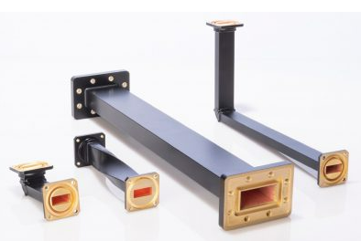
Figure 1 - Rectangular Waveguide Sections [3]
Waveguides are often hollow and filled with either vacuum, dielectric material or dry pressurised air or a similar gas. In most instances, pressurised air is used as it is comparatively straightforward to manage - this prevents any conductive moisture from entering the waveguide, slows the oxidation of the waveguide components, and helps to prevent arcing at very high power levels [4]. Generally, the aspect ratio (width to height) is 2:1 to prevent generation of any field variations within the height and any unwanted modes.

Task Methodology
The Ansys Electronic Desktop tool was used to design a rectangular waveguide made of Perfect Electrical Conductor (PEC). In task 1a, the waveguide was filled with a vacuum. In task 1b, the waveguide was filled with Teflon. The relative permeability of the Teflon was 1 and the relative permittivity is 2.1 (these figures were provided in the task brief).
The dimensions – all given in millimetres - of the waveguide were derived from the author’s student number (2030773) as follows:

$x= first two numbers of the student ID$ = 20mm
$y=$ $\frac{3rd and 4th number of the student ID}{2}$ (rounded to the nearest integer) = 15mm
$$z=50$$

Waveguide ports were assigned as wave ports 1 and 2 (at each end of the model). Three modes were assigned.
The frequency sweep was set across a relatively wide range of 2GHz to 30GHz to ensure capture of the cutoff frequency.
Cutoff frequencies obtained for each mode were compared to values derived from the empirical calculations. The dominant mode was also identified.
Magnitudes and vectors of both electronic and magnetic fields were obtained using the Ansys Electronic Desktop software.
A picture of the model is given in Figure 2. It is important to note that this waveguide differs from the usual desirable 2:1 aspect ratio [1] [2] [5] and would not be used in practice.
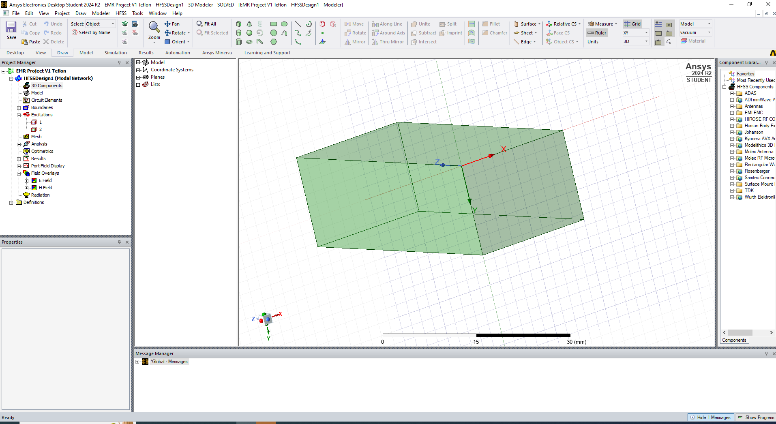
Figure 2 - Model of Waveguide Section

Task 1a Results – Vacuum Fill
Figures 3 through 19 show the results obtained from the HFSS simulation on the vacuum-filled waveguide.

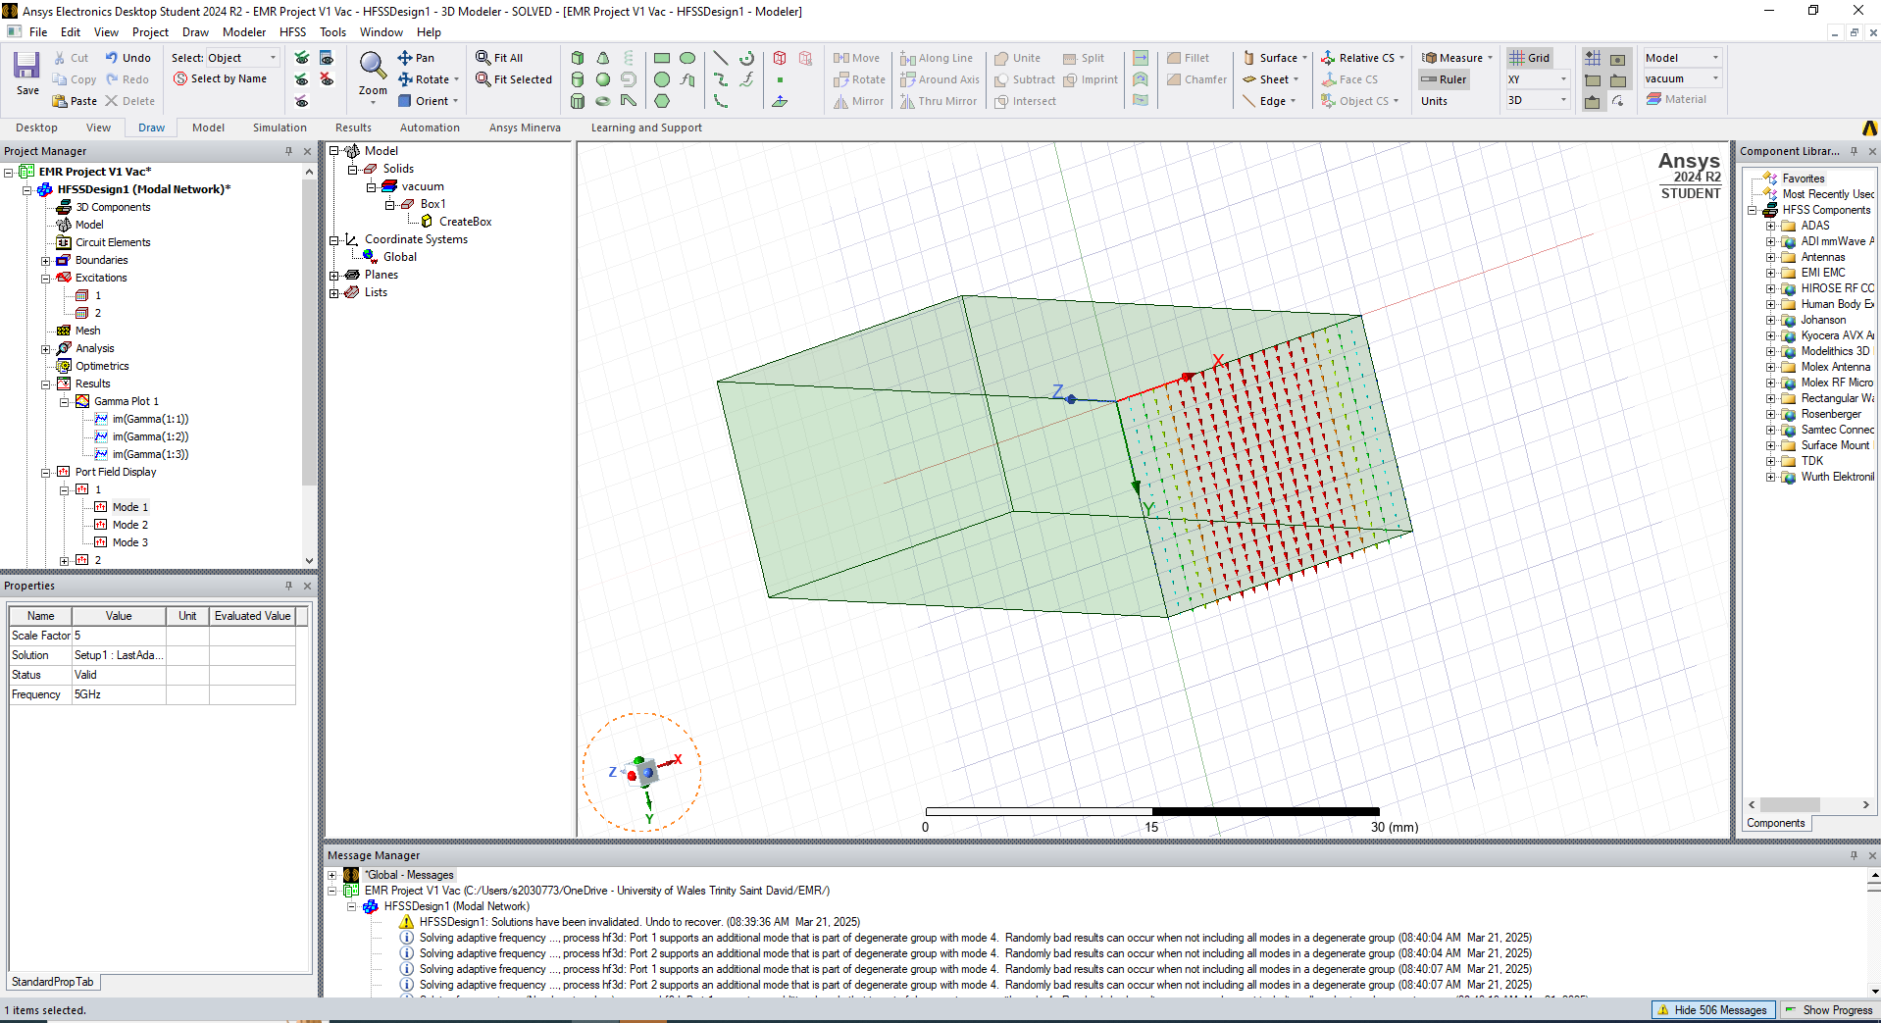
Figure 3 - Vacuum, Port 1, Mode 1
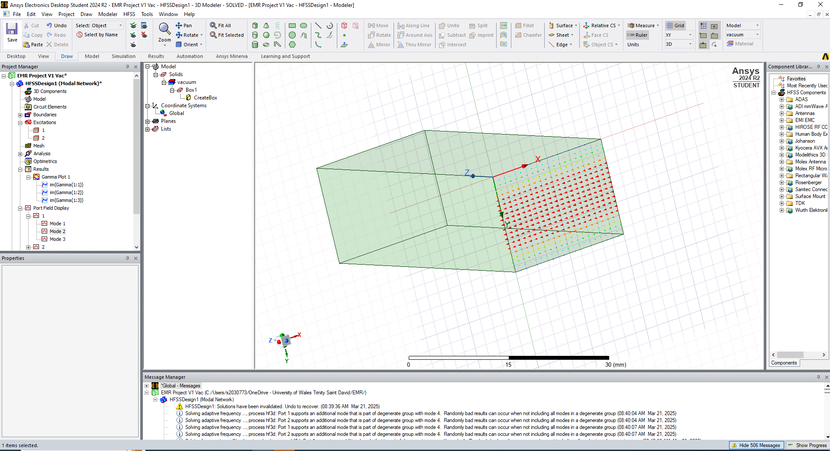
Figure 4 - Vacuum, Port 1, Mode 2
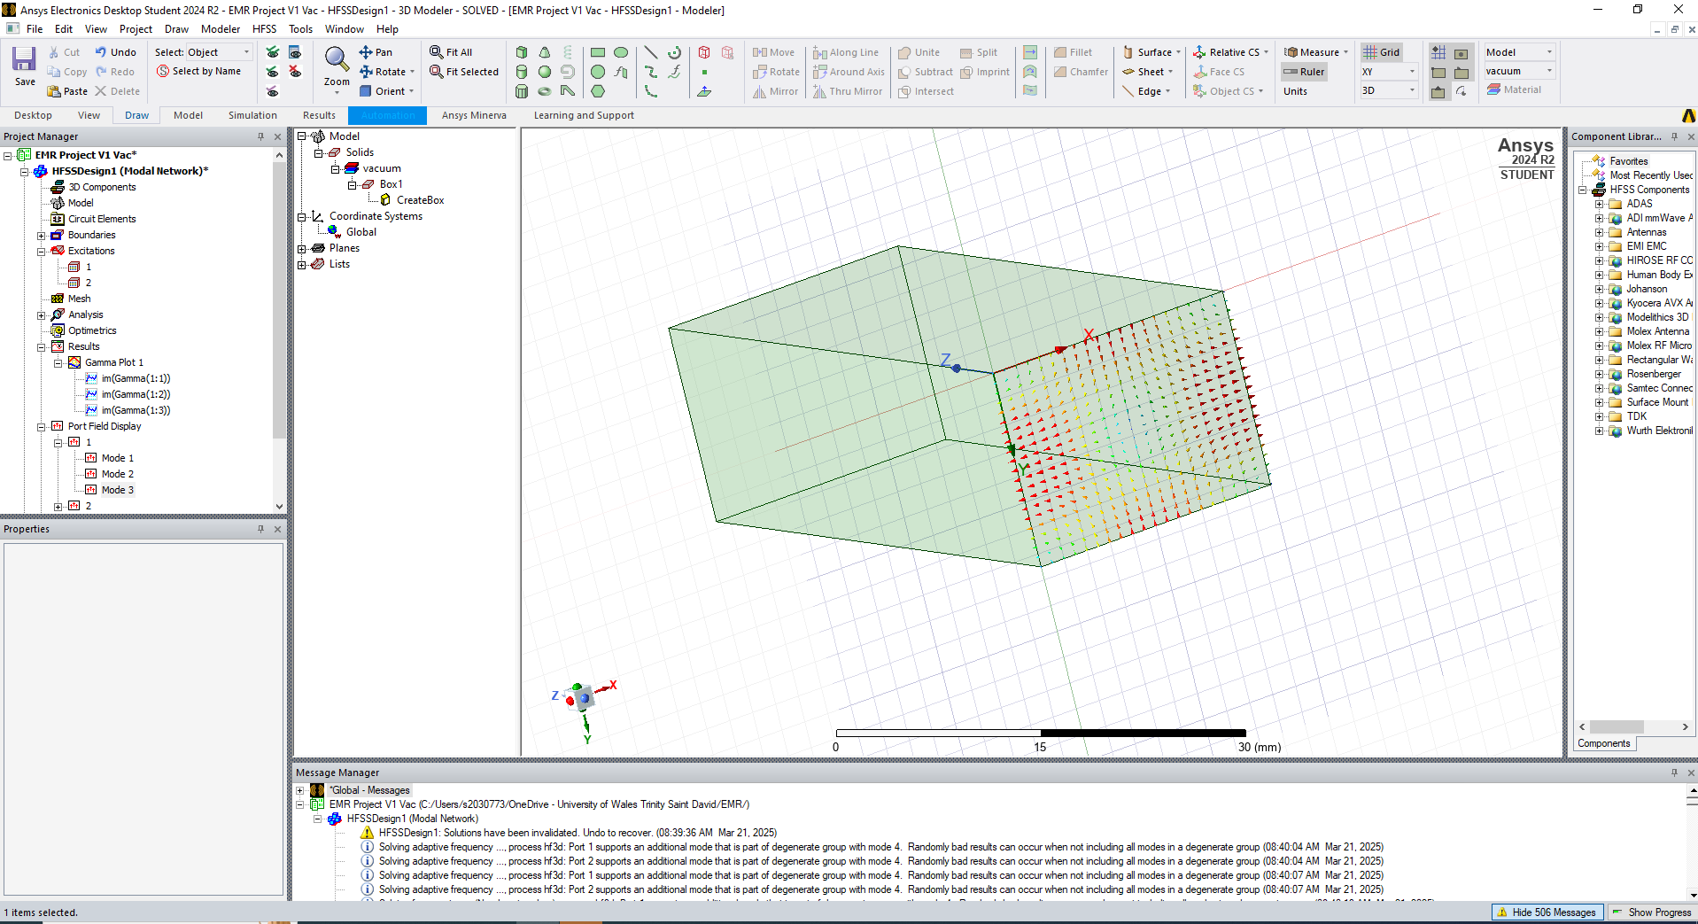
Figure 5 - Vacuum, Port 1, Mode 3

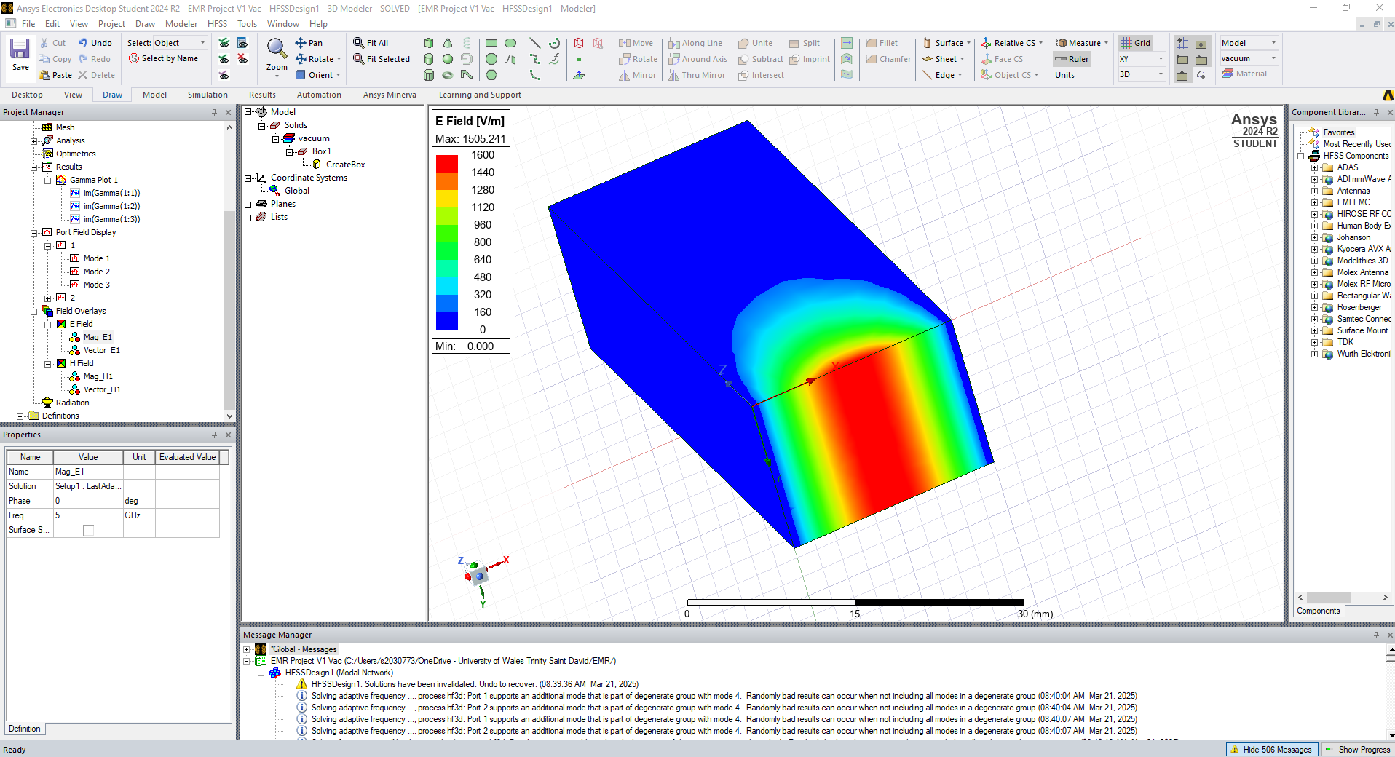
Figure 6 - Mode 1, Electric Magnitude
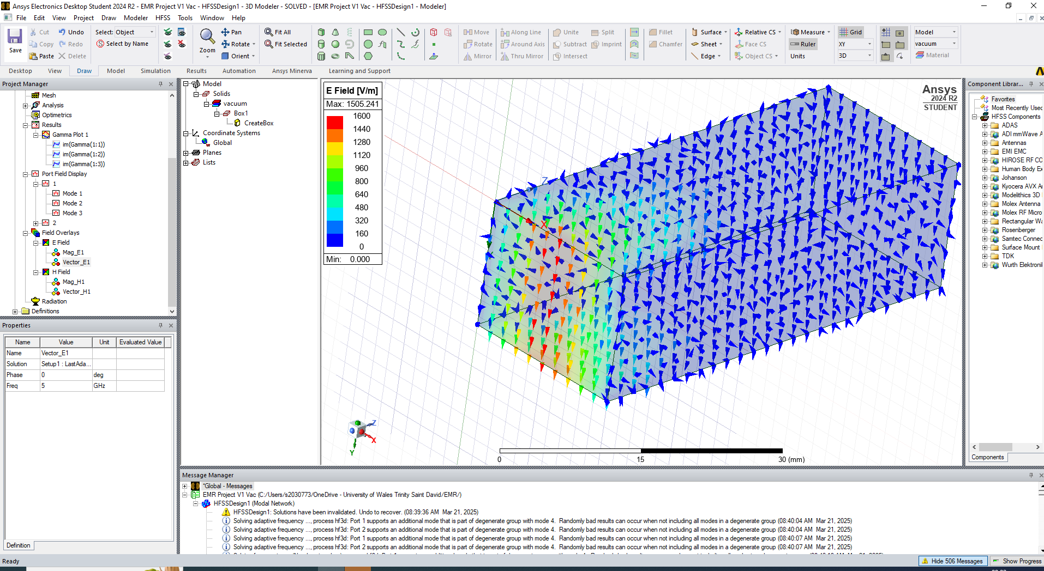
Figure 7 - Mode 1, Electric Vector
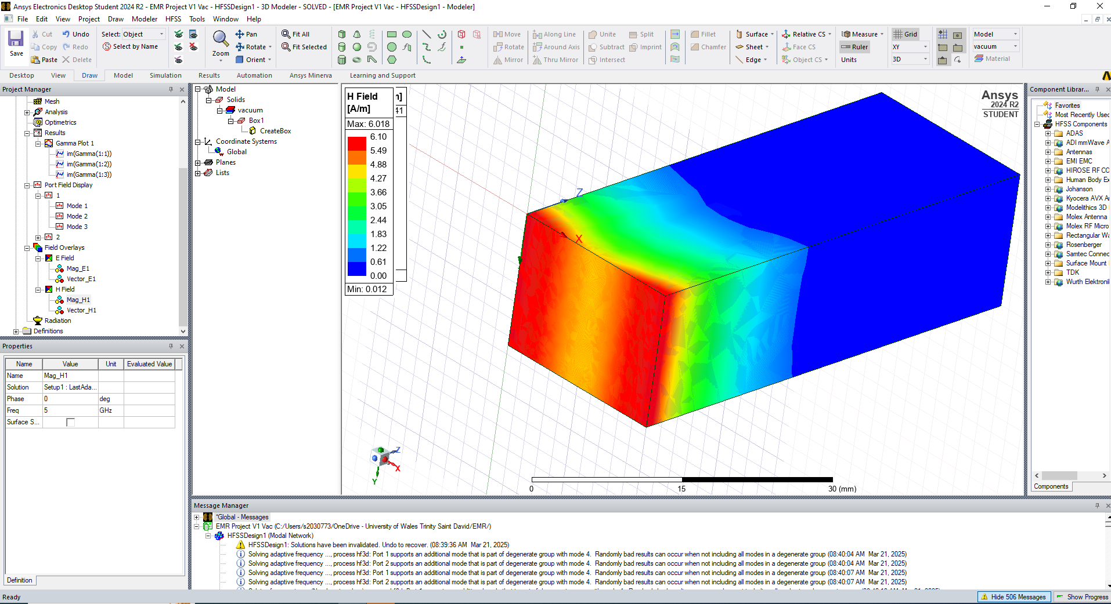
Figure 8 - Mode 1, Magnetic Magnitude
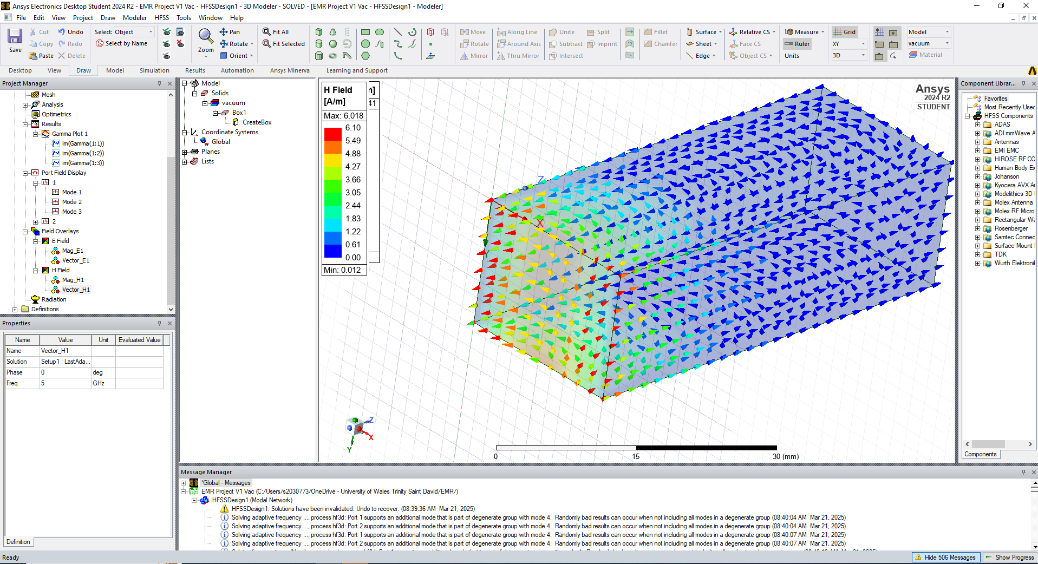
Figure 9 - Mode 1, Magnetic Vector
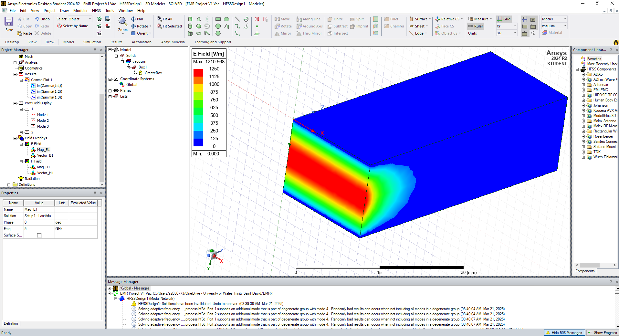
Figure 10 - Mode 1, Electric Magnitude
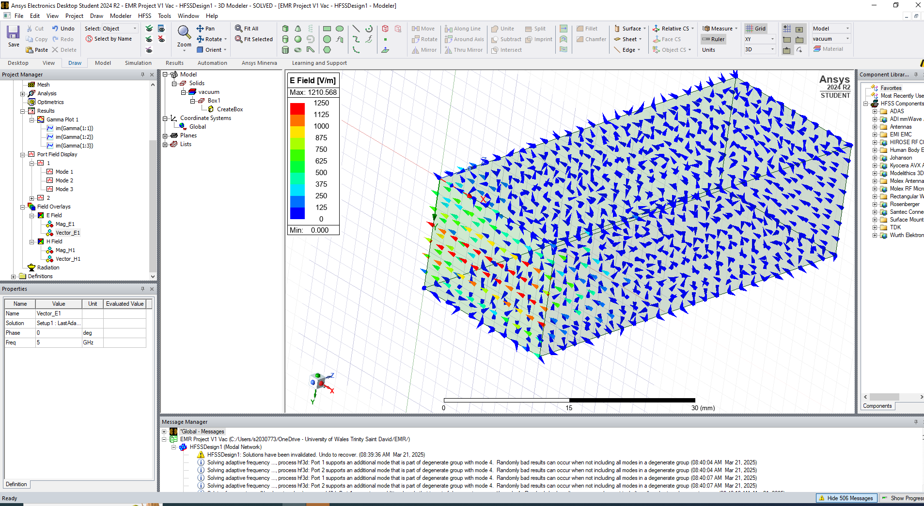
Figure 11 - Mode 2, Electric Vector
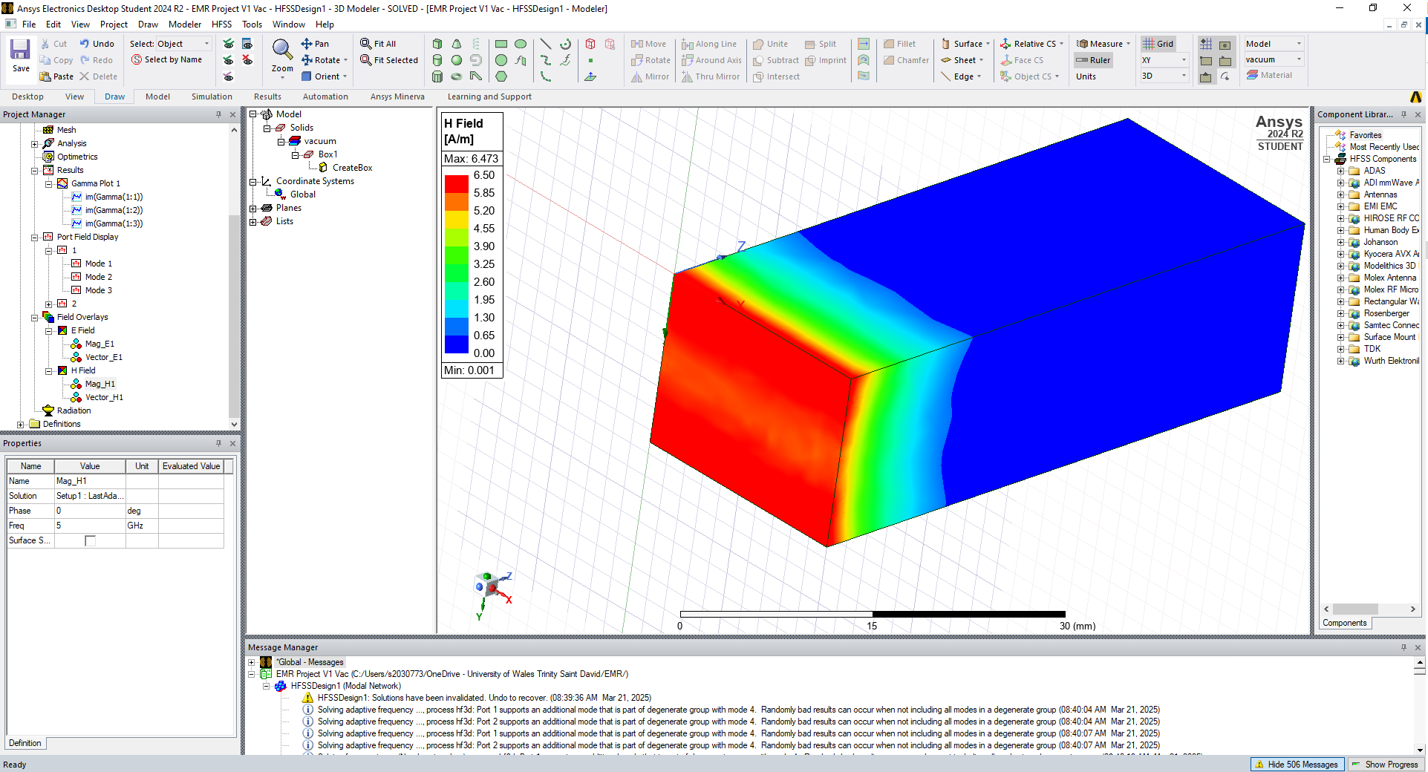
Figure 12 - Magnetic Magnitude
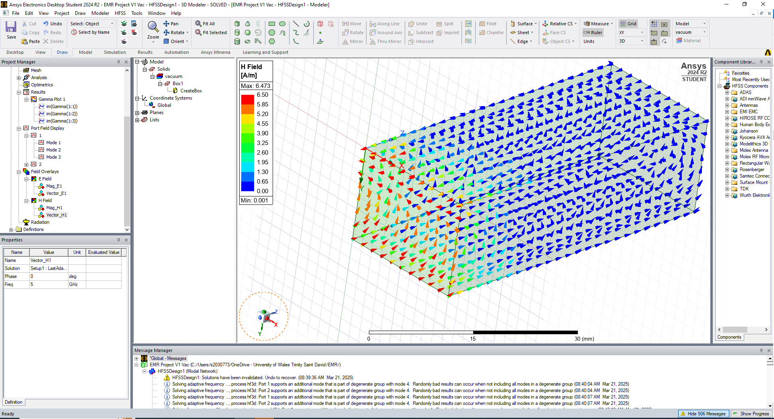
Figure 13 - Mode 2, Magnetic Vector
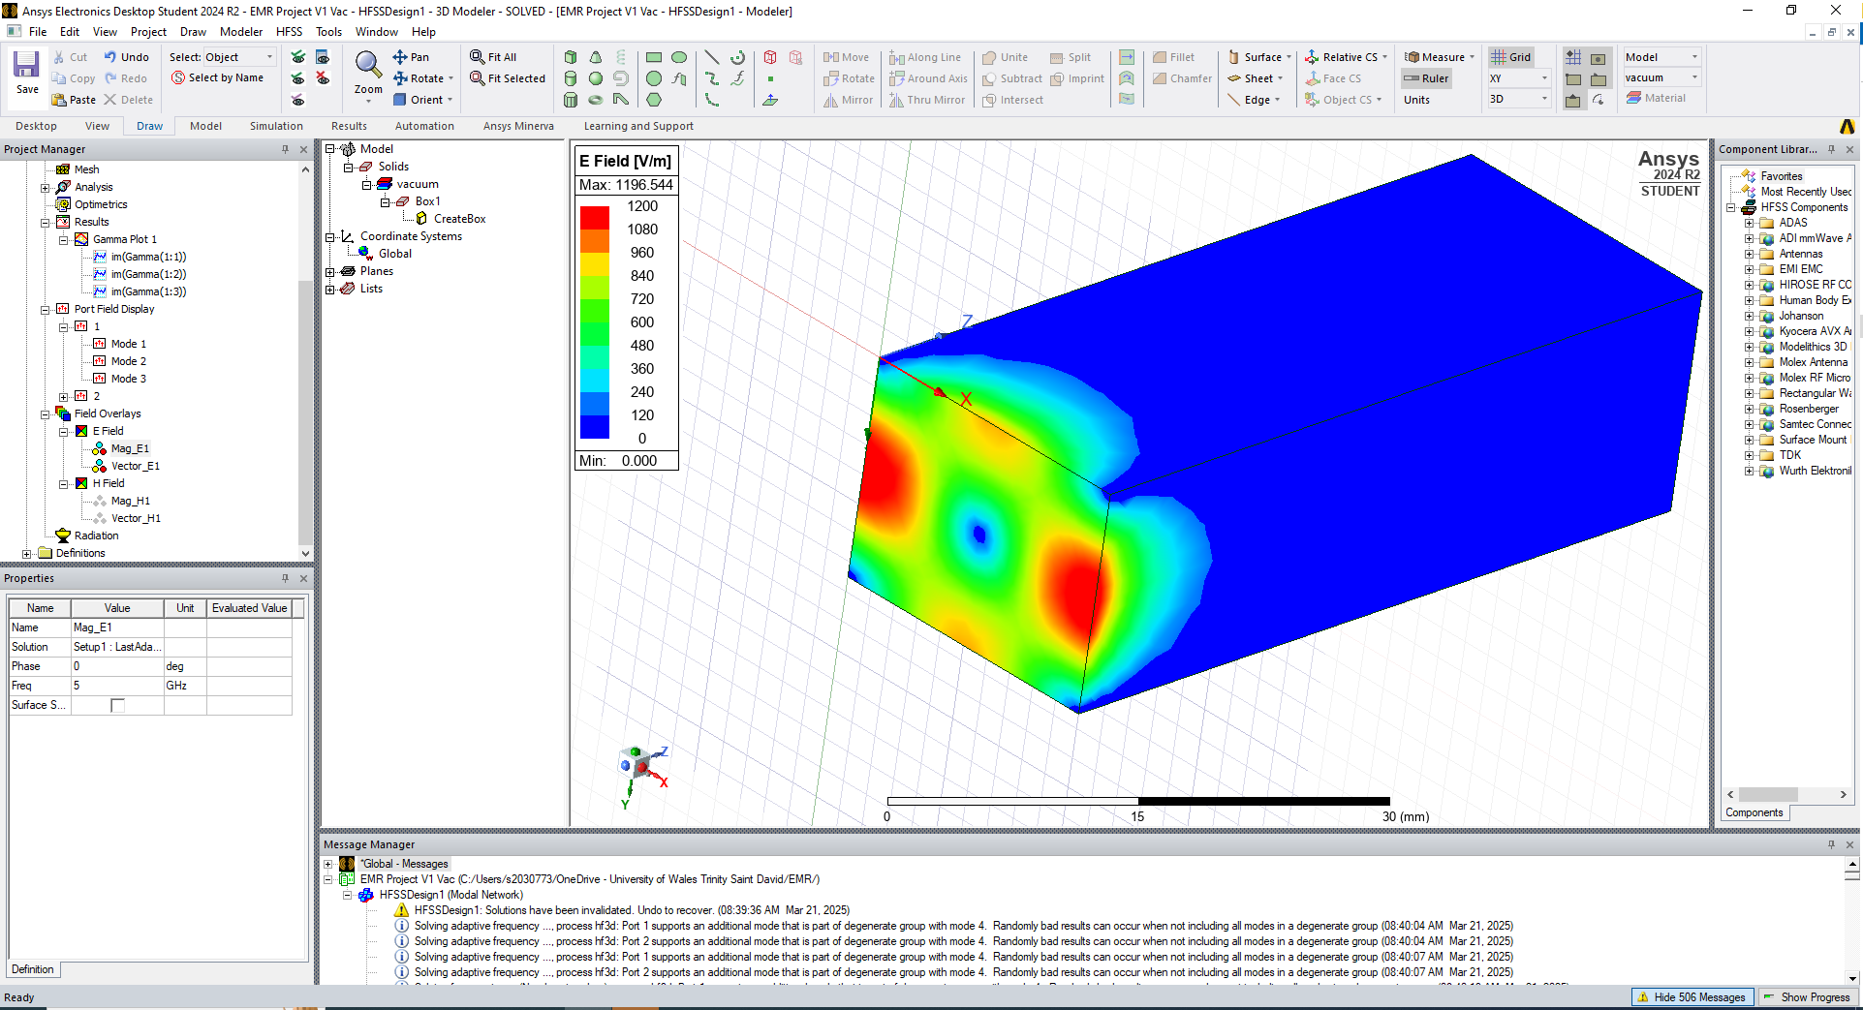
Figure 14 - Mode 3, Electric Magnitude
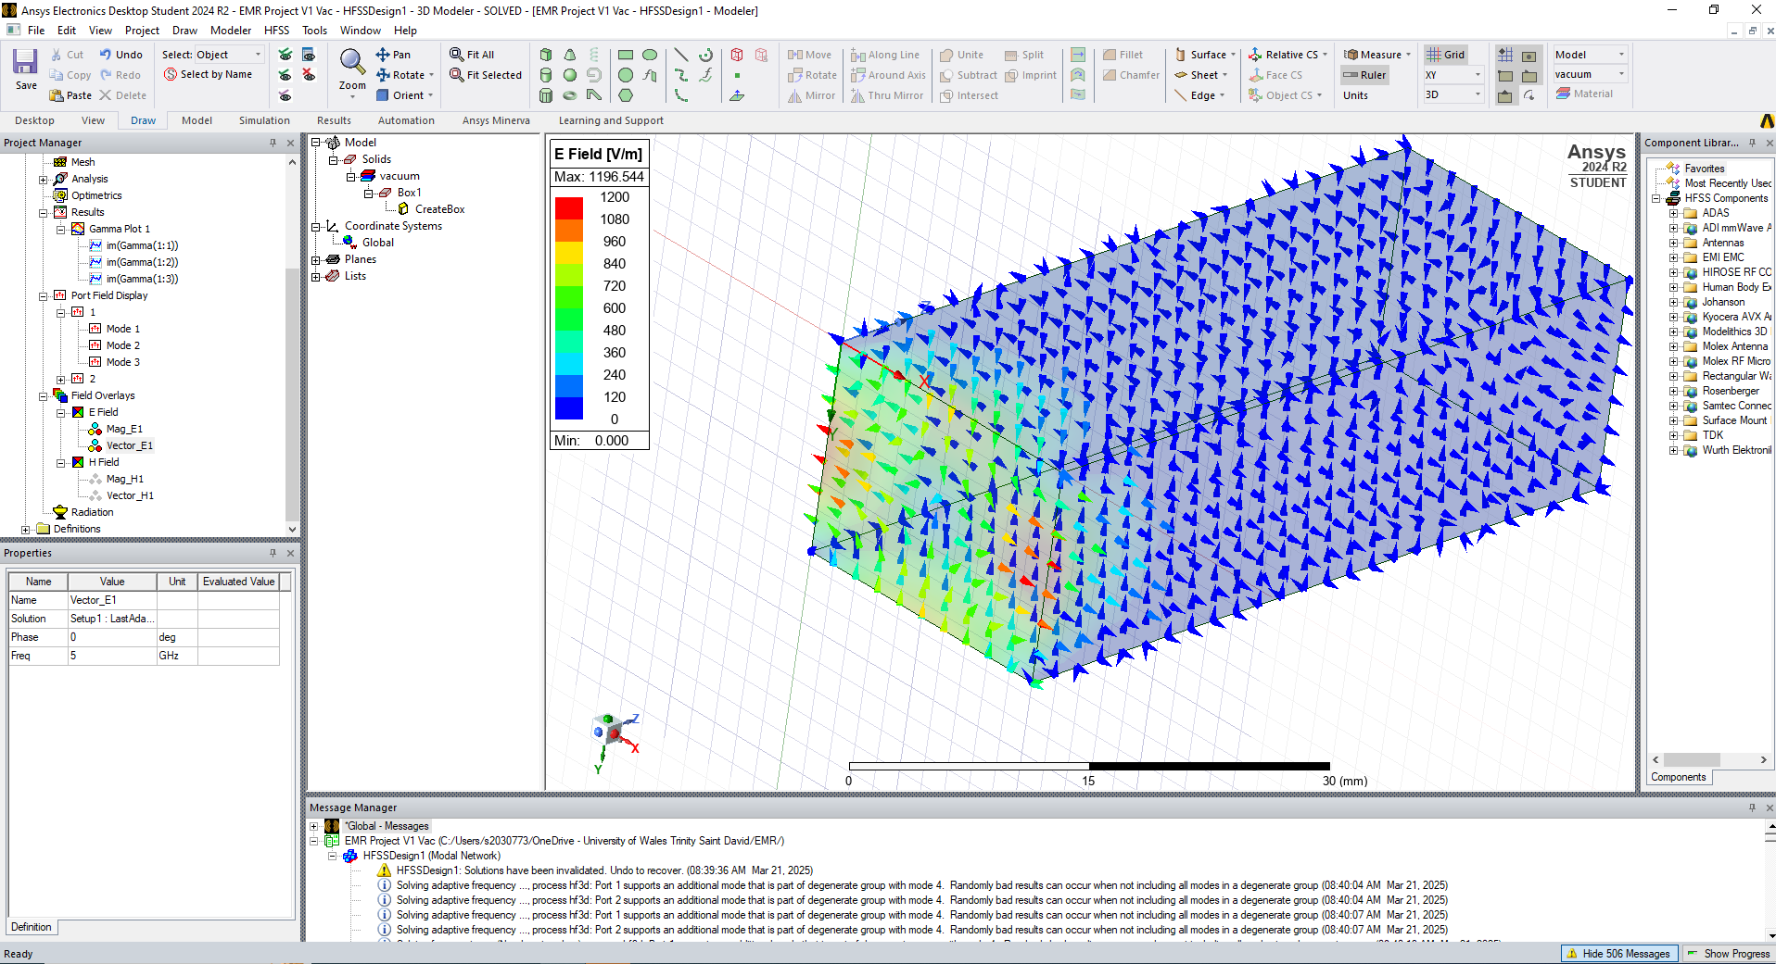
Figure 15 - Mode 3, Electric Vector
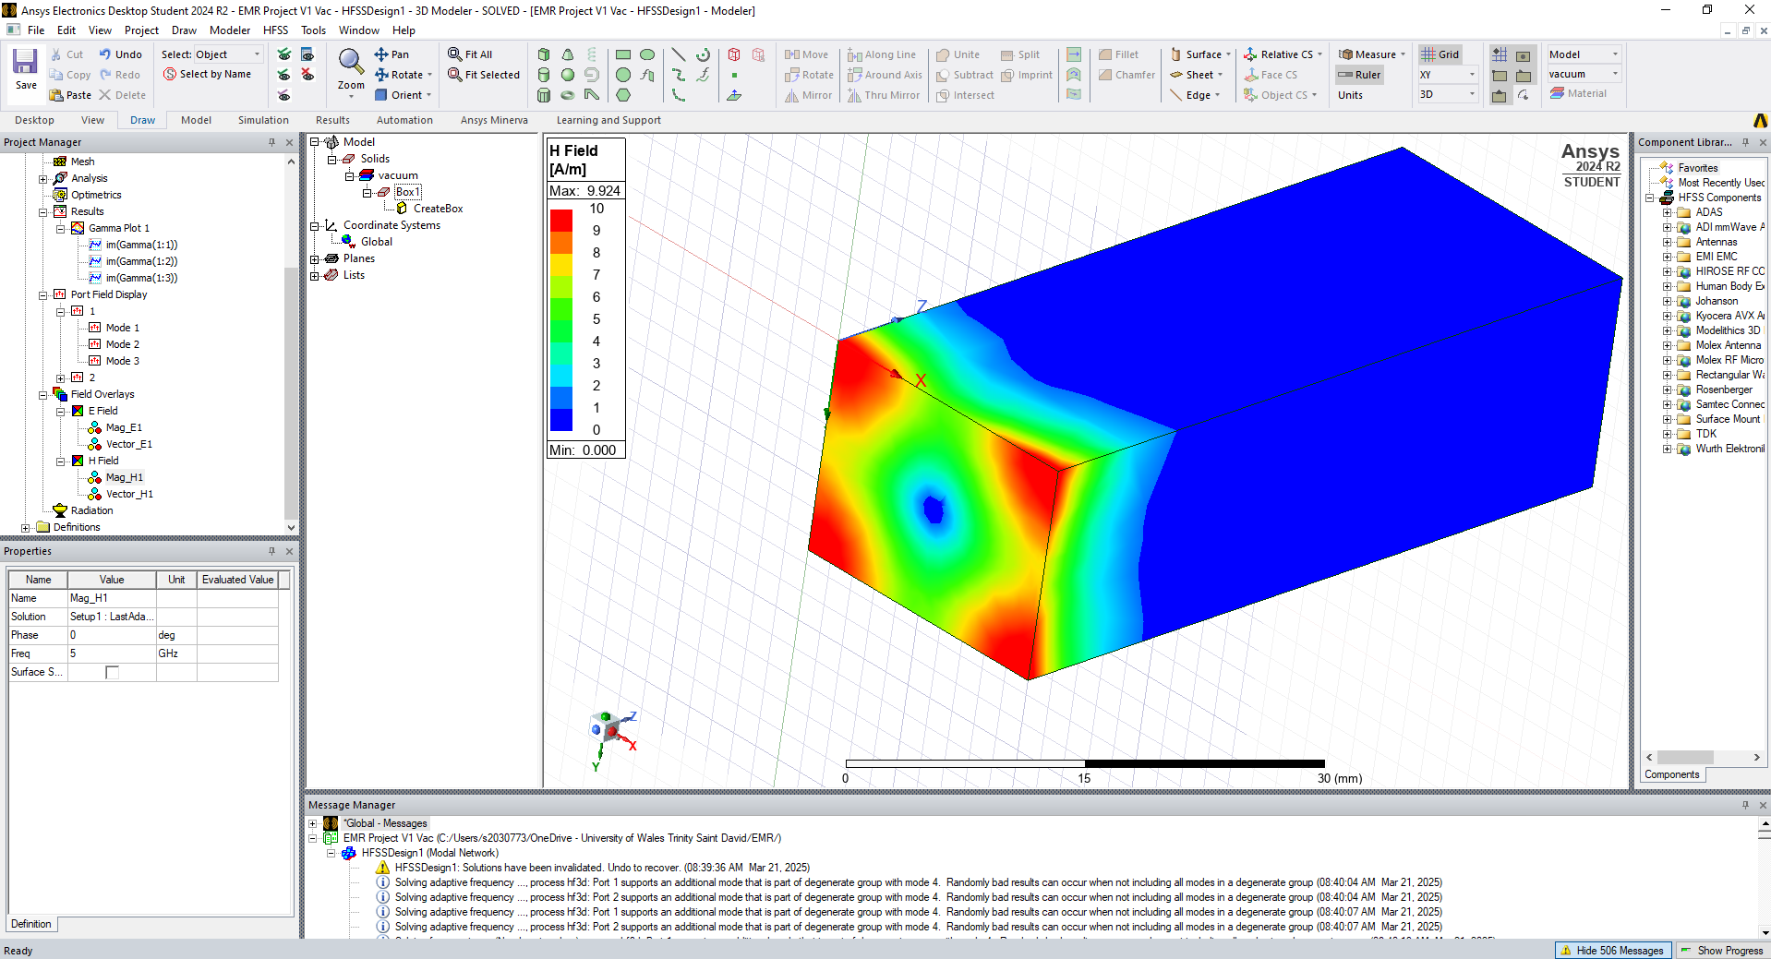
Figure 16 - Mode 3, Magnetic Magnitude
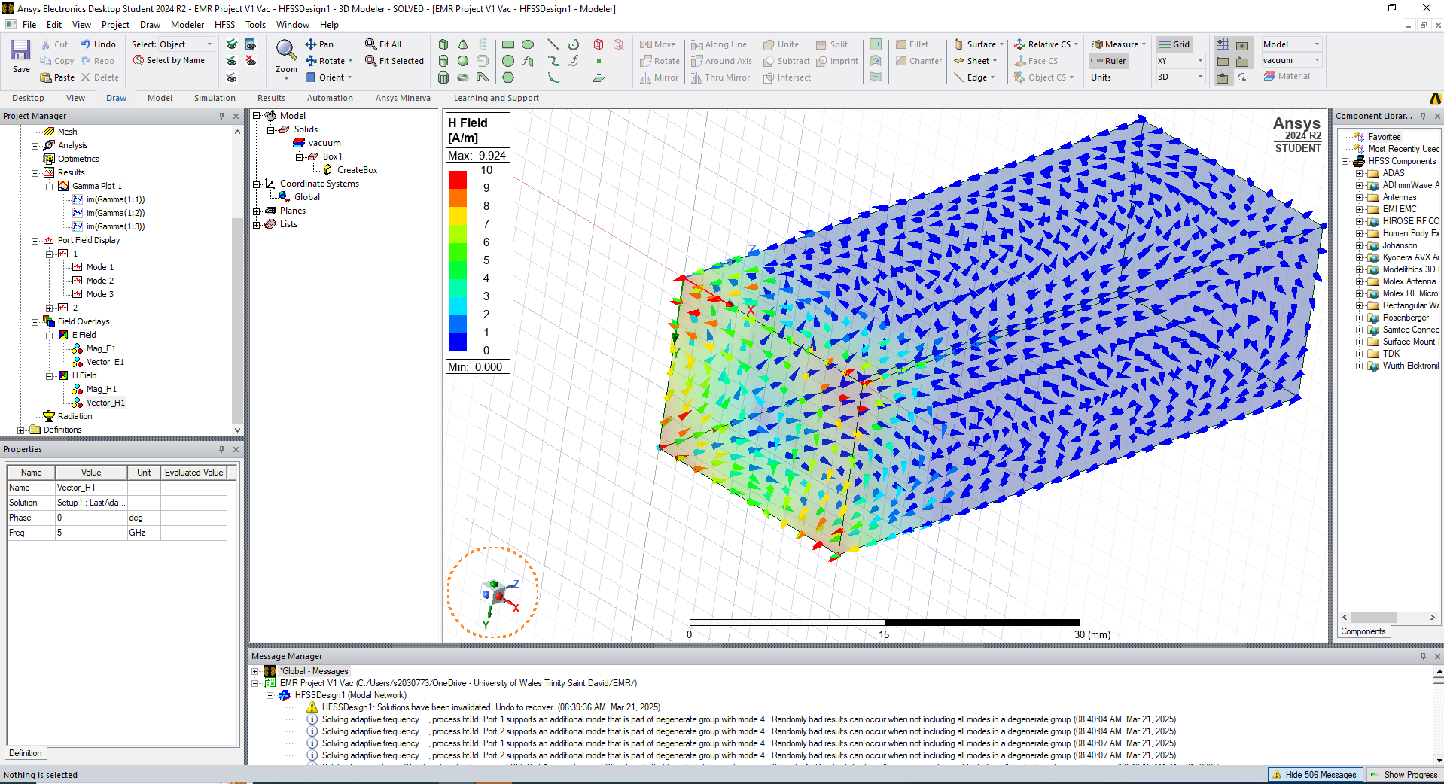
Figure 17 - Mode 3, Magnetic Vector
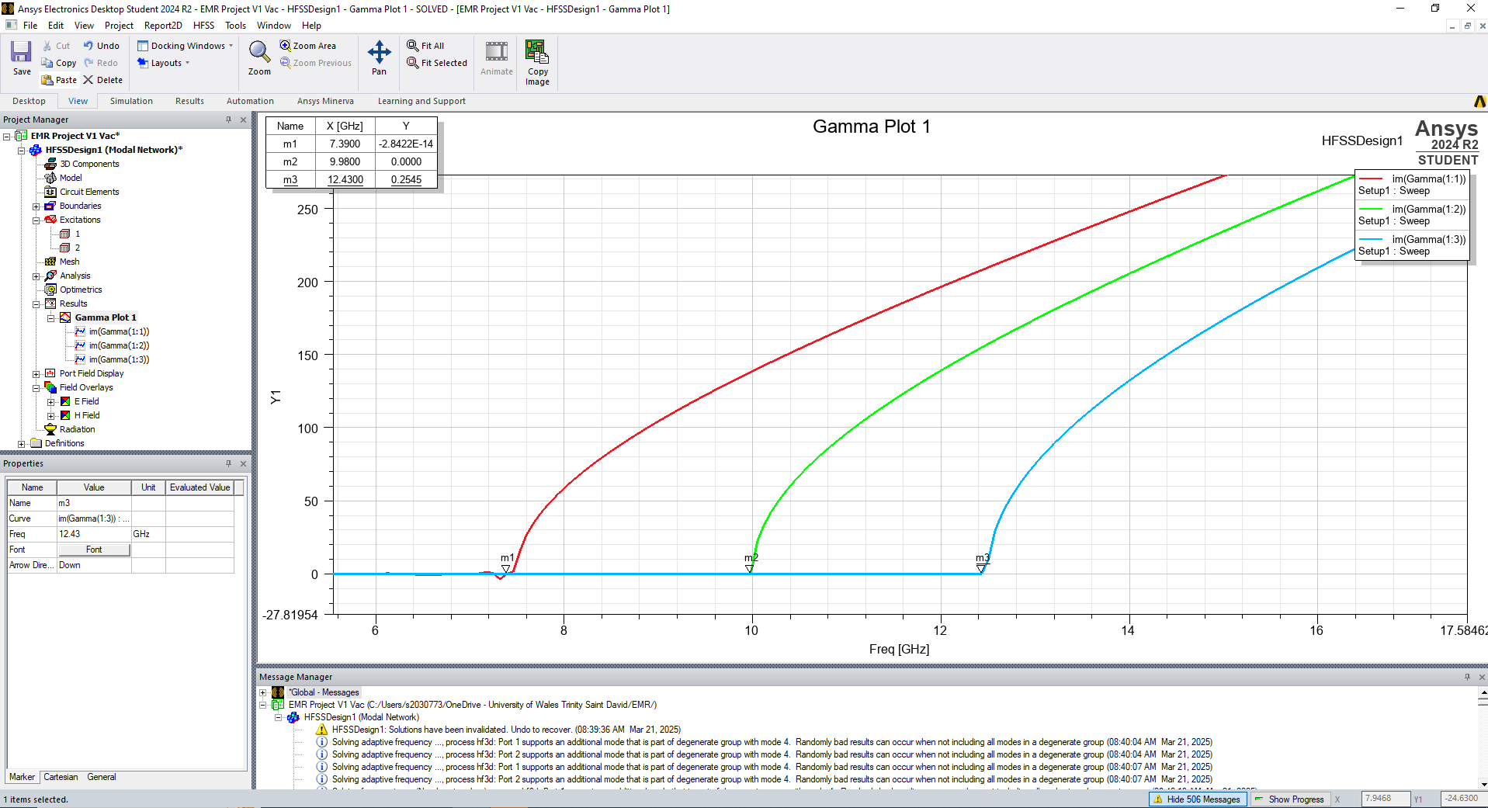
Figure 18 – Rectangular Waveguide Cutoff Frequency Plot
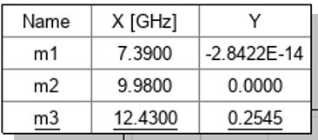
Figure 19 - Cutoff Frequencies - Vacuum

3.1 Task 1a Discussion & Calculations

3.1.1 Cutoff Frequency
The cutoff frequencies depicted in the rectangular plot are shown in Figure 19.
The cutoff frequency of the waveguide can be calculated using Equation 1, given below [6]:

$$\begin{aligned}F_{c}=\frac{c}{2}\sqrt{{\left(\frac{m}{a}\right)}^{2}+{\left(\frac{n}{b}\right)}^{2}}\#\left(Equation 1\right)\end{aligned}$$

$F_{c}$ = Cutoff frequency (Hz)
$C$ = Speed of light in the transmission medium (vacuum - 3x10⁸ m/s)
$m$ = Number of half-wavelength variations of the electric or magnetic field in the width of the waveguide
$n$ = Number of half-wavelength variations of the electric or magnetic field in the height of the waveguide
$a$ = Width of waveguide (m)
$b$ = Height of waveguide (m)

Modes:
The modes can be ascertained from Figure 2, Figure 3, and Figure 4.
In Figure 2, there is one half-wavelength across the width of the port (TE₁₀)
In Figure 3, there is one half-wavelength across the height of the port (TE₀₁)
In Figure 4, there is one half-wavelength across both the width and height of the port (TE₁₁)

Mode 1 (TE₁₀)
$$F_{c}=\frac{3∙{10}^{8}}{2}\sqrt{{\left(\frac{1}{0.02}\right)}^{2}+{\left(\frac{0}{0.015}\right)}^{2}}=7.5e9=7.5GHz$$
Mode 2 (TE₀₁)
$$F_{c}=\frac{3∙{10}^{8}}{2}\sqrt{{\left(\frac{0}{0.02}\right)}^{2}+{\left(\frac{1}{0.015}\right)}^{2}}=1e10=10GHz$$
Mode 1 (TE₁₁)
$$F_{c}=\frac{3∙{10}^{8}}{2}\sqrt{{\left(\frac{1}{0.02}\right)}^{2}+{\left(\frac{1}{0.015}\right)}^{2}}=1.25e10=12.5GHz$$

The results calculated above were compared to the results given by the Ansys simulation:

Table 1 - Cutoff Frequency Comparison for Vacuum-Filled Waveguide
Waveguide Cutoff Frequencies – Vacuum Fill
Mode | Simulation Result (GHz) | Calculated Result (GHz)
Mode 1 | 7.39 | 7.5
Mode 2 | 9.98 | 10
Mode 3 | 12.43 | 12.5

It can be seen from Table 1 that there is relatively good agreement between the calculations and the simulations. There is slightly more discrepancy between the results in mode 1, but this is likely due to the exact placement of the marker. If the marker is placed at the point indicated by the blue circle, this gives a result of 7.48GHz which is a better match to the calculated value.
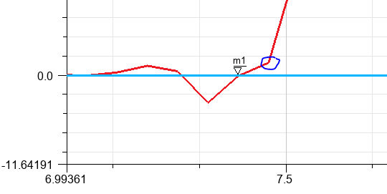
Figure 20 - Mode 1 Marker

3.1.2 Dominant Mode
The dominant mode is defined as the mode It is the lowest-order mode that can be supported by the waveguide for a given frequency or wavelength. It has the lowest cutoff frequency [6]. The dominant mode in this instance is the TE₁₀ mode, with a 7.5GHz cutoff frequency.

4. Task 1b Results – Teflon Fill
Figures 21 through 37 show the results obtained from the HFSS simulation on the Teflon-filled waveguide.
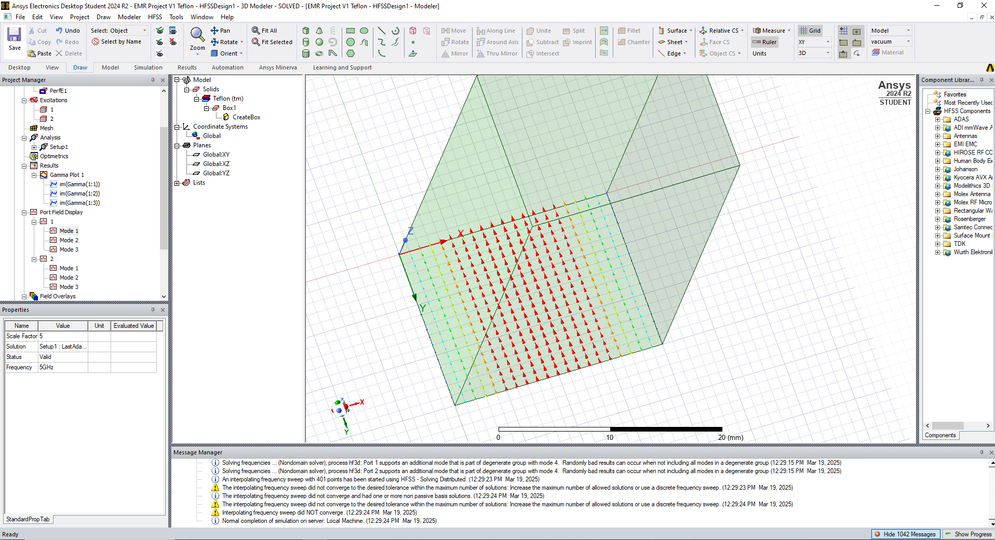
Figure 21 - Port 1, Mode 1
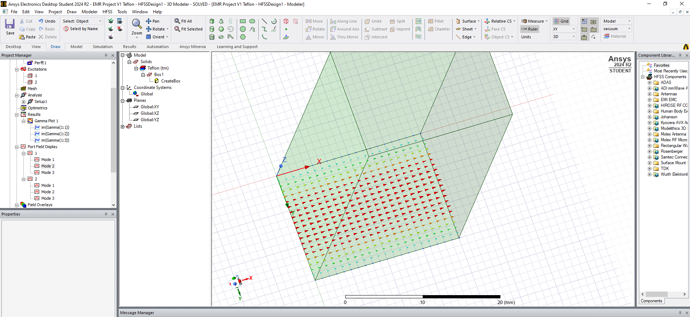
Figure 22 - Port 1, Mode 2
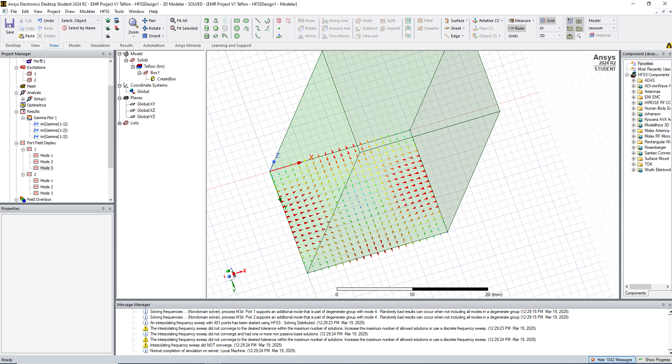
Figure 23 - Port 1, Mode 3
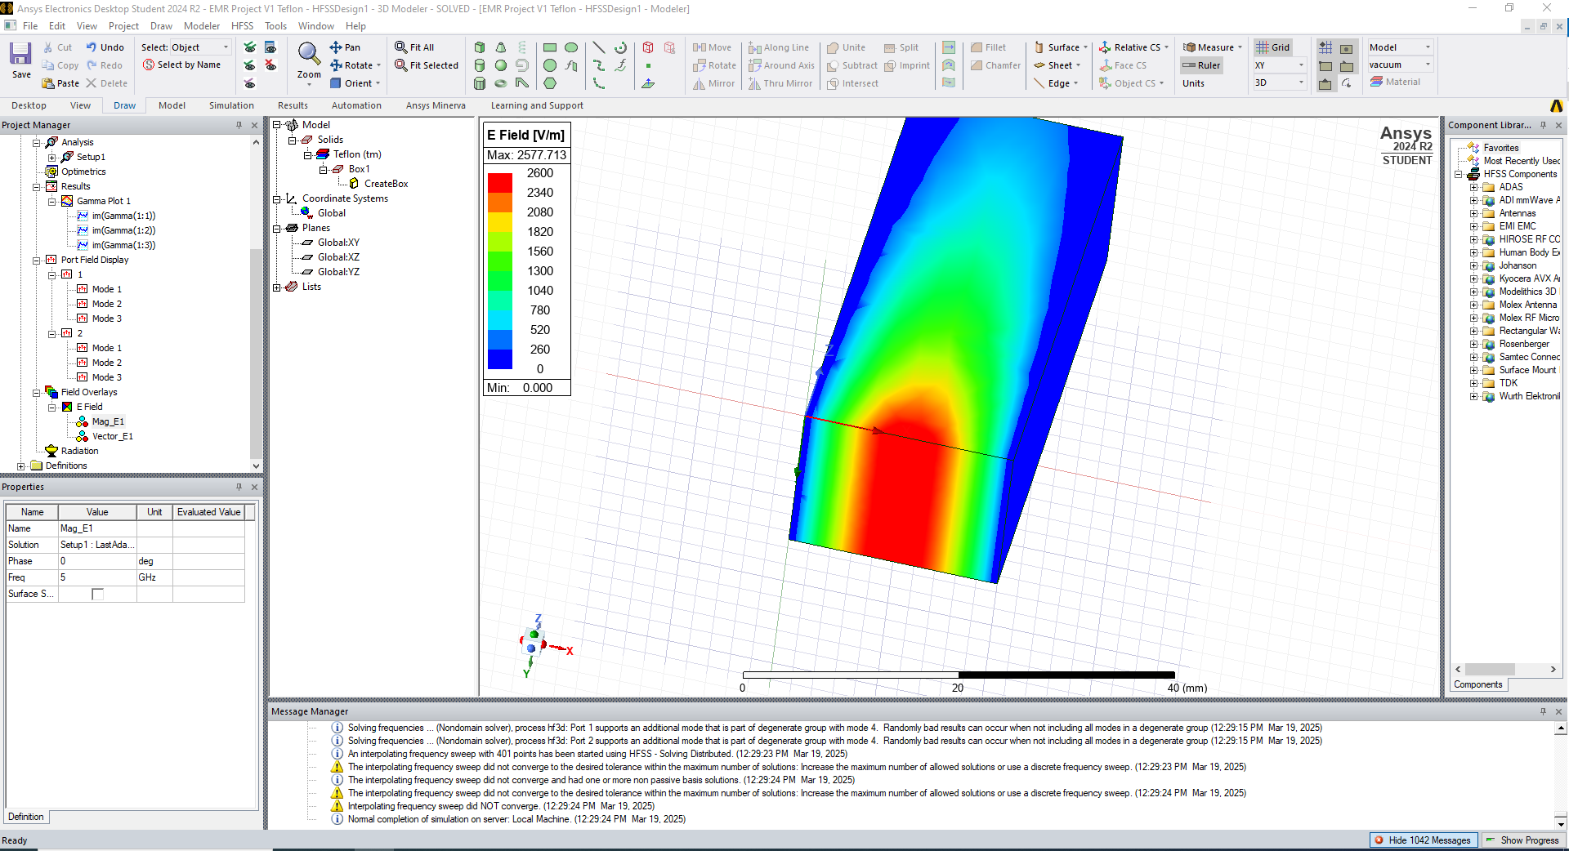
Figure 24 – Mode 1, Electric Magnitude
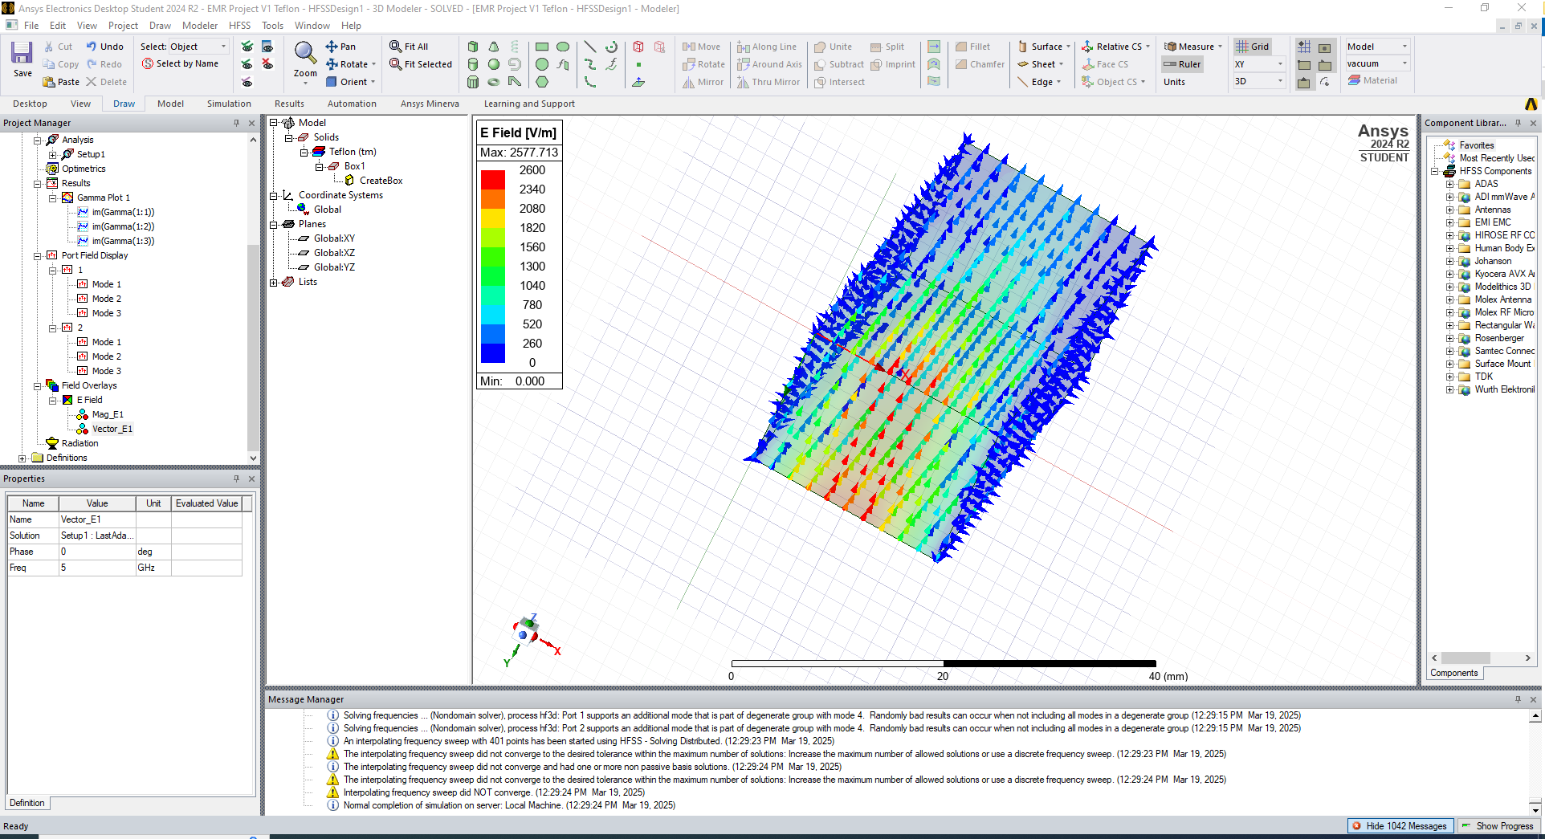
Figure 25 – Mode 1, Electric Vector
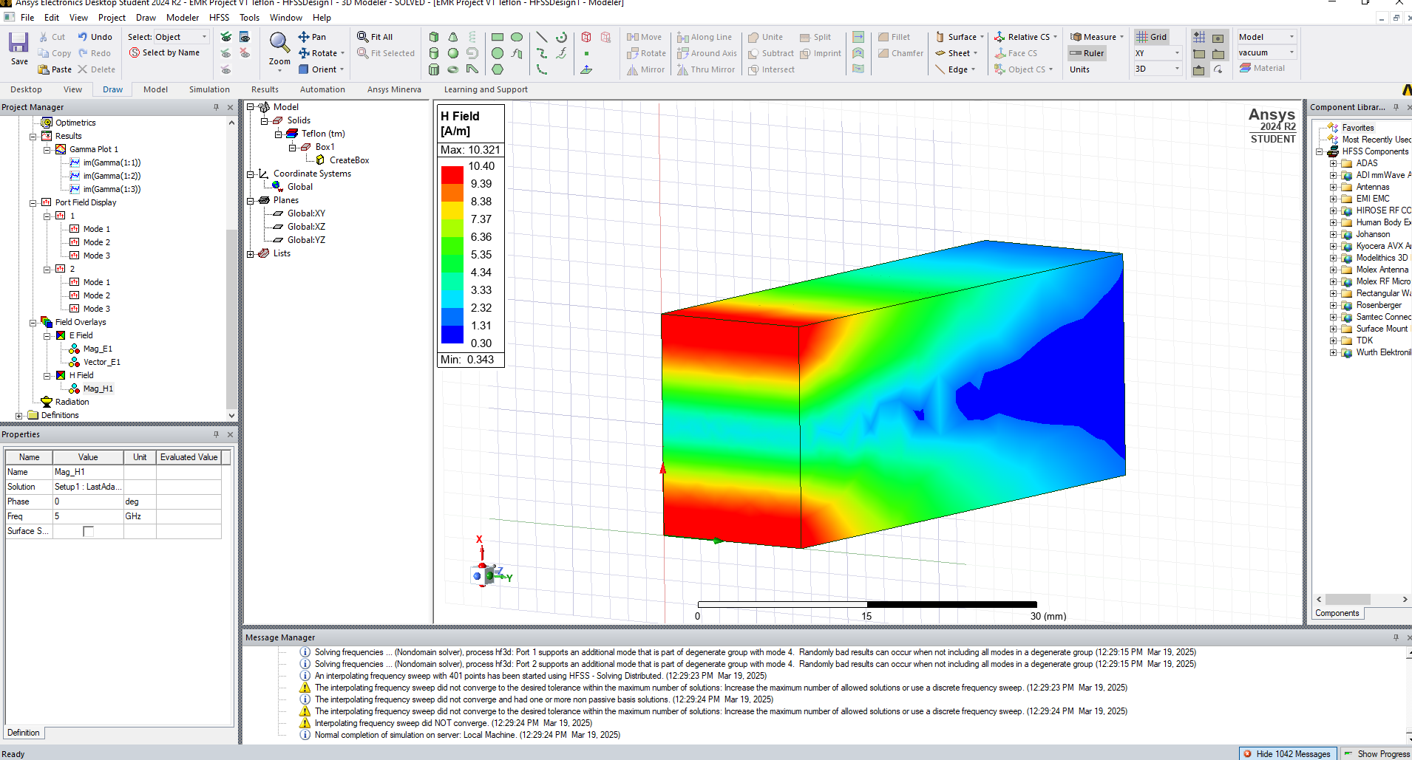
Figure 26 - Mode 1, Magnetic Magnitude
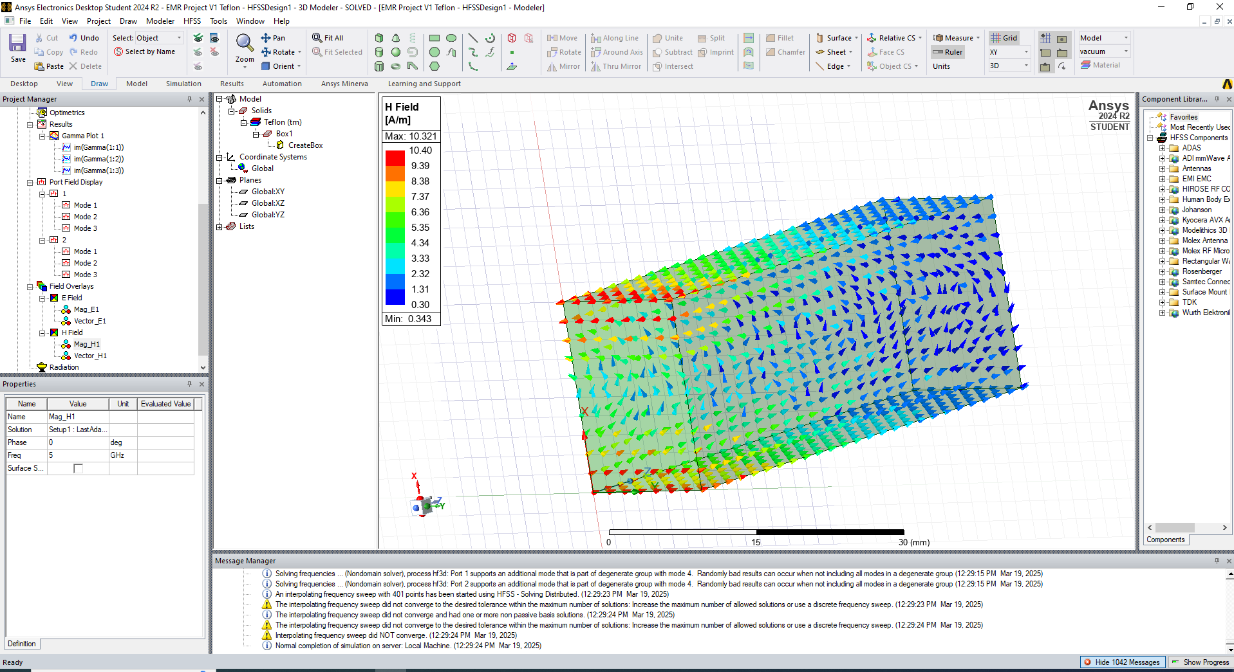
Figure 27 - Mode 1, Magnetic Vector
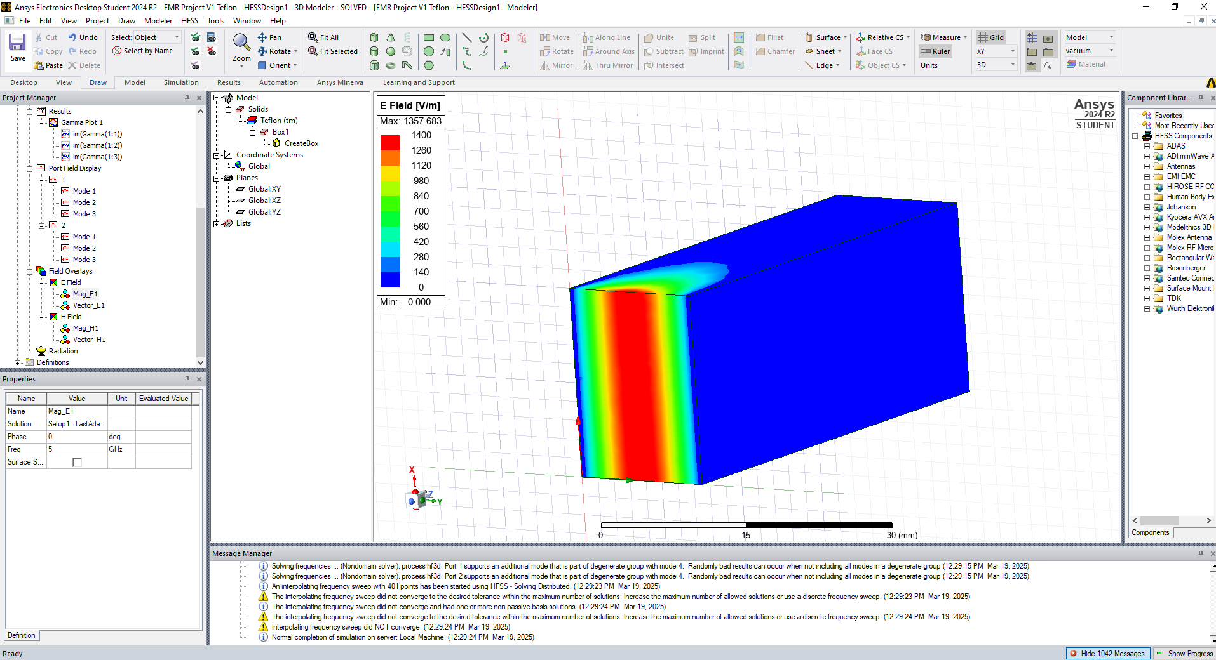
Figure 28 - Mode 2, Electric Magnitude
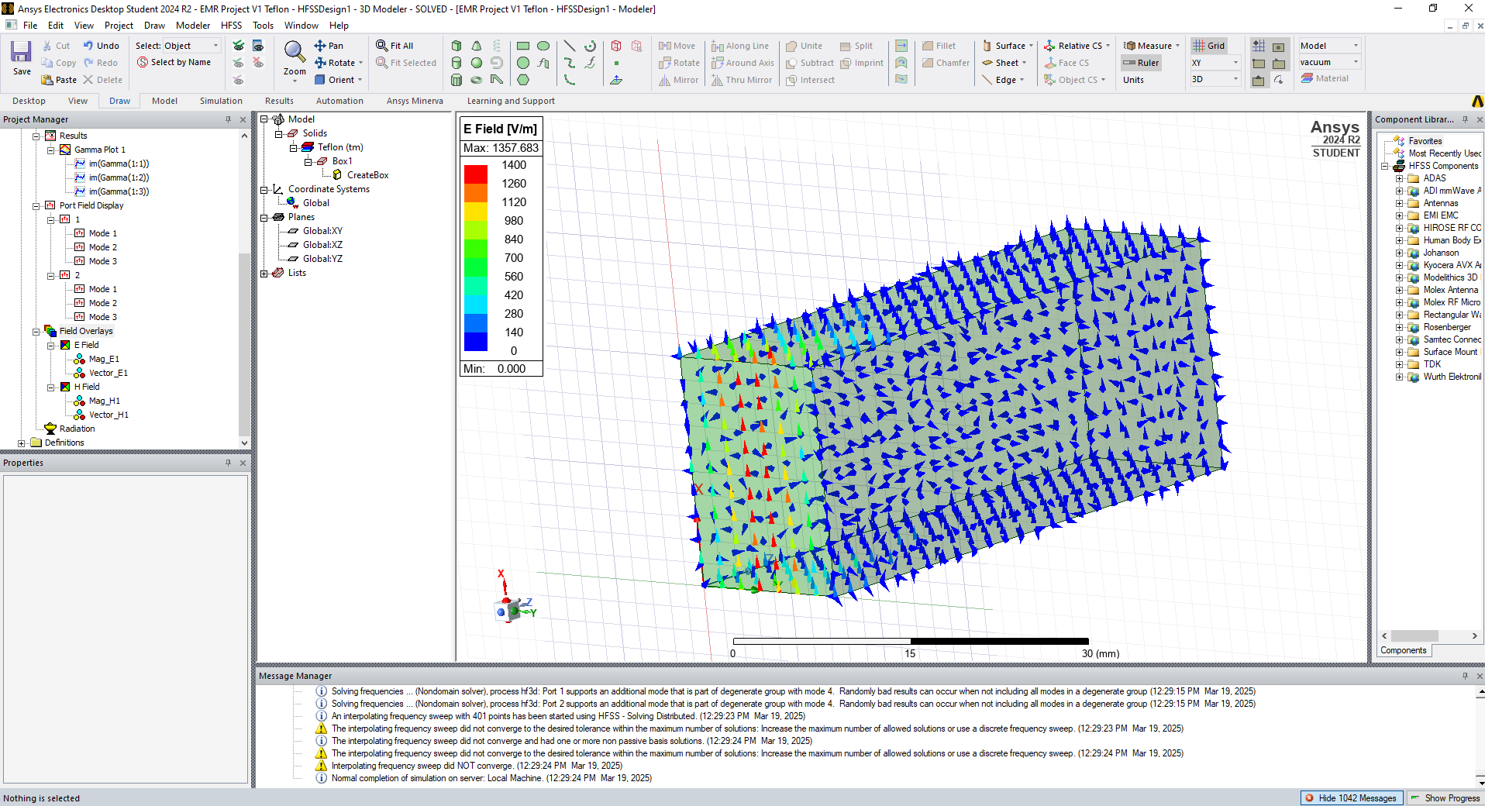
Figure 29 - Mode 2, Electric Vector
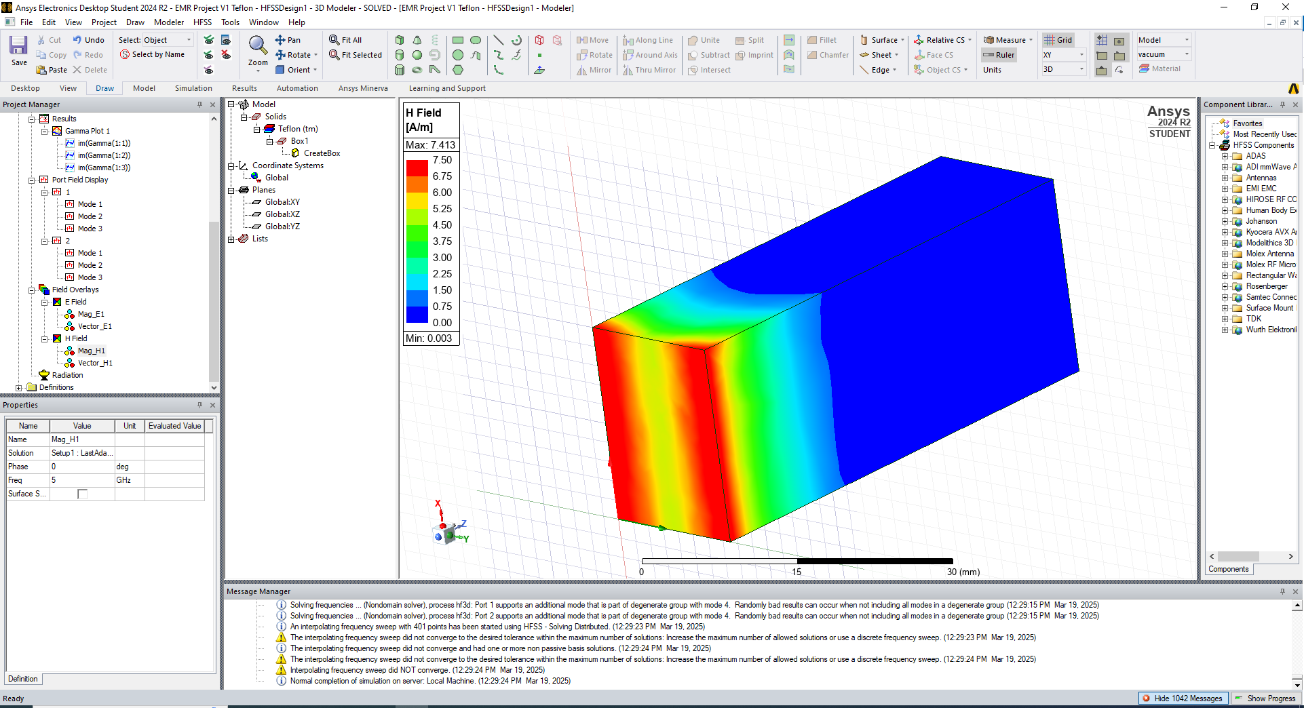
Figure 30 - Mode 2, Magnetic Magnitude
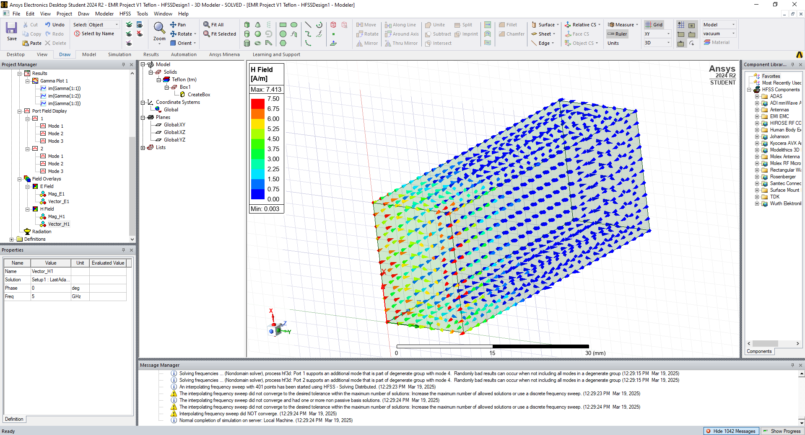
Figure 31 - Mode 2, Magnetic Vector
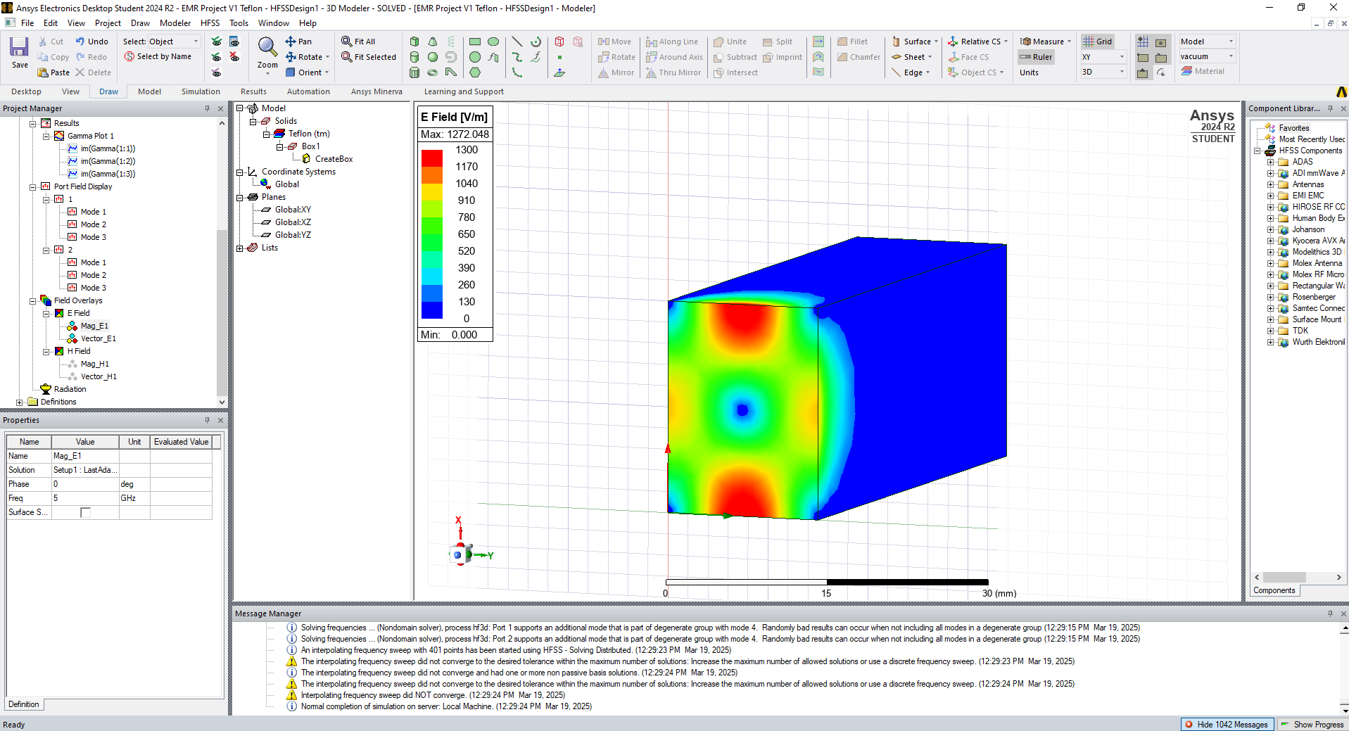
Figure 32 - Mode 3, Electric Magnitude
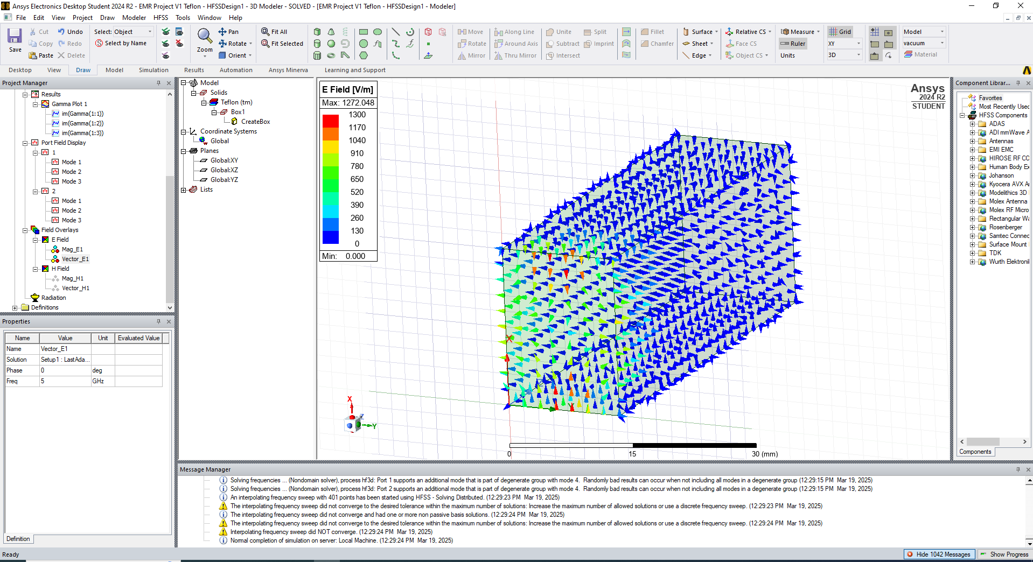
Figure 33 - Mode 3, Electric Vector
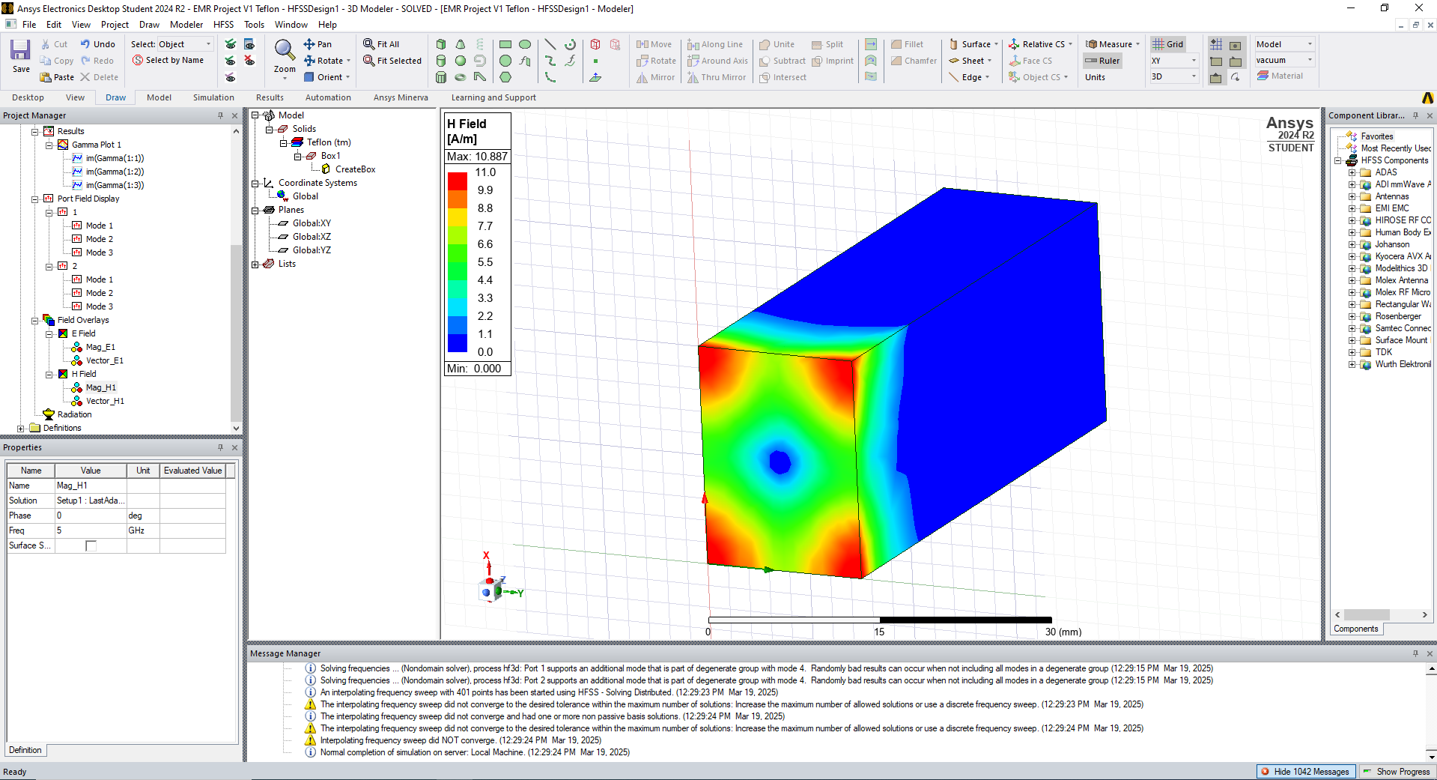
Figure 34 - Mode 3, Magnetic Magnitude
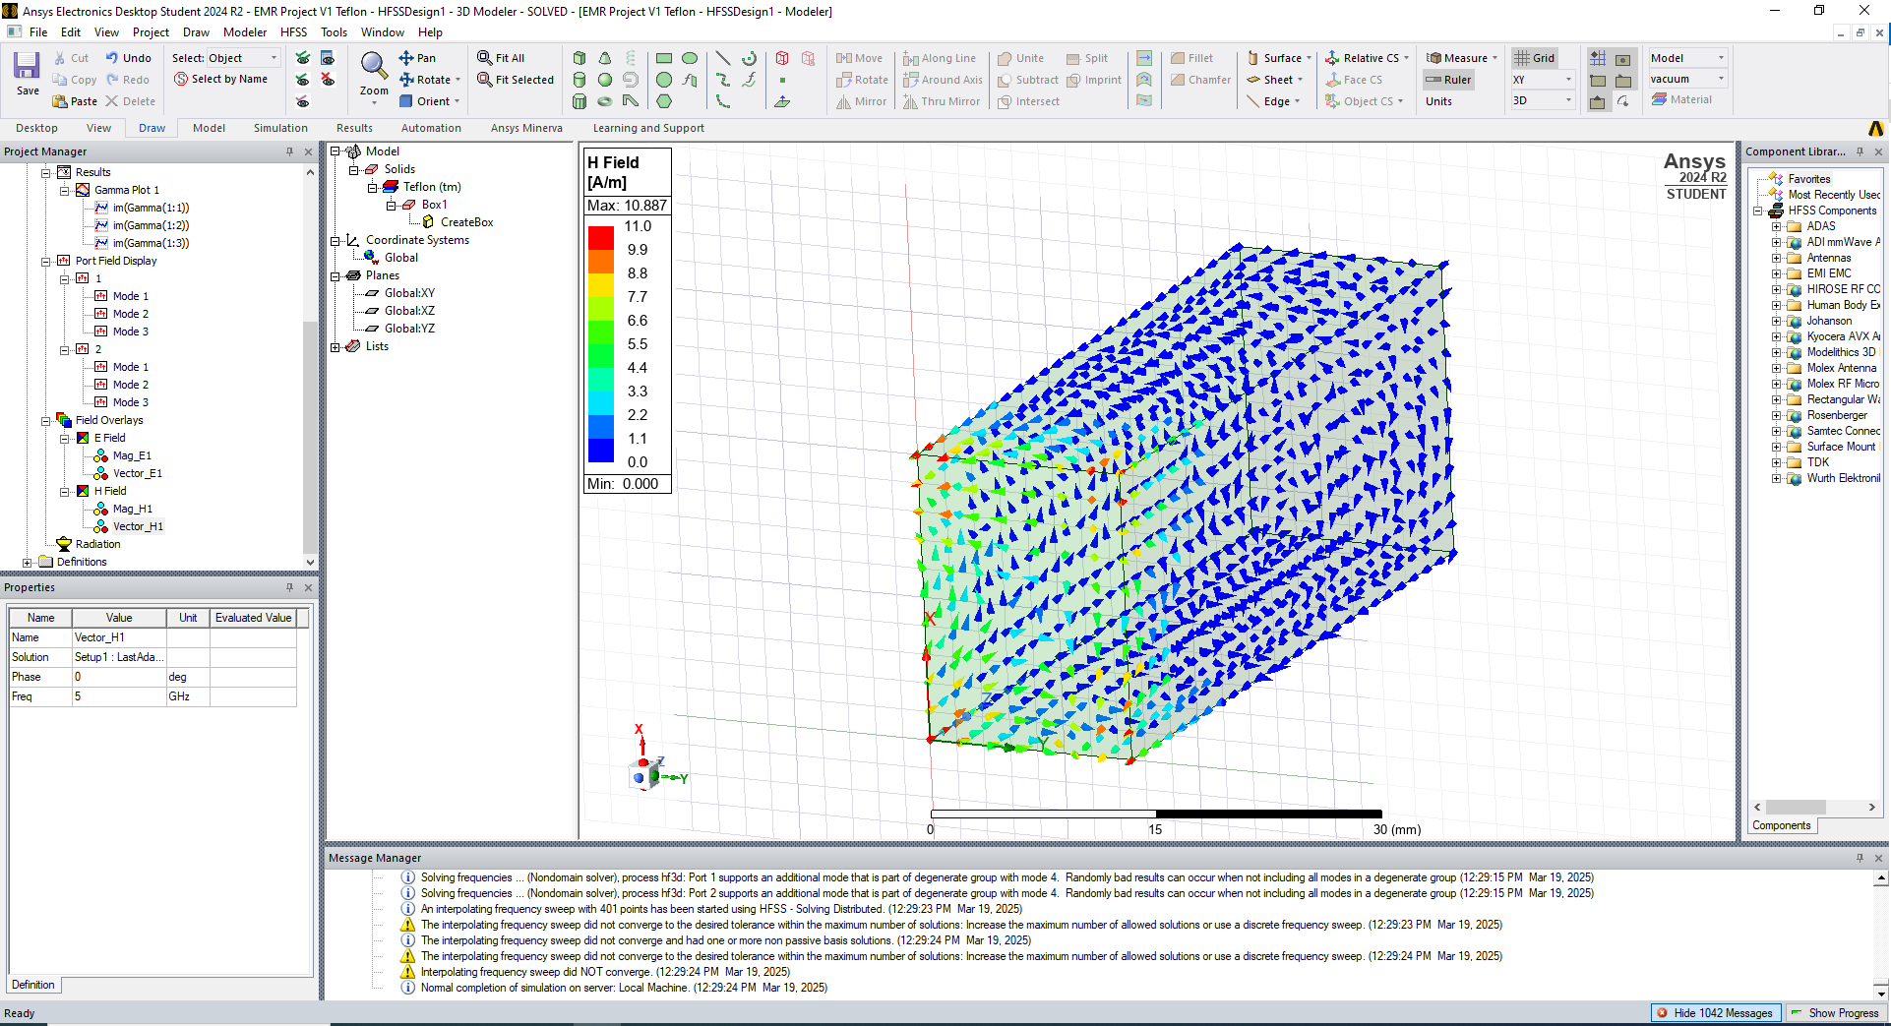
Figure 35 - Mode 3, Magnetic Vector
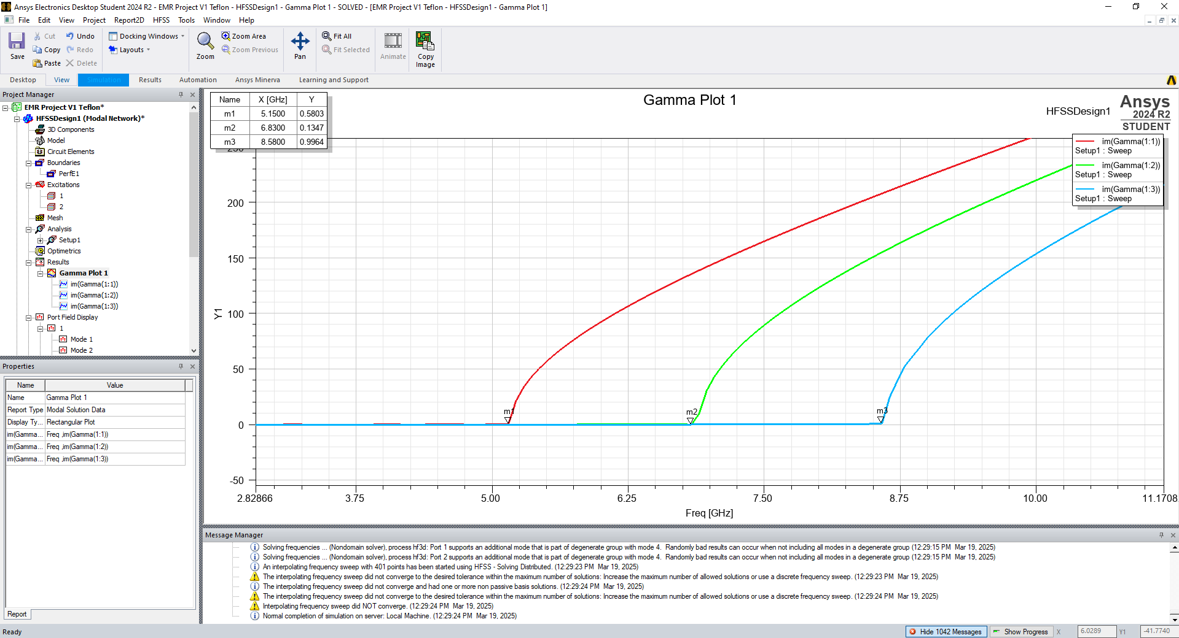
Figure 36 - Rectangular Cutoff Frequency Plot
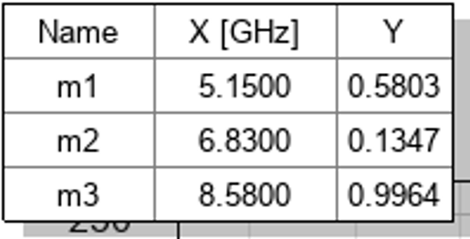
Figure 37 - Cutoff Frequencies – Teflon

4.1 Task 1b Discussion & Calculations

4.1.1 Cutoff Frequency [6]
The cutoff frequencies depicted in the rectangular plot are shown in Figure 36 - Cutoff Frequencies – Teflon
The cutoff frequency of the waveguide can be calculated using Equation 1.

$$\begin{aligned}F_{c}=\frac{c}{2}\sqrt{{\left(\frac{m}{a}\right)}^{2}+{\left(\frac{n}{b}\right)}^{2}}\#\left(Equation 1\right)\end{aligned}$$

$F_{c}$ = Cutoff frequency (Hz)
$C$ = Speed of light in the transmission medium (m/s)
$m$ = Number of half-wavelength variations of the electric or magnetic field in the width of the waveguide
$n$ = Number of half-wavelength variations of the electric or magnetic field in the height of the waveguide
$a$ = Width of waveguide (m)
$b$ = Height of waveguide (m)

To calculate the speed of light in the transmission medium Equation 2 (given below) is used [7]:
$$\begin{aligned}c_{medium}=c_{vac ∙}\frac{1}{\sqrt{εμ}}\#\left(Equation 2\right)\end{aligned}$$

$C_{medium}$ = speed of light in a medium
$C_{vac}$ = speed of light in a vacuum (3.0x10⁸ m/s)
μ = permeability of the medium (Teflon: 1)
ε = permittivity of the medium (Teflon: 2.1)
$$c_{medium}=3∙ {10}^{8} ∙ \frac{1}{\sqrt{2.1}}=2.0702∙{10}^{8}$$

Modes:
The modes in the Teflon-filled waveguide are identical to the modes identified in the vacuum-filled waveguide.

Mode 1 (TE₁₀)
$$F_{c}=\frac{2.0702∙{10}^{8}}{2}\sqrt{{\left(\frac{1}{0.02}\right)}^{2}+{\left(\frac{0}{0.015}\right)}^{2}}=5.18e9=5.18GHz$$
Mode 2 (TE₀₁)
$$F_{c}=\frac{2.0702∙{10}^{8}}{2}\sqrt{{\left(\frac{0}{0.02}\right)}^{2}+{\left(\frac{1}{0.015}\right)}^{2}}=6.9e9=6.9GHz$$
Mode 1 (TE₁₁)
$$F_{c}=\frac{2.0702∙{10}^{8}}{2}\sqrt{{\left(\frac{1}{0.02}\right)}^{2}+{\left(\frac{1}{0.015}\right)}^{2}}=8.63e9=8.63GHz$$

The results calculated above were compared to the results given by the Ansys simulation:

Table 2 - Cutoff Frequency Comparison for Teflon-Filled Waveguide
Waveguide Cutoff Frequencies – Teflon Fill
Mode | Simulation Result (GHz) | Calculated Result (GHz)
Mode 1 | 5.15 | 5.18
Mode 2 | 6.83 | 6.90
Mode 3 | 8.58 | 8.63

Once again, there is a relatively good match between the calculated and simulated cutoff frequencies. The model can be considered validated as there is relatively good agreement between the simulation and the calculations. Both values also fall entirely inside of assigned OFCOM frequency bands [8].

4.1.2 Dominant Mode
The dominant mode in this instance once again is the TE₁₀ mode, with a 5.18GHz cutoff frequency.

5. Waveguide Results Discussion
The results that the cutoff frequencies in the dielectric (Teflon) filled waveguide are all approximately 30% lower than the results in the vacuum-filled counterpart – this is no surprise, as the value for C is approximately 30% lower in Teflon than in a vacuum. Of course, no model exactly simulates real-world performance, and no waveguide will ever be perfectly conductive, nor will the Teflon be perfectly pure, or the entire assembly free of boundary effects, losses, or even the most minor sources of attenuation or interference. Nonetheless, there is good agreement between the calculated result and the simulation, such that subsequent physical experiments could be conducted with a high level of confidence.

6. Dipole Antennas
The dipole antenna derives its name from the fact it is made up of two symmetrical halves, extending in opposite directions from the feed [9]. Half-wave dipole antennas consist of two conductive segments, where the approximate length is one half of the desired operating frequency [10]. The two halves are separated by an insulator, into which a signal is fed. Generally, the emitted radiation is relatively omnidirectional making it useful in communication networks where the antenna cannot move but devices in its area must maintain a reliable connection. Reflectors can be added to improve the radiating characteristics of antenna [11]. There are too many specific types of dipole antenna to list in this paper, including those that differ from the traditional design and have numerous radiating elements, such as the biconical dipole [12].
While dipoles have been traditionally used in communications, research in recent years has applied them to a broad selection of uses such as radio astronomy, RF energy harvesting and biomedicine. Significant advancement has also been made combining them with RF beam forming circuitry and the creation of dipole phased arrays [11].
An example of a real dipole antenna is given in Figure 38.
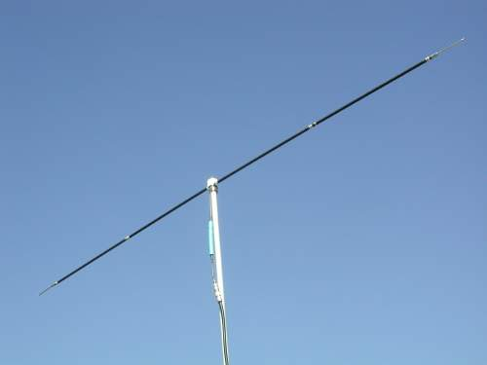
Figure 38 - Large Dipole Antenna [13]

7. Task 2 – Half-Wave Dipole Antenna
The Ansys Electronic Desktop tool was used to design a half-wave dipole antenna of 1mm diameter, constructed from PEC. The antenna was intended to radiate electromagnetic waves of 𝜆mm, with 𝜆 being the first three digits of the author’s student ID (2030773).

$λ= 203$mm
$L=$ $\frac{λ}{2}$ = $\frac{0.203}{2}=0.1015=0.102$ (rounded to the nearest integer)

Waveguide length (L) was 102mm.
Port impedance was set to 50Ω. The radiating surface is rectangular and located between the two halves of the antenna.
An S-Parameter plot was generated and the radiation plot obtained using tools in the Ansys Electronics Desktop package.
A picture of the model is given in Figure 39.

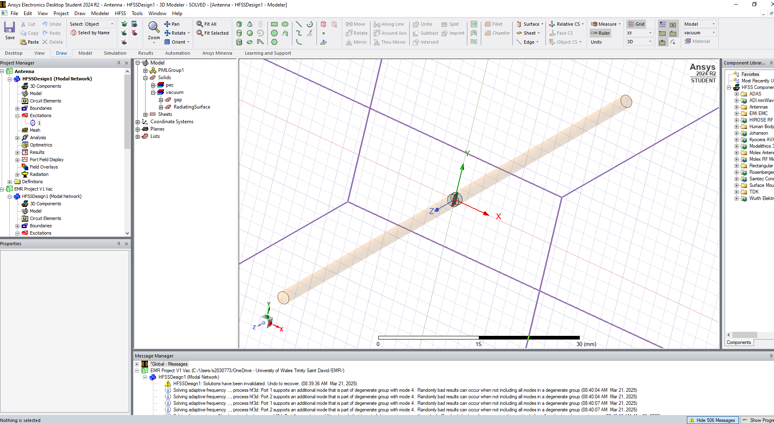
Figure 39 - Antenna Model

7.1 Half-Wave Dipole Antenna Results
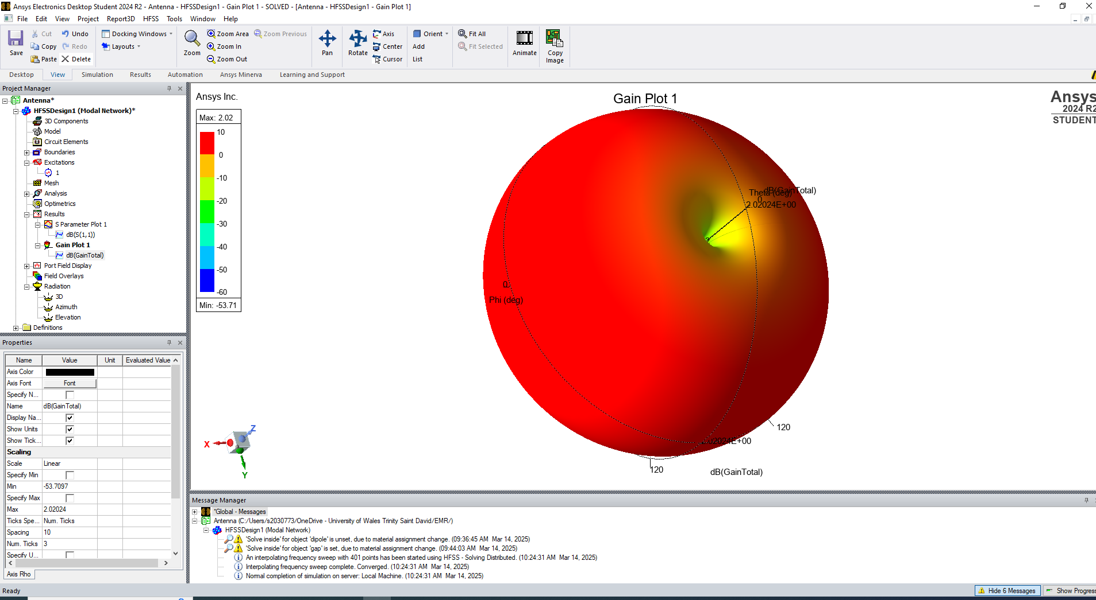
Figure 40 – Half-Wave Dipole Antenna 3D Gain Plot
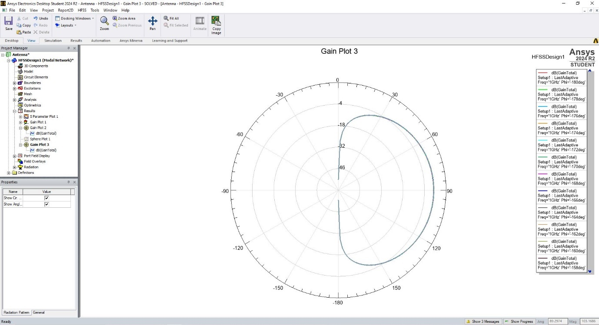
Figure 41 - 2D Gain Plot – note, this is a 2D view and would be revolved through 360° to form the torus shape above

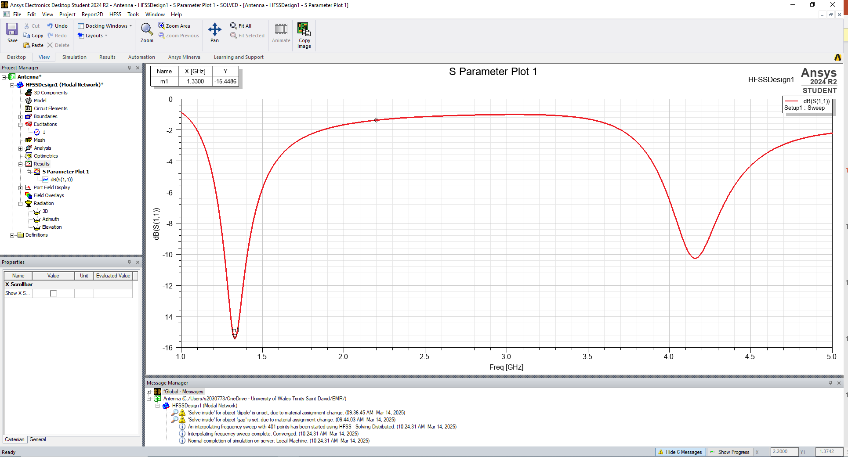
Figure 42 – Half-Wave Dipole Antenna S-Parameter Plot

7.2 Task 2 Discussion & Calculations

7.2.1 Antenna Operating (Resonant) Frequency
The resonant frequency can be determined using the following equation (3):
$$\begin{aligned}f=\frac{c}{λ}\#\left(3\right)\end{aligned}$$

Where:
f = resonant frequency,
c = speed of light,
$λ$ = wavelength
$$f=\frac{3 ∙{10}^{8}}{0.203}=1.47783e9=1.48GHz$$
The resonant frequency of the antenna given by the S-parameter plot from the simulation is 1.33GHz. This is 0.15GHz lower than the calculated value – this is worthy of consideration were this design to be created in the UK, as the Office of Communications (OFCOM) Frequency Allocation Table [8] is extremely granular. There are 22 separate frequency allocations between 1.3 and 1.5 GHz – as such, precise use of the spectrum is incredibly important to ensure that the law is followed and not unwittingly broken.
At the 1.33GHz point, the spectrum is used primarily for radiolocation and radio navigation [8]. It is likely that these uses require an antenna with significantly more directivity and range – as such, it would be unusual to see a small dipole antenna of these dimensions if this frequency was found to be correct.
At the 1.48GHz point, the spectrum is used for satellite TV broadcasting [8].
Further experiments should be conducted to determine the exact operating frequency with more accuracy.
A second resonance can be noted at approximately. 4.15GHz in Figure 42. Typically, dipole antennas are designed to operate at their first resonance – this results in more useful radiation patterns, and rapid impedance shifts (with changing input frequency) are avoided [12]. Ordinarily, to change the resonant frequency of the antenna, its dimensions must be changed. In the event this is not possible, or if this change would result in an antenna being unfeasibly large, an inductor can be placed in the radiating element - as additional inductance will lower the resonant frequency [14]

7.3 Antenna Radiation Pattern
The designed antenna exhibits an omnidirectional torus-shaped radiation pattern with low directivity. Directivity is an increase in power density at a given direction at a given distance [15] – or, in simple terms, how concentrated a radiation pattern is in a certain direction. If a pattern is omnidirectional, this means that the power radiated is relatively equal in most directions, as depicted in Figure 40. Antennas exhibiting this omnidirectional pattern would be ideally suited to use in telecommunications (mobile networks, wifi systems) where the antenna must stay fixed, but devices move relative to it and a steady connection must be maintained.

8. Conclusion
This work has found that High Frequency Simulation Software is a valuable tool for the theoretical analysis of waveguides, but that the values it provides are not perfect enough to be exclusively relied on.
This paper has found that dielectric filled waveguides have lower cutoff frequencies than their vacuum-filled counterparts. This makes them more useful than their vacuum filled counterparts, as they will transmit a wider variety of frequencies, however it is likely that dielectric filled waveguides come at significant financial cost due to the added complexity of manufacture. The calculated cutoff frequencies and simulated values agree well, with the dominant mode results being within 0.03GHz of each other.
The half-wave dipole antenna was found to have a useful omnidirectional pattern, but the calculated operating frequency of 1.48GHz differs significantly from the simulated 1.33GHz value.
The author suggests that future work should include the production and test of both the waveguide and antenna examined in this paper for further validation work to be conducted.

References

[1] | Naval Air Systems Command, Electronic Warfare and Radar Systems Engineering Handbook, Naval Air Warfare Center, 1999.
[2] | Space Machine, “Ultimate Guide to Waveguides,” [Online]. Available: https://www.space-machine.com/ultimate-guide-to-waveguides. [Accessed 2025].
[3] | Sky Brokers, “Waveguide Assemblies C-, DBS-, Ka- or Ku-band,” [Online]. Available: https://sky-brokers.com/product/waveguide-assemblies/.
[4] | Dolph Microwave, “Reasons for Pressurizing Waveguides,” 10 April 2024. [Online]. Available: https://www.dolphmicrowave.com/default/why-are-waveguides-pressurised.
[5] | N. M. Ridler, R. Ginley, J. Hesler, K. A, P. R and W. D, “Towards Standardized Waveguide Sizes and Interfaces for Submillimeter Wavelengths,” in 21ST INTERNATIONAL SYMPOSIUM ON SPACE TERAHERTZ TECHNOLOGY, OXFORD, 2010.
[6] | RF Wireless World, “Dominant Mode in Waveguides: Rectangular & Circular Explained,” [Online]. Available: https://www.rfwireless-world.com/terminology/waveguide/dominant-mode-in-waveguides.
[7] | Maxwells Equations, “The Wave Equation,” [Online]. Available: https://maxwells-equations.com/equations/wave.php.
[8] | OFCOM, “United Kingdom Frequency Allocation Table, Issue 18,” 2017.
[9] | J. Healy, “Antenna, Here is a Dipole,” QST, June 1991.
[10] | Elprocus, “Dipole Antenna : Working & Its Applications,” [Online]. Available: https://www.elprocus.com/dipole-antenna/.
[11] | E. A. S. R. T. Christian Lly Sosa, “Performance Analysis of Dipole Antenna Applications: A Literature Review,” International Journal of Research Publication and Reviews, 2024.
[12] | C. Gandy, “BBC Research & Development White Paper WHP 132 - Dipole Antennas,” British Broadcasting Corporation, 2006.
[13] | Low Power Lab, “Half-Wavelength dipole,” 19 April 2017. [Online]. Available: https://lowpowerlab.com/guide/rf-best-practices/half-wavelength-dipole/.
[14] | S. S. A. S. M. D. Mounika, “Design of Dipole Antenna and various radiation patterns for various lengths,” Global Journal for Research Analysis, 2017.
[15] | W. Stutzrnan, “Estimating Directivity and Gain of Antennas,” 2014.

