University of Wales Trinity Saint David

Assessment 1
Written report on Marketing Fundamentals
Blogging to communicate on Diageo

Program: BA Business Management
Student: Stefania Prohnitchi
Student number: 1917713
Course: Marketing Fundamentals
Tutor: Tushara Balendran

London 2021

Content:
- Introduction ………………………………………………………………………. 3
- Marketing environment and main goals of Diageo ………………………………. 3
- Blog posts …………………………………………………………………………. 5
3.1 Background of Diageo ………………………………………………………… 5
3.2 Products ……………………………………………………………………….. 5
3.3 Promoting ………………………………………………………….………….. 8
- Conclusion ………………………………………………………………………… 8
References …………………………………………………………………………10

- Introduction
The drink maker, one of the most hard and sophisticated field to develop into industry, but not in twenty-first century. Diageo is the world's leading manufacturer of premium alcoholic beverage, never had as a goal to direct brands and branding skill into shareholder value, changes have happened. Competition never sleeps, and successful new features are fast becoming the norm. Out of the desire to stay competitive, Diageo constantly brings product innovations. The company has developed all the major innovative features of beverage shuttles, from handles with vertical slats inside, display shuttles or separable shuttles. Together with clients, it launches new trends in the field.
- Marketing environment and main goals of Diageo
By means of Diageo’s website I found their focusing in marketing strategies elaborating main scops, they are focused on strategic priorities support like:
Sustain growing quality - creating sustainable and consistent quality growth is at the heart of their ambition to be ‘one of the best performing’.
Smart invest - investing in the future success of business – but that investment needs to be ‘smart’ to support the delivery of consistent performance and enable sustainable, quality growth.
Promote positive use of alcohol - to change the way the world drinks for the better, by promoting moderation and addressing the harmful use of alcohol. Diageo goal for people is to ‘drink better, not more’ – because they are proud of their brands and know that the best way for them to be enjoyed is responsibly and it makes a lot of appreciation.
Inclusion and diversity of champions - Performance Ambition is fuelled by their purpose and values. It drives us to create an inclusive culture where every individual can thrive and to champion inclusion and diversity in our business and in society more broadly.
The pioneer in the sustainability of glass - any company should positively impact the communities in which we live, work, or general environment source, sell and protect the natural resources on which we all depend on.
Diageo is in a continuous state of development and innovation, and this fact is observed at all levels of the company. Thus, Diageo's strategy has been adapted for the penetration of new markets, including that of India through Rowson Reserve whiskey. A whiskey made from a blend of Indian whiskeys, and the superior liquid and packaging that offers a premium product feel allowed it to stand out on the shelves of Indian stores. In Nigeria, Diageo introduced the first cider known as Harp Lime. The cider was received positively, sales gradually increasing year by year, and the ads from Harp Lime had a positive influence on the Diageo brand.
Part of the Diageo strategy illustrates that in order to occupy a significant position in the alcoholic beverage industry, they must deliver a sense of value through the message they communicate. Therefore, the company has an active set of programs designed to train employees and leaders, which promotes a culture of efficient management and supports sustainable development in the overall growth of the business.
Therefore, by adopting new strategies, Diageo is able to deliver not only alcoholic beverages to customers everywhere, but also a development message, which underlies the company. Through the innovations implemented, Diageo has discovered a steady growth in underdeveloped markets.
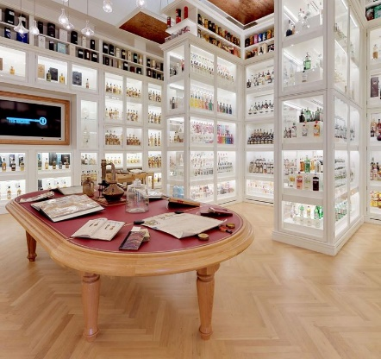
(Source: https://www.diageo.com/en/our-brands/ )
3. Blog posts
3.1 Background of the Diageo
Diageo was launch as a global leader in the food and beverage industry in 1997. In 2000, they left the food market and focused on the alcoholic beverage industry only. Diageo currently owns a significant number of brands in the alcoholic beverage industry, beverage categories including: BEER, WHISKEY, VODKA, WINE, ROM, GIN, etc. Diageo currently owns 14 brands that it considers a priority on the global market. Among them are: Johnnie Walker Whiskey, Crown Royal Whiskey, Smirnoff, Cîroc, Guinness, J&B Whiskey etc.
Of the total revenues, the beer brands owned by Diageo, including Guinness, represent 20%, while that of wines by 5% according to data provided by Diageo in 2015. This means that the size of Diageo produces a favourable environment. Large-scale development when it comes to production, sales, and marketing. Due to the major changes in the last decade of the global market and the globalization phenomenon that has taken shape, Diageo has been forced to concentrate its resources and staff in new and strong regions. This new restructuring has allowed the company to streamline its distribution, distillation, bottling and packaging process for its own brands.
3.2 Products
As one of the biggest manufacturing alcohol company in the world Diageo has also vast type of drinks, for example the famous and one of the oldest product of the company is Guinness Drought Beer (founded in 1759, Dublin, Ireland). The UK’s distributors are offering pack by 4x440ml by different prices, Tesco - £4.49 (£2.56/litre), meanwhile ASDA do it by £4.24 (2.41/litre).
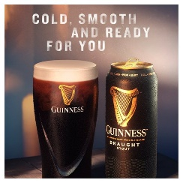
(Source: https://groceries.asda.com/product/stout/guinness-draught-stout-beer/)

The world’s bestselling Scotch Whisky, Jonnie Walker was developed in the 19th century and can be found in spirits kiosks of London by £20.45 (70 cl). Having different colour labels which means that every bottle has different age for a minimum of 12 years before being blended.
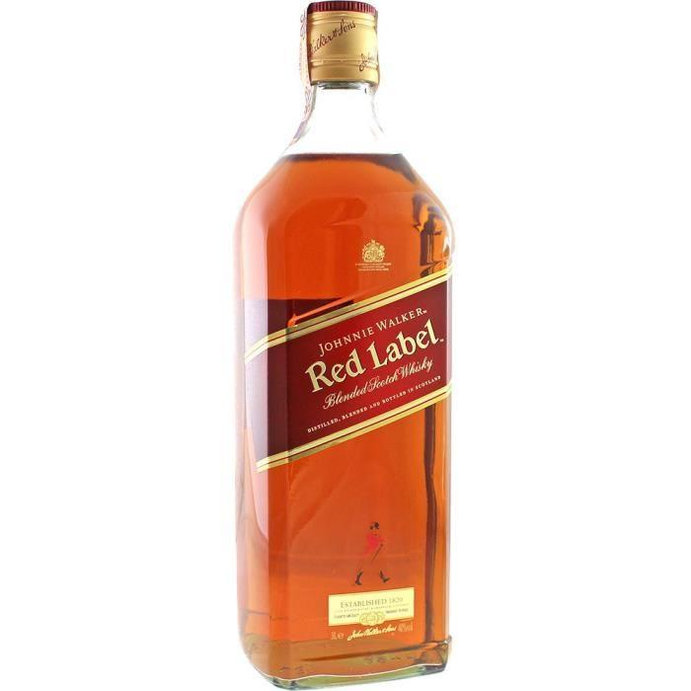
(Source https://www.drinksandco.co.uk/whisky/johnnie-walker-red-label-3l )

The Baileys Original Irish Cream who welcomed costumers in 1997 at the present time can not be compared with any other liqueur. ASDA supermarket sells by £22.00 (£22.00/litre) but Tesco’s shops give you opportunity to have it cheaper by £20.00 (£20.00/litre).

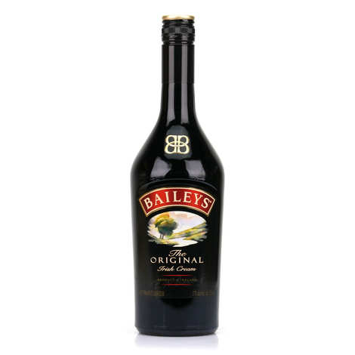
(Source https://www.bienmanger.com/2F36344_Baileys_Original_Irish_Cream_Whisky.html )

Another treasure of Diageo the Captain Morgan - a classic choice of spiced but not pricey rum. Named in honour of a real-life person in the 17th century, Jamaica. The bottle size of 70cl in ALDI is sold by £13.75 (£19.64/litre) meanwhile in Sainsbury’s is £14.50 (£20.71/litre).
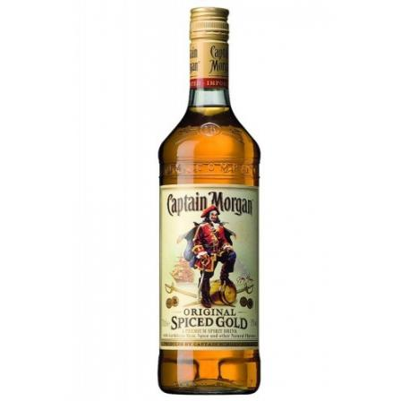
(Sourc:https://www.drinksandco.co.uk/rum/captain-morgan-original-spiced-gold-3l)

Finally, at least but not last other Diageo’s creation is Cîroc, is only one premium vodka in the world manufactured by using grapes from the Charente-Maritime region, also known as one of the most beautiful destination of France. In comparison with others Cîroc is new branded product which was introduced on the market on 2003. It can be purchased by £38(70cl) a bottle at TESCO and £30(70cl) at ASDA. What really makes this brand unique is flavour for every occasion and spoilt for your choice.
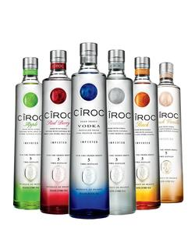
(Source: https://alky.co.uk/products/ciroc-collection )

3.3 Promoting:

Some companies hire celebrities as creative directors who are responsible for promoting the brand for a solid salary or percentage of sales. This was initiated by the extremely successful collaboration of Sean Combs, also known as P. Diddy, with Diageo as part of the promotion of Cîroc vodka in the United States - they raised the brand from the 50th place in the ranking of the best-selling premium vodkas in the world to the second.
A contract with the alcohol company Diageo helped to David Beckham earn more money in 2014 than in all previous years. According to the publication, Beckham received $ 75 million as a result of a partnership with the British spirits producer Diageo and through a contract to promote consumer goods with Global Brands Group. Together with Diageo, Beckham launched the Haig Club whiskey and, as previously stated will play a "fundamental role" in the development of the brand in order to bring it to a new audience.

- Conclusion:
Being in constant process will bring you success, feeling every field of company,
industry and market, Diageo till nowadays is one of the highest stages of success. Therefore, from the above analysis of marketing it can be concluded that Diageo has gained much success and profitability in the global aviation market with its highly efficient services, effective work environment. The goals and objectives of the business organization are formulated because of the company’s mission and purpose. The formulated goals and objectives of the business organization are communicated across all the levels of the business organizations.

References:
Wilson, R.M. and Gilligan, C., 2012. Strategic marketing management. Routledge.
Podgorodnichenko, N., Edgar, F. and McAndrew, I., 2020. The role of HRM in developing sustainable organizations: Contemporary challenges and contradictions. Human Resource Management Review, 30(3), p.100685.
Tunnicliffe, V., Metaxas, A., Le, J., Ramirez-Llodra, E. and Levin, L.A., 2020. Strategic environmental goals and objectives: setting the basis for environmental regulation of deep seabed mining. Marine Policy, 114.
Mullins, J.W., Walker, O.C., Boyd, H.W. and Larréché, J.C., 2013. Marketing management: A strategic decision-making approach. New York: McGraw-Hill.
Wibowo, A. and Alfen, H.W., 2014. Identifying macro-environmental critical success factors and key areas for improvement to promote public-private partnerships in infrastructure. Engineering, Construction and Architectural Management.
Website:
https://www.diageo.com/
https://www.vedomosti.ru/business/articles/2015/03/13/alkogolnii-kontrakt-pomog-bekhemu-zarabotat-75-mln
https://twid.studio/projects/diageo/

