Student name | Yordanka Kancheva
Student number | 2017633
Module name | Workplace Culture and its Impact on Organisational Efficiency BMSW 5105
Lecture name | Abdi Rahman
GXO EAST MIDLANDS

THE CULTURE OF WORKPLACE
and how does it Impact on Organisational Efficiency



Table of Contents

Introduction 1
Background Information on GXO 2
Critically assessment the Workplace Culture at GXO 5
Analysing the Impact of Environment Factors on Work Culture at GXO: A Critical Appraisal Utilizing an Appropriate Framework 6
PESTEL analysis 6
Porter’s 5 forces 9
Exploring the Relationship between Organizational Structure and Workplace Culture at GXO 11
Assessing and Examining the Essential Components of Ethical Organizational Culture in GXO: Strategies for Enhancing Ethical Culture Environment 13
Enhancing GXO Workplace Culture: Identifying Barriers Recommendations, and their Impact on Organizational Efficiency 15
Barriers to Effective Functioning of GXO's Workplace Culture 15
Recommendations to Enhance GXO's Workplace Culture 17
Positive Impact on Organizational Efficiency 17
Conclusion 19
List of References 20

Introduction

In this report will be discussed, analysed, and evaluated the organizational culture of GXO, a global leader in supply chain solutions and logistics services which places a strong emphasis on Environmental, Social, and Governance (ESG) principles, considering them a competitive advantage and an integral part of its business strategy (GXO official website, 2023).

The aim of the report is to focus on its ethical elements and their impact on the workplace. The report will discuss key issues related to ethical behaviour and workplace culture within GXO, drawing insights from academic frameworks such as Schein's model (1996), McKinsey 7s, and Kotter's 8-step plan to provide recommendations for enhancing GXO's workplace culture. These frameworks offer valuable insights into promoting ethical behaviour, aligning organizational elements, and driving cultural change within an organization.
In addition, the report will incorporate a PESTEL analysis to evaluate the external macro-environmental factors that can impact GXO's organizational culture. The analysis will explore political, economic, sociocultural, technological, environmental, and legal factors.

Furthermore, will be analysed the impact of Porter's Five Forces on GXO's organizational culture and competitive positioning. These forces include barriers to entry, supplier power, buyer power, threat of substitute products or services, and rivalry among existing competitors.

This text gives more understanding of why addressing the identified barriers to effective workplace culture at GXO is crucial for enhancing organizational efficiency. Beer's model (2009) will be used to identify and understand these barriers, as it provides a comprehensive framework for analysing organizational culture and its challenges.

Background Information on GXO

GXO, a global leader in supply chain solutions and logistics services, operates as an independent company after its successful spin-off from XPO Logistics (Freight Waves, 2023). With a strong focus on Environmental, Social, and Governance (ESG) principles, GXO considers them a competitive advantage and an integral part of its business strategy (GXO official website, 2023).

The company's extensive network of warehouses and distribution centres allows it to provide end-to-end logistics services, including warehousing, transportation, and last-mile delivery, to a diverse customer base (Freight Waves, 2023). GXO is recognized as the world's largest pure-play contract logistics provider, with over 130,000 team members and approximately 970 facilities spanning around 200 million square feet (GXO official website, 2023).

Under the leadership of CEO Malcolm Wilson, GXO's organizational structure comprises a dedicated leadership team and a Board of Directors overseeing ESG initiatives and ensuring ethical and compliance standards (GXO official website, 2023). The company leverages innovative technologies such as automation, robots, and wearable scanners to enhance productivity, safety, and efficiency (Freight Waves, 2023).

GXO actively integrates its ESG strategy throughout the organization, collaborating with customers and landlords to lower emissions, recycle products, and reduce waste (GXO official website, 2023). These sustainability efforts have earned industry recognition, including an "AA" ESG rating from MSCI and being named one of America's Most Responsible Companies by Newsweek.

Workforce development is a significant focus for GXO, with GXO University serving as a global training and development platform, offering employees numerous opportunities for skill expansion and career advancement. The company is dedicated to fostering diversity, inclusion, and belonging, aiming to strengthen talent pipelines and create employment opportunities for historically underrepresented populations (Freight Waves, 2023).

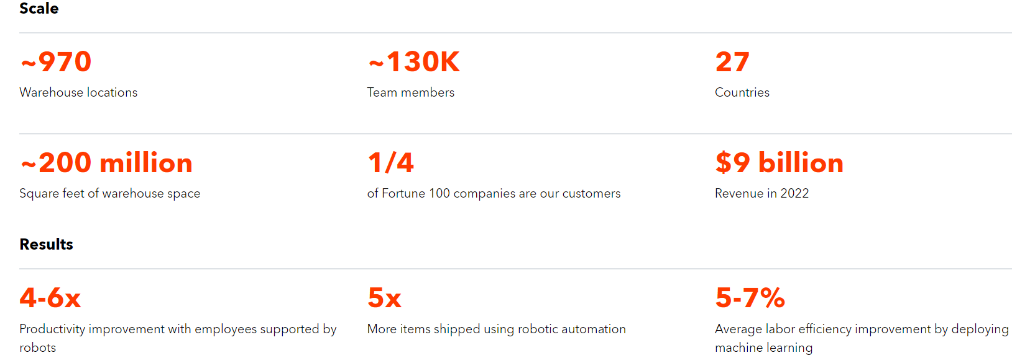
Data from the official website of GXO (2023)

Critically assessment the Workplace Culture at GXO

Organizational culture significantly influences the work climate, business success, task execution, goal setting, and individual guidance (Stare, 2011). It also plays a vital role in performance and decision-making (Davidson, 2000). GXO's success hinges on its unique workplace culture, which fosters excellence and adds value to the company and customers. To enhance the ethical work environment, a comprehensive evaluation of environmental factors, the interplay between organizational structure and the work environment, and key elements of ethical organizational culture is crucial.

https://www.youtube.com/watch?v=dRudpXHocc8 GXO – watch ESG in action
Source: the official website of GXO (2023)

Analysing the Impact of Environment Factors on Work Culture at GXO: A Critical Appraisal Utilizing an Appropriate Framework

Economical, Legal, Political, Social, Technological
Customers, Suppliers, Competitors, Intermediates

PESTEL analysis

The PESTEL analysis, as defined by Johnson, Scholes, and Whittington (2019), is a framework used to evaluate external macro-environmental factors that can affect an organization. It provides insights into the overall business environment and identifies key factors influencing strategic decisions.
Applying the PESTEL analysis to GXO, the official website (2023) highlights the following external factors and their impact on the organizational culture:
Political Factors: Government regulations and policies can directly impact GXO's operations, leading to changes in strategies and processes. For example, trade tariffs or import/export restrictions can disrupt supply chains and logistics networks. New regulations related to labour practices or safety standards may require the implementation of policies and procedures to ensure compliance, fostering a culture of employee well-being and safety. GXO's compliance with the Uighur Forced Labor Prevention Act and restrictions on goods from Xinjiang reflect their commitment to human rights and ethical sourcing, influencing the organizational culture.
Economic Factors: During economic instability, GXO may need to adjust pricing, improve efficiency, and explore new markets due to changes in demand for logistics services. This can create job insecurity and stress for employees. However, the growth of e-commerce, automation, and outsourcing presents opportunities for GXO and fosters a positive work culture. These advancements streamline processes, boost productivity, and generate new job prospects. GXO's commitment to cost reduction, waste reduction, and environmental sustainability also contributes to an enhanced work culture.
Sociocultural Factors: An increased emphasis on work-life balance and employee well-being can lead to the adoption of flexible work arrangements and wellness programs, promoting a culture of work-life integration and employee happiness. Sociocultural changes can also impact consumer preferences and demand for sustainable and socially responsible supply chain practices, requiring GXO to adapt its offerings and strategies accordingly.
GXO's focus on diversity, inclusion, and belonging programs and emphasizing employee engagement, competitive compensation, health, safety, and professional growth can contribute to a work culture that values equality, teamwork, and different perspectives.
Technological Factors: For GXO, embracing modern technologies such as automation, robotics, and artificial intelligence can enhance operational efficiency, improve inventory management, and reduce costs. However, integrating innovative technologies may also require significant investments in infrastructure, workforce upskilling, and change management processes.
Environmental Factors: The organization may need to adopt eco-friendly practices, such as implementing green logistics solutions, optimizing energy usage, and reducing carbon emissions. Environmental changes can also create opportunities for instance GXO's implementation of ESG initiatives, renewable energy sources, waste diversion, and efficient operations can promote a work culture that values sustainability, environmental stewardship, and reducing the carbon footprint.
Legal Factors: The implementation of new labour regulations or environmental standards may require the organization to modify its practices and invest in additional training or infrastructure. Legal changes can also impact GXO's contractual relationships with suppliers, customers, and business partners, necessitating contract revisions or renegotiations.

P | E | S | T | E | L
Political | Economical | Social | Technological | Environmental | Legal
Government regulations and policies related to logistics and supply chain management  -The impact of trade agreements and geopolitical factors on GXO's operations | -Macro-economic trends and conditions affecting the logistics industry  - The impact of economic growth, inflation rates, and currency exchange rates on GXO's financial performance | - Consumer behaviour and logistics demands  - The changing preferences and expectations of customers regarding sustainability, ethics, and social responsibility | - The role of technology in GXO's operations, such as automation, artificial intelligence, and data analytics  - The impact of emerging technologies on GXO's efficiency, competitiveness, and customer experience | - GXO's environmental practices and initiatives outlined in the ESG report  - The impact of climate change, resource scarcity, and sustainability regulations on GXO's operations and reputation | - Laws and regulations governing the logistics industry, including transportation, labour, and data privacy  - Any legal challenges or compliance requirements that may impact GXO operations

Porter’s 5 forces

The model of five competitive forces (Porter, M. 1980)

Porter's (1980) theory of competitive forces provides a framework for analysing the industry dynamics and identifying factors that impact the profitability and competitiveness of organizations, allowing GXO to understand the industry landscape and its competitive position.
Barriers to entry: GXO benefits from economies of scale achieved through automation and efficient operations. This creates a barrier for new entrants. Focus on innovative and sustainable solutions, along with its strong brand identity, makes it difficult for competitors to replicate its offerings. The high capital requirements of the logistics industry and GXO's established distribution channels further deter new entrants. In addition, GXO's commitment to compliance with laws and regulations, including ethical business practices, creates an enabling environment and acts as a barrier to businesses that do not meet these standards.
Determinants of supplier power: GXO reduces supplier power through differentiated inputs and supplier diversification efforts. Its scale and volume give it leverage, while the company's emphasis on sustainability minimizes the impact of resource inputs on total costs or differentiation.
Buyer Power: GXO's large customer base and market position reduce buyer power. A company's strong brand identity, transparency and customer relationships provide the necessary information and reduce buyer power.
Threat of substitute products or services: GXO operates in the logistics and supply chain industry, which has various alternative providers and service options. This creates a moderate threat of substitutes.
To mitigate this threat, GXO's focus on automation, advanced technology, sustainability, and customer-centric solutions.
Determinants of Rivalry: Determinants of Rivalry: GXO differentiates itself through innovative solutions, automation, sustainability, and advanced technologies, reducing rivalry. Its strong brand identity and investment in technology increase customer switching costs, further reducing rivalry and GXO's focus on sustainability and advanced technology gives it a competitive edge.
The company fosters a culture of excellence, customer focus and sustainability through innovation, ethical practices, and differentiation. By leveraging economies of scale, differentiation, and brand identity, GXO creates barriers to entry and reduces supplier and buyer power.

Exploring the Relationship between Organizational Structure and Workplace Culture at GXO

The organizational structure of a company plays a crucial role in defining reporting relationships, establishing hierarchy, and facilitating communication (Awa, 2016). It determines how different departments and individuals are connected within the organization. Small firms often adopt a centralized functional structure, while medium-sized firms tend to have a decentralized divisional structure.
GXO has a complex organizational structure that combines decentralization, hierarchy, and a mix of functional and divisional approaches. The decentralized structure empowers regional leaders, promoting accountability and autonomous decision-making to respond quickly to local market dynamics and customer needs. While GXO primarily follows a decentralized structure, it may also incorporate elements of centralization in certain aspects of its operations. Centralization is top-level authority making key decisions. In GXO's case, executive positions such as the CEO and President establish clear reporting relationships and play a central role in decision-making processes.
The hierarchical aspect establishes clear reporting relationships, facilitating effective communication and decision-making. The functional structure organizes departments based on specialized functions, allowing for deep expertise in areas such as compliance, human resources, finance, and strategy. The divisional structure provides autonomy to each division, enabling customization and responsiveness to regional markets.

This organizational structure has several implications for GXO. It fosters a culture of accountability and localized decision-making, ensures efficient communication and coordination through clear reporting relationships, promotes specialization and expertise within specific areas, and allows for adaptability and responsiveness to regional market dynamics. By leveraging these structural elements, GXO can navigate its operations, shape its organizational culture, and enhance overall success.

Organisation Structure 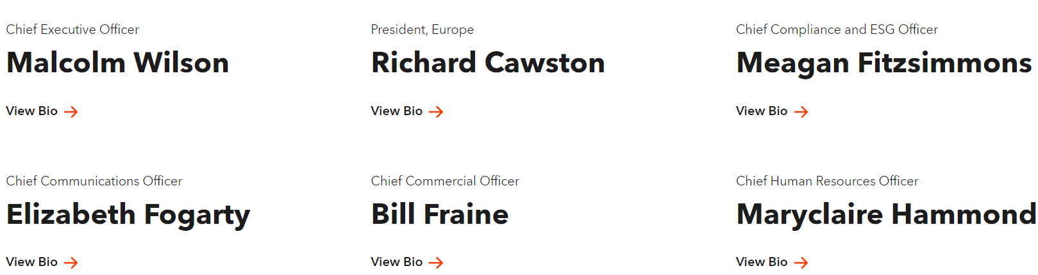 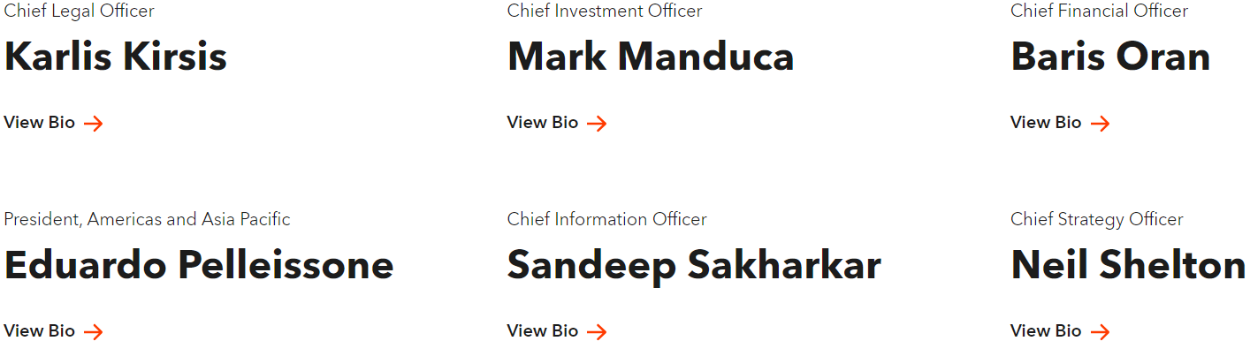
Source: the official website of GXO

Assessing and Examining the Essential Components of Ethical Organizational Culture in GXO: Strategies for Enhancing Ethical Culture Environment

To evaluate and promote ethical behaviour in GXO, academic frameworks such as Schein's model, McKinsey 7s, and Kotler's 8-step plan can be employed.
According to Schein, organizational culture consists of three levels:
- Artefacts and behaviours - represent the visible aspects of culture, such as symbols, rituals, and behaviours (Schein, 1996). In the case of GXO this is the code of conduct and training programs on ethics.
- Espoused values, and underlying assumptions - refers to the stated beliefs and values of the organization, which guide employees' behaviour and decision-making (Schein, 1996). GXO promotes ethical values among employees by clearly communicating its commitment to integrity, respect, and ethical business practices. This can be reinforced through leadership messages, internal communications, and performance evaluation criteria that emphasize ethical behaviour.
- Underlying assumptions, represents the unconscious beliefs and norms that shape behaviour within the organization (Schein, 1996). GXO promotes them by fostering an open and transparent culture where employees feel safe to raise concerns or dilemmas. This can be achieved through the establishment of reporting channels, whistle-blower protections, and creating a culture of trust and psychological safety.
Additionally, the McKinsey 7s framework can be applied to examine the alignment of ethical elements within GXO's organizational culture. The framework considers seven interdependent elements: strategy, structure, systems, shared values, skills, style, and staff (Peters & Waterman, 1980). The alignment of these elements is crucial for promoting an ethical culture within GXO. Systems such as performance management and reward systems should incentivize and recognize ethical behaviour.
In line with Kotter's eight-step plan (Kotter, 1996), the following steps can be implemented at GXO to foster an ethical culture:
1. Create a sense of urgency: Communicate the importance of ethical behaviour and its impact on long-term organizational success.
2. Create a collaborative alliance: Establish a diverse group of leaders who champion ethical practices and drive cultural change.
3. Craft a vision and formulate a strategic plan: Clearly articulate the desired ethical culture and the strategies to achieve it.
4. Cascade the vision to all employees, reinforcing the importance of ethical behaviour and its alignment with the organization's values and mission.
5. Empower action: Provide employees with resources, training, and support to make ethical decisions and take appropriate actions.
6. Generate short-term wins: Celebrate and recognize examples of ethical behaviour, reinforcing the importance of ethical conduct and motivating employees.
7. Consolidate gains and produce more change: Embed ethical practices into policies, procedures, and performance management systems, consistent recognition and integration.
8. Embed the changes into the corporate culture: Integrate ethical values and behaviours into the core values and norms of GXO's organizational culture, with ongoing reinforcement, training, and assessments.

One ethical dilemma likely to influence the culture of GXO is the issue of supply chain sustainability and responsible sourcing. As a logistics provider, GXO operates in an industry with significant environmental impacts. The ethical dilemma arises when the organization faces pressure to prioritize financial performance over environmental responsibility.
To address this dilemma, GXO can adopt a stakeholder-oriented approach, considering the interests of various stakeholders, including customers, employees, communities, and the environment, in its decision-making processes (Freeman, 1984). GXO should invest in sustainable practices, such as reducing emissions, promoting circular economy principles, and collaborating with customers and landlords to achieve environmental goals. By integrating sustainability initiatives into its core operations, GXO can demonstrate its commitment to responsible business practices and inspire a culture of environmental responsibility among employees. This ethical dilemma provides an opportunity for GXO to align its profit objectives with environmental sustainability, thus shaping its organizational culture around ethical principles.

Enhancing GXO Workplace Culture: Identifying Barriers Recommendations, and their Impact on Organizational Efficiency

Barriers to Effective Functioning of GXO's Workplace Culture

While GXO has cultivated a workplace, culture centred around inclusion and sustainability, several barriers may hinder its effective functioning. Identifying and addressing these barriers is crucial for enhancing the workplace culture and improving organizational efficiency. Here are some key barriers that GXO may encounter:
- Lack of Leadership Alignment: Inconsistent alignment and communication among leaders within GXO can impede the implementation of the desired workplace culture (Beer, 2009). Misalignment may result in conflicting priorities, inconsistent messaging, and a lack of unified vision, which can undermine employees' understanding and commitment to the intended culture.
- Resistance to Change: Employees and leaders may resist embracing cultural changes due to fear, uncertainty, or a preference for the status quo (Beer, 2009). This resistance can hinder the adoption of new values, behaviours, and practices necessary for a thriving workplace culture.
- Communication Gaps: Ineffective communication channels or practices can create barriers to transparent and inclusive communication. This may lead to misunderstandings, lack of information sharing, and decreased engagement among employees (Beer, 2009).
- Lack of Employee Empowerment: Employees may feel disempowered if they do not have opportunities to contribute their ideas, provide feedback, or have a sense of ownership in shaping the workplace culture (Beer, 2009). This can result in reduced motivation, decreased job satisfaction, and limited innovation within the organization.

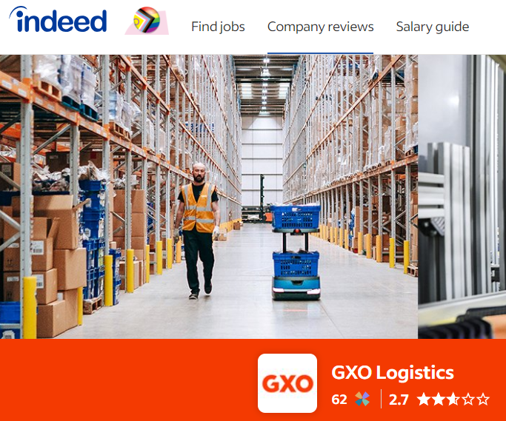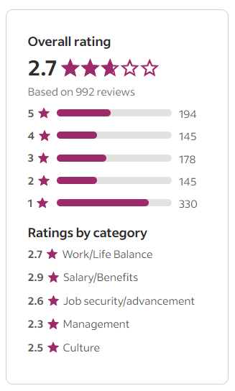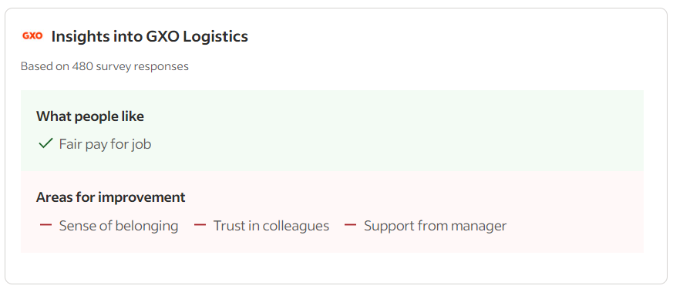
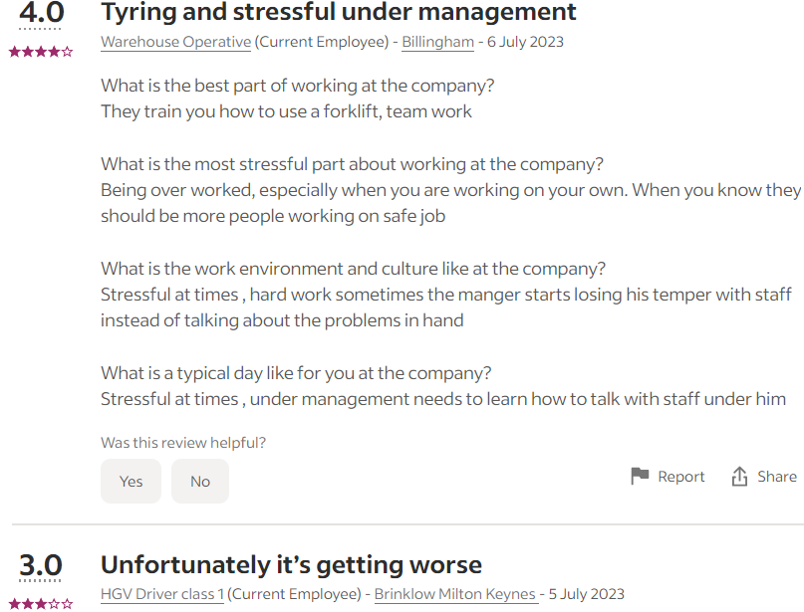
Source: https://uk.indeed.com/cmp/Gxo-Logistics/reviews

Recommendations to Enhance GXO's Workplace Culture

To address these barriers and enhance GXO's workplace culture, the following recommendations are proposed:

- Leadership Alignment and Engagement: GXO should invest in leadership development programs and initiatives to foster alignment and engagement among its leaders (Beer, 2009). This can involve regular meetings, workshops, and training sessions that promote shared values, a unified vision, and consistent communication across all levels of leadership.

- Change Management and Employee Involvement: Implementing effective change management strategies is crucial for overcoming resistance to cultural changes (Beer, 2009). GXO should involve employees at all levels in the change process, seeking their input, and providing opportunities for them to participate in decision-making.

- Communication Enhancement: GXO should prioritize improving communication channels and practices to ensure transparent and inclusive communication (Beer, 2009). This can involve implementing regular meetings, creating online platforms for idea sharing and feedback, and fostering an open-door policy for employees to express their thoughts and concerns.

- Employee Empowerment and Recognition: GXO should provide opportunities for employee empowerment and recognition (Beer, 2009). This can be achieved by encouraging employees to contribute ideas, providing platforms for knowledge sharing and collaboration, and recognizing and rewarding employees who exemplify the desired cultural values.

Positive Impact on Organizational Efficiency

Implementing the recommended strategies will positively impact GXO's organizational efficiency in the following ways:
Improved employee alignment and engagement will enhance productivity and teamwork, as employees will understand and actively contribute to the organizational goals and values.
Addressing resistance to change and involving employees in the change process will reduce disruption and enhance the organization's agility, allowing for smoother implementation of cultural changes and increased adaptability.
Enhancing communication channels will foster better collaboration, knowledge sharing, and problem-solving, leading to more efficient processes and decision-making within GXO.
Employee empowerment and recognition will boost morale, job satisfaction, and employee retention. This, in turn, will reduce turnover costs and ensure a skilled and committed workforce, contributing to overall organizational efficiency.
By addressing the identified barriers and implementing the recommended strategies, GXO can strengthen its workplace culture, leading to improved organizational efficiency and a more positive and productive work environment.

Conclusion

In conclusion, this report has explored the organizational culture of GXO and its impact on ethical behaviour. By analysing key issues, literature, and frameworks, valuable insights have been gained.

The evaluation using Schein's model, McKinsey 7s, and Kotter's 8-step plan emphasized the importance of artefacts, values, and assumptions in promoting ethical behaviour. Recommendations such as aligning leadership, managing change effectively, enhancing communication, empowering employees, and recognizing their contributions can enhance the workplace culture and improve organizational efficiency.

The PESTEL analysis highlighted the influence of political, economic, sociocultural, technological, environmental, and legal factors on GXO's culture. Adapting to these factors enables GXO to align its culture with stakeholder expectations and industry trends.

Porter's Five Forces analysis emphasized the significance of barriers to entry, supplier and buyer power, threat of substitutes, and rivalry among competitors. Leveraging strengths such as economies of scale, differentiation, and sustainability initiatives contributes to a positive work culture.

Addressing ethical dilemmas, particularly supply chain sustainability and responsible sourcing, is crucial for shaping GXO's culture. Adopting a stakeholder-oriented approach and integrating sustainability initiatives reinforce GXO's commitment to responsible business practices.

In conclusion, by enhancing its organizational culture, GXO can foster an ethical work environment, employee satisfaction, and organizational success. Aligning culture with values, goals, and external factors positions GXO as a leader in ethical business practices and sustainable supply chain solutions.

List of References

Alvesson, M. (2012). Understanding organizational change.
Awa, K. I. (2016). Functional structure and operational issues: An examination of core challenges and remedies. IOSR Journal of Business and Management, 18(1), 1-4.
Beer, M. (2009). High commitment, high performance: How to build a resilient organization for sustained advantage.
Browaeys, M., Price, M., & Price, R. (2011). Understanding Cross-Cultural Management (2nd ed.).
Brown, M. E., & Trevino, L. K. (2018). Do role models matter? An investigation of role modelling as an antecedent of perceived ethical leadership. Journal of Business Ethics, 150(1), 127-144.
Freeman, R. E. (1984). Strategic management: A stakeholder approach. Pitman.
Freight Waves. (2023, June 26). GXO Direct launches in UK with plans for future European expansion. Retrieved from https://www.freightwaves.com/news/gxo-direct-launches-in-uk-with-plans-for-future-european-expansion
Harvey (2015, quoted in Lewis, 2018, p. 86) provides an excellent survey.
Johnson, G., Scholes, K., & Whittington, R. (2019). Exploring Strategy: Text and Cases (12th ed.). Pearson.
Kaptein, M., & Wemple, J. (2019). The effect of ethical culture and ethical leadership on employees' ethical decision-making: A three-level mediation model. Journal of Business Ethics, 156(3), 727-742.
Kotler, J. P. (1996). Leading Change. Harvard Business Review Press.
McKinsey & Company. (n.d.). The 7S Framework.
Mullins, L., & Christy, G. (2016). Management & Organisational Behaviour (Eleventh ed.).
Porter, M. E. (1980). Competitive strategy: Techniques for analysing industries and competitors.
Schein, E. H. (1996). Culture: The missing concept in organization studies. Administrative Science Quarterly, 41(2), 229-240.
Stare, A. (2011). The impact of the organisational structure and project organisational culture on project performance in Slovenian enterprises. Management, 16(2), 1-22. Retrieved from https://hrcak.srce.hr/74888 (Accessed: 27.06.2023).
Trevino, L. K., Weaver, G. R., & Reynolds, S. J. (2014). Behavioural ethics in organizations: A review. Journal of Management, 40(1), 123-152.

