Melanie Rowland 1602402
With reference to classroom observation and practice, demonstrate an understanding of the effective application of three educational theories. Reference academic literature as appropriate.
The Welsh Assembly Government (2017) states that by 2021 the education system in Wales will be reformed, providing learners with experiences which create young adults that are “ambitious creative learners” (Welsh Assembly Government 2017), who are skilled in literacy, numeracy and digital competency. In order to achieve this, it would be reasonable to suggest that educators need to be able to give students the basic emotional skills and learning tools to enable them to feel confident enough to be a part of the evolving learning environment. This is not a new idea, rather it is the writer’s assertion that Welsh Assembly policy is merely bringing together what educators have already been a part of for many years – creating bold, autonomous learners who feel safe and confident enough to take risks. The theory behind this goes back many years and has been suggested by a variety of theorists under a range of different names. It primarily takes influence from constructivist theory that suggests that learners get their best information from doing and from active learning, rather than by instruction or being “lectured” (David 2015) as well as that of behaviourists who suggest that people are more inclined to behave in a positive way if there is tangible reward (David 2015). The aim of this assignment is to look at both constructivist theorists and behaviourist practitioners and demonstrate examples of how these theories are put into practice in a classroom.
The theory of rewarding positive behaviour is a common one – parents and educators have long recognised that if good behaviour is rewarded then it is likely to be repeated. A leading theorist in the field of positive reward or conditioning is B.F Skinner who based his work on Thorndike’s law of effect (Encyclopaedia Britannica 1998). Skinner used experiments on rats to develop a theory of “operant conditioning” (Skinner 1938 cited in McLeod 2015). The idea behind this operant conditioning is that educators use positive reinforcers or rewards to increase the likelihood of positive behaviours being repeated, whilst giving punishers, or negative responses to discourage negative behaviour. Skinner performed various behaviour experiments using rats and suggested that most human and animal behaviour “can be explained as a product of (this type of) successive approximation” (McLeod 2007) meaning that that behaviours could be modified by a system of successively adapting and changing what was expected from the subject in order to receive a reward. This links with his theory of Behaviour Modification using a token system – issuing tangible rewards for positive behaviour. In real terms, this is achieved in a variety of ways. In a mainstream setting, tools such as pebbles in a jar, raffle tickets, star charts or reward charts are often employed to recognise positive behaviour. Conversely, a setting may use ‘time out’ or loss of golden time as a punisher.

Golden time reward chart - an example of a positive reinforcer (Skinner 1938)

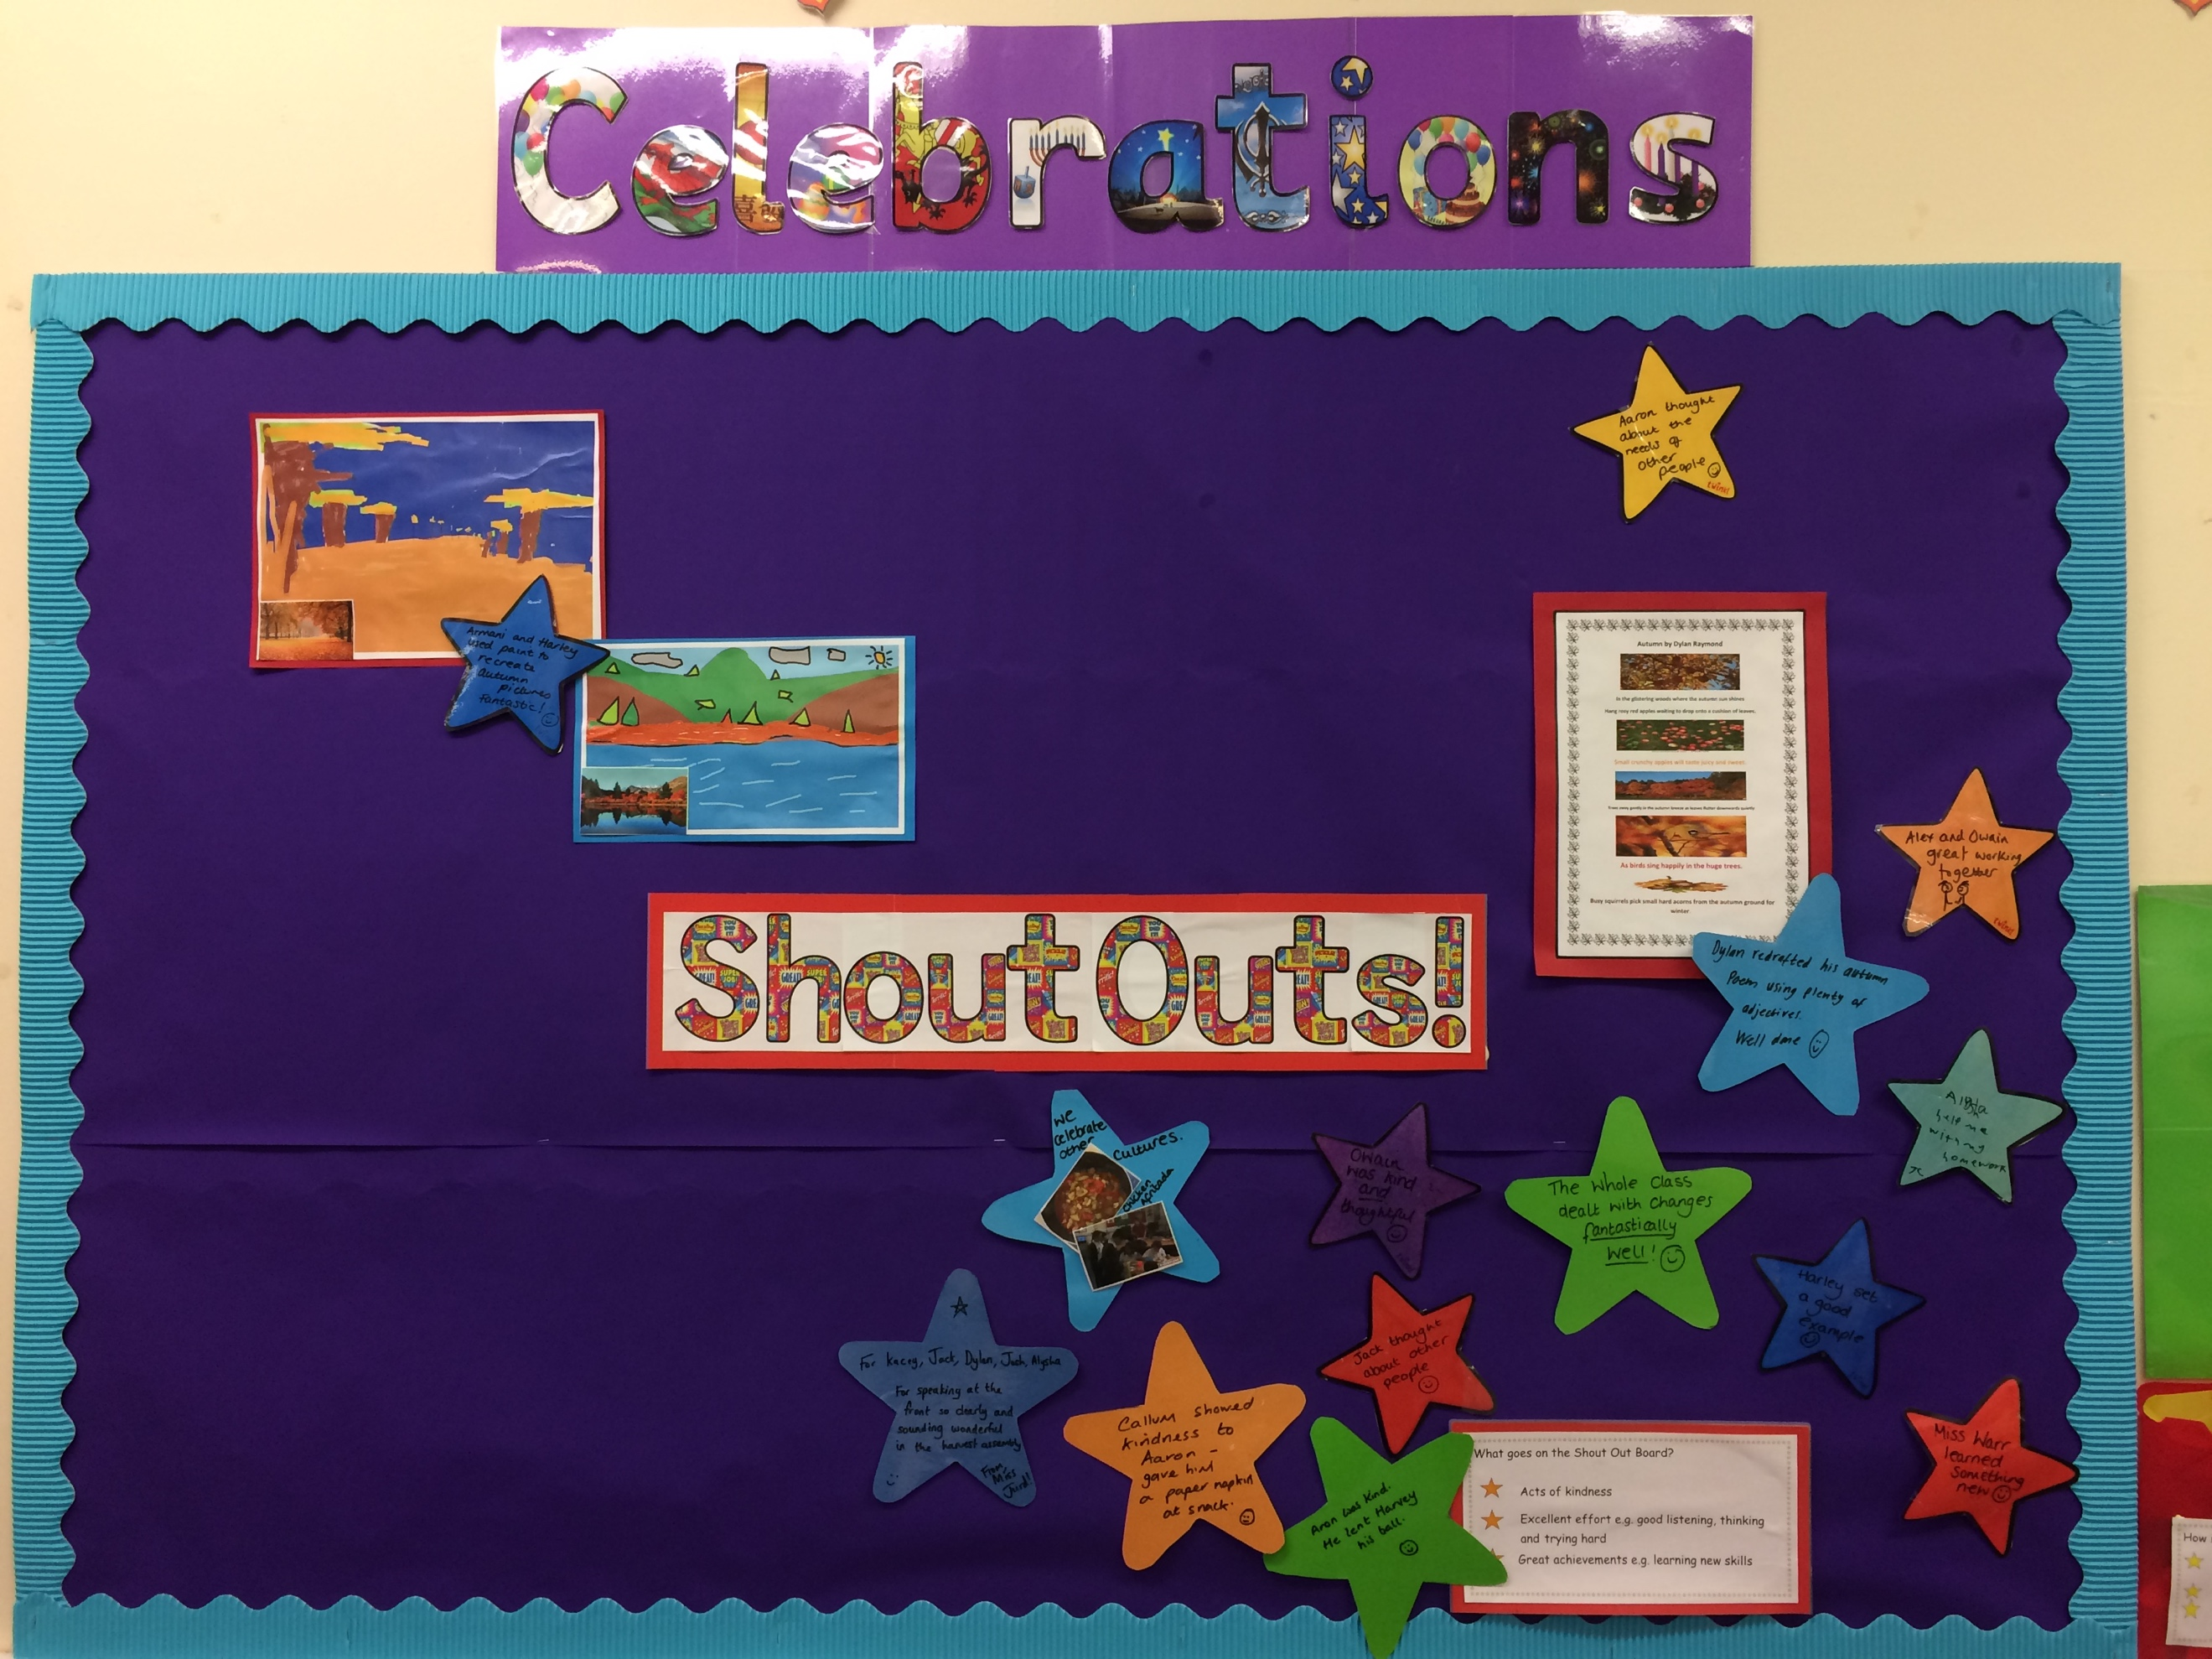
Another example of a positive reinforcer– this shout out board praises positive behaviours.
In an Additional Learning Needs (ALN) setting, most specifically when working with learners who have Autistic Spectrum Condition (ASC) the use of visual timetables or “now and next” charts are common. These charts provide the positive reinforcer- if you complete this task you will be rewarded by an activity that you enjoy. They are immediate and visual which is more accessible to a student with autism (The National Autistic Society no date) who are often more visual learners and need a ‘real’ pictorial support that they can refer back to and that makes sense to them (Quill 1997).
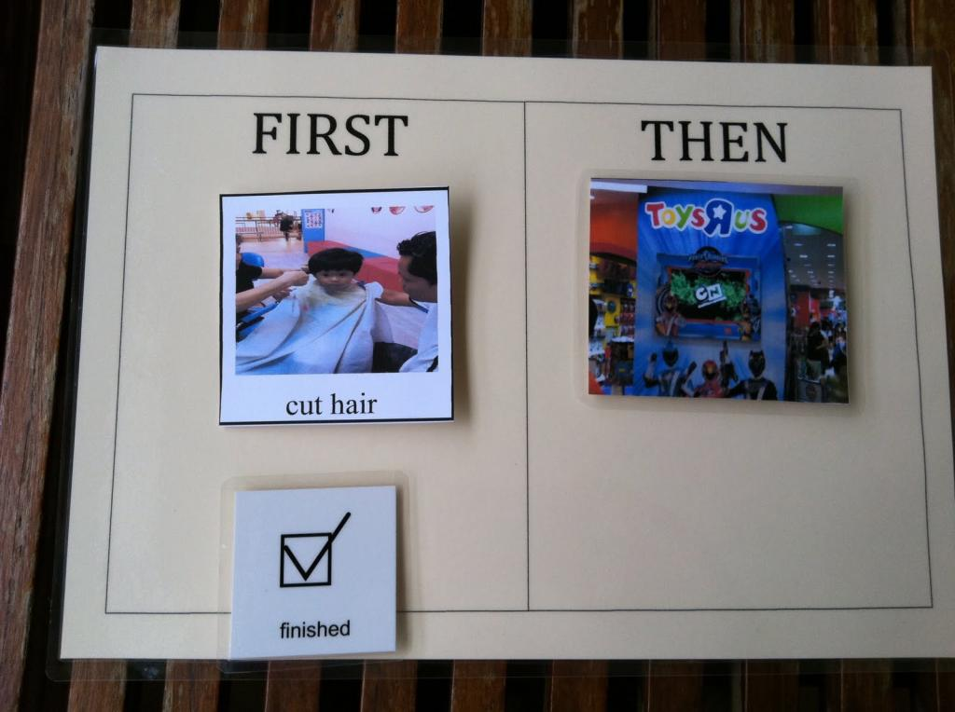
Now and next chart (Autism speaks 2017)
It is important to note that with some children, punishers can be counter productive. For example; a child with a conduct disorder such as Oppositional Defiant Disorder (ODD) which is defined as “A disruptive behaviour pattern of childhood and adolescence characterized by defiant, disobedient, and hostile behaviour (sic) especially toward adults in positions of authority” (Merriam-Webster , no date) is likely to react badly to a negative consequence and this could affect the child’s subsequent behaviour pattern. (NHS 2013) In this instance, it may be more appropriate to use a less obvious tactic such as ignoring the unwanted behaviour. (McLeod 2007) In these circumstances it is also very important to be selective and consistent with both positive and negative reinforcers. Students must be clear about the behaviour which elicits a positive or negative response and this needs to be consistently applied by all those who work with the student (Lee and Snodgress 2013). Unfortunately this is not always the case and it is the writers experience that students who are not provided with fair and consistent reinforcers will often reject the reward altogether, or will play one staff member off against another and in some cases tell lies in order to gain reward illicitly.
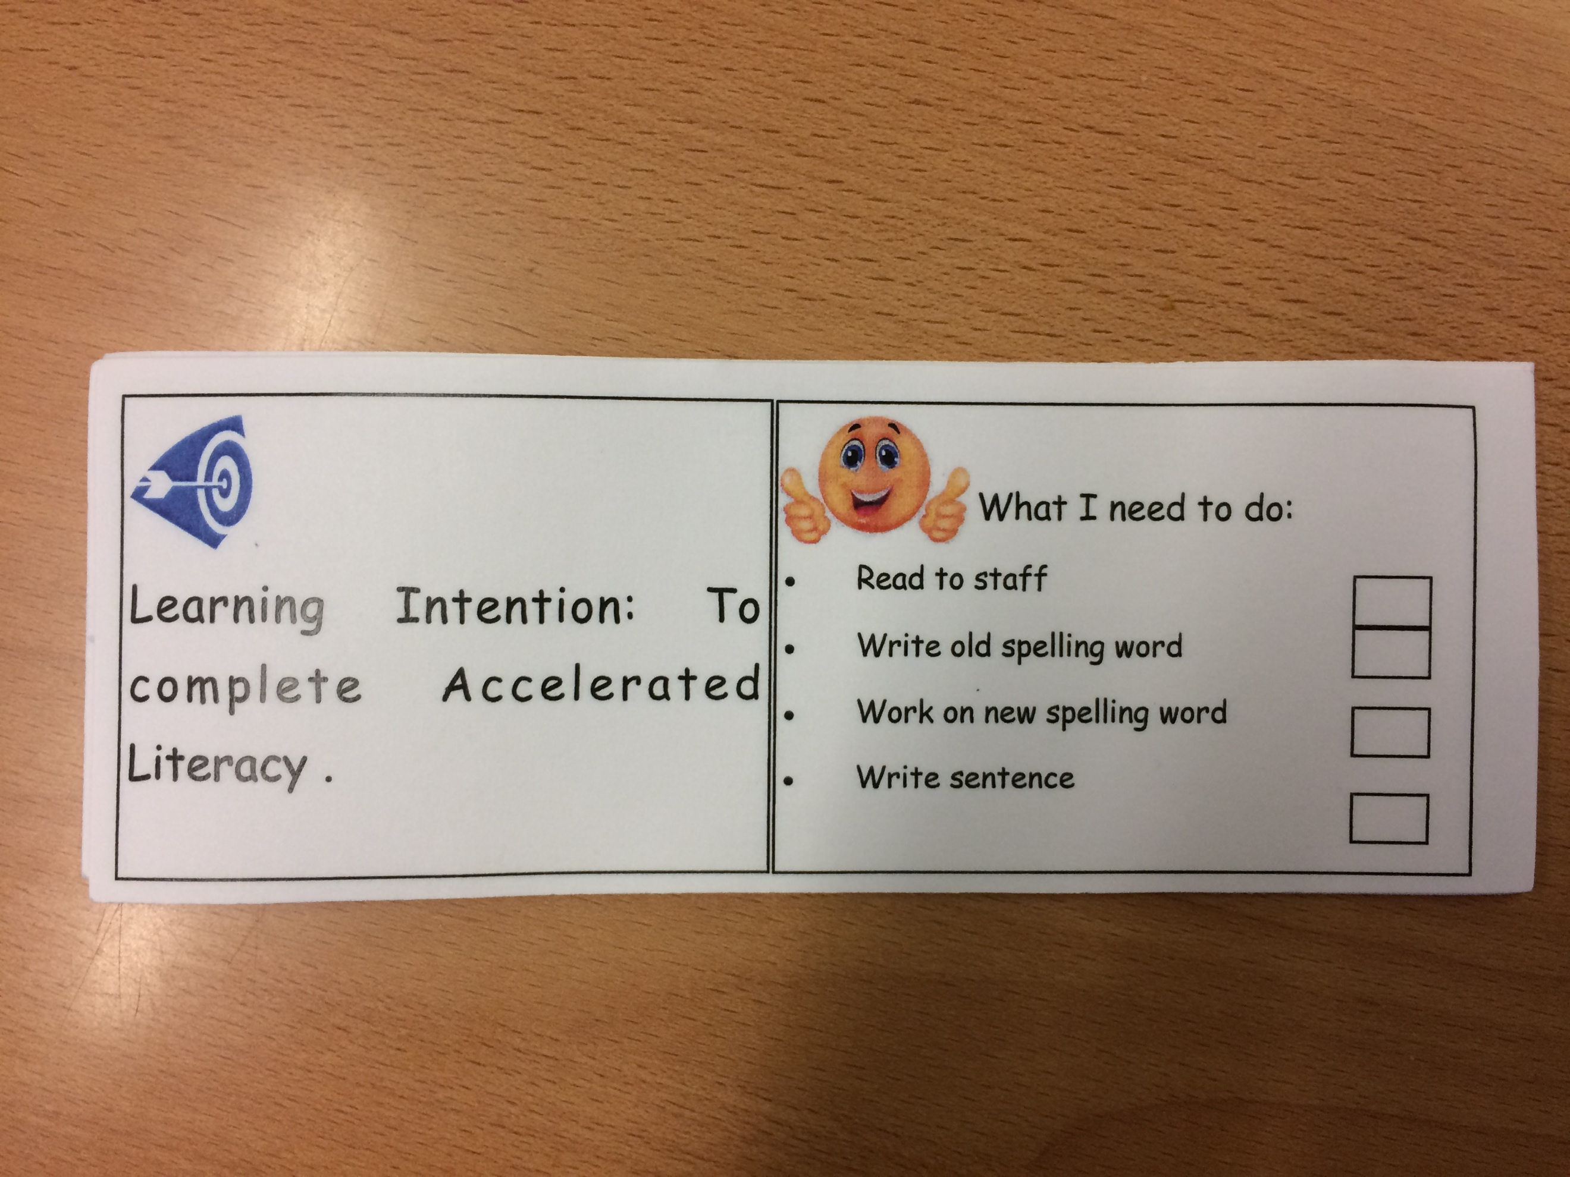
Lev Vygotsky believed that we learn best from working collaboratively with others. He suggests that developmental functions appear first on a social level before being shown on an individual level. Vygotsky suggests that this applied to so called “higher functions” such as logical memory and the formation of concepts of ideas (Vygotsky 1978). This interaction is vital to development and Vygotsky is quoted as saying “What a child can do in co-operation today he can do alone tomorrow” (Vygotsky cited in Palmer 2017). Vygotsky believed that if children are scaffolded and supported in activities that are challenging for them they will not only be able to complete them, but they will be able to advance to yet more difficult activities with confidence. This is evident in a modern classroom in principles of Visible Learning and Assessment for Learning. Students work together, with more knowledgeable and similar ability peers and staff to explore different concepts using methods such as “Think-Pair-Share” (Lyman 1981 cited in McTighe and Lyman Jr 1988) and mind mapping. Students are scaffolded and supported to create their own targets and to challenge their own knowledge and learning. Use of success criteria which is accessible and completed by students means that they can, with support, set their own idea of what a good piece of work looks like and state how they will achieve it. 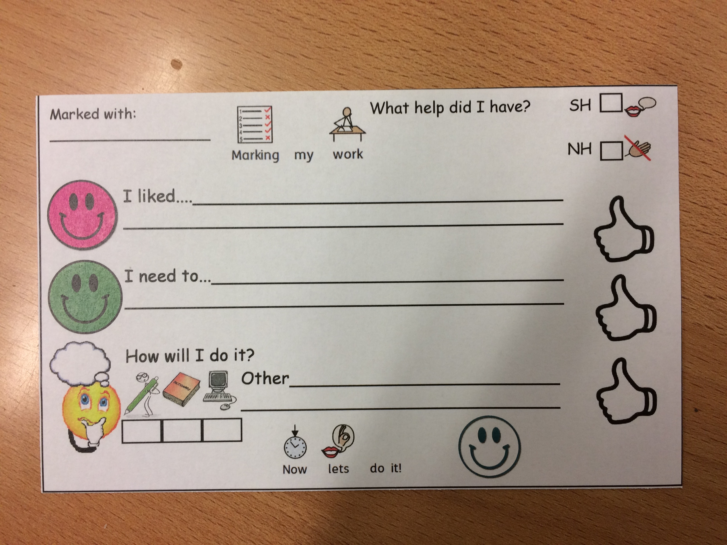
Two examples of scaffolded Assessment for Learning. Students work with staff to complete both success criteria and marking sheets to assess their own work as well as that of others. The idea is that, in time, students will have less intervention from staff and more independence in their work.


One of the principals of modern education is a Person-Centred approach – that is, treating each student as an individual and differentiating and structuring work so that it is suitable for each individual. This has been part of Welsh Assembly guidance and is a key feature of the new developments in Additional Learning Needs (ALN) provision (WAG 2015). It originates from theorists such as Jerome Bruner who believed that learners should not be taught according to an age or developmental stage but that they should be allowed to attempt the “foundations of any subject….at any age in some form” (Bruner cited in Weibell 2011). Like Vygotsky, Bruner believed that students and teachers should work collaboratively and that students should play an active role in decision making about their learning. (J.S.Bruner 1961) This links back to Socratic Learning – a constructivist approach which takes its influence from the philosopher Socrates and encourages inquiry based learning which is heavily student focussed (Lam 2011). This approach fits into Visible learning and Assessment for Learning in that students are encouraged to not only think about how they are learning, but to comment on their own understanding. In the example shown the use of mid-point check in to establish students’ understanding of a task allows the students the chance to lead the direction the lesson takes and allows a student-teacher dialogue.
Bruner also developed the concept of a “Spiral Curriculum”(Weibell 2011) where students revisit activities and ideas at repeated intervals to embed and enhance their learning. This can be seen in modern practice when looking at Pie Corbett’s (2016a) work on drafting and redrafting as well as Assessment for Learning when looking at marking – revisiting targets and going back over previously learned subjects to ensure knowledge is embedded. This also ties in with new and potential Government guidelines based on the Donaldson report (Welsh Assembly Government 2015) which suggests that building on prior knowledge and learning is key to an effective curriculum.
In conclusion the writer believes that the constructivist theory and behaviourist approach are both evident in many different aspects of effective provision of education. Whether practitioners realise their origins or not they feature heavily in our practice today. From target setting and marking, through to involving and encouraging students to take an active role in their own learning journey and reflect on their progress, these methods are thought to be the way to create the autonomous, brave learners that government expect our children to be.

References
David, L. “Classical and Operant Conditions (Skinner) Learning Theories June 19 20015 [online] Available at https://www.learning-theories.com/operant-conditioning-skinner.html (Accessed 10.11.2017)
David, L. “Constructivism” Learning Theories (June 20 2015) [online] Available at: https://www.learning-theories.com/constructivism.html (Accessed 10.11.2017)
Encyclopaedia Britannica (1998) Conditioning Psychology https://www.britannica.com/topic/conditioning#ref154465 (accessed 5.11.2017)
The National Autistic Society (No date) Visual Supports [online] Available at: http://www.autism.org.uk/about/strategies/visual-supports.aspx accessed 31.10.2017
Kelly, C. Five tips for a child with autism” https://www.autismspeaks.org/blog/2015/01/05/five-tips-helped-improve-my-childs-behavior (Accessed 6.11.2017)
Lam, F, (2011) The Socratic Method as an Approach to Learning and its Benefits [online] Available at : http://repository.cmu.edu/cgi/viewcontent.cgi?article=1126&context=hsshonors (Accessed 9.11.2017)
Lee, J and Snodgress, M. (2013) ‘To Condition the Child’ [Blog] Developmental Psychology at Vanderbilt Available at https://my.vanderbilt.edu/developmentalpsychologyblog/2013/12/to-condition-the-child/ (Accessed 9.11.2017)
McTighe, J and Lyman Jr, F. (1988) Cueing Thinking in the Classroom: The Promise of Theory-Embedded tools [online] Available at: http://ascd.com/ASCD/pdf/journals/ed_lead/el_198804_mctighe.pdf (Accessed on 9.11.2017)
Merriam-Webster Definition of Oppositional Defiant Disorder [online] Available at: https://www.merriam-webster.com/dictionary/oppositional%20defiant%20disorder (Accessed 9.11.2017)
National Health Service UK (2013)New guidelines on child antisocial behaviour [online}. Available at: https://www.nhs.uk/news/pregnancy-and-child/new-guidelines-on-child-antisocial-behaviour/ (Accessed 23.10.2017)
Quill, K.A. (1997) “Instructional Considerations for Young Children with Autism: The Rational for Visually Cued Instruction” Journal of Autism and Developmental Disorders 27 (6), (December 1997), pp 697-714 [online] Available at https://link.springer.com/article/10.1023/A:1025806900162 (Accessed 9.11.2017)
Talk 4 Writing (2016) Talk4Writing – the key to raising attainment http://www.talk4writing.co.uk (accessed 9.11.2017)
Vygotsky L.S. (1978) Mind in Society: Development of Higher Psychological Processes USA: Harvard College
Wales: Department for Children, Education, Lifelong Learning and Skills, (2017) Education in Wales: Our national mission Cardiff: Welsh Assembly Government [Online] Available at: http://gov.wales/docs/dcells/publications/170926-education-in-wales-en.pdf (Accessed 06.11.2017)
Weibell, C.J. (2011) principles of learning: 7 principles to guide personalized, student- centered learning in the technology enhanced, blended learning environment. [online] Available at https://principlesoflearning.wordpress.com (accessed 8.11.2017)
Welsh Assembly Government (2015) Successful Futures – Report om the Curriculum and Assessment Arrangements in Wales Cardiff: Welsh Assembly Government [Online] Available at http://www.uwtsd.ac.uk/media/uwtsd-website/content-assets/documents/wcee/successful-futures.pdf ( Accessed 10.11.2017)

