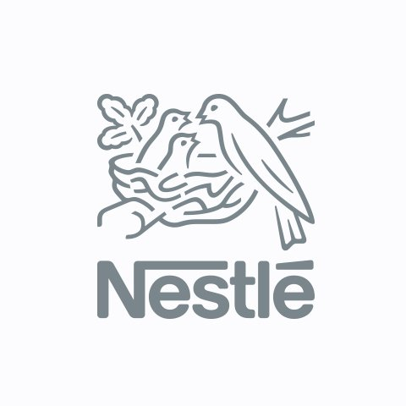

Group Blog

Group Members:
Viktoria Vartigorova-Ivanova, 1906318
Azhda Mustafa, 1907558
Stefaniya Milanova, 1908761
Milen Enchev, 1908493
Valentina Vasileva, 1909485

Module Tutor: Tushara Balendran
Module: Marketing Fundamentals
LCBB4004

May 2020

Background of Nestle Azhda Mustafa
Our company NESTLE's history commences in 1866 when US brothers Charles and George Page founded the Anglo-Swiss Condensed Milk Company. The father of Nestlé, the German-born pharmacist Henri Nestlé, created a ground-breaking baby nutrition in 1867.
Henri Nestle understood the value of branding at the very beginning of 1868. His emblem, showing tiny birds feeding in an oak branch nest, was built on the crest of his ancestors. While it has been modified over the years, the Nestle logo remains familiar and distinctive today.

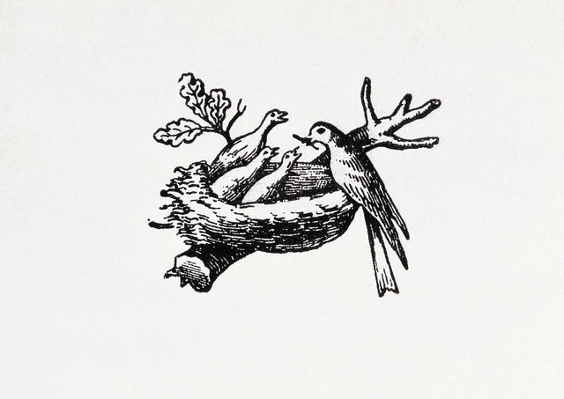
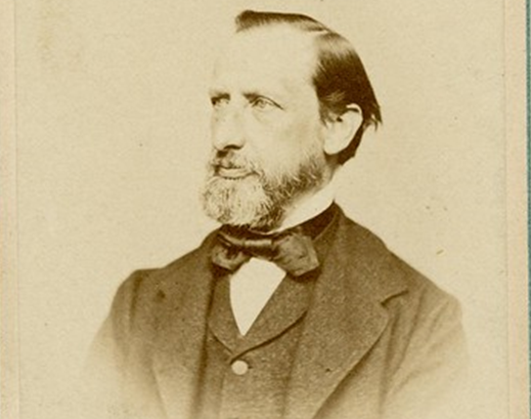

A portrait of Henri Nestle (1867) The Nestle trademark in 1868

Anglo-Swiss and Nestlé combined in 1905, creating Nestlé & Anglo-Swiss Milk Company. The organization has two head offices, Vevey and Cham, and is opening a new office in London for the distribution of dairy productsIn 1914, the war broke out across Europe and interrupted the manufacture of the business, but conflicts too strengthened the market for Nestlé dairy products in the form of big government agreements. In 1916, the Norwegian dairy group Egron was formed by Nestlé & Anglo-Swiss.
- In 1929, Nestle acquired the biggest chocolate corporation in Switzerland, Peter-Cailler-Kohler, which dates to 1819.
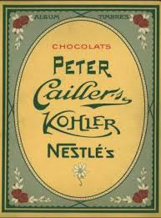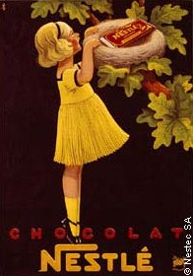
- Coffee price has crashed, and we launch Nescafé in 1938!

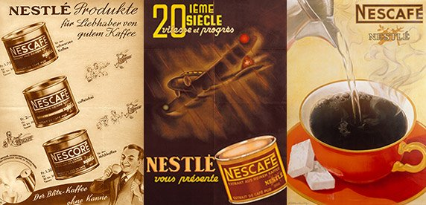

- The company in 1947, introduces Maggi soups and flavourings to its produce line and incorporates the brand - Nestlé Alimentana.
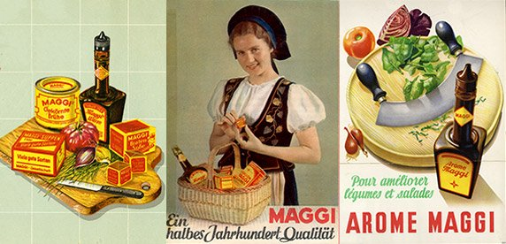

In 1960, with a growing number of households purchasing freezers, request for ice cream is increasing. Nestlé purchases the German producer Jopa and the French manufacturer Heudebert-Gervais to capitalise on this development and adds the Swiss brand Frisco in 1962.

Our organization moreover owns the UK conserved food firm Crosse & Blackwell at that year. The company has been buying Findus, one of the primary businesses to sell frozen food in EU, since 1945.

Nestlé expands beyond food and drink for the first time in 1974, becoming a minority shareholder in the global cosmetics company L'Oréal. Following years of growth in the 1980s and 1990s, Nestlé dispose of unprofitable brands and promotes increasingly healthy consumers in line with its new ambition for 'Health, Nutrition and Wellness.' The business is developing in the United States, Eastern Europe and Asia and strives for global leadership in water, ice cream and animal feed.

Our company celebrates its 150th anniversary as a company in 2016.
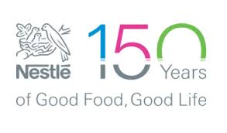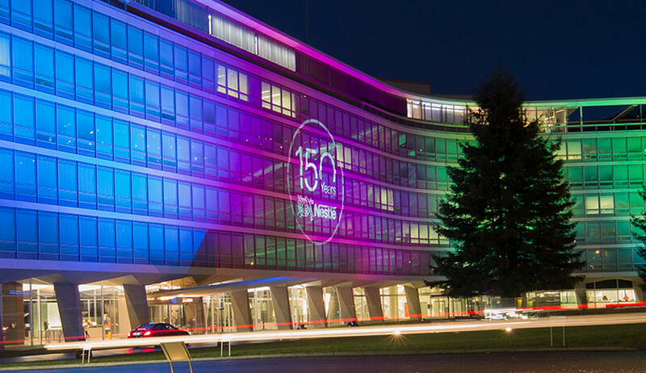
Our "Good Food, Good Life" goal is aimed at providing customers with the best quality, healthiest options in a wide variety of food and beverage categories and wellness opportunities, from morning to evening.
Innovation has been at the heart of our enterprise since its inception. Since Henri Nestlé created Farine Lactée to reduce infant mortality, we 're committed to increasing child mortality. Behind each of Nestlé 's products are a team of engineers, designers, nutritionists, scientists, regulators, and representatives of customer care devoted to building consumer sureness in safe, high-quality goods: safety and excellence are non-negotiable at Nestlé.
Our vision and values are to be a competitive and leading company in the areas of nutrition, health, and wellness.
For more information please visit: https://www.nestle.com/

Product Milen Enchev
Our portfolio includes over 2000 brands. We cover almost every division in food and beverage business. Through our brands, we bring joy, flavor and encouraging our customers to maintain a healthy and happy lifestyle, building on over 150 years of experience. We produce Baby food, Bottled water, Cereals, Chocolate and Confectionery, Coffee, Chilled & frozen food, Ice-cream, Dairy, Drinks, Food service, Healthcare nutrition and Petcare. Some of our most popular brands are KitKat, Nescafé, Milo, Nesquik, Maggi, Purina and Nespresso.
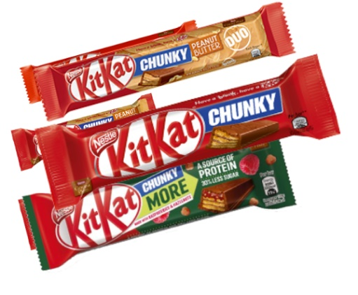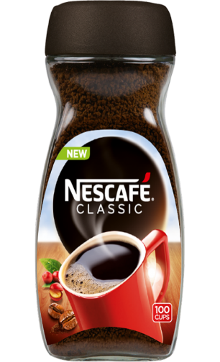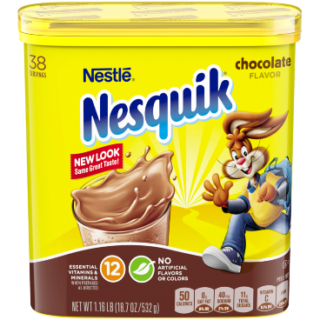
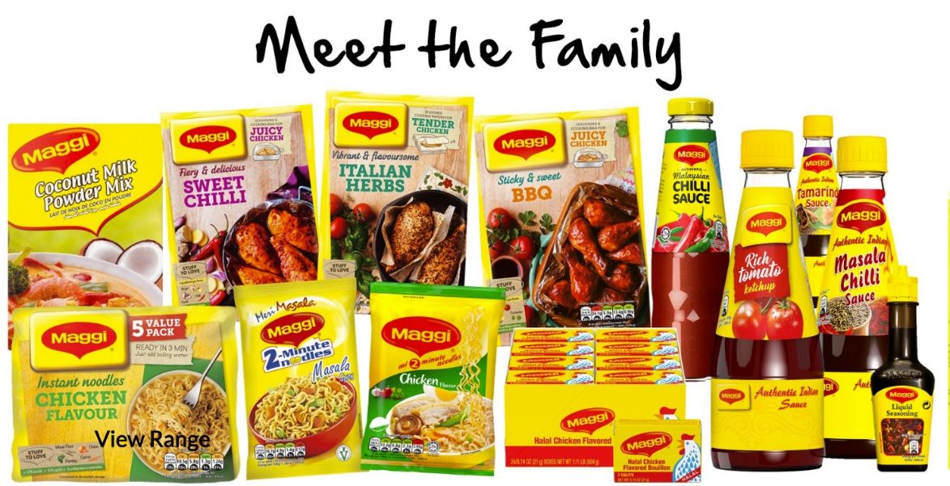
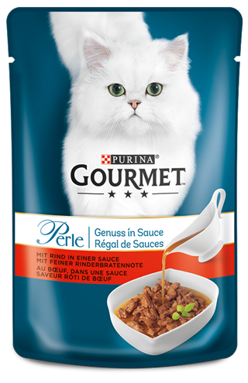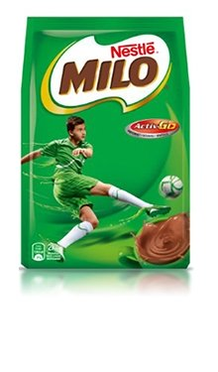
We are proud to say that Nescafe is one of our best seller products. Our Nescafe Coffees are Nescafe Classic, which is world famous, Nescafe Gold, Nescafe 2in1 and 3in1, Nescafe ready to drink and Nescafe Azera.
Nescafe 2in1 and 3in1 is suitable for everyone, but especially for people with busy lifestyle. 2in1 formula consist sweet creamy white and 3in1 formula includes coffee, sugar, cream and creamer. You can have it anywhere, at home, at the office or on your way to a meeting, all you need is a hot water. They are single-serve sachets with convenient and easy recognizable packaging, that you even can carry it in your pocket.
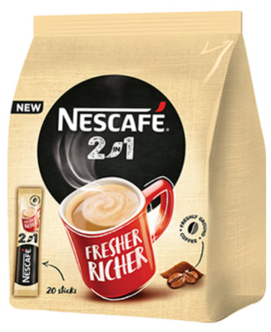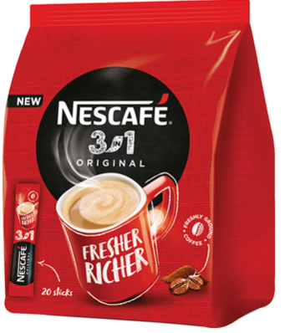
Nescafe ready to drink are Nescafe Shakissimo and Nescafe Smoovlate. Nescafe Shakissimo is ready to drink chilled latte, you just need to shake it before to consume it. We produce it in a convenient plastic cups and bottles, its really depends on your preferences. Shakisimo has 3 different variations – Espresso, Macchiato and Cappuccino. Each Shakissimo corresponds to a different color so you can easily differentiate them. Smoovlatte is one of our very popular, on-the-go cold beverages, can so you enjoy the perfect mixture of silky-smooth milk and great taste coffee in resealable and convenient bottle.
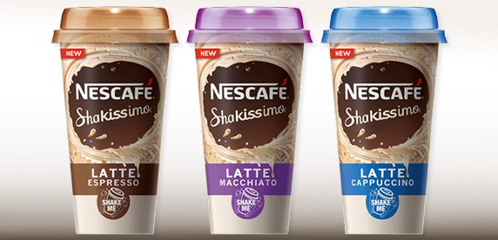
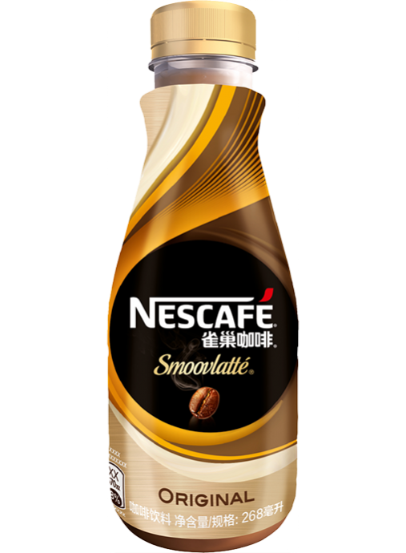

Nescafe Azera Americano is an instant coffee for our barista style coffee lovers. It has a smooth and well-balanced flavor. You don’t need a coffee machine for Nescafe Americano, only hot water. You can enjoy the taste of smooth barista style coffee without having barista skills or coffee machine. All you need is hot water and to be Americano lover. Nescafe Azera also produces Espresso and Intenso, a coffee with stronger coffee-kick. When is come to packaging we decided to produce the coffee in 100% recycling metal tins with a rounded, rectangular shape and in single-served sachets. For two consecutive years we collaborated with CROWN Aerosols & Promotional Packaging Europe to create a packaging to popularize Nescafe Azera. The result was phenomenal, after the final touching was completed and the products were in stores, we could say that Nescafe Azera stand out among other coffees.

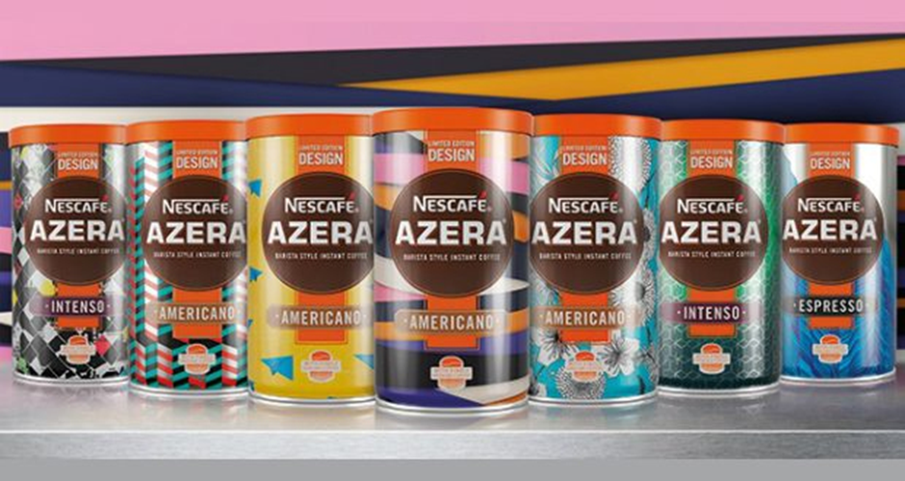
Quality and safety are of our top priorities. We have created a Quality Policy, that helps us to follow all quality practices and health & safety regulations. Also, quality is assembled through the product development, accordingly necessities of our customers. We believe that good quality product can’t be provided without applying the internationally recognized Good Manufacturing Practices (GMP). GMP that we use covers all aspects of manufacturing. To ensure that our products are always safe for the customers and prevent any food hazard and any food contamination we apply the HACCP system through the whole food production process (from raw materials to distribution and consumption).
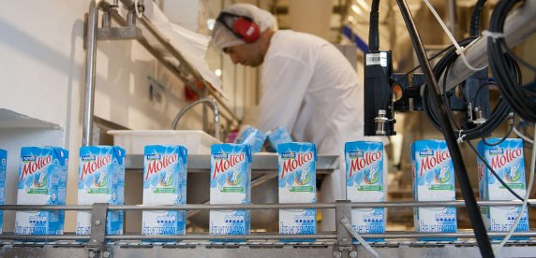
(Clean packing line for our products)

Price Stefaniya Milanova
Hello KitKat Lovers!
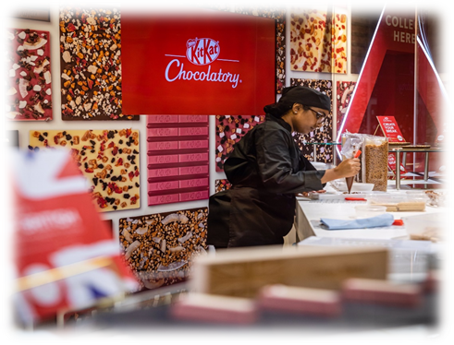
Nestle company persistently investing in our brands and always strive to create innovative products that respond to continuously changing consumer’s needs.
The project KitKat Chocolatory® has been established because of the demand for a distinctive luxury confectionary product. This global project commenced 5 years ago and already accomplished in Japan, Australia, Canada, Brazil and since the end of 2019 in England.
Nestle has a powerful position in the premium chocolate segment. The company is working hard over 80 years to develop and improve our KitKat brand in aspiration to continually fulfil your high expectations by offering high-quality, delicious and healthy products at affordable prices.
We believe that the new luxury and handmade Special KitKat selection will satisfy the most fastidious and pretentious customers.

WELCOME TO
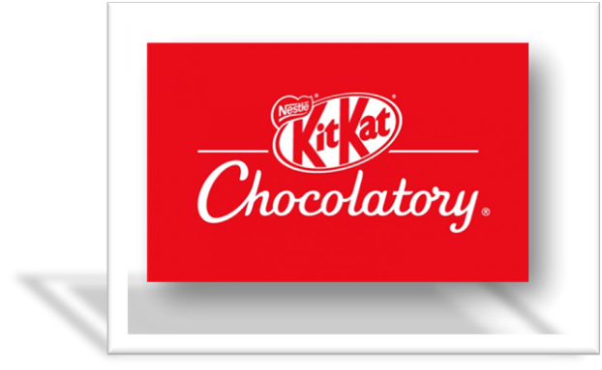
Are you ready for chocolate adventure?

In KitKat Chocolatory® all confections are handcraft and have their own unadulterated taste. You can choose among the numerous different flavours, wrapped with 4 types of chocolate – milk, dark, white and ruby. Pick up your favourite crispy fingers for starting price from £7.50.

Gourmet touch with six-finger KitKat for £7.50

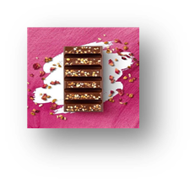
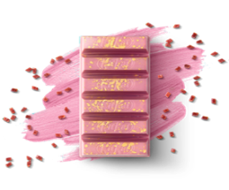
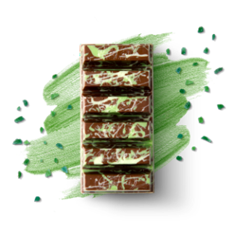
Ian’s Creation
Fig, cardamom, milk chocolate, pistachios and rose petals.
Springtime in Japan
Apple, ruby chocolate and cherry pieces.
Zingtastic Gin & Tonic
Gin and tonic, milk chocolate and lime crystals.

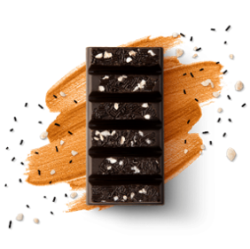
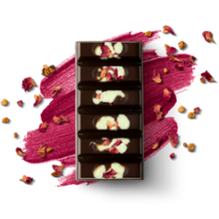
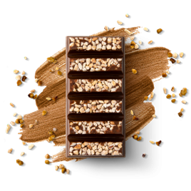
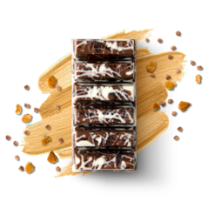
Billionaire's Treasure Nuttylicious Jewels of the East Whisky & Ginger
Salted caramel, Hazelnut praline, Pistachio, cardamom, Whisky, ginger,
milk chocolate, milk chocolate, dark chocolate, dark chocolate
buttery shortbread peanut and caramelised pistachios and ginger pieces.
and caramel pieces. hazelnut pieces. and delicate rose petals.

Double delicious with twelve-finger KitKat for £12.00

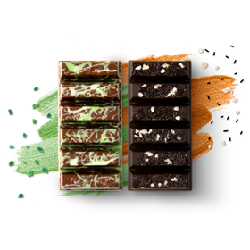
The Mixologist
Gin and Tonic,
Whisky and Ginger
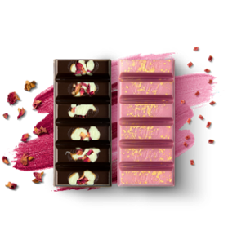

The Explorer
Springtime in Japan
and Jewels of the East
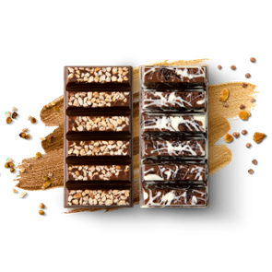

The Chocolatier
Billionaire's Treasure
and Nuttylicious

Posh Gold KitKat Bar for £25.00

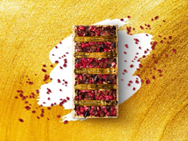

Limited Edition

Raspberry, pomegranate,
dark chocolate and
real 23-carat gold leaf

HAVE A BREAK, HAVE A KITKAT!
‘CREATE YOUR BREAK’
Our experts from KitKat Chocolatory® know that you want to explore the abundance of incredible flavours. That’s why we will give you the possibility to combine your favourite tastes and create a unique KitKat bar. You can also add more fascination by personalising your choice and delight beloved ones with a beautiful gift box.
And the best thing is that now for the first time you have the option to buy your favourite KitKat luxury chocolate from our ONLINE shop. There is no difference in the price.
If you prefer to rest at home, just click on the website
https://www.kitkatchocolatory.co.uk and enjoy.

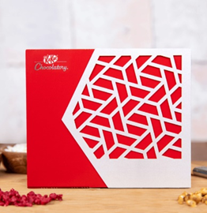
How to do it:

Step 1:
Choose a gift box size
Step 2:
Choose your favourite tastes for your bar
Step 3:
Customize the gift box with a message
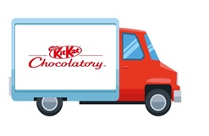
If you are purchasing from our website, bear in mind that the KitKat Chocolatory bars are handcraft and our professionals need time to prepare your perfect product.
When the order is already placed, the estimated DELIVERY will be between 3 and 5 working days

Our team will be more than happy if you share your experience from KitKat Chocolatory and if you have any recommendations, please do not hesitate to contact us.

Place Valentina Vasileva
How Nestle makes it products available to the customers
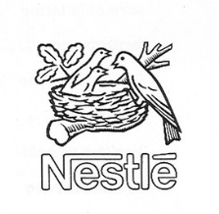
Nestle is headquartered in Switzerland. Most of its sales revenues come from the US and the European consumer market zone. Our products are available all across the world. They follow the typical FMCG distribution channel. Nestle manufactures products in bulk quantity, aimed for global distribution. The bulk amount of goods is then distributed by Nestle’s logistics unit, C&F agents and regional logistics partners based on the market demand in different regional market places.

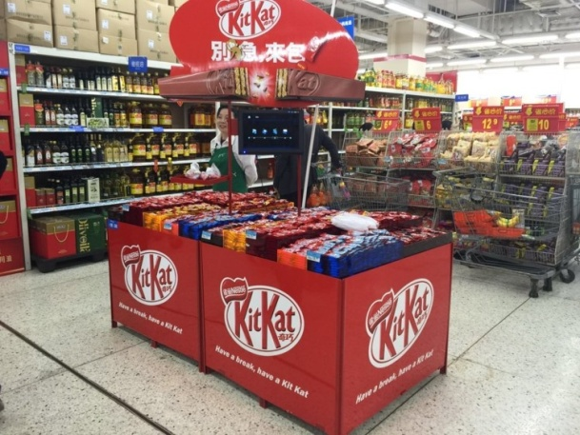
The distribution channels and the distribution zones
The most common distribution channel used by the company is the following;
- Manufacturer to C & F agent to regional distributors to local retailers to consumer

In some regions, where Nestle has its factories, the following distribution channel is also used in those places;
- Manufacturer to logistics partners to bulk buyers to consumers
We make our products available to the target consumers through an extensive distribution strategy. As mentioned, earlier, an extended supply chain process is maintained for the placement of its products across the countries. An extensive distribution strategy helps the company to capture the global market through a high distribution volume. And since, we deal on food items that consumers need in their day to day lives, therefore, this strategy has been effective for us to capture the target consumers who demand quality items at reasonable prices.
In order to streamline our global distribution, we divide our global market into 6 regions.
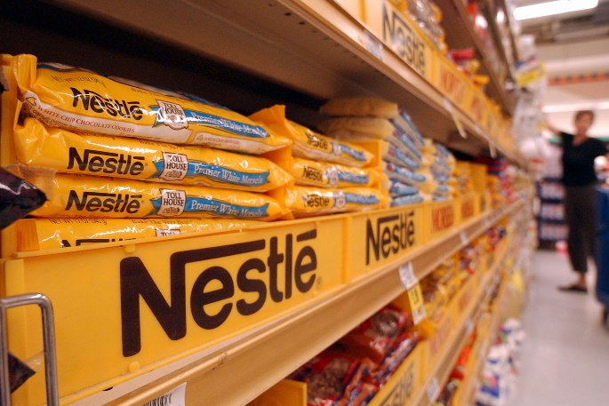
- Americas (largest market)
- Europe (second largest market)
- Middle East and North Africa
- Asia
- Oceania
- Sub Saharan Africa

Nestle’s products are available across 200 countries in these regions combined. We also have active operations in most of these countries, which allow us to have a greater control on the consumer markets. Nestle also has around 30 product development and research centres across the global distribution zones.
How the customers get these products
The logistics partners and the regional distributors of Nestle make sure that the products are made available at the supermarkets, hypermarkets, superstores, and general stores. Basically, the regional distributors make sure that the products are available across all the major retail channels in a country. The robust distribution strategy of the company has even made possible for our products to be available in many rural areas as well. In most countries, in the specified distribution zones, the regional distributors are directly employed by Nestle or the company’s C&F agents. The company, however, usually does not own its own retail outlets except in Switzerland. A few Nestle retail outlets can be seen in Switzerland and some other countries. Recently we have also opened a Nestle exclusive brand store in Brazil after setting up a major operations division there. But it is less significant given the size and scale of the company’s operations.
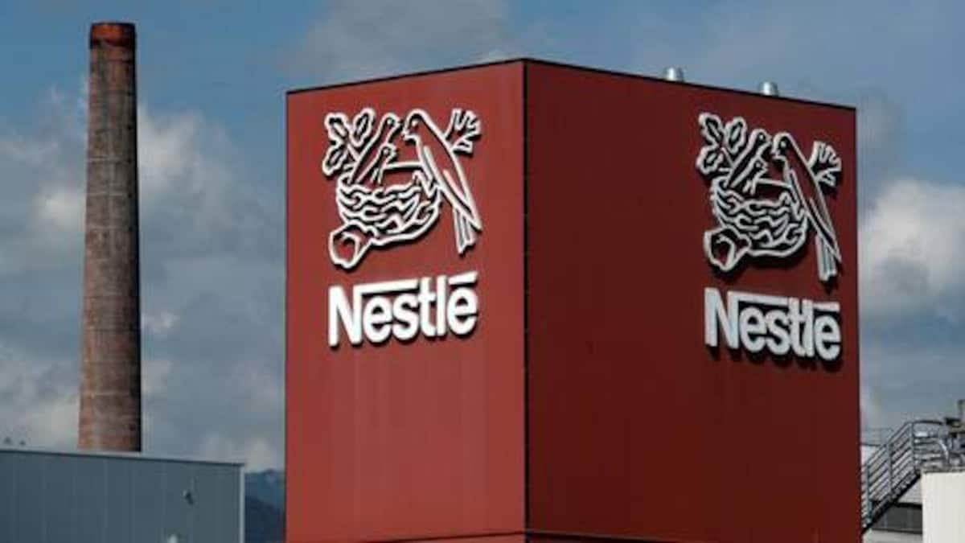Regional operating office of Nestle
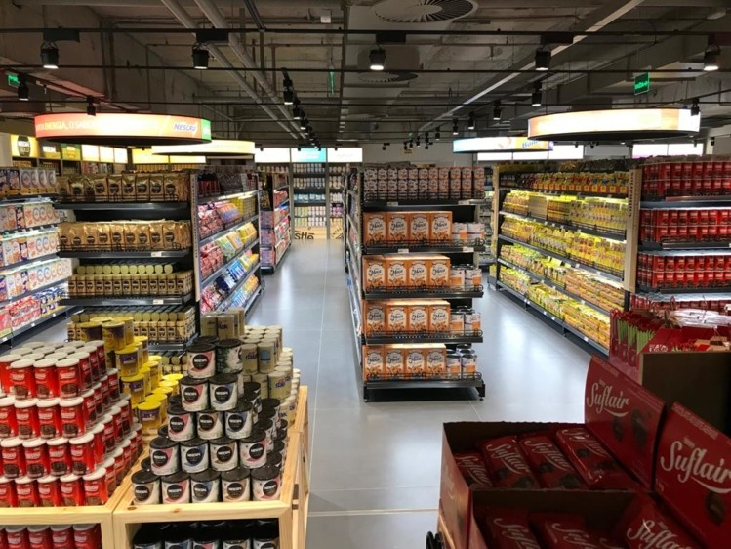
Nestle brand store in Brazil
How the customers are motivated across the channels
We offer discounts on our products to motivate the customers into purchasing them. However, this strategy is not common across our global distribution channels. We mainly rely on our brand image and popularity to pull the consumers in the retail channels. We maintain a significant amount of control on our regional distribution channels, which allows us to offer products at competitive prices, and thus, attract the customers of middle-income group to upper income classes.
Online presence
We do not have ecommerce division of our own. The products are sold at the physical retail stores due to the concentration of customers in this channel. However, the company does avail its products on Amazon, eBay, and country-wise ecommerce sites, which helps the customers to purchase these items online if they want to. However, since these websites are not managed by us, therefore, the effective distribution across these channels are not guaranteed by the company. This is one area in which the company could invest on, since the consumers are now gradually moving towards online purchase habits. However, having a company-owned online distribution channel may also create unnecessary expenses for the business. As of now, Amazon does help us reach out to more customers and helps them get Nestle items at fair prices.

Promotion Viktoria Vartigorova-Ivanova

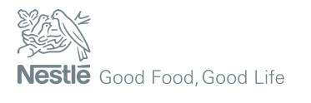
Our portfolio includes more than 2000 brands, which are forming the image of our company as one of the leading and most prosperous on the food and beverage market. As the promotion plays an important role in the marketing mix to create a great brand reputation, our biggest brands (Nescafé, KitKat, Nespresso, Maggi) make a strong commitment to present their products, reaching the modern consumers in the best possible ways.

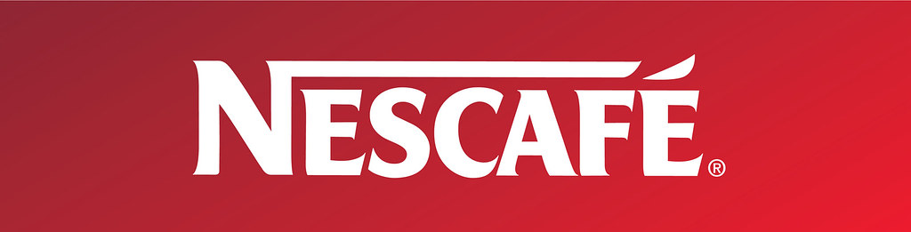
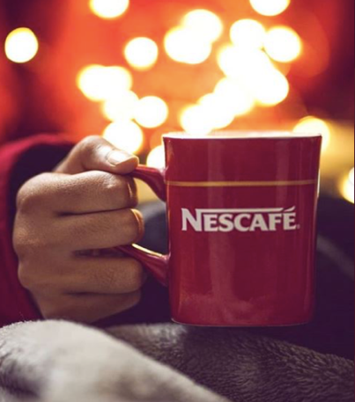
Our legendary coffee brand Nescafe believes that offering a good morning coffee or a delicious afternoon latte is not just enough, that is why we are trying to inspire you through meaningful messages and real connections that lead to new beginnings.

Our company launched a touching TV, cinema and online advertisement with the motto ‘For the moments that matter’, inviting our consumers to stay close to those who matter. The campaign titled “Those few people” focuses on the importance of spending time with the ones we care about, comparing the care we give in our relations with the care of preparing a cup of Nescafé Gold.
We believe that the truly meaningful connections, that enrich our lives are precious and worth saving. The aim of our campaign is to emphasize the message that everyone will meet around 80,000 people in their lifetime, but only few of them will be truly special, so we need to make an effort to save them.
You can watch the ad at:
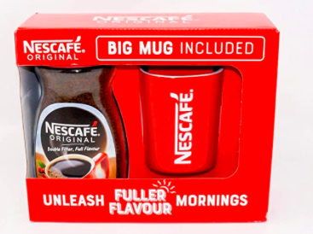
https://www.youtube.com/watch?v=jZtEXMBbaZg

As we know how enjoying is a cup of coffee, we strive to keep your coffee mug always full of delightful coffee, with great taste and rich aroma. So, we are constantly trying to offer you a variety of promotions, to enhance your coffee experience – ‘Buy 2, get 1 free’, free branded mugs, shakers, cups, or 50% extra free coffee with every jar.
To explore more delightful coffee choices, and to find out our latest promotions, you can visit our website:
www.nescafe.com
or follow us on our social media accounts:


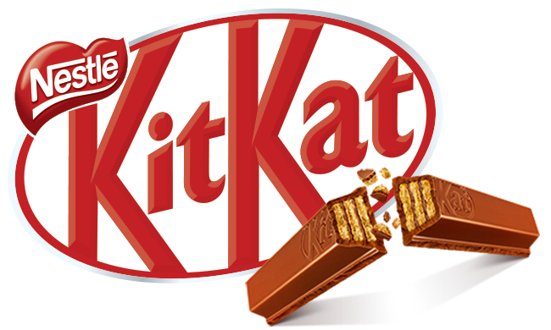

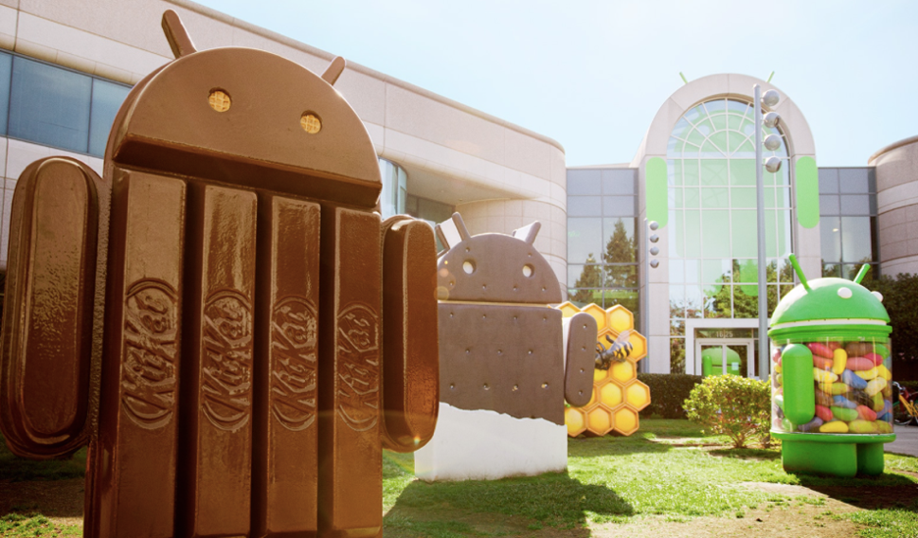
Another star of our iconic collection – KitKat, is excited to announce its collaboration with the world’s most famous mobile platform - Android. This partnership helps us give even more KitKat fans the opportunity to enjoy their brake.

The cooperation with Google is the latest step in our aspiration to get the full benefit of digital platforms and online content to develop closer relationships with our consumers.

To explore Android KitKat 4.4, please visit:
https://www.android.com/versions/kit-kat-4-4/

To get even more tasty content, please visit:
www.kitkat.com
You can also find us on social media:

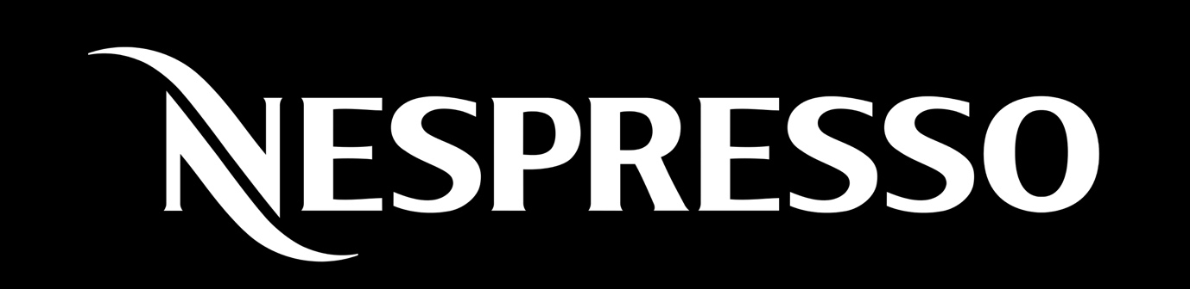

From its founding in 1986, our company has completely transformed the way people enjoy their espresso coffee. It has formed the coffee culture around the world. In addition to build lasting relationships with our consumers, our company uses celebrity endorsement as a promotional marketing tool. We have chosen George Clooney to be our global brand ambassador. Since 2006, he has been a partner with our brand in Europe and other foreign markets, fascinating fans and coffee appreciators in broadcasts and print campaigns.

George Clooney often shares the screen with other celebrities like John Malkovich, Danny Devito, Matt Damon, Andy Garcia, Natalie Dormer and many more.

What makes George Clooney a true partner is his passion for sustainability. His ongoing support demonstrates our determination to sustainability, recycling and dedication to high quality coffee. George gives an example of defying category standards in his effort to give positive support on global issues and champion sustainability, a mission that mirrors that of Nespresso.
You can watch some of the Nespresso adverts with George Clooney by visiting:
https://www.youtube.com/watch?v=DfyeXrdZZ1o
https://www.youtube.com/watch?v=-aBIn5p4OQ8&list=PLQtGRwrVzmv6EHuJlkuGrMLc2jSu-LiwA&index=9
https://www.youtube.com/watch?v=cAodY4bmvKw
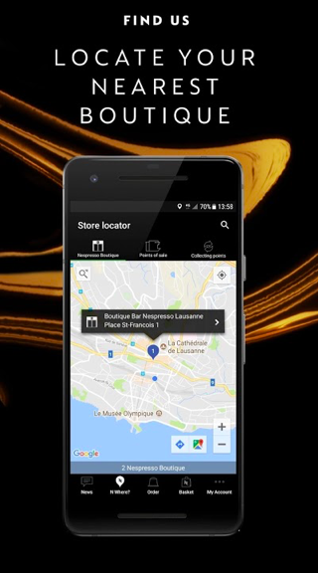
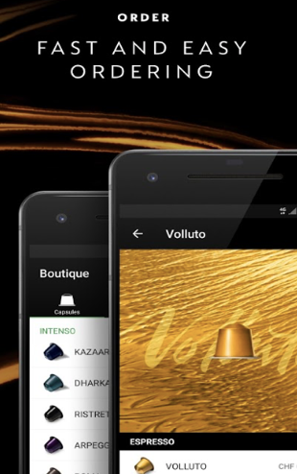
We are driven by the desire to delight our modern consumers with innovations, keeping the brand relevant and contemporary. To meet your expectations, we have created an application, which allows you to buy coffee capsules, machines, accessories on the go or at home. The app always keeps you up to date with the last news, new Nespresso machines, recipes and even more.

For more information, please, visit:
https://www.nespresso.com/uk/en/

You can download the app here:
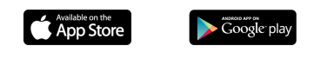

References:
References by Azhda Mustafa:
Anon (2016) urs schmidt design. Available at: https://www.ursschmidtdesign.ch/en_nestle_150_map.html
(Accessed 15 May 2020)

Englishteastore.com. (2019). EnglishTeaStore.com. Available at: https://www.englishteastore.com/nestle-history.html.
(Accessed: 15 May 2020)

lamalleapapa.com. (n.d.). La malle à Papa - La malle à Papa. Available at: http://lamalleapapa.com/marque/nestle-peter-cailler-kohler
(Accessed 15 May 2020).

NESTLE (2013) Mission & vision available at : https://www.nestle-esar.com/aboutus/missionvision
(Accessed: 07 April 2020)

NESTLE (2020) Our vision available at: https://www.nestle.com/randd/ourvision (Accessed: 07 April 2020)

NESTLE (2020) Company Founder Henri Nestle available at: https://www.nestle.com/aboutus/history/company-founder-henri-nestle
(Accessed: 07 April 2020)

NESTLE (2020) Nestle company history available at: https://www.nestle.com/aboutus/history/nestle-company-history
(Accessed: 07 April 2020)

References by Milen Enchev:
Crowncork.com, 2020. Premium Coffee, Urban Culture and Vibrant Decorations. [Online]
Available at: https://www.crowncork.com/food/success-stories/nescaf-azera
(Accessed 14 May 2020).
Kitkat.co.uk, 2020. Kitkat Collection. [Online]
Available at: https://www.kitkat.co.uk/content/kitkatcollection/FourFinger
(Accessed 14 May 2020).
Maggi.co.uk, 2020. Meet the family. [Online]
Available at: https://www.maggi.co.uk
(Accessed 14 May 2020).
Nescafe.com, 2020. NESCAFÉ 2in1. [Online]
Available at: https://www.nescafe.com/our-coffees/nescafe-2in1
(Accessed 14 May 2020).
Nescafe.com, 2020. NESCAFÉ 3in1 Original. [Online]
Available at: https://www.nescafe.com/our-coffees/nescafe-3in1-original
(Accessed 14 May 2020).
Nescafe.com, 2020. NESCAFÉ AZERA Americano. [Online]
Available at: https://www.nescafe.com/our-coffees/nescafe-azera-americano
(Accessed 14 May 2020).
Nescafe.com, 2020. NESCAFÉ Classic. [Online]
Available at: https://www.nescafe.com/our-coffees/nescafe-classic
(Accessed 14 May 2020).
Nescafé.com, 2020. Nescafé launches Shakissimo, a chilled coffee range for Europe. [Online]
Available at: https://www.nestle.com/media/news/nestle-launches-shakissimo
(Accessed 14 May 2020).
Nescafe.com, 2020. NESCAFÉ Shakissimo. [Online]
Available at: https://www.nescafe.com/our-coffees/nescafe-shakissimo
(Accessed 14 May 2020).
Nescafe.com, 2020. Nescafe Smoovlatte. [Online]
Available at: https://www.nescafe.com/our-coffees/nescafe-smoovlatte
(Accessed 14 May 2020).
Nesquik.com, 2020. NESQUIK Chocolate Powder. [Online]
Available at: https://www.nesquik.com/en/products/powder/nesquikr-chocolate-milk-powder-small
(Accessed 14 May 2020).
Nestle.com, 2020. Brands. [Online]
Available at: https://www.nestle.com/brands
(Accessed 14 May 2020).
Nestle.com, 2020. Milo. [Online]
Available at: https://www.nestle.com/brands/allbrands/milo
(Accessed 14 May 2020).
Nestle.com, 2020. Quality and Safety. [Online]
Available at: https://www.nestle.com/aboutus/quality-and-safety
(Accessed 14 May 2020).
Nestle.com, 2020. Which products and brands do you own?. [Online]
Available at: https://www.nestle.com/ask-nestle/our-company/answers/which-products-and-brands-do-you-own
(Accessed 14 May 2020).
Purina.co.uk, 2020. GOURMET® PERLE CHICKEN MINI FILLETS IN GRAVY. [Online]
Available at: https://www.purina.co.uk/cat/gourmet/product-range/perle/chicken
(Accessed 14 May 2020).

References by Stefaniya Milanova:
Chocolatory.co.uk (2020). KitKat Chocolatory.
Available at: https://www.kitkatchocolatory.co.uk/ (Accessed 20 Apr. 2020)

Doradea, K. (2019). KitKat’s First Canadian DIY “Chocolatory” Finally Opens In Toronto Next Month [IMAGE]. Available at: https://www.narcity.com/eat-drink/ca/on/toronto/toronto-kitkat-store-opens-in-november-with-a-magical-diy-chocolatory (Accessed 9 May 2020)

Laycock, M. (2019). KitKat revolution will mean 1,500 flavours available. [IMAGE]. Available at: https://www.yorkpress.co.uk/news/17919678.nestle-launches-new-kitkat-chocolatory---biggest-break-since-chunky-39-s-launch/ (Accessed 9 May 2020)

Vektorstock.com (2020). Delivery van with container vehicle cartoon vector [IMAGE]. Available at: https://www.vectorstock.com/royalty-free-vector/delivery-van-with-container-vehicle-cartoon-vector-26666390 (Accessed 8 May 2020)

References by Valentina Vasileva:
Bhasin, H., (2020). Marketing Mix Of Nestle - 4 Ps Of Nestle - Nestle Product Marketing Mix.
[online] Marketing91.
Available at: https://www.marketing91.com/marketing-mix-nestle/
(Accessed 8 May 2020)

Harvard Business Review (2020). Customizing Global Marketing. [online]
Available at: https://hbr.org/1986/05/customizing-global-marketing
(Accessed 8 May 2020)

Heart Of Codes (2020). Marketing Mix Of Nestle | 4Ps Of Marketing Mix Of Nestle. [online]
Available at: http://heartofcodes.com/marketing-mix-of-nestle/
(Accessed 8 May 2020)

Nestlé Global (2020). Where Can I Buy Nestlé Products? [online]
Available at: https://www.nestle.com/ask-nestle/products-brands/answers/where-can-i-buy-nestle-products
(Accessed 8 May 2020)

Nestle (2020). Marketing Mix-The 4P’S – Nestle. [online]
Available at: https://nestleblogcom.wordpress.com/category/marketing-mix-the-4ps/
(Accessed 8 May 2020)

References by Viktoria Vartigorova-Ivanova:
Amazon (2020) Nescafe Original Red Square Coffee Big Mug Cup New Design Perfect Gift. [IMAGE]
Available at: https://www.amazon.co.uk/Nescafe-Original-Square-Coffee-Perfect/dp/B07HJ9J8G7
(Accessed: 23 April 2020)

Kotler, P. and Armstrong, G. (2020) Principles of Marketing. 8th edn. Harlow: Pearson

Little Black Book (2018) The True Meaning of Friendship Takes Centre Stage in New Nescafe Gold Campaign.
Available at:https://www.lbbonline.com/news/the-true-meaning-of-friendship-takes-centre-stage-in-new-nescafe-gold-campaign
(Accessed: 22 April 2020)

Nescafe Coffee (2020) Twitter @NESCAFE [IMAGE]
Available at: https://twitter.com/NESCAFE/status/1233337310315499520/photo/1
(Accessed: 23 April 2020)

Nespresso (2019) What Can You Do with Nespresso App.
Available at: https://www.nespresso.com/it/en/scarica_app
(Accessed: 23 April 2020)

Nespresso (2019) George Clooney becomes Nespresso global brand ambassador by extending his relationship with the brand in North America.
Available at: https://www.nestle-nespresso.com/newsandfeatures/George-Clooney-becomes-Nespresso-global-brand-ambassador-by-extending-his-relationship-with-the-brand-in-North-America
(Accessed: 23 April 2020)

Nestle (2013) Google and Nestle Announce Android KitKat
Available at: https://www.nestle.co.uk/en-gb/media/pressreleases/google-and-nestlé-announce-android-kitkat
(Accessed: 23 April 2020)

Nestle (2016) KitKat. [IMAGE]
Available at: https://www.kitkat.com/
(Accessed: 23 April 2020)

Nestle (2020) Good Food, Good Life. [IMAGE]
Available at: https://www.nestle.com/
(Accessed: 23 April 2020)

Nestle (2020) Nescafe Logo. [IMAGE]
Available at:
https://www.flickr.com/photos/nestle/9782622621/in/photostream/lightbox/#
(Accessed: 23 April 2020)

