ryanwilkinswilliams@gmail.com
1702928@student.uwtsd.ac.uk
Ryan Wilkins-Williams (1702928)
Module Tutor(s): Michael Dacey, Tim Bashford
Programming 1
ACCA4004_MT

Contents
Introduction 1
Part A 1
Question 1: 1
Question 2: 2
Question 3: 2
Question 4: 2
Part B: 3
Exercise 1: 3
Exercise 2: 3
Appendix: 3
Exercise 1 code: 3
Exercise 2 code: 4

Introduction
The following report is a detailed showing of programs and questions that are completed as part of the Programming 1 module. It will be a showcase of everything I have learnt so far in this module.

Part A

Question 1:
What is a variable? A variable much like its English definition is something that can change, being able to change the value is extremely important, even in programming. Many different functions may need to call upon the same variable for example it could be cost; but cost can vary with different things like sales and tax changes so the variable needs to be able to adapt to this.
If it was just one set number like an integer it wouldn’t have the ability to change but because it’s a variable the program has the ability to rewrite this number based on its use, so if the variable was cost and something like tax did change then the program could also update that variables number to.
A variable also has four key requirements. The first of these is the type, there are numerous types which all have different functions, an example of a type would be a string; this is a text value like “hello” or a number like “1”, you can use any combination of letters numbers and symbols inside a string. A variable also has its own allocated memory, this is where the computer can store it to know what value to pull. When it comes to creating a variable it must also have its own unique identifier or in other words, a name. This name can’t match any other variable used or system command but the user does have the freedom to call it anything they want for example if it’s a customer’s it can be “customerName”.

Question 2:
A loop is a part of code that the program will run again and again until it does what it’s required to move on to the next stage. It is possible to limit the number of times it loops by using a counting loop. The programmer will enter the set number of times they want this loop too run.
A counting loop for a program could be used when the user wants to limit something like how many tries a person would get in a game. The count could be set to five to limit to five tries and once this mark was reached it would move on to the next stage.

Question 3:
When a program starts to run the computer system will jump straight to the main body of the program, this is a function. In C++ program creator can provide default values for a functions arguments. All of a functions argument names will be bound by the creator declaring the function.
An argument may have any type, be it string, int etc. A function call specifies the name of a function and its specific list of arguments, it will pass the arguments values to the each function they need to go too.
An argument is a value or a variable name, so its’ real-world uses are extremely common in programs.

Question 4:
In Object Orientated programming a class is the definition of an object method and variables. An object is a specific instance of a class, it will contain real values instead of variables. It is one of the main drivers behind object orientated programming. It is possible for a class too have sub sections called sub-classes, they can create their own methods and variables that are not related to the main class. There is a name for this structure and it is called the hierarchy.

Part B:
A program has been provided which allows the user to input different number and display the highest, lowest and all entered values. The following section will detail how this program has been implemented.
The first section is the header file, this is where all variables and commands are defined for use in the main body:
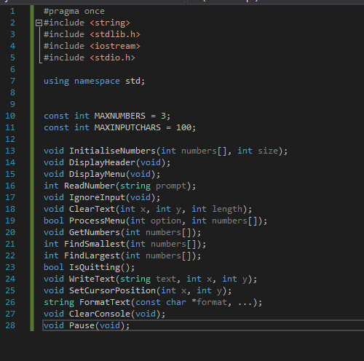
The initial few lines give the program access to different libraries included within visual studio, for example include string gives the program the ability to be able to use plain text. Const int is the first set of parameters that have been set. The defined parameters are Max numbers, to limit the max amount of numbers the user may enter and maxinputcharacters which will limit the user to 100 characters.
Following this are a set of commands that will be used through the running of the program. Next is the main body, this is where the program uses all its set functions to complete its intended task.
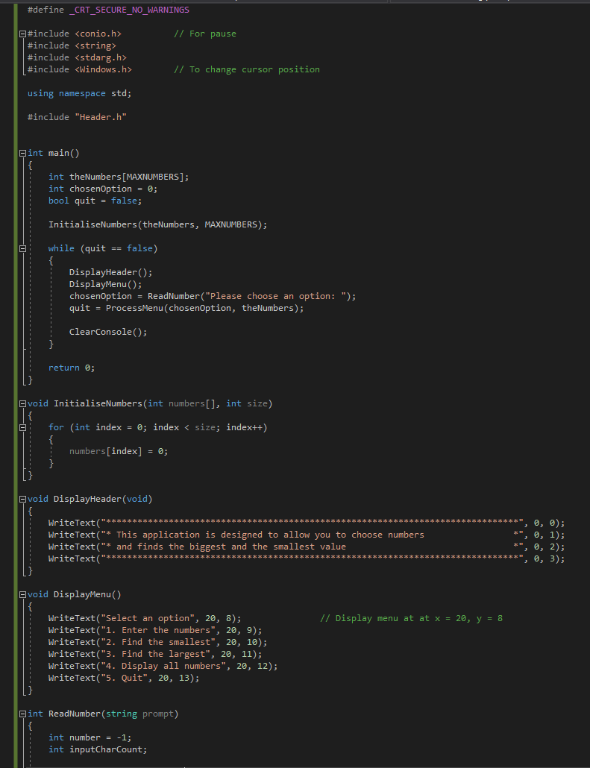
Much like the header file the first few lines are her to give access to different libraries made available in visual studio. Include header is what connects the main body to the header file so it can use all of the variables.
Int main is where the real work gets put in, this is where the program will begin its operations as the user navigates through the program. In this main section the program sets and calls on default values for the numbers and for the option selected before the user enters theirs. It also sets the programs quit default to false so the program does not just exit.
The next section is initialise numbers, this is where the user begins to select their chosen values.
Following is a header that will create a header that gives the user basic instruction on how the program works.
Next is a display of the menu options, this is so the user knows what function each number will perform.
Read number will read the users inputted option, it will then tell this to the process menu switch so it can open the relevant section.
The same basis of code is used to find the smallest and largest values of the inputted numbers set with minor changes to work either way. The main different being the use of the smallest and larger variables that would be allocated to their respective values earlier in the program.
The next option is where the user decides if they would like to quit, this is determined by them entering yes or no.

Part C:

Exercise 1:
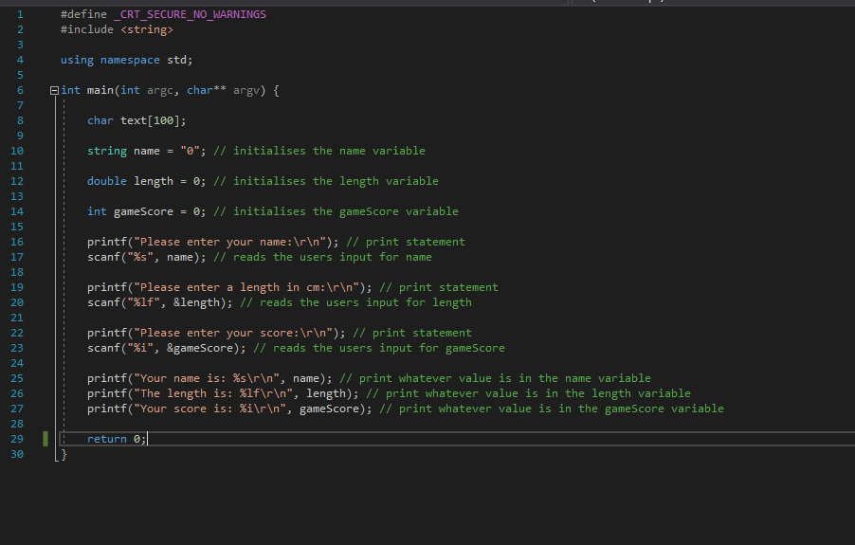

Exercise 2:
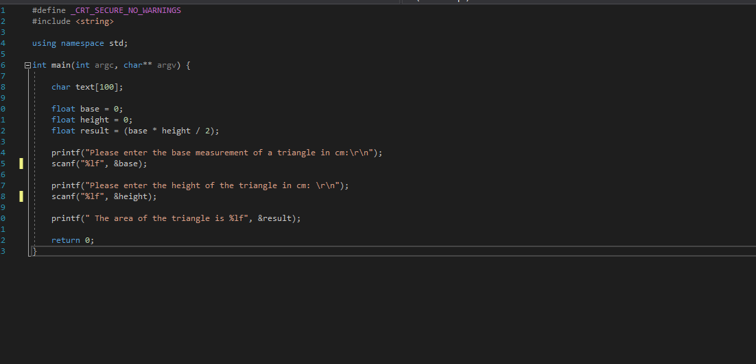

Appendix:

Part B code:
Main.h

#pragma once

const int MAXNUMBERS = 3;
const int MAXINPUTCHARS = 100;

void InitialiseNumbers(int numbers[], int size);
void DisplayHeader(void);
void DisplayMenu(void);
int ReadNumber(string prompt);
void IgnoreInput(void);
void ClearText(int x, int y, int length);
bool ProcessMenu(int option, int numbers[]);
void GetNumbers(int numbers[]);
int FindSmallest(int numbers[]);
int FindLargest(int numbers[]);
bool IsQuitting();
void WriteText(string text, int x, int y);
void SetCursorPosition(int x, int y);
string FormatText(const char *format, ...);
void ClearConsole(void);
void Pause(void);

Menu.cpp

// AssignCode_Menu.cpp : Defines the entry point for the console application.
//

#define _CRT_SECURE_NO_WARNINGS

#include "stdafx.h"
#include <conio.h> // For pause
#include <string>
#include <stdarg.h>
#include <Windows.h> // To change cursor position

using namespace std;

#include "Main.h"

int main()
{
int theNumbers[MAXNUMBERS];
int chosenOption = 0;
bool quit = false;

InitialiseNumbers(theNumbers, MAXNUMBERS);

while (quit == false)
{
DisplayHeader();
DisplayMenu();
chosenOption = ReadNumber("Please choose an option: ");
quit = ProcessMenu(chosenOption, theNumbers);

ClearConsole();
}

return 0;
}

void InitialiseNumbers(int numbers[], int size)
{
for (int index = 0; index < size; index++)
{
numbers[index] = 0;
}
}

void DisplayHeader(void)
{
WriteText("*******************************************************************************", 0, 0); // Top left hand corner of screen is x = 0, y = 0
WriteText("* This application is designed to allow you to choose numbers *", 0, 1); // Next line down is x = 0, y = 1, etc
WriteText("* and finds the biggest and the smallest value *", 0, 2);
WriteText("*******************************************************************************", 0, 3);
}

void DisplayMenu()
{
WriteText("Select an option", 20, 8); // Display menu at at x = 20, y = 8
WriteText("1. Enter the numbers", 20, 9);
WriteText("2. Find the smallest", 20, 10);
WriteText("3. Find the largest", 20, 11);
WriteText("4. Display all numbers", 20, 12);
WriteText("5. Quit", 20, 13);
}

int ReadNumber(string prompt)
{
int number = -1;
int inputCharCount;

WriteText(prompt, 20, 14);
inputCharCount = scanf("%i", &number);
if (inputCharCount == 0) // Wasn’t a number, so ignore what they typed in!!
{
IgnoreInput();
}

ClearText(20, 14, prompt.length() + inputCharCount); // Clear the text at this line

return number;
}

void IgnoreInput(void)
{
char ch;
while ((ch = getchar()) != '\n' && ch != EOF);
}

void ClearText(int x, int y, int length)
{
// Write space ' ' characters starting at x, y for 'length' times
string spaces(length, ' ');
WriteText(spaces, x, y);
}

bool ProcessMenu(int option, int numbers[])
{
string message;
bool quit = false;

switch (option)
{
case 1:
GetNumbers(numbers);
break;
case 2:
WriteText(FormatText( "The smallest value is %i", FindSmallest(numbers)), 20, 15);
Pause();
break;
case 3:
WriteText(FormatText("The largest value is %i", FindLargest(numbers)), 20, 15);
Pause();
break;
case 4:
quit = IsQuitting();
break;
case 5:
quit = IsQuitting();
break;
default:
WriteText("Unknown option value entered", 20, 15);
Pause();
break;
}

return quit;
}

void GetNumbers(int numbers[])
{
for (int index = 0; index < MAXNUMBERS; index++)
{
numbers[index] = ReadNumber("Enter number: ");
}
}

int FindSmallest(int numbers[])
{
int smallest = numbers[0];

for (int index = 0; index < MAXNUMBERS - 1; index++) // <-- subtract 1
{
if (numbers[index + 1] < smallest)
{
smallest = numbers[index + 1];
}
}

return smallest;
}

int FindLargest(int numbers[])
{
int largest = numbers[0];

for (int index = 0; index < MAXNUMBERS - 1; index++) // <-- subtract 1
{
if (numbers[index + 1] > largest)
{
largest = numbers[index + 1];
}
}

return largest;
}

bool IsQuitting()
{
char input[100];
string response;

bool quit = false;

WriteText("Do you really wish to quit? ", 20, 13);
scanf("%99s", input);

response = input;

if (response == "YES")
{
quit = true;
}

return quit;
}

void WriteText(string text, int x, int y)
{
SetCursorPosition(x, y);
printf(text.c_str());
}

// JUST USE THIS FUNCTION
// This function positions cursor in Console window,
// and you DON'T need to understand it!!!
void SetCursorPosition(int x, int y)
{
static HANDLE handle = NULL;
if (!handle)
{
handle = GetStdHandle(STD_OUTPUT_HANDLE);
}
COORD coords = { x, y };
SetConsoleCursorPosition(handle, coords);
}

// JUST USE THIS FUNCTION
// This function does creates a string
// using a format string and values i.e.
// FormatText("Number is %i", 5) returns "Number is 5",
// and you DON'T need to understand it!!!
string FormatText(const char *c_format, ...)
{
char ch[100];
va_list args;
va_start(args, c_format);
vsnprintf(ch, 100, c_format, args);
va_end(args);
return string(ch);
}

// JUST USE THIS FUNCTION
// This function clears the screen,
// and you DON'T need to understand it!!!
void ClearConsole(void)
{
system("cls");
}

void Pause(void)
{
// Pause
while (1) { if (_kbhit()) break; }
_getch(); // Clear the keypress
}

Exercise 1 code:
#define _CRT_SECURE_NO_WARNINGS
#include <string>

using namespace std;

int main(int argc, char** argv) {

char text[100];

string name = "0"; // initialises the name variable

double length = 0; // initialises the length variable

int gameScore = 0; // initialises the gameScore variable

printf("Please enter your name:\r\n"); // print statement
scanf("%s", name); // reads the users input for name

printf("Please enter a length in cm:\r\n"); // print statement
scanf("%lf", &length); // reads the users input for length

printf("Please enter your score:\r\n"); // print statement
scanf("%i", &gameScore); // reads the users input for gameScore

printf("Your name is: %s\r\n", name); // print whatever value is in the name variable
printf("The length is: %lf\r\n", length); // print whatever value is in the length variable
printf("Your score is: %i\r\n", gameScore); // print whatever value is in the gameScore variable

return 0;
}

Exercise 2 code:
#define _CRT_SECURE_NO_WARNINGS
#include <string>

using namespace std;

int main(int argc, char** argv) {

char text[100];

float base = 0;
float height = 0;
float result = (base * height / 2);

printf("Please enter the base measurement of a triangle in cm:\r\n");
scanf("%lf", &base);

printf("Please enter the height of the triangle in cm: \r\n");
scanf("%lf", &height);

printf(" The area of the triangle is %lf", &result);

return 0;
}

