Work-based Report on Communication for Performance

Table of contents

Page 3 - The relevance of the communication cycle for effective communication in management.
Page 4 & 5 - The importance of selecting a suitable tone, language, and level of formality in management communications.
Page 6 & 7 - Assess the effectiveness of a range of verbal and written communication methods within your area of the organisation
Page 8 - Evaluate theories of motivation relevant to your workplace.
Page 9 & 10 - Evaluate the principal factors that may affect performance and motivation in the workplace.
Page 11 - Select a theory of motivation - apply it to your workplace – evaluate the impact
Page 12 - Develop appropriate criteria to evaluate one's ability to communicate effectively
Page 13 - Collect and analyse feedback on own verbal and written communication skills
Page 14 - Gap Analyses
Page 15 - Personal development plan

The relevance of the communication cycle for effective communication in management.

Within my children’s entertainment company, the communication cycle is extremely critical. Service and entertainment provided to customers are determined by the quality of message handed from management to employees.

The message: In the message, employees can be told what is expected of them. The message is what your employees convey about your business and builds reputation. When an employee knows your business message and successfully conveys this to the consumer you know you have effectively communicated your company message.

The receiver: This is the person you want to communicate with. In a children’s entertainment business this will be the parent (person who booked your services) and in turn the child whose party it is.

Feedback: After each event or visit we thank the customer for using our service. On most occasions the customer will thank us and inform us they are happy with our service.

Sender: The sender is the company owner who provides the outline and what is expected of the employee concisely.

The importance of selecting a suitable tone, language, and level of formality in management communications.
Appropriate tone:
As we are an entertainment business, our tone is always fun unless we are dealing with an emergency. As most of our employees are under 19 years old and are in their teens, we have found that keeping communications light and face to face can benefit them as written format can be read in different ways when you are a younger person than how the message is intended. As an adult in the workplace, you understand the tone of communication differently than a teenager whose first experience of employment was with us.

Language:
Keeping language precise is critical for a child-focused business. It would be appropriate for us to speak differently to each member of our staff because they are all individuals. We have learnt their ways, and this enables us to use the language that they understand.

For example, if Lilly was having a difficult day and wasn’t performing to her usual standard, I would know that something had happened. Questioning and listening would be the way we would communicate to help her understand that outside factors have contributed to her poor performance. We would work through a resolution to prevent this from happening again.

But if Chloe performed poorly, I would at once say that wasn’t your finest day. She would tell me why. I’d explain that I always needed the highest quality from her. I'd talk about what she could have done better, and she would take that on board and get on with it.
As two hugely different employees from two quite different backgrounds, knowing them is necessary to effectively manage them.

Language %
What is said – 7%
Voice or Tone – 38%
Gestures, etc. – 55%
Overall, the management of staff in an entertainment business relies on face to face.

Level of formality
Due to our profession, we do not conduct ourselves in a formal manner. While working, we ask that everyone treats each other with respect, be professional, and have fun. As a company that works with children, our staff can meet the needs of the child’s party in a professional manner, but at the same time, also at a level where the child feels special.

Assess the effectiveness of a range of verbal and written communication methods within your area of the organisation

Written-
As the business owner it is my responsibility to plan and prepare for parties that are primarily at weekends and school holidays. I have found that as most of my staff are aged between the ages of fifteen and twenty-two, the most effective way has been using a Facebook group, google calendar and google drive.

We also have a Google Calendar where our admin person and I will input bookings. This is accessed by our senior staff who usually host each party or birthday visit. This gives a clearer picture of the day.

Facebook Group
Facebook groups have been highly effective. We have a post that allows the staff to access our rota. This lets staff know their shifts for the week ahead. We do aim to always have a month of shifts, but they are always subject to change as we take more bookings. The staff are always aware of this.
We have a monthly thread asking for staff availability. In this thread, we ask if they have anything booked or need any days off so we can work on the rota for the month. As a result of this, we are able to structure our rota and plan everything in advance. Also, it helps when we have multiple people off on one day. This makes them think if they need the time off and can it be moved to allow others the day off. My staff are fully supportive of us all and understand when the business needs them, so their teammates are under less pressure.

Google Docs / Drive
Every Friday a Google Doc is filled in fully structuring each team's day for Saturday and Sunday. During the school holidays we work two days at a time. The structure includes picking up staff and taking them home. It will include what the job is, time of job, customer name, phone number, child's name and age. It's clear and concise to enable the team to do their jobs. This is available to our senior staff and younger staff via the group link. This helps as there is no back and forth between different messaging platforms and if there are questions, we usually have them the day before, so they are answered when everyone isn't busy working. This makes things less stressful.

Google Calendar
The calendar allows me to communicate clearly with our admin assistant who works remotely from London whilst studying. Our goal as a business is to always book 1 team out, and then we use the monthly thread to keep track of the availability of our staff. We then proceed on to book further teams depending on staff availability. If a weekend in a future month is exceptionally busy that we haven't asked for staff availability, we will ask in the Facebook group for availability for that day. This will enable us to take the bookings. But we always know we can always supply one team as I am the main host, and we have eight other staff members.

Verbal -
I am always available to answer questions the teams have in the morning. Our days are always positive, and the seniors' jobs are to keep everyone happy and motivated. All staff when agreeing to work for Crazy Characters know that a positive, happy and can-do attitude is needed to do the work we do with children.

Evaluate theories of motivation relevant to your workplace.

As the business owner, my motivation is different to what it is for the staff.

My motivation is intrinsic and is to build a reputable business and be a leading provider of children's entertainment. My motivation is to ensure the child has a memorable experience and that the parent will refer to us as the best company they have ever used. I am also led by extrinsic motivation in the terms of money. My business needs money I know I must continue to market to gain more business and network with potential customers for my business to grow.

Initial motivations for my staff are primarily based on money, which is extrinsic. They are also fuelled by providing excellent service and being the best that they can be. They are fuelled by the feelings they get from seeing the reaction of children when they entertain. In addition, they have the feelings they have when they have made a child's dream come true.

Evaluate the principal factors that may affect performance and motivation in the workplace.

Referring to Maslow’s Hierarchy of needs of staff within Crazy Characters
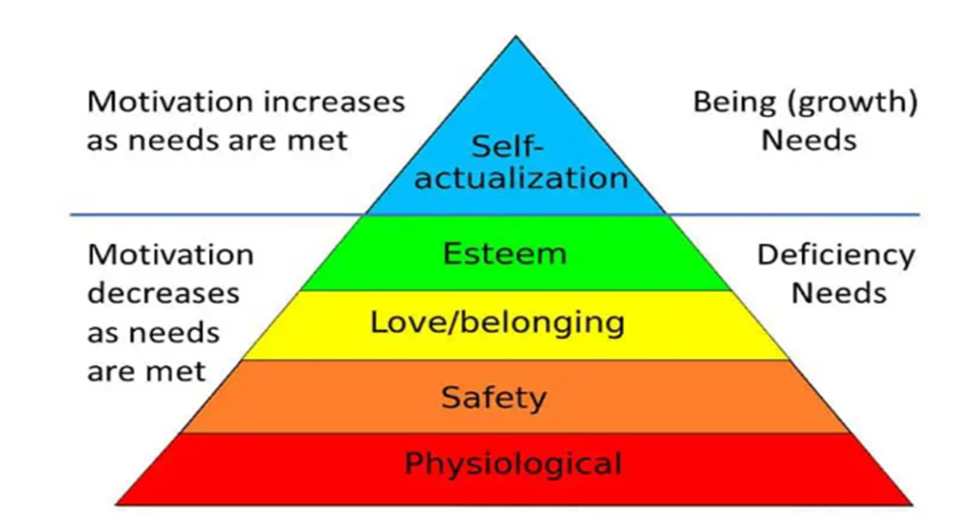

Physiological (Physical) All staff members who work for Crazy Characters are not reliant on their earnings for their livelihood. Depending on the age of the person, it could be either a second job they use for disposable income or a second job they work along with being a student at university. All members of staff live at home, so they have little or no money to pay for housing. In the case of our younger members of staff, their income is used for fun.

Safety (Security): All members of our staff know they are safe when they are at work. The older staff at our company all have mothering instincts. It is for this reason that they are appointed to the position, so that they can take care of everyone and keep everyone safe. There is a full awareness of all safety procedures among the staff, and every environment is actively assessed for possible risks by the staff.

Belonging (Love) We call ourselves the Crazy Crew. None of our staff have the dreaded feeling when coming to work. This is because they always know we will have fun. This is even when we are extremely busy as the end outcome is entertaining. Entertaining is fun. We are a family and work together as a team. In our team, there's a lot of lifting each other up, so if anyone isn't feeling their best, then their team members will help and pick up any slack that may exist.

Esteem (Ego) When staff join Crazy Characters it’s because me as the owner sees there is something special there. There are some people who come to us who are not fully confident. We train all our staff members to perform. We build their confidence and push their abilities. Our staff are proud to represent the company. It is a starter job, most employees first experience in a workplace and we know they won't be with us forever as they grow up and move onto higher education or full-time employment with better pay but they will always leave us more confident than when they started. Although our longest staff member is 3 years and the average person working with us has been 2 years, it shows that it is not about the money with most. Instead, it is about the status and feel of achievement being part of a business that loves and cares for their staff and customers.
Self-actualization (Being): Once our staff are fully confident in their performing capabilities, we have found that they want to do more. Most staff start as character performers. This involves them dressing in costume and acting like the character they are dressed in. We have found that when they are fully confident, they ask to carry out other duties such as being a party host who is not in character. The party host is a speaking position, so not only are they required to dance but oversee the character, the flow of a party and manage any risks that may come about. Also, we give our staff freedom to suggest better ways of doing things. As they are in the job, who better to suggest changes. We always listen and, on many occasions, made the changes suggested to us.

Select a theory of motivation - apply it to your workplace – evaluate the impact

Selected theory of motivation - Herzberg's Hygiene Theory.
Herzberg's motivation theory divides need into two categories. Hygiene and motivators.

Hygiene (dissatisfiers) refers to working conditions and the environment.
Within a children's entertainment business, we will visit multiple venues and homes throughout our working day. There are occasions where working conditions are out of our control. However, we always manage the risk for our employees and communicate with customers what is expected of the venue. This will ensure we can offer the service they have hired us to. Every working day is organised the day before so each member of staff will know their role for the day and what is expected of them. Although our staff aren't given structured breaks every hour they work around 20 minutes, the rest of the hour is spent traveling between destinations. We ensure that all staff are fed and watered all day at no expense to the company and no breaks are deducted from employees' working hours. This is something we feel has worked very well for employee satisfaction and employee retention. Our staff members do not need to rely on anyone but us to get to work. Every hour with us is paid and the employee does not need to spend any of their wages throughout the day.

Our motivators (Satisfiers) Supplying a positive impact
After each visit or party any communication from the customer is shown to the team. Customers who are extremely happy with our services always message us to thank us. We receive these messages for eight out of ten jobs. This is unless it is a repeat customer who knows what we do is always good. This customer does not feel the need to send us thanks. However, the staff and I take satisfaction from them being a repeat customer and the fact that they continue to book us is proof that they are happy.

Develop appropriate criteria to evaluate one's ability to communicate effectively

In order to effectively manage and communicate with our employees, it is crucial to understand how each individual employee takes motivation and criticism.
Each job is outlined the day before, so employees have a prior understanding of the visit or event. Before every visit it is the host's role to remind employees how the characters dress, pose, and act. Staff usually remember, but as the characters are always different, a reminder is always needed. Sometimes our female employees need to be reminded that they are playing a male character. Our hosts use movements to motivate their staff. This energizes the staff before they must come into action.
Every staff member has been dressed in character, so all hosts understand how challenging it is to be an entertainer dressed in a mascot. Hosts ask throughout their time entertaining if the staff members are OK. As employees appearing in character are non-verbal, we have measures in place where an employee can make their host aware of any emergency or illness at any time using hand gestures or by squeezing the host.
In every visit or job, our hosts will congratulate employees for doing their all and share at least one thing they excelled at. Then they will ask if the employee was happy. If anything negative happened that was out of the characters or hosts control that is discussed and ways are thought about making it better next time or if nothing could have been changed all employees understand that they can't make everything amazing every time and the staff have the ability and choose to just move on and not let the bad experience dictate the future days visits and bounce back.
As a business owner, I am always positive. In my personality I always find the positive in people and that is what makes me an effective manager and business owner. I will never ask anyone to do anything I am not prepared to do. If someone needs to be supported, I am there, and this is being passed on to all my employees. Everyone supports everyone.

Collect and analyse feedback on own verbal and written communication skills

When discussing my own verbal communication skills with employees the following feedback was received.

Verbal - Most staff said they liked how happy and positive I am all day and that my priority is making sure they are all looked after and fed. They say they feel like they are not in a job and that they know I am their boss but see me as a friend or a second mother.
Written - They appreciate the fact that I am transparent with all the work that I ask them to complete. Everything is accessible to them so that they know their shifts and jobs before coming to work so they can dress appropriately.

Analysing the data collected
Verbal – As we are in a fun and sometimes pressured environment, I don’t think I would change the way I verbally communicate with my staff.
Written – As planning is everything in an events and entertainment business I must be as transparent as I am. Previously I would only release the weekend rota on the tuesday. I found that planning further in advance helped me be able to manage how much more work I could take on and make more profit at the same time.

Overall, I am happy with the feedback received from my staff.

Gap Analysis

GAP ANALYSIS
Current State (FROM) | GAPS | Desired Future State (TO)
Care for staff to much | Staff need a lot of emotional support that is non work related. | Not care to much about nonrelated work situations
Overspending during the working day. | Less profit due to overspending | More profit but still meeting the ethos of the business where the staff are fed and watered.

Personal Development Plan
What do I want to do? | How can I do it? | What resources will I need? | How will I measure success? | Target Date for Review
Be less emotionally involved with employees. | Talk less about outside of work problems. | Me – Make sure discussions are not had about non-work-related issues or keep conversations lighter and have less gaps in the day where such conversations happen. | I will worry less.  I will receive less text messages asking for advice. | 3 Months.
Spend less money on food and drinks during the working day. | Purchase multi packs of soft drinks, water and snacks.  Avoid fast food outlets.  Aim to buy meal deals from supermarkets so it is easy to buy  And not eat straight away and can be consumed when needed. | Time – Make time to go and prepurchase.  Visit the supermarket earlier in the shift to avoid needing fast food. | Spending less and receiving more profit.  For example, a multipack of 12x water bottles cost £3, when buying water per bottle on the go it costs around £1 each. This is the same for soft drinks and snacks.  A container – I will need a snack container or bag to keep items in. | Straight away.  This weekend.

References
Ryan, R. M., & Deci, E. L. (2000). Self-determination theory and the facilitation of intrinsic motivation, social development, and well-being. American Psychologist, 55, 68-78.
Maslow, A. H. (1943). A theory of human motivation. Psychological Review, 50(4), 370-96.
Maslow, A. H. (1970a). Motivation and personality. Harper & Row.
Herzberg, F. (1964). The motivation-hygiene concept and problems of manpower. Personnel Administration

