Nofil Gohar

STUDENT NO. 2240760

A comparison of the marketing methods of two multinational hotel brands
(Six Senses and Holiday Inn)

Marketing Essentials BMIH4005
MODULE TUTOR: Dale Clarke

SUBMISSION DATE: 19TH OF MAY 2023

WORD COUNT: 1600 excluding sources and appendices

This essay compares Six Senses and Holiday Inn, two international hotel businesses, in terms of their marketing strategies. Both businesses compete fiercely in the hospitality sector and serve a variety of clientele. To comprehend how each company goes about luring and keeping clients, this essay will look at the similarities and differences between their marketing tactics. The analysis's central claim is that although Six Senses targets wealthy older generations looking for distinctive luxury experiences, Holiday Inn appeals to younger generations through its marketing tactics. This will be accomplished by using a variety of theoretical frameworks as analytical tools throughout the essay. To comprehend the behaviours of the audiences that each brand targets, the target market segmentation framework will first be used. Secondly, the branding strategies framework will be used to evaluate how Six Senses and Holiday Inn create brand loyalty. Finally, the analysis will delve into the world of digital marketing channels to evaluate both firms' social media strategies, online presences, and digital campaigns. These frameworks allow us to compare the marketing strategies used by Six Senses and Holiday Inn in relevant ways.
International hotel companies Six Senses and Holiday Inn use different marketing strategies, each with its own advantages, disadvantages, opportunities, and dangers. Although they have certain differences, they also have some things in common when it comes to how they go about marketing.
With its personalised experiences and sustainability-focused strategy, Six Senses stands apart in the luxury market. Its appeal to wealthy and environmentally aware tourists is based on its dedication to wellness, local culture, and eco-friendly practises. However, because it restricts the brand's reach and prospective client base, this luxury positioning can also be a negative.
On the other side, Holiday Inn has a reputation for consistently providing guests with high-quality, reasonably priced lodging. This is where it excels. The company serves a wide range of clients, including budget-conscious tourists, working families, and businesspeople. The difficulty of standing out from other mid-range hotel brands is one weakness, though.
Both brands have room for expansion and modification. Six Senses can capitalise on the rising demand for eco-friendly travel experiences by using its environmental initiatives. By combining technology-driven experiences and flexible workspaces, Holiday Inn can consider more improvements to appeal to younger generations.
Both businesses are threatened by competition in the dynamic environment of internet travel agents and direct booking platforms. While Holiday Inn confronts competition from other mid-range companies and other lodging options, Six Senses competes with other luxury hotel chains.
Despite their differences, Six Senses and Holiday Inn have a common understanding of the value of a strong online presence. Both businesses aggressively use websites, social media networks, and online reservation platforms to draw in and keep clients. Additionally, both brands place a high priority on the client experience and happiness, with Holiday Inn emphasising consistent quality and effective service delivery and Six Senses emphasising on personalised interactions and attention to detail.
The approaches to product, price, place, promotion, people, procedure, and tangible proof used by the two international hotel brands Six Senses and Holiday Inn differ. We may find parallels, contrasts, and how these decisions affect their overall brand strategies by contrasting their approaches in these areas.
Product: Six Senses focuses on providing distinctive luxury experiences centred around sustainability and wellness. Their properties frequently have opulent lodgings, spas, and immersive activities like cultural exchanges and organic farming. Holiday Inn, in contrast, seeks to deliver uniform quality and comfort to a variety of customers, with standardised amenities and services created for families, business travellers, and budget-conscious individuals.
Price: Six Senses portrays itself as a high-end luxury brand, focusing on wealthy people ready to spend more for upscale experiences and eco-friendly business methods. The value and distinctiveness of their offerings are reflected in their pricing. Holiday Inn, on the other hand, emphasises accessibility and value for money while adopting a more reasonable price plan to cater to a wider market segment.
Location: Six Senses carefully chooses sites that complement their brand identity, frequently in stunning natural settings or fascinating cultural hubs. Their homes are frequently in remote locations, giving them a feeling of exclusivity. However, Holiday Inn prioritises accessibility and convenience, positioning their hotels in the heart of cities, close to airports, and in the vicinity of well-known tourist attractions.
Promotion: Six Senses engages its affluent target audience through a combination of focused marketing efforts, alliances with upscale travel agencies, and social media presence. Their marketing places a strong emphasis on the distinctive experiences, sustainability programmes, and wellness options. Holiday Inn has a larger strategy to connect with their diversified client base, utilising both online and offline platforms, loyalty programmes, and family-friendly promotions.
People: Both brands understand the value of highly skilled and committed employees in providing excellent visitor experiences. In order to ensure that their personnel embodies their brand ideals of wellness and sustainability, Six Senses places a strong emphasis on personalised service and attention to detail. Holiday Inn places a priority on offering welcoming and effective service, ensuring a unified experience throughout all of their facilities.
Process: From pre-arrival to post-departure, Six Senses offers visitors customised experiences with a focus on seamless and personalised processes. Their procedures are designed to convey exclusivity and meticulousness. To increase visitor satisfaction, Holiday Inn places a strong emphasis on effective processes, including smooth check-in and check-out procedures, standardised amenities, and simplified operations.
Physical Evidence: Six Senses meticulously considers architectural features, natural components, and eco-friendly practises while designing its buildings to create an opulent and sustainable environment. The tangible proof creates a lasting impression and promotes their brand values. With standardised room designs, Holiday Inn places a strong emphasis on providing guests with spotless lodgings. This ensures consistency and dependability throughout all of their facilities.
Overall, the product, pricing, site, advertising, people, procedure, and physical evidence of Six Senses and Holiday Inn are different. While Holiday Inn appeals to a wider market with consistent quality and affordability, Six Senses targets the luxury segment with special experiences and sustainability-focused products. By defining their target market, market positioning, and overall guest experience, these decisions have an impact on their overall brand initiatives. Both brands can successfully differentiate themselves and attract the targeted client groups by having a clear understanding of their target markets and matching their marketing strategies accordingly.
We may examine factors like website traffic, demographics, and online activity using the Similar Web tool to learn more about the target markets for Six Senses and Holiday Inn. This information aids in identifying the unique traits and preferences of their individual audiences.
Six Senses focuses primarily on the luxury market, luring wealthy people looking for exclusive and eco-friendly experiences. According to the Similar Web data, regions with higher disposable incomes and a preference for luxury travel may have higher levels of website visitors. The demographics may also show that a greater proportion of older age groups appreciate health, environmental awareness, and individualised services.
Holiday Inn, on the other hand, caters to a wider market, which includes budget-conscious tourists, families, and business visitors. The Similar Web data could indicate a larger demographic reach by reflecting higher website traffic from regions with a mix of leisure and business travel. As Holiday Inn caters to millennial and Gen Z tourists, the data may also show a higher percentage of younger age groups.
Comparing their targeting methods, Six Senses concentrates on attracting wealthy people who value luxury, sustainability, and individualised experiences. Partnerships with upscale travel agents, specialised digital campaigns, and interactions with social media influencers that share their brand values may all be part of their marketing strategies. Six Senses tries to attract a specialised market segment by evoking a sense of exclusivity and emphasising distinctive goods.
Holiday Inn, in comparison, uses a more open-ended targeting approach to connect with a wider variety of travellers. Online and offline advertising, collaborations with airlines or travel websites, and loyalty programmes to encourage repeat business are just a few of their marketing strategies. Families, business travellers, and individuals looking for inexpensive lodging are drawn to Holiday Inn by its emphasis on value for money, convenience, and constant quality.
Six Senses and Holiday Inn take diverse positions within their respective market sectors and adjust their marketing strategies accordingly. To appeal to the wealthy elder generation, Six Senses strives to provide a sense of luxury, sustainability, and individualised experiences. Holiday Inn, which predominantly caters to the younger generation, focuses on accessibility, affordability, and satisfying the different demands of families, business travellers, and vacationers on a tight budget.
The analysis of factors and customer data using the Similar Web tool, in conclusion, offers important insights into the various client segments of Six Senses and Holiday Inn. With Six Senses appealing to the luxury category and Holiday Inn focusing on a wider client base, their targeting tactics are in line with the market categories they plan to serve. By being aware of their target's likes and traits
The investigation carried out in this essay has supported the thesis statement, which contends that Holiday Inn targets younger generations and Six Senses concentrates on wealthy elder generations.
In this paper, we compared and contrasted the marketing strategies used by Six Senses and Holiday Inn. In order to understand their internal and external issues, we first conducted a situational analysis. Then, in order to comprehend their strategies for the following areas: product, pricing, place, promotion, people, process, and tangible evidence, we examined their marketing mix. Finally, we looked at their segmentation, targeting, and positioning strategies, contrasting how they position themselves in the market and target various client segments. The comparison of Six Senses and Holiday Inn's marketing strategies offers insightful information. As well as examining new trends and issues in the hospitality sector that might affect their marketing techniques in the future, more research could examine how effective these strategies are at luring and keeping customers.

Azhar Mohd Harif, M.A., Nawaz, M. and Hameed, W.U. (2022). The role of open innovation, hotel service quality and marketing strategy in hotel business performance. Heliyon, 8(9), p.e10441.
https://www.sciencedirect.com/science/article/pii/S2405844022017297
Alam, M. (2016). SWOT ANALYSIS OF M-COMMERCE AND WHAT COMES NEXT? Sai Om Journal of Commerce & Management: A Peer Reviewed International Journal. [online] Available at: https://www.semanticscholar.org/paper/SWOT-ANALYSIS-OF-M-COMMERCE-AND-WHAT-COMES-NEXT-
Gehrels, S., Wienen, N. and Mendes, J. (2016). Comparing hotels’ employer brand effectiveness through social media and websites. Research in Hospitality Management, [online] 6(2), pp.163–170. Available at: https://www.mendeley.com/catalogue/921970b5-6cfd-3b29-a1c7-2e1d9224bcd8/
Kenton, W. (2023). Marketing Mix: The 4 Ps of Marketing and How to Use Them. [online] Investopedia. Available at: https://www.investopedia.com/terms/m/marketing-mix.asp.
Pearson.com. (2016). Kotler & Keller, Marketing Management | Pearson. [online] Available at:https://www.pearson.com/us/higher-education/product/Kotler-Marketing-Management-15th-Edition/9780133856460.html.
Lam, T. and Hsu, C.H.C. (2006). Predicting behavioral intention of choosing a travel destination. Tourism Management, [online] 27(4), pp.589–599.
Dallabona, A. (2015). Luxury fashion flagship hotels and cultural opportunism: The cases of Hotel Missoni Edinburgh and Maison Moschino. Hospitality & Society, 5(2), pp.117–143. https://www.pearson.com/us/higher-education/product/Kotler-Marketing-Management-15th-Edition/9780133856460.html
Kotler, P. and Keller, K.L. (2011). A Framework for Marketing Management. [online] www.scholars.northwestern.edu. Prentice Hall. Available at: https://www.scholars.northwestern.edu/en/publications/a-framework-for-marketing-management.
ResearchGate. (n.d.). (PDF) Brand experience: What Is It? How Is It Measured? Does It Affect Loyalty?[online] Available at:
https://www.researchgate.net/publication/228168877_Brand_experience_What_Is_It_How_Is_It_Measured_Does_It_Affect_Loyalty
ResearchGate. (n.d.). The relationship between customer satisfaction and customer loyalty. Int J Contemp Hosp Manag | Request PDF. [online] Available at: https://www.researchgate.net/publication/242336251_The_relationship_between_customer_satisfaction_and_customer_loyalty_Int_J_Contemp_Hosp_Manag
Hudson, S., Huang, L., Roth, M. S., & Madden, T. J. (2016). The influence of social media interactions on consumer–brand relationships: A three-country study of brand perceptions and marketing behaviors. International Journal of Research in Marketing, 33(1), 27-41.
Laroche, M., Habibi, M. R., & Richard, M. O. (2013). To be or not to be in social media: How brand loyalty is affected by social media? International Journal of Information Management, 33(1), 76-82.
InterContinental Hotels Group PLC. (2019). Holiday Inn® Hotels & Resorts. [online] Available at: https://www.ihgplc.com/en/our-brands/holiday-inn.
Six Senses (2022). Sustainable Resorts and Responsible Travel | Six Senses. [online] www.sixsenses.com. Available at: https://www.sixsenses.com/en/sustainability.
Bitner, M.J., Booms, B.H., & Mohr, L.A. (1994). Critical service encounters: The employee's viewpoint. Journal of Marketing, 58(4), 95-106.
Li, X., & Wang, D. (2019). The effect of customer reviews on hotel booking intentions and the moderating role of hotel brand image. Journal of Travel Research, 58(4), 612-626.
Carroll, B., & Siguaw, J.A. (2003). The evolution of brand extensions: An empirical assessment. Journal of Product & Brand Management, 12(2), 102-118.
Hennig-Thurau, T., Malthouse, E.C., Friege, C., Gensler, S., Lobschat, L., Rangaswamy, A., & Skiera, B. (2010). The impact of new media on customer relationships. Journal of Service Research, 13(3), 311-330.
O'Cass, A., & Ngo, L.V. (2011). Creating superior customer value for B2B firms through supplier–brand relationships. Industrial Marketing Management, 40(1), 24-36.Bowen, J.T., & Chen, S.L. (2001). The relationship between customer loyalty and customer satisfaction. International Journal of Contemporary Hospitality Management, 13(5), 213-217.

https://www.similarweb.com/website/sixsenses.com/#overview

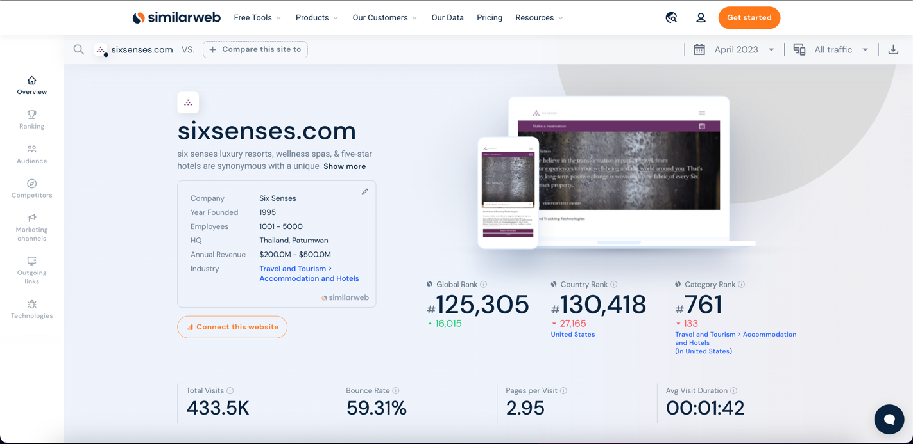

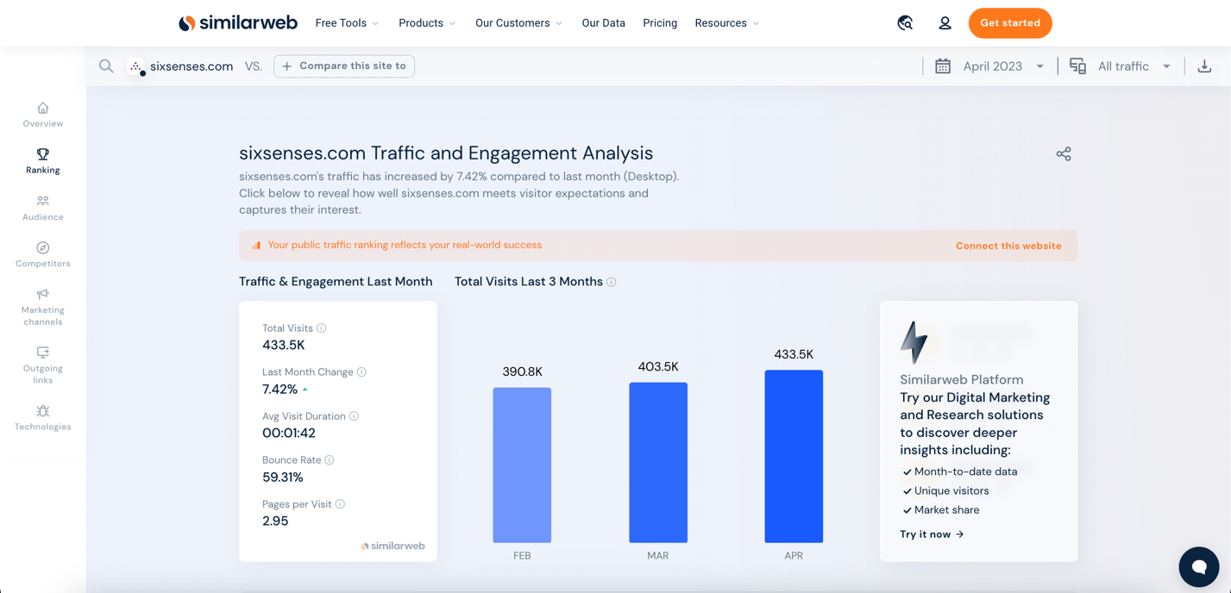

https://www.similarweb.com/website/holidayinn.com/#overview



