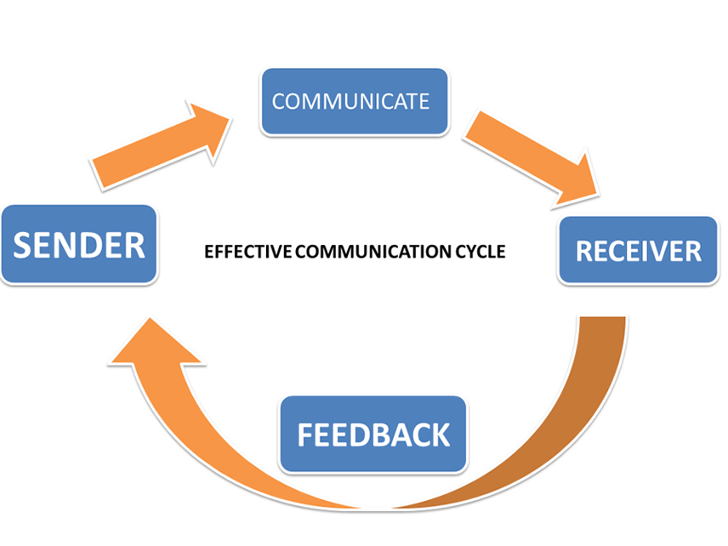
Exceeding a managerial role within your workplace requires you to have a variety of skills the primary being communication. Good communication skills are crucial for a manager to have in order to achieve a high standard workplace environment. The objective of communication is to get your message across, from the sender to the receiver, with countless platforms to hand, the message once received is followed by feedback. This is known as the communication cycle.

In order to communicate effectively the senders message needs to be clear and pre meditated for the best possible outcome, identifying how best to communicate to the receiver considering tone, approaching with formality and use of jargon speech within some work environments alongside knowing your communicator and how they perceive messages considering their language, culture and interpersonal lives if needed. Observation is an important required skill needed for communicating effectively. Paying close attention to each stage of the cycle, examining the receiver’s facial expressions or if using an online network, their responses. ensuring your message was received and understood correctly without misinterpretation. Within my workplace miscommunication is common due to the surrounding noise barriers of the restaurant resulting in uncompleted food orders being served which is then later returned as a complaint.
This is just one of many barriers for communication another being information overload. Too much information directed towards an employee can result in their well-being and often mental health being negatively impacted affecting performance and productivity. This is seen as a one of the most major barriers in communication and can be resolved by informing your employer about your workload and the using of organisational/ time management skills. As well as this, Emotional barriers are also seen as major barriers for communication due to its numberless motives e.g., sexuality, health, home life etc. A resolution to this would be to apply observational skills detecting their work-based performance, utilising soft skills ensuring the company’s given support. Furthermore, perceptual barriers in the workplace are challenging and hard to overcome in account of colleagues disagreeing, where conflict and resolution skills are incorporated to prevent escalation.
Being the initiator of communication, it is evident your tone needs to match your message, as well as other non-verbal cues including gestures, eye contact, touch etc. Selecting the appropriate tone brings clarification to your message preventing any miscommunication or discomforting atmospheres where conflict can easily arise for example, a situation occurred where the words “I’m not sure” were misinterpreted as they were spoken negatively causing conflict between two of my colleagues. This highlights the importance of tone within communicating as a manager, using language best fitting the formality of the environment; from delegating tasks to staff meetings, maintaining a formal language is needed to succeed in a formal professional workplace. It is important for yourself and your colleagues to feel safe and secure when in the workplace ensuring they are happy and aware of the support your workplace gives. Giving staff recognition when performing well boosts workplace morale and enthusiasm such as employee of the month, appraisal letters Alongside E-mails, reports, posters etc.
These are all written communication methods, in oppose to team meetings, job interviews, online meetings etc which are all verbal forms of communication. Letters sent from your workplace must always be formally written as its contents are usually of importance for instance, a performance review or recommendation letter and is a written piece of evidence reflecting your workplaces professionalism. Communicating using E-mail is a more recent form of communication and is used throughout the majority of workplaces seen today. The upkeep of formality when writing a work/business related E-mail is also important when speaking for your company/ business, this method of communication is so widespread and commonly used it is easy to subside your professionalism. Communicating verbally also requires a professional attitude and formal approach one example of this would be formal meetings. A formal meeting is between a set time and date where one or a group of colleagues gather for a discussion; delving deeper into formality making sure your appearance is appropriate and best suited for the meeting and workplace in general.
One perfect example would be looking back on my workplace and experience where I was informed about an annual assessment meeting, my employer at the time was uncharismatic and robotic presenting the meeting with an unenthusiastic attitude making me feel unseen and undervalued. In addition to this, nonverbal cues such as facial gestures were prevented due to the COVID19 pandemic and the imperative need for wearing masks, this can be seen as a temporary barrier for nonverbal cues.
Depicted in the two tables below shows the most used written and verbal communication methods within my own area of organisation and the approach of tone language and formality for each.9
Written | Tone | Language | Formality
E-mails | Presented with a formal tone relating to the message received. | Written in a respectful and professional manner. | Approaches with formality in any company sent E-mail.
Posters | Written in an enthusiastic tone encouraging staff. | Shows motivational language supporting customers colleagues and the company. | Displayed both formally and informally depending on the context.
Policies | Approaches in a formal influential tone. | Written professionally and formally displaying regulations. | formally approached and written representing the workplace.

Verbal | Tone | Language | Formality
meetings | Correctly suited to the type of meeting. | Maintains formality and professionalism. | Both attitude and appearance are presented formally.
Job Interviews | A warm happy tone projecting enthusiasm. | Shows welcoming and respectful language | Maintains a formal approach throughout the interviews.

As you can see above, my workplace presents E-mails formally and in a professional, respectful manner no matter its purpose. With McDonald’s being popular to such a wide range audience maintaining formality is crucial in any form of communication in name of the business/organisation. E-mails have proven to be most effective when written communication is needed in my workplace as it’s the fastest and most efficient way of informing a colleague However some would argue against this as they may not check their E-mails regularly. This issue is common and is often seen in my organisation. One solution to this would be to possibly remind colleagues to check E-mails, I feel as though this method would prove to be the most successful, effectively using verbal communication informing staff about their received E-mail. This can be done via team meetings, 1:1 meetings or simply a discussion.
The purpose of Posters in my workplace is to encourage and motivate staff and is written in a positive, enthusiastic manner showing support to customers, colleagues’, and the company; alongside posters illustrating regulations and policies where formality of language and tone is upheld; advertising new menu items and promotions along with recognition pictures and company information. A poster can have a variety of objectives from decorative to informative and depending on its purpose can be written both formally and informally. They are placed in and around my workplace break room creating a more welcoming environment for colleagues/ new employees. Posters are also often used to display workplace policies and rules reminding staff of the regulations and how to maintain them such as hygiene, health and safety etc. As stated in the above first table, tone and language are approached formally due to importance of clarity when informing employees of company rules. It is crucial policies are written in a direct manner diminishing the chances for miscommunication leaving the reader well informed and self-assured. Although my workplace delivers posters and policies in a high standard, I feel this is an area for improvement possibly introducing monthly meetings highlighting company regulations as some employees may not read the displayed messages. This is commonly seen within my workplace where colleague’s appearances overtime breaks company regulations for example facial piercings, jewellery etc, therefore I feel continuous meetings on the subject would be a suitable resolution.
In regard to communicating verbally within my workplace the communicators tone is always professional and best suited to the conversation. As seen above, meetings is a chosen method of verbal communication seen in my place of work alongside job interviews. Both of which is approached formally and respectfully maintaining an interested, enthusiastic tone throughout. Due to the company’s constant high number of teenage employment, formal meetings can be pressuring and intense, This can be improved by informing the employee about witness privileges and other entitlements.
Motivation by definition is “a reason or reasons for acting or behaving in a particular way”, referenced from Oxford languages. Analysing this I see that the reasons for acting in a particular way, is down to the topic responsible for awakening the motivation. It is a feeling of eagerness and enthusiasm driving people towards success and accomplished goals. As well as this I also feel that the amount of commitment relies on the amount of motivation. I find my opinion best fits Douglas McGregor’s theory of motivation, dividing his opinion into two separate theories X and Y, basing motivation on workplace environment and interactions. When working in a dull undervalued environment seeing efforts go unnoticed is a demotivator resulting in feeling invisible and unnoticed. “Organisations with happy employees outperform the competition by 20%”, a quote from CIC Welbeing.com. This shows that with greater motivation comes greater excelling accomplishments highlighting the importance of recognition and motivational language in the workplace.
McGregor’s theory on motivation dissects workers into category like theories, evaluated by the individuals’ attitude towards work and how it changes due to the effectiveness of motivation within the company. I feel as though this theory of motivation best applies to my workplace as both recognition and unrecognition are seen frequently. Due to it mainly being a busy fast paced environment making It is easy for recognition to go unnoticed resulting in unsatisfied employees, and in some instances resignation letters. Overall, I feel my workplace best fits McGregor’s Y theory. Regarding that not all co-workers get their deserved praise, assessing my colleagues’ attitudes and facial expressions throughout shifts, the company in which I work’s motivation methods are of a high standard as is due to recognition being a prime objective within staff environments for management.
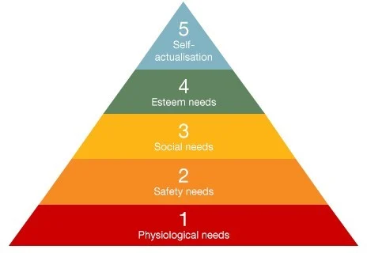
Shown underneath is a table showing Maslow’s theory of motivation and its 5 consisting levels

Motivation has been considered as a topic by many including Abraham Maslow. Maslow’s theory of motivation consists of 5 levels the first being phycological needs. Followed on by safety needs, social needs, then esteem needs leaving self-actualization needs at the top. Each is a factor and can potentially form inner pressures resulting in behavioural changes. This five-tier hierarchical model must be fulfilled in the correct order, to ascend moving onto the upcoming need. Phycological needs such as food/ drink warmth etc, are seen to be most important. Regarding managing a workplace it is important that reasonably scheduled shifts alongside appropriate numbers of rest days are assigned etc, This Is the first level, followed by safety needs. Moving all your attention onto this second level, improving your financial status, health and wellbeing, and overall bettering your sense of security, all in safe working environments. The third level is social needs and is crucial in achieving a feeling of belonging and acceptance with different types of relationships and social friendly gatherings, in result loneliness Is easily avoided. Moving onto esteem needs, identifying recognition and praise directed towards yourself reflecting the communicators respect and to sustain it alongside maintaining appreciation and when given, reciprocated. This is important towards your reputation and if not upheld could result in feelings of a low personal worth. Placed at the top is self-actualization needs. This is becoming self-aware and motivated in improving yourself, achieving your full potential and is seen as the apex level within Maslow’s hierarchical structure. Completing these levels has you feeling fulfilled due to the structure of the levels and the correct approach to satisfy needs according to Maslow.
I feel as though this theory of motivation fits my workplace within specific aspects. As a manager problem solving is a common needed skill along with assuring your workplace safety and reassuring colleagues of your safe environment when questioned. Reflecting more into social needs, my workplace demonstrates a variety of ways preventing isolation, from crew events to communitive employee competitions and games along with recognition posters encouraging staff to achieve. Promotions and new job positions within my workplace are constant making its easy for someone with the right motivation to excel.
In the workplace there are many principal factors that affect performance and motivation. The types of factors commonly seen can be both intrinsic and extrinsic motivators influencing workers performance. For instance, salary is a major motivator and is usually addressed first when coming into new employment alongside other information however can act as a downside when it comes to maintaining good performance and motivation. Salary can motivate intrinsically for example workers are more then satisfied with their income and find work environment enjoyable showing salary not to be a motivator in performance. However, also motivates extrinsically and can result in workers showing no enthusiasm towards the company, negatively impacting morale, and new employee motivation due to the fulfilment receiving pay 6checks.
Recognition and reward are another big motivator within the workplace creating uplifting positive atmospheres showing the company/ employers appreciation. This can be viewed as intrinsic motivation for example, your workplace behaviour may result in surprising rewards and unexpected praise regarding your performance. The appraisal is unexpected as it was without agenda making it an intrinsic motivator. As well as this, recognition and reward can also project out to be extrinsic motivators, having workers succeeding in tasks efficiently in hopes of receiving something int return.
Relationships with leaders is seen as formal within organisations, upholding the level of formality throughout the workplace environment. An example of extrinsic motivation, being at conflict with the manager therefore attitude is best suited to avoid punishment. Whereas intrinsic motivation for this factor highlights the relationship and great level of respect between employer and employee.
The same conclusion can be drawn when speaking about the relationships between colleagues. Where extrinsic motivation is used, to prevent any uneasy atmospheres. Along with intrinsic motivation suggesting fulfilment when working around colleagues
Motivation is crucial when considering performance, the more motivation put in, the greater the performance, exceling in set targets/goals identifying needs for improvement and resolving them. Looking back on McGregor’s Y theory of motivation, identifying that it is most efficient when surrounded by the right environment as well as ensuring colleagues know they are appreciated. Which ever chosen forms of motivation used, intrinsic/extrinsic. It is important a form of motivation is applied when in work as an unmotivated attitude appears dull and unenthusiastic possibly implementing tone and some other nonverbal cues resulting in communication issues
Below shows criteria developed for evaluating my own ability to communicate effectively,
Tone | Nonverbal
Language | Body language
Gesture | Formality

Carefully analysing each key form of communication identified, I have concluded in assessing my own ability to communicate the key areas best suited to myself are tone, language, and nonverbal gestures such as facial expressions/hand gestures. When communicating to colleagues I feel as though my tone is always positive and encouraging, leaving co-workers in a more uplifting mood. The upkeep of correct tone within communication is extremely important and I feel as though I demonstrate a good example of this when communicating. Language on the other hand I feel that assessing my communicative abilities has resulted in surfacing language barriers, for example, mental health barriers where verbal communication is affected. This is triggered by stress from work overload and formal meetings resulting in major anxiety surfacing. It is important before communicating to consider your style of language as it reflects back on you and your workplace and Is an area needed for improving to achieve full effective communication. Within assessing my nonverbal gestures I find that my hand gestures have proven to be most effective as it physically walks you through the conversation resulting in minimal confusion. in addition, facial gestures are prominent and seen as a successful way of expressing the conversation. Looking back at prevouse conversations I know that using facial expressions is effective when conversating and am confident I utilise them correctly best fitting the conversation.
Shown below are two swot diagrams analysing work colleagues’ feedback on my own verbal and written communication skills. With the first table showing verbal communication skills while the second shows written.

Strengths | Weaknesses | Opportunities | Threats
- Has great listening skills and use of soft skills.  - Appropriate use of language in the appropriate situation.  - Speaks in a motivating positive.  - Very enthusiastic  - Applies gestures. | - Interpersonal barriers.  - Mental health barriers/ anxiety.  - Formal meetings. | - Initiate conversations more  - Be more involved  - Be more confident | - To considerate and lenient when enforcing rules  - Anxiety  - Unexperienced in formal gatherings. E.g. meetings.
As seen above my approach to verbal communication Is professional, motivating and positive as stated under strengths with a delicate approach to listening accumulating soft/ listening skills. Weaknesses seen above include interpersonal barriers and mental health barriers. When this feedback was given it was said I “hold myself anxiously” when in large groups/ formal situations In which I agree.
Strengths | Weaknesses | Opportunities | Threats
- Approaches with formality  - Writes in a formal tone in both e-mail and letters.  - Creativity. - Designing posters, informing crew information; | - Bad organisational skills  - Time management | - Job promotion | - Technological threats. (battery dying)  - Misinformation of contact details.

Seen above in strengths, my approach towards written communication is formal and respectful taking the reader under consideration by correctly using tone. Examples of this would be emails, letters, posters etc. however it is seen that my organisation and time management skills are big weaknesses and can affect communication.
As a manager I feel I must appropriate skills needed for the role and to possibly excel further into promotions and higher company positions. My use of tone language and formality when communicating Is always upheld, applying them at the right time best fitting the situation utilising my observational skills along with my soft skills, as well as maintaining enthusiasm and motivation throughout the workplace encouraging staff and maintaining workplace morale. It is evident I have areas needed for improving as seen in the swot analysis two I am lacking in two crucial skills needed as a manager and can be seen as the biggest barriers in achieving effective communication and workplace. Reflecting on this feedback, they are areas needed for improving alongside others shown within the tables above. Shown below is a personal development plan I have created addressing my weaknesses and a plan for improving them.

What needs improving | How this is achieved | How will I measure success
organisational skills | Keeping up with cleanliness and organisation of my desk. | Get my degree in leadership and communication.
Social skills | Interacting more with colleagues initiating more conversations. | Social events/gathering attended resulting in a more sociable life

References
https://www.thetrainingbox.eu.com/the-communication-cycle/
Motivation. motivation noun - Definition, pictures, pronunciation and usage notes | Oxford Advanced Learner's Dictionary at OxfordLearnersDictionaries.com. (n.d.). Retrieved April 8, 2023, from https://www.oxfordlearnersdictionaries.com/definition/english/motivation

https://www.cicwellbeing.com/blog/what-makes-a-happy-workplace/
https://www.statisticssolutions.com/maslows-hierarchy-of-needs/
https://www.toppr.com/guides/fundamentals-of-economics-and-management-cma/leadership-and-management/mcgregors-model-of-motivation/
https://www.verywellmind.com/what-is-maslows-hierarchy-of-needs-4136760

