

Student Name: Molly Ndoya
Student ID: 2423296

Module code: BMHP5023
Module: Introduction to Physiology

Assignment Title: Component 1: Written Assignment (Case Study Report)
Table of Contents
Introduction 3
Section 1: Anatomy and Physiology 3
Section 2: Pathophysiology and Impact 5
Section 3: Monitoring & Data Use 7
Section 4: Evidence-Based Lifestyle Recommendations 9
Conclusion 10
Reference List 12

Case Study 2- Asthma in Adolescents

Introduction
Asthma is a long-term respiratory disease which takes place in the respiratory airways of lungs. It causes the airways to be inflamed, swell, and constrict. This makes it difficult to breathe in and out with freedom in the lungs. Recurrences of asthma comprise cough breaths, wheezing, and turning chest-pains. The symptoms can either be mild or harsh and periodical in nature.
Asthma is a childhood condition that may extend to adolescence and adulthood as well (Ödling et al., 2023). Multiple risk factors may be involved in enhancing the possibility of developing asthma or having poor control of asthma. These are family history of asthma, allergen exposure, air pollution, smoking and secondhand smoke. Changes in the style of life at that stage (smoking or vaping) may exacerbate the symptoms. Asthma attacks also occur following respiratory infections. Inadequate medication, compliance and incompetence about the condition may also pose a greater risk.
Asthma may exert a great influence on everyday life. Severe asthma can have an impact on sleep or physical exercise, attendance at school and well-being (Peftoulidou et al., 2023). Acute asthma attacks can demand urgent healthcare or call for hospitalization.
The aim of this report is to increase the knowledge of asthma among adolescents. It is going to argue about the structure and the physiology of the breathing system and how asthma changes normal breathing. It will examine the ability of lifestyle in asthma control. In the report will be the importance of monitoring breathing data and evidence-based lifestyle change to support the effective and safe management of asthma.

Section 1: Anatomy and Physiology
Asthma
Describe the respiratory system structure (Asthma)
The human respiratory system is a complex network of organs and tissues which are developed to offer entry of oxygen in the body and removal of carbon dioxide (Swenson, 2025). The air traveling through the mouth and the nose is where this system originates and then it is filtered, heated and humidified. The air then enters the trachea through the pharynx and larynx, and the trachea consists of a tube that is made up of a cartilage ring. This trachea again bifurcates into two minor bronchi and each of them triggers a lung. These bronchi multiply further to create small tubes known as bronchioles which further divide to reach to a point where they are formed to groups of small air sacs known as alveoli.
The airways in the lungs create an inverted tree-like configuration where several branches amplify the various body surfaces of exchange (Jradi et al., 2026). Each healthy adult lung has about 480 million alveoli, which is a massive surface area of about 70-80 square meters to perform optimal gaseous diffusion.
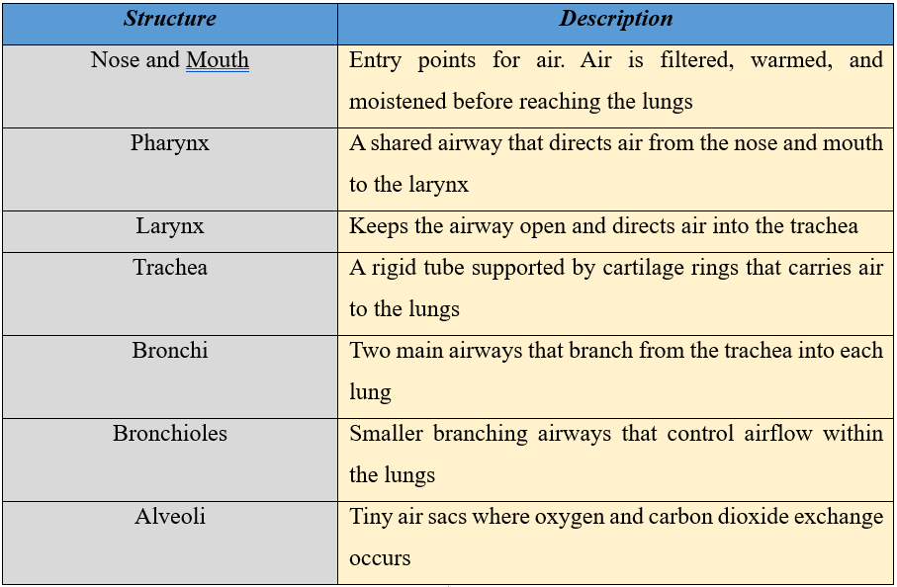
Table 1: Structure of the Respiratory System
Asthma is a disease that affects millions of individuals. More than 300 million people in the world have been estimated to have asthma and as a result, the condition has been said to rank among the most prevalent chronic diseases (who.int, 2024). In the United Kingdom alone, the current government statistics show that approximately 3.9 million children of the age six and above are diagnosed to be having the asthma disease, which is equivalent to 6.5 percent of a populated country of England.

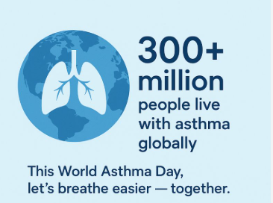
Figure 1: People Globally Live with Asthma
(Source: who.int, 2024)
Explaining Mechanical Respiratory and Gas Exchange
Mechanical respiration may be referred to as physical respiration which comprises of breathing, inhaling and expelling (Kaimakamis and Chasapidou, 2022). During inhalation, the diaphragm flattensand compresses and is pulled up and out by the external intercostal muscles, pulling the rib cage during the same direction. It dilates the thoracic cavity and lowers the pressure of air inside the lungs leading to the drawing in of air. Diaphragm or intercostal muscles relax when it expires hence decreasing the volume of the thorax and increasing the volume of lungs expelling air.
Under this condition, gaseous exchange occurs after the presence of air inside the alveoli and diffusion of the blood-air barrier (thin layer) between the air in the alveoli and the blood in the surrounding capillaries. The oxygen in the alveolar space is transported into the blood where oxygen concentration is high and bound to hemoglobin in the red blood cells. Simultaneously, there will be greater diffusion of the blood carbon dioxide with higher concentration into the alveoli to be eliminated.

Section 2: Pathophysiology and Impact
Asthma
How irritants cause inflammation and affect breathing
Asthma is a genetic inflammatory illness which prevents the normal airway functioning (Chung et al., 2022). In open airways the normal respiratory system is freely passable by air. The airways of asthma are sensitive, and they respond excessively to bronchi irritants such as smoke, allergen substances, cold air or attacks by viruses (Gohal et al., 2024). When these irritants are inhaled, their activation of the immune system takes place.
Some of the chemicals released by inflammatory cells are histamine and leukotrienes. The effects of these substances include swelling of the airway lining; sphincter zing smooth muscle surrounding airways (bronchoconstriction) and release of excessive mucus. All these alterations lead to tightening of the airway lumen and increase the airflow resistance. This makes breathing out exercise extremely difficult and brings about such conditions as wheezing, coughing, and chest tightness, and shortness of breath.
Since the flow of air is limited, less oxygen is delivered to the alveoli, and the process of removing carbon dioxide is less effective. In the processes of asthma flare-up, such an imbalance may lead to lower oxygen levels in the blood. Added to this is repeated or uncontrolled inflammation, which may also result in airway remodeling, whereby the airway walls over time become larger and less stretchy, with long-term effects of diminished lung function.
Impact of smoking/vaping and infections on lung function
The biology of airways is changed by lifestyle causes that have a significant influence on the intensity of asthma (Evans et al., 2025). Smoking exposes the airways lining to thousands of poisonous chemicals and these chemicals literally result in the fact that the bronchial walls become inflamed and distended. This accelerates the worsening of lung operation, prevalence of symptoms, and reaction in traditional anti-inflammatory treatments in asthmatic individuals, including inhaled corticosteroids. Cilia that help clear the mucus is also destroyed by smoking predisposing the airway to infection further aggravating the inflammation and obstruction of airways (Tiotiu et al., 2021).
Vaping can be advertised as a less harmful option, yet it has been proven to be unhealthy. Meta-analyses have established that use of e-cigarettes is linked to a risk of 20–36% of the probability of asthma diagnosis and 44% higher probability of asthma exacerbations than with non-use (Hall, 2025). Vapor chemicals irritate airway tissues and negatively impact lung immune responses.
Virus induced cold and influenza cause the initiation of the inflammatory cascades in already inflammatory airways. These infections increase the practitioner secretion of mucus and bronchoconstriction, which are likely to result in vulnerable episodes and pulmonary sufficiency. Such lifestyle habits as vaping or smoking strengthen this effect because they form the cycle of inflammation, otherwise ineffective clearance and recurrent attacks of asthma (WHO, 2024).
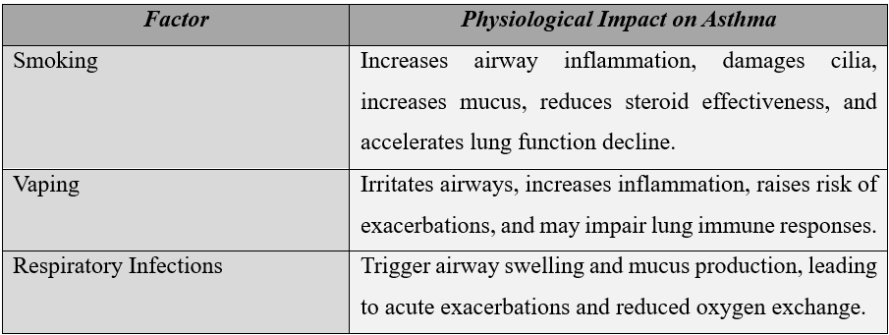
Table 2: Physiological Impact on Asthma

Section 3: Monitoring & Data Use
Importance of Tracking Health Data
Follow-up of health information is essential in dealing with chronic disorders such as asthma (Kapri et al., 2023). Peak expiratory flow (PEF) is a major indicator employed when treating asthma patients to determine how well they can clear their lungs of air. This basic test enables patients and clinicians to gain insight into airway obstruction even before it can be known. Peak flow registers regularly can also show a pattern and the onset of asthma improvement, so what can be done is taken in time, be it the right medication or avoidance of the triggers.
Asthma is chronic in nature, being one of the most pervasive diseases in the world, especially in childhood, and the disease affects children and youth. In the world, 262 million people had asthma in 2019, as has been indicated by the World Health Organisation (Song et al., 2022). In UK, however majority are diagnosed and managed but very Insignificant number of those with asthma yet dependent on basic annual care including frequent reviews and action plans are looked at.
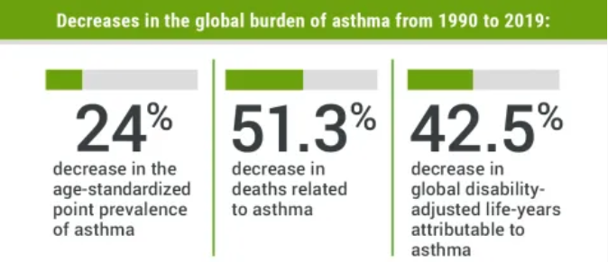
Figure 2: Decreases in the Global Burden of Asthma from 1990-2019
(Source: Saeid et al., 2021)

It is estimated to have about 434 million individuals in the world who could have asthma by the year 2025. It is approximated that approximately 7.2 million of them exist in the UK where it afflicts eight per everyone hundred people.
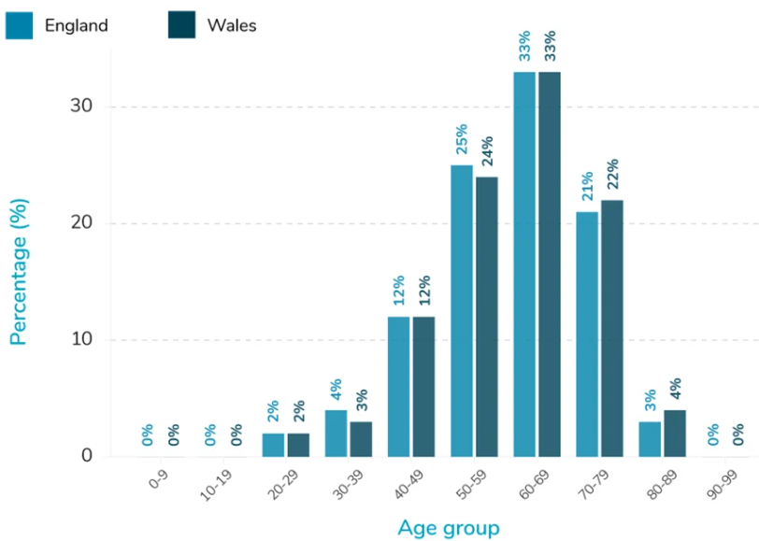
Figure 2: People with Asthma in England and Wales
(Source: chemist-4-u.com, 2025)
How Routine Data Helps Manage the Condition
Routine data promotes individualized asthma action plans and self-management. The daily monitoring assists in telling the difference between the usual variability and the clinically significant deteriorations. An example would be PEF twice a day (mornings and afternoons) due to the possibility of diurnal fluctuation and clarifying the tendency of the results instead of a single score (asthmaandlung.org.uk, 2024).
Indications have shown that in cases where education and periodical review are administered, patients going through treatments and quality of life have been found to improve through the application of monitored. Lastly, trend data may enable medical personnel to initiate treatment, decrease exacerbation and eliminate severe attacks and offer more straightforward and appropriate control over asthma.

Section 4: Evidence-Based Lifestyle Recommendations
Suggesting Realistic Lifestyle Changes
Asthma treatment does not only end with medication; the clinical problems and the lung volume can be significantly enhanced with relevant lifestyle modifications. Smoking and vaping cessation is also one of the recommendations. Particularly, the UK clinical guidance is created to educate, and support the adolescents to abandon smoking and vaping, referring to the NHS stop-smoking services, as the two factors observe the progression of poor asthma management and airway inflammation.
Regular exercise is also another lifestyle choice. Even though exercise can induce breathlessness in those with uncontrolled asthma, studies indicate that the right activity enhances lung performance, asthma management, living standards, and lowers inflammation without aggravation of the situation (Kuder et al., 2021).
Weight management is also significant, as well as nutrition. There is evidence that eating patterns of high-quality fruits and vegetables can improve airways, and losing weight (5-10%) in overweight people can also help manage asthma symptoms and control (Stoodley et al., 2019).
Support with Research (Such as NICE Guidelines, Clinical studies)
The adaptation of factors, which will involve smoking, vaping, air pollution, and other environmental causes of asthma, will be part of the routine on asthma management, according to the NICE / BTS / SIGN guidelines on asthma (Nice.org.uk, 2024). Such principles support the self-management plans to include education on how to section triggers and how to avoid them.
Various systematic reviews justify lifestyle interventions, including physical activity and dietary changes.
Explaining How These Changes Improve Physiological Outcomes
Lifestyle interventions which affect the pathophysiology of asthma include reducing airway inflammation and improving lung mechanics. Higher levels of inflammatory mediators and damage of the airway epithelium are the effects of smoking and vaping; the effect of cessation of both exposures will lower the levels of inflammatory mediators and facilitate the responsiveness to the treatment. Frequent exercises increase cardiovascular and respiratory efficiency which assists in strengthening the breathing muscles and the flow of oxygen to the body tissue. Systemic inflammation is reduced with a healthier diet and decreased weight, and this is linked with a reduction in symptoms and exacerbations of asthma. Together, the overall effect of these changes is positive with them aiding in the provision of better long-term control and reduction of the variability of peak flows.

Conclusion
This report has examined asthma as a long-term respiratory disease, which affects airways structure and normal lung functions. It explained the construction and the role of the respiratory system and how asthma interferes with the normal mechanical breathing system as well as the gas exchange by inflaming the airway and narrowing bronchial smooth muscles and the secretion of mucus. The findings indicated that the lifestyle intervention factors particularly, smoking, vaping and respiratory infection were enormous, and affected the symptoms and the severity of asthma due to increased airways inflammation and worsened lung retainment.
The report on the necessity of verifying the respiratory data, including the peak expiratory flow, and the symptoms trend. Regular data gathering improved the detection of deteriorating asthma management, increased adherence to management plans, and prevented the intensity of attacks. UK and international statistics have shown signs of the efficiency of surveillance on asthma on the result and lightened health load.
Evidence-based lifestyle recommendations were found to bring about physiological effects of alleviating airway inflammation, airway lung mechanics, and medication responsiveness. The dominant interventions offered by both NICE guidelines and clinical research were found to be vaping and smoking cessation, physical activity, weight, and infection prevention.
Health professionals played a significant role in the management of asthma processes such as patient education, and facilitation of behavioral change. By improving knowledge, self-management, and healthy living, the health workers could help adolescents to cope with asthma effectively and safely, and threat respiratory well-being and life quality in the long term.

Reference List
‌ Ödling, M., Andersson, N., Janson, C., Melén, E., Bergström, A. and Kull, I. (2023) ‘Health-related quality of life decreases in young people with asthma during the transition from adolescence to young adulthood: a birth cohort study.’ BMC pulmonary medicine, 23(1), pp. 24-34. Available at: https://doi.org/10.1186/s12890-022-02259-6
asthmaandlung.org.uk (2024). Peak flow variability calculator. [online] Available at: https://www.asthmaandlung.org.uk/healthcare-professionals/adult-asthma/diagnosis-testing/perf-calc [Accessed 7 Feb. 2026].
Chemist4U (2025). Asthma Statistics Report. [online] Guides. Available at: https://www.chemist-4-u.com/guides/research-insights/asthma-statistics/ [Accessed 7 Feb. 2026].
Chung, K.F., Dixey, P., Abubakar-Waziri, H., Bhavsar, P., Patel, P.H., Guo, S. and Ji, Y. (2022) ‘Characteristics, phenotypes, mechanisms and management of severe asthma.’ Chinese medical journal, 135(10), pp.1141-1155. Available at: https://doi.org/10.1097/CM9.0000000000001990
Evans, D.J., Sly, P.D., Foster, P. and Donovan, C. (2025) ‘Who gets asthma, and why?.’ Medical Journal of Australia, 223, pp.S19-S23. Available at: https://doi.org/10.5694/mja2.70085
Gohal, G., Moni, S.S., Bakkari, M.A. and Elmobark, M.E. (2024) ‘A review on asthma and allergy: current understanding on molecular perspectives.’ Journal of Clinical Medicine, 13(19), pp. 5755-5775. Available at: https://doi.org/10.3390/jcm13195775
Hall, R. (2025). Young vape users are three times as likely to start smoking, study finds. [online] The Guardian. Available at: https://www.theguardian.com/society/2025/aug/19/young-vape-users-three-times-as-likely-to-start-smoking-study [Accessed 7 Feb. 2026].
Jradi, W., Duhm, K. and da Costa, C.P. (2026) ‘Developmental Impact of Maternal Immune Activation on the Fetal Immune System and Lung.’ European Journal of Immunology, 56(1), pp. e70128-e70138. Available at: https://doi.org/10.1002/eji.70138
Kaimakamis, E. and Chasapidou, G. (2022) ‘Respiration: physiology, pathology, and treatment.’ In Wearable Sensing and Intelligent Data Analysis for Respiratory Management (pp. 3-28). Available at: https://doi.org/10.1016/B978-0-12-823447-1.00004-X
Kapri, A., Pant, S., Gupta, N., Paliwal, S. and Nain, S. (2023) ‘Asthma history, current situation, an overview of its control history, challenges, and ongoing management programs: an updated review.’ Proceedings of the National Academy of Sciences, India Section B: Biological Sciences, 93(3), pp.539-551. Available at: https://doi.org/10.1007/s40011-022-01428-1
‌Kuder, M.M., Clark, M., Cooley, C., Prieto-Centurion, V., Danley, A., Riley, I., Siddiqi, A., Weller, K., Spyros Kitsiou and Nyenhuis, S.M. (2021) ‘A Systematic Review of the Effect of Physical Activity on Asthma Outcomes.’ The Journal of Allergy and Clinical Immunology In Practice, [online] 9(9), pp. 3407-3421. e8. Available at: doi:https://doi.org/10.1016/j.jaip.2021.04.048.
Nice.org.uk. (2024). Recommendations | Asthma: diagnosis, monitoring and chronic asthma management (BTS, NICE, SIGN) | Guidance | NICE. [online] Available at: https://www.nice.org.uk/guidance/ng245/chapter/recommendations [Accessed 7 Feb. 2026].
Peftoulidou, P., Gioulvanidou, M., Chrysochoou, E.A. and Hatziagorou, E. (2023) ‘Physical activity and quality of life in children with well-controlled asthma.’ Journal of Asthma, 60(5), pp.1031-1037. Available at: https://doi.org/10.1080/02770903.2022.2123742
Saeid Safiri, Carson-Chahhoud, K., Nahid Karamzad, Sullman, M.J.M., Seyed Aria Nejadghaderi, Taghizadieh, A., Bell, A.W., Ali-Asghar Kolahi, Khalil Ansarin, Mansournia, M.A., Collins, G.S. and Kaufman, J.S. (2021). Prevalence, Deaths, and Disability-Adjusted Life-Years Due to Asthma and Its Attributable Risk Factors in 204 Countries and Territories, 1990-2019. CHEST Journal, [online] 161(2), pp.318–329. doi:https://doi.org/10.1016/j.chest.2021.09.042.
Song, P., Adeloye, D., Salim, H., Dos Santos, J.P., Campbell, H., Sheikh, A. and Rudan, I. (2022) ‘Global, regional, and national prevalence of asthma in 2019: a systematic analysis and modelling study.’ Journal of global health, 12, pp. 04050-04052. Available at: https://doi.org/10.7189/jogh.12.04052
Stoodley, I., Williams, L., Thompson, C., Scott, H. and Wood, L. (2019) ‘Evidence for lifestyle interventions in asthma.’ Breathe, [online] 15(2), pp.e50–e61. Available at: doi:https://doi.org/10.1183/20734735.0019-2019.
Swenson, E.R. (2025) ‘The pathway for carbon dioxide: from tissues to lungs.’ In On Oxygen (pp. 211-228). Available at: https://doi.org/10.1016/B978-0-443-21877-4.00008-5
Tiotiu, A., Iulia Ioan, Wirth, N., Romero-Fernandez, R. and Francisco-Javier González-Barcala (2021). The Impact of Tobacco Smoking on Adult Asthma Outcomes. International Journal of Environmental Research and Public Health, [online] 18(3), pp.992–992. doi:https://doi.org/10.3390/ijerph18030992.
World (2024). Asthma. [online] Who.int. Available at: https://www.who.int/news-room/fact-sheets/detail/asthma [Accessed 7 Feb. 2026].
World (2024). WHO publishes new tobacco and asthma knowledge summary. [online] Who.int. Available at: https://www.who.int/news/item/30-07-2024-who-publishes-new-tobacco-and-asthma-knowledge-summary? [Accessed 7 Feb. 2026].

