Hotel Trinity
Swansea, South Wales
Email: hoteltrinity56@gmail.com

Christmas Special Menu
Classic Fish and Chips  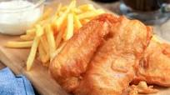  Cook: 35 mins  Price: 27.50 | Irish Beef Stew  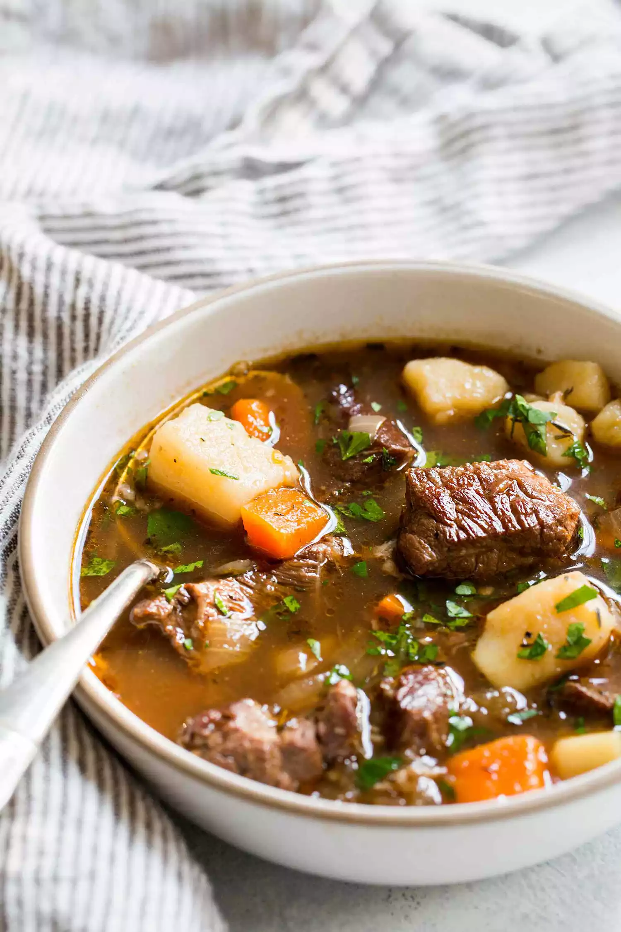  Cook: 30 mins  Price: 35.50
Bangers and Mash with onion gravy  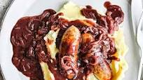  Cook: 40 mins  Price: 25.60 | Bara Brith  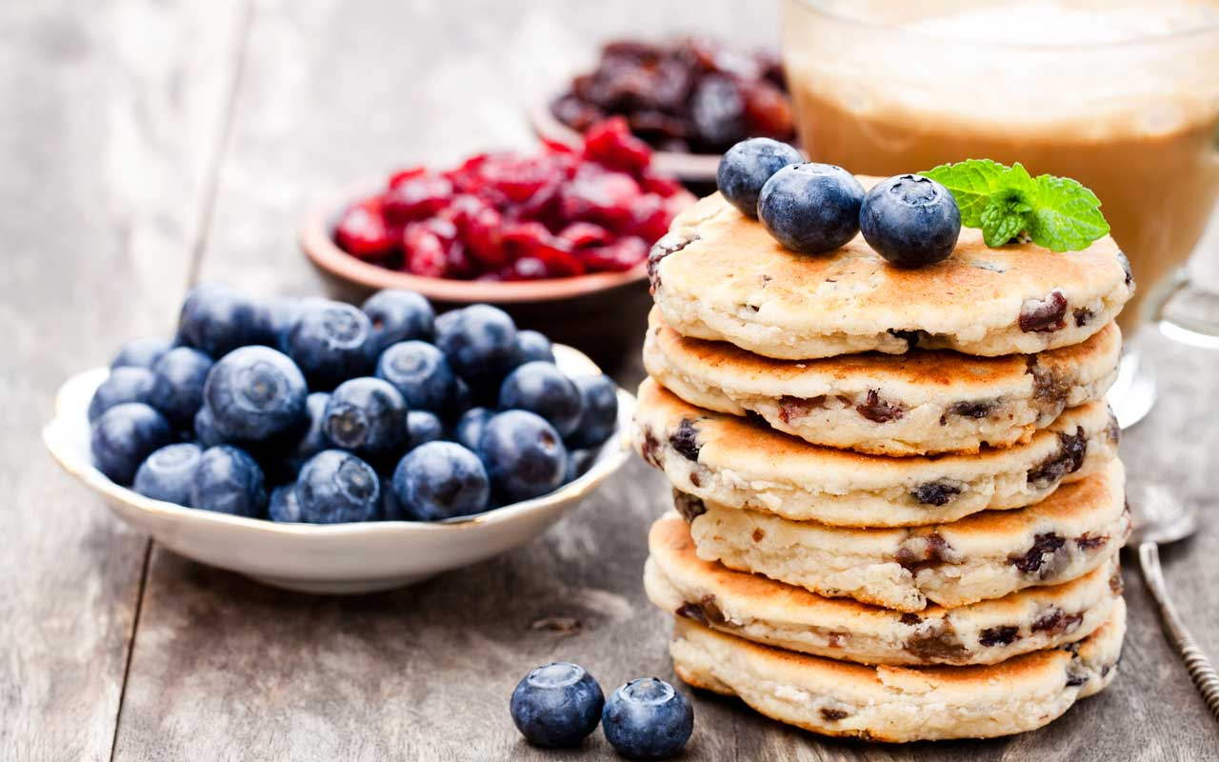  Cook: 30 mins  Price: 22.00

Availability: 10 am – 12 pm
Payment


Traditional eggnog 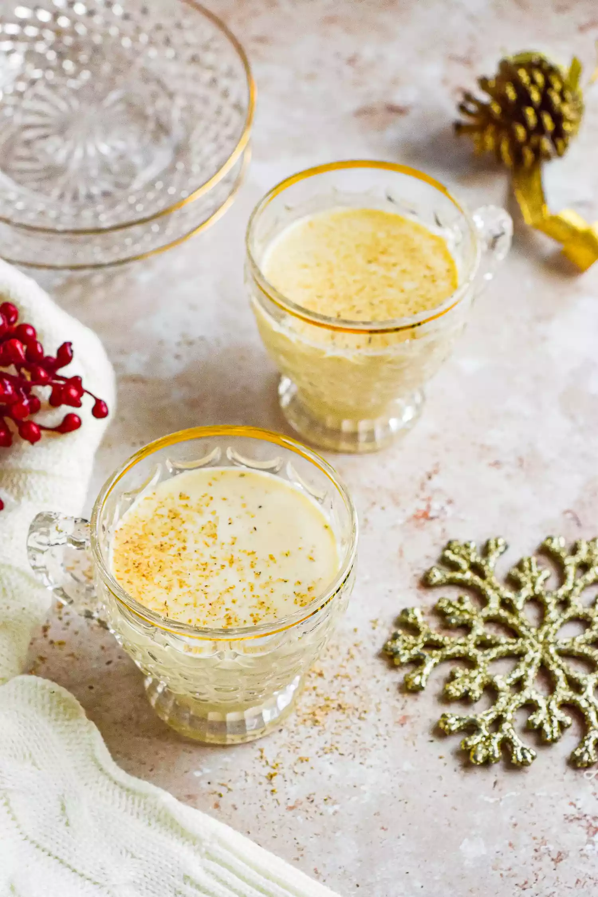  Price: 6.70 | Pudding with Brandy sauce  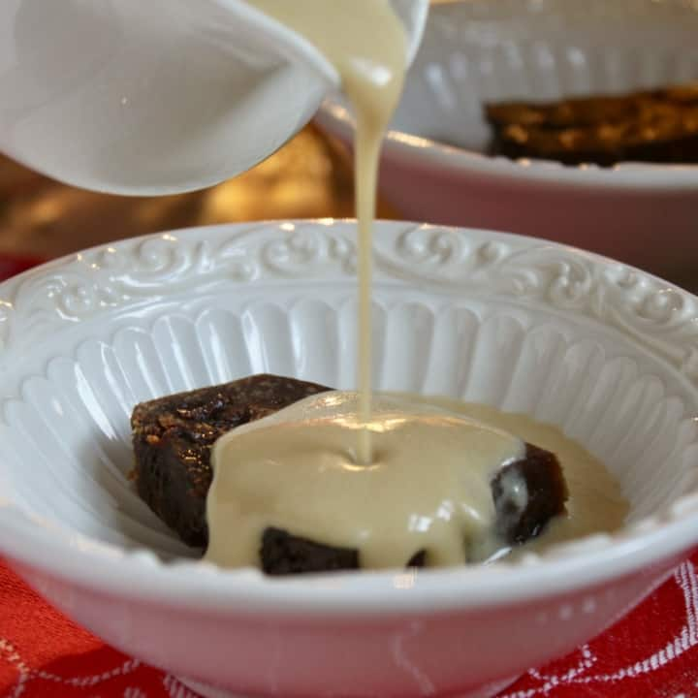  Price: 5.00
Organic wine    Price: 8.80 | Warm Chocolate Sponge  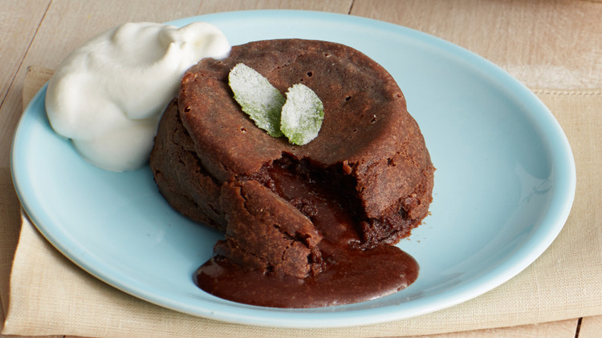  Price: 6.00

drinks & Desserts
Payment gateway




Availability: 10 am – 11 PM
Payment

