LCBB4004 Marketing Fundamentals
Assessment 1 30% Blog

Student name: JASKARAN SINGH SIDHU
Student ID: 2222831
Length: 2000
Due Date:31.03.23

Marks & Spencer
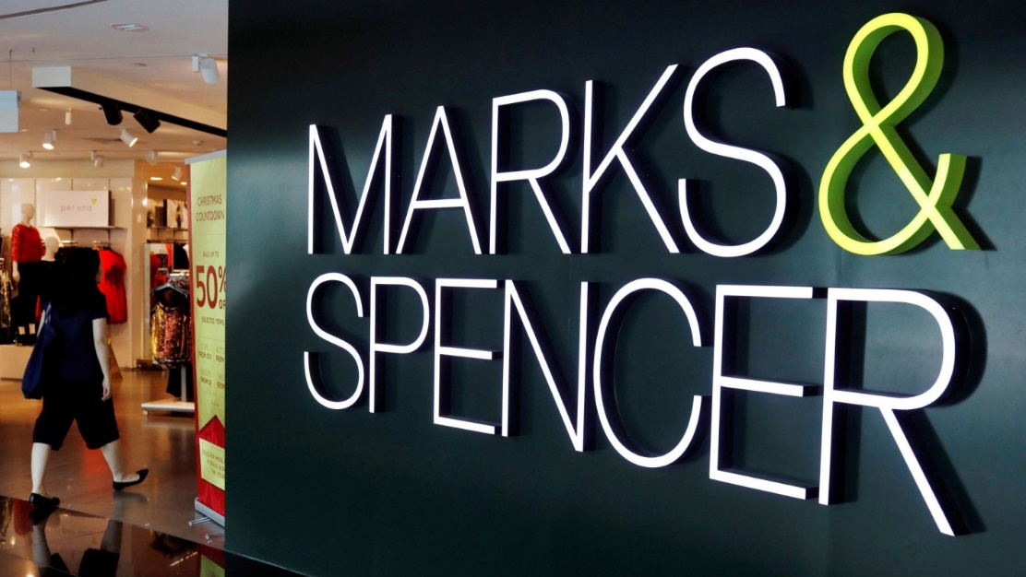
It is no longer practical for businesses to rely solely on mass marketing strategies to draw customers in today's vibrant and competitive business environment. The conventional strategy of casting a wide net to attract a large customer base has become obsolete as customers demand more individualised and customised experiences. Kotler (1989) stated that "most forms of mass marketing are dead." As a result, market segmentation has emerged as the crucial action that every organisation must take in order to maintain its competitiveness and satisfy its target market. One of the top retailers in the UK, Marks & Spencer, will have its segmentation, targeting, and positioning strategies critically examined in this blog.
The well-known British retailer Mark & Spencer, also known as M&S, has been a mainstay of the UK high street for more than 135 years (Marks & Spencer, 2022). Michael Marks and Thomas Spencer established the business in 1884, and since then it has developed into one of the UK's most recognisable brands. M&S has a market share of about 7% and is one of the biggest clothing retailers in the UK (The Guardian, 2022). The business' food hall is well-known for its premium, fresh produce, and it has won many awards for its offerings.

The early years of M&S
Michael Marks, a Polish immigrant who was born in Russia and fled to the UK in 1882, established M&S in Leeds in 1884. Marks opened a shop in Kirkgate Market selling a variety of clothing and household items, and his clientele quickly grew to be locals. Thomas Spencer, the cashier at a nearby wholesale business, and Marks partnered in 1894 (Jain 2017). They started the M&S we know today by opening their first store together in Manchester.

Expansion and innovation
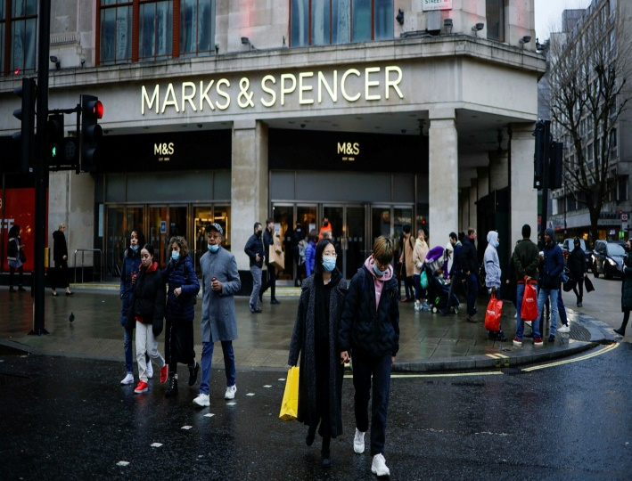
M&S kept expanding over the following few decades. The business launched its first product under its own brand, St. Michael, in the 1920s. St. Michael quickly gained popularity and customer trust (Kotler 1989). M&S opened its first food hall in the 1930s and provided customers with a variety of premium, fresh produce. M&S continued to innovate in the 1950s and 1960s, opening the first self-service store and in-store restaurant. The business also went global, opening its first overseas location in Paris in 1975. (The Guardian, 2017).

Challenges and changes
Despite having a long history of success, M&S has recently faced some major difficulties. The business found it difficult to adapt to shifting consumer trends in the 1990s, which resulted in a decline in sales. In response, M&S underwent a significant reorganisation, closing any stores that were not profitable and concentrating on its core food and clothing lines. Online shopping presented a brand-new obstacle for M&S in the 2000s. The company lagged behind rivals like Amazon and Asos in e-commerce adoption, which cost it market share. However, M&S has made significant investments in its online store recently, and as a result, sales have increased (The Guardian, 2022).

Marks & Spencer – Segmentation, Targeting and Positioning
The well-known British retailer Marks & Spencer (M&S) sells a variety of goods including clothing, food, and housewares. The clientele of the business is diverse, ranging from young adults to middle-aged and senior citizens. By dividing its customer base into various groups based on demographic, psychographic, and behavioural factors, M&S has adopted a market segmentation approach (McDonald & Dunbar, 2012). These factors include age, gender, income, way of life, attitudes, and purchasing patterns. M&S can create products and marketing plans that are tailored to the needs of each segment of its customer base by understanding their preferences and needs.
For instance, M&S has introduced a variety of clothing lines for various age groups, such as "Per Una" for younger women and "M&S Collection" for middle-aged customers. Through its assortment of goods and services, M&S caters to customers of all ages, from millennials to baby boomers. Customers in the middle to upper classes looking for high-quality goods at competitive prices make up the company's main target market. M&S has adopted a multi-channel strategy, utilising physical stores, e-commerce platforms, and mobile applications, to reach these customers.
To reach customers abroad, the business also places a strong emphasis on international growth. The positioning strategy of M&S is based on providing premium goods at competitive prices. By providing a wide range of goods and services to meet the needs of various customer segments, the company hopes to set itself apart from other retailers.
To stay competitive in the global business environment, companies now need to use market segmentation as a key tool. Companies like M&S can successfully meet the needs and preferences of their customers by segmenting their customer base and creating targeted marketing strategies. M&S's segmentation, targeting, and positioning strategies have been effective in addressing a wide range of consumers while upholding a distinct and clear brand identity. According to Kotler (1989), mass marketing is no longer the best strategy for businesses to draw in customers. Instead, the secret to success is a focused strategy based on market segmentation.
Market segmentation has been used by Marks and Spencer to create products that are tailored to the requirements of particular customer groups. The company has also adopted various pricing strategies for various market segments. It employs a variety of techniques for promotion, including advertising and sales promotions. It is dedicated to serving a wide range of customers, as evidenced by its robust online presence and eco-friendly business practises.

Marketing mix
- Product: Marks and Spencer carries a wide selection of goods, including clothing, housewares, and food. The business has created products that are tailored to the needs of particular customer groups using market segmentation.
- Price: The firm uses a pricing strategy that accounts for the worth of its goods. For various market segments, Marks and Spencer uses different pricing strategies.
- Place: With more than 950 stores, including more than 300 food-only stores, the company is well-represented in the UK. It also has an online platform so that it can reach more people.
- Promotion: The business employs a variety of marketing strategies, including public relations, sales promotions, and advertising (M&S 2022). Through its website, social media, and print media, it advertises its products.
- People: Customers receive a tailored shopping experience from a team of employees at Marks and Spencer. The business also funds staff training and development initiatives.
- Process: To give customers a seamless shopping experience, the company has streamlined its processes. Customers, for instance, can easily return items bought online and picked up in-store.
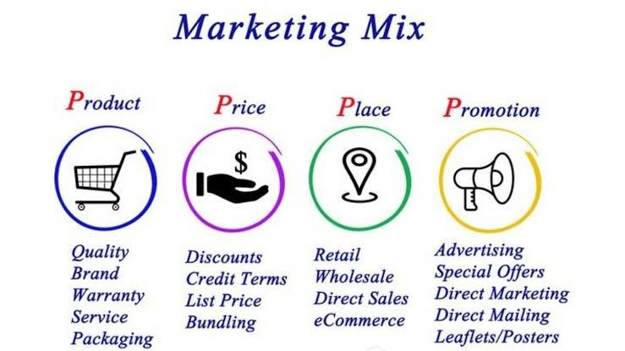
- Physical evidence: The distinct look and feel of Marks and Spencer stores reflects the company's brand identity. The business also makes investments in environmentally friendly procedures, like using recyclable materials for packaging.

Segmentation variables
Marks & Spencer divides the market using a variety of segmentation factors, including geographic, psychographic, and demographic segmentation.

By using demographic segmentation, the market is divided according to variables like age, gender, income, occupation, level of education, and family size. Marks & Spencer uses demographic segmentation to target particular age groups with clothing lines that are tailored to their needs, such as baby boomers and older shoppers. Based on lifestyle, values, attitudes, and personality traits, psychographic segmentation is used. Marks & Spencer divides its market into segments based on psychographic characteristics by emphasising quality, affordability, and sustainability in its products, which appeal to customers who are socially and environmentally responsible.
Markets are segmented based on their geographic characteristics, such as cities, regions, and countries. Marks & Spencer targets customers in the UK and other nations where the company has a presence using geographic segmentation (Statista 2022). The business also customises its offerings to meet the unique requirements and tastes of customers in various locales, such as by providing halal meat options in areas with sizable Muslim populations.
Marks & Spencer uses behavioural segmentation in addition to these segmentation variables to target customers based on their purchasing habits. To encourage customers to keep making purchases from the brand, the business offers loyalty programmes and tailored promotions. Marks & Spencer can effectively target and serve the varied needs and preferences of its customer base thanks to the use of multiple segmentation variables.

Current targeting and positioning strategies
Targeting middle-aged and older consumers with high disposable incomes, Marks & Spencer (M&S) has positioned itself as a premium and sustainable fashion brand. The business has historically concentrated on women's clothing and food, but in recent years it has widened its product line to include men's clothing, home goods, and beauty items.
Targeting multiple distinct segments within its target market, M&S has adopted a multi-segment targeting strategy. The company's primary target markets are men over 40 who want smart casual clothing and women over 35 who care about quality and sustainability. With a distinct clothing line sold under the "Per Una" brand and marketed to young women who are fashion-conscious, M&S also targets the younger generation. M&S has also entered the home goods and beauty industries, focusing on customers looking for premium products with a focus on sustainability.
Quality and sustainability are the main focuses of M&S' positioning strategy. By 2025, the company's "Plan A" initiative, which was introduced in 2007, aims to make M&S the most environmentally friendly retailer in the world (Marks & Spencer, 2021). Reducing waste and carbon emissions, sourcing sustainable materials, and promoting ethical labour practises in its supply chain are all part of M&S's sustainability initiatives. The company's emphasis on sustainability is in line with the ideals of its target market, which includes customers who are becoming more conscious of how their purchases will affect the environment.

Critical Evaluation
The well-known British retailer Mark & Spencer (M&S) has been in business for more than 135 years. Given the company's recent history of difficulties, it is crucial to assess its current situation critically. The struggle of M&S to stay relevant in the face of heightened competition from other retailers ranks among the company's biggest problems. Many customers are turning to e-commerce sites like Amazon and Asos for their needs in fashion and home goods as online shopping becomes more popular. M&S has made an effort to keep up by investing in its own online store, but it hasn't been as successful as its rivals.
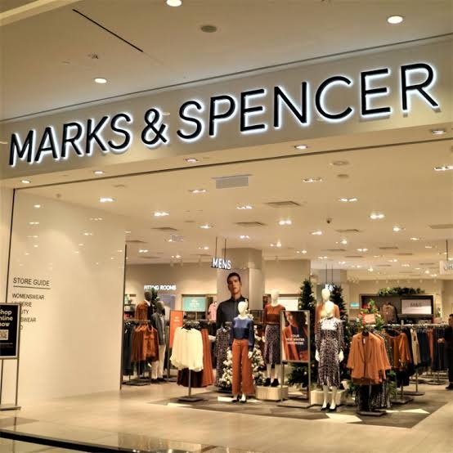
The struggle M&S is having to attract younger customers is another issue. Although the company has made an effort to appeal to younger customers with more contemporary clothing lines, the brand has long been associated with an older demographic and has not yet had a significant impact. M&S has a number of strengths that it can build on despite these obstacles. One of these is its standing for excellence. M&S has a long history of producing high-quality food and clothing, and it can capitalise on this reputation by continuing to sell high-quality goods and informing customers of this fact.

M&S' dedication to sustainability is another one of its advantages. The business has made significant efforts to lessen its environmental impact and has established challenging goals to do so. Many customers look for this commitment to sustainability in the brands they choose to support, and it can be a strong selling point for M&S. M&S is up against some sizable obstacles in the current retail environment, but it still has a lot going for it. M&S can set itself up for future success by maintaining its focus on quality and sustainability and by figuring out how to appeal to younger customers.
M&S has chosen a multi-segment targeting approach to reach various customer segments with specialised products. The positioning strategy of the business is centred on sustainability and quality, which are values shared by its target market. M&S has been able to stand out in a highly competitive market and maintain a strong brand image by focusing on sustainability and a specific customer base.
The development of Mark & Spencer from a single market stall to one of the most recognisable retail brands in the UK has been a long and fascinating one. Over the years, the company's dedication to innovation, quality, sustainability, and philanthropy has been a major contributor to its success. M&S has demonstrated its adaptability and ability to remain relevant despite having to deal with a number of difficult challenges, such as adjusting to shifting consumer trends and the expansion of e-commerce. M&S is well-positioned to continue to be a mainstay on the UK high street for many years to come thanks to its emphasis on offering top-notch products and first-rate customer service.

References
Jain, P. (2017). Impact of market segmentation on customer satisfaction: A study of retail industry in UK. Journal of Retailing and Consumer Services, 36, 136-142. https://doi.org/10.1016/j.jretconser.2016.12.005
Kotler, P. (1989). From mass marketing to mass customization. Planning Review, 17(3), 4-10. https://doi.org/10.1108/eb054418
Kotler, P. (1989). What is marketing? Harvard Business Review, 67(4), 120-125.
M&S. (2022). About M&S. Retrieved from https://corporate.marksandspencer.com/about
Marks & Spencer. (2022). About us. Retrieved from https://corporate.marksandspencer.com/aboutus.
Marks & Spencer. (2022). Our history. Retrieved from https://corporate.marksandspencer.com/aboutus/ourhistory
Marks & Spencer. (2022). Sustainability. Retrieved from https://corporate.marksandspencer.com/sustainability
McDonald, M. H., & Dunbar, I. (2012). Market segmentation: How to do it, how to profit from it. John Wiley & Sons.
Statista. (2022). Marks & Spencer: Retail sales worldwide from 2015 to 2021. Retrieved from https://www.statista.com/statistics/297161/retail-sales-of-marks-and-spencer-worldwide/
The Guardian. (2017, May 3). Marks & Spencer: a brief history.

