DEVELOPING PROFESSIONAL PRACTICE
NAME: RHIAN CERYS PARKER
STUDENT NUMBER: 1707451
CIPD MEMBERSHIP NUMBER : 48759195
DATE: 14 NOVEMBER 2017

CIPD INTERMEDIATE CERTIFICATE
IN HUMAN RESOURCES MANAGEMENT LEVEL 5

I declare that this assignment is my own work and that any information obtained from books and other sources have been appropriately referenced.

Signed : R C Parker Date 14/11/2017
Contents
1. ACTIVITY 1 4
1.1 What is a HR Professional 4
1.2 CIPD Professions Map 5
2. ACTIVITY . 6
2.1 What is conflict and group dynamics 6
2.2 Conflict resolution 8
3. ACTIVITY 3-PROJECT MANAGEMENT 10
3.1 Organisational change 10
4. ACTIVITY 4 11
4.1 Self assessment 11
4.2 Personal Development Plan (PDP) 12
4.3 Learning Styles 13
4.4 Reflective Practice 16
REFERENCES 17

ACTIVITY 1

1.1 What is a HR Professional

A HR Professional can be interpreted in different ways by people. Is it a profession or is it a behaviour? Being a professional can relate to all aspects of our professional lives. Being a professional requires a person to examine how they conduct themselves in the workplace, when managing people in the workplace; and a professional would be expected to develop the skills and principles required to support this role.

The CIPD published a research report in 2015 entitled From Best to Good Practice: Developing Principles for the profession. The CIPD define professionalism in this report as “professional is an ambiguous, evasive concept. The word ‘professionalism’ is sometimes used narrowly to describe a standard of conduct at work (for example behaving in a ‘professional’ manner). It can also reflect individuals’ own beliefs about their capabilities and status. For example, an individual with a particular knowledge and expertise may be called a ‘professional’ regardless of whether their occupational group is recognised formally as a ‘profession’”. (CIPD, 2015)

Historically being ‘a Professional’ involved a large amount of administrative work and required to carry out a wide range of basic admin tasks such as employment, contracts, payroll, policies and procedures. The role has changed vastly over recent years and the focus of the role has changed. A mix of the two ingredients are considered essential, namely ‘Infrastructure factors’ and ‘Differentiators (Motivators). A difference now observed in the traditional HR role and the contemporary HR function is now ‘summed up’ as ‘Adding Value’” (CIPD, 2016).

Taylor and Woodham state “whether you are a member of a professional body or possess some special expertise is irrelevant. A professional is someone who carries out their job – whatever it is – to a high standard……According to this definition professionalism in HR is not one-dimensional. (CIPD, 2016)

The CIPD have produced a Code of Conduct for CIPD Members (see Appendix A).
These standards are expected to be adhered to for all members of the CIPD, again these contribute to the standards and behaviours expected of ‘HR Professionals’ and must be upheld as set out in the Code of Professional Conduct. (CIPD, 2017)
These obligations are grouped into four areas:
- Professional Competence and Behaviour
- Ethical Standards and Integrity
- Representative of the Profession
- Stewardship.

1.2 CIPD Professions Map

In 2009 the CIPD introduced the CIPD Profession Map. This sets out the standards for HR professionals; the knowledge, behaviours and activities required to become a Hr Professional.

This is a successful tool for all professionals or individuals working towards becoming a professional in order “to meet the standards to define or benchmark their HR capability at individual, team, function and organisational levels. (CIPD, 2017)
The CIPD Profession Map captures the knowledge and behaviours that HR and L&D professionals need to demonstrate in order to meet our requirements for professional membership.
The map defines the building blocks of effective people management practice across ten professional specialisms, and describes eight fundamental behaviours that underpin good practice regardless of specialism.
The Map is flexible, so you can choose what to focus on depending on your area of work, the level of accountability you have in your role, and your career develop.
The CIPD Profession Map includes 10 professional areas, eight behaviours and found bands (see Fig 1)
Professional Areas –
Describes what activities are required and what you need to know for each area of the HR profession at four bands of professional competence.
Behaviours -
Describes behaviours and HR professionals need to carry out activities. Each behaviour is described across four bands of professional competence.
Bands and transitions –
Describes the four bands of professional competence and the transition challenges faced when moving from one bad to the next. How their contribution and success is measured.

Fig. 1 – CIPD Profession Map

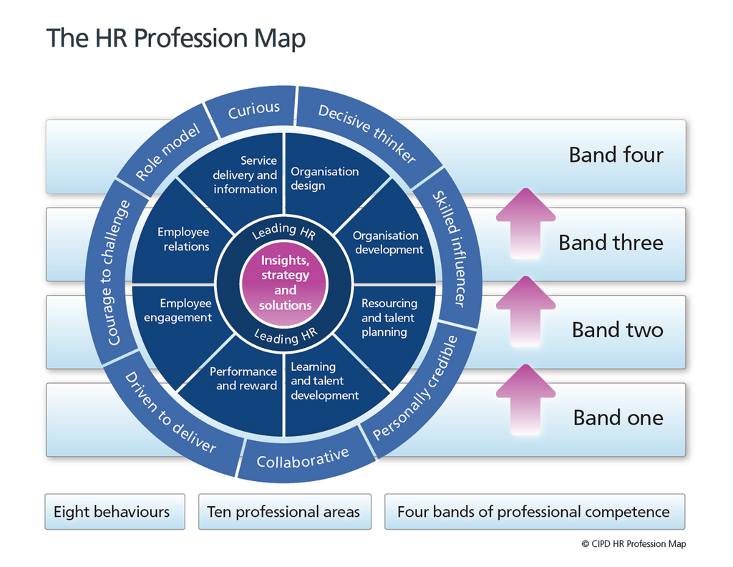

2. ACTIVITY .

2.1 What is conflict and group dynamics
Conflict can be described as :

- to come into collision or disagreement; be contradictory, at variance, or in opposition; clash; to fight or contend; do battle. (verb)
- a fight, battle, or struggle, especially a prolonged struggle; strife; controversy; quarrel: conflicts between parties; discord d of action, feeling, or effect; antagonism or opposition, of interests or principles: (DICTIONARY.COM, n.d.)
Conflict can be considered as a positive or negative process. It is likely that most people will experience some form on conflict in the workplace. Conflict is a difference of ideas or opinions. In a team consisting of people from different backgrounds and with different skills and experience, it is likely that you will experience some form of conflict. (www.dlsweb.rmit.edu.au, 2017).
The dynamics of a group of individuals can depend on the behaviours of individuals and how they interact or influence others within the group, or if a member is added in or taken away from the group, this can lead to conflict.
Negative and positive conflict:

Positive Conflict: |  | A difference of ideas or opinions can be very productive in a team environment. It can encourage creative solutions to problems and generate innovation, variety and increased communication.  Positive conflict can also clear the air between team members, raise issues for clarification and resolution and improve relationships.

Negative Conflict: |  | In some instances varied opinions are not productive. This is generally because the conflict is not communicated and dealt with appropriately.  When conflict is handled ineffectively it may result in:  - Team members becoming frustrated  - Competition between team members and the development of a win-lose environment  - Increased stress levels and low morale  - Low levels of job satisfaction and increased staff turnover
The single most common contributor to conflict is differences in personality or styles of working, supporting a relational view of conflict.’ (CIPD, 2015)
The CIPD also recognise the benefits of resolving conflict (CIPD, 2008)
- Almost a third of respondents report that training in conflict management has led to a reduction in the number of disciplinary and grievance cases, 28% think there has been an improvement in employee morale and 25% believe there has been an increase in team performance and productivity.
- In all, 13% of HR practitioners say conflict management training has helped reduce employee absence levels, 12% have seen a reduction in employment tribunal claims and 10% report a reduction in employee turnover.
- \potential gain in their organisation as a result of more effective management of conflict, followed by higher employee engagement at 30% and improved productivity and greater internal efficiency at 12%.

It is clearly recognised that conflict management and resolution should be addressed. It is important that organisations ensure they have robust systems in place to manage conflict. Taylor and Woodhams state “line managers are at the heart of most workplace conflict, whether causing it, experiencing it, dealing with it or coping with its consequences.” (CIPD, 2016)

2.2 Conflict resolution
Conflict resolution can be managed in a number of ways. Two forms of conflict resolution are:
- The interest based Relational Approach
- Mediation
The Interest-Based Relational Approach
There are other benefits that you might not expect, such as:
- Increased understanding.
- Better group cohesion.
- Improved self-knowledge.

To use the IBR approach effectively, everyone involved should practice active listening, empathy, have a good understanding of body language, be emotionally intelligent and employ anger management techniques. All those involved will need to follow the six steps:

- Make sure that good relationships are a priority.
- Separate people from problems.
- Listen carefully to different interests.
- Listen first, talk second.
- Set out the "facts."
- Explore options together.
.
The IBR approach may not be appropriate for all situations. For example, you may not be able to resolve differences in such a consensual, collaborative way if your organization is in a crisis. On these occasions, you may have to "pull rank" as a leader and make quick decisions about disputes and conflicts. (WWW.MINDTOOLS.COM.)
Mediation

Mediation is considered an impartial process to help team members resolve disagreements, ease workplace tensions, disagreements before they escalate. Mediation differs from disciplinary and grievance procedures by offering a more informal and flexible approach.

I feel that the above approaches can be implemented in my workplace due to the current issues experienced are mainly based around staff, personalities and often a clash of personalities. The above methods can be applied and will ensure that staff involved will take on board other individual feelings and by taking this on board can resolve the situation by finding solutions amongst them to avoid the situation further escalating.

ACTIVITY 3-PROJECT MANAGEMENT
  - Organisational change
Factors that cause organisational change The following factors are relevant to a project that involved transformational change in my workplace during September 2017.
- challenges of growth
- changes in strategy
- competitive pressures, including mergers and acquisitions
- learning new organisation behaviours and skills
- employment relationship and fundamentally changing the way businesses operate. In order to remain competitive in such a climate of uncertainty, agility has become a business priority.
CIPD Factsheet state “managers have to be able to introduce and manage change to ensure the organisational objectives of change are met, and that they gain the commitment of their people, both during and after implementation. Often, at the same time, they also have to ensure that business continues as usual.
Failure to introduce effective change can have a high impact: loss of market position, removal of senior management, loss of stakeholder credibility, loss of key employees, and reduction in employee engagement.
One organisational response to change is that organisational forms are themselves evolving. Therefore, the change management response will have to be adaptive. For example, the increased competitive challenges and the need to be responsive to the changing environment are resulting in emerging organisational models. Traditional organisational models following functional or matrix lines are being supplemented by new models that rely on project teams, on networks and on virtual structures.
In theory, some of these newer models, for example virtual and project-based structures, allow increased flexibility to respond to change. However such models are not always introduced uniformly, and in practice often introduce other issues that also impact upon change management, for example ability to share knowledge and to operate efficiently. These may also impact effectiveness of communication or employee commitment, which themselves have implications for change effectiveness (CIPD, 2017)
3.1 The transition process
High levels of trust between Management and employees are required to ensure this the transition is an efficient process with minimal conflict.
Change is considered an emotional process for all involved and those leading the to bring about the change must be aware of this and plan for the reactions of those affected, this will also ensure high levels of momentum throughout the process.
I have recently been involved in a project in my workplace with a decision was made to ‘split’ staff teams into areas and regions in order for the individual staff teams to be based within specific localities. The staff team involved approximately 40 staff members working from one base and providing a service to region across Swansea, Neath, Port Talbot and Carmarthenshire. Due to distance of the area covered and travel time implications, a decision was made by the Directors to ‘split’ the team into two. This would then result in two smaller staff teams, less travel to work and providing services within a smaller locality thus reducing travel time to work, distance covered across the working day, direct support from line manager and one to one mentoring between staff members and management.
As part of this process of decision making regarding staffing and relocation of staffing made by myself and other Managers and Directors within the organisation met on 3 or 4 occasions to discuss the process involved (staffing requirements, practicalities of implementing the processes; communication methods, timescales). The decision made by the Managers was a difficult decision as it was recognised amongst us that staff involved will be resistant and the following problems were encountered:

- Staff negativity
- Apprehension
- Fear of change
- Conflict

Agreement was made around the how the changes were communicated to staff. I was involved with meeting with staff individually, discussing any concerns and reinforcing that the decisions were made in the best interests of staff taking into account their preferences of travel to work area, staff skills and needs of the service users to which the services are delivered within the regions. On balance although there was some anxiety and concerns raised by staff members involved this provided to be a positive experience, which involved one to one discussions with staff and on occasions negotiating skills to persuade staff involved.

4. ACTIVITY 4

4.1 Self assessment
My role as a Manager to support a number of teams within the Company that I work, requires me to support individual staff and Managers of teams in basic areas of HR and training requirements, in addition to policies and procedures and ensuring effective service delivery. This role also requires myself to develop my skills and knowledge in Hr, employment law, service delivery, conflict management. I have identified two main areas that I would like to further progress and develop my expertise as follows:
- Employee relations
- Service delivery and information
I undertook a self assessment of areas of my practice in order that I can identify areas of my professional development needs and identify any gaps and further areas of development that are required for me to progress across the bands. I currently identify myself as being in band 1 and practicing as a ‘Technician1. I require some development in my behaviours and skills so that I can transition across into band 2 to further enhance my knowledge and skills required to transition further across the bands in the future (Band 1 to 4). (CIPD, 2017)

4.2 Personal Development Plan (PDP)
The outcome of this assessment identified areas for development within my Professional Development Plan (PDP). Some of the areas identified for development, which I have included in my PDP are:
Employee Relations

- Current employment law (with in-depth specialist knowledge where appropriate)
- Maintaining accurate and up-to-date documentation, information and records, in line with legislation
- Monitoring HR activity to ensure it complies with employee relations plans and legislation
- Providing accurate and appropriate advice and information about employee relations policies and practices
- Working with managers and employees to ensure they are adhering to the organisation’s values and behaviours in everyday
- practice
- Giving advice, training and support to individuals and managers to encourage a positive work environment
- Key employee relations issues
- Methods for communicating employee policies and procedures
To meet the requirements and develop the areas identified on my PDP, I will undertake the following:
- Weekly mentoring sessions with HR Manager/team to further my knowledge and professional practice
- Attend CPD Events
- Complete my CIPD Level 5, HR in the workplace
- Weekly meetings and mentoring sessions with staff members and managers
- Familiarise myself with the policies and procedures of my organisation
- Mentoring sessions with Managing Director
- Attendance at weekly Manager and Directors meeting to ensure compliance with the service delivery requirements of the Company.

4.3 Learning Styles
I completed the Learning Style Questionnaire revised by Honey & Mumford,. Following completion of the Honey and Mumford Learning styles questionnaire, it was identified that my strong preference for my learning style is a Pragmatist; I was also identified as a moderate preference to the style of a Theorist and very low preferences to the learning styles of an activist and Reflector. (Honey & Mumford, 1982). Due to my learning style identified I feel the methods chosen to meet the aims and objectives within my PDP I feel they are realistic and achievable aims to be met in line with the learning styles identified.
The characteristics of the four learning styles are summarised in the following table (Fig 2).
Fig 2 Honey and Mumford Learning styles and attributes below:
Learning style | Attributes | Activities
Activist | Activists are those people who learn by doing. Activists need to get their hands dirty, to dive in with both feet first. Have an open-minded approach to learning, involving themselves fully and without bias in new experiences. | - Brainstorming  - problem solving  - group discussion  - puzzles  - competitions  - role-play
Theorist | These learners like to understand the theory behind the actions. They need models, concepts and facts in order to engage in the learning process. Prefer to analyse and synthesise, drawing new information into a systematic and logical 'theory'. | - Models  - statistics  - stories  - quotes  - background information  - applying theories
Pragmatist | These people need to be able to see how to put the learning into practice in the real world. Abstract concepts and games are of limited use unless they can see a way to put the ideas into action in their lives. Experimenters, trying out new ideas, theories and techniques to see if they work. | - time to think about how to apply learning in reality  - case studies  - problem solving  - discussion
Reflector | These people learn by observing and thinking about what happened. They may avoid leaping in and prefer to watch from the sidelines. Prefer to stand back and view experiences from a number of different perspectives, collecting data and taking the time to work towards an appropriate conclusion. | - paired discussions  - self analysis questionnaires  - personality questionnaires  - time out  - observing activities  - feedback from others  - coaching  - interviews
Original definitions
Honey and Mumford's original definitions are as follows.
Learning style | Honey and Mumford definition
Activist | Activists involve themselves fully and without bias in new experiences. They enjoy the here and now, and are happy to be dominated by immediate experiences. They are open-minded, not sceptical, and this tends to make them enthusiastic about anything new. Their philosophy is: "I'll try anything once". They tend to act first and consider the consequences afterwards. Their days are filled with activity. They tackle problems by brainstorming. As soon as the excitement from one activity has died down they are busy looking for the next. They tend to thrive on the challenge of new experiences but are bored with implementation and longer term consolidation. They are gregarious people constantly involving themselves with others but, in doing so, they seek to centre all activities around themselves.
Theorist | Theorists adapt and integrate observations into complex but logically sound theories. They think problems through in a vertical, step-by-step logical way. They assimilate disparate facts into coherent theories. They tend to be perfectionists who won't rest easy until things are tidy and fit into a rational scheme. They like to analyse and synthesize. They are keen on basic assumptions, principles, theories models and systems thinking. Their philosophy prizes rationality and logic. "If its logical its good." Questions they frequently ask are: "Does it make sense?" "How does this fit with that?" "What are the basic assumptions?" They tend to be detached, analytical and dedicated to rational objectivity rather than anything subjective or ambiguous. Their approach to problems is consistently logical. This is their 'mental set' and they rigidly reject anything that doesn't fit with it. They prefer to maximise certainty and feel uncomfortable with subjective judgements, lateral thinking and anything flippant.
Pragmatist | Pragmatists are keen on trying out ideas, theories and techniques to see if they work in practice. They positively search out new ideas and take the first opportunity to experiment with applications. They are the sort of people who return from courses brimming with new ideas that they want to try out in practice. They like to get on with things and act quickly and confidently on ideas that attract them. They tend to be impatient with ruminating and open-ended discussions. They are essentially practical, down to earth people who like making practical decisions and solving problems. They respond to problems and opportunities 'as a challenge'. Their philosophy is "There is always a better way" and "If it works it's good".

4.4 Reflective Practice
In order for me to develop the required areas have been identified in my PDP. I must ensure that I assess the methods identified and implement within the timescales specified. I will ensure that I meet with the mentors within the departments as specified, mentoring sessions with Managers and Directors. I will also meet with staff members as required and seek to maintain good communication links and seek to address issues raised by the staff members involved and seek to resolve any issues of conflict.
My learning needs identify areas where I will be spending time with staff, managers and mentors. During this time I can reflect on the methods that I have previously adopted and learn new ideas shared by others from their own experiences and practices. I can also research practices adopted by others outside of the organisations, access sources of information offered by CIPD and government legislation. I will also need to consider the framework set by Government departments (CSSIW, Social Care Wales).
I do not forsee any significant barriers ahead to progress with by PDP. The organisation that I work within are supportive of employees. Some cost implications may need to be considered for specific training and education requirements, however this has already been identified and met due to my current attendance on the CIPD Level 5 HR in the workplace course.
Mentoring sessions with Directors and Managers will have a smaller cost implication due to the impact on my time spent with individuals. However this is considered as part of my role to further enhance my knowledge and skills and underpins the values of the HR Department within the Company. We have identified a need to develop the HR Department within the workplace and my PDP should further support in this area providing that I can meet the objectives set within this PDP. My organisation has identified the need to improve the area of employee relations and service delivery, meeting the challenges ahead of me as set out in my PDP should also underpins the aims of the organisation.

REFERENCES
CIPD, 2008. Leadership and the Management of Conflict at work, LONDON: CIPD.
CIPD, 2015. FROM BEST TO GOOD PRACTICE RACTICE : DEVELOPING PRINCIPLES FOR THE RROFESSION, LONDON: CIPD.
CIPD, 2015. WORKPLACE CONFLICT : EMPLOYEE EXPERIENCES, LONDON: CIPD.
CIPD, 2016. HUMAN RESOURCE MANAGEMENT: PEOPLE AND ORGANISATIONS. 2ND ed. LONDON: CIPD.
CIPD, 2016. STUDYING HUMAN RESOURCE MANAGMENT. 2ND EDITION ed. LONDON: CIPD.
CIPD, 2017. CHANGE MANAGEMENT LEARN HOW TO MANAGE AND SUPPORT CHANGE MANAGEMENT INITIATIVES EFFECITVELY. [Online].
CIPD, 2017. CODE OF PROFESSIONAL CONDUCT. [Online]
Available at: https://www.cipd.co.uk/about/what-we-do/professional-standards/code
[Accessed 14 NOVEMBER 2017].
CIPD, 2017. The CIPD Profession Map. [Online]
Available at: https://www.cipd.co.uk/learn/career/profession-map
[Accessed 14th November 2017].
CIPD, n.d. Using the Professions Map A guide. [Online]
Available at: https://whttps://www.cipd.co.uk/learn/career/profession-map/user-gude
[Accessed 14th November November 2017].
DICTIONARY.COM, n.d. DICTIONARY.COM. [Online]
Available at: http://www.dictionary.com/browse/conflict
Honey, P. & Mumford, A., 1982. Manual of Learning styles. London: P Honey.
WATSON, G; REISSNER, S C, 2014. Developing skills for business ledership. s.l.:CIPD.
www.dlsweb.rmit.edu.au, 2017. What is conflict. [Online]
Available at: https://www.dlsweb.rmit.edu.au/toolbox/leadership/toolbox/rm/rm_c19.html
WWW.MINDTOOLS.COM, n.d. Managing conflict Using the "Interest-Based Relational" Approach. [Online]
Available at: https://www.mindtools.com/pages/article/newLDR_81.htm
[Accessed November 2017].

APPENDIX A – CIPD CODE OF CONDUCT

