Programme: Master of Business Administration
Module: Strategic Management
Module code: LCMB7003
Module tutor: Dr Robert Ejike Udeogu

Assignment Title: Strategic Analysis of Netflix

Student name: Florina Maria Vlad
Student ID number: 2227241

AI Acknowledgement
I acknowledge the use of the AI tool (Grammarly) to find any grammatical mistakes in my report from 22nd June 2026 to 24th June 2026 with the following prompt.
- Please look through my paper and find any grammatical mistakes that can be observed.
However, I confirm that no AI-generated text is incorporated throughout the report, and I have properly cited all sources.

Executive Summary
This report assesses Netflix's strategic position in the UK streaming market and outlines appropriate strategies for maintaining competitive advantage in a growing and competitive streaming market. The external analysis showed that technological innovation, evolving consumption habits and the development of digital entertainment offer opportunities, while the high level of competition, market saturation and the increasing costs of content pose a threat to profitability. PESTEL and Porter's Five Forces analyses showed that the industry is not attractive due to competitive pressures and low switching costs. The internal analysis revealed that Netflix's recommendation algorithms, data analytics capabilities, original content development and brand reputation are important sources of competitive advantage. The Resource-Based View and VRIN framework showed that these intangible resources offer sustainable advantages, and value chain analysis revealed that technology development and operations are two value-creating activities. The main challenge that Netflix is facing is the growth constraint in traditional streaming services. Therefore, the following report calls for an interactive entertainment ecosystem combining streaming and games. The strategy is likely to be implemented by leveraging Netflix's technological strengths and flexible resources, as well as by utilising the Ansoff Matrix and the SAFe evaluation.
Table of Contents
Executive Summary 2
List of Figures 5
List of Tables 5
Section 1: Report 6
1.1 Introduction 6
1.2 Organisational Context and Overview 7
1.3 External Environment Analysis 10
1.3.1 PESTEL Analysis 10
1.3.2 Industry Environment Analysis 11
1.3.3 Porter's Five Forces Analysis 12
1.3.4 External Strategic Implications 13
1.4 Internal Environment Analysis 14
1.4.1 Resource Analysis 14
1.4.2 Capabilities and Core Competencies 15
1.4.3 VRIN Analysis 15
1.4.4 Dynamic capabilities 16
1.4.5 Value Chain Analysis 17
1.4.6 Benchmarking Analysis 17
1.4.7 Internal Strategic Implications 18
1.5 SWOT synthesis and strategic position 19
1.6 Comprehensive and Holistic Organisational Evaluation 21
1.6.1 CSR and Sustainability Strategy 21
1.6.2 Balanced Scorecard Analysis 22
1.7 Strategic Choices and Strategic Implementation 24
1.7.1 Current Business-Level Strategy 24
1.7.2 Strategic Options Available 24
1.7.3 Ansoff Matrix Evaluation 25
1.7.4 SAFe Evaluation 26
1.7.5 Recommended Strategy and Implementation Plan 27
1.7.6 Implementation Challenges 28
1.7.7 Change Management and Risk Mitigation 29
1.8 Conclusion 30
Section 2: Reflective Account 31
References 34
Appendices 39
Appendix A: Extracts from Netflix’s Sustainability and ESG Disclosures 39

List of Figures
Figure 1: Business model canvas of Netflix (Author, 2026) 8
Figure 2: SWOT Analysis of Netflix UK (Author, 2026) 19
Figure 3: Strategic Options Available for Netflix UK (Author, 2026) 24
Figure 4: Ansoff Matrix for Netflix UK Strategic Options (Author, 2026) 25
Figure 5: SAFe Evaluation of the Interactive Entertainment Ecosystem Strategy (Author, 2026) 26
Figure 6: Gibbs' Reflective Cycle (Praveena et al., 2025) 31

List of Tables
Table 1: Competitor Comparison in the UK Streaming Market (Author, 2026) 9
Table 2: PESTEL Analysis Netflix UK (Author, 2026) 11
Table 3: Porter's Five Forces Analysis of Netflix UK (Author, 2026) 12
Table 4: Resource Analysis (Author, 2026) 15
Table 5: VRIN Analysis (Author, 2026) 16
Table 6: Benchmarking Analysis (Author, 2026) 17
Table 7: Netflix Balanced Scorecard Framework (Author, 2026) 23
Table 8: Strategic Implementation Roadmap for the Interactive Entertainment Ecosystem (Author, 2026) 28

Section 1: Report

1.1 Introduction
This report is a strategic analysis of Netflix in the UK streaming industry as a management consultant. Strategic management is a process that can help an organisation attain sustainable competitive advantage by matching its internal resources and capabilities with external opportunities and threats in a dynamic and hypercompetitive environment (Hitt et al., 2024). The report, therefore, assesses Netflix's strategic position and long-term competitiveness. Uses PESTEL, Porter's Five Forces, VRIN, SWOT and Value Chain analysis to evaluate the external and internal environment. The Balanced Scorecard is used to measure organisational performance, and the Ansoff Matrix and SAFe analysis are used to measure strategic alternatives and recommendations. Challenges and implementation measures are also identified in the report. The following sections discuss the organisational context, strategic evaluation and recommendations for implementation in order to sustain Netflix's competitive position in the UK streaming market.

1.2 Organisational Context and Overview
Netflix was started in 1997 as a DVD-by-mail rental company but evolved through a succession of innovations that have strategic value to become the most successful subscription video-on-demand (SVOD) platform in the world (Zhang, 2024). When the firm switched to streaming in 2007, an audacious act to respond to technological change and the change in consumer preferences, it was a disruptive one, and its decision to invest further in its original content decreased reliance on third-party studios and enhanced differentiation. In the more recent past, Netflix has ventured into gaming, which is an indication of an effort to use existing technologies and content resources to develop new growth opportunities and stop depending on subscriptions as the sole money source (Gürer et al., 2025).
Roblek and Meško (2018) explain that a vision is a description of what an organisation wants to be like in the future, and a mission is how it is going to achieve it and the markets that it will serve. Strategic choices have been made primarily based on the vision of Netflix to be the most popular entertainment service in the world and the mission to entertain people all over the world with ease and accessibility to a variety of content. The strategic actions and the organisational purpose are consistent in investments in original products, artificial intelligence-based personalisation, and internationalisation (Netflix, 2025; Macdonald et al., 2026). Nevertheless, as the pressure to generate more profit by raising prices and advertising-based subscriptions mounts, the long-term equilibrium between the interests of shareholders and the value of customers will be questioned, which may result in possible conflicts between the groups of stakeholders.
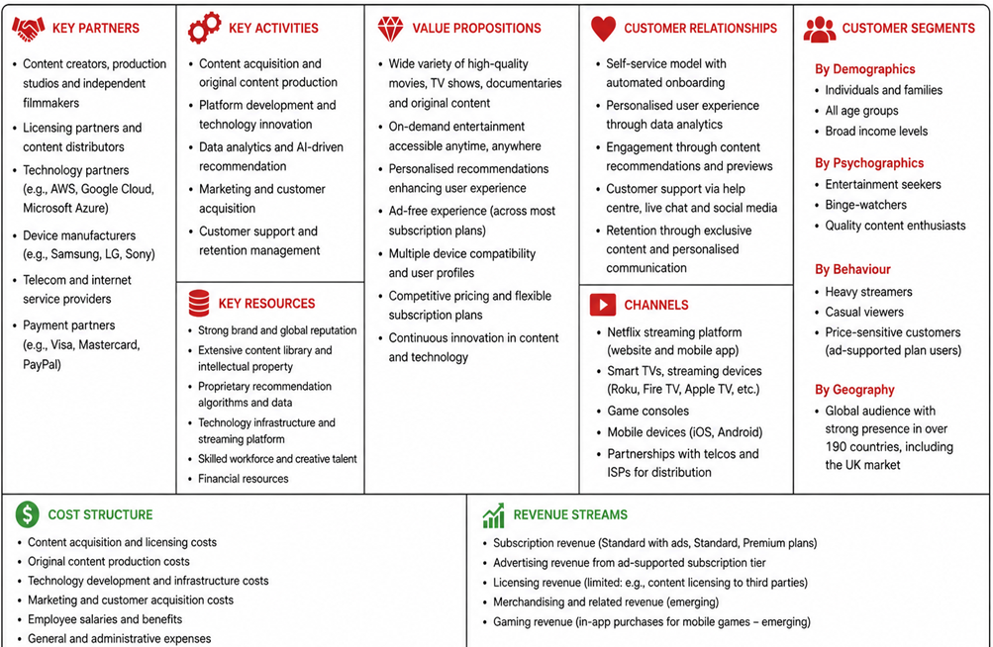
Figure 1: Business model canvas of Netflix (Author, 2026)
The business model of Netflix is focused on providing personalised entertainment based on subscription and advertising income. The convenience, exclusive content and algorithm-driven recommendations form its value proposition and are enhanced by core resources such as proprietary data, brand equity, and content libraries. Scalability is achieved through strategic alliances with production studios, telecommunications providers and technology companies. However, content cost inflation and the growing competition are also posing a threat to the sustainability of that model, forcing it to constantly innovate to keep a competitive advantage (Johnson et al., 2023).
Competitor | Key Strength | Strategic Position
Netflix | Original content, personalisation | Market leader
Disney+ | Strong franchises (Marvel, Disney) | Major challenger
Amazon Prime Video | Ecosystem integration | Diversified competitor
Apple TV+ | Premium original content | Niche premium player
BBC iPlayer | Free UK public content | Domestic substitute
Table 1: Competitor Comparison in the UK Streaming Market (Author, 2026)
The UK streaming market is established but still has average growth, led by the shift in viewing patterns and online consumption trends. Rivalry in the industry has been enhanced by competition with Disney+, Amazon Prime Video, Apple TV+ and BBC iPlayer (Jenei et al., 2025). Netflix has been able to sustain a top position in the market despite these pressures thanks to its vast content offering, established brand recognition and sophisticated recommendation system, though it will have to continue to adapt to market changes to maintain that status.

1.3 External Environment Analysis
Through external environment analysis, such as PESTEL and Porter's Five Forces, organisations can gain insight into opportunities and threats that affect their strategic competitiveness and long-term performance. Macro-environmental and industry-specific factors are critical to understanding market dynamics, the attractiveness of the industry and the impact of external factors on strategic decision-making for Netflix UK.

1.3.1 PESTEL Analysis
The political, economic, social, technological, environmental and legal factors are interwoven factors that influence Netflix's external environment in the UK streaming market. Politically, regulators are taking a closer look at digital platforms and content regulation, making it harder to comply with the quickly changing regulations and increasing barriers for smaller players (Kausche and Weiss, 2024). The economic impact of inflation and the cost-of-living crisis has led to greater consumer price sensitivity, driving demand for more affordable subscription pricing (Office for National Statistics, 2026; Ofcom, 2025). But with the advertising-supported tiers, there is a massive opportunity to attract price-sensitive customers as well as provide new revenue streams.
The streaming services remain a popular choice now, as social influences continue to make on-demand or personalised entertainment a preferred choice over traditional broadcast. However, shifting preferences and content fatigue demand ongoing investments in quality programming. The biggest opportunity for Netflix is technological advances. AI, machine learning and sophisticated recommendation engines enhance customer engagement and build user retention (Macdonald et al., 2026). At the same time, technology spreads rapidly, so technological advantages are not sustainable in the long term because they can be imitated by technology competitors over time.
Stakeholders are demanding transparency over the energy usage and carbon emissions of Netflix's streaming infrastructure and data centres, which is driving up environmental pressure (Keilbach, 2025; Netflix, 2023). Sustainability programs can improve the image of a business, but they also raise costs. Compliance with GDPR, IP laws and the ongoing digital content laws is still critical, legally. Non-compliance may lead to financial penalties and damage to reputation.
Factor | Key Issue | Strategic Impact
Political | Digital content regulation | Increases compliance costs but raises entry barriers
Economic | Inflation and cost-of-living pressures | Encourages demand for lower-cost subscription tiers
Social | Shift towards on-demand entertainment | Expands streaming demand and engagement
Technological | AI and recommendation systems | Enhances personalisation and customer retention
Environmental | Sustainability expectations | Improves reputation but increases operational costs
Legal | GDPR and copyright laws | Protects data and content but increases regulatory obligations
Table 2: PESTEL Analysis Netflix UK (Author, 2026)
Notably, the biggest opportunities for Netflix are technological innovation and shifting consumer habits, while the biggest threats are market saturation, regulatory complexity and fierce competition. These factors are crucial from a strategic perspective since they directly impact customer acquisition, retention and long-term profitability.

1.3.2 Industry Environment Analysis
Based on Manjarres Zarate et al. (2025) analysis of the industry, it involves studying aspects that directly impact competitive actions and profitability. The UK streaming industry is moderately growing, highly digital and maturing (PwC, 2024). Structural segments in the market are the premium subscription service providers like Netflix, Disney+ and Apple TV+, the ecosystem-based players such as Amazon Prime Video and the publicly funded players like BBC iPlayer.
The industry is still appealing because of the steady demand of consumers for digital entertainment, but profitability is being increasingly squeezed by increasing production costs for content and by competition. Success is no longer measured based on market growth but rather in terms of achieving differentiation, customer retention and operational efficiency.

1.3.3 Porter's Five Forces Analysis
Porter's Five Forces framework is used to assess the competitiveness of an industry by analysing five structural forces that affect profitability and strategic action (Salam et al., 2025), which can help to understand Netflix's competitive position in the UK streaming market.
Force | Intensity | Strategic Implication
Threat of New Entrants | Low–Moderate | High capital and content investment requirements create entry barriers.
Bargaining Power of Suppliers | Moderate | Content creators and studios possess valuable intellectual property.
Bargaining Power of Buyers | High | Low switching costs enable consumers to move easily between platforms.
Threat of Substitutes | High | Gaming, social media, YouTube and traditional television compete for attention.
Competitive Rivalry | Very High | Disney+, Amazon Prime Video, Apple TV+ and BBC iPlayer intensify competition.
Table 3: Porter's Five Forces Analysis of Netflix UK (Author, 2026)
Threat from new entrants is moderate as capital requirements are high, content acquisition costs are high, and incumbent brands have a strong position. Supplier power is moderate as content creators and production studios have valuable IP, but Netflix's expanding original content binges lessen their reliance on external suppliers.
The power of the buyer is high, as it is easy to switch between streaming services with relatively low switching costs. But the danger of a substitute is also present, as traditional television, gaming platforms, social media and short-form video services battle it out for consumer attention. The competition is fierce, with the major streaming service providers investing heavily in content and engaging in price wars. Industry profit and strategic behaviour are significantly affected by these forces from an Industrial Organisation (I/O) point of view (Hitt et al., 2024). Netflix's competitive advantage is thus built on sustaining its difference by its proprietary content and its strength of brand and data-led personalisation, not just on the attractiveness of the industry.

1.3.4 External Strategic Implications
The external environment indicates that Netflix needs to focus on innovation and diversification to maintain its competitive edge. There is potential to grow into gaming and advertising-supported services due to technological developments and shifting consumption patterns. But competition is growing, and market maturity and content costs are increasing, which poses a risk to profitability. Thus, Netflix's strategy should focus on differentiation, customer retention, and ecosystem expansion, not just on subscriber growth. This supports the argument of Abdeen et al. (2025) that firms need to match their strategic decisions with external opportunities and threats in order to be competitive in the long run.

1.4 Internal Environment Analysis
An internal analysis helps companies discover their resources, capabilities, and core competencies that form the basis for sustainable competitive advantage. The Resource-Based View (RBV) suggests that the key to achieving superior performance lies in the ability to own and effectively utilise valuable resources that are difficult for competitors to replicate (Mailani et al., 2024). Hence, it is crucial to analyse Netflix's internal environment to gain insights into its strategic capabilities and future competitiveness.

1.4.1 Resource Analysis
Netflix has a number of tangible and intangible resources that can help create value. With financial resources like healthy cash flows and significant market capitalisation, it can invest in original content and technological advancements continuously. However, these resources are only at competitive parity, as there are other companies like Disney and Amazon that have similar financial resources. Strategic agility is supported by organisational resources such as a global structure, managerial know-how, and a data-driven culture (Johnson et al., 2023). The physical resources are cloud infrastructure, data centres and production facilities, and the technological resources are proprietary algorithms for recommendations and streaming architecture.
Most importantly, Netflix's intangible resources are the key sources of competitive advantage. Human resources involving engineers, data scientists, and creative professionals enhance innovation and adaptability. Artificial Intelligence capabilities, original content development, and gaming expansion boost differentiation. Moreover, a good brand reputation and customer trust further solidify market leadership. Intangible assets are harder to replicate than tangible resources, and thus offer more strategic value (Adedoyin et al., 2026).
Resource Type | Examples | Strategic Significance
Financial | Cash flows, investments | Competitive parity
Organisational | Culture, management | Valuable capability
Physical | Infrastructure | Temporary advantage
Technological | Algorithms, platform | Strong advantage
Human | Engineers, creatives | Sustainable advantage
Innovation | Original content | Sustainable advantage
Reputation | Brand image | Sustainable advantage
Table 4: Resource Analysis (Author, 2026)

1.4.2 Capabilities and Core Competencies
RBV suggests that resources gain strategic importance when combined with organisational capabilities (Mailani et al., 2024). One of the most significant features of Netflix is its recommendation system, which helps to improve customer engagement and retention by delivering personalised recommendations. Data Analytics enables data-driven investment decisions and better content performance (Rahman, 2025). Original content development has lessened reliance on outside studios and increased differentiation. Furthermore, platform management can lead to operational efficiency and scalability. All these capabilities are the essence of Netflix, and they directly add to customer value.

1.4.3 VRIN Analysis
The VRIN framework is used to assess the value, rarity, difficulty of imitation, and non-substitutability of resources (Barney, 1991). Netflix's funds are useful, but not uncommon, as others are similarly well-financed. These resources, therefore, offer competitive parity and do not give them a sustainable competitive advantage. Even though financial resources only create competitive parity, the combination of technological savvy, user data and organisational learning structures by Netflix generates the resources that are valuable, rare and hard to copy. Thus, the integrated data, personalisation and organisational-learning capabilities of Netflix could offer more lasting benefits, and original content could offer a more transient benefit because other companies can also invest a lot of money in exclusive production (Cui, 2024; Hsiao, 2024).
Table 5: VRIN Analysis (Author, 2026)

1.4.4 Dynamic capabilities
Dynamic capabilities are the capacity of an organisation to reconfigure resources and adjust to the changing environment (Cavusgil and Deligonul, 2024). Netflix's launch of advertising-supported subscriptions is a good example of the company's dynamic capabilities, as it broadens its revenue streams and caters to the price sensitivity of consumers. The company's move into gaming is a sign of its efforts to build a gaming ecosystem outside of video streaming (Gürer et al., 2025). Likewise, AI-driven investments boost customisation and efficiency. The strategic efforts highlight Netflix's ability to adapt and stay competitive in a rapidly changing industry.

1.4.5 Value Chain Analysis
Porter's Value Chain framework is a way of dividing organisational activities into primary and support activities to allow identification of where cost advantage or differentiation is gained (Porter, 1985). The main activities for Netflix are content acquisition and production, platform management, digital distribution, marketing and customer service. Support activities include organisational infrastructure, human-resource management, technology development and procurement.

1.4.6 Benchmarking Analysis
Benchmarking involves comparing the capabilities of Netflix with key competitors and their performance. It involves content analysis and recommendation systems, ecosystem integration, brand strength and data analytics analysis that helps to understand the advantages, weaknesses and strategic gaps more clearly.
Table 6: Benchmarking Analysis (Author, 2026)
Table 6 shows that in recommendation systems, data analytics, etc., Netflix has a better performance in providing the best personalisation and content decisions. But Disney+ has more to play with in terms of its franchise, while Prime Video boasts more assets from Amazon's vast ecosystem. This is not a complete victory for Netflix, as it could be hard to maintain without spending on content. The company should, therefore, further the integration of the ecosystem through partnerships, selective acquisitions and interactive services. These actions could help close capability gaps, diversify revenue and enhance customer retention, but also present a high level of investment, integration and execution risk (Cui, 2024; Netflix, 2025; Hsiao, 2024).

1.4.7 Internal Strategic Implications
Netflix's core internal assets are its recommendation algorithms, data analytics, brand and ability to redefine its digital capabilities. These resources enable personalisation, scalability and customer engagement. Netflix, however, doesn't have the ecosystem integration that Amazon has, and the franchise ownership that Disney has. Its internal standing thus is conducive to expansion into interactive entertainment, but it will take more expertise in the gaming industry, IP and outside partnerships. The internal analysis thus leads to related diversification as opposed to immediate diversification into totally unrelated industries.

1.5 SWOT synthesis and strategic position
The external and internal analysis indicates that Netflix has a favourable position in the UK market, with its intangible assets, innovation capabilities, and resources that enable it to differentiate itself from competitors and make it difficult to imitate (Barney, 1991; Netflix, 2025). The opportunities to diversify revenues and meet shifting consumer preferences include the rise of digital consumption, AI, and advertising-supported streaming and gaming (Gürer et al., 2025; Gao et al., 2023). But high competition, market maturity, regulatory pressure and the rising costs of content are still limiting profitability, subscriber growth and the exclusive content-based advantage in general.

Figure 2: SWOT Analysis of Netflix UK (Author, 2026)
Data-driven personalisation, brand reputation and adaptive innovation are more important for Netflix's advantage than industry attractiveness, as shown in Figure 2. However, these strengths do not negate its vulnerability to low switching costs, strong competition and subscription dependency, which can limit strategic flexibility (Chalaby, 2024). The company should therefore look for related diversification beyond traditional streaming – gaming, advertising and ecosystem partnerships. A phased approach would give Netflix the opportunity to leverage existing capabilities while minimising investment risk, testing customer acceptance and filling capability gaps.

1.6 Comprehensive and Holistic Organisational Evaluation

1.6.1 CSR and Sustainability Strategy
CSR has gone beyond philanthropy and become a strategy for value creation for stakeholders and legitimacy for the organisation. The Stakeholder Theory suggests that in strategic decision-making, organisations ought to take into account the interests of various stakeholders like customers, employees, shareholders, suppliers and society (Freeman, 1984). The Triple Bottom Line also examines the performance of an organisation in economic, social and environmental terms (Elkington, 1997).
However, the energy use of content creation, cloud infrastructure, data transfer, and customer devices still poses environmental problems for streaming companies (Keilbach, 2025; Netflix, 2024). Sustainability efforts, therefore, improve the sense of legitimacy but offer little direct competitive benefit.
Socially, Netflix is promoting diversity, inclusion and employee well-being with its content strategy and organisational policies. Its paid-sharing features and subscription-price changes, though, show a conflict between revenue and value to the customer. While these efforts are geared toward monetisation, they can also impact customer perceptions of affordability and fairness (Netflix, 2025).
Transparent reporting and board oversight help to build investor confidence and organisational stability from a governance standpoint (Chitraju, 2025). But there can be conflicts between the interests of shareholders and other stakeholders when it comes to maximising shareholder returns. The tensions illustrate the compromises that exist in an environmental, social and governance agenda.
More importantly, Netflix's CSR programs are aligned with its mission and are enhancing its reputational capital. However, ESG agendas often clash with profit motives, indicating that sustainability is more of a supporting role than a driver. Long-term value creation, therefore, needs to be enhanced by embedding environmental and social goals in corporate strategy, not just for reputation and compliance purposes.

1.6.2 Balanced Scorecard Analysis
Financial measures are not enough to measure organisational performance (Hajji, Chtaoui and Bouhmala, 2025). The Balanced Scorecard is a tool that combines financial and non-financial indicators to ensure that the operations are aligned with the strategic goals (Kaplan and Norton, 1992).
Netflix's financial objective is to grow revenue and boost profitability (Netflix, 2025). Industry metrics such as revenue growth rates, operating margins and subscriber growth are key, with efforts like advertising-supported subscriptions and gaming expansion to support these metrics.
Customer perspective is about improving customer satisfaction and customer retention (Kaplan and Norton, 1992). Subscriber growth, engagement, and churn rates are among the performance metrics. Investments in original content and personalised recommendations are essential activities to achieve these goals.
As far as internal business processes, Netflix is looking to make content production more efficient and effective. Some of the main factors are content release frequency, streaming reliability and platform performance. AI and data analytics investments boost process efficiency and customer experience (Akter et al., 2025).
The learning and growth perspective emphasises innovation and organisational capabilities. For example, specialist employee development, investment in innovation, and new-product capabilities are indicators of whether Netflix has the knowledge and resources necessary for future growth (Kaplan and Norton, 1992). Artificial Intelligence adoption, Gaming development and talent acquisition are strategic initiatives.
Perspective | Objectives | KPIs | Targets | Initiatives
Financial | Enhance profitability | Revenue growth, operating margin | Sustainable growth | Advertising tier, gaming expansion
Customer | Improve retention | Churn rate, engagement | Higher loyalty | Original content, personalisation
Internal Process | Increase efficiency | Streaming quality, release frequency | Operational excellence | AI and analytics investments
Learning and Growth | Foster innovation | New products, talent productivity | Continuous innovation | AI adoption, gaming development
Table 7: Netflix Balanced Scorecard Framework (Author, 2026)
The Balanced Scorecard may include both financial and non-financial measures, but the set of indicators it proposes has disadvantages. Revenue growth and operating margin could lead to price hikes or cost cuts that affect the short-term bottom line, but erode consumer confidence. Subscriber growth is also less informative in a mature market in the UK than churn, customer lifetime value and revenue from new services. In addition, engagement can be a sign of dissatisfaction. Return on content investment, platform reliability and release success should be included in internal-process measures. Learning measures should evaluate gaming skills, retention of specialist staff and the responsible governance of AI. To avoid overlooking stakeholder risks, environmental performance, data protection and customer fairness should be added to the mix as well.

1.7 Strategic Choices and Strategic Implementation

1.7.1 Current Business-Level Strategy
Netflix's differentiation strategy is mainly achieved by having exclusive original content, sophisticated recommendation algorithms and excellent user experience, all of which are implemented using Porter's Generic Strategies (Cui, 2024; Macdonald et al., 2026). The development of advertising-supported subscription and various pricing options, however, suggests some aspects of a cost leadership and differentiation strategy. Netflix has a different approach than differentiation, as they are now looking to create value while keeping costs down to meet evolving consumer tastes and competitive threats. Therefore, the company aims to maintain its competitive edge by leveraging content innovation, technological capabilities, and enhanced accessibility to boost customer retention and long-term profitability.

1.7.2 Strategic Options Available
Netflix has a number of strategic options to continue growing and building a competitive advantage in the highly developed UK streaming market.

Figure 3: Strategic Options Available for Netflix UK (Author, 2026)
The only options available are limited, with market penetration being one of the least attractive options, as the UK streaming market is maturing. Content diversification can be a powerful differentiation tool, but it demands a lot of investment and can be easily copied. Gaming expansion opens up new revenue streams and takes advantage of Netflix's technological prowess. The most appealing option is interactive entertainment as it brings together content, gaming, and personalised experiences, which improves customer engagement and decreases the reliance on subscription income (Gürer et al., 2025; Netflix, 2025). Moreover, this approach will benefit Netflix's dynamic capabilities and enhance its long-term competitive advantage in a competitive market.

1.7.3 Ansoff Matrix Evaluation
Netflix's strategic options are shown to have different levels of risk and growth potential in the Ansoff Matrix. Market penetration is the least risky, but has limited growth because of market maturity. Content diversification is a way to enhance differentiation by providing more content, but it takes a significant investment. Gaming expansion is product development, which involves utilising current customers and technologies to create more revenue streams (Gürer et al., 2025). The interactive entertainment business is a diversification play and is the riskiest, but also the most promising, in the long term. Hence, diversification via integrated entertainment services offers better strategic value and sustainable competitive advantages (Shi and Zailani, 2025).
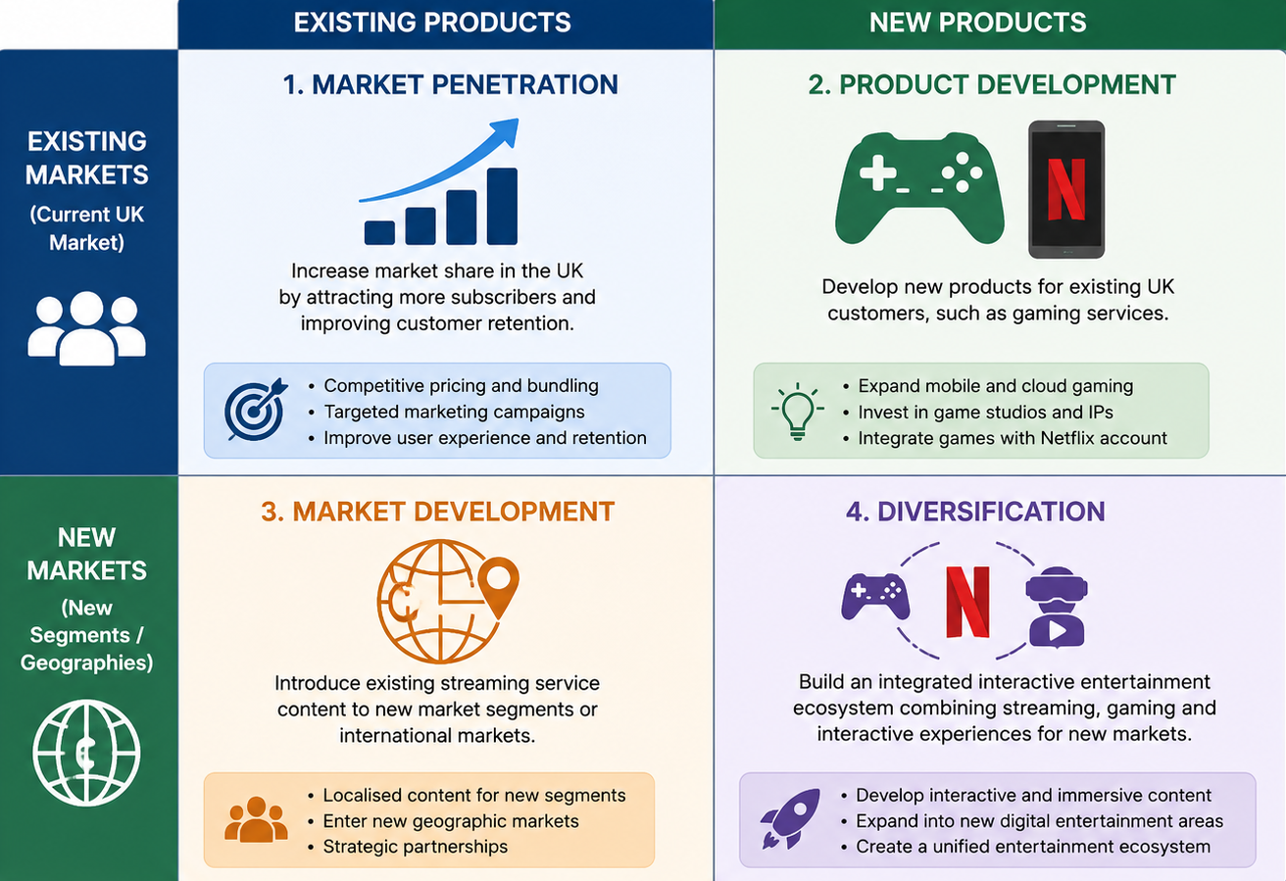
Figure 4: Ansoff Matrix for Netflix UK Strategic Options (Author, 2026)

1.7.4 SAFe Evaluation
The proposed interactive entertainment ecosystem is appropriate in that it directly addresses market saturation, high competition and increasing competition from other digital entertainment and gaming (Lee and Lee, 2024). It also leverages Netflix's existing brand, customer data, recommendation technology and digital-distribution capabilities.

Figure 5: SAFe Evaluation of the Interactive Entertainment Ecosystem Strategy (Author, 2026)
Figure 5 shows that the potential for acceptability is high as the strategy may help to increase engagement and diversify revenue. But investors might worry about the risk of investing in a gaming company, and customers may not want to use the gaming services if they make Netflix's streaming service less desirable or less affordable. Feasibility should thus be rated as moderate and not moderate-high. Netflix has money, a platform, and a big customer base, but it lacks in large-scale game development, specialist gaming talent, console distribution and gaming IP. These gaps would have to be filled in via recruitment, acquisitions, gaming-studio partnerships and deals with console or cloud-platform providers. A phased implementation would therefore be more achievable than the immediate full-scale diversification (Johnson et al., 2023; Gürer et al., 2025).

1.7.5 Recommended Strategy and Implementation Plan
The suggested approach is to build an interactive entertainment ecosystem that combines streaming, gaming and immersive digital experiences. This recommendation is based on external and internal analyses. The technological developments and changing consumer preferences were identified as key opportunities through PESTEL analysis, and the Five Forces analysis revealed that market maturity and strong competition pose challenges to growth in the traditional streaming market. Thus, diversifying from subscriptions becomes strategically important.
Netflix has valuable resources and capabilities that can help it implement this strategy from a Resource-Based View perspective. The VRIN criteria are fulfilled by recommendation algorithms, data analytics and brand reputation, which are sustainable competitive advantages (Cui, 2024). In addition, value chain analysis revealed that technology development and operations are among the value-creating activities that can contribute to the growth of the ecosystem.
Balanced Scorecard analysis also indicates alignment with financial growth, customer engagement, internal innovation and learning objectives. Gaming expansion opens up new revenue opportunities, enhances customer retention, and decreases reliance on subscriptions (Gürer et al., 2025). An interactive ecosystem is not just content diversification, but it is an ecosystem that provides new growth opportunities, as well as taking advantage of existing capabilities. Hence, the suggested approach is the most suitable to maintain competitive advantage and improve long-term value creation in a highly competitive industry.
Phase | Timeline | Key Activities | Expected Outcome
Phase 1 | Short-term | Invest in gaming technologies, AI capabilities and strategic partnerships. | Capability development and resource acquisition.
Phase 2 | Medium-term | Integrate gaming and interactive services into the existing streaming platform and expand content offerings. | Enhanced customer engagement and service diversification.
Phase 3 | Long-term | Develop a fully integrated entertainment ecosystem through continuous innovation and global expansion. | Sustainable competitive advantage and revenue diversification.
Table 8: Strategic Implementation Roadmap for the Interactive Entertainment Ecosystem (Author, 2026)
The implementation roadmap is a phased approach to reduce risk and enable capability development. First investments in gaming technologies and artificial intelligence set the necessary resources and partnerships. After that, the platform is enhanced with gaming and interactive elements to boost customer engagement (Gürer et al., 2025). Finally, Netflix creates an integrated entertainment system that is continually innovating and expanding globally. This is a step-by-step process that allows for transformation without compromising efficiency and long-term competitiveness.

1.7.6 Implementation Challenges
There are a number of challenges to implementation. There are significant risks with the investment in gaming equipment and content. Technological challenges involve platform integration and cybersecurity issues. Platform integration and cybersecurity risks might hinder implementation and create operational and data-security threats to the business (Saeed et al., 2023). Organisational resistance can also occur as employees have to learn new skills and adapt to a wider gaming and interactive-entertainment approach (Kotter, 2012). Market uncertainty is another challenge, as customer acceptance of gaming services is still unpredictable. Furthermore, competitors have significant resources and may copy strategic initiatives, which can lead to intense competition and lower expected returns.

1.7.7 Change Management and Risk Mitigation
Kotter's 8-Step Model is an appropriate change management approach for dealing with implementation risks (Kotter, 2012). Creating urgency and articulating a vision can help minimise organisational resistance. Cross-functional teams and empowerment of employees enable capability building and innovation. Short-term victories should be celebrated to maintain momentum, and ongoing communication helps to maintain commitment. The risks of financial investments can be reduced by making investments in phases and establishing strategic partnerships (Guo, 2025). Technological risks call for cybersecurity improvements and infrastructure upgrades. To institutionalise change and to effectively implement the proposed strategy, continuous monitoring and feedback mechanisms are necessary.

1.8 Conclusion
Netflix is well placed in the UK streaming market, but its subscription model is at risk due to market maturity, high competition, low switching costs and high content spend. Its benefits are not primarily based on the attractiveness of the industry, but on data analytics, recommendation technology, brand reputation and organisational adaptability. So, Netflix should build a phased interactive entertainment system, with a combination of streaming, gaming and personalisation. This related diversification would leverage its platform, data and customer base and generate new revenue opportunities. But it requires filling in the holes in game development, specialist talent, IP and platform partnerships, with tangible targets, stakeholder management and cybersecurity controls.

Section 2: Reflective Account
Gibbs' Reflective Cycle is a systematic approach to reflection which involves six steps to assist in continuous learning and a systematic reflection, strategic analysis and growth process that has taken place in the preparation of this report (Praveena et al., 2025).
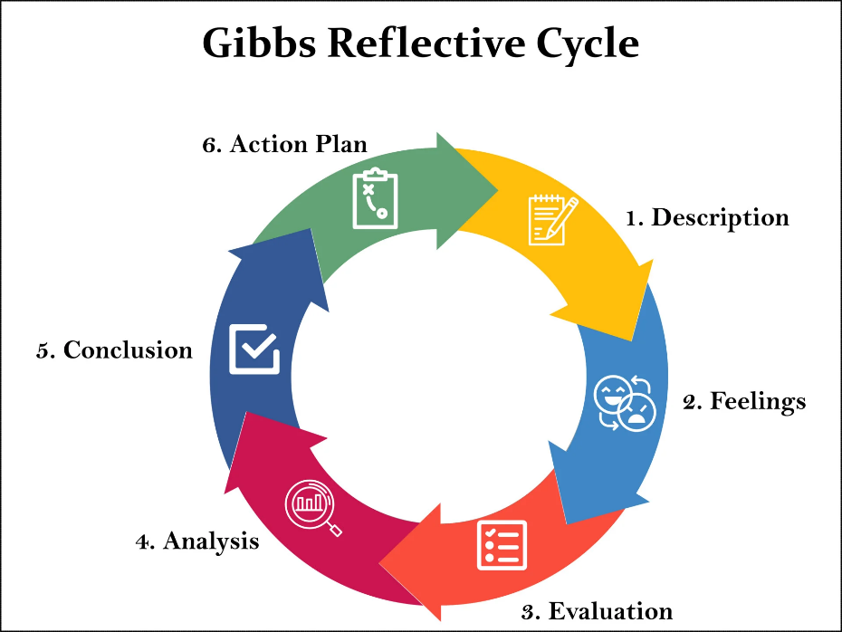
Figure 6: Gibbs' Reflective Cycle (Praveena et al., 2025)
Description
This reflective piece reflects on my learning in the Strategic Management module and the preparation of my strategic analysis for Netflix UK. The task required me to go beyond the concept of strategy and use it in a real organisation under competitive pressure. I chose Netflix since I had already interacted with the company as a customer, but the task inspired me to look at it from a managerial and analytical point of view. For the report, I have used academic sources, company information and industry evidence, and then applied PESTEL, Porter's Five Forces, VRIN, SWOT, Value Chain, Balanced Scorecard, Ansoff Matrix and SAFe analysis. This process made me realise that a strategic recommendation should be based on evidence and not on opinion.
Feelings
Initially, I was interested and a little unsure, as the module required a more critical approach than description. I was worried about choosing the correct frameworks, connecting them and creating a post-graduate level argument within the word count. But as the lectures went on, I became more confident. Questions and class activities by the lecturer and discussions on previous topics brought back important concepts and reinforced the link between theory and practice. I also kept myself motivated by choosing Netflix, as I could relate my customer experience to the strategic issues highlighted in the report.
Evaluation
The best part of the experience was understanding the value of various frameworks to the larger strategic picture. PESTEL and Porter's Five Forces were useful for analysing the external environment of Netflix, and VRIN, Value Chain and internal analysis were useful for analysing the resources, capabilities and competitive advantage of Netflix. The Balanced Scorecard, Ansoff Matrix and SAFe analysis proved helpful in transitioning from diagnosis to recommendation. The assignment helped me to develop my research skills as I was required to find academic and industry sources of information instead of general information. However, it was a difficult process. Careful planning was needed to manage a large quantity of material, to avoid too much description and to keep the analysis brief. I have overcome these challenges and still gained from the assignment in terms of my academic writing, time management and analytical judgement.
Analysis
This module has influenced my thinking on strategic management. Until now, I've only seen strategy as a growth and profit plan. I now see it as a constant cycle of analysing external change, internal capability and stakeholder expectations, before making decisions. When competition, content costs, regulation and consumer behaviour shift, even market leaders need to adapt, as the Netflix case demonstrated. It also illustrated that there was no single framework that could be used. Each model offers a different lens, and a stronger analysis is achieved through a critical combination of the models. I was taught that recommendations have to be realistic, acceptable and feasible. For instance, the proposed interactive entertainment ecosystem was logical, as it tied together the strengths of Netflix's technology with the opportunities and challenges of the market.
Conclusion
Overall, the assignment helped me a lot in my academic and professional development. It helped me to develop critical thinking skills, analyse evidence and use theory to solve a modern business problem. I learned through an interactive teaching method and independent study. I now understand strategic management as a discipline based on evidence, adaptive and practical, not a collection of models.
Action Plan
For future assignments, I will start research earlier and develop a better reading plan for academic journals and company reports/industry data. I will practise synthesising sources rather than describing them individually and will use frameworks more judiciously to prevent repetition. I will work on improving my ability to interpret and forecast data to make more analytical and realistic recommendations. Lastly, I will keep following Netflix and other international digital companies to learn how organisations react to technological innovation, customer expectations and competition. These activities will help me grow my MBA and be ready to take on management roles in the future.

References
Abdeen, H., De-Pablos-Heredero, C., Cosculluela-Martínez, C. and Montes-Botella, J.-L. (2025) ‘Strategic leadership and its impact on dynamic capabilities and sustainable competitive advantages’, Management Decision. https://doi.org/10.1108/MD-07-2024-1682 (Accessed: 22 June 2026).
Adedoyin, S., Oyakhire, V., Odijie, K. and Abolarinwa, S.I. (2026) ‘Intangible corporate resources and sustainable competitive advantage’, EcoForum, 15(2). https://doi.org/10.4316/efj.v15i2.3039 (Accessed: 23 June 2026).
Akter, S., Akhter, R., Rahman, M.B. and Naidu, P. (2025) ‘AI-driven business analytics for competitive advantage in service-oriented enterprises: customer experience and efficiency’, 5(3), pp. 389–423. https://doi.org/10.63125/mx0k6019 (Accessed: 22 June 2026).
Barney, J.B. (1991) ‘Firm resources and sustained competitive advantage’, Journal of Management, 17(1), pp. 99–120.
Cavusgil, S.T. and Deligonul, S.Z. (2024) ‘Dynamic capabilities framework and its transformative contributions’, Journal of International Business Studies, 56(6). https://doi.org/10.1057/s41267-024-00758-8 (Accessed: 24 June 2026).
Chalaby, J.K. (2024) ‘The streaming industry and the platform economy: an analysis’, Media, Culture & Society, 46(3), pp. 552–571. https://doi.org/10.1177/01634437231210439 (Accessed: 22 June 2026).
Chitraju, S. (2025) ‘Building trust through transparency: the role of disclosure in risk governance’, SSRN Electronic Journal. https://doi.org/10.2139/ssrn.5603270 (Accessed: 23 June 2026).
Cui, Y. (2024) ‘Research on Netflix’s expansion and competitive strategies in the global markets’, Highlights in Business, Economics and Management, 41, pp. 107–114. https://doi.org/10.54097/4nyc7106 (Accessed: 24 June 2026).
Elkington, J. (1997) Cannibals with Forks: The Triple Bottom Line of 21st Century Business. Oxford: Capstone.
Freeman, R.E. (1984) Strategic Management: A Stakeholder Approach. Boston, MA: Pitman.
Gao, B., Wang, Y., Xie, H. and Hu, Y. (2023) ‘Artificial intelligence in advertising: advancements, challenges, and ethical considerations in targeting, personalization, content creation, and ad optimization’, SAGE Open, 13(4). https://doi.org/10.1177/21582440231210759 (Accessed: 23 June 2026).
Guo, X. (2025) ‘Risks and coping strategies in financial investments in the new era’, International Journal of Finance and Investment, 2(1), pp. 70–73. https://doi.org/10.54097/efkrcx79 (Accessed: 24 June 2026).
Gürer, M., İslamoğlu, G. and Ateşçi, E. (2025) ‘Netflix’s effort to enhance user experience with gaming strategy’, in IGI Global eBooks, pp. 249–276. https://doi.org/10.4018/979-8-3373-1957-5.ch010 (Accessed: 22 June 2026).
Hajji, Z., Chtaoui, A. and Bouhmala, A. (2025) ‘Balanced scorecard and performance management: a literature review’, International Journal of Research in Economics and Finance, 2(3), pp. 14–25. https://doi.org/10.71420/ijref.v2i3.75 (Accessed: 22 June 2026).
Hitt, M.A., Ireland, R.D., Hoskisson, R.E. and Harrison, J.S. (2024) Strategic Management: Concepts and Cases: Competitiveness and Globalization. 14th edn. Boston: Cengage Learning.
Hsiao, Y.-H. (2024) ‘The business strategy analysis of Netflix’, Transactions on Social Science Education and Humanities Research, 11, pp. 760–767. Available at: https://pdfs.semanticscholar.org/0418/cdfee079cdbf834abd369556b64f1fc6fb43.pdf (Accessed: 23 June 2026).
Jenei, S., Nagy, R., Moreno-García, E., Dénes DÁVID, L., Pallás, E.I. and Végh, K. (2025) ‘The rise of streaming services: a challenge to traditional television?’, Journal of Cultural Analysis and Social Change, pp. 2547–2559. https://doi.org/10.64753/jcasc.v10i4.3291 (Accessed: 24 June 2026).
Johnson, G., Regnér, P., Angwin, D., Whittington, R. and Scholes, K. (2023) Exploring Strategy. 13th edn. Harlow: Pearson.
Kaplan, R.S. and Norton, D.P. (1992) ‘The balanced scorecard—measures that drive performance’, Harvard Business Review, 70(1), pp. 71–79.
Kausche, K. and Weiss, M. (2024) ‘Platform power and regulatory capture in digital governance’, Business and Politics, pp. 1–25. https://doi.org/10.1017/bap.2024.33 (Accessed: 23 June 2026).
Keilbach, J. (2025) ‘(Non)Knowing the environmental impact of video streaming: complexity, transparency, and corporate sustainability reporting’, Media Industries, 12(1). https://doi.org/10.3998/mij.7630 (Accessed: 24 June 2026).
Kotter, J.P. (2012) Leading Change. Boston, MA: Harvard Business Review Press.
Lee, S. and Lee, H. (2024) ‘Netflix’s entry and domination of the video streaming market: a focus on disruptive innovation’, Journal of Digital Contents Society, 25(11), pp. 3179–3198. https://doi.org/10.9728/DCS.2024.25.11.3179 (Accessed: 23 June 2026).
Macdonald, O.N., Kelechi, A.K., Victor, A.I. and Uchechi, O.C. (2026) ‘A review of Netflix’s adoption of artificial intelligence and impact on strategic business decision making’, International Journal of Research and Innovation in Applied Science, 11(4), pp. 82–94. https://doi.org/10.51584/IJRIAS.2026.11040005 (Accessed: 24 June 2026).
Mailani, D., Hulu, M.Z.T., Simamora, M.R. and Kesuma, S.A. (2024) ‘Resource-based view theory to achieve a sustainable competitive advantage of the firm: systematic literature review’, International Journal of Entrepreneurship and Sustainability Studies, 4(1), pp. 1–15. https://doi.org/10.31098/IJEASS.V4I1.2002 (Accessed: 22 June 2026).
Manjarres Zarate, B.A., Pinillos Castillo, W.R. and Valbuena Montoya, D.H. (2025) ‘Competitiveness and competitive strategies’, Ciencia y Reflexión, 4(1), pp. 294–319. https://doi.org/10.70747/CR.V4I1.105 (Accessed: 23 June 2026).
Netflix (2023) Netflix 2022 Environmental, Social & Governance Report. Available at: https://s22.q4cdn.com/959853165/files/doc_downloads/2023/06/29/Netflix_2022-ESG-Report-FINAL.pdf (Accessed: 24 June 2026).
Netflix (2024) ‘Our sustainability progress: three years in’. Available at: https://about.netflix.com/news/netflix-sustainability-progress-three-years-in (Accessed: 14 July 2026).
Netflix (2025) Annual Report 2024. Available at: https://ir.netflix.net/financials/annual-reports-and-proxies/default.aspx (Accessed: 14 July 2026).
Ofcom (2025) Media Nations 2025. London: Ofcom. Available at: https://www.ofcom.org.uk/siteassets/resources/documents/research-and-data/multi-sector/media-nations/2025/media-nations-2025-uk-report.pdf (Accessed: 13 July 2026).
Office for National Statistics (2026) ‘Consumer price inflation, UK: December 2025’. Available at: https://www.ons.gov.uk/economy/inflationandpriceindices/bulletins/consumerpriceinflation/december2025 (Accessed: 12 July 2026).
Porter, M.E. (1985) Competitive Advantage: Creating and Sustaining Superior Performance. New York: Free Press.
Praveena, K.S., Juslin, F., Patil, C.M. and Bhargavi, K. (2025) ‘Using Gibb’s reflective model approach for enhancing project-based learning among students through reflective assessment’, Journal of Engineering Education Transformations, 38(2), pp. 148–155. Available at: https://journaleet.in/index.php/jeet/article/view/2071 (Accessed: 24 June 2026).
PwC (2024) UK edition: Entertainment & Media Outlook 2021–2025. Available at: https://www.pwc.co.uk/industries/technology-media-and-telecommunications/insights/entertainment-media-outlook.html (Accessed: 22 June 2026).
Rahman, M.M. (2025) ‘Data analytics for strategic business development: a systematic review analyzing its role in informing decisions, optimizing processes, and driving growth’, Journal of Sustainable Development and Policy, 1(1), pp. 285–314. https://doi.org/10.63125/he1tfg25 (Accessed: 23 June 2026).
Roblek, V. and Meško, M. (2018) ‘The importance of vision and mission for organizational development and growth’. Available at: https://www.researchgate.net/publication/333534541_The_importance_of_vision_and_mission_for_organizational_development_and_growth (Accessed: 24 June 2026).
Saeed, S., Altamimi, S.A., Alkayyal, N.A., Alshehri, E. and Alabbad, D.A. (2023) 'Digital transformation and cybersecurity challenges for business resilience: issues and recommendations', Sensors, 23(15). https://doi.org/10.3390/s23156666 (Accessed: 22 June 2026).
Salam, S., Ningsih, F., Ilham, M., Awaluddin, M. and Sudirman (2025) ‘Industrial competitiveness through Porter’s five forces framework’, Al-Kharaj: Journal of Islamic Economic and Business, 7(2). https://doi.org/10.24256/kharaj.v7i2.7370 (Accessed: 23 June 2026).
Shi, X. and Zailani, S. (2025) ‘Capabilities and resources for value creation and sustainable competitive advantage: a study of the Chinese video game industry’, Sustainability, 17(2), p. 605. https://doi.org/10.3390/su17020605 (Accessed: 24 June 2026).
Zhang, J. (2024) ‘Netflix evolution and strategy for future development’, Lecture Notes in Education Psychology and Public Media, 51(1), pp. 36–40. https://doi.org/10.54254/2753-7048/51/20240649 (Accessed: 24 June 2026).

Appendices

Appendix A: Extracts from Netflix’s Sustainability and ESG Disclosures
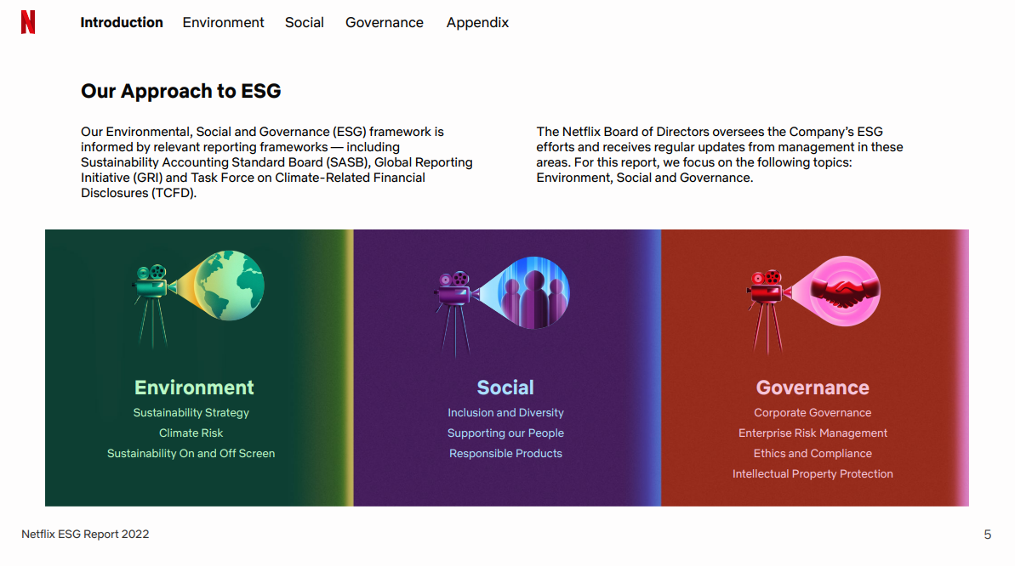
Source: Netflix (2023)
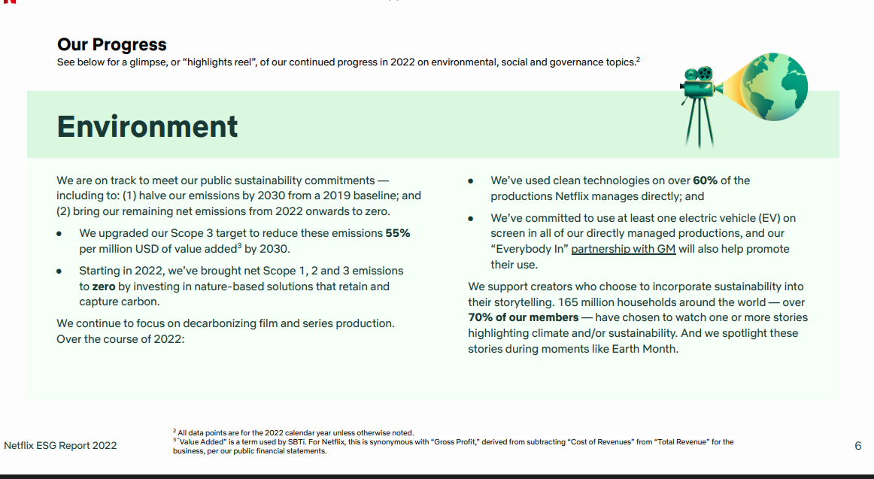
Source: Netflix (2023)

