PEOPLE MANAGEMENT
People Management
Chrysanthos Bikos/2210947
University of Wales Trinity Saint David
10 November 2023

Executive Summary
People management is the core of effective leadership within any organisation. This executive summary highlights the issues that were asked to investigate.
One of the problems identified for this assignment is that inadequate management abilities are causing sales to decline. Profit margins have been inflated due to issues observed in the UK food business, which is related to inadequate performance management abilities.
Even when equality and diversity were put in place, an additional inquiry revealed that they were disregarded and not upheld. The research's primary findings point to the differences in people's conceptions of what constitutes leadership and management. In today's complicated and quickly evolving corporate world, managing and leading at the same time is a valuable and dynamic method.

Contents Page
Contents
1.0 Introduction 4
2.0 Findings 5
2.1 Introduction 5
2.1.1 Leadership 6
2.1.2 Team Building 7
2.1.3 Motivation of Employees 8
2.1.4 Performance Management 9
2.1.5 Equality and Diversity 10
2.1.6 Flexi Working 11
3.0 CONCLUSION 12
4.0 Recommendations 13
5.0 Appendices 14
REFERENCE LIST 16

1.0 Introduction
This report was requested by Trinity Saint David University of Wales on September 25, 2023, and the due date for submission is November 10, 2023.
This report's objective is to assess managers' roles and competencies in a critical manner in order to enable successful people management. Chrysanthos Bikos, a University of Wales Trinity Saint David student, compiled this report.
The aim of this assignment is to critically analyse how firms successfully manage the performance of their workforce, as well as the responsibilities and competencies needed for managers to support effective people management.
To do this, an overview of the issues that managers confront in terms of effective teamwork, flexible work schedules, employee motivation, and equitable treatment will be provided.
The evidence for this report will be critically analysed using references, theories, and models. This assignment will be supported by information gathered from books, websites, and journals.

2.0 Findings

2.1 Introduction
The findings being studied for this assignment, which focuses on examining the levels managers need to successfully support good people management and how organisations successfully manage the performance of their workforce.
We must pay careful attention to how team members, managers, and leaders interact, gather, and work together, and we must make sure that everyone is aware of the negative effects our unproductive work habits have on others' productivity (Crowley, 2018)

So, what is People Management?
The term "people management" refers to a collection of procedures that cover the entire process of hiring, developing, and retaining personnel while continuing to support the organization's operations and offer direction to its workforce (Ghosh, 2021).
When an organisation is properly managed, its workforce is more likely to give it their all, accomplish its goals, and feel appreciated and content in their positions.
Please find below the key components of successful People Management:
Managers play an important role in the workplace, acting as leaders and facilitators of organisational goals. The tasks and abilities required for a manager vary based on the exact level and type of management, but there are some general functions and talents that are vital for effective management in most settings.
As Herrity (2023) explains, there are numerous layers of management within an organisation. The word "manager" can be used to describe both leading others and overseeing tasks and projects. It's useful to comprehend the extent of this role, whether you're applying for a management position or are just curious about what it includes.
At Papa John's, excellent career progression is one of our core beliefs! Some members of the store team now own them, and many have become general managers! However, Papa John's founder, John Schnatter, stated that he has "no confidence" in the management group currently in place at the pizza restaurant, attributing the company's low pizza sales to "poor leadership." (Rogers and Whitten, 2018).

2.1.1 Leadership
A leader's function is diverse and varies depending on the setting and the organisation, but it often entails guiding, motivating, and persuading individuals or groups to achieve common goals or objectives.
Co-founder and former Apple CEO Steve Jobs was renowned for his transformative and innovative leadership. He fostered a culture of design and user-centric thinking, pushed for perfection, and encouraged creativity—all of which have contributed to Apple's success.
Following a protracted power battle with the board of directors and the company's then-CEO, John Sculley, Jobs left Apple in 1985. Jobs founded NeXT, a computer platform development company that specialised in computers for higher education and corporate industries, that same year, taking a few Apple colleagues with him.
Apple was close to bankruptcy in 1997 when Jobs rejoined the company. The company recovered under his direction, and by the time he left as CEO in 2011, Apple was among the most lucrative and valued businesses in the world. Just goes to show how a single man's vision and leadership abilities can alter the course of history!
According to Belbin (Mindtools, 2023), you may enhance your contribution to the team by managing your limitations and using your strengths as a team member by being aware of your place within the group. The Belbin model is frequently used by team leaders and team-development specialists to assist in the creation of more balanced teams.
A coordinator's responsibilities are comparable to those of a conventional leader. Coordinators lead their team towards the goal in a methodical and effective manner because they have a firm understanding of the team's general objectives and a gift for assigning work to the appropriate individuals (Channell, 2021).

2.1.2 Team Building
When it comes to team building, there are several theories and models that you can use to guide your efforts. Although teams and groups have certain similarities, they also differ greatly. Groups often focus on individual tasks, while a team is a group of individuals who have come together to work towards a shared goal (Surbhi, 2023)
One of the widely accepted and practical theories for team building is Bruce Tuckman's Stages of Group Development (Vaida, 2021), which outlines the various stages that teams typically go through as they form and develop. Here's how you can apply this theory to team building (See Appendix A):
Engaging in enjoyable activities that alter one's perspective on the other allows people to interact in a new environment (Deiratani, 2021).
SKY plans team-building activities in escape rooms, where workers must cooperate to answer riddles and do tasks. This encourages cooperation and problem-solving abilities.
Unfortunately a poor example of team building gone wrong is when Whigham, then the director of creative ideas for a South Carolina public relations agency, arranged a company kickball game. However, things didn't go as planned on game day!
In the last play, Whigham threw himself into the air to escape being tagged out, breaking both his fibula and tibia when he landed. The game concluded with the sound of an ambulance's siren, plastic surgery, and a workers' compensation claim. Whigham left the company as a result of what had started out as a team-building programme (Crockett, 2019).

2.1.3 Motivation of Employees
Motivation is the readiness to put in the work necessary to help the organisation reach its objectives while also satisfying one's own needs.
As Nickerson states (2023), motivation components, according to Herzberg et al. (1959), are required to increase job satisfaction.
Herzberg identified the following as motivators (See Appendix B):
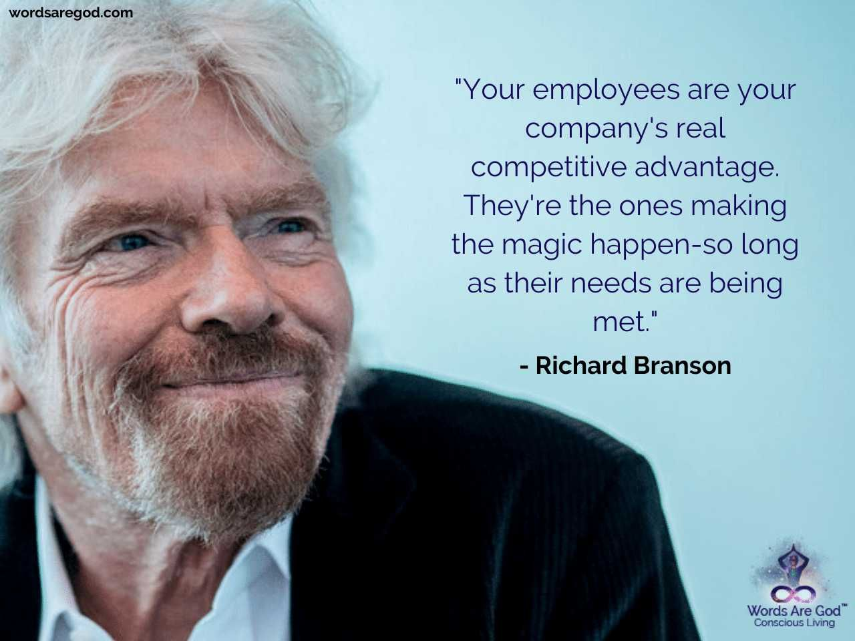
Richard Branson, the founder of the Virgin Group, is often regarded as a charismatic and highly motivated individual. The foundation of Richard Branson's employee motivation strategy is a blend of autonomy, respect, trust, and an emphasis on fostering a happy and fulfilling work environment.
But General Electric's infamous "rank and yank," or 20-70-10, system—which mandated yearly performance reviews for staff members and the termination of the lowest 10%—is a terrible illustration of motivational skills, the system was eventually scrapped (Barton, 2017).
One example of this would be if you are driven by a shift of mindset and feel obligated to work for a nonprofit or volunteer for an organisation because it makes you feel good to help people (Indeed, 2022).

2.1.4 Performance Management
Performance Management is a systematic and ongoing process that involves planning, monitoring, developing, and evaluating the performance of individuals, teams, and organizations to ensure that goals and objectives are met effectively and efficiently.
Performance measurements are critical performance indicators that are used to create goals and assess their accomplishment. There are four KPI’S (Key Performance Indicators) that are used to evaluate success which is:
Financial KPIs: These indicators assess the financial health and performance of a company.
Customer KPIs: These metrics focus on aspects related to customer satisfaction, acquisition, retention, and loyalty.
Operational KPIs: These indicators evaluate the efficiency and effectiveness of specific operations within an organization.
Marketing KPIs: These metrics assess the effectiveness of marketing efforts and campaigns.
As Stewart (2021) explains, the significance of Performance Management lies in its ability to foster a culture of positive reinforcement, well-being, and constructive improvement.
One of the biggest retailers in the UK, Tesco, employs performance management to keep an eye on a number of different areas of its business. KPIs for sales, customer happiness, inventory turnover, and worker productivity are included in this. Unfortunately according to Belfast Telegraph (2023), the corporation made the shocking admission that it had probably exaggerated profits by £250 million due to problems found in its UK food sector.

2.1.5 Equality and Diversity
The concept of equality states that every person should be treated equally, impartially, and without prejudice, regardless of their personal traits, including gender, race, ethnicity, age, religion, disability, sexual orientation, or social standing. Diversity is the range of origins, life experiences, viewpoints, and personal qualities that people offer to a community, business, or organisation.
So, what is the difference between equality and diversity?
Ensuring equal opportunity for workers, job applicants, and employees is the cornerstone of workplace equality. Employers ought to select candidates based on their aptitude and skills. Hiring individuals with a variety of protected characteristics—such as race or religion—is the cornerstone of workplace diversity. Although it may be difficult to summarise diversity, individualism is at the core of it all (Peninsula Group, 2023)
Regarding diversity management, IBM has always been in the forefront. However, the management of diversity mostly focused on offering equal employment opportunities and disregarding inequalities. Louis Gerstner's appointment as CEO in 1993 brought about this transformation.

It astonished Gerstner how little diversity there was among the company's senior leadership. It seemed to him that the corporation maintained a macho culture despite its best efforts to foster diversity. He established eight task forces on diversity in 1995, focusing on groups including women and men, Asians, African Americans, LGBT (lesbian, gay, bisexual, and transgender) people, Hispanics, Native Americans, and workers with disabilities (Lumen Learning, 2018).
Having said that, diversity and equality are essential. Leaders should support DEI policies and programmes and seek for methods to create more inclusive cultures in order to attract top people and achieve sustained success.

2.1.6 Flexi Working
Flexible Working also referred to as flexi work or flexible work arrangements, describes different work schedules and arrangements that provide workers more autonomy over where, when, and how they work.
Examples of Flexi Working (Indeed Editorial Team, 2023) are as follows (See Appendix C):
Amazon employees with flexible work schedules can pick when to start and stop their workdays as long as they stay productive and fulfill job criteria. Additionally, Amazon recently launched Term Time Contracts, which permit workers to take time off for childcare during the Christmas, Easter, and summer holidays.
However former Twitter CEO Jack Dorsey informed staff members in May 2020 that they may work remotely or from home forever. On the other hand, distributed working will be much, much harder, as stated by incoming CEO Parag Agrawal (Kelly, 2022).
Government policies and laws have been implemented. Not only do parents and carers have the legal right to request flexible work schedules, but all employees do as well.
We refer to this as "making a statutory application."
For eligibility, employees must have worked for the same employer for a minimum of 26 weeks (GOV.UK, nd).

3.0 CONCLUSION
Main Issues Facing Managers
Although the phrases "manager" and "leader" are frequently used interchangeably, there are important distinctions between the two jobs, making people management essential to any organisation.
A leader focuses on motivating and enabling others to collaborate towards a common objective, whereas managers typically concentrate on resource management and process optimisation (Flint, 2023).
The primary problem, as indicated by the research, is that people's perceptions of what a manager and leadership are different. Being both a manager and a leader simultaneously is a valuable and dynamic approach in today's complex and rapidly changing business environment.
Main Points of Role
In the modern workplace, effective leadership is vital for guiding teams and organisations toward their goals, with a focus on inspiring, influencing, and balancing stability with innovation. Team building activities promote collaboration, communication, and problem-solving, fostering strong working relationships.
Motivation, a cornerstone of employee engagement, can be fuelled by understanding and addressing individual and group motivations, as outlined in Herzberg's Two-Factor Theory. Equality and diversity are essential, promoting inclusivity, innovation, and fairness in the workforce. Meanwhile, flexible work schedules, like flextime, provide a better work-life balance by accommodating workers' changing requirements.
Success in many roles, including people management, depends on effective communication. People managers that are successful are able to communicate effectively with their colleagues in a variety of settings. To reach a large audience, they strike a balance between being direct and being kind (Moe, 2022).
In conclusion, effective people management is an ongoing process that requires continuous learning and adaptation to the needs of your team and the organisation.

4.0 Recommendations
Now that the vision has been developed and your team is committed to it, there can be a lengthy road ahead before it is realised. This is the essence of true leadership, which clarifies why management needs it so much (Mayhew, 2019).
The results show that in order to be more successful in your position, you need to develop your management and leadership abilities. Understand your strengths and weaknesses as both a manager and a leader.
The following are some particular steps you can take to strengthen the abilities needed for success:
Team Building: Learn how to select the right team members, motivate them, and create a positive team culture.
Leadership: The first step is self-awareness! Find a mentor or coach who has experience in both management and leadership.
Motivation of Employees: Encourage your staff members' career development. Recognize and appreciate your employees' efforts and accomplishments.
Equality and Diversity: Policies against harassment and discrimination should be made clear and enforced. It should be safe for workers to report any instances of harassment or discrimination.
Flexi Working: The key piece of legislation related to flexible working in the UK is the "Flexible Working Regulations 2014," which amends the Employment Rights Act 1996. All eligible employees in the UK have the right to request flexible working, including part-time work, job-sharing, flexitime, compressed hours, and remote working.

To sum up, the ability to manage people has been essential to one's success as a manager and leader. The workplace is always changing, so it's important to keep your skills updated in order to stay competitive.

“Coming together is a beginning, staying together is progress, and working together is success.” - Henry Ford (no date)

5.0 Appendices

Appendix A
Forming: Ice Breaking: In the forming stage, team members are often polite and cautious.
Storming: Conflict Resolution: In the storming stage, conflicts and disagreements may arise as team members assert themselves.
Norming: Building Trust: In the norming stage, trust and cohesion start to develop.
Performing: Task-Focused Activities: The performing stage is where the team is most productive.
Adjourning: Closure and Reflection: In the adjourning stage, when the team disbands, team-building activities can help team members reflect on their accomplishments and the experiences they've had together.

Appendix B
Achievement: Opportunities for employees to set and achieve challenging goals can lead to a sense of accomplishment and satisfaction.
Recognition: Acknowledgment and appreciation of employees' efforts and achievements can motivate them.
Work Itself: Meaningful, interesting, and engaging work can be a powerful motivator.
Responsibility: Giving employees autonomy and responsibility for their work can lead to job satisfaction.
Advancement and Growth: Opportunities for career development and personal growth can motivate employees.

Appendix C
The primary advantage is that you will have more free time, which will relieve some of the strain to maintain a work-life balance.
The advantages of working from home are a welcome diversion from the conventional 5-day workweek for many employees, independent contractors, and small business owners.
A full-time role is shared by two people through job sharing.

REFERENCE LIST

Barton, E. (2017) Inspiring employees requires some simple steps, but many bosses fail to hit the right note, BBC Worklife.
Belfast Telegraph (2023), How did the Tesco accounting scandal unfold and who are the trio in court?
Channell, M. (2021) Belbin’s Team Roles: How can Team Roles Improve Performance In The Workplace? TSW Training.
Crockett, Z. (2019) The worst team-building exercises in history, the HUSTLE.
Crowley, D. (2018) Smart teams: communicate, congregate, collaborate: how to work better together, Wiley.
Deiratani, A. (2021) What is Team Building? TeamBonding, Better Teamwork. Happier Teams.
Flint, J. (2023) WHAT IS THE KEY DIFFERENCE BETWEEN A MANAGER AND A LEADER? Salford Professional Development.
Ghosh, P. (2021) What is People Management? Complete Process and Best Practices, Spiceworks.
GOV.UK Flexible working, Contracts of employment and working hours.
Herrity, J. (2023) What are the Primary Responsibilities of a Manager? Indeed Career Guide.
Indeed Career Guide. (2022) 6 Common Types of Workplace Motivation.
Indeed Editorial Team. (2023) Examples of flexible working (Including their benefits), Indeed Career Guide.
Kelly, J. (2022) Twitter Employees Can Work From Home ‘Forever’ Or ‘Wherever You Feel Most Productive And Creative’, Forbes.
Lumen Learning (2018) Organizational Behaviour, Optional Case Study: Managing Diversity at IBM, Lumen Learning.
Mayhew, J. (2019) Leadership Skills for Managers and the Importance of these Skills, Virtual Speech.
Mindtools (2023) Belbin’s Team Roles, Leadership and Management, Mindtools.
Moe, K. (2022) What is people management? Leadership & Management, BetterUp.
Nickerson, C. (2023) Herzberg’s Two-Factor Theory Of Motivation-Hygiene, Simply Psychology.
Peninsula Group, (2023) Equality and diversity in the workplace, Peninsula Group, HR and Health & Safety Experts.
Rogers, K. and Whitten, S. (2018) Papa John’s founder says he has ‘no confidence’ in current management team, including CEO Steve Ritchie, CNBC.
Stewart, A. (2021) What is performance management in the workplace? Breathe, Employee Performance.
Surbhi, S. (2023) Difference Between Group and Team, Key Differences.
Vaida, S. (2021), GROUP DEVELOPMENT STAGES. A BRIEF COMPARATIVE ANALYSIS OF VARIOUS MODELS, Studia Universitatis Babes-Bolyai.

