Marketing Plan for Premier Inn

Student Name –Sakiba Islam
Marketing Essentials- BMIH4005
Student ID -2210233
Professor- Ruth Tailor Davies

Introduction
The marketing plan serves as a central hub around which the rest of the company's management can organise and carry out their duties. It not only aids in coordinating the efforts of its own division, but also those of the company as a whole by bringing in new clients (Ghandour et al., 2015).Because the hospitality industry places a significant emphasis on the creation of experiences and interaction with consumers and patrons, marketing strategies that encourage customer loyalty while also making an effort to attract new customers are an essential component of ensuring the success of the hospitality industry. This paper will discuss the marketing strategy that Premier Inn has devised in order to bring in new customers.

About Premier Inn
More than 72,000 hotel rooms are managed by Premier Inn, making it the largest hotel chain in the United Kingdom. The United Kingdom is home to the headquarters of this hotel chain. As a hotel management company, it competes with chains like Travelodge and Ibis and operates in a variety of settings, from downtown areas to suburban malls and airports (Tempest, G., 2008).

SWOT Analysis
Strengths | Weaknesses | Opportunities | Threats
- Awarded "Hotel Chain of the Year"  - Largest hotel chain in UK,  - Highly publicised  - Highest Quality & Most Popular Brand | - Sharp brand competition results in slim profit margins.  - Not as extensive a global footprint as major hotel chains | - Strategic collaborations  - Paying attention to online advertising  - Integrating the customer's perspective into the branding process | - Backpacker hostels  - Immense competition  - Private room rentals

Porter’s five forces
Bargaining power of supply | Threats of substitute | Industry rivalry | Bargaining power of the buyer | Threat of entrants
- Furniture and Fittings  - Food and beverage  - Hotel employees | - Camping  - Caravan clubs  - Country houses | - ACCOR  - Days Inn Worldwide, Inc.  - Travelodge Hotels Ltd. | - Low bargaining power of individual buyer  - For group buyers, the power is high | Low threat of entrance due to high entry barriers of the industry

Macro analysis
Political | Economic | Social | Technological | Environmental | Legal
- Taxes  - Competition  - Immigration laws | - Strong pound  - Inflation  - Interest rate | Changing customer preferences compelled to introduction new services. | Using advanced technology for increased customer interactions and providing safety. | - Water-efficient showers  - Energy-saving lights solar energy | General Data Protection Regulation Act  Gas Safety Act,  Health and Safety Acts

Situational Analysis
Customers are looking for places to unwind as lockdowns are being lifted following the COVID-19 epidemic. Premier Inn guarantees great service in addition to increased safety measures such as offering sanitisers to each guest, cleaning each room twice daily with disinfectant, and requiring all employees to wear masks at all times (Rahman, 2021). In order to accommodate the fact that not everyone has the same requirements for restful sleep, a variety of pillows are provided. Beds have been carefully chosen and tested to ensure a similar feel throughout the hotel.Prices are listed clearly and openly as a flat rate per room rather than per person. Although it has been challenging, the company has kept prices the same in response to client demand and in light of the uncertainty caused by Brexit.
British businesses across the board, from the poultry industry to the transportation sector, are feeling the effects of staff shortages caused by the ongoing health crisis and Brexit. The company said that the tight labour market and high hotel occupancy rates, especially in popular tourist areas like London, made for a difficult operating environment (Ghandour et al., 2015). Whitbread, the owner of the Premier Inn chain, revealed a £1 billion yearly loss as revenues dropped by almost three-quarters due to Covid-19 lockdowns (Rahman, 2021). However, the hospitality business reported a boom in summer reservations to coastal and mountain areas.

Objectives of the Marketing Plan
Premier Inn’s marketing efforts over a specified time period can be better planned, executed, and monitored with the help of a marketing plan. Marketing plans might incorporate multiple marketing tactics for different marketing teams within the firm, all striving to achieve the same business goals (Ghandour et al., 2015). This plan focuses more on the post-Covid and Brexit periods.

Strategy
It would be fair to say that the hospitality sector has been struggling as of late. Guests themselves have little trouble using digital means of communication. Instagram, YouTube, and Facebook rule the online world, and they all play a role in luring customers to a hotel or restaurant. The primary strategy of the marketing plan is to use online strategies (Ghandour et al., 2015). Premier Inn can benefit from digital marketing because it increases exposure to its rooms, restaurants, and other facilities across multiple digital channels.

Tactics - Online Marketing Channels

First-party Data for Specific Campaigns
The advertising team envisions a future in which Premier Inn can tailor each guest's visit to their website so that no two people have the same experience. Hotels will be able to tailor advertisements to specific visitors by using information collected from their customers' reservations (Rejeb et al., 2020). Premier Inn, in order to adjust to the ever-increasing availability of customer data, must place a premium on good data hygiene, or the practice of selecting and discarding irrelevant or useless information. Premier Inn may wish to alter its focus from "aspirational marketing" to "essential marketing," since the marketing industry as a whole may be compelled to move away from third-party sources.

Virtual Tour of Location
Many contemporary travellers like to have a visual sense of a hotel and its surroundings before making a reservation. It can make visitors feel more comfortable in your city and less like they've stumbled into a weird new world. Revenue in the virtual reality market is predicted to increase from less than £4.5 billion in 2021 to even more than £11 billion by 2024 (Campbell, 2022). If Premier Inn is serious about being at the forefront of the hospitality industry, it might want to explore adopting the latest technological developments.

User-generated Content for Instagram
Friends and family recommendations are the most trusted type of brand message online. Instagram in particular is a great platform for user-generated material (Revine, 2022). Premier Inn should ditch the hashtags and instead come up with more innovative ways to reach its demographic.

Standing out on Meta Search Engines
Meta search engines are a type of third-party software that may be used to quickly and easily compare many hotels with one another based on criteria such as pricing, services, and customer satisfaction. As a useful promotional tool, they can increase bookings, but they will not be the only ones making use of it (Arias, 2022). Customers are more inclined to make a reservation if they believe they are receiving good value for the money.

Actions
- Premier Inn management may develop hyper-personalized advertisements for their target demographic by tracking visitors' IP addresses and website activity (Rejeb et al., 2020). Premier Inn may tailor the content and design of its website to each individual customer by using dynamic promotions, varying their offerings, and even changing the site's layout.
- Visitors and event organisers alike may use virtual tours to choose the ideal location (Campbell, 2022). Premier Inn could gain more lucrative group leads and increase the number of guests who travel alone if they featured virtual tours on their website.
- Having visitors assist in attracting their own circles and the individuals who visit Premier Inn on social media is a smart technique for utilising good material. Visitors will post about Premier Inn hotel on Instagram if they had a good experience, but they can help them along by giving them something special as soon as they check-in (Revine, 2022).
- Premier Inn profiles can include high-quality images and videos shot by professionals. Premier Inn can provide an accurate representation of what it would be like to stay there. Put Premier Inn hotels' best foot forward for all to see. (Gannt Chart added in the Appendix 2))

Control
- Weekly Review of first-party data for specific campaigns.
- VR Set Upgrading and Feedback from customers.
- Build new content ideas for Instagram.
- Engage with new professionals for change in the course of contents.

Conclusion
After lockdowns caused by the COVID-19 pandemic were removed, customers began seeking places to relax. One of Premier Inn's biggest assets is the company's dedication to a comprehensive, all-encompassing approach to marketing across all available channels. Premier Inn's administration may create hyper-customized adverts for its ideal clientele by monitoring their IP addresses and clicking patterns. With virtual tours available on their website, Premier Inn stands to acquire more solo travellers and perhaps more profitable group leads. If guests have a positive stay at the Premier Inn, they may share their experience on Instagram. Meta search engines have the potential to boost reservations, but they won't be the only ones taking advantage of this.

References
Arias, R., 2022. What is Hotel Metasearch Marketing? + 6 best search engines 2022. [online] Cloudbeds. Available at: &lt;https://www.cloudbeds.com/articles/hotel-metasearch-marketing/&gt; [Accessed 30 Nov. 2022].
Campbell, K., 2022. Hotel Virtual Tours: The Complete Guide. [online] Hotel Virtual Tours: The Complete Guide | Cvent Blog. Available at: https://www.cvent.com/en/blog/hospitality/hotel-virtual-tours&gt; [Accessed 30 Nov. 2022].
Ghandour, R., Bilal, J. and Mudassar, H., 2015. Relationship between Service Quality, Customer Retention and the role of Social Media-Case study Premier Inn Hotel (UK). Journal of Organizational Studies and Innovation, 2(4), pp.1-12.
Rahman, M., 2021. Marketing mix of Premier Inn. [online] howandwhat. Available at: https://howandwhat.net/marketing-mix-premier-inn/&gt; [Accessed 30 Nov. 2022].
Rejeb, A., Rejeb, K. and Keogh, J.G., 2020. Potential of Big Data for Marketing: A Literature Review. Management Research and Practice, 12(3), pp.60-73.
Revine, 2022. Instagram Hotel Marketing: Strategies and tips for more engagement. [online] Revfine. Available at: https://www.revfine.com/instagram-hotel-marketing/&gt; [Accessed 30 Nov. 2022].
Tempest, G., 2008. The development and launch of Premier Inn. Hospitality Review, 10(4), pp.5-11.

Appendix 1

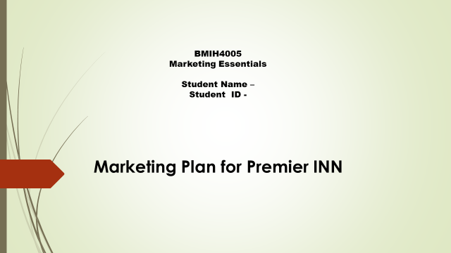

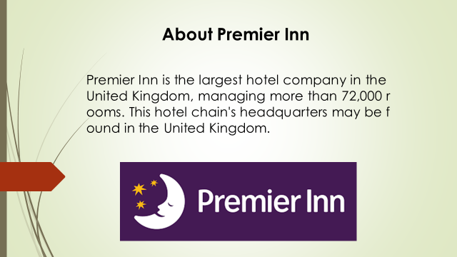

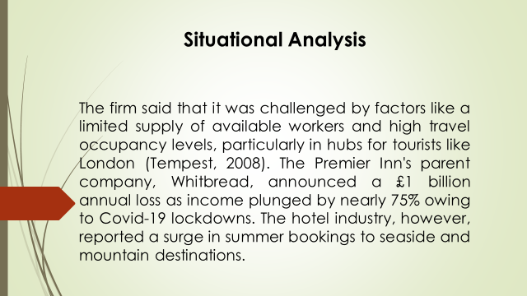

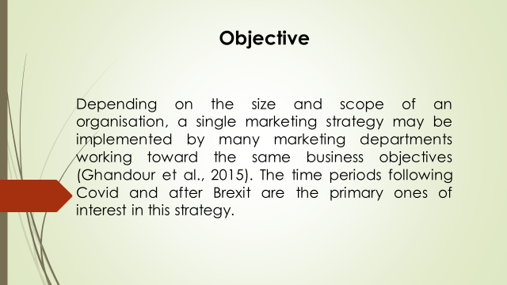

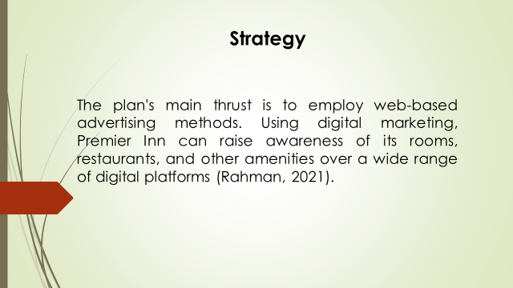

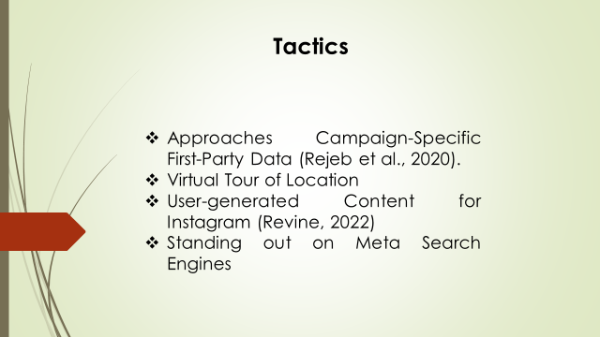

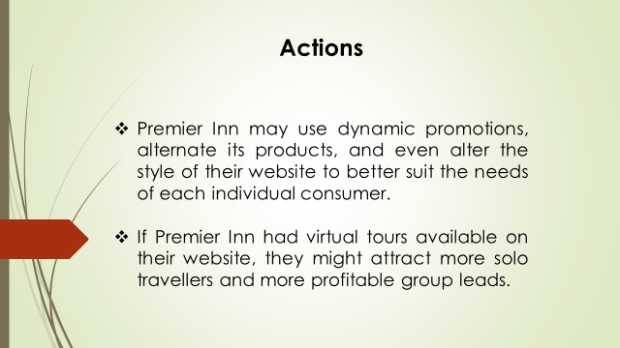

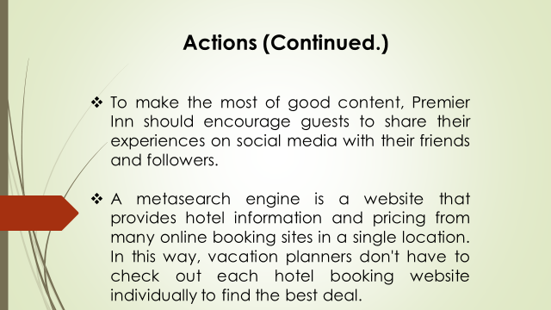

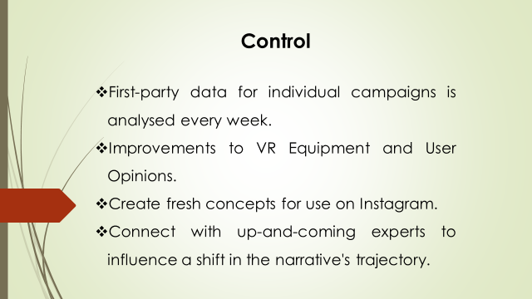

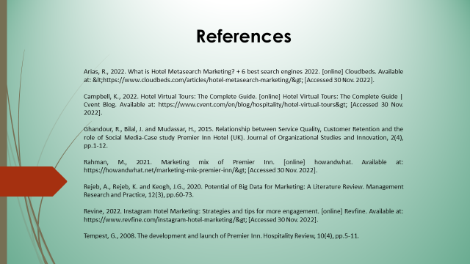

Apendix2
Gannt Chart



