Please write clearly in block capitals.
Centre number: | 6 |  | 6 |  |  | 9
Centre name: | University of Wales Trinity Saint David
Learner number (1st 7 digits of CIPD Membership number): | 9 | 1 |  | 1 | 6 |  | 9 | 9 |  | 3
Learner surname: | SANDERSON
Learner other names: | LYDIA
Unit code: | 5CO02
Unit title: | Evidence-based practice
Assessment ID: | CIPD_5CO02_25_01
Assessment start date: | 18.06.25
Assessment submission date: | 22.09.25
First resubmission date for centre marking – if applicable:
Second resubmission date for centre marking – if applicable:
Declared word count: | Task 1: 3177 Task 2: 930

Q1. Evaluate the concept of evidence-based practice (EBP) and provide two examples of where Technivara could use it to ensure sound decision-making in people practice. (AC 1.1)

Barends, Rousseau and Briner (2014) define evidence-based practice as making “good-quality decisions” which are based on “a combination of critical thinking and the best available evidence”. They emphasise that poor decisions lead to poor outcomes, highlighting the importance of seeking high-quality evidence to ensure the best possible decisions are made. Relying solely on personal experience can result in flawed judgements with negative effects. Evidence helps mitigate bias, providing a factual basis to guide decision-making.
Evidence can come from scientific research, organisational data, practitioner expertise, and stakeholder perspectives (CIPD, 2025). No single source is sufficient, so multiple forms must be considered to reach a reasonable conclusion. However, not all evidence is equal. Raby and McNaughton (2021) stress the need to assess validity and trustworthiness by examining research questions, study design, sampling, data collection, analysis, conflicts of interest, and ethical considerations.
The CIPD outlines six steps to evidence-based decision-making: asking, acquiring, appraising, aggregating, applying, and assessing. Organisations must identify the issue, acquire and appraise evidence, weigh findings, apply decisions, and evaluate the outcome.
At Technivara, the People Practice continues using outdated, paper-based processes, causing errors, inefficiencies, and limited access. A digital HR system could improve data storage and accuracy. Evidence can be gathered by benchmarking similar companies’ systems, assessing processing times, error rates, and employee satisfaction, and reviewing system reports for security and usability. Critical appraisal is essential as supplier reports may be biased, and data may be exaggerated. Summarised findings can guide the decision to implement a digital HR system, train staff, ensure compliance, and measure success via task completion, error rates, and employee surveys. Success could be measured through task completion times, error rates, and employee satisfaction surveys.
Additionally, Technivara have acknowledged it is time to expand the business. They should question how to move towards implementing more effective recruitment strategies, so they can have the most qualified candidates to align with organisational needs and scalability.
Again, they must gather evidence, such as how competitive companies recruit, the current recruitment metrics, such as time and cost to hire, retention of employees in comparison to competitive companies. There may be suggested changes in the evidence such as online job boards, structured interviews, AI CV screening. Their traditional methods of hiring may not attract the most suitable candidates.
They need to present the data to leadership and invest in new applications to help with recruitment. They may also need to train hiring managers in better recruitment practices.
They will also need to have performance measurements to track the improvement. This may be comparisons of time and cost per hire. Employee feedback of the recruitment process can also be an indicator of success.

Overall, evidence-based practice is essential for organisational decision-making. It provides a structured and reliable framework to evaluate potential changes, ensuring that outcomes are informed by credible evidence rather than personal bias, and ultimately adds value to the organisation.

Q2. Evaluate one appropriate analysis tool and one appropriate analysis method that Technivara might apply to recognise and diagnose issues, challenges, and opportunities. (AC 1.2)

Analytical tools are essential in people practice supporting organisational change and development. One effective tool is PESTLE analysis, which the CIPD (2025) recognises as valuable for identifying long-term challenges and opportunities. It aids strategic planning by highlighting gaps, areas for improvement, and productivity opportunities. For Technivara, PESTLE is useful for understanding the evolving external market.
PESTLE stands for political, economic, social, technological, legal, and environmental factors. Politically, Technivara must consider changes such as Brexit or the war in Ukraine that affect supply chains. Economically, while the company is strong after years of growth, expansion strategies must address fluctuating interest rates and inflation. Socially, attracting a younger workforce requires updating recruitment systems and branding, potentially using digital solutions over outdated paper-based methods. Technologically, modernising processes is essential to remain competitive. Legally, GDPR compliance is critical, and paper-based systems increase breach risks; digital systems offer more security and efficiency. Environmentally, reducing paper usage supports sustainability and enhances company image. All of these considerations in the PESTLE analysis model can highlight areas for improvement for Technivara. They can use these to further construct designs to implement these improvements.
Compared to SWOT, which focuses on internal strengths and weaknesses (Makos, 2024), PESTLE provides a broader perspective on external influences. However, the CIPD (2025) cautions that it can rely on assumptions, oversimplify complex factors, and neglect internal considerations, limiting actionable insights in rapidly changing environments.
Additionally, qualitative methods such as interviews provide valuable insights. Alsaawi (2014) explains that structured, unstructured, or semi-structured interviews gather in-depth qualitative data. Technivara could use interviews to understand employee perceptions, identify barriers, and explore opportunities, supporting company expansion and daily operational improvements.
Interviews offer rich, detailed data and allow follow-up questions to strengthen evidence. Denzin (2001) highlights that interviews uncover contextual and meaningful information. However, disadvantages include potential employee reluctance to answer honestly and interviewer bias influencing responses. Alsaawi (2014) emphasises the importance of researcher neutrality and keeping focus on the target topic. Independent interviewers may reduce bias, though they could lack contextual knowledge and increase costs.

Q3. Explain the main principles of critical thinking including how these might apply to your own and others’ ideas to assist objective and rational debate at Technivara (AC 1.3)

Paul and Elder (2012) define critical thinking as “the art of analysing and evaluating thinking with a view to improving it”. To critically evaluate, evidence must be assessed, different viewpoints considered, and conclusions supported by objective reasoning. Although there is no universal model of critical thinking, several principles are widely agreed upon. Critical thinking ensures well-informed and effective decision-making.
Firstly, Human Resources Management (HRM) (2021) acknowledges the importance of being able to identify and assess arguments. Both parties’ point of view needs to be identified and the reasons behind them. At Technivara, senior leadership favours traditional practices after sixteen years of growth, with Bill, the founder, advocating continuity. In contrast, People Practice Manager, Sue, sees the need to modernise HR processes to address compliance issues and inefficiencies. Both perspectives are valid and must be considered.
Secondly, arguments should be analysed for strengths and weaknesses, supported by evidence. Paul and Elder (2012) argue that open-mindedness allows assessment of alternative viewpoints. Bill’s argument for maintaining traditional practices may cite recent success of the company. However, this may have been due to other influencing factors, such as increased demand for products or lack of competition. Conversely, Sue’s case for change is opinion-based and requires supporting data on administrative inefficiencies, time spent, and risks of the current system versus a digital alternative.
Critical thinking also involves evaluating evidence quality. Barends, Rousseau, and Briner (2014) suggest asking: Where and how was the evidence gathered? Is it the best available? Is it sufficient? Could it be biased? Evidence must be credible, verifiable, and balanced to avoid favouring one perspective and overlooking counterarguments.
The final main principle of critical thinking, according to HRM, is the ability to construct a well-reasoned and logical argument, which is supported by evidence. There needs to be clarity within the argument, to avoid ambiguity and miscommunication. If the decision is made to implement new digital systems, there needs to be a clear reason for the change when proposing it. For example, why current practices are outdated with examples, are there difficulties with data analysis in the current practice or misplacing of documents.
Critical thinking means using credible evidence and weighing perspectives to reach sound
conclusions. In people practice, this enables managers to give well-supported
recommendations that balance leadership concerns with HR goals, leading to sustainable
decisions.

Q4. Explain two decision-making processes that Technivara could apply to ensure that effective outcomes are achieved. (AC 1.4)

CMI (2020) recognises how important it is for managers to make effective decisions under restrictive conditions. The most appropriate approach must be considered in the correct context and with the correct information to avoid a costly risk.
Technivara seem to have a tradition-led decision-making process from the top of the hierarchy. Embracing a more structured and methodical approach can encourage improvement during company expansion and organisational change.
One useful framework is De Bono’s (1985) Six Thinking Hats, which encourages considering a problem from multiple perspectives.
The white hat focuses on objective facts and figures. Technivara can assess the efficiency of their current system, comparing problem resolution times with companies using similar digital systems. Evidence from the People Practice team on workforce planning can strengthen the case for change.
The red hat considers emotions and intuition. This hat does not typically take into consideration a pragmatic approach. Staff may feel anxious about using a new system, while others may welcome the update. Acknowledging these emotional responses helps manage the transition effectively.
The black hat considers risks and approaches problems with caution. A new digital system is costly, especially if it proves unsuitable, and migrating data may disrupt workflows. Acknowledging these risks enables precautions, such as a phased rollout, to pre-empt potential issues.
The yellow hat views a problem with optimism and considers the benefits. Digital systems improve efficiency, compliance, data security, and scalability, supporting Technivara’s long-term growth.
The green hat encourages creativity and alternative solutions. Piloting the system in specific teams before company-wide adoption allows testing and problem-solving.
Finally, the blue hat focuses on organisation and planning, coordinating the discussion into an actionable rollout strategy. For Technivara, this might involve a clear agenda, identification of challenges, and tailored solutions to guide the transition.
Overall, De Bono’s model ensures decisions consider both evidence and emotions, promoting a comprehensive and balanced approach to organisational change.
Another tool is Lewin’s (1951) Force Field Analysis, which identifies driving and restraining forces affecting change (Tahir, 2019). For Technivara, the desired change is moving to a digital HR system.
Driving forces include improved accuracy, accessibility, and efficiency in data management. Advanced HR systems offer clearer workforce insights for evidence-based decisions, while competitor pressure and GDPR compliance risks highlight Technivara’s need to keep pace.
Restraining forces include the founder’s preference for traditional methods, staff training requirements, and cost implications. Driving forces can be strengthened by presenting data, case studies, and a business case showing short-term costs versus long-term benefits. Restraining forces can be reduced by involving the founder in decision-making, providing digital training, and ensuring a seamless transition.
The use of a force field analysis can help the people practice team proactively plan how to implement change and overcome resistance, particularly from the long-standing staff.

Q5. Assess two different ethical perspectives including how these could be used at Technivara to inform and influence decision-making. (AC 1.5)

Johnson (2006) defines ethical perspectives as moral guidelines that support decision making. The CIPD (2024) suggest it helps judge what is right or wrong and consider fairness in a decision. The CIPD emphasise the importance ethics in people practice when decisions involve less favourable outcomes, such as redundancies or dismissals.
Utilitarianism aims to provide “the greatest good for the greatest number of people” (Johnson, 2006). This perspective considers both short-term and long-term consequences. Johnson outlines a three-step process: identify all courses of action, consider the costs and benefits, and then select the option that produces the greatest overall good. Within organisations, this framework emphasises outcomes that benefit the wider group.
At Technivara, utilitarian reasoning could support the decision to implement a digital HR system. While the transition entails financial costs and staff training, long-term benefits, such as reduced errors, improved workforce planning, and faster processes, would outweigh short-term challenges.
However, since the theory aims to maximise happiness, it can support a positive working environment. Decisions are made with the wellbeing of employees in mind, encouraging fairness and consideration of how outcomes affect the wider group. Levin (2019) praises the framework for being relatively straightforward, focusing on consequences and helping leaders make clear, outcome-oriented decisions.
Utilitarianism’s focus on maximising happiness can be unrealistic, as some negative consequences are unavoidable. For example, redundancies may harm individuals but secure the company’s long-term survival and benefit the wider workforce. This highlights a key limitation: prioritising the majority may overlook individual rights and wellbeing.
Ultimately, the theory provides a clear, outcome-focused framework for decision-making in the workplace, but oversimplifies the realistic challenges presented in company decisions,
In contrast, deontological ethics takes a duty-based approach. Mohn (2022) argues that actions should be judged as right or wrong regardless of the outcome. Even if an action leads to positive results, it should not be undertaken if the action itself is morally wrong.
From a deontological perspective, Technivara’s paper-based system should be judged by the company’s duty to employees, not the benefits of a digital system. This includes duties of transparency, providing accurate information, and fairness in decision-making, which outdated paper records may compromise.
Deontological ethics provides straightforward rules for behaviour: an action is either right or wrong. This removes ambiguity in decision-making and gives employees confidence in how ethical standards will be applied. It also ensures that people are not sacrificed for the sake of the majority, protecting rights and duties.
A disadvantage of this perspective is that actions can be carried out regardless of the consequences. Levin (2019) highlights that motives can be difficult to judge, meaning actions that appear duty-based may not always be ethical. Furthermore, ignoring consequences can harm organisations. For instance, resisting redundancies out of duty to employees may secure short-term jobs but risk the company’s survival if financial pressures grow.
In conclusion, deontology offers clear guidance on actions but its rigidity and disregard for
consequences can be impractical, as businesses must balance short-term obligations with
long-term survival.

Q6. Appraise two different ways that Technivara could measure financial and non-financial performance, providing one example of each. (AC 3.1)

Return on Investment (ROI) is a financial tool for assessing the value of business investments. Friedlob and Plewa (1996) suggest business owners seek profitability across operations. ROI provides a percentage return by comparing gains with costs, helping determine whether a decision is financially worthwhile.
Technivara could apply ROI to evaluate a digital HR system against its current paper-based one. Costs, including purchase, training, and maintenance, would be weighed against savings, such as reduced admin time and fewer errors. This calculation offers the people practice team quantifiable data to persuade the CEO and stakeholders. Tan (2022) highlights that ROI supports management in enhancing shareholder value and making evidence-based choices.
An advantage of ROI is its ability to monitor financial performance over time. Technivara could demonstrate cost savings in administration, printing, and error reduction through visual data, providing stakeholders with clear evidence of progress. This enables informed, data-driven decision-making rather than reliance on assumptions.
However, ROI also has limitations. It can encourage short-term thinking, overlooking initiatives with delayed but greater benefits. Tan (2022) highlights that management may prioritise improving short-term performance at the expense of long-term benefits, even if certain projects could generate higher overall returns in the future. For example, investments in employee development or retention may not provide instant savings but can reduce recruitment costs and enhance productivity in the long run.
Furthermore, ROI calculations typically focus on direct, measurable costs and benefits, while ignoring less tangible or hidden factors. For example, the time employees spend away from core tasks to complete training, or improvements in employee morale and customer service, may not be fully captured.
In conclusion, ROI is useful for business cases as it demonstrates quantifiable results. However, it should not be the sole measure, as long-term and non-financial benefits are equally important.
Employee Engagement surveys gather qualitative and quantitative insights into employee perceptions. Bartkiv (2025) explains these surveys provide valuable information on culture, wellbeing, and engagement, supporting informed decisions and effective strategies. CIPD (2025) note that surveys allow organisations to track employee views on workplace changes over time. Technivara could measure attitudes before, during, and after moving to a digital HR system, identifying whether staff feel it improves efficiency and reduces frustrations.
The value of engagement surveys lies in linking morale to retention, productivity, and performance (Bartkiv, 2025). Regular use supports continuous improvement by highlighting shifts in employee views and assessing whether initiatives deliver value beyond financial outcomes.
However, employee engagement surveys also present limitations. They are inherently subjective and may be influenced by other external factors, such as workload pressures, management style, or external circumstances, rather than the new HR system itself. It can be difficult to isolate the direct impact of a particular organisational change.
Overall, employee engagement surveys can offer valuable insight into employee perceptions and the impact of change in a non-financial analysis. However, the subjectivity of the data can limit the usefulness of the data. It would be a good analysis alongside an ROI analysis, as both objective and subjective data can give a more balanced assessment.

Q7. Explain how people practices could add value at Technivara and identify two methods that might be used to measure the impact of these people practices. (AC 3.2)

Taylor and Woodhams (2022) argue that the primary function of people management is to create value for the organisation, its stakeholders, and the wider community. Von Moltke (2024) defines this value as “the unique benefits and contributions the HR function delivers to an organisation and its employees,” stressing the need for alignment with organisational strategy. The Oxford English Dictionary defines impact as “the effect of an action,” reinforcing the view that the value of people practice is demonstrated through its measurable outcomes.
The CIPD (2017) suggests that a decision made by people practice needs to be insightful, relevant and actionable. This framework acknowledges the impact of people practice decisions, which can be short and long term, positive and negative, direct and indirect. This highlights the importance of an evidence-based approach to people practice.
People practice create value by improving efficiency. For Technivara, shifting to digital platforms streamlines recruitment, performance management, and reporting, reducing HR’s administrative burden and enabling more strategic work. These systems also provide data to anticipate organisational needs, supporting better decisions.
HR adds value by enhancing employee experience through well-being, inclusion, and career development policies that boost engagement and performance. Evidence-based strategies and workforce analytics further align HR with business goals, identify skills gaps, and guide training to sustain competitiveness.
Measuring the impact of people practice is essential in demonstrating its value. Without effective evaluation, there is a risk that HR initiatives may not address organisational priorities or justify the resources invested.
One effective tool for this is cost–benefit analysis (CBA), which Stobierski (2019) defines as a method of comparing the advantages and disadvantages of a decision. Decisions with benefits outweighing costs are deemed valuable. CBA enables HR professionals to critically assess outcomes and use resources efficiently. Both financial and non-financial factors are considered, with values assigned to each for direct comparison. For example, Technivara’s move from a paper-based to a digital HR system involves costs such as implementation, training, and short-term productivity loss, while benefits include reduced administrative workload, improved data accuracy, and faster compliance with GDPR. CBA demonstrates how HR decisions contribute to operational efficiency and strategic adaptability, aligning initiatives with organisational goals and generating sustainable value.
People practice can demonstrate financial effectiveness through tools such as return on investment (ROI), which calculates profitability by dividing gains by costs and expressing the result as a percentage (HRM, 2021). ROI provides a clear measure of value but is most effective when tracked over time to capture both initial costs and long-term benefits.
Technivara’s adoption of a digital HR system illustrates this. High upfront costs for software, training, and implementation limit immediate returns such as labour savings and reduced paper use. However, Tan (2022) cautions against focusing solely on short-term performance, as long-term benefits often outweigh initial expenses. For Technivara, lower ongoing costs and sustained gains in efficiency, compliance, and reduced administrative workload gradually increase ROI, demonstrating the long-term value of the investment.
To effectively gain a holistic evaluation of the value of people practice decisions, a method of evaluation can be employed. This method can capture the human impact, ensuring decisions deliver both economically and strategic value.

Q8. Table 1 shows Technivara's turnover and recruitment data for 2024. Sue has asked you to convert the data into percentage form, for each of the departments, to show:

- leavers as a % of the total number of employees
- vacancies as % of the total number of employees
- positions filled as a % of the total number of employees (AC 2.1)

You don’t need to provide a reference or in-text citation for AC 2.1

Table 1.xlsx




Q9. When you have completed Table 1, present your findings using a minimum of three different types of diagrammatical forms. (AC 2.2)

You don’t need to provide a reference or in-text citation for AC 2.2

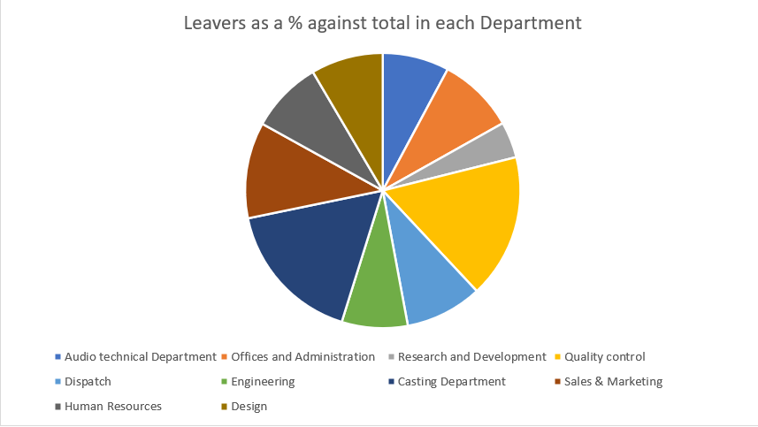
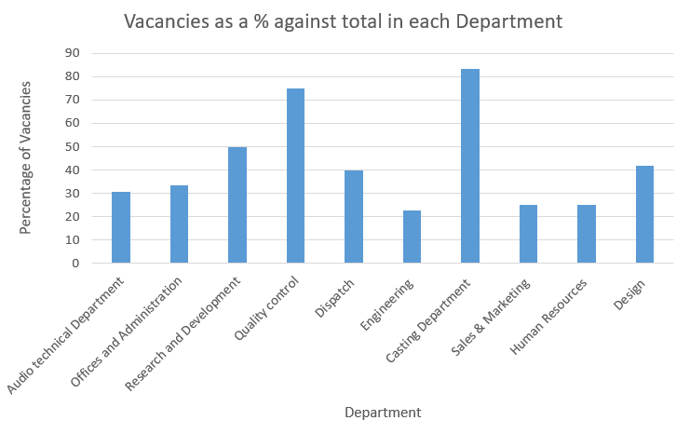
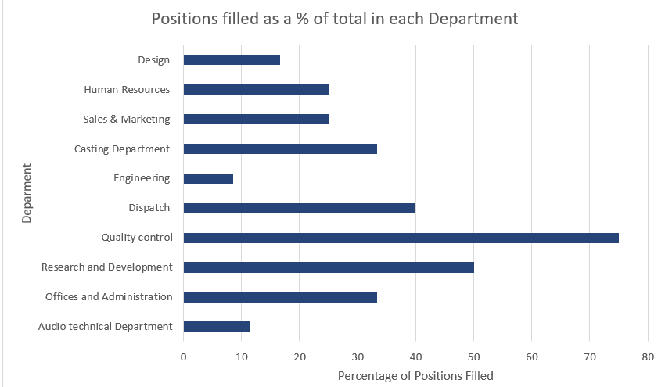

Q10. Table 2 contains evaluation feedback from 42 employees who attended a recent learning and development activity. Sue would like you to review the feedback and identify patterns, themes or trends that might be occurring and make recommendations based on your findings. (AC 2.3)

The feedback indicates that the training was well-received and of good quality overall. A strong majority (92.86%) of participants felt that the objectives were clearly explained from the outset, setting a positive foundation for learning. The resources provided were also valued, with 85.71% agreeing they were of good quality. Facilitators were particularly praised, with 92.86% of staff strongly agreeing or agreeing that they were knowledgeable, and 78.57% noting their ability to explain topics clearly.
However, while these aspects were highly rated, just over half of respondents agreed that the overall structure of the training was good, suggesting that improvements could be made in how the sessions were organised and delivered. Some staff reported feeling confused at times with the information presented, which may have affected engagement. Indeed, 76.19% did not feel they could appropriately participate in questions and answers, and 78.57% felt that the objectives set at the start were not fully achieved.
This may relate to perceived relevance. Some participants felt their prior knowledge did not equip them to engage effectively, while 42.86% were unsure and a third disagreed that their learning preferences were considered before the training. This highlights a need to tailor content more effectively to different learning styles and ensure inclusivity.
Overall, staff recognised the training as informative and of good quality, but many were unsure of its practical value. Over half (52.38%) were not sure, and 33.33% disagreed, that it would be useful in their daily work. Similarly, 57.14% were unsure, and 26.19% disagreed, that the content linked to areas where they felt they needed improvement.
In conclusion, while the training was delivered by knowledgeable facilitators and supported with quality resources, staff feedback highlights room for improvement in the structure, relevance, and alignment with workplace needs to maximise its impact.
The CIPD (2025) stresses that performance management seeks to maximise employee value creation through learning and development, setting suitable objectives, and holding staff accountable for performance. Considering this alongside staff feedback, two recommendations can be made.
Firstly, while facilitators were knowledgeable, employees felt delivery lacked structure, limiting effectiveness. Greater clarity and engagement are required. This could involve streamlining content flow, building in interactive opportunities for questions and discussion, and revisiting objectives throughout to confirm achievement. Although informative, training would be far more effective with these adjustments
Research supports this approach: Bell and Kozlowski (2008) highlight that active, learner-centred training is the most effective method of delivery. They highlight that formal training designs should be used to support self-regulated learning. By enabling employees to actively engage with the content, they are more likely to understand, retain, and apply what they have learned in practice.
The benefits of a structured approach include higher engagement, clearer understanding, and greater confidence in applying learning, which supports productivity and organisational performance. Conversely, continuing without changes risks confusion, disengagement, and reduced motivation, limiting benefits. Employees may even question their competence, affecting productivity
Structuring training sessions more effectively also increases return on investment (ROI), as time and money spent are more likely to produce measurable outcomes. Staff who clearly understand objectives and content can more effectively apply learning, improving workplace performance. Conversely, failing to act could waste resources and reduce productivity.
Secondly, the training content needs to be better tailored to topics that are directly relevant to staff’s daily work, and areas for improvement should be clearly identified to ensure the training is worthwhile. This may involve gathering information on staff learning preferences and workplace challenges in advance so that the training can be designed to be more relevant, inclusive, and practically applicable. Such information can be collected through manager-led performance reviews or staff surveys, which help identify where employees feel they need to improve and how they believe these improvements can be achieved most effectively. Bartkiv (2025) explains surveys are a valuable way to gain employee insight for management to make informed decisions, for example planning a constructive programme.
The CIPD (2025) emphasises the importance of objective setting in performance management, noting that clear objectives can serve as motivating tools. For training to be effective, employees should be actively involved in setting their own goals and committed to achieving them, ensuring that learning is meaningful and directly applicable to their work. Srivastava (2023) emphasises that training in the workplace needs to equip employees with the “necessary tools and knowledge to perform their tasks more efficiently, thereby boosting productivity”.
The benefit of ensuring training aligns with relevant staff roles and needed areas for improvement, maximises its usefulness in daily work. This will improve the work of individuals and the overall workforce.
If the training is not applicable to the role, then it has wasted employee time. It can also result in minimum impact on performance and lead to disengagement from future training sessions.
Ensuring the training is relevant is a worthy investment as it can improve the practicable application of improvements. This can ensure staff are more likely to embed their learning into their work, improving performance and financial outcomes of their work. If the content of the course is not applicable in the current work environment, the investment in training, both time and money, is unlikely to yield any results. Additionally, Srivastava (2023) highlights that relevant training is crucial in employee retention. High turnover rates are an unwanted expense with lost money involved in recruitment costs, disrupted workflow, and lost institutional knowledge.
Overall, whilst the training was informative, its impact was limited with issues in the structure and relevance. Addressing these issues with ensure future training is informative and applicable in the workplace, ultimately increasing the financial gain of the training.

References
Alsaawi, A. (2014) 'A critical review of qualitative interviews', European Journal of Business and Social Sciences, 3(4), pp. 149–156. Available at: https://www.researchgate.net/publication/280155117_A_Critical_Review_of_Qualitative_Interviews (Accessed: 5 August 2025)
Bartkiv, Y (2025) ‘The Importance, Purpose, and Benefits of Employee Engagement Surveys’ FaceUp Blog, 25 April. Available at: https://www.faceup.com/en/blog/importance-and-purpose-of-employee-surveys (Accessed: 6 September 2025)
Barends, E., Rousseau, D.M., & Briner, R.B. (2014) Evidence-Based Management: The Basic Principles, Center for Evidence-Based Management. Available at: https://moodle.uwtsd.ac.uk/pluginfile.php/553367/mod_resource/content/1/Evidence-Based-Practice-The-Basic-Principles-vs-Dec-2015.pdf. (Accessed: 29 July 2025)
Bell, B, S. & Kozlowski, S, W, J. (2008) ‘Active Learning: Effects of Core Training Design Elements on Self-Regulatory Processes, Learning, and Adaptability’, Journal of Applied Psychology, 92(2) pp. 296-316 https://doi.org/10.1037/0021-9010.93.2.296
CIPD (2017) ‘Creating and Capturing Value at Work: Who Benefits? Part 1’, CIPD. Available at: https://www.cipd.org/globalassets/media/knowledge/knowledge-hub/reports/creating-and-capturing-value-at-work_2017-who-benefits-2_tcm18-33097.pdf (Accessed: 6 September 2025).
CIPD (2024) Ethical Practice and the Role of People Professionals, CIPD. Available at: https://www.cipd.org/uk/knowledge/factsheets/ethics-role-hr-factsheet/ (Accessed: 30 August 2025)
CIPD (2025) Employee Engagement and Motivation, CIPD. Available at: https://www.cipd.org/uk/knowledge/factsheets/engagement-factsheet/#assessing-and-measuring-employee-engagement (Accessed: 6 September 2025)
CIPD (2025) Evidence-Based Practice for Effective Decision-Making, CIPD. Available at: https://www.cipd.org/uk/knowledge/factsheets/evidence-based-practice-factsheet/#what-is-evidencebased-practice (Accessed: 29 July 2025)
CIPD (2025) ‘Performance Management: An Introduction’, CIPD. Available at: https://www.cipd.org/uk/knowledge/factsheets/performance-factsheet/#one (Accessed: 9 September 2025)
CIPD (2025) PESTLE Analysis, CIPD. Available at: https://www.cipd.org/uk/knowledge/factsheets/pestle-analysis-factsheet/ (Accessed: 5 August 2025)
Chartered Management Institute [CMI] (2020) Decision Making. Available at: https://www.managers.org.uk/knowledge-and-insights/resource/decision-making/ (Accessed 29 August 2025)
De Bono, E. (2017) Six Thinking Hats. Revised Edn. London: Penguin Books.
Denzin, N.K. (2001) ‘The Reflexive Interview and a Performative Social Science’, Qualitative Research, 1(1). Available at: https://journals-sagepub-com.ezproxy.uwtsd.ac.uk/doi/epdf/10.1177/146879410100100102
Friedlob, G, T. and Plewa, F, J. (1996) Understanding Return on Investment. Canada: John Wiley & Sons
Human Resources Management [HRM] (2021) ‘Critical Thinking’, Human Resources Management Handbook. Available at: https://hrmhandbook.com/core/critical-thinking/ (Accessed: 20 August 2025)
Human Resources Management [HRM] (2021) ‘How to Calculate ROI of Human Resources’, Human Resources Management Handbook. Available at: https://hrmhandbook.com/core/hr-roi/ (Accessed: 6 August 2025)
Johnson, C, E. (2006) Ethics in the Workplace: Tools and Tactics for Organizational Transformation. USA: SAGE Publications
Levin, N (2019) Introduction to Ethics: An Open Educational Resource. California: N.G.E Far Press
Makos, J. (2024) SWOT and PESTLE Analysis: 5 Important Questions Answered. Available at: https://pestleanalysis.com/swot-and-pestle-analysis/ (Accessed: 8 August 2025)
Mohn, E. (2022) Deontological Ethics. Available at: https://www.ebsco.com/research-starters/religion-and-philosophy/deontological-ethics (Accessed 9 September 2025)
Oxford University Press (no date) ‘impact’, Oxford English Dictionary. Available at: https://www.oed.com/dictionary/impact_n?tl=true (Accessed: 16 September 2025)
Paul, R. and Elder, L. (2012) Critical Thinking. Tools for Taking Charge of Your Learning and Your Life. 3rd edn. London: Pearson Education. Available at: https://books.google.co.uk/books?id=yBzzDwAAQBAJ&printsec=frontcover&source=gbs_ge_summary_r&cad=0#v=onepage&q&f=false (Accessed: 24 August 2025)
Raby, P. and McNaughton, R. (2021) ‘A Simplified Approach to Critically Appraising Research Evidence’, Nurse Researcher. https://doi.org/10.7748/nr.2021.e1760
Stobierski, T. (2019) ‘What is Cost-Benefit Analysis & How to do it’, Harvard Business School Online. Available at: https://online.hbs.edu/blog/post/cost-benefit-analysis (Accessed: 6 September 2025)
Strivastava, P. (2023) ‘Evaluating the Role of Training Programs in Enhancing Employee Skills and Retention’, Journal of Business and Management, 25(8) pp. 66-71. Available at: https://www.iosrjournals.org/iosr-jbm/papers/Vol25-issue8/Ser-1/G2508016671.pdf (Accessed: 9 September 2025)
Tahir, U. (2019) Lewin’s Force Field Analysis (Change Management), Change Management Insight. Available at: https://changemanagementinsight.com/lewins-force-field-analysis-change-management/ (Accessed: 2 September 2025)
Tan, R (2022) ‘A Guide to Understanding Return on Investment’ Nexea, 6 April. Available at: https://www.nexea.co/a-guide-to-understanding-return-on-investment-roi/ (Accessed: 6 September 2025)
‌Taylor, S. and Woodhams, C. (2022) Studying Human Resource Management a Guide to the Study, Context and Practice of HR. 3rd edn. London: Kogan Page.
Von Moltke, N. (2024) ‘HR Value Proposition: Examples & 8 Steps To Develop It’, AIHR. Available at: https://www.aihr.com/blog/hr-value-proposition/ (Accessed: 6 August 2025).

