
University of Wales Trinity Saint David
(Birmingham)

MBA INTERNATIONAL BUSINESS
Human-Capital Management (LCMB7023)
Assessment Component 1: Individual Report
Innovating New Working Practices and Breeding an Environment Where Talent May Grow
Student Name: | Hetvi Patel
Student ID: | 2520131
Programme: | MBA International Business
Module: | Human Capital Management
Lecturer: | Dr Eno Maycock
Word Count: | 2649 words
Submitted on: | 10/14/2026

Table of Contents
Task A: Designing Innovative Working Practices 6
1. Critical Evaluation: Traditional Work Design vs. Contemporary Innovative Working Practices 6
2. Recommended Innovative Working Practices for NexSpace 9
Pillar 1: Flexible Working 9
Pillar 2: Cross-Functional Agile Teams 10
Pillar 3: Digital Collaboration Technologies 11
Task B: Creating an Environment Where Talent Grows 12
1. How Organisations Create Environments Where Talent Flourishes 12
2.Talent Growth Strategy for NexSpace 13
Building a Learning Organisation 13
Creating Psychological Safety and Wellbeing 14
Enabling Job Crafting and Career Pathways 15
Measuring Impact 15
Task C: Reflective Report 16
1. AI as a Strategic Decision-Support Tool in HRM 16
2. Reflective Analysis: Three Examples of Using AI 16
3. Personal Capability Development Plan 17
References 19
Appendix 22

List of Tables
Table Number | Title
Table 1 | Personal Capability Development Plan
Table 2 | NexSpace 12-Month Integrated Transformation Roadmap (Appendix B)

List of Figures
Figure Number | Title
Figure 1 | The Ability, Motivation, Opportunity (AMO) Model Applied to NexSpace
Figure 2 | Mechanistic versus Organic Work Design: Comparison Matrix
Figure 3 | The Job Demands-Resources (JD-R) Model Applied to NexSpace
Figure 4 | NexSpace Integrated Innovative Work Design Framework
Figure 5 | NexSpace Strategic Talent Ecosystem
Figure 6 | Gibbs’ Reflective Cycle Applied to My Use of AI

List of Abbreviations
Short Form | Full Form
AI | Artificial Intelligence
AMO | Abilities, Motivation and Opportunity
HIWS | High-Involvement Work Systems
HPWS | High-Performance Work Systems
HR | Human Resources
HRM | Human Resource Management
JD-R | Job Demands–Resources
MBA | Master of Business Administration
NHSX | NexSpace Health Systems
SDT | Self-Determination Theory
STS | Sociotechnical Systems Theory
UAE | United Arab Emirates
UK | United Kingdom
UX | User Experience

Task A: Designing Innovative Working Practices

1. Critical Evaluation: Traditional Work Design vs. Contemporary Innovative Working Practices
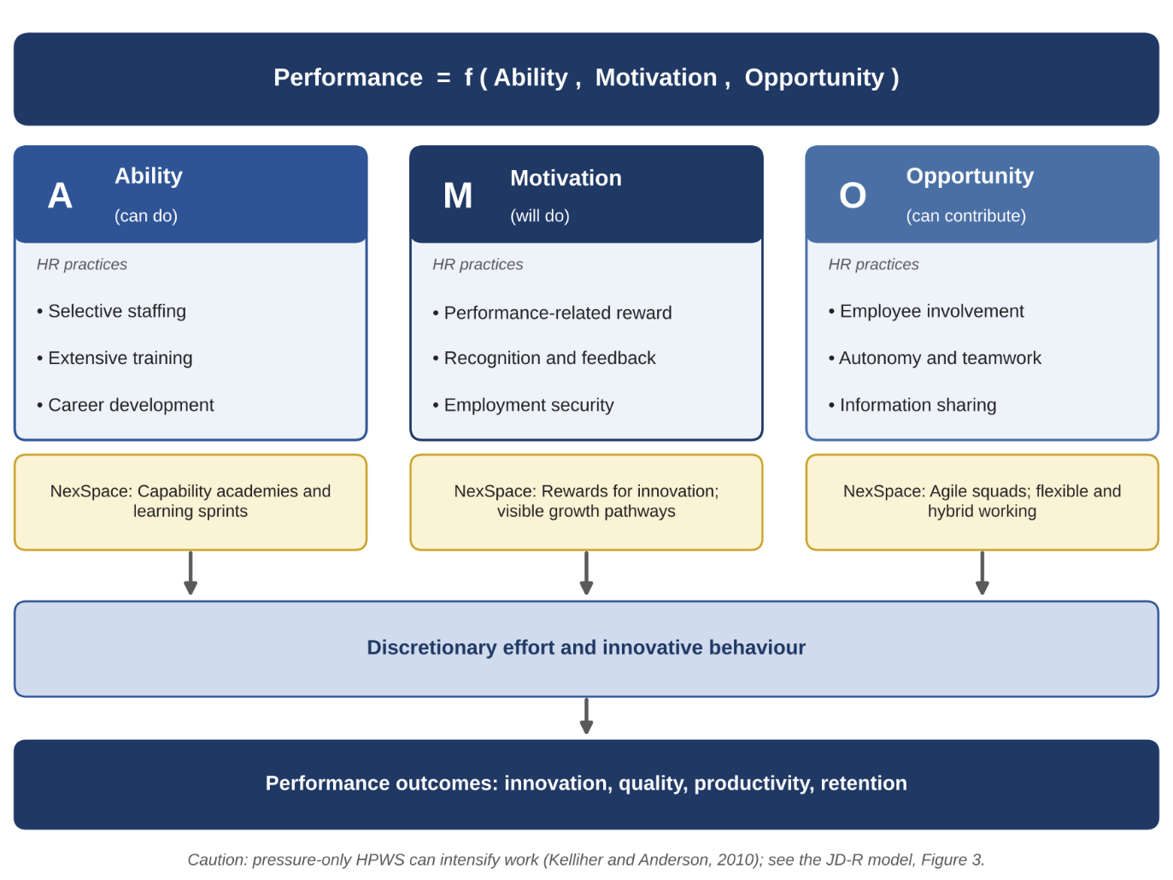
Traditional work design in healthcare technology organisations is typically hierarchical, standardised and siloed. Burns and Stalker’s (1961) mechanistic model; fixed roles, centralised authority and formalised procedures supports compliance and clinical safety but slows decision-making and limits creativity, as seen at NexSpace. The solution is not to remove structure but to redesign it selectively. O’Reilly and Tushman’s (2013) ambidexterity perspective is crucial: NexSpace must exploit its validated clinical platform while exploring new AI-enabled innovations. This requires more organic, flexible and collaborative practices, supported by governance to maintain regulatory safety.
Figure 1: The Ability-Motivation-Opportunity (AMO) Model Applied to NexSpace (Source: Adapted from Appelbaum et al., 2000; Boxall and Purcell, 2016; Kelliher and Anderson, 2010; the NexSpace applications are the author’s own analysis)
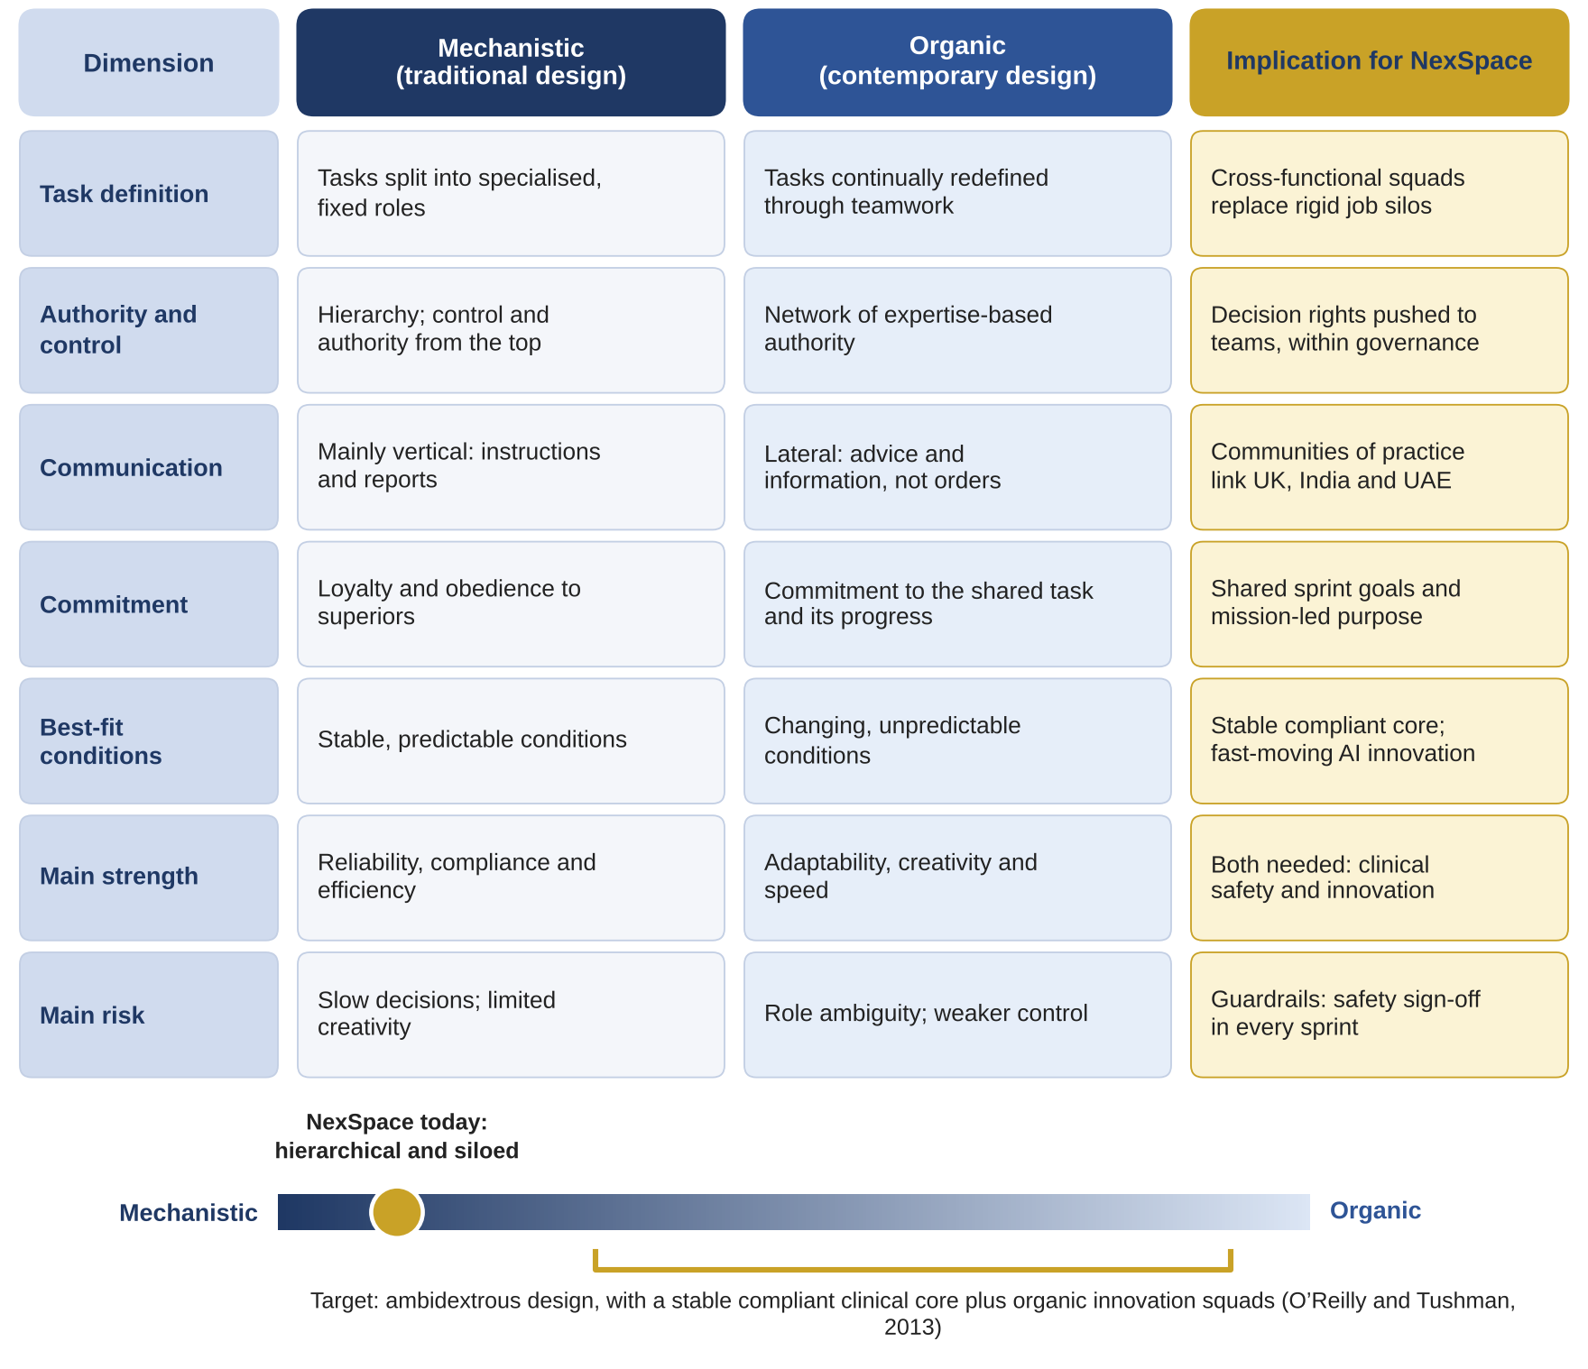
High-Performance Work Systems (HPWS), grounded in the AMO framework, combine selective staffing, extensive training, involvement and performance-related rewards to ensure employees are able, motivated and enabled to contribute (Appelbaum et al., 2000; Boxall and Purcell, 2016). HPWS can strengthen innovation and collaboration for knowledge-intensive roles at NexSpace. However, they also carry risks. Flexible and high-involvement practices may intensify work (Kelliher and Anderson, 2010), and the JD-R model shows that high demands undermine wellbeing unless balanced by resources such as autonomy and support (Demerouti et al., 2001; Bakker and Demerouti, 2007). This tension mirrors
NexSpace’s challenge of balancing wellbeing with high performance expectations.
Figure 2: Mechanistic versus Organic Work Design: Comparison Matrix (Source: Adapted from Burns and Stalker, 1961; O’Reilly and Tushman, 2013; the NexSpace implications are the author’s own analysis)
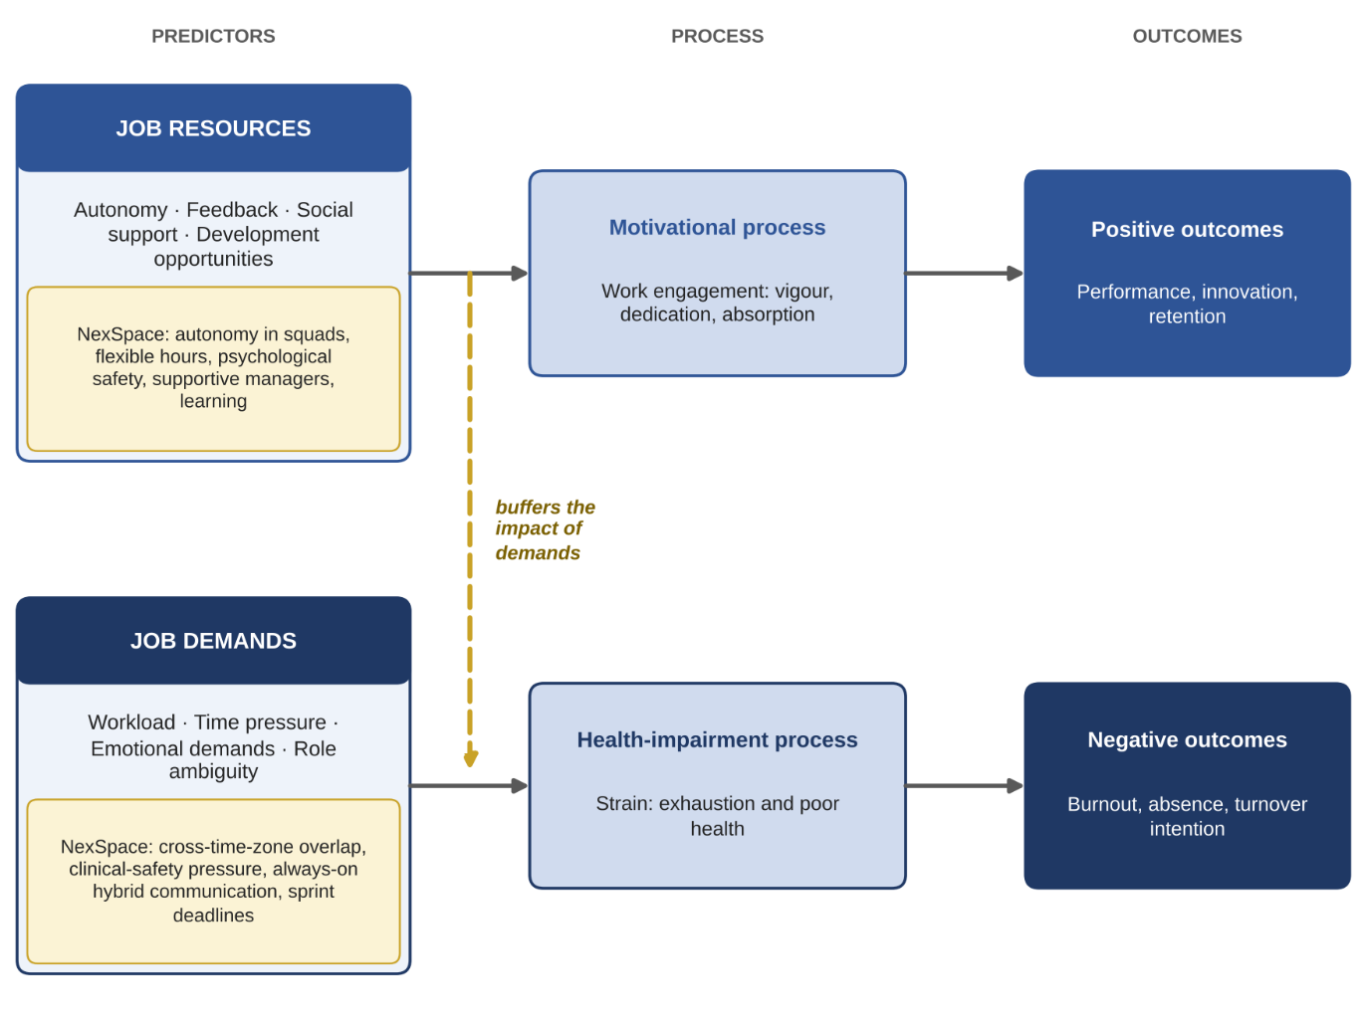
High-Involvement Work Systems (HIWS) deepen employee participation by distributing power, information and rewards (Lawler, 1986). Their psychological mechanism: meaning, competence, self-determination and impact; aligns with Self-Determination Theory, which links autonomy, competence and relatedness to intrinsic motivation and creativity (Deci and Ryan, 2000). HIWS therefore address NexSpace’s slow decision-making and limited creativity, yet HIWS also have contextual limitations: unbounded autonomy is unsafe in clinical software development, meaning decision rights must be clearly defined and bounded by regulatory governance.
Figure 3: The Job Demands-Resources (JD-R) Model Applied to NexSpace (Source: Adapted from Demerouti et al., 2001; Bakker and Demerouti, 2007; the NexSpace examples are the author’s own analysis)
Agile working provides the operational mechanism for enabling innovation within these constraints. Agile practices: cross-functional teams, short iterations, rapid feedback and continuous learning replace sequential hand-offs with collaborative problem-solving (Rigby, Sutherland and Takeuchi, 2016). This reflects Edmondson’s (2012) argument that innovation depends on “teaming”, or learning across boundaries in real time. Agile working therefore addresses NexSpace’s collaboration challenges (c) and supports faster innovation cycles. However, agile is not universally applicable: it suits exploratory work but may be inefficient for compliance-heavy tasks.
Hybrid and flexible working extend autonomy and support employee wellbeing, but they also introduce risks. Telework can improve flexibility yet weaken knowledge exchange and social cohesion if poorly managed (Allen, Golden and Shockley, 2015). Geographically dispersed teams innovate less unless electronic dependence and structure are deliberately designed (Gibson and Gibbs, 2006). These risks are visible at NexSpace, where hybrid working has weakened collaboration across the UK, India and UAE.
Sociotechnical Systems Theory (STS) integrates these insights by emphasising joint optimisation of technical and social subsystems (Trist and Bamforth, 1951; Pasmore, 1988). For NexSpace, this means AI platforms, digital tools and agile processes must be designed alongside roles, norms and team structures. Technology alone cannot deliver innovation; it must be embedded within redesigned work systems that support collaboration, autonomy and learning.
Overall, contemporary innovative practices offer significant advantages for NexSpace, but only when applied critically. The organisation must balance autonomy with safety, flexibility with wellbeing, and innovation with regulatory compliance an ambidextrous approach that integrates HPWS, HIWS, agile working, hybrid models and sociotechnical principles.

2. Recommended Innovative Working Practices for NexSpace
Drawing on these theories, NexSpace should adopt an integrated work design built around three pillars: cross-functional collaboration, hybrid and flexible working, and digital collaboration technologies. Together, these practices form a coherent system that enhances innovation, collaboration, agility and wellbeing.

Pillar 1: Flexible Working
NexSpace should adopt a hybrid-by-design model with two core collaboration days per week and flexible scheduling on other days. “Bandwidth hours” (e.g., 10:00-16:00 UK time) would ensure synchronous overlap across the UK, India and UAE. Job rotation and short secondments between product, data science and clinical liaison roles would broaden skills and strengthen cross-functional understanding.
The theoretical justification is strong:
- AMO: flexibility increases opportunity to contribute.
- JD‑R: autonomy acts as a resource that buffers demands.
- SDT: autonomy enhances intrinsic motivation.
To prevent flexibility from becoming “always-on” intensification (Kelliher and Anderson, 2010), NexSpace should establish clear availability norms and monitor overtime through people analytics. Expected performance impacts include reduced burnout, improved cross-time-zone collaboration and stronger retention of high performers.
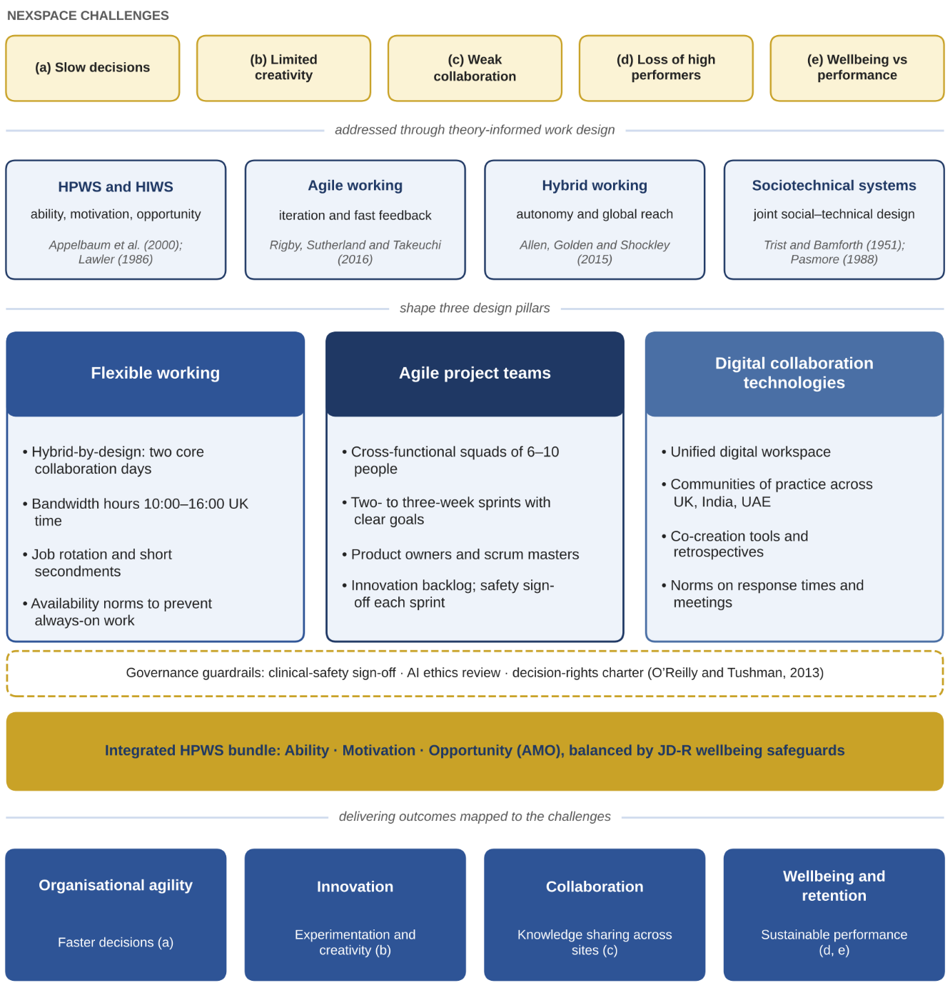
Figure 4: NexSpace Integrated Innovative Work Design Framework (Source: Author’s own synthesis, drawing on Appelbaum et al., 2000; Lawler, 1986; Rigby, Sutherland and Takeuchi, 2016; Allen, Golden and Shockley, 2015; Trist and Bamforth, 1951; O’Reilly and Tushman, 2013)

Pillar 2: Cross-Functional Agile Teams
Small, stable squads (6-10 people) should combine AI engineers, clinicians, UX designers, data scientists and implementation specialists. Working in two- to three-week sprints, teams would prototype features, test algorithms with partner hospitals and iterate based on feedback. Product owners would prioritise an innovation backlog, while scrum masters remove blockers.
This design operationalises:
- Organic structure (Burns and Stalker, 1961)
- High involvement (Lawler, 1986)
- Teaming (Edmondson, 2012)
- Ambidexterity (O’Reilly and Tushman, 2013)
Embedding regulatory and clinical-safety checks within each sprint’s “definition of done” ensures compliance without slowing innovation. Expected impacts include faster innovation cycles, fewer hierarchical delays and closer alignment with clinician and patient needs.

Pillar 3: Digital Collaboration Technologies
A unified digital workspace should integrate messaging, video, document sharing and project management. Digital communities of practice (Wenger, 1998) for AI engineers, clinicians and product managers would support knowledge sharing. Digital whiteboards would enable co-creation, while explicit norms on response times and documentation would reduce overload.

This aligns with:
- STS: technology must support social processes.
- Knowledge creation theory: converting tacit to explicit knowledge (Nonaka and Takeuchi, 1995).
Expected impacts include stronger knowledge sharing across countries, reduced duplication and more effective remote collaboration.

Together, these practices form a coherent HPWS/HIWS bundle in which flexibility, involvement and technology reinforce one another. When supported by wellbeing safeguards, they create an organisational environment where employees can innovate, collaborate and adapt. Addressing NexSpace’s challenges (a-e) and strengthening long-term competitive advantage.

Task B: Creating an Environment Where Talent Grows

1. How Organisations Create Environments Where Talent Flourishes
NexSpace’s loss of high performers (challenge d) and managers’ difficulty balancing wellbeing with performance (challenge e) indicate that the organisation is not yet converting human capital into sustained advantage. Human capital theory positions employee skills as assets that generate returns when invested in (Becker, 1964), while the resource‑based view argues that valuable, rare and hard‑to‑imitate talent drives competitive advantage (Barney, 1991). Strategic talent management therefore requires a differentiated focus on pivotal roles and a system for developing, engaging and retaining them (Collings and Mellahi, 2009). Job embeddedness theory reinforces this: employees stay when they experience strong fit, meaningful links and high perceived sacrifice (Mitchell et al., 2001). When growth pathways are unclear, fit weakens and the perceived sacrifice of leaving declines, making turnover more likely.
Senge’s (1990) learning organisation provides a foundational lens for understanding how talent flourishes. Its five disciplines: personal mastery, mental models, shared vision, team learning and systems thinking, embed learning into everyday work rather than occasional training. This is particularly relevant for NexSpace, where AI-enabled healthcare requires continuous upskilling in technical, clinical and ethical domains. However, critics argue that Senge’s model is idealistic and difficult to operationalise. Argyris and Schön’s (1978) distinction between single-loop and double-loop learning strengthens the framework: double-loop learning encourages employees to question underlying assumptions, such as whether an algorithm’s clinical objectives are appropriate, rather than merely correcting errors. This deeper learning is essential for innovation and ethical AI development.

Learning cannot occur without psychological safety. Edmondson (1999) defines psychological safety as a shared belief that the team is safe for interpersonal risk-taking asking questions, admitting mistakes, challenging decisions and offering ideas. It predicts learning behaviour, innovation and error reporting (Edmondson and Lei, 2014), all critical in a sector where patient safety and ethical AI are paramount. Kahn’s (1990) engagement theory complements this by identifying psychological safety, meaningfulness and availability as conditions for personal engagement. The JD‑R model further explains how supportive leadership acts as a resource that protects wellbeing (Bakker and Demerouti, 2007). For NexSpace, psychological safety directly addresses challenge (e): managers who can discuss workload openly can recalibrate expectations before burnout leads to resignations.
Employee Experience (EX) provides a holistic perspective on how employees interpret their work environment. EX integrates physical, cultural and technological elements that shape how employees feel, perform and grow. A positive EX strengthens job embeddedness, supports wellbeing and enhances discretionary effort. In NexSpace’s context, EX is weakened by limited growth opportunities, inconsistent collaboration across countries and unclear workload expectations. Strengthening EX requires redesigning work processes, leadership behaviours and learning systems to create an environment where employees feel valued, supported and able to develop. Job crafting theory completes the talent-flourishing framework by recognising employees as active shapers of their roles. Through task, relational and cognitive crafting, employees align their work with strengths, interests and values (Wrzesniewski and Dutton, 2001). Tims and Bakker (2010) reinterpret crafting through the JD-R model: employees seek resources, seek challenges and reduce hindering demands. Crafting supports autonomy and competence needs identified by Self-Determination Theory (Deci and Ryan, 2000), increasing engagement and retention. However, unmanaged crafting can create role ambiguity or uneven workloads, so it requires clear boundaries and manager dialogue.
Together, these theories show that talent flourishes when learning is continuous, psychological safety is strong, employee experience is positive and employees have agency to shape their roles. NexSpace must therefore build a strategic talent ecosystem that integrates these elements into daily work.
2. Talent Growth Strategy for NexSpace
Figure 5 conceptualises NexSpace’s strategic talent ecosystem, integrating learning organisation principles (Senge, 1990), psychological safety (Edmondson, 1999), employee experience (EX) and job crafting (Wrzesniewski and Dutton, 2001). The strategy aims to strengthen capability development, retention, wellbeing and innovation.

Building a Learning Organisation
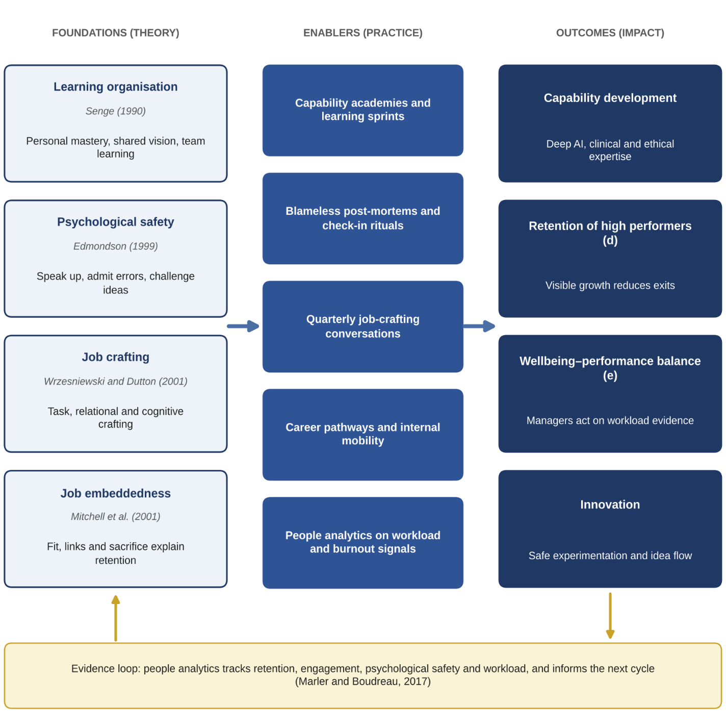
NexSpace should establish capability academies focused on AI and data science, clinical knowledge, product management, ethical AI and people analytics. These academies should use blended learning online modules, workshops, mentoring and project-based assignments. Learning must be embedded within agile teams through documented lessons learned, shared in communities of practice and periodic “learning sprints” exploring new technologies or clinical domains. Kolb’s (1984) experiential learning cycle: concrete experience, reflection, conceptualisation and experimentation should guide learning design. A shared talent vision, emphasising growth and safer, smarter healthcare, will align learning with organisational strategy. Systematic training also strengthens the “ability” component of the AMO framework (Appelbaum et al., 2000).
Figure 5: NexSpace Strategic Talent Ecosystem (Source: Author’s own synthesis, drawing on Senge, 1990; Edmondson, 1999; Wrzesniewski and Dutton, 2001; Mitchell et al., 2001; Marler and Boudreau, 2017)

Creating Psychological Safety and Wellbeing

Managers should be trained to model curiosity, admit mistakes, invite challenge and respond constructively to bad news. Regular check-in rituals: weekly pulse discussions, workload reviews and team retrospectives should normalise open dialogue. Small experiments such as A/B tests and pilots should be framed as learning opportunities, supported by blameless post-mortems that focus on insights rather than blame (Edmondson, 1999). People analytics should monitor workload indicators such as overtime, late-night working and meeting overload, enabling evidence-based adjustments to staffing and priorities (Marler and Boudreau, 2017). Because monitoring can feel intrusive, it must be transparent, aggregated where possible and governed by data-protection principles to maintain trust (Tursunbayeva, Di Lauro and Pagliari, 2018). Strengthening psychological safety will reduce burnout, improve engagement and support ethical decision-making in AI development.

Enabling Job Crafting and Career Pathways

Quarterly development conversations should include structured job-crafting discussions where employees identify tasks to expand, reduce or reshape. Managers should co-design feasible adjustments, ensuring alignment with team goals and regulatory requirements. Clear career pathways; for example, AI engineer → senior AI engineer → AI ethics lead, or clinical liaison → product owner → regional clinical director should be mapped and supported by an internal job board and short-term projects that allow employees to test new roles. Strengths-based assessments should guide project allocation. These measures strengthen fit, links and perceived sacrifice (Mitchell et al., 2001), enabling high performers to grow within NexSpace rather than exit. They also enhance EX by giving employees clarity, agency and meaningful progression.

Measuring Impact

Impact should be tracked through retention of high performers, internal mobility rates, psychological safety scores, engagement levels and workload indicators. These metrics should be reviewed in the same governance forum that oversees agile work systems, ensuring alignment between talent strategy and work design. Continuous monitoring will allow NexSpace to refine its talent ecosystem and maintain a healthy balance between wellbeing and performance.

Task C: Reflective Report

1. AI as a Strategic Decision-Support Tool in HRM

Artificial Intelligence is increasingly central to strategic HRM because it improves the quality and speed of decisions. People analytics can reveal patterns in engagement, burnout and skills gaps, while AI‑enabled talent systems support recruitment, mobility and personalised learning. Predictive analytics also strengthen workforce planning (Marler and Boudreau, 2017; Tambe et al., 2019). Yet AI carries ethical risks: algorithms may reinforce bias (Raghavan et al., 2020), employees expect transparent decisions (Floridi and Cowls, 2019), and automation can distort judgement. As a future HR professional, my responsibility is to interpret AI critically, challenge bias and ensure decisions remain human‑centred and compliant with regulations such as the Data Protection Act (2018).

2. Reflective Analysis: Three Examples of Using AI
I applied Gibbs’ (1988) reflective cycle to evaluate how AI supported and challenged my capability development.
Example 1: Literature search. AI helped me quickly identify key theories such as HPWS, HIWS, psychological safety and job crafting. This broadened my perspective and accelerated my initial research. However, I noticed myself trusting AI summaries too readily, which made me aware of my tendency to prioritise efficiency over depth. I learned that while AI is excellent for scanning, genuine academic understanding requires critical reading of original sources. Going forward, I will use AI only as a starting point, not a substitute for scholarly engagement.
Example 2: Structuring the assignment. AI provided a logical structure for Tasks A, B and C, improving clarity and ensuring alignment with the brief. Yet I realised that accepting AI-generated structures without questioning them risks weakening the argument’s relevance to the case study. This experience taught me to treat AI as a planning partner rather than an architect. I now consciously adapt AI suggestions to fit context, ensuring that my analytical voice remains central.
Example 3: Self-development insights. AI helped me identify emerging HR capabilities such as ethical AI governance, people analytics and strategic HR. Although the suggestions were helpful, some were generic and required filtering against my personal goals. This highlighted the importance of reflective judgement: AI can generate options, but only I can determine which capabilities align with my values and career direction.
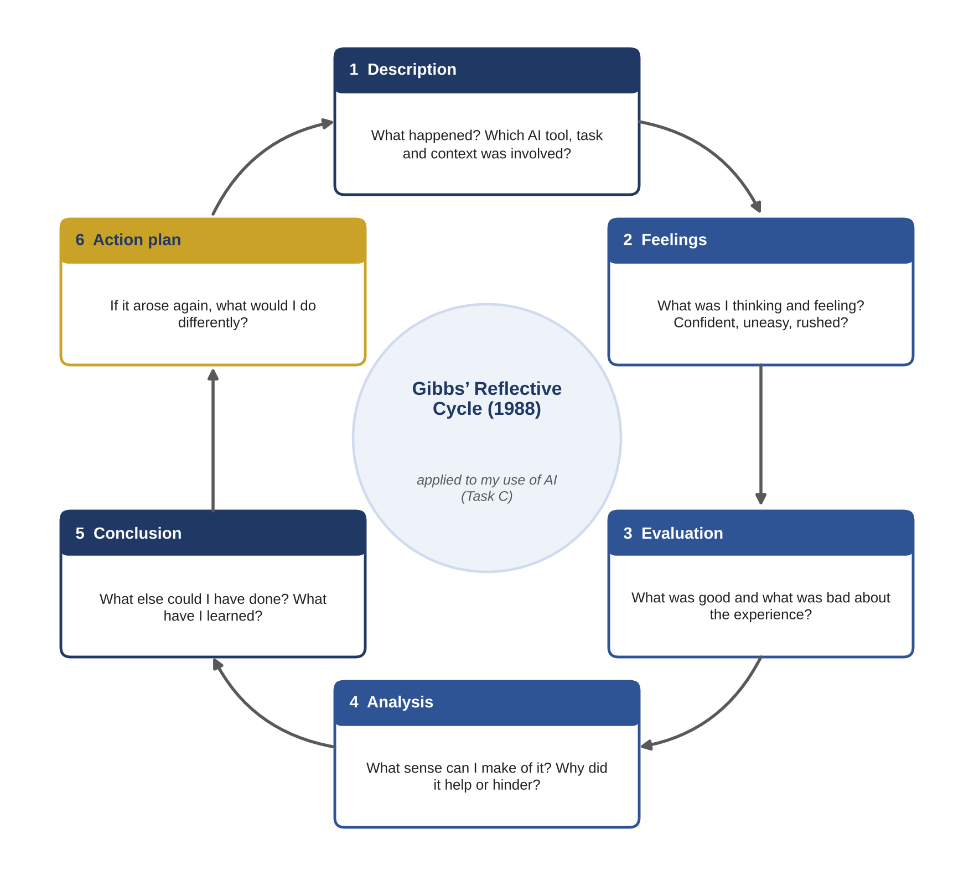
Figure 6: Gibbs’ Reflective Cycle Applied to My Use of AI (Source: Adapted from Gibbs, 1988)
Across these experiences, AI enhanced my efficiency and broadened my thinking, but also revealed the importance of critical evaluation, ethical awareness and human judgement, the foundations of responsible HR practice.
3. Personal Capability Development Plan
To strengthen my future employability, understood as the adaptive capacity to identify and realise career opportunities (Fugate, Kinicki and Ashforth, 2004), I will focus on three capability areas aligned with HR competencies at the intersection of people, business and technology (Ulrich et al., 2008):
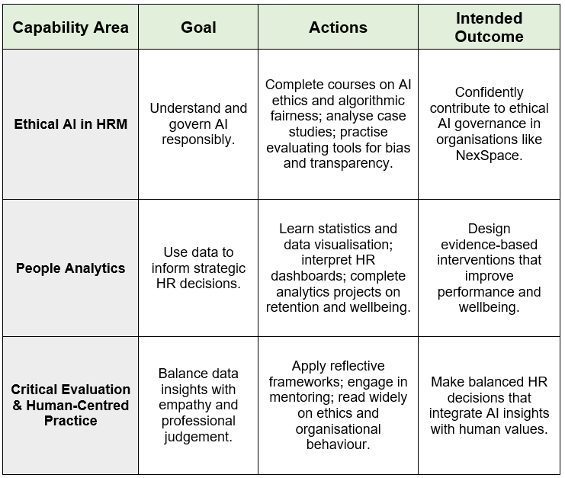
Table 1: Personal Capability Development Plan (Source: Author’s own analysis)

Together, these capabilities will enable me to act as a strategic, ethical and human‑centred HR professional capable of leveraging AI without losing sight of the people it affects.

References
Allen, T.D., Golden, T.D. and Shockley, K.M. (2015) ‘How effective is telecommuting? Assessing the status of our scientific findings’, Psychological Science in the Public Interest, 16(2), pp. 40-68.
Appelbaum, E., Bailey, T., Berg, P. and Kalleberg, A.L. (2000) Manufacturing advantage: Why high-performance work systems pay off. Ithaca, NY: Cornell University Press.
Argyris, C. and Schön, D.A. (1978) Organizational learning: A theory of action perspective. Reading, MA: Addison-Wesley.
Bakker, A.B. and Demerouti, E. (2007) ‘The job demands-resources model: State of the art’, Journal of Managerial Psychology, 22(3), pp. 309-328.
Barney, J. (1991) ‘Firm resources and sustained competitive advantage’, Journal of Management, 17(1), pp. 99-120.
Becker, B.E. and Huselid, M.A. (1998) ‘High performance work systems and firm performance: A synthesis of research and managerial implications’, Research in Personnel and Human Resources Management, 16, pp. 53-101.
Becker, G.S. (1964) Human capital: A theoretical and empirical analysis, with special reference to education. New York: Columbia University Press.
Boxall, P. and Purcell, J. (2016) Strategy and human resource management. 4th edn. London: Palgrave Macmillan.
Burns, T. and Stalker, G.M. (1961) The management of innovation. London: Tavistock.
Collings, D.G. and Mellahi, K. (2009) ‘Strategic talent management: A review and research agenda’, Human Resource Management Review, 19(4), pp. 304-313.
Data Protection Act (2018) c. 12. London: The Stationery Office.
Deci, E.L. and Ryan, R.M. (2000) ‘The “what” and “why” of goal pursuits: Human needs and the self-determination of behavior’, Psychological Inquiry, 11(4), pp. 227-268.
Demerouti, E., Bakker, A.B., Nachreiner, F. and Schaufeli, W.B. (2001) ‘The job demands-resources model of burnout’, Journal of Applied Psychology, 86(3), pp. 499-512.
Dietvorst, B.J., Simmons, J.P. and Massey, C. (2015) ‘Algorithm aversion: People erroneously avoid algorithms after seeing them err’, Journal of Experimental Psychology: General, 144(1), pp. 114-126.
Edmondson, A. (1999) ‘Psychological safety and learning behavior in work teams’, Administrative Science Quarterly, 44(2), pp. 350-383.
Edmondson, A.C. (2012) Teaming: How organizations learn, innovate, and compete in the knowledge economy. San Francisco: Jossey-Bass.
Edmondson, A.C. and Lei, Z. (2014) ‘Psychological safety: The history, renaissance, and future of an interpersonal construct’, Annual Review of Organizational Psychology and Organizational Behavior, 1, pp. 23-43.
Floridi, L. and Cowls, J. (2019) ‘A unified framework of five principles for AI in society’, Harvard Data Science Review, 1(1).
Fugate, M., Kinicki, A.J. and Ashforth, B.E. (2004) ‘Employability: A psycho-social construct, its dimensions, and applications’, Journal of Vocational Behavior, 65(1), pp. 14-38.
Gibbs, G. (1988) Learning by doing: A guide to teaching and learning methods. Oxford: Further Education Unit, Oxford Polytechnic.
Gibson, C.B. and Gibbs, J.L. (2006) ‘Unpacking the concept of virtuality: The effects of geographic dispersion, electronic dependence, dynamic structure, and national diversity on team innovation’, Administrative Science Quarterly, 51(3), pp. 451-495.
Kahn, W.A. (1990) ‘Psychological conditions of personal engagement and disengagement at work’, Academy of Management Journal, 33(4), pp. 692-724.
Kelliher, C. and Anderson, D. (2010) ‘Doing more with less? Flexible working practices and the intensification of work’, Human Relations, 63(1), pp. 83–106.
Kolb, D.A. (1984) Experiential learning: Experience as the source of learning and development. Englewood Cliffs, NJ: Prentice Hall.
Lawler, E.E. (1986) High-involvement management. San Francisco: Jossey-Bass.
Lepak, D.P. and Snell, S.A. (1999) ‘The human resource architecture: Toward a theory of human capital allocation and development’, Academy of Management Review, 24(1), pp. 31-48.
Marler, J.H. and Boudreau, J.W. (2017) ‘An evidence-based review of HR analytics’, The International Journal of Human Resource Management, 28(1), pp. 3-26.
Mitchell, T.R., Holtom, B.C., Lee, T.W., Sablynski, C.J. and Erez, M. (2001) ‘Why people stay: Using job embeddedness to predict voluntary turnover’, Academy of Management Journal, 44(6), pp. 1102-1121.
Nonaka, I. and Takeuchi, H. (1995) The knowledge-creating company. New York: Oxford University Press.
O’Reilly, C.A. and Tushman, M.L. (2013) ‘Organizational ambidexterity: Past, present, and future’, Academy of Management Perspectives, 27(4), pp. 324-338.
Parasuraman, R. and Manzey, D.H. (2010) ‘Complacency and bias in human use of automation: An attentional integration’, Human Factors, 52(3), pp. 381-410.
Pasmore, W.A. (1988) Designing effective organizations: The sociotechnical systems perspective. New York: Wiley.
Raghavan, M., Barocas, S., Kleinberg, J. and Levy, K. (2020) ‘Mitigating bias in algorithmic hiring’, Proceedings of the 2020 Conference on Fairness, Accountability, and Transparency, pp. 469-481.
Rigby, D.K., Sutherland, J. and Takeuchi, H. (2016) ‘Embracing agile’, Harvard Business Review, 94(5), pp. 40-50.
Schön, D.A. (1983) The reflective practitioner. New York: Basic Books.
Senge, P.M. (1990) The fifth discipline. New York: Doubleday.
Spreitzer, G.M. (1995) ‘Psychological empowerment in the workplace: Dimensions, measurement, and validation’, Academy of Management Journal, 38(5), pp. 1442-1465.
Tambe, P., Cappelli, P. and Yakubovich, V. (2019) ‘Artificial intelligence in human resources management’, California Management Review, 61(4), pp. 15-42.
Tims, M. and Bakker, A.B. (2010) ‘Job crafting: Towards a new model of individual job redesign’, SA Journal of Industrial Psychology, 36(2), pp. 1-9.
Trist, E.L. and Bamforth, K.W. (1951) ‘Some social and psychological consequences of the longwall method of coal-getting’, Human Relations, 4(1), pp. 3-38.
Tursunbayeva, A., Di Lauro, S. and Pagliari, C. (2018) ‘People analytics: A scoping review’, International Journal of Information Management, 43, pp. 224-247.
Ulrich, D., Brockbank, W., Johnson, D., Sandholtz, K. and Younger, J. (2008) HR competencies. Alexandria, VA: SHRM.
Wenger, E. (1998) Communities of practice. Cambridge: Cambridge University Press.
Wrzesniewski, A. and Dutton, J.E. (2001) ‘Crafting a job’, Academy of Management Review, 26(2), pp. 179-201.

Appendix

Appendix A: Statement on the Use of Generative AI
Generative AI tools (Microsoft Copilot and ChatGPT) were used to support early-stage thinking for this report. AI assisted in clarifying theoretical concepts, identifying relevant academic frameworks, and suggesting initial structural outlines for Tasks A, B and C. AI also supported brainstorming during the development of the innovative work design, talent ecosystem and capability development plan.
Because generative AI can produce inaccurate or fabricated citations, every reference included in this report was independently verified using academic databases, publisher records or library catalogues. All arguments, interpretations and final wording were produced through critical evaluation and manual refinement by the author. AI was used as a supplementary thinking aid, not as a source of academic authority.
The author retains full responsibility for the originality, accuracy, critical analysis and academic integrity of this report.

Appendix B: Integrated 12-Month Strategic Roadmap
This roadmap integrates the recommendations from Task A (Innovative Working Practices), Task B (Talent Growth Strategy) and Task C (Reflective Capability Development) into a coherent, phased 12-month transformation plan. The sequence prioritises diagnostics, safeguards, learning systems, agile structures and leadership capability ensuring that innovation, wellbeing and regulatory compliance develop together.

Table 2: NexSpace 12-Month Integrated Transformation Roadmap
Months | Phase | Key Actions | Success Indicators
1-2 | Diagnose & Safeguard | • Conduct baseline diagnostics: attrition, cycle time, collaboration network, workload patterns. • Run psychological safety survey and manager briefings. • Perform bias audits on HR analytics and AI-supported decision tools. • Map regulatory constraints into decision-rights matrix. | • Diagnostic baselines approved by governance forum. • Bias audit completed with mitigation plan. • Psychological safety baseline established.
3-5 | Launch Structures | • Pilot cross-functional pods and global guilds. • Implement unified digital workspace and documentation norms. • Finalise hybrid charter (anchor days + bandwidth hours). • Launch NexSpace Growth Academy (AI, clinical, product, ethics). | • Pods operating with sprint cadence. • Guild participation rates. • Charter adoption across UK-India-UAE. • Academy enrolment and completion rates.
5-7 | Embed Flexibility, Autonomy & Trust | • Introduce stretch roles and short secondments. • Implement human-in-the-loop oversight for AI HR tools. • Begin structured job-crafting conversations. • Establish availability norms to prevent intensification. | • Stretch roles filled. • Human override rate monitored. • Job-crafting adjustments documented. • Reduction in late-night working.
7-9 | Pilot, Evaluate & Adjust | • Evaluate pods, hybrid model and guilds against baseline metrics. • Launch internal talent marketplace for short-term projects. • Run reflective practice workshops for managers (Gibbs, Kolb, Schön). • Review workload indicators using people analytics. | • Improvement in cycle time and collaboration density. • Increase in mobility applications. • Psychological safety score improvement. • Reduced overtime and meeting overload.
9-12 | Scale & Sustain | • Scale pods across product lines. • Expand Growth Academy modules and mentoring. • Launch coaching programme aligned with Ulrich et al. (2008) competencies. • Integrate talent ecosystem metrics into quarterly governance reviews. | • Retention of high performers. • eNPS improvement. • Delivery speed and clinical-quality indicators. • Increased internal promotions and mobility.

Appendix C: Alignment of Roadmap with Theoretical Foundations
This appendix strengthens academic rigour by explicitly linking each roadmap phase to the theories used in Tasks A, B and C.

1. Diagnostics & Safeguards (Months 1-2)
- JD-R Model: Identifies demands (workload, time pressure) and resources (autonomy, support).
- Ethical AI (Floridi & Cowls, 2019; Raghavan et al., 2020): Bias audits ensure fairness and transparency.
- Psychological Safety (Edmondson, 1999): Baseline measurement enables targeted interventions.

2. Launch Structures (Months 3-5)
- HIWS & SDT: Pods and guilds increase autonomy, competence and relatedness.
- STS Theory: Digital workspace + norms = joint optimisation of social and technical systems.
- Ambidexterity (O’Reilly & Tushman, 2013): Pods support exploration while platform teams support exploitation.

3. Embed Flexibility & Trust (Months 5-7)
- AMO: Hybrid charter increases opportunity; stretch roles increase ability; autonomy increases motivation.
- Job Crafting (Wrzesniewski & Dutton, 2001): Structured crafting supports engagement and retention.
- Human-in-the-loop AI: Maintains ethical judgement and regulatory compliance.

4. Pilot & Evaluate (Months 7-9)
- Learning Organisation (Senge, 1990): Reflection, feedback loops and shared learning.
- Kolb (1984) & Gibbs (1988): Experiential learning embedded in retrospectives and workshops.
- People Analytics (Marler & Boudreau, 2017): Evidence-based adjustments to workload and staffing.

5. Scale & Sustain (Months 9-12)
- Resource-Based View (Barney, 1991): Developing rare, valuable talent capabilities.
- Job Embeddedness (Mitchell et al., 2001): Clear pathways and coaching strengthen fit, links and sacrifice.
- Ulrich et al. (2008): Leadership competencies embedded into coaching and development.

Appendix D: Expanded Capability Development Plan
This appendix deepens Task C by showing how your personal development aligns with NexSpace’s transformation.

Capability Area 1: Ethical AI & People Analytics
- Complete courses on algorithmic fairness, bias mitigation and HR analytics.
- Apply learning through small projects analysing workload, burnout and mobility patterns.
- Shadow data governance meetings to understand regulatory constraints.

Capability Area 2: Strategic HR & Organisational Design
- Study agile HR, sociotechnical systems and ambidexterity.
- Participate in cross-functional pods to experience organic structures.
- Lead a mini-project redesigning a workflow using JD-R and SDT principles.

Capability Area 3: Human-Centred Leadership
- Train in coaching (Whitmore, 2017), psychological safety and reflective practice.
- Facilitate retrospectives and learning sprints.
- Build competence in conflict resolution and cross-cultural communication (UK-India-UAE).

