
Name  Student id | Meet Dineshbhai Malani  2504764
Module: | Marketing Management
Module code: | LCMB7024
Lecturer: | Dian Mayasari (Birmingham) | Internal Verifier: | Vasilios Tavlaridis/ Hoang Dang Nguyen
Assignment Title: | Assessment component 2:  Marketing Portfolio

Table of Contents
Introduction 2
Element 1: Segmentation, Targeting, Differentiation, and Positioning (STDP) Analysis for a New Brand Concept 2
Element 2: 4P marketing mix 6
Element 3: Marketing Strategy Pitch 9
Element 4: Reflection 10
Conclusion 11
Reference list 12

Introduction
The given proposal seeks to create a new protein-based brand, M&S PROVIA. The brand will consider detailed analysis using STP analysis and 4Ps marketing mix as part of a comprehensive brand development strategy.

Element 1: Segmentation, Targeting, Differentiation, and Positioning (STDP) Analysis for a New Brand Concept
Marks and Spencer (M&S) is an old UK retailer that has a very clear strategic direction in healthier and sustainable food lines. PROVIA - Protein Vitality Range - is a high-end M&S sub-brand, which delivers high-protein, and clean-label foods (RTD shakes, high-protein yoghurts, snack bars and balanced ready meals) based on natural protein sources with pea, oat, whey where applicable. This product comes with added functionality that includes probiotics, fibre and recyclable packaging (M&S, 2024). This is directly positioned at the heart of M&S in their Health and Wellbeing pledges and in their Plant Kitchen/ healthy ranges.
Reason for selecting PROVIA
Protein and functional foods have transitioned into the mainstream within the country of the UK. This functional-foods market was already multi-billion-dollar in 2023 and expected to expand at a rapid pace, indicating that innovation based on proteins is clearly open to opportunity (grandviewresearch, 2025).
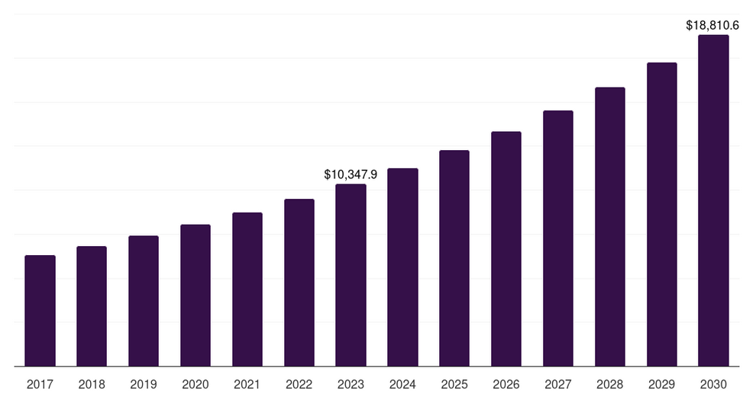
Figure 1: Functional food market in UK
(Source: grandviewresearch, 2025)
On the shopper level, a current UK awareness indicates that high proportions of customers is already adding or are intending to add more protein to their diets. As per the study done by AHDB, about 28% said they were already actively adding protein to their diets, and a second group was planning to add it (ahdb, 2025). This indicates post-2020 lifestyle and health preoccupations convenience, gut health and muscle preservation at any age. The market in the UK also has one of the fastest-growing plant-based proteins retailers, which will provide PROVIA with a chance to combine animal- and plant-based proteins under a single quality umbrella (IMARC, 2025).The younger generations, in particular the Gen Z and younger millennial generations, are highly health-conscious and focus on sustainability and functionality during their food purchases. Hence, they are seeking high-protein diets and products positioned as wellness-related.
Segmentation
The differentiated segmentation strategy taken by PROVIA focuses on different segments that it gets with varied messages and product variants. The value propositions given to each of the segments differ slightly such as high-protein content which will appeal to athletes, balanced nutrition suits professionals (Reitano et al. 2024). Plant-based innovation that will suit flexitarians, and family health for parents.This allows M&S to expand its market base without losing its unified brand identity of the best protein nutrition based on everyday and premium protein foods.
- Health & fitness active people who go to the gym regularly and are amateur athletes interested in muscle recovery and performance nutrition.
- Professionals or commuters that are time-starved yet also require convenient, nutritionally complete food and on-the-go shakes.
- Flexitarian are those who are plant-forward consumers, those who are interested in the concept of plant proteins and sustainability based on plant-based meals, pea/oat shakes (Hess, Robinson and Scheett, 2025).
- Wellness seekers and functional shoppers focus on wellness on probiotics, guts and clean.
- Parents who purchase healthier alternatives to children and households are family shoppers.
Targeting
The main audience for this product can be young and health-aware urban high professionals (18-35 years old) with active lifestyles, but concerned about sustainability and seeking convenient and high quality nutrition. It is a group of early adopters of new formats (RTD, high-protein yoghurts, bars), and is socially influential. Secondary target has been with busy working people (35 to 50) who need to have healthier convenience food and suitable protein sources for the family. Hence, this will follow a differentiated targeting strategy that will focus on two distinct consumer groups.
Differentiation
The main differentiation is similar credentials of M&S premium food and modern functional-nutrition that is transparent macros per portion, clean ingredient lists, a mixed-protein strategy and visible sustainability claims. PROVIA follows a differentiation strategy based on every day integration architecture that is based on branding and marketing. Unlike specialist-sports brands who typically look at supplements, PROVIA looks at the day-to-day food types appropriate to both everyday meals and snacks. This broadened its market beyond hardcore athletes.
Positioning

Everyday protein, premium taste, nutrition that fits life is on-line for the new brand. The positioning strategy is based on psychographic positioning attributes. PROVIA will be located in the middle of premium grocery and functional nutrition which is greater perceived quality and taste than sports supplement brands, but more functional and protein-focused than ordinary supermarket ready meals. This capitalizes on the M&S trust and grabs the growing UK market of protein and functional foods.
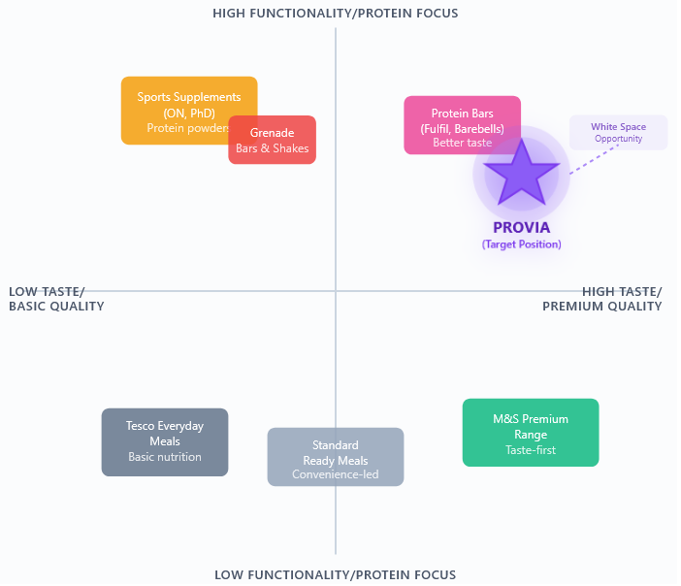
Figure 2: Perceptual positioning map
STDP analysis shows that PROVIA has the opportunity to exploit the increasing demand of functional, protein rich and sustainability food products in the UK market. The segmentation is effective to reach a wide range of health-conscious patrons, and targeting Gen Z and millennials is in line with the current trend in wellness and lifestyle (Sadom, Farzana Quoquab and Mohammad, 2025). PROVIA will identify a distinct niche between daily convenience and high nutrition, based on the trusted quality and clean-label innovation, as well as sustainability credentials of M&S. Such positioning enhances the leadership of M&S in the market, which is dynamic in health and vitality food.

Element 2: 4P marketing mix
Product
The SKU list for the will consist of ready-to-drink (RTD) protein shakes, high-protein snack bars (top protein, on average 20 g), high-protein yoghurts with added probiotics, and ready meals with high protein content (e.g., chicken and quinoa bowls, plant-protein lentil bowls). The brand strategy of everyday protein, premium taste, sustainable living is backed with the product design. Functional/ specialised nutrition has a good growth in the UK market. For example, the UK specialised nutrition market which is largest at USD 6,158.6 million in 2024 and will increase to USD 9,518.7 million in 2030 (grandviewresearch, 2025b). Additionally, the UK healthy snacks market is projected to be USD 3.00 billion in 2024, and the offer of high-protein foods is mentioned as one of the strong examples of market development.
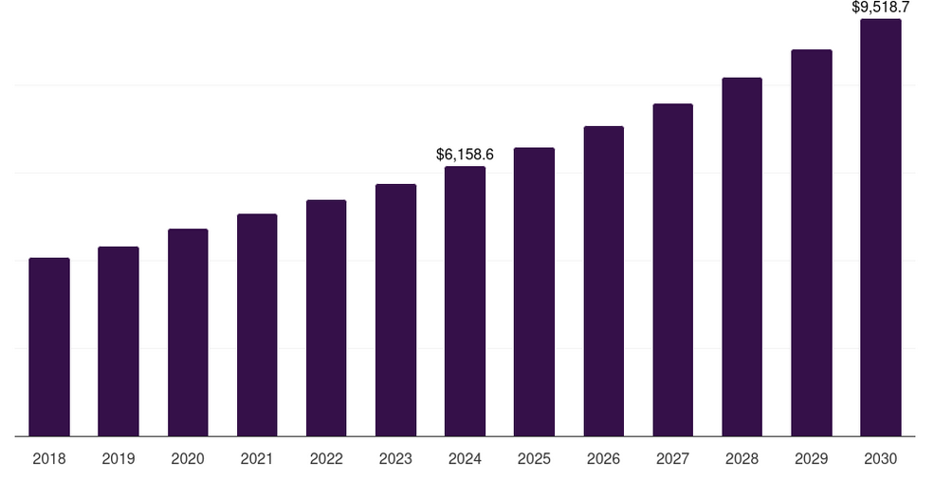
Figure 3: Nutrition market of the UK
(Source: grandviewresearch, 2025b)
In terms of branding, the items will have clean-label ingredients (no artificial additives, clearly indicated protein levels and macronutrients) and claims of recyclability packaging and responsible sourcing. This goes with the new consumer behaviour which focuses on health, convenience and sustainability. The premium feature of M&S and the positioning of the PROVIA implies that the sensory attributes (taste, texture, variety of flavours) should be high to make consumers perceive that they are purchasing more than a generic protein bar. The product range will address several use-cases that are beneficial in terms of segmentation and targeting strategy as the product range targets not only hardcore gym users but also time-pressed professionals and wellness-oriented shoppers (Voráček, Čáslavová and Šíma, 2020). Lastly, innovation within the product range will fit into the brand differentiation of offering functional nutrition and combining it with the convenience of everyday and the luxury of high-quality food.
Price
The pricing of PROVIA would be based on its competitors which will consider the high quality and level of functional ingredients and sustainability but also needs to be competitive to the extent that it will attract the target segments to try and adopt the product. The UK grocery industry is experiencing the pressure of the cost-of-living and inflation. According to one source, 28% of UK grocery baskets are now composed of promotional goods, and 40% of UK shoppers only purchase grocery products when being promoted (internationalsupermarketnews, 2023). And grocery inflation has been observable: the UK Office for National Statistics figures demonstrate that the prices of most of the daily food products are on the increase. This implies that consumers are ready to buy premium, more functional and higher-quality food, but they are price-sensitive and value-oriented.
Therefore, the pricing strategy can include a price range £2 for 20g for PROVIA protein bar which will be close to the competitor price at around £2.79. In the case of RTD shakes and ready meals the premium margin will be increased, although this will be compensated under the functional and brand trust. Further, the pricing strategy will involve deals and promotions to attract trial, pay-off loyalty and get listed in shops.
Moreover, the pricing policy will consist of introductory offers/promotions (e.g., bundle offers -bar + shake) in order to facilitate trial, pay-off loyalty, and gain listing in retailers. Since the UK customers are accustomed to the offers and bargain deals, the promotional pricing will help to enter the brand and adopt it without damaging the high positioning permanently.
Place
PROVIA will also use the existing M&S multi-channel retail presence: (1) M&S physical stores (food halls and M&S Simply Food convenience stores), (2) M&S online grocery/e-commerce platform (M&S.com and M&S Food delivery), (3) chosen third-party online groceryers (e.g., Ocado) and (4) complementary channels (e.g. gyms/fitness-centres pop-up and corporate wellness deals).
The online grocery and convenience snacking trend is robust in the UK. The data of the healthy snacks growth focused on e-commerce growth as a factor (imarcgroup, 2023). Having both an in-store and online presence means that PROVIA reaches the target audiences (urban professionals, younger consumers) at the point at which they shop: convenience, click and collect, delivery, and impulse retailing. Moreover, the retailing in marketplaces as a premium brand strengthens the quality of the brand.
In-store, the physical shelving will support the positioning of functional snack/meal by erecting eye-level shelving in the health/nutrition snack aisle, and cross merchandising in fitness/meal-solutions departments. Online, specific landing pages will be created with names such as Protein and vitality landing pages, subscription kits and sample kits will increase exposure. Alternative approaches that the brand can employ include store-within-store (M&S health/active category) or shop-in-shop at partner gyms. Notably, place strategy is consonant with brand promise of daily convenient and high-quality access. Its presence in mainstream retail (not just in the specialized sports nutrition stores) will help to reach a wider audience and make PROVIA an everyday protein brand rather than a niche one.
Promotion
The promotion mix will aim at creating awareness on the functional-nutrition credentials, premium quality, sustainability story and daily convenience that PROVIA offers. The main promotional levers: online promotion (social media influencers, in particular, fitness/wellness micro-influencers), in-store promotion (sponsorship of fitness events, wellness fairs), partnerships with gyms/workspaces, in-store point-of-sale (POS) displays and online content (recipes, user stories).
Considering the UK consumer behaviour, the younger consumers (18-35) are driven by the trends in social media on high-protein, natural, and clean snacks. Thus, promotions run by influencers and filled with content find a response in the key target. It will also be advertised by the use of introductory product bundles such as ‘Try the PROVIA Starter Pack’.
The message that PROVIA will deliver in the form of highlighting 20 g protein per portion, blend of plants and dairy, no artificial additives, recyclable pack, and will help underline differentiation. Communications will make PROVIA seem like functional food in active life, taste in everyday life and trust. In-store taste stations (trial, gym giveaways) will be supported by sampling efforts.

Element 3: Marketing Strategy Pitch
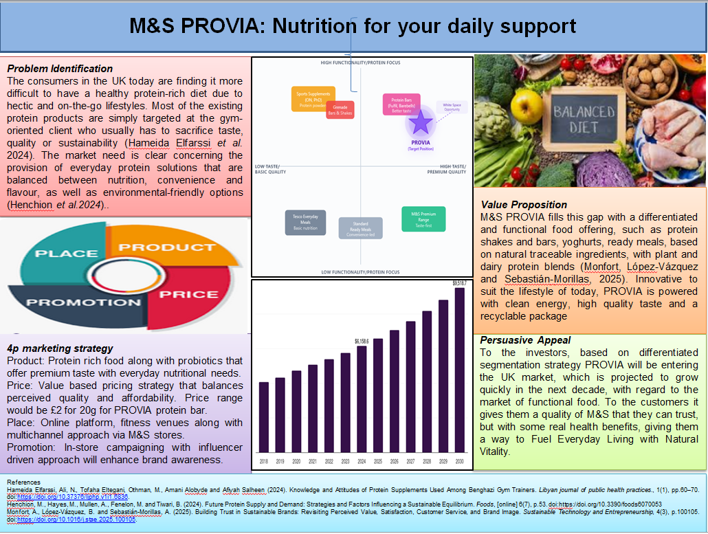
Problem Identification
The consumers in the UK today are finding it more difficult to have a healthy protein-rich diet due to hectic and on-the-go lifestyles. Most of the existing protein products are simply targeted at the gym-oriented client who usually has to sacrifice taste, quality or sustainability (Hameida Elfarssi et al. 2024). The market need is clear concerning the provision of everyday protein solutions that are balanced between nutrition, convenience and flavour, as well as environmental-friendly options (Henchion et al.,2024).
Value Proposition
M&S PROVIA fills this gap with a differentiated and functional food offering, such as protein shakes and bars, yoghurts, ready meals, based on natural traceable ingredients, with plant and dairy protein blends (Monfort, López-Vázquez and Sebastián-Morillas, 2025). Innovative to suit the lifestyle of today, PROVIA is powered with clean energy, high quality taste and a recyclable package.
4p marketing strategy
Product: Protein rich food along with probiotics that offer premium taste with everyday nutritional needs.
Price: Value based pricing strategy that balances perceived quality and affordability.
Place: Online platform, fitness venues along with multichannel approach via M&S stores.
Promotion: In-store campaigning with influencer driven approach will enhance brand awareness.
Persuasive Appeal
To the investors, PROVIA will be entering the UK market, which is projected to grow quickly in the next decade, with regard to the market of functional food. To the customers it gives them a quality of M&S that they can trust, but with some real health benefits, giving them a way to Fuel Everyday Living with Natural Vitality.

Element 4: Reflection
Reflecting on Brand Concept Development
The creation of the new brand concept M&S PROVIA became a learning experience that contributed to my enrichment and deepened my comprehension of the connection between strategic brand development and the needs of the consumers and market trends. I started by defining an actual issue in the UK food industry, namely the unavailability of daily, quality protein choices, that address health, flavor, and sustainability. The interpretation of this insight into a concise value proposition involved a lot of research work on the existing data in the UK market and changing consumer behaviour (Rintamäki and Saarijärvi, 2021). I understood that it is highly important to base creative ideas on evidence-based analysis. The development of PROVIA enabled me to combine creativity and strategy, creating a brand that was not only a solution to a void in the market but also enhanced the responsibility of M&S to health and wellbeing.
The Retrospective of the Marketing Strategy Creation
The development of the marketing plan also made me sharpen my analytical and planning abilities. Application in the STDP framework and the 4ps marketing mix helped me to understand the way to design a holistic brand strategy that guarantees a consistency between the segmentation, targeting and positioning, and the tactical marketing components. I also got to know how to strike a balance between aspirational branding and practical application - everything that a marketer makes, whether it comes to pricing or promotion, has to be based on the overarching brand promise. Another aspect of the process that enhanced my skills in professional marketing practice is that I am now able to interpret market statistics correctly and apply them to persuade my strategic decisions.
Consideration of Making the Pitch and Pitching
The process of preparing and presenting the marketing strategy pitch pushed me to the limits of communicating the strategy on paper and not just an audience-driven message. I got to understand that a powerful pitch is based not only on facts, but also clarity, narration, and confidence. One of the main skills I got was simplifying complex market knowledge into investor-friendly language. In the pitch, I was paying attention to a manner in which I addressed the Uniqueness of PROVIA as a solution to a real consumer issue and yet in a manner that was palatable to both customers and stakeholders. The experience has enhanced my presentation and communication skills especially in engagement and professionalism.
Critical Reflection and Future Improvement
In the course of this project, I realised the necessity to combine creativity and data analysis with the presentation delivery into a unified strategy. Nevertheless, when working on future projects, I would improve my practice by performing primary consumer research to reinforce the insight validity. I would also practice my pitch presentation in more detail so as to be better timed and emotional. In general, the experience has helped me improve my strategic thinking, market analysis, and communication skills to a considerable extent, as well as equip me in the future with the capacity to perform at the brand management and marketing consultancy levels.

Conclusion
This study highlights product development named PROVIA for M&S that critically reflects on the efficient brand strategy based on innovation, sustainability along with the approach of customer centricity. This new product will address the emerging UK dietary trends which are focused as per functionally, health and convenience.

Reference list

ahdb (2025). Consumers demand natural, high protein dairy products | AHDB. [online] Ahdb.org.uk. Available at: https://ahdb.org.uk/consumer-insight-consumers-demand-natural-high-protein-dairy-products. [Accessed 30 Oct. 2025]
grandviewresearch (2025a). UK Functional Foods Market Size & Outlook, 2030. [online] Grandviewresearch.com. Available at: https://www.grandviewresearch.com/horizon/outlook/functional-foods-market/uk. [Accessed 30 Oct. 2025]
grandviewresearch (2025b). UK Specialized Nutrition Market Size & Outlook, 2030. [online] Grandviewresearch.com. Available at: https://www.grandviewresearch.com/horizon/outlook/specialized-nutrition-market/uk [Accessed 30 Oct. 2025].
Hameida Elfarssi, Ali, N., Tofaha Eltegani, Othman, M., Amani Alobyde and Afiyah Salheen (2024). Knowledge and Attitudes of Protein Supplements Used Among Benghazi Gym Trainers. Libyan journal of public health practices., 1(1), pp.60–70. doi:https://doi.org/10.37376/ljphp.v1i1.6836.
Henchion, M., Hayes, M., Mullen, A., Fenelon, M. and Tiwari, B. (2024). Future Protein Supply and Demand: Strategies and Factors Influencing a Sustainable Equilibrium. Foods, [online] 6(7), p.53. doi:https://doi.org/10.3390/foods6070053
Hess, J.M., Robinson, K. and Scheett, A.J. (2025). Vegetarianísh—How ‘Flexitarian’ Eating Patterns Are Defined and Their Role in Global Food-Based Dietary Guidance. Nutrients, [online] 17(14), p.2369. doi:https://doi.org/10.3390/nu17142369.
IMARC (2025). UK Plant-Based Food Market 2033. [online] Imarcgroup.com. Available at: https://www.imarcgroup.com/uk-plant-based-food-market. [Accessed 30 Oct. 2025]
imarcgroup (2023). UK Healthy Snacks Market 2033. [online] Imarcgroup.com. Available at: https://www.imarcgroup.com/uk-healthy-snacks-market. [Accessed 30 Oct. 2025]
internationalsupermarketnews (2023). 28% of UK grocery baskets are now made up of promotional purchases as price-sensitive Brits battle cost-of-living pressures. [online] Internationalsupermarketnews.com. Available at: https://internationalsupermarketnews.com/28-of-uk-grocery-baskets-are-now-made-up-of-promotional-purchases-as-price-sensitive-brits-battle-cost-of-living-pressures/ [Accessed 30 Oct. 2025].
M&S (2024). Health & Wellbeing. [online] Marks & Spencer. Available at: https://corporate.marksandspencer.com/sustainability/our-products/health-wellbeing. [Accessed 30 Oct. 2025]
Monfort, A., López-Vázquez, B. and Sebastián-Morillas, A. (2025). Building Trust in Sustainable Brands: Revisiting Perceived Value, Satisfaction, Customer Service, and Brand Image. Sustainable Technology and Entrepreneurship, 4(3), p.100105. doi:https://doi.org/10.1016/j.stae.2025.100105.
Reitano, M., Selvaggi, R., Chinnici, G., Pappalardo, G., Yagi, K. and Pecorino, B. (2024). Athletes preferences and willingness to pay for innovative high-protein functional foods. Appetite, [online] 203, p.107687. doi:https://doi.org/10.1016/j.appet.2024.107687.
Rintamäki, T. and Saarijärvi, H. (2021). An integrative framework for managing customer value propositions. Journal of Business Research, [online] 134(134), pp.754–764. doi:https://doi.org/10.1016/j.jbusres.2021.05.030.
Sadom, M., Farzana Quoquab and Mohammad, J. (2025). ‘Nourish to flourish’: boosting functional food and socially conscious purchase of Gen-Y and Gen-Z consumers. British Food Journal. doi:https://doi.org/10.1108/bfj-09-2024-0902.
Voráček, J., Čáslavová, E. and Šíma, J. (2020). Segmentation in sport services: a typology of fitness customers. AUC KINANTHROPOLOGICA, 51(2), pp.32–47. doi:https://doi.org/10.14712/23366052.2015.30.

