Understanding and engaging in the customer experience:
BMSW5103 8 September 2021

Natasha Brookes (1806574)

Molly Jack

Contents
Abstract
Introduction
History of Tesco
Creating official name of Tesco
Customer CRM
Strategic CRM
Customer experience
CEM or CRM Experience
Michael porter Five forces
Five forces
Pestle
Marketing Mix
SWOT
Recommendations
Conclusions
References

Abstract:
The research in this report will be focused on analysing the impact of relationship marketing and customer loyalty considered through Tesco plc. First, I will be discussing relationship marketing and partly discuss the relation between cost, loyalty and overall customer interaction. Relationship marketing is based on trust communication, commitment and a promised fulfilment for the customer’s needs. What systems have been implemented to further enhance relationship marketing? Customer’s loyalty schemes that are executed in different supermarkets, this research will investigate whether loyalty systems contribute to customer loyalty having an impact on overall sales, rapport with the company itself and do the benefits through loyalty schemes work to improve customer satisfaction as a result.

Introduction
Relationship marketing is very important in this fast modern world since consumers all around the world are seeking more sophisticated ways of seeking out knowledge on the products and services they desire and as a result and further looking for better offers. This forces customers and therefore marketers to know other choices than have previously ever been available.
Since its culmination the retail market has now reached an unprecedented number of options available to the customer, as a result, this ever-changing and (exponentially) growing market is providing more to customers of every type worldwide.
Retailers are focusing on relationship marketing more now than ever, it being an efficient and proven way of establishing a bond with the customer effectively (if done correctly) it can be a reliable way of generating an innumerable amount of reliable commerce. Tesco’s place in the current UK market is among the highest in the region, therefore they hold several advantages which will lead to or in this case maintain long-term growth in the market and help it keep its continued place. Building and maintaining relationships have a long-term influence, this needs implication with a strategic marketing plan. To maintain an influence on individual customers most importantly is to attract customers and build a relationship of respect for customer loyalty. Once reliable communication is established trust and an emphasis on keeping the shopping experience content for the customer can be further expanded on, not only making the customer’s life easier but ensuring that the company keeps another customer reliably seeking them out for (in this instance) commerce.
History of Tesco
Tesco’s first opened by Jack Cohen back in 1919 it first started with a small grocery stool which is based in the east end of London which became a great success. After that was established, the business continued to expand into a brand in 1924. (Tesco, 2021)
Creating official name as TESCO
Tesco’s was introduced by the founder creating the label by using the supplier’s first name initial which is TES, then he went on to use his own initials, which was CO.
The name first originated from the sales of a private-label brand of tea which had the initials T.E this was where T.E Stockwell was established back in 1947. It first started with a small self-help store which was based in Hertfordshire.

Tesco introduced its own brand of private label products that came about after long extensive research.
In 2000 it launched its own e-commerce business Tesco.com
Since 2001 Tesco has become more established all over Britain, the company started to buy small businesses throughout the country, over the years they have increased their services by offering customers different services such as introducing mobile phone networks and currently providing banking plus car insurance. Tesco has expanded with different types of stores such as Tesco Metro, Tesco extra, Tesco express, Tesco Home Plus and One stop. (Tesco, 2021)

Goals of Tesco’s: There have been many strategies to help improve Tesco’s company in this community but from the small retail market and switching them into hypermarkets increasing the numbers of customers and ultimately improving profits and sales. It aims to examine the impact of supplier power, buyer power, the threat of substitutes and competitive rivalry

Customer relationship marketing.
Introduced first in 1983. It has become very important nowadays as the world has become more modernised, CRM is a technology for managing all the companies’ relationships by interacting with customers and new potential customers, the service is provided to improve the relationship between the customer and the company. keeping both the customer and the company connected with streamlined processes that help to produce profitability. Customers talk about CRM when they speak of this, they are referring to a CRM system, this tool helps the customer with contact management, agent productivity and sales management by using CRM tools to manage customer relationships throughout the lifecycle this includes digital commerce, marketing, sales plus customer services
Who is CRM for?
CRM is designed for everyone to use from sales, business development, marketing, customer services, recruitment or service users
CRM solutions help the company to keep a continuous relationship not only with individual people including customers, colleagues, suppliers and services users. The life cycle helps to provide finding new customers while supporting and winning their business. This helps to maintain external interactions and relationships while focusing on success internal. A CRM tool is used to keep customer and prospect contact information, record service issues, manage marketing campaigns, identify sales opportunities all in one place, this can further be used for contacting customers for ingoing deals, showing any recent changes that the customer experience when engaging any new prospective customers by providing more information within the business, by creating more information about every customer interaction being available to everyone at your company, who may need to access it at any given time. Having visibility plus being able to access data easily will help to collaborate and increase productivity. this provides the information about all customers and who they have been communicating with, what they purchased, how much they have purchased and the price they have paid for the product, plus so much more CRM can help any company of all different sizes drive their business growth to the maximum (Greenberg, 2019)

CRM is an information industry that provides for methodises, software and Internet potential that helps an organisation deal with customer relationships in official order.
CRM manages different aspects of interaction in ways to let the company be successful when dealing with customers this includes providing sales and service and respecting. This not only improves the company’s relationship, but it also helps all views of the customer’s interaction all in one place.
CRM systems are planned and scheduled; they control the pre-sales and post-sales activities within the organisation. Mainly concentrates on the prospects for the customers providing technical support and field service, salesforce and a full-time access call centre. The main aim is for them to provide long-term profits and growth while understanding customer behaviour. Customer feedback is very important, and it helps to gauge better investment returns. The strategy is to stay focused on the revenue and customer satisfaction of the business to maximise its profitability. While implementing customer-centric processes. This can focus on satisfying customers and fostering behaviour. (Nasir, 2015)
Develop the CRM strategy
CRM is a high-level action plan that analyses the people, process and technology to maximise the achievement of all customer-related goals. This helps with analysing a clear insight into all the different strengths and weaknesses of the company’s strategy before creating a CRM vision. The data that is collected from all levels within the association from the executive down through the managers, channel partners while alongside the customer-contact people to reach the most important, that’s the customers. The most important achievement is to have a customer interaction through customer touchpoints that are processed through those touchpoints.

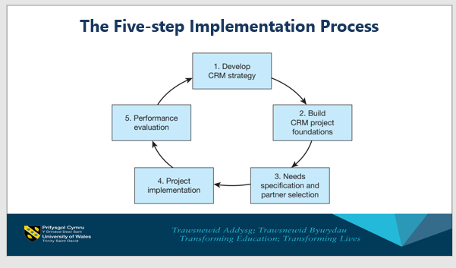
(UWTSD, 2021)
Customer experience:
Customer experience has become increasingly more popular now that it has managed to branch out into more fluid forms of outreach, as a result, this outreach (expressed in different forms of advertising and media) have successfully managed to draw in more demand over the years. CX (Customer Experience) reports and analyses how customers feel and how they perceive the whole experience they encounter by purchasing goods and services through interacting with a certain company. The customer is more likely to return for your goods and services through an already established understanding of what the customer desires and prefers from the company they’ve interacted with and preferred products and services of the brand. When the company is efficient at creating an exceptional customer experience, they will be more likely to reliably profit and therefore expand in the greater market.

Customer Experience is a term used to explain how interaction and experiences that the customer has with your business are perceived by them. It is important to get feedback from all customers so you can properly understand the successes and pitfalls that the business possesses in a normal day-to-day scenario, understanding this better can lead to you optimising the overall experience and as a result, making it easier, more enjoyable or even a better price per visit, Good customer feedback will often reflect on their point of view, what is happening on their end and what they experience so you will know if the customer satisfied all have good or bad service. When we enter the store our first impressions are also part of the customer experiences, the ratings of interactions with managers and sales whether they were helpful or not, ways of making payment accessible and easy. When purchasing any goods, they could be the wrong size or maybe even faulty. This information may be needed to refer to in order to know the product number of information details. If making an order was easy and if they experienced a fast delivery or suffered long delays, this information gathered is vital to the success of the whole experience. From when you first discover the item to doing your own research such as purchasing your product and having it shipped to you. The whole experience measures up by who you make them feel about the company overall will also depend on the physical, emotional and psychological connection that the customer receives through your brand and services. (Payne and Frow, 2021)
CEM or CXM (image of CEM) What is a customer experience? Definition and examples (marketbusinessnews.com) 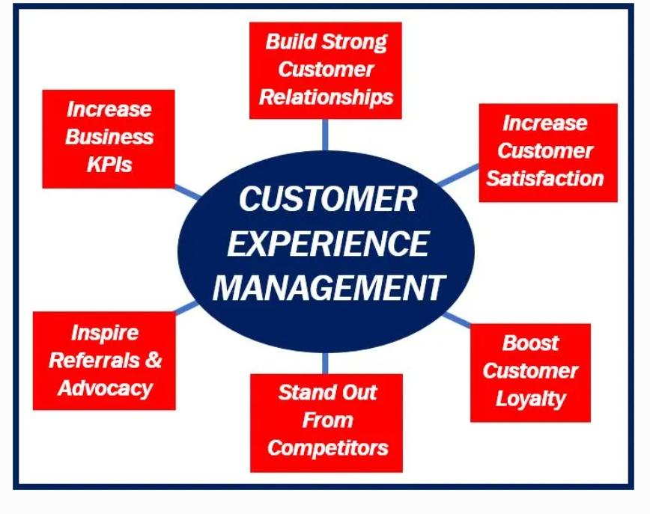
CEM or CXM
The customer's interactions with the seller: this is to build a relationship to optimize the experience of customer loyalty. The CEM track, focus and organise all the interactions fulfilling the customers wants and needs. This can be achieved through a software program that automatically collects and studies all their customer feedback. This can be achieved when the system reports the customer's insight by integrating with all other existing customers that are linked to their software, providing data for the organisation. Now there is a more advanced type of AI technology that has become more frequently used. This is robotic process automation also known by the name RAP which has become the most advanced way of achieving what is known as the best drive of customer experience. (Market business news, 2021)
RPA enterprise provides information from the deterministic automation that transfers this intelligent automation edge by ultimately two human empowered automation. Companies that are advancing in this modern age are forever updating and reintroducing different business models, information that is gathered on sales, marketing and post-sales. Customers sometimes (change their business needs to those changes as efficiently as possible within a short period of time.
Larger companies can afford to have the option of buying high-tech companies that are used to provide a better and more efficient customer experience.
Michael Porter’s five forces: (Definition of 5 forces)
when doing business worldwide five forces are very important to become successful due to these forces one can analyse the company composition and forecast what will be in store for the company in future.
Bargaining power supplier: Tesco’s bargaining power is low due to the huge amount of goods that they buy one-time, high numbers of suppliers all over the UK, profits are obtained by bulk buying original cost offered to Tesco’s by the supplier.
Bargaining power of the buyer: Tesco’s have an increasing number of buyers and their popularity is also increasing continuously, they have good quality products and a variety there are at a reasonable rate which is demanded by the buyer. The buyer seeing the price is very important how it is the impact on purchase. There are many other competitors in the market offering the same goods, but prices could be slightly varied. The buyer has higher bargaining power.
Competitive rivalry: Tesco’s most main competitive areas staff, savouries Waitrose and Marks & Spencer’s, competitors are local especially outside the UK.
Threat from substitutes: prices of products goods and services are always a challenge when competing with other companies are known as this can cause problems for both companies in the same industry, Internet shopping is on the increase and is one of the major threats from substitutes plus local corner shops.
Threats from new entrants: there has been an increase in the number of supermarkets, plus the local competitors are tough competition, so it makes it much harder for new entrants, supermarkets with new entrants alter the variety of products as dissatisfied products, providing new big deals whenever another entrant appears.
Information systems: supply chain systems are created in order to provide product availability and socket control for all its customers.
Everything customer must experience the checkout process this means that the system needs to have simple smart ways to process goods at the tills but at the same time be sophisticated through simple ways to operate the system. Self-checkout stores are in operation more than ever now self-scanned system help to speed up the process but the new technology that is providing neatly helps to predict when tills need to be opened before the queues start to build up causing a backup of customers in-store. (Rahman,2020)
Tesco’s pestles analyse:
pestle analysis of Tesco’s one of the main external factors impacting the company
Tesco’s are many different environments facts and decisions being made by managers within the organisation this will include things like trade obstacles, new laws, demographic change, government policy and tax changes these decisions come as macro change which is analysed by managers this model will provide the classified information between the political factors, economic, social factors, technological factors, legal factors plus environmental factors
Tesco’s has been successful over the many years the growth market places such as Asia and Central Europe advanced and now operating in countries such as Hungary, Poland checked the public, Thailand, South Korea, Taiwan and Republic of Ireland also Tesco’s announced at Tesco’s and developed hypermarkets in countries such as Malaysia. (Parker, 2018)

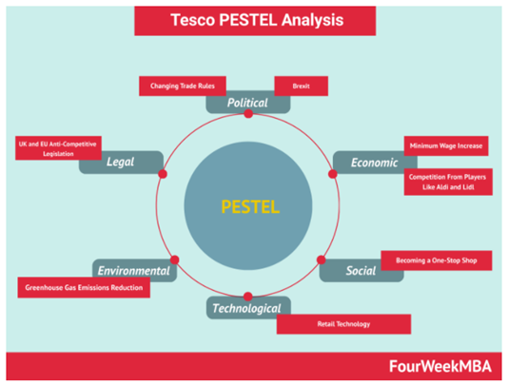
(Parker, 2018)
Political factor:
Political factors are referred to as government policy that must 9have a good intervention in the economy, political decisions impact several areas for a business such as education officials, the health of the nation and quality of the economy such as road and rail systems. What goods and services does the government provide and what are the priorities in the terms of business support. So, on a political fact, Tesco's must have to deal with the British and Colombian politics with regards to cells and supplies of coffee. Many governments are involved within the service.
Economical: as the foundations of employment change there are major impacts on a firm’s behaviour this can include taxation changes in exchange rates economic growth interest and inflation, inflation can provoke high wage demands which will lead to high wage demands from employees and raise costs within the company. High Currencies can have major effects causing exporting to become difficult as increase price of foreign currency, higher interest rates could cause loss of investments as they could be an increase in foreign currency, demands for the firms’ products could go to a higher national income this will become very costly to the company but could also boost their demands. Fluctuation and stock-market tax increases consider the effect the bottom line of Tesco’s causing economic factors to have a large impact internal and external.

Social factor:
when dealing with different changes within the company the social trends can determine that the goods and availability causing the population to start ageing causing Tesco’s to commit to pension payments for their employees as staff are living longer causing them to have to work up to a late stage of years in life, plus the company’s ability employing staff to keep them within the company to a late stage in their life, there has been a demand increase in sheltered accommodation the medicines whereas the demand for things such as toys of falling these factors may be caused by the impact of migration and also to the changes in fashion.

Technical factors: as we are reading to more technological stages there are many new products and processes that are on the increase such as high-definition televisions computer games online gambling, shopping channels. This is helping the demands and aided design barcoding and proven ways for a whole for businesses to get a better result from technology. Nowadays the modernism is clearly on the increase by improving the quality and reducing costs can help benefit consumers as well as all the organisations providing goods and services. These new technologies have become a major part of Tesco’s continuous success.

Legal factor: over recent years there have been many label changes that have had major impacts on phones behaviour by introducing the legalisation of disability and age discrimination has become great are requirements for the increase of minimum wages so firms can recycle recent laws that affect the organisation’s actions this could include in effect by firms costs new systems are produced to be developed or are there is a demand in the likelihood of customers buying goods and using the services.
Competition laws are used to protect companies against larger organisations exploiting their firms with monopoly power. Consumer law is helping to protect customers again.
Health and safety legislations are there to help people to be able to work in a safe environment this covers things such as all accidents and safety equipment training and the appropriate any unfair practices which may be led through wrong details and descriptions of the products or services caused by the misleading customer. Employment law covers staff in any issues such as unfair dismissal working hours management wages and redundancy the aim protects employees against the abuse of their managers.
Environmental factor:
Environment factors are there to overlook things like weather and climate many industries can have an impact on the goods and services through the changes of the temperature which can help destroy farming, tourism and insurance, adding major climate changes and increase global warming awareness of the greater environmental external factors are becoming more very important issues that have to be considered within the company the growth voracity to have major concerns in the environment telling impact with travelling and transportation for the industry this can include more taxes being introduced on their travel but also the success on demand of hybrid cars this is helping the general movement towards environmentally friendly products and processes helping demand patterns to increase and create business opportunities worldwide. Tesco’s is helping the environment by using fossil fuel for transportation purposes is becoming successful but is high demands and a major challenge. (Frue, 2020)
Strategic CRM
The main purpose is the development of the customer-centric business, its main aim is to win over customers to keep them. This is achieved by providing better service, winning and keeping customers. This can be achieved by providing better value than their competitors. The main aim of the culture is focused on leadership behaviours that are created in the company system. Customer-centric culture focuses on the best way to enhance customer value, customer satisfaction and information provided by the company for the customer which shares all business ideas that can help improve the services and shows how they value the cost.
Many companies try to stay focused on customer-centric, customer-focused, customer-led and customer-oriented, but few succeed in the end. To choose a company that provides the best performance quality and designs or features.
Product-oriented: Nearly all new start the company product-oriented this can lead to customers' voices missing out on important decisions such as selling, services, marketing and decision making are introduced so very little research is conducted on the customer’s behalf. Most of the time management makes the final decisions about what they believe the customer will want. This can lead to products that are over-engineered and over specified for the requirements of the market causing products or services to become very costly to customers. Businesses not only choose the best quality performance and design or features but can miss out on important things that the customer needs and those marketing.
Production oriented: businesses believe that all customers choose low priced products, therefore companies 10 work towards developing low-cost routes to market, doing this helps the appropriate subsystem segments to develop the economy and keeping costs down as low as possible to improve sales customer satisfaction.
Sale oriented: most businesses conclude that investing enough in public relations cells and advertisement and so promotions will encourage the customer to buy most of the time the self-orientation follows the production organisation. The company produces low-cost products which they must shift as many as possible to heavily help the inventory.
Customer-oriented: most companies beliefs are always putting the customer first, by collecting customer and competitive information this can help the company’s performance there is evidence that the customer-centricity plays a major part in fulfilment however the different stages of marketing and other orientations for the economic development this argument should be open to all companies in order to find out what works for them. (Greenberg, 2009)

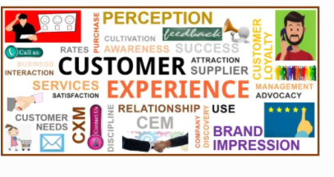 (Market business news, 2021)

Marketing mix
The marketing mix is defined as the 4ps this is the Price, product, promotion and place. it’s designed to influence the customer’s decision-making and lead the company to make a profit, who wants the product, problem-solving for the consumer by helping them to deal with all challenges, what are the competitive advantages, for example, the competitors, what is the quality, plus do they come with a guarantee or do they provide an after service. Can you have an example of the goods from the representative such as service or product? The feedback providing the pros and cons, researching all products.
Place: where can the product be purchased and were it made, what is the location because this can affect customer service by the way they can quickly respond to the orders requested by the customer,
Price: This can determine what kind of profit can be made through selling the item is there any growth in that investment, can they afford to give any discount or any special deals. When pricing the product will the consumer feel what they have just purchased is worth it? Feeling they have just got a deal.

Promotion: Have you advertised this product enough so that customers know about the goods. Promotion is the least experienced principle to be taken seriously but it is as important as all the other sectors of this model. Making sure you target the corrected area, so the promotion stands above all other competitors, date, time.
Product: This represents an item of service to satisfy the customers standards, providing their wants and needs this is to make sure its to the best standers to effectively market the products and services. The most important thing is what differentiates it from its competitors’ products and services. (Josh,2018)
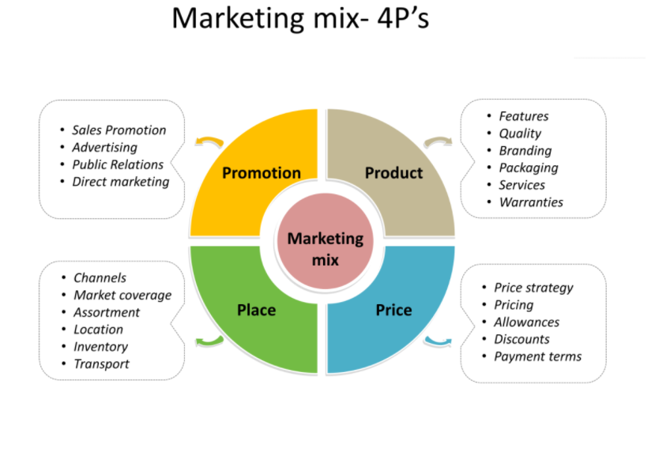
(Pinterest,2021)

SWOT analysis for Tesco
Tesco strengths:
Tesco is the leading retailer known as the number one supermarket in the UK. It holds the highest sales and revenue as compared to any other supermarket in Great Britain. its annual profit in 2018 was 28%.
leading market share, there are four leading marketing chains Tesco is the top of the leader board. Dominating the market with a 27% share. becoming the most popular supermarket in Ireland. with Tesco has opened 6,966 stores worldwide. Knowing their diversity, the retailer has opened several offside stores while excelling in their marketing product range. such as mobile phone business, financial and telecom services. they have become the largest private employer by producing more than 734k jobs opportunities worldwide. while maintaining several international awards along the way this in clues Best grocer in 2018, Britain’s favourite supermarket award, Tesco runs a superior technology in the best optimal way to help create an enhanced experience for the customer, this is being done through RFID- barcode system which counts the products automatically, this has an advanced mobile payment app. also available is the M-commerce facility these different features help to not only speed up the service but to make all sales and information transactions be produced correctly making a simplified business model. Knowing that Tesco helps you to reduce incurring a low cost and helping the environment with its strict efficient waste management it has created a very reliable supply chain network while it bears a profitable relationship with its suppliers.

Tesco Weakness:
Tesco operations in the US and Japan failed back in 2012, its export operation failed after 9 years in Japan, plus the chain store must also close down in America after trading there for 5 years. Back in 2017, Tesco was subjected to a fraud trial while also being faced with an accounting scandal, this ended up with the retailer being charged with fines due to producing false documentation showing account declaration and misrepresentation of profits. Tesco decreased in operation cost back in 2018, making its shares decrease by 9% back in October 2018, this was Tesco worst performance since the Brexit referendum. The low-cost strategy had a big impact on Tesco as they are known for its price leader reputation, which lead to reduced profit margin. Poor operational performance in several of its stores in certain other countries, how this occurred was by not doing enough research before opening another one of their franchises before entering these markets. Clubcard controversy, back in 2018 Tesco introduced its loyalty card system to the company by collecting points after it started Tesco decided to double or quadruple the points without informing any prior notice to its customers, with backfired on the retailer causing massive backlash from very angry customers.
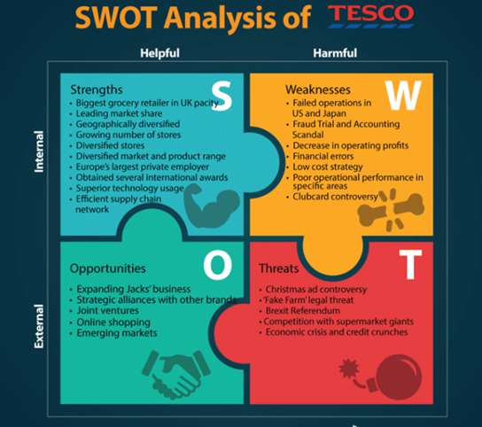
(Parker, 2018)
Tesco Opportunities: Expanding Jacks business. Tesco has expanded by introducing Jack’s new discount store which has shown significant growth. It shows that there is a great opportunity to grow and become a very successful competitor in the marking industry competing with other franchises such as Lidl and Aldi. while developing its brand strategically with repetitive companies giving Tesco an excellent opportunity to offer more products and attract more customers. in their area that has a poor performance, Tesco can provide profound market knowledge which can help improve sales and profit in such regions. online shopping can avail a great opportunity by growing and upgrading its online shopping business as well as home delivery services. Tesco have many stores in developing countries but expanding its business to emerging countries such as Turkey, Indonesia and South Korea can be a profitable opportunity for the company
Tesco threats: Tesco’s has been known for misleading its customers with fake brand names which lead to legal proceedings over this issue back in 2017. There has been some competition with other supermarket giants, which has threatened Tesco’s market position with ASDA and Aldi acquisition. Last of all is the economic crisis with government regulations, legal and tax matters upheaving the operational efficiency and performance of Tesco. (Parker, 2018)

Recommendation
Tesco CRM is very important for their retail industry
The advantages and disadvantages that I found are that Tesco is a multimillion company that must provide a top service for its customers even though the covid 19, I have found that within this report that there are so many different areas that must be addressed, monitored and continually maintained throughout. There as to be communication not only to every customer but to all staff and the consumer in order to maintain the best standard regardless of what the future may hold there are many different aspects that have to be researched and investigated to keep all competitors at bay and staying number one is a constant battle for all industries now that the world has been faced with this pandemic. This report has covered the customer’s experience and the different marketing, plus analysing the consumer’s behaviour. all added up together to keep Tesco has every customer’s number one choice

Conclusion
Based on the customer cognitive experience and how they are affected when shopping online this report has processed an integrated e-CRM framework at has identified different series that have linked the main psychological differences that have affected the customer’s commitment. Alongside this, through the managerial implications, the different strategies using the framework shows that customers the reason why they maintain a long-term relationship with the company, by using an integrated framework throughout this report shows there are interrelated explanations why it has worked and plan to continue high maintenance, so the customer always has complete satisfaction.
This framework has successfully shown the CRM needs and how they directly enhance customer value management, customer trust and customer satisfaction have all worked together hand in hand, through Tesco’s introducing CRM system for tracking customer commitment, sales and services
This is very vital for the consumer also for each individual customer to help not only the company’s reputation but for maximum satisfaction that is the goal for retailers in this fast modern retail race to keep has many customers completely happy while staying as a leader in the chain for not only retail in-store but to keep more people adding to your online services and continue shopping with Tesco. So, knowing the covid has not only affected everyone daily the future will remain the same for ever-changing and while the world goes through these massive changes for the future it’s the understanding and engaging in every customer that is the number one priority for success.

References
Buttle, F. (2008) Customer Relationship Management. Taylor and Francis.
Frue, K. (2020) Understanding the PEST Factors in PEST Analysis. Available: https://pestleanalysis.com/pest-analysis/ (Accessed: 6 September 2021)
Greenberg, P. (2009) CRM at the speed of light, 4th ed., San Francisco, CA: McGraw-Hill.
Josh, A. (2018) An Analysis of Tesco’s Marketing Mix, Communications and Growth Strategy. Available: https://15writers.com/sample-reports/analysis-tesco-marketing-strategy/ (Accessed: 6 September 2021)
Nasir, S. (2015), Customer relationship management strategies in the digital era translated by Anonymous Business Science Reference, Hershey, Pennsylvania.
Parker, B. (2018) Tesco SWOT Analysis 2019. Available: https://bstrategyhub.com/tesco-swot-analysis-2019swot-analysis-of-tesco/ (Accessed: 8 September 2021)
Payne, A. and Frow, P. (2005), A Strategic Framework for Customer Relationship Management. American Marketing Association.
Pinterest.com (2021) Marketing strategy social media. [Image] Available: https://www.pinterest.com/signup/thirdpartyage/ (Accessed: 6 September 2021)
Rahman, M. (2020) Porter’s five forces analysis of Tesco. Available: https://howandwhat.net/porters-five-forces-analysis-tesco/ (Accessed: 6 September 2021)
UWTSD (2021) “The five step Implementation process” Understanding customer experience in the workplace, Week 8 Slide 4, [Moodle] (Accessed 6 September 2021)

