Marius-Catalin Bobitiu
StudentID: 1813436
Lecturer: Balendran Kandasamy
Module Code: ACCA6026_LON
Data warehousing & data mining
Assessment 2

Table of Contents
Introduction 1
1.1 Purpose and Practice of Data Mining 1
1.2 Dataset Description and Exploration 2
1.3 Data Pre-processing and Post-processing 4
1.4 Sample Runs and Analysis Methods 7
1.5 Business Recommendations 13
1.6 Reflective Commentary 13
References 14

Table of Figures
Figure 1 - Data loaded into Weka Software, ready for pre-processing 2
Figure 2 - Data loaded into Weka Software, ready for pre-processing 3
Figure 3 - BMI attribute containing 201 missing values 3
Figure 4 - Class distribution of the stroke attribute in Weka 4
Figure 5 - BMI attribute after running ReplaceMissingValues filter 4
Figure 6 - ReplaceMissingValues filtering on BMI missing data 5
Figure 7 - Removal of the ID attribute before modelling. 5
Figure 8 - NumericToNominal filter applied to the stroke attribute 6
Figure 9 - Number of strokes visualisations in Tableau Public 6
Figure 10 - Stroke data after running ClassBalancer filter 7
Figure 11 - J48 classifier selected in Weka 8
Figure 12 - J48 output showing model results 8
Figure 13 - Logistic classifier selected in Weka 9
Figure 14 - Logistic output showing model results 9
Figure 15 - Random Forest classifier selected in Weka 10
Figure 16 - Random Forest output showing model results 10
Figure 17 - Simple K-Means selected in Weka 11
Figure 18 - Simple K-Means clustering output 11
Figure 19 - Confusion matrix for the best-performing classifier 12

Introduction

Purpose and Practice of Data Mining
Data mining means looking at data to find useful patterns, connections and tendencies that can help you forecast what will happen and make choices. It’s used in healthcare and business, and the biggest benefit in both is the same: changing simple data into something actually helpful. Within healthcare, data mining often helps diagnose, predict illnesses, calculate risk and categorize patients. Looking at recent research, we see that machine learning and data mining are now very common for predicting clinical issues and helping with decisions, especially when lots of patient data needs fast and reliable analysis.
For this project, data mining is being used to predict strokes. The first step is categorizing (classification) where you try to work out if someone is likely to suffer a stroke, looking at things like their age, if they have high blood pressure, heart problems, glucose levels and BMI. A system like this could allow hospitals and health services to find people at higher risk sooner and give them help to avoid a stroke. Stroke prediction using structured data from patients has been done before, but how good the results are is very dependent on the quality of the data and the way the predictions are modelled.
The second step is grouping (clustering). This is different from categorization because it doesn't use the fact of whether a stroke happened. It simply puts patients into groups of those with similar features. This grouping can highlight patterns in how people live and their health that would be valuable for planning for the health of the public. Essentially, data mining isn't intended to replace a doctor’s opinion, but to help it by finding trends you wouldn't easily discover just by looking at the information by hand.
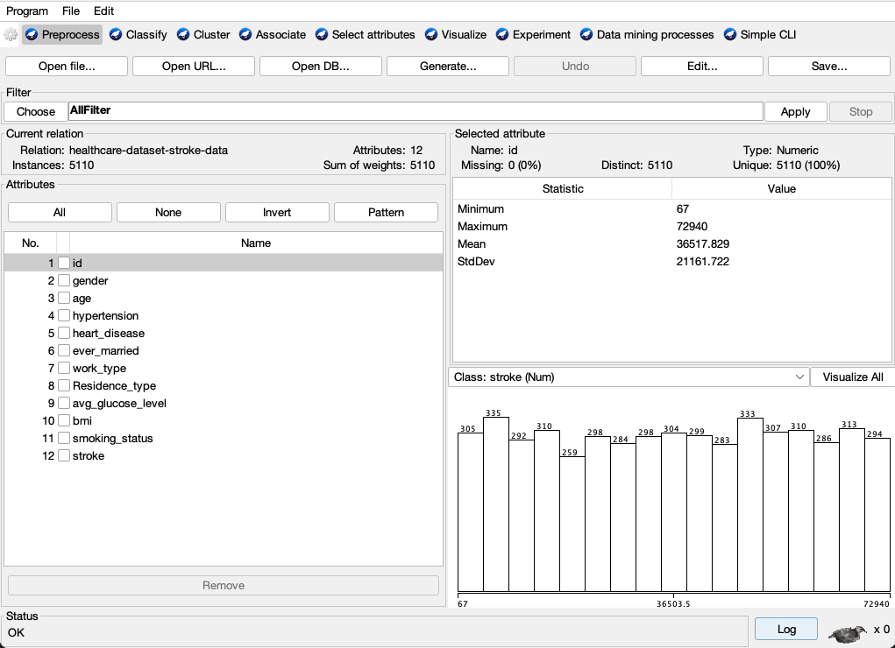
Figure 1 - Data loaded into Weka Software, ready for pre-processing

1.2 Dataset Description and Exploration
This report uses the Stroke Prediction Dataset, which is a public dataset on Kaggle that uses 11 clinical features to guess whether a patient is likely to have a stroke. The assignment brief also says that it has demographic, lifestyle, and medical variables like age, gender, hypertension, heart disease, marital status, work type, residence type, average glucose level, BMI, smoking status, and stroke outcome. This is good for both classification and clustering because it has a mix of numerical, categorical, and binary attributes.
When you include the ID field, the dataset has 5,110 records and 12 columns. The target variable is stroke, which is a binary variable that shows whether or not the patient had a stroke. For example, age, BMI, and average glucose level are numerical variables.
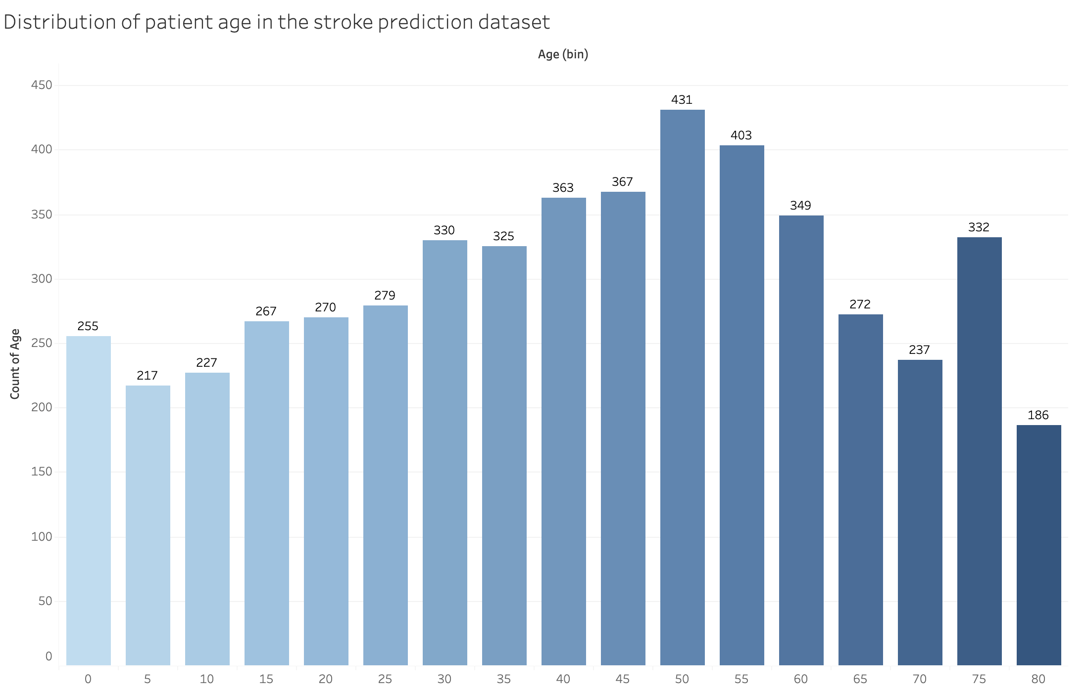
Figure 2 - Data loaded into Weka Software, ready for pre-processing
Gender, work type, and smoking status are examples of categorical variables. Heart disease, hypertension, and stroke are all binary variables. This variety is good for data mining, but it also means that the dataset needs to be pre-processed before it can be modelled in Weka.
One big problem is missing data. The BMI attribute contains 201 missing values, which is a noticeable amount in a dataset of this size. Removing all of those rows would reduce the dataset and could make the analysis less reliable, so handling missing values is an important preprocessing step.
Figure 3 - BMI attribute containing 201 missing values
Another big problem is that the classes are not balanced. There are 4,861 cases that are not strokes and only 249 cases that are strokes in the dataset. This means that the positive class makes up about 4.9% of the whole dataset. This is important because a model could get a high accuracy score just by guessing the most common class most of the time. Because of this, the dataset needs to be looked at closely before any model can be called successful.
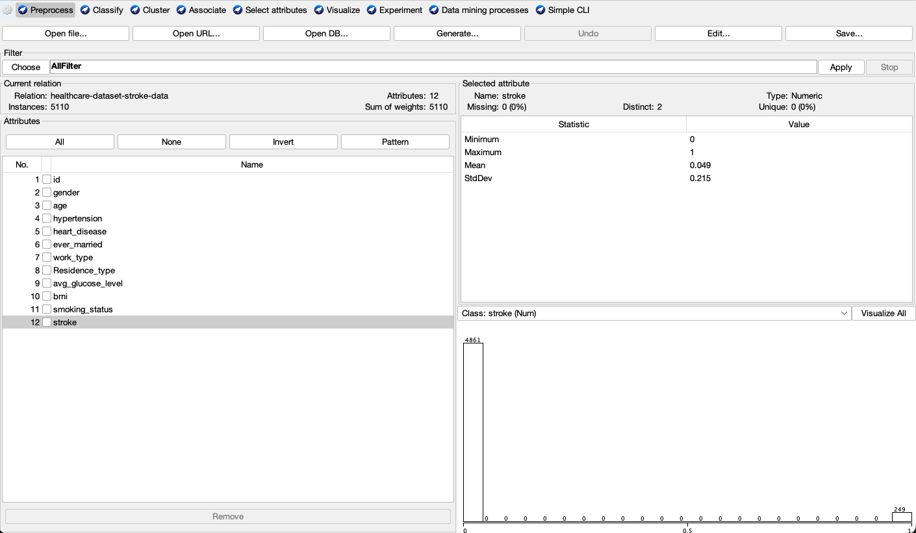
Figure 4 - Class distribution of the stroke attribute in Weka
So, exploratory analysis should focus on summary statistics for numbers, frequency counts for categories, and visualisations like histograms, boxplots, and class distribution charts. Weka was made to help with this process by preprocessing, visualising, and comparing different methods, which makes it a good choice for the assignment.

1.3 Data Pre-processing and Post-processing
Before mining in Weka, the dataset had to be cleaned and prepared. This stage is important because the quality of the models depends heavily on the quality of the data used. In this case, the dataset contains mixed attribute types, missing values, and a strong class imbalance, so preprocessing was not just a minor technical step. It was a key part of the analysis. The brief also specifically asks for missing value handling, preparation of categorical variables, balancing the dataset where needed, feature selection or engineering, and post-processing used to interpret the results. ￼
The first issue was missing values, especially in the BMI field. The dataset contains 201 missing BMI values, which is a noticeable amount for a dataset of this size. Deleting every row with a missing BMI value would reduce the number of usable records and could make the class imbalance issue slightly worse. Because of this, the missing values were handled in Weka using the ReplaceMissingValues filter rather than deleting the affected rows.
Figure 5 - BMI attribute after running ReplaceMissingValues filter
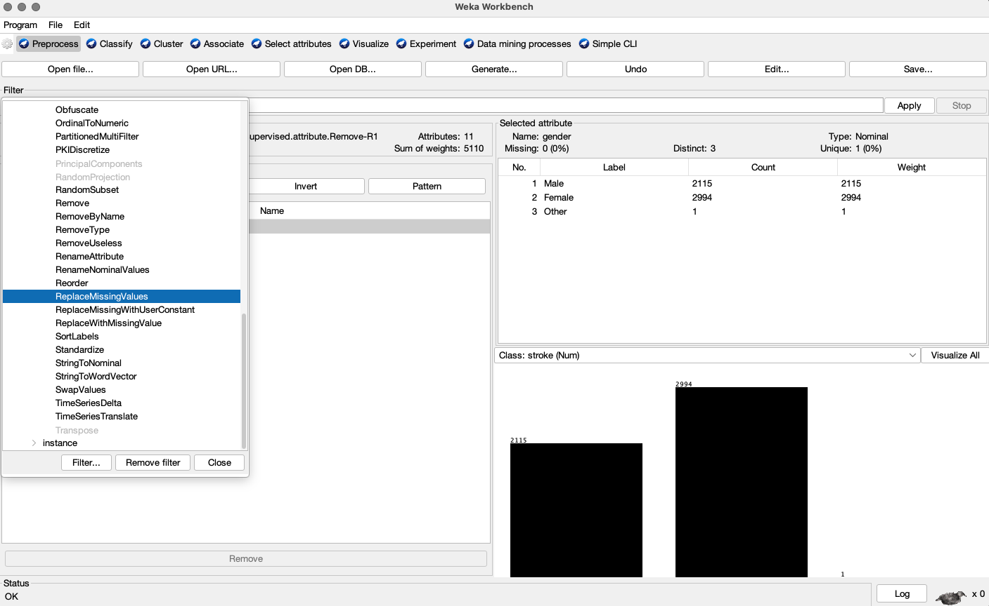
Figure 6 - ReplaceMissingValues filtering on BMI missing data
The second step was to review the attribute types and prepare the data for classification. The dataset contains both nominal and numeric variables. Nominal variables include gender, work_type, Residence_type, ever_married, and smoking_status, while numeric variables include age, avg_glucose_level, and bmi. Many Weka classifiers can work directly with nominal variables, so full one-hot encoding was not necessary here. However, it was still important to remove unnecessary fields such as id, since this attribute has no predictive value and would only add noise to the model.
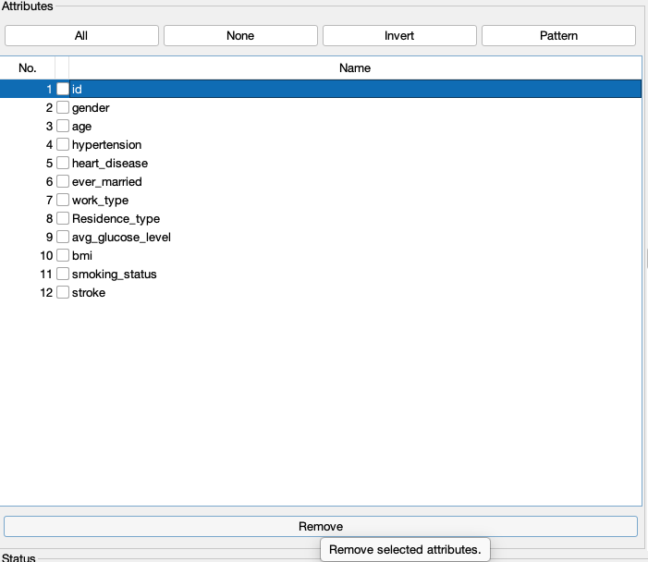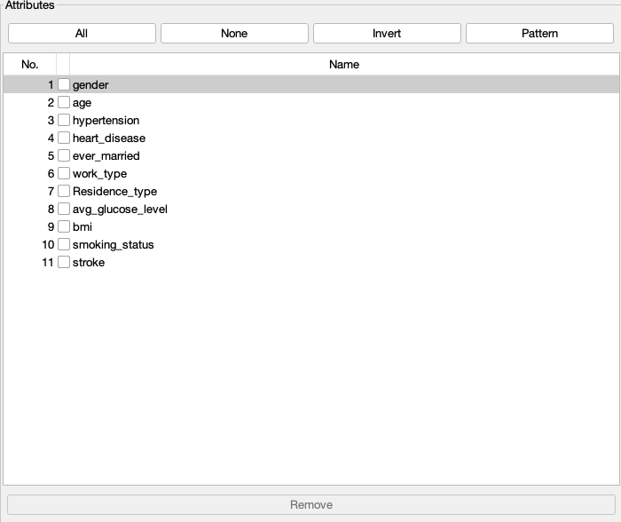
Figure 7 - Removal of the ID attribute before modelling.

Another important preprocessing step was making sure the target variable was in the correct format. The stroke attribute was initially read by Weka as a numeric field, even though this is a classification problem. Because of that, it had to be converted from numeric to nominal using the NumericToNominal filter so that Weka would treat it as a class label rather than a continuous value.
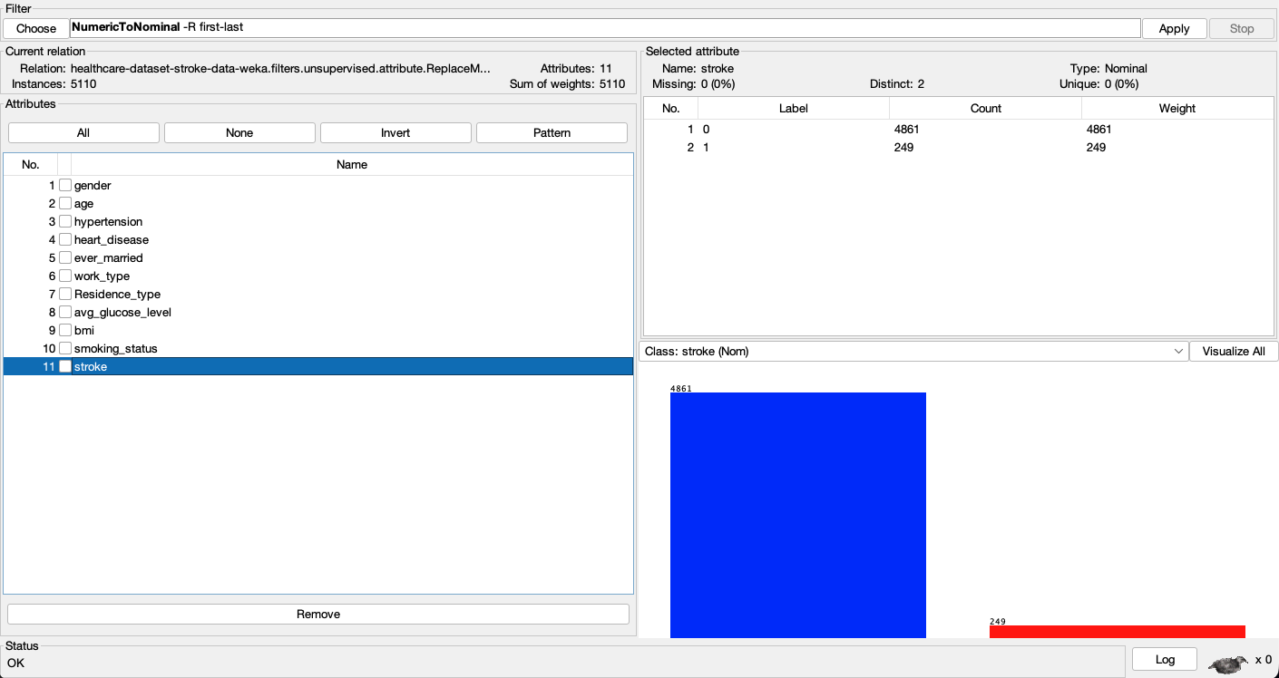
Figure 8 - NumericToNominal filter applied to the stroke attribute
The third and most important issue was class imbalance. The stroke class represents only a small part of the dataset, which means a model could appear to perform well overall while still failing to identify stroke cases properly. This is especially important in a healthcare problem like this, where identifying the minority class matters more than simply achieving a high overall accuracy score. After converting the target variable to nominal, the ClassBalancer filter was applied in Weka to reduce the effect of the imbalance between the majority and minority classes. This was done to improve the model’s ability to recognise stroke cases more effectively and not just favour the majority class.
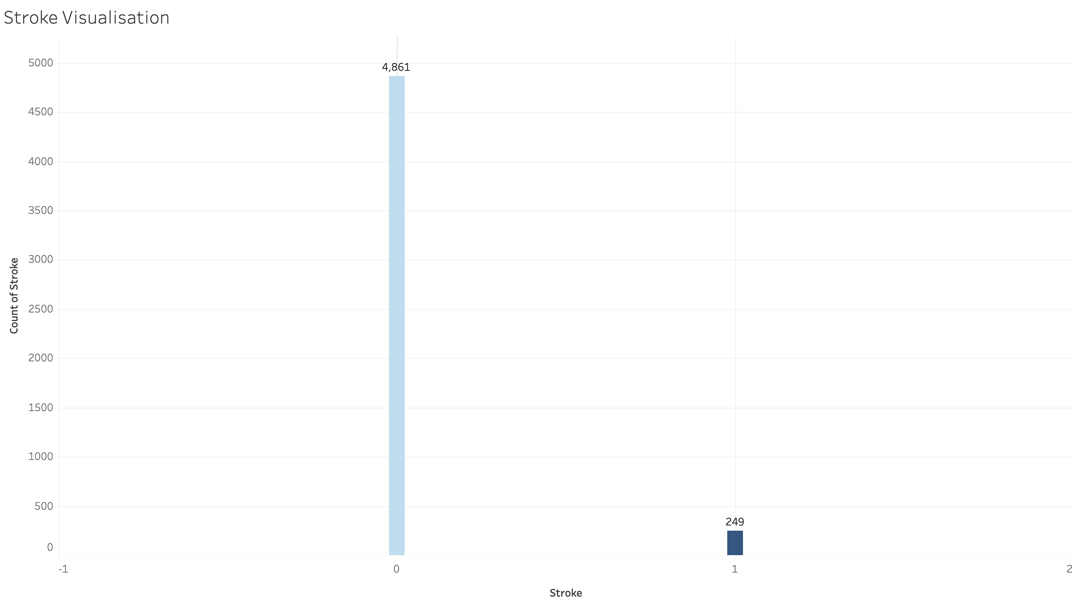
Figure 9 - Number of strokes visualisations in Tableau Public
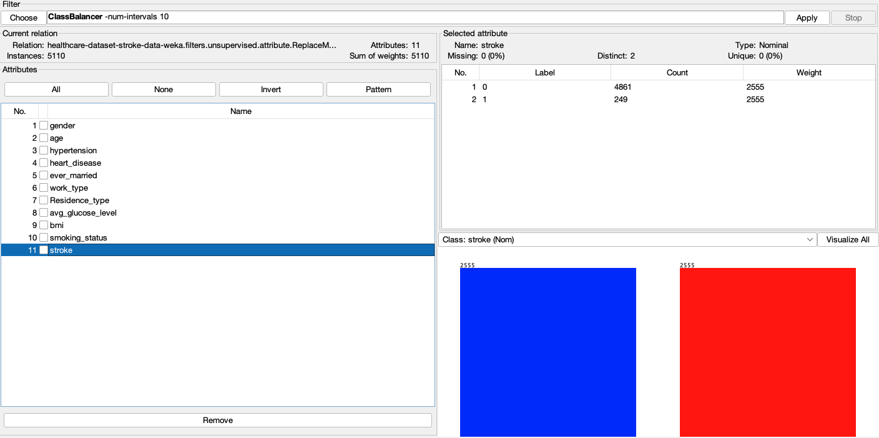
Figure 10 - Stroke data after running ClassBalancer filter
Feature selection is another useful part of preprocessing. Not all attributes contribute equally to prediction, and removing weaker variables can sometimes improve both clarity and model performance. In this dataset, variables such as age, hypertension, heart_disease, avg_glucose_level, and bmi are likely to be more useful than identifiers or less relevant social variables. However, this should be tested rather than assumed. Weka provides attribute selection tools that can rank predictors or reduce the number of variables before training. Even where feature selection is not fully applied, considering it is still important when comparing algorithms.
After the models are run, post-processing is mainly about interpreting the results properly. This means looking beyond raw accuracy and focusing more on precision, recall, F1-score, and AUC, since these are more useful for imbalanced classification problems. Confusion matrices are also important because they show whether the model is missing real stroke cases. The final step is to present these results clearly using tables, charts, and short comparisons between models rather than just pasting raw Weka output. This makes the findings easier to understand and easier to connect to the practical recommendations later in the report.

1.4 Sample Runs and Analysis Methods
This section explains the main methods used to analyse the dataset in Weka and why they were suitable for this particular task. The brief asks for sample runs, justification of algorithms, and justification of evaluation measures, so this section does not just list the models used. It explains why they were chosen for stroke prediction and how their performance was judged. Since most of the mining work had to be done in Weka, the analysis was carried out mainly through Weka Explorer, using its classification and clustering tools to compare outputs such as confusion matrices, ROC area, and class-level prediction results.
The first classifier used was J48 decision tree. This was a sensible starting point because it is easy to interpret and produces simple decision rules. In a healthcare context, that matters, because it is useful to understand not only how accurate a model is, but also how it reaches its predictions. A decision tree can show how variables such as age, average glucose level, hypertension, and heart disease divide patients into higher-risk and lower-risk groups. J48 is commonly used in Weka as an initial baseline because it is fast to run and the output is much easier to follow than more complex methods.
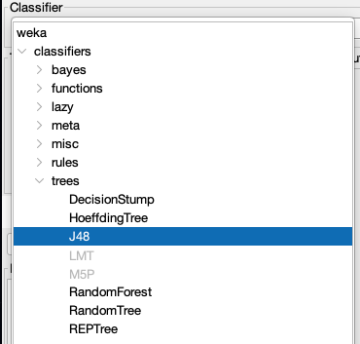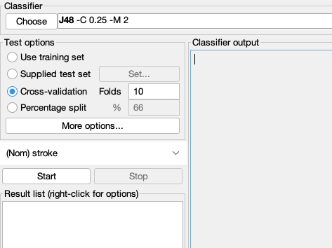
Figure 11 - J48 classifier selected in Weka
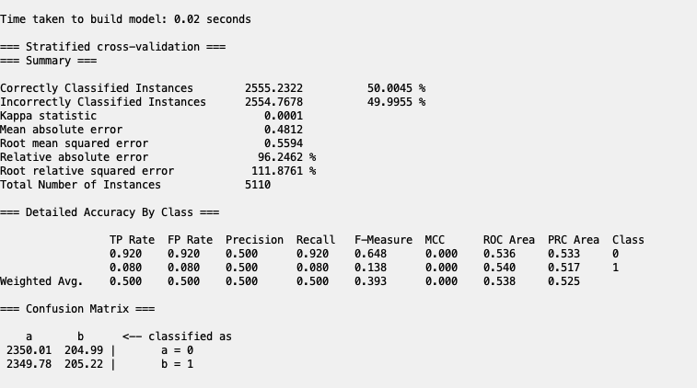
Figure 12 - J48 output showing model results
The second method used was Logistic. This was appropriate because the target variable is binary, with stroke recorded as either present or absent. Logistic regression is widely used in medical prediction because it works well with structured tabular data and provides a strong statistical baseline. In this report, it was useful because it allowed comparison between a traditional statistical model and machine learning models such as J48 and Random Forest. If logistic regression performed similarly to the more advanced models, that would suggest the relationships in the data were relatively simple. If it performed worse, it would suggest that the data contains more complex, non-linear relationships.
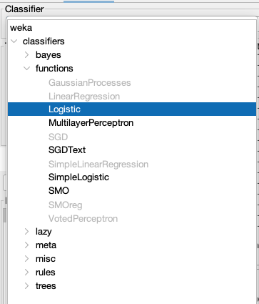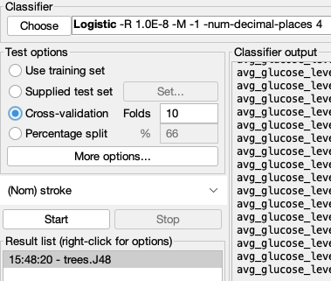
Figure 13 - Logistic classifier selected in Weka
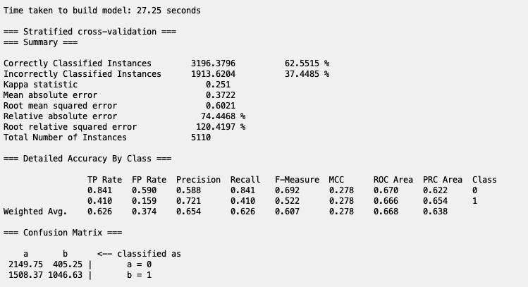
Figure 14 - Logistic output showing model results
The third classifier used was Random Forest. This was included because ensemble methods often perform better than single decision trees, especially when the data contains mixed variables and more complex relationships. Random Forest builds many trees and combines their predictions, which usually makes it more stable and less likely to overfit. It is also commonly used in stroke prediction studies and is often reported as one of the stronger-performing methods for structured healthcare datasets. This made it a sensible model to test here, especially since it could be run in Weka under the same evaluation settings as the other classifiers.
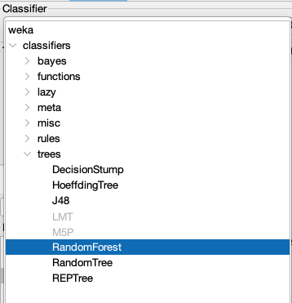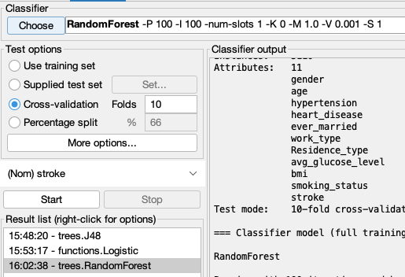
Figure 15 - Random Forest classifier selected in Weka
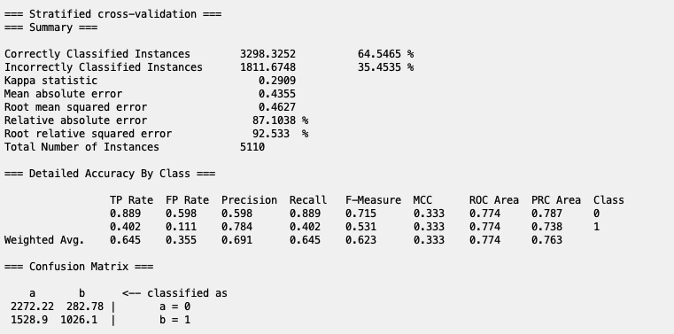
Figure 16 - Random Forest output showing model results
For unsupervised analysis, Simple K-Means was also used. This was relevant because the brief is not only about predicting stroke, but also about identifying patterns or clusters in the data. Unlike classification, clustering does not use the stroke label directly. Instead, it groups patients based on similarity across their health and lifestyle variables. This can help reveal patient profiles, such as older people with higher glucose levels or younger lower-risk groups. Using clustering alongside classification made the analysis broader and more complete.
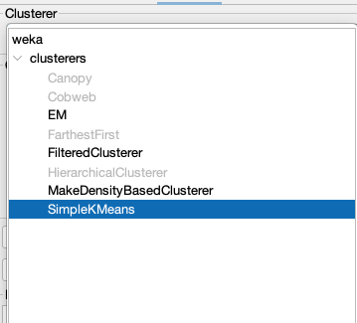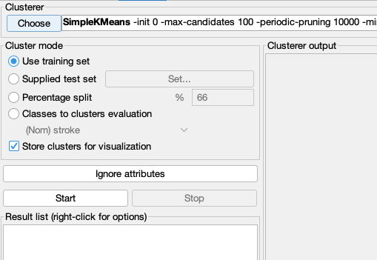
Figure 17 - Simple K-Means selected in Weka
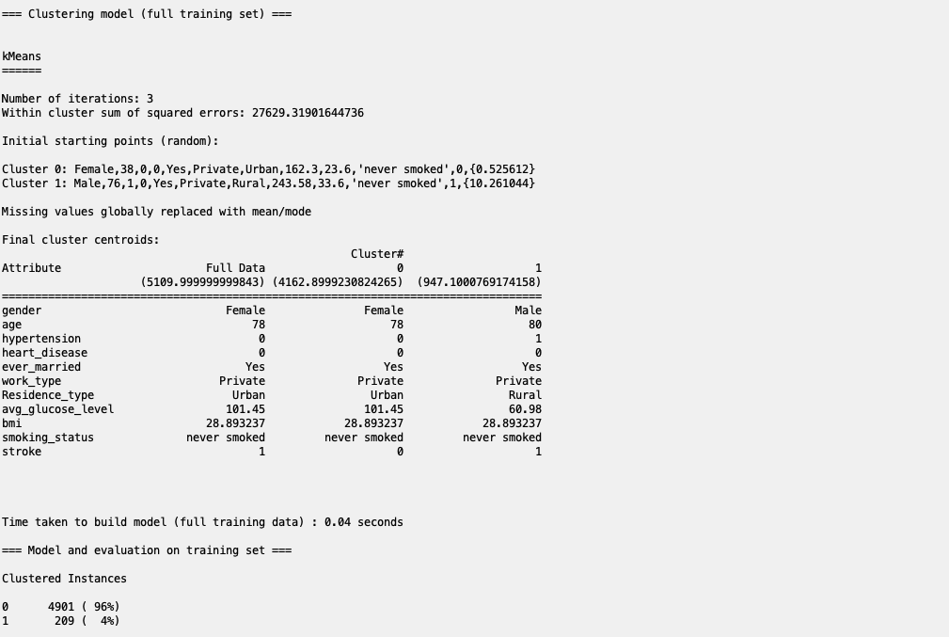
Figure 18 - Simple K-Means clustering output
The evaluation method also needed to be justified. For this dataset, 10-fold cross-validation was used because the dataset is not especially large and the target class is highly imbalanced. Cross-validation reduces the chance of the results depending too heavily on one single train-test split and gives a fairer basis for comparing the models. This is more reliable than carrying out one random split and judging all models from that alone.
Just looking at accuracy was not enough for this dataset. Since stroke cases make up only a small percentage of the data, a model could achieve high accuracy simply by predicting the majority class most of the time. Because of that, the more useful measures were precision, recall, F1-score, and AUC. Recall was especially important because it shows how well the model identifies actual stroke cases. In a healthcare setting, failing to identify stroke cases is more serious than producing some false positives. AUC was also helpful because it gave a broader view of how well the model separated the two classes.
Table 1 - Comparison of classifier results using accuracy, precision, recall, F1-score and AUC
Classifier | Accuracy (%) | Precision  (Stroke=1) | Recall  (Stroke=1) | F1-score  (Stroke=1) | ROC Area  (Stroke=1) | Notes
J48 | 50.00 | 0.500 | 0.080 | 0.138 | 0.540 | Easy to interpret, but performed very poorly on stroke cases
Logistic | 62.55 | 0.721 | 0.410 | 0.522 | 0.666 | Better balance than J48, with the highest recall for stroke cases
Random Forest | 64.55 | 0.784 | 0.402 | 0.532 | 0.774 | Best overall performance, with the highest accuracy, precision, F1, and AUC

Table 1 shows that J48 performed the weakest overall, with an accuracy of only 50.00% and a recall of just 0.08 for the stroke class. This means it failed to identify most stroke cases and was therefore not suitable on its own for this dataset. Logistic performed better, reaching a recall of 0.41 for stroke cases, which was the highest of the three classifiers. Random Forest gave the strongest overall performance, with the highest accuracy, precision, F1-score, and ROC area. Although its recall was slightly lower than Logistic, it produced the best overall balance between identifying stroke cases and maintaining stronger classification performance across the dataset.
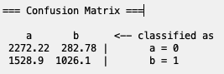
Figure 19 - Confusion matrix for the best-performing classifier
Figure 19 shows the confusion matrix for the Random Forest classifier, where class ‘a’ represents non-stroke cases and class ‘b’ represents stroke cases. The matrix shows how many cases were correctly and incorrectly assigned to each class. Although Random Forest performed best overall, it still missed some true stroke cases, which shows why recall remains important in this type of healthcare prediction task.
When presenting the sample runs from Weka, it was important to include more than just the final percentage correct. The full classifier output, confusion matrix, class-level precision and recall, and ROC area were more useful for comparing the models properly. A side-by-side comparison table made it easier to identify which method performed best overall. In this kind of report, the strongest model is not necessarily the one with the highest raw accuracy, but the one that gives the best balance between identifying stroke cases correctly and avoiding too many misleading predictions.
Overall, the methods used gave a balanced analysis of the dataset. J48 was useful because it was easy to interpret, Logistic Regression provided a good baseline, Random Forest offered stronger predictive power, and Simple K-Means added a pattern-based view of the data. Together, these methods allowed the results to be compared in terms of both predictive strength and interpretability.

1.5 Business Recommendations
The results of the classification and clustering analysis suggest that predictive models should be used by healthcare providers as an early screening support tool rather than as the final basis for decisions. If a model can identify higher-risk patients with a reasonable level of recall, it could help flag individuals who need further assessment, especially where factors such as age, hypertension, heart disease, BMI, and average glucose level appear together. This would be particularly useful in primary care or public health settings, where large numbers of patients may need to be reviewed quickly and efficiently.
Another recommendation is that public health organisations could use clustering results to support more targeted prevention strategies. Different groups of patients are likely to have different risk profiles, so using the same intervention for everyone may not be the most effective approach. For example, one cluster may mainly include older patients with stronger medical risk factors, while another may reflect more lifestyle-related patterns. This would allow awareness campaigns and prevention programmes to be more focused.
The findings also suggest that organisations should be careful about relying on accuracy alone when judging predictive systems. Because the dataset is highly imbalanced, a model may appear to perform well overall while still doing a poor job of identifying actual stroke cases. For that reason, measures such as recall and AUC are more useful when deciding whether a model has practical value.
Finally, any model developed from this dataset should be tested on larger and more representative datasets before being used in real-world healthcare settings. These systems should support clinical judgement, not replace it. Their main value lies in helping organisations prioritise follow-up, improve prevention planning, and make better use of limited healthcare resources.

1.6 Reflective Commentary
This analysis showed that data mining can be useful for healthcare prediction, but it also showed that the quality of the results depends heavily on preprocessing and evaluation. One of the biggest issues in this dataset was class imbalance, because it meant that high accuracy on its own could be misleading. This made it necessary to focus more on recall, precision, F1-score, and AUC rather than just overall accuracy.
One strength of the analysis was that it compared more than one method instead of relying on a single model. Using J48, Logistic, and Random Forest made it easier to compare interpretability against predictive performance, while Simple K-Means added another perspective by identifying possible patterns in the data. Another strength was that Weka made it fairly easy to test different methods in one place and compare their outputs directly.
The main limitation was the dataset itself. Although it was useful for learning and model comparison, it is still a relatively small public dataset with missing BMI values and a very uneven class distribution. That means the findings should be interpreted carefully and should not be assumed to apply directly to real clinical settings. Another limitation was that some preprocessing steps, such as balancing and handling the target variable type, had a strong effect on how the analysis could be carried out.
If I were doing this again, I would spend more time comparing different balancing methods and testing whether feature selection changed the results in a useful way. I would also compare the Weka output with another tool to check whether the results were consistent. Overall, this task was useful because it showed that good data mining is not only about choosing a model, but also about making sensible decisions throughout the whole process.

References
- Wang, W., Kiik, M., Peek, N., Curcin, V., Marshall, I.J., Rudd, A.G., Wang, Y., Douiri, A., Wolfe, C.D. and Bray, B. (2020) 'A systematic review of machine learning models for predicting outcomes of stroke with structured data', PLOS ONE, 15(6), e0234722. Available at: https://doi.org/10.1371/journal.pone.0234722.
- Hassan, A., Arshad, S., Khokhar, M., Mohammed, N., Alghamdi, A.M., Alfakeeh, A.S., Ali, Z., Alsufyani, A. and Elhasnaoui, A. (2024) 'Predictive modelling and identification of key risk factors for stroke using machine learning', Scientific Reports, 14(1), 11498. Available at: https://doi.org/10.1038/s41598-024-61665-4.
- Soriano, F. (n.d.) Stroke Prediction Dataset. Kaggle. Available at: https://www.kaggle.com/datasets/fedesoriano/stroke-prediction-dataset.
- Frank, E., Hall, M.A. and Witten, I.H. (2016) The WEKA Workbench: Online Appendix for Data Mining: Practical Machine Learning Tools and Techniques. 4th edn. Hamilton, New Zealand: University of Waikato. Available at: https://www.cs.waikato.ac.nz/ml/weka/Witten_et_al_2016_appendix.pdf.
- Hassan, A., Arshad, S., Khokhar, M., Mohammed, N., Alghamdi, A.M., Alfakeeh, A.S., Ali, Z., Alsufyani, A. and Elhasnaoui, A. (2024) ‘Predictive modelling and identification of key risk factors for stroke using machine learning’, Scientific Reports, 14(1), 11498. Available at: https://doi.org/10.1038/s41598-024-61665-4.
- Hassan, A. et al. (2024) ‘Predictive modelling and identification of key risk factors for stroke using machine learning’, Scientific Reports, 14, 11498.
- Sutcu, M. et al. (2025) ‘Predicting Stroke Risk Using Machine Learning: A Data-Driven Approach’.
- Frank, E., Hall, M.A. and Witten, I.H. (2016) The WEKA Workbench. University of Waikato.
- Zhu, J. et al. (2024) ‘Processing imbalanced medical data at the data level…’.
- Owusu-Adjei, M. et al. (2023) ‘Imbalanced class distribution and performance evaluation metrics’.
- Kumar, V. et al. (2022) ‘Addressing Binary Classification over Class Imbalanced Data’.
- Kokkotis, C. et al. (2022) ‘An Explainable Machine Learning Pipeline for Stroke Prediction’.
- Kitova, K. et al. (2024) ‘Stroke Dataset Modeling: Comparative Study of Machine Learning Approaches’, Algorithms, 17(12), 571.
- Frank, E., Hall, M.A. and Witten, I.H. (2016) The WEKA Workbench: Online Appendix for Data Mining: Practical Machine Learning Tools and Techniques. University of Waikato.
- Singh, R. et al. (2024) ‘Optimizing early diagnosis by integrating multiple machine learning approaches for improved stroke prediction’, Scientific Reports.
- Hassan, A. et al. (2024) ‘Predictive modelling and identification of key risk factors for stroke using machine learning’, Scientific Reports, 14, 11498.
- Sutcu, M. et al. (2025) ‘Predicting Stroke Risk Using Machine Learning: A Data-Driven Approach’.
- El-Geneedy, M. et al. (2025) ‘A comprehensive explainable AI approach for enhancing stroke prediction’, Scientific Reports.
- Akinwumi, P.O. et al. (2024/2025) ‘Evaluating machine learning models for stroke prediction’.
- Srinivasu, P.N. et al. (2024) ‘An Interpretable Approach with Explainable AI for Heart Stroke Prediction’.

