

Management Economics LCBB5008
~ Assessment 1 ~

Management Economics: Coursework essay

Lecturer: Dr. Taye Osadiya
Student: Vladimir Mihai BARA – 2110942

Table of Contents:

- Introduction – max 100w / 150-2750=2600
- Q1.1. The fundamental economic problems presented in the case study – 600w / 25marks.
- Q1.2. Various solutions to solve the economic problems encountered in the case study – 600w/ 25marks.
- Q2.1. The relevance of demand and supply in this case study - 600w / 25marks
- Q2.2. The difference between elasticity and inelasticity of demand when analysing the fuel price changing – 400w / 15marks
- Q2.3. Analysing the laws of supply and demand - 300w / 10 marks
- Conclusion – max 150w (GT 2750 w / 100marks)
- References

“The first lesson of economics is scarcity: There is never enough of anything to satisfy all those who want it. The first lesson of politics is to disregard the first lesson of economics.”
― Thomas Sowell, Is Reality Optional?: And Other Essays (Hoover Institution Press Publication, 1993)

- Introduction:
The content of this essay proposes a macroeconomic analysis of the UK market post-Covid-19 pandemic. As Dr T. Osadiya, underlines economics represent the ‘Household’ – ‘Oiko’ – Management – ‘Nomos’ – (2023, p.5.). Therefore, we will look at the case study proposed by the Institute for Government in 2021 about the demand and supply of chain disruption in the aftermath of covid-19 pandemic.
We will pursue our analysis by answering two topics identified in the case study. The first topic will cover the fundamental economic problems. And, the second topic will talk about demand and supply, especially the difference between elasticity and inelasticity of demand when analysing the price changes in the cost of fuel. Also, we will look at the laws of supply and demand.
Nevertheless, we will observe, during our essay, the interdependence of the UK market with other markets and how this has the potential to impact and affect the supply chain.

- Q1.1. The fundamental economic problems presented in the case study:
The case study presented by the Institute for Government in 2021 brings together at least eleven fundamental economic problems that we will briefly list below.
Q1.1.1. Covid-19 Rules of doing business:
The case study brought by the Institute for Government in 2021 gravitated around the impact of the Covid-19 pandemic globally. The UK Government reacted to the pandemic in a similar way as other governments of major developed economies reacted, by imposing movement restrictions in order to limit the potential spreading of the Covid-19 virus. Those movement restrictions and social distancing, like keeping 2 meters apart from each other in any interaction, made impossible the functions of pretty much all the business. There was essential business that was running during the pandemic as their employee was key workers such as NHS doctors and nurses, careers, teaching staff, etc.
Some businesses adapt quickly and even explode as they are in a niche that used to have limited face-to-face interaction with the public, like those that have an online selling products platform like Amazon, or food delivery like Deliveroo. The market research group, Research FDI, analyse a study conducted by the New York Times in January 2021 that states Amazon's profits increased by nearly 200% since the debut of Covid-19 pandemic (Research FDI, 6th January 2021). Also, Deliveroo, the UK food delivery company, reported a rise of 114% in orders, worth £1.65bn during the Covid-19 lockdown, claims a study from April 2021 from The Guardian (The Guardian, 15 April 2021).
Even though the UK Government imposed restrictions by social distancing, it reacted to support businesses affected by the pandemic by offering financial support by paying the employee salary, business rate relief, or loan scheme, etc (Gov UK). A report of the UK Parliament from 2023 claims that the total estimated cost of government Covid-19 measures ranges between £310bn to £410bn (UK Parliament September 2023).
Q1.1.2. Shortages of demand due to an increase in demand:
All the UK Government financial aid to businesses places a great number of individuals in the position of having spare time, by forcing them to stay home and receiving government financial aid. This directly led to a greater increase in demand for goods and services. However, the supply chain was decreased by the same Government actions that forced individuals to socially distance each other and stay at home. This creates greater pressure on the supply chain and affects the demand chain as well. All 3 conditions were met in order to struggle along the shortage of supply: an increase in demand, a decrease in supply, and government intervention, as the article from WallStreetMojo also underlines (Aswathi J., Wall Street Mojo, 2010).
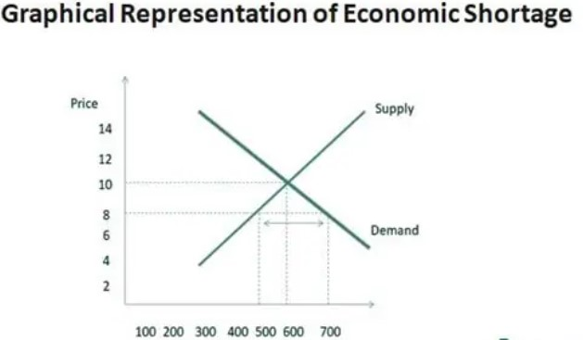
We can graphically represent the economic shortage by elevating the demand line and the supply line striving to reach it. Everything that is under the equilibrium point, where the supply graph meets the demand line represents the economic shortage:
Figure 1. Diagram of Graphical Representation of Economic Shortage when the demand is greater than supply chain. (Source WallStreetMojo, https://www.wallstreetmojo.com/ economic-shortage/)
Eventually, individuals were forced to reorient themselves to different goods and services for their needs. This situation was created by the fact that the supply chain was put under greater stress and could not deliver what and when was needed. For that reason, macroeconomically was a set of circumstances that started to coexist with a shortage of demand, purely due to the fact that the market tends to reach an equilibrium point.
Q1.1.3. Shortages of supply amplified by the shortage of drivers:
In order for the supply chain to reach the consumers, the goods have to be delivered by truck drivers from different markets that connect with the UK market. There were a lot of issues that led to a shortage of drivers in the UK, and this amplified the shortages in the supply chain.
Q1.1.4. BREXIT’s effect on the demand and supply chain facilities:
Prior to the pandemic times, BREXIT impacted UK economic growth by the fact that an important part of workers left England for other markets, especially for their native countries, voluntarily or forced by the UK Government's certain conditions. For example, this situation led to the temporary agricultural workforce leaving England and caused the UK to concentrate more on imports. However, the needed level of imports for the UK market couldn’t be reached due to the fact that the truck driver’s benefits start to be greater in EU countries than in the UK. Therefore, BREXIT amplified the supply chain shortages.
As the British economist, Paul Andrew Ormerod suggests all the small individual economic decisions are similar to a butterfly moving wings that compounded have the force to disrupt the existing economic status quo (Ormerod Paul, 1998).
Q1.1.5. Panic buying of scarce resources:
It is obvious that the market forces created the shortage, and it wasn’t created by nature, so there wasn’t a characteristic of scarcity, even if the effect seems similar. Scarcity could be permanent, compared to shortages that are temporary on the market. And the ‘invisible forces’ of the market tend to readjust to the equilibrium point. However, the individual panicked and acted to buy in bulk, and this created a quicker turnover of the goods and services, at a certain point the media presented the situation as a scarce resource on the market amplified the panic and impulse to buy from the clients.
There are lots of examples of the effects of panic, however, we list only ‘fruits and vegetable issues’. For example, all the supply issues create a situation where the fruits and vegetables in UK supermarkets can be bought in only small amounts and not in bulk. Even though, the report of EIT Food reveals in 2020, that UK customers increased their vegetable consumption by 31%, and the consumption of fruit by 35% during the coronavirus pandemic (Jerome Smail’s article in December 2020 in Food Manufacture UK).
This kind of rationalization of resources amplified the consumer’s panic and created, in the UK free market, a similar flavor of feeling to final consumers, like in a commanded economy similar to communist countries. However, this situation was only temporary in the UK market, contrary to the long-time acute panic feeling in the communist markets.
Q1.1.6. Shortage of fuel supply:
Fuel supply represents the blood for the economy and the shortage of it, has a great impact on a major developed economy.
Driver shortage coupled with the ‘alarming buying’ of goods (Institute for Government, 2021) contributed to the fuel supply issues. The media presented, in 2021, during the pandemic time, extremely long queues in order to be able to put petrol in the car. This situation amplified the panic described above. The main issue was the fact that the fuel resources couldn’t reach the final consumer due to the fact that there weren’t enough drivers to deliver the fuel to the pumps. Also, the fuel truck drivers decided to go on strike when the pressure was accruing on them to deliver the fuel intensively. This disrupted the fuel chain supply even more (Bloomberg, analyse 2022).
Q1.1.7. Rocketed price changes in the cost of fuel:
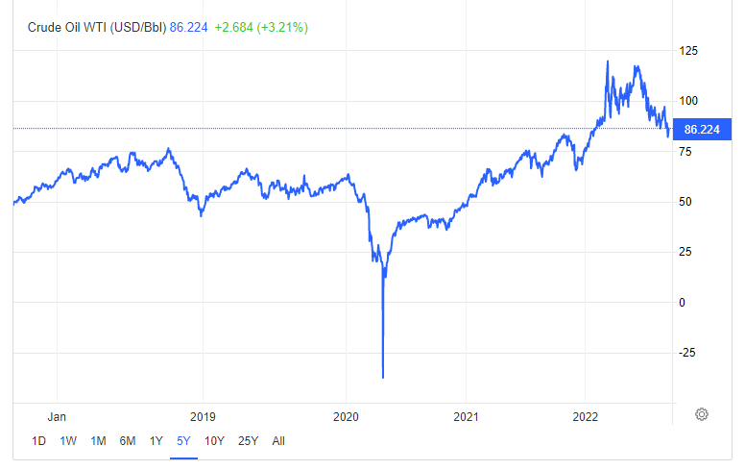
As the coronavirus lockdowns affected the global economy, there was a situation in the global commodity market when the price of oil became negative in April 2020. However, the fuel supply chain was disrupted by the driver shortage, and the accrued demand for goods and services. For that reason, the negative oil price was marked as a profit for the agile commodities traders and for the Petrol station stakeholders, and not really for the end consumers. On top of that, another economic Black Swan arose with the start of the war in Ukraine in February 2022, signaling a fuel-rocketed price swap in a relatively short period of time, from the macroeconomic point of view. The following graph represents this crude oil price situation unique in time as the price went into a negative value.
Figure 2. Evolution of Crude Oil trade price over 5 years presented by Trading Economics. (Source: https://tradingeconomics.com/commodity/crude-oil)
Q1.1.8. High borrowings of funds to meet the surging high cost of living:
Financial institutions adapted to the pandemic situation as the demand for monies was high due to the costs of livings that went up.
Q1.1.9. The end of furlough and redundancies:
Q1.1.10. Bankruptcies due to lack of funds to pay the high borrowings resulted to the high cost of living:
Q1.1.11. Shift in consumer appetite from services to goods:
- Q1.2. Various solutions to solve the economic problems encountered in the case study:
There are at least eight solutions to solve the economic problems encountered in this case study. We will analyse each of them.
Q1.2.1. Government intervention:
Q1.2.2. Relaxing some Covid-19 rules:
Q1.2.3. Developing shortage management team strategy:
Q1.2.4. Create and improve supplier corroborations network:
Q1.2.5. Create alternative ways to reduce waste:
Q1.2.6. Assess and improve own supply chain:
Q1.2.7. Work with suppliers to reduce prices:
Q1.2.8. Keep stakeholders informed and up to date:
- Q2.1. The relevance of demand and supply in this case study:
Q.2.1.1. Pricing strategy to reduce and manage the pressure of demand and supply:
Q2.1.2. Competition and driving the prices to be low and reduce price:
Q2.1.3. Helps to expand business productivity (e.g. Amazon online platform management)
Q2.1.4. Marketing strategy it helps to promote the business concept
Q2.1.5. Helps to balance inventory management strategy (e.g. just in time system)
Q2.1.6. Finance attraction through investments – initial public offering (IPO) to raise high capital investment by creating a massive investment spree
Q2.1.7. Greater worker retention and satisfaction through high-salary payment
Q2.1.8. Management of risks to maintain the equilibrium of demand and supply
Q2.1.9. Management of shortage and supply and help shifting market demand – by matching demand and supply
- Q2.2. The difference between elasticity and inelasticity of demand when analysing the fuel price changing:
Q2.2.1. Elasticity definition
Q2.2.2. Inelasticity definition
Q2.2.3. The difference between elasticity and inelasticity with examples
- Q2.3. Analysing the laws of supply and demand:
In macroeconomics exist four basic laws of supply and demand. Knowing them would help any business owner
- Conclusion: 35w
As we navigate through the economic problems underlined by the study case from 2021 rise by the Institute of Government, we observed the complexity of issues raised by covid-19 pandemic.
- References:
- Thomas Sowell, Is Reality Optional?: And Other Essays (Hoover Institution Press Publication, 1993)
- Osadiya T. (2023), Introduction to Economics. Amazon, p.5.
- Research FDI, January 2021, https://researchfdi.com/resources/articles/amazon-covid-19-pandemic-profits/ (accessed on 15 December 2023)
- The Guardian, April 2021, https://www.theguardian.com/business/2021/apr/15/deliveroo-doubles-orders-during-latest-covid-lockdown (accessed on 15 December 2023)
- Official website of UK Government, Gov.uk, https://www.gov.uk/government/collections/financial-support-for-businesses-during-coronavirus-covid-19 (accessed on 15 December 2023)
- Official website of UK Parliament, September 2023, https://commonslibrary.parliament.uk/research-briefings/cbp-9309/#:~:text=The%20Covid%2D19%20pandemic%20resulted,per%20person%20in%20the%20UK. (accessed on 15 December 2023)
- Ormerod Paul (1998), Butterfly Economics: A New General Theory of Economics and Social Behaviour, ed. Faber and Faber.
- Jerome Smail, December 2020 in Food Manufacture UK, https://www.foodmanufacture.co.uk/Article/2020/12/15/EIT-report-shows-rise-in-fruit-and-veg-consumption# (accessed on 15 December 2023)
- Bloomberg, November 2022, https://www.bloomberg.com/news/articles/2022-11-22/shortage-looms-for-diesel-world-s-most-crucial-fuel?leadSource=uverify%20wall (accessed on 15 December 2023)

