Qualification: CIPD Diploma in Applied Human Resources

Module Name: Contributing to the Employee Engagement in the Workplace

Word Count: 3503

Student Name: Stephanie Rayner
Student Number: 1907192
CIPD Membership Number: 55478507

By signing below, I confirm that the work/evidence presented is my own, unaided work. I understand the regulations pertaining to candidate malpractice and the action that may be taken as a result.

Signed:

Date: 13th December 2020

Contents Page

Title | Page Number
Be able to assess levels of employee engagement within the organisation. | 3 - 6
Evidence | 7 - 22
Be able to evaluate current organisational approaches to employee engagement. | 23 - 26
Evidence | 27 - 65
Be able to recommend and plan strategies to raise levels of employee engagement within an organisation. | 66 - 67
Evidence | 68 - 73
Evidence Matrix | 74 - 76
Bibliography | 77

Be able to assess levels of employee engagement within the organisation.

Identify, and justify selection of, suitable diagnostic tools for measuring employee engagement in the organisation.

Due to the COVID-19 pandemic, I have limited access to resources within the Organisation and therefore unable to undertake an assessment of employee engagement within Swansea Council however, I have made reference to a Covid-19 Employee Engagement survey that was undertaken by the Corporate Management Team in August 2020.

Swansea Council recognises the effect Covid-19 has had and continues to have on employees both within their personal and working lives and as such, the Corporate Management Team (CMT) issued a survey to office-based staff requesting feedback regarding well-being and working from home arrangements during such unprecedented times. It also provided an opportunity for CMT to gain the view of individuals regarding their wellbeing and future working arrangements, (EV1).

This approach is in line with the view of (Engage for Success, 2020), who state that organisations need to understand the needs of their workforce and predict the future wellbeing demands.

CMT considered the most effective approach and as detailed within (EV2), issuing a survey with the appropriate questions also providing an opportunity for open feedback was considered the only tool available due to being in National lockdown at the time.

The chosen approach by CMT was to issue a survey via Microsoft Forms which according to (SHRM, 2020) if conducted effectively could provide senior managers with constructive feedback from employees, enabling them to consider options of improvement. Issuing a survey at such time whereby employees may be feeling anxious and less engaged could send a positive message to staff that their opinions are still valued. However, CMT also needed to evidence that the feedback was considered and employees were being listened to. Failure to do so could have resulted in low staff morale and lack of future engagement. Results of the survey were issued via the Chief Executives Blog, (EV3) and also via StaffNet, (Swansea Council, 2020).

It is difficult to determine the exact number of employees who saw sight of the survey as there are around 4,500 employees with Swansea.gov email addresses however, the IT Department confirmed that around 2,500 employees access the system every day and therefore the response of 1,600 employees (65%) is believed to be an appropriate sample size providing meaningful results.

An objective as detailed within the Organisational and Development Strategy, (EV4) is to ‘Create Engagement within and External of the Council’. The engagement survey therefore focused on employee well-being and questioned whether employees are aware of the initiatives offered by Swansea Council. 90% of employees responded positively regarding their wellbeing with 10% experiencing a negative impact since the commencement of the pandemic In relation to accessing wellbeing initiatives, 77% confirmed they were aware of how to access such initiatives. This proving the success of regular communication issued to staff during the Pandemic, (EV5) in addition to the information via StaffNet in relation to Employee Mental Health and Wellbeing, (EV6).

This approach being in line with (CIPD, 2020) which recognises communication as vital part of employee engagement. Consideration must be taken regarding access to technology and the appropriate communication methods to ensure the information reaches the whole workforce.

An analysis of the survey results is detailed below:

With regard working from home, the below chart illustrates those respondents who like working from home, and the percentage relates to the % response from the directorates where the employees are currently working.

It is clear from the responses that the majority like working from home (87%).

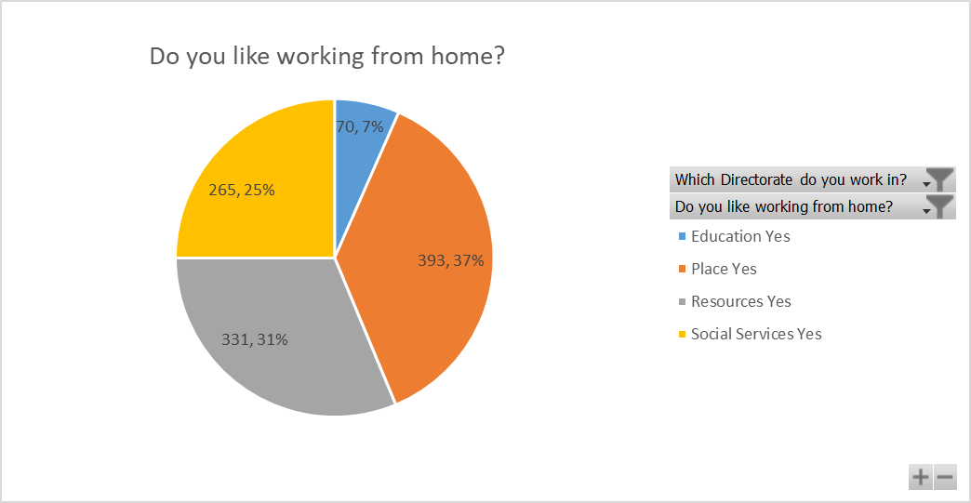

Please see below figures in relation to responses within each Directorate.
Which Directorate do you work in? | Total | % of responses
Education | 92 | 6%
Place | 627 | 39%
Resources | 449 | 28%
Social Services | 437 | 27%
Grand Total | 1605

When questioned whether staff would prefer to continue working from home,
84% want to continue to work from home 2 days a week or more with 21% want to continue to work from home full time.

This is in line with the future ways of working detailed within (Human Resources Today, 2020) who make reference to the future of employee engagement focussing on a organisations having a flexible and adaptable approach with home working becoming the norm.

The responses in relation IT equipment and software were very positive with 92% confirming they has the necessary equipment and the majority of staff stated they have internet access at home, 99.5%. However, there was a balanced response regarding having the necessary equipment, 51% being positive and 49% negative. As a response to this, the Authority have provided a scheme where employees are able to reclaim monies for equipment they have purchased, (EV7). Again, this evidencing that CMT have considered employee feedback.

Having analysed the responses regarding communication with managers, 95% confirmed they were happy with the type of communication and 94% confirmed they were happy with the frequency of communication and the future of virtual meetings. This again evidencing that managers within Swansea Council are maintaining effective communication with their teams which again is a main focus of employee engagement, (Human Resources Today, 2020).

Below provides a snapshop of real issues being experienced by the workforce during the present time in respect of employee’s productivity now they are working from home.
NEGATIVE COMMENT
Difficult to access information required to do role
Difficult to access colleagues (knowledge) to assist with role
Miss socialising with colleagues
ICT – wifi issues, equipment issues, no access to printing
No proper workspace at home
Home too distracting (children etc.)
Social contact/loneliness/isolated/bored
Difficult to manage the team
Not available for the team as much as would like

POSITIVE COMMENT
Less travelling
Less distractions / interruptions
Better focus/concentration
Can do everything online / teams
Better work life balance
Feel better/happier at home
Better working environment
Flexibility / Better time management
Less stressed
Time to develop new skills

Whilst there are mixed views in relation to the positive and negative impact of working from home, as detailed earlier within the analysis, the majority of employees would prefer to have a flexible approach to work in the future and maintain working from home arrangements.

Organisations have no control over the current crisis and Swansea Council is no different, however, they do have control over the way in which they interact with the workforce. The current times are requiring staff to ‘go above and beyond’ their normal duties and therefore employee engagement is a vital factor for the future of the organisation.

According to (HR Review, 2020), to maintain high levels of employee engagement, organisation are encouraged to stay in touch with their employees and work with them to build the future for the organisation.

The results of the engagement survey and feedback provided by CMT evidence a culture of ’Let’s learn from the challenges we face to come together and build a better future’ (Human Resources Today, 2020).

Following an analysis of the survey, I considered the period in which the survey was issued, i.e. National Lockdown, Summer months and as such wanted to determine whether individuals perceptions would differ should the survey be issued during the Winter months and at a time whereby personal circumstances may have been affected.

Unfortunately, I was unable to conduct interviews outside of the HR Team and therefore chose to meet with HR colleagues who may have experienced different challenges throughout the Pandemic, (EV8).

Having analysed the responses, one individual confirmed they did not complete the survey however, if issued again felt they would be in a better position to provide a meaningful response.

The majority of individuals have experienced challenges during the pandemic but seem to be getting used to the new ways of working.

On reflection of both the Employee Engagement Survey results, the interviews and my own views regarding the new ways of working, I would provide a recommendation to CMT for another engagement survey to be issued during the Winter months as individuals working from home is more realistic and individuals circumstances are back to some kind of normality. In addition, the darker nights may have an impact on individuals mental health and wellbeing which is a vital factor for consideration during such unpreceded times.

EV1

Employee engagement survey – working from home during the covid-19 pandemic and beyond.

Which Directorate do you work in?
- Education
- Place
- Resources
- Social Services

Which Council office building are you normally based at?
- Civic Centre
- Clydach Depot
- Guildhall
- Heol Y Gors (Cave Street)
- Other
- Pipehouse

How would you rate your well-being since the COVID-19 pandemic?
- Very Good
- Good
- Neutral
- Poor
- Very Poor

Do you know where to access information and advice for support with your health and wellbeing?
- Yes
- No
- Maybe

Do you like working from home?
- Yes
- No
- Neutral

How often did you work from home before the pandemic?
- 1 day a week
- 1 or 2 days a month
- 2 days a week
- 5 days a week
- More than 2 days a week
- Never

How often do you work from home now?
- 1 day a week
- 1 or 2 days a month
- 2 days a week
- 5 days a week
- More than 2 days a week
- Never

After COVID, how often would you like to work from home (if your role allows you to work from home)?
- 1 day a week
- 1 or 2 days a month
- 2 days a week
- 5 days a week
- More than 2 days a week
- Never

How much of your role can you carry out at home?
- All of it
- Half
- Most
- None
- Not a lot
- Quarter

How productive do you feel working from home compared to working in the office?
- Less productive
- More productive
- The same

After COVID-19 I feel that working from home will enable me to be more effective in my role (i.e. able to meet deadlines etc.)
- Agree
- Disagree
- Neutral – neither agree nor disagree
- Strongly agree
- Strongly disagree

Do you have all the necessary equipment to work from home?
- No
- Yes

Do you have all the necessary software and applications to work from home?
- No
- Yes

Do you have access to the internet to work from home?
- No
- Yes

Do you need additional ICT training or support to work remotely?
Maybe
- No
- Yes

Are you happy with the type of communication you currently receive from your line manager?
- Yes
- No
- Maybe

Are you happy with the frequency of communication you receive from your line manager?
- Yes
- No
- Maybe

Do you like attending virtual meetings?
- Neutral (neither like nor dislike it)
- No
- Yes

After COVID-19, how often do you think you will want to attend the workplace to have fact to face meetings with your manager?
- Daily
- Monthly
- Never – I’m happy using Teams
- Once a week
- Twice a week

After COVID-19, how often do you think you will need to attend face to face meetings with your team members and colleagues?
- Daily
- Monthly
- Never – I’m happy using Teams
- Once a week
- Twice a week

Please provide any further comments regarding your working arrangements and wellbeing during this time:

EV2

HI Steph

It was the only tool as we were in full lockdown when decisions were made. There was no other option open to us at the time.

There was an overwhelming response, the highest return rate we had seen – over 50% of the 4500 we targeted when usually we get about 20%.

As the survey was about working from home, many had something to say about it and we asked for feedback on what support people wanted, so it was timely.

Regards, Linda

Linda Phillips Chartered FCIPD, MLitt. HSD  Swyddog Prosiect Datblygu Sefydliadol  Adnoddau Dynol a Datblygu Sefydliadol  Ystafell 212, Neuadd y Ddinas  Abertawe  SA1 3PE  Rhif ffôn: 07471 145355  Gwefan: www.abertawe.gov.uk  Twitter: www.twitter.com/cyngorabertawe  Facebook: www.facebook.com/swanseacitycouncil | Linda Phillips, Chartered FCIPD, MLitt. HSD Certified Professional  OD Project Officer  Human Resources and Organisation Development  Room 212, The Guildhall  Swansea  SA1 3PE  Tel. No. 07471 145355  Website: www.swansea.gov.uk  Twitter: www.twitter.com/swanseacouncil  Facebook: www.facebook.com/swanseacitycouncil

From: Stephanie Rayner <Stephanie.Rayner@swansea.gov.uk>
Sent: 01 November 2020 09:37
To: Linda Phillips <Linda.Phillips@swansea.gov.uk>
Subject: Engagement Survey

Hi Linda

I understand that you have had involvement regarding the Covid-19 Employee Engagement Survey, whilst it is difficult for me to engage with members of the Corporate Management Team during this time, please can you advise on the chosen method used for such feedback i.e. survey and whether this was the most effective diagnostic tool to be used?

Thank you, Steph

Stephanie Rayner
Partner Busnes AD a DS
HR and OD Business Partner

 01792 636098
 stephanie.rayner@swansea.gov.uk
 stephanie.rayner@abertawe.gov.uk

EV3



Search Results for: survey results

Interesting results from staff
August 21, 2020 by Phil Leave a Comment
The recent staff survey on agile and home-working will be essential to help us plan for where we’ll all work in the coming months and years. More than 1,600 staff responded and the initial results are very interesting. We had a particularly good response from staff based at the Civic Centre and the Guildhall.

In terms of well-being since the onset of the pandemic, 90% of staff rated this positively and most were very clear on where and how to access well-being support from the Council.

Two thirds of staff like working from home, 20% felt neutral and only 13% stated that they didn’t like it. Of the positive responses, 47% worked from home at least one day a week before the pandemic, but just over 1% were working from home for 5 days pre-Covid. Now 73% of staff are working from home five days a week and 97% of staff are working more than two days a week from home. Post-Covid 84% of staff want to continue to work from home at least two days a week or more: and 21% want to work from home full-time.

78% of staff can do all or most of their work at home, 14% can do half of their work at home and less than 1% can do no work from home. 85% stated that they felt either at least as or more productive working from home. However, only half of respondents said they had all of the equipment they needed to work from home. This doesn’t appear to be ICT-related as 92% have all the software and applications they need, 99.5% have internet access at home and only 4% felt they needed additional ICT training.

However, a number of staff have said they require additional equipment such as monitors and keyboards, among other things.

6% of staff stated that they didn’t like attending virtual meetings. 95% were satisfied with the communications from their line manager. Staff preferences for working with managers and colleagues in the future produced a mixed response as you can see from the tables below.
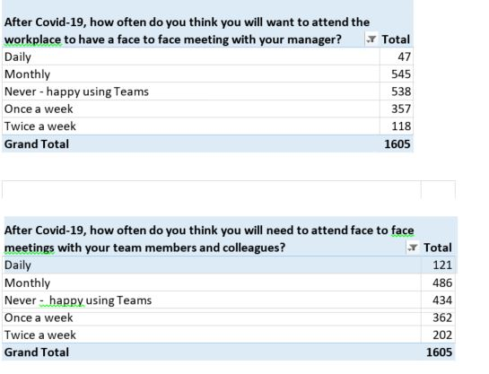
It’s really positive that so many staff took the time to respond and that on average 90% who did respond are performing well and are happy working from home. It’s important we now work closely with Heads of Service to use the responses from you all to guide our strategy for agile working by office-based staff and develop policies which facilitate it. However, the results also point to the need to be flexible in our approach so that we can properly cater for a variety of needs and preferences. I’ll update you all as this work progresses.

EV 4



Organisational Development (OD)

Strategy Aspirations 2017-22

- Strategic Context
  - The Council’s workforce is one of the most important elements in service delivery. Welsh Councils employ 140,000 people, which means 1 in 9 of the total Welsh workforce is directly employed in delivering services that communities need. A Welsh Local Government Association (WLGA) workforce spokesman said recently:
“The sustainability of public services is identified by the sustainability of the workforce delivering them”
This concept of a sustainable workforce is the keystone of this OD strategy. Only a sustainable workforce approach can deliver the aspirations and well-being objectives in the Swansea Council Corporate Plan. This strategy delivers particularly on the Transformation & Future Council priority within the Corporate Plan.
  - The external environment continues to be volatile and uncertain, exerting both positive and negative influences, with the potential to affect the Council’s organisational development. Key areas include:
- Continuous or perma-austerity, meaning staff and managers have to continually innovate to meet rising demand for services, thinking commercially and digitally about how to deliver, commission and fund services
- The importance of sustainable local communities, which has seen a significant increase in community ownership and the need to develop services in partnership with residents. Staff, managers and councillors are using a holistic approach now more than ever
- Workforce integration and movement across sectors as the Social Services and Well-being Act (SSWBA) brings community health services staff together and as staff move between public / third sectors and higher education organisations in Swansea
- Agile working practices are growing and an agile culture is developing which has an impact on leadership and management styles
- Local government reform (LGR) and the drive towards regional and shared services with partners’ means different ways of working and delivering services, in some cases new governance models such as joint ventures or arm’s length companies. This is leading to a rise in generic cross-sector skills not just techno-professional competence and greater matrix working across teams
- The need for transformational leadership skills to embrace change and deliver on the Council’s priorities at pace
- Emerging new technologies and the drive towards digital, embracing and interpreting these changes into innovative new ways of working and delivering projects. This includes growing business intelligence capability to inform decision-making. This also has brought a heightened emphasis on data management and security
- The success of the City Deal which is driving new ways of thinking, governance models, new relationships and networks, and driving innovative solutions for the City.

  - Create Engagement Within and External of the Council

To enable organisational success, there is a need to ensure that all the people of the Council understand and are working towards the Councils vision, aims and priorities. To achieve this, the Council must work in a collaborative and inclusive manner where all people understand how they contribute and how they feed into the bigger picture.
The WBFG Act, SSWB Act and the recent LGR paper means that the Council must begin to work in a more collaborative way with partners to co-design, co-deliver and co-own issues and initiatives.

The objectives to meet this aim are:

- Extend the culture where all staff feel empowered, motivated, engaged and valued by 2022 and beyond.
- Extend the culture of collaboration internally and externally and increase matrix working by 2022 and beyond.

To meet the objective of further developing a culture where all staff feel empowered, motivated, engaged and valued by 2022 and beyond, we will:

- Review & co-produce an employee charter where managers and employees agree expectations
- Build on engagement initiatives to enhance peoples understanding of how they fit into the bigger picture
- Define and create an identity and community for 3rd and 4th tier managers
- Develop staff 'idea' and ‘knowledge’ hubs to co-develop and test potential ideas and share knowledge and experience
- Review gaps in the innovation community and direction of focus

To meet the objective of extending the culture of collaboration internally and externally and increase matrix working by 2022 and beyond.

- Create a strategy to develop behaviours and capacity for co-creation & co-production by building upon existing relationships with other Local Authorities, Agencies and the WG

1.4 Become An Agile Organisation

In today’s world of austerity and ever-changing circumstances, flexibility and speed are considered key components to adapt, survive and thrive. Therefore, there is a need for effective and decisive decision making at the right level, whilst relevant risks and issues are highlighted and reported. There is also a need to ensure that the Council has the right skills and experiences within teams, so they can react quickly and effectively to any given situation and work across boundaries.

The objective to meet this aim is:

- To enable individuals and teams to work across departmental, directorate and organisational boundaries by 2021

To meet this objective we will:
- Review policies and practices in ways which increase secondments and job sharing across the Council and actively support progression opportunities
- Review how to empower decision making at the appropriate levels and assess and log the risks
- Review ways to increase matrix working
- Review the change plan, update actions, responsibilities, and communicate

EV5

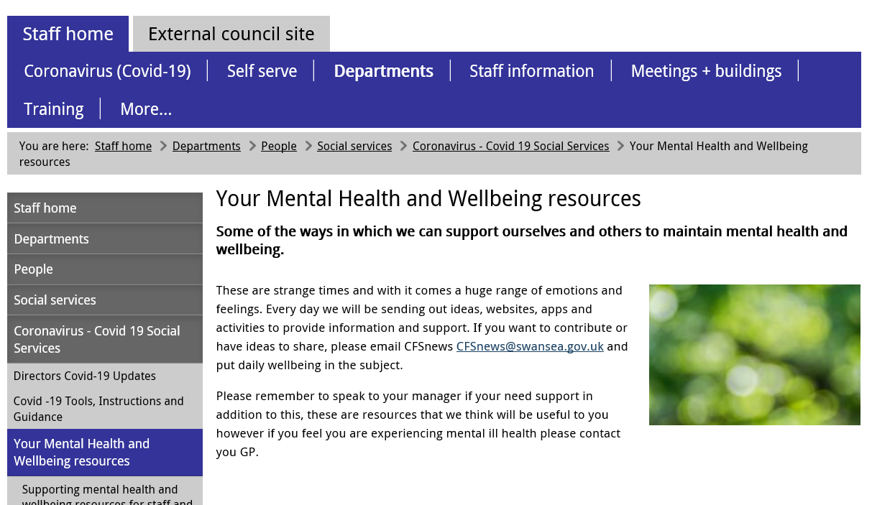
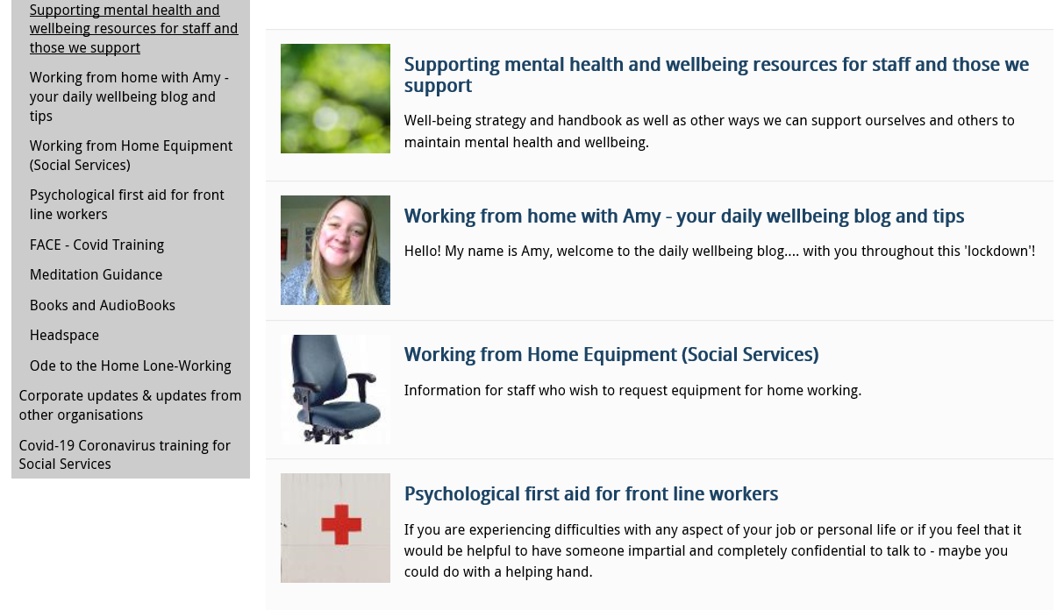
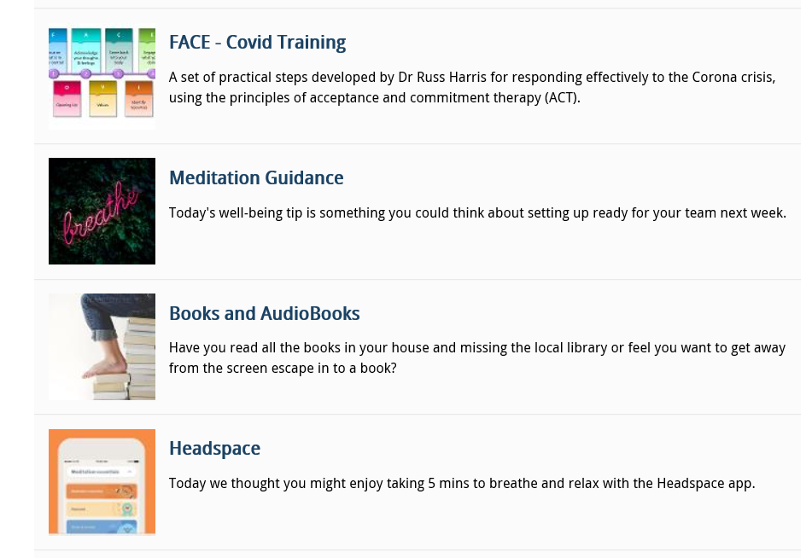

EV6

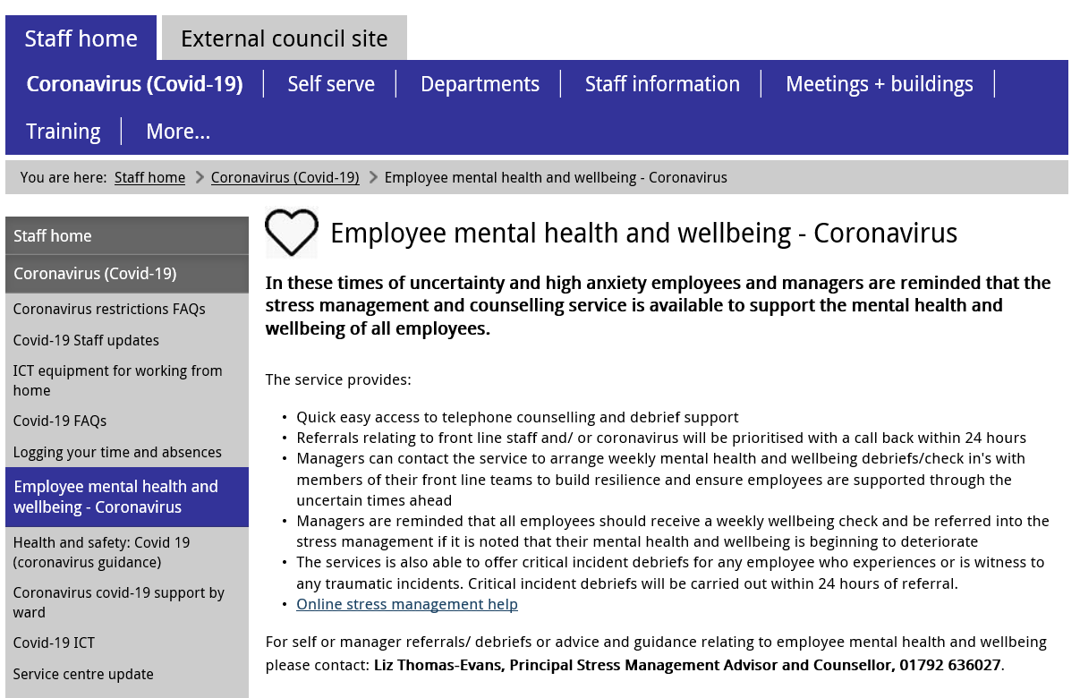
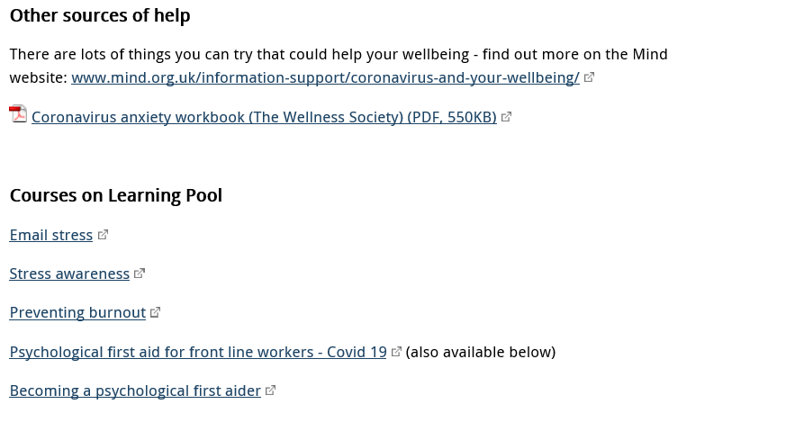

EV7

EV8

Interviews with HR Colleagues re: Employee Engagement
Interviews conducted via Microsoft Teams

During the discussions, I made reference to the Employee Engagement survey issued by the Corporate Management Team in August 2020.

I asked them to confirm if they had completed the survey and if they were will to share the feedback they provided.

If no, I asked if there were any specific reasons as to why they felt they were unable to complete it at that time.

If yes, I asked if a further survey was issued, would their view be any different and if so, why?

Principal HR & OD Business Partner
Thursday 5th November 2020 at 11.30am
NR stated she didn’t complete the survey as she felt she couldn’t provide a fair assessment of the working arrangements due to personal circumstances at the time the survey was issued, i.e. children being at home and she was experiencing significant differences in her workload. NR explained she was not undertaking her normal roles and responsibilities due to the challenges the HR Team were facing in relation to Covid-19 and specifically her role in relation to advising Education and Schools who saw a drastic change in demand for services during the pandemic.

NR explained she didn’t feel the survey was relevant at the time it was issued and as such couldn’t answer truthfully as it wasn’t a true reflection of what the future of working from home would look like.

SR asked if the survey was issued again, did NR feel she would be in a position to respond.

NR confirmed that whilst we are working in an ever changing environment, her son has now returned to school and therefore is able to provide meaningful feedback in relation to working from home arrangements and the engagement within her role and Team.

HR Advisor
Thursday 5th November 2020 at 12.30pm

KF confirmed she did complete the survey. Whilst she recognised the impact Covid-19 had in relation to both personal and working lives which she explained were very different and challenging at that point in time, she felt working from home improved her work life balance due to no longer being required to commute back and forth the workplace.

KF referred to the volume of work and increased pressures within her role and the requirement to liaise closely with the Education HR Team as she was fairly new to the area. KF felt the daily Teams meeting were invaluable in enabling her to undertake her role and felt if she was still within the office environment, she wouldn’t be able to undertake her role as effective as she has done working from home in a quitter environment.

The only negative KF had was the lack of opportunity for social engagement with colleagues which has been the main impact for her personally.

SR asked if the survey was issued again, did KF feel her responses would be any different. KF would be happy to complete the survey again and didn’t feel her responses would be any different. She is enjoying working from home and feels she has appropriate engagement and her Manager and Colleagues.

HR Advisor
Friday 6th November 2020 at 11am
CM confirmed she completed the survey. During the time of issue, CM had a young child at home and therefore the feedback provided was a snapshot in time.
CM felt she has received the appropriate support since lockdown in March 2020 and has built closer relationships with colleagues due to the daily meetings with the Team.

CM explained that prior to the pandemic she did not work from home as she would prefer to attend the office and distinguish between work and home life however, reflecting on the past 7 months, she feels home working is beneficial but going forward would like the flexibility of attending the office a few days a week.

SR asked if the survey was issued again, did CM feel her responses would be any different. CM stated her responses would be different due to her son being back in school and therefore is able to be fully committed in undertaking her role. Business as usual cases have recommenced and there is a requirement to conduct virtual meetings which is a new way of working.

Also, she feels that the Winter months would be more challenging due to the longer days and dark evenings. She accepts that working from home is becoming the norm as such accepts it is longer term.

Project Officer
Friday 27th October 2020 at 9.00am
LP confirmed she did complete the survey however, due to her experiences within the Council, she didn’t feel her feedback would be valued. LP explained that the majority of her work is done in isolation and as a result has been feeling isolated as she doesn’t have a strong working relationship with her line manager and as such receives very little communication.

She stated that colleagues within the Team have been very engaging and supporting which is very appreciated. However, she doesn’t have the opportunities for socialising as she had if she was working in an office environment.

LP explained that due to her medical condition, she would prefer to work at a formal workspace as she didn’t feel the she had the appropriate equipment however, she provided this feedback within the survey and as such has now been able to purchase specific equipment and claim monies back from the Authority which is positive.

SR asked if the survey was issued again, did LP feel her responses would be any different. LP explained that she now feels that she has been listened to and therefore would if completed again, she would be more positive with her respsones.

Training Officer
Wednesday 4th November 2020 at 4pm
RH explained that she did complete survey. Whilst she has found the past few months difficult as she was newly appointed at the time of Lockdown and therefore hadn’t had an opportunity to established relationships within the Team. She has 2 small children at home which has been challenging however, she feels she has been provided with the flexibility to undertake work whenever she can.

RH feels she has received excellent support from the Team and appreciated the regular communication received from an Authority perspective, which has provided her with an understanding of the support that is available to her.

SR asked if the survey was issued again, did RH feel her responses would be any different. RH stated her responses may be different has her children have returned to School and therefore feels she is able to engaged and committed to her work. She feels she is now able to undertake her role within her normal working hours and therefore has an improved work life balance.

Be able to evaluate current organisational approaches to employee engagement.

The four key ‘enablers’ of employee engagement according to (MacLeod Review, 2009) as cited by (CIPD, 2019) are:
- Leadership providing details about the organisation from a strategic perspective
- Line Managers playing a vital role in motivating and supporting employees making them feel valued
- Encouraging employee voice, involving employee’s in decision making
- Values of the organisations are actually reflected within the organisational culture, ‘what we say is what we do’.
Whilst people management and HR practices drive employee engagement, they can also become a barrier where employee’s become demotivated. (CIPD, 2019) refer to people being naturally motivated to do a good job and as such the role of line managers is vital in motivating and leading their team.

Swansea Council over the past few years has faced challenging times due to significant budget savings, resulting in the decision to delete the Head of Human Resources post. As you see within the Senior Management Structure, (EV9), Human Resources does not have a seat on the Corporate Management Team and as such in the absence of such specialism at a strategic level within the Organisation may not have such a strong influence and could be seen as a barrier when considering and implementing effective HR Practices.

As referenced by (ACAS, 2014), Organisations regarded as having high levels of employee engagement branded as an ‘employer of choice’, have a clear vision that everyone feels part of, understanding what motivates employees, giving employees a voice, ensuring equality within the workplace.

The Corporate Plan 2020 – 2022 for Swansea Council, (EV10, EV11) clearly describes the Council’s vision for Swansea, key 6 priorities the organisation values and principles that will underpin the delivery of the priorities and overall strategy. There is a clear link to the Strategic Equality Plan reassuring employees of equality within the workplace, which is a key factor of employee engagement.

The overall aims and objectives of Swansea Council are incorporated into the Organisational Strategy detailing the performance management process, which identifies individual and team objectives enabling employees to have a clear understanding of the value they bring to the organisation as a whole. This is discussed between managers and employees during monthly 121’s and the annual appraisal, (EV12).

This again being a factor for high levels of employee engagement with performance management clearly linked to employee engagement providing individuals with regular constructive feedback, supportive in training and development opportunities showing appreciation and a basic ‘thank you’ for the contribution they are making, (Engage for Success, 2020).

When considering Swansea Council as an ‘employer of choice’, the below provides an insight into the benefits Swansea Council has to offer which is attractive to both current and future employees.
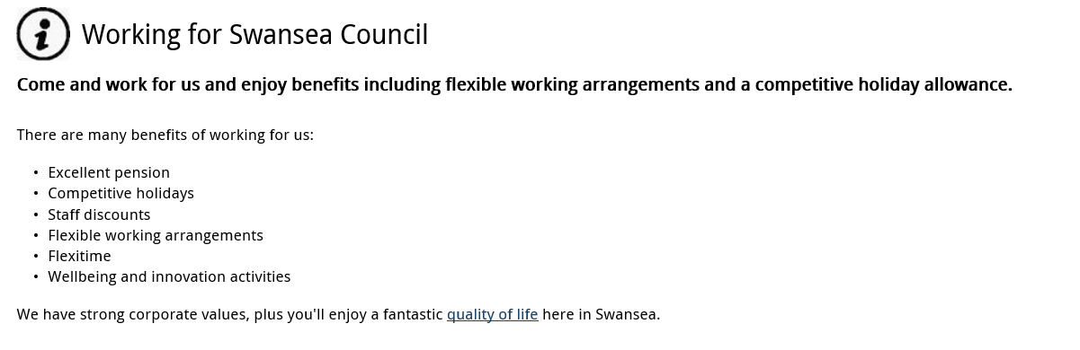
This being in addition to the terms and conditions of employment which go ‘above and beyond’ the legal requirements (EV13), thus evidencing organisational commitment resulting in higher levels of engagement. However, this does not include details of the psychological contact describing the expectations formed within the workplace e.g. maintain trust and confidence which should form part of the culture within the Organisation where employee’s feel valued and listened to. The role of the Line Manager is vital in building such culture within the working environment which should form part of the performance management discussions.

A key ‘hot spot’ within Swansea Council is reduced sickness absence. Having analysed the absence data within Swansea Council for the period 2018/2019 and 2019/2020, it is evident that stress is the highest reason for sickness, resulting in an increase in both Long Term and Short Term absences.
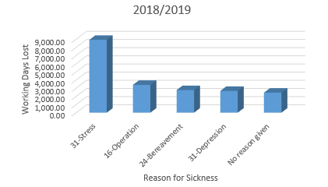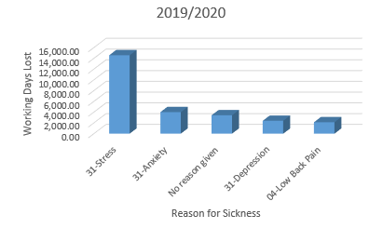

Prior to the COVID-19 pandemic, Swansea Council introduced a flexible working pilot across a number of departments including the Service Centre and HR&OD allowing employees to have a flexible approach to work managing their own time with the emphasis being on work output, (EV13, EV14). The data below evidences that the pilot has reduced sickness absence within both service areas.

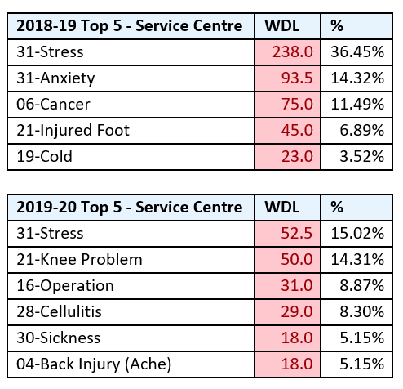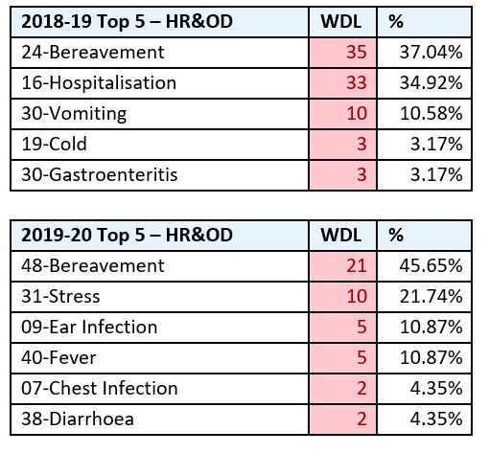

The positive benefits of flexible working is evidenced within a survey conducted by (People Management, 2019) which confirms that employees felt flexible working improved their mental health and helped them maintain a work life balance which again is an important factor for high levels of employee engagement.

Due to the ongoing budget savings within the Authority, the Corporate Management Team has implemented spending restrictions stating that Managers should assume that posts should be deleted and full savings taken, unless exceptional circumstances dictate otherwise (EV16). CMT consider vacancy monitoring across the Organisation and approval as necessary.

Whilst this instruction may be necessary from a budget perspective, recruitment and selection opportunities are restricted resulting in less opportunities for succession planning and promotional opportunities within the Organisation. This may have a negative impact on the workforce as individuals are expected to do ‘more with less’ resulting in individuals being less engaged and committed to the Organisation.

(ACAS, 2020) state that Organisation success is built on people. If Organisations attract, recruit and retain the correct people, they are more likely to have a happier, motivated and productive workforce.

Whilst the Authority are facing challenging times, they recognise the benefits of employee engagement and as a result of reviewing the OD Strategy, have implemented a number of initiatives:
- Ideas Hub – tool for employee engagement, facilitator for employees for put their ideas forward, engage with the Head of Service for consideration and put ideas into practice. As a result employees feel their views are listened to.
- Mentoring Programme – build skill set of individuals not just within their job roles but within their areas of interest. Engage employees and develop their leadership capacity.
- Leadership Hub – available for all to attend on a monthly basis. As a result of COVID-19 they now take place every 2 months and delivery has been modified to being webinar based.

The purpose of Swansea Council’s OD Strategy is to change the culture of the organisation, not just building on the skills and capability of the workforce but to engage people who ‘want to’ work for the Authority rather than ‘ought to’ or ‘have to’ (Woodhams, 2016).

Following a request from members of the HR & OD Team to provide their views regarding Swansea Council’s approach in relation to Employee Engagement, unfortunately due to current work pressures as a result of Covid, I only received two responses, (EV18). Having reviewed the responses, it is clear that both individuals recognise the potential barriers of conducting surveys as the lack or responses does not provide a true reflection of the views of the workforce. From a personal perspective, one responded confirmed that he felt engaged with his immediate Team and that his views were valued.

EV9
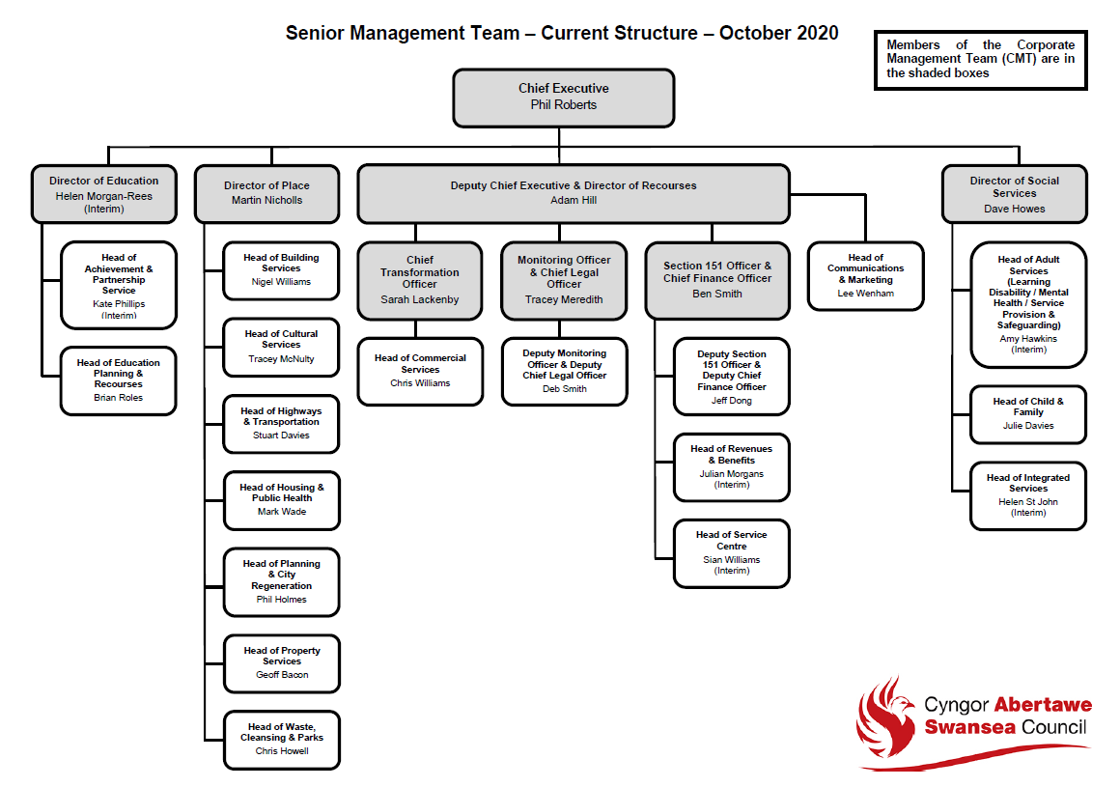

EV10
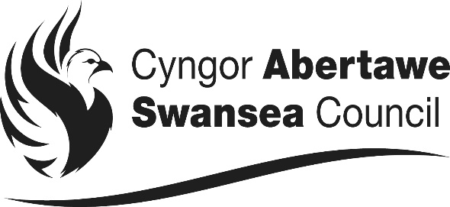

SCHEDULE OF THE MAIN TERMS AND CONDITIONS WHICH APPLY TO THE POST OF:
XXXXX within Catering/Cleaning Facilities Unit of Swansea Council

- This Agreement constitutes a written Contract of Employment for the purposes of the Employment Rights Act, 1996 and, other appropriate employment legislation.

- Your Contract of Employment consists of this statement of written particulars of employment, together with your original appointment documents. The main terms of your Contract are those contained in the National Joint Council for Local Authorities, Local Terms and Conditions and Local Agreements made collectively with the appropriate recognised Trade Union. The Local Terms and Conditions and Local Agreements are documented in Swansea Council’s Employee Handbook. Any changes to these Local Terms and Conditions and Local Agreements will be notified to you.

- Name of employer: Swansea Council.

- Name of employee: XXXXX

- Date of commencement of employment with Swansea Council as XXXXX within Catering/Cleaning Facilities of the Authority is XXXXX.

- Term of Employment
The term of employment shall commence on the XXXXX and is Permanent/Temporary

If you require a Work Permit, the Council will need confirmation from the UK Border Agency that you are able to live and work in the UK. It is your responsibility to ensure that you have a valid Work Permit.

- Continuous Employment
Your period of continuous employment for statutory employment rights began on XXXXX. This is because you have previous continuous service with an organisation covered by the Redundancy Payments (Local Government Modification) Orders, (which cover Local Authorities and related bodies or any other organisation from which you have been transferred via TUPE regulations) which is continuous to the employment with Swansea Council. This date therefore will be included in calculating your entitlement to: a redundancy payment, sickness allowance, maternity leave and annual leave entitlement.

8. Date on which this statement is given: XXXXX

9. Job Title
You are employed in the post of XXXXX based within the Catering/Cleaning Facilities Unit of the Council.

10. Place of Work
The main business address of the Swansea Council is Civic Centre, Swansea, SA1 3SN and you will normally work at the fixed centre of XXXXX. You may also be required to undertake any agile working arrangements i.e. hot desking etc adopted by the Council. You may also be asked to work from your home if service needs dictate. Health and Safety Risk Assessments will be carried out as necessary.

  - Hours of Work
Your normal working week comprises of XXXX hours, and meal breaks will not be paid.

You will work to broadly conform to academic term dates and be present when the school is in session. For administrative purposes, academic term dates are as follows: Autumn Term, 1st September – 31st December; Spring Term, 1st January – 30th April; Summer Term, 1st May – 31st August.

As part of your contract, you will be required to work a week during February half term and the last week of August, which is a 4 day week and therefore you will be expected to work your contracted hours over 4 days.

There may be occasions when you will be requested to be flexible and your line manager will ask you to work additional hours or be able to change working patterns / days in line with the needs of the Service, complying with the Working Time Regulations as in accordance with any rotas / working arrangements within your place of work. Full consultation will be undertaken with you and your personal circumstances taken into consideration. Your manager will be reasonable in making such requests and will seek to achieve this by mutual agreement. The Council will seek to achieve a reasonable work life balance wherever possible.

Examples of arrangements you may be asked to work include:

  - Weekends
  - Unsocial Hours
  - Night Working
  - Shift Working
  - Bank Holidays
  - Standby arrangements
  - Mornings / Evenings

You may be requested to also work a reasonable amount of overtime on an ad-hoc basis at critical times to ensure that service delivery is maintained and specific project deadlines are achieved. Any overtime will be paid in line with the Overtime Policy or Time off in lieu Policy. In civil emergencies the Council will require you to participate in any role as deemed necessary and appropriate.
  - Flexibility of duty
Whilst your post and place of work are as described above, the Council may ask you to work at any of its establishments within the geographical boundary of Swansea Council.

If the Council needs to ask you to transfer this will be subject to full consultation with you and your personal circumstances being taken fully into consideration, which will include:

- your domestic and family circumstances
- the nature of the work to be undertaken
- your knowledge, skills, experience and qualifications
- the alternative post being graded differently by no more, and no less, than one pay grade (pay protection will apply if the new post is graded lower)
- the distance and travelling time of the move in terms of location
- the hours of work
- the business need for the move
- the duration
- the timescale for the move, and
- the selection process, if appropriate

12. Salary details, method of payment and calculation of hours
Your current salary is £XXXXX per annum, pro rata on Spinal Column Point XX within salary grade XX. Your salary will increase within the scale by annual increments, (up to the maximum of the scale), however annual increments may be withheld if an employee is subject to the Council’s Capability Policy. It should be noted that officers with less than 6 months’ service by 1st April shall be granted their first increment 6 months after their appointment, promotion or regrading.

Whilst your contract is worked over XXXX Weeks per annum you will be paid on an annualised basis whereby you will receive your pay spread evenly over 52 weeks.

For part time staff, the annual salary is pro rata dependent upon the number of hours worked compared with the annual salary of a full time member of staff.

Your annual salary is paid monthly on the 25th day of each month (or nearest working day before) by BACS system into your bank or building society account. For each calendar month you will receive 1/12th of your annual salary.

Your hourly rate for full time and part time employees is calculated as follows:-

(Annual salary/365 days) x 7 = hourly rate
37 hours
13. Probation
All new appointments to Swansea Council are subject to a six month period of probation during which there will be regular appraisals. The Council may extend the six month probationary period where appropriate.

Posts in Children’s Establishment and those covered by Warner are subject to a probationary period, which comprise of reports at the following intervals after appointment:

- Three months
- Six months
- Nine months
- Twelve months

All Social Worker Staff must register and maintain their Social Care Wales Registration.

14.1 Leave
Every employee is entitled to paid annual leave. The amount of leave entitlement will depend on your length of unbroken service in Local Government. A summary of the annual leave entitlement is given below:-

Continuous Local Government Service of:
Up to 5 years  24 days | Over 5 years  Up to 10 years  29 days | 10 years & Over  33 days
Your leave year will run from the month following your Birthday.

If you are a part time employee, you are entitled to a pro rata entitlement, agreed with your Line Manager.

14.2 Bank Holidays
In addition to the annual leave set out above you are entitled to eight bank holidays plus one extra statutory day at Christmas. If you are a part time employee, you will have a pro rata entitlement, agreed with your Line Manager.

Certain Services have to be provided on Bank Holidays and if you work in such a service, you will be contractually required to work at these times and will be given a day in lieu and paid the relevant Single Enhanced Rate to compensate you. Other employees may be required to work on a Bank holiday where necessary for the needs of the Service.

15. Maternity Rights
Rights of pregnant women to leave and pay are in accordance with the NJC Agreement referred to in paragraph 2, and are detailed in Swansea Council’s Maternity Policy. These rights are dependent on pregnant women complying with criteria and notification requirements. The legislation and employment policies relevant to pregnancy, paternity leave and adoption leave are available in the Employee Handbook.

- Sickness
Swansea Council operates a Management of Absence Policy and Management of Absence Administrative Procedure, which is available in the Employee Handbook or from your Line Manager. Your entitlement to sickness allowance, as per Part 2 of the NJC Green Book is as follows:-

During 1st year of service | 1 month’s full pay and (after completing 4 months’ service) 2 months’ half pay
During 2nd year of service | 2 months’ full pay and 2 months’ half pay
During 3rd year of service | 4 months’ full pay, 4 months’ half pay
During 4th & 5th year of service | 5 months’ full pay, 5 months’ half pay
After 5 years’ of service | 6 months’ full pay, 6 months’ half pay

Absence in respect of industrial disease, accident or assault arising out of or in the course of employment with the Council is entirely separate from absence in respect of normal sickness and shall not be set off against the other for the purpose of calculating entitlements under the scheme. In line with the Management of Absence Policy the payment of occupational sick pay may be suspended in certain circumstances. Please refer to the Management of Absence Policy and Absence Administrative Procedures for more information.

17. Pensions
The pension arrangements for this post are administered by Swansea Council Pension Fund. Employee contribution rates will be tiered, details of which can be found in the Employee Handbook.

All payments which are considered pensionable are taken into account. Regular reassessments and re-bandings will take place to take into account, for example, pay awards, increments and promotions.

The band ranges will be increased each April in line with the Pensions (Increase) Act 1971, which is currently the Consumer Prices Index (CPI). The Regulations set out that the employer will be responsible for assessing each employee and setting their contribution rate.

Employees will be allocated into contribution pay bands and all payments which are considered pensionable will be taken into account.

The Council must enrol employees into the LGPS and you will become a member of the Pension Scheme automatically on appointment, provided you have a contract of at least 3 months and are aged under 75 but have the right to opt out if you so wish. If your contract is for less than 3 months you will not be automatically brought into the Pension Scheme but you may elect to join if you wish.

If you have transferred or have been promoted into this post, your pension arrangements remain unchanged.

18. Notice
Either party may terminate this Contract by giving notice in writing to that effect. The minimum periods of notice to which you are entitled from the Council are:

Period of Continuous Employment with Swansea Council | Minimum Notice Period
Less than 6 months  6 months up to 2 years  2 years or more but less than 12 years  12 years or more continuous employment with the Council | 1 week  4 weeks  1 week for each completed year of continuous employment with the Council (with a minimum of 4 weeks notice).  12 weeks

The minimum periods of notice of termination of your employment which you are required to give to the Council are:

Post to the Council | Notice Period
Posts in Grade 1 to Grade 8 (spinal column points 1 - 29)  Posts in Grade 9 and above (Spinal Column Points 30 and above) | 1 month  2 months

An earlier departure date can be mutually agreed between the employee, line manager and HR & OD. In certain circumstances the Council may require you to not attend work during your notice period and you will still receive pay during this period. There may also be circumstances where the Council will not require you to work your notice period and instead you will receive pay in lieu of notice.

If the Council issues you with notice of termination of employment, this will be sent to you in writing by way of a termination letter which will confirm a) the date the notice of termination of employment commenced and b) the end date of your employment with Swansea Council.

19. Deduction from Salary
Where an overpayment of salary, wages, or any other form of expense is made, the Council will reclaim the overpayment via a deduction from salary. It is the right of the Council to reclaim any overpayment at a reasonable rate.

Where you have exceeded your annual leave entitlement or permitted flexi time allowance, the Council may reclaim this overpayment from you via a deduction from salary.

If you are on the flexi time system and you exceed your agreed number of debit hours Swansea Council may deduct the excess from your salary. Likewise if you are on the flexi time system any hours in debit at the effective date of termination will be deducted from your final salary. This principle will also apply should you have overtaken your annual leave entitlement and wish to leave Swansea Council’s employ, and a deduction equivalent to the excess will be deducted from your final salary.

Deductions from salary may take place if you:

- Fail to attend work through an impediment, avoidable or otherwise such as imprisonment or imposition of bail conditions.
- Fail to attend an arranged medical appointment with the Occupational Health Advisers. If you fail to attend a medical appointment, without good reason, a deduction will be taken from your salary. This amount will be reviewed annually.
- Any training / course fees paid by the Council for your benefit and fail to complete the course without good reason or leave the Council within two years of completing the training / course.

The above list is not exclusive or exhaustive

Swansea Council also reserves the right to require you to repay to Swansea Council, either by deduction from salary or any other method:

- Losses sustained in relation to the property or monies of the Council, client, customer, visitor or other employee of the Council during the course of your employment and which were caused through breach of the Council’s rules or any dishonesty on your part;
- Any amounts of remuneration, expenses or any other payments (statutory, discretionary, etc) which are overpaid to you whether made by mistake in fact or through any misrepresentation or otherwise;
- Any other sums owed to the Council, including, but not limited to, outstanding loans or advances, or relocation expenses.

Any underpayment of salary will be rectified in the next available pay period after the underpayment has been identified.

Any overpayment of salary is recoverable over a reasonable period which will be agreed with the Council and you. As a general rule this would ordinarily be recovered in no less than the period in which the overpayment occurred.

It is your responsibility to check each payslip received and inform Service Centre Help Desk of any errors suspected.

Knowingly continuing to receive any payments you are not entitled to is a disciplinary offence.

- General Data Protection Regulation (GDPR)
By signing this contract you are confirming that you have read and understood the Council’s Data Protection Policy, a copy of which is available on our website. You must comply with the terms of this Policy, and the provisions of the General Data Protection Regulation and the Data Protection Act, at all times when handling or processing personal data on the Council’s behalf in the proper performance of your job duties and responsibilities during your employment. This includes personal data relating to any current or former employee, worker, agency worker, apprentice, volunteer, contractor, consultant, client, service user, customer or supplier of the Council, or personal data relating to any other third party.
  - Your Privacy
Swansea Council is the Data Controller for the personal information you will be asked to provide in relation to your appointment to this post. We will use this information to fulfil certain legal obligations and administer any service or benefit that we are responsible for as part of your employment e.g. statistical Information and reporting.

We may check information provided by you, or other information about you provided by a third party, against other information we hold. We may also contact third parties to verify the accuracy of the information. For example, we may contact your previous employer with specific questions about your employment with them. We will only do this to prevent or detect fraud, as we are permitted to do by law.

Data Protection Law describes the legal basis for our processing of your data as one based on the pursuit of our legitimate interests. For further information about how Swansea Council uses your personal data, including your rights as a data subject, please see our corporate privacy statement at https://www.swansea.gov.uk/privacynotice on our website.

You must inform your line manager immediately of any change in the personal information you have provided to us, such as a change of address or your personal circumstances.
20.2 Prevention of Fraud - Data Matching
Personal information you have supplied to the Council as an employee will be retained on both manual and computerised records of the Council, and the Council shall use the same for data matching purposes under the Council’s Anti-Fraud and Corruption Policy & Strategy, in order to detect and take action against fraud, debt, or any other civil or criminal law right of the Council.

- Trade Union Membership
You are entitled to be a member of a Trade Union of your choice.

This Council, as your employer, supports the principles of collective bargaining and therefore encourages employees to join a Trade Union of their choice. You will be bound by the outcome of collective bargaining whether or not you are a member of a trade union. However, not every Trade Union is recognised for collective bargaining purposes. For practical purposes this is best conducted by representatives of the employer and the employees.
The Council is represented on joint national and provincial councils dealing with such matters. It is equally sensible for you to be in membership of a Trade Union representing your group of employees on the appropriate negotiating bodies at national, provincial and local levels.

The Council will, at your written instruction, deduct from your salary the subscription to a trade union recognised by the Council for negotiating purposes.
All collective agreements will be represented in the Employee Handbook which will be immediately updated as soon as possible.

22. Health and Safety
All Swansea Council employees, irrespective of their position or employment status, have a responsibility to comply with the Health and Safety at Work etc. Act 1974. Swansea Council Corporate Health and Safety Policy, its arrangements and all subordinate policies provides a framework to meet our duty of care and obligations under law.

The Policy requires that each employee is responsible for conducting work in a manner which is safe for them, their colleagues and the public who may be affected by what they do or do not do - say or do not say. Every employee is expected to be involved in health and safety every day and will be provided with the opportunity to contribute positively to a safer and healthier workplace.

In particular each employee must cooperate with the Council and will:

- Follow health and safety information, instructions and training on safe systems of control and you must notify your Manager of any shortcomings in their health and safety arrangements.
- Employees should carry out any reasonable management request but not undertake any work which they are not competent, appropriately trained, appropriately equipped or authorised to carry out safely.
- Report all hazards and potential risks to your Manager.
- Attend Health and Safety training courses as required by your Manager and the Swansea Council
- Use any equipment, machinery, safety devices, protective clothing provided to them in accordance with any training and instruction as identified in risk assessments or safe procedures
- Not misuse or interfere with any item, sign, article, piece of equipment, engineered system or facility provided in the interest of Health, Safety and Welfare or Fire Safety
- Participate in pro-active accident/ill health prevention and monitoring measures as required by the Swansea Council and advise their manager or the Occupational Health and Wellbeing Unit of any health matter that may affect their ability to undertake their work duties safely.
- Report all accidents or near misses to your Manager or Supervisor.

The Corporate Health and Safety Policy forms part of this contract of employment and the Policy will be made available to you for further reference and clarity of your obligations under the Policy particularly if you have a management role.

The Swansea Council Disciplinary Policy applies to all employees and covers compliance to health and safety rules and standards which cause or could cause risk to the individual, other employees or the public.

Serious and deliberate violation of Swansea Council’s Health & Safety Policy, health and safety rules and standards may be viewed as gross misconduct under the Disciplinary Policy of the Swansea Council.

23. Car and Subsistence Allowances
If your post requires you to undertake duties away from your fixed centre of work you will be required to be qualified to drive a vehicle and use your own car for business purposes or have the ability to travel within and outside of Swansea Council boundaries in an efficient and most cost effective manner. It will be your responsibility to ensure it is suitably safe for business purposes and that you are appropriately insured for business purposes and hold a valid driving licence. Should you have a disability and be unable to drive, then you may seek alternative means of transport/assistance, which must be an effective and cost effective method of travelling.

If you use your own car for transport, then a single car user rate will be used for all authorised car use. The single rate will be the HMRC rate as set out in the Employee Handbook. Out of county use will be reimbursed on the basis of fixed rates.

For further information please refer to the Council’s Car, Travel and Subsistence Allowance Policy.

24. Employment outside the United Kingdom
Not applicable.

25. Employees’ General Obligations
Employees of Swansea Council are reminded of the confidentiality of information given to them or acquired by them in the course of their employment. Any breach of confidentiality will lead to disciplinary action under the Disciplinary Policy of Swansea Council.

All employees wishing to undertake secondary employment outside or within the Council, or to engage in a private business in any capacity, shall inform their line manager who will escalate the request to their Head of Service in writing giving sufficient details about the proposed job role, the organisation with which this job would be taken, the proposed number of hours to be worked in each week and any other relevant information. Please refer to the Secondary Employment Policy for more information.

Subject to any obligations you may have to make a disclosure in accordance with the Whistle Blowing Policy you shall not, at any time during your employment (except insofar as you are required to do so as part of your duties) or at any time after your employment has terminated, for any reason whatsoever, disclose to any person any information as to the practice business service or affairs of the Council, or its successors in title or the Council’s or its successors in title, customers, clients, or service receivers, without the prior written consent of the Council and shall not, for the avoidance of doubt, release any information concerning any part of the authority involved in trading or charging activities.

Subject to the provisions of the Patents Act 1977 and the Registered Designs Act 1949 and the Copyright, Designs and Patents Act 1988, or any modification for the time being in force, if, at any time during your employment with the Council, you alone or in participation with others, either employees, members, clients or partners of the Council, produce, make, discover or manufacture, during the course of your employment or that which might reasonable be expected to result from the carrying out of your duties, produce, make, discover or manufacture any invention, intellectual property goods or thing capable of ownership, you shall pass all information in your possession to the Council upon written request and in any event at the termination for whatever reason of your employment and shall agree by the signing of this agreement that all rights and obligations under this clause shall be the rights and obligations of the Council and you waive your actual and/or moral rights in this respect.

The copyright of any intellectual, training / IT programmes and written material produced by you in the course of your employment shall be vested in the Council.

You are required to notify Human Resources & Organisational Development promptly, of any change of your personal or contact details such as name, address, telephone number, and next of kin, and of any circumstances which might affect the Council’s insurance cover for you. The Council reserves the right to share this information with appropriate officers as necessary.

If you fail to advise Occupational Health of any changes to your health status relating to any issue of potential disability under the provisions of the Equality Act 2010, the Council will not be held liable for a failure to make reasonable adjustments or undertake relevant assessments. Should you fail to disclose information which could adversely affect the health and safety of either yourself or another you may be subject to disciplinary action.

26. Professional Bodies
The Council will pay any fees where registration or membership to a professional body where it is an essential requirement for an employee to carry out their duties.

Where registration or membership to a professional body is not an essential requirement for you to carry out your duties, you should endeavour to belong to a professional body that represents your profession and pay the appropriate fees.

Staff who are required to have registration or professional membership as a condition of their employment and fail to continue with their registration / professional membership will be in breach of contract which could result in the termination of their employment or being placed on leave without pay.

27. Contractual Policies
The following policies have contractual status and any proposed amendment will be consulted upon and notified to you by giving the appropriate notice after collective agreement through the recognised trade unions:

- Management of Absence Policy and Absence Administrative Procedure
- Disciplinary Policy
- Capability Policy
- Grievance Policy
- Harassment and Bullying Policy
- Health and Safety Policies
- Redundancy Policy
- Redeployment Policy

These policies can be found in the Employee Handbook. The Council reserves the right to review, revise, amend or replace the contents of this handbook, and introduce new policies from time to time reflecting the changing needs of the business.

28. Rehabilitation of Offenders Act, 1974
If this post is exempt from the provisions of the Rehabilitation of Offenders Act 1974, it is made to you subject to the following;

That you have made a true disclosure of all criminal cautions, charges, reprimands or warnings.

Should you not have a true disclosure of any criminal cautions, charges, reprimands or warnings, then your employment may be terminated immediately.

29. Disclosure and Barring Service (DBS)
This post due to its nature, duties and responsibilities, may be subject to a check by the Disclosure and Barring Service. The level of check will be dependent on the nature of the post. Should you have any queries in relation to this check by the DBS, please contact the Service Centre Helpdesk. If your post requires a DBS check, then the following applies:

You are required to inform the Department immediately if you are convicted of a criminal offence, after a DBS Application has been processed for you.

Due to the nature of your employment, the Council may require you to undertake further checks by the DBS, periodically after your date of commencement. This may be done at any time after your first period of employment with the Council.

The post is offered to you subject to the following:

- that you have made a true disclosure of all criminal offences
- that the DBS check to be undertaken does not reveal any offences which in the opinion of the Director may be such that your appointment will have to be terminated/withdrawn.

In view of the sensitive nature of some work, any employee who is aware of any allegation/accusation against them or any offence must advise their Line Manager and HR & OD.

Please refer to your appointment letter and line manager to confirm whether a check is necessary.

30. Disclosure of criminal convictions whilst in employment
You are required to disclose details to your manager if you are cautioned, arrested and subsequently charged, cautioned or prosecuted for any offence whilst in employment with Swansea Council.

In respect of road traffic offences, you should inform the Council of the offence accordingly if you are required to drive as part of your duties.

31. Service Specific Requirements
As part of your role you will be expected to comply with the following service specific terms and conditions as set out on the sheet entitled ‘Service Specific Terms and Conditions’.
32. Please note that failure to comply with any provision in this contract will be classed as gross misconduct and may lead to dismissal.
Please confirm that you have read and accepted the terms and conditions laid out in this document by signing below:-

Signature on Behalf of  Swansea Council |  | Signature of Employee
Signed: | Alison Cosker | Signed:
Position : | Catering and Cleaning Manager | Name:
Date: |  | Date:

NB. Both copies to be signed by both parties; with one copy being retained by the employee and the other returned to Catering/Cleaning Facilities Unit of Swansea Council.

EV11

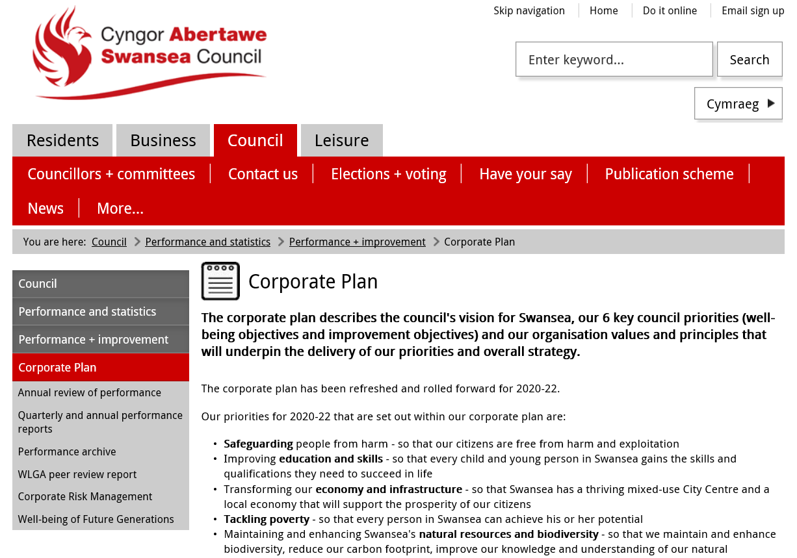
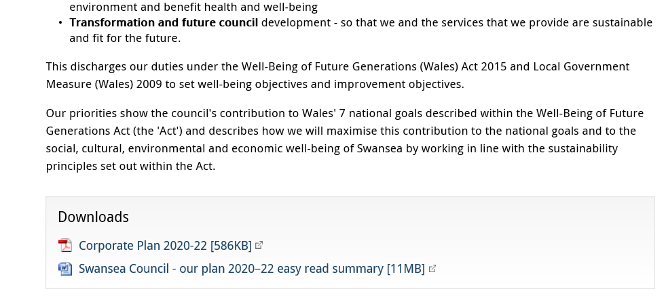

EV12

 | Swansea Council  Our Plan  2020 – 2022
 | This is an Easy Read Summary. You can read our Corporate Plan in more detail at www.swansea.gov.uk/corporateimprovementplan
Hard words | If you see any words in red you can read more about what they mean on the last page
 | To find out more or ask for another format  Call us on  01792 636732
     | Email us at  accesstoservices@  swansea.gov.uk  Thank you to everyone who helped with this Plan  West Glamorgan People First,  Your Voice Advocacy
 | Swansea is a great place to live work and visit. But we have some challenges like poverty that we are working to overcome
 | The law says the Council must plan for how we want Swansea to be in the future. We must say what we will do to make it happen.
 | Our Plan sets out six priorities. We think these are the most important things to do now
 | Our priorities will help us make life better in Swansea and Wales
 | Our Plan links to our Strategic Equality Plan so we can make sure people are treated fairly

Our Five Ways of Working
 | We will get things done by using five ways of working. These are
 | Involving people in the things that matter to them
 | Making sure everybody works together
 | Thinking of the future
 | Sharing plans with partners so we help each other meet our priorities
 | Stopping problems from happening or getting worse
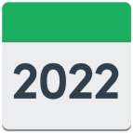 | Here are the main things we want to do in the next 2 years

Keeping people safe from harm
 | This means making sure people feel and are safe  Especially people who need help most
 | We will
 | Continue to keep children and adults who may need our  help safe
 | Make sure keeping people safe from harm is ‘everyone’s business’ so we all work together
 | Support our Looked After Children
 | Raise awareness of domestic abuse and stop it happening
 | Help communities come together and stop people feeling lonely
 | Support adults to remain safe living at home
 | Help young carers and care leavers with advice, support
 | Make our city dementia and older people friendly
Improving education and skills
 | This means every child and young person getting the skills they need to succeed in life
 | We will
 | Help schools improve the attendance, reading, writing and maths of all children
 | Offer Welsh language schools and promote welsh in all schools
 | Respect young people’s rights by Involving them in decisions about their education and community
 | Make sure children who need extra help get it
 | Build and look after school buildings in a way that benefits the community and environment
 | Improve skills for the future through apprenticeships
 | Support lifelong learning to reflect the changing nature of work
 | Make sure young people have the right skills to get jobs in the future
Transforming our economy
 | This means finding new ways to make and do things so people have good jobs. We want a busy City Centre with lots of reasons to visit and spend money
 | We will
 | Work with our City deal partners to invest in our city and economy
 | Work together with local partners to find ways to make Swansea wealthier
 | Make sure people who don’t have good jobs have a chance to train or find work when we build things
 | Look after and improve the places people visit Swansea to see and activities they do
 | Make sure there are chances for people to take part in the things they enjoy
 | Find space for new houses to be built that people can afford
 | Protect people from scams, unfair businesses and pollution
 | Look for new ways to get and use energy without damaging the environment
 | Look after our beaches, parks and water
Tackling poverty
 | This means making sure every person in Swansea has a chance to live a good life
 | We will
 | Work together to stop people being poor
 | Listen carefully to people who are poor to understand how we can make things better
 | Make sure young children are ready to start school
 | Make sure all young people get a job, learn skills or go to school or college
 | Help people get the benefits and help they need
 | Build Council houses and support affordable homes
 | Look at how to make energy bills lower for poorer people and better for the environment
 | Work to stop homelessness
 | Make sure everyone feels welcome and part of their community
Looking after our environment
 | This means looking after the air, water, land, animals, plants and insects in Swansea. By learning more about them we can try to help make them even better
 | We will
   | Agree a plan to make sure Swansea is a good home for nature and we look after important plants and animals
 | Make sure the places where plants and animals live are better connected
 | Decide how we can best look after trees and plant more
 | Map all the green places in Swansea so we can look after them
 | Find ways to get less greenhouse gases get into the air from our economy
 | Use less energy and change to climate change friendly energy
 | Take action to stop climate change
 | Make sure our city centre is as green as possible
 | Look after our parks and plant wildflowers
 | Help children and adults learn about the nature
 | Get people to use less stuff and recycle more
Changing how we do things for the future
 | This means changing how the council does the things we do to make sure they work well in the future
 | We will
 | Make sure Council staff have the right skills to help people
 | Make sure we treat people fairly
 | Make sure we buy things in a way that is good for people and the planet
 | Help people learn how to get what they need online
 | Look at doing things with other local Councils wherever we can
 | Work together with businesses and groups where we can
 | Help communities and local groups run and own things where they can
 | Help our staff learn and use Welsh
 | Put money aside to be spent in communities on what communities want
 | Write a plan for how we get people involved in the things that matter to them
Hard Words
Partners | Our partners are groups we work with like the Health, the Police, voluntary groups and businesses
Priorities | These are important things we plan to do first
Strategic Equality Plan | This plan says how we make sure people are treated fairly. You can read an Easy Read summary at https://www.swansea.gov.uk/sep
Economy | The economy of Swansea is all the things we do and make and all the money we spend on things
City Deal | We work with other local councils to invest in the city and the future so we all benefit
Environment | The environment is where we live. It is the land, water, air, and everything that lives in or on it. For example plants, animals and fish
Climate change | is about changes to the world’s long term weather patterns like our air and water getting warmer
Greenhouse gases | These are gases that are making our planet get warmer

EV13

Monthly 121 Form – 2020/2021

Name: | Stephanie Rayner
Date:
Key Activities for this month:
Key Issues from last month:

Progress Against Team Critical Behaviours (as reflected in Oracle)

CM 4.3 - Identify and Implement Improvements to service delivery, engaging people in the change process and encouraging them to contribute ideas.
Regular discussions with BP’s to ensure a consistent approach – weekly meetings arranged
Requested ideas from HRA’s regrading support BP’s can provide

M. Introducing Change and New ways of working (relating to the HR Operating model)
BP’s have oversight of case management – Initial meeting to discuss way forward and offer any advice and support to HRA’s
Sickness management – Review of sickness within Catering and Cleaning – Continue to monitor and support

V. Working Together
Best Practice Meetings with HRA’s to discuss processes and procedures – Lessons learnt/Good news stories
Develop Future People
Support to Swansea Council in developing Future People
Support to the HR Function in developing Future People (including line management responsibilities where appropriate).
Personal Development Activities  (achieved and identified for the future). | HR Diploma – Commencing on 25th September 2019
Progress Against Objectives and Success Criteria

Objective 1: Team Objective  Delivery of HR service to time, quality and cost 100% delivery against KPIs | High quality HR advice provided to Education, Schools and other Departments as and when required.
Objective 2:  Work with own team and others to maximise resources and share experience and knowledge | I will always encourage working together as a Team and supporting each other to ensure individuals engage with any improvements/changes.  Whilst I continue to develop my knowledge within Education and Schools, I will support the Team with any queries.
Objective 3:  Build strong working relationships. Communicate well with colleagues, internal and external stakeholders | Continue to build effective working relationships within a new area of work and within my role. Effective communication with Managers and Schools building trust and confidence to ensure a high quality HR service.  Continue to communicate effectively with colleagues to encourage engagement as a team going forward.
Objective 4:  Trust work colleagues to carry out their work effectively | Overview of Case Management has enabled me to review the cases and offer advice and support. Removing myself from the operational procedures.  Sickness management – Arrangements of regular review meetings with HRA’s to ensure progress.  Restructures – Allocate HRA from the outset and determine their role throughout the process.  (All information saved on the shared drive so I am able to monitor any progress being made).
Objective 5:  Adapt, improve, try, learn | I feel I have adapted and embraced the new ways of working introduced within the Team and the requirements within my role as HR Business Partner through a challenging period.  My knowledge and experience within Education has provided me with new learning and development opportunities.  I acknowledge that there are areas that I need to learn and improve which hopefully will be gained through further development.
Objective 6:  Introducing Change and New Ways of Working | I have embraced the new ways of working  within the Team and try to encourage others when introducing news systems and processes.  Continue to monitor the Redeployment Portal.  The changes within the Business Partner  role have at times been challenging however, I feel I have continued to participate with introducing changes and improvements to the HR service  provided.  I am willing to provide my view in relation to the changes and continue to have a positive work ethic.

Comments on New Ways of Working Pilot

Do you consider yourself to be more productive? | No change
Has your work life balance improved? | Yes – More flexibility
Would you want to revert back to the previous arrangements or continue with the new arrangements? | Continue with new arrangements
Has your daily/ work travel changed, reduced or increased? | No Change, I attend meetings as and when required by the Service Area.
Do you believe that working relationships have changed and/or improved? | Changed within the Team however, I believe that is also as a result of the restructure.

Any Other Comments:
Line Manager Comments:

Council Desired Behaviours
Work as a team | Lead by example | Respect and value everyone
Focus on the future | Have a 'can do' attitude | Be honest and trustworthy

EV14
New Ways of Working - Modern Flexible Working Pilots

The Transformation and Future Council Corporate Priority aims to modernise where, when, how, and the way in which we work in order to increase agility and flexibility.

With this in mind, the Council has committed to undertaking a range of flexible working pilots across a number of service areas and functions.

The aim of the pilots are to create a modern workplace that promotes personal responsibility and a culture based on trust, (in short, an ‘adult-to-adult’ organisation) alongside flexibility and agility by taking a proactive approach to increasing the flexibility of working hours.

The following pilots are suggested, and will be scoped out in more detail with the pilot teams.

(ONLY OUTLINE THE PILOT YOU WILL BE UNDERTAKING – DECIDED TO DO)

Pilot: Removal of Core Hours and Time Recording

It is proposed that the teams identified to undertake the pilots will work alongside HR and Trade Unions to co-design.

The pilots will be:

- Voluntary for members of the pilot team
- Business need first
- Staff can still take flexi and record annual leave on interflex
- Measure on outputs and outcomes through clear work plans and targets – move away from managing by time

Pilot: Removal of manager approval for flexi adjustments for the wider Council on self-service

In line with the Business Support Programme (BSP) principles, this option would look to increase self-service by moving from manager approval to self-approval for all flexi and leave adjustments.

- Voluntary for members of the pilot team
- Business need first
- There will be no core times – this will increase the flexibility of when people can work
- Staff can still take flexi and record annual leave on interflex
- Measure on outputs and outcomes through clear work plans and targets – move away from managing by time
- Any adjustments to flexi or request for annual leave won’t have formal approval on oracle. Teams will agree how they manage this.

What will it mean for you?

If you decide to take part in the pilot then you will be part of a test to see whether a move to these new ways of working will be if benefit to you and the organisation. You will gain more autonomy over where, when and how you do your work. It will give you more flexibility to combine home and work life in a balanced way that suits you and the organisation.

The pilot will run for 12 months with a formal review at 6 months. However, there will be regular meetings throughout so that we can make any changes and listen to your feedback.

The pilots are voluntary. You can decide whether you opt in or out. If you do opt in you can still opt out at any time.

We have scheduled in workshops where we would like you to come along and discuss the pilots and think about how we can make them work for you.

Decision by – we would like you to make a decision by the 12th October 2018 if possible.

We have some FAQ’s that will answer some of the key questions you may have and we are working to develop these as we move forward.

EV15



Update for CMT & Leadership Team

New Ways of Working Pilot

Following the presentations to CMT (16th may 2018) and Leadership Team (7th June 2018) regarding the New Ways of Working (Flexible) Pilots, phase one of the pilot is due to commence in November 2018 and will run for a period of 12 months.

Phase one will include the following service areas and staff will be invited to join the pilot:

- HR & OD
- The Service Centre
- Corporate Property Services

The pilot involves:

The removal of time recording (clocking in and out) and core hours – to enable the focus to shift to ‘output and outcomes’ and not ‘time’ – promoting a culture based on performance.

The high level principles of the Pilot are:

- There will be Manager’s discretion as to how output is recognised and what is expected from employees (No set number of days, hours or restrictions)
- Trust is key to the pilot and works both ways
- Managers need a Fair and Consistent approach across the service
- Focus shift from working in time to Output and Outcomes
- No change to any current Flexible Working Arrangements (E.g. guaranteed non-working days)
- One to one meetings are key to monitor outcomes and output
- Adult to Adult conversation
- Complete removal from the Flexi Policy and Processes

Some of the expected benefits of the pilot to both the Organisation and workforce are:

- Reduction in sickness, increased productivity, efficient use of buildings assets, increased agility/flexibility and increased customer satisfaction
- Improve work-life balance, increase in morale and intrinsic motivation, greater autonomy, improved working relationships and increased empowerment
- Create a modern workplace that promotes personal and team responsibility and a culture based on trust
- Reward – more attractive employer

Training has been delivered to managers who are leading the workforce through this period of change and team workshops are scheduled to take place from 4th October to 10th October 2018.

The Trade Unions have been engaged in the process and will attend the staff workshops.

Communications on the pilot will be sent out throughout week commencing 1st October 2018 to update Managers and the workforce.

Work to commence the phase 2 pilots will commence early next year.

EV16

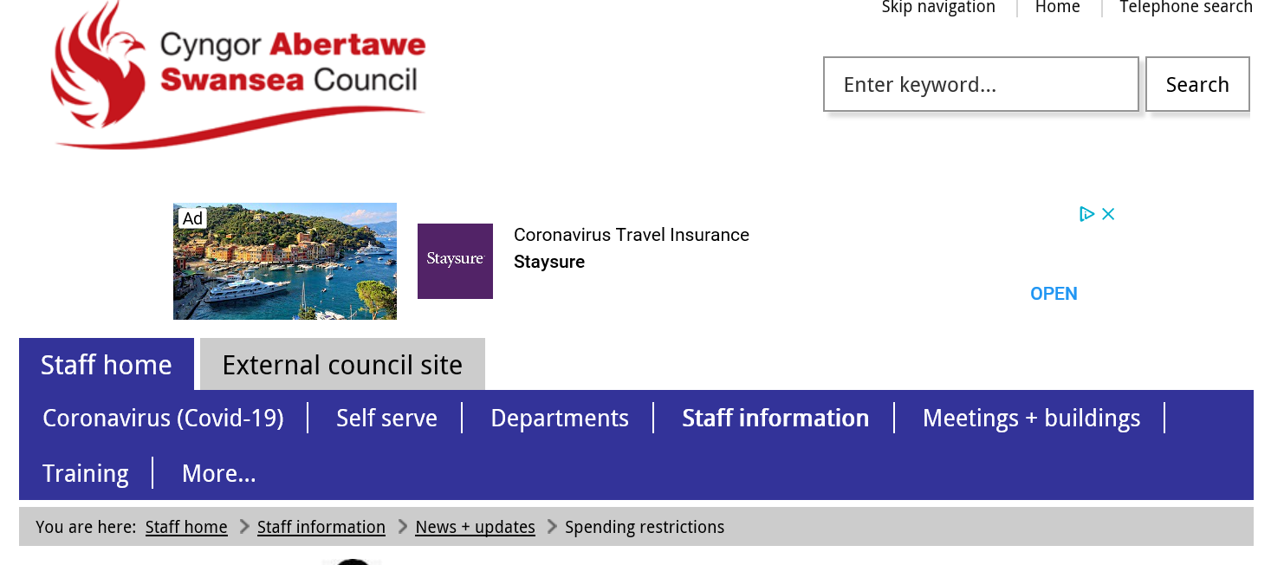

Spending restrictions
You will all be aware of the continued difficult financial position that the Council finds itself in and the continued poor outlook for finances going forward. It is important that action continues to be taken NOW across all areas of the Council to restrict every aspect of all discretionary spend. This is designed to limit overspending in the current year and reduce spending going forward.

Colleagues will appreciate why we must be tighter than ever in controlling spend and ensuring that we achieve value for money in everything that we do.
These instructions apply to all services and all employees, including the Housing Revenue Account. Schools are also advised to adopt these restrictions.
Failure to comply with these instructions may result in disciplinary action.

Overriding Instruction
The following conditions MUST be adhered to:-
1) It is imperative that all responsible officers ensure full compliance with:
a) Financial procedure rules
b) Contract procedure rules
c) Virement rules
There is no authority to exceed approved budgets
2) All Officers must also adhere to the principles and specific instructions listed below.

Spending Restriction Principles
- Do not commit any expenditure which is not absolutely essential
- Delay expenditure where this is possible
- Make no commitments which restrict the Council's ability to make future savings
- Do not submit grant bids that incur future (or indeed current) costs to the Council, or commit us to future levels of match funding which may not be sustainable. A reminder that all applications for grant funding must now be subject to decision by the Council's External Funding Panel
- Commit no new expenditure to areas outside of explicit corporate priorities
- Work on the basis that any leavers, retirees or other departing staff will not be replaced now or in the future. There will be exceptions but plan accordingly. CMT will be monitoring vacancies on a weekly basis.
- Internal support services and supplies should always be used in preference to external contractors subject to best value considerations.
- Don't forget that you are required to deliver your savings targets agreed in the budget, including contributions to any cross cutting targets.
- Ensure that your service priorities are clear and visible, so the Members and the public can understand what we will do and what we won't do.
- Internal advertising platforms are available and are to be considered prior to seeking and proceeding with external advertising. For further information please contact Commercial Services on sales@swansea.gov.uk or 01792 635457.

Specific Instructions
These instructions cannot cover all possible examples, so Officers are expected to take them alongside the principles and apply the same approach to all areas of expenditure.

Recruitment and Pay:
- Assume that where vacancies occur they will not ordinarily be filled, posts should be deleted and full savings taken, unless exceptional circumstances dictate otherwise.
- Filling vacant posts can only be done through the express evidenced agreement of the Head of Service and relevant Director and in line with the Council's policies in respect of the redeployment pool. Any vacancies to be filled should positively seek re-deployees as a priority. CMT will be issuing a list of posts that are exempt from this rule but exceptions will be minimal.
- Any decision to advertise externally must be explicitly approved by the relevant Director however the post may be funded. All external recruitment will be subject to routine reporting and monitoring to CMT to test strict adherence to this rule.
- During this period alternatives to filling the post should be used
- Assume that temporary and fixed term contracts end at next renewal. Again, Director approval will be required for any exceptions.
- Functions carried out by grant funded posts cease when the grant falls off and the posts are deleted from the establishment.
- Honoraria should no longer be used except in very exceptional circumstances, seek HR advice on this. CMT will review a list of all extant honoraria to test they remain justified.
- Only use agency staff with Director's approval - ie when either they would reduce costs or in the case of severe expertise shortage
- All non-contractual overtime must be approved by the relevant HoS in advance and in line with budget rules
- When people leave, accrued leave should be taken in the notice period, not paid for in lieu
- Do not write off overpayments to staff. Recover in most appropriate way, even if it is our mistake

EV17
Employee Engagement Initiatives

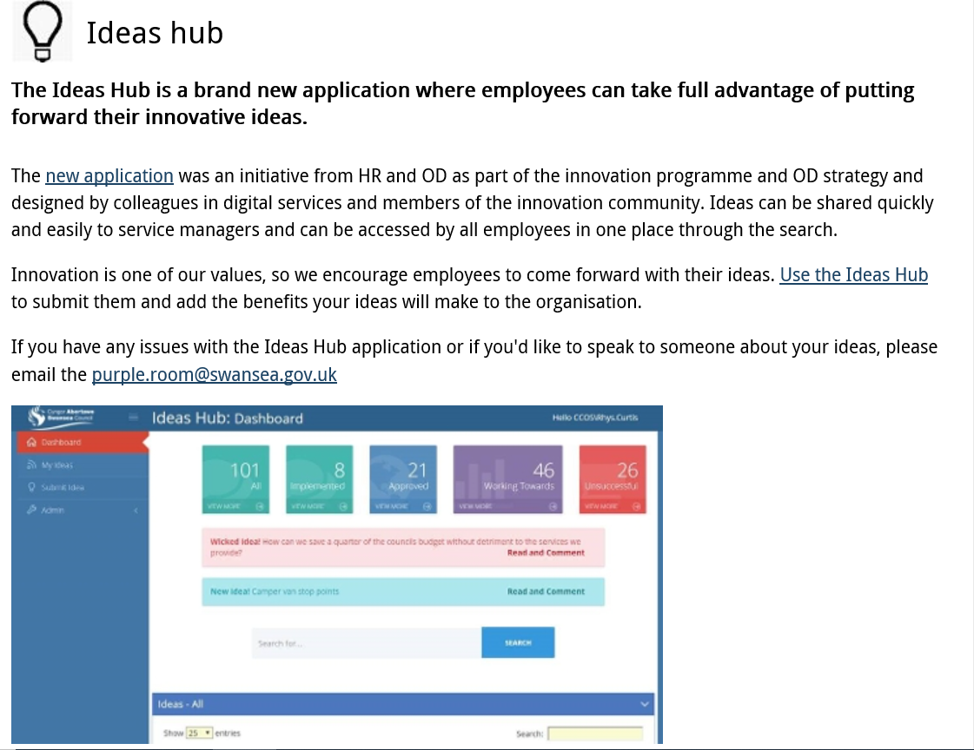

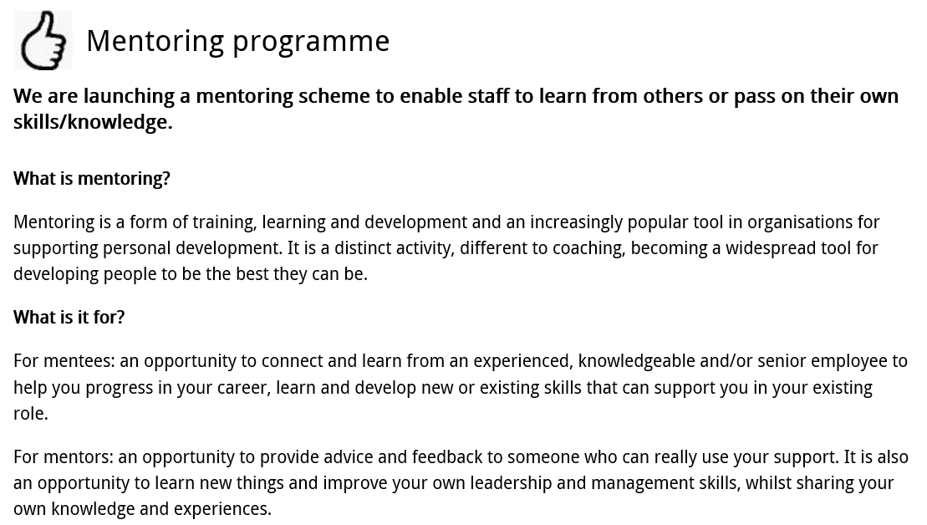

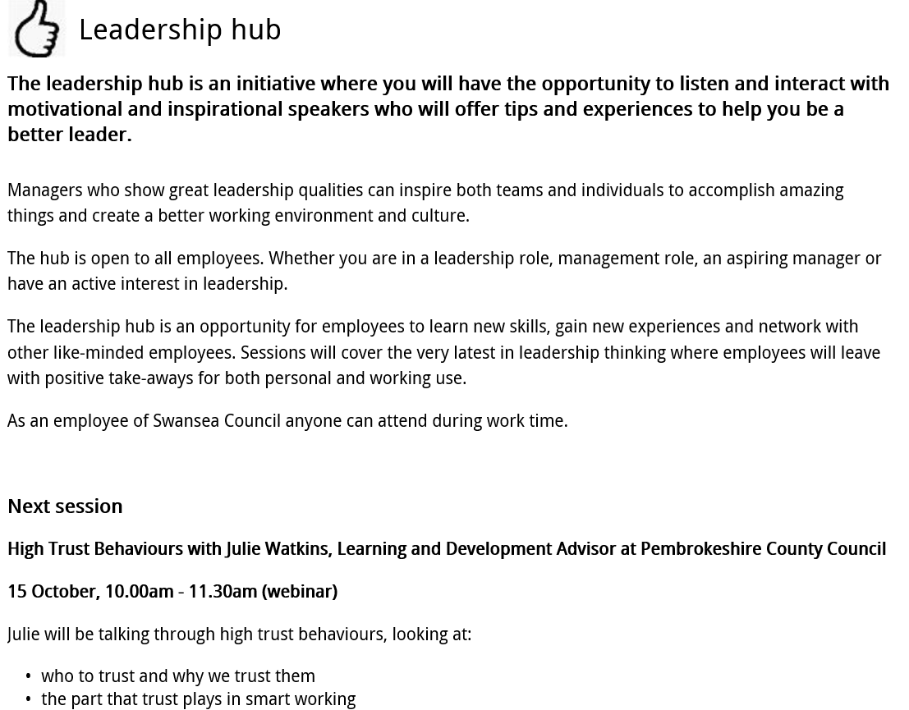

EV18

From: Linda Phillips <Linda.Phillips@swansea.gov.uk>
Sent: 03 December 2020 16:37
To: Stephanie Rayner <Stephanie.Rayner@swansea.gov.uk>
Subject: RE: Employee Engagement - Your Views

My response:
I think the Council relies too much on surveys – this is not as inclusive as it could be. We often forget that not everyone is technologically savvy.
Then, digital responses are sometimes not quite what we would want. However, with COVID there is not much choice, and therefore we need to get more people comfortable with digital surveys if we are to get the engagement we need.

Hope this is OK

Lind

Linda Phillips Chartered FCIPD, MLitt. Proffesiynol Ardystiedig HSD  Swyddog Prosiect Datblygu Sefydliadol  Adnoddau Dynol a Datblygu Sefydliadol  Ystafell 212, Neuadd y Ddinas  Abertawe  SA1 3PE  Rhif ffôn: 07471 145355  Gwefan: www.abertawe.gov.uk  Twitter: www.twitter.com/cyngorabertawe  Facebook: www.facebook.com/swanseacitycouncil | Linda Phillips, Chartered FCIPD, MLitt. HSD Certified Professional  OD Project Officer  Human Resources and Organisation Development  Room 212, The Guildhall  Swansea  SA1 3PE  Tel. No. 07471 145355  Website: www.swansea.gov.uk  Twitter: www.twitter.com/swanseacouncil  Facebook: www.facebook.com/swanseacitycouncil

From: Stephanie Rayner <Stephanie.Rayner@swansea.gov.uk>
Sent: 30 November 2020 09:05
To: Linda Phillips <Linda.Phillips@swansea.gov.uk>
Subject: RE: Employee Engagement - Your Views

Hi Linda

By the end of the week would be fab

Thank you

From: Linda Phillips <Linda.Phillips@swansea.gov.uk>
Sent: 30 November 2020 08:57
To: Stephanie Rayner <Stephanie.Rayner@swansea.gov.uk>
Subject: RE: Employee Engagement - Your Views

HI
When do you need this as I cant fit it in before Wed

L

Linda Phillips Chartered FCIPD, MLitt. Proffesiynol Ardystiedig HSD  Swyddog Prosiect Datblygu Sefydliadol  Adnoddau Dynol a Datblygu Sefydliadol  Ystafell 212, Neuadd y Ddinas  Abertawe  SA1 3PE  Rhif ffôn: 07471 145355  Gwefan: www.abertawe.gov.uk  Twitter: www.twitter.com/cyngorabertawe  Facebook: www.facebook.com/swanseacitycouncil | Linda Phillips, Chartered FCIPD, MLitt. HSD Certified Professional  OD Project Officer  Human Resources and Organisation Development  Room 212, The Guildhall  Swansea  SA1 3PE  Tel. No. 07471 145355  Website: www.swansea.gov.uk  Twitter: www.twitter.com/swanseacouncil  Facebook: www.facebook.com/swanseacitycouncil

From: Stephanie Rayner <Stephanie.Rayner@swansea.gov.uk>
Sent: 28 November 2020 20:08
To: Nicola Reid <Nicola.Reid@swansea.gov.uk>; Carryl Evans <Carryl.Evans@swansea.gov.uk>; Rhys Curtis <Rhys.Curtis@swansea.gov.uk>; Linda Phillips <Linda.Phillips@swansea.gov.uk>; Leanne Evans <Leanne.Evans@swansea.gov.uk>; Angela Edwards <Angela.Edwards@swansea.gov.uk>; Mathew Fisher <Mathew.Fisher@swansea.gov.uk>
Subject: Employee Engagement - Your Views

Hi All

I am currently working on an Employee Engagement assignment and was wondering if you could provide me with a brief written statement regarding your view of the Authority’s approach to Employee Engagement and any reasons as to why you have such views? Positive or negative as I have to undertake a review of the responses.

I know everyone is really busy but if you are able to respond as soon as possible I’d really appreciate it.

Thanks, Steph
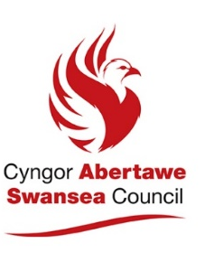
Stephanie Rayner
Partner Busnes AD a DS
HR and OD Business Partner

 01792 636098
 stephanie.rayner@swansea.gov.uk
 stephanie.rayner@abertawe.gov.uk

From: Mathew Fisher <Mathew.Fisher@swansea.gov.uk>
Sent: 01 December 2020 10:30
To: Stephanie Rayner <Stephanie.Rayner@swansea.gov.uk>
Subject: RE: Employee Engagement - Your Views

Hi Steph

In my opinion from a HR&OD perspective we are fairly good from an employee engagement perspective , especially since COVID19. I have daily meetings within my team, are kept up to date witch changes and also have the opportunity to provide an opinion and feel that it is valued.

From an authority wide perspective, I don’t think the whole workforce is properly engaged with when it comes to seeking opinions of staff. We rarely receive any surveys in regards to how the staff think we could possibly improve our services or are asked for feedback on decisions that are being made at Senior Management level.

However, I know the % return on these surveys are always quite low across the authority which doesn’t help, but if staff were made aware on the outcome of these surveys I think this would increase participation in them.

Hope this helps

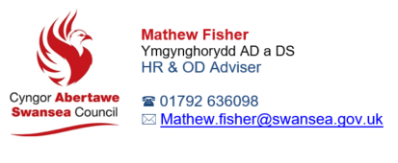

From: Stephanie Rayner <Stephanie.Rayner@swansea.gov.uk>
Sent: 28 November 2020 20:08
To: Nicola Reid <Nicola.Reid@swansea.gov.uk>; Carryl Evans <Carryl.Evans@swansea.gov.uk>; Rhys Curtis <Rhys.Curtis@swansea.gov.uk>; Linda Phillips <Linda.Phillips@swansea.gov.uk>; Leanne Evans <Leanne.Evans@swansea.gov.uk>; Angela Edwards <Angela.Edwards@swansea.gov.uk>; Mathew Fisher <Mathew.Fisher@swansea.gov.uk>
Subject: Employee Engagement - Your Views

Hi All

I am currently working on an Employee Engagement assignment and was wondering if you could provide me with a brief written statement regarding your view of the Authority’s approach to Employee Engagement and any reasons as to why you have such views? Positive or negative as I have to undertake a review of the responses.

I know everyone is really busy but if you are able to respond as soon as possible I’d really appreciate it

Thanks, Steph

Stephanie Rayner
Partner Busnes AD a DS
HR and OD Business Partner

 01792 636098
 stephanie.rayner@swansea.gov.uk
 stephanie.rayner@abertawe.gov.uk

Be able to recommend and plan strategies to raise levels of employee engagement within an organisation.

According to (SHRM, 2020), employee engagement levels are influenced by Line Managers through effective communication, building a trusting working environment and providing reward and recognition for the efforts of the employee.

As referenced by (ACAS, 2014), Organisations regarded as having high levels of employee engagement branded as an ‘employer of choice’, have a clear vision that everyone feels part of, understanding what motivates employees, giving employees a voice, ensuring equality within the workplace

The best practice approach is evidenced within the ‘100 best companies to work for’ list detailed by (The Sunday Times, 2020), examples of which are detailed below:

- Beaverbrooks – Award winning family run jewellers operating a culture of achievement, celebrating and rewarding success recognising the importance of regular performance management which they feel is important in motivating teams.
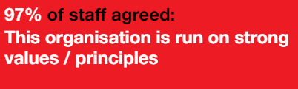
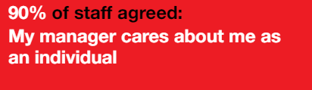

- Churchill Retirement Living – Privately owned, family run organisation with five key principles, trust, openness, respect, communication and honesty. Also recognising the important of wellbeing within their employees. Again, this is an important factor of employee engagement.
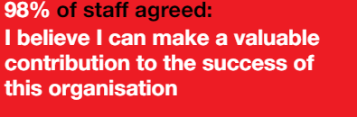
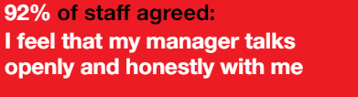

The feedback from staff within both organisations evidences that the vital factors for high levels of employee engagement are considered.

According to (Forbes, 2017), the majority of Strategic Managers believe that their people are the most important asset. However, this is only true when employees feel fully engaged and understand their role within the organisation.

The following 5 steps are vital in improving employee engagement:
- Ensure the right people are in the right roles, utilising individual and team strengths.
- Provide training and development opportunities enabling employees to be effective within their roles.
- Assign meaningful work ensuing employees understand their contribution towards the overall organisation objectives.
- Regular informal and formal communication, encouraging a culture of trust and confidence.
- Ongoing engagement discussions, allowing individuals the opportunity to feel their views are valued.

It is important for Organisation to prioritise the key principles improving performance and productivity which in turn will drive greater financial benefits.

Some of the important factors for improving employee engagement are being considered by Swansea Council including the review of the Performance Management process. Following a discussion with a Principal HR & OD Business Partner (EV19), it is evident that the whilst performance management is incorporated into the Authority’s Organisational Development Strategy, it has been recognised that the current process is not fit for purpose and does not reach the whole workforce.

The revised process, will enable HR to provide template 121/appraisal forms to ensure consistency with the documentation used. A paper based system will be created allowing Manual workers the opportunity to engage with their managers and also have an understanding of the contribution they make to the wider Organisation. Again this being an important factor of improving employee engagement.

Ongoing discussions have taken place with the Corporate Management Team and Leadership regarding the developments of the performance management process. This evidencing that ‘buy in’ from a strategic level and also identifies the current barriers in that employee’s may not be fully engaged due to the lack of awareness in relation to the performance management process which therefore doesn’t provide CMT will an accurate reflection of the views of the Workforce.

CMT have agreed to the development of the process, regular reviews being undertaken, and rolling service specific objectives with behaviours and individual development requirements. Which is in line with the view of (SHRM), who detail employee engagement forming part of the organisational culture and is viewed as a fundamental factor benefiting the organisation as a whole. A number of factors to consider are the views of employees, gain leadership support, and the integration of engagement objectives into policies with the ultimate goal of making employee engagement a core value within the organisation.

Due to the COVID-19 pandemic, the build of the system is currently on hold and as such the Authority it continuing with the current process. The Oracle project is due to recommence in January 2021, with the reintroduction of the process in Autumn 2021. This ensuring that the current process doesn’t cease however, there is a vision for the future development of the programme.

In relation to the additional barriers currently faced by Swansea Council in improving Employee Engagement, unfortunately due to current capacity of the Corporate Management Team I had limitations on who I could access for discussion however, I arranged a virtual meeting with the Strategic HR & OD Manager who has a direct link with CMT and a Principle HR & OD Business Partner, (EV20).

During the discussion, it became apparent that whilst there has been effective communication during the pandemic, (EV21) this was been aimed towards employees with IT access (approx. 4000) which is only a third of the workforce. This is a significant barrier as the majority of communication is issued electronically and as such corporate communications issued may not be reaching the whole workforce.

Part of the discussions included the development of the Ideas Hub below which provides staff with an opportunity of submitting innovative ideas.

Ideas Hub

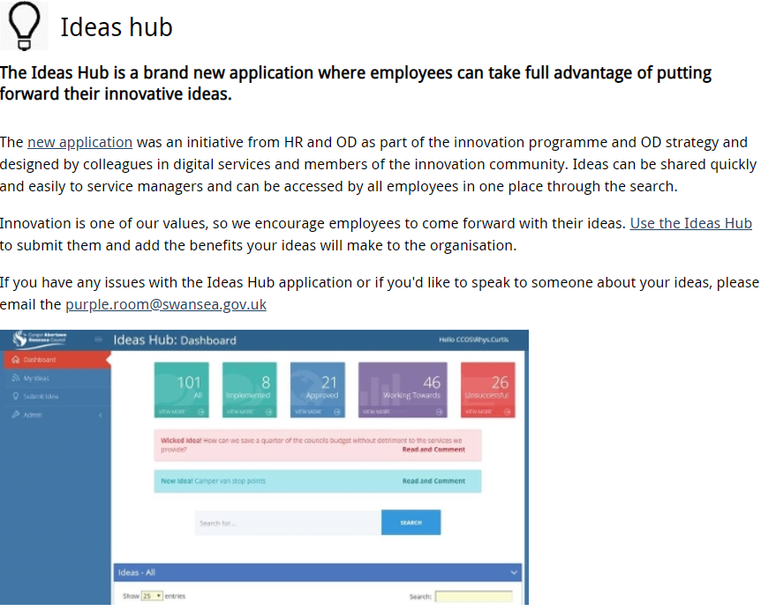

A suggested being taken forward to CMT which does not have any cost implications is for a Head of Service or relevant Senior Manager to provide feedback if the idea is approved or unsuccessful providing the reasons why, as detailed within the discussion notes, this could be a ‘quick win’ in improving employee engagement.

Another consideration was for an Employee App to be created which would allow staff instant access to their employment records including corporate communication issued. Unfortunately, due to the current demands on Digital Services in supporting the new ways of working and the budget implications of such App, it was agreed that we would not proceed with the suggestion at this time however, it was definitely something that could overcome the communication barriers and ensure engagement with the whole workforce.

The future of the working environment remains unknown however, Swansea Council should continue to focus on opportunities for employee engagement creating opportunities for the future.

As stated in (Human Resources Today, 2020),’Let’s learn from the challenges we face to come together and build a better future’.

EV19

Discussion re: Performance Management

Friday 9th October 2020

Wyn Matthews – Principal HR & OD Business Partner
Stephanie Rayner – HR & OD Business Partner

During a discussion with a Principal HR & OD Business Partner who has taken the lead on reviewing the Performance Management process, the current situation regarding the performance management process is that those who have access to the online appraisal system (approximately 4,000 employees) undertake the annual appraisal process.

The current process comprises of two strands being competency framework and objectives settings, in additional to a developmental aspect.
Ultimately, everyone has been discouraged by the competencies, as individuals and managers are required to select the appropriate competency; however, it is difficult to determine what is relevant to both the individual and roles.
List of competencies was not effective or flexible and as such contributed greatly to the poor uptake on completion of appraisals.
Objective setting can be adopted to meet the requirements of the individuals however, the competencies were having a negative impact.

The online system is not an effective tool as it is not user friends and doesn’t get the best out of performance management discussions. Managers and Employees end up focussing on the system rather than the discussion itself. Again, contributing to the poor uptake of the appraisal system.

Outside of the on line process, there are different mechanisms of appraisal throughout the organisation ranging from 121 appraisals to group appraisals e.g. corporate building undertake group appraisals which is not something that is encouraged. Performance Management should be personal to the individual. There is a high percentage of take up for group appraisals however there is question as to whether there is any benefit to the individuals. This evidences that there is no consistency across the organisation.

Some areas of work i.e. Social Services undertake regular supervision which is built into their way of working, however, there is a difference between supervision and appraisal and sometimes that shouldn’t get lost in discussion. If individuals are having regular supervision, they may not have an appraisal. Supervision is focused on case management rather than individual targets, development and training needs.

If there are regular 121’s or check in’s, which are ongoing throughout the year, anything raised during an annual appraisal should not be a surprise.

Whilst it is recognised that Swansea Council is a diverse organisation and as such difficult to have a one size fits all approach there still needs to be some consistency with the process.

Performance Management is incorporated into the Organisation Development strategy which identified that the process for organisation needed to be reviewed and updated. A comparison was undertaken to other LA’s which identified national trends around performance management and it was clear that more and more organisations were recognising regular communications and interactions between managers and employees was leading to check in’s and regular 121 meetings.

During conversations with Local Authorities, it seemed that the approach was similar to that of Swansea Council however, Newport purchased a performance management process software tool, ‘clear review’, which was effectively a process that sends automatic notifications in relation to check in’s which encouraged managers. Newport were looking of ways to adapt the system for their operational workforce which was difficult in itself due to IT accessibility. Positive feedback in relation to office based staff.

Unfortunately, Swansea Council were unable to consider the purchase of this software due to budget constraints.

A decision was made by Swansea Council to progress with the development of the Oracle Fusion system. As a result, HR were trying to find a LA who had implemented Oracle Fusion to which they had discussions with a Council in South East England, who provided a webinar to see what the Oracle system was able to do and how they adapted it.

The next steps were that HR held a workshop with key managers across different directorates within the Council, office based and operational workforce. Discussions around the current performance management process, obtaining their views in relation to regular reviews and this was practical within the areas of work. The response was generally positive and felt it would be beneficial.

Ongoing discussions have taken place with CMT and Leadership regarding the developments of the performance management process. November 2019, report to CMT reminding them of current process, feedback from workshop, reaffirmed the trends previously reported. Summary/recommendation – CMT agreed to development of process, regular reviews, rolling service specific objectives, behaviours and individual development requirements.

Remove competences and ratings from the system
Pilot the system within key teams and areas, range of services for an initial period of 6 months, some paper based systems.
Pilot areas to develop their own 121 forms with support from HR&OD and test as part of the process.
Provide paper based system, if successful mirror development in the Oracle Cloud system.

Due to the COVID-19 pandemic, build of the system is currently on hold and as such the Authority it continuing with the current process. The Oracle project is due to recommence in January 2021, with the reintroduction of the process in Autumn 2021.

EV20

Discussion re: Performance Management

Friday 9th October 2020

Adrian Chard – Strategic HR & OD Manager
Nicola Reid – Principal HR & OD Business Partner
Stephanie Rayner – HR & OD Business Partner

The aim of the discussion was to discuss ways of improving Employee Engagement within Swansea Council and consider any potential organisational barriers to these and how these could be overcome.

A main focus of discussion was the Employee Engagement survey which is issued to the workforce on an annual basis. It was recognised that there is a significant Barrier of communication to manual workers which needs to be overcome to enable the Authority to have a true reflection of the views of their workforce.

Due to the lack of response/engagement in relation to staff survey, we considered alternative cost effective methods of communication including line managers approaching staff to determine their views in relation to communication, creating email addresses for all staff who would be able to access via their personal computers, creating an employee app for instant access.

We discussed the ideas hub which provides staff with an opportunity to relay innovative ideas regarding the Organisation. The Strategic Manager explained that there has been very little ‘buy in’ regarding this and it is seemingly due to the lack of responses when staff are submitting ideas. It was our view for employee’s to engage with the ideas hub, they should feel they are listened to and as such received a response whether the idea was being considered or no. It was agreed for the Strategic Manager to relay this to CMT to consider commitment for a Head of Service to respond to the suggestion irrelevant as to whether it was being considered or not. We felt this was a ‘quick win’ to overcome the current barrier in relation to engagement without any cost implications.

Historically there has been a culture of mistrust due to fear of retribution and employee’s don’t feel there are listened to if they raise anything. Whilst the message in relation to staff survey’s is that they are anonymous, this is questioned by the workforce. Individual’s working within small teams can be identified and therefore not open and transparent with their views.

However, HR are aware that a previous staff survey identified culture issues within a Department which resulted in relevant action being taken. Therefore, the views of the employee’s working I the specific area have changed somewhat as they now feel they can more open with their views and they feel they have a ‘voice’.

It is a suggestion for the Authority to consider ways of relaying this case to the workforce without specific details which will evidence that action could be taken should any concerned be raised.

Whilst this has been the view previously, the recent engagement survey did have a positive response however, it was aimed at employee’s who have IT access who are able to easily respond and also the group of employee’s or are more likely to submit responses in relation to the normal annual survey.

It is evident that feedback from the survey has been listened to which has resulted in price limited home working fund being provided for employee’s to access should they require additional equipment to assist them working from home.

Unfortunately, the Authority will not have a view of a whole workforce engagement until they are able to reach all of the workforce.

A number of strategies are being reviewed in light of the pandemic e.g. Accommodation Strategy and Agile Working Strategy which will provide a clear direction of working arrangements going forward and subsequently improve employee engagement.

It was recognised that whilst suggestions can be made in relation to overcoming barriers in relation to employee engagement, the focus for the Authority since March 2020 is to ensure the wellbeing and engagement of staff and considering the short to medium term rather than longer term strategies.

EV21

Coronavirus Communications
http://www.swansea.gov.uk/staffnet/coronavirusinformation

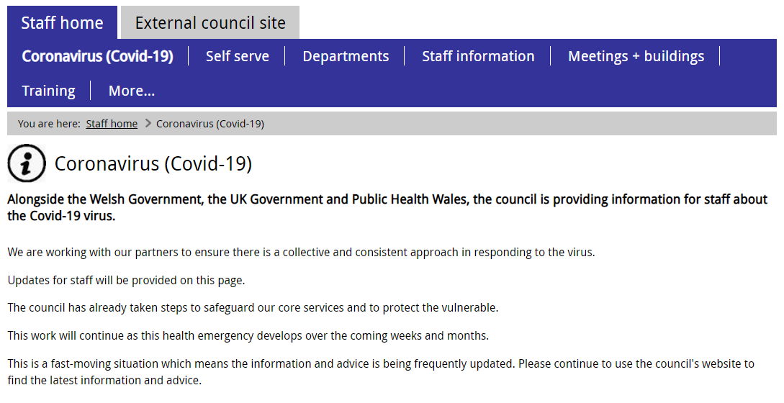
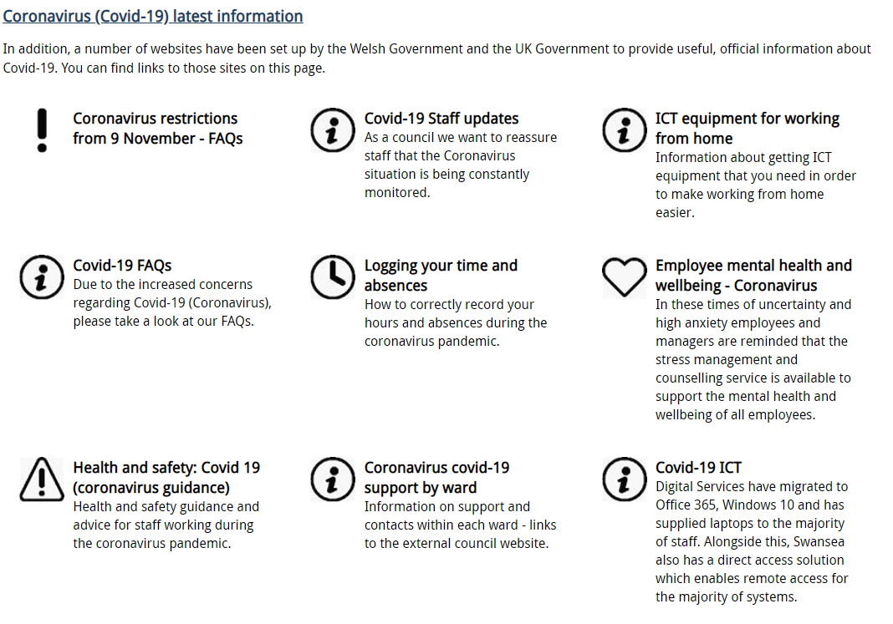

Candidate name: Stephanie Rayner |  |  |  |  | CIPD Membership/registration No.:  55478507
Qualification title: CIPD Level 5 Diploma in Applied Human Resources |  |  |  |  | Unique Learner No. (ULN):  1907192
Unit code | Unit title |  | Assessment criteria no. | Evidence description | Evidence reference number |  | Assessor  initials | I/V initials if sampled
5AEEG | Contributing to Employee Engagement in the Workplace |  | 1.1, 1.2, 1.3, 1.4 | Employee Engagement Survey | EV1
5AEEG | Contributing to Employee Engagement in the Workplace |  | 1.1, 1.2, 1.3, 1.4 | Email justifying diagnostic tool used | EV2
5AEEG | Contributing to Employee Engagement in the Workplace |  | 1.1, 1.2, 1.3, 1.4 | Chief Executives Blog re: Survey Results | EV3
5AEEG | Contributing to Employee Engagement in the Workplace |  | 1.1, 1.2, 1.3, 1.4 | Extract from the Organisational Development Strategy | EV4
5AEEG | Contributing to Employee Engagement in the Workplace |  | 1.1, 1.2, 1.3, 1.4 | Communication issued to staff regarding wellbeing | EV5
5AEEG | Contributing to Employee Engagement in the Workplace |  | 1.1, 1.2, 1.3, 1.4 | Employee Mental Health and Wellbeing support | EV6
5AEEG | Contributing to Employee Engagement in the Workplace |  | 1.1, 1.2, 1.3, 1.4 | Email regarding IT Home working Kit | EV7
5AEEG | Contributing to Employee Engagement in the Workplace |  | 1.1, 1.2, 1.3, 1.4 | Interviews with HR Colleagues | EV8
5AEEG | Contributing to Employee Engagement in the Workplace |  | 2.1, 2.2 | Senior Management Structure | EV9
5AEEG | Contributing to Employee Engagement in the Workplace |  | 2.1, 2.2 | Corporate Plan | EV10
5AEEG | Contributing to Employee Engagement in the Workplace |  | 2.1, 2.2 | Swansea Council – Our Plan 2020-2022 | EV11
5AEEG | Contributing to Employee Engagement in the Workplace |  | 2.1, 2.2 | 121 Form | EV12
5AEEG | Contributing to Employee Engagement in the Workplace |  | 2.1, 2.2 | Contract of Employment | EV13
 | Contributing to Employee Engagement in the Workplace |  | 2.1, 2.2 | New Ways of Working Pilot – Manager Briefing Note | EV14
 | Contributing to Employee Engagement in the Workplace |  | 2.1, 2.2 | Report to CMT – New Ways of Working | EV15
 | Contributing to Employee Engagement in the Workplace |  | 2.1, 2.2 | Spending Restrictions | EV16
 | Contributing to Employee Engagement in the Workplace |  | 2.1, 2.2 | Employee Engagement Initiatives | EV17
 | Contributing to Employee Engagement in the Workplace |  | 2.1, 2.2 | Colleagues responses in relation to Employee Engagement approach | EV18
 | Contributing to Employee Engagement in the Workplace |  | 3.1, 3.2, 3.3 | Discussion Notes – Performance Management | EV19
 | Contributing to Employee Engagement in the Workplace |  | 3.1, 3.2, 3.3 | Discussion Notes – Barriers of Improving Employee Engagement | EV20
 | Contributing to Employee Engagement in the Workplace |  | 3.1, 3.2, 3.3 | Coronavirus Communications | EV21
Candidate declaration:
- I confirm that the work/evidence presented for assessment is my own unaided work.
- I have read the assessment regulations and understand that if I am found to have ‘copied’ from published work without acknowledgement, or from other candidate’s work, this may be regarded as plagiarism which is an offence against the assessment regulations and leads to failure in the relevant unit and formal disciplinary action.
- I agree to this work being subjected to scrutiny by textual analysis software if required.
- I understand that my work may be used for future academic/quality assurance purposes in accordance with the provisions of the Data Protection Act 1998.
- I understand that the work/evidence submitted for assessment may not be returned to me and that I have retained a copy for my records.
- I understand that until such time as the assessment grade has been ratified through internal and external quality assurance processes it is not final.
Signature: |  |  |  |  |  | Date: | 13.12.2020

Notes on candidate evidence matrices

Candidates should be encouraged to develop a matrix indicating how their evidence relates to each unit/module and learning outcomes/assessment criteria. This helps advisors and assessors to support candidates to draw links between units and encourage cross-referencing and the possible multi-use of evidence.

Evidence matrices can be developed using the unit/module and learning outcomes/assessment criteria, giving candidates an opportunity to link their evidence to each outcome.

Another approach is to have a more generic form where candidates list evidence and tick relevant boxes to show coverage.

Whatever approach is employed candidates should be encouraged to complete these forms themselves and not expect assessors to do this for them.

Bibliography

ACAS (2014) ‘The People Factor - engage your employees for business success’. Available at: https://moodle.uwtsd.ac.uk/pluginfile.php/255715/mod_resource/content/1/Advisory-booklet-The-People-Factor.pdf (Accessed 8th November 2020).

CIPD (2019) ‘Employee Engagement and motivation’. Available at: https://www.cipd.co.uk/knowledge/fundamentals/relations/engagement/factsheet (Accessed 8th November 2020)

CIPD (2020) ‘Employee Communication’. Available at: https://www.cipd.co.uk/knowledge/fundamentals/relations/communication/factsheet (Accessed 1st November 2020)

Engage for Success (2020) ‘People Trends – Demographic change’. Available at: https://engageforsuccess.org/people-trends-demographic-change (Accessed 1st November 2020)

Engage for Success (2020) ‘What is Employee Engagement’. Available at: https://engageforsuccess.org/what-is-employee-engagement (Accessed 8th November 2020)
Forbes (2017) ‘5 Powerful Steps to Improve Employee Engagement’. Available at: https://www.forbes.com/sites/brentgleeson/2017/10/15/5-powerful-steps-to-improve-employee-engagement/?sh=212141341d5f (Accessed 28th November 2020)

HR Review (2020) ‘Employee Engagement during Covid-19’. Available at: https://www.hrreview.co.uk/analysis/axel-schiphof-employee-engagement-during-covid-19/125643 (Accessed 1st November 2020)

Human Resources Today (2020) ‘Employee Engagement’. Available at: https://www.humanresourcestoday.com/employee-engagement/ (Accessed 1st November 2020)

People Management (2019) ‘Flexible work improves mental health’. Available at: https://www.peoplemanagement.co.uk/news/articles/flexible-work-improves-mental-health (Accessed 8th November 2020)

SHRM (2020) ‘Developing and Sustaining Employee Engagement’. Available at: https://www.shrm.org/resourcesandtools/tools-and-samples/toolkits/pages/sustainingemployeeengagement.aspx. (Accessed 8th November 2020)

SHRM (2020) ‘Managing Employee Surveys’. Available at: https://www.shrm.org/resourcesandtools/tools-and-samples/toolkits/pages/managingemployeesurveys.aspx (Accessed 1st November 2020)

SHRM ‘Developing an Employee Engagement Strategy’. Available at: https://www.shrm.org/foundation/ourwork/initiatives/resources-from-past-initiatives/Documents/Developing%20an%20Employee%20Engagement%20Strategy.pdf (Accessed 13th December 2020)

Sunday Times (2020) ‘Best 100 Mid Companies 2020’. Available at: https://www.b.co.uk/the-lists/mid-companies/ (Accessed 28th November 2020)

Swansea Council (2020) ‘2020 Well-being Survey’. Available at: http://www.swansea.gov.uk/staffnet/article/58811/2020-well-being-survey (Accessed 1st November 2020)

