Module Assignment Submission
Cover Page

Student Name: | Emma Henderson-Wright
Student Number: | 1811453
Module No: | BMMB7013
Module Title: | Strategic Management

Date submitted: | 19/09/2022
Time submitted: | 23:40
Statement of Confirmation of Authenticity
By the act of making this submission, the student declares that this is the work of the student named above. Where materials have been used from other sources it has been properly acknowledged. If this statement is untrue, the student acknowledges that an assessment offence has been committed. Proven incidents of plagiarism, collusion or cheating can result in a learner being withdrawn from a
qualification.
Attention is drawn to the Plagiarism, Collusion and Cheating Policy and Unfair Practice policies of the University and ILM.
Permission for ILM to use this script
ILM uses learners’ submissions – on an anonymous basis – for assessment standardisation. By submitting, both the centre and the learner agree that ILM may use this script on condition that identifying information is removed. However, if you are unwilling to allow ILM use this script, please refuse by ticking the box: □

Contents
Executive Summary. 3
1.0 Introduction. 3
2.0 S.W.O.T. Analysis. 4
2.1 P.E.S.T.L.E. Analysis. 10
2.2 Porters Five Forces. 12
2.3 Mintzberg five P’s. 14
2.4 Hyper personalisation of customer care. 15
3.0 Conclusion. 16
4.0 Recommendations. 17
References 18
Appendix 1 21

Executive Summary.

This report is on the superstore brand Tesco PLC. The purpose of this report is to critically analyse the internal and external environment when changing or tweaking strategic direction, to ensure that customer centrality is at the forefront of the organisation. Starting with internal analysis a SWOT will be conducted and analysed to identify Strengths, Weaknesses, Opportunities and Threats. The external environment analysis will follow, this will be conducted by using the P.E.S.T.L.E model. The next model that will be analysed is Porters five forces, alongside this there will be analysis of Mintzberg five P’s. Conclusions will be made throughout the report and Strategic Direction will be defined. The report will conclude with recommendations that will be suggested by changing or tweaking the organisations strategic direction. Throughout the report there will be tables and diagrams as applicable.

Introduction.

According to Tesco.com (2022) Jack Cohen in 1919, started a simple market stall, selling groceries. In 1924, Cohen partnered with T.E. Stockwell and made the first own brand product, tea, which was called Tesco tea, Tesco an amalgamation of T.E. S from T.E. Stockwell and CO from Cohen. In 1929, Cohen opened the first Tesco shop and sold Tesco branded products, the first being Tesco tea. In the 1930’s Cohen began expanding, building more Tesco’s, and introducing more products. Tesco was floated on the stock market in 1947. In 1958, after travelling to North America, and encouraging self-service in shops, Tesco opened the first supermarket. During the 1960’s, Tesco continued to purchase more stores, and began to offer more products such as household goods and clothing. In 1968 Tesco opened the first superstore, a larger building with more variety of food and non-food products. In 1973 Tesco introduced petrol stations alongside their superstores and started selling fuel. Sadly, Jack Cohen passes away in 1979. In the 1980’s Tesco focus on cutting prices and making affordable products, including a healthy eating range.
During the 1990’s Tesco.com (2022) made many significant changes, most of which are still valid today. In 1992 they introduced the computers for schools’ initiative, raising £185 million worth of equipment for U.K. schools. The business brand slogan was launched in 1993, ‘Every little helps’ is still being used today and is very recognisable. In 1995 Tesco starts to expand into Central Europe and introduces its loyalty programme Tesco Clubcard. The Tesco Clubcard initiative gained nearly 5 million customers and helped Tesco to overtake competitors in the market. In 1997 Tesco launched financial services, banking and insurances are available, offering special offers for Tesco Clubcard members. In 2000, Tesco.com is launched. Tesco has internet traffic of 20,000,000 customers visiting their site every month. In 2001 Tesco supports Race for Life, with millions of colleagues and customers fundraising every year. In 2003, Tesco partner with o2 to start up Tesco mobile, available as pay-as-you-go or on a monthly contract. In 2009, Tesco invests £150 million on it’s Clubcard relaunch, where customers can double their vouchers, and use with partners. Since 2009 Tesco state they have been working towards becoming carbon Neutral by 2050.
In the 2010’s Tesco.com (2022) focus on encouraging healthy eating and community projects. In 2012, Tesco encourage customers to donate items for charity. Working with the Trussell Trust and FareShare to help people in need, Tesco has food drop off points and donates 20% on any donations made by customers. 2015 Tesco introduced the bags of help scheme. Tesco uses the money from single plastic carrier bag sales to fund projects improving or creating green spaces in the local community. In 2015 working together with FareShare, Tesco provides their surplus food daily, free of charge, in all U.K. stores. Healthy eating has been a priority for Tesco and in 2016 they start to provide free fruit for children, this was to encourage healthy eating from a young age, and to ensure that children had access to it. In 2019, Tesco teamed up with Chef Jamie Oliver, to establish the Tesco Community Cookery School. The Cookery School, developed with FareShare, will give advice and training to communities, sharing knowledge on nutrition and avoiding food waste.
According to Scholes et al (2002, P9) the definition of strategy is ‘the direction and scope of an organisation over the long term, which achieves advantage in a changing environment through its configuration of resources and competences with the aim of fulfilling stakeholder expectations’. The purpose of this report is to reshape the strategic direction after a pandemic to ensure that Tesco is delivering the best customer care, it can be resilient in the face of another pandemic and sustain a competitive advantage.

2.0 S.W.O.T. Analysis.

Sarsby (2016) states that S.W.O.T is a simple four box framework. The acronym S-Strengths, W-Weaknesses, O-Opportunities and T-Threats, is a widely used strategy tool, used for analysis in many sectors. It can be used in organisations of any size, and it can also be used for analysing individuals. The beauty of this framework is that it is simple to use and can be applied in all organisations, at all levels and different depths. According to Vlados (2019), When conducting SWOT Analysis, the organisation can list their strengths and weaknesses, this is the knowledge on the internal environment. The opportunities and threats are knowledge on the external environment, this may be out of the organisations control, however, by having an awareness of any opportunities or threats they may be facing, they can use this to their advantage and prepare a strategy accordingly.
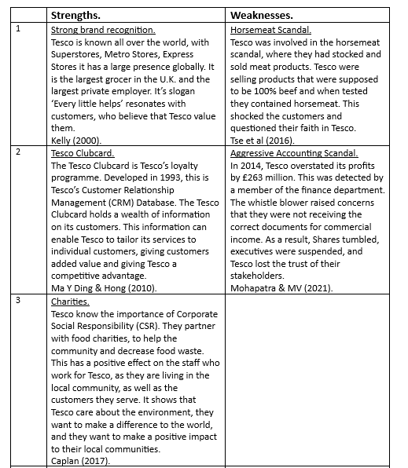
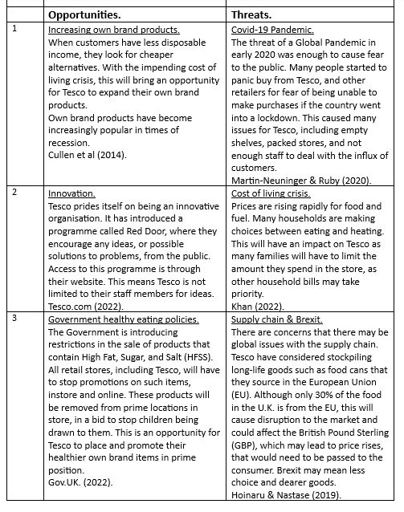
One of Tesco’s biggest strengths is their loyalty programme. The Tesco Clubcard, started in 1993, has been through many changes. The Clubcard is the key to Tesco gaining data on their customers as individuals. The basic Tesco Clubcard is free and easy to sign up on Tesco.com (2022), by signing up the customer must give personal information including name, address, mobile phone number. These personal details are the start of the data Tesco will hold, they will potentially know genders, marital status, and demographics of their customers by this one simple form. According to Spethmann (2004) the data received is not seen by the Clubcard holder, it does not affect them in any way, they do not even think about the information they are giving, only the perks they are receiving, but this information drives business decisions made by Tesco. The data analysed by Tesco Clubcard was the driver for its financial services and mobile telephone services.
Simms (2007) disagrees with Spethmann (2004), that the information received by Tesco, does affect the customer in many ways. Tesco have processed more than 25 million Clubcard’s. They are used in stores and online for 80% of purchases. Tesco know what customers buy, from that information they can analyse customers lifestyles, they know whether they party every weekend, have a baby, what size clothing they are. For banking customers and mobile phone customers the amount of data held is immense. Tesco will know how much money they have, how much they save, how much they spend and where they are spending it. Tesco will know how much time they spend on the phone and the locations they are calling from and to, whether they send text messages, their internet use. When all this information is combined, Tesco hold a wealth of information on their customers. This knowledge is not always used to reward their customers and there has been incidents where Tesco have suspected shoplifting and informed the authorities, with all the information needed, such as names and addresses, retrieved using their Clubcard. Simms (2007) states that customers should think about the information being gathered and use Clubcard’s with caution.
Tesco continues to use and adapt its loyalty programme, when a customer scans their Clubcard they will receive 1% back in rewards. Rewards can be spent on groceries at face value or doubled up with partners for experiences such as day trips to LEGOLAND. Money off vouchers is personalised on the items that the customer buys the most. Laleye (2022) explains that Tesco have a Clubcard Plus membership. This membership has a subscription fee of £7.99 a month and will give customers 10% off two shops a month of their choosing and 10% off brands such as F&F clothing and Fox & Ivy homeware. These purchases are in store only and must be made via the app. Tesco have a delivery saver plan, there are many options available, including joining for six or twelve months and having peak or off-peak delivery slots. This has increased in popularity since the Covid-19 pandemic when many customers were unable to secure a delivery slot due to unprecedented demand. Johnson (2020) states that Tesco are trying to compete with Amazon’s fresh delivery service in the U.K. and therefore Tesco plans to compete, by making it a part of the Clubcard Plus service.
Tesco’s largest weakness is the investigation by the Financial Reporting Council (FRC) of the U.K. According to Walker (2014) the FRC are investigating because there has been an overstatement of £263 million. They wish to investigate the years 2012 to 2014 inclusively. PricewaterhouseCoopers who are Tesco’s accountancy firm have been working with the FRC. The Serious Fraud Office (SFO) also opened an investigation. As the overstatement was because of booking commercial deals too early with suppliers, the SFO had to contact the suppliers, Unilever, and Diageo. Evans & Fleisher (2014) agree with Walker (2014) that there is an accounting issue because Tesco had prematurely booked income, they also delayed booking of expenses, which would make it a serious offence, not a mistake. It was important to get all the evidence, from all parties involved. While the investigation was happening, Tesco reportedly suspended eight of its senior executives over the serious accounting issue.
Jolly & Bray (2016) states that Tesco co-operated with the investigation by the FRC and SFO. Three executives were taken to court, their lawyers continued to defend them, and they denied any wrongdoing. On the 23^{rd of} January 2019, the SFO published the Deferred Prosecution Agreement on their webpage SFO.Gov.UK. (2022). Tesco had been under investigation since October 2014, they were culpable of false accounting and would be fined £129 million with a further £3 million investigation costs. Tesco also agreed to an £85 million payment of compensation for bondholders and shareholders. The three executives were acquitted on the charges. On the 8^{th of} June 2020, the FRC announced on it’s webpage FRC.Org.Uk. (2022), that the case against Tesco, its executives and former auditors would be closed. This was due to the prosecution by the SFO at Southwark Crown Court.
According to Woods (2011) the aggressive accountancy scandal damaged Tesco’s reputation. In 2015, they reported losses of £6.5 billion. Kukreja & Gupta (2012) state that because of the aggressive accountancy scandal its shares decline massively, the lowest it had been in eleven years, the first day that the scandal was announced shares fell by 6.5 %. The profits reported in October 2014, for the six-month period ending August 2014, fell by an unbelievable 91.9% to only £112 million, the profit was £1.3 billion the year before. With Tesco being the largest supermarket chain in the U.K., it is one of the biggest corporate taxpayers, ipso facto, this impacted the U.K. treasury. Shareholders started selling their shares at a loss. Tesco aware of the financial issues it was facing, it sold off some divisions that were non-core, such as Blinkbox its video streaming service. Tesco streamlined its staff, losing up to 10,000 members and closed the pension scheme, meaning that future employees would receive a lower rate.
Tesco has continually innovated over the last 100 years. Innovation continues to be an opportunity for Tesco. According to Alexander (2020) technology has played a significant role in Tesco’s advancements of the past ten years. As access to the internet has grown in homes, so has Tesco.com, allowing a home shopping delivery service to the public. Tesco have fully embraced technology and its ability to reach more people. The correct use of technology and innovation can lead to a competitive advantage. Tesco are fully aware that there are many great innovators, who are not employed by Tesco. They have their Red Door programme that is available to any member of the public, this can be accessed at any time on their website Tesco.com (2022). According to M2 Presswire (2018), Tesco joined forces with the World Agri-Tech innovation summit, they have created an opportunity to pair up suppliers with agricultural start-up companies, to accelerate innovation in the supply chain.
Tesco is continually looking forward. They utilise technology, the self-service checkouts being a prime example. According to Watson (2005), Tesco is increasing the number of self-service checkouts, trying to double them in every store. Tesco are frustrated with cash handling; they feel that it wastes the time of their staff, and customers now rely on paying by card, card has overtaken cash for the first time, and this trend will continue to grow. Tesco have discussed having cashless stores for the future and are interested in anything that will add value to the staff and the customer. Daily Mail London, England (2015) explains that some customers completely disagree with the praise that supermarkets give to their self-service checkouts. Stating that they are inefficient and stressful to use, with some being utterly embarrassed when the machines do not work properly. Those with medical issues find that it heightens their condition, or their disability means that it is impossible to use. Other customers would simply just rather human interaction. Many people feel that this is bad customer service from Tesco because they are trying to limit the choice of having manned checkouts available.
A major threat that most people have not encountered prior to 2020 is a pandemic. The global pandemic Covid-19 disrupted everyone’s lives. Many businesses closed overnight as the U.K. was plunged into lockdown. The only businesses that remained open were food and fuel distributors, Tesco being one of them. A threat of a pandemic will spark a response of panic buying because the public are concerned about the supply chain. Panic buying started prior to being in lockdown. Martin-Neuninger & Ruby (2020) state that stores had to make changes quickly which included, restricting products per customer, reducing opening hours, and begging the public to shop as they would normally. As the pandemic progressed Tesco had to make further changes, such as introducing sanitising stations, social distancing, one way traffic, Perspex screens, and more customers moving to online purchasing.
According to Partridge (2021) Tesco had to make many changes at their own cost, they also had to hire more staff to keep up with the demand of the public, to offset the staff members that were informed by the health board that they must not go to work, they must isolate for a minimum of twelve weeks as they had underlying health conditions, and the staff who contracted the disease, so were unable to attend their workplace. Tesco incurred many costs when operating during the Covid-19 pandemic, £892 million, and as a result its profits fell by 20%. Tesco states that customers shopping habits have now changed, they are finding that customers visit the store less that pre-covid, however, they are doing a larger shop during that visit, with an average of 50% more in each trolley.
In conclusion, a pandemic is a threat to all organisations. Many people would assume that Tesco would thrive during a pandemic, as most other sectors had to close its doors. What the public did not consider were the changes that Tesco had to make to keep trading, they had a responsibility to keep their staff and the public safe, these changes cost a great deal of money.

2.1 P.E.S.T.L.E. Analysis.
P.E.S.T.L.E Analysis, defined by White (2021), as a model that a business can use when evaluating the macroenvironment, is an excellent framework, widely used by many organisations. The acronym P.E.S.T.L.E represents six factors that can impact on the organisation, Political, Economic, Social, Technological, Legal, and Economical. Johnson et al (2020) state that looking at the wider environment will allow organisations to be aware of possible threats and to be able to seize any potential opportunities. Perera (2017) explains that an organisation should consider each factor separately, some examples in each factor could include: - Political - Government policies, health policies, Brexit. Economic – poverty, employment status, disposable income. Social – Values, ethics, cultures. Technological – Customer Relationship Management (CRM), the internet, social media. Legal – regulations, laws, guidelines. Environmental – Corporate Social Responsibility (CSR), carbon footprint, negative environmental impacts.
Political.
- Tesco must know and follow Government guidelines. Ying & O’Clery (2021) state global organisations must adapt to each country. This will mean keeping up to date, as political changes can be made often, particularly in the case of a pandemic. There were many changes made by the government during the Covid-19 pandemic. Tesco had to be abreast of all government guidelines and adhere to them in each country.
- The Government during the Covid-19 pandemic encouraged healthy eating among citizens. The research suggested that individuals with a healthier lifestyle were less at risk of serious illness if they were to catch the disease. Boons et al (2021) state that the government will continue to promote healthy living and childhood obesity issues. The government is introducing the restriction of sale, promotion, and product placement of foods with High Fat, Sugar, and Salt (HFSS). Tesco will have to follow these guidelines and make the relevant changes in their stores to comply.
Economic.
- There is a cost-of-living crisis. This is because of the pandemic and the war in Ukraine. According to the Guardian News & Media (2022) prices are hitting the highest ever with inflation reaching 10%. This will have an impact on individuals and businesses. The Government is attempting to offset some of these issues including the fuel increases, they are supporting individuals and businesses, however, food prices have been rising exponentially. This will affect Tesco as people will have less disposable income.
- There is an energy emergency. The war in Ukraine is impacting on the price of energy. The Telegraph Group (2021) states that because of rising energy bills, households on low incomes will suffer. They will see an average of 16% of their disposable income go towards high energy bills. This will have an impact on the money they have available to spend on food and ipso facto Tesco’s customers will have to make decisions on what they buy and who from, to get the most for their money.
Social.
- Tesco continues to follow trends and support their customers with their dietary decisions. Customers beliefs and values are important to Tesco. According to Guardian Newspapers (2020) stores are selling more plant-based products, with customers looking for alternative foods. Customers are interested in meat free products that have vegan and vegetarian customers in mind. Tesco owns the brand wicked kitchen, in December 2020 they unexpectedly sold out of their “no turkey roast crown” online, despite increasing their Christmas meal alternatives from six products to ten.
- As society individuals are becoming more health conscious. Tesco must support their customers, staff and the community with their health and wellbeing. Johnson et al (2018) states that Tesco and Tesco Bank, continue to make changes of support. This support will also be in line with Government Guidelines, such as the HFSS legislation, which aims to support healthier lifestyles from childhood.
Technological.
- According to Mukerjee (2013) technological advancements assist in Tesco’s values of getting to know their customers. Tesco’s CRM holds a wealth of information on their customers who are part of their loyalty programme. This technology can record every interaction with each individual customer. The technology track’s geographical locations, dates, times, and products purchased. Tesco having this information gives them a competitive advantage.
- Leng & Wee (2017) state that Tesco self-service checkout is available globally. There are benefits to the customer, faster checkout times, less interaction with others, compatible with their digital lifestyles. The largest benefit to Tesco is that they need less employees to supervise that section. Tesco’s scan and shop, where customers can scan the products as they shop, is becoming increasing popular, and is becoming available in more stores. Tesco continually innovate and invest in technology.
Legal.
- There are many laws that Tesco must adhere to. Legal changes and government guidelines have an impact. The food promotion and placement regulations 2021 on HFSS means that each Tesco store will need to be modified. Buza et al (2010) explain that changes in store are not as simple as they may appear. There are legalities, such as storing chemicals next to food, that will need to be considered.
- Laws can come into force very quickly, and effect Tesco. Marriott (2021) states that because of shopworkers being abused at work throughout the Covid-19 pandemic, 88% verbally and 9% physically, that there must be a law to protect retail workers being abused by customers. The police, Crime, Sentencing, and Courts Act 2022 received Royal Assent on the 28th of April 2022. This law is to provide tougher sentencing for anyone abusing workers who deal with the public. Tesco has many customer facing roles, this new law will assist them in attracting employees, who may now feel safer working with the public. This will also impact on the customer, most customers do not want to witness, or be involved in any violence while shopping in stores.
Environmental.
- Tesco.com (2022) is passionate about the environment. Claiming that 40% of food is wasted, they want to do their part to eliminate food waste and help others who are in food poverty. Tesco, claim they have not sent any food to landfill since 2009. Any unsold food is sent to charities, community groups and the colleague shop, anything left is used as animal feed or converted into energy.
- To avoid food waste Tesco work with its suppliers on the sale of products that would previously be viewed as unacceptable. Caplan (2017) explains that products, particularly fruits and vegetables, that do not look standard are perfectly edible. The perfectly imperfect range including potatoes, strawberries, and apples are sold for a reasonable price, adding value to customers, and reducing food waste. Tesco will continue working with suppliers to reduce food waste and help the environment.
In conclusion, there are many factors in the external environment. Tesco must continually adapt to comply with its own core purpose, which is “serving our customers, communities and planet a little better every day” Tesco.com (2022).

2.2 Porters Five Forces.

The five forces model by Porter (2008) is a framework used to analyse organisations. By comparing others in the same industry and by knowing their own organisation, they can adapt the organisations strategy, increase their profits, and gain competitive advantage. The first force is Competitive Rivalry, examining and understanding their competitors, and comparing the similarities and differences to their own organisation. The second force is Supplier Power, it is important to understand how many suppliers are offering the goods or services required by the organisation. The fewer suppliers, the more power they hold, more suppliers mean the organisation has more choice to switch and more power for better deals. The third force is Buyer Power, how many organisations does the buyer have to choose from? The more choice for the buyer the more power they have, the less choice for the buyer the more power the organisation holds. The fourth force is the Threat of Substitution, can the customer substitute the products that they purchase from the organisation by making it themselves? The fifth force is the Threat of New Entry, can anyone enter the market with ease or are there many barriers preventing them?
Competitive Rivalry – High.
According to Statista.com (2022), there are Ten well known supermarkets and some independent stores. Tesco, Sainsbury’s, Asda, Morrisons, Aldi, Lidl, The Co-operative, Waitrose, Iceland and Ocado. Out of the Ten, there are four who are referred to as the big four. Tesco is the market leader in the U.K. and its closest rivals are Sainsbury’s, Asda and Morrisons. The diagram in Appendix 1, shows that Tesco leads its closest competitor, Sainsbury’s, by over 12% with 27.3% of the market share. Hassan & Parves (2013) state that Sainsbury continues to follow Tesco’s lead, introducing their own loyalty programme the Nectar card. This CRM has worked for Sainsbury’s to build their own loyal customers; however, Tesco’s customers have remained loyal to them. Steenkamp & Sloot (2018) explain that the disruption to the market by Lidl and Aldi has had an impact on Tesco with its hard discounted goods. Aldi is one of the leading global brands in the retail sector.
Supplier Power – Low.
As there are many thousands of suppliers available, Tesco can use its Brand name and reputation to negotiate the best deals with suppliers. Wang (2010) state that because Tesco buy in such great volumes, they can choose any supplier and tell them what prices they are willing to pay. Tesco holds more power than suppliers. Tesco is aware of this fact and have previously treated suppliers very badly. According to Poulter (2016) Tesco have been found guilty by the Ombudsman of treating suppliers unfairly. They have withheld payments to suppliers, delaying the payments for years, making the suppliers financially unstable and in some cases causing bankruptcy.
Buyer Power – Low.
According to Ryle (2013) Tesco is present in over 14 countries and serves over 50 million customers every week. It is a long-established brand, trading for over a hundred years, and thanks to its Tesco Clubcard loyalty programme, it has amassed millions of loyal customers. Humby et al (2004) agree with Ryle (2013) that Tesco has millions of loyal customers, the values that Tesco have portrayed to their customers is that they are always there to help them. The customer base is so large that at this stage any customer losses to another company would not have an impact. This is the reason that the buyer power is low.
Threat of Substitution – Low.
Church et al (2015) explains that growing your own food is not very common among households. There are many reasons for this, it takes time, money, and space. The proportion of the U.K. said to be growing its own produce is only 15%, this, however, could be as little as one item. It seems that most people who grow their own food do so for pleasure and to satisfy their own beliefs and values. An activity with health and well-being advantages, and it is not pursued for economic reasons. It is unlikely that there would ever be a way that individuals in great numbers would be able to be completely self-sufficient and never have to make any purchases, be that food, cleaning products, and hygiene products. For this reason, the threat of substitution is low.
Threat of New Entry – Low.
Entering this market and causing disruption to Tesco would require a vast amount of capital. Many organisations have entered but have not managed to get any large market share. According to Thompson et al (2012), Aldi entered the U.K market in the 1990’s, with hope of causing disruption. Aldi’s no frills, affordable prices did attract customers. Aldi has been able to grow, it has 960 supermarkets that can be found in many towns and cities across the U.K. Aldi aimed to have 10% of the market share by 20202, they have failed to reach that amount. Tesco as the market leader, being able to succeed over others who have entered the market previously, is the reason that a new entrant being a threat to them is very low.
In conclusion, Tesco are in a good position. Tesco have built a loyal following of customers through their values and customer care. Customers believe that Tesco care about them and that they do everything to help them improve their lives and save money. Customers feel that Tesco know them on a personal level. Tesco know and understand its business, competitors, suppliers, and all threats that they may face. Tesco uses this information for its own benefit, some of which may not be completely moral.

2.3 Mintzberg five P’s.

Mintzberg (1987) defines strategy as a plan. Mintzberg (1993) states that it is vital that an organisation must research their environment. External and Internal analysis is crucial, and it should be used with the five P’s model to create a strategy. Mintzberg five P’s model, named because each part starts with P. Planning – brainstorm and plan with purpose. Ploy – outsmart competitors to gain a competitive advantage. Position – Use the market position as an advantage to create unique products or selling points. Pattern – reflect on the past to see patterns of successes or failures. Shape the future building upon successes that have happened. Perspective – connected to the organisations culture, beliefs, values, and attitudes. The mission statement and organisations core values will influence any strategic decisions.

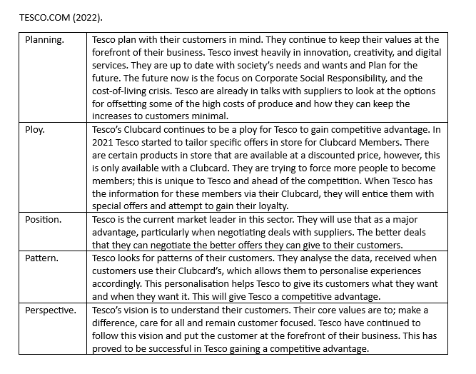
In conclusion, Tesco has thrived because they know their customers and continue to personalise its organisation. Their loyalty programme Clubcard continues to provide the data to make the customer feel valued. They have made adaptations to the format of the Clubcard over the years, and must continue to do so, especially through difficult times such as a pandemic.

2.4 Hyper personalisation of customer care.

According to McKinsey & Company (2020) organisations should be striving to give their customers the best personalised experience. During the Covid-19 Pandemic the public widely isolated themselves, businesses were closed, and employees were forced to work from home. This had never been experienced before and businesses had to respond quickly and make adaptions. Customers are central to an organisation and must be treated as such. Organisation must know their customers and tailor their products, services, special offers and advertising, to suit them as an individual rather than a collective. This personalisation needs to be in all interactions whether that is face to face, or online. The ‘care of one’ is integral for a business’s success, leading to a competitive advantage. Customer centrality, through hyper personalisation, should be at the forefront of organisations, prioritised and implemented by 2025.
McKinsey & Company (2020). Tesco.com (2022).
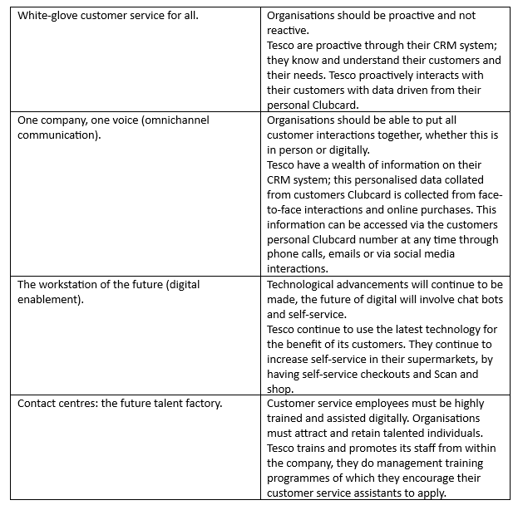
In conclusion, Tesco’s loyalty programme continues to be their greatest strength. Tesco understand that customer centrality is the key to success, they continue to provide personalised services both in person and digitally. Tesco must keep this as their focus as they move forward with technology and innovation.

3.0 Conclusion.

This report on Tesco PLC, starts with internal analysis. SWOT Analysis has been conducted to identify Tesco’s Strengths, Weaknesses, Opportunities and Threats. Tesco’s biggest strength continues to be its loyalty programme Tesco Clubcard, which gives Tesco a wealth of information. The biggest weakness is the financial accountancy scandal, where Tesco were found guilty of Aggressive Accounting. Not only did Tesco incur huge fines but they lost trust among their shareholders and stakeholders. The greatest opportunity for Tesco is technology, it is an innovative organisation that pursues the latest trends for the benefit of its customers. The largest threat is another lockdown from Covid-19 or another pandemic, these changes can cost a large amount on safety measures.
To analyse the external environment, P.E.S.T.L.E Analysis was conducted, the results of this analysis show that the Clubcard is invaluable. For Tesco’s success to continue they must carry on following their own core values. Porter’s five forces analysis reveal that Tesco’s care about their customers, they want customer centrality and lifetime loyalty. Tesco are trying to achieve this by following their own values and staying strong to their roots. Analysis using Mintzberg five P’s model shows that Clubcard is their biggest strength, they know their customers and how to make them feel valued. The ‘care of one’ model by McKinsey & Company (2020) proved again that the Clubcard made a huge difference for Tesco. It’s ability to collate data and personalise experiences is second to none.
Overall, Tesco is in a very strong position. It is the market leader in the U.K. It wants to be customer centric and make improvements on the lives of its customers, employees, communities, and the planet. Its strategic direction follows its core values, and they continue to innovate. Their strategic direction can be tweaked to make improvements; however, a dramatic change would not be necessary for this organisation, as it is customer centric. The following recommendations will tweak the direction and improve Tesco’s customer centrality.

4.0 Recommendations.

Short term – Tesco must improve on the customer care and personalisation that the customer has come to expect. The customer will always want more. The introduction of Clubcard + has not attracted many customers. Tesco could use its normal Clubcard points and offer customers a month free Clubcard +, when they have a certain number of points. To gain the points customers must spend a certain amount, so the spending would offset the monthly fee – but the customer feels valued and that they are being rewarded. Every customer wants something for nothing.
Medium term – During the pandemic the need for food deliveries increased. Tesco should look at other options of making food deliveries, that do not require staffing, using the latest technology, they could trial Drones. A Drone would make the delivery remotely and avoid human contact upon receipt. This would eliminate extra staff being needed. Various other organisations are trialling this successfully.
Long term – Urban Fulfilment Centres (UFC) could be introduced in every town and city. Using automated machines, that can gather shopping. It will be quicker and cheaper than the shopping being picked by hand, and would also limit numbers of staff in stores, particularly during social distancing.

References

ALEXANDER, I.N., 2020. The influence of technological innovations on organization's competitive advantage: Case study on Irish food retail company (Tesco).
BOONS, F., DOHERTY, B., KÖHLER, J., PAPACHRISTOS, G. and WELLS, P., 2021. Disrupting transitions: Qualitatively modelling the impact of Covid-19 on UK food and mobility provision. Environmental innovation and societal transitions, 40, pp. 1-19.
BUZA, K., BUZA, A. and KIS, P.B., 2010. Towards better modeling of supermarkets, 2010 International Joint Conference on Computational Cybernetics and Technical Informatics 2010, IEEE, pp. 499-503.
CAPLAN, P., 2017. Win‐win?: Food poverty, food aid and food surplus in the UK today. Anthropology Today, 33(3), pp. 17-22.
CHURCH, A., MITCHELL, R., RAVENSCROFT, N. and STAPLETON, L.M., 2015. ‘Growing your own’: A multi-level modelling approach to understanding personal food growing trends and motivations in Europe. Ecological Economics, 110, pp. 71-80.
CULLEN, C., MCFEELY-HANCOX, A. and LEDWITH, S., 2014. To identify and analyse how income and population is impacting on Generation X consumers shopping experience in retailing. And to investigate how retailers/brands are responding to the trends (identified above) which are impacting on Generation X consumers.
DAILY MAIL London, England., 2015. SELF-SERVICE TILLS: YOUR FURY: It's REALLY struck a nerve - the Mail's crusade against those maddening automated checkouts. Now readers vent their frustration - store bosses take note! [Scot Region Edition 2]. 2015. London (UK): Solo Syndication, a division of Associated Newspapers Ltd.
EVANS, P. and FLEISHER, L., 2014. Accounting Issue Pressures Tesco. Brussels: Dow Jones & Company Inc.
FRC.Org.UK (2022), Available at: https://www.frc.org.uk/ (Accessed 04/09/2022).
GUARDIAN NEWS & MEDIA,. 2022. What new measures could Rishi Sunak introduce in spring statement? Chancellor is expected to announce support to help with the cost of living crisis and war in Ukraine; Chancellor is expected to announce support to help with the cost of living crisis and war in Ukraine. 2022.
GUARDIAN NEWSPAPERS. 2020. Veganattone and 'no turkey' crowns: it's a merry vegan Christmas for UK retailers; Waitrose, Tesco, and M&S report surges in vegan food sales, as grocery chains expand plant-based ranges. 2020.
GOV.UK. 2022, Available at: https://www.gov.uk/ (Accessed 05/09/2022).
HASSAN, A. and PARVES, M., 2013. A Comparative Case Study Investigating the Adoption of Customer Relationship Management (CRM) The Case of Tesco and Sainsbury's. International Journal of Managing Value and Supply Chains, 4(1), pp. 1.
HOINARU, R. and NĂSTASE, M., 2019. A balanced approach: Brexit from political and business perspectives, Proceedings of the International Conference on Business Excellence 2019, pp. 804-816.
HUMBY, C., HUNT, T. and PHILLIPS, T., 2004. Scoring points: How Tesco is winning customer loyalty. Kogan Page Publishers.
JOHNSON, G., WHITTINGTON, R., REGNÉR, P., ANGWIN, D. and SCHOLES, K., 2020. Exploring strategy. Pearson UK.
JOHNSON, J., 2020. Tesco deliveries will be free for premium Clubcard members to rival Amazon Fresh. London (UK): Express Newspapers PLC.
JOHNSON, S., ROBERTSON, I., COOPER, C.L., DICKINSON, J. and JONES, N., 2018. Tesco Bank Wellbeing Case Study. WELL-BEING. Springer, pp. 179-188.
JOLLY, D. and BRAY, C., 2016. 3 Former Tesco Executives Charged with Fraud Over Accounting Scandal. New York: New York Times Company.
KELLY, J., 2000. Every little helps: an interview with Terry Leahy, CEO, Tesco. Long range planning, 33(3), pp. 430-439.
KHAN, N., 2022. The cost of living crisis: how can we tackle fuel poverty and food insecurity in practice? British Journal of General Practice, 72(720), pp. 330-331.
KUKREJA, G. and GUPTA, S., 2012. Tesco accounting misstatements: Myopic ideologies overshadowing larger organisational interests. Wall Street Journal, .
LALEYE, T., 2022. Tesco Clubcard explained: Clubcard Plus customers can save up to £40 each month. London (UK): Express Newspapers PLC.
LENG, H.K. and WEE, K., 2017. An examination of users and non-users of self-checkout counters. The International Review of Retail, Distribution and Consumer Research, 27(1), pp. 94-108.
M2 PRESSWIRE., 2018. Tesco joins World Agri-Tech Innovation Summit in search for innovative start-ups. 2018. Coventry: Normans Media Ltd.
MA, Y., DING, J. and HONG, W., 2010. Delivering customer value based on service process: The example of Tesco. com. International Business Research, 3(2), pp. 131.
MARRIOTT, S., 2021. Nottinghamshire police chief backs call to protect shopworkers from abuse. Mansfield: NLA Media.
MARTIN-NEUNINGER, R. and RUBY, M.B., 2020. What does food retail research tell us about the implications of coronavirus (COVID-19) for grocery purchasing habits? Frontiers in Psychology, 11, pp. 1448.
MCKINSEY & COMPANY, 2020. Available at: https://www.mckinsey.com/capabilities/operations/our-insights/the-care-of-one-hyperpersonalization-of-customer-care (Accessed 12/09/2022).
MINTZBERG, H., 1987. The strategy concept I: Five Ps for strategy. California management review, 30(1), pp. 11-24.
MINTZBERG, H., 1993. The pitfalls of strategic planning. California management review, 36, pp. 32.
MOHAPATRA, P. and MV, N.K., 2021. Accounting Scandal at Tesco. IUP Journal of Accounting Research & Audit Practices, 20(4).
MUKERJEE, K., 2013. Strategizing for CRM to leverage its benefits. Business strategy series, 14(4), pp. 118-122.
PARTRIDGE, J., 2021. Tesco profits fall as Covid costs offset sales surge. London (UK): Guardian News & Media Limited.
PERERA, R., 2017. The PESTLE analysis. Nerdynaut.
PORTER, M.E., 2008. The five competitive forces that shape strategy. Harvard business review, 86(1), pp. 78.
POULTER, S., 2016. Bullying Tesco 'behaved just like the mafia' Supermarket used strong-arm tactics to squeeze suppliers - who waited up to 2 years to get paid. London (UK): Solo Syndication.
RYLE, S., 2013. The making of Tesco: A story of British shopping. Random House.
SARSBY, A., 2016. SWOT analysis. Lulu. com.
SCHOLES, K., JOHNSON, G. and WHITTINGTON, R., 2002. Exploring corporate strategy. Financial Times Prentice Hall. pp.9.
SFO.Gov.UK. 2022, Available at: https://www.sfo.gov.uk/, (Accessed 03/09/2022).
SIMMS, A., 2007. Getting to know you. New statesman (1996), 136(4850), pp. 24.
SPETHMANN, B., 2004. Loyalty's Royalty. PROMO (Danbury, Conn.), 17(3), pp. 32.
STATISTA.COM. 2022, Available at: https://www.statista.com/, (Accessed 06/09/2022).
STEENKAMP, J. and SLOOT, L., 2018. Retail disruptors: The spectacular rise and impact of the hard discounters. Kogan Page Publishers.
TELEGRAPH GROUP Ltd. 2021 Lowest income families to be hit hardest by rising living cost crisis; Soaring energy bills and national insurance hike add to mounting pressure on the worst-off. 2021. London (UK):
TESCO.COM. 2022, Available at: https://www.tesco.com/, (Accessed 02/09/2022).
THOMPSON, C., CLARKE, G., CLARKE, M. and STILLWELL, J., 2012. Modelling the future opportunities for deep discount food retailing in the UK. The International Review of Retail, Distribution and Consumer Research, 22(2), pp. 143-170.
TSE, Y.K., ZHANG, M., DOHERTY, B., CHAPPELL, P. and GARNETT, P., 2016. Insight from the horsemeat scandal: Exploring the consumers’ opinion of tweets toward Tesco. Industrial management + data systems, 116(6), pp. 1178-1200.
VLADOS, C., 2019. On a correlative and evolutionary SWOT analysis. Journal of strategy and management, 12(3), pp. 347-363.
WALKER, I. and PARIS, C., 2014. U.K Agency Probes Tesco's Accounting. Hong Kong: Dow Jones & Company Inc.
WANG, H., 2010. Buyer power, transport cost and welfare. Journal of Industry, Competition and Trade, 10(1), pp. 41-53.
WATSON, D., 2005. TESCO PLAN CASHLESS CHECKOUTS; Stores 'will only take plastic: Streets Edition. Glasgow (UK): MGN Ltd.
WHITE, S.K., 2021. What is a PEST analysis? Preparing your business for external impacts. CIO.
WOODS, M., 2011. Risk Management in Retail: Tesco PLC (2004–2019). Risk Management in Organisations. Routledge, pp. 109-156.
YING, F. and O’CLERY, N., 2021. Modelling COVID-19 transmission in supermarkets using an agent-based model. Plos one, 16(4), pp. e0249821.

Appendix 1

Statista.com (2022).


