Qualification: CIPD Diploma in Applied Human Resources

On the Job Training - Question 2: Infographic and a Reflective Statement on Performance Management

Name: Sarah Debra Tillman

CIPD Membership Number: 55478686

Word Count: 538

By signing below, I confirm that the work/evidence presented is my own, unaided work. I understand the regulations pertaining to candidate malpractice and the action that may be taken as a result.

Signed: S D Tillman Date: 16 August 2020

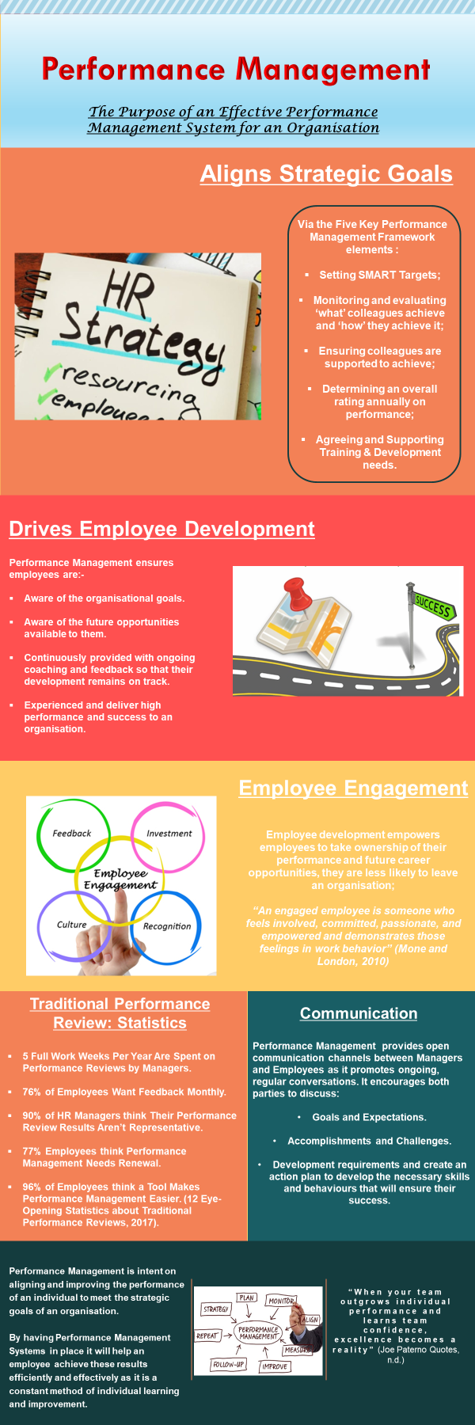
Performance Management - Infographic

Reflection of Performance Management

Performance Management

Key points I have identified about Performance Management are: -

- It’s a strategic approach. The aim is to deliver results simply by improving the performance and capability of an individual from day one.

- It is part of an on-going communication process.

- It should include a focus on performance improvement, development and managing behaviour.

- It is continuous and recurring in nature.

This approach is familiar and is similar in principle to the structure used within my organisation, Mid and West Wales Fire and Rescue Service as follows: -

New Employee

Upon commencement with the Service an employee is required to work a probationary period, during which time they are required to demonstrate, following the necessary training and assistance, the ability to perform all aspects of their role to a satisfactory standard.

To do this, the employee would initially meet with their Line Manager who would plan each monthly review process by setting targets, outlining the objectives and provide a timetable of supervision communicated.

Each month the employee would formally meet with their Line Manager to carry out an interview, and a record is kept of the action agreed at each stage. Any development needs identified are addressed appropriately and development plans are put in place with the outcome reviewed.

Throughout the probation period, an employee has regular informal meetings with their Line Manager; it is not just restricted to the monthly review meetings.

The above is line with CIPD who state, “effective performance management relies on both formal and informal process” (Performance Management, Factsheets, CIPD, 2019).

This is also in keeping with the formal performance management system in terms of meeting regularly, recording the outcomes of each meeting and identifying actions points which employees would be expected to work towards to prior to their next review.

Individual Development Review (IDR)

MAWWFRS undertakes annual IDR. The primary purpose is to identify and develop strengths and provide an opportunity for all employees to reach their potential in their current and future roles.

Employees will complete the IDR which will be reviewed by their Line Manager who will evaluate and review the comments and meet with the individual and provide feedback / suggest suitable training courses.

This in return enables the employee to make an effective contribution to the success of the Organisation.

The above mirrors a typical Performance Management System:

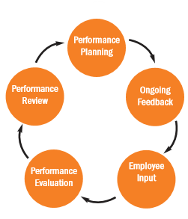
(Typical Performance Management Process, n.d.)

Point to Consider

I did not consider ‘carrying out exit interviews’ to be an element of performance management. For example, by identifying the cause of someone leaving. The exit interview should provide invaluable feedback to an organisation and technically shape any future programs:

“they can provide valuable HR insights into how to improve performance management processes in the future, thereby potentially improving overall retention rates and boosting productivity” (Hearn, Hearn and Archive, 2017).

Final Thought

Throughout the research into Performance Management I believe this should be a proactive approach throughout any organisation as it will achieve results not only for the organisation but the entire workforce.

However, my thoughts are that not all organisations undertake any form of performance management and simply view it as a “means to an end” and do not see the benefit.

Reference List

Performance Management Infographic

BrainyQuote. n.d. Joe Paterno Quotes. [online] Available at: <https://www.brainyquote.com/quotes/joe_paterno_386821> [Accessed 15 August 2020].

https://www.hrmagazine.co.uk/article-details/aligning-performance-management-with-business-strategy#:~:text=The%20five%20key%20PMF%20elements,supporting%20training%20and%20development%20needs.

https://www.rollingarrays.com/blog/why-performance-management-matters/

Mone, E. and London, M., 2010. Employee Engagement Through Effective Performance Management. New York: Routledge, p.xvi.

TruQu. 2017. 12 Eye-Opening Statistics About Traditional Performance Reviews. [online] Available at: <https://truqu.com/en/blogs/12-eye-opening-statistics-about-performance-reviews/> [Accessed 15 August 2020].

Reflective Statement

CIPD. 2019. Performance Management | Factsheets | CIPD. [online] Available at: <https://www.cipd.co.uk/knowledge/fundamentals/people/performance/factsheet#6292> [Accessed 16 August 2020].

Hearn, S., Hearn, S. and Archive, A., 2017. 5 Ways You Can Use Exit Interviews to Improve Performance. [online] TLNT. Available at: <https://www.tlnt.com/5-ways-you-can-use-exit-interviews-to-improve-performance/> [Accessed 16 August 2020].

Shrm.org. n.d. Typial Performance Management Process. [online] Available at: <https://www.shrm.org/hr-today/trends-and-forecasting/special-reports-and-expert-views/Documents/Performance-Management.pdf> [Accessed 16 August 2020].

