Yohan Mendis [2218843]
University of Wales Trinity Saint David |
A statistical exploration of satisfaction amongst non-traditional undergraduate students in a UK University
LCDB7011 – Quantitative Research Methods

Abstract

Student satisfaction is generally a well-researched area with numerous studies explaining many factors contributing to it. Amongst these studies, the SERVQUAL model has been used widely in explaining the relationship between service quality and student satisfaction. However, these studies focus mainly on explaining satisfaction levels amongst traditional students.
Various authors and industry bodies point out to the fact that non-traditional student segment in the higher education industry has grown rapidly during the recent past. However, the studies conducted in relation to the factors that contribute to non-traditional student (NTS) satisfaction is limited. Therefore, this study aims to fill this void by evaluating the relationships between the factors identified by the SERVQUAL model and NTS satisfaction. The study is conducted in a UK university located in Birmingham. Based on literature five hypothesis was generated. Data was collected using a questionnaire from a sample of 112 students. A multi variable regression analysis was used to test the hypothesis.
First of the key findings indicated that ‘reliability aspects of the programme’ is not a significant determinant of NTS satisfaction despite having a positive impact. The second key finding of the study was that ‘responsiveness of staff’ and ‘assurance provided by staff’ has a negative impact on satisfaction of the NTS. The third and final significant finding is the confirmation of a positive and strong relationship between ‘empathy shown by staff’ and ‘tangible aspects of the programme’ with satisfaction levels of NTS.

Key words:

Student Satisfaction, Non-Traditional Students, SERVQUAL, Multi-variable regression Analysis
Table of Contents
Abstract i
List of figures iii
List of Tables iii
Abbreviations iv
1. Introduction 1
1.1. Background of the study. 1
1.2. Factors affecting student satisfaction. 1
1.3. Measuring student satisfaction and service quality 2
1.4. Satisfaction among non-traditional undergraduate students 2
1.5. Aim and objective of the research. 3
2. Review of literature 4
2.1. Summary of key previous research findings 4
2.2. The research gaps. 10
2.3. Proposed research aim, objectives, and questions 11
3. Research Methodology 13
3.1. Research approach 13
3.2. Study location 13
3.3. Population and choice of the sample 14
3.4. Survey instrument 15
3.5. Data collection 16
3.6. Ethical considerations 16
4. Data Analysis 17
4.1. Satisfying the conditions for parametric tests 17
4.2. Reliability and validity 18
4.3. Regression analysis 22
5. Results 24
6. Discussion and conclusion 26
6.1. Theoretical implications of the findings 26
6.2. Limitations and future research 28
7. References 29
8. Appendices 38
Appendix 1 – The use of the SERVQUAL model in variety of studies 38
Appendix 2 – Contributions from research to developing the questionnaire. 39
Appendix 3 – Final Questionnaire following the pilot study. 42
Appendix 4 – Frequency of responses 43
Appendix 5 - Evidence of normal distribution of data 44

List of figures

Figure 1 - Theoretical framework showing the relationship between independent and dependant variables. 12

List of Tables

Table 1 - Composition of the total population for the study 14
Table 2 - Choice of the sample 15
Table 3 - Summary of demographical data 17
Table 4 - Reliability estimates for the factors. 18
Table 5 - Summary of Principal Component Analysis & Item Inter-Correlation Analysis for Reliability of the programme 19
Table 6 - Summary of Principal Component Analysis & Item Inter-Correlation Analysis for Responsiveness of the staff 20
Table 7 - Summary of Principal Component Analysis & Item Inter-Correlation Analysis for Assurance given by staff. 20
Table 8 - Summary of Principal Component Analysis & Item Inter-Correlation Analysis for Empathy shown by staff. 20
Table 9 - Summary of Principal Component Analysis & Item Inter-Correlation Analysis for Tangible aspects of the programme 21
Table 10 - Summary of Principal Component Analysis & Item Inter-Correlation Analysis for Overall satisfaction of the programme 21
Table 11 - Collinearity diagnostics for dependent variable 'Overall Satisfaction' 21
Table 12 - Summary of the regression model 22
Table 13 - Regression estimates showing the relationship between the independent variables and Overall Satisfaction (n = 112) 23
Table 14 - Summary of findings for the hypothesis 24

Abbreviations

BAME – Black Asian Minority Ethnic groups
DV – Dependant Variable
HE – Higher Education
HEIs – Higher Education institutes
HESA – Higher Education Statistics Agency
IV – Independent Variable
LGBTQ – Lesbian, Gay, Bisexual, Transgender, Queer
NTS – Non-Traditional Students
WP – Widening Participation

Introduction

Background of the study.

The accessibility of information regarding a university's excellence has led to increased competitiveness within the higher education realm (Gul et al., 2019, Bovil, 2020). Consequently, to attract and retain accomplished and esteemed students, educational institutions must offer excellent services and maintain a favourable global standing (Gul et al., 2019, Mogaji and Yoon, 2019). Achieving this necessitates universities to undergo quality assessment procedures to ensure their ability to compete effectively in the educational domain. However, Ali et al. (2016) suggest that gauging student satisfaction based on their evaluation of a university's service quality is a complex undertaking. But, conducting such evaluations could serve as a means for the university to establish stronger connections with both current and potential students (Gul et al., 2019, Mogaji and Yoon, 2019, Bovil, 2020). Thus, studies of student satisfaction continue to be of importance to Higher education Institutes (HEIs). This study is conducted in this backdrop where student satisfaction is becoming ever more important.

Factors affecting student satisfaction.

As stated by Osman and Saputra (2019), the satisfaction of students with their courses and learning environment significantly influences their learning experience. Effective teaching cannot be attributed to a single factor alone (Rueda et al. 2017). Instead, it encompasses a range of attributes, including demonstrating enthusiasm, providing constructive feedback, empathizing with student difficulties, and delivering engaging content (Seng, 2013, French and Kennedy, 2017, Musa et al. 2022). These factors contribute to measurable distinctions in the quality of teaching that are tangible (Alves and Raposo, 2009). Enhancing the quality of higher education services relies heavily on an institution's ability to project a positive overall impression to potential students through a variety of decision-making processes, operational procedures, and human resource practices (Khodayari & Khodayari, 2011).

Measuring student satisfaction and service quality

Existing literature presents several valid frameworks for assessing service quality in higher education (Martha-Martha, and Priyono, 2018, Teeroovengadum et al., 2019, Latif et al., 2019). Amongst these frameworks the SERVQUAL model has been applied in a variety of educational context by researchers (Cuthbert, 1996, Arambewela, and Hall, 2006, Ada, et al., 2017, Gupta, and Kaushik, 2018). It was first proposed by Parasuraman, Zeithaml, and Berry (1985) and has since been adapted and applied to various service industries, including higher education. The SERVQUAL model identifies five key aspects contributing to service quality (Parasuraman, et al., 1985). Section 2.1.2 of this report explains the key factors identified by the SERVQUAL model.
As mentioned previously, the SERVQUAL model has been widely applied in various contexts within higher education to assess and improve service quality and perceived satisfaction among students as can be seen in appendix 1. Considering these strong empirical credentials, this study will use the SERVQUAL model as a basis of evaluating satisfaction levels of the participants of the study.

Satisfaction among non-traditional undergraduate students

Higher education (HE) is undergoing a significant transformation in the 21st century, driven by the changing demographics of students and the evolving landscape of educational offerings (Qureshi, et al., 2020, Mccall, et al., 2020, Wong, and Chapman, 2023). Traditional, full-time, residential students are no longer the sole demographic within higher education institutions (HESA, 2022). Instead, the student body is becoming increasingly diverse, encompassing individuals with unique needs and expectations. Among this diverse group are non-traditional students, a term used to describe individuals who do not fit the traditional profile of a college or university student (Gilardi and Guglielmetti, 2011; Kahu, 2013; Schuetze, 2014).
Multiple studies related to factors contributing to satisfaction levels of NTS across various disciplines and geographical locations have been carried out. For example, one of the studies conducted by Fuchs, Fangpong, and Southam, (2022) focused on students in Hospitality programmes and Sutherland, et al, (2023) which focused on students on a science programme. Other examples of studies conducted across geographical regions include Quinn, et al, (2009) which focused on the HEIs operating in the European region, Ada, et al., (2017) which focused on HEIs in Middle East, and Hwang and Choi, (2019) which focused on the HEIs in east Asian region.
Nevertheless, there is currently a dearth of empirical data pertaining to the factors that impact the perceived quality of services for non-traditional undergraduate business students in UK. The application of the SERVQUAL model to non-traditional student satisfaction is particularly relevant due to the unique challenges and expectations this demographic brings to higher education. Non-traditional students often have different priorities, including work and family commitments, and may have limited time and resources to invest in their education (Marshall, 2013; Heathcote, Savage and Hosseinian-Far, 2020).
Despite the wide application of the SERVQUAL model within the higher education context, application of it in specifically measuring mature student satisfaction remains understudied. Therefore, there is a significant void of knowledge which warrants further exploration (Further elaborated in section 2.2).

Aim and objective of the research.

As mentioned above, measuring student satisfaction is important for the HEIs. Furthermore, the changes to the educational reforms have resulted in a growth of NTS as mentioned in section 1.4 above. Many studies around the world have been focusing on factors affecting student satisfaction across different fields.
This research aims to investigate factors identified by the SERQUAL model contributes to satisfaction among NTS regarding their educational institution. To reach this aim, this study will focus on the following objective.
(RO.1) To examine how the SERVQUAL factors shape perceived satisfaction of NTS enrolled on an undergraduate Business programme in the UK.

The next section of this report will focus on conducting a detailed review of existing literature which will enable to lay the theoretical foundation of the study and justify the premise set by the research objective as stated above.

Review of literature

Summary of key previous research findings

    - Growth of non-traditional students and importance of their satisfaction
Student satisfaction has been a subject for a number of studies (Marshall, 2013, Khodayari, and Khodayari, 2011, Gul, et al., 2019, Khan, et al., 2022). Many authors agree on defining student satisfaction as “a short-term attitude, resulting from an evaluation of a students’ educational experiences, services and facilities provided by the institution” (Elliot and Healy, 2001, Kanwar and Sanjeeva, 2022). Numerous studies focus on student satisfaction in general as explained in sections 1.2 and 1.3 above. However, there is a consensus amongst authors that the landscape of the student body is changing (Gul et al., 2019, Mogaji and Yoon, 2019, Bovil, 2020). As noted in section 1.4, the student body is becoming increasingly diverse, encompassing individuals with unique needs and expectations. Among this diverse group are non-traditional students, a term used to describe individuals who do not fit the traditional profile of a college or university student (Gilardi and Guglielmetti, 2011; Kahu, 2013; Schuetze, 2014). Thus, it is increasingly becoming vital to study this growing body of students (ibid).
Non-traditional Students (NTS) are those who don't fit the mould of what is typically considered a university student based on criteria such as age, background, and prior academic experience (Qureshi, Khawaja, & Zia, 2020). According to numerous studies (Gilardi and Guglielmetti, 2011; Kahu, 2013; Schuetze, 2014), these students are frequently identified as mature learners (those who are 21 years of age or older), part-time students, people from less affluent socioeconomic backgrounds, people who must provide for others, and people who have previously stopped pursuing higher education. Khan et al. (2022) highlights the significance of the relationship between quality of education and student satisfaction. Other similar studies (Quinn et al., 2009, Rueda et al., 2017, Latif et al., 2019) have explored variety of other factors which impacts student satisfaction. Therefore, it is deemed essential to have a thorough understanding of the factors affecting student satisfaction in line with the objectives of this research. This section will explore the emerging trends amongst the wealth of literature surrounding student satisfaction.

    - Relationship between satisfaction and quality in higher education
Universities and similar tertiary education establishments need to gauge diverse indicators of service quality, encompassing organizational and methodological structures, reputation analyses, learning atmospheres, faculty research output, and student encounters and achievements (Latif et al., 2019). To manage and enhance the standard of services delivered, universities should consistently appraise service quality (Latif et al., 2019). The assessment of service quality in academic institutions frequently varies according to the requirements of the service's recipients. In an educational setting, the individual who is a student, whether presently registered or not, can be viewed as the customer. As outlined by Quinn et al. (2009), a given student might perceive a specific university, program, or field of study as exceptionally excellent. Quality assessment techniques rooted in industry often prioritize the student perspective, thereby adding to the complexity of the issues involved.
Quality education is characterized by sound pedagogy and developmental effectiveness, equipping students to actively participate in society (Ewell, 2010). Given the multifaceted nature of "quality in higher education," its interpretation varies across different contexts, often shaped by international organizations, researchers, and stakeholders in the field (Duque, 2021). Prior to subjectively and statistically evaluating the present state of a higher education institution, a set of criteria must be established (Seyfried and Pohlenz, 2018; Turyahikayo, 2019). Overseeing quality within higher education presents a complex challenge, involving a multitude of separate entities, divisions, and groups (Beerkens, 2018). These entities and divisions encompass academic departments, comprised of educators and students, administrative units facilitating student admissions and enrolment, as well as auxiliary services such as laboratories and libraries (Alzafari and Ursin, 2019).
An extensive examination of contemporary literature undertaken by Camilleri (2021) concluded that higher education establishments have the capacity to evaluate the excellence of their services based on factors like "their resources, student-centric teaching, impactful research, and interaction with stakeholders" (p. 268), employing diverse performance markers and measures. This allows them to appraise the perceived quality of their services, a dimension that might undergo alteration due to the initial impact of the COVID-19 pandemic, which prompted a shift from conventional and blended learning methods to entirely virtual and remote course delivery (Camilleri, 2021). Moreover, as indicated by Borishade et al. (2021), there exists a connection, driven by student contentment, between student satisfaction and the quality of services, signifying a robust correlation between these two factors. Demir et al. (2020) also propose that service quality not only impacts the reputation of the educational institution but also shapes students' inclination to afford varying levels of tuition (Demir et al., 2020). In alignment with Borishade et al. (2021), Demir et al. (2020) additionally propose a "direct correlation between quality and willingness to pay" (p. 1,436).
Several studies (Ham and Hayduk, 2003; Min and Khoon, 2014; Ada et al., 2017; Gul et al., 2019; Skarpeta et al., 2019) suggest that socio-demographic variables such as age and gender play a role in shaping perceptions of services within higher education. Findings from Min and Khoon (2014) and Gul et al. (2019) emphasize that factors like nationality and academic year significantly impact the way educational services are perceived.
Nonetheless, there appears to be a noticeable gap in the existing literature concerning the influence of socio-demographic characteristics on how service quality is evaluated by mature business students. The concluding set of hypotheses in this investigation will examine the manner in which gender, academic year, and nationality impact students' perceptions of the quality of services provided by their educational institution.

    - Factors affecting service quality at universities.
Measuring service quality in higher education has been the subject of many studies as highlighted by Oldfield and Baron, (2018); Mogre et al. (2018); Osman and Saputra, (2019). Trautwein and Bosse (2017) suggest that students' perceptions of the learning environment have a more significant effect on learning compared to the physical setting itself. Consequently, the challenges related to teaching and learning are shaped not only by instructors' curriculum design and organization, but also by how students perceive and construe these design and organization aspects (Rueda et al., 2017). The manner in which students comprehend task expectations, assessments, and the educational setting constitutes the foundation for their learning frameworks within the field of business studies (Fuchs, 2021a).
Similar to various other service industries, higher education has encountered challenges when it comes to assessing student satisfaction. As highlighted by Abbas (2020), sustaining excellence demands consistent and deliberate endeavours. Within educational institutions, continuous staff training and enhancement, as well as refining policies and systems, remain key priorities (Gupta and Kaushik, 2018; Latif et al., 2019). Consequently, the maintenance of elevated service quality standards calls for ‘continuous improvement’.
Amongst attempts to study service quality in higher education, the SERVQUAL model, established by Parasuraman et al. (1985, 1988), stands out as the most renowned and frequently employed instrument for assessing the calibre of services (Calvo-Porral et al., 2013). The SERVQUAL model and its adaptations have found extensive application across diverse service sectors such as "banking, retail, wholesale, health, and education," as indicated by Narang (2012, p. 359).

    - The application of the SERVQUAL model in measuring service quality at universities
Service quality is defined as "a form of attitude, related but not equivalent to satisfaction, and results from comparison of expectations with perceptions of performance" by Parasuraman et al. (1988, p. 15). According to O'Neill and Palmer (2004, p42), "the difference between what a student expects to receive, and his/her perceptions of actual delivery" can be used to define service quality in the context of higher education. This concept has been widely employed in numerous research intended to gauge the quality of services provided by higher education. (Cuthbert, 1996; Soutar and McNeil, 1996; Tan and Kek, 2004; Arambewela and Hall, 2006; Barnes, 2007; Wong et al., 2012).
As explained in section 1.3 above, SERVQUAL model developed by Parasuraman, et al., (1985) remains the most widely used across many industries including higher education. This model consists of five primary elements for evaluating service quality linked to teaching and learning: tangibles, reliability, responsiveness, assurance, and empathy. Explained below are the key elements identified by the SERVQUAL model and their application in a Higher Education Context.

- Reliability of the programme
In higher education, the "Reliability" factor pertains to the consistency and dependability of academic programs, support services, and administrative processes (Fuchs K., Fangpong, K., and Southam A., 2022). Additionally, it is crucial to assess the institution's reliability and responsiveness (Gupta and Kaushik, 2018); this encompasses factors such as consistent grading criteria, precise student records, and staff conduct, among others.
Study conducted by Fuchs, K. and Fangpong, (2021) conclude that students in HEIs which was flexible in course Scheduling (Ensuring that courses are offered as scheduled and that students can rely on the availability of required courses for their programs of study) had better satisfaction among students. Similarly, student satisfaction was noted to be higher in institutes which provide consistent and fair grading practices, timely feedback on assignments and exams, and transparent assessment criteria (Fernandes, et al., 2013, Alzafari, and Ursin, 2019). Moreover, offering accurate and dependable academic advising to help students plan their course of study and meet their academic goals (Green, 2014) and having streamlined administrative processes related to admissions, registration, financial aid, and student records to reduce errors and delays has also been identified as key factors which have a direct relationship with student satisfaction (Ewell, 2010, Turyahikayo, 2019, Mogaji, and Yoon, 2019).

- Responsiveness of the staff
The "Responsiveness" factor in higher education focuses on the institution's willingness and ability to assist students promptly and effectively (Fuchs, Fangpong, and Southam, 2022). Several studies assessing responsiveness have concluded that ensuring that faculty and staff are accessible to students for questions, concerns, and academic support is directly related to overall student satisfaction (Dib, & Alnazer, 2013, Alzafari, and Ursin, 2019). Students have also rated their institutes highly where timely and clear communication with students regarding important information, deadlines, and updates are provided (Bovill, 2020, Fiorini, Borg, and Debono, 2022). This also includes providing mechanisms for addressing and resolving student issues and complaints in a timely manner (Gul, Jan, and Shah, 2019). Fuchs, (2021b) goes onto state that offering responsive support services, such as counselling, tutoring, and career services, to address students' needs also has a positive impact on the student satisfaction levels.

- Assurance provided by staff.
"Assurance" in higher education relates to the competence, credibility, and trustworthiness of the institution, faculty, and staff (Fuchs, Fangpong, and Southam, 2022). Two main dimensions contributing to the establishment of quality assurance involve the proficiency of academic personnel in addressing inquiries in a professional manner and the effectiveness of communication between staff, faculty, and students (Hwang and Choi, 2019).
Several studies have noted ensuring that faculty members are well-qualified, experienced, and capable of delivering high-quality instruction results in higher perceptions of assurance (Kahu, & Nelson, 2018, Bovill, 2020). Moreover, maintaining academic rigor and standards to uphold the credibility of degrees and certificates awarded by the institution has also been identified as factors related assuring students of quality which also results in higher levels of satisfaction (Rueda, Benitez, and Braojos, 2017). Fiorini, Borg, and Debono, (2022) highlighted that demonstrating professionalism in all interactions with students, including courteous behaviour, transparency, and ethical conduct resulted in students attributing higher levels of credibility to the staff and the institution. Another study conducted by Kahu, & Nelson, (2018), identified that maintaining accreditation and compliance with industry standards to validate the quality of education provided has been highly regarded by students resulting in high student satisfaction levels.

- Empathy shown by the staff.
Another influential aspect is empathy, which can impact individuals' perception of service quality (Latif et al., 2019). Empathy entails the ability to understand and acknowledge a student's emotions, even when the academic staff might be unable to resolve the concern (Gul et al., 2019). Empathy involves ensuring the learner's sense of being acknowledged by addressing their emotions, thereby enriching their educational journey (Hwang and Choi, 2019; Fuchs, 2021b, Fuchs, Fangpong, and Southam, 2022).
Variety of factors have been identified by various researchers which impacts the students’ perception related to empathy:
- Personalized Support: Offering individualized support and guidance to help students navigate academic challenges, career decisions, and personal issues (Fiorini, Borg, and Debono, 2022).
- Cultural Sensitivity: Recognizing and respecting the diverse backgrounds and cultural identities of students and creating an inclusive and welcoming environment (Kahu, & Nelson, 2018).
- Student-centred Approach: Focusing on the student as the centre of the educational experience and tailoring services to meet their unique needs (Kahu, & Nelson, 2018, Bovill, 2020).
- Feedback Mechanisms: Providing opportunities for students to provide feedback on their experiences and using this feedback to make improvements (Rueda, Benitez, and Braojos, 2017).
Based on the evidence provided by these studies it can be concluded that elements related to empathy shown by the staff has a direct and positive relationship with student satisfaction.

- Tangibles aspects of the programme
The term "tangibles" pertains to aspects of a student's educational encounter, encompassing features such as the campus environment, technological resources, and the quality of instructional materials (Latif et al., 2019). It encompasses:
- Campus Facilities: The condition and accessibility of classrooms, libraries, laboratories, and other physical spaces. Institutions must ensure that these spaces are well-maintained and conducive to learning (Rueda, Benitez, and Braojos, 2017).
- Technological Resources: The availability of up-to-date technology, such as computer labs, Wi-Fi access, and online learning platforms. Institutions should provide students with the tools they need for academic success (Fiorini, Borg, and Debono, 2022, Kahu, & Nelson, 2018).
- Educational Materials: The quality and availability of textbooks, course materials, and digital resources. Institutions must ensure that students have access to essential learning materials (Alzafari, and Ursin, 2019).
- Physical Appearance: The professionalism and appearance of faculty, staff, and administrative personnel. This includes attire, demeanour, and accessibility (Alzafari, and Ursin, 2019).
Fuchs, Fangpong, and Southam, (2022) concludes in their study that having good tangible evidence in a programme will enhance the student satisfaction level.

The research gaps.

Student satisfaction in general is a well-researched area (Bell, 2022). However, majority of these studies focuses on conventional students (Sutherland, et al., 2023). Thus, a general gap exists in relation to exploring the satisfaction levels among NTS.
Moreover, most studies have explored academic experiences of mature students (Gupta, and Kaushik, 2018; Bell, 2022; Fiorini, et al. 2022) there's often a lack of emphasis on non-academic factors such as social integration, sense of belonging, and extracurricular engagement, which can greatly influence overall satisfaction as identified by the SERVQUAL model. These studies often overlook the role of institutional support mechanisms tailored specifically for mature students, such as academic advising, flexible scheduling, or tailored orientations. Exploring the impact of these services on satisfaction can provide actionable insights (Seng 2013, Fuchs and Fangpong, 2021).
Furthermore, the contexts of the studies vary significantly. Many studies have taken place in foreign countries (Azoury, et al., 2014, Green, 2014, Ali, et al., 2016, Duque, 2021). Furthermore, many studies are also conducted across various disciplines. For example, Hospitality (Kennedy et al., 2019, Fuchs, 2021a), science (Fiorini, et al., 2022), engineering (French and Kennedy, 2022), Business (Gilardi and Gugliemetti, 2011, Min and Yoon, 2019, Seyfried and Pohlenz 2020).
Thus, a void remains to be filled by a study which encompasses multiple aspects related NTS satisfaction levels specifically within the geographical region of UK which also focuses on undergraduate Business programmes.

Proposed research aim, objectives, and questions

Taking into consideration the ‘research gap’ identified above, this research aims to explore the impact of the five elements identified by the SERVQUAL model on NTS. Addressing this gap in research will contribute to a more holistic understanding of mature student satisfaction, aiding educational institutions in crafting tailored strategies to enhance their experiences and outcomes. In order to reach this aim, this study will focus on the following objective.
(RO.1) To examine how the SERVQUAL factors shape perceived satisfaction of NTS enrolled on an undergraduate Business programme in the UK.
The study will focus on answering the following research questions.
(RQ.1) Does the factors identified in the SERVQUAL model affect the satisfaction levels amongst NTS enrolled in an undergraduate business programme?
Using the examined literature as a foundation, the theoretical framework that follows directs the research effort helps it adequately address the stated study objectives.
    - Theoretical framework
As identified in section 2.2, the existing research regarding the impact of SERVQUAL factors on satisfaction levels among undergraduate NTS in UK for Business programmes is under researched.
As illustrated in figure 1, reliability, responsiveness, assurance, empathy, tangibles have been identified as independent variables whereas satisfaction levels would be noted as dependant variable in line with the past research (Latif et al, 2019, Alzafari and Ursin, 2019, Camilleri, 2021, Fuchs, Fangpong, and Southam, 2022).
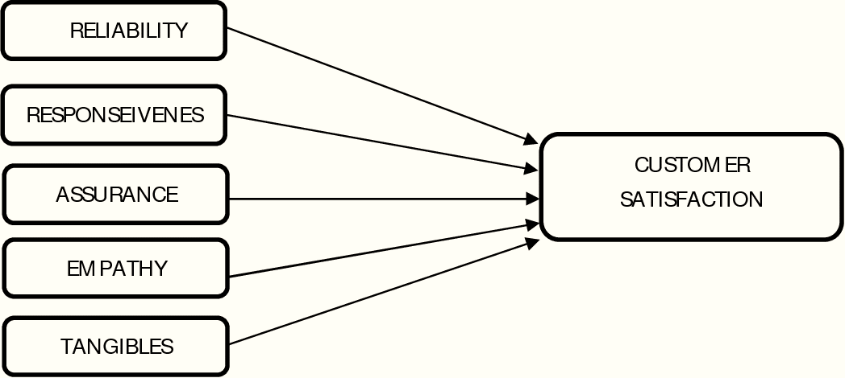
Dependent variable
Independent variables
Figure 1 - Theoretical framework showing the relationship between independent and dependant variables.

    - Statement of hypothesis
The following hypotheses has been formulated considering the theoretical framework and research objectives, based on the literature evidence examined in section 2.1.3. The five service quality dimensions that were put forward in the previous section are directly related to the hypothesis.
Hypothesis 1 (H₁): The reliability aspects of the programme have a significant positive impact on student satisfaction.
Hypothesis 2 (H₂): The responsiveness of the staff has a significant positive impact on student satisfaction.
Hypothesis 3 (H₃): The assurance provided by the staff has a significant positive impact on student satisfaction.
Hypothesis 4 (H₄): The empathy shown by the staff has a significant positive impact on student satisfaction.
Hypothesis 5 (H₅): The tangible aspects of the programme have a significant positive impact on student satisfaction.

Having established the hypothesis for the study, the next section will explain the details related to the methodological aspects used in validating them.

Research Methodology

This section will explain the fundamental elements and phases of the research methodology employed in answering the proposed research question in section 2.3. It will explain the methodology employed, the strategies utilized, the chosen research approach, as well as ethical considerations pertinent to the study. Furthermore, this section will delve into the construction of the research instrument, methods for sampling, and the process of data collection.

Research approach

Many service quality studies in HE has predominantly followed a quantitative deductive methodology (Govender & Ramroop, 2012; Dib & Alnazer, 2013; Azoury et al. 2013; and Mang’unyi and Govender, 2017).
Following the precedents set by the previous studies, a deductive approach has been employed due to its appropriateness within the context of this study. This approach allows for the testing of formulated hypotheses, leading to their validation or refutation by the researcher. This perspective harmonizes seamlessly with the positivist research philosophy and the ontology of objectivism embraced in this study.

Study location

This study will present a preliminary examination of the factors affecting satisfaction among students at the Birmingham Campus. The study will provide the management a crucial chance to compare the results and evaluate the effects of the adopted procedures and actions. In improving student satisfaction overall, this will help to improve the currently existing methods and suggest new procedures to be used when necessary. Even though this study only uses one institution as a case study, the study's conclusions are probably generalizable to other HEIs that serve NTS.

Population and choice of the sample

The population for this study consists of students who are enrolled on the BA in Leadership and Management programme during the 2022/23 academic year at the Birmingham campus. table 1 provides the number of students consisting of the total population of the study.

Table 1 - Composition of the total population for the study

    - Sample choice and distribution
Given the timescale for completing the study, it is not practical conduct a survey to cover the entire population for collecting data. Hence, a representative sample of the population has been chosen to depict and describe the greater population. A random sample technique has been adopted in this study to gather data from respondents considering the objectives of the study and the fact that the researcher wants to make broad conclusions about an overall degree of NTS satisfaction in HE. The technique used in this case was stratified proportional random sampling with the aim of reducing sampling error (Sharma, 2017). Students were divided into 3 strata according to their year of study, and samples were chosen from each year are proportionate to the size of each stratum.
Consequently, a sample of 112 students (n=112) was chosen across the 3 years of study as illustrated in table 2.
Table 2 - Choice of the sample

Survey instrument

A comprehensive examination of service quality models and the literature pertaining to service marketing was conducted to formulate the required questionnaire. The creation of the questionnaire aimed to address and assess two key facets: the satisfaction and loyalty of students, along with the quality of services within HEIs. Within the context of the questionnaire's development, student satisfaction, was identified as the dependant variable. Meanwhile, service quality dimensions and demographic factors were considered as independent variables.
The questionnaire contained thirty-two (32) questions formulated based on findings from literature. Appendix 2 illustrates the relationship of the constructs of the study and the questionnaire. All questions were presented using a 5-point Likert scale with 1 being “Strongly Disagree” and 5 being “Strongly agree” apart from demographical variables.

    - Pilot Testing
Pilot testing a questionnaire is a significant step in the research process. It enables enhancement of validity, enhance reliability, identify issues, and minimise bias (Kennedy, et al. 2019).
An expert panel and peers were invited to provide feedback on the initial version of the questionnaire. Subsequently, three student focus groups were employed to test the second version. After undergoing another round of piloting and finalisation, the questionnaire was then ready for distribution among students (See Appendix – 3)

Data collection

As mentioned in section 3.3.1, groups of students were chosen using the method of proportionate stratified random sampling. For the ease of administering data collection, particular classes of students from each year of study were chosen to distribute the questionnaire.
Each questionnaire was accompanied by a cover letter that guaranteed the students' confidentiality and outlined the survey's purpose, as well as the estimated time required for completion. The researcher addressed the class and conveyed the purpose, assuring the students of their anonymity, emphasizing the importance of answering all questions, and advising against participation if they had already taken the survey in a different session. This consistent procedure was followed throughout all years of the study. At the beginning of the class, the questionnaires were distributed. To ensure that the students' course grades would not influence their participation, the survey was administered before the midterm exam grades were handed out. A summary of the demographics of the participants is presented in table 3.

Ethical considerations

Ensuring the safeguarding of participant data in a confidential and anonymous manner is considered the norm for conducting research, as stipulated by the British Educational Research Association (2018). Ethical considerations must be taken into serious account by all researchers, particularly when involving human subjects. In this study, upholding confidentiality and anonymity stands out as an ethical dimension to be carefully considered. To achieve this, the researcher will abstain from requesting any personal contact details from respondents. Stringent measures have been taken to uphold the confidentiality of responses and the secure storage of data.

Data Analysis

The data has been thoroughly examined using SPSS v28, employing various descriptive statistical analyses. Prior to examining the formulated hypotheses, several measures were implemented to verify the appropriateness of the data for analysis in this research (Field, 2018). Reliability and validity are fundamental components that must be guaranteed in any well-founded research (ibid). Appendix 4 shows the frequency of the responses to the measurement items. Table 3 illustrates the demographic data of the participants.
Table 3 - Summary of demographical data

Satisfying the conditions for parametric tests

Research literature suggests that data should be distributed normally and a minimum sample of over 100 (n>100) in order to use parametric statistical tests (Field, 2018, Saunders, et al., 2023). A visual inspection of the distribution curves was carried out to ascertain the normality of distribution. As can be seen in appendix 5, all histograms for the measurement items showed majority of the data fall within the area of the normal distribution curve. This satisfies the conditions needed to justify the use of parametric tests.

Reliability and validity

As per the methodological literature, reliability pertains to the extent to which a measurement is devoid of random errors and accurately represents the internal consistency of a measuring instrument (Tavakol and Dennick, 2011, Saunders, et al., 2023). In this study, Cronbach's alpha coefficients have been calculated to ensure the reliability of the scales employed (ibid). Additionally, standard deviation and mean values were computed for both the constructs and individual measurement items.
All Cronbach's alpha estimates align favourably with the established benchmark of 0.70 (Tavakol, and Dennick, 2011, Saunders, et al., 2023) (refer to Table 4). Furthermore, the standard deviation estimates and mean values presented in Table 4 indicates acceptable variance (indicating consistency of data) which corroborate the satisfactory reliability of the scales employed in this research. Hence, this study has successfully achieved acceptable levels of internal consistency and homogeneity. Therefore, validity, denoting the precision of the measuring instrument and its capacity to assess the intended attributes, has been substantiated.
To understand the interrelationships among variables and constructs, factor analysis was performed, an essential step in affirming research validity (Bro and Smilde, 2014, Field, 2018). Principal component analysis (PCA) was employed to elucidate the factor structure in this investigation. In accordance with established criteria which is minimum factor loading should exceed 0.4 (Stevens, 1992, Field, 2018) the variables exhibited robust loading onto the conceptualized constructs, with the lowest loading recorded at 0.823. Statistically speaking, the variables effectively gauge the constructs, and the loadings for each factor can be found in tables 5 to 10.
Moreover, an assessment of the inter-item correlations for each factor was conducted. The inter-item correlation for each factor demonstrates strong consistency, ranging from 0.672 to 0.997 (refer to Tables 5 to 10). These inter-item findings signify that the items within each factor are closely aligned and effectively measure the intended constructs, providing additional evidence of validity in this research.

Table 4 - Reliability estimates for the factors.

To confirm discriminant validity in this research, additional assessments of collinearity diagnostics were carried out. As stated by Belsley et al., (2005) the risk of multicollinearity arises when an estimated coefficient with a condition index exceeding 20 significantly influences the variances of two or more variables. This does not apply to this study, as demonstrated by the results in table 11. In this table, the condition index computed for all independent variables in the multivariate regression analysis was below the threshold of 20. Therefore, it is valid to infer that the factors assessed in this study are indeed satisfactorily distinct from each other.
Table 5 - Summary of Principal Component Analysis & Item Inter-Correlation Analysis for Reliability of the programme
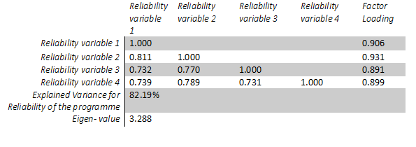
Table 6 - Summary of Principal Component Analysis & Item Inter-Correlation Analysis for Responsiveness of the staff
Table 7 - Summary of Principal Component Analysis & Item Inter-Correlation Analysis for Assurance given by staff.
Table 8 - Summary of Principal Component Analysis & Item Inter-Correlation Analysis for Empathy shown by staff.
Table 9 - Summary of Principal Component Analysis & Item Inter-Correlation Analysis for Tangible aspects of the programme

Table 10 - Summary of Principal Component Analysis & Item Inter-Correlation Analysis for Overall satisfaction of the programme

Table 11 - Collinearity diagnostics for dependent variable 'Overall Satisfaction'

Regression analysis

In line with the conceptual framework and following the verification of the research reliability and validity, a regression analysis was performed to investigate the proposed relationships between independent and dependent variables, as outlined in figure 1. Multiple regression analysis was employed to explore how several independent variables predict a single dependent variable, a methodological approach recognized as the most suitable technique for assessing relationships between multiple variables (Everitt and Dunn, 2001, Murtagh and Heck, 2012, Saunders, et al., 2023). By employing this multiple regression analysis approach, this study aimed to elucidate how each individual independent variable contributes to explaining the variance in the dependent variable.
In the process of regression analysis, several crucial statistical measures were computed, including R-squared (R²), Adjusted R-squared, and the Regression F-Value. Additionally, the β coefficients, t-values, and significance levels for each independent variable were determined. The outcomes of the regression analysis are detailed in Table 12.

Table 12 - Summary of the regression model

The R² value of 0.911 indicates a ‘good fit’ of the model (Field, 2018, Saunders, 2023). In other words, the independent variables in the model explain approximately 91% variance of the dependant variable of this study which is ‘overall satisfaction’.
Table 13 summarises the key parameters of the model. These includes β values which indicates relationship between overall satisfaction (dependant variable) and each predictor (independent variable) (Field, 2018). The t – values and p – values are used in ascertaining the significance level of the contribution made by each predictor (ibid). This will be further explained in section 5 – Results below.

Table 13 - Regression estimates showing the relationship between the independent variables and Overall Satisfaction (n = 112)
Table 13 also indicates additional indexes of collinearity in the form of Tolerance levels and Variance Inflation Factor (VIF). Methodological literature suggests a tolerance level should measure above 0.2 (Menard, 2000) and the VIF should not be close to 10 (Myers, 1990). However, the tolerance and VIF values for this study fails to be within the parameters identified by literature.
Nevertheless, similar studies conducted in the past has identified similar trends when used the SERVQUAL attributes in measuring student satisfaction (Hasan et al., 2008, Gregory, 2019, Sibai et al., 2021). The authors of these studies argue that the attributes identified by the SERVQUAL model has strong interrelationships and it is natural to identify higher levels of multicollinearity indexes (ibid). However, as mentioned in section 4.1 the condition index is below the threshold and is deemed satisfactory in establishing there is no threat of multicollinearity in this study.

Results

The regression model results provided in table 13 are explained in further details below.
Student satisfaction (DV) was regressed on reliability aspects of the programme (IV) to test hypothesis H₁. The results indicate an increase of one unit of reliability aspects of the programme only predicted an increase of 0.010 of student satisfaction (β=0.010). Furthermore, the significance level was 0.924 (p=0.924) which is beyond the highest acceptable standards of 0.05 (95% confidence). Therefore, reliability aspects of the programme are not a significant predictor of student satisfaction. Thus, H₁ is not supported.
Student satisfaction (DV) was also regressed on responsiveness of the staff (IV) to test hypothesis H₂. The results indicate an increase of one unit of responsiveness of the staff resulted in a decrease of 0.023 of student satisfaction (β= -0.023). Furthermore, the significance level was 0.883 (p=0.883) which is beyond the highest acceptable standards of 0.05 (95% confidence). Therefore, responsiveness of the staff is not a significant predictor of student satisfaction. Thus, H₂ is not supported.
Student satisfaction (DV) was regressed on assurance provided by staff (IV) to test hypothesis H₃. The results indicate an increase of one unit of assurance provided by staff resulted in a decrease of 0.171 of student satisfaction (β= -0.171). Furthermore, the significance level was 0.127 (p=0.127) which is beyond the highest acceptable standards of 0.05 (95% confidence). Therefore, responsiveness of the staff is not a significant predictor of student satisfaction. Thus, H₃ is not supported.
Student satisfaction (DV) was regressed on empathy shown by staff (IV) to test hypothesis H₄ and tangible aspects of the programme (IV) to test H₅. The results indicate an increase of one unit of each variable resulted in an increase of student satisfaction by 0.446 (β=0.446) and 0.649 (β=0.649) respectively. Furthermore, the significance level was lower than 0.001 for both H₄ and H₅ (p<0.001) which is below the highest acceptable standards of 0.05 (95% confidence). Therefore, empathy shown by staff and tangible aspects of the programme are significant predictors of student satisfaction. Thus, H₄ and H₅ are supported.
Table 14 summarises these key findings.

Table 14 - Summary of findings for the hypothesis
Hypothesis | Supported / Not Supported
H₁ - The reliability aspects of the programme have a significant positive impact on student satisfaction. | Not Supported
H₂ - The responsiveness of the staff has a significant positive impact on student satisfaction. | Not Supported
H₃ - The assurance provided by the staff has a significant positive impact on student satisfaction. | Not Supported
H₄ - The empathy shown by the staff has a significant positive impact on student satisfaction. | Supported
H₅ - The tangible aspects of the programme have a significant positive impact on student satisfaction. | Supported

Discussion and conclusion

As mentioned in section 2.3, this study aimed to explore the impact of the five elements identified by the SERVQUAL model on NTS satisfaction. First of the key findings as summarised in table 14 indicates that ‘reliability aspects of the programme’ is not a significant determinant of NTS satisfaction despite having a positive impact. The second key finding of the study was that ‘responsiveness of staff’ and ‘assurance provided by staff’ has a negative impact on satisfaction of the NTS. The third and final significant findings is the confirmation of a positive and strong relationship between ‘empathy shown by staff’ and ‘tangible aspects of the programme’ with satisfaction levels of NTS.
These findings will be discussed below further in detail.

Theoretical implications of the findings

    - Relationship between ‘reliability of the programme’ and NTS satisfaction
Previous studies using traditional students (Gupta and Kaushik, 2018, Fuchs K., Fangpong, K., and Southam A., 2022) highlighted reliability aspects of an undergraduate programme have a significant impact on student satisfaction. As explained in section 5 this study concludes that reliability of the programme impacts satisfaction of NTS although the significance much smaller than anticipated.
In other words, this implies that factors such as accuracy of record keeping, strong commitment to academic excellence, and operational efficiency of the programme which were some of the measurement items of this study are not considered to be contributing to satisfaction a great deal. Therefore, it appears that NTS may have different priorities when it comes to satisfaction. Currently, there is no research evidence that explains similar trends. Thus. this study proposes investigating this phenomenon as an area for further research.

    - Negative impact between NTS satisfaction and ‘responsiveness of staff’ and ‘assurance provided by staff’.
As explained in section 2 of this report previous studies have found strong and positive relationships between responsiveness of staff and assurance provided by staff with student satisfaction (Dib, & Alnazer, 2013, Alzafari, and Ursin, 2019, Bovill, 2020, Fiorini, Borg, and Debono, 2022 Fuchs, Fangpong, and Southam, 2022). However, again the participants in these previous studies have been traditional undergraduate students.
In contrast to these findings, this study concluded staff responsiveness and assurance provided by staff had a negative impact on satisfaction levels among NTS. This implies that formal organisational policies which are aimed at ensuring uniformity and equality has been perceived as a hinderance rather than a facilitator of satisfaction. This has significant policy implications for management.
No previous literature can be found explaining this phenomenon. Therefore, it is proposed to conduct further studies investigating the relationship between NTS satisfaction and responsiveness and assurance.

    - Positive and strong relationship between ‘empathy shown by staff’ and ‘tangible aspects of the programme’.
This study re-affirms the findings from some of the previous studies which stated empathy shown by staff and tangible aspects have a strong and positive relationship with student satisfaction (Rueda, Benitez, and Braojos, 2017, Kahu, & Nelson, 2018, Gul et al., 2019, Hwang and Choi, 2019, Fiorini, Borg, and Debono, 2022).
Once again this has significant implications to the management of the university as it clearly indicates where the priorities are for the NTS at the university. For example, additional support provisions, financial assistance, Availability of learning aids and equipment appears to be highly valued by the NTS. Thus, any institutes which has student satisfaction in its heart will prioritise such facilities.

Limitations and future research

The findings of this empirical study should be considered in light of certain limitations, and acknowledging these constraints may open up new avenues for future research.
Firstly, it's important to note that the results of this study are specific to the industry it focused on, and therefore, they cannot be applied universally to other industries due to the unique methodology and findings tailored to this specific service context. Another limitation pertains to the measurement items used in SERQUAL, which were all expressed in positive terms, possibly leading to a bias known as "yes-saying." While it is generally considered good research practice to include both positively and negatively worded items in surveys (as suggested by Salazar in 2015), it's worth noting that this approach may pose challenges for respondents who may experience comprehension difficulties or take longer to complete the questionnaire as a result.

In terms of future research directions, many areas were proposed in section 6.1. This study primarily focused on students as customers in the higher education sector (as supported by Quinn et al. in 2009 and Mark in 2013), it's important to recognize that the education industry serves various customer groups with diverse needs and expectations. Therefore, future research efforts could explore how to satisfy these other customer segments effectively. Further to this, it may be valuable to explore the relationships between satisfaction amongst NTS and the factors identified by the SERVQUAL model in different contexts (Such as geographic regions, different programmes etc)

References

Abbas, J. (2020) ‘HEISQUAL: A modern approach to measure service quality in higher education institutions’, Studies in Educational Evaluation, 67, p.100933.
Ada, S., Baysal, Z.N. and Erkan, S.S.S. (2017) ‘An Evaluation of Service Quality in Higher Education: Marmara and Nigde Omer Halisdemir Universities' Department of Education Students’, Universal Journal of Educational Research, 5(11), pp. 2056-2065.
Ali, F., Zhou, Y., Hussain, K., Nair, P. K., and Ragavan, N. A. (2016) ‘Does higher education service quality effect student satisfaction, image, and loyalty? A study of international students in Malaysian public universities’, Quality Assurance in Education. 24, pp.70–94.
Alves, H., and Raposo, M. (2009) ‘The measurement of the construct satisfaction in higher education’, Service Industries Journal, 29, pp. 203–218.
Alzafari, K. and Ursin, J. (2019) ‘Implementation of quality assurance standards’, in European higher education: does context matter?’, Quality in Higher Education, 25(1), pp.58-75.
Arambewela, R. and Hall, J. (2006) ‘A comparative analysis of international education satisfaction using SERVQUAL’, Journal of Services Research, 6, pp. 141-163.
Azoury, N., & Daou, L., & El Khoury, C., (2014) ‘University image and its relationship to student satisfaction- case of the Middle Eastern private business schools’, International Strategic Management Review. 2(1), pp. 1-8.
Barnes, B.R. (2007) ‘Analysing service quality: the case of post-graduate Chinese students’, Total Quality Management & Business Excellence, 18(3), pp. 313-331.
Beerkens, M. (2020) ‘Evidence-based policy and higher education quality assurance: progress, pitfalls and promise’, Impact Evaluation of Quality Management in Higher Education, pp. 38-53.
Bell, K. (2022) ‘Increasing undergraduate student satisfaction in Higher Education: the importance of relational pedagogy’, Journal of further and higher education, 46(4), pp. 490–503.
Belsley, D. A., Kuh, E. and Welsch, R. E., (2005) Regression diagnostics: Identifying influential data and sources of collinearity. John Wiley & Sons.
Borishade, T. T., Ogunnaike, O. O., Salau, O., Motilewa, B. D., & Dirisu, J. I. (2021) ‘Assessing the relationship among service quality, student satisfaction and loyalty: the NIGERIAN higher education experience’. Heliyon, 7(7).
Bovill, C., (2020) ‘Co-creation in learning and teaching: The case for a whole-class approach in higher education’. Higher education, 79(6), pp.1023-1037.
British Educational Research Association, (2018) Ethical guidelines for educational research. 4th edn. Available at: https://www.bera.ac.uk/researchers-resources/publications/ethical-guidelines-for-educational-research-2018 (Accessed: 17 June 2023).
Bro, R. and Smilde, A.K., (2014). ‘Principal component analysis’. Analytical methods, 6(9), pp.2812-2831.
Camilleri, M.A. (2021) ‘Evaluating service quality and performance of higher education institutions: a systematic review and a post-COVID-19 outlook’, International Journal of Quality and Service Sciences, 13(2), pp.268-281.
Cuthbert, P.F. (1996) ‘Managing service quality in HE: is SERVQUAL the answer? Part 2’, Managing Service Quality, 6(3), pp. 31-35.
Demir, A., Maroof, L., Sabbah Khan, N.U. and Ali, B.J. (2021) ‘The role of E-service quality in shaping online meeting platforms: a case study from higher education sector’, Journal of Applied Research in Higher Education, 13(5), pp.1436-1463.
Dib, H. & Alnazer, M. (2013) ‘The impact of service quality on student satisfaction and behavioural consequences in higher education services’, International Journal of Economy, Management and Social Sciences, 2, pp. 285-290.
Duque, J.F. (2021) ‘A comparative analysis of the Chilean and Colombian systems of quality assurance in higher education’, Higher Education, 82, pp.669-683.
Elliott, K., & Healy, M. (2001) ‘Key factors influencing student satisfaction related to recruitment and retention’. Journal of Marketing for Higher Education, 10(4), pp.1–11.
Everitt, B. and Dunn, G., (2001) Applied multivariate data analysis (Vol. 2). London: Arnold.
Ewell, P. (2010) ‘Twenty years of quality assurance in higher education: What’s happened and what’s different?’, Quality in higher education, 16(2), pp.173-175.
Fernandes, C., Ross, K. and Meraj, M., (2013) ‘Understanding student satisfaction and loyalty in the UAE HE sector’. International journal of educational management, 27(6), pp.613-630.
Field, A. P., (2018) Discovering statistics using IBM SPSS statistics. 5th edn, North American edition. Thousand Oaks, California: Sage Publications Inc.
Fiorini, L.A., Borg, A. and Debono, M., (2022) ‘Part-time adult students’ satisfaction with online learning during the COVID-19 pandemic’. Journal of Adult and Continuing Education, 28(2), pp.354-377.
French, S. and Kennedy, G., (2017). ‘Reassessing the value of university lectures’. Teaching in Higher Education, 22(6), pp.639-654.
Fuchs K., Fangpong K., and Southam A., (2022) ‘The perceived service quality in higher education: An empirical study using the SERVPERF dimensions’, Frontiers in education (Lausanne), 7.
Fuchs, K. (2021a) ‘Advances in tourism education: a qualitative inquiry about emergency remote teaching in higher education’, Journal of Environmental Management and Tourism, 12(02 (50)), pp.538-543.
Fuchs, K. (2021b) ‘Innovative teaching: A qualitative review of flipped classrooms’, International Journal of Learning, Teaching and Educational Research, 20(3), pp.18-32.
Fuchs, K. and Fangpong, K., (2021) ‘Using the SERVQUAL framework to examine the service quality in higher education in Thailand’. Education Quarterly Reviews, 4(2).
Gilardi, S., & Guglielmetti, C. (2011). ‘University Life of Non-Traditional Students: Engagement Styles and Impact on Attrition’. The Journal of Higher Education, 82(1), pp.33–53.
Govender, K. & Ramroop, S. (2012) ‘The relationship among the postgraduate research climate, service experience, quality and satisfaction’, African Journal of Business Management, 6, pp. 8917-8926.
Green, P., (2014) ‘Measuring service quality in higher education: A South African case study’. Journal of International Education Research (JIER), 10(2), pp.131-142.
Gregory, J.L., (2019) ‘Applying SERVQUAL: Using service quality perceptions to improve student satisfaction and program image’. Journal of Applied Research in Higher Education, 11(4), pp.788-799.
Gul, S., Jan, S., and Shah, F. A. (2019) ‘The impact of service quality on students’ satisfaction in higher education institutes of Khyber Pakhtunkhwa’, Review of Economics and Development Studies. 5(1), pp. 217–224.
Gupta, P. and Kaushik, N. (2018) ‘Dimensions of service quality in higher education–critical review (students’ perspective)’, International journal of educational management, 32(4), pp.580-605.
Ham, L. and Hayduk, S. (2003) ‘Gaining competitive advantages in higher education: analysing the gap between expectations and perceptions of service quality’, International Journal of Value-Based Management, 16, pp. 223-242.
Hasan, H.F.A., Ilias, A., Rahman, R.A. and Razak, M.Z.A., (2008) ‘Service quality and student satisfaction: A case study at private higher education institutions’ International business research, 1(3), pp.163-175
Heathcote, D., Savage, S., & Hosseinian-Far, A. (2020). ‘Factors affecting university choice behaviour in the UK higher education’. Education Sciences, 10(8), pp. 1–22.
Higher Education Statistics Agency (HESA). (2022). Non-continuation summary: UK Performance Indicators | HESA. Available at: https://www.hesa.ac.uk/data-and-analysis/performance-indicators/non-continuation-summary (Accessed on: 15/08/2023)
Holliday, E. (2014) ‘Sampling Error’, In: Michalos, A.C. (eds) Encyclopaedia of Quality of Life and Well-Being Research. Springer, Dordrecht.
Hwang, Y.S. and Choi, Y.K. (2019), ‘Higher education service quality and student satisfaction, institutional image, and behavioural intention’, Social Behaviour and Personality: an international journal, 47(2), pp.1-12.
Kahu, E. R. (2013). ‘Framing student engagement in higher education’. Studies in Higher Education, 38(5), pp. 758–773.
Kahu, E. R., & Nelson, K. (2018) ‘Student engagement in the educational interface: understanding the mechanisms of student success’, Higher Education Research and Development, 37(1), pp. 58–71.
Kanwar, A., Sanjeeva, M. (2022) ‘Student satisfaction survey: a key for quality improvement in the higher education institution’. Journal of Innovative Entrepreneurship 11(27)
Kennedy, L.G., Kichler, E.J., Seabrook, J.A., Matthews, J.I. and Dworatzek, P.D., (2019) ‘Validity and reliability of a food skills questionnaire’, Journal of nutrition education and behaviour, 51(7), pp. 857-864.
Khan, S., Zaman, S.I. and Rais, M., (2022) ‘Measuring student satisfaction through overall quality at business schools: a structural equation modelling: student satisfaction and quality of education’, South Asian journal of social review (issn: 2958-2490), 1(2), pp.34-55.
Khodayari, F., and Khodayari, B. (2011) ‘Service quality in higher education: Case study: Measuring service quality of Islamic Azad University, Firoozkooh branch’, Interdisciplinary Journal of Research in Business, 1, pp. 38-46.
Latif, K. F., Latif, I., Farooq Sahibzada, U., and Ullah, M. (2019) ‘In search of quality: measuring higher education service quality (HiEduQual)’, Total Quality Management & Business Excellence. 30, pp. 768–791.
Mang’unyi, E. and Govender, K., (2017) ‘Using the Higher Education Performance Framework to Assess Service Quality and Satisfaction among Private University Students’, International Review of Management and Marketing, 7(3), pp. 299-309.
Marshall, C. A. (2013). ‘Good Foundations: Prediction of Degree Success in Non-traditional Students’. Widening Participation and Lifelong Learning, 15(2).
Martha-Martha, N.G. and Priyono, İ., (2018). ‘The effect of service quality on student satisfaction and student loyalty: An empirical study’. Journal of Social Studies Education Research, 9(3), pp.109-131.
Mccall, D., Western, D., & Petrakis, M. (2020). ‘Opportunities for change: What factors influence non-traditional students to enrol in higher education?’ Australian Journal of Adult Learning 60(1).
Menard, S., (2000) ‘Coefficients of Determination for Multiple Logistic Regression Analysis’. The American Statistician, 54(1), pp.17–24.
Min, S. and Khoon, C.C. (2014) ‘Demographic factors in the evaluation of service quality in higher education: A Structural Equation Model (SEM) approach’, International Journal of Marketing Studies, 6(1), p.90.
Mogaji, E. and Yoon, H., (2019) ‘Thematic analysis of marketing messages in UK universities’ prospectuses’. International Journal of Educational Management, 33(7), pp.1561-1581.
Mogre, S., Farkiya, R. & Zokarkar, S. (2018) ‘Service Quality in Management Institutions: Perceived and Expected Quality Gaps in Viewpoint of Students’, IOSR Journal of Business and Management, 20(4), pp. 19-28.
Murtagh, F. and Heck, A., (2012). Multivariate data analysis (Vol. 131). Springer Science & Business Media.
Musa, N., Ali, M., and Maryam R., (2022) ‘Characteristics of an Effective University Professor From Students’ Perspective: Are the Qualities Changing?’, Frontiers in education (Lausanne), 7.
Myers, R. H., (1990) Classical and modern regression with applications. PWS-Kent Publishing, Boston.
O’Neill, M.A., and Palmer, A. (2004) ‘Importance-performance analysis: a useful tool for directing continuous quality improvement in higher education’, Quality Assurance in Education, 12(1), pp. 39-52.
Oldfield, B. M. & Baron, S. (2018) ‘Student Perceptions of Service Quality in a UK university Business and Management Faculty’, Quality Assurance in Education, 8(2), pp. 85-95.
Osman, A. R., and Saputra, R. S. (2019) ‘A pragmatic model of student satisfaction: A viewpoint of private higher education’, Quality Assurance in Education. 27(1), pp. 142–165.
Parasuraman, A., Zeithaml, V. A., & Berry, L. L. (1985) ‘A Conceptual Model of Service Quality and Its Implications for Future Research’. Journal of Marketing, 49(4), 41-50.
Parasuraman, A., Zeithaml, V., and Berry, L. (1988) ‘SERVQUAL: a multiple-item scale for measuring consumer perceptions of service quality’, Journal of Retailing, 64(1), pp. 12-40.
Quinn, A., Lemay, G., Larsen, P., and Johnson, D.M. (2009) ‘Service quality in higher education’, Total Quality Management, 20(2), pp.139-152.
Qureshi, F., Khawaja, S., & Zia, T. (2020). ‘Mature undergraduate students’ satisfaction with online teaching during covid-19’. European Journal of Education Studies, 7(12).
Rahman, M.M., Tabash, M.I., Salamzadeh, A., Abduli, S. and Rahaman, M.S., (2022) ‘Sampling techniques (probability) for quantitative social science researchers: a conceptual guideline with examples’, Seeu Review, 17(1), pp.42-51.
Rivas, J., Hale, K. and Burke, M.G., (2019) ‘Seeking a sense of belonging: Social and cultural integration of international students with American college students’, Journal of International Students, 9(2), pp.682-704.
Rueda, L., Benitez, J., and Braojos, J. (2017) ‘From traditional education technologies to student satisfaction in Management education: A theory of the role of social media applications’, Information and Management. 54(8), pp. 1059–1071.
Salazar, M. S. (2015). ‘The dilemma of combining positive and negative items in scales’. Psicothema 27, pp.192–199.
Saunders, M., Bristow, A., Lewis, P. and Thornhill, A. (2015), ‘Understanding research philosophy and approaches to theory development’, in Saunders, M., Lewis, P. and Thornhill, A. (Eds), Research Methods for Business Students, Pearson Education, Harlow, pp.128-171.
Saunders, M., Lewis, P & Thornhill, A., (2023) Research Methods for Business Students. 9th edn, Pearson, Harlow.
Schuetze, H. G. (2014). ‘From Adults to Non-Traditional Students to Lifelong Learners in Higher Education: Changing Contexts and Perspectives’. Journal of Adult and Continuing Education, 20(2), pp. 37–55.
Seng, E. L. K., (2013) ‘A qualitative study of factors contributing to international students' satisfaction of institutional quality’. Asian Social Science, 9(13), p.126.
Seyfried, M. and Pohlenz, P. (2020) ‘Assessing quality assurance in higher education: quality managers’ perceptions of effectiveness’, Impact Evaluation of Quality Management in Higher Education, pp. 24-37.
Sharma, G., (2017) ‘Pros and cons of different sampling techniques,’, International journal of applied research, 3(7), pp.749-752.
Sibai, M.T., Bay Jr, B. and Dela Rosa, R., (2021) ‘Service Quality and Student Satisfaction Using ServQual Model: A Study of a Private Medical College in Saudi Arabia’. International Education Studies, 14(6), pp.51-58.
Skarpeta, K., Koemtzi, M. and Aidonis, D. (2020) ‘Measuring internal service quality: the case of the Greek public higher education institutions’, The TQM Journal, 32(2), pp. 268-287.
Soutar, G., and McNeil, M. (1996) ‘Measuring service quality in a tertiary institution’, Journal of Educational Administration, 34(1), pp. 72-82.
Stevens, J. P., (1992) Applied multivariate statistics for the social sciences, 2nd edn. Hillsdale, NJ:Erlbaum.
Sutherland, K., Ginna, B., de Villiers, S., Margarietha, J., Millear, P. M. (2023) ‘Non-traditional students’ preferences for learning technologies and impacts on academic self-efficacy’, Journal of computing in higher education, pp. 1–22.
Tan, K.C. and Kek, S.W. (2004) ‘Service quality in Higher Education using an enhanced SERVQUAL approach’, Quality in Higher Education, 10(1), pp. 17-24.
Tavakol, M. and Dennick, R., (2011) ‘Making sense of Cronbach's alpha’. International journal of medical education, 2, p.53.
Teeroovengadum, V., Nunkoo, R., Gronroos, C., Kamalanabhan, T.J. and Seebaluck, A.K., (2019) ‘Higher education service quality, student satisfaction and loyalty: Validating the HESQUAL scale and testing an improved structural model’. Quality assurance in education, 27(4), pp.427-445.
Trautwein, C. and Bosse, E. (2017) ‘The first year in higher education—critical requirements from the student perspective’, Higher education, 73, pp.371-387.
Turyahikayo, E. (2019) ‘The Influence of Knowledge Management on Internal Quality Assurance in Higher Education Institutions’, Higher Education Research, 4(6), pp.80-87.
Wong, K., Tunku, U. and Rahman, A. (2012) ‘Constructing a survey questionnaire to collect data on service quality of business academics’, European Journal of Social Sciences, 29(2), pp. 209-221.
Wong, W.H. and Chapman, E., (2023) ‘Student satisfaction and interaction in higher education’. Higher Education, 85(5), pp.957-978.

Appendices

Appendix 1 – The use of the SERVQUAL model in variety of studies
Area of research | Related Studies
Teaching and Learning Services: Universities and colleges use SERVQUAL to evaluate the quality of teaching and learning experiences. This includes assessing faculty performance, course materials, instructional methods, and the overall classroom experience. | Dib, H. & Alnazer, M. (2013)  Bovill, C., (2020)  Fuchs, K. (2021b)
Administrative Services: Higher education institutions use SERVQUAL to evaluate the quality of administrative services, such as admissions, registration, financial aid, and academic advising. This helps identify areas where administrative processes can be improved to enhance student satisfaction. | Ewell, P. (2010)  Turyahikayo, E. (2019)  Mogaji, E. and Yoon, H., (2019)
Online Learning and Technology Services: In the context of e-learning and technology services, institutions use SERVQUAL to assess the quality of online courses, learning management systems, technical support, and digital resources. | Rueda, L., Benitez, J., and Braojos, J. (2017)  Kahu, E. R., & Nelson, K. (2018)  Fiorini, L.A., Borg, A. and Debono, M., (2022)
Student Engagement and Interaction: SERVQUAL is used to assess the quality of student-faculty and student-staff interactions, including communication, responsiveness, and the ability of staff and faculty to address individual student needs. | Gul, S., Jan, S., and Shah, F. A. (2019)  Bovill, C., (2020)
Continuous Improvement: SERVQUAL is not a one-time assessment but a tool for continuous improvement. Institutions regularly collect feedback from students and use the model to monitor changes in service quality and satisfaction over time. | O’Neill, M.A., and Palmer, A. (2004)  Alzafari, K. and Ursin, J. (2019)  Camilleri, M.A. (2021)
Benchmarking and Comparison: Higher education institutions may use SERVQUAL to benchmark themselves against peer institutions or to compare service quality across departments or units within the same institution. | Arambewela, R. and Hall, J. (2006)  Gupta, P. and Kaushik, N. (2018)  Khan, S., Zaman, S.I. and Rais, M., (2022)
Accreditation and Quality Assurance: Some accreditation bodies may consider SERVQUAL data as part of their evaluation process to ensure that institutions meet specific quality standards in terms of service delivery and student satisfaction. | Barnes, B.R. (2007)  Mang’unyi, E. and Govender, K., (2017)  Beerkens, M. (2020)

Appendix 2 – Contributions from research to developing the questionnaire.
Construct | Survey question (Measurement Item) | Literature reference
(A) Reliability of the programme –  The degree of consistent and accurate delivery of services by the University within specified parameters. (Reliability involves upholding commitments and fulfilling promises made to customers). | (A1) Lecturers are efficient in providing feedback on my performance and progress. | Fernandes, C. et al., (2013). Understanding Student Satisfaction and Loyalty in The UAE HE Sector. International Journal of Educational Management, 27, pp. 613-630.
 | (A2) In my university, I feel there is a commitment to academic excellence. | Green, P. (2014). Measuring service quality in higher education: A South African case study. Journal of International Education  Research, 10, 131-142.
 | (A3) My Classes are held in accordance with the schedule of lectures and without delays | Fuchs, K., and Fangpong, K. (2021). Using the SERVQUAL Framework to  Examine the Service Quality in Higher Education in Thailand. Educ. Q. Rev. 4,  363–370. doi: 10.31014/aior.1993.04.02.286
 | (A4) Staff at the university have precise records of students’ activities (e.g., exam results, attendance) | Fuchs, K., and Fangpong, K. (2021). Using the SERVQUAL Framework to  Examine the Service Quality in Higher Education in Thailand. Educ. Q. Rev. 4,  363–370. doi: 10.31014/aior.1993.04.02.286
(B) Responsiveness of the staff –  willingness or readiness of employees to provide the service. | (B1) I can easily contact my lecturers for advising and consultation. | Gatfield, T. (2000). A scale for measuring student perceptions of quality: an Australian Asian perspective. Journal of Marketing for Higher Education,10(1), pp.27-41. Parasuraman, A. et al., (1985). A conceptual model of service quality and its implications for future research. Journal of Marketing, pp. 41-50.
 | (B2) Academic Staff keeps students informed about developments related to learning. | Parasuraman, A. et al., (1985). A conceptual model of service quality and its implications for future research. Journal of Marketing, pp. 41-50.
 | (B3) Administration staff is friendly at the University. | Miao, H. & Bassham, M.W. (2006) Embracing customer service in libraries. Library Management, 28, 53–61.
 | (B4) My university provides helpful career services and advice. | Engelland, B.T., Workman, L. and Singh, M. (2000), “Ensuring service quality for campus career services centers: a modified SERVQUAL scale”, Journal of Marketing Education, Vol. 22 No. 3, pp. 236-45.
(C) Assurance provided by the staff –  freedom from risk, danger or doubt through professional services, excellent technical knowledge, attitude courtesy, and good communication skills | (C1) Lecturers have the knowledge to answer my questions | Parasuraman, A. et al., (1985). A conceptual model of service quality and its implications for future research. Journal of Marketing, pp. 41-50.  Heathcote, D., Savage, S., & Hosseinian-Far, A. (2020). ‘Factors affecting university choice behaviour in the UK higher education’. Education Sciences, 10(8), pp. 1–22.
 | (C2) I feel safe anywhere on campus. | Abu Hasan, H. F., Ilias, A., Abd Rahman, R., & Abd Razak, M. Z. (2008). Service quality and student satisfaction: A case study at private higher education institutions. International Business Research, 1(3), 163-175.
 | (C3) Academic staff at the university provide professional answers to students’ questions. | Fuchs, K., and Fangpong, K. (2021). Using the SERVQUAL Framework to  Examine the Service Quality in Higher Education in Thailand. Educ. Q. Rev. 4,363–370. doi: 10.31014/aior.1993.04.02.286  Martha-Martha, N.G. and Priyono, İ., (2018). ‘The effect of service quality on student satisfaction and student loyalty: An empirical study’. Journal of Social Studies Education Research, 9(3), pp.109-131.
 | (C4) The faculty implements educational programs with clear aims for each specialization | Fuchs, K., and Fangpong, K. (2021). Using the SERVQUAL Framework to  Examine the Service Quality in Higher Education in Thailand. Educ. Q. Rev. 4,363–370. doi: 10.31014/aior.1993.04.02.286  Martha-Martha, N.G. and Priyono, İ., (2018). ‘The effect of service quality on student satisfaction and student loyalty: An empirical study’. Journal of Social Studies Education Research, 9(3), pp.109-131.
(D) Empathy shown by staff –  politeness, respect, consideration, and friendliness of contact personnel. | (D1) Lecturers stimulates and maintains my interest in the course. | Hampton, M., (1993). Gap analysis of college student satisfaction as a measure of professional service quality. Journal of Professional Services Marketing, 9(1), pp.115-128.
 | (D2) Academic advisors are interested in my progress. | Hampton, M., (1993). Gap analysis of college student satisfaction as a measure of professional service quality. Journal of Professional Services Marketing, 9(1), pp.115-128.
 | (D3) My university offers a variety of scholarships and financial assistance. | Hanaysha, Jalal & M, Dileep & Yeop Abdullah, Othman. (2012). SERVICE QUALITY AND SATISFACTION: STUDY ON INTERNATIONAL STUDENTS IN UNIVERSITIES OF NORTH MALAYSIA. International Journal of Research in Management. 3. 116-133.
 | (D4) Services are provided in a secure and confidential way. | Parasuraman, A. et al., (1985). A conceptual model of service quality and its implications for future research. Journal of Marketing, pp. 41-50.
(E) Tangible aspects of the programme –  the physical evidence of service such as the appearance of the personnel. | (E1) My university has a sufficient number of computer labs with the software programs I need. | Kara AM, Tanui E, Kalai JM (2016) Educational service quality and students’ satisfaction in public universities in Kenya. Int J Educ Soc Sci 3: 37-48.  Martha-Martha, N.G. and Priyono, İ., (2018). ‘The effect of service quality on student satisfaction and student loyalty: An empirical study’. Journal of Social Studies Education Research, 9(3), pp.109-131.
 | (E2) The classrooms have modern teaching support equipment such as projectors and computers. | Kara AM, Tanui E, Kalai JM (2016) Educational service quality and students’ satisfaction in public universities in Kenya. Int J Educ Soc Sci 3: 37-48.  Heathcote, D., Savage, S., & Hosseinian-Far, A. (2020). ‘Factors affecting university choice behaviour in the UK higher education’. Education Sciences, 10(8), pp. 1–22.
 | (E3) My university is conveniently located. | Saleem, S. S., Moosa, K., Imam, A., & Khan, R. A. (2017). Service Quality and Student Satisfaction: The Moderating Role of University Culture, Reputation and Price in Education Sector of Pakistan. Iranian Journal of Management Studies, 10(1), 237–258.
 | (E4) My university has a variety of extracurricular activities. | Lumley S, Ward P, Roberts L, Mann JP. Self-reported extracurricular activity, academic success, and quality of life in UK medical students. Int J Med Educ. 2015;6:111–117
(F) Student Satisfaction | (F1) I am satisfied with the academic excellence and credibility of my university. | Camilleri, M.A. (2021) ‘Evaluating service quality and performance of higher education institutions: a systematic review and a post-COVID-19 outlook’, International Journal of Quality and Service Sciences, 13(2), pp.268-281
(F) Student Satisfaction | (F2) I am satisfied with the responsiveness of the academic and administrative staff at my university. | Gul, S., Jan, S., and Shah, F. A. (2019) ‘The impact of service quality on students’ satisfaction in higher education institutes of Khyber Pakhtunkhwa’, Review of Economics and Development Studies. 5(1), pp. 217–224.
(F) Student Satisfaction | (F3) I am confident I have made the right choice of the university | Camilleri, M.A. (2021) ‘Evaluating service quality and performance of higher education institutions: a systematic review and a post-COVID-19 outlook’, International Journal of Quality and Service Sciences, 13(2), pp.268-281
(F) Student Satisfaction | (F4) I am happy with the facilities provided by my university. | Gul, S., Jan, S., and Shah, F. A. (2019) ‘The impact of service quality on students’ satisfaction in higher education institutes of Khyber Pakhtunkhwa’, Review of Economics and Development Studies. 5(1), pp. 217–224.
(F) Student Satisfaction | (F5) I am confident in recommending my university to another friend or family member. | Saleem, S. S., Moosa, K., Imam, A., & Khan, R. A. (2017). Service Quality and Student Satisfaction: The Moderating Role of University Culture, Reputation and Price in Education Sector of Pakistan. Iranian Journal of Management Studies, 10(1), 237–258.
(F) Student Satisfaction | (E5) Administration staff provides services at the promised time. | Parasuraman, A. et al., (1985). A conceptual model of service quality and its implications for future research. Journal of Marketing, pp. 41-50.  Martha-Martha, N.G. and Priyono, İ., (2018). ‘The effect of service quality on student satisfaction and student loyalty: An empirical study’. Journal of Social Studies Education Research, 9(3), pp.109-131.
(G) Demographical variables | (F1) Age  (F2) Gender  (F3) Employment status  (F4) Number of dependents  (F5) Ethnic origin  (F6) Year of study | Hughes, J.L., Camden, A.A., Yangchen, T., Smith, G.P., Rodríguez, M.M.D., Rouse, S.V., McDonald, C.P. and Lopez, S., 2022. Guidance for researchers when using inclusive demographic questions for surveys: Improved and updated questions. Psi Chi Journal of Psychological Research, 27(4), pp.232-255.

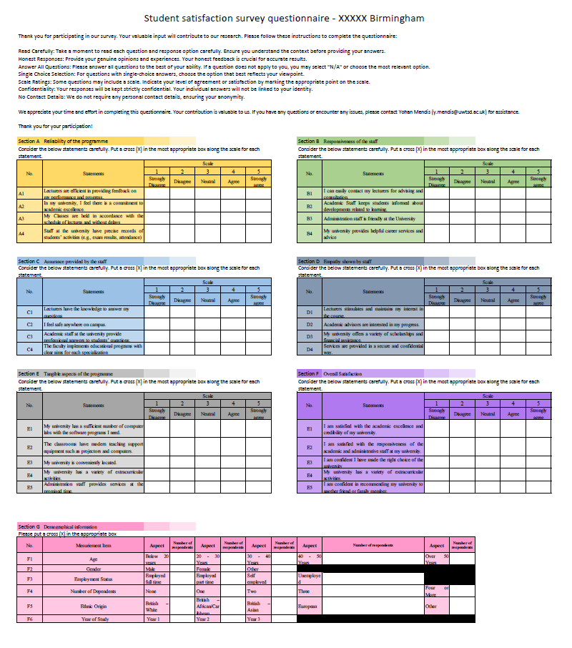
Appendix 3 – Final Questionnaire following the pilot study.

Construct | Measurement Item | Response Frequency
Construct | Measurement Item | Strongly Disagree | Disagree | Neutral | Agree | Strongly Agree
Reliability of the programme | Lecturers are efficient in providing feedback on my performance and progress. | 15 | 10 | 9 | 47 | 39
Reliability of the programme | In my university, I feel there is a commitment to academic excellence. | 9 | 13 | 18 | 55 | 25
Reliability of the programme | My Classes are held in accordance with the schedule of lectures and without delays | 3 | 5 | 14 | 58 | 40
Reliability of the programme | Staff at the university have precise records of students’ activities (e.g., exam results, attendance) | 2 | 12 | 28 | 54 | 24
Responsiveness of the staff | I can easily contact my lecturers for advising and consultation. | 14 | 11 | 9 | 49 | 37
Responsiveness of the staff | Academic Staff keeps students informed about developments related to learning. | 8 | 17 | 16 | 45 | 34
Responsiveness of the staff | Administration staff is friendly at the University | 9 | 13 | 18 | 55 | 25
Responsiveness of the staff | My university provides helpful career services and advice | 9 | 13 | 18 | 56 | 24
Assurance provided by staff | Lecturers have the knowledge to answer my questions | 15 | 10 | 9 | 47 | 39
Assurance provided by staff | I feel safe anywhere on campus. | 7 | 15 | 34 | 39 | 25
Assurance provided by staff | Academic staff at the university provide professional answers to students’ questions. | 6 | 13 | 23 | 55 | 23
Assurance provided by staff | The faculty implements educational programs with clear aims for each specialization | 9 | 13 | 18 | 56 | 34
Empathy Shown by staff | Lecturers stimulates and maintains my interest in the course. | 9 | 15 | 26 | 30 | 40
Empathy Shown by staff | Academic advisors are interested in my progress. | 7 | 14 | 19 | 54 | 26
Empathy Shown by staff | My university offers a variety of scholarships and financial assistance. | 9 | 13 | 18 | 56 | 24
Empathy Shown by staff | Services are provided in a secure and confidential way. | 4 | 20 | 23 | 42 | 31
Tangible aspects of the programme | My university has a sufficient number of computer labs with the software programs I need. | 8 | 15 | 24 | 48 | 25
Tangible aspects of the programme | The classrooms have modern teaching support equipment such as projectors and computers. | 15 | 10 | 9 | 48 | 38
Tangible aspects of the programme | My university is conveniently located. | 11 | 15 | 21 | 50 | 23
Tangible aspects of the programme | My university has a variety of extracurricular activities. | 8 | 18 | 23 | 33 | 38
Tangible aspects of the programme | Administration staff provides services at the promised time. | 9 | 13 | 18 | 55 | 25
Overall Satisfaction | I am satisfied with the academic excellence and credibility of my university. | 10 | 19 | 21 | 50 | 20
Overall Satisfaction | I am satisfied with the responsiveness of the academic and administrative staff at my university. | 7 | 16 | 24 | 48 | 25
Overall Satisfaction | I am confident I have made the right choice of the university | 9 | 14 | 19 | 53 | 25
Overall Satisfaction | My university has a variety of extracurricular activities. | 4 | 15 | 21 | 42 | 38

Appendix 4 – Frequency of responses

Appendix 5 - Evidence of normal distribution of data
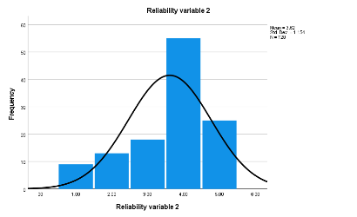
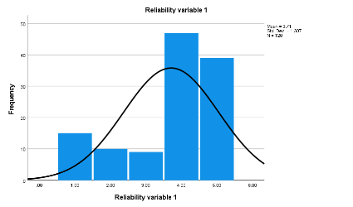
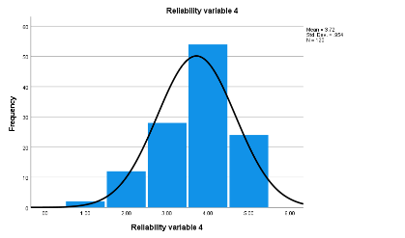
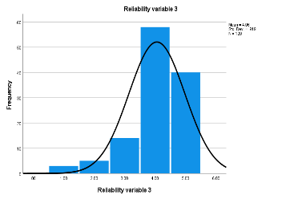
Histograms for Reliability aspects of the programme

Histograms for Responsiveness of the staff
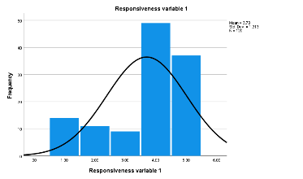
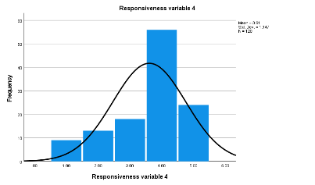
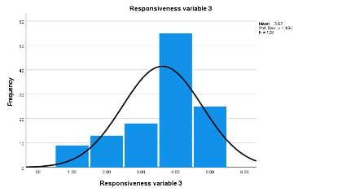
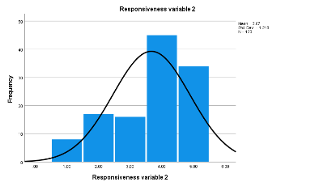

Histograms for Assurance given by the staff

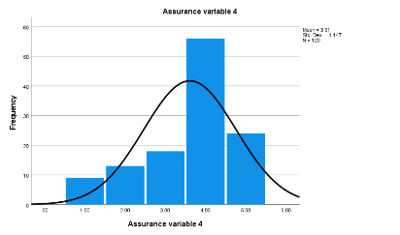
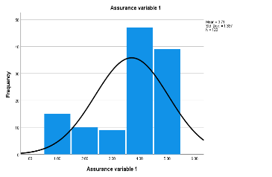
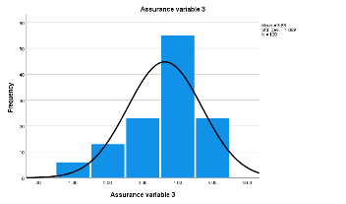
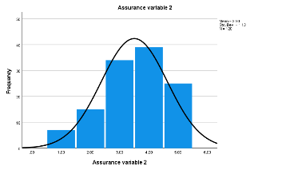

Histograms for Empathy shown by the staff
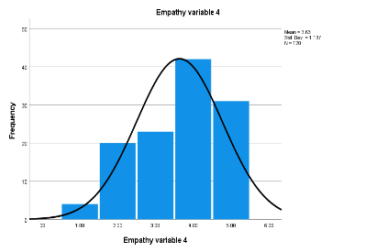
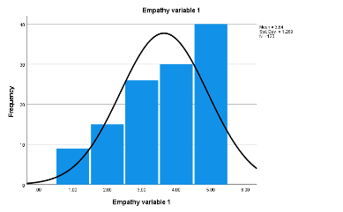
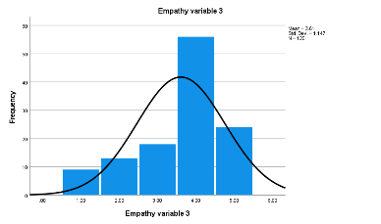
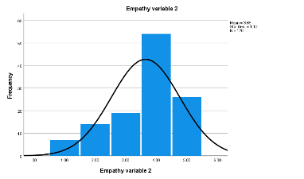
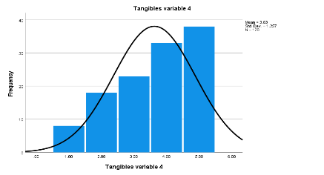
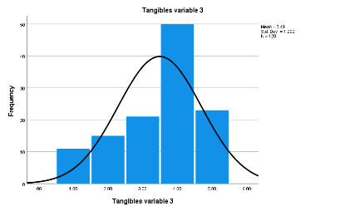
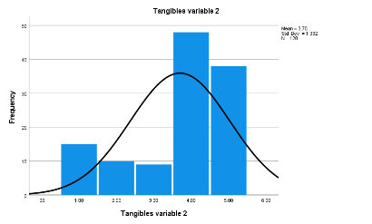
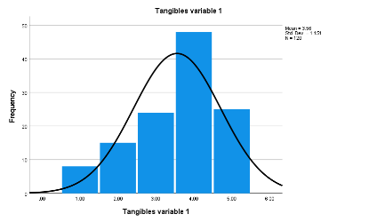
Histograms for Tangible aspects of the programme

Reflections on my learnings from the module

Introduction

Reflection is an essential component of the learning process because it promotes self-awareness, critical thinking, problem-solving, and continuous improvement. It not only enhances the quality of learning but also contributes to personal and professional development (Wain, 2017, Chang, 2019).
This section will explain my experience of learning during the undertaking of the ‘Quantitative Research Methods’ (LCDB 7011) which was an essential component of my doctoral studies. Many authors have developed models of reflections which encapsulates the various stages of which an individual go through in order to produce meaningful reflections. Such models include Kolb (1984), Gibbs reflective Cycle (1988), Jones (1992), Driscoll (2007) etc. Amongst various such models I have chosen the Driscoll’s model as a framework in constructing my reflections purely due to the ease of use.
According to Driscoll (2007), firstly, it's crucial to provide context by describing the situation or experience. He proposes answering the question ‘What?’ as the initial step. This step helps to gain a clear understanding of the situation at hand. Following that, we should engage in reflection by posing the question, "So, what did we learn from this experience?" This allows us to extract meaningful insights from the experience. Lastly, we should consider ‘now what will we do?’, the actions we intend to take based on this reflection. Will we modify our behaviour, experiment with something new, or continue as we currently are? It's worth noting that the outcome of reflection may also indicate that no changes are necessary, and we may feel that our current approach is appropriate. Such an outcome is perfectly valid, and there's no need for concern if no alterations come to mind (Study Skills, 2023).
The next section of this report will explain my learning in detail using these steps as a guidance.

‘What’ I did during the module?

We undertook the task of learning quantitative research methods at doctoral level with in a very tight time frame of twelve weeks. During this time, we explored various aspects of quantitative research which included designing quantitative research, validity and reliability in quantitative studies, development of survey instruments adhering to principles of relevance, conciseness, and efficiency, and conducting statistical analysis using the SPSS software to name a few.
Taught sessions were predominantly lecture based and was conducted via MS Teams platform. Sessions also included watching pre-recorded videos, interactive sessions, and question and answer sessions regularly. We also spent time on discussing the assessment task for this module. I continued to work on my chosen area of study which is “Satisfaction among non-traditional students” in higher education for the purpose of the assessment task of this module.
I gathered evidence from a vast body of literature to justify my premise of the study. Once the premise was established, I derived key hypothesis through the review of literature. I was required to work with an artificial set of data due to the time constraints preventing collection of real data. I used the SPSS software to conduct the statistical analysis. This was a novel experience as I had not used the assistance of a software in conducting statistical analysis. Once I completed my draft work, I had the opportunity to gather feedback as a formative assessment. I felt this was valuable as it provided the opportunity to ensure I am heading in the right direction.
In a nutshell, learning quantitative methods at the doctoral level was a formidable task, characterized by complex statistical concepts, advanced software applications, and an overwhelming amount of data analysis. The learning process required me to grapple with intricate formulas, statistical tests, and research methodologies. It involved numerous lectures, readings, and practical exercises to build a solid foundation in this field.

‘So, what’ did I learn from this experience?

The "So What?" stage compels me to consider the significance of this experience. I encountered many challenges during this journey. There were moments of frustration and self-doubt, particularly when faced with complex statistical analyses. There was one instance where my regression model did not confirm to the normal expectations. I found it deeply disturbing as I wasn’t sure of the causing the disturbance. I was panicking initially as I did not know what to do in such situations. On hindsight, I realise such panic is common amongst amateur researchers such as myself who are at an early stage in the process of learning research methods. However, these challenges forced me to develop resilience and problem-solving skills. The process of struggling and persevering through these difficulties has been a valuable learning experience in itself.
Engaging in quantitative methods at the doctoral level has deepened my understanding of research methodologies and their practical applications. I've learned how to critically analyse data, identify statistical patterns, and draw meaningful conclusions. Moreover, this experience has instilled in me a greater appreciation for the rigor and precision required in academic research. I've come to realize that quantitative methods are essential tools for generating empirical evidence and contributing to the body of knowledge in my field.

‘Now what’ will I do?

The final stage, "Now What?" prompts me to reflect on the future and the actions I will take based on my learning. As I move forward in my doctoral program and beyond, I intend to develop and apply the quantitative methods knowledge I've gained to my research endeavours further. I will design more robust studies, select appropriate statistical analyses, and interpret findings with greater confidence and accuracy. Additionally, I plan to seek opportunities to collaborate with experts in the field and engage in interdisciplinary research that leverages quantitative methods to address complex questions.
Furthermore, I recognize the importance of continuous learning and improvement. To maintain and enhance my quantitative skills, I will stay updated on the latest developments in statistical techniques and software applications. I'll also seek feedback from mentors and peers to refine my research practices.

Conclusion

In conclusion, learning quantitative methods at the doctoral level has been a difficult but transformative experience. Driscoll's Reflective Model has allowed me to systematically explore this journey, from the challenges faced to the valuable knowledge gained. As I move forward, I am confident that this expertise will play a pivotal role in my academic and research pursuits, enabling me to make meaningful contributions to my field.

References

Chang, B., (2019) ‘Reflection in learning’. Online Learning, 23(1), pp.95-110.
Driscoll, J., (2007) Practicing Clinical Supervision: A Reflective Approach for Healthcare Professionals. Edinburgh: Elsevier.
Gibbs, G., (1998) Learning by Doing: A Guide to Teaching and Learning Methods. Oxford: Further Education Unit, Oxford Polytechnic.
Kolb, D., (1984) Experiential Learning: Experience as the Source of Learning and Development. Upper Saddle River: Prentice Hall.
Study Skills, (2023) Reflective Practice Toolkit. Available at: https://libguides.cam.ac.uk/reflectivepracticetoolkit/models Accessed on: 05/09/2023.
Wain, A., (2017) ‘Learning through reflection’. British Journal of Midwifery, 25(10), pp.662-666.

