An Analysis of JCB

- Current Operating Conditions
  - JCB business overview according to Oxford Economics
    - JCB’s direct contribution to GDP was £414 million. JCB’s supply chain, its R&D activities and total spending by employees (direct & indirect) in the wider economy generated a further £996 million of GDP, making the overall contribution in excess of £1.4 billion.
    - JCB’s direct contribution to the Exchequer was £145 million in business taxes paid by the company and in income taxes paid by JCB employees. A further £400 million is generated indirectly through the supply chain, which means that total tax revenues are £545 million.
    - For every full-time JCB employee in the UK (6,000 in total), another three employees (18,000 in total) are engaged elsewhere in its UK supply chain to support JCB’s activities. This means that the company supports 24,000 jobs in the UK.
    - JCB’s export revenues of £1.35 billion make a positive contribution to the UK’s trade balance with the company accounting for 0.6% of all manufactured goods exported.
    - JCB spends £669 million on goods and services on its UK-based supply chain, of which £225m (38%) is spent in the West Midlands, with £105m (16% of the total) spent in Staffordshire.
    - JCB’s total economic contribution equates to 0.9 % of UK manufacturing sector GDP
    - JCB engages 3,300 suppliers
    - JCB exports 75% of its machines to around 140 countries.
    - JCB has set up manufacturing operations in India, China, Brazil and America
    - JCB is trading in 140 markets
    - 3% of JCB turnover is spent on R&D
    - JCB has a strong brand reputation which is leveraged for consumer products and devices, second only to our competitor CAT in this market. (Anon., 2018)
1.1.1-1.1.6 (Blogger, 2013), 1.1.7-1.1.11 (West, 2015)
  - Global influences
    - JCB is now the world’s third-biggest manufacturer of construction machinery, behind Caterpillar of the US and Japan’s Komatsu. (West, 2015)
    - Construction markets are thriving with the top 5 markets projected for year 2030 to be China , USA, India, Indonesia and the UK in descending order. China, the United States and India will account for 57% of all global growth in the construction and engineering markets by 2030. China alone will add USD$2.1TN to construction related output. (Mills, 2016)
    - The suitability of JCB solutions for military applications is demonstrated by large utilisation and orders in British and USA forces. The USA ordered USD$209M of machines in 2005 and recently extended that order by USD$72.8M in 2018 taking production to 2020. (Anon., 2018)
    - Natural disasters are an unfortunate but very real driver for construction equipment, Egawa, Kawamura, Ikuta and Eguchi summarise this within Japan. (Eiji Egawa, 2013)
    - Substitutes for JCB offerings are on the rise with new China based competitors breaking in to markets.
    - Brexit and a release from EU legislation may relieve emission restrictions for our diesel based power trains.
    - Appetite for environmentally friendly brands will boost demand for future cleaner or alternative power solutions.
    - JCB market growth (28% in 2018) is increasing year on year and outpacing the industry (21%) (JCB, 2018)
  - Potential impact
    - Military Activity
Overseas deployment of forces in conflict, peace keeping or disaster relief roles may generated demand for supporting hardware. Examples of rapid orders to supply forces were seen in the Iraq II conflict for British forces. (Sengupta, 2002)
We should establish an analysis plan to understand needs of forces.
    - Construction
Looking at the construction spend in the UK, Private Housing and Commercial are major areas of value. Infrastructure is close behind. It is important for JCB to assess how our portfolio is distributed across the sectors within construction. As demonstrated by many governments after the 2007 recessions, infrastructure spend boomed in an effort to balance the shrinkage of spending in private sectors and stabilise the economy. (Bivens, 2017) Being well distributed across construction sectors is key to minimising sensitivity to market variability.
Table 1 - UK Construction Sector Value Q3 2018
Construction new orders main figures, Quarter 3 (July to Sept) 2018, Great Britain
Seasonally adjusted, volume £ million and percentage change
Type of work | Value (£m) | Most recent  quarter on  previous quarter | Most recent  quarter on a  year earlier | Most recent  4 quarters on  a year earlier
All New Work | 11,075 | 3.4% | -30.7% | -13.1%
All New Housing | 3,350 | -5.3% | -14.3% | -0.3%
Public | 207 | -43.7% | -57.1% | -17.7%
Private | 3,143 | -0.8% | -8.3% | 1.6%
All Other Work | 7,725 | 7.7% | -36.0% | -18.2%
Infrastructure | 2,075 | -9.4% | -68.0% | -34.6%
Public | 1,618 | 31.9% | 11.4% | -1.8%
Private Industrial | 1,000 | 9.6% | -8.7% | -9.5%
Private Commercial | 3,032 | 10.4% | -0.5% | -10.3%
(ONS, 2018)

    - Trade
A huge reliance on the EU can be seen for the UK when examining general trade at almost 35% for the top 5 EU countries. The single biggest trade country is the USA at 13.2%.
This underlines the importance of gaining clarity on EU trade conditions after Brexit.
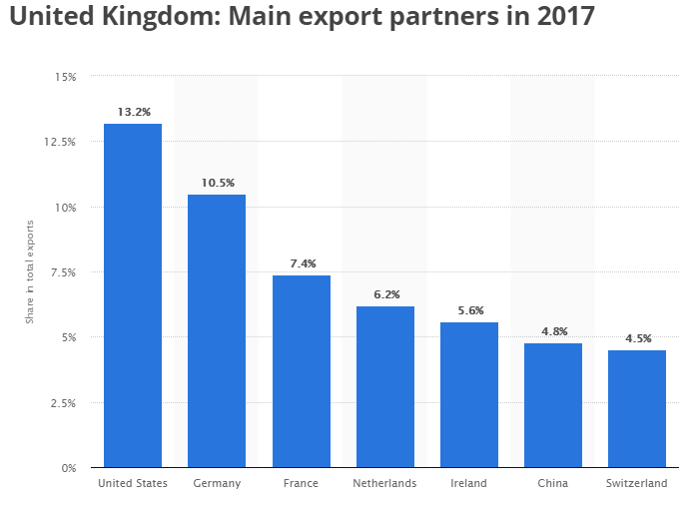
Figure 1- UK Main Export Partners 2017 (Anon., 2017)

- Analysis
  - SWOT
Table 2- SWOT Analysis for JCB
SWOT | Strengths | Weaknesses
Internal Factors | International presence & dealer support network  Strong reputation in construction  Diverse product line  Strong YoY market increases | Weak presence outside construction – lack of market diversification  Increasing competition (# of competitors & pricing)  Sales are weak outside European market
 | Opportunities | Threats
External Factors | Continuous growth in India  Expansion of manufacture in overseas markets  Market diversification – eg Military, logistics, …  Wide product range and readiness to match to needs | Trade agreement uncertainty with EU  US trade agreement uncertainty  Aggressive pricing by eastern competitors and ongoing competition with major competitors (CAT, Komatsu etc.)  Dependency on construction and the changing distribution in markets.

  - TOWS
Table 3 - TOWS Analysis for JCB
 |  | Opportunities | Threats
 |  | - Continuous growth in India  - Expansion of manufacture in overseas markets  - Market diversification – eg Military, logistics, …  - Wide product range and readiness to match to needs | - Trade agreement uncertainty with EU  - US trade agreement uncertainty  - Aggressive pricing by eastern competitors and ongoing competition with major competitors (CAT, Komatsu etc.)
Strengths | - International presence & dealer support network  - Strong reputation in construction  - Diverse product line  - Strong YoY market increases | - SO  - Diversify  - Leverage reputation in construction to provide confidence in other industries: logistics often required to move JCB product, what ese can JCB do in the logistics realm, are beneficial partnerships possible? | - ST  - Combat pricing with value  - Leverage strong dealer network, support and regional manufacture (faster delivery) to bring benefit to customers and win business.
Weaknesses | - Weak presence outside construction – lack of market diversification  - Increasing competition (# of competitors & pricing)  - Sales are weak outside European market | - WO  - Emerging market positioning  - Analyse profitability and market potential in EU vs other regions. Buying earlier in to the Indian market may help build market share ahead of competitors and push them out or reduce the threat | - WT  - Offsetting  - If JCB can build a presence in complimentary or alternative markets to construction, we may be able to realise higher returns to offset the pricing competition in construction

- JCB Position
  - JCB is seeing growth that corresponds with emerging markets. JCB has a presence there but this needs to expand in order to capitalise on the market potential (as per the projections for construction). Our competitors will also be manoeuvring to take advantage therefore we should be conscious to establish a strong foothold as quickly as possible.
    - Possible strategies to leverage include:
      - utilising the dealer network to increase awareness and pursue contracts.
      - proximity & scale of our manufacturing sites in USA, India, Indonesia & China to expedite time to supply
      - brand promotion to reinforce JCB reputation in new markets, we can re-cycle material globally at minimal cost
      - inviting government owners for infrastructure projects relating to major events, eg Olympics, world cup to etc to existing JCB projects or sites
  - Military spending on JCB products has helped our revenue and shield us from negative affects of competition in construction in recent years. This is a ready and proven product and should be promoted to allies or current countries. This would help strengthen diversification of income.
  - Construction dominates JCB business. Where else can our products become a standard? Logistics seems like a natural opportunity to be explored given that almost all of our product relies on logistics for distribution and much of our supply needs mechanised handling (eg telehandler) in the logistics and warehousing chain. Ignoring our own experience, our telehandlers, lifts, loaders etc could be used extensively in dry, raw and palletised material movement. A task force should be established to explore how our current products or adaptations thereof could be readily offered into other industries. An initial target could be to reach 15% non-construction related sales by 2020.
  - JCB operates in a market with a demand relationship – the gradient is shallow but there are opportunities to reduce cost with scale. We have a small level of demand elasticity.
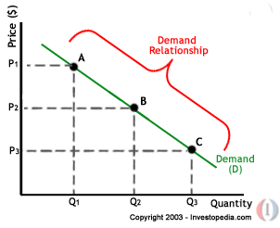
Figure 2 - Demand relationship (Hayes, n.d.)
As competition increases globally for machinery, pricing is being eroded along with profit. The more we can maximise our demand, the better economies of scale we will see in our manufacturing which will translate to lower cost of production. In effect, increase how elastic we are.
    - Generating demand
      - Inline with 3.1&3.2 there are many ways to influence the demand for our product. Recycling the extensive research completed with our users and the technical innovations would be a low cost way to differentiate JCB from our competitors as the tool of choice. (Jackson, 2013)
    - Demand planning vs build to order
      - JCB has always built to order – this minimises the liability of finished goods however, it means our supply chain economics may not be optimised in terms of procurement batches / lots and our the supply time to customers is prolonged in comparison to competitors. The speed of supply needs to be assessed in terms of value for our customers.
        - Extending lean methodologies will optimise the make to order efficiency but may not quickly offset the value of speed to supply to customers.
      - Introducing a mix of ‘build to order’ and ‘building to forecast’ should be considered. A task force to assess what product lines could adopt this model with low risk of redundancy or parking lot time.

- World Economic Outlook (IMF, 2018)
The following concerns raised by the IMF will not be explored for JCB: “slow growth in labour productivity combined with aging populations in developed countries and the rise in AI and robotics.”
  - Labour rates
    - Declining populations in both Advanced and emerging economies will present challenges in JCB production but may also influence the need to design products that are less reliant on people.
    - Furthermore, the impact of migration could skew the workforce availability across economies.
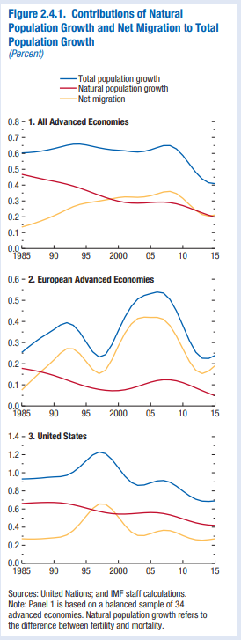
Figure 3 - Population & Migration projections for Economies (IMF, 2018)

- Recommendations for JCB
  - Make manufacturing Smart & Connected
    - We have already established the need to be “lean” and win in pricing by reducing manufacturing costs through scale and introducing some hybrid demand and build forecasting.
    - Line based manufacturing industries are changing globally, and the use of automation is increasing rapidly. This may be difficult to imagine for our diverse product lines however, with some re-modelling of what, where and how we produce we can take advantage of automation.
      - Identify our single biggest product line (by volume).
      - Rationalise the sites (what can be amalgamated) for this product and what can be built elsewhere.
      - Standardise as much as possible on the product.
      - Design automation to build standard elements.
        - Allow for future adaptations
  - Use smart manufacturing as a complimentary data set
    - Besides automation for efficiency in production, adding telemetry during production can aid testing and prediction of quality for produce.
    - Add this data to design parameters and in service telemetry and you begin to have a digital twin of your product. This can rapidly accelerate future development. It can also boost the quality the customers receive and allow JCB to be more pro-active in reliability support.
The result of introducing this kind of automation and connected technology is that you can reduce the labour involved in manufacturing firstly but subsequently you can impact labour needs for design and service.
Calderone eloquently summarises how industry is becoming connected and the advantages that can be realised. (Calderone, 2018)
Our construction industry may be behind Silicon Valley in terms of it’s adoption of technology but this is changing rapidly. Smart concrete such as Giatec (Giatec, 2018) is a prime example of how the industry is becoming connected and familiar with the benefits. As such, JCB won’t be alone in educating our customers – in fact, they may be already looking to be connected.
  - Manufacture in the emerging target market
    - JCB has over 20 factories globally to ensure supply. Looking ahead to the growth in construction in China, USA, India and Indonesia, it is essential that we expand and scale production facilities in those regions to be competitive on cost and time to supply.
    - China may be the single greatest opportunity for growth but also the most difficult to establish our business. Acquisition of some smaller machinery companies may aid the speed at which we can penetrate China and other markets. Partnerships could also be considered but due to our strong reliance on reputation and leading technology, a partnership could be a high risk strategy.

In short, JCB should take action now to simultaneously build intelligence into our manufacturing and reduce dependency on labour.
Additionally, JCB must scale in emerging markets, especially for construction to ensure we can supply the demand ahead of competitors and secure market share.

- Bibliography
Anon., 2017. The Statistics Portal. [Online]
Available at: https://www.statista.com/statistics/270374/main-export-partners-for-the-united-kingdom/
[Accessed 01 December 2018].
Anon., 2018. Brand Addition. [Online]
Available at: http://www.brandaddition.com/project/jcb/
[Accessed 01 December 2018].
Anon., 2018. The Construction Index. [Online]
Available at: https://www.theconstructionindex.co.uk/news/view/us-army-orders-180-more-jcb-excavators
[Accessed 01 December 2018].
Bivens, J., 2017. EPI. [Online]
Available at: https://www.epi.org/publication/the-potential-macroeconomic-benefits-from-increasing-infrastructure-investment/
[Accessed 12 December 2018].
Blogger, D., 2013. The Construction Index. [Online]
Available at: https://www.theconstructionindex.co.uk/the-digger-blog/view/did-you-know-jcb-contributes-14-billion-to-gdp
[Accessed 01 December 2018].
Calderone, 2018. Manufacturing Tomorrow. [Online]
Available at: https://www.manufacturingtomorrow.com/article/2018/01/the-connected-factory/10819/
[Accessed 20 December 2018].
Eiji Egawa, K. K. M. I. T. E., 2013. Use of Construction Machinery in Earthquake Recovery, s.l.: Hitachi.
Giatec, 2018. Giatec. [Online]
Available at: https://www.giatecscientific.com/case-studies/
[Accessed 2018].
Hayes, A., n.d. Investopedia. [Online]
Available at: https://www.investopedia.com/university/economics/economics4.asp
[Accessed 20 December 2018].
IMF, 2018. Chapter 2: LABOR FORCE PARTICIPATION IN ADVANCED ECONOMIES: DRIVERS, Washington DC: IMF.
IMF, 2018. IMF. [Online]
Available at: https://www.imf.org/en/Publications/WEO/Issues/2018/03/20/world-economic-outlook-april-2018
[Accessed 20 December 2018].
Jackson, T., 2013. Equipment World. [Online]
Available at: https://www.equipmentworld.com/the-innovations-center-where-jcbs-equipment-design-magic-happens/
[Accessed 20 December 2018].
JCB, 2018. JCB. [Online]
Available at: https://www.jcb.com/en-gb/news/2018/09/record-sales-for-jcb-as-market-rebound-stays-strong
[Accessed 01 December 2018].
Mills, F., 2016. The B1M. [Online]
Available at: https://www.theb1m.com/video/top-5-construction-markets-by-2030
[Accessed 01 December 2018].
ONS, 2018. ONS. [Online]
Available at: https://www.ons.gov.uk/businessindustryandtrade/constructionindustry/bulletins/constructionoutputingreatbritain/october2018andnewordersjulytoseptember2018
[Accessed 30 December 2018].
Sengupta, K., 2002. Independent. [Online]
Available at: https://www.independent.co.uk/news/uk/home-news/armys-equipment-exposed-as-unfit-to-fight-desert-war-171614.html
[Accessed 12 December 2018].
West, K., 2015. The Guardian. [Online]
Available at: https://www.theguardian.com/business/2015/apr/11/jcb-britain-yellow-digger-money-machine-sales
[Accessed 01 December 2018].

