Student Name: FIZZA RIZWAN
Student number: 2422238
Lecturer: Parese Ahmed
Module: Changemakers: Creativity and Value Creation
Module code: BMHP5014
Assignment Title: Component 1: Online Portfolio of Set Exercises

Task 1 – Concept Map: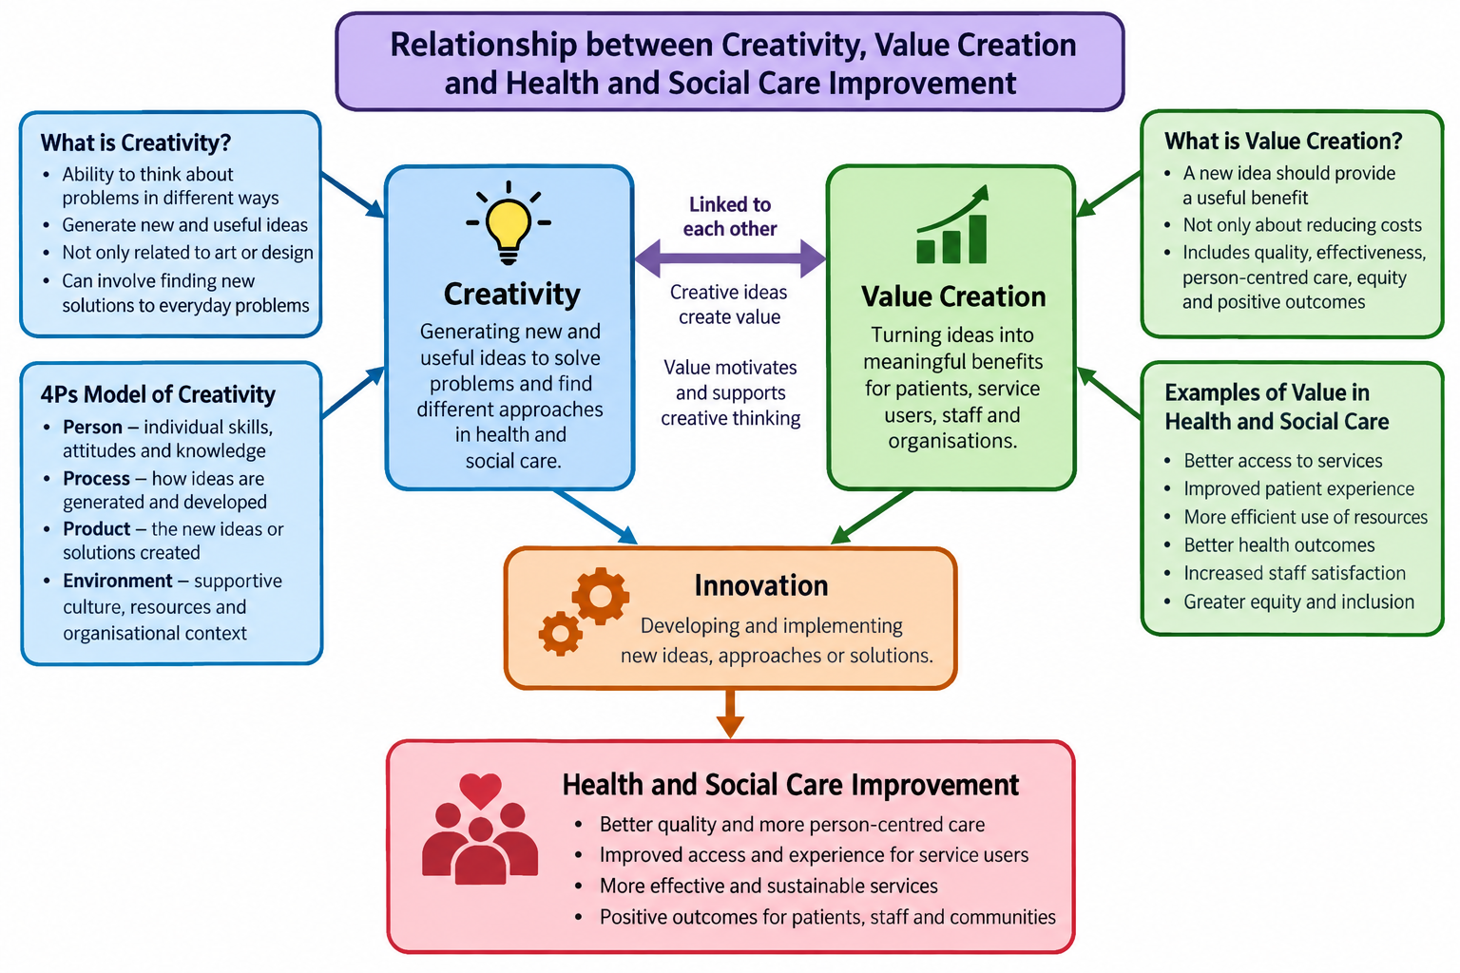

References Harvard style
Holden, R.J., Boustani, M.A. and Azar, J. (2021) ‘Agile innovation to transform healthcare: innovating in complex adaptive systems is an everyday process, not a light bulb event’, BMJ Innovations, 7(2), pp. 499–503. Available at: BMJ Innovations (Accessed: 01/10/2026)
Peng, Y., Wu, T., Chen, Z. and Deng, Z. (2022) ‘Value cocreation in health care: systematic review’, Journal of Medical Internet Research, 24(3), e33061. JMIR (accessed:01/10/2026)
World Health Organization, OECD and World Bank (2019) Delivering quality health services: a global imperative for universal health coverage. Geneva: World Health Organization. Available at: https://www.who.int/publications/i/item/9789241513906 (Accessed: 01/10/2026)

Task 2 – Reflection on the Group Activity
Gibbs’ Reflective Cycle
Description:
The paperclip exercise gave me the opportunity to work alone and with my classmates. It asked us to think of different uses and possibilities, helping me understand how divergent thinking generates a range of ideas and convergent thinking helps choose the most suitable ones. I first tried some ideas independently. When I was unsure how to approach part of the task, I spoke with my group, whose explanations helped me see options I had not considered.
Feelings:
At first, I felt uncertain because I did not know exactly what kinds of responses were expected. Talking with other students made the task easier: we exchanged suggestions, explained our reasoning and helped each other understand the activity. Sharing my thoughts in this way also made me more comfortable about contributing.
Evaluation:
One strength of the activity was the opportunity to hear viewpoints that differed from my own. Comparing suggestions showed me that a problem can have several possible solutions, rather than one obvious answer. Group discussion also helped me build confidence and think more imaginatively. A difficulty was that I hesitated to suggest ideas because I worried they might be wrong. This highlighted the need to accept uncertainty and explore possibilities before judging them.
Analysis:
This exercise helped me see that creative thinking can develop through collaboration as well as individual effort. Listening to other people can extend an initial idea or lead to a different approach. I also learned to generate a range of possibilities before evaluating them. This is the purpose of divergent thinking; convergent thinking follows by comparing the options and choosing those that best fit the task.
This lesson is useful in health and social care, where professionals need to communicate and work together to respond to problems. Colleagues and service users may view the same situation differently, so listening to these perspectives can help a team develop a more appropriate response. Creative thinking can support person-centred practice when ideas are assessed against each person's needs, preferences and safety.
Conclusion:
In summary, the paperclip activity taught me not to settle on the first idea without considering alternatives. Working with others can improve creativity because each person brings different experiences and ways of thinking. Using Gibbs’ (1988) cycle helped me reflect on what happened, what I learned and how I can transfer this learning to future group work.
Action Plan:
For future group tasks, I will contribute ideas earlier instead of dismissing them because they may not be perfect. In health and social care practice, I will listen to colleagues and service users and take their views into account when considering solutions. I will first use divergent thinking to list possible approaches, then use convergent thinking to judge which option is most suitable, safe and realistic. This will help me develop my creativity, communication and teamwork.
Reference:
Gibbs, G. (1988) Learning by Doing: A Guide to Teaching and Learning Methods. Oxford: Oxford Polytechnic.
Task 3 – Case Study of a UK Innovation: NHS Virtual Wards
NHS virtual wards allow selected patients to receive hospital-level care at home when this is clinically appropriate, rather than staying in a hospital bed. Healthcare professionals continue to assess and monitor patients, using methods such as telephone contact, digital devices and remote-monitoring equipment.
The innovation lies in rethinking where care can be delivered safely. Instead of assuming that every patient must remain in hospital, a multidisciplinary team can use technology and shared information to monitor a suitable patient at home and review whether their care plan needs to change.
Virtual wards may create value by offering eligible patients an alternative to remaining in hospital. Being cared for in familiar surroundings can be more comfortable and may make it easier to tailor support to a person's circumstances. When appropriate, this approach may also help avoid some admissions or reduce the length of a hospital stay.
Families and unpaid carers may appreciate having the patient at home while professional support remains available. However, home-based care is not suitable for everyone. Some people may not have reliable internet or suitable devices, may find digital systems difficult to use, or may not have someone who can help at home. Services should assess these circumstances rather than assume every patient can use the technology or provide their own support.
Overall, virtual wards illustrate how a different care model, supported by technology, can offer patients choice while helping services use hospital resources carefully. Their success depends on clear communication between professionals, reliable monitoring, suitable technology and decisions based on individual clinical and social needs. Patient safety and access must remain central, so people are not excluded because of digital or practical barriers.
References
Banks, H., Dhami, R., Kelly, M.P., Sniehotta, F.F. et al. (2026) ‘Commissioners’ views and experiences of implementing virtual wards in Integrated Care Systems in England: a longitudinal qualitative study using the Consolidated Framework for Implementation Research (CFIR)’, BMC Health Services Research.
NHS England (2024) Virtual wards operational framework. Available at: https://www.england.nhs.uk/long-read/virtual-wards-operational-framework/ (Accessed: 27 September 2026).
Task 4 – Research Task: Mental Health Stigma
Stigma around mental health can affect whether people feel able to ask for professional help. It may involve expecting to be judged, fearing discrimination or believing negative stereotypes about people who experience mental health difficulties. Such concerns can lead some people to delay support, with possible consequences for their wellbeing and access to care.
Clement et al. (2015) reviewed 144 studies, involving 90,189 participants, to examine how stigma relates to help-seeking. Their review found an association between stigma and lower help-seeking. Worries about disclosure were important because people sometimes feared that others would learn about their mental health difficulties. The authors also reported that stigma could be a particularly strong deterrent for some groups, including young people, men and ethnic minority groups. The findings suggest that reducing stigma may remove one barrier to accessing support, although it will not address every barrier on its own.
Tunks et al. (2023) examined access to primary-care support for common mental health problems in England by reviewing 30 studies. Their findings indicated that stigma and people's understanding of mental health influenced whether they sought help. The review also described concerns about services, including perceptions that mental health was not always prioritised in primary care and that psychological therapy could be difficult to obtain. The quality of the relationship between a patient and a healthcare professional was another factor affecting access.
Taken together, the studies indicate that stigma should not be treated only as a personal attitude. It can combine with gaps in knowledge, concerns about disclosure and difficulties accessing services to discourage people from seeking help. Health and social care organisations should therefore challenge harmful stereotypes while also making services approachable, accessible and responsive to people's needs.

References
Clement, S., Schauman, O., Graham, T., Maggioni, F., Evans-Lacko, S., Bezborodovs, N., Morgan, C., Rusch, N., Brown, J.S.L. and Thornicroft, G. (2015) ‘What is the impact of mental health-related stigma on help-seeking? A systematic review of quantitative and qualitative studies’, Psychological Medicine, 45(1), pp. 11–27. doi: 10.1017/S0033291714000129.
Tunks, A., Berry, C., Strauss, C., Nyikavaranda, P. and Ford, E. (2023) ‘Patients’ perspectives of barriers and facilitators to accessing support through primary care for common mental health problems in England: A systematic review’, Journal of Affective Disorders, 338, pp. 329–340. doi: 10.1016/j.jad.2023.06.035.

Task 5 – Podcast
The audio icon should be clickable in Word

Task 6 – NHS Leadership Framework Analysis
Key components of the NHS Healthcare Leadership Model – approximately 200 words
The NHS Healthcare Leadership Model describes behaviours that can help people lead and improve services in health and social care. Its nine dimensions are inspiring shared purpose, leading with care, evaluating information, connecting our service, sharing the vision, engaging the team, holding to account, developing capability and influencing for results. Together, these dimensions cover purpose, compassion, evidence-informed decisions, partnership working, communication, staff involvement, accountability, development and collaboration.
https://www.nhs.uk/conditions/
https://www.nhs.uk/mental-health/
https://www.nhs.uk/nhs-services/
https://www.nhs.uk/live-well/
https://www.nhs.uk/conditions/nhs-health-check/
https://www.nhs.uk/conditions/coronavirus-covid-19/
https://www.nhs.uk/conditions/type-2-diabetes/
https://www.nhs.uk/conditions/high-blood-pressure-hypertension/
https://www.nhs.uk/conditions/antibiotics/purpose, leading with care, evaluating information, connecting our service, sharing the vision, engaging the team, holding to account, developing capability and influencing for results.
Inspiring, shared purpose means helping people understand why their service matters. Leading with care involves treating people with compassion, while evaluating information means considering evidence before making decisions. Connecting our service focuses on how teams and organisations work together. Sharing the vision means explaining a clear direction for the future. Engaging the team encourages staff to contribute and feel that their views matter. Holding to account involves clear expectations and responsibility. Developing capability supports staff to build their knowledge and skills, while influencing for results involves building relationships that help achieve improvements. These behaviours can help leaders support staff and improve services.
Engaging the team involves including staff and showing that their ideas and contributions are important. Holding to account involves setting clear expectations and supporting people to take responsibility. Developing capability focuses on helping people develop their skills and prepare for future challenges. Finally, influencing for results involves building relationships and collaboration to achieve positive outcomes.
Together, these dimensions encourage leaders to support staff, work collaboratively, use information effectively and improve health and social care services.
One component: Engaging the Team
Engaging the team can help create conditions for innovation in the NHS because staff who feel heard may be more willing to suggest improvements. A leader could invite team members to identify a problem affecting patient access and ask everyone to propose possible responses. Instead of rejecting an unusual suggestion immediately, the leader could help the team consider the benefits, risks and practicality of each option before deciding what might be tested.
A leader could encourage staff to share ideas about problems in their workplace and suggest possible improvements. For example, during a team meeting, a leader could ask staff what makes it difficult for patients to access a service and then encourage everyone to suggest possible solutions. The leader should listen without immediately rejecting unusual ideas. Staff could then work together to identify which ideas are practical and could be tested.
Staff are more likely to speak openly when they feel safe to raise questions and discuss mistakes without being humiliated. O’Donovan and McAuliffe (2020) reviewed factors that support psychological safety in healthcare teams. This research is relevant because open communication can support learning and improvement. A leader who welcomes different views can encourage staff participation and help a team consider changes that may improve patients’ experiences and the quality of care.PubMed Central (PMC)
References
NHS Leadership Academy (n.d.) Explore the Healthcare Leadership Model. Available at: NHS Leadership Academy – Healthcare Leadership Model (Accessed: 27 September 2026).
. O’Donovan, R. and McAuliffe, E. (2020) ‘A systematic review of factors that enable psychological safety in healthcare teams’, International Journal for Quality in Health Care, 32(4), pp. 240–250. doi:10.1093/intqhc/mzaa025.

Task 7 – Self-Reflection Journal Entry
Completing this portfolio has changed how I understand creativity and value in health and social care. Previously, I mainly associated creativity with coming up with unusual ideas. I now see it as looking at a problem from different angles and considering whether a new approach could improve a service or the experience of the people using it.
I have also learned that creativity and innovation are related but not identical. An idea becomes an innovation when it is put into practice and used to make a change. Studying virtual wards helped me consider how technology and a different way of organising care can affect how NHS services are delivered.
My view of value creation has broadened as well. Value is not limited to reducing costs; it can also mean improving outcomes, access, patient experience, wellbeing and person-centred care. An improvement should be considered in terms of the benefits it brings to patients, staff and services, not simply whether it is cheaper.
The tasks have highlighted the importance of teamwork and leadership. Listening to other people's ideas can help a group develop a better response, while leaders can make it easier for staff to contribute. In my future practice, I intend to remain open to new suggestions, listen to service users and colleagues, and think carefully about how changes may affect the quality and safety of care. Overall, the portfolio has helped me understand creativity as a practical part of improving health and social care.
Reference List

1. Banks, H., Dhami, R., Kelly, M. P., Sniehotta, F. F. et al. (2026) ‘Commissioners’ views and experiences of implementing virtual wards in Integrated Care Systems in England: a longitudinal qualitative study using the Consolidated Framework for Implementation Research (CFIR)’, BMC Health Services Research. [Click here to open source]
1. Clement, S., Schauman, O., Graham, T., Maggioni, F., Evans-Lacko, S., Bezborodovs, N., Morgan, C., Rüsch, N., Brown, J. S. L. and Thornicroft, G. (2015) ‘What is the impact of mental health-related stigma on help-seeking? A systematic review of quantitative and qualitative studies’, Psychological Medicine, 45(1), pp. 11–27. doi:10.1017/S0033291714000129. [Click here to open source]
2. Gibbs, G. (1988) Learning by Doing: A Guide to Teaching and Learning Methods. Oxford: Oxford Polytechnic. [Click here to open source]
3. Holden, R. J., Boustani, M. A. and Azar, J. (2021) ‘Agile innovation to transform healthcare: innovating in complex adaptive systems is an everyday process, not a light bulb event’, BMJ Innovations, 7(2), pp. 499–503. doi:10.1136/bmjinnov-2020-000574. [Click here to open source]
4. NHS England (2024) Virtual wards operational framework. (Accessed: 27 September 2026). [Click here to open source]
5. NHS Leadership Academy (n.d.) Explore the Healthcare Leadership Model. (Accessed: 27 September 2026). [Click here to open source]
6. Peng, Y., Wu, T., Chen, Z. and Deng, Z. (2022) ‘Value Cocreation in Health Care: Systematic Review’, Journal of Medical Internet Research, 24(3), e33061. doi:10.2196/33061. [Click here to open source]
7. Tunks, A., Berry, C., Strauss, C., Nyikavaranda, P. and Ford, E. (2023) ‘Patients’ perspectives of barriers and facilitators to accessing support through primary care for common mental health problems in England: A systematic review’, Journal of Affective Disorders, 338, pp. 329–340. doi:10.1016/j.jad.2023.06.035. [Click here to open source]
8. World Health Organization, OECD and World Bank (2019) Delivering quality health services: a global imperative for universal health coverage. Geneva: World Health Organization. [Click here to open source]
9. NHS England (2017) Improvement knowledge and skills. [Click here to open source]

