ACADEMIC & EMPLOYABILITY SKILLS
Table of Contents
Introduction: 3
Section 1: 4
Provide a brief personal overview of yourself: 4
Include four screen grabs from your initial PowerPoint presentation that introduced yourself. 5
List the key points that you learned when trying to produce and deliver a successful PowerPoint presentation: 5
Section 2: Skills Evaluation 6
Identify and explain the skills required for successful (1) HE learning (2) Employability. 6
Conduct a Self-Evaluation exercise to discover your strengths and weaknesses, personality type, suitable career suggestions etc. 7
Section 3: 9
List both your long-term goals and short term 9
Create an Action Plan for the Academic and Personal/Professional Skills you need to attain or improve. 9
Section 4: Application 12
Section-5: Conclusion 16
Conclusion: 18
Section 6: Appendix 19
Appendix 1: About myself 19
Appendix 2: Big five personality test 21
References: 24

Introduction:
The main aim of this assignment is to understating the skills which an individual should develop in order to achieve the desired goal in near future and the personal development plan will help to understand how I could be able to achieve my desired goals. The compact of employability and my strengths and weakness also defined in this assignment.

Section 1:

Provide a brief personal overview of yourself
My name is Otilia Elvira Keresi and I am a confident woman. I want to live a healthier lifestyle and I would like to run a business on my own. As I like to read computer science I have developed some skills on that subject. The main reason behind the liking is the focus and patience for making a plan or document and I also enjoy the debugging technique of an application. I want to complete my master degree on that subject.
I want to be an IT technician and I love to work and the passion for doing any work will help me to achieve my desired goal. I want to work as a technician so my responsibility are going to be to oversee day to day running the IT department. Computer has always been my first priority. On a serious note I always love the role of leadership through my communication that has helped me to set my identity in the workplace. The confidence has helped me to get through the new challenges. I would like to exploit on my strengths which could be helping me in achieving my goals in the future.

Include four screen grabs from your initial PowerPoint presentation that introduced yourself.
For the screen grabs, refer to Appendix 1.

List the key points that you learned when trying to produce and deliver a successful PowerPoint presentation:
The skills which I have learned while making the PowerPoint presentation are:
Speaking: I have learned that speaking in any presentation is very important and the speaking must be in a natural rate of speech and very clear and distinct.
Body language: In order to share a positive body language at the time of presentation I need to maintain eye contact with the audience.
Questions: In order to establish good communication I have learned that question and answer session with the audience is very important.
Behavior: Humor will help me share my positive motivation at the time of the presentation as well as enthusiasm and focusing on the topic is also very important.

Section 2: Skills Evaluation

Identify and explain the skills required for successful (1) HE learning (2) Employability.
HE learning:
Higher learning is basically referred by HE learning and there are some skills which are required to understand HE learning properly:
A passion for the work: a passion for work is very important for the applicants as it will help to accomplish any work without making any mistake (Cottrell, 2015).
Ability to complete the task: The applicants must have the ability to complete any task within a specific time frame.
Good written English: The applicants must have the knowledge of English and need to be grammatically correct at the time of writing anything in English.
An inquiring mind: regarding any topic, the applicants must need to be ready to gain knowledge from the outside sources.
Ability to work independently: the applicants must need to understand the importance of working independently.
Positive attitude: The applicants must need to find positive things in any of the tasks because it will show the positive attitude of the applicants (Cottrell, 2015).
Employability:
In order to understand the concept of employability and entrepreneurship first, an individual needs to learn the four skills of the employability and these are:
General Awareness: This skill is basically referred to political issues, safety issues, health and environmental issues and ethical issues and etc (Bryson, 2016).
Numeracy Skills: a gathering of statistical information, understanding of basic numeracy and also the process of gathering any numerical information are referred by this skill.
Personal skill: the balance of work, stress level management, self-estimation development, and maintenance are basically referred to by this skill.
Interpersonal skill: The establishment of a good and healthy relationship with the boss and other employees are basically referred to by this skill.
Communication skill: The ability to listen and the process of following the instruction basically referred by this. Additionally, the individual should have the ability to provide sustainable logical arguments and must need to ensure good oral presentation as well as have the ability to defend that argument (Bryson, 2016).

Conduct a Self-Evaluation exercise to discover your strengths and weaknesses, personality type, suitable career suggestions etc.
Strengths: I have some skills which will help me to meet the desired goal. I think positively in any situation as well as the perseverance ability. I am pretty much open-minded. Most importantly, I have the confidence of finding solutions to any situations in life. I am very much straight forward as I tell the truth in front of individuals which I believe is my strength as it helps me in saving time for all of us.
Weakness: I have a low level of confidence and I am not able to work independently as well as I have low volunteer capacity and low level of general awareness. I am unable to evaluate what I would want to do in my life. Additionally, I am lacking in the integrity of internal work as I cannot take anything to be serious. These are my weakness where I need to improve myself.
Career suggestion: As I have a deep interest in computer it will be helpful for me if I chose a career related to the IT means it will be better for me if my job role is to develop any kind of IT applications. I have interest in IT sector so it will be benefited for me if I become an entrepreneur in the same field.
Personality type: I have the ability to motivate my colleagues that’s why they came to me for the suggestions and I am open-minded also.
So in order to understand my strength, weakness and personality I have to take the Big five personality test (refer to Appendix 1), The result shows some contradiction because the result refers that I am not so open-minded as well as I am extrovert and sometimes I suffer from anxiety and I am quite an emotion while handling any tough situation.

Section 3:

List both your long-term goals and short-term
Short term plan: As a short-term plan I need to develop my weakness means I need to develop the skills like confidence, independent working approach, low level of volunteer capacity, lack in the integrity of the internal network and low level of general awareness knowledge. Additionally, this development will help me to achieve my dream more efficiently.
Long-term plan: I wanted to run a business on my own and becoming an ideal leader is the long-term goal for me and in order to achieve that goal I need to complete all the courses on the computer very effectively. In order to learn the computer courses effectively I need to learn the course in the university because from there I will gain more knowledge on leadership.

Create an Action Plan for the Academic and Personal/Professional Skills you need to attain or improve.
Skills | The process of improvement | Resources | Timeframe
Confidence | Understanding the importance of the task as well as the knowledge of the task will help me to enhance my level of confidence (Schore, 2015). | I can gain knowledge about the topic if I was able to take help from my teachers as well as the students. | 30 days
Independent | In order to be a independent worker I need to first know the key points of dividing a task into some different categories as well as I need to perform on that task without taking help from the others because it will help me to gain a good level of confidence which will help me to be a independent worker. Additionally if I can complete a task within a specific time frame then it will help me to be an independent. | Motivation will play a major role for becoming independent and the help from the teachers will help me to enhance my motivation level which will help me to become an independent worker as well as helps from the other students will motivate me to accomplish any work by my own self. | 60 days
low level of volunteer capacity | I can able to increase the capacity of volunteering by understanding the importance of the volunteering and different aspect of the volunteering. | In order to increase my volunteering I can take the help from the books as well as the journals because it will help me to understand the different expert’s point of view. | 60 days
low level of general awareness knowledge | As I want to improve my skill of general awareness, I need to read many books and journalsbecause. It will help me in understanding the different aspects of general awareness. I also need to understand the different first aid technique, ethical issues and the global and political situation of places because it also comes under the general awareness category. | Help from the students and the teachers will help me to increase the general awareness knowledge and the different kind of books, journals and articles will help me in increasing my knowledge of general awareness (Sanford, 2017). | 60 days
lack in the integrity of the internal network | I wanted to be an entrepreneur and in order to be one, I need to develop my skill in this field and if I was able to work in any networking company as an intern then it will provide me with the practical as well as theoretical knowledge also. | The internship will help to practical knowledge in the business sector will help me to gain theoretical knowledge of being an effective leader in the business world | 90 days
Source: Created by author

Section 4: Application
WELFARE OF THE STORED DATA
For protecting and safekeeping of the data which I like, need and do not want to lose, the rule of “in the three different places” is followed. To clearly understand this rule, we must first understand the very concept of ‘backup’. We generally make some very common mistakes while taking a backup, which are:
- When we copy files into a new folder in the same machine, it cannot be treated as a backup
- When we use a hard drive to take backup of the computer, but they are in the same location, we cannot call it a backup
- When we use an SD card in the same machine to take backup of the computer, it is not backup
“The Three Different Places” Rule
The golden rule followed to take backup of any computer or data is "the three different places" rule. It consists of three parts: three copies of data, two formats of data and an off-site location of storage. This is why sometimes it is also known as the "3-2-1" rule. The primary idea of the rule is as follows:
Three copies of each data: According to data safety standards followed all over the world, three copies of each and every data is made and stored. Two copies of the data are not considered safe according to the backup technique.
Two formats of data: Each and every data needed to be backed up should be done so in two different formats for safekeeping. The two formats of data guarantee much safety(Dennyand Nguyen, 2016). For example- a DVD and a hard drive or an SD card and a drop box are prone to minor problems in terms of ensuring security to the data.
An off-site location: An off-site location along with all the existing local locations such as own house, computer etc. ensures the safety of the backed up data. The primary target is not to keep all the copies in one place, but to rather diversify the location and minimising the chance of destroying every copy in a single probable incident.
Following these three rules ensures a much higher chance of having the data safe regardless of any event of destruction of person or property.
List of Probable Disaster Scenario
Disaster is a natural or unpredictable event causing loss to life and property. It is impossible for us to predict any disaster or accident or to control its outcome for that matter. The possible scenarios I can think of are as follows:
- House fire destroying all my property
- Any person formatting my machine knowingly or unknowingly
- Any natural calamity such as earthquake, flood, blizzards etc.
- Hardware crashing can also be a reason for losing my data making it impossible for data recovery
- Virus attack is also a common reason for losing the data
- We may even forget the cloud id and password, thus making it impossible for me to recover the data
These are some of the possible scenarios where I can lose my data. In case of any fire, the third rule comes into play. Since it is also stored in an off-site location, any possible damage to that copy of my data is minimal. The off-site location ensures the safety of my data in case of a natural calamity such as flood, earthquake etc. Three copies at different physical location guarantee that my backup is safe even when the hardware crashes. Two formats of my backup at three different locations also safeguard me against any possible virus attack. Cryptowall is a Trojan horse virus which encrypts all my data and files. We are blackmailed into paying in order for them to decrypt them. One way is to format the computer and thus to lose all my data and backup (if any). But the off-site and three different copies that I always have a copy of my data always at hand. So a combination of the ‘3-2-1' rule during different compromising situations ensures complete safety of the much-valued data.
Organisation and Management of Time
One of the basics for any successful endeavour is the management and utilisation of the available time to optimise the use of it. To understand the importance and better use the time we have at hand, we must understand some salient features of time management. They are:
Limited Resource: We must ingrain in our mind that time is a limited resource. Any unproductive time can be deemed as waste. So careful planning and managing time help us to use the time better and minimise wastage.
Rushing: Rushing any work, however, affects the outcome of the task to a great extent. So, proper and requisite time should be allotted for each task for a favourable result. Proper planning prevents stressing out.
Time Management: Understanding the advantages of time management will greatly help us to derive at the desired helm. Time management also helps to better understand ourselves as better time framing for any task can be done only when we understand ourselves, e.g. How much time would we need for a particular job? or which time is optimum for which task? These can only be ascertained only if we know at what speed or with how much time could I finish the task without compromising the quality of work (Oettinger et al.,2015).
Delegation: We must also know that a single individual can not do each and every work. Thus, the delegation of the parts of the work is necessary for completion of the task on time and with great precision. It is of paramount importance to veer off excessive and unnecessary pressure.
Steps Taken To Ensure Productivity
- Proper and sufficient understanding of the task makes it easier to execute the job properly unhindered.
- Dividing the large job into smaller tasks also helps to better understand the task and completion of the smaller goals also helps to complete the job faster.
- Planning and better utilisation of the time available could lead to work satisfaction and reduce time wastage.
- Delegating parts of the work to competent people to complete smaller targets and striving towards the larger goal as a whole.

Section-5: Conclusion
PDP PLAN
 | Short-Term Time Frame | Mid-Term Time Frame | Long-Term Time Frame
Section 1: My target of starting a business | Understanding and comprehension of the course to become a leader by travelling around the world and meeting with different people. | Gaining the requisite experience in the field greatly increases my chances | The goal of becoming an entrepreneur upon completing education from my university.
Section 2: Necessary skills and knowledge | Understanding the basic and primary concepts for being an entrepreneur and making time to study on the subject | Understanding the intricacies of being an effective leader. | Real life application of the learned concepts and practical on hand use and experience through self-education
Section 3: Following a healthier lifestyle and asking the same from people | I have observed that following a healthier lifestyle would help me in getting a sound mind and body. This would help me in making effective decision for my business and employees in the process. | Observing the handling technique of any real-life business problems | Performing practical concepts helps better growth of my business
Section 4: Resources | Books, research on the internet, journals, tech magazines. | Attending seminars, conferences | Internship and day-to-day handling of business
Section 5: Time Schedule of completion | Six months | One year | One year
Starting Time Frame | 1 month | 7 months | After mid-term examinations
Finish Time Frame | 6th month of the first year | 7th month of the second year | After completion of the course
Table 2: PDP Plan
Source: Created by the author
I have gained valuable insights from the experience and practical demos given in the class and have identified areas where I need to improve in order to excel in the coming days. I constantly strive for up gradation and development of necessary skills to further my career as a whole.
Recommendations:
If online test regarding the confidence, independence, low level of volunteer capacity, low level of general awareness knowledge, and lack in the integrity of the internal network in business field will be available for me to improve the skills more efficiently, then my current status will be understandable such that I could be able to improve on my decision making skills.

Conclusion:
In understanding the need to improve for future and development of the skills for a viable result and to fulfil the lack of my skill, this paper has been a great reference. The personal development plan has also helped me to achieve my desired goal as well to build my personality with full strength and confidence.

Section 6: Appendix

Appendix 1: About myself
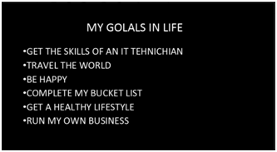
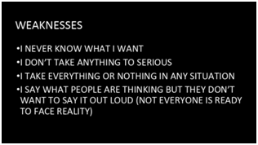
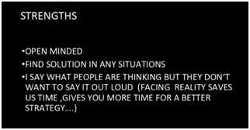
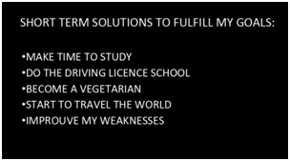
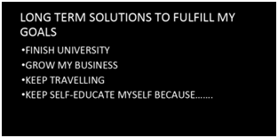

Appendix 2: Big five personality test
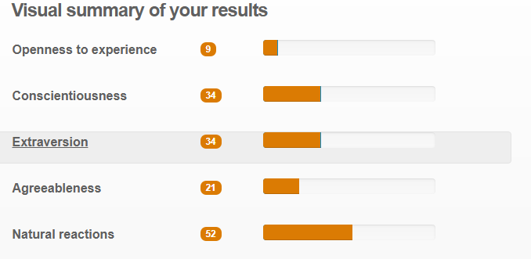
Appendix 3: Cryptowall report
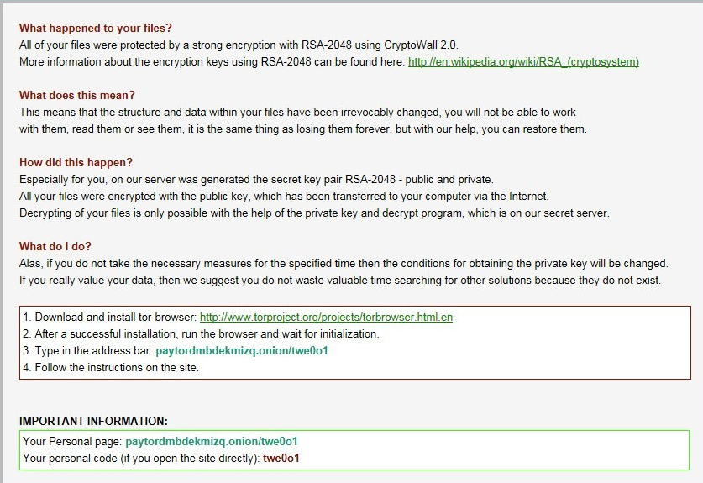

References:
Bryson, C., 2016. Engagement through partnership: Students as partners in learning and teaching in higher education.
Cottrell, S., 2015. Skills for success: Personal development and employability. Macmillan International Higher Education.
Denny, M. and Nguyen, H., AT&T Intellectual Property I LP, 2016. Methods, systems, and products for data backup. U.S. Patent 9,311,192.
Oettingen, G., Kappes, H.B., Guttenberg, K.B. and Gollwitzer, P.M., 2015. Self‐regulation of time management: Mental contrasting with implementation intentions. European Journal of Social Psychology, 45(2), pp.218-229.
Sanford, N., 2017. Self and society: Social change and individual development. Routledge.
Schore, A.N., 2015. Affect regulation and the origin of the self: The neurobiology of emotional development. Routledge.

