Diagram of circuit
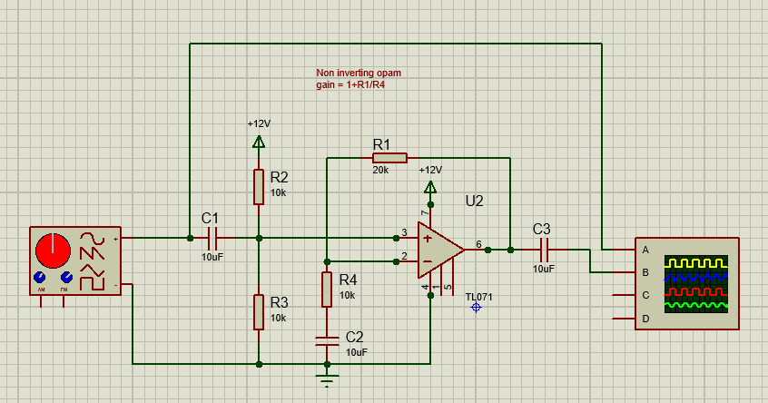
For all the tests 100mv were inputted
GBP calculations done using ideal values
Freq |  | V-out | Freq |  | v-out
100 |  | 300mv | 200 |  | 300mv
500 |  | 300mv | 1k |  | 300mv
2k |  | 300mv | 5k |  | 300mv
10k |  | 300mv | 20k |  | 300mv
50k |  | 295mv | 100k |  | 290mv
200k |  | 245mv | 500k |  | 115mv
250k |  | 215mv = 0.707
Max value *0.707 represent by the orange line

GBP calculations done using real values done in protus
Freq |  | V-out | Freq |  | v-out
100 |  | 300mv | 200 |  | 300mv
500 |  | 300mv | 1k |  | 300mv
2k |  | 300mv | 5k |  | 300mv
10k |  | 300mv | 20k |  | 300mv
50k |  | 300mv | 100k |  | 297.85mv
200k |  | 293.75mv | 500k |  | 267.5mv
250k |  | 290mv | 1M |  | 210mv
980k-----990k=215mv=0.707 of the max value

Breadboard
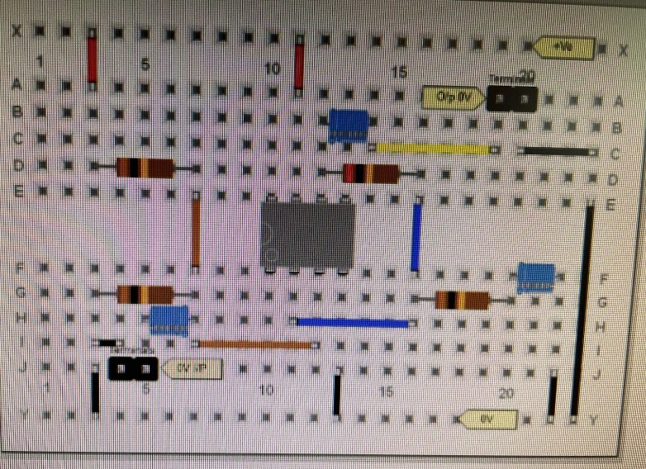
This is the breadboard design that I used then making my breadboard I put the supply rails on X and 0v on Y. the input and out went on the two terminals the bottom left was input and top right was output.

Real values tested on breadboard
Freq |  | V-out | Freq |  | v-out
100 |  |  | 200 |  | 100mv
500 |  | 120mv | 1k |  | 136mv
2k |  | 216mv | 5k |  | 336mv
10k |  | 376mv | 20k |  | 384mv
50k |  | 368mv | 100k |  | 384mv
200k |  | 376mv | 500k |  | 300mv
250k |  | 368mv | 1M |  | 200mv
990k=215mv=0.707

Easy pc design

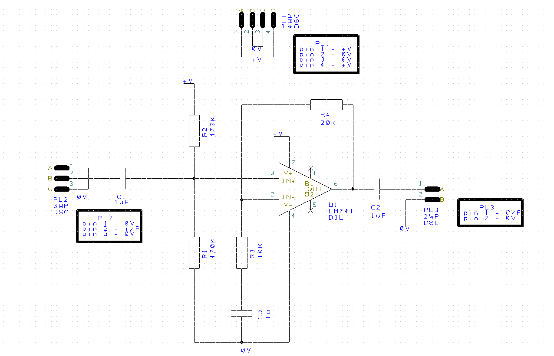
This is the lay out designed in easy pc this makes a amplifier with a gain of 3.
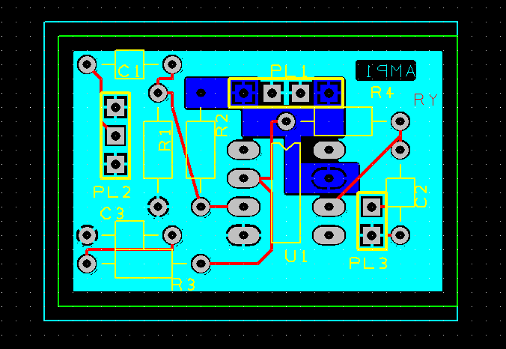
This is the easy pc design put on a breadboard ready to be printed once printed I then soldiered the components to the board giving a final product that look like this.

Real values tested on a pcb
Freq |  | V-out | Freq |  | v-out
5000 |  | 4.11 | 100000 |  | 3.22
10000 |  | 4.11 | 114500 |  | 2.96
15000 |  | 4.11 | 150000 |  | 2.21
20000 |  | 4.11 | 200000 |  | 1.68
25000 |  | 4.11
50000 |  | 4.01
75000 |  | 3.92



