

Marketing Plan on Marriott Hotel

Strategic Marketing

Yingjie Zang 2100728

Lisa Knight

Contents
Executive Summary 1
1.0 Introduction 2
2.0 SOSTAC 3
2.1 Situation Analysis 3
2.2 Objectives 4
2.3 Strategy 4
2.3.1 Market Segmentation 5
2.3.2 Market Targeting 5
2.3.3 Market Positioning 6
2.4 Tactics 6
2.5 Actions 7
2.6 Control 7
3.0 SMART 8
3.1 Specific 8
3.2 Measurable 8
3.3 Attainable 9
3.4 Relevant 9
3.5 Time-bound 10
4.0 Recommendations 11
5.0 Conclusions 12
6.0 Reference 13

Executive Summary

The outbreak has hit the tourism industry hard around the whole world, each country took measures to fight against the pandemic. China did a good job during the war against pandemic. China has kept a positive attitude towards the COVID-19 and China has effectively brought the epidemic under control (Liu et al, 2020). China's tourism recovered and revitalized by taking targeted and feasible measures. The domestic atmosphere is stable enough to develop tourism again. In addition, China, with its large population and large number of travelers, is the perfect place to revive Marriott hotels. In summary, the main coping strategies focus on Marriott's business in China.The strategic marketing objective is clear, that is increase hotel revenue by 10% in one year compared to last year. The report plans to take measures to recovery the hospitality industrial of The Marriott International Hotel in China. The hotel will achieve the goal through five specific steps, the main session is the trust of tourists and propaganda and keep customers. This requires the joint efforts of all departments in the Marriott hotel.

1.0 Introduction

The hospitality and tourism are the most hardest industries since COVID-19, and the a number of hospitality and tourism businesses have experienced huge financial challenges due to travel restrictions, lockdown measures and social distancing measures (Fotiadis et al, 2021). Companies took varies of actions against the impact of COVID-19, such as layoffs, changes in operations and reduced services (Abbas et al, 2021). But these measures resulted in rising unemployment, especially in tourism-oriented countries (Jones & Comfort, 2020). On the other side, these measures have to some extent prevented the recovery of tourism (Afwa et al, 2021). Based on the situation, The Marriott International Hotel need a specific strategic marketing objective. It aimed to speed up the return to normality of hotel running and minimize the impacts of the economic crisis.Develop Marriott's business in China during pandemic is a result of overall consideration. I will use SOSTAC and SMART principle to make the analysis and propose a specific marketing plan. Our goal is increase hotel revenue by 10% within one year compared to last year and our target market is Chinese domestic tourists. Then the hotel has a market plan for the goal.

2.0 SOSTAC

SOSTAC is a systematic, logical and powerful tool for making market plan. It conclude situation analysis, objectives, strategy, tactics, actions and control (Naim, 2020). SOSTAC is same applies to the formulation of Marriott Hotel marketing strategy objectives. It is necessary to find out the specific points that could drive the development of Marriott Hotel in China and then plan to implement the specific measures. The SOSTAC model will be the ideal in planning a successful market plan for the Marriott Hotel.
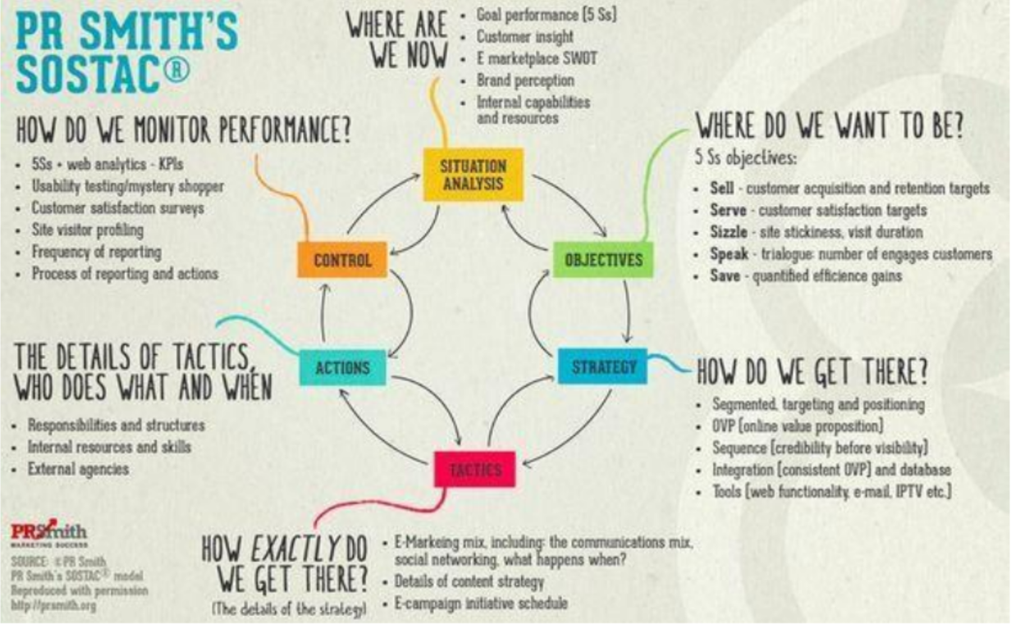

2.1 Situation Analysis
The outbreak of COVID-19 has dealt a major blow to the tourism industry. The prevalence of the virus almost effected everything and it has a profound influence on hospitality globally as well. A lots of international hotel companies have suffered the economic losses from the different degrees of lockdown requirements. The Marriott International Hotel also had been influenced across the broad. The unstable international situation and inflation have also made it difficult for the hotel industry to operate. It is harsh that political and economic environment around Marriott Hotel, and the competition in the market is fierce (Bagnera et al, 2002). Based on this situation, Marriott have to rely on its existing resources and capabilities to against the hard situation. It need find a right place to extend and develop it’s business. There are several factors that impact the recovery on hospitality, for instance, pandemic is inconstant and uncertain, the hotel cannot predict how long the outbreak will last. And people are worried about catching the disease if they travel (Shin & Kang, 2020). But opportunities come with challenges. China did a good job during the war against pandemic. China has kept a positive attitude towards the COVID-19 and China has effectively brought the epidemic under control. COVID-19 has led to new changes in tourism concepts and tourism industry in China. In order to break through the siege, China's tourism recovered and revitalized by taking targeted and feasible measures and resuming “inbound and outbound tourism” and “domestic tourism”. China carried out many policy to support the recovery of tourism industry, such like (i) prophylactic measures, (ii) tourism recovery and development, (iii) policy support, and (iv) departmental management (Shao et al, 2021).China has published a series of supportive policy and China have a bright prospect in tourism. And it has a large population and large number of travelers, in conclusion, China could be a promising place to revive the Marriott Hotels. Another good thing is that the hotel has good performance in service and and resource integration capabilities (Sadek, 2022), and these sound capacities enable the hotel to catch the opportunities. As the world’s leading international hotel management company, Marriott must take a series of actions at this time to against the bad impact of the pandemic. The Marriott could rely on it’s the previous solid foundation to revitalize the hotel business.

2.2 Objectives
The Objective element of SOSTAC focus on “Where are we want to go or want to be?” It ask for a specific destination to achieve. In this report, the hotel plans to focus on Marriott's business in China to drive overall recovery, minimize the impact of the epidemic on hotel revenues. Our goal is increase hotel revenue by 10% within one year compared to last year, here it refers to the goal of business in China. and our target market is Chinese domestic tourists.

2.3 Strategy
In this part, systematic solutions to problems will be proposed. It concludes specific analysis and steps for planing. Here the hotel’s analysis it from three perspectives market segmentation, market targeting and market positioning.

2.3.1 Market Segmentation
Market segmentation is a kind of the market classification process that could help marketers to divide the overall product market into several consumer groups in order to meet the need of the differences in consumer desires, purchasing behavior and habits through market research (Raza& Govindaluri, 2022). Each consumer group is what we called the market segment which is constituted by consumers with similar demand tendencies. In the segmented market, it is much easy to understand information and make feedback to it. If the consumer change their demand, companies could change their marketing strategies rapidly. Correspondingly, they will develop other countermeasures to adapt to the changes in market demand, meanwhile improving their recovery capability and competitiveness are vital for companies surviving(Dolnicar, 2020). In the context of the pandemic, the departure point for passengers is the very important principle of market segmentation. Accordingly, I divided Chinese consumer group into long-distance travelers and short-haul travelers. That does not mean the other elements are unimportant, such like occupancy and demand, the hotel should keep the security of guests the first place.

2.3.2 Market Targeting
Through market segmentation, target market is easier to be settled. The target market is one or several sub-markets where the company can meet customers’ needs within the best services and products (McCarthy,1979). When companies choose the target market, specifying the features of the target clients and how to meet their needs during their marketing competitions(Ozkeser, 2019), and it can find the target market and avoiding shortcomings of companies,use the financial and material advantages of the target market to avoid blindly bumping into the huge market. Differential market strategy should be given more attention. It is necessary that design specific products for the different sub markets to satisfy consumers’ demands.

2.3.3 Market Positioning
Market positioning refers to the marketing design that companies pay more attention to consumers’ internal needs (Wendell,1956), having a certain image of the brands as well the requirements of the products, retaining a deep impression and a unique position (Camilleri, 2018), to enhance its competitiveness. Marriott hotel has the first class intimate service, which is a great advantage (Manning et al, 2018). This is the most attractive point for tourists. In China the hotel mainly serves Chinese tourists as a superior hotel. Through the analysis of strategy, there are five specific measures for the marketing plan. Due to the lack of knowledge and experience in pandemic prevention and control, the Marriott Hotel did suffer a lot in the early days during the pandemic. So improve the ability of controlling COVID-19 is a vital point. The hotel needs to go from five parts, they are customers’ trust, original customers, propaganda, minimize costs and talent management. First thing is gain trust from customers. Keep the original VIP customers and extend the VIP period. Doing a good job of promoting the hotel during the outbreak. Minimize costs, drive down costs by streamlining processes to reduce operating costs. Pay attention to talent management.

2.4 Tactics
In this part, objectives are further designed into detailed actions. First of all, safe distant is required, lobby security should ensure that everyone enters the hotel stay in a safe distant (Rawal et al, 2020). Each people keep 1 meter is necessary. For ensure the security of customers that do not connect with other people, hotel provides shutter service. And hotel should keep a medical team in it. Strengthen the construction of medical team and carry out elimination work regularly (Shin et al, 2021). In addition, charity activities should be targeted during the pandemic, too much charity activities will bring customers a feeling of insecurity. Although charity activity is a positive propaganda of hotel, some customers will have concerns about being infected. To keep the original VIP customers, Marriott will extend the VIP period. Hotel could initiate the free cancellation service in the year and provide the re-booking assistance. These measures will be informed by e-mail and showed on Marriott's website home page. Propaganda wok is important for recovery. Marriott's website home page should convey the information that the hotel is preparing to receive customers and do a considerate prevention work. Increase the discount and give VIP discount coupons could also display on the Marriott's website home page. Minimize costs.Rotation system can be used during an outbreak.This reduces the risk of human exposure to infection, reduces overhead costs, and keeps employees from losing their jobs. Energy saving is also a important method to reduce cost. Improve the security of high performance employees.Employees with good worker performance should be rewarded with appropriate epidemic prevention materials and bonus. To ensure that employees work hard to unite and advance in special period.

2.5 Actions
The security department is responsible for reception of reservations, casual guests, groups, inquiries, luggage storage, and room reservations. The front office is responsible for the transportation and protection of customers, improve consumer satisfaction. The information department in charge of communication with customers. Keep the original VIP customers and extend the VIP period. The hotel can get customers' goodwill by sending them condolences in the form of emails. And call customers to inform them of the extension of VIP validity. Interaction through e-mail sending between customers and Information Department could got some information such as travel willing and suggestion. The publicity department is responsible for hotel publicity. User advocacy is a very good way to promote, for example,customers will receive coupons for showing photos and reviews on social media platforms when they stayed at Marriott hotels.

2.6 Control
If the final calculate result shows that the revenue is 10% higher than last year, then it illustrates that the plan is effective.

3.0 SMART

SMART goals analysis strategy stands for – Specific, Measurable, Attainable, Realistic, and Time (Bjerke & Renger, 2020). The SMART goal will specify a measurable outcome that help The Marriott International Hotel complete the goal of recovery.

3.1 Specific
Explicit and specific means that performance objectives should be more detailed and specific on the basis of performance standards. So narrow down the target market is necessary. Clear and well-defined goal could more straightforward to guide us to accomplish our goals. First, the target group of services are mainly China domestic tourists and customers. Increase hotel revenue by 10% within one year compared to last year in the China region. Then, systematic plans are designed, including task assignment of different apartments in the Marriott Hotel. Last, the final achievements should be measured by calculating net profit and comparison.

3.2 Measurable
What to measure and how to measure are two key components of SMART analysis. Simply, the hotel needs to measure net profit from the start of the program to one year later. In order to better control the operating situation, the hotel can summarize each quarter. Meanwhile, customer reviews also need to be monitored, so that the hotel can find the employees or departments that perform well. In the market strategy objective, the hotel needs to calculate net profit at the end of the year, and compare it with last year's net profit. It will be clear that whether it achieves the goal.
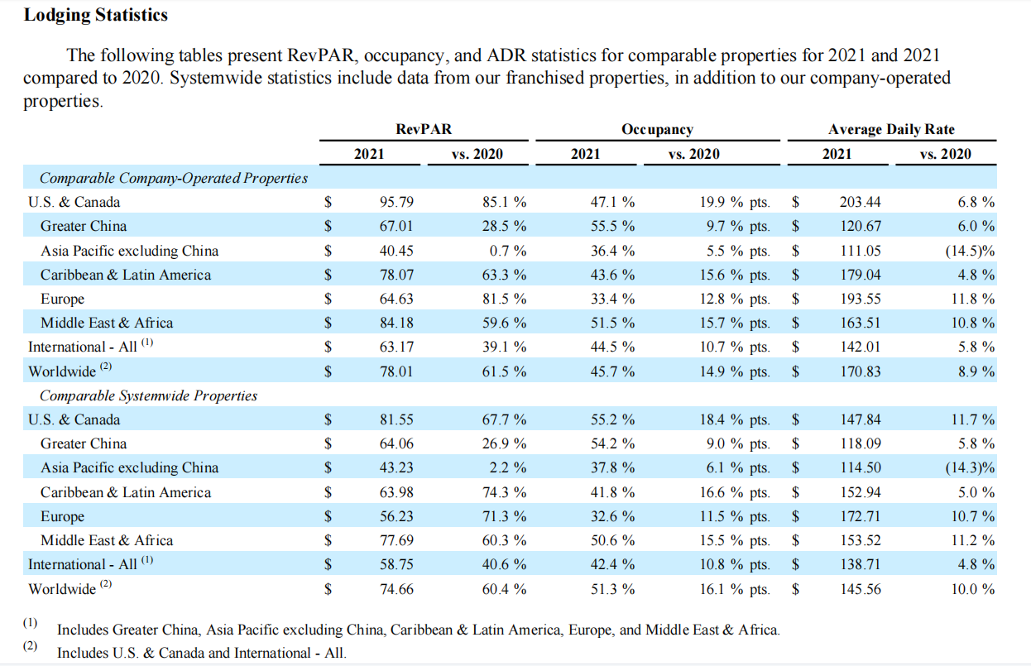

3.3 Attainable
Is the goal available for the Marriott Hotel. Make sure the hotel can reasonably accomplish our goal within a certain time-frame. If setting an unrealistic goals that looks good on the strategic document but hard to increase the profit of the Marriott Hotel, that is not wise enough . Second, setting the goal too low, leading to under-utilization of the resources at the Marriott Hotel. Our goal is increasing hotel revenue by 10% within one year compared to last year in the China region. So the hotel does not set the goal like increase hotel revenue by 60% within one year, obviously, it is impossible even for the best Hotel during the pandemic.

3.4 Relevant
The goal may align with broader objectives to increase overall revenues, increasing revenues in China region could help to gain a lot of rich experience of against pandemic. It also drive the development for the whole hospitality industry.

3.5 Time-bound
The goal must be time-bound, this market strategy must has start date and finish date. If the goal is not time-constrained, there will be no motivation and urgency. That is dangerous for achieving the goal. The duration of the program is one year of our marketing plan. It is a long term goal that requires patience and step by step.

4.0 Recommendations

In this market strategy objectives, the hotel puts forward a series of measures to recovery the Marriott Hotel. Except these measures, there are two more opinions for the Marriott Hotel. With the epidemic, Marriott hotels can take advantage of the opportunity to make a big push into digital technology. Using big data analyze customer data to accurately determine customer needs and preferences. The hotel will get more customers through this method. At the same time, protecting the personal data and trip data of customers is as much important as use them. On the other hand, more extensive and deeper propaganda is necessary. Marriott hotel could tightly seize the opportunity of Internet, that is promotion through travel bloggers. Travel bloggers usually have a number of followers, followers will experience the same hotel as the travel bloggers.So they are the good choice to do propaganda.

5.0 Conclusions

COVID-19 had given a big damage to hospitality and tourism industries. the Marriott Hotel need a recovery so that the hotel has chosen to focus on one relatively dynamic market, China. Our goal is increasing hotel revenue by 10% within one year compared to last year in the China region. In this plan the hotel puts forward a series of measures to recovery the Marriott Hotel. The report makes a analysis through using SMART and SOSTAC principle. Each step have a specific action after analyzing the situation, objectives, strategy, tactics, actions and control. In this process, the main session is the trust of tourists, propaganda,reduce costs and keep customers. In the end, net profit and the performance of employees and departments will be measured.This is a complete market plan with a specific strategy objective, witch lays a foundation for the recovery of the Marriott Hotel.

6.0 Reference

[1]. Abbas, J., Mubeen, R., Iorember, P. T., Raza, S., & Mamirkulova, G. (2021). Exploring the impact of COVID-19 on tourism: transformational potential and implications for a sustainable recovery of the travel and leisure industry. Current Research in Behavioral Sciences, 2, 100033.

[2]. Afwa, A., Djajasinga, N. D., Sudirman, A., Sari, A. L., & Adnan, A. N. M. (2021). Raising the Tourism Industry as an Economic Driver Post COVID-19. In 2nd Annual Conference on blended learning, educational technology and Innovation (ACBLETI 2020) (pp. 118-123). Atlantis Press.

[3]. Bjerke, M. B., & Renger, R. (2017). Being smart about writing SMART objectives. Evaluation and program planning, 61, 125-127.

[4]. Bagnera, S. M., Stewart, E., & Edition, S. (2020). Navigating hotel operations in times of COVID-19. Boston Hospitality Review, 1-7.

[5]. Camilleri, M. A. (2018). Market segmentation, targeting and positioning. In Travel marketing, tourism economics and the airline product (pp. 69-83). Springer, Cham.

[6]. Dolnicar, S. (2020). Market segmentation for e-tourism. Handbook of e-tourism, 1-15.

[7]. Ozkeser, B. (2019). Impact of training on employee motivation in human resources management. Procedia Computer Science, 158, 802-810.

[8]. Fotiadis, A., Polyzos, S., & Huan, T. C. T. (2021). The good, the bad and the ugly on COVID-19 tourism recovery. Annals of Tourism Research, 87, 103117.

[9]. Gössling, S., Scott, D., & Hall, C. M. (2020). Pandemics, tourism and global change: a rapid assessment of COVID-19. Journal of sustainable tourism, 29(1), 1-20.

[10]. Gholamhosseinzadeh, M. S., Chapuis, J. M., & Lehu, J. M. (2021). Tourism netnography: How travel bloggers influence destination image. Tourism Recreation Research, 1-17.

[11]. Hao, F., Xiao, Q., & Chon, K. (2020). COVID-19 and China’s hotel industry: Impacts, a disaster management framework, and post-pandemic agenda. International journal of hospitality management, 90, 102636.

[12]. Hallberg, G. (1995). All consumers are not created equal: The differential marketing strategy for brand loyalty and profits. John Wiley & Sons.

[13]. Jones, P., & Comfort, D. (2020). The COVID-19 crisis and sustainability in the hospitality industry. International journal of contemporary hospitality management.

[14]. Kilani, Y. M. (2021). SMART Business Role in Supporting Marketing Strategies among Telecommunication Organizations Injordan. Turkish Journal of Computer and Mathematics Education (TURCOMAT), 12(6), 4568-4582.

[15]. Liu, W., Yue, X. G., & Tchounwou, P. B. (2020). Response to the COVID-19 epidemic: the Chinese experience and implications for other countries. International Journal of Environmental Research and Public Health, 17(7), 2304.

[16]. McCarthy, E. J., Shapiro, S. J., & Perreault, W. D. (1979). Basic marketing (pp. 29-33). Ontario, CA, USA: Irwin-Dorsey.

[17]. Manning, C., deRoos, J., O'Neill, J. W., Bloom, B. A., Agarwal, A., & Roulac, S. (2018). Hotel/lodging real estate industry trends and innovations. Journal of Real Estate Literature, 26(1), 13-41.

[18]. Naim, A. (2021). Applications of Marketing Framework in Business Practices. International Journal of Innovative Analyses and Emerging Technology, 1(6), 171-186.

[19]. Nunes, L. (2019). Sustaining a Digital Online Influence Through Personal Branding: A Case Study of Travel Bloggers. University of Johannesburg (South Africa).

[20]. Redjeki, F., Narimawati, U., & Priadana, S. (2021). Marketing Strategies Used by Hospitality Businesses in Times of Crisis of the COVID-19 Pandemic: Case Study. ENDLESS: International Journal of Future Studies, 4(1), 121-131.

[21]. Rodríguez-Antón, J. M., & Alonso-Almeida, M. D. M. (2020). COVID-19 impacts and recovery strategies: The case of the hospitality industry in Spain. Sustainability, 12(20), 8599.

[22]. Raza, S. A., & Govindaluri, S. M. (2022). Pricing and market segmentation coordination in a push–pull supply chain with sequentially observed demand. Computers & Industrial Engineering, 164, 107882.

[23]. Rawal, Y. S., Pal, S., Bagchi, P., & Dani, R. (2020). Hygiene and Safety: A Review of the Hotel Industry in the Era of COVID-19 Pandemic. Bioscience Biotechnology Research Communications, 13(10), 79-83.

[24]. Shin, H., & Kang, J. (2020). Reducing perceived health risk to attract hotel customers in the COVID-19 pandemic era: Focused on technology innovation for social distancing and cleanliness. International Journal of Hospitality Management, 91, 102664.

[25]. Sadek, H. (2022). The Impact of Diversify Management on Achieving Competitive Advantage in Cairo Hotels. Journal of Association of Arab Universities for Tourism and Hospitality, 22(2), 154-173.

[26]. Shin, H., Sharma, A., Nicolau, J. L., & Kang, J. (2021). The impact of hotel CSR for strategic philanthropy on booking behavior and hotel performance during the COVID-19 pandemic. Tourism Management, 85, 104322.

[27]. Shin, H., Sharma, A., Nicolau, J. L., & Kang, J. (2021). The impact of hotel CSR for strategic philanthropy on booking behavior and hotel performance during the COVID-19 pandemic. Tourism Management, 85, 104322.

[28]. Shao, Y., Hu, Z., Luo, M., Huo, T., & Zhao, Q. (2021). What is the policy focus for tourism recovery after the outbreak of COVID-19? A co-word analysis. Current Issues in Tourism, 24(7), 899-904.

[29]. Z. Sun, R. Li, P. He, Y. Shi, et al. (2020).Perspective crisis: The Impact of COVID-19 on Hotel Industry and Its Response Retrieved from Huamei Consulting. https://www.meadin.com/yj/212678.html.

