Appendices

Contents Page
Page No.
Appendix 1 3
Appendix 2 20
Appendix 3 23
Appendix 4 24
Appendix 5 26
Appendix 6 28
Appendix 7 29
Appendix 8 32
Appendix 9 34
Appendix 10 37
Appendix 11 38
Appendix 12 40
Appendix 13 41
Appendix 14 42
Appendix 15 43
Appendix 16 56

Appendix 1

APPLICATION FOR ETHICAL APPROVAL

In order for research to result in benefit and minimise risk of harm, it must be conducted ethically. A researcher may not be covered by the University’s insurance if ethical approval has not been obtained prior to commencement.

The University follows the OECD Frascati manual definition of research activity: “creative work undertaken on a systematic basis in order to increase the stock of knowledge, including knowledge of man, culture and society, and the use of this stock of knowledge to devise new applications”. As such this covers activities undertaken by members of staff, postgraduate research students, and both taught postgraduate and undergraduate students working on dissertations/projects.

The individual undertaking the research activity is known as the “principal researcher”.

Ethical approval is not required for routine audits, performance reviews, quality assurance studies, testing within normal educational requirements, and literary or artistic criticism.

Please read the notes for guidance before completing ALL sections of the form.

This form must be completed and approved prior to undertaking any research activity. Please see Checklist for details of process for different categories of application.

SECTION A: About You (Principal Researcher)

Full Name: |  |  | Alice McLoughlin
Tick all boxes which apply:
Member of staff: | ☐ | Student: |  | x | Honorary research fellow: | ☐

Faculty/School/Centre: | SWWCTE: YR ATHROFA
Campus: | Carmarthen
E-mail address: | alicem399@gmail.com
Contact Telephone Number: | 07375424653
For students:
Student Number: | 1501819 | Undergraduate | X
Programme of Study: | BA Primary Education (QTS) | Taught Postgraduate | ☐
Director of Studies/Supervisor: | Dr Sioned V Hughes | Research | ☐

SECTION B: Approval for Research Activity

Has the research activity received approval in principle?  (please check the Guidance Notes as to the appropriate approval process for different levels of research by different categories of individual) |  | YES | x | NO | ☐
 |  |  |  | Date
If Yes, please indicate source of approval (and date where known): | Research Degrees Committee |  | ☐
 | Faculty Research Committee |  | ☐
 | Other (write in) |  | x | 08/02/19
Approval in principle must be obtained from the relevant source prior to seeking ethical approval.

SECTION C: External Ethical Guidance Materials

Please list the core ethical guidance documents that have been referred to during the completion of this form (including any discipline-specific codes of research ethics, and also any specific ethical guidance relating to the proposed methodology). Please tick to confirm that your research proposal adheres to these codes and guidelines.
The research is within the bounds of the normal classroom and in accordance with the SWWCTE school guidelines for parental consent as per SWWCTE letter | x
The research will be conducted within the BERA (British Educational Research Association) guidelines – Ethical Guidelines for Educational Research (2018). | x
The research will adhere to the University research guidelines | x

SECTION D: External Collaborative Research Activity

Does the research activity involve collaborators outside of the University? |  | YES | ☐ | NO | x
If Yes, please provide the name of the external organisation and name and contact details for the main contact person:
Institution
Contact person name
Contact person e-mail address

Where research activity is carried out in collaboration with an external organisation
Does this organisation have its own ethics approval system? | YES | ☐ | NO | x
If Yes, please attach a copy of any final approval (or interim approval) from the organisation

SECTION E: Details of Research Activity

Indicative title: | Building self-esteem in children with additional learning needs and the impact this can have on their academic progress
Proposed start date: | 11/02/19 | Proposed end date: | 29/04/19
Purpose of research activity (including aims and objectives)
Outline the purpose, aims and objectives of the research activity, including key research questions. Show briefly how existing research has informed the proposed activity and explain what the research activity will add and how it addresses an area of importance. (Maximum 300 words)
The research project aims to explore the importance of building the self-esteem of children with additional learning needs (ALN) and the impact this will have on their academic progress. The research aims to capture the views and strategies used by our current generation of practitioners and students in order to contribute to an informed dissertation regarding the process of building self-esteem in children with ALN. Maslow (1943) has highlighted the need to improve children’s self-esteem as pupils need to have a positive image of themselves and to feel that they have appreciation from others for their contributions in order to reach their full potential.
The primary research I wish to undertake will provide an insight into how it complements and effects children with ALN’s learning within the classroom.
(this box should expand as you type)
Proposed methods
Provide a brief summary of all the methods that may be used in the research activity, making it clear what specific techniques may be used. If methods other than those listed in this section are deemed appropriate later, additional ethical approval for those methods will be needed. (Maximum 600 words)
Interviews – a group of children from different classes will be involved in a semi-structured interview where they will be invited to respond to key questions. The children will be in an informal setting and I will make notes of their responses. The children will not be forced into participating and no direct individual questioning will take place if a child does not wish to respond. Exit: all children will be asked if they wish to take part. The children will use the traffic light fans and if at any point they wish to leave the interview or withdraw then they may do so. I will check on the children’s feelings regularly. No names will be used in the writing. I will interview different teachers to see how they teach elements of internet safety and gain an insight into their opinions and experiences surrounding the effect that social media has on learning in general. Furthermore, I may interview other members of staff within the school that do not hold a teaching post. For example, the headteacher or classroom assistants. Exit: staff participation will be voluntarily and this notion will be expressed to staff participants from the outset. The staff will be informed that they can withdraw from the interview or not respond to a question at any time without providing notice.

Observation/Field notes – I will observe and make notes of a variety of teaching and learning encounters throughout my research. Throughout my observations, I will take note of the children’s engagement and enjoyment. At times, I may focus on observing the whole class or individual children that are of interest to the research project. Or, during a session I may observe the teacher’s approach to teaching and learning and their pedagogical approaches to certain situations. For example, if a child withdraws from a teacher and learning encounter. Observations will be made in my personal observation handbook. Once again, no names shall be mentioned however, a pseudonym may be used if necessary. To further enhance my research, I may discuss my notes with the teacher or children to gather a more detailed perspective or explanation for certain actions or attributes displayed.

Questionnaire – Depending on the children’s responses throughout the research period I may create and administer a questionnaire if I believe that this will assist me to gather quality data. Throughout the creation of the questionnaire, I will adhere to and follow the training provided by the University during my second year of study when the design and distribution of a questionnaire was necessary for a specific module. The questionnaire may focus on qualitative or quantitative data, or both, depending on its focus. Furthermore, the questionnaire may be administered to learners, staff or both. If a questionnaire is necessary, then participants will not be required to list their name or personal information. However, they may be asked to share their status in the school (i.e.pupil or teacher) if the questionnaire is completed by both learners and staff and a participant’s role is significant to the analysis. A cover letter will accompany the questionnaire which will explain to the participant the reason for and nature of the research questionnaire. The questionnaire will be distributed via physical means only. Once participants have completed the questionnaire, their response will be gathered and placed within the response pool for analysis. For the questions posed within the questionnaire, there will be numerous ways for the individual to respond. This includes provided answers to questions to gather quantitative and qualitative data with the option, if necessary, for the individual to further comment their opinion or experience. Exit: before the participant submits the questionnaire, they have the right to retain their response. However, once I receive the participant’s response and it is added to the pool, there will be no fair means of identifying their response in order to return it to them. This will be explained in the cover letter.

Learning walk – To support my research I may conduct a learning walk through the school to observe displays and discuss certain aspects of provision with members of staff or pupils. These learning walks may be self-directed or facilitated by a learner, group of learners or member of staff. Prior to the learning walk I will obtain consent from a member of staff. Exit: Prior to evidencing the walk (by means of written, photographic or audio methods) I will ask the participant who hosted the walk for their consent to use the information they provide in my research.

Video or audio taping – I will record certain teaching and learning encounters that I believe would contribute towards my research project. Video or audio taping will be used during group or individual interviews (with the interviewees prior permission) and later utilised to contribute towards my discussion and synthesis. Photographic evidence may also be collected. However, prior to this I will engage with the class teacher to enquire whether all children in the situation can be photographed. Following this information from the member of staff, I will act with caution when utilising a camera and I will ensure those children, if any, who are not permitted to being photographed are not photographed. Recording of good practice or interviews with teachers and other members of staff may also be gathered to contribute towards the research project. Prior to recording any research participant, I will gain their permission initially and act in an ethical manner throughout.

Examples of pupils’ work – Where I feel examples of pupils’ work would support my research, I may request samples. Exit: Prior to gathering samples of work, I will ensure that I have the class teacher’s consent and the consent of the people to which the work belongs. Upon gathering samples, I will take responsibility of the work and ensure that confidentiality and security is upheld.

Location of research activity
Identify all locations where research activity will take place.
The proposed study/research activity will be conducted in Pontarddulais Primary School and a partnership primary school (school details have yet to be released by faculty).

(this box should expand as you type)
Research activity outside of the UK
If research activity will take place overseas, you are responsible for ensuring that local ethical considerations are complied with and that the relevant permissions are sought. Specify any local guidelines (e.g. from local professional associations/learned societies/universities) that exist and whether these involve any ethical stipulations beyond those usual in the UK (provide details of any licenses or permissions required). Also specify whether there are any specific ethical issues raised by the local context in which the research activity is taking place, for example, particular cultural sensitivities or vulnerabilities of participants.
(this box should expand as you type)

SECTION F: Scope of Research Activity

Will the research activity include: | YES | NO
Use of a questionnaire or similar research instrument? | x | ☐
Use of interviews? | x | ☐
Use of diaries? | x | ☐
Participant observation with their knowledge? | x | ☐
Participant observation without their knowledge? | ☐ | x
Use of video or audio recording? | x | ☐
Access to personal or confidential information without the participants’ specific consent? | ☐ | x
Administration of any questions, test stimuli, presentation that may be experienced as physically, mentally or emotionally harmful / offensive? | ☐ | x
Performance of any acts which may cause embarrassment or affect self-esteem? | ☐ | x
Investigation of participants involved in illegal activities? | ☐ | x
Use of procedures that involve deception? | ☐ | x
Administration of any substance, agent or placebo? | ☐ | x
Working with live vertebrate animals? | ☐ | x
Other primary data collection methods, please explain in this box | ☐ | x

If NO to every question, then the research activity is (ethically) low risk and may be exempt from some of the following sections (please refer to Guidance Notes).

If YES to any question, then no research activity should be undertaken until full ethical approval has been obtained.

SECTION G: Intended Participants

Who are the intended participants: | YES | NO
Students or staff at the University? | ☐ | x
Adults (over the age of 18 and competent to give consent)? | x | ☐
Vulnerable adults? | ☐ | x
Children under 18? | x | ☐
Prisoners? | ☐ | x
Young offenders? | ☐ | x
Those who could be considered to have a particularly dependent relationship with the investigator or a gatekeeper? | ☐ | x
People engaged in illegal activities? | ☐ | x
Others (please identify): | ☐ | x

Participant numbers and source
Provide an estimate of the expected number of participants. How will you identify participants and how will they be recruited?
The estimated number of participants will be 30 children aged between 4 and 11 However, this number may be subject to change.
Additionally, head teachers, teachers, support staff and school staff will be invited to participate in the research.
Prior to conducting the research, I will obtain consent from the head teacher or senior mentor in the school setting.

this box should expand as you type)

Information for participants: | YES | NO | N/A
Will you describe the main research procedures to participants in advance, so that they are informed about what to expect? | x | ☐ | ☐
Will you tell participants that their participation is voluntary? | x | ☐ | ☐
Will you obtain written consent for participation? | x | ☐ | ☐
Will you explain to participants that refusal to participate in the research will not affect their treatment or education (if relevant)? | x | ☐ | ☐
If the research is observational, will you ask participants for their consent to being observed? | x | ☐ | ☐
Will you tell participants that they may withdraw from the research at any time and for any reason? | x | ☐ | ☐
With questionnaires, will you give participants the option of omitting questions they do not want to answer? | x | ☐ | ☐
Will you tell participants that their data will be treated with full confidentiality and that, if published, it will not be identifiable as theirs? | x | ☐ | ☐
Will you debrief participants at the end of their participation, in a way appropriate to the type of research undertaken? | x | ☐ | ☐
If NO to any of above questions, please give an explanation
(this box should expand as you type)

Information for participants: | YES | NO | N/A
Will participants be paid? | ☐ | x | ☐
Is specialist electrical or other equipment to be used with participants? | ☐ | x | ☐
Are there any financial or other interests to the investigator or University arising from this study? | ☐ | x | ☐
Will the research activity involve deliberately misleading participants in any way, or the partial or full concealment of the specific study aims? | ☐ | x | ☐
If YES to any question, please provide full details
(this box should expand as you type)

SECTION H: Anticipated Risks

Outline any anticipated risks that may adversely affect any of the participants, the researchers and/or the University, and the steps that will be taken to address them.

If you have completed a full risk assessment (for example as required by a laboratory, or external research collaborator) you may append that to this form.

Full risk assessment completed and appended?

Yes ☐
No x

Risks to participants
For example: emotional distress, financial disclosure, physical harm, transfer of personal data, sensitive organisational information
The risk to participants is that they be involved in the research without consent. Therefore, I will ensure that all consent procedures are in place by informing the children and staff of my research. I will explain to the children and staff that they have the right to withdraw and can leave the research, or express that they do not wish any data to be used, at any time. For example, I will ask the children if I can use their answers from the interviews in my research and share my notes. I will also monitor the children’s wellbeing and stop any activity if any child is becoming upset/uncomfortable
(this box should expand as you type)
If research activity may include sensitive, embarrassing or upsetting topics (e.g. sexual activity, drug use) or issues likely to disclose information requiring further action (e.g. criminal activity), give details of the procedures to deal with these issues, including any support/advice (e.g. helpline numbers) to be offered to participants. Note that where applicable, consent procedures should make it clear that if something potentially or actually illegal is discovered in the course of a project, it may need to be disclosed to the proper authorities
N/A

(this box should expand as you type)
Risks to investigator
For example: personal safety, physical harm, emotional distress, risk of accusation of harm/impropriety, conflict of interest
The risk to the researcher is that I may be accused of unprofessional practice. I will manage the risk by adhering to the BERA guidelines and following my plan of ethical practice.

(this box should expand as you type)
University/institutional risks
For example: adverse publicity, financial loss, data protection
There should be no risk to the University if I manage the risk to the participant and the researcher as detailed above. I will conduct the research and represent the results honestly.
I will always comply with ethical, legal and professional frameworks, obligations and standards as required by the statutory and regulatory authorities, as well as with the university’s Research Integrity and Ethics Code of Practice.

(this box should expand as you type)
Adverse outcomes
List measures put in place to limit any adverse effects or outcomes of research activity where appropriate. Include any emergency protocols.
I will manage the risk by adhering to the BERA guidelines and following my plan of ethical practice. I will always comply with ethical, legal and professional frameworks, obligations and standards as required by the statutory and regulatory authorities, as well as with the University’s Research Integrity and Ethics Code of Practice.
Loss of data- upon collection of research I will assume full responsibility for the safekeeping of the data. To ensure the participant’s response is safe it will be kept in a folder on my person until the research has been analysed and utilised at which time will be destroyed.
If in event that a participant’s response is lost at the fault of the author or a third party then the individual will not be able to be identified as no personal details are listed on the questionnaire.

(this box should expand as you type)

Disclosure and Barring Service
If the research activity involves children or vulnerable adults, a Disclosure and Barring Service (DBS) certificate must be obtained before any contact with such participants. | YES | NO | N/A
Has a DBS certificate been obtained? | x | ☐ | ☐

SECTION I: Feedback, Consent and Confidentiality

Feedback
What feedback will be provided to participants, how will this be done and when?
I will not be providing feedback to participants as it is not relevant for the research. If the participants request feedback from the response then I, as the author, will provide a summary of the data collected.

(this box should expand as you type)
Informed consent
Describe the arrangements to inform potential participants, before providing consent, of what is involved in participating. Describe the arrangements for participants to provide full consent before data collection begins. If gaining consent in this way is inappropriate, explain how consent will be obtained and recorded.
Participation consent- children
I will converse with my class teacher and senior mentor inform them of the research I will be undertaking, providing reason and rationale behind the research. However, I will verbally ask children identified to participate whether they wish to participate, e.g. use traffic light fans to support the children. If they show the green face, then I know they are happy to take part. If they show the red face, then I know they are not willing. This will be an individual exercise so that children are encouraged to respond honestly with their interest and wellbeing in mind. Children will also be informed that they can approach me at any time and discuss their contribution to the research project and explain whether they wish to participate.

Participation consent- teachers
For the class teachers, I will ask them to sign a document if they agree to take part in the research. If they are not willing to sign this document, then I shall not use them in my research. The consent form will include a box for the participant to tick if they agree with the statements, e.g. I confirm that I have read and understand the information sheet dated 11/02/19 for the above study. I have had the opportunity to consider the information, ask questions and had these answered satisfactorily. I understand that my participation is voluntary and that I am free to withdraw at any time, without giving any reason. I understand that any information given by me may be used in future report, articles or presentations by the research team. I understand that my name will not appear in any report, articles or presentations. I agree to participate in the above study.

(this box should expand as you type)
Confidentiality / Anonymity
Set out how anonymity of participants and confidentiality will be ensured in any outputs. If anonymity is not being offered, explain why this is the case.
I will ensure that no individual data (raw scores, individual identifiable performance outcomes) are made available to Schools/Parents, etc. Only non-identifiable summary/aggregate data can be provided in this way.

I will also place a statement on the consent form indicating that ‘if you decide to remain anonymous, maintaining your anonymity will be a priority and every practical precaution will be taken to disguise your identity. If you prefer anonymity, there will not be any identifying information on audiotapes and transcripts without your prior consent. All materials generated from this or any interview will remain confidential.’

(this box should expand as you type)

SECTION J: Data Protection and Storage

In completing this section refer to the University’s Research Data Management Policy and the extensive resources on the University’s Research Data Management web pages (http://uwtsd.ac.uk/library/research-data-management/).
 | YES | NO
Does the research activity involve personal data (as defined by the Data Protection Act)?  “personal data” means data which relate to a living individual who can be identified—  (a) from those data, or  (b) from those data and other information which is in the possession of, or is likely to come into the possession of, the data controller, and includes any expression of opinion about the individual and any indication of the intentions of the data controller or any other person in respect of the individual. | ☐ | x
If YES, provide a description of the data and explain why this data needs to be collected:
(this box should expand as you type)
Does it involve sensitive personal data (as defined by the Data Protection Act)?  “Sensitive personal data” means personal data consisting of information as to –  (a) the racial or ethnic origin of the data subject,  (b) his political opinions,  (c ) his religious beliefs or other beliefs of a similar nature,  (d) whether he is a member of a trade union (within the meaning of the Trade Union and Labour Relations (Consolidation) Act 1992),  (e) his physical or mental health or condition,  (f) his sexual life,  (g) the commission or alleged commission by him of any offence, or  (h) any proceedings for any offence committed or alleged to have been committed by him, the disposal of such proceedings or the sentence of any court in such proceedings. | ☐ | x
If YES, provide a description of the data and explain why this data needs to be collected:
(this box should expand as you type)

Will the research activity involve storing personal data on one of the following: | YES | NO
Manual files (i.e. in paper form)? | x | ☐
University computers? | ☐ | x
Private company computers? | ☐ | x
Home or other personal computers? | x | ☐
Laptop computers/ CDs/ Portable disk-drives/ memory sticks? | x | ☐
“Cloud” storage or websites? | ☐ | x
Other – specify: | ☐ | x
For all stored data, explain the measures in place to ensure data confidentiality, including details of password protection, encryption and anonymisation:
Confidentiality will be upheld by not requesting participant names on any piece of data collected. Data will be stored in a locked cupboard and password protected computer. Any correspondence between my tutor and myself will be through a password protected e-mail account.

(this box should expand as you type)

Will the research activity involve any of the following activities: | YES | NO
Electronic transfer of data in any form? | ☐ | x
Sharing of data with others at the University? | ☐ | x
Sharing of data with other organisations? | ☐ | x
Export of data outside the European Union or importing of data from outside the UK? | ☐ | x
Use of personal addresses, postcodes, faxes, emails or telephone numbers? | ☐ | x
Publication of data that might allow identification of individuals? | ☐ | x
Use of data management system? | ☐ | x
Data archiving? | ☐ | x
If YES to any question, please provide full details, explaining how this will be conducted in accordance with the Data Protection Act (and/or any international equivalent):
(this box should expand as you type)

List all who will have access to the data generated by the research activity:
The researcher, supervisor and module co-ordinator

(this box should expand as you type)
List who will have control of, and act as custodian(s) for, data generated by the research activity:
The researcher, Alice McLoughlin

(this box should expand as you type)
Give details of data storage arrangements, including where data will be stored, how long for, and in what form. Will data be archived – if so how and if not why not.
Participants that provide responses will have their data stored securely by the researcher. Once the data has been analysed by the researcher then it will be destroyed so that there is no physical trace of the data. This process will also be in accordance to the Data Protection Act (1998).

The data collection period will range from 11/02/19 until 29/04/19. Following the 29/04/19, there will be no longer be a use for the data and all data will be destroyed at this point in time.

(this box should expand as you type)

SECTION K: Declaration

The information which I have provided is correct and complete to the best of my knowledge. I have attempted to identify any risks and issues related to the research activity and acknowledge my obligations and the rights of the participants.

In submitting this application I hereby confirm that I undertake to ensure that the above named research activity will meet the University’s Research Ethics and Integrity Code of Practice
Signature of applicant: | Alice McLoughlin | Date: | 08/02/19

For students:
Teacher / Senior Mentor / Headteacher: | Dr Sioned Hughes
Signature: | Alice McLoughlin
Date: | 08/02/2019

Supervisor:
Signature:
Date:

Checklist: Please complete the checklist below to ensure that you have completed the form according to the guidelines and attached any required documentation:
x | I have read the guidance notes supplied before completing the form.
x | I have completed ALL RELEVANT sections of the form in full.
x | I confirm that the research activity has received approval in principle
☐ | I have attached a copy of final/interim approval from external organisation (where appropriate)
☐ | I have attached a full risk assessment (and have NOT completed Section H of this form) (where appropriate)
x | I understand that it is my responsibility to ensure that the above named research activity will meet the University’s Research Ethics and Integrity Code of Practice.
x | I understand that before commencing data collection all documents aimed at respondents (including information sheets, consent forms, questionnaires, interview schedules etc.) must be confirmed by the DoS/Supervisor, module tutor or Head of School.

RESEARCH STUDENTS AND STAFF ONLY
All communications relating to this application during its processing must be in writing and emailed to pgresearch@uwtsd.ac.uk , with the title ‘Ethical Approval’ followed by your name.
You will be informed of the outcome of your claim by email; therefore it is important that you check your University and personal email accounts regularly.

STUDENTS ON UNDERGRADUATE OR TAUGHT MASTERS PROGRAMMES should submit this form (and receive the outcome) via systems explained to you by the supervisor/module leader.

This form is available electronically from the Academic Office web pages: http://www.uwtsd.ac.uk/academic-office/

Application Process

All staff research projects and all research students must submit the Ethical Approval Form to the University Ethics Committee via the Academic Office (pgresearch@uwtsd.ac.uk). Staff research directly in relation to personal study for taught undergraduate or Masters programmes should be submitted via the Faculty procedures explained below.

Taught masters and taught undergraduate research Ethical Approval Forms are considered within Faculties. Faculties will provide details of the specific processes for this. Where the Ethical issues within any single ethical application are of particular concern the Faculty will refer these to the University Ethics Committee. Any student activity that involves the collection of primary data needs to undergo Ethical approval, this includes assignment work as well as dissertations.

Notes for guidance in completion of this form

Section A: About You
Please complete all relevant sections

Section B: Approval for research activity
Research proposals must be approved in principle before applying for Ethical Approval. The proposal approval only becomes final when the ethical approval is received.

The process for proposal approval varies according the individual and programme of study:
- Research students, by application on form PG1 to the Research Degrees Committee
- Taught students by review of research proposal within Faculties (Faculties provide specific details of these processes)
- Staff, by agreement by the Head of School/Assistant Dean

Section C: External Ethical Guidance materials
Many discipline areas are required to operate with the discipline specific codes of research ethics (for example health, psychology, education etc.), any such codes must be listed and you must tick to confirm that you have consulted with these.

Section D: External Collaborative Research Activity
Provide details of the external collaborative partners, where appropriate you might want to submit a copy of the external collaboration agreement with the Ethical Approval Form. If the partner requires the research to be subject to its own internal Ethical approval process then please provide details of that process and a copy of any final (or interim) approvals received from the organisation.

Section E: Details of Research Activity
Remember that the individuals reviewing this Ethical Approval Form may not have seen your research proposal, and also may not be experts in the specific area of your research. The information provided should therefore be jargon free and clearly stated.
Indicative Title: please use the same title as used on the research proposal.
Purpose: the Ethical approval process will want to ensure that the methods you propose are adequate and appropriate to address the research aims and objectives. Excessive additional data collection can be seen as unethical.
Proposed Methods: the Ethical approval process seeks to ensure that you understand the methods that are intended, and that the implementation of those methods will be appropriate and without unnecessary impact on respondents. Please be specific.
Location: this needs to mention geographical location and also local situation (for example, within Local Authority Offices in Cardiff, using a private room but close to other individuals). If you are collecting data within an organisational setting then you need to explain the permissions that you have obtained to do this.
Research Activity outside of the UK: please complete this section in detail, and note any guidance you have received. Also describe your own familiarity (or not) with the location that you will be utilising.

Section F: Scope of Research Activity
Please tick ALL of the research activities that might be undertaken. If any additional types of activity are intended then please add an extra box and describe these.
If you have answered no to all questions in F then sections G and J do not need to be completed. Section H should be considered, and may be completed. Signatures are still required in section K.

Section G: Intended Participants
Please tick all categories that might apply.
Numbers & Source: if you are using a series of different methods or research activities please list numbers for each stage/phase. Be clear about how you will find respondents. Will you use intermediaries, and if so how? How will you ensure compliance with your sampling strategy?
Information for participants: all participants should be appropriately informed about the research, what is expected of them and what will happen to the information that they provide. The Ethical review process does not ask to see this documentation, but requires this to be reviewed and approved by the Director of Studies in the case of research students, the supervisor/module tutor in relation to students on taught programmes and the Head of School/Assistant Dean in relation to staff research.

Section H: Anticipate Risks
All research carries some level of risk. The answers you provide to questions in this section will be reviewed to ensure that you have an appropriate understanding of the type of risks involved and how you can mitigate against these risks. If you have completed a full risk assessment, as required for example for laboratory work, field work, clinical tests, diving operations, or by a collaborative partner, you may append that to this form. In that case, please tick the box indicating this has been provided. You will not then be required to complete Section H.
Risk to participants Think very carefully about how your actions/questions/discussions might affect the people you are involving as participants. You might identify the risk as small but it would still be a risk. Many types of question have the potential to make respondents less content with their life / job; you need to recognise and try to ameliorate any such effects
If these are business owners, time with you may reduce profit.
In some locations physical risk is very real to both participants and yourself, please consider this.
Risk to you, the researcher Think about where you will meet people, if there are any dangers involved in the location. If you are meeting people as individuals think about using a public place. In general do not visit people in their own homes or remote locations. If you are talking to individuals about certain issues think about how their responses might affect you emotionally. What about the risk of collecting insufficient data?
Risk to the University When undertaking your research, you are acting as a member of the University (student or staff). Professionalism is important, so it is important to be well organised and well prepared. Punctuality, clarity etc. are all part of this. What will you do to ensure this? You must ensure you do not harm the good name of the University in any way and do nothing to undermine the reputation of the research it conducts and sponsors. Upholding high standards of conduct and integrity are vital in this regard. You must also conduct the research in such a way to minimise the potential for claims of negligence made against the University, its researchers and any collaborating individual or organisation. In this respect you should always comply with ethical, legal and professional frameworks, obligations and standards as required by statutory and regulatory authorities, as well as the university’s Research Integrity and Ethics Code of Practice. Research misconduct in this respect can take many forms, including:
- fabrication: making up results or other outputs (eg, artefacts) and presenting them as if they were real
- falsification: manipulating research processes or changing or omitting data without good cause
- plagiarism: using other people’s material without giving proper credit
- failure to meet ethical, legal and professional obligations: for example failure to declare competing interests; misrepresentation of involvement or authorship; misrepresentation of interests; breach of confidentiality; lack of informed consent; misuse of personal data; and abuse of research subjects or material
- improper dealing with allegations of misconduct: failing to address possible infringements such as attempts to cover up misconduct and reprisals against whistle-blowers

Adverse Outcomes. Think carefully about the possibilities, and cover here

Section I: Feedback, Consent and Confidentiality
Feedback to participants: outline your approach. Will interview transcripts be shared with respondents to check accuracy? Will summaries of questionnaire analysis be made available to respondents in some way? Will an overview report be provided? How and when?
Informed consent: Draft letter / e-mail / or heading (or footer) section of questionnaire must be approved by DoS/supervisor (if research student), supervisor/module tutor if taught student, or Head of School / Assistant Dean if a member of staff.
Confidentiality/Anonymity. Explain clearly how you will ensure confidentiality and anonymity.

Section J: Data Protection and Storage
Before completing this section it is necessary to read the University’s Research Data Management information. The questions that follow are designed to ensure compliance with the Data Protection Act as well as established research protocols.

Many research activities will involve electronic transfer of data and use of data management systems in the summarisation and analysis of data. You will need to explain these in relation to compliance with the Data Protection Act.
Think carefully about who will have access to your data, this will include supervisors and examiners. Also that a thesis will be made available via the University library and the British Library system. If you are seeking an access bar for a period of time after completion then mention it here. If you will provide a copy of your findings, or intend to give a presentation, to a facilitating/ supporting/accessing organisation then explain that in this section. But also think about the general principle of data sharing, as explained in the Research Data Management information.
In terms of storage of data please ensure security, and also mitigate against loss of data.

Section K: Declaration
Ensure the appropriate countersignatures have been provided
Look carefully at the checklist and ensure that you comply with and tick all that are relevant to your research.

Appendix 2

Electives Research Report
Alice McLoughlin
BAED Student
University of Wales, Trinity St David
Research Question
Building self-esteem in children with additional learning needs and the impact this will have on their academic progress.
Aim and Rationale
The research aims to capture the views and strategies used by our current generation of practitioners and students in order to contribute to an informed dissertation regarding the process of building self-esteem in children with ALN. Maslow (1943) has highlighted the need to improve children’s self-esteem as pupils need to have a positive image of themselves and to feel that they have appreciation from others for their contributions in order to reach their full potential.
The primary research I wish to undertake will provide an insight into how it complements and effects children with ALN’s learning within the classroom.

Research Methods
- Observations of lessons taught by teachers in foundation phase and key stage 2
- Interviews with the ALNCO, family liaison officer, teachers and pupils from year 1, year 4, year 5 and year 6.
- Questionnaires distributed to teachers

Main Findings
Overall, there was positive feedback from the pupils on their school. The children interviewed, spoke of their love for their school, that they “always want to come to school” and how “happy” the school and staff make them feel. The staff are dedicated to building the self esteem of learners through various strategies and interventions.
Planning and Pupil Voice
To meet the needs of the learners in the class the teachers always differentiate the class work given. IEP’s are created in order to help plan for children with additional learning needs. The strengths and targets of the pupils are noted and the teachers are conscious of them in their planning. The pupils are given the opportunity to be involved in the planning of lessons through the ‘Reflect and Plan’ (RAP) strategy which the teachers use at the beginning of each new topic. Children spoke of how this makes them feel like “they have their say on what they would like to learn”. An overall action plan to improve different areas of learning and extra-curricular activities in the school is on display at the front door of the school.
Pupil voice is promoted in the school in the form of the student council. Children are chosen for the roles in the classroom through a voting system which includes the pupils and the teachers. Children are able to voice their concerns and recommendations on how to improve the school by talking to children on the student council who will then pass on the information to a member of staff. Many changes have been made in the school due to the recommendations made by the school council and the presence of the school council makes the children feel important and part of the decision making made within the school in regards to improving their school experience.

Celebration of work and achievements
All children are encouraged to work to the best of their ability and the pupils have spoken of the pride they have towards the work they have completed and the encouragement they receive to achieve their targets. Wall displays of children’s work can be seen throughout the school and special wall displays such as ‘Publish Your Work’ and ‘Work To Bee Proud Of’ have been erected in classrooms to allow pupils to display the work their proud of to their fellow classmates. The pupils have reported that they feel “special” and “happy” when they are given the opportunity to have their work on display. Written and verbal feedback is provided to children on completion of activities. Feelings of content were expressed by pupils in regards to feedback provided by teachers. Pupils spoke of the encouragement that constructive criticism provided in order “to work harder to reach targets”. The children are required to express their feelings towards the activity and respond to the feedback given with a ‘learning lagoon’ in foundation phase or a written comment in key stage 2, which helps the teachers to understand the areas the child is struggling with. A rewards system ‘Pinecones’ is in place in the school to help promote good behaviour and to positively reinforce hard work.

Wellbeing
Teachers have shown from their response in the questionnaires that they are able to identify the traits/characteristics of children who are at risk of having low self-esteem. If a child appears to be a cause for concern, their behaviour is recorded and kept on a log on the myconcern website. Children with low self-esteem are referred to the family liaison officer who practices and adapts a range of strategies and interventions according to the needs of the learners.
Teachers also promote and build self-esteem in their lessons. A lesson observed in year 1 promoted the self esteem and the self confidence of the children through a story ‘Perfectly Norman’ which told the story of a little boy who had wings but was afraid to show this special quality to anyone because he feared the reaction of other children and hiding this special quality that made him happy began to make him sad. The teacher asked the children questions throughout the story regarding how they thought the boy felt and how they would feel if they were in that boy’s position. The children showed they understood the meaning of different emotions as they explained how they would feel “sad”, “unhappy” and “disappointed” if they were in the boy’s position. At the end of the story the boy overcomes his fear of what other people think about his special quality and decides to show it off to everyone which encourages other children to display their special qualities too. The teacher discussed the moral of the story to the children and explained that they should not feel ashamed of special talents or qualities they have and should instead be proud of them.
The school has shown their dedication to the promotion of children’s wellbeing which can be seen through their investigation of the children’s feelings and worries towards school. The children have taken part in a pupil’s attitude towards self and school (PASS) survey at the beginning of the school year. This survey was based on 9 questions and analysed the well-being of the pupils. Lots of cross-curricular activities were carried out and the children gained an insight into the feelings, thoughts, concerns and worries of the children.
The school is currently implementing a growth mindset scheme throughout the school. This will hope to promote determination and resilience within the children.

Impact of Findings on Research Project
I have seen a variety of strategies and interventions that are in place in order to help build the self-esteem of learners. Information provided by teachers has also made me consider the importance of providing “an environment that is flexible, comfortable and safe to allow self-expression”. The school has shown their dedication to promoting self esteem and self confidence in learners as teachers are aware that “when learners don’t have confidence in their ability, its difficult then for them to grow and make progress”. This awareness and the positive impact that the strategies and interventions in place have on the children has helped to reinforce my belief that building the self esteem of children with additional learning needs will have an impact on their learning progress and is essential in order to help pupils reach their full potential.

I would like to thank all of the staff in Pontarddulais Primary School for allowing me to carry out my research for my extended essay. Everyone has been very helpful and accommodating while answering questions and providing information to help support my research project. I have thoroughly enjoyed my time spent in the school.

Appendix3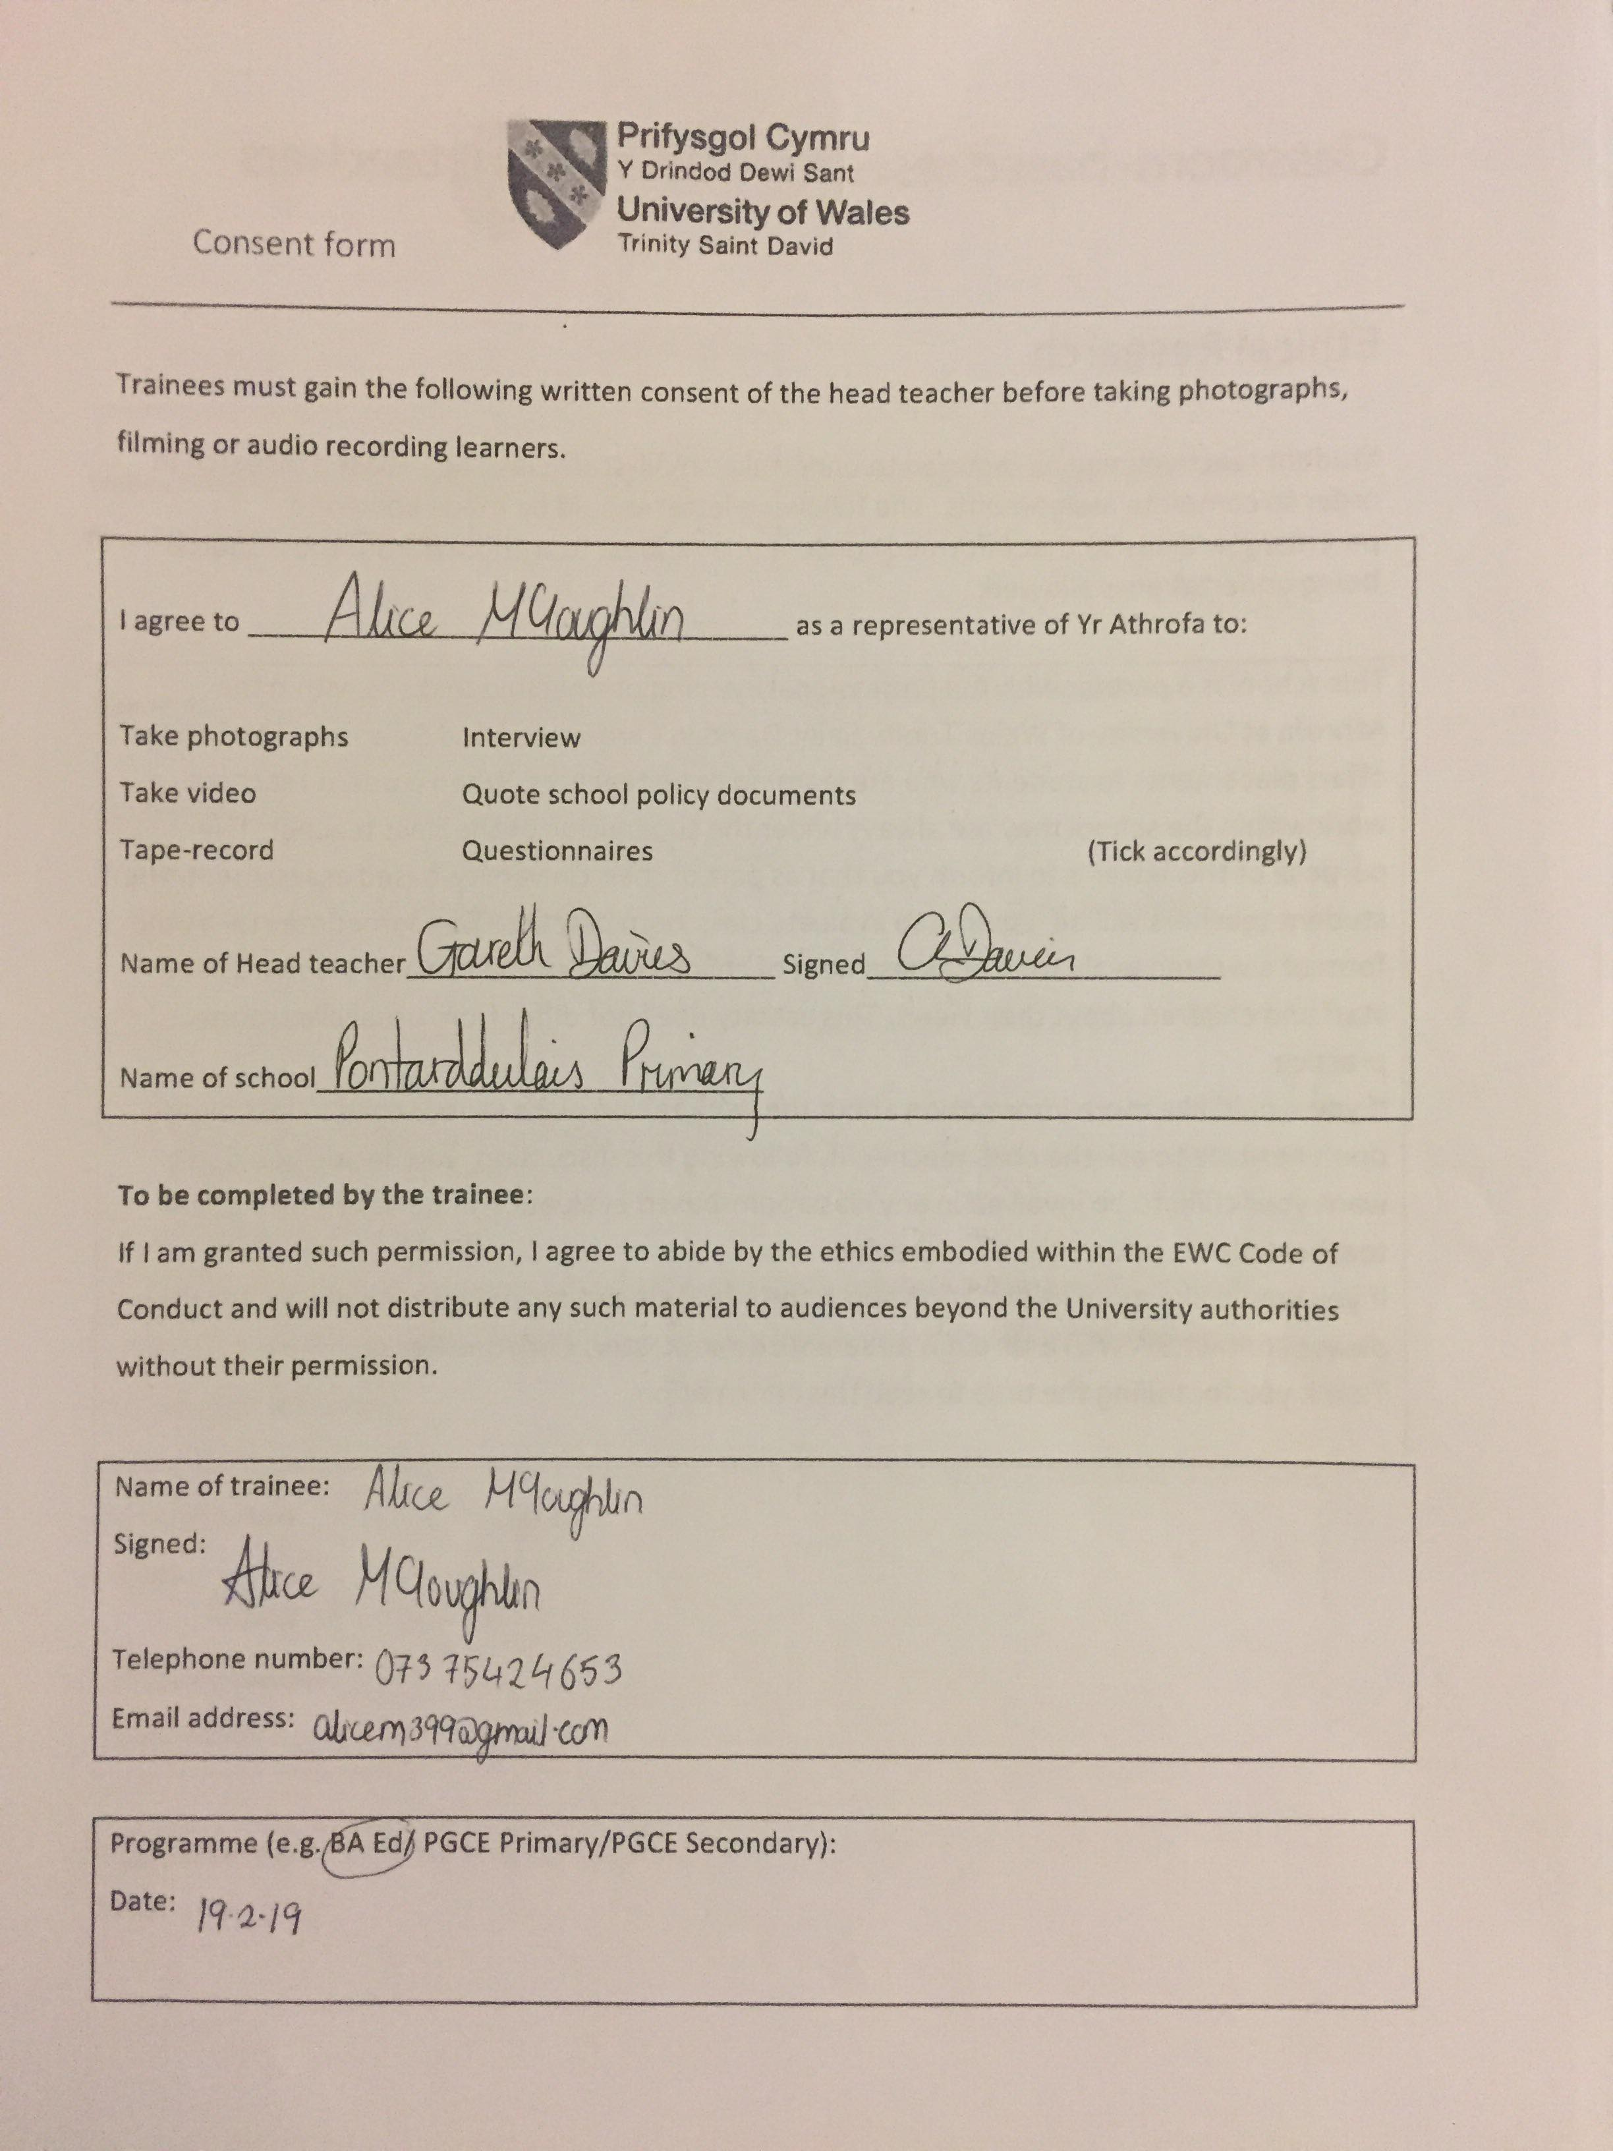

Appendix 4
Rhif Adnabod Cyfranogwr:
Participant Identification Number:
PARTICIPANT INFORMATION SHEET

Teitl Y Prosiect: / Project Title:
Building self-esteem in children with additional learning needs and the impact this can have on their academic progress

Dear Participant:

My name is Alice McLoughlin and I am a student on the BA Primary Education (QTS) course at the University of Wales Trinity Saint David Carmarthen.

I would like to invite you to participate in my research project. This project will aims to discover how building the self-esteem of children with additional learning needs will impact on their learning experiences. Through your participation in the questionnaire and/or interviews, I hope to ascertain different views on this topic in the Foundation Phase/Key Stage 2.

All questionnaires/interviews will be kept strictly confidential to the researchers involved and at NO time will individual questionnaires be released to the general public. Your participation in this study is completely voluntary so you can withdraw from the questionnaire/interview at any stage.

My questionnaire/interview should take about 5-10 minutes to complete, but there is no time constraint. There are also no right or wrong answers. Attached to this letter is a consent form. I understand that your time is at a premium but your opinions are very valuable to me.

After careful and precise analysis of the data obtained from this questionnaire, I will be happy to provide you with a copy of the findings at your request. The results of this questionnaire/interview will hopefully enhance my understanding.

I thank you in advance for your time and participation. If any questions do arise, feel free to contact me at your convenience.

ENW A CHYFEIRIAD YR YMCHWILYDD | NAME & ADDRESS OF RESEARCHER  Alice McLoughlin  University of Wales  Trinity St David  Carmarthen  SA31 3EP  c/o Dr Sioned V Hughes  University of Wales  Trinity Saint David  Carmarthen  SA31 3EP

Appendix 5
FFURFLEN GANIATÂD CYFRANOGIAD | PARTICIPATION CONSENT FORM
Teitl Y Prosiect: / Project Title:
Building self-esteem in children with additional learning needs and the impact this can have on their academic progress
Enw'r Ymchwilydd / Name of Researcher:
Alice McLoughlin

1 | Cadarnhaf fy mod wedi deall y wybodaeth a roddwyd gan ......................... (enw’r ymchwilydd) ar gyfer ei chynnig ymchwil. Rwyf wedi cael y cyfle i ystyried y wybodaeth, gofyn cwestiynau, ac rwyf wedi cael ateb boddhaol i’r rhain. |  | I confirm that I understand the information given by ……………for her research proposal. I have had the opportunity to consider the information, ask questions and have had these answered satisfactorily.
2 | Deallaf fy mod yn cymryd rhan o’m gwirfodd a bod croeso i mi dynnu’n ôl ar unrhyw adeg, heb roi rheswm. |  | I understand that my participation is voluntary and that I am free to withdraw at any time, without giving any reason.
3 | Deallaf y gellir defnyddio unrhyw wybodaeth a roddir gennyf mewn adroddiadau, erthyglau neu gyflwyniadau gan y tîm ymchwil. |  | I understand that any information given by me may be used in future reports, articles or presentations by the research team.
4 | Deallaf na fydd fy enw’n ymddangos mewn unrhyw adroddiadau, erthyglau neu gyflwyniadau. |  | I understand that my name will not appear in any reports, articles or presentations.
5 | Cytunaf i gymryd rhan yn yr astudiaeth uchod. |  | I agree to take part in the above study.
Enw’r Cyfranogwr Name of Participant |  |  |  | Llofnodwyd  Signature
Ymchwilydd  Researcher |  |  |  | Llofnodwyd  Signature

Cewch wrthod cymryd rhan yn yr astudiaeth hon. Cewch ddod â’ch cyfranogiad yn yr astudiaeth hon i ben unrhyw bryd. Os penderfynwch barhau’n ddienw, bydd sicrhau hynny’n flaenoriaeth a chymerir pob cam ymarferol i guddio pwy ydych. Os yw’n well gennych fod yn anhysbys, ni fydd unrhyw wybodaeth yn eich enwi ar dapiau sain na thrawsgrifiadau o’r cyfweliad hwn nac o unrhyw un arall. Ni fydd neb yn clywed unrhyw dapiau sain nac yn gweld unrhyw drawsgrifiadau heb eich cydsyniad o flaen llaw. Bydd deunyddiau a grëir yn sgil y cyfweliad hwn neu unrhyw gyfweliad arall yn aros yn gyfrinachol. | You may decline to participate in this study. You may end your participation in this study at any time. If you decide to remain anonymous, maintaining your anonymity will be a priority and every practical precaution will be taken to disguise your identity. If you prefer anonymity, there will not be any identifying information on audiotapes or transcripts of this or any interview. No-one will hear any audiotapes or see any transcripts without your prior consent. All materials generated from this or any interview will remain confidential.

Ar ôl llenwi’r ffurflen, dychwelwch hi yn yr amlen a ddarperir (lle bo’n berthnasol). Rhoddir un copi i’r cyfranogwr a chedwir y gwreiddiol yn ffeil y tîm ymchwilio yn: | When completed please return in the envelope provided (if applicable). One copy will be given to the participant and the original to be kept on the file of the research team at:
ENW A CHYFEIRIAD YR YMCHWILYDD | NAME & ADDRESS OF RESEARCHER  …………  c/o Dr Sioned V Hughes  University of Wales  Trinity Saint David  Carmarthen  SA31 3EP

Appendix 6

The 16 Habits of Mind identified by Costa and Kallick (2006) include:
- Persisting
- Thinking and communicating with clarity and precision
- Managing impulsivity
- Gathering data through all senses
- Listening with understanding and empathy
- Creating, imagining, innovating
- Thinking flexibly
- Responding with wonderment and awe
- Thinking about thinking (metacognition)
- Taking responsible risks
- Striving for accuracy
- Finding humour
- Questioning and posing problems
- Thinking interdependently
- Applying past knowledge to new situations
- Remaining open to continuous learning

Appendix 7
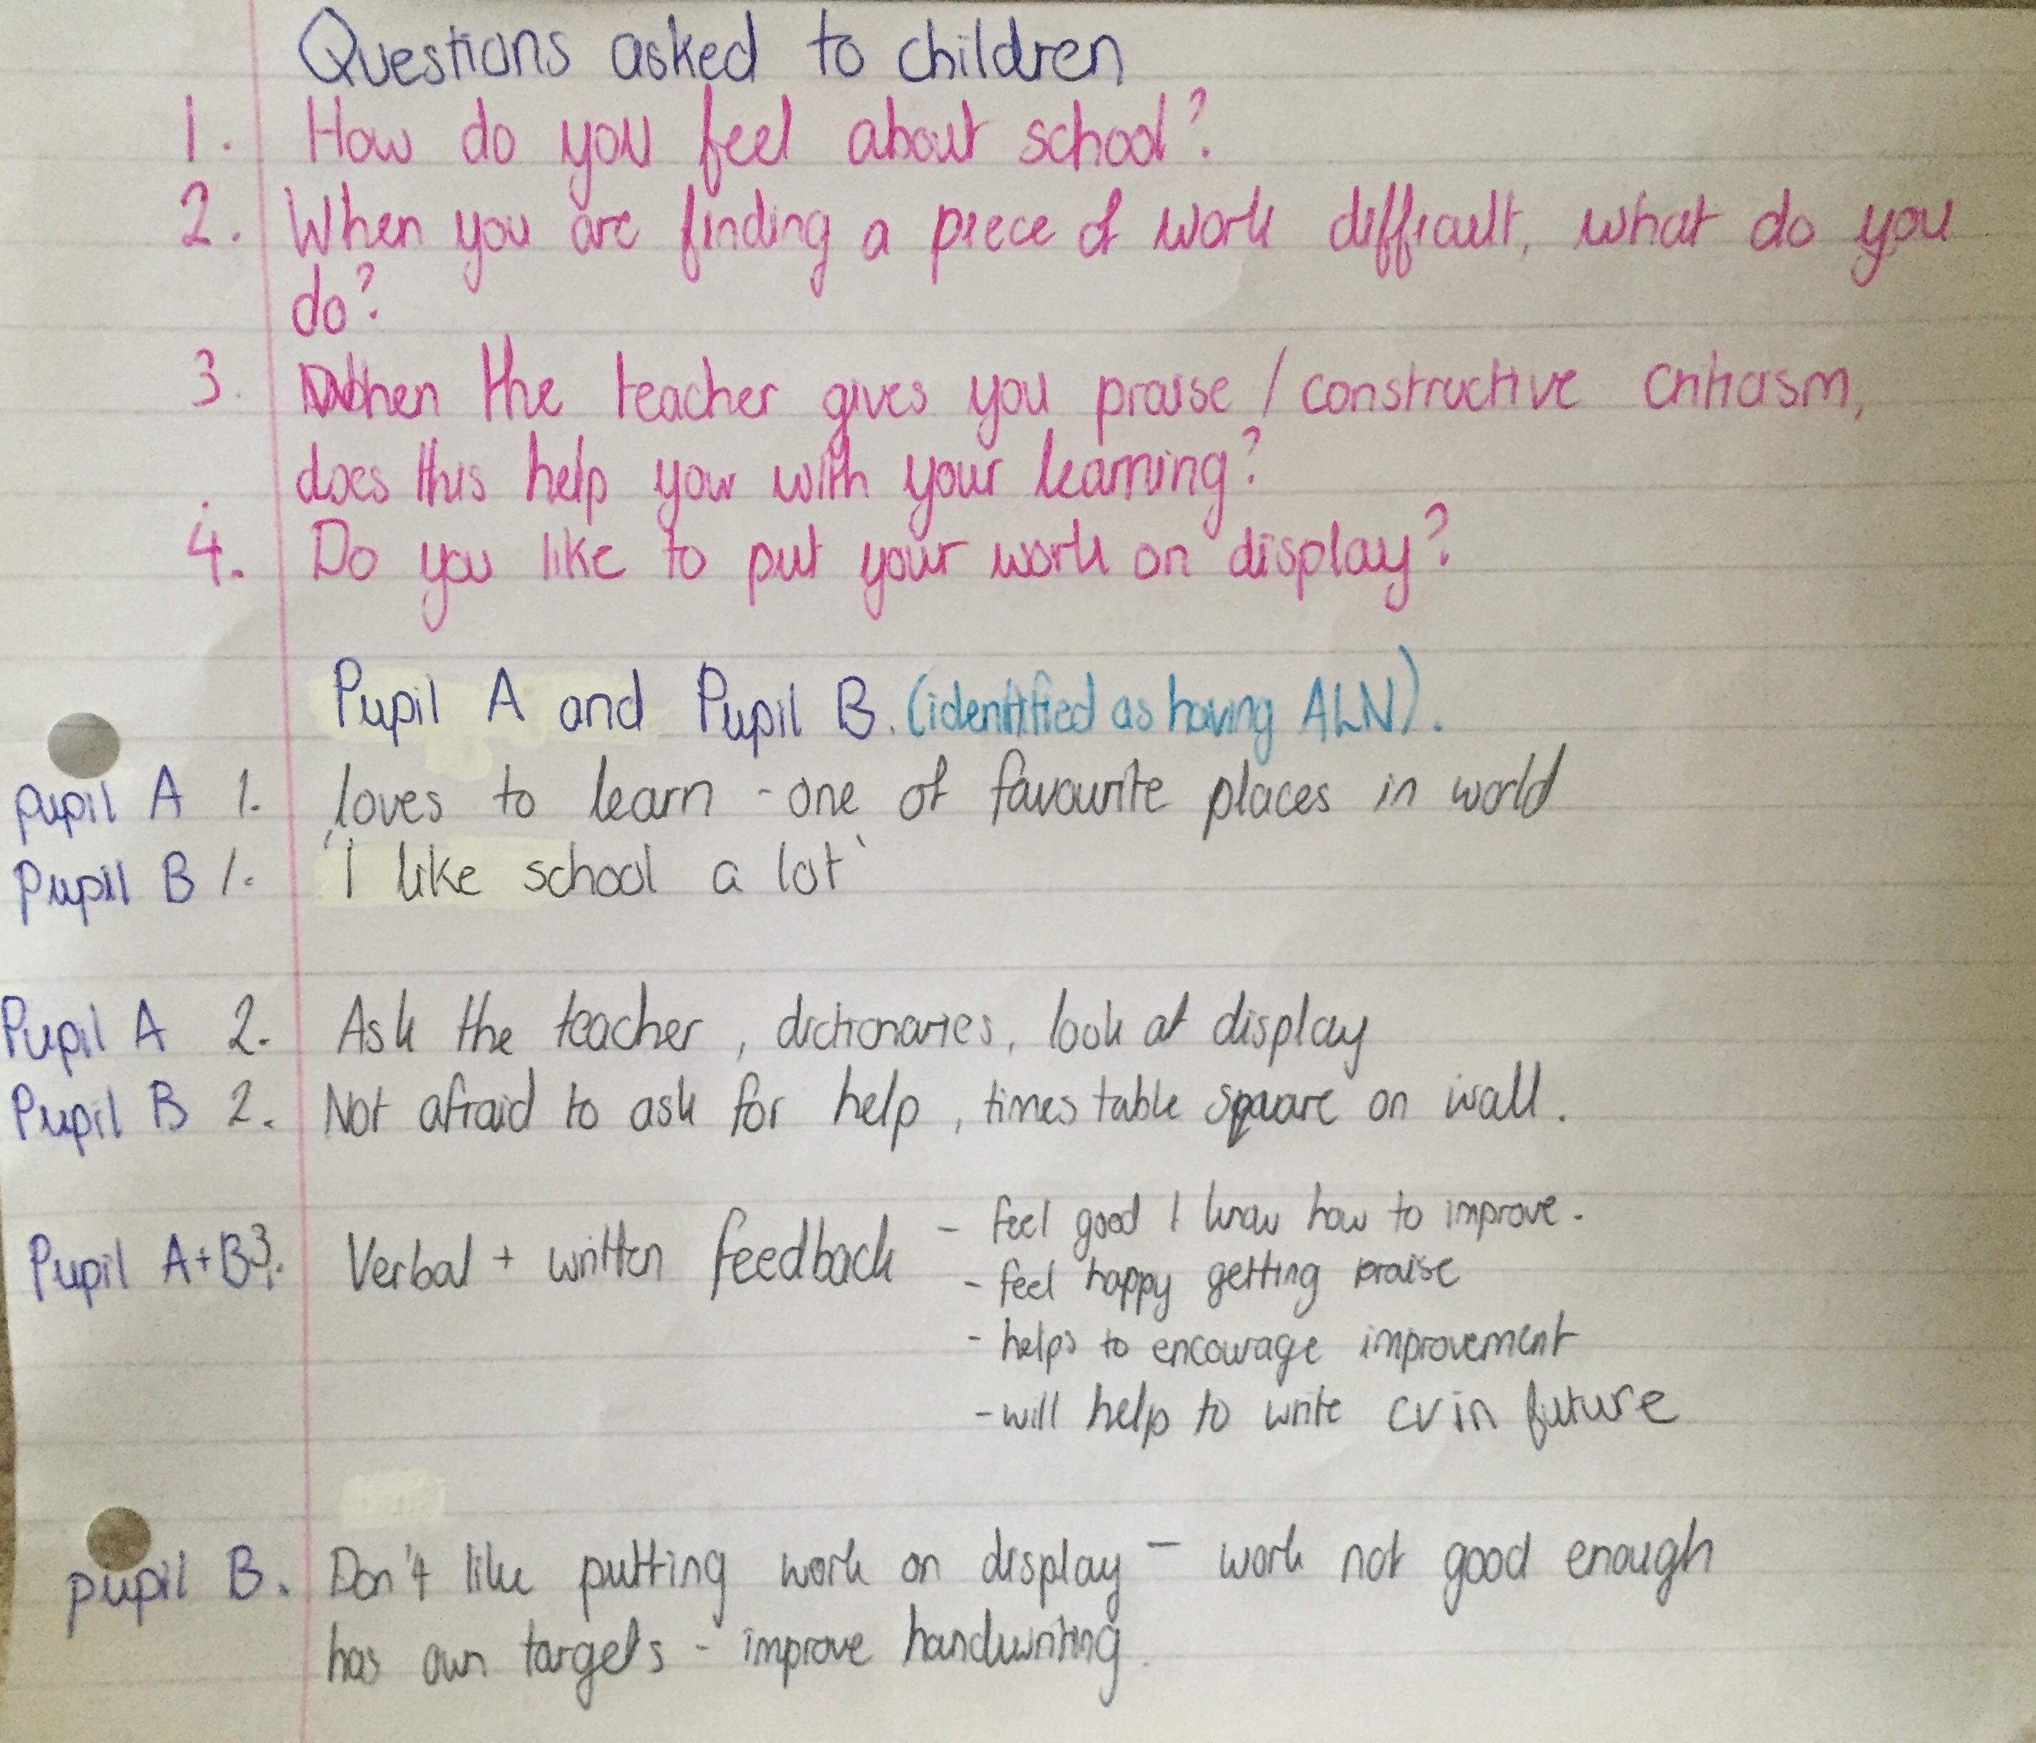
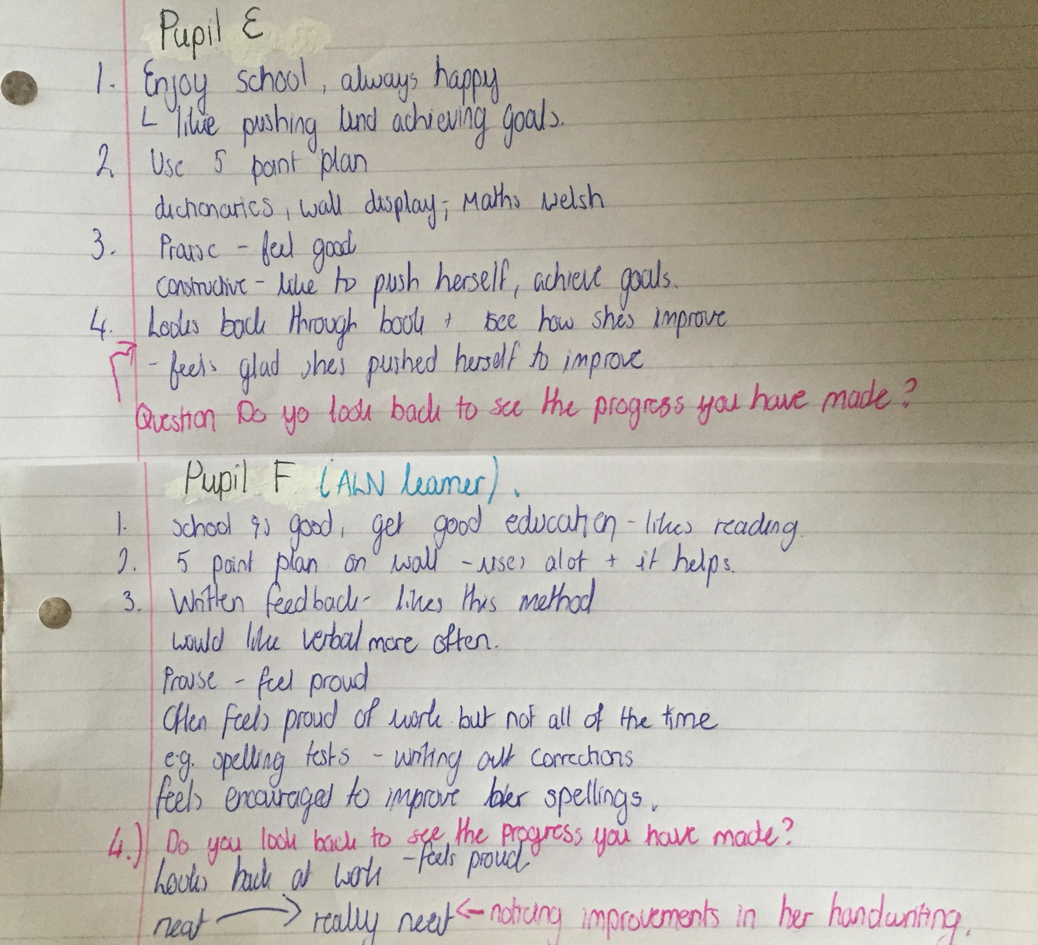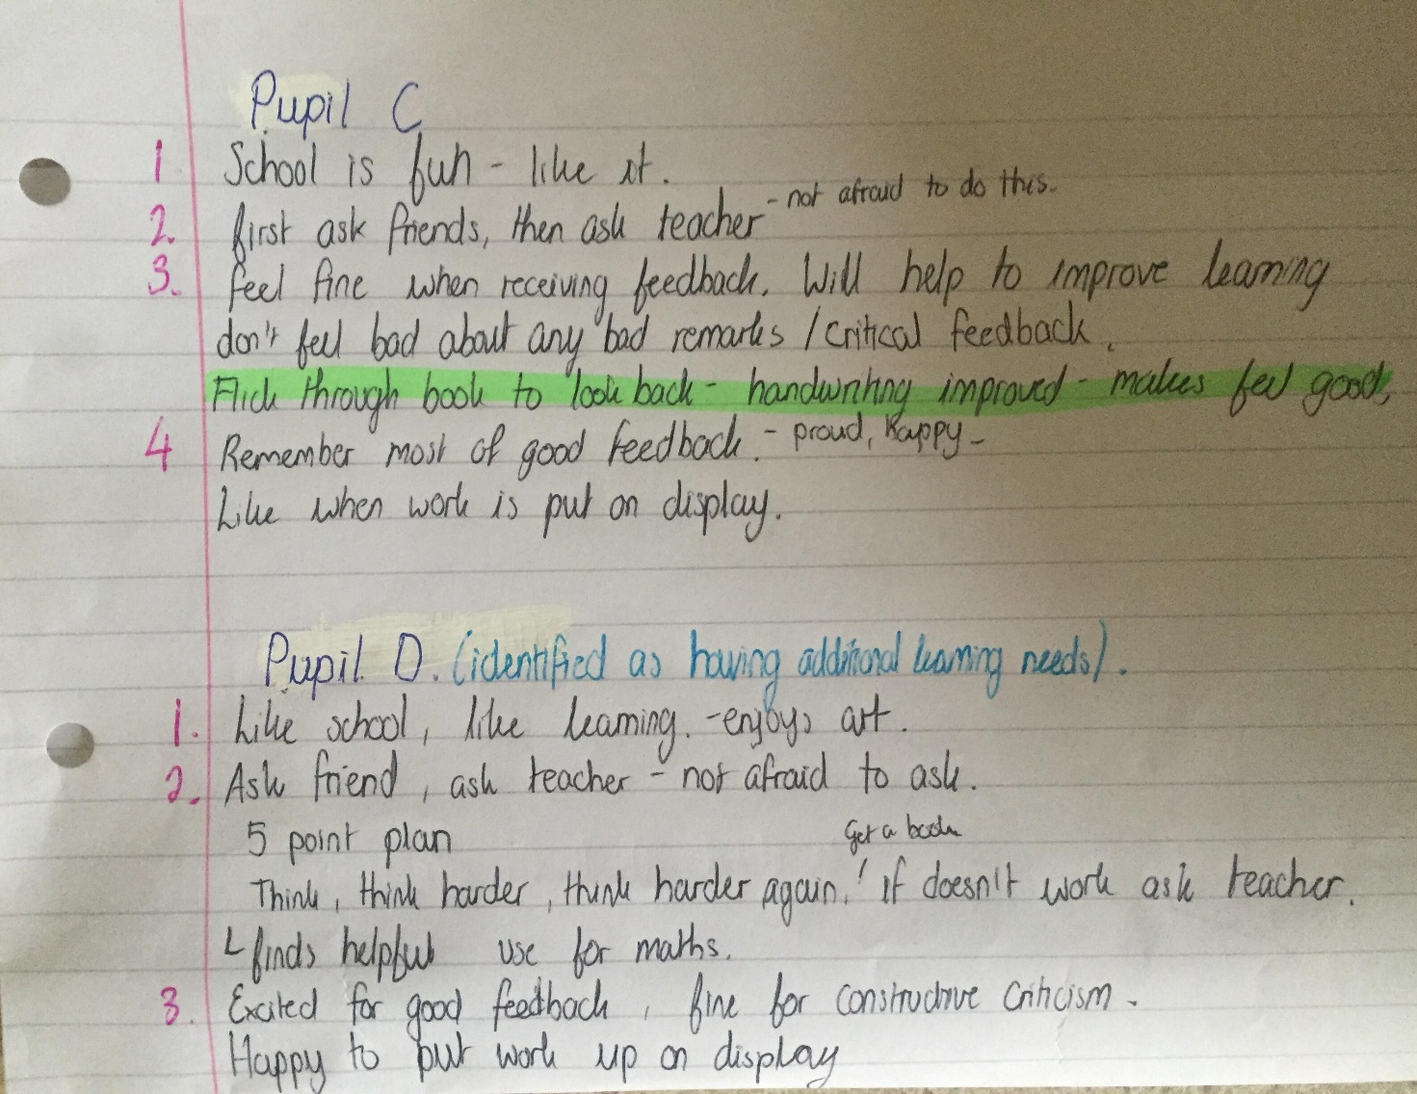

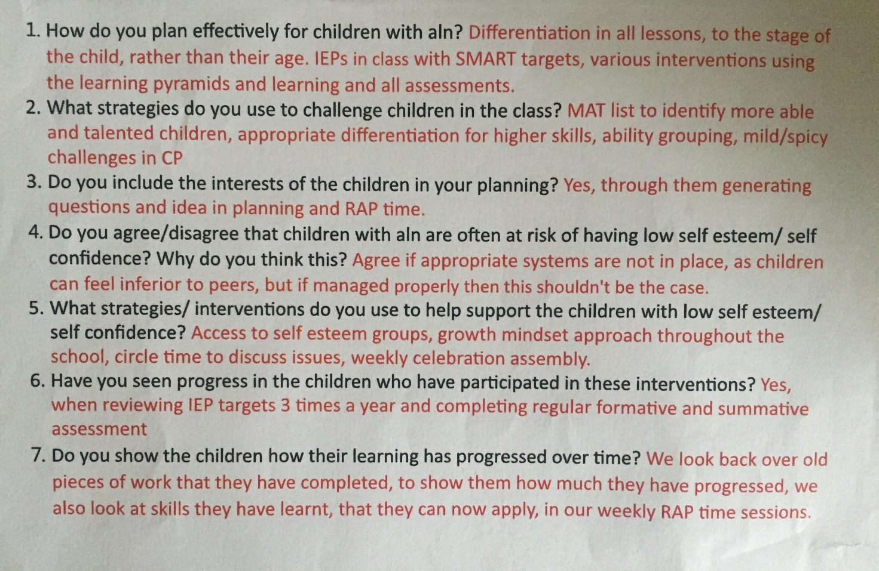
Appendix 8

Appendix 9

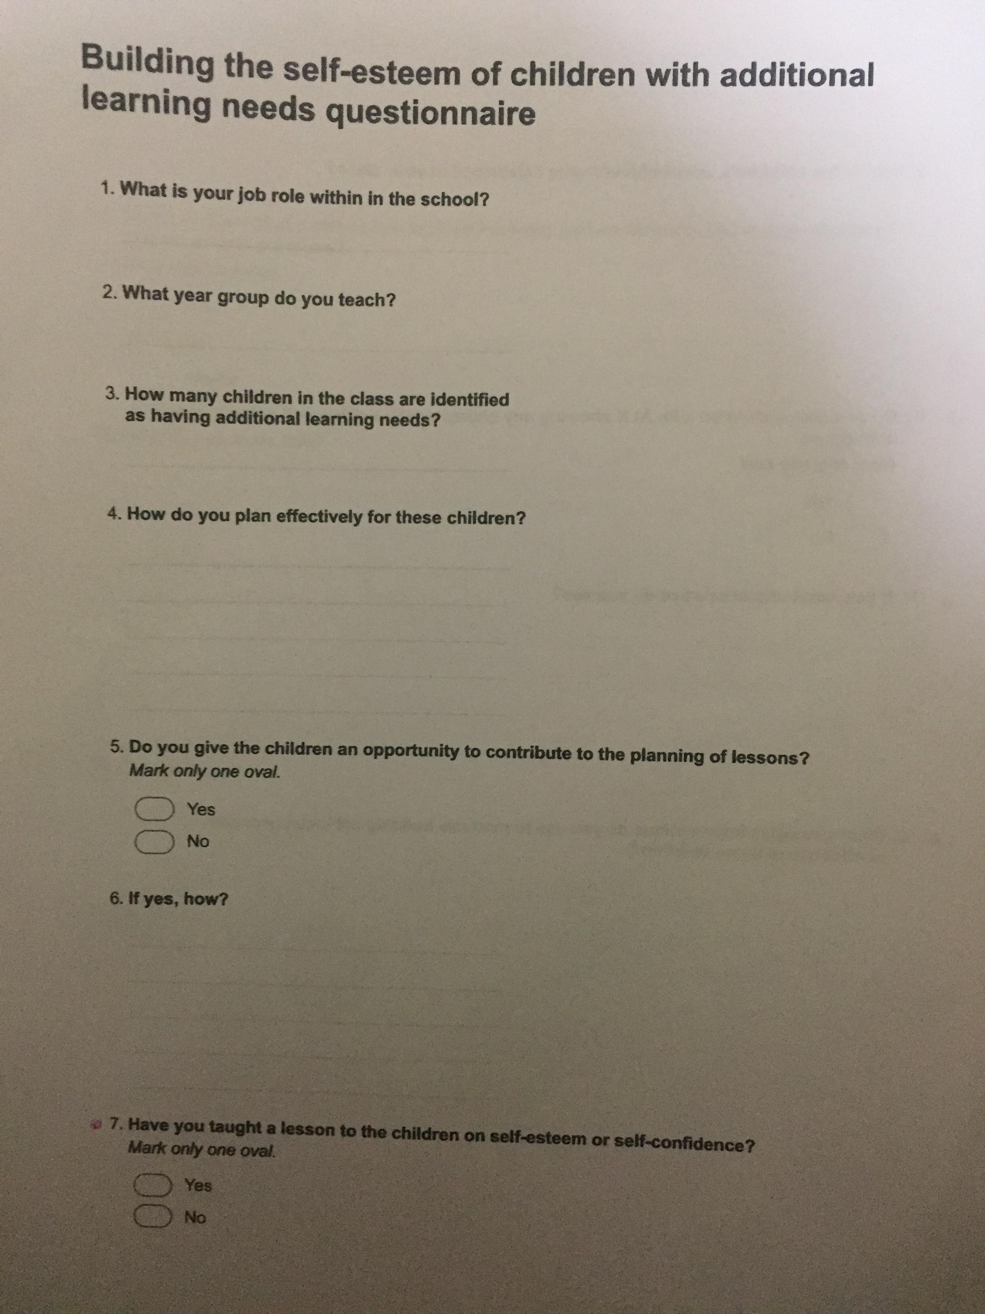

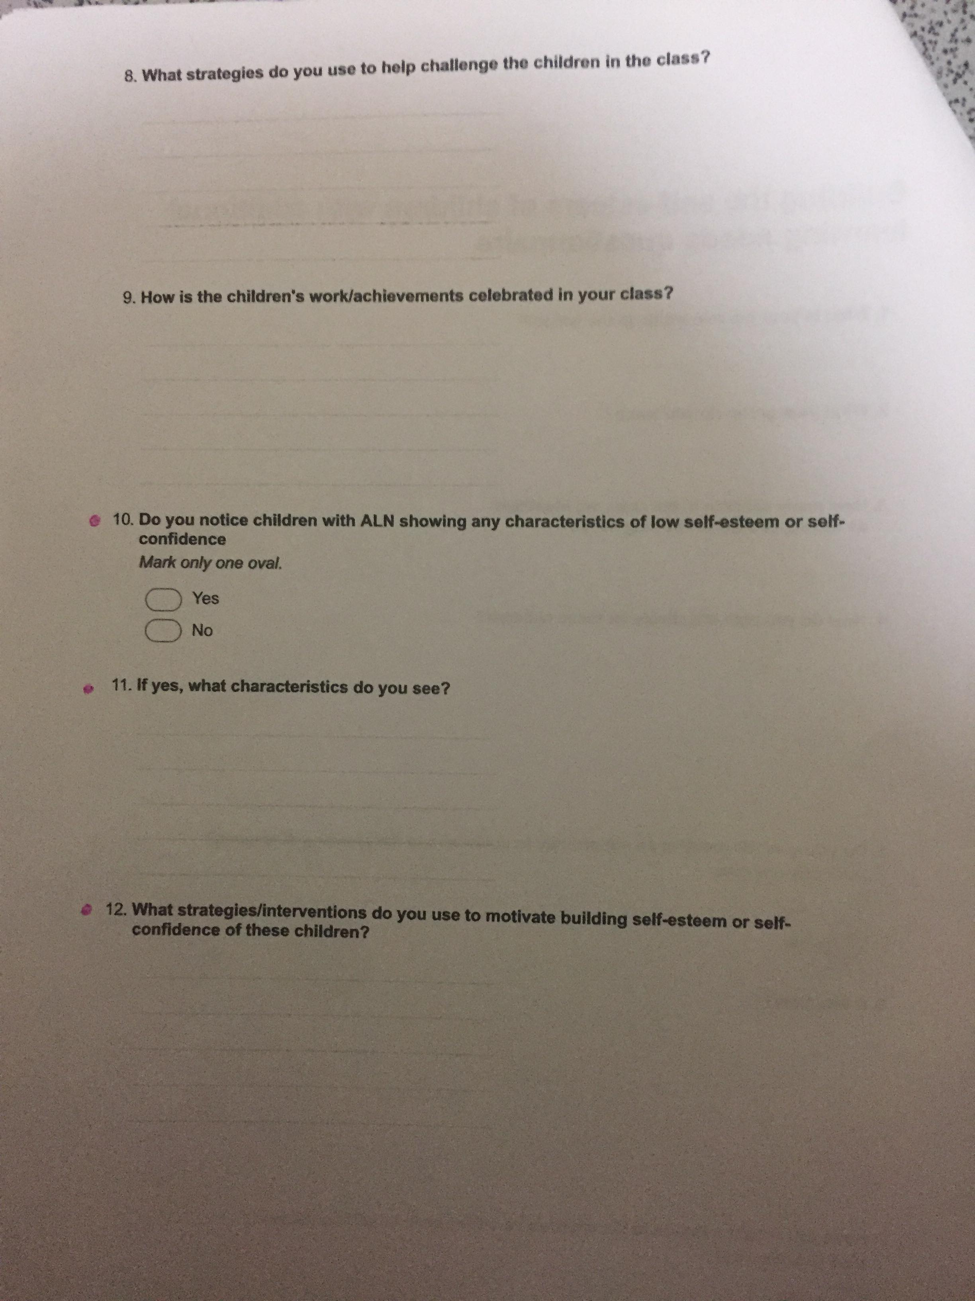

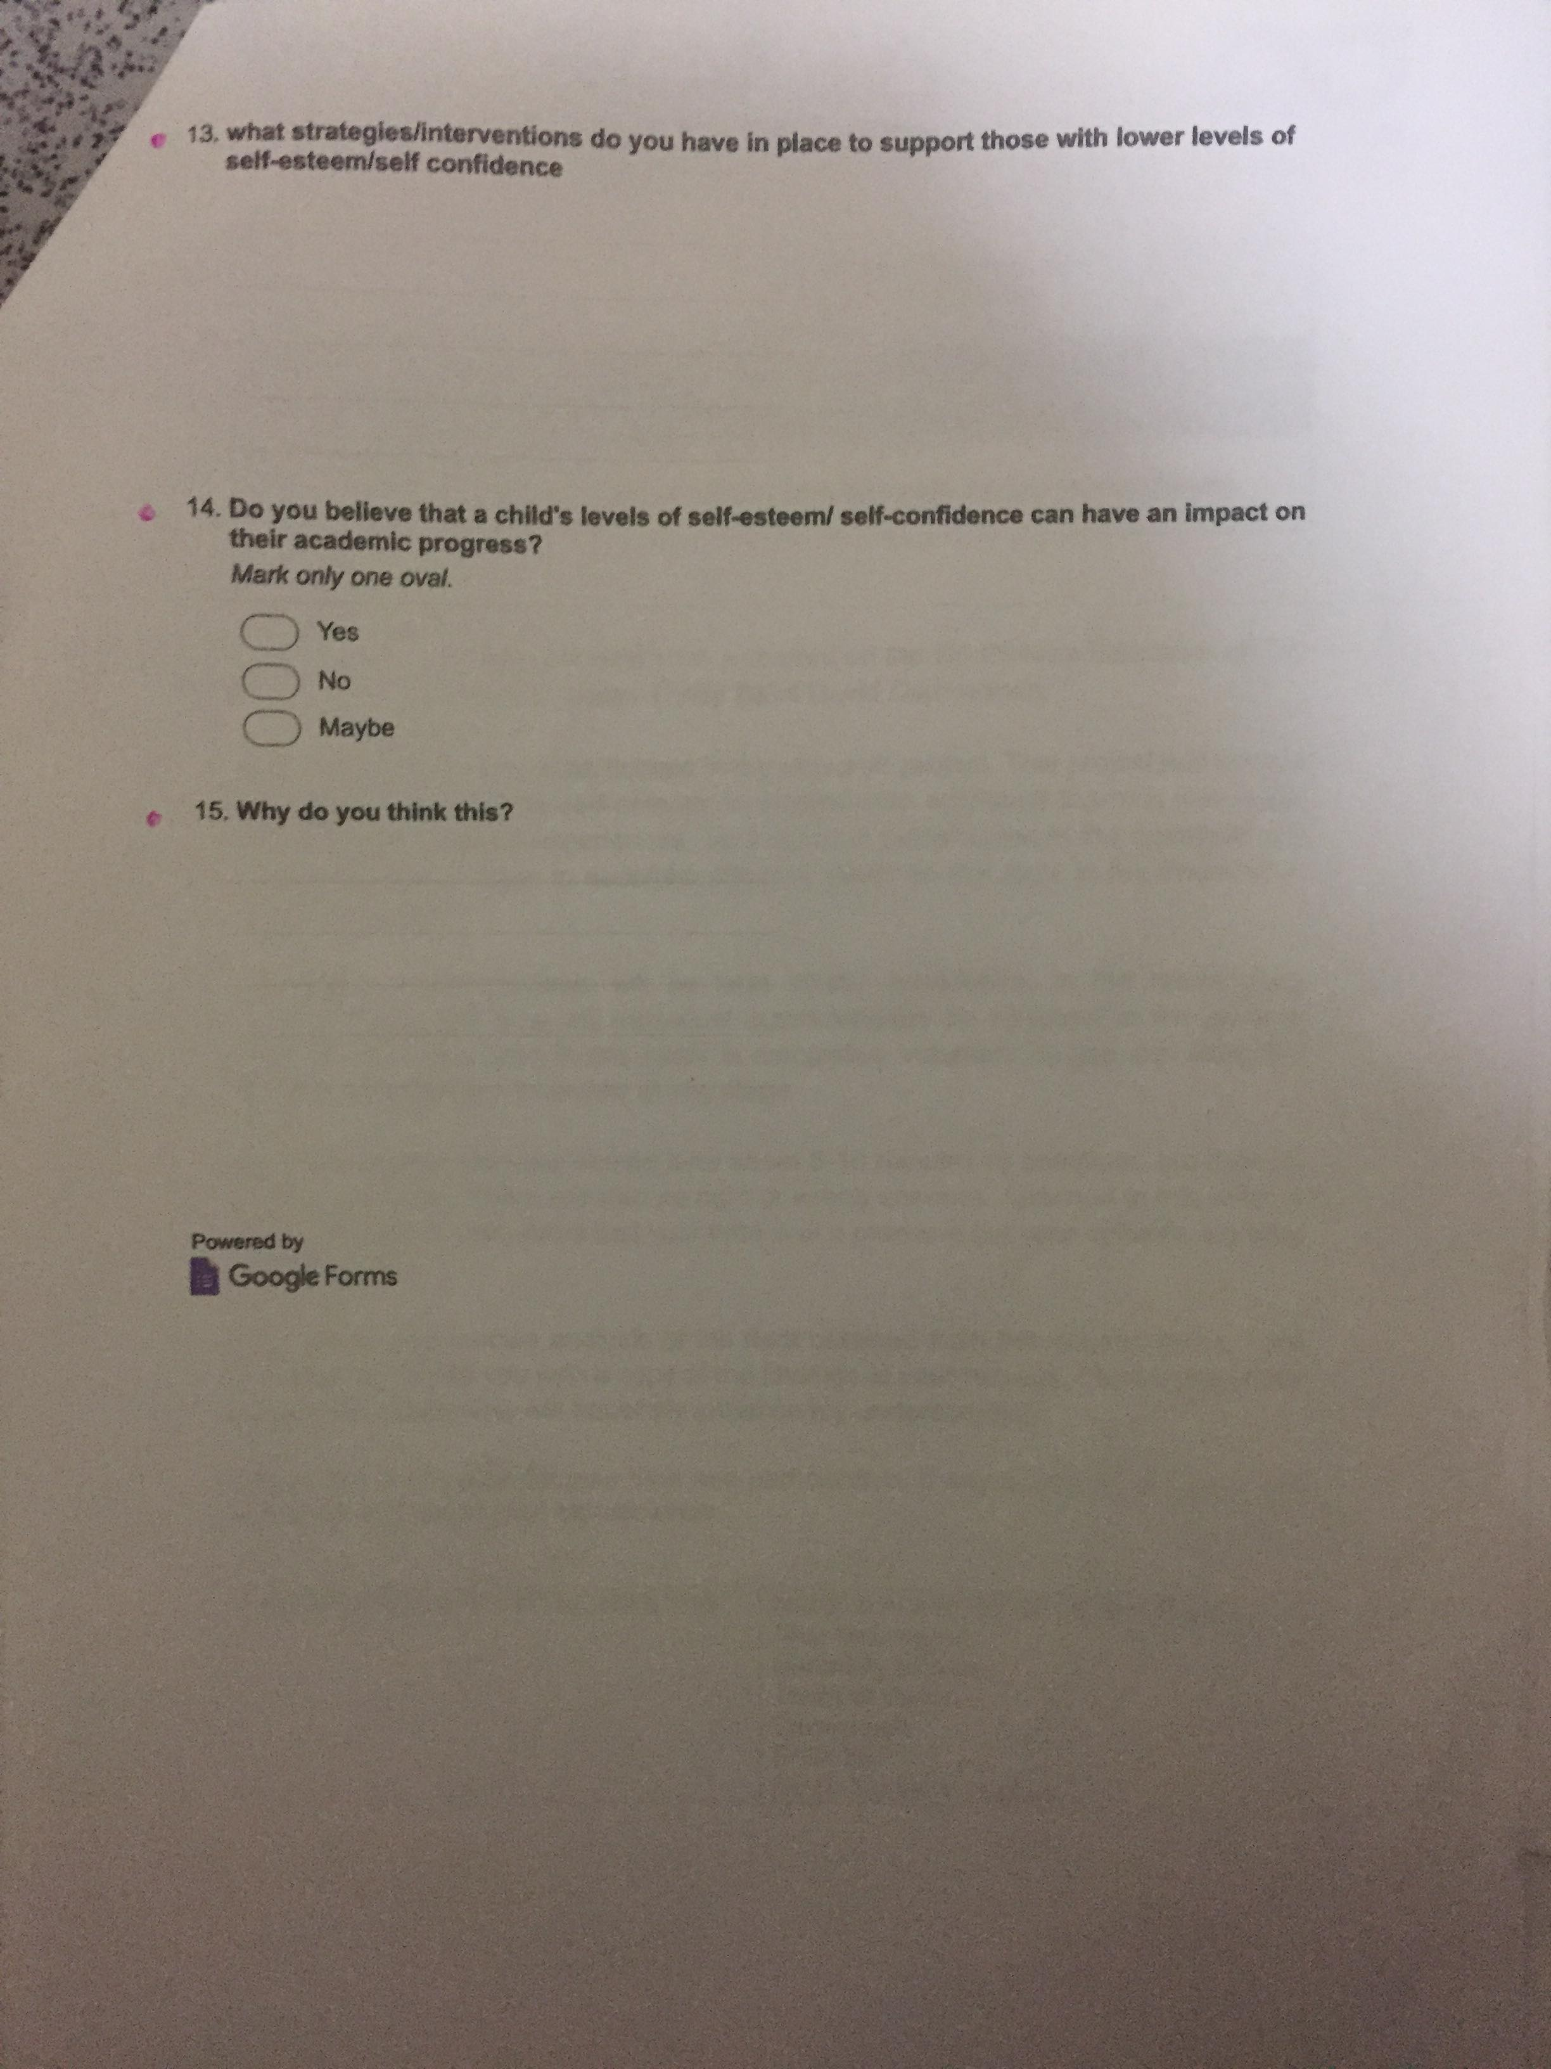

Appendix 10

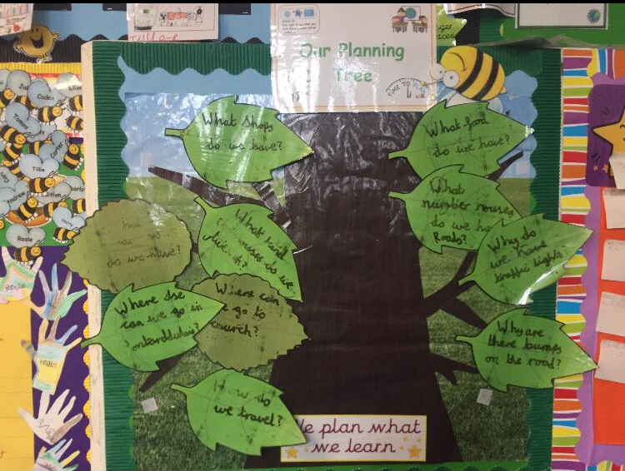

Appendix 11
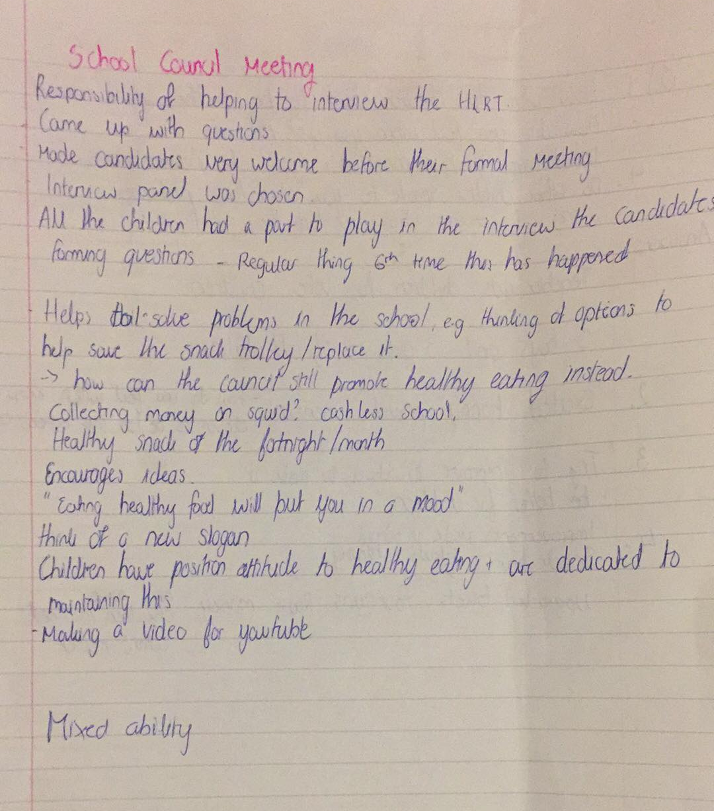

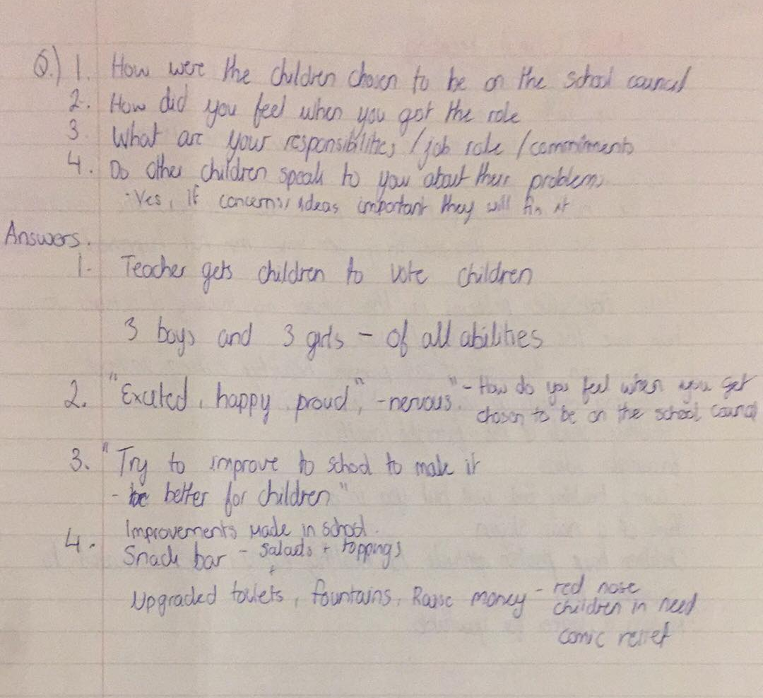

Appendix 12
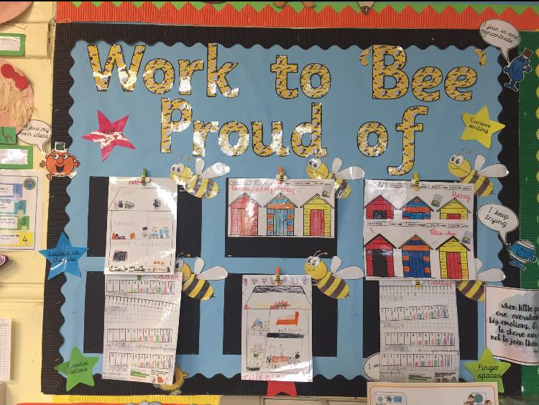

Appendix 13

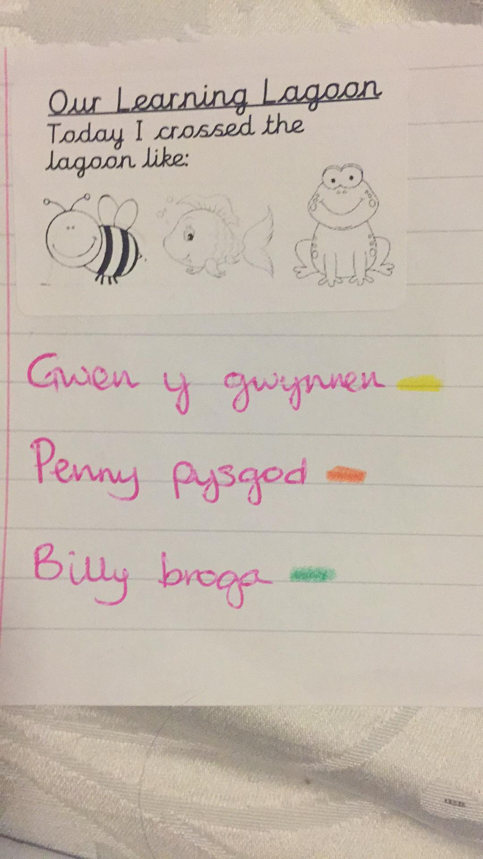

Appendix 14

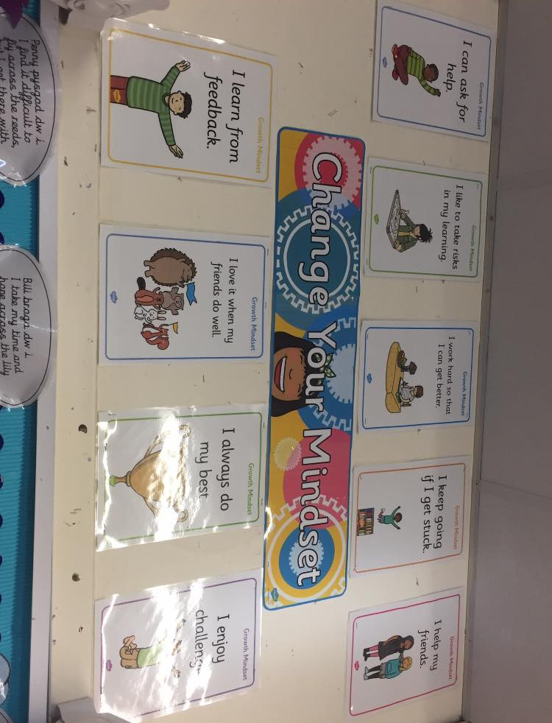

Appendix 15

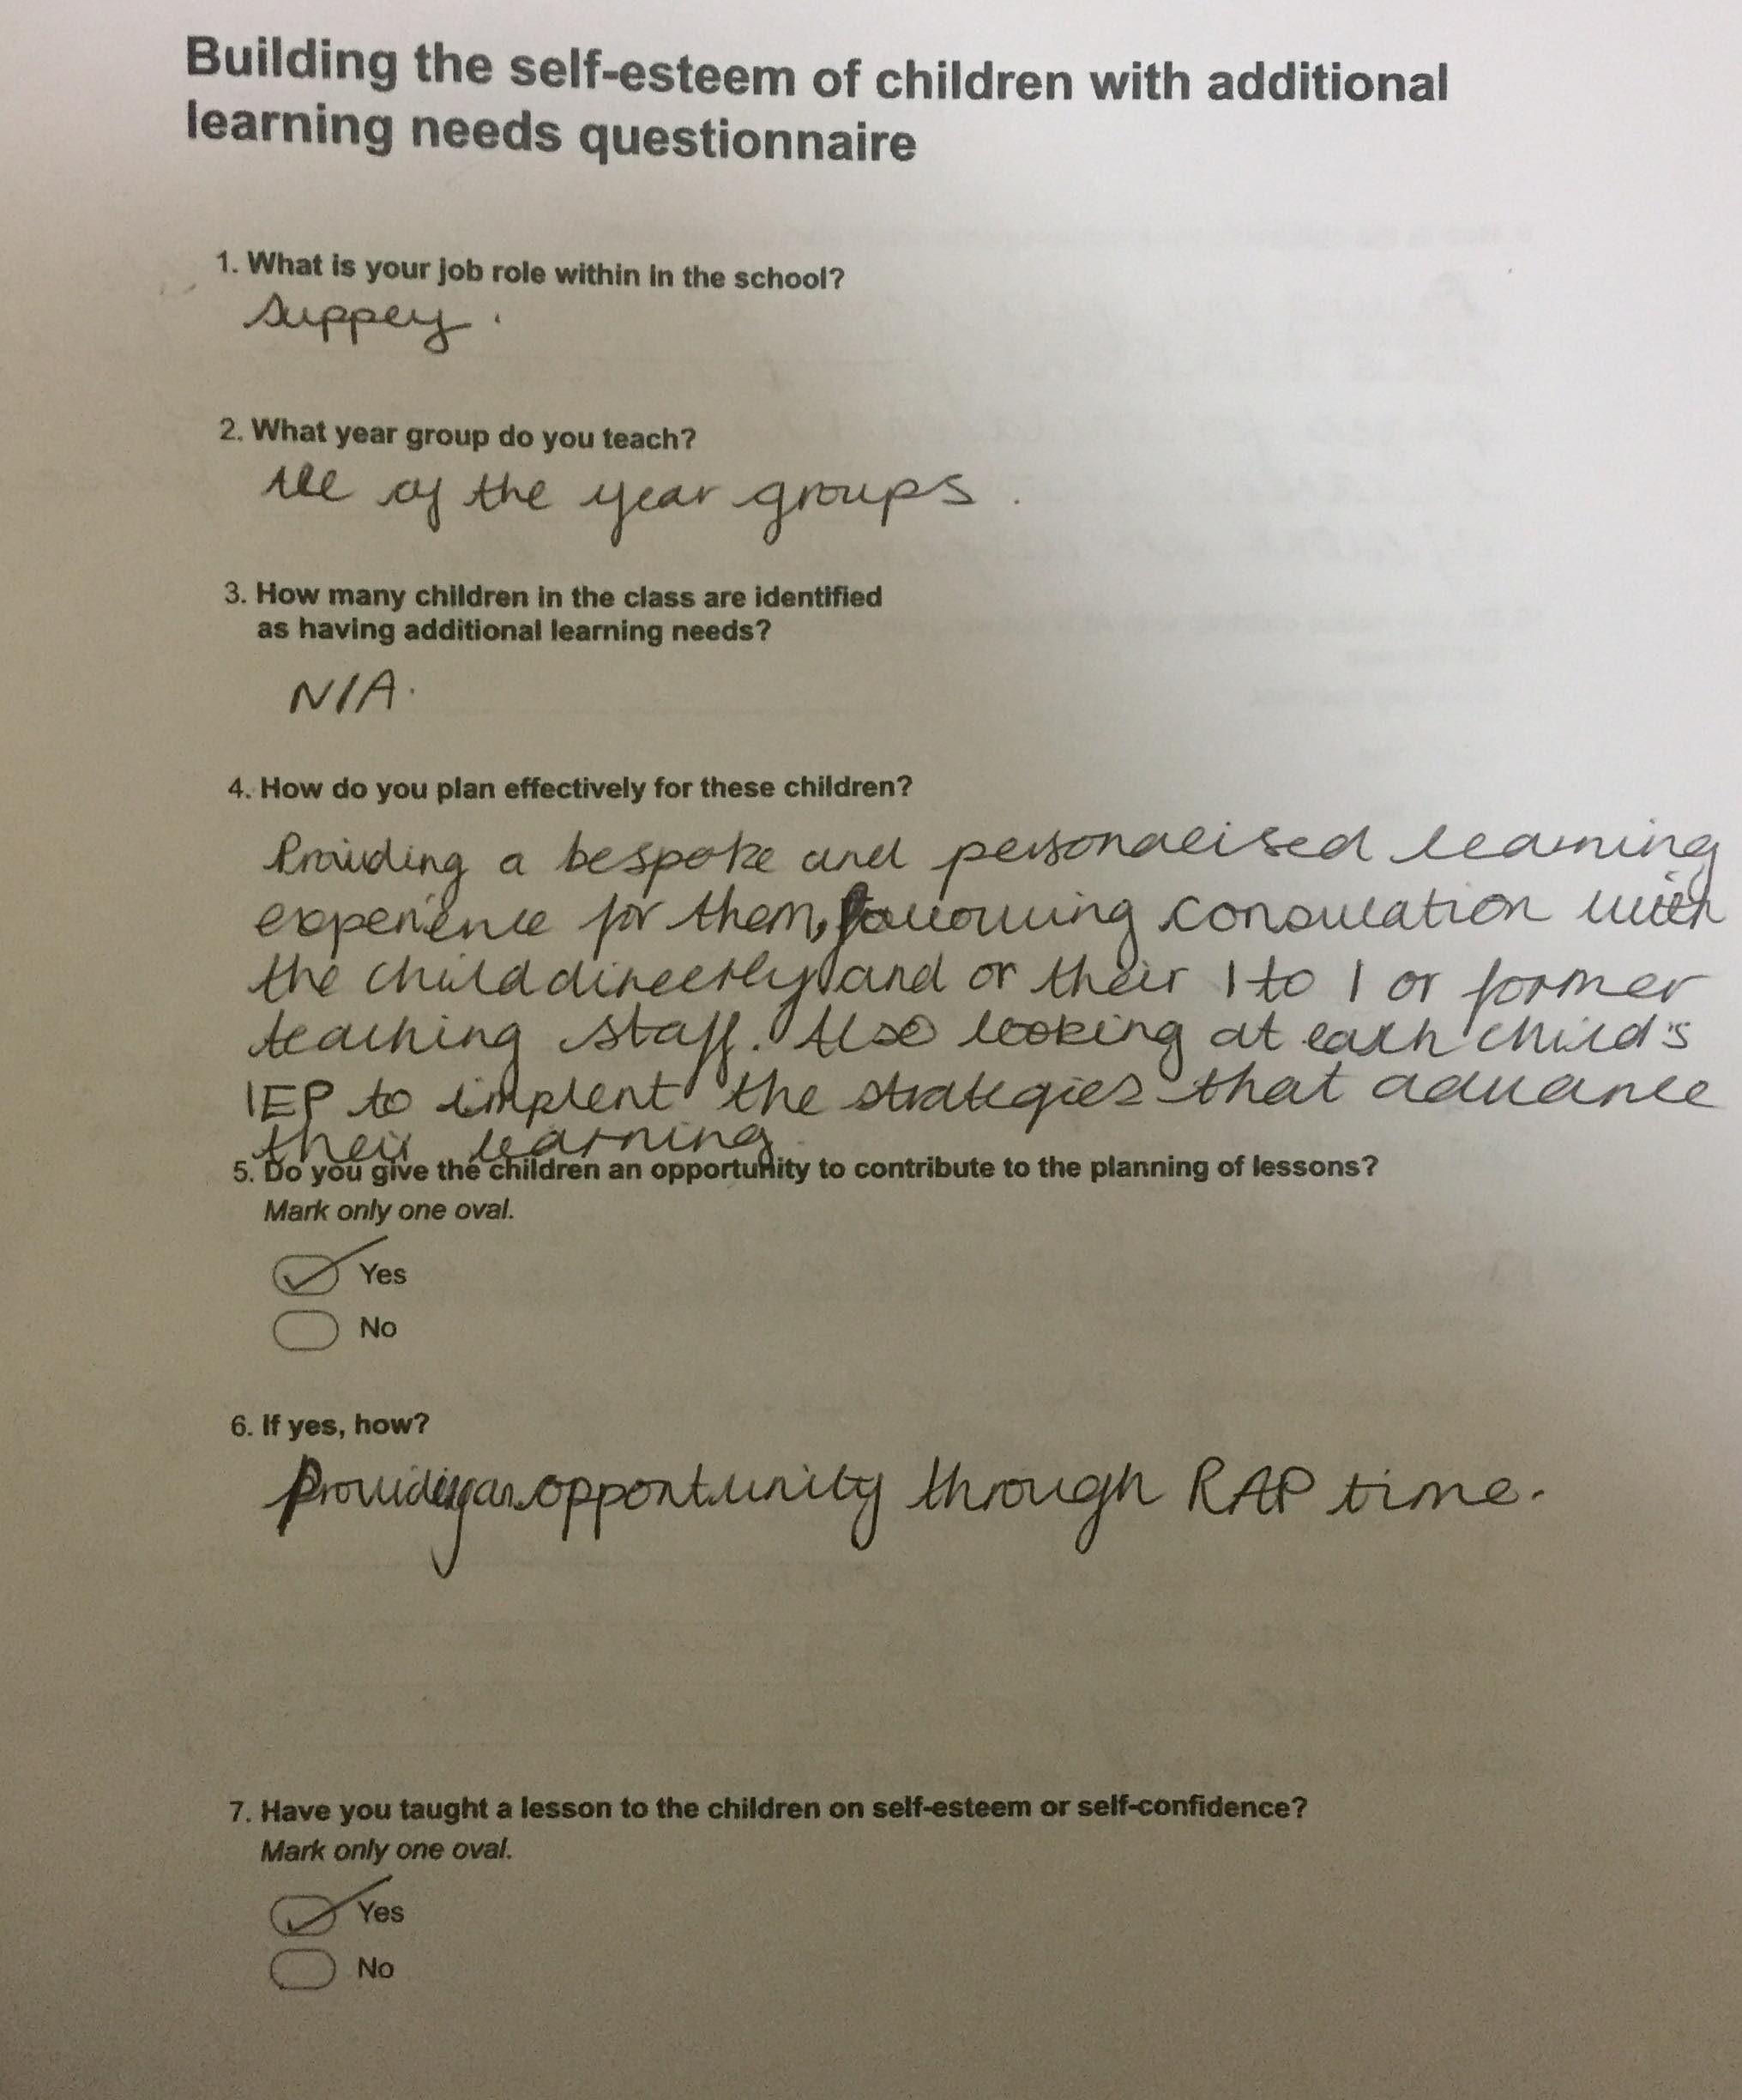

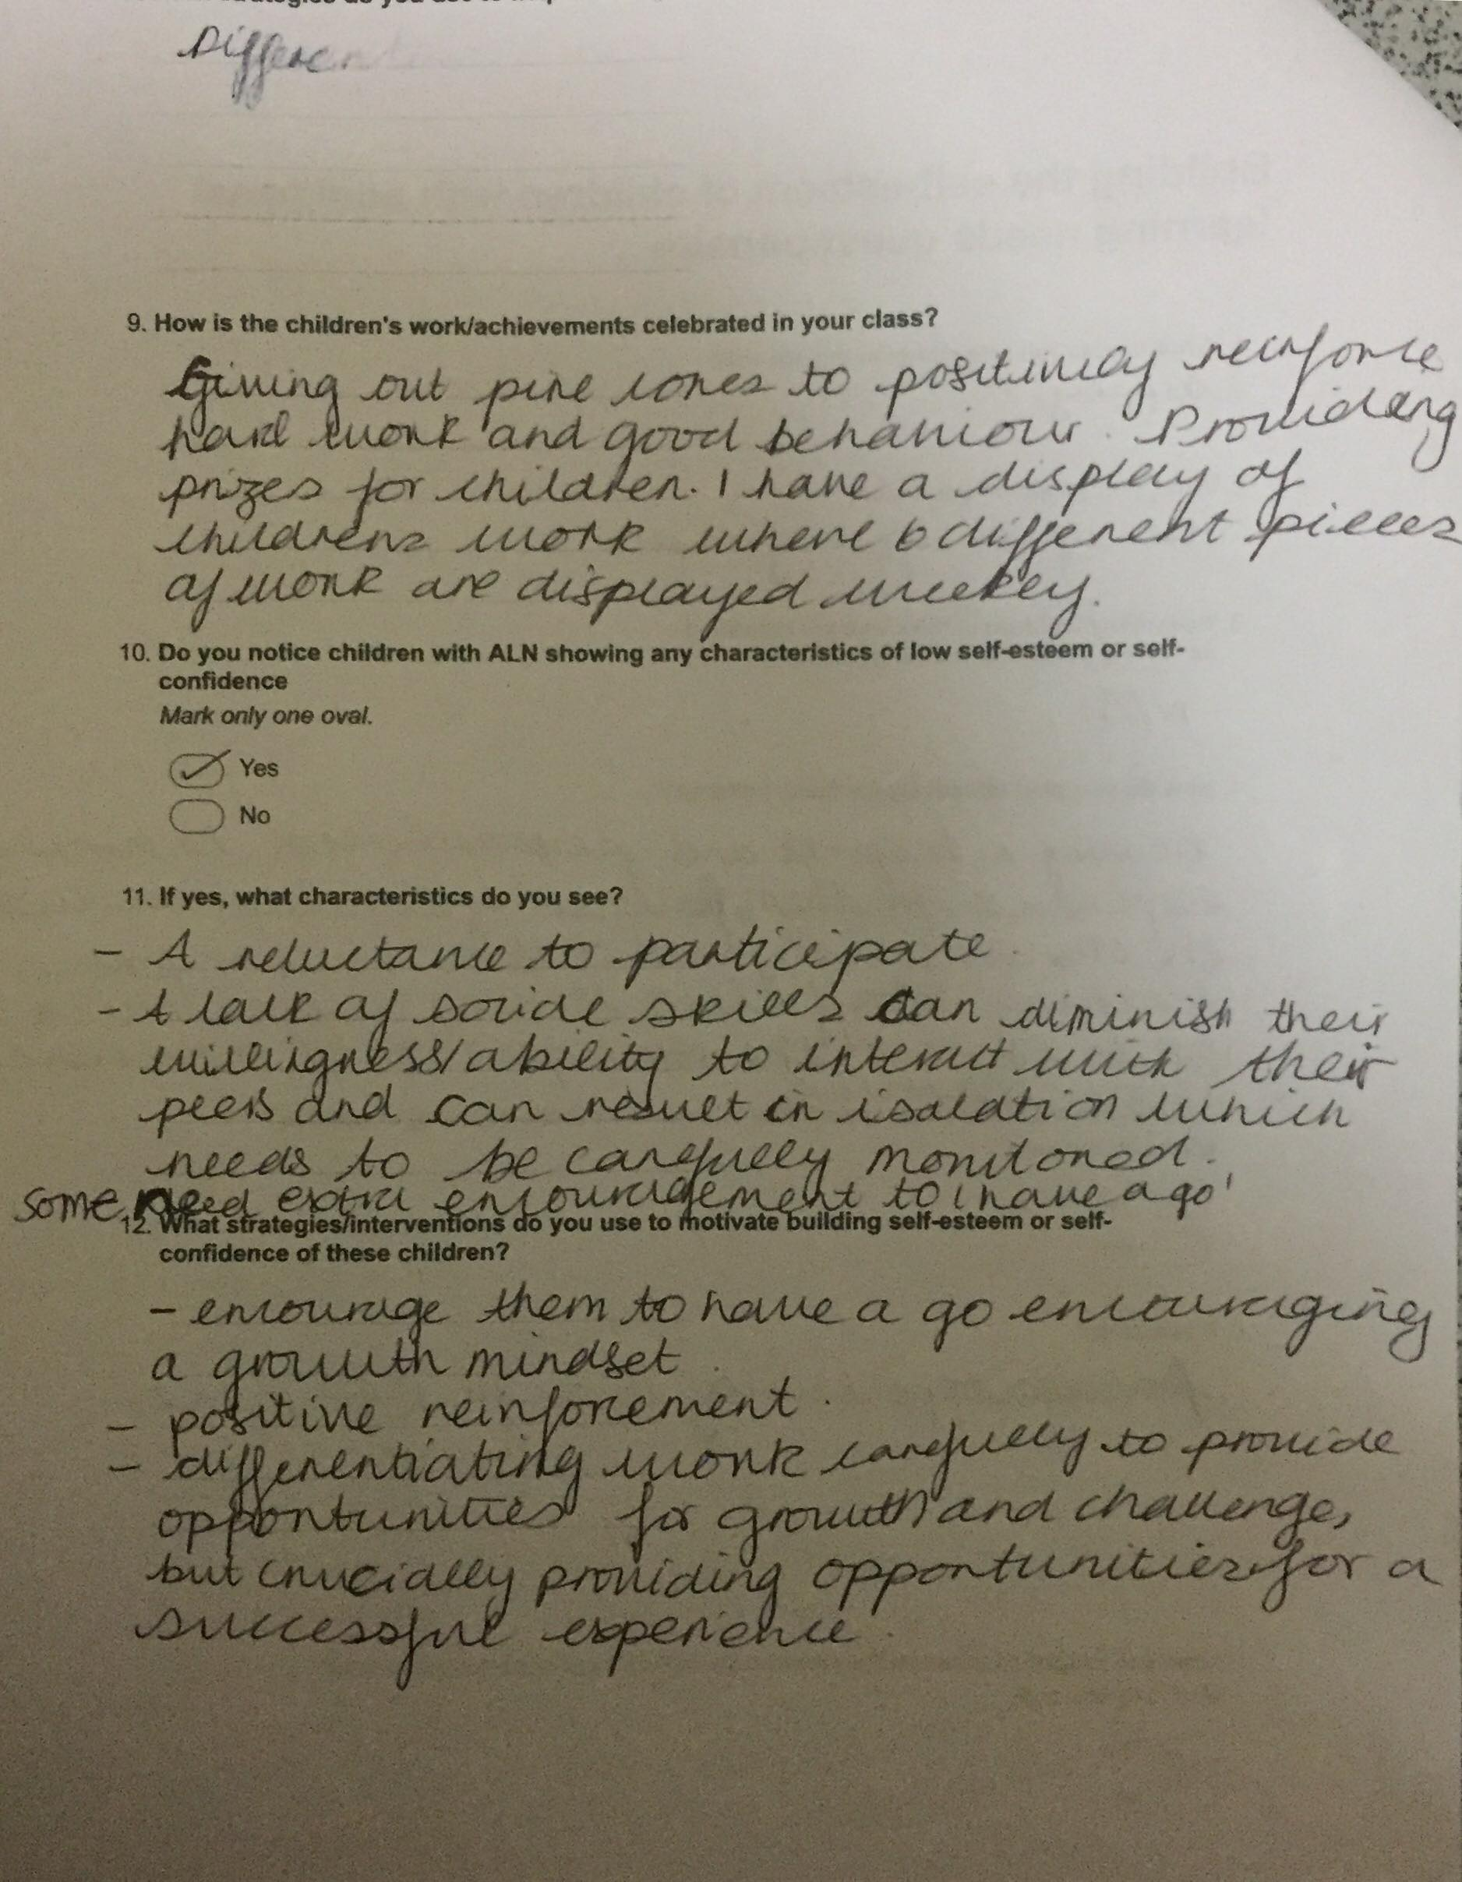

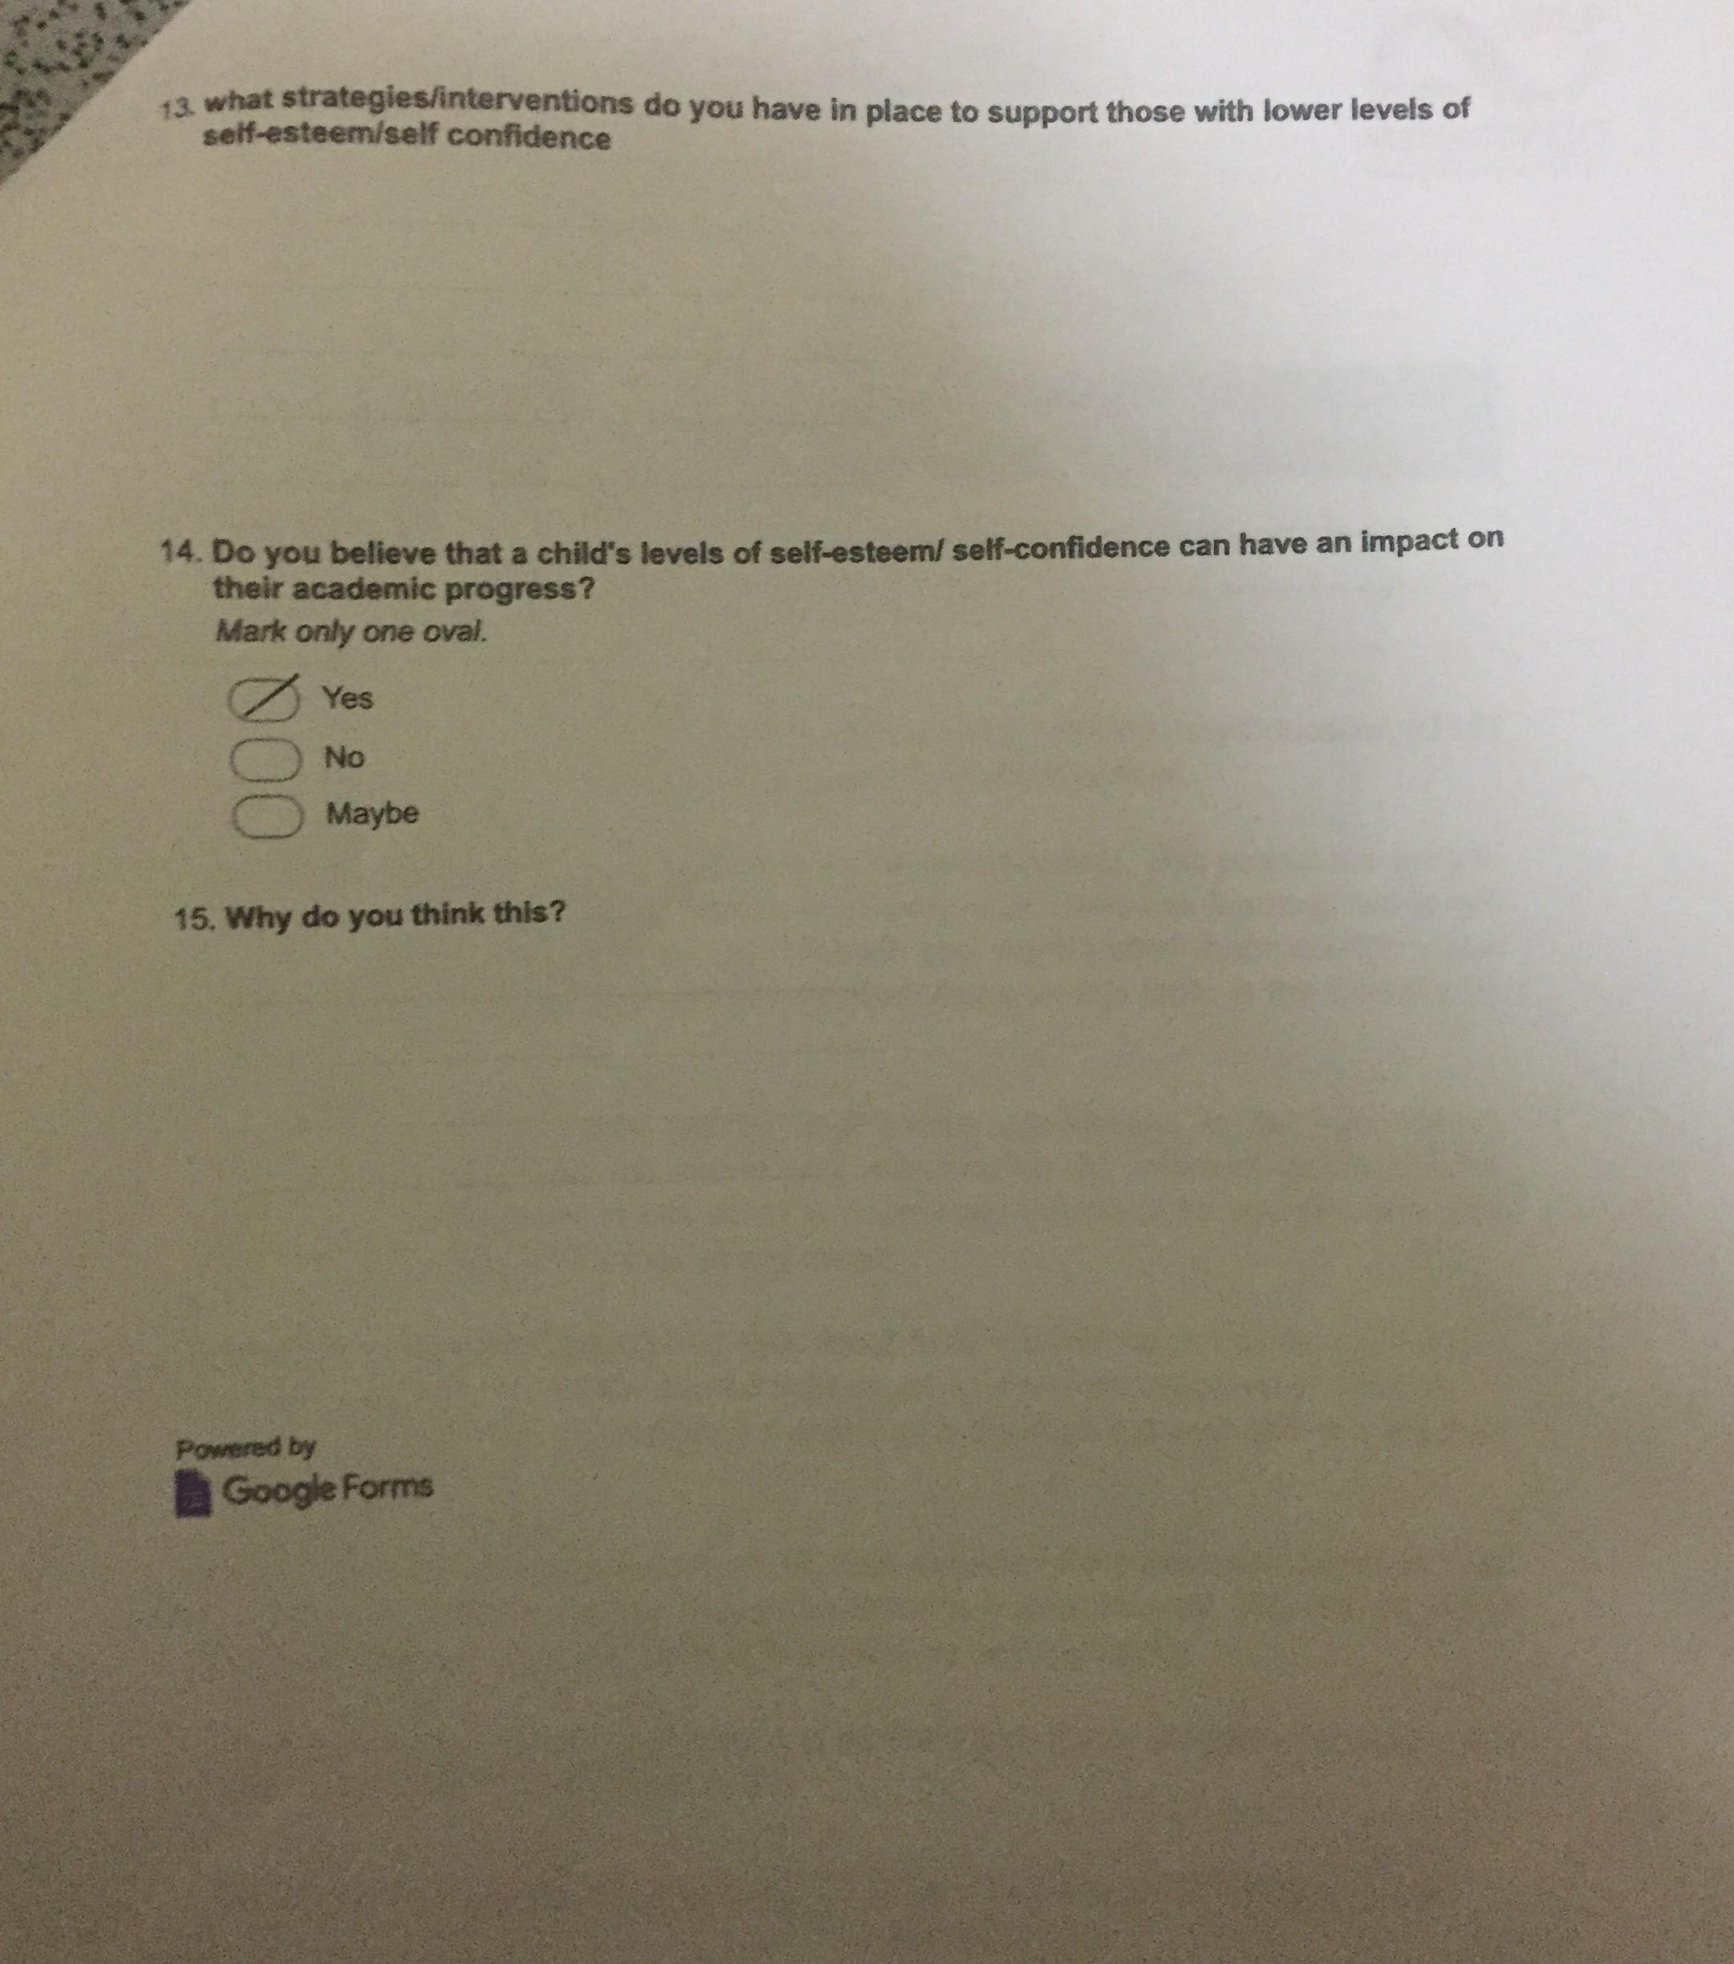

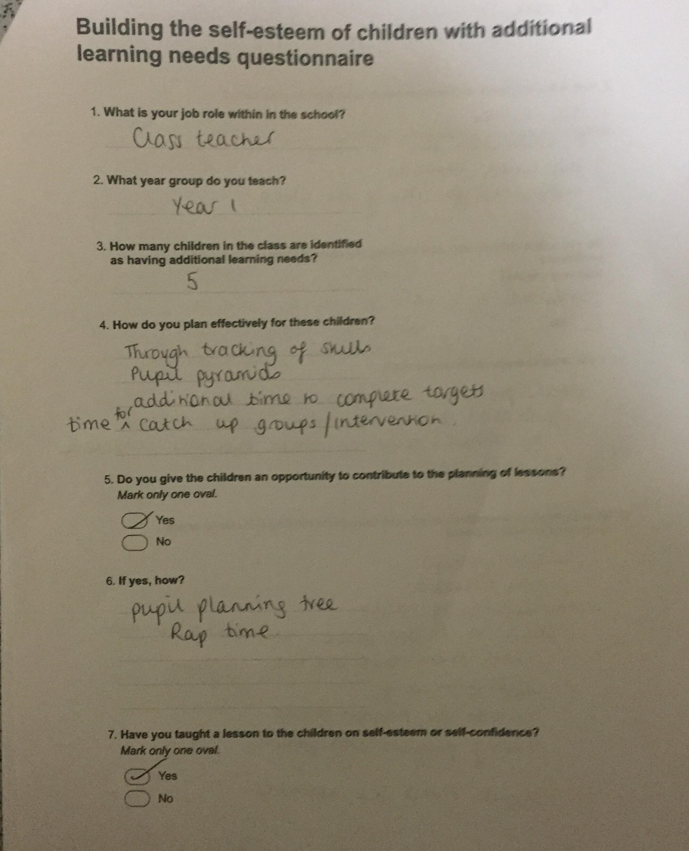

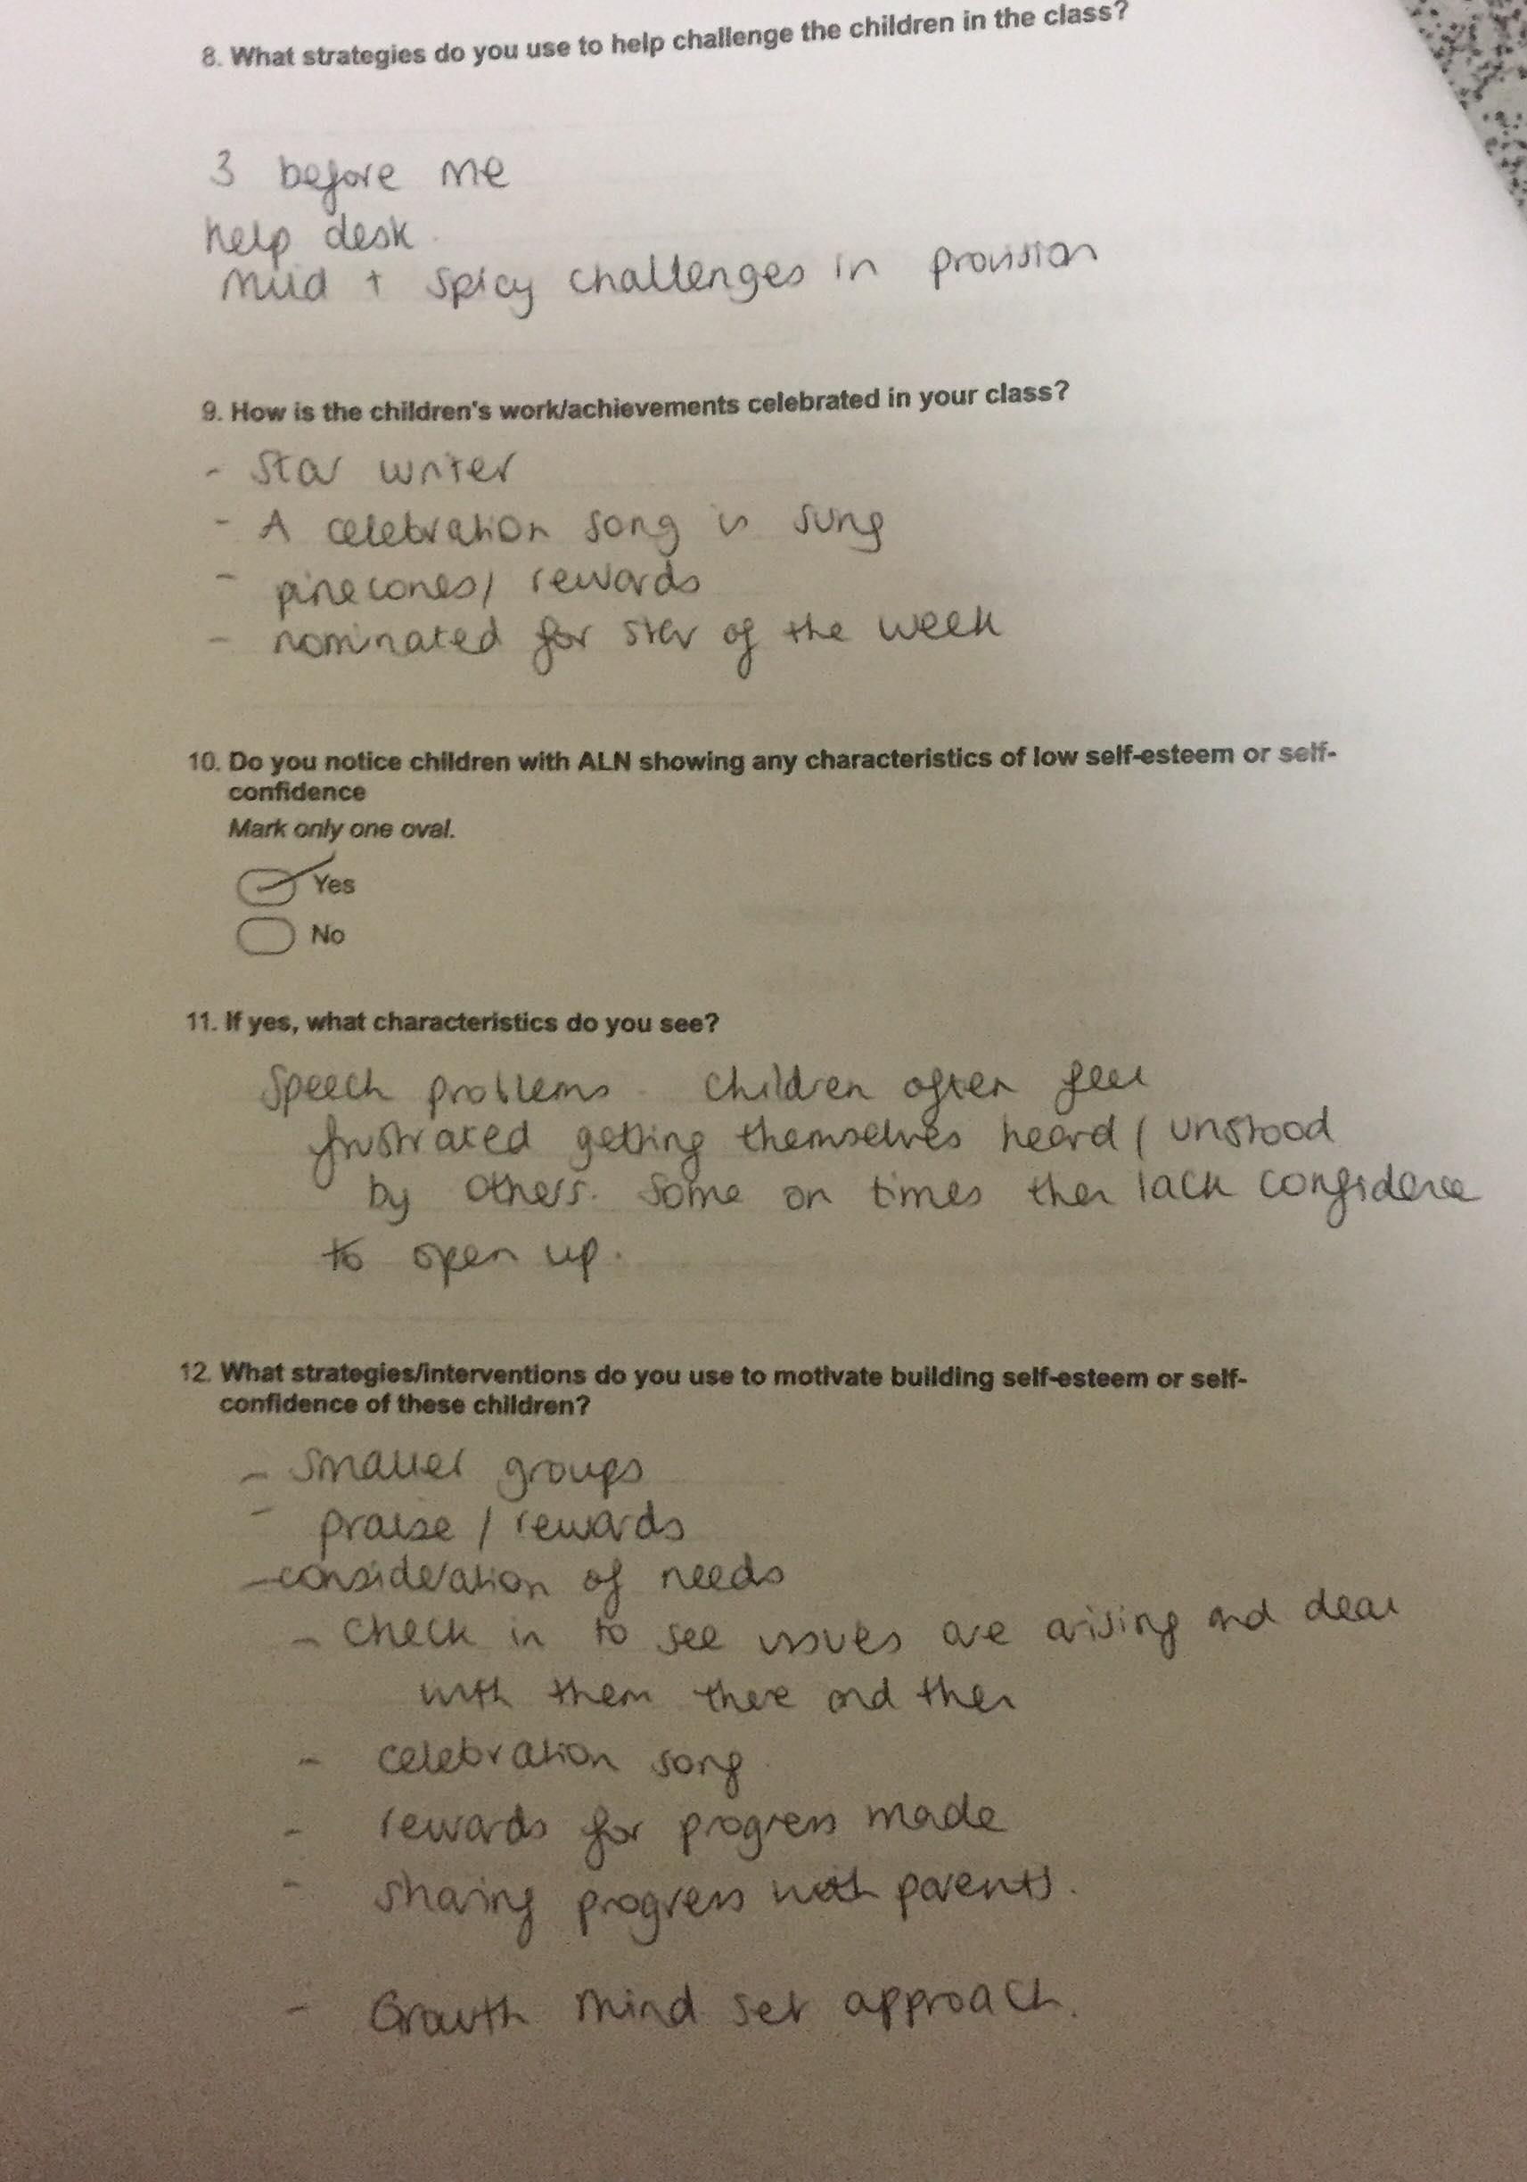

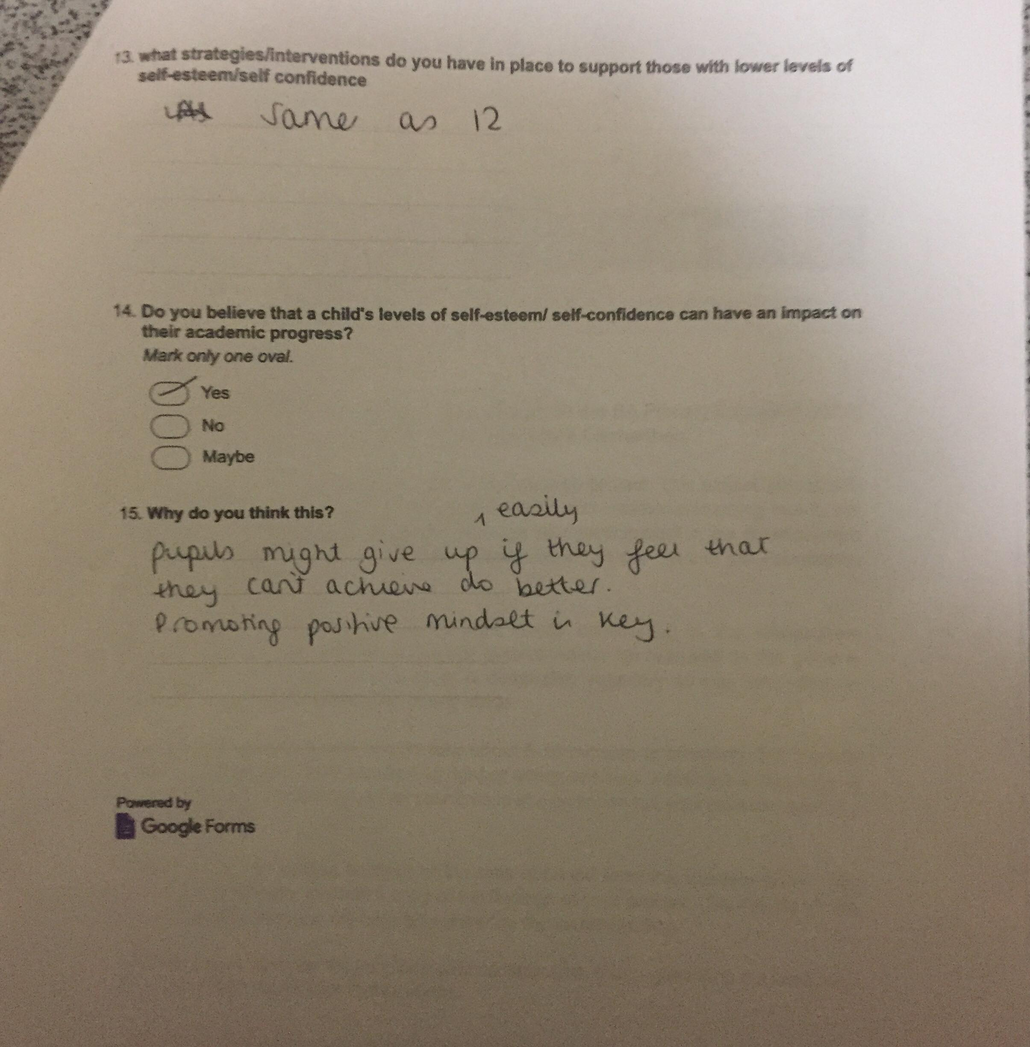

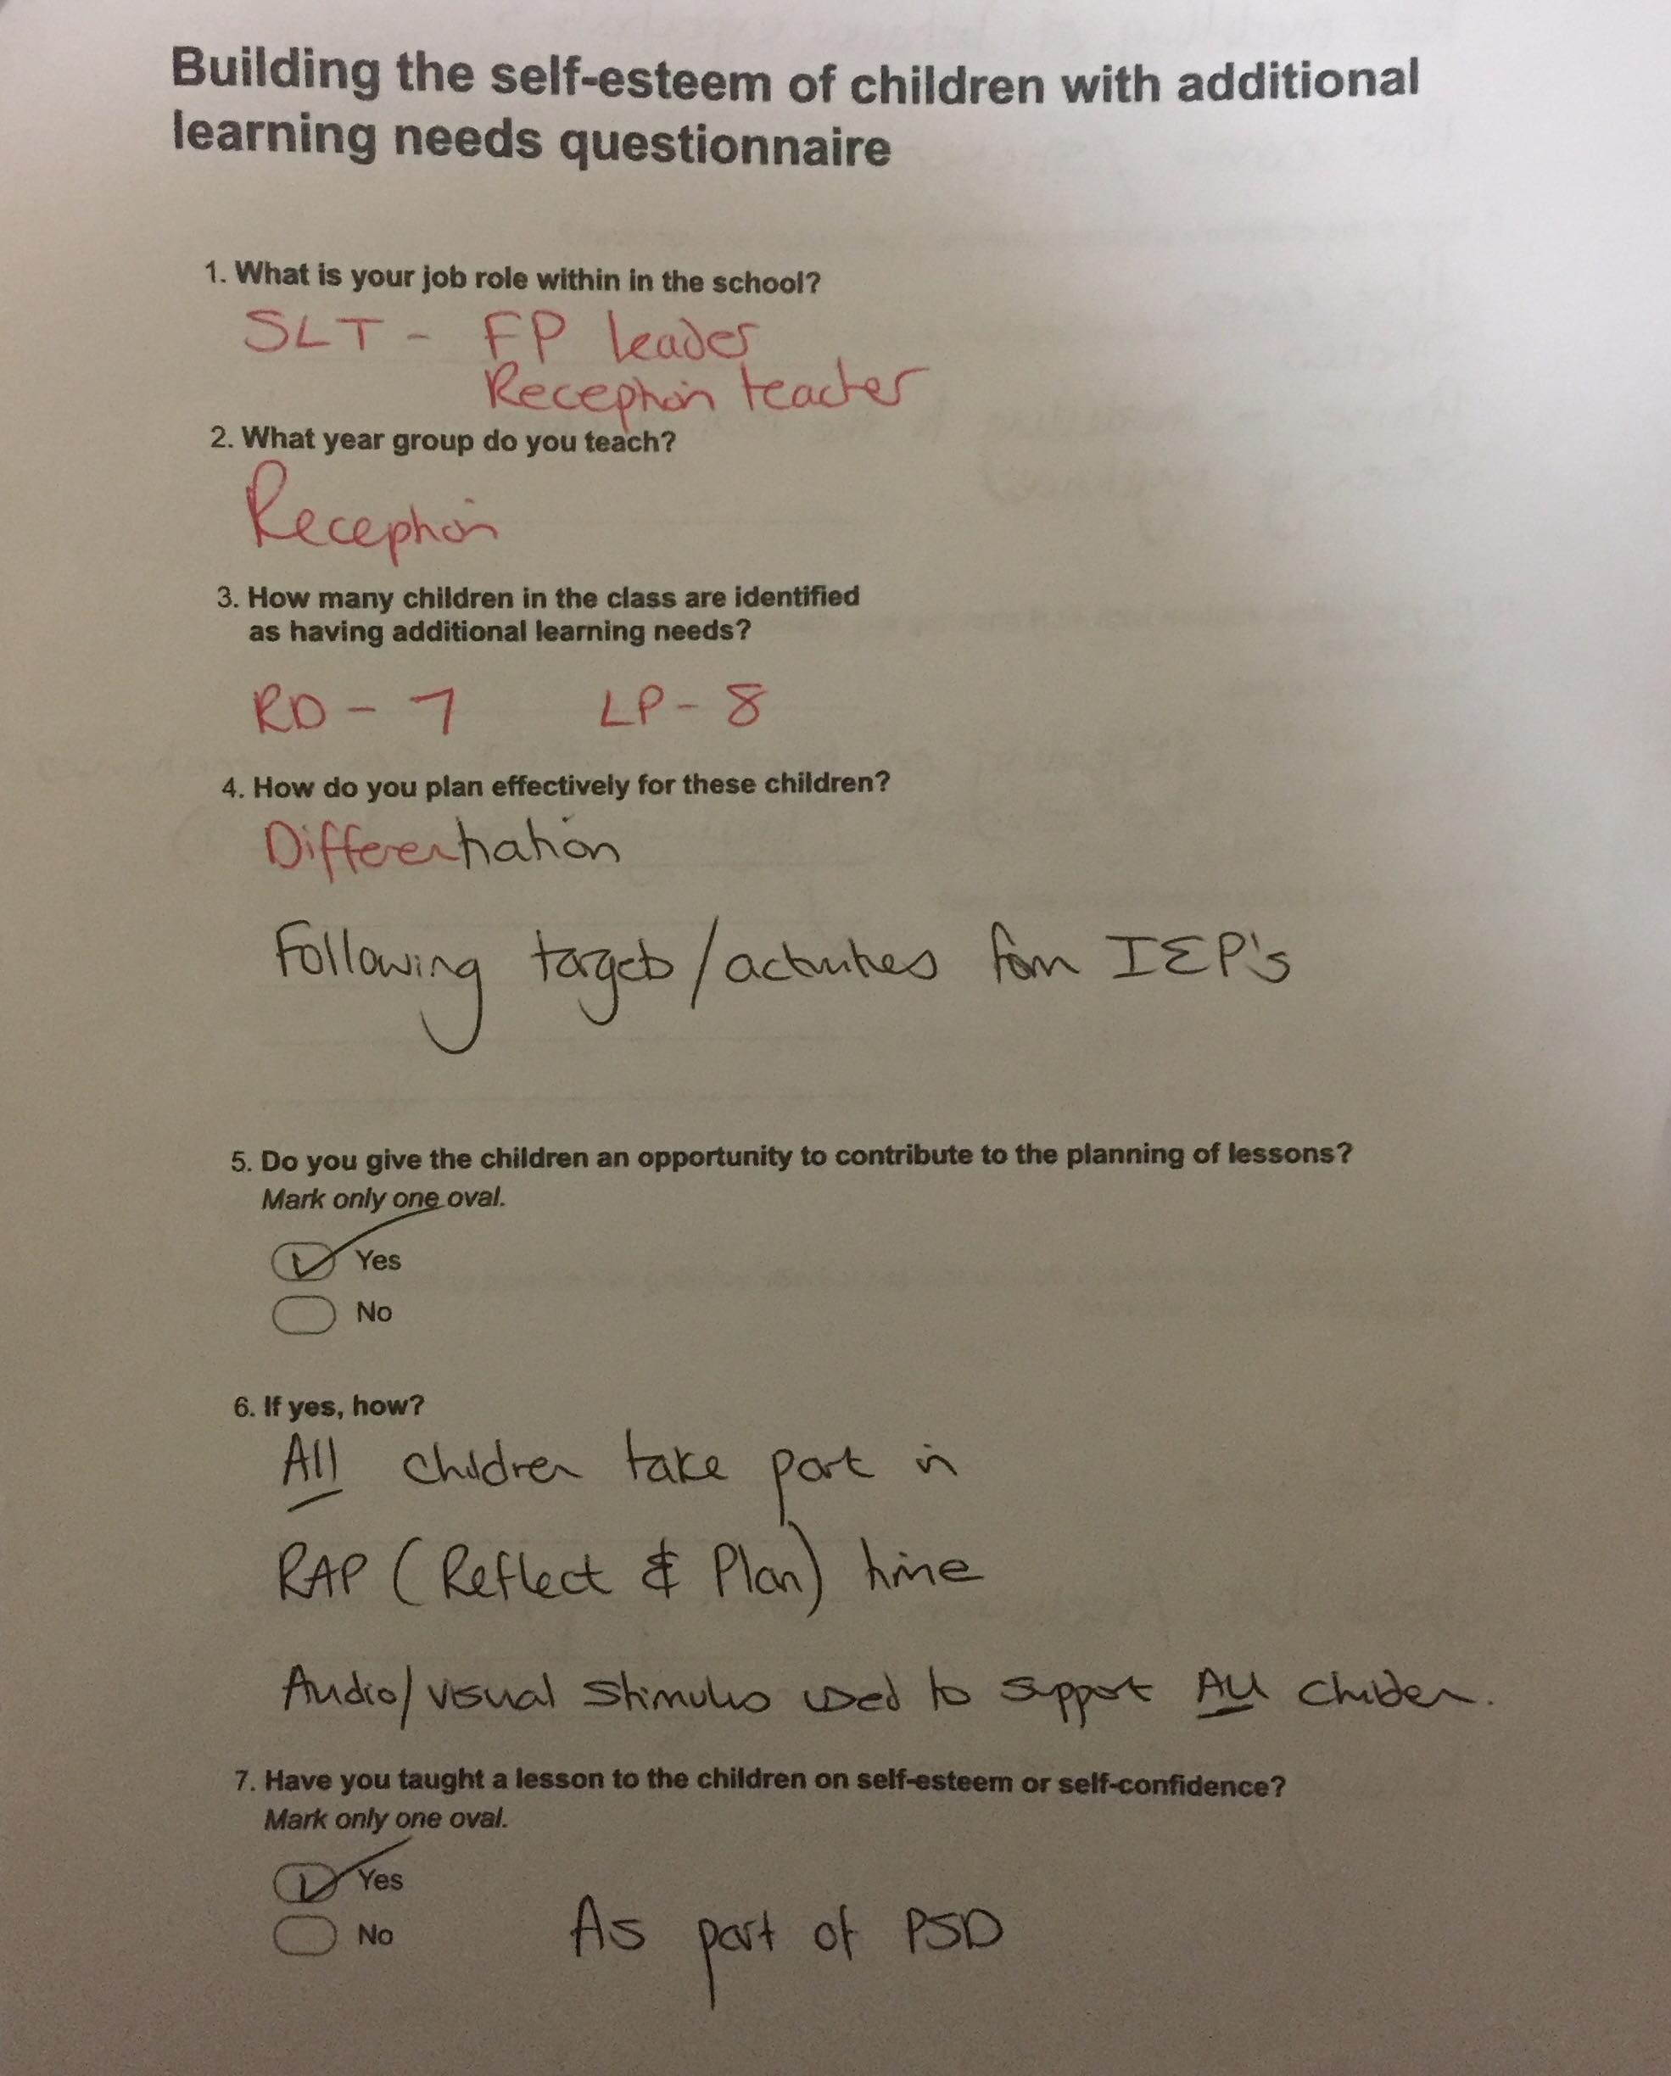

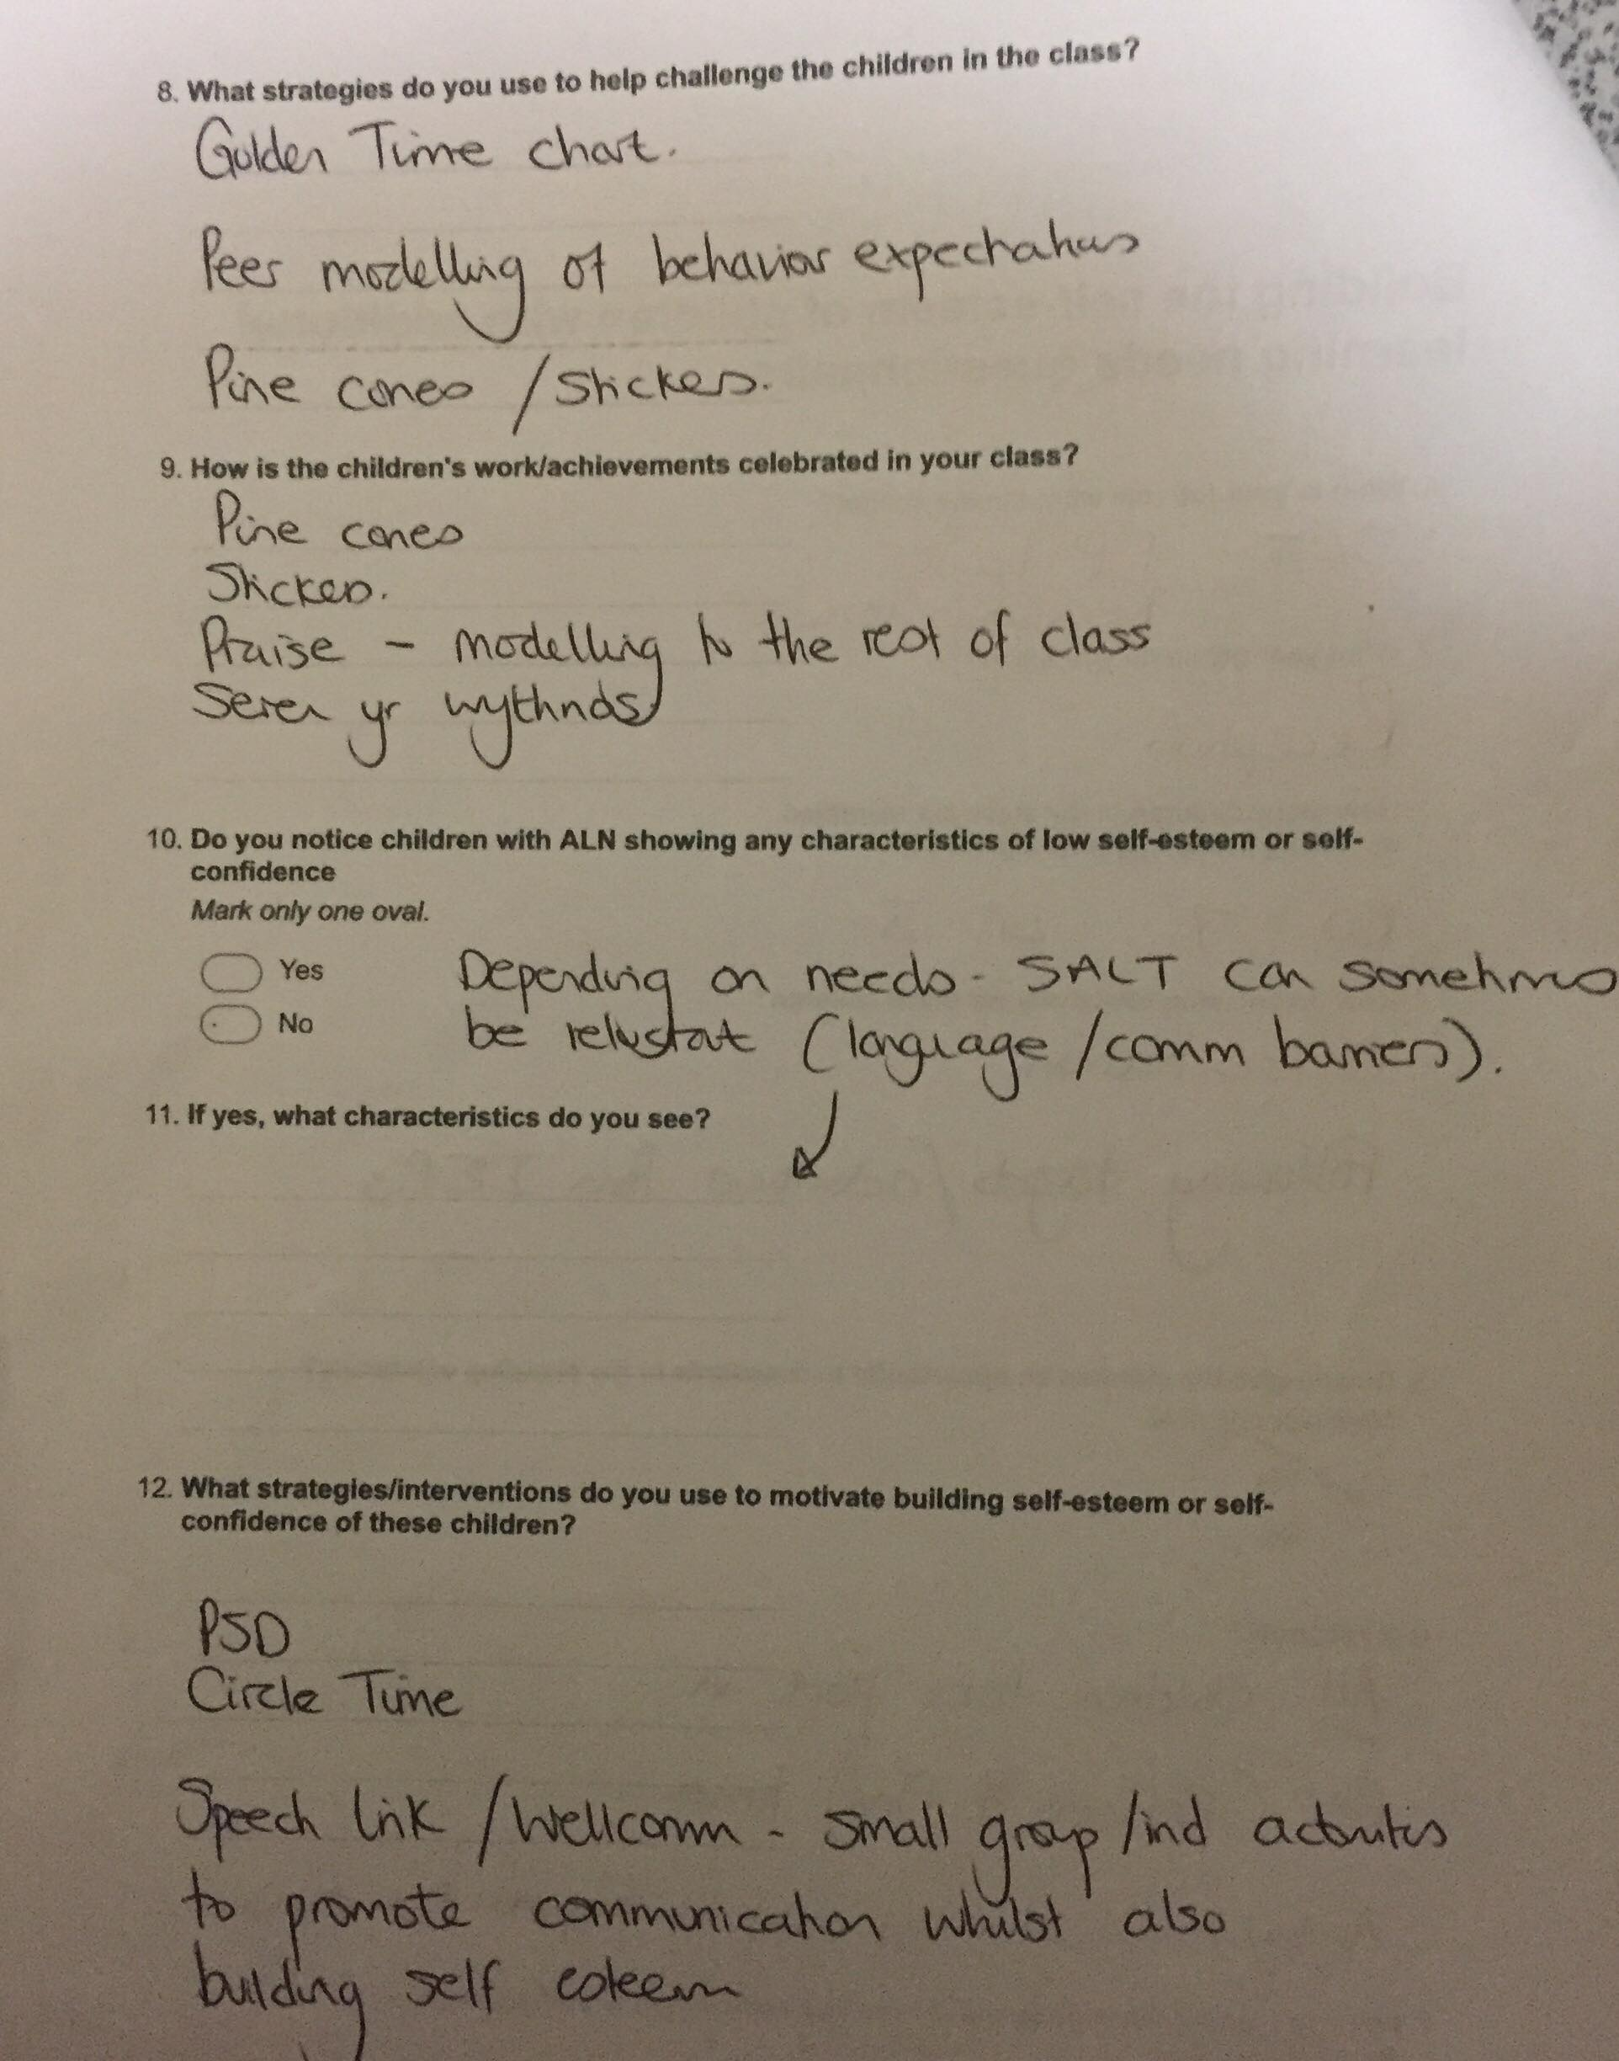

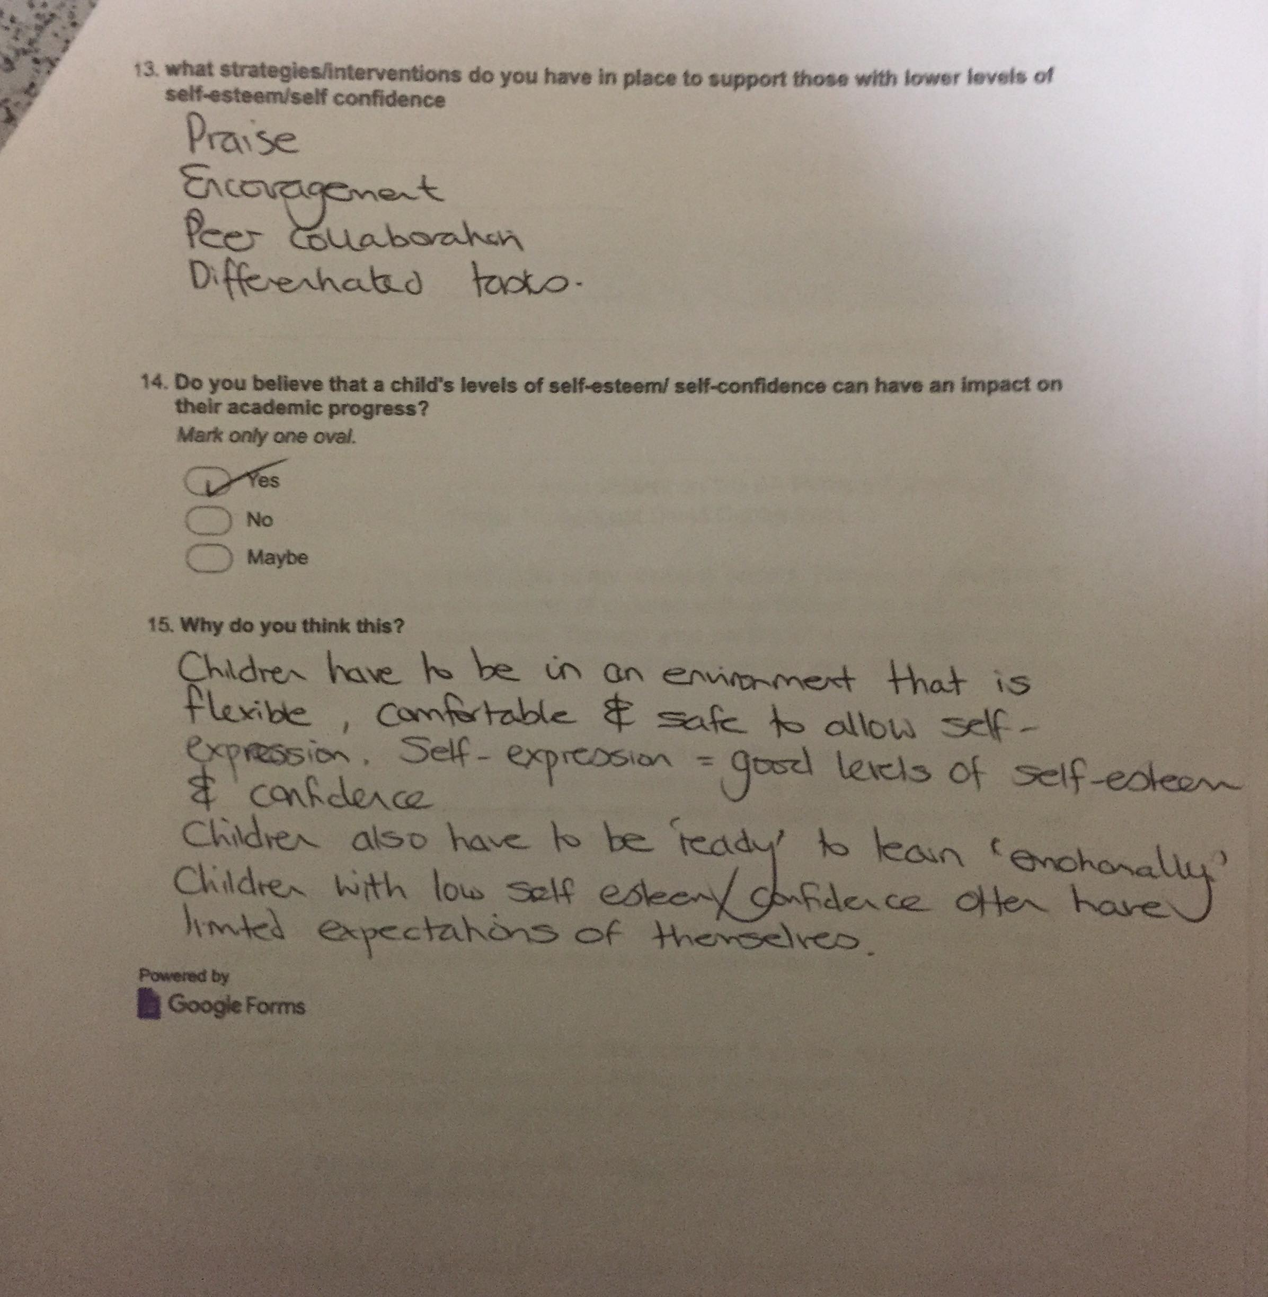

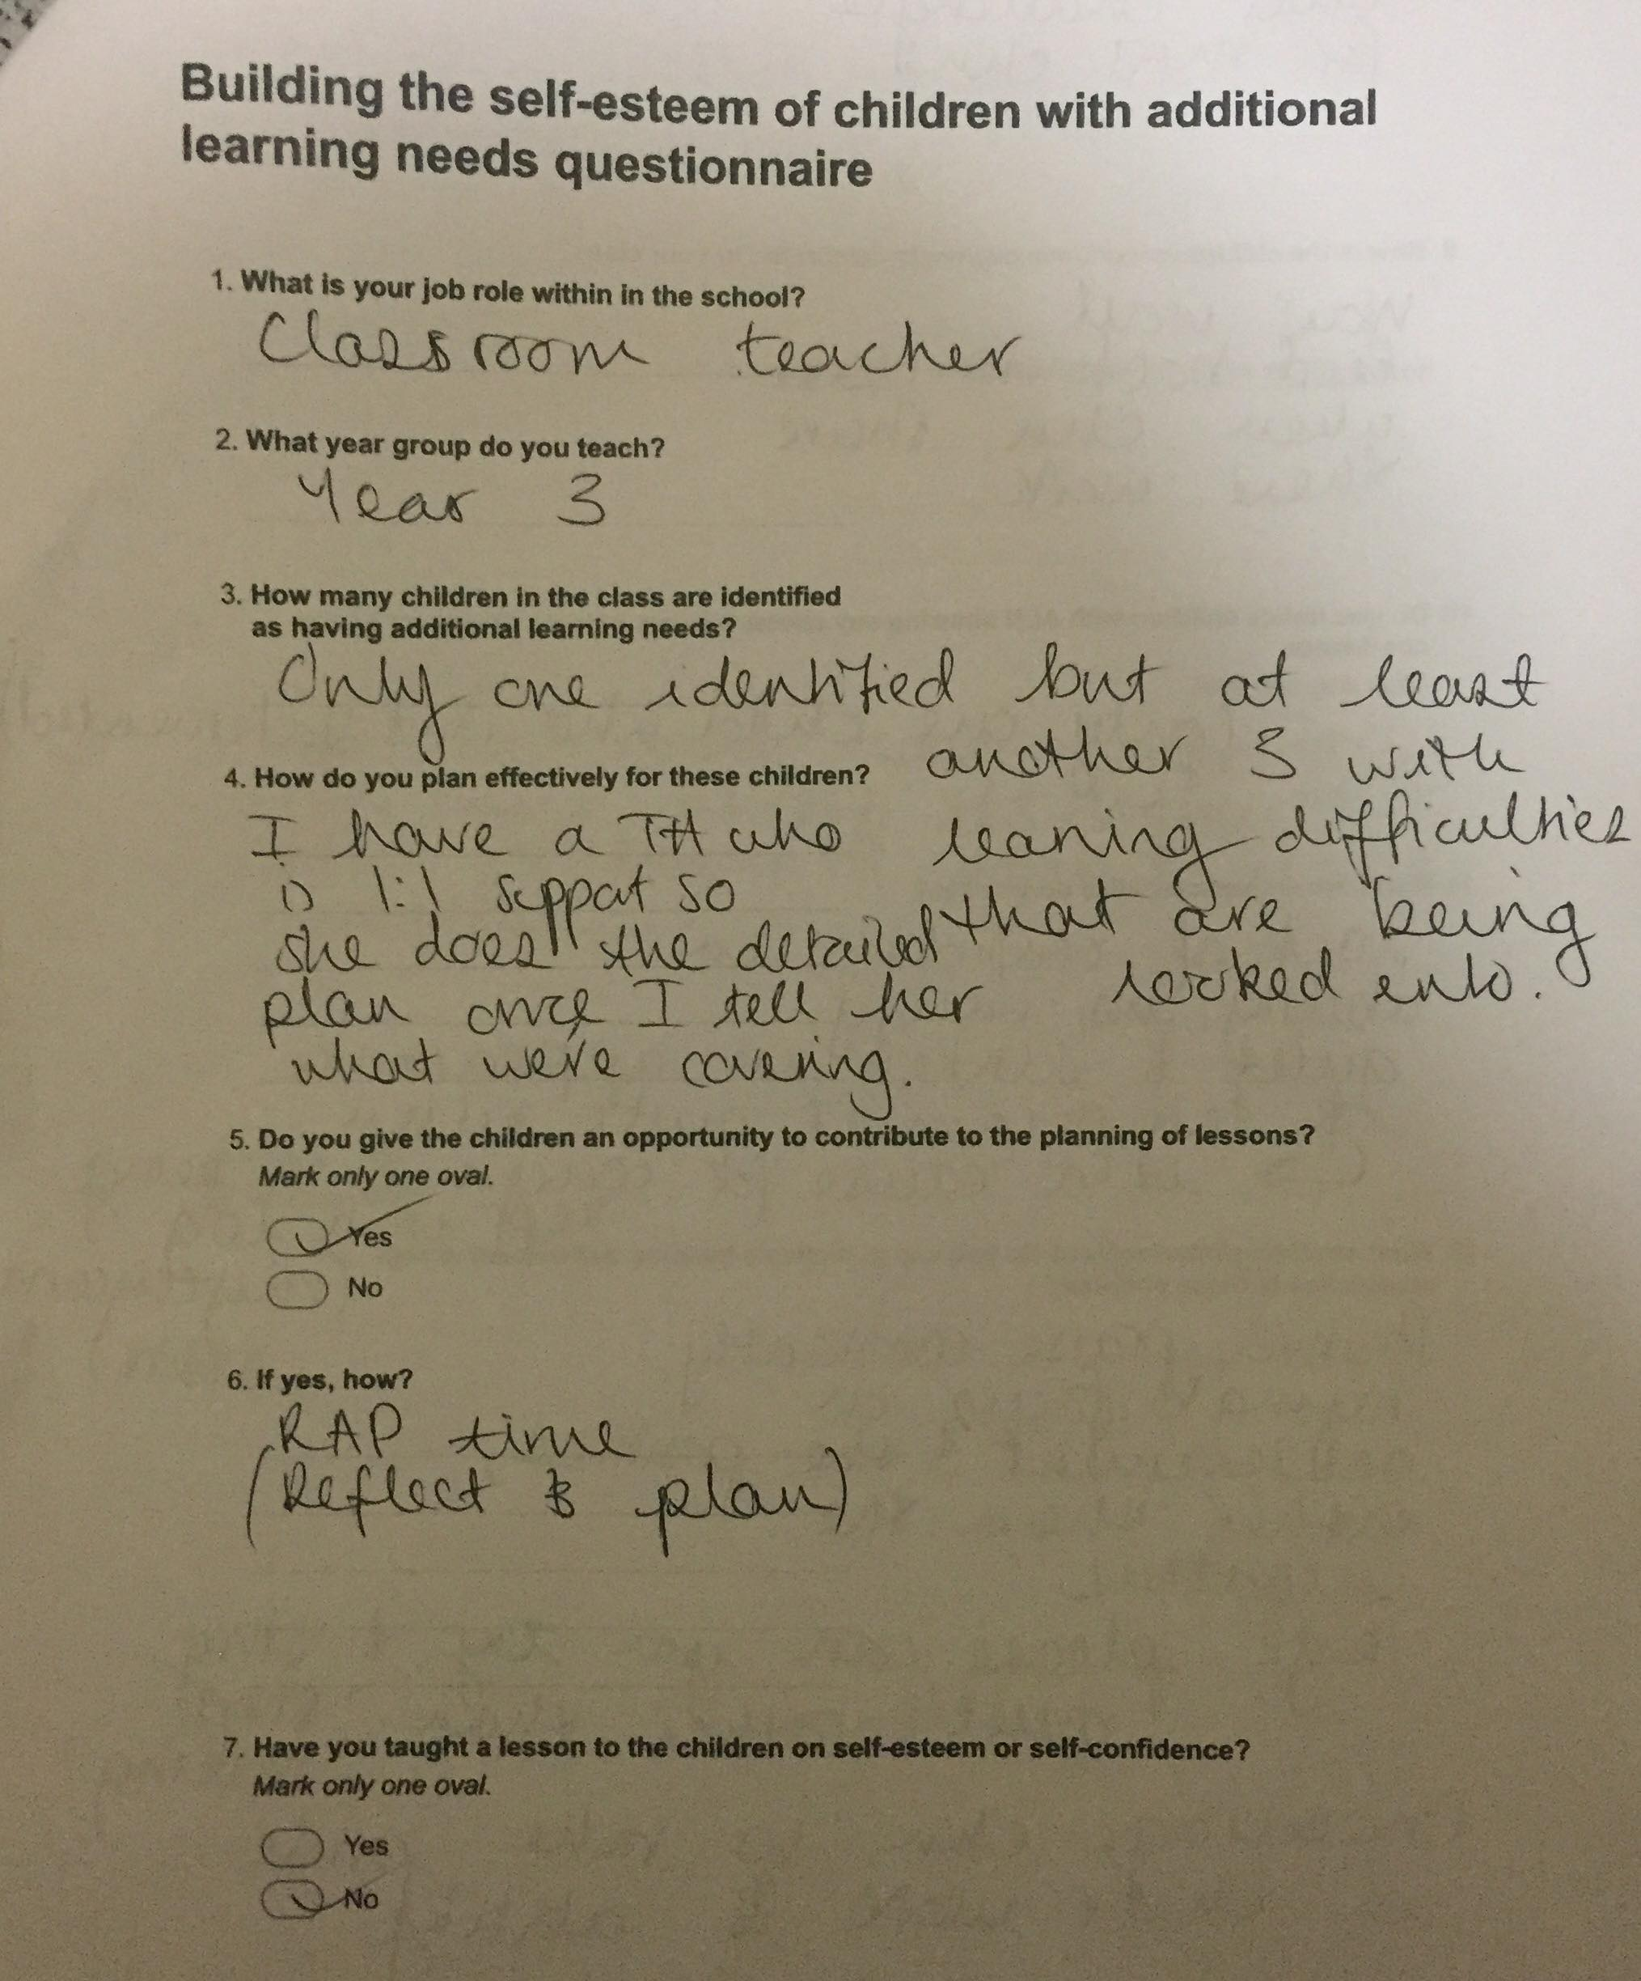

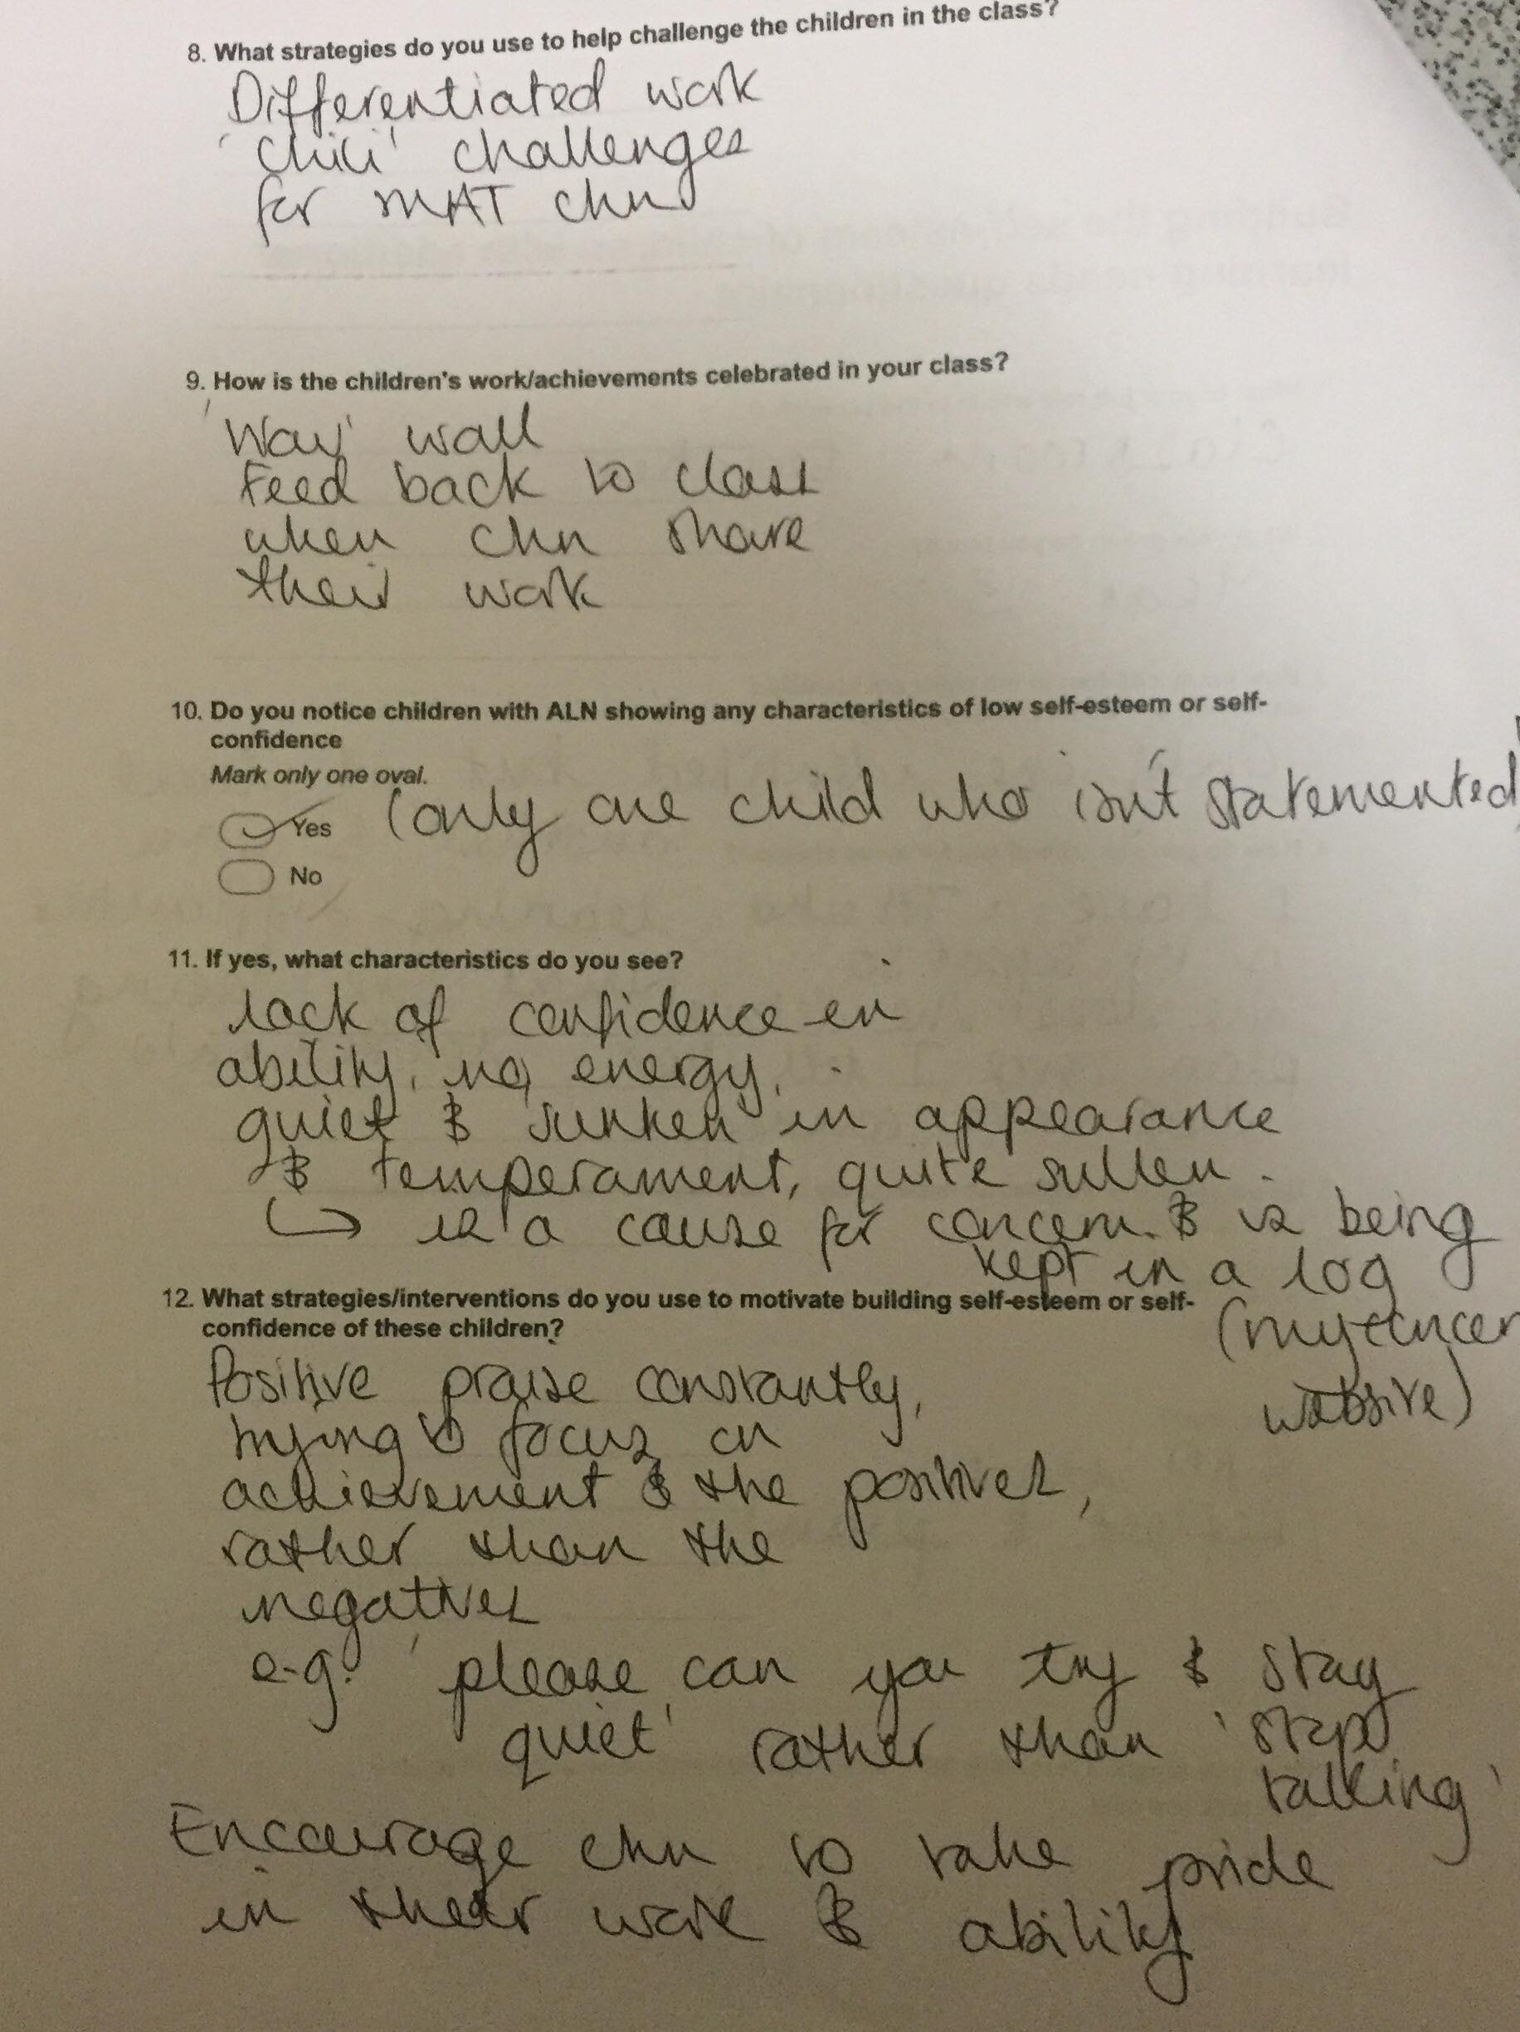

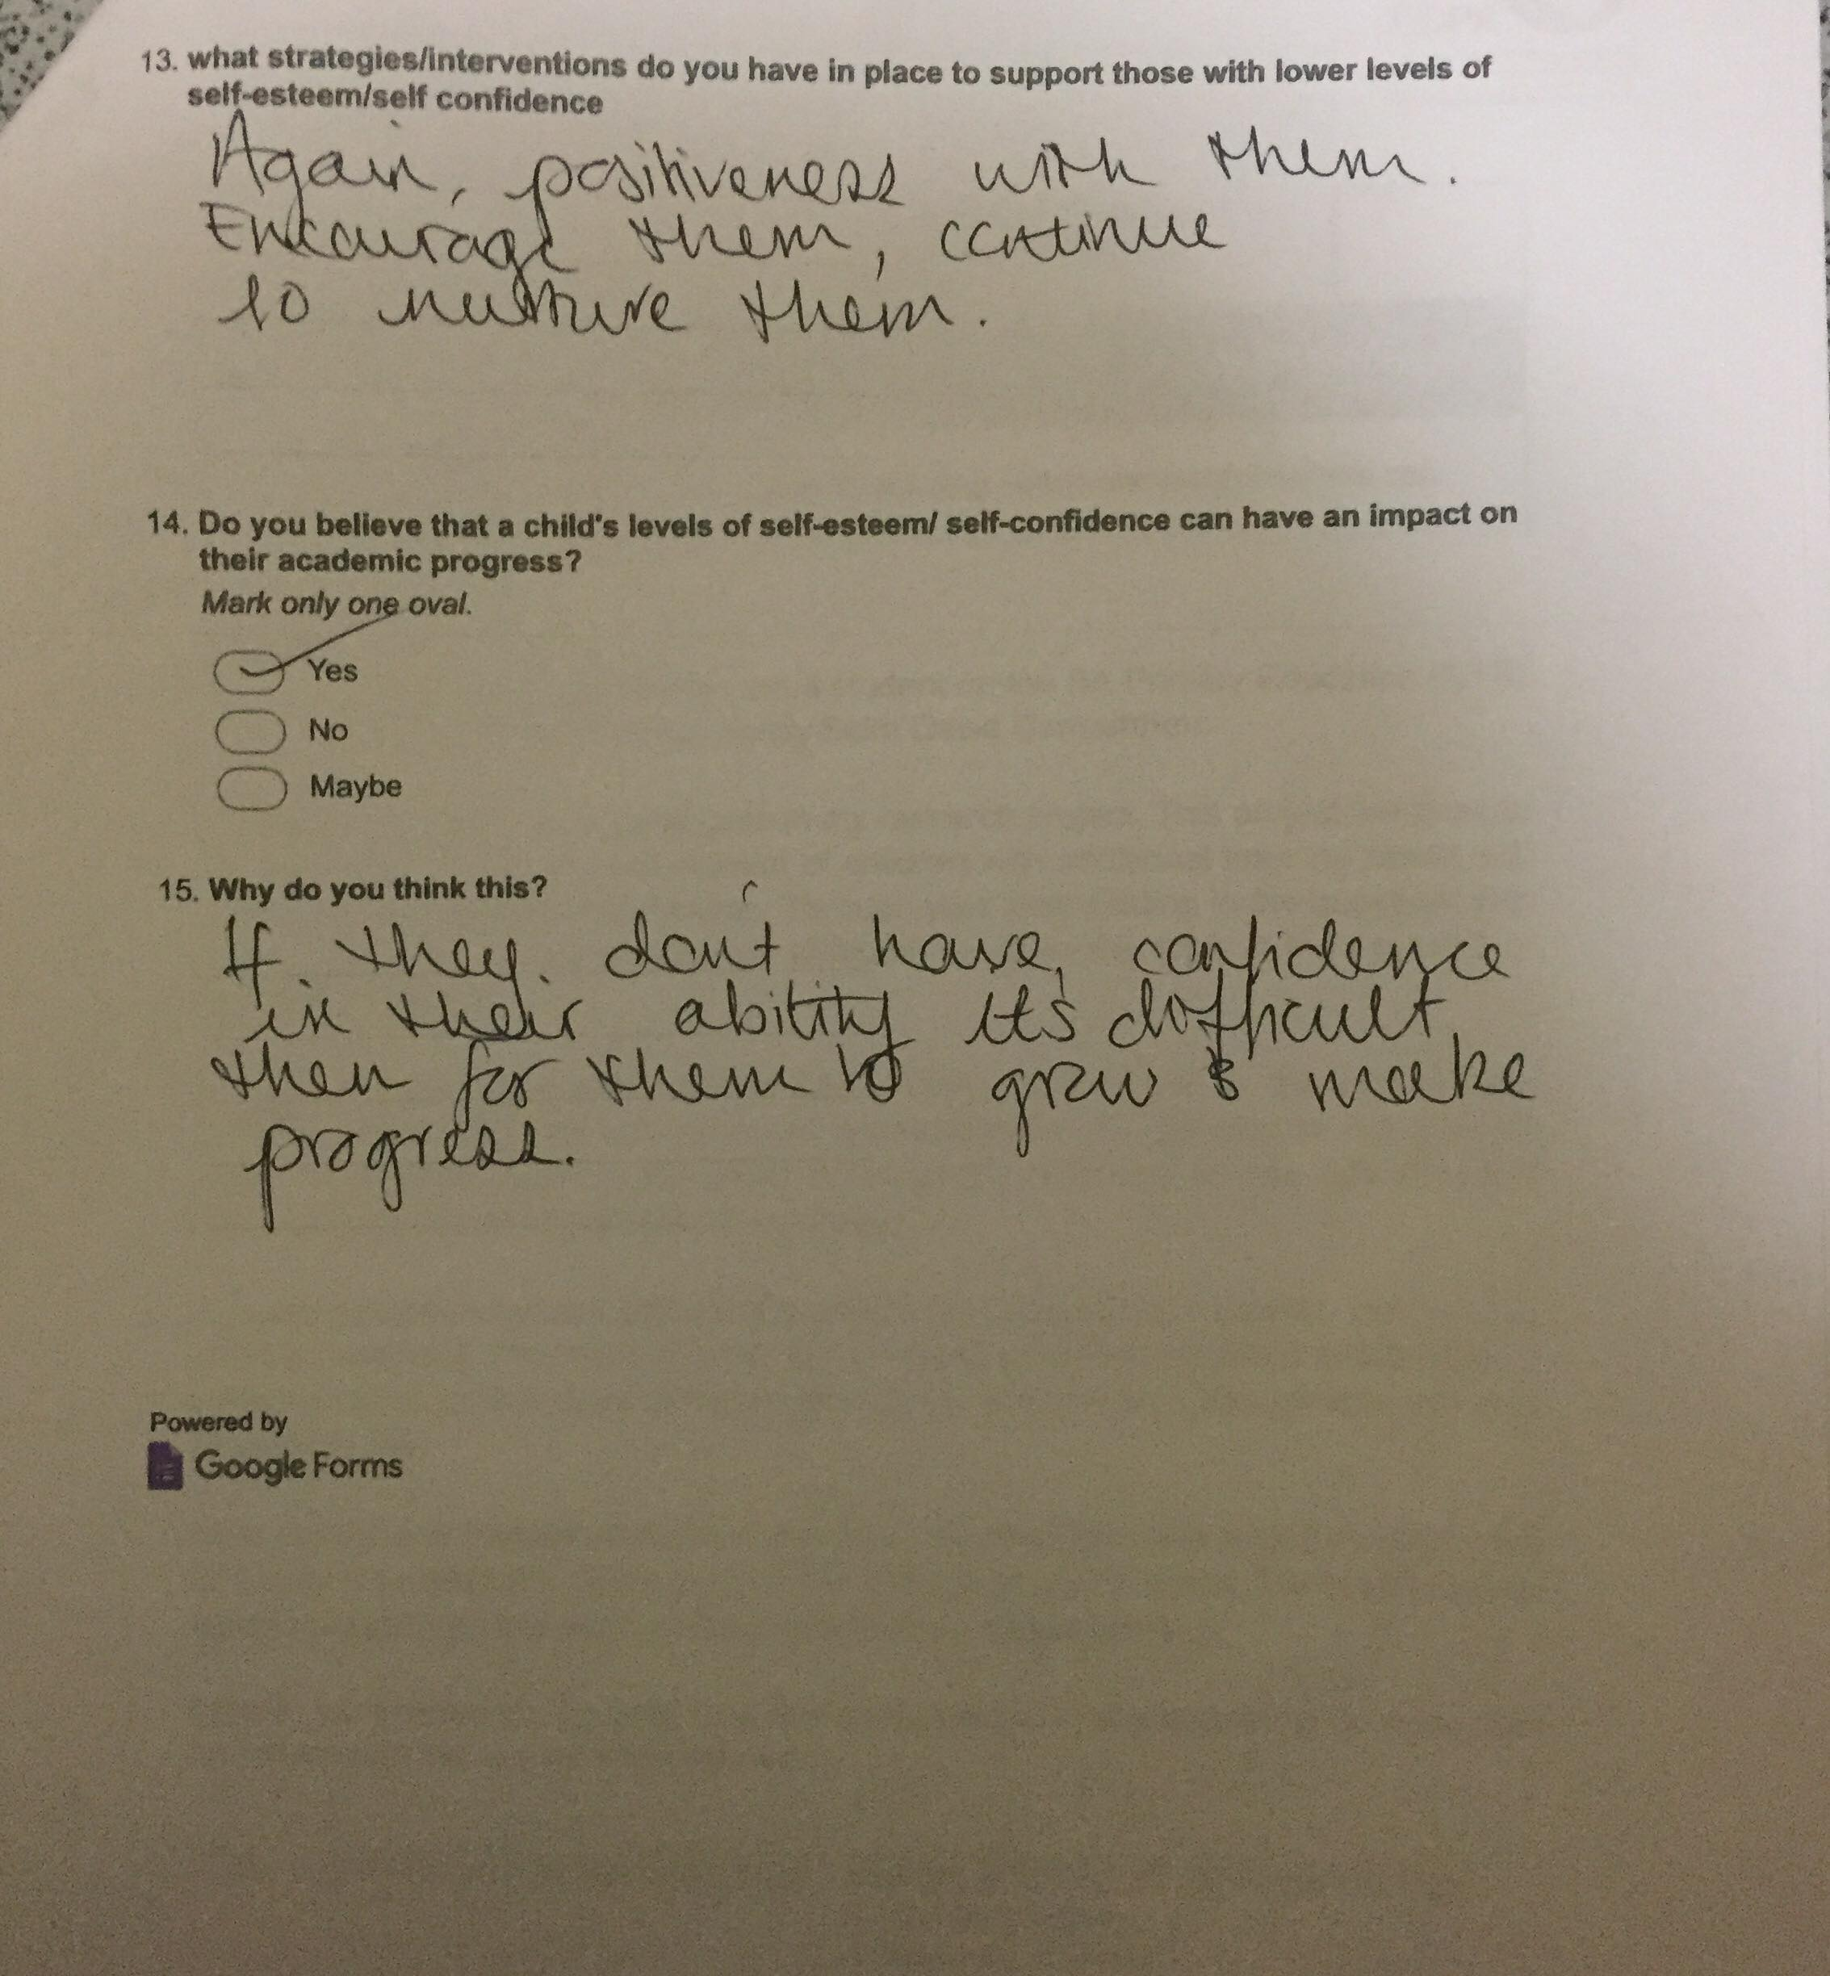

Appendix 16



