Lillie Preston Thomas
2533374
BMSK4016
Academic research and skills

Contents
Introduction 2
Employees 2
Pros to an employee of remote management 2
Cons to an employee of remote management 3
Recommendations 3
Workplace example 5
Manager 5
Pros to managers of remote management 5
Cons to managers of remote management 6
Recommendations 6
Workplace example 7
Organisation 7
Pros to the company of remote management 7
Cons to the company of remote management 7
Recommendations 8
Workplace example 9
Conclusion 9
Reflection 9
Reference list 10

Introduction

Remote work is becoming more common in many companies around the world. With the help of computers, the internet, and online communication tools, many employees can now work from home or from different locations instead of working in a traditional office. Because of this change, remote management has become very important for businesses.

Remote management means that managers lead and support their employees even when they are not working in the same place. Managers use online meetings, messages, and different programs to communicate with their teams and organise work. This way of working can help companies continue their work even when employees are in different cities or countries.

Remote work can bring many benefits for employees, managers, and companies. Employees may enjoy more flexibility, save time by not travelling to work, and feel more comfortable working from home. Managers can hire workers from many places and may also reduce company costs because a large office is not always needed. However, remote work can also create some challenges. Communication can sometimes be harder, teamwork may be more difficult, and some employees may feel lonely when they work alone at home.

Managers may also find it harder to check work and support their teams. This assignment will discuss the advantages and disadvantages of remote work and remote management for employees, managers, and companies, and explain how businesses can manage remote work successfully.

Employees

Pros to an employee of remote management
Remote work offers several important advantages for employees. One major benefit is increased productivity. When individuals work from home or in a quiet environment, they often face fewer distractions compared to a traditional office setting. As a result, they can concentrate better and complete tasks more efficiently (Buffer, 2023). In addition, remote work provides greater flexibility, allowing employees to choose where and sometimes when they work. This flexibility can improve comfort and motivation, leading to higher job satisfaction.

Another key advantage is improved work–life balance. Employees can manage their schedules more effectively, giving them more time to spend with family or attend to personal responsibilities. They can also take breaks when needed, which can help reduce stress and support overall well-being (International Labour Organization, 2020). Furthermore, remote work removes the need for daily commuting. This not only saves time and money but also reduces fatigue and stress, making daily life more manageable.

Remote work also expands employment opportunities. Workers are not limited by their location and can apply for jobs in different cities or even countries. This allows employees to find roles that better match their skills and career goals (Owl Labs, 2022). Overall, remote work can create a more flexible, balanced, and productive working experience for employees.

Cons to an employee of remote management

Remote work also presents several challenges for employees. One major disadvantage is the feeling of isolation and loneliness. When individuals work from home, they have fewer opportunities to interact with colleagues face-to-face, which can reduce social connection and negatively affect mental well-being (International Labour Organization, 2020). Over time, this lack of interaction may lead to decreased motivation and engagement at work.
Another issue is communication difficulties. Remote work relies heavily on digital tools such as emails, messaging apps, and video calls, which can sometimes lead to misunderstandings or delays in communication. Without in-person discussions, it can be harder to share ideas clearly or resolve problems quickly (Owl Labs, 2022). This can also affect teamwork and collaboration.

Additionally, remote employees may find it difficult to separate work from personal life. Working from home can blur boundaries, causing some individuals to work longer hours or struggle to switch off after work. This can lead to increased stress and burnout (Buffer, 2023). Some employees may also lack a suitable workspace at home, which can reduce productivity and comfort.

Finally, managers may find it harder to monitor performance and provide support, which can leave employees feeling unsupported or overlooked. Overall, while remote work offers flexibility, it can also create challenges related to isolation, communication, and work-life balance for employees.

Recommendations

There are some ways companies and workers can make remote work better. First, companies should talk with their workers often. Managers can have regular online meetings to explain work and answer questions. This helps workers understand their jobs and feel part of the team. Second, companies should give workers the right tools. Employees need good internet, computers, and the right programs to do their work. When workers have the right tools, they can do their jobs more easily. Another recommendation is to have a clear work time. Workers should try to start and finish work at the same time each day. This helps them keep a good balance between work and home life. It is also good for workers to have a quiet place to work at home. A clean and comfortable workspace can help people focus better. Finally, workers should remember to take breaks. Resting during the day can help people feel less tired and less stressed. This can help them stay happy and do their work well.
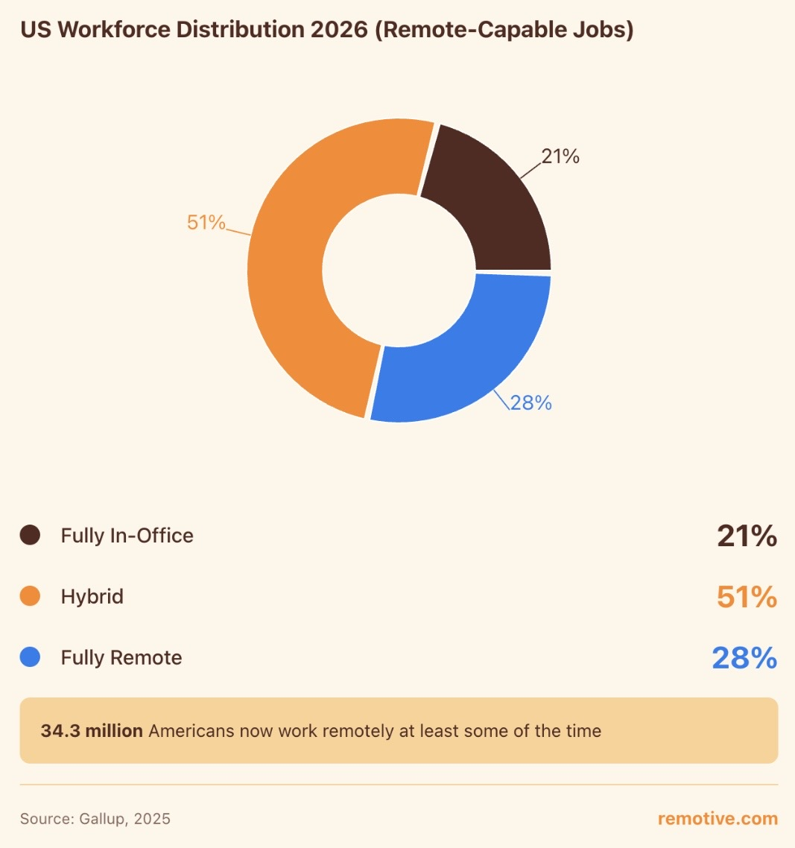

Quanttitaive data is information shown in numbers, like how many employees work or how many hours they work.
Qualitative data is information in words, how employees feel or what they think about their work.

Workplace example

A company lets workers work from home. For example, a customer service worker answers calls and emails using a computer and the internet. They start work in the morning and finish in the afternoon. They can ask their manager questions online. This helps workers save time and feel more comfortable at home.

Manager

Pros to managers of remote management

Remote work offers several important advantages for managers. One key benefit is access to a wider talent pool. Managers are no longer limited to hiring employees within a specific geographic area and can recruit skilled workers from different cities or even countries. This allows organisations to find the best candidates for roles and build more diverse and capable teams (Owl Labs, 2022).

Another advantage is reduced operational costs. With fewer employees working in a physical office, businesses can save money on expenses such as rent, utilities, and office supplies. These cost savings can be reinvested into other areas of the business, such as employee development or new technologies (Global Workplace Analytics, 2023). This makes remote work a cost-effective option for many organisations.

Remote work can also increase productivity and performance. Many employees report being more focused and efficient when working from home due to fewer workplace distractions. This can result in improved output and better overall team performance, making it easier for managers to achieve organisational goals (Buffer, 2023).

Additionally, remote management encourages the use of digital tools and systems that improve communication and task tracking. Managers can monitor progress, set clear goals, and evaluate performance through online platforms, which can enhance organisation and accountability. Overall, remote work allows managers to reduce costs, improve productivity, and access a broader range of talent, making it a valuable approach for modern businesses.

Cons to managers of remote management

One significant drawback of remote work for managers is the challenge of overseeing employee performance and ensuring team unity. Without direct, in-person supervision, it can be more difficult for managers to track progress and confirm that tasks are being completed to the expected standard. This may create uncertainty around employee productivity and responsibility (Owl Labs, 2022). In addition, communication can become less effective in a remote setting, as managers depend on digital platforms such as emails and virtual meetings. These methods can sometimes lead to confusion, delays, or misinterpretation of information, which may slow down decision-making (Buffer, 2023).

Moreover, maintaining strong working relationships and a positive team environment can be harder when employees are physically separated. Workers may feel less connected to their colleagues and the organisation, making it challenging for managers to build team spirit and engagement (International Labour Organization, 2020). For instance, managers may not easily notice signs of stress, low motivation, or dissatisfaction among employees when interactions are limited. As a result, providing timely support and guidance becomes more difficult.

In conclusion, remote work can create obstacles for managers in supervising staff, communicating effectively, and maintaining team motivation, which may negatively affect overall organisational performance.

Recommendations

Managers should try to balance the advantages and disadvantages of remote work. Remote work can help managers save money, find skilled workers, and give employees more flexibility. However, it can also make communication and teamwork more difficult. Because of this, managers need to plan carefully and support their teams.
First, managers should communicate with their employees regularly. They can organise online meetings to discuss tasks, answer questions, and make sure everyone understands their work. Clear communication helps workers feel connected to the team and reduces confusion
Second, managers should provide the right tools and technology. Employees need good computers, stable internet, and the correct programs to do their work. When workers have the right tools, they can work more efficiently and avoid technical problems.
Managers should also encourage workers to keep a clear work schedule. Employees should try to start and finish work at the same time each day. This helps workers separate their work life from their home life and avoid stress.
It is also important for managers to support teamwork. They can create group meetings or team projects so workers can share ideas and help each other.
By improving communication, giving the right tools, and supporting teamwork, managers can reduce the disadvantages of remote work and enjoy its many benefits.

Workplace example

A company manager leads a team that works from home. The manager has a short online meeting every morning to explain the work for the day. Workers use their computers to finish their tasks and send updates. If someone needs help, they message the manager online for support.

Organisation

Pros to the company of remote management

One key benefit of remote work for companies is the decrease in running costs. When employees work from home, businesses spend less on office space, electricity, and equipment. This reduction in expenses allows organisations to invest more in other areas, such as improving technology or supporting employee growth (Global Workplace Analytics, 2023). Additionally, remote working gives companies the opportunity to recruit from a much larger talent pool. Employers are not limited to hiring locally and can select qualified candidates from different locations, which can strengthen the overall workforce (Owl Labs, 2022).

Moreover, remote work can improve employee efficiency. Many workers are able to concentrate better in a home environment where there are fewer interruptions compared to a busy office. This can lead to higher levels of productivity and better results for the company (Buffer, 2023). For instance, employees who do not need to commute often have more time and energy to focus on their responsibilities, which can positively impact their performance.

In conclusion, remote working offers several advantages for companies, including lower costs, access to a wider range of employees, and increased productivity. These benefits make remote work a valuable strategy for organisations in today’s working environment.

Cons to the company of remote management

One significant disadvantage of remote work for companies is the increased risk of communication breakdowns and reduced collaboration. When employees are not physically present, it can be more difficult to exchange ideas quickly or work together effectively on tasks. Relying on digital communication methods, such as emails and virtual meetings, may result in delays or unclear messages, which can slow down business operations (Gartner, 2021). In addition, remote work can weaken organisational culture. Without regular in-person interaction, employees may feel less connected to the company and its values, which can reduce engagement and loyalty (Microsoft, 2022).

Another challenge is maintaining data security and protecting company information. With employees working from various locations and using different networks, businesses face a higher risk of cyberattacks or data breaches. For example, unsecured home networks or personal devices can make sensitive information more vulnerable (National Cyber Security Centre, 2020). This means companies may need to invest more in cybersecurity measures and training.

Furthermore, supervising employee performance can be more difficult in a remote setting. Managers may find it harder to assess productivity and provide immediate support when needed. As a result, some employees may underperform without direct oversight.

In conclusion, remote work can create challenges for companies in terms of communication, organisational culture, security, and performance management, which may affect overall efficiency and success.

Recommendations

Companies should try to use remote work in a good and balanced way. Remote work can help companies save money and give workers more freedom. But it can also cause some problems with talking to each other and working as a team. Because of this, companies need to manage remote work carefully. First, companies should talk with workers often. Managers can have regular online meetings to explain the work and answer questions. This helps workers understand their tasks and feel part of the team. Second, companies should give workers the right tools. Workers need good computers, strong internet, and the right programs to do their jobs. When workers have good tools, they can work more easily and finish their tasks on time. Companies should also have clear work rules and schedules. Workers should know when they start work, when they finish, and what work they must do. This helps workers stay organised and responsible. Another good idea is to encourage teamwork. Managers can organise team meetings so workers can share ideas and help each other. Finally, companies should care about their workers. When workers feel supported and less stressed, they often work better and help the company succeed.

Workplace example

A small company has workers who work from home. The manager has a short online meeting every morning. The manager tells the team what work they need to do. Workers use their computers to do their work and send messages if they need help. This helps everyone work together.

Conclusion
In conclusion, remote work has good points and bad points for workers, managers, and companies. Today, many people work from home because on computers and the internet make it easy to talk and work online. Remote work can help workers feel more comfortable and give them more freedom. For workers, working from home can save time and money because they do not need to travel to work every day. This can help workers feel less tired and less stressed. Workers can also spend more time with their families. However, some workers may feel lonely because they do not see their coworkers often. Some people may also find it hard to stop working because their home is also their workplace. For managers, remote work can help them find workers from many places. Managers are not limited to people who live near the office. It can also help companies save money because they do not need a big office. However, it can sometimes be harder for managers to check work and talk with their team. For companies, remote work can make workers happier and help the company save money. But companies may also have problems with teamwork, communication, or technology. Overall, remote work can work well if it is managed properly. Companies should communicate clearly, give workers the right tools, and support their teams so everyone can work well together.

Reflection
Description
Remote working involves completing work tasks outside of a traditional office, usually from home, with the use of technology such as laptops, email, and video conferencing. In my experience, I attended online meetings, completed tasks independently, and communicated with colleagues through digital platforms rather than face-to-face. This was a different way of working compared to a typical office environment and required me to adapt my routine.
Feelings
At first, I felt positive about remote working because it gave me more flexibility and saved time on commuting. I found it less stressful and more comfortable to work from home. However, after some time, I began to feel isolated and less connected to my team. I also felt frustrated at times when communication was slow or unclear, which made some tasks more difficult to complete.
Evaluation
There were both advantages and disadvantages to remote working. One main advantage was flexibility, as I could manage my time more effectively. I also found that I could focus better on tasks without interruptions, which improved my productivity. In addition, I saved money and time by not travelling.
However, there were also disadvantages. A key issue was the lack of social interaction, which made me feel isolated. Communication with colleagues was sometimes difficult, leading to misunderstandings. Another challenge was separating work from home life, as I sometimes found it hard to switch off from work. There were also distractions at home that could reduce my concentration.
Analysis
The positive aspects of remote working are mainly linked to independence and flexibility, which can increase motivation and productivity. However, the negative aspects show the importance of communication and teamwork in a working environment. Without regular interaction, it is harder to build relationships and share ideas. This experience also highlights the importance of time management and self-discipline when working remotely, as there is less supervision compared to an office setting.
Conclusion
Overall, remote working can be beneficial, but it also presents challenges. While it allows for flexibility and improved focus, it can lead to isolation and communication difficulties. From this experience, I have learned that remote working requires good organisation, communication skills, and the ability to manage boundaries between work and personal life.
Action Plan
In the future, I will improve my remote working by creating a clear daily routine and setting specific working hours to maintain a better work–life balance. I will also make sure to communicate regularly with colleagues through meetings or messages to avoid misunderstandings. Additionally, I will set up a dedicated workspace to reduce distractions and improve focus. Finally, I will try to stay socially connected with my team to reduce feelings of isolation.

Reference list

Buffer. (2023). State of remote work 2023. https://buffer.com/state-of-remote-work
International Labour Organization. (2020). Working from home: Estimating the worldwide potential. https://www.ilo.org
Owl Labs. (2022). State of remote work report. https://owllabs.com/state-of-remote-w
Global Workplace Analytics. (2023). Latest telecommuting statistics. https://globalworkplaceanalytics.com
International Labour Organization. (2020). Working from home: Estimating the worldwide potential. https://www.ilo.org
Gartner. (2021). Remote work trends and challenges. https://www.gartner.com
Microsoft. (2022). Work trend index report. https://www.microsoft.com
National Cyber Security Centre. (2020). Cyber security guidance for businesses. https://www.ncsc.gov.uk

