Jonathan Jones 2310528

Data Security and complaince (DDA – SEm3) (ACCA5034) Assignment

Importance of Firewalls VPNS and Network access control
Jonathan Jones
Student University of Wales Trinity St David, Swansea, Wales
2310528@student.uwtsd.ac.uk

Abstract- In today’s digital age, the security of organisational networks is paramount. This paper explores the critical roles of firewalls, Virtual Private Networks (VPNs), and Network Access Control (NAC) in safeguarding organisational data and resources. Firewalls act as the first line of defence by filtering incoming and outgoing traffic based on predetermined security rules. VPNs provide secure remote access to the network, ensuring data encryption and privacy over public networks. NAC enforces security policies by controlling device access to the network, thereby preventing unauthorised access and potential breaches. Through a comprehensive analysis, this paper highlights the importance of integrating these security measures to create a robust and resilient network infrastructure.
- Introduction
Data Security and Compliance are critical aspects of Information Technology. They focus on safeguarding data, information systems, and networks from threats while ensuring compliance with laws and regulations. This involves measures to prevent unauthorised access, use, disclosure, disruption, modification, or destruction of information.
Data security includes strategies and techniques such as access control, network security, database and infrastructure security, intrusion detection systems (IDS), firewalls, and encryption. These measures protect digital data from cyber threats like cyber-attacks, data breaches, and identity theft.
On the other hand, compliance ensures that an organisation’s data security policies and procedures align with legal, regulatory, and contractual obligations. This includes standards like the General Data Protection Regulation (GDPR)in Europe and the UK the Health Insurance Portability and Accountability Act (HIPAA)in the US, and the Payment Card Industry Data Security Standard (PCI DSS).
In the modern digital age, where data breaches and cyber threats are increasingly common, effective data security and compliance have become more important than ever. In the UK alone there were an estimated 7.78m cyber-crimes reported against businesses in the last year[8]. Organisations need robust security measures to protect their sensitive data and maintain trust with their customers and stakeholders. Simultaneously, they must meet their compliance obligations to avoid legal penalties and reputational damage.
In the following sections, we will delve deeper into why modern organisations need to create an environment that protects, detects, reacts, and safeguards applications using the organisation’s IT systems and infrastructure. We will also explore various security technologies such as Firewalls and VPNs,and Network Access Controls and their role in enhancing data security and compliance.
- The need for data security in organisations
In the digital age, data is a valuable asset, and effective data security measures are not just an IT concern but a business imperative. Organisations need to adopt a proactive approach to data security, investing in robust security infrastructure, and fostering a culture of security awareness among employees[1]. This approach helps them navigate the complex landscape of data security and compliance, protect their valuable assets, and maintain the trust of their customers and stakeholders.
Modern organisations need to create an environment that protects, detects, reacts, and safeguards applications using the organisation’s IT systems and infrastructure for several reasons:
- Increasing Cyber Threats:
The number and sophistication of cyber threats are increasing. These threats can lead to data breaches, identity theft, and other forms of cybercrime. Organisations need to protect their IT systems and infrastructure to mitigate these risks. .
- Regulatory Compliance:
Many industries have regulations that require organisations to protect data and privacy. For example, the General Data Protection Regulation (GDPR) requires organisations to protect the personal data and privacy of EU citizens. Non-compliance can result in hefty fines. In the UK, these rules have been implemented through the Data Protection Act 2018. [7]
- Business Continuity:
Cyber-attacks can disrupt business operations, leading to downtime and loss of revenue. By protecting their IT systems and infrastructure, organisations can ensure business continuity. [3]

- Protecting Reputation: A data breach can damage an organisation’s reputation, leading to loss of customers and revenue. By safeguarding their IT systems and infrastructure, organisations can protect their reputation.
- Financial Impact: The financial impact of a data breach can be significant, including the cost of remediation, legal fees, potential fines, and loss of business.
- Security technologies
- Firewalls
Firewalls are a cornerstone of network security, acting as the first line of defence in a network’s security infrastructure [4].Here is how they contribute to network security:
- Traffic Control: Firewalls manage incoming and outgoing network traffic based on pre-established security rules. They create a barrier between secure internal networks and untrusted external networks, such as the Internet, effectively controlling the flow of traffic.
- Blocking Unauthorised Access: Firewalls use a set of defined rules to block unauthorised access to or from a private network, preventing intruders from accessing sensitive data.
- Implementing Security Policies: Firewalls enable organisations to enforce their network security policies. Administrators can set rules determining what inbound or outbound traffic is permitted.

- Logging and Auditing: Firewalls have the capability to record and report on the traffic that passes through them. This data is invaluable for auditing purposes and for identifying patterns that could signal a cyber-attack.
- Protection Against Various Threats: Firewalls offer protection against a variety of threats, including IP spoofing, packet sniffing, and DDoS attacks.
Firewalls can be implemented in many ways depending on the requirements of the organisation implementing them.
A single firewall can be placed directly at the point where the organisations trusted network meets an untrusted network such as the internet.
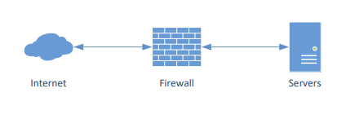
Figure 1 single firewall setup
Another design uses two firewalls. One at the edge of the trusted network the second is placed after the public facing servers of the organisation, such as web servers. This allows reasonable access for the public to these webservers whilst the organisations data is kept secure behind the second. The area between the two firewalls is known as the Demilitarised Zone (DMZ)
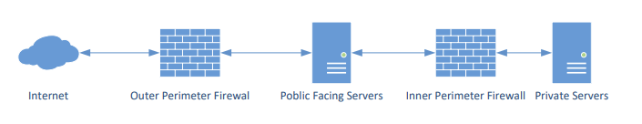
Figure 2 two firewall set up

The above diagrams are basic concepts. They do however form the basis for more complex real-life examples such as the National Health Service shown below.
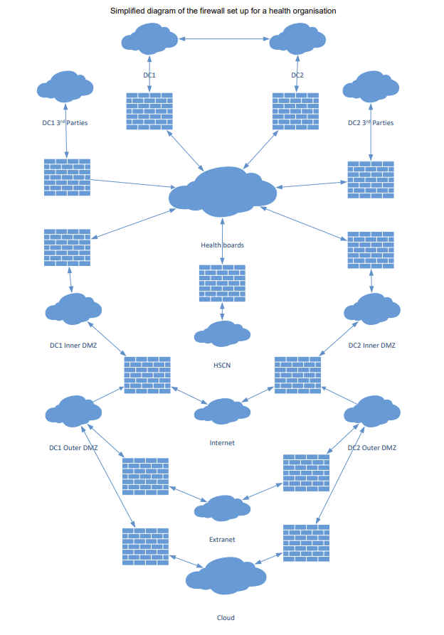
Figure 3 Firewall Set up for Health Boards
In conclusion, firewalls are an integral component of any network security strategy. They provide a fundamental layer of security that safeguards the network’s overall health and integrity. However, it is important to note that while firewalls are a critical part of network security, they are just one piece of the puzzle. A comprehensive network security strategy should also encompass other elements such as intrusion detection systems, encryption, and regular security audits. This multi-layered approach ensures a robust defence against potential cyber threats[2].
- VPNS

With the rise in the number of workers working remotely or using Bring Your Own Devices, this has raised the issue of how they can connect to their organisations private network and how safe is the data that is being transmitted over the internet.

Whilst data is in transit over the internet it is susceptible to third parties being able to infiltrate this data. This could give them the IP addresses of the sender and the receiver and

Virtual Private Networks (VPNs) indeed play a significant role in network security[6]. They provide a secure connection between a user’s device and a server over the internet, effectively “tunnelling” the user’s data through the public internet.
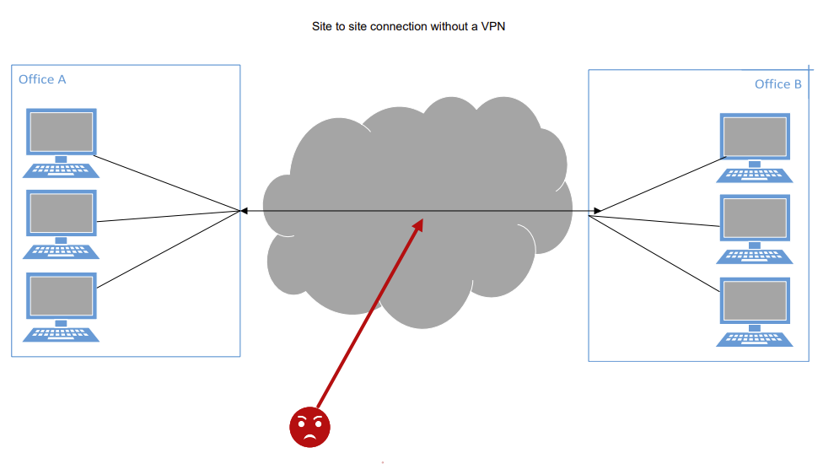
Figure 4 Site to Site connection without VPN
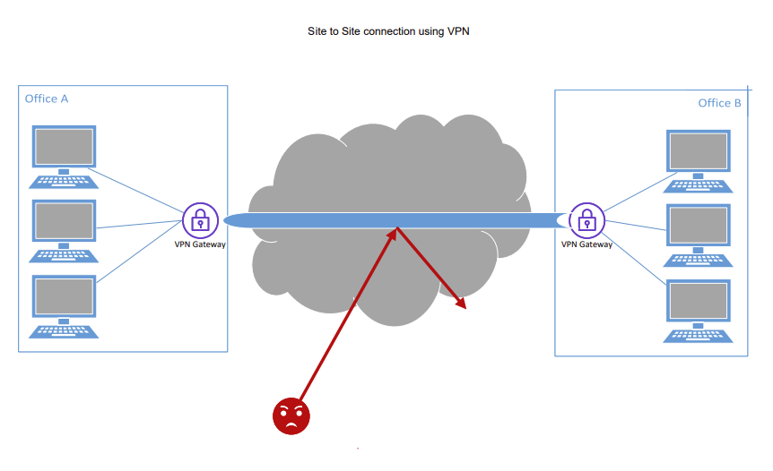
Figure 5 Site to Site connection with VPN
Here is a refined explanation of how they contribute to network security

- Data Encryption: VPNs employ robust encryption protocols to secure data that is transmitted over the network. This means that even if a hacker manages to intercept the data, they would not be able to decipher it due to the encryption. [11]
- Secure Remote Access: VPNs enable users to securely access a private network from remote locations. This feature is particularly beneficial for organisations with remote employees or multiple office locations, ensuring secure and reliable access to necessary resources.

- Anonymity: By concealing the user’s IP address, VPNs provide anonymity and protect the user’s privacy. This makes it challenging for third parties to track the user’s online activities, enhancing privacy and security.

- Safe Public Wi-Fi Use: Public Wi-Fi networks are often unsecured, making them a prime target for hackers. VPNs can provide a layer of security when using these networks, protecting the user’s data from potential threats.

In summary, VPNs are a critical tool in the realm of network security. They help secure data, control access, and provide a safe and private browsing experience. However, like firewalls they are just one piece of the puzzle in a comprehensive network security strategy. It is also important to note that while VPNs enhance security, they should be used in conjunction with other security measures for optimal protection.

- Network access controls

Network Access Control (NAC) is a crucial component for organisations to secure their network infrastructure. It ensures that only authorised users and devices can access the network, thereby reducing the risk of security breaches. By enforcing security policies, NAC helps maintain compliance with regulatory standards and internal security protocols. Furthermore, NAC can prevent malware, viruses, and other cyber threats by ensuring that devices meet security requirements before granting access. NAC also provides visibility into who and what is accessing the network, allowing for better monitoring and control.

There are several types of NAC, each with its own approach to managing network access:

- Discretionary Access Control (DAC): Access is granted based on the identity of the user and the discretion of the resource owner. This type is flexible but can be less secure.

- Role-Based Access Control (RBAC): Access is assigned based on the user’s role within the organisation. This method is scalable and easier to manage.

- Mandatory Access Control (MAC): Access is based on fixed policies set by a central authority. This type is highly secure but less flexible.

- Attribute-Based Access Control (ABAC): Access is allowed based on attributes (e.g., user, resource, environment). This method is highly flexible and can be tailored to specific needs.

- Challenges in Implementing Security Technologies

Implementing Firewalls and VPNs in an organisation’s network security infrastructure is not without its challenges:

Firewall Management Challenges:

Rule Complexity and Optimisation: Managing many firewall rules across multiple devices can lead to rule sprawl and complexity[5].

Performance Optimisation: Ensuring efficient handling of network traffic while minimizing latency and bottlenecks.

Compliance and Policy Adherence: Ensuring firewall compliance with industry regulations and security policies.

VPN Challenges:

The sudden spike in VPN usage can lead to bandwidth and performance issues.
If VPNs are not properly configured or if they rely on outdated encryption protocols, they could become points of vulnerability.

NAC Challenges

Addressing Visibility Issues in Network Access: Achieving comprehensive visibility into network access is crucial for effective NAC management. Without clear insight into who is accessing the network and which devices are in use, network administrators face significant challenges in enforcing strong security controls.

Managing Unauthorised Access: Controlling unauthorised network access is vital in maintaining a secure environment. Unwanted external intruders or even internal personnel can become significant threats if they gain access without appropriate permissions.

IT systems often consist of a combination or both cloud and on-premises networks. These systems can be geographically scattered and include numerous devices, assets and virtual machines. Access is granted to all these devices, and keeping track of them can be difficult.

Policy Management: Organisational decision-makers draft policies, which the IT department then translates into code for implementation. Effective coordination between these groups is crucial to ensure the access control system remains current and functions as intended.
.

Excessive Permissions and Exceptions: Administrators may grant unnecessary permissions to users to prevent any delays in development, a practice that lowers the level of security provided by the access control system

Monitoring and Reporting: Organisations must continuously monitor access control systems to ensure compliance with internal policies and government regulations.

Integrating Network Access Control (NAC) into existing security measures can present several challenges for businesses.

Addressing Scalability-Related Issues: As organisations grow, so does the complexity and scale of their network infrastructure. NAC solutions need to be scalable to accommodate this growth.

Ensuring Compliance Capabilities: NAC solutions need to have robust compliance capabilities to ensure that they meet all relevant regulatory requirements.

- Future Directions in Data Security and Compliance
Looking ahead, several trends and technologies are poised to shape the future of data security and compliance:

Artificial Intelligence (AI) and Machine Learning (ML): These technologies are expected to play a significant role in cybersecurity, making it increasingly difficult to distinguish between humans and machines online.

Privacy Enhancing Technologies (PET): Techniques like homomorphic encryption and secure multi-party computation enable processing data in encrypted form, reducing exposure [9].

Blockchain: This technology could potentially transform compliance by creating more secure, transparent, and efficient systems. [10]

Cyber Resilience: The focus of cybersecurity is expected to shift from defending against attacks to building resilience and capacity for recovery.

Cloud Computing: While cloud computing has seen significant growth, some predict a shift back towards on-premises solutions for certain applications.

These trends indicate that the field of data security and compliance is evolving rapidly, and organisations will need to stay ahead of these changes to effectively protect their data and maintain compliance.

- Conclusion
The integration of firewalls, VPNs, and Network Access Control is essential for maintaining the security and integrity of an organisation’s network. Firewalls provide a critical barrier against external threats, while VPNs ensure secure communication channels for remote users. NAC plays a pivotal role in enforcing security policies and controlling access to network resources. Together, these technologies form a multi-layered defence strategy that significantly reduces the risk of cyber-attacks and data breaches. Organisations must prioritize the implementation and continuous monitoring of these security measures to protect sensitive information and maintain operational continuity in an increasingly connected world.

Table of contents
Contents
Table of contents 9
List of Figures and tables 11
List of Acronyms 11
Introduction 12
Organisation Structure 12
Policy and Procedures 13
Top-Down 13
Bottom-Down 14
Recommendations 14
Data Protection Compliance 14
UK GDPR 15
Implications 15
Recommendations 15
Security Standards 16
Suggested and Recognised Standards 16
ISO/IEC 27001 16
NIST Computer Resource Centre. 17
SP800-12 An introduction to Information Security 17
SP800-30 Guide for Conducting Risk Assessments 17
SP800-35 Guide to Information Technology Security Systems 17
Cyber Assessment Framework (CAF) 17
Recommendations 17
Governance and Strategic Planning for security 17
Strategic Alignment 18
Risk Management 18
Resource Management 18
Performance Measures 18
Value Delivery 18
Recommendations 18
Risk Management 18
Recommendations 18
Contingencies Planning 19
What do we need contingencies for 19
Steps to create a contingency plan 21
Develop Contingency Planning Policy 22
Conduct Business Impact Analysis 22
Identify Preventative Controls 22
Create Contingency Strategies 22
Develop Contingency Plan 22
Testing and Training 22
Review and update 22
Recommendations 22
Conclusion 23

List of Figures and tables
Fig 1 1 CIA Triad
Fig1 2 Organisation Structure
Fig1 3 Policy Development
Fig1 4 Proposed Risk Matrix
Fig1 5 Proposed Risk Register
Fig1 6 Sphere of Use
Fig1 7 Sphere of Protection
Fig1 8 Contingency Plan Development

List of Acronyms

ISU - Information Security Unit
EDO – Executive Director of Operations
CISO – Chief Information Security Officer
CRO – Chief Risk Officer
DPO - Data Protection Officer
SCOM – Security Monitoring
ISO – international Organisation for Standardisation
ICE – Institute of Civil Engineers
CAF – Cyber Assessment Framework
NIS – Network and Information Systems
UK GDPR - UK General Data Protection Regulation
ICO - Information Commissioner’s Office

Introduction
Following a loss of critical systems last year and a data breach. The board decided to introduce a new Information Security Unit (ISU). Its primary objective will be to ensure the protection of our organisations data and digital assets. This report outlines the approach to be taken, considering key factors such as organisational structure, policies and procedures, data protection compliance, security standards, contingency planning, governance and strategic planning for security, and risk management.
With Data being our number one resource for the organisation, it is imperative that its security is embraced by all departments and their staff.
The CIA triad forms the basis of successful data security and from there we can build our systems, policies, and procedures.
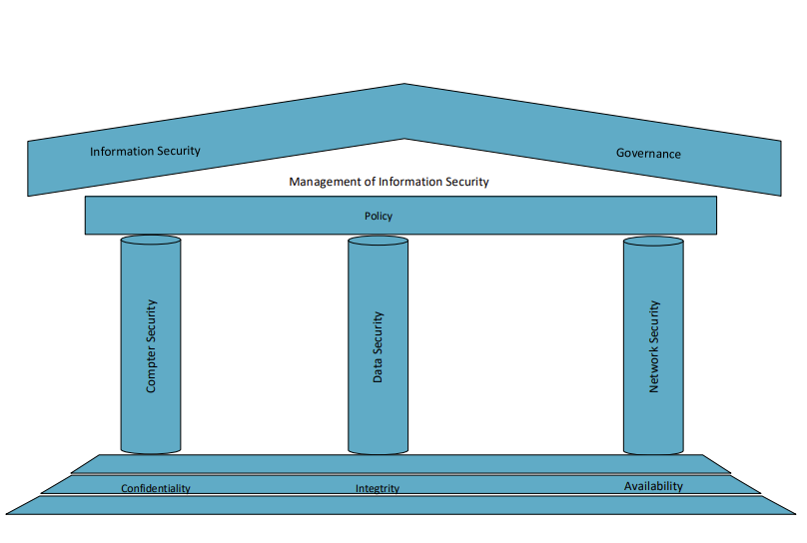
Fig 1 1CIA Triad

Organisation Structure

The Information Security Department will oversee the development and upkeep of policies, standards, guidelines, and procedures that pertain to information security across the organisation. Their role includes conducting educational programs on security awareness to ensure everyone understands their part in upholding security. In essence, the ISU is the backbone that supports the security program as defined by the policy.
Chief information Security Officer - Will head up the ISU and ultimately be responsible for all decisions made by the unit. Will be pivotal in driving forward the concept of Information security and liaising with the Executive Director on formulating Policies.
Cyber Governance Lead – Answering to the Chief Information Security Officer, they will drive forward the ensure that the IT resources are optimised, and value is gained, they will help formulate strategies and policies that will also align with the companies’ wider goals.
Cyber Security Compliance lead - Will be responsible for ensuring that the company and its employees are compliant with all applicable laws and regulations adopted policies and Frameworks
Principle Project Manager - This unit will project management team with a high level of understanding in information security. Their duties will be to assist the other departments for up-and-coming projects

Head of Cyber Security – They will head up a team of cyber security experts for deal with Cyber resiliency, Security Monitoring (SCOM), and access control
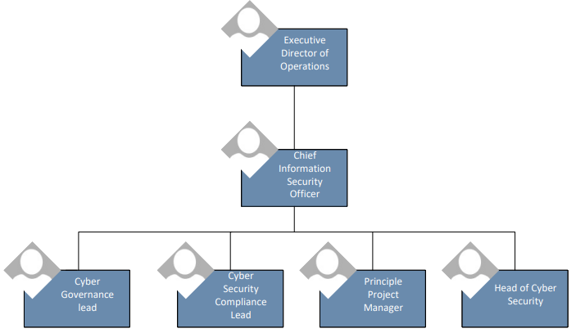
Fig 1 2Organisation Structure

Policy and Procedures
The one of the key roles of the ISU will be the development. implementation and monitoring of policies and procedures referring to IT and data safety. Working closely with the chief officers to develop Polices, they will help drive and educate all departments on said policies to formulate adopted standards.
The approach to how Polices are developed can be approached either by Top-Down or a Bottom-Up method.

Top-Down
Decisions are made by Top management and then communicated to the rest of the team. Managers gather knowledge, analyse it and make actionable conclusions. Policies are then communicated and implemented by the rest of the organisation.
The benefit of this method is the approach remains the same and carried out by the same team. This provides a well-practiced process that can grow more efficient over time.
Bottom-Down
Decisions are developed from all teams giving them a choice in decision making. This can become convoluted however, as teams may only see their own perspective rather than a holistic view.

Recommendations
Whilst both methodologies have their merits, it is accepted that Top-Down is more successful than Bottom-Up [12].

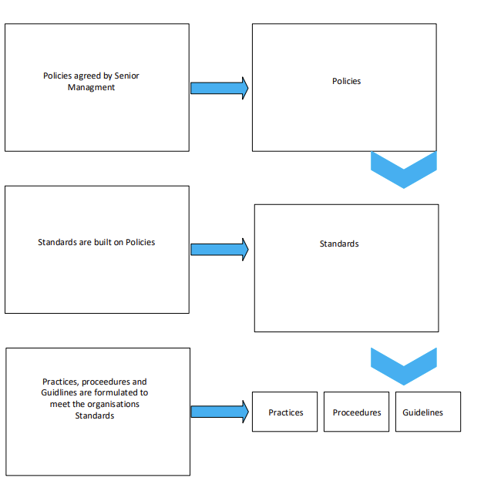
Fig 1 3Policy Development

Data Protection Compliance

Having suffered a data breach last year, this has been marked as a high priority for the ISU. From the investigation into the breach, it was concluded that it was avoidable. Lack of training for staff and irregular reviewing of the data held played significant roles in the breech. The investigation also highlighted a weakness in how the backups of the data were held. Whilst it did not play a part in the breach, it will be an area that needs to be addressed.

UK GDPR
The UK GDPR sets stringent requirements for data protection and privacy. It mandates organisations to process personal data securely by implementing appropriate technical and organisational measures. Compliance with UK GDPR is essential for protecting individuals’ privacy rights and avoiding legal penalties.
The seven Key Principles are :
Lawfulness, fairness, and transparency - Have a valid reason for collecting the data, ensure the data collected is used lawfully and be clear how the data will be used
Purpose Limitation– Record the purpose of collecting data and specify it in your Privacy information for individuals. Should you wish to use the data for any other purpose you will require consent from the individual.
Data minimisation - Hold only the data you need for the purpose
Accuracy -Take reasonable steps to ensure the data you hold is not incorrect or misleading. Take reasonable steps to correct or erase any incorrect data. Keep data updated
Storage limitation - Justify how long personal data will be kept and keep it no longer than needed. Adopt a policy setting retention period wherever possible
Integrity and confidentiality – Have appropriate security measures to protect the data
Accountability - You are required to take responsibility for what you do with the data and be able to demonstrate your compliance.

Implications

The Information Commissioner’s Office (ICO), the supervisory authority for the GDPR can impose fines of £17.5 million or 4% of the annual worldwide turnover
For serious breaches of the data protection principles, we have the power to issue fines of up to £17.5 million or 4% of your annual worldwide turnover, whichever is higher.
Loss of reputation and market share [13].

Recommendations

A full review of the current access controls will need to be implemented. Role Based Access Control will be implemented. Proof of concept work will be carried out to adopt Just In Time Access for data classified as highly sensitive[18]. This should further strengthen the safety of the data.
A comprehensive training program for all staff will be put together highlighting the importance of data protection from the company, staff and customers view. Employees will have to pass the training and will need to resit the test every year.
Policy’s will need to be rewritten to ensure that staff are dealing with data correctly
The backup systems for the data will need to be improved. Currently data at rest on the backup systems are not encrypted. Work will also be carried out to investigate the feasibility of having offline copies of the data ensuring there will be immutability built into the system.

Security Standards

The ISU will ensure the organisation will adhere to established data and information security standards the benefits of which include:
Protection of Sensitive Information - Data and information security standards provide a framework for protecting sensitive information from unauthorised access, disclosure, alteration, and destruction. By implementing these standards, organisations can safeguard personal data, intellectual property, and other critical information assets.
Regulatory Compliance - Adhering to data and information security standards ensures compliance with legal and regulatory requirements. In the UK, organisations must comply with the UK GDPR, which mandates stringent data protection measures. Non-compliance can result in severe penalties and legal actions
Risk Mitigation - Implementing security standards helps organisations identify and mitigate risks associated with data breaches and cyber-attacks. By following best practices and guidelines, organisations can reduce vulnerabilities and enhance their overall security posture.
Reputation Management - Maintaining robust data and information security practices enhances an organisation’s reputation. Customers, partners, and stakeholders are more likely to trust organisations that demonstrate a commitment to protecting their data.

Suggested and Recognised Standards

ISO/IEC 27001
ISO/IEC 27001 is an international standard for information security management systems (ISMS). It provides a systematic approach to managing sensitive information.
The standard details requirements for establishing, implementing, maintaining, and continually improving an Information Security Management System (ISMS). The goal of the ISMS is to enhance the security of the organisation's information assets. Organisations that meet the standard’s requirements can choose to be certified by an accredited certification body following a successful completion of an audit
ISO/IEC 27001 requires that management systematically examine the organisation’s information security risks, taking account of the threats, vulnerabilities, and impacts. It also requires the design and implementation of a coherent and comprehensive suite of information security controls and/or other forms of risk treatment (such as risk avoidance or risk transfer) to address those risks that are deemed unacceptable.
The standard promotes a comprehensive approach to information security, vetting people, policies, and technology. It is a tool for risk management, cyber-resilience, and operational excellence. It is applicable to organisations of any size or any industry. It is also possible to gain accreditation

NIST Computer Resource Centre.
Whilst the UK has its own Cyber security resource, NIST’s recourses are widely accepted globally and provide an alternative for the ISO 2001.
They provide a vast number of guidelines assist in helping you adopt new polices, carry out risk assessments and technical best practices for computer systems. Some guidelines include

SP800-12 An introduction to Information Security
Provides a broad overview of computer security needs and how to select appropriate security controls.

SP800-30 Guide for Conducting Risk Assessments
Provides guidance on the preparation, conducting and monitoring of risk assessments [15]

SP800-35 Guide to Information Technology Security Systems
Provide roles and responsibilities of the organisation’s staff who are responsible for implementing and managing the security services life cycle [14]

Cyber Assessment Framework (CAF)
A framework specifically designed to help protect against cyber incidents . Particularly organisations that are subject to the Network and Information (NIS) Regulations. It aims to give guidance to manage risk, protect against attacks , detect cyber-attack events and minimise the impact of cyber incidents. [19]

Recommendations
The recommendation to the board is that the company adopt the ISO27001. This framework has been widely accepted by our business sector and competitors. By also gaining the accreditation, it will give confidence to our stakeholders that we have an organisation committed to information security.
The organisation is subject to the NIS Regulations and therefore will continue to follow CAF.

Governance and Strategic Planning for security
The Cyber Governance Lead will be responsible for Governance and Strategic Planning. They will be responsible for:

Strategic Alignment
Align information security with the organisation's broader objectives. The benefit of this is the organisation will adapt its thinking to making business decisions with information security in mind [16]

Risk Management
Identifying, analyse and mitigating potential threats and vulnerabilities.

Resource Management
Design security architectures suitable for its current needs and flexibility to for changes in the future. Ensure relevant resource and budgets are allocated.

Performance Measures
Develop suitable performance measures for all policies and objectives are measured. It will increase accountability and help with further decision making

Value Delivery
Ensure that security investments provide a positive return on investment by meeting various objectives. It ensures that resources spent on information security are constrained within the overall enterprise resource objectives
These goals are vital for effective Information Security Governance. They assist in aligning security initiatives with business objectives, managing risks, efficiently utilising resources, measuring performance, and delivering value. They offer a comprehensive approach to managing information security within an organisation.

Recommendations
Work with the senior management team to information security strategies that will align with the company’s goals
Set performance measures

Risk Management
Currently each unit of the organisation has its own risk register, often using different designs and methodologies. The majority of units however have adopted risk assessments method using a 3 X 3 matrix.

Recommendations
ISU will work closely with all departments in establishing a global risk register and adopting a 5 x 5 risk matrix, allowing for a more granular risk rating. This will allow the organisation to prioritise risks more accurately. Each risk will be owned by the head of unit and will have a review date set of every six months. This should help reassess the risks due any factors that may have changed. The Cyber Governance lead will be the point of contact for this work.

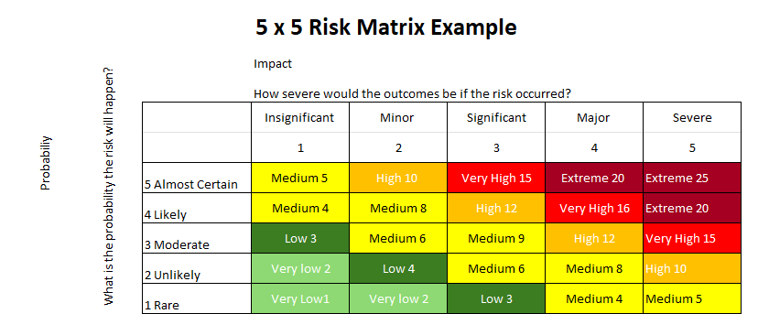
Fig 1 4 Proposed Risk Matrix

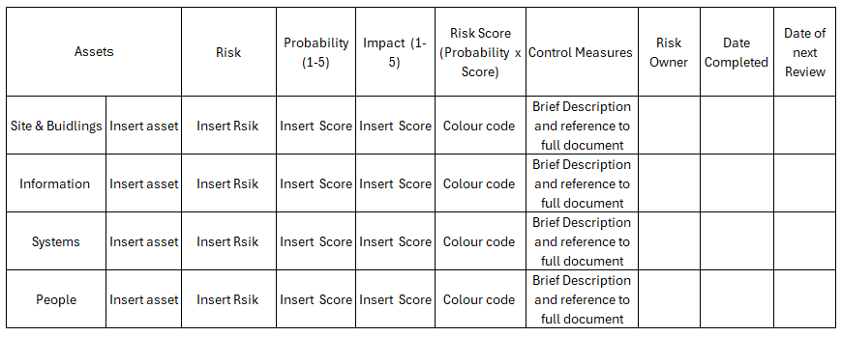
Fig 1 5 Proposed Risk Register

Contingencies Planning
Last year’s outages of the systems identified weaknesses in the contingency plans. The breakdown in communication between departments saw a longer outage than it should have been. Uninterruptible power supply had gone untested and failed when the was a power loss. These are unacceptable errors for the business and will need to be improved on.

What do we need contingencies for
Information lies at the centre of any Information Security Framework. From a technology perspective data can be vulnerable from the internet, the private network of the organisation and the systems they use. Added to that, people can play a significant role in whether that information stays secure. It should be added that we are not just talking about people acting maliciously. People may not be trained correctly on how to use the systems for example.
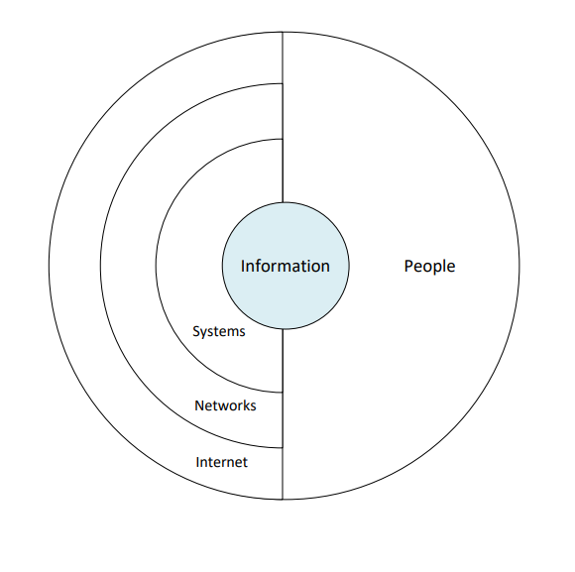
Fig 1 6 Sphere of Use

To limit the risk of loss of information, measures need to be taken at each of these points to combat the vulnerabilities the Sphere of Protection indicates some area of risk and what can be put into place to help combat them. By implementing these measures, you create Defence in Depth.

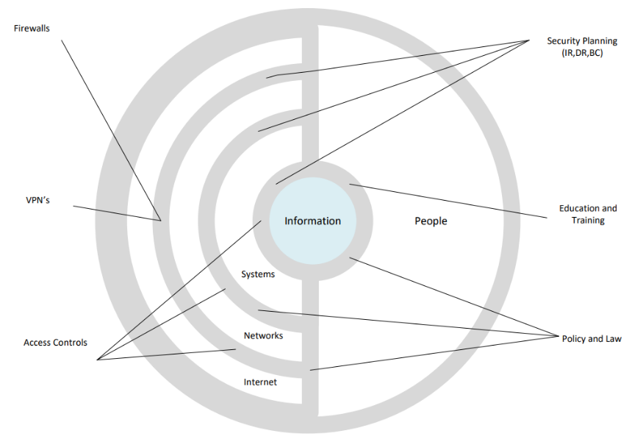
Fig 1 7 Sphere of Protection

Steps to create a contingency plan

A Simple overview of a contingency plan can be described as below

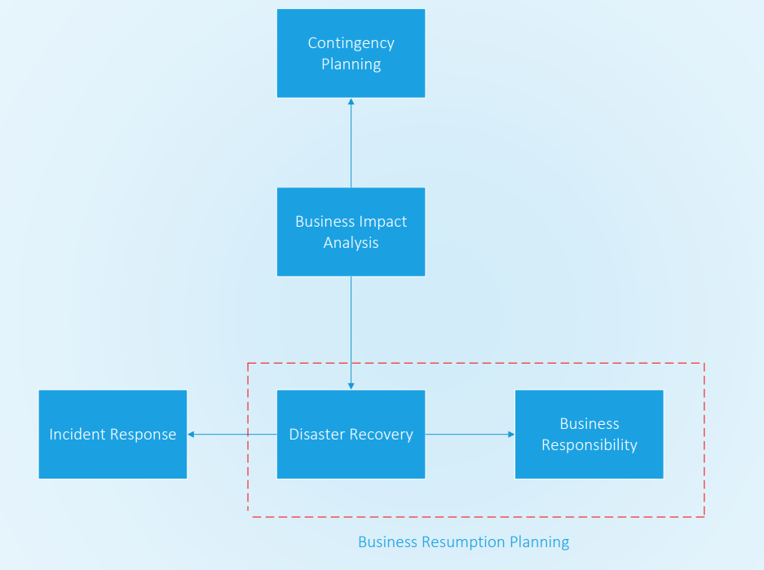
Fig 1 8 Contingency Plan Development

However, to give a greater understanding the NIST SP800-34 Rev1 recommends the following: [17]

Develop Contingency Planning Policy
To ensure effective contingency planning, organisations must establish a well-defined policy. This policy serves as the cornerstone, providing guidance and alignment for all subsequent actions.
A contingency Planning Policy Statement should be produced that articulates the organisation’s overall contingency objectives. It defines the framework and delineates responsibilities for system contingency planning. Senior management must actively support and participate in developing this program policy

Conduct Business Impact Analysis
The BIA enables the Information System Contingency Planning (ISCP) Coordinator to thoroughly understand system components, supported business processes, and their interdependencies. From this you can assess the consequences of potential disruptions. and establish recovery priorities along with the required resources to do so

Identify Preventative Controls
Preventive measures can mitigate or eliminate outage impacts identified in the Business Impact Analysis (BIA). These measures are preferable to recovery actions post-disruption if they are feasible and cost-effective examples include uninterruptable power supplies and emergency shutdown switches

Create Contingency Strategies
Develop strategies to get the business up and running after some disruption. This could be by mirroring your infrastructure across 2 or more different sites or implementing a restore of backups

Develop Contingency Plan
The plan should be concise and easy to read. Remember this plan could be used by someone not necessarily familiar with the task at hand. Try to use checklists where possible.

Testing and Training
Test the plans and train staff accordingly. Get feed back from staff . Make improvements it required

Review and update
Set a realistic timeframe to review and update

Recommendations
The ISU will follow NIST SP800 -34 to layout and improve its contingency plans.
Look into the feasibility of Governance/compliance Software a single place to store all policies, who owns them and when they are to be reviewed
The Cyber Governance lead and Cyber Compliance will work together on both these tasks.

Conclusion
The setting up of the ISU is a big task. The budget and resources to allow this to happen will also be substantial. However, the cost of not doing this may be even bigger. It is well accepted that its not a case of if you suffer a cyber-attack or data breach, but when. The company were relatively lucky with our systems outages and data breach last year. Can we say we will be if it happens again?
Should the board approve the recommendations given in this report it is approximated that it will take 24 months to get everything into place. Further to the proposed recommendations its suggested that a list of priorities is made as follows
Creation of Top-Down Polices aligning with Legislation, Frameworks and the company’s wider objective
Encrypt backup data and investigate immutable backup strategies
Work toward ISO270001 and accreditation
Implement a universal risk register and adopting a standard for how the risk assessments are done

References
[1] 8. Stallings,Network Security Essentials: Applications and Standards, Global Edition, 6th Ed. Pearson Education, 2016.
[2] O. L, et al., "Toward a modern secure network based on next-generation firewalls: recommendations and best practices," vol. 238, pp.1029-1035, 2024. doi: https://doi.org/10.1016/j.procs.2024.06.130. Available: https://www.sciencedirect.com/science/article/pii/S1877050924013668
[3] National Audit Office. "Investigation: WannaCry cyber attack and the NHS National Audit Office (NAO), May 15, 2024. https://www.nao.org.uk/reports/investigation-wannacry-cyber-attack-and-the-nhs/#publication-details (accessed Jul. 16, 2024)." https://www.nao.org.uk. https://www.nao.org.uk/reports/investigation-wannacry-cyber-attack-and-the-nhs/#publication-details (accessed 16-07-).
[4] "Firewall Technology's Importance in the Fight against the Internet Security," doi: 10.58314/099098.
[5] N. Lu and Y. Yang, "Application of evolutionary algorithm in performance optimization of embedded network firewall," vol. 76, pp.103087, 2020. doi: 10.1016/j.micpro.2020.103087. Available: https://www-sciencedirect-com.ezproxy.uwtsd.ac.uk/science/article/pii/S0141933120301551
[6] J. Longworth, "VPN: from an obscure network to a widespread solution," vol. 2018, no. 4, pp.14-15, 2018. doi: 10.1016/S1361-3723(18)30034-4. Available: https://www-sciencedirect-com.ezproxy.uwtsd.ac.uk/science/article/pii/S1361372318300344
[7] "The Data Protection Act ." www.gov.uk. https://www.gov.uk/data-protection (accessed 22/07/).
[8] Home Office. "Cyber Security Breaches Survey 2024." www.gov.uk. https://www.gov.uk/government/statistics/cyber-security-breaches-survey-2024/cyber-security-breaches-survey-2024#summary (accessed 22/07/).
[9] N. Kaaniche, M. Laurent and S. Belguith, "Privacy enhancing technologies for solving the privacy-personalization paradox: Taxonomy and survey," vol. 171, pp.102807, 2020. doi: 10.1016/j.jnca.2020.102807. Available: https://www.sciencedirect.com/science/article/pii/S1084804520302794
[10] S. Doughman. "How blockchain can improve data security in healthcare." https://www.weforum.org. https://www.weforum.org/agenda/2023/12/healthcare-data-breaches-blockchain-cybersecurity/
[11] H. Poston. "Virtual Private Networks (VPNs)." inforsec.institute.com. https://www.infosecinstitute.com/resources/cryptography/virtual-private-networks-vpns/#:~:text=VPNs%20heavily%20use%20cryptographic%20algorithms,use%20asymmetric%20cryptography%20as%20well. (accessed 23/07/).
[12] S. AlGhamdi, K. T. Win and E. Vlahu-Gjorgievska, "Information security governance challenges and critical success factors: Systematic review," vol. 99, pp.102030, Dec 2020. doi: https://doi.org/10.1016/j.procs.2024.06.130. Available: https://dx.doi.org/10.1016/j.cose.2020.102030
[13] ICO. "A guide to the data protection principles ." ico.org.uk. https://ico.org.uk/for-organisations/uk-gdpr-guidance-and-resources/data-protection-principles/a-guide-to-the-data-protection-principles/ (accessed 25/07/).
[14] Grance Tim, Hash Joan, M. Stevens, K. O'Neal and Bartol Nadya, "NIST SP 800-35
Guide to Information Technology Security Services." csrc.nst.gov. https://csrc.nist.gov/pubs/sp/800/35/final (accessed 25/07/24).
[15] 2. Joint Task Force Transformation Initiative, "NIST SP 800-30 Rev. 1." https://csrc.nist.gov/pubs/sp/800/30/r1/final. https://csrc.nist.gov (accessed 25/07/24).
[16] A. C. Johnston and R. Hale, "Improved security through information security governance," vol. 52, no. 1, pp.126-129, Jan 2009. doi: 10.1145/1435417.1435446.
[17] M. Swanson. "Contingency planning guide for federal information systems (draft)." https://purl.fdlp.gov/GPO/gpo52605
[18] C. Kunze. "Configuring Microsoft Intune just-in-time admin access with Azure AD PIM for Groups." https://techcommunity.microsoft.com. https://techcommunity.microsoft.com/t5/intune-customer-success/configuring-microsoft-intune-just-in-time-admin-access-with/ba-p/3843972 (accessed 28/07/).
[19] National Cyber Security Centre. "Cyber Assessment Framework." www.ncsc.gov.uk. https://www.ncsc.gov.uk/collection/cyber-assessment-framework (accessed 28/07/).

