Name | Student Number | Date | Lecturer’s Name | Your score
Emese lakatos | 2506108 | 10.23.2025 |  | To be filled by the marker  ___/40
You will have 75 minutes to complete this assessment. It is divided into three sections: note-taking, paraphrasing and writing a paragraph.
---------------------------------------------------------------------------------------------------------------------
1. Take diagrammatic notes from the passage below using the space provided:

As a student you've got a lot on your plate - academic work, social life, work commitments, career plans, relationships and finances - sometimes stress can get in the way of this juggling act. When you recognise that you have become overwhelmed with stress, adopt a few strategies to help you manage your triggers more effectively. Those strategies could include exercising; you simply need to get your heart racing, for example by going for a brisk walk or a bike ride. Another suggestion is to try mindfulness, a relaxation technique originating in Buddhism. It is used by clinicians to improve patients' physical and mental health as it can significantly lower stress levels. Thirdly, why not speak to your friends and family - they know you best and care about you the most. What's more, studies suggest that socialising with a friend just once a week can reduce your stress levels and improve your mood as much as therapy or counselling. Simple time management techniques can also help you to feel more relaxed and focused. Try creating a written schedule, breaking your tasks down into manageable chunks, planning accordingly and allocating yourself time every day to relax or socialise. Finally, an obvious but often overlooked solution: get enough sleep, as no one functions at 100% when they're tired.
Adapted from: https://www.prospects.ac.uk/applying-for-university/university-life/5-ways-to-manage-student-stress

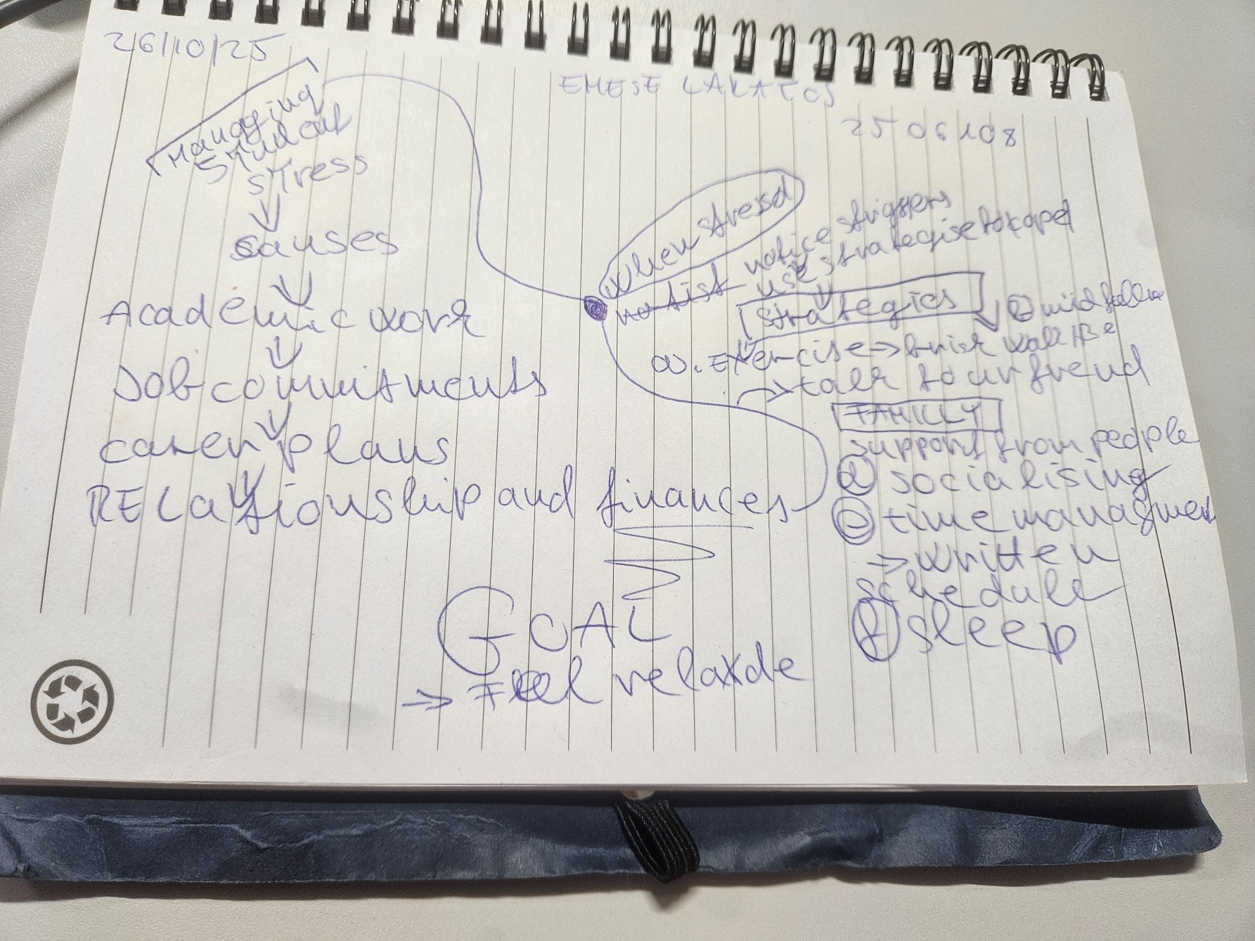
Space for your notes (max 12 marks):
Managing student stress
Causes
Academic work
Job commitments
Carer plans
Relationships and finances stress=juggling too much
When stressed
Notice triggers
Use strategies to cope
Strategies

2. Paraphrase the following sentences (max 3 marks for each, max 12 marks in total):

a) Good time management techniques can help you feel more relaxed and focused.
____________________making a good planning support to deal with managing the time for to be on time with out any late.we can organising for preparation this is also cost less stress _____________________________________________________________________________________________________________________________________________________________________________________________________________________________________________________________________________________________________________________________________________________________________

b) Speaking to your friends and family can significantly lower stress levels.
Talking with peopple who is close to me helps reduce stress becouse they understand u best and its can be offer more comfort adviced and help, make me calmer happier and clear minden _______________________________________________________________________________________________________________________________________________________________________________________________________________________________________________________________________________________________________________________________________________________________

c) University life offers numerous opportunities for personal growth and development. Begin at uni allow students le learn new skills gain to be more independence and meet with people from different backgrand its help to grow all both academically and persionally preparing for my future work and life excellenging ____________________________________________________________________________________________________________________________________________________________________________________________________________________________________________________________________________________________________________

d) Attending lectures regularly is crucial for understanding course material.

To help to learn more to be more confident for assigmentsm a_____________________________________________________________________________________________________________________________________________________________________________________________________________________________________________________________________________________________________________________________________________________________________________________

3. Write a well-structured paragraph (8 sentences) on the following topic:

Strategies for managing a student budget and reducing costs while at university.

Your paragraph must be written in full sentences (no bullet points) and in an academic style.

(max 16 marks in total)

__managing money at5 uni can be difficult. First off all making the simple monthly budget its help to track income and spending in addition importand to pay for essentialis like rent bus train food like cooking at home instead eating out we can borrow books from library taking a part time job can also help with finantially overall with good planning and smart choices students can manage theire budget and avoid financial problames ___________________________________________________________________________________________________________________________________________________________________________________________________________________________________________________________________________________________________________________________________________________________________________________________________________________________________________________________________________________________________________________________________________________________________________________________________________________________________________________________________________________________________________________________________________________________________________________________________________________________________________________________________________________________________________________________________________________________________________________________________________________________________________________________________________________________________________________________________________________________________________________________________________________________________________________________________________________________________________________________________________________________________________________________________________________________________________________________________________________________________________________________________________________________________________________________________________________________________________________________________________________________________________________________________________________________________________________________________________________________________________________________________________________________________________________________________________________________________________________________________________________________________________________________________________________________________________________________________________________________

