BA Business Management
LCBB5000
Module Lecturer : Zahra Mohammadnazari
Student name: Laura Bardas
Student ID : 2128922

Contents
Part 1 3
Introduction 3
(A) 3
1 3
2 3
3 4
4 4
5 5
6 5
(b) 6
(c) 8
1 8
2 10
Conclusion 13
References 14
Part 2 15
References: 19

Part 1

Introduction
The data governance has become a crucial factor for any organization and there are a number of tools that are being used on that purpose. The goal of this report is to compare Excel and SPSS to be able to find out if SPSS can perform the tasks that Excel can perform. Also, some tasks that can be easily performed with SPSS will be platform in this report such as finding correlation, drawing scatterplot, and so on. It will be helpful for Greenmed Healthcare to be able to choose the optimal data processing tool for their organization.

(A)

1
Mean is statistical data that is often utilized to understand the spread of a dataset, and for any type of data, average value can come in handy. For the data that has been provided, average value can be found based on the data of Hadoop. To be able to obtain the average value, Microsoft Excel is an easy process and the time required to obtain the output is very minimal (Guerrero et al., 2019).
=AVERAGE (B: B)
Using the formula shown above, the average value was obtained because all the data in the B column contains the processing time data of Hadoop. Also, there are no other places where data related to Hadoop is available, so using B: B will include all Hadoop data. In addition to that, Average formula can exclude the nonnumeric value cell, which is the column heading as well as the empty cells, so this formula is perfect to get the result (Guerrero et al., 2019). Using average formula on excel, the mean value that was achieved from here was 2.776889.

2
The average value has been obtained in the previous task and another similar term is known as median. The median is a value that is located exactly at the middle of the spread of a dataset, which means through a median data, a good idea about the spread of the dataset can be obtained (Guerrero et al., 2019). Based on the situation, median data may be required for analysis, even more than the average value but calculating the median value requires to sort data out. Microsoft Excel formula makes life easier as these additional tasks of sorting data are not needed.
=Median(C:C)
The above shown formula is the one that has been applied to be able to obtain the median data of the data that is relevant to Spark. Similar to average data, the median values are only available on C column, and no other column contains values that are applicable to Spark, so directly C:C is applicable. By doing so, the outcome that has been obtained from there is 2.74691 that means this is value is located on exactly the middle point of the spread of the Spark data processing related data.

3
Up until now, all the tasks required to utilize only one column which made it easier to find the values. However, in question no 3, two different columns will be required to utilize to be able to obtain the required data. The first task is to find the highest value that can be found related to R which will be available in the D column. Once found, then the next step can be performed where the date data of that maximum processing time data will be extracted (Walkenbach, 2010). As two different cells are used, and the data related to the maximum data needs to be looked up in another column, VLOOKUP can come in handy in this case. Vlookup formula provides the opportunity to utilize various cells and related data of one cells to the other can be extracted easily, but some modification in the data table may be required to be able to utilize this formula because this formula cannot look for data in the left direction and the date data is available on the first column, so here Vlookup formula can not work (Walkenbach, 2010). To make the formula work, a new column has been introduced before column A, which means the Date column has become column B (Harvey, 2010). In the new column A, the R processing data has been copied so that the Vlookup formula can be used.
=VLOOKUP ((MAX (A: A)), A2:B51,2, FALSE)
This is the formula that has been written with the aim to obtain the value that is required in this case. In this formula, the first term is Vlookup that instructs Excel to show which function to use. The first term inside the formula is max (A: A) which instructs that the maximum value that is available in the A column needs to be found. Once that value has been obtained, the A2 to B51 value will be included, and the maximum value found will be looked for in the 2nd column of the array which is B column. The final term of the formula says False which refers to finding the exact max for the max value found, not an approximate value (Harvey, 2010). 1/16/2023 this is the data that has been obtained that means the max R processing value takes place on 16th January.

4
Standard deviation is a significant value which needs to be identified in the case of Python, and there is a simple formula available for that. For standard deviation, there are two different formula liableble in Excel, and among them, the sample one will be used in this task (Liengme, 2008).
=STDEV.S(F: F)
In this formula, STDEV refers to calculating standard deviation, and s refers to sample. By taking the F column into consideration and applying standard deviation formula, the result that has been obtained is 1.297206.

5
The processing time of each platform is significantly different, and to be able to find the most optimal platform that can process within the shortest period of time, the average of each of the columns needs to be calculated (Liengme, 2008). One simple way of finding the values of each column can be finding out the average below each column, but it can create several issues as the whole column has been considered for other tasks. Under the situation, it becomes crucial to use new columns to find the average values as needed.
Hadoop | Spark | R | Python | Tableau
2.776889 | 2.932219 | 2.754784 | 2.573181 | 2.830279
These are the average values that represent the time required by each platform to perform tasks. Based on these data that has been shown, it can be said that the minimum time is required by Python as the average time is lowest for this platform (Liengme, 2008).

6

These average values have been found which shows various platforms require various amount of processing time to perform various tasks. As shown in the table, Python is the fastest among them all because Python only requires 2.5 time, but the other platforms can not even perform the tasks within 2.6 unit time. It shows the significant performance of Python in terms of processing time. The Spark requires more time than any other platform, and the rests fall in between.

(b)
This average value has already been calculated based on the provided data, but these data are written so it is difficult to read or interpret. Each data needs to be read and memorized to be able to compare the data to the next one to find out which one is bigger (Walkenbach, 2007). To remove this issue, Excel provides the opportunity to study data and graphically present it as needed. To be able to do so, there are various ways available, and PivotTable is one that can be utilized in this case.

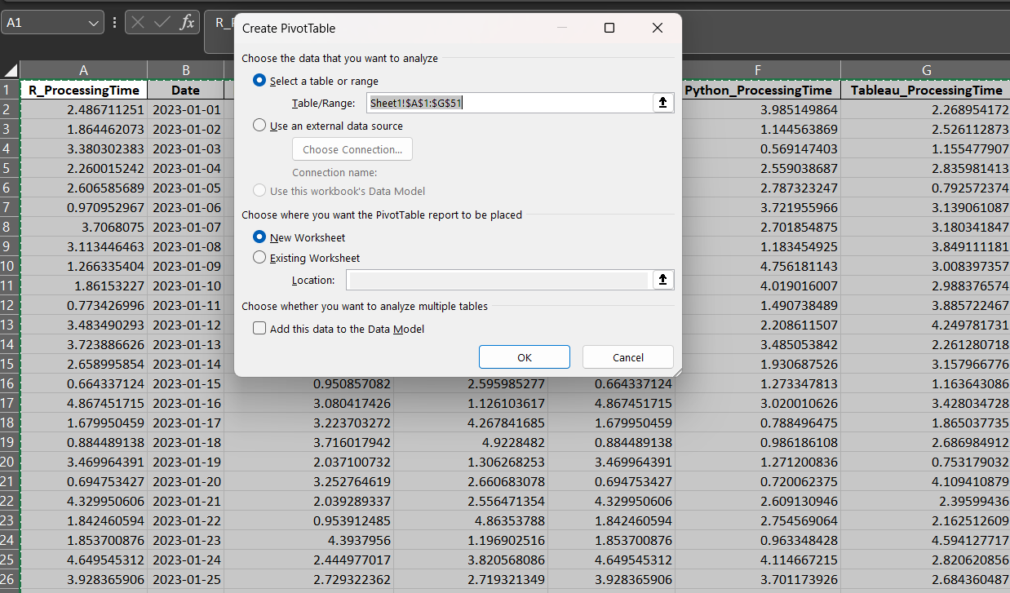
By selecting all the data in the PivotTable and selecting New Worksheet creates the PivotTable on a different sheet than the one currently active.

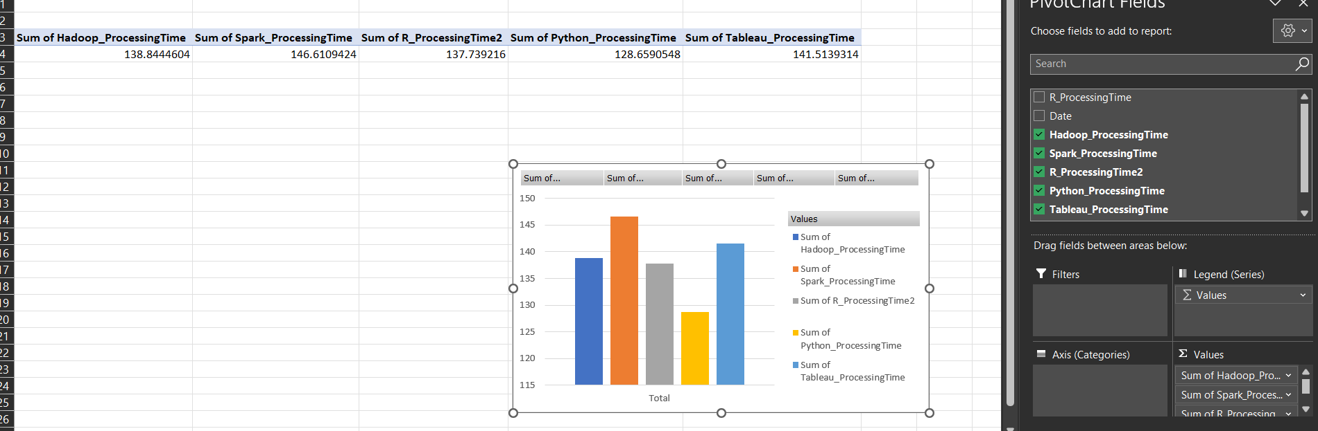
By selecting the processing time, and counting their sum values, the chart was produced where different columns represent the sum of different platform’s processing time.

The summed processing time that has been obtained through the analysis were utilized to create the chart shown above. By selecting the data on the right hand table, the chart was automatically created in the PivotTable (Walkenbach, 2007). This chart was chosen due to the fact that all the data that is required in this chart can be easily visible such as the column that has most value or lower value can be easily seen just by looking at those. Also, the legends are shown to be able to easily identify which bar represents which data.

(c)

1
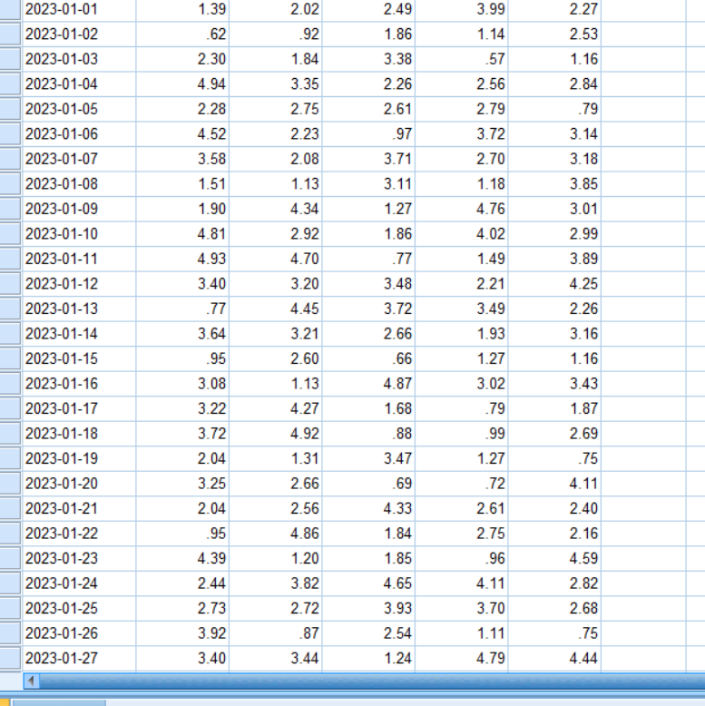
First, the data needs to be inputted in the SPSS so that the further analysis can be performed using SPSS. With that aim, the data has been placed in the SPSS as shown in the picture. The variable type needs to be set properly so that the SPSS analysis that will be performed can provide accurate data (Abbott, 2014).
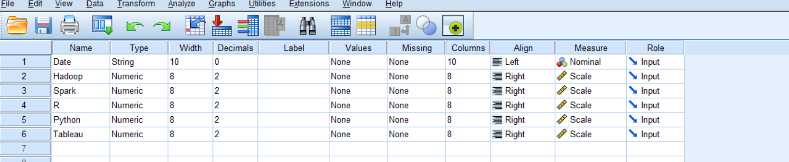
As shown in the above picture, the measure of the variables has been changed and set to scale so that the values can be compared with each other (Abbott, 2014).
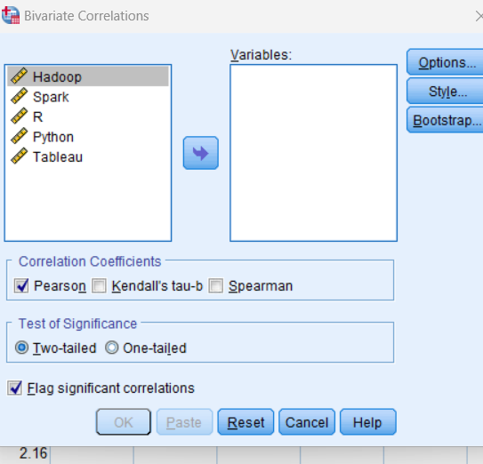
Correlation refers to creating a relationship between two random varaiables and to find out if they are connected with each other. To be able to run these types of analysis through SPSS, an Analyze option is available in the ribbon, and from there correlate option can be found (Abbott, 2014). Using this option provides Bivariate Correlations option which has produced this box where all the variables are available, but among these variables, Hadoop and Tableau has been chosen for this analysis.
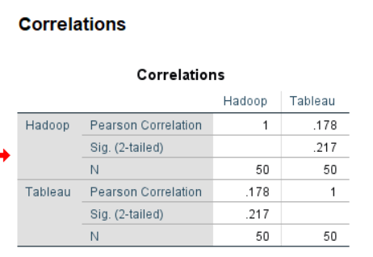
Here the correlation has been presented which was calculated by the SPSS, and from here, the correlation that exists can be identified. Here, the first significant value is the Pearson Correlation value that is found to be .178 which is close to 0. This value being close to 0 indicates that the relationship is present but is very weak (McCormick and Salcedo, 2017). Also, if the value is positive that means the relationship is positive, thus increase of one variable will push the other to increase. Another significant value is the p value which here is .217 which is higher than the 0.05 value that means the correlation is not as signifncinat (McCormick and Salcedo, 2017).

2
Through SPSS, charts and graphs can be easily created and these can be utilized to obtain various significant results. The goal of this part is to create scatter plot which is an important plot and can be drawn with the help of SPSS. All the graph related tasks need to be performed under Graphs option, so this option was chosen, and from there, chart builder was selected (McCormick and Salcedo, 2017).
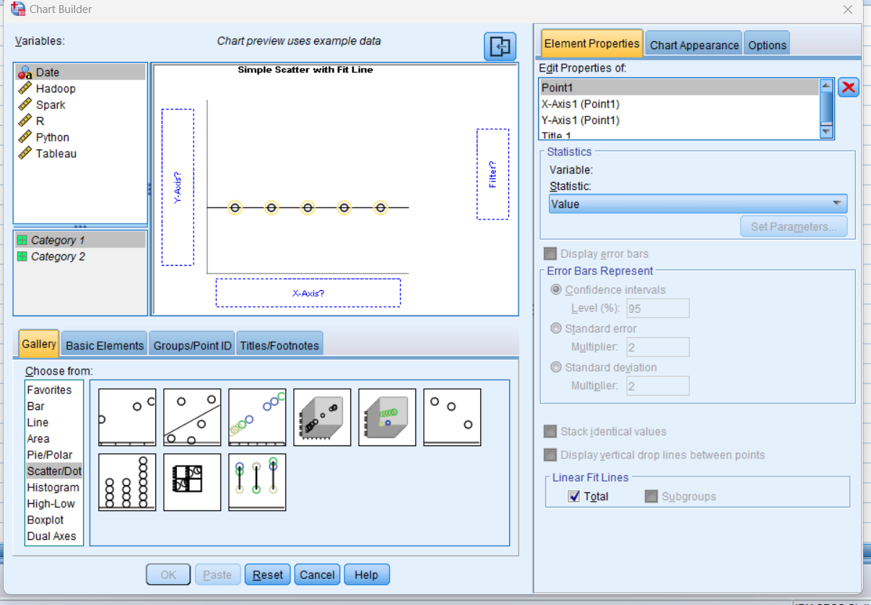
It is possible to create various types of charts using the chart builder option that is available in the SPSS. As shown, bar, line, area, histogram, etc. options are shown, but among them, scatterplot is the one that is required. So, scatter/Dot was chosen which provided with multiple style of scatterplot, and the second one was chosen which provided the chart on the above. The chart is yet empty, and variables name needs to be inputted in the axis names.
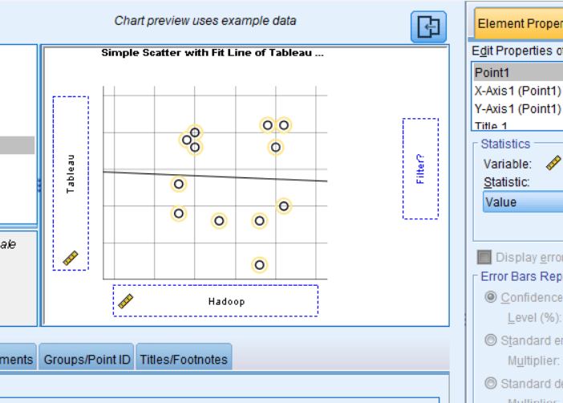

By inputting the variables, this is the preview of the scatterplot that has been shown by the SPSS, and it means that the chart builder is now ready to export the chart (McCormick and Salcedo, 2017).
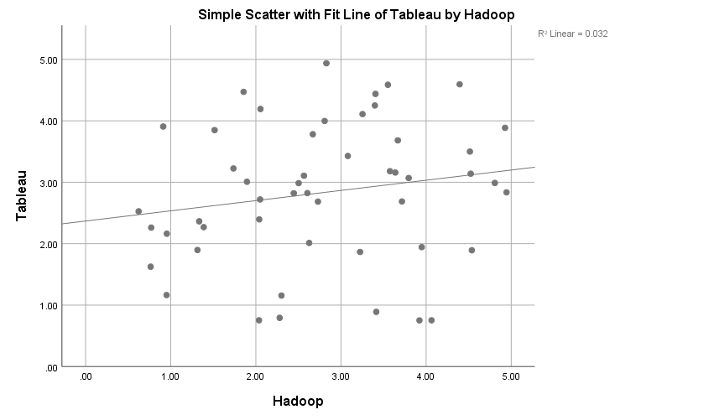
This is the scatterplot generated by SPSS where the fit line is visible, and the values are scattered around the graph. In this graph, a number of values are present, so the fit line that has been obtained can be marked as reliable (McCormick and Salcedo, 2017). If the presence of data was low, then the reliability of the chart would have decreased. Also, the fit line does not go through many points which means that the correlation that exists between these two variables is not as significant (McCormick and Salcedo, 2017).

Conclusion
A number of tasks has been performed to showcase that the tasks that are required by GreenMed Healthcare can be performed through SPSS with relative ease. A number of complex tasks such as finding correlation and such that requires multiple steps through Excel can be performed with relative ease when using SPSS. It is recommended for the organization to use SPSS as they will be able to get their job done and it will be an easier way for them to perform their data processing related tasks.

References
Abbott, M.L., 2014. Understanding educational statistics using Microsoft Excel and SPSS. John Wiley & Sons.
Guerrero, H., Guerrero, R. and Rauscher, 2019. Excel data analysis. Springer International Publishing.
Harvey, G., 2010. Excel 2010 Workbook for Dummies. John Wiley & Sons.
Liengme, B., 2008. A guide to Microsoft Excel 2007 for scientists and engineers. Academic Press.
McCormick, K. and Salcedo, J., 2017. SPSS statistics for data analysis and visualization. John Wiley & Sons.
Walkenbach, J., 2007. Excel 2007 charts (Vol. 1). John Wiley and Sons.
Walkenbach, J., 2010. Excel 2010 bible (Vol. 593). John Wiley & Sons.

Part 2

- Discuss the advantages and disadvantages of using SPSS, Excel or Tableau using relevant practical examples.

The comparison of SPSS, Excel, and Tableau in the context of data analysis involves examining their distinct advantages and disadvantages, each shaped by their features, intended user base, and the complexity of tasks they can handle.

SPSS (Statistical Package for the Social Sciences)

Advantages:
- Advanced Statistical Analysis: SPSS is renowned for its robust statistical analysis capabilities. It's highly efficient in handling large datasets and complex statistical operations, making it a preferred choice for researchers and statisticians (Field, 2013).
- User-Friendly Interface: Despite its advanced capabilities, SPSS offers a user-friendly interface, including a menu-driven approach that simplifies the process of conducting complex analyses (George & Mallery, 2019).

Disadvantages:
- Cost: One of the significant drawbacks of SPSS is its cost, making it less accessible for individual researchers or small organisations (Pallant, 2020).
- Limited Data Visualisation: While SPSS can perform complex statistical analyses, it lags in data visualisation capabilities compared to tools like Tableau (Field, 2013).

Excel

Advantages:
- Versatility and Accessibility: Excel is a widely accessible tool that offers a range of functionalities from basic data entry and management to more advanced features like pivot tables and basic statistical analysis (Walkenbach, 2015).
- Data Manipulation: It provides robust features for data sorting, filtering, and manipulation, making it useful for various data management tasks (Frye, 2016).

Disadvantages:
- Limited in Advanced Statistical Analysis: Excel is not suitable for highly complex statistical analyses, especially when dealing with large datasets (Walkenbach, 2015).
- Error-Prone: Manual data entry and formula setup in Excel can be error-prone, which may lead to inaccurate results (Frye, 2016).

Tableau

Advantages:
- Exceptional Data Visualization: Tableau specializes in data visualization, offering intuitive and dynamic graphical representations of data, which are easy to interpret and share (Chabrow, 2014).
- Handling Large Datasets: It efficiently handles large datasets and integrates data from various sources seamlessly (Murray, 2017).

Disadvantages:
- Cost and Learning Curve: Similar to SPSS, Tableau is expensive, and its sophisticated features require a learning curve for new users (Chabrow, 2014).
- Limited Statistical Analysis: While great at visualisation, Tableau does not offer the depth of statistical analysis that SPSS provides (Murray, 2017).

Practical Examples:
- An educational researcher uses SPSS to analyse survey data from thousands of participants, benefiting from its advanced statistical tests like ANOVA and regression analysis (Field, 2013).
- A small business owner uses Excel for budgeting and financial forecasting due to its accessibility and ease of use for basic calculations (Walkenbach, 2015).
- A marketing team employs Tableau to create interactive dashboards that visually represent sales data, enhancing their presentations and decision-making processes (Murray, 2017).

In conclusion, the choice between SPSS, Excel, and Tableau largely depends on the specific requirements of the task at hand, including the complexity of the data, the need for statistical analysis, and the emphasis on data visualisation. Each tool has its niche, making them complementary in many data analysis environments.

b) Explain the importance of Data Governance with examples.

Data Governance is a critical aspect of managing an organisation's information assets, ensuring that data is accurate, accessible, secure, and used in compliance with regulations and company policies. Its importance is particularly pronounced in contexts like the UK, where various industries and the public sector handle large volumes of sensitive and personal data. Here are key reasons why Data Governance is essential, illustrated with examples from the UK:
- Compliance with Regulations: In the UK, organisations must comply with the General Data Protection Regulation (GDPR) and the UK Data Protection Act 2018. Data Governance helps ensure that personal data is handled legally and ethically. For instance, the NHS (National Health Service) in the UK has stringent data governance policies to ensure patient data is managed in line with these regulations, protecting patient confidentiality and ensuring data security.
- Data Quality and Reliability: Maintaining high-quality, reliable data is essential for effective decision-making. For example, in the financial sector, banks like Barclays have to ensure the integrity of their data for risk management and to provide accurate information to both customers and regulators.
- Risk Management: Effective Data Governance helps in identifying and mitigating risks related to data breaches and misuse. The UK's Information Commissioner's Office (ICO) often imposes fines on companies that fail to protect consumer data, emphasizing the need for robust data governance to avoid such risks.
- Operational Efficiency: Proper Data Governance ensures that data is organised and can be easily accessed by authorised personnel, leading to increased operational efficiency. In the public sector, for instance, the UK Government Digital Service works to make government data more accessible and usable, improving public services delivery.
- Reputation Management: Companies that mismanage data can suffer reputational damage. For example, the Cambridge Analytica scandal, which involved the misuse of personal data from Facebook, had significant reputational repercussions for both companies in the UK and globally.
- Innovation and Economic Growth: Good Data Governance can also drive innovation and economic growth. In the UK, the Financial Conduct Authority (FCA) encourages innovation in the financial services sector while ensuring that data is used responsibly and ethically, contributing to the country's economic health.
- Customer Trust: Maintaining customer trust is essential in the digital age. UK companies like Tesco use data governance frameworks to ensure customer data is used responsibly, which in turn helps maintain customer loyalty and trust.
In conclusion, Data Governance in the UK is not just a regulatory requirement but a strategic imperative. It supports compliance, risk management, operational efficiency, innovation, and customer trust, all of which are crucial for the long-term success and sustainability of organisations.

References:

Cadwalladr, C., & Graham-Harrison, E. (2018). Revealed: 50 million Facebook profiles harvested for Cambridge Analytica in major data breach. The Guardian. [Online] Available at: https://www.theguardian.com/

Chabrow, E. (2014). The importance of data visualization. Data Analytics.

Commissioner's Office (ICO). (2021). Data Protection Act 2018. [Online] Available at: https://ico.org.uk/

European Union. (2016). General Data Protection Regulation (GDPR). [Online] Available at: https://gdpr-info.eu/

Field, A. (2013). Discovering Statistics Using IBM SPSS Statistics. Sage.

Financial Conduct Authority (FCA). (2021). Data Ethics in Financial Services. [Online] Available at: https://www.fca.org.uk/

Frye, C. (2016). Excel Data Analysis: Modeling and Simulation. Springer.

George, D., & Mallery, P. (2019). SPSS for Windows step by step: A simple guide and reference. Allyn & Bacon.

Murray, D. (2017). Tableau Your Data!: Fast and Easy Visual Analysis with Tableau Software. Wiley.

National Health Service (NHS). (2020). NHS Data Governance Policy. [Online] Available at: https://www.nhs.uk/

Pallant, J. (2020). SPSS Survival Manual. McGraw-Hill Education.

Tesco PLC. (2020). Tesco's Data Governance Framework. [Online] Available at: https://www.tescoplc.com/

UK Government Digital Service. (2020). Government Data Standards and Guidelines. [Online] Available at: https://www.gov.uk/government/organisations/government-digital-service

Walkenbach, J. (2015). Excel 2016 Bible. Wiley

